**Geography**

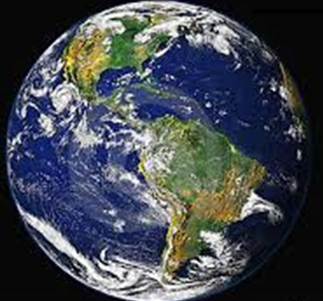

What is Geography?



**Learning Intentions:**

* Describe and compare the characteristics of places in different locations.
* Identify and describe the interconnections between people and the environment.
* Describe the location of selected countries.
* Identify simple patterns in the distribution of features of places.
* Recognise the importance of the environment and identify different views on how to respond to geographical challenges.
* Develop geographical questions to investigate and collect and record information and data from different sources to answer these questions.
* Represent data and the location of places and their characteristics in simple graphic forms, including large-scale maps that use the cartographic (mapping) conventions of scale, legend, title and north point.
* Describe the location of places and their features using simple grid references, compass, direction and distance.
* Interpret data to identify spatial distributions and simple patterns and draw conclusions.
* Present findings using geographical terminology in a range of texts.
* Propose individual action in response to a local geographical challenge and identify the expected effects of your proposed action.

**GETTING KNOWLEDGE READY**

1. Discuss what you know about ***geography*** with someone at home. Write some of the words that came up in your discussion in the speech bubbles.

________________________

________________________

________________________

________________________

1. Read the following information.

**INTRODUCTION**

**What is Geography?**

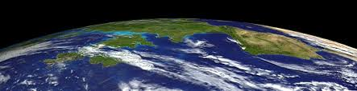

The word ***geography*** comes from the Greek words *gē,* meaning ***earth***, and *graphia* meaning ***writing*** (*geōgraphia)*. Geography is…

***the study of the earth and its features including natural characteristics and human life and the effects of human activity.***

Basically, Geography is about the world we live in. It is linked to *Nature*, *Natural Environments* and *Natural Features* such as volcanoes, rivers and weather.

1. View the following YouTube clip about Geography at:

<http://tinyurl.com/qho4vdn>

**GEOGRAPHICAL TERMINOLOGY**

1. Here are some words you will need to learn to help you understand more about geography. Read each word and say it out aloud. Ask an adult if you are saying it correctly. The next box shows you what the word means (definition).

|  |  |
| --- | --- |
| Word | Definition |
| characteristic | A special quality that makes a person, thing, or group different from others. |
| location | A place or position. |
| environment | The area in which something exists or lives. |
| country | A place that is controlled by its own government. |
| feature | An interesting or important part, quality, ability, etc. |
| scale | An indication of the relationship between the distances on a map and the corresponding actual distances. E.g. 1cm on a map is equal to 1km in real life. |
| legend | A list of the symbols on a map or chart. |

<http://www.merriam-webster.com/dictionary>

<http://dictionary.kids.net.au>

1. On the lines below, list at least 5 questions that you would like to ask about the earth’s features, e.g. What is the highest mountain in the world and where is it?

|  |
| --- |
|  |
|  |
|  |
|  |
|  |
|  |
|  |
|  |
|  |
|  |
|  |
|  |
|  |
|  |
|  |
|  |
|  |
|  |
|  |
|  |
|  |
|  |
|  |
|  |
|  |
|  |
|  |
|  |
|  |
|  |
|  |
|  |
|  |
|  |
|  |
|  |

1. Choose one of the questions you listed last week. Research the answer and present your work on the following page, as a Word document or PowerPoint. Include photos, diagrams, maps and your source of information. Here is an example:

**What is the highest mountain in the world and where is it?**

Mount Everest, in the Himalayan mountain range on the border of Nepal and the Chinese region of Tibet, is the highest mountain in the world. The peak of Mount Everest is 8,850 metres (29,035 feet) above sea level. No other mountain on Earth has a higher altitude.

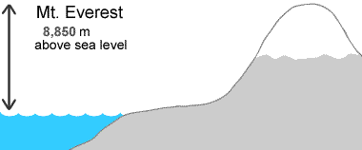

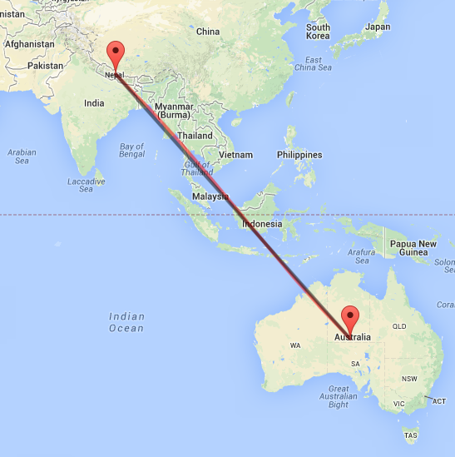

<http://geology.com/records/highest-mountain-in-the-world.shtml>

<http://www.distancefromto.net/distance-from/Australia/to/Nepal>

Question:________________________________________________________

_________________________________________________________________

|  |
| --- |
|  |
|  |
|  |
|  |
|  |
|  |
|  |
|  |
|  |
|  |
|  |
|  |
|  |
|  |
|  |
|  |
|  |
|  |
|  |
|  |
|  |
|  |
|  |
|  |
|  |
|  |
|  |
|  |
|  |
|  |
|  |
|  |
|  |
|  |
|  |
|  |

|  |
| --- |
|  |

**GEOGRAPHY QUIZ**

1. Circle the correct answer. The word ***geography*** comes from the Greek words *gē,* meaning ***earth***, and *graphia* meaning ***writing*** (*geōgraphia)*.

***TRUE*** or ***FALSE***

1. Circle the correct answer. Geography is the study of past events, particularly in human affairs.

***TRUE*** or ***FALSE***

1. Colour-code each word to its correct meaning.

|  |  |
| --- | --- |
| Word | Definition |
| legend | A special quality that makes a person, thing, or group different from others. |
| feature | A place or position. |
| country | The area in which something exists or lives. |
| scale | A place that is controlled by its own government. |
| environment | An interesting or important part, quality, ability, etc. |
| characteristic | An indication of the relationship between the distances on a map and the corresponding actual distances. E.g. 1cm on a map is equal to 1km in real life. |
| location | A list of the symbols on a map or chart. |

1. Circle the correct answer. The highest mountain in the world is:
2. Mount Macedon.
3. Magic Mountain.
4. Mount Everest.
5. Circle the correct answer. Mount Everest is in the:
6. Dandenong Ranges.
7. The Himalayan mountain range.
8. The Swiss Alps.
9. Circle the correct answer. Mount Everest is:
10. 8 850 metres above sea level.
11. 2 000 metres above sea level.
12. 5 500 metres above sea level.

**Score: __ / 12**

**REFLECTION**

***a***. ***What is most interesting thing you discovered about Geography?***

|  |
| --- |
|  |
|  |
|  |
|  |
|  |
|  |
|  |
|  |
|  |
|  |
|  |
|  |
|  |
|  |
|  |