Maths Talk



Number
- digits
- place value
- fractions
- decimals
- multiplication & division
- tables charts x1 – x12
- counting patterns – 2s, 4s, 5s, 6s, 8s, 9s, 10s, 11s, 12s
- money

Measurement
- perimeter
- area
- volume
- capacity
- length
- mass
- thermometer
- time

Space
- pentagon
- hexagon
- octagon
- lines
- 3-dimensional objects
- prisms
- pyramids
- direction
- symmetry
- tessellations

Chance & Data

- data
- graphs
- chance
- tally

Place Value

It shows you the position of a digit.
For example:
The place value of 3 in the number 357 is hundreds.

hundreds
3tens
5 units
7
Digits

Numbers 0 – 9 are called digits. The digits are:

0, 1, 2, 3, 4, 5, 6, 7, 8, 9

Digits are grouped together to make larger numbers.
88, 64, 999, 357

Fractions

A fraction is part of a group or a whole, e.g. ½ of the circle is shaded.

The top number in a fraction is called a numerator and the bottom number the denominator.

Multiplication & Division

Multiplication and division are linked together. If you know one multiplication fact you should be able to work out division. For example:

3 x 5 = 15 and 15 ÷ 3 = 5

Turn over to study the Multiplication tables 1 – 12.

Digits are grouped together to make larger numbers.
88, 64, 999, 357
Decimals

A decimal is a fraction written using a dot (decimal point) to separate the fractional part of the number from the whole number. Eg.

= 0.5
1.5 =
1/10 = 0.1

Digits are grouped together to make larger numbers.
88, 64, 999, 357

× 2

0 x 2 = 0
1 x 2 = 2
2 x 2 = 4
3 x 2 = 6
4 x 2 = 8
5 x 2 = 10
6 x 2 = 12
7 x 2 = 14
8 x 2 = 16
9 x 2 = 18
10 x 2 = 20
11 x 2 = 22
12 x 2 = 24

× 1

0 x 1 = 0
1 x 1 = 1
2 x 1 = 2
3 x 1 = 3
4 x 1 = 4
5 x 1 = 5
6 x 1 = 6
7 x 1 = 7
8 x 1 = 8
9 x 1 = 9
10 x 1 = 10
11 x 1 = 11
12 x 1 = 12

× 4

0 x 4= 0
1 x 4= 4
2 x 4= 8
3 x 4 = 12
4 x 4 = 16
5 x 4 = 20
6 x 4 = 24
7 x 4 = 28
8 x 4 = 32
9 x 4 = 36
10 x 4 = 40
11 x 4 = 44
12 x 4 = 48

×3

0 x 3 = 0
1 x 3 = 3
2 x 3 = 6
3 x 3 = 9
4 x 3 = 12
5 x 3 = 15
6 x 3 = 18
7 x 3 = 21
8 x 3 = 24
9 x 3 = 27
10 x 3 = 30
11 x 3 = 33
12 x 3 = 36

Tables continued

× 5

0 x 5 = 0
1 x 5 = 5
2 x 5 = 10
3 x 5 = 15
4 x 5 = 20
5 x 5 = 25
6 x 5 = 30
7 x 5 = 35
8 x 5 = 40
9 x 5 = 45
10 x 5 = 50
11 x 5 = 55
12 x 5 = 60

×6

0 x 6 = 0
1 x 6 = 6
2 x 6 = 12
3 x 6 = 18
4 x 6 = 24
5 x 6 = 30
6 x 6 = 36
7 x 6 = 42
8 x 6 = 48
9 x 6 = 54
10 x 6 = 60
11 x 6 = 66
12 x 6 = 72

× 7

0 x 7 = 0
1 x 7 = 7
2 x 7 = 14
3 x 7 = 21
4 x 7 = 28
5 x 7 = 35
6 x 7 = 42
7 x 7 = 49
8 x 7 = 56
9 x 7 = 63
10 x 7 = 70
11 x 7 = 77
12 x 7 = 84

× 8

0 x 8 = 0
1 x 8 = 8
2 x 8 = 16
3 x 8 = 24
4 x 8 = 32
5 x 8 = 40
6 x 8 = 48
7 x 8 = 56
8 x 8 = 64
9 x 8 = 72
10 x 8 = 80
11 x 8 = 88
12 x 8 = 96

Tables continued

× 9

0 x 9 = 0
1 x 9 = 9
2 x 9 = 18
3 x 9 = 27
4 x 9 = 36
5 x 9 = 45
6 x 9 = 54
7 x 9 = 63
8 x 9 = 72
9 x 9 = 81
10 x 9 = 90
11 x 9 = 99
12 x 9 = 108

× 10

0 x 10 = 0
1 x 10 = 10
2 x 10 = 20
3 x 10 = 30
4 x 10 = 40
5 x 10 = 50
6 x 10 = 60
7 x 10 = 70
8 x 10 = 80
9 x 10 = 90
10 x 10 = 100
11 x 10 = 110
12 x 10 = 120

× 11

0 x 11 = 0
1 x 11 = 11
2 x 11 = 22
3 x 11 = 33
4 x 11 = 44
5 x 11 = 55
6 x 11 = 66
7 x 11 = 77
8 x 11 = 88
9 x 11 = 99
10 x 11 = 110
11 x 11 = 121
12 x 11 = 132

× 12

0 x 12 = 0
1 x 12 = 12
2 x 12 = 24
3 x 12 = 36
4 x 12 = 48
5 x 12 = 60
6 x 12 = 72
7 x 12 = 84
8 x 12 = 96
9 x 12 = 108
10 x 12 = 120
11 x 12 = 132
12 x 11 = 144

Counting Patterns

These counting patterns are shown in the following tables:

2 2, 4, 6, 8, 0

2, 4, 6, 8, 10, 12, 14, 16, 18, 20

4 4, 8, 2, 6, 0

4, 8, 12, 16, 20, 24, 28, 32, 36, 40

5 5, 0, 5, 0, 5

5, 10, 15, 20, 25, 30, 35, 40, 45, 50

6 6, 2, 8, 4, 0

6, 12, 18, 24, 30, 36, 42, 48, 54, 60

8 8, 6, 4, 2, 0

8, 16, 24, 32, 40, 48, 56, 64, 72, 80
Counting patterns continued

9 9, 8, 7, 6, 5, 4, 3, 2, 1, 0

9, 18, 27, 36, 45, 54, 63, 72, 81, 90

10 0, 0, 0, 0, 0, 0, 0, 0, 0, 0

10, 20, 30, 40, 50, 60, 70, 80, 90, 100

11 1, 2, 3, 4, 5, 6, 7, 8, 9, 10

11, 22, 33, 44, 55, 66, 77, 88, 99, 110

12 2, 4, 6, 8, 0,

12, 24, 36, 48, 60, 72, 84, 96, 108, 120

Money

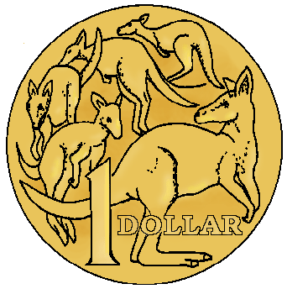  $1 coin | 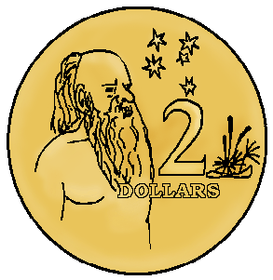  $2 coin
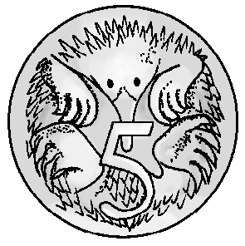  5 cent coin | 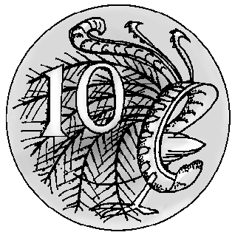  10 cent coin
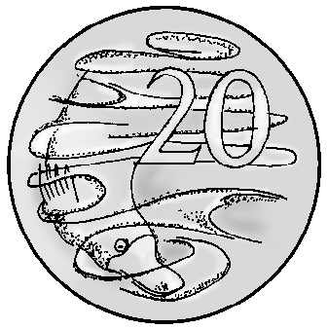  20 cent coin | 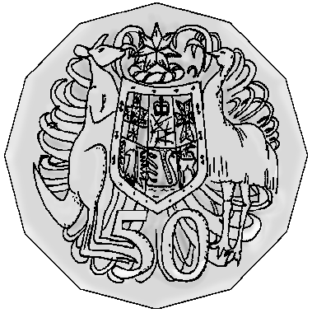  50 cent coin
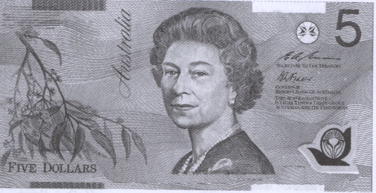  $5 note | 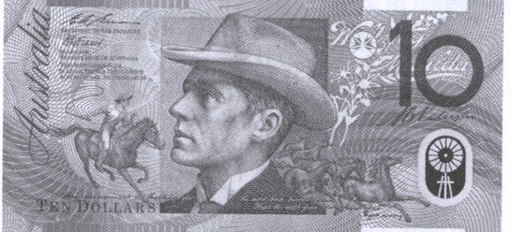  $10 note
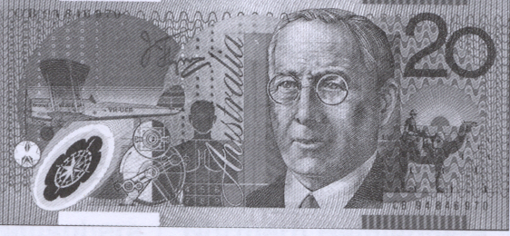  $20 note | 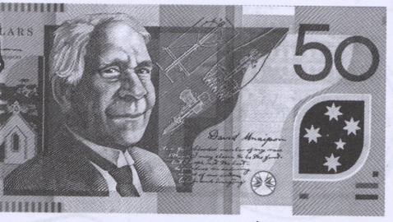  $50 note
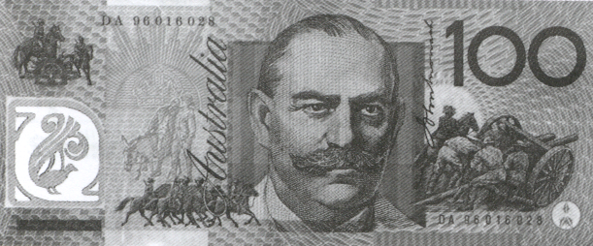

$100 note

Perimeter

When you measure perimeter, you measure the distance around the outside of an object.
10 cm

10cm10cm

5cm

10 + 10 + 10 + 5 = 35cm
Area

Area is the amount of space covered or taken up by an object.

It takes 19 coins to measure
the area of this octagon.

Capacity

Capacity is the amount a container can hold.

This soft drink can hold 250 ml.

Volume

Volume is the amount of space something takes up.

The volume of this box is 8 blocks.

Measurement continued
Length

To measure how long an object or distance is.

Mass

Mass usually relates to weight.
Remember that size or quantity does not always relate directly to mass.

The elephant has greater mass than the mouse.

Thermometer

A thermometer is an instrument that measures the temperature.

Time

analogue clockdigital clock

2:30pm

Pentagon

five sided shape

Hexagon

six sided shape

Octagon

eight sided shape

Lines

A horizontal line runs across from either left to right or right to left.

A vertical line runs straight up or down

This line is called a diagonal.

Parallel lines – lines that are the same distance apart. They can be drawn in any direction.

Space continued

3D

3D objects are solid shapes. They have three dimensions: length, width and depth.
Prisms

A prism is an object where both the base and top end are directly opposite one another and the sides are parallel.

Pyramids

A pyramid is a shape where the base is solid and the sides join at the top, to make a point.

Tessellations

Tessellations are patterns and shapes that repeat endlessly without leaving gaps.
Symmetry

Sides of a shape that match exactly the same when folded.

Data

Number information that is collected from the survey.
Below is an example of data (information) collected on students’ favourite cars.

Honda 15

Subaru 5

Porsche 25

Ford 15

Ferrari 20

Graph

A graph is a picture that shows information.

Chance

The likelihood of something happening.

Terms such as:
likely, unlikely, possible and impossible are used.

Tally

A method of recording data.

Small vertical lines are used to represent numbers. eg.

equals 5.

