English Skills

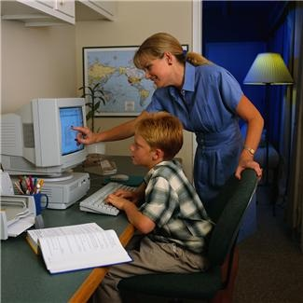

*How can I present my work using technology?*



**Please read before you begin**

|  |  |
| --- | --- |
| Welcome to Module M. In this Module you will be asking yourself  How can I present my work using technology?  To help you answer this question, these are your learning intentions. | **C:\Users\jselim\Desktop\computerboy.jpg** |

|  |  |
| --- | --- |
|  | Learning Intentions for Module M |

Writing Workshop

Study the style and techniques used in your work presentation.

Grammar and Punctuation

Precise sentences

How Words Work

Captions

Spelling and Phonics

Study your 10 given spelling words as well as your own 10 words for your test at the end of the Set. In phonics, you will look at the sounds of ‘er’ and ‘ir’

|  |  |
| --- | --- |
| Contents | |
| Set One | Reading and Writing Workshop   * Learn the steps to create a border using technology * Talk to someone at home and complete activities about creating a border using technology   Spelling activities and Phonics   * Ten given words and ten words of your own choice * The sound made by the letters ‘er’   Grammar and Punctuation   * Precise sentences   How words work   * Captions   Spelling test  Spell the words for this Set |
| Set Two | Reading and Writing Workshop   * Create WordArt using technology   Spelling activities and Phonics   * Ten given words and ten words of your own choice. * The sound made by the letters ‘ir’   Grammar and Punctuation   * Precise sentences   How words work   * Captions   Spelling test   * Spell the words for this Set   Reflection   * Answer written questions about what you have learnt in the module |

|  |  |
| --- | --- |
| books,boys,childhood,children,concentration,educates,educations,Fotolia,homework,kids,knowledge,learning,learns,males,Photographs,readings,reads,schools,students,studies | Getting Knowledge Ready |

Let’s look at the presentation of your work. This is the time when you are putting the finishing touches on your work before you publish it.

Presentation can mean a lot of things. Please write five questions that start with who, what, where, when and how on the presentation of your work

Who\_\_\_\_\_\_\_\_\_\_\_\_\_\_\_\_\_\_\_\_\_\_\_\_\_\_\_\_\_\_\_\_\_\_\_\_\_\_\_\_\_\_\_\_\_\_\_\_\_\_\_\_\_\_\_\_\_\_

What\_\_\_\_\_\_\_\_\_\_\_\_\_\_\_\_\_\_\_\_\_\_\_\_\_\_\_\_\_\_\_\_\_\_\_\_\_\_\_\_\_\_\_\_\_\_\_\_\_\_\_\_\_\_\_\_\_

Where\_\_\_\_\_\_\_\_\_\_\_\_\_\_\_\_\_\_\_\_\_\_\_\_\_\_\_\_\_\_\_\_\_\_\_\_\_\_\_\_\_\_\_\_\_\_\_\_\_\_\_\_\_\_\_\_

When\_\_\_\_\_\_\_\_\_\_\_\_\_\_\_\_\_\_\_\_\_\_\_\_\_\_\_\_\_\_\_\_\_\_\_\_\_\_\_\_\_\_\_\_\_\_\_\_\_\_\_\_\_\_\_\_

How\_\_\_\_\_\_\_\_\_\_\_\_\_\_\_\_\_\_\_\_\_\_\_\_\_\_\_\_\_\_\_\_\_\_\_\_\_\_\_\_\_\_\_\_\_\_\_\_\_\_\_\_\_\_\_\_\_

|  |
| --- |
| Set One |



Presentation is an important part of writing. This is where you have finished your drafts and you are ready to publish your work and it’s ready to show others.

It’s important to make the final copy of your writing look good and interesting so that it stands out. You want as many people as possible to read your work. Using computer software to help with the presentation of your work is a great idea.

This Set we are going to be looking at inserting a page border to your word document. You will need to have available a copy of Microsoft Word and computer access.

Please read the following steps on how to insert a page border in Microsoft Word.

Step 1: Open Microsoft Word and choose Page Layout in the toolbar.

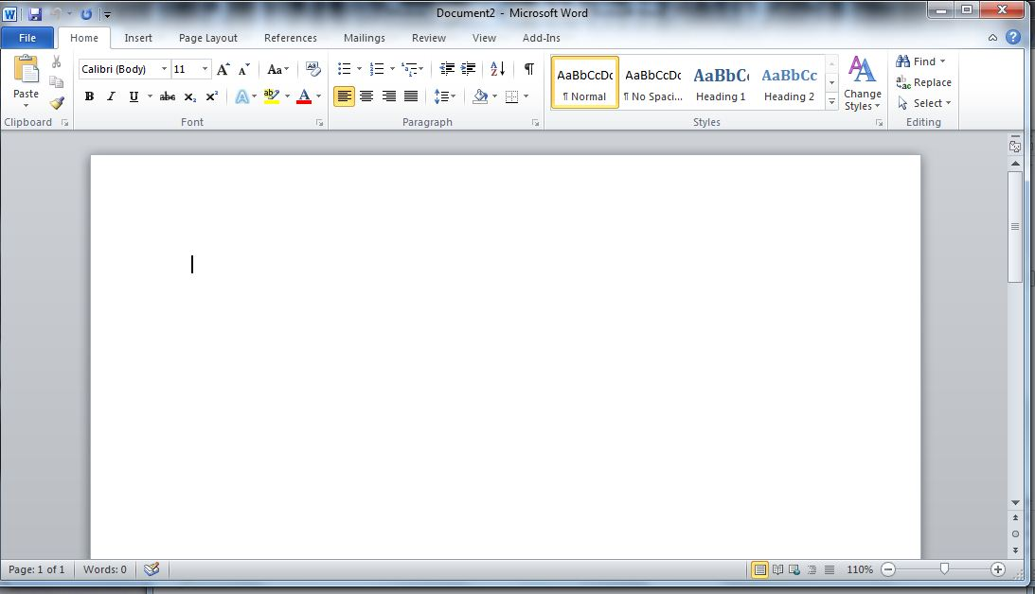

Step 2: Choose the Page Borders option from the menu. A Borders and Shading window should open.

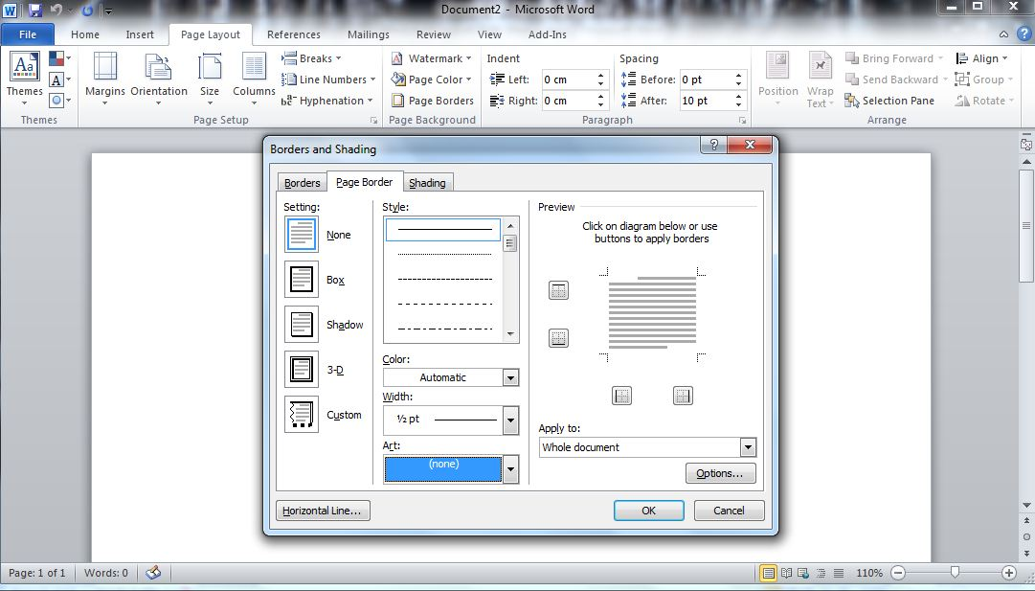

Step 3: From the Borders and Shading window, click on the arrow under the Art section. This should bring up some different types of borders.

How are you going so far?

\_\_\_\_\_\_\_\_\_\_\_\_\_\_\_\_\_\_\_\_\_\_\_\_\_\_\_\_\_\_\_\_\_\_\_\_\_\_\_\_\_\_\_\_\_\_\_\_\_\_\_\_\_\_\_\_\_\_\_

\_\_\_\_\_\_\_\_\_\_\_\_\_\_\_\_\_\_\_\_\_\_\_\_\_\_\_\_\_\_\_\_\_\_\_\_\_\_\_\_\_\_\_\_\_\_\_\_\_\_\_\_\_\_\_\_\_\_\_

\_\_\_\_\_\_\_\_\_\_\_\_\_\_\_\_\_\_\_\_\_\_\_\_\_\_\_\_\_\_\_\_\_\_\_\_\_\_\_\_\_\_\_\_\_\_\_\_\_\_\_\_\_\_\_\_\_\_\_

\_\_\_\_\_\_\_\_\_\_\_\_\_\_\_\_\_\_\_\_\_\_\_\_\_\_\_\_\_\_\_\_\_\_\_\_\_\_\_\_\_\_\_\_\_\_\_\_\_\_\_\_\_\_\_\_\_\_\_

Step 4: Scroll down the different types of borders and choose the one that you like.

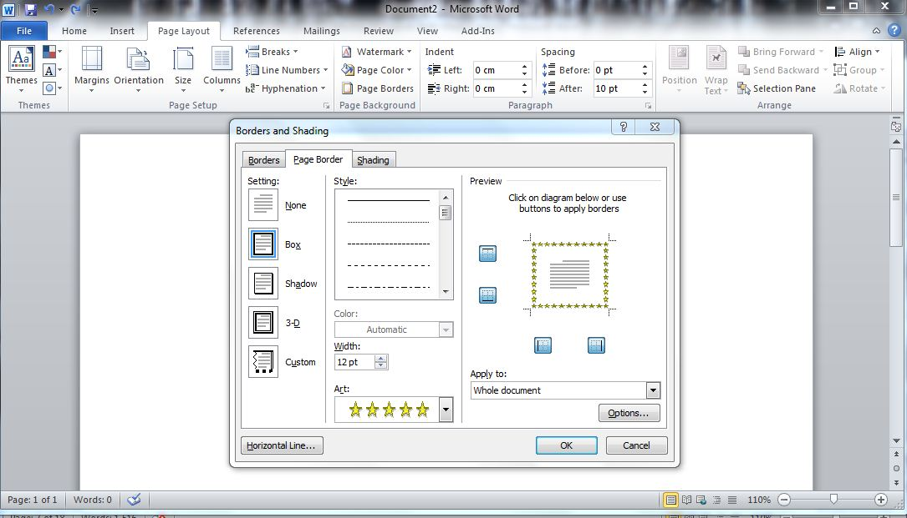

Step 5: Then click on OK.

Step 6: Now your page should have its own interesting border!

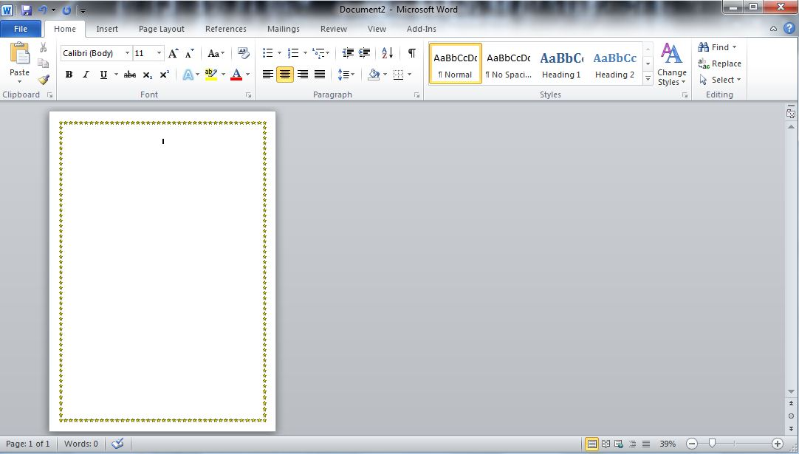

Now have a go at using some different page borders for yourself! Have fun! ☺

|  |  |
| --- | --- |
| C:\Users\jmiller\AppData\Local\Microsoft\Windows\Temporary Internet Files\Low\Content.IE5\O584SN30\MC900053962[1].WMF | Grammar and Punctuation |

The order of a sentence

A sentence is a group of words that express a complete thought. A sentence has two main parts:

* a subject (what the sentence is about)
* a predicate (what happens to the subject)

For example: The dog (subject) is barking (predicate).

A sentence always starts with a capital letter and usually ends with a full stop.

Full stop.

The cat liked to drink milk.

Capital letter.

C:\Users\crt\AppData\Local\Microsoft\Windows\Temporary Internet Files\Content.IE5\K975LXFD\MC900438167[1].wmf

I like to drink milk after I have eaten my dinner.

The following sentences are mixed up. You need to put them in order. Write the sentence on the lines below. A good trick to help you is to remember the sentence begins with a capital letter and usually finishes with a full stop.

1.

|  |  |  |
| --- | --- | --- |
| grow in spring. | the flowers | I like to see |

\_\_\_\_\_\_\_\_\_\_\_\_\_\_\_\_\_\_\_\_\_\_\_\_\_\_\_\_\_\_\_\_\_\_\_\_\_\_\_\_\_\_\_\_\_\_\_\_\_\_\_\_\_\_\_\_\_\_\_

\_\_\_\_\_\_\_\_\_\_\_\_\_\_\_\_\_\_\_\_\_\_\_\_\_\_\_\_\_\_\_\_\_\_\_\_\_\_\_\_\_\_\_\_\_\_\_\_\_\_\_\_\_\_\_\_\_\_\_

\_\_\_\_\_\_\_\_\_\_\_\_\_\_\_\_\_\_\_\_\_\_\_\_\_\_\_\_\_\_\_\_\_\_\_\_\_\_\_\_\_\_\_\_\_\_\_\_\_\_\_\_\_\_\_\_\_\_\_

\_\_\_\_\_\_\_\_\_\_\_\_\_\_\_\_\_\_\_\_\_\_\_\_\_\_\_\_\_\_\_\_\_\_\_\_\_\_\_\_\_\_\_\_\_\_\_\_\_\_\_\_\_\_\_\_\_\_\_

2.

|  |  |  |
| --- | --- | --- |
| tasks to do | to finish his work. | Tim has many |

\_\_\_\_\_\_\_\_\_\_\_\_\_\_\_\_\_\_\_\_\_\_\_\_\_\_\_\_\_\_\_\_\_\_\_\_\_\_\_\_\_\_\_\_\_\_\_\_\_\_\_\_\_\_\_\_\_\_

\_\_\_\_\_\_\_\_\_\_\_\_\_\_\_\_\_\_\_\_\_\_\_\_\_\_\_\_\_\_\_\_\_\_\_\_\_\_\_\_\_\_\_\_\_\_\_\_\_\_\_\_\_\_\_\_\_\_\_

\_\_\_\_\_\_\_\_\_\_\_\_\_\_\_\_\_\_\_\_\_\_\_\_\_\_\_\_\_\_\_\_\_\_\_\_\_\_\_\_\_\_\_\_\_\_\_\_\_\_\_\_\_\_\_\_\_\_\_

\_\_\_\_\_\_\_\_\_\_\_\_\_\_\_\_\_\_\_\_\_\_\_\_\_\_\_\_\_\_\_\_\_\_\_\_\_\_\_\_\_\_\_\_\_\_\_\_\_\_\_\_\_\_\_\_\_\_\_

3.

|  |  |  |
| --- | --- | --- |
| Mrs. Smith | the library. | looks after |

\_\_\_\_\_\_\_\_\_\_\_\_\_\_\_\_\_\_\_\_\_\_\_\_\_\_\_\_\_\_\_\_\_\_\_\_\_\_\_\_\_\_\_\_\_\_\_\_\_\_\_\_\_\_\_\_\_\_

\_\_\_\_\_\_\_\_\_\_\_\_\_\_\_\_\_\_\_\_\_\_\_\_\_\_\_\_\_\_\_\_\_\_\_\_\_\_\_\_\_\_\_\_\_\_\_\_\_\_\_\_\_\_\_\_\_\_\_

\_\_\_\_\_\_\_\_\_\_\_\_\_\_\_\_\_\_\_\_\_\_\_\_\_\_\_\_\_\_\_\_\_\_\_\_\_\_\_\_\_\_\_\_\_\_\_\_\_\_\_\_\_\_\_\_\_\_\_

\_\_\_\_\_\_\_\_\_\_\_\_\_\_\_\_\_\_\_\_\_\_\_\_\_\_\_\_\_\_\_\_\_\_\_\_\_\_\_\_\_\_\_\_\_\_\_\_\_\_\_\_\_\_\_\_\_\_\_

|  |  |
| --- | --- |
|  | How Words Work |

Captions:

* this is a phrase or sentence that explains a picture, diagram or chart
* they are used often in nonfiction texts
* always begin with a capital letter
* if a caption is a sentence, then it may end with a full stop

Below is an example of a caption.



The caption ‘Just Married!’ is used here to explain what the picture is about.

Here is another example of a caption.

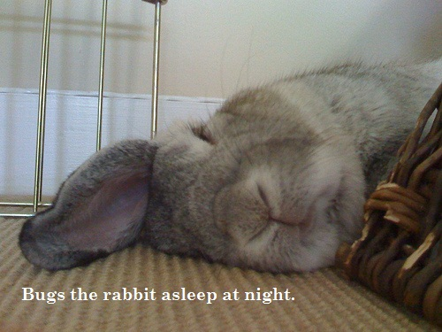

Does the caption help you understand what’s in the photo?

\_\_\_\_\_\_\_\_\_\_\_\_\_\_\_\_\_\_\_\_\_\_\_\_\_\_\_

Why or why not?

\_\_\_\_\_\_\_\_\_\_\_\_\_\_\_\_\_\_\_\_\_\_\_\_\_\_\_\_\_\_\_\_\_\_\_\_\_\_\_\_\_\_\_\_\_\_\_\_\_\_\_\_\_\_\_\_\_\_\_

\_\_\_\_\_\_\_\_\_\_\_\_\_\_\_\_\_\_\_\_\_\_\_\_\_\_\_\_\_\_\_\_\_\_\_\_\_\_\_\_\_\_\_\_\_\_\_\_\_\_\_\_\_\_\_\_\_\_\_

\_\_\_\_\_\_\_\_\_\_\_\_\_\_\_\_\_\_\_\_\_\_\_\_\_\_\_\_\_\_\_\_\_\_\_\_\_\_\_\_\_\_\_\_\_\_\_\_\_\_\_\_\_\_\_\_\_\_\_

\_\_\_\_\_\_\_\_\_\_\_\_\_\_\_\_\_\_\_\_\_\_\_\_\_\_\_\_\_\_\_\_\_\_\_\_\_\_\_\_\_\_\_\_\_\_\_\_\_\_\_\_\_\_\_\_\_\_\_

\_\_\_\_\_\_\_\_\_\_\_\_\_\_\_\_\_\_\_\_\_\_\_\_\_\_\_\_\_\_\_\_\_\_\_\_\_\_\_\_\_\_\_\_\_\_\_\_\_\_\_\_\_\_\_\_\_\_\_

\_\_\_\_\_\_\_\_\_\_\_\_\_\_\_\_\_\_\_\_\_\_\_\_\_\_\_\_\_\_\_\_\_\_\_\_\_\_\_\_\_\_\_\_\_\_\_\_\_\_\_\_\_\_\_\_\_\_\_

\_\_\_\_\_\_\_\_\_\_\_\_\_\_\_\_\_\_\_\_\_\_\_\_\_\_\_\_\_\_\_\_\_\_\_\_\_\_\_\_\_\_\_\_\_\_\_\_\_\_\_\_\_\_\_\_\_\_\_

\_\_\_\_\_\_\_\_\_\_\_\_\_\_\_\_\_\_\_\_\_\_\_\_\_\_\_\_\_\_\_\_\_\_\_\_\_\_\_\_\_\_\_\_\_\_\_\_\_\_\_\_\_\_\_\_\_\_\_

\_\_\_\_\_\_\_\_\_\_\_\_\_\_\_\_\_\_\_\_\_\_\_\_\_\_\_\_\_\_\_\_\_\_\_\_\_\_\_\_\_\_\_\_\_\_\_\_\_\_\_\_\_\_\_\_\_\_\_

Below are some captions and photos. Match the caption with the right photo and then write the matching caption underneath.

Digging in the soil.

|  |  |
| --- | --- |
| D:\Users\james\Desktop\untitled.bmp | D:\Users\james\Desktop\Water_Slide_[1].jpg |

\_\_\_\_\_\_\_\_\_\_\_\_\_\_\_\_\_\_\_\_\_\_\_\_\_\_\_\_\_\_\_\_ \_\_\_\_\_\_\_\_\_\_\_\_\_\_\_\_\_\_\_\_\_\_\_\_\_\_\_\_\_

Goats eating grass.

|  |  |
| --- | --- |
| D:\Users\james\Desktop\250px-Supermarkt[1].jpg | D:\Users\james\Desktop\4382078-goats-grazing-in-farm[1].jpg |

\_\_\_\_\_\_\_\_\_\_\_\_\_\_\_\_\_\_\_\_\_\_\_\_\_\_\_\_\_\_\_\_ \_\_\_\_\_\_\_\_\_\_\_\_\_\_\_\_\_\_\_\_\_\_\_\_\_\_\_\_\_

|  |  |
| --- | --- |
|  | Spelling |

Ten Spelling Words for Set One

again very forty almost friend

answer person teacher saucer silver

1. Write as many rhyming words as you can for the word

very\_\_\_\_\_\_\_\_\_\_\_\_\_\_\_\_\_\_\_\_\_\_\_\_\_\_\_\_\_\_\_\_\_\_\_\_\_\_

\_\_\_\_\_\_\_\_\_\_\_\_\_\_\_\_\_\_\_\_\_\_\_\_\_\_\_\_\_\_\_\_\_\_\_\_\_\_\_\_\_\_

2. Write a sentence with the words silver and saucer.

\_\_\_\_\_\_\_\_\_\_\_\_\_\_\_\_\_\_\_\_\_\_\_\_\_\_\_\_\_\_\_\_\_\_\_\_\_\_\_\_\_\_\_\_\_\_\_\_\_\_\_\_\_\_\_\_\_\_\_\_\_

\_\_\_\_\_\_\_\_\_\_\_\_\_\_\_\_\_\_\_\_\_\_\_\_\_\_\_\_\_\_\_\_\_\_\_\_\_\_\_\_\_\_\_\_\_\_\_\_\_\_\_\_\_\_\_\_\_\_\_\_\_

\_\_\_\_\_\_\_\_\_\_\_\_\_\_\_\_\_\_\_\_\_\_\_\_\_\_\_\_\_\_\_\_\_\_\_\_\_\_\_\_\_\_\_\_\_\_\_\_\_\_\_\_\_\_\_\_\_\_\_\_\_

\_\_\_\_\_\_\_\_\_\_\_\_\_\_\_\_\_\_\_\_\_\_\_\_\_\_\_\_\_\_\_\_\_\_\_\_\_\_\_\_\_\_\_\_\_\_\_\_\_\_\_\_\_\_\_\_\_\_\_\_\_

\_\_\_\_\_\_\_\_\_\_\_\_\_\_\_\_\_\_\_\_\_\_\_\_\_\_\_\_\_\_\_\_\_\_\_\_\_\_\_\_\_\_\_\_\_\_\_\_\_\_\_\_\_\_\_\_\_\_\_\_\_

\_\_\_\_\_\_\_\_\_\_\_\_\_\_\_\_\_\_\_\_\_\_\_\_\_\_\_\_\_\_\_\_\_\_\_\_\_\_\_\_\_\_\_\_\_\_\_\_\_\_\_\_\_\_\_\_\_\_\_\_\_

\_\_\_\_\_\_\_\_\_\_\_\_\_\_\_\_\_\_\_\_\_\_\_\_\_\_\_\_\_\_\_\_\_\_\_\_\_\_\_\_\_\_\_\_\_\_\_\_\_\_\_\_\_\_\_\_\_\_\_\_\_

\_\_\_\_\_\_\_\_\_\_\_\_\_\_\_\_\_\_\_\_\_\_\_\_\_\_\_\_\_\_\_\_\_\_\_\_\_\_\_\_\_\_\_\_\_\_\_\_\_\_\_\_\_\_\_\_\_\_\_\_\_

\_\_\_\_\_\_\_\_\_\_\_\_\_\_\_\_\_\_\_\_\_\_\_\_\_\_\_\_\_\_\_\_\_\_\_\_\_\_\_\_\_\_\_\_\_\_\_\_\_\_\_\_\_\_\_\_\_\_\_\_\_

\_\_\_\_\_\_\_\_\_\_\_\_\_\_\_\_\_\_\_\_\_\_\_\_\_\_\_\_\_\_\_\_\_\_\_\_\_\_\_\_\_\_\_\_\_\_\_\_\_\_\_\_\_\_\_\_\_\_\_\_\_

This Set we will be looking at the sound made by the letters ‘**er**’. This sound is found in many words. It makes an er sound when you say it out loud.

For example say the word *person* out loud and count the sounds you can hear, p/**er**/s/o/n. Can you hear the er sound?

1. Circle the er sound in the following words and draw a picture of it.

|  |  |  |
| --- | --- | --- |
| teacher | saucer | silver |

1. Fill in the er sound in the following words.

answ \_\_\_ \_\_\_ mast \_\_\_ \_\_\_ mod \_\_\_ \_\_\_ n west \_\_\_ \_\_\_ n

1. Put one of the ‘**er**’ sounding words in a sentence. Don’t forget to begin your sentence with a capital letter and finish with a full stop.

\_\_\_\_\_\_\_\_\_\_\_\_\_\_\_\_\_\_\_\_\_\_\_\_\_\_\_\_\_\_\_\_\_\_\_\_\_\_\_\_\_\_\_\_\_\_\_\_\_\_\_\_\_\_\_\_\_\_\_\_\_\_\_\_

\_\_\_\_\_\_\_\_\_\_\_\_\_\_\_\_\_\_\_\_\_\_\_\_\_\_\_\_\_\_\_\_\_\_\_\_\_\_\_\_\_\_\_\_\_\_\_\_\_\_\_\_\_\_\_\_\_\_\_\_\_\_\_\_

\_\_\_\_\_\_\_\_\_\_\_\_\_\_\_\_\_\_\_\_\_\_\_\_\_\_\_\_\_\_\_\_\_\_\_\_\_\_\_\_\_\_\_\_\_\_\_\_\_\_\_\_\_\_\_\_\_\_\_\_\_\_\_

\_\_\_\_\_\_\_\_\_\_\_\_\_\_\_\_\_\_\_\_\_\_\_\_\_\_\_\_\_\_\_\_\_\_\_\_\_\_\_\_\_\_\_\_\_\_\_\_\_\_\_\_\_\_\_\_\_\_\_\_\_\_\_\_

\_\_\_\_\_\_\_\_\_\_\_\_\_\_\_\_\_\_\_\_\_\_\_\_\_\_\_\_\_\_\_\_\_\_\_\_\_\_\_\_\_\_\_\_\_\_\_\_\_\_\_\_\_\_\_\_\_\_\_\_\_\_\_\_

\_\_\_\_\_\_\_\_\_\_\_\_\_\_\_\_\_\_\_\_\_\_\_\_\_\_\_\_\_\_\_\_\_\_\_\_\_\_\_\_\_\_\_\_\_\_\_\_\_\_\_\_\_\_\_\_\_\_\_\_\_\_\_\_

\_\_\_\_\_\_\_\_\_\_\_\_\_\_\_\_\_\_\_\_\_\_\_\_\_\_\_\_\_\_\_\_\_\_\_\_\_\_\_\_\_\_\_\_\_\_\_\_\_\_\_\_\_\_\_\_\_\_\_\_\_\_\_\_

\_\_\_\_\_\_\_\_\_\_\_\_\_\_\_\_\_\_\_\_\_\_\_\_\_\_\_\_\_\_\_\_\_\_\_\_\_\_\_\_\_\_\_\_\_\_\_\_\_\_\_\_\_\_\_\_\_\_\_\_\_\_\_\_

|  |  |
| --- | --- |
| It’s time for your spelling test  Give your sheet of words to someone at home. Ask them to test your spelling of the ten words you were given to learn this Set. You might even like to practice your words once again before you have your test. | j0226124 |

|  |  |
| --- | --- |
| Spelling Words for Set One | |
| Set One Module Words | Set Two Own Words |
| again |  |
| very |  |
| forty |  |
| friend |  |
| answer |  |
| person |  |
| teacher |  |
| saucer |  |
| silver |  |
| almost |  |

****

**Checklist**

This Set you should have completed the following tasks. Please tick the tasks you have completed.

* Reading and Writing workshop*—*Presentation of your work
* Spelling activities—LCWC and own Words
* Phonics- The ‘er’ sound
* Grammar and Punctuation —Precise sentences
* How Words Work— Captions
* Spelling and Dictation test

|  |
| --- |
| End of Set 1 |

|  |
| --- |
| Set Two |



Remember these two important things we learned in Set One:

* Presentation is important because it makes our work interesting.
* Page borders help us to present our work nicely.

Today we are going to use WordArt in Microsoft Word.

Here are the steps to follow.

Step 1: Open a word document and then type the words ‘Technology is amazing!’

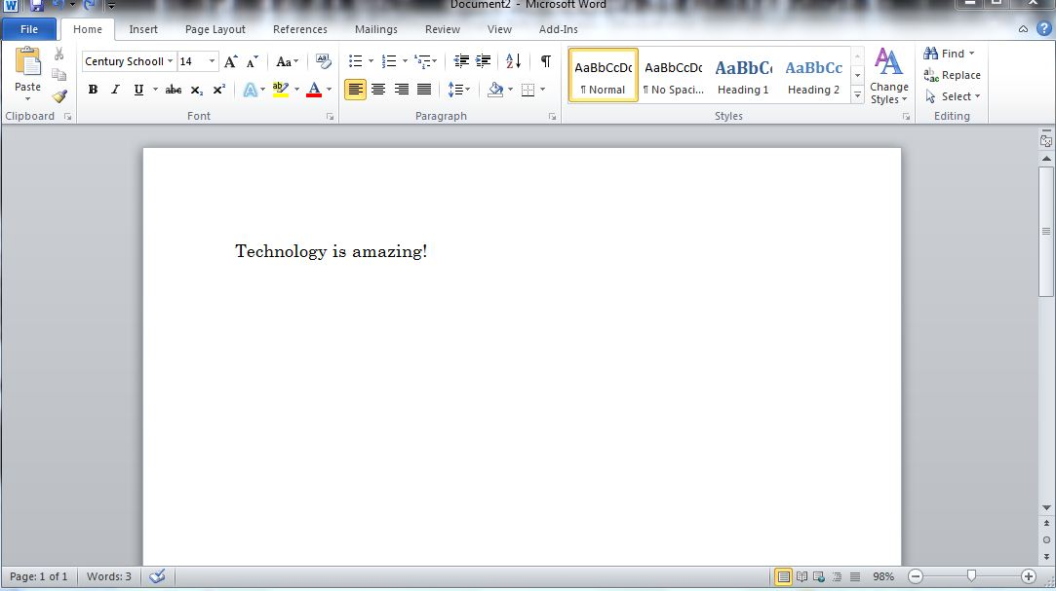

Step 2: Then press the insert tab in the tool bar.



Step 3: Then click on the WordArt tab.

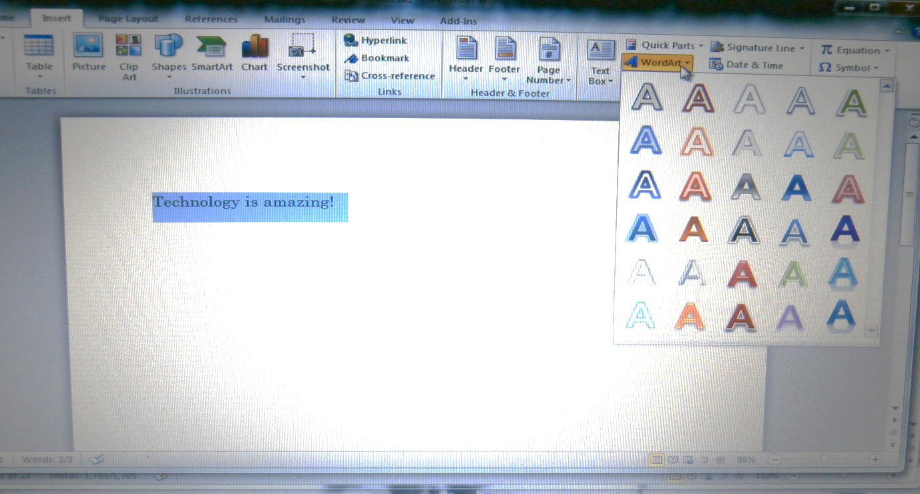

Step 4: Click on the style you like.

Step 5: Now you have a great heading for your document!



Step 6: Then enter a border style that we showed you from last Set. Now you have some great presentation tips for your work which you can use in the future!

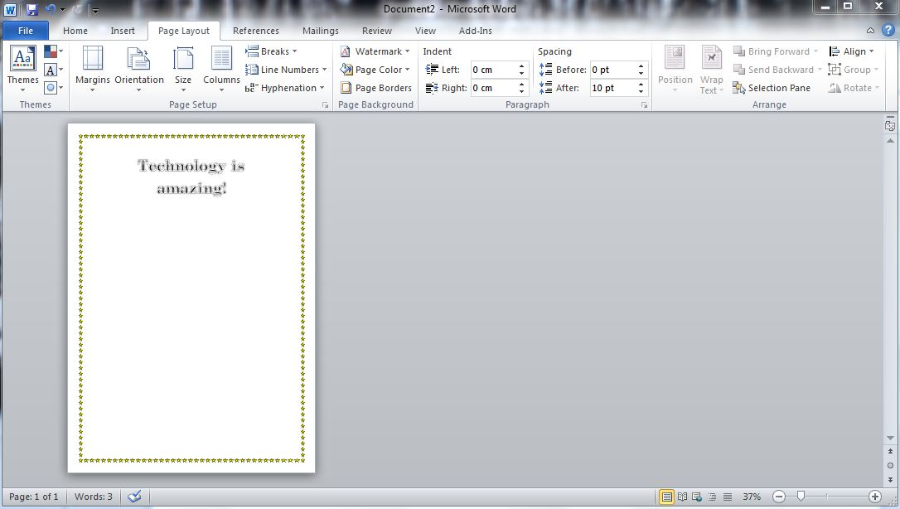

Please show your completed work to someone at home.

|  |  |
| --- | --- |
|  | Daily Reading |

Remember to do your daily reading. Make sure you can find something enjoyable to read for about 15 minutes each day with someone at home.

|  |  |
| --- | --- |
|  | Spelling, Phonics and How Words Work |

It’s time for you to learn your words for this Set. They are at the back of this Module. You also need to choose ten words for **My** **Own Words.**

These can be from:

|  |  |
| --- | --- |
|  | * your own writing |
|  | * your reading |
|  | * your memory |
|  |  |

Ten Spelling Words for Set Two

caught before beautiful thought too

third firm stir thirty circus

1. Write the antonyms (opposites) to these words from the spelling list:

ugly \_\_\_\_\_\_\_\_\_\_\_\_\_\_\_\_\_\_\_\_ free \_\_\_\_\_\_\_\_\_\_\_\_\_\_\_\_\_\_\_\_\_\_\_\_

after \_\_\_\_\_\_\_\_\_\_\_\_\_\_\_\_\_\_\_\_ loose \_\_\_\_\_\_\_\_\_\_\_\_\_\_\_\_\_\_\_\_\_\_\_

1. Write an acrostic poem for stir:

S\_\_\_\_\_\_\_\_\_\_\_\_\_\_\_\_\_\_\_\_\_\_\_\_\_\_\_\_\_\_\_\_\_\_\_\_\_\_\_\_\_\_\_\_\_\_\_\_\_\_\_

T\_\_\_\_\_\_\_\_\_\_\_\_\_\_\_\_\_\_\_\_\_\_\_\_\_\_\_\_\_\_\_\_\_\_\_\_\_\_\_\_\_\_\_\_\_\_\_\_\_\_\_

I\_\_\_\_\_\_\_\_\_\_\_\_\_\_\_\_\_\_\_\_\_\_\_\_\_\_\_\_\_\_\_\_\_\_\_\_\_\_\_\_\_\_\_\_\_\_\_\_\_\_\_\_

R\_\_\_\_\_\_\_\_\_\_\_\_\_\_\_\_\_\_\_\_\_\_\_\_\_\_\_\_\_\_\_\_\_\_\_\_\_\_\_\_\_\_\_\_\_\_\_\_\_\_\_

1. Fill in the gaps for these list words

b \_\_\_\_ a u \_\_\_\_ \_\_\_\_\_ \_\_\_\_\_ \_\_\_\_\_ l

th \_\_\_\_\_ \_\_\_\_\_ d \_\_\_\_\_ \_\_\_\_\_ \_\_\_\_\_ \_\_\_\_\_ us

This Set we are looking at the *‘ir’* sound in words. These letters contain one vowel and one consonant. They are usually found in the middle of words.

Say the word firm aloud. You will notice that the *ir* sound in firm is found in the middle of the word.

Sometimes the *ir* sound is at the end of the word. An example of this is the word stir.

1. Underline the *ir* sound in each word and then write it out.

sir bird circle birth

\_\_\_\_\_\_\_\_\_\_\_ \_\_\_\_\_\_\_\_\_\_\_\_ \_\_\_\_\_\_\_\_\_\_\_\_ \_\_\_\_\_\_\_\_\_\_\_\_

Match the words below with their meanings.

|  |
| --- |
| circus thirty firm  third stir birthday |

Which word means:

a. A place where people perform. \_\_\_\_\_\_\_\_\_\_\_\_\_\_\_\_\_\_\_\_\_\_\_\_\_\_\_

b. After the number twenty nine. \_\_\_\_\_\_\_\_\_\_\_\_\_\_\_\_\_\_\_\_\_\_\_\_\_\_\_

c. The day someone is born. \_\_\_\_\_\_\_\_\_\_\_\_\_\_\_\_\_\_\_\_\_\_\_\_\_\_\_

d. Before fourth. \_\_\_\_\_\_\_\_\_\_\_\_\_\_\_\_\_\_\_\_\_\_\_\_\_\_\_

e. Can be strong. \_\_\_\_\_\_\_\_\_\_\_\_\_\_\_\_\_\_\_\_\_\_\_\_\_\_\_

Last Set we learned that captions help people to understand what is in a photo, picture or graphic. They are also used in timetables.

Below is a timetable of what Jack studies at school. The pictures are all jumbled up. Find the correct caption and draw an arrow to the matching picture. One has been done for you.

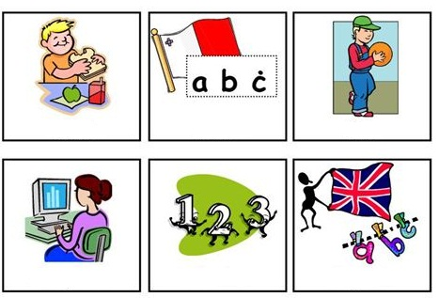 Jumbled Captions

|  |  |  |
| --- | --- | --- |
| Morning Maths Class | Morning Computer Class | Lunch time |
| Afternoon English Class | Afternoon Physical Education Class | After Italian Language Class |

|  |  |
| --- | --- |
| C:\Users\jmiller\AppData\Local\Microsoft\Windows\Temporary Internet Files\Low\Content.IE5\O584SN30\MC900053962[1].WMF | Grammar and Punctuation |

This Set we will learn how to use question marks? and exclamation marks !

What are questions?

* Sentences that ask for information or action.
* For example:

*Have you got the time?*

Here are some ways you can write questions.

1. Begin with one of the *wh* words (what, when, where, which, who, whose, why).

*What* is going on?

*Why* do you want to know?

1. Begin with part of the verb *to be*, to be able (*can*), *to have* or *to do.*

*Am* I allowed to go to the park?

*Can* we eat the rest of the cake?

*Have* they packed their toys away?

*Do* you like camping?

What is an exclamation mark?

1. Looks like this (!)
2. Used at the end of a sentence
3. To show how strong feelings such as happiness, surprise, disgust or amazement.

*That dog stinks! Give it a bath!*

*Call the fire department, quickly!*

Often, the exclamation mark is used after a word or phrase.

*Ah! Help!*

*Fantastic!*

Read these two lines. How does the exclamation mark change the way you read the second sentence?

*I don’t believe it.*

*I don’t believe it!*

\_\_\_\_\_\_\_\_\_\_\_\_\_\_\_\_\_\_\_\_\_\_\_\_\_\_\_\_\_\_\_\_\_\_\_\_\_\_\_\_\_\_\_\_\_\_\_\_\_\_\_\_\_\_\_\_\_\_\_\_\_\_

\_\_\_\_\_\_\_\_\_\_\_\_\_\_\_\_\_\_\_\_\_\_\_\_\_\_\_\_\_\_\_\_\_\_\_\_\_\_\_\_\_\_\_\_\_\_\_\_\_\_\_\_\_\_\_\_\_\_\_\_\_\_

\_\_\_\_\_\_\_\_\_\_\_\_\_\_\_\_\_\_\_\_\_\_\_\_\_\_\_\_\_\_\_\_\_\_\_\_\_\_\_\_\_\_\_\_\_\_\_\_\_\_\_\_\_\_\_\_\_\_\_\_\_\_

\_\_\_\_\_\_\_\_\_\_\_\_\_\_\_\_\_\_\_\_\_\_\_\_\_\_\_\_\_\_\_\_\_\_\_\_\_\_\_\_\_\_\_\_\_\_\_\_\_\_\_\_\_\_\_\_\_\_\_\_\_\_

\_\_\_\_\_\_\_\_\_\_\_\_\_\_\_\_\_\_\_\_\_\_\_\_\_\_\_\_\_\_\_\_\_\_\_\_\_\_\_\_\_\_\_\_\_\_\_\_\_\_\_\_\_\_\_\_\_\_\_\_\_\_

\_\_\_\_\_\_\_\_\_\_\_\_\_\_\_\_\_\_\_\_\_\_\_\_\_\_\_\_\_\_\_\_\_\_\_\_\_\_\_\_\_\_\_\_\_\_\_\_\_\_\_\_\_\_\_\_\_\_\_\_\_\_

Question mark or exclamation mark?

What should these sentences finish with? Draw a question mark or an exclamation mark below.

1. Stop making all that noise (! Or ?)

\_\_\_\_\_\_\_\_\_\_\_\_\_\_\_\_\_\_\_\_\_\_\_\_\_\_\_\_\_\_\_\_\_\_\_\_\_\_\_\_\_\_\_\_\_\_\_\_\_\_\_\_\_\_\_\_\_\_\_

1. How old are you (! Or ?)

\_\_\_\_\_\_\_\_\_\_\_\_\_\_\_\_\_\_\_\_\_\_\_\_\_\_\_\_\_\_\_\_\_\_\_\_\_\_\_\_\_\_\_\_\_\_\_\_\_\_\_\_\_\_\_\_\_\_\_

1. What is your name (! Or ?)

\_\_\_\_\_\_\_\_\_\_\_\_\_\_\_\_\_\_\_\_\_\_\_\_\_\_\_\_\_\_\_\_\_\_\_\_\_\_\_\_\_\_\_\_\_\_\_\_\_\_\_\_\_\_\_\_\_\_\_

1. This is the best party ever (! Or ?)

\_\_\_\_\_\_\_\_\_\_\_\_\_\_\_\_\_\_\_\_\_\_\_\_\_\_\_\_\_\_\_\_\_\_\_\_\_\_\_\_\_\_\_\_\_\_\_\_\_\_\_\_\_\_\_\_\_\_\_

1. Call the police now (! Or ?)

\_\_\_\_\_\_\_\_\_\_\_\_\_\_\_\_\_\_\_\_\_\_\_\_\_\_\_\_\_\_\_\_\_\_\_\_\_\_\_\_\_\_\_\_\_\_\_\_\_\_\_\_\_\_\_\_\_\_\_

1. What are you doing (! Or ?)

\_\_\_\_\_\_\_\_\_\_\_\_\_\_\_\_\_\_\_\_\_\_\_\_\_\_\_\_\_\_\_\_\_\_\_\_\_\_\_\_\_\_\_\_\_\_\_\_\_\_\_\_\_\_\_\_\_\_\_

It’s time for your spelling test

Before starting the test, write down some things you have done to help you learn your words.

\_\_\_\_\_\_\_\_\_\_\_\_\_\_\_\_\_\_\_\_\_\_\_\_\_\_\_\_\_\_\_\_\_\_\_\_\_\_\_\_\_\_\_\_\_\_\_\_\_\_\_\_\_\_\_\_\_\_\_\_\_\_\_\_

\_\_\_\_\_\_\_\_\_\_\_\_\_\_\_\_\_\_\_\_\_\_\_\_\_\_\_\_\_\_\_\_\_\_\_\_\_\_\_\_\_\_\_\_\_\_\_\_\_\_\_\_\_\_\_\_\_\_\_\_\_\_\_\_

\_\_\_\_\_\_\_\_\_\_\_\_\_\_\_\_\_\_\_\_\_\_\_\_\_\_\_\_\_\_\_\_\_\_\_\_\_\_\_\_\_\_\_\_\_\_\_\_\_\_\_\_\_\_\_\_\_\_\_\_\_\_\_\_

|  |  |
| --- | --- |
| Spelling Words for Set Two | |
| Set Two Module Words | Set Two Own Words |
| caught |  |
| before |  |
| beautiful |  |
| thought |  |
| too |  |
| third |  |
| firm |  |
| stir |  |
| thirty |  |
| circus |  |

Reflection

Look back on what you have learnt in this module and answer the following questions.

1. What presentation tips did you learn in Microsoft Word?

\_\_\_\_\_\_\_\_\_\_\_\_\_\_\_\_\_\_\_\_\_\_\_\_\_\_\_\_\_\_\_\_\_\_\_\_\_\_\_\_\_\_\_\_\_\_\_\_\_\_\_\_\_\_\_\_\_\_\_\_\_\_\_\_\_\_

\_\_\_\_\_\_\_\_\_\_\_\_\_\_\_\_\_\_\_\_\_\_\_\_\_\_\_\_\_\_\_\_\_\_\_\_\_\_\_\_\_\_\_\_\_\_\_\_\_\_\_\_\_\_\_\_\_\_\_\_\_\_\_\_\_\_

1. What does a caption usually go with?

\_\_\_\_\_\_\_\_\_\_\_\_\_\_\_\_\_\_\_\_\_\_\_\_\_\_\_\_\_\_\_\_\_\_\_\_\_\_\_\_\_\_\_\_\_\_\_\_\_\_\_\_\_\_\_\_\_\_\_\_\_\_\_\_\_\_

\_\_\_\_\_\_\_\_\_\_\_\_\_\_\_\_\_\_\_\_\_\_\_\_\_\_\_\_\_\_\_\_\_\_\_\_\_\_\_\_\_\_\_\_\_\_\_\_\_\_\_\_\_\_\_\_\_\_\_\_\_\_\_\_\_\_

1. What does a sentence begin with?

\_\_\_\_\_\_\_\_\_\_\_\_\_\_\_\_\_\_\_\_\_\_\_\_\_\_\_\_\_\_\_\_\_\_\_\_\_\_\_\_\_\_\_\_\_\_\_\_\_\_\_\_\_\_\_\_\_\_\_\_\_\_\_\_\_\_

\_\_\_\_\_\_\_\_\_\_\_\_\_\_\_\_\_\_\_\_\_\_\_\_\_\_\_\_\_\_\_\_\_\_\_\_\_\_\_\_\_\_\_\_\_\_\_\_\_\_\_\_\_\_\_\_\_\_\_\_\_\_\_\_\_\_

1. What does a sentence often end with?

\_\_\_\_\_\_\_\_\_\_\_\_\_\_\_\_\_\_\_\_\_\_\_\_\_\_\_\_\_\_\_\_\_\_\_\_\_\_\_\_\_\_\_\_\_\_\_\_\_\_\_\_\_\_\_\_\_\_\_\_\_\_\_\_\_\_

\_\_\_\_\_\_\_\_\_\_\_\_\_\_\_\_\_\_\_\_\_\_\_\_\_\_\_\_\_\_\_\_\_\_\_\_\_\_\_\_\_\_\_\_\_\_\_\_\_\_\_\_\_\_\_\_\_\_\_\_\_\_\_\_\_\_

1. Write some words that have the ‘sh’ sound in them.

\_\_\_\_\_\_\_\_\_\_\_\_\_\_\_\_\_\_\_\_\_\_\_\_\_\_\_\_\_\_\_\_\_\_\_\_\_\_\_\_\_\_\_\_\_\_\_\_\_\_\_\_\_\_\_\_\_\_\_\_\_\_\_\_\_\_

\_\_\_\_\_\_\_\_\_\_\_\_\_\_\_\_\_\_\_\_\_\_\_\_\_\_\_\_\_\_\_\_\_\_\_\_\_\_\_\_\_\_\_\_\_\_\_\_\_\_\_\_\_\_\_\_\_\_\_\_\_\_\_\_\_\_

\_\_\_\_\_\_\_\_\_\_\_\_\_\_\_\_\_\_\_\_\_\_\_\_\_\_\_\_\_\_\_\_\_\_\_\_\_\_\_\_\_\_\_\_\_\_\_\_\_\_\_\_\_\_\_\_\_\_\_\_\_\_\_\_\_\_

\_\_\_\_\_\_\_\_\_\_\_\_\_\_\_\_\_\_\_\_\_\_\_\_\_\_\_\_\_\_\_\_\_\_\_\_\_\_\_\_\_\_\_\_\_\_\_\_\_\_\_\_\_\_\_\_\_\_\_\_\_\_\_\_\_\_



**Checklist**

This Set you should have completed the following tasks, please tick the tasks you have completed ,

* Reading and Writing Workshop—Presentation of your work
* Spelling activities—LCWC and own Words
* Phonics- ir sound
* Grammar and Punctuation —Precise sentences
* How Words Work— Captions
* Spelling test

|  |
| --- |
| **End of Set Two** |

|  |
| --- |
| **YOUR QUESTIONS OR COMMENTS** |