English Skills

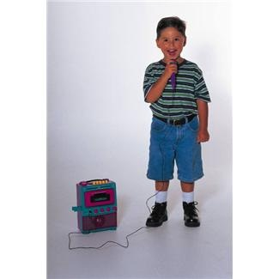

*How can I conduct an interesting interview?*



|  |  |  |  |  |
| --- | --- | --- | --- | --- |
| **Please read before you begin**   |  |  | | --- | --- | | Welcome to Module N. In this Module you will be asking yourself  How can I conduct an interesting interview?  To help you answer this question, these are your learning intentions. | C:\Users\jselim\Desktop\microphone.jpg |  |  |  | | --- | --- | |  | Learning Intentions for Module N |   Writing Workshop  Study the style and techniques used to write an interview  Grammar and Punctuation  Learn about past, present and future tense.  How Words Work  Homonyms and initials.    Spelling and Phonics  Study your 10 given spelling words as well as your own 10 words for your test at the end of the Set. In phonics, you will look at the sounds that the letters ‘ck’ and ‘ew’ make. |

|  |  |
| --- | --- |
| Contents | |
| Set One | Reading and Writing Workshop   * Exploring the Text - reading and learning about how to write an interview * Talk to someone at home and complete activities on interviews   Spelling activities and Phonics   * Ten given words and ten words of your own choice * The ‘ck’ sound   Grammar and Punctuation   * Present tense   How words work   * Homonyms   Spelling test  Spell the words for this Set |
| Set Two | Reading and Writing Workshop   * Write an interview   Spelling activities and Phonics   * Ten given words and ten words of your own choice. * The ‘ew’ sound   Grammar and Punctuation   * Past and future tense   How words work   * Initials   Spelling test   * Spell the words for this Set   Reflection   * Answer true or false questions about the topic |

|  |  |
| --- | --- |
| books,boys,childhood,children,concentration,educates,educations,Fotolia,homework,kids,knowledge,learning,learns,males,Photographs,readings,reads,schools,students,studies | Getting Knowledge Ready - Interviews |

**For you to do:**

Think about where you have seen someone being interviewed. Maybe you saw someone being interviewed on TV. You could have heard an interview on the radio. Brainstorm words about what you know about interviews in the boxes below.

Radio

Interview

|  |
| --- |
| Set One |

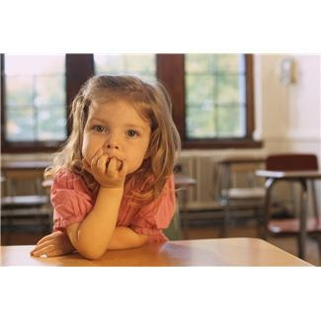

This Set we are looking at an interview. An interview is a conversation between people. One person asks questions for the other person to answer.

An interview has an introduction where we find out what the topic is about. The interviewer then asks more questions for the other person to answer.

Here is an example of an interview:

C:\Users\crt\AppData\Local\Microsoft\Windows\Temporary Internet Files\Content.IE5\K975LXFD\MC900365394[1].wmf**Isaac’s Interview with Dylan Stockland**

Dylan Stockland is Isaac’s favourite rugby league player. Isaac won a competition to interview Dylan for school. Here are some of Isaac’s questions and Dylan’s answers.

|  |
| --- |
| **Isaac:** *What is your best achievement in rugby league?*  **Dylan*:*** *I’ve been part of a team that has won three premiership titles.*  **Isaac:** *What makes a great player?*  **Dylan:** *Great players play fair and are good sports. It’s important to play together as a team.*  **Isaac:** *What are some of things we don’t know about you?*  **Dylan:** *My nickname is Stocky and I kick with my left foot.* |

Now think of your favourite sportsperson. If you are not sure, have a chat with your supervisor to help you with some ideas. Write your sportsperson in the box below.

The editor of the newspaper, “*Sports News Today*” has asked you to interview this sportsperson. Write your interview below. Ask someone at home to pretend they are that sportsperson and write down their responses to your questions.

|  |  |
| --- | --- |
| Introduction | ____________________________________________  ____________________________________________  ____________________________________________ |
| Question 1: | ____________________________________________  ____________________________________________  ____________________________________________  ____________________________________________ |
| Answer: | ____________________________________________  ____________________________________________  ____________________________________________  ____________________________________________  ____________________________________________ |
| Question 2: | ____________________________________________  ____________________________________________  ____________________________________________  ____________________________________________ |
| Answer: | __________________________________________  ____________________________________________  ____________________________________________  ____________________________________________ |

It’s a good idea to do some research on the person you are going to interview. This can help you work out the questions to ask them. Depending on who they are, you can conduct an internet search or others about them.

These are all good tips for a great interview!

|  |  |
| --- | --- |
| C:\Users\jmiller\AppData\Local\Microsoft\Windows\Temporary Internet Files\Low\Content.IE5\O584SN30\MC900053962[1].WMF | Grammar and Punctuation |

What is present tense?

The present tense is the way we write verbs to show events or actions happening now or all the time.

Here are some examples:

Right now, I **am reading** a book.

I **read** fiction and nonfiction every day.

My friend **reads** a lot too.

The verbs am reading, read and reads are in the present tense.

Don’t forget that verbs are *action* or *doing* words!

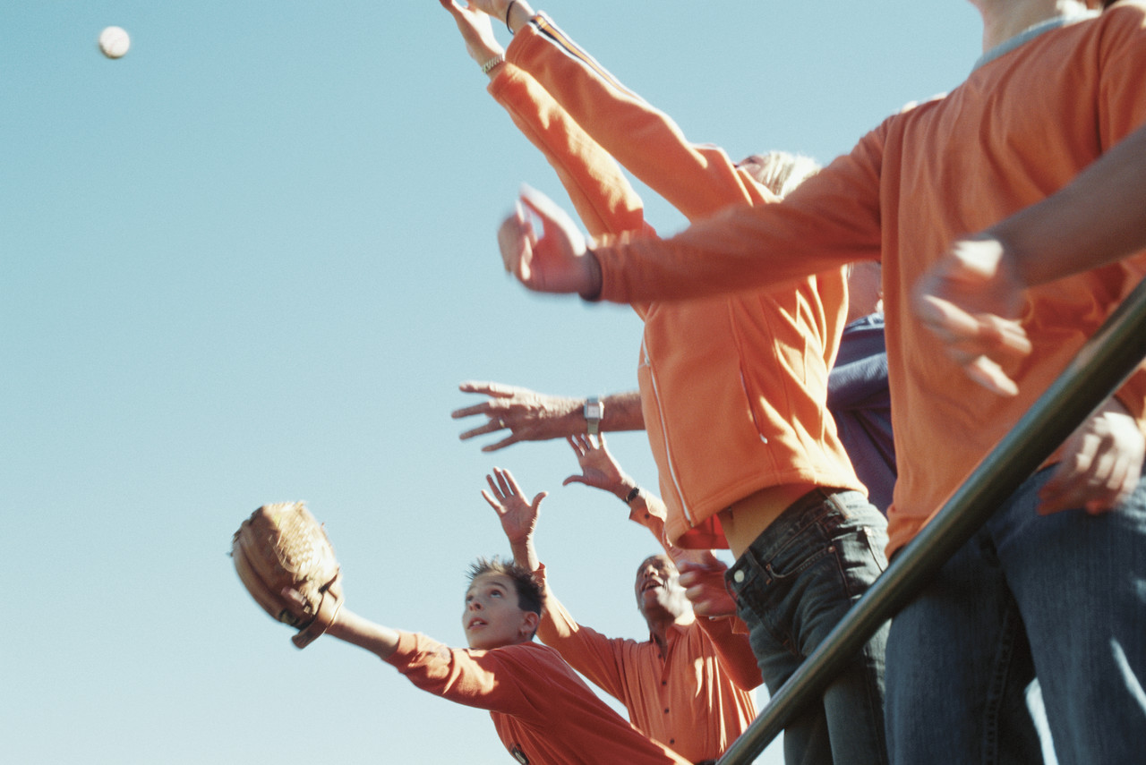

**For you to do:** Complete with the correct present tense

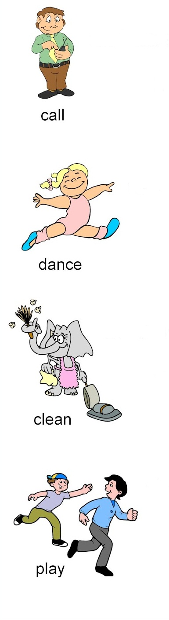

Watch my sister __ __ __ __ __.

Daddy can __ __ __ __me on his phone.

Can I __ __ __ __ tag with you?

Laura likes to __ __ __ __ __her house.

|  |  |
| --- | --- |
|  | How Words Work |

What are homonyms?

Homonyms are words that have the same sound or spelling but the words have different meanings.

For example, the words *bear* and *bare* sound the same, but they are spelled differently and have different meanings.

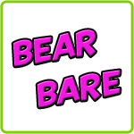

Here is another example.

In this sentence the word *lying* means not telling the truth

I hope you are not lying to me.

My books are lying on the table.

In this sentence the word *lying* means something is in a place

**For you to do**

Match the meaning with the correct homonym by putting (a) or (b) in the space in the sentence. The first one is done for you

1. small clock worn on wrist
2. look at
3. one sheet of paper
4. to call someone on an electric pager
5. participate in a sport
6. theatre piece
7. a tiny amount
8. past tense of bite
9. a writing instrument which uses ink
10. an enclosed area
11. The kids are going to watch **(b)** TV tonight.

What time is it? I have to set my watch**_(a)**.

1. Which page ___ is the homework on?

Please page___ the doctor if you need help.

1. Let’s play ___ soccer after school.

The author wrote a new play__.

1. Ouch! The mosquito bit ___ me!

I’ll have a little bit__ of sugar in my tea.

1. My rabbits are in a pen__ outside.

Please sign this form with a black pen__.

Draw a picture showing the following homonyms:

Watch (a clock) Watch (look at)

|  |  |
| --- | --- |
|  |  |

Play (a game) Play (theatre)

|  |  |
| --- | --- |
|  |  |

|  |  |
| --- | --- |
|  | Spelling |

Ten Spelling Words for Set One

buckle stick clock picked bricks

then shining animals begin truly

1. Fill in the gaps in the sentence with the correct word from the spelling list.

The __ __ __ __ __ showed what the time was.

The __ __ __ __ __ __ __ were loud because they were hungry.

The boy was looking for a __ __ __ __ __.

1. Draw these list words:

bricks animals

This Set we are exploring the letter sounds of ck. The letters ck has two consonants. These letters are used in many words.

For example, in the word clock. Say it as clo-ck and out loud. Can you hear the ck sound?

Now circle the two words in each line that have the ck sound.

1. stick picked believe
2. lion buckle bricks
3. rock struck smack

Find the ck sounding words in the grid.

|  |  |  |  |  |  |  |  |  |  |
| --- | --- | --- | --- | --- | --- | --- | --- | --- | --- |
| A | R | T | I | S | C | O | U | T | A |
| S | L | S | Y | X | V | L | H | T | T |
| T | J | H | E | D | E | U | O | W | R |
| R | O | O | S | E | B | C | T | C | O |
| O | P | I | C | K | E | D | O | W | K |
| C | W | T | K | S | T | L | I | Q | T |
| K | Z | V | M | K | L | E | I | C | R |
| F | X | C | B | S | T | I | C | K | K |

____________ ______________ _____________

____________ ______________ _____________

|  |  |
| --- | --- |
| It’s time for your spelling test  Give your sheet of words to someone at home. Ask them to test your spelling of the ten words you were given to learn this Set. You might even like to practise your words once again before you have your test. | j0226124 |

|  |  |
| --- | --- |
| Spelling Words for Set One | |
| Set One Module Words | Set One Own Words |
| then |  |
| shining |  |
| animals |  |
| begin |  |
| truly |  |
| buckle |  |
| stick |  |
| clock |  |
| picked |  |
| bricks |  |

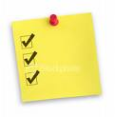

**Checklist**

This Set you should have completed the following tasks. Please tick the tasks you have completed.

* Reading and Writing workshop*—*Interview
* Spelling activities—LCWC and own Words
* Phonics- The ‘ck’ sound
* Grammar and Punctuation —Present tense
* How Words Work— Homonyms
* Spelling and Dictation test

|  |
| --- |
| End of Set 1 |

|  |
| --- |
| Set Two |



This Set we would like you to interview someone in your family. You will also need to include an introduction to the interview as well.

Firstly, you will need to come up with some practice questions to ask. Here are some to help examples to help you.

*What was your favourite subject when you were at school?*

*What are some your strongest memories of when you were at school?*

*What was the last book you read?*

*What do you like to do in your spare time?*

*What is something you are proud of?*

C:\Users\crt\AppData\Local\Microsoft\Windows\Temporary Internet Files\Content.IE5\XGYY5H84\MC900365708[1].wmf

*C:\Users\crt\AppData\Local\Microsoft\Windows\Temporary Internet Files\Content.IE5\K975LXFD\MC900383604[1].wmf*A good interview is a bit like having a good chat with someone.

The person you are interviewing should not give one word answers to your questions because the interview will be too short and boring.

Think carefully about your questions.

For example, the first question above, “*What was your favourite subject when you were at school?*

will probably only allow your family member to answer with one word, such as “*Maths*”.

A better question to ask would be, “*What was your favourite subject when you were at school,*

*and why?*” The interviewee might answer, “Art, because *I really loved going to the art room and the smell of the paint,”*– much more interesting, don’t you think?

On the next page you will find a draft for your question and answer interview.

|  |  |
| --- | --- |
| Introduction | ______________________________  ______________________________  ______________________________ |
| Question 1 | ______________________________  ______________________________  ______________________________ |
| Answer | ______________________________  ______________________________  ______________________________  ______________________________ |
| Question 2 | ______________________________  ______________________________  ______________________________ |
| Answer | ______________________________  ______________________________  ______________________________ |
| Question 3 | ______________________________  ______________________________  ______________________________ |
| Answer | ______________________________  ______________________________  ______________________________ |
| Question 4 | ______________________________  ______________________________  ______________________________  ______________________________ |
| Answer | ______________________________  ______________________________  ______________________________ |

|  |  |
| --- | --- |
|  | Daily Reading |

Also, remember to do your daily reading. Make sure you can find something enjoyable to read for about 15 minutes each day to someone at home.

|  |  |
| --- | --- |
|  | Spelling, Phonics and How Words Work |

It’s time for you to learn your words for this Set. They are at the back of this Module. You also need to choose ten words for **My** **Own Words.**

These can be from:

|  |  |
| --- | --- |
|  | * your own writing |
|  | * your reading |
|  | * your memory |

1. Write the ten words you have chosen, in the My Own Wordscolumn on the page at the back of Set Two.

Learn these and the ten words given to you for this Set. Remember to use L.C.W.C. to help you learn these.

Ten Spelling Words for Set Two

sugar sailor eighth receive school

grew stew nephew chew dew

1. Find the dictionary meaning for the following list words:

School _____________________________________________

____________________________________________________

____________________________________________________

Dew _______________________________________________

____________________________________________________

____________________________________________________

Nephew ____________________________________________

____________________________________________________

____________________________________________________

1. Choose three of your spelling words and write them in order from the least amount of letters to the most letters.

_________________________________________________________

_________________________________________________________

_________________________________________________________

This Set we are going to study the ew sound. The ew sound has one vowel and one consonant. It appears in many words.

Say the word ch-ew out loud. Can you hear the ew sound?

Now fill in the ew sound in the following words.

gr__ __ neph __ __ ch __ __ d __ __

Draw a jewel Draw a newspaper

|  |  |  |
| --- | --- | --- |
|  |  |  |

Put the words *nephew, grew* and *chew* in a sentence.

___________________________________________________________

___________________________________________________________

____________________________________________________________

Draw a line under the ew sounds in the following words:

drew crew blew new threw

**Initials**

Initials are the first letters of people’s names or titles.

For example if a person’s name is Max Nile, his initials would be M.N.

When we shorten a name we also use a full stop.

Here are some examples of shortening people’s names:

Doctor = Dr. Mistress = Mrs.

Mister =Mr. Mister David Cobb= Mr.D.Cobb

Write the following names the short way.

Doctor Jones ___________________________________________

Mister Barker _________________________________________

Mistress Smith ________________________________________

Mister Carr ___________________________________________

Doctor Fenn ___________________________________________

Mister Tom Travis _____________________________________

|  |  |
| --- | --- |
| C:\Users\jmiller\AppData\Local\Microsoft\Windows\Temporary Internet Files\Low\Content.IE5\O584SN30\MC900053962[1].WMF | Grammar and Punctuation |

What is past tense?

The past tense is any form of a verb we use to describe *what has already happened*. Here are two ways to use the verb *write* in the past time.

|  |  |
| --- | --- |
| Yesterday I **wrote** a story. | I **have written** a story. |

Fill the gaps in the sentences with the correct past tense verbs.

|  |  |  |
| --- | --- | --- |
| played | chased | won |

We __ __ __ __ __ __ on the swings at recess yesterday.

Last Set my dog __ __ __ __ __ __ a cat.

Last year my team __ __ __ the basketball championship.

**What is future tense?**

The future tense is any form of a verb we use to talk about *what has not happened yet*. Here are some examples.

I will shout.

I might shout.

I won’t be shouting.

**For you to do:**

Complete the sentences with will or won’t.

It’s very hot. I __ __ __ __ drink some water.

I’m sure that all my friends __ __ __ __ like my new motorbike.

Sally’s party is starting at 12.00 so I __ __ __ __ be able to get

there on time.

Read the following sentence and underline the correct answer.

1. We *will go/went/go* to the supermarket in a minute.
2. She *saw/will see/ see* the new baby tomorrow.
3. The policeman *will arrive/arrived/arrive* in twenty minutes.
4. Your teacher *talked/will talk/* to you tomorrow.
5. We *will /get up/got up* at 6.00 o’clock every day next Set.

It’s time for your spelling test

Before you give your sheet of words to someone at home to test you on this Set’s words, take a moment to write down some of the things you have done this Set to help you learn your words.

________________________________________________________________

________________________________________________________________

________________________________________________________________

|  |  |
| --- | --- |
| Spelling Words for Set Two | |
| Set Two Module Words | Set Two Own Words |
| sugar |  |
| sailor |  |
| eighth |  |
| receive |  |
| school |  |
| grew |  |
| stew |  |
| nephew |  |
| chew |  |
| dew |  |

Reflection

Now it’s time to see how much you can remember about what you have learnt in this module. Please circle if the following questions are either true or false.

Text Type

An interview doesn’t have any questions in it. True or False

Spelling and Phonics

The ‘ck’ sound has a vowel in it. True or False

Text and Grammar Skill

Future tense means something that hasn’t happened yet.

True or False

Past tense means it has happened.

True or False

How Words Work

Initials can be a short way for people’s names. True or False



**Checklist**

This Set you should have completed the following tasks, please tick the tasks you have completed ,

* Writing—Interview
* Spelling activities—LCWC and own Words
* Phonics- ew sound
* Grammar and Punctuation —Past and future tense
* How Words Work— Initials
* Spelling test

|  |
| --- |
| **End of Set Two** |

|  |
| --- |
| **YOUR QUESTIONS OR COMMENTS** |