Maths

Pointing and Counting

Baking

**Copyright**

*The Department of Education and Training (DET) encourages the dissemination and re-use of information provided in this document.*

Material on this website is provided under a Creative Commons Attribution 4.0 international licence, with the exception of:

* any images, photographs, trademarks or branding, including the Victorian Government logo and the DET logo; and
* content supplied by third parties.



For licence conditions, see: [Creative Commons Attribution 4.0 international licence](http://creativecommons.org/licenses/by/4.0/)

**Attribution**

Material to be attributed as:

© State of Victoria (Department of Education and Training)

|  |  |
| --- | --- |
| Learning Intentions | what-is-a-learning-style_pg8 |

###### Associate number names with numerals

###### Use one-to-one correspondence when counting and point to each item as the counting takes place

Note: Activity sheets are numbered and provided at the back of this resource

**Task 1**

**Step 1**

Sing one, two buckle my shoe and 1, 2, 3, 4,5 See Activity sheet 12

**Step 2**

Act out of the traditional song/story, *Ten in the Bed.* You will have to have a bed, either real or pretend, and nine toys in the bed.

Your child will be the *Little One*.

Let your child act out the song, with the ten toys. See Activity sheet 14

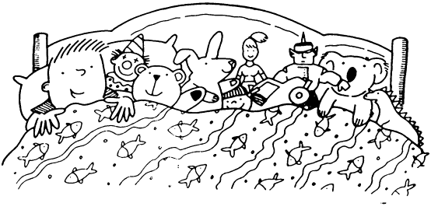

###### math2Task 2

**Step 1**

Revise the rhyme: *One, Two, Three, Four, Five.*

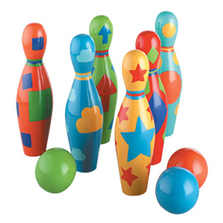

**Step 2**

Play Skittles.

As you play, count how many

skittles are knocked over each time.

**Step 3**

Put out some old envelopes and cards.

Ask: *Do you have an envelope for every card?*

*How can you find out?*

Ask your child to match envelopes with letters.

Repeat this procedure varying the number of envelopes and letters.

Make sure your child counts or matches one to one each time.

**Step 4**

Revise the word *one* and the numeral *1.*

Use Activity sheet 1 and cut along the marked lines.

Ask your child to find the cards to match both numeral and number word amongst the cards you have cut out. Play some flashcard games:

*Put your hands on your head when you see the numeral for one.*

*Touch your toes when you see the number word for one.*

**Step 5**

**Use Activity sheet 2.**

Colour all the pictures for *one*.

###### math2Task 3

**Step 1**

Introduce: *Two Little Kittens*. See Activity sheet 15

**Step 2**

Count to 10 clapping (jumping, hopping, shaking hands, etc.) with every count.

**Step 3**

Revise the word one and the numeral 1 using the flashcards,   
e.g. *Stand up when you see the numeral for one.*

*Turn around when you see the number word one*, etc.

**Step 4**

Put out some toy people, and a number of sweets or pieces of fruit.

Ask: *Do you have a sweet for everybody?*

*How can you find out?*

Repeat this procedure, varying the number of toys and sweets.

Make sure your child counts or matches one-to-one each time.

**Step 5**

**Use Activity sheet 3.**

Introduce the worksheet.

Your child is to find out if there is a banana for each monkey, a fish for every hook

and a bone for each dog by counting first then drawing lines to check their answers.

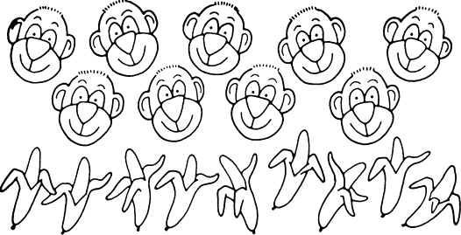

###### math2Task 4

**Step 1** Revise: *Two Little Kittens*

**Step 2** **Use Activity sheet 4.**

Introduce this worksheet that revises counting skills.

Count the objects in each group, then draw a group to match.

**Step 3** Introduce the term ***set*.**

From a very early age, children unconsciously use the mathematical skill of sorting. The following work will give your child further practice sorting objects according to particular attributes, e.g. size, shape, colour, use, etc., and introduce the term *set.*

Use Activity sheet 6 and cut along the marked lines.

Show your child the pile of cut-out children. Ask your child to put the cut-out girls into a group and the cut-out boys into a group.

Place a piece of string or ribbon around each group.

Say: *We have a* ***set*** *of girls and a* ***set*** *of boys.*

***Set*** *is a different way of saying* ***group****.*

*What is the same about the pictures in this set?*

(They are all girls.)

*What is the same about the pictures in this set?*

(They are all boys.)

Move a picture of a boy into the set of girls.

*Does this picture belong in this set*? (No.)

*Why not?* (Because he is not the same. This is the set of girls.)

**Step 4**

Ask your child to sort some coloured blocks into two different sets.

Depending on how he/she sorts the blocks say:

*I can see a set of red blocks and a set of all the other blocks.*

Ask your child to put the blocks into another two *sets* and ask him or her to tell you about the *sets*. Repeat this several times.

Put the blocks into two *sets* yourself and ask your child to tell you about the *sets.*

###### math2Task 5

Finish this week’s work by **baking** some **biscuits**.

Use your favourite recipe, or try the one included on **Activity sheet 5.**

Look at the activity as a maths project and let your child do the work as much as possible.

Can your child put the finished biscuits into *sets,* or divide them into equal *sets* for each member of the family?

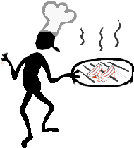

###### math2Task 6

**Step 1**

Revise the rhyme *Two Little Kittens*.

Introduce *The Beehive* See Activity sheet 16.

**Step 2**

Put out a number of bottles, some with lids, some without.

Ask your child to count the bottles.

Are there more bottles with lids or more bottles without lids?

If each bottle was to have a lid, does you need more bottles or more lids?

How many?

**Step 3**

Ask your child to put the bottles in order from largest to smallest.

Is that the same as tallest to shortest?

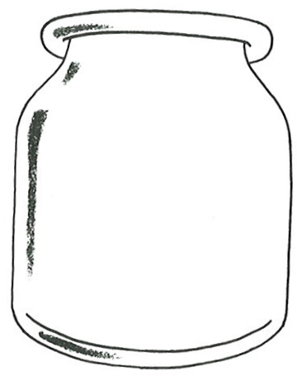 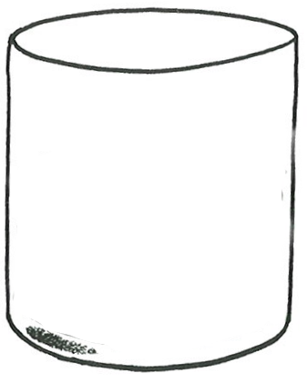 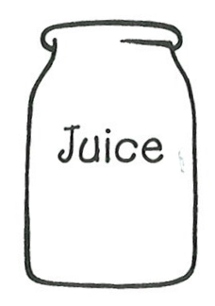 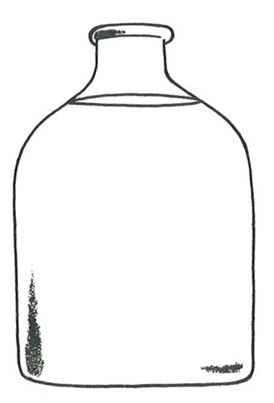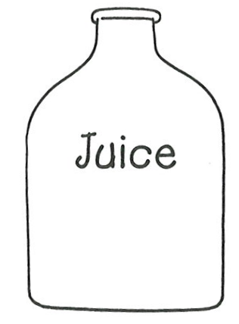

**Step 4**

Ask your child to put the bottles into two sets.

Can this be done in several ways, e.g. glass/not glass, with lids/without lids, with labels/without labels, coloured/not coloured?

Is your child using the term sets?

**Step 5**

Can he or she put the cut-out children from **Activity sheet 6**, into two sets in lots of different ways (girls/boys, pants/skirts, long hair/short hair, hands in pockets/hands not in pockets, etc.)?

After several turns, ask your child to paste the cut-outs into two sets.

**Task 7**

**Step 1**

Revise *The Beehive*.

**Step 2**

Put out an egg carton.

Place from one to five small stones in each segment down one side of the container.

Ask your child to put the same number of gumnuts (pasta, beans, etc.) in the corresponding segment down the other side.

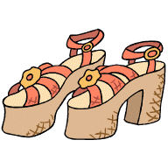

**Step 3**

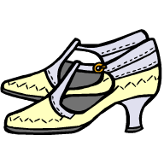Put out a collection of shoes on the floor.

Ask your child to match the shoes and find the pairs.

Ask your child to put the shoes into two different sets. He or she may sort by colour, type (lace-ups, buckles), who the shoes belong to, or even their use (sports shoes, good shoes).

Encourage your child to talk about what they are doing.

**Step 4**

Tip a jumbled collection of items out on to the floor. This may be toys, household items or even the contents of the junk drawer.

Give your child time to investigate the objects.

Ask your child to make a set of red things.

Ask: What is the same about all the things in the set you have made?

(All the things in this set are red.)

Then what about these things?

(They are the set of things that are not red.)

Repeat this step again, choosing another attribute, e.g. shape, size.

**Step 5**

**Use Activity sheet 7.**

Complete the worksheet: Things I do at night/Things I do during the day.

**Task 8**

**Step 1**

Introduce Ten Little Fish. See Activity sheet 22

**Step 2**

Ask your child to count whatever is appropriate, keeping the counting within his or her range, e.g. the buttons on his jacket

fruit in the bowl

stripes on his socks, etc.

**Step 3**

Put out a collection of clothing.

Ask your child to sort it into two sets.

Ask him or her to describe the sets.

Give your child lots of practice at this activity, asking him or her to sort the clothes in different ways. For example, this is the set of clothes I wear when it is cold, this is the set of clothes I wear when it is hot, clothes I like/clothes I don’t like, clothes with patterns/clothes without patterns, clothes you have made/clothes you have bought, clean clothes/dirty clothes, etc.

Sort the clothes by the occasion they might be worn, and see if he or she can work out your criterion.

**Step 4**

**Use Activity sheet 8.**

Help your child to cut out the animal pictures from the worksheet.

Can he or she put them into two sets, in lots of different ways?

Encourage your child to talk about the sets he or she makes.

Keep the pictures to use again.

|  |  |
| --- | --- |
| **math2Task 9** |  |

**Step 1**

Revise the counting rhymes *One, Two Buckle My Shoe*

*Ten Little Fish*

**Step 2**

Talk about things that are always in twos - eyes, ears, earrings, shoes, socks, slippers, hands, gloves, feet, etc.

Introduce the numeral ***2*** and the number word ***two***.

Use the numeral and number word cards to play some can you find type games.

**Step 3**

Help your child to make a basket.

Talk about two as you do it: two halves, paste two squares, etc.

1. Take a piece of paper approximately 15 cm square.
2. Fold it in half and then fold each side to the central fold line, marking out four rectangles.
3. Turn the paper and fold it again exactly the same way, giving you sixteen squares.

|  |  |
| --- | --- |
| 1. Cut as in diagram 2. Paste or staple as in diagram. 3. Add a handle. 4. Decorate.   Fill with ***B*** food for lunch: bread and butter, biscuits, bananas! |  |



**Task 10**

|  |  |
| --- | --- |
| **Step 1**  Introduce the number rhymes Five Little Ladies and Five Little Soldiers*. See activity sheet 21*  **Step 2**  Draw eight *paddocks* on a polystyrene tray.  Write the numerals 1 or 2 in each paddock.  Ask your child to put the matching number of play dough balls in each paddock. |  |

**Step 3**

Discuss the order of your day’s normal routine. For example, we get up, then we have breakfast, then we do school work, etc.

**Step 4**

**Use Activity sheet 9.**

Your child is to cut out the pictures on the worksheet and paste them in a line.

**Step 5**

**Use Activity sheet 10.**

Follow the instructions on the sheet to identify the hot and cold things

Draw the little and big objects as instructed.

*Which things are hot?*

00078709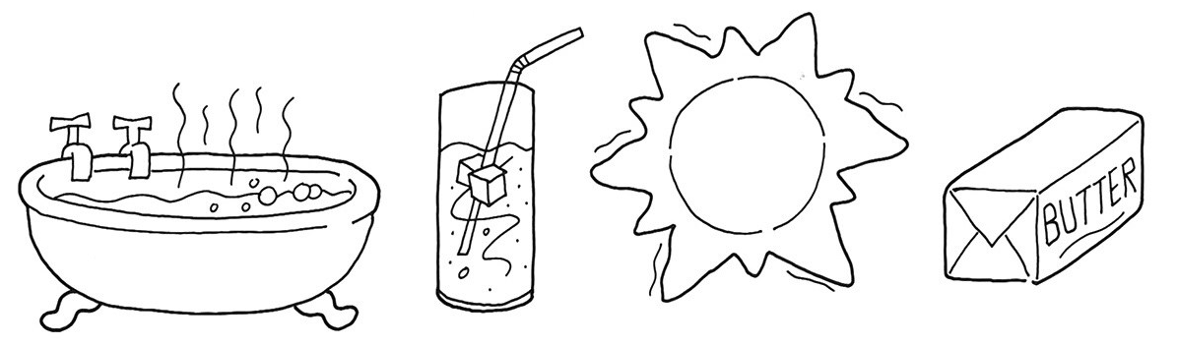

**Step 6**

**Use Activity sheet 11.**

Follow the instructions on the sheet to draw the big and little things beside the original objects

**Activity Pages** Baking

**Maths Activity Sheet 1**

|  |  |  |  |
| --- | --- | --- | --- |
| **three** |  | **two** | **one** |
| **4** | **3** | **five** | **four** |
| **5** |  | **2** | **1** |

|  |
| --- |
| **Maths Activity Sheet 2** |

**Maths Activity Sheet 3**

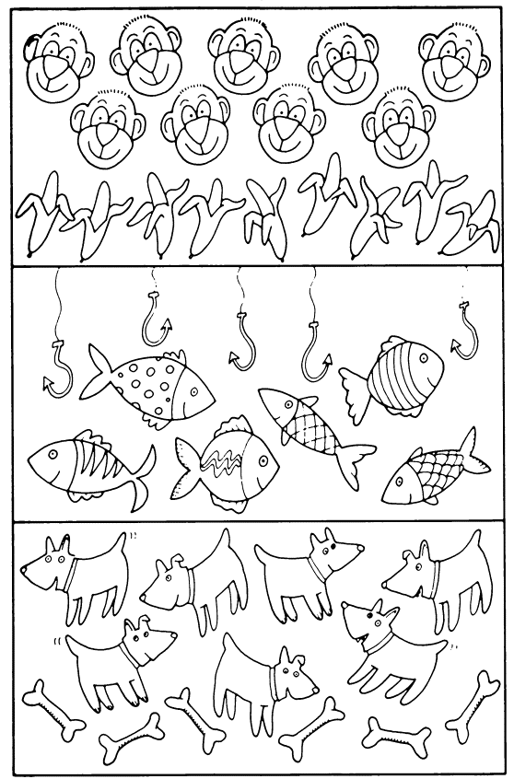

**Maths Activity Sheet 4**

**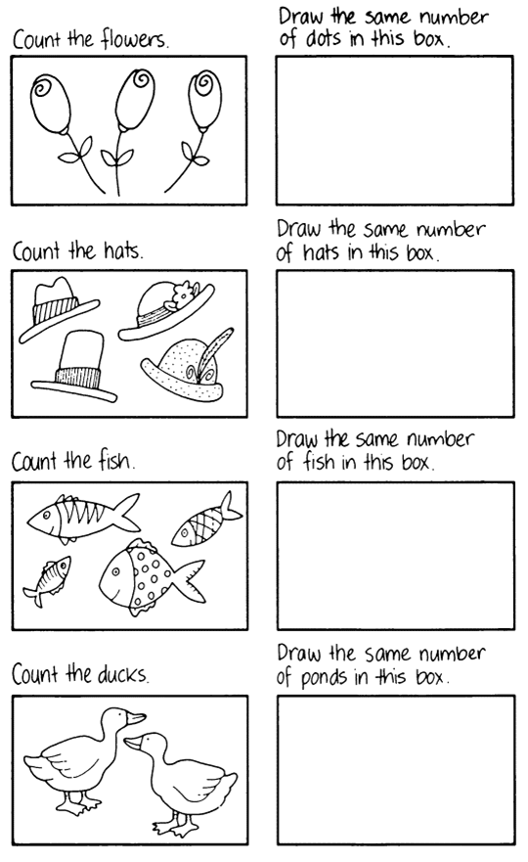**

**Maths Activity Sheet 5**

###### Easy Biscuit Recipe

##### Ingredients

180 gms butter

1 cup brown sugar

1 egg

1 teaspoon vanilla essence

2 cups plain flour

 teaspoon baking powder

THIS RECIPE MAKES ABOUT THIRTY SIX BISCUITS BUT THE DOUGH WILL KEEP IN THE REFRIGERATOR FOR UP TO TWO WEEKS AND IN THE FREEZER FOR SEVERAL MONTHS.

##### Method

1. Cream butter, gradually add sugar, and cream well.
2. Add egg and vanilla, beat well.
3. Sift flour with baking powder and stir into creamed mixture.
4. Divide mixture into three equal portions.
5. j0232549Add: Choc-chips to one portion

Chopped nuts to one portion

Chopped glace cherries and chopped nuts to the final portion.

1. Roll each portion into a long roll. (Chill if sticky.)
2. Slice thinly, place on baking tray.
3. Bake in moderate oven for 7-10 minutes.

**Maths Activity Sheet 6**

**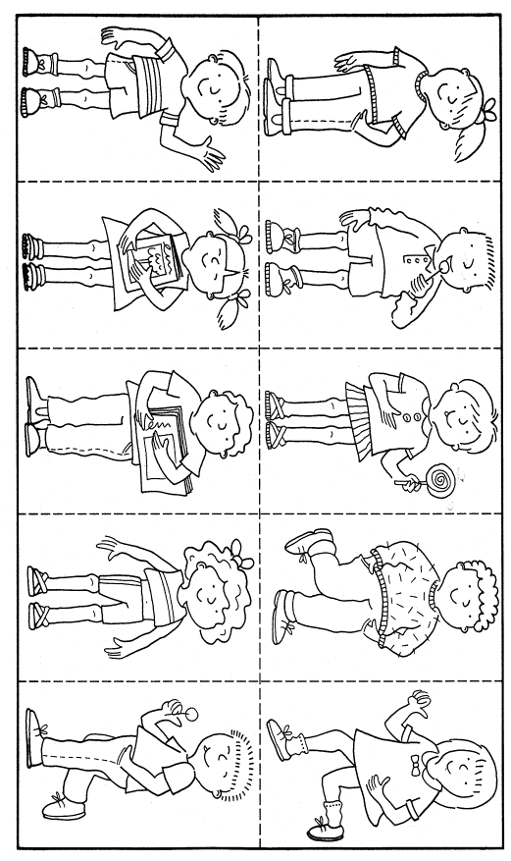**

**Maths Activity Sheet 7**

Talk about the things you do during the day

and the things you do at night

Colour the daytime happenings.

Circle the night-time happenings.

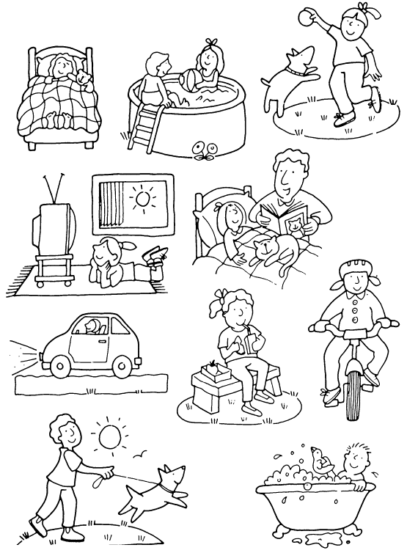

**Maths Activity Sheet 8**

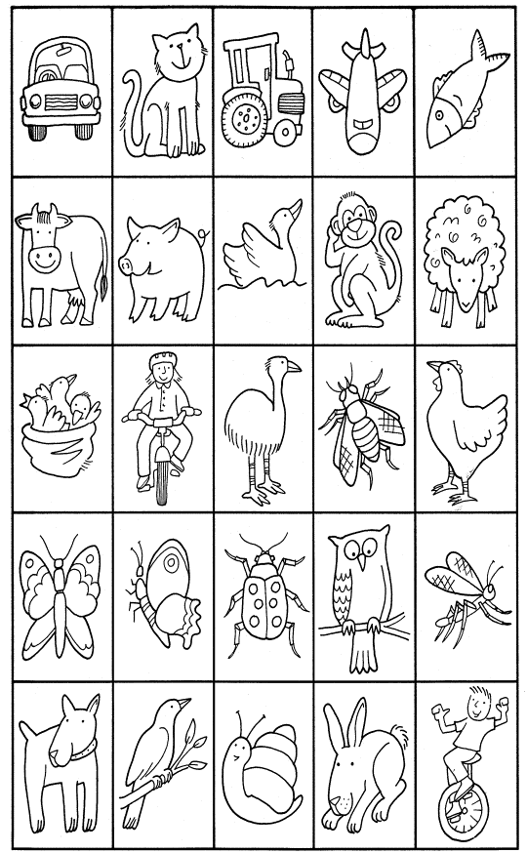

**Maths Activity Sheet 9**

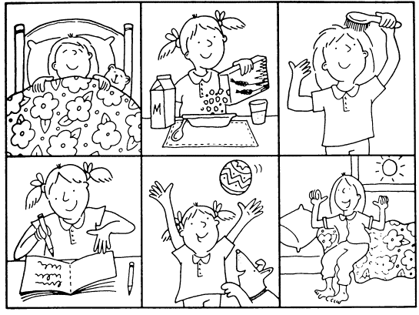

**Maths Activity Sheet10**

Choose a colour to circle the cold things in this set

Choose a colour to circle the hot things in this set.

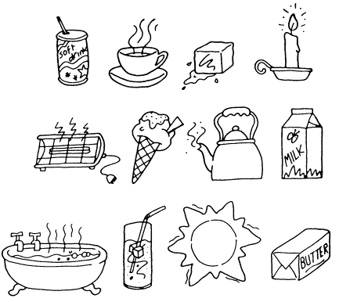

**Maths Activity Sheet 11**

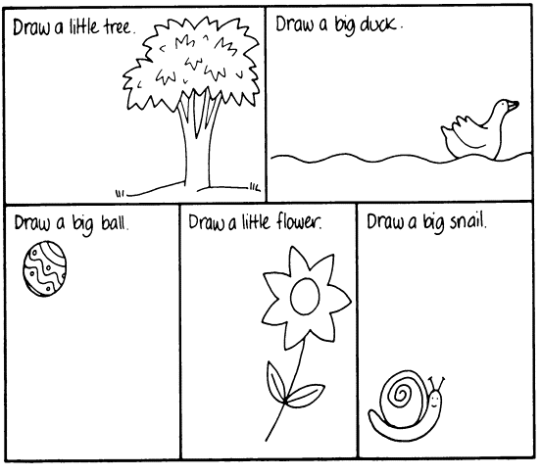

**Maths Activity Sheet 12**

**One, two, buckle my shoe**

One, two, buckle my shoe  
Three, four, shut the door  
Five, six, pick up sticks  
Seven, eight, lay them straight  
Nine, ten, begin again

Okay everybody, one more time

One, two, buckle my shoe  
Three, four, shut the door  
Five, six, pick up sticks  
Seven, eight, lay them straight  
Nine, ten, that's the end

That's the end

**1, 2, 3, 4, 5, Once I Caught a Fish Alive**

One, Two, Three, Four, Five,

Once I caught a fish alive,

Six, Seven, Eight, Nine, Ten,

Then I threw him back again.

Why did you let him go?

Because he bit my finger so.

Which finger did he bite?

This little finger on my right.

**Maths Activity Sheet 13**

Tic, Tac, Toe

Tic, tac, toe, here I go.

Where I land I do not know.

To play the game Tic, Tac, Toe choose a topic sheet of mixed symbols and images

Your child taps each picture in turn, as you say the rhyme together

He or she stops at the picture when the rhyme finishes. He or she counts the objects in that particular picture or names the image, then the rhyme begins again.

**Maths Activity Sheet 14**

**Ten in the Bed**

There were ten in the bed and the Little One said,

“Roll over! Roll over!”

So they all rolled over and one fell out.

There were nine in the bed and the little one said,

“Roll over! Roll over!”

So they all rolled over and one fell out.

There were eight in the bed and the little one said,

“Roll over! Roll over!”

So they all rolled over and one fell out.

There were seven in the bed and the little one said,

“Roll over! Roll over!”

So they all rolled over and one fell out.

There were six in the bed and the little one said,

“Roll over! Roll over!”

So they all rolled over and one fell out.

There were five in the bed and the little one said,

“Roll over! Roll over!”

So they all rolled over and one fell out.

There were four in the bed and the little one said,

“Roll over! Roll over!”

So they all rolled over and one fell out.

There were three in the bed and the little one said,

“Roll over! Roll over!”

So they all rolled over and one fell out.

There were two in the bed and the little one said,

“Roll over! Roll over!”

So they all rolled over and one fell out.

There was one in the bed and the little one said,

“I’m lonely! I’m lonely!”

So they all climbed back in

**Maths Activity Sheet 15**

Two Little Kittens

Two little kittens, one stormy night,  
Began to quarrel, and then to fight;  
One had a mouse and the other had none,  
And that's the way the quarrel begun.  
  
"I'll have that mouse," said the biggest cat,  
"You'll have that mouse? We'll see about that!"  
"I will have that mouse," said the eldest son;  
"You shan't have that mouse," said the little one.  
  
I told you before 't was a stormy night  
When these two little kittens began to fight;  
The old woman seized her sweeping broom,  
And swept the two kittens right out of the room.  
  
The ground was covered with frost and snow,  
And the two little kittens had nowhere to go.  
So they laid them down on the mat at the door  
While the old woman finished sweeping the floor.  
  
Then they crept in, as quiet as mice,  
All wet with snow and as cold as ice;  
For they found it was better, that stormy night,  
To lie down and sleep than to quarrel and fight.

**Maths Activity Sheet 16**

The beehive

Here is the beehive.  
But where are all the bees?  
Hiding away where nobody sees.  
Here they come flying out of their hive.  
One, two, three, four, five!

Here is the beehive.  
But where are all the bees?  
Hiding away where nobody sees.  
Here they come flying out of their hive.  
One, two, three, four, five!

Buzz up high. Buzz down low.  
Buzzing fast. Buzzing slow.  
Buzz to the left. Buzz to the right.  
Buzz all day but sleep at night.

Here is the beehive.  
But where are all the bees?  
Hiding away where nobody sees.  
Here they come flying out of their hive.  
One, two, three, four, five!

Two Little Eyes

Two little eyes to look around.  
Two little ears to hear each sound.  
  
One little nose to smell what's sweet.  
One little mouth that likes to eat.

**Maths Activity Sheet 17**

Can you Walk on Two Legs?

Can you walk on two legs, two legs, two legs?

Can you walk on two legs,

Round and round and round?

I can walk on two legs, two legs, two legs,

I can walk on two legs,

Round and round and round.

Can you hop on one leg, one leg, one leg?

Can you hop on one leg,

Round and round and round?

I can hop on one leg, one leg, one leg,

I can hop on one leg,

Round and round and round.

Can you wave with one hand, one hand, one hand?

Can you wave with one hand,

Round and round and round?

I can wave with one hand, one hand, one hand,

I can wave with one hand,

Round and round and round.

Can you wave with two hands, two hands, two hands?

Can you wave with two hands,

Round and round and round?

I can wave with two hands, two hands, two hands,

I can wave with two hands,

Round and round and round.

**Maths Activity Sheet 18**

Mary at the Cottage Gate

One, two, three, four

Mary at the cottage door

Two, four, six, eight

Mary at the garden gate

The Squirrel

Five little squirrels, sitting by the door

One ran away and then there were four

Four little squirrels, climbing up a tree

One ran down and that left three

The little squirrels, with coats so new

One got dirty and then there were two

Two little squirrels sitting in the sun

One got sun burnt and that left one

**Maths Activity Sheet 19**

Goldilocks

When Goldilocks went to the house of the bears,

Oh what did her blue eyes see?

A bowl that was huge,

A bowl that was small,

A bowl that was tiny and that was all,

She counted them one, two, three.

When Goldilocks went to the house of the bears,

Oh what did her blue eyes see?

A chair that was huge,

A chair that was small,

A chair that was tiny and that was all,

She counted them one, two, three.

When Goldilocks went to the house of the bears,

Oh what did her blue eyes see?

A bed that was huge,

A bed that was small,

A bed that was tiny and that was all,

She counted them one, two, three.

When Goldilocks went to the house of the bears,

Oh what did her blue eyes see?

A bear that was huge,

A bear that was small,

A bear that was tiny and that was all,

They growled at her “Grrrrr! Grrr! Grr!”

**Maths Activity Sheet 20**

Three Little Kittens

The three little kittens, they lost their mittens,

And they began to cry,

"Oh, mother dear, we sadly fear,

That we have lost our mittens."

"What!   Lost your mittens, you naughty kittens!

Then you shall have no pie."

"Meow, meow, meow."

"Then you shall have no pie."

The three little kittens, they found their mittens,

And they began to cry,

"Oh, mother dear, see here, see here,

For we have found our mittens."

"Put on your mittens, you silly kittens,

And you shall have some pie."

"Purr, purr, purr,

Oh, let us have some pie."

The three little kittens put on their mittens,

And soon ate up the pie,

"Oh, mother dear, we greatly fear,

That we have soiled our mittens."

"What, soiled your mittens, you naughty kittens!"

Then they began to sigh,

"Meow, meow, meow,"

Then they began to sigh.

The three little kittens, they washed their mittens,

And hung them out to dry,

"Oh, mother dear, do you not hear,

That we have washed our mittens?"

"What, washed your mittens, then you're good kittens,

But I smell a rat close by."

"Meow, meow, meow,

We smell a rat close by."

**Maths Activity Sheet 21**

Ten Fingers

I have ten little fingers and they all belong to me.  
I can make them do things, would you like to see?  
I can shut them up tight, I can open them wide.  
I can put them together, I can make them hide.  
I can make them jump high, I can make them jump low.  
I can rolly, rolly, them around and fold them just so.

Five Little Ladies

Five little ladies going for a walk.   
Five little ladies stopping for a talk.  
Along came five little gentlemen,  
And they all danced together and that makes 10!

Five Little Soldiers

Five little Soldiers stand in a row,  
Four stand up straight and one bends low.  
Along came the Seargent and what do you think?  
Up pops the Soldier, as quick as a wink.

**Maths Activity Sheet 22**

Ten Little Fish

One little fishy swimming in the sea.  
Along came another one, and then there were two.

Two little fishies swimming in the sea.  
Along came another one, and then there were three.

Three little fishies swimming in the sea.  
Along came another one, and then there were four.

Swimming swimming swimming in the sea.  
That big ol’ shark will never catch me.

Four little fishies swimming in the sea.  
Along came another one, and then there were five.

Five little fishies swimming in the sea.  
Along came another one, and then there were six.

Six little fishies swimming in the sea.  
Along came another one, and then there were seven

Swimming swimming swimming in the sea.  
That big ol’ shark will never catch me.

Seven little fishies swimming in the sea.  
Along came another one, and then there were eight.

Eight little fishies swimming in the sea.  
Along came another one, and then there were nine.

Nine little fishies swimming in the sea.  
Along came another one, and then there were ten.

Swimming swimming swimming in the sea.  
That big ol’ shark will never catch me.

Swimming swimming swimming in the sea.  
That big ol’ shark will never catch me.

Swimming swimming swimming in the sea.  
That big ol’ shark will never catch me.

He’ll never,  
Never,  
Never,  
Never,  
That big old shark will never catch me!