Geography Inquiry



**Why is Mackay Harbour where it is?**



**Learning Intentions**

- Describe places and environments and identify the reasons for their locations.

- Collect information and record physical and human characteristics of a harbour and their own chosen location.

|  |
| --- |
| **Part 1**  [https://encrypted-tbn3.gstatic.com/images?q=tbn:ANd9GcS3aREXe6J3WR2G0EpywYf7GDxzKaYSaxM9zo2wwqwp3bvbFogl](https://www.google.com.au/imgres?imgurl=http://mw2.google.com/mw-panoramio/photos/medium/6955734.jpg&imgrefurl=http://www.distancebetweencities.net/mackay_queensland_australia_and_coonamble_new-south-wales_australia/photos&docid=Xd550ZUYew7LGM&tbnid=FtknOdEK-yAayM:&w=500&h=318&ei=FjUCVcHeJ4vm8AX61IGgBg&ved=0CAIQxiAwAA&iact=c)  **Mackay Harbour Queensland** |

**Introduction**

In this Module you will investigate why places are built where they are.

In **Part 1** you will investigate why Mackay Habour in Queensland is located where it is.

In **Part 2** you will go on a field trip, collect and record information on why your chosen location is built where it is.

Why are some sites chosen for settlement?



They are chosen because the **natural** and **human** features suit the purpose.

Read about why Mackay is situated where it is.

Read the information on Mackay Harbour and refer to your study on physical and human features to examine the reasons for its location.



**Where is Mackay Harbour?**

Mackay Harbour is in Mackay, North Queensland. It is about 950km north of Brisbane and 126km south of Proserpine. It is only a 10 minute drive from Mackay city. It is only 2km from the mouth of the Mackay River.

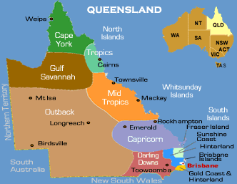 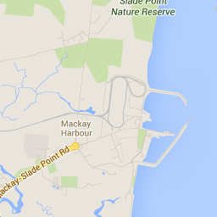

<http://www.sea-seek.com/images/x2/4/18/pix_9256.jpg>

**What are the characteristics of Mackay Harbour?**

Mackay Harbour has so many different features, both human and natural. The following photos highlight some of these features.

***Aerial photo of Mackay Harbour***

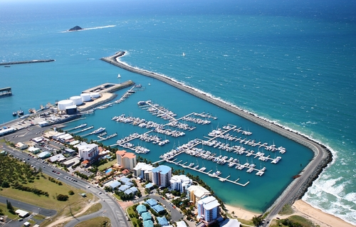

marina

Port

beaches

Housing and hotels

[](http://www.google.com.au/url?sa=i&source=images&cd=&cad=rja&uact=8&docid=zI_0oNIWw9ko4M&tbnid=ouYMvVDUiK53IM&ved=0CAgQjRw&url=http://www.clker.com/clipart-cartoon-eyes-looking-down-.html&ei=Lwz8U_zbGoLf8AWenoDoAQ&psig=AFQjCNGhbnvt9fewVMkRrLDG8bIduIiJbw&ust=1409113519515929)**Let’s take a closer look**

View the photos of Mackay with your supervisor. Discuss the following:

* natural and human features
* attractions (for tourists)
* attractions (for residents)
* recreation
* weather in Mackay (tropical, dry or temperate)
* industry
* transport by sea

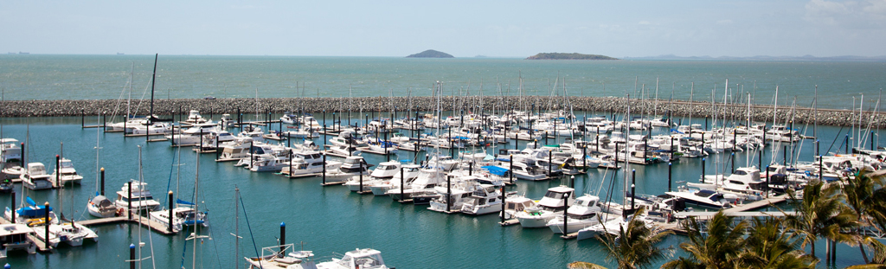

*Marina – for tourists and residents*

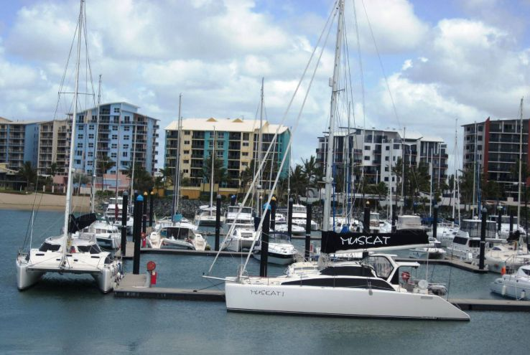 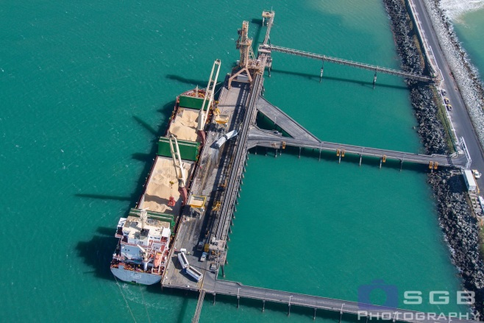

*Marina, housing and hotels Port and Harbour – used to transport sugar cane*

**Mackay Photos**

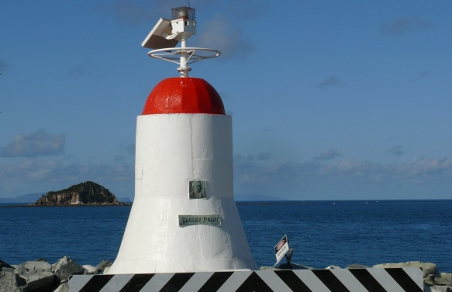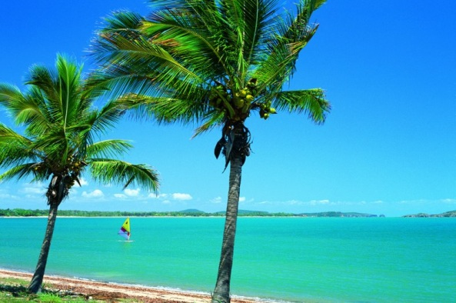

beaches light beacon

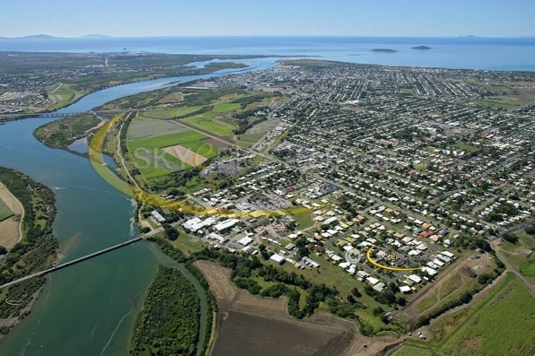 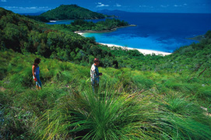

*City Centre, suburbs and Mackay River parks*

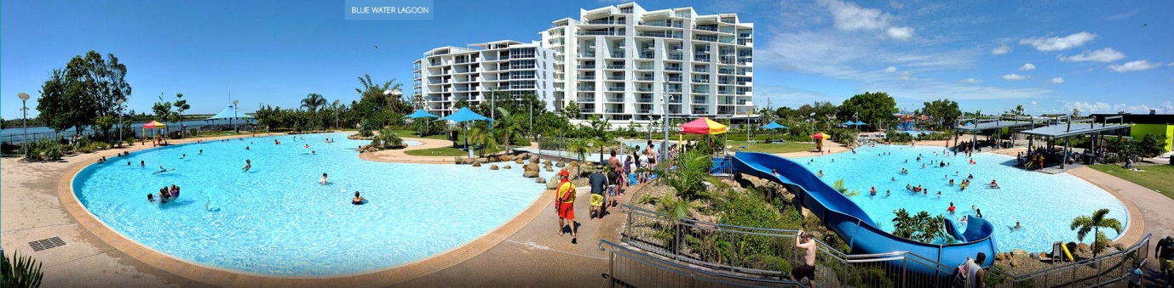

*Tourist accommodation*

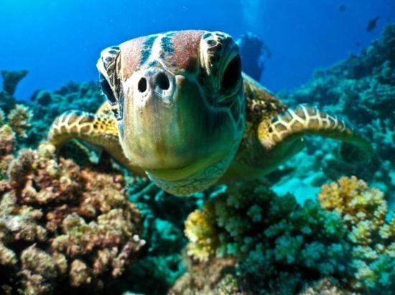 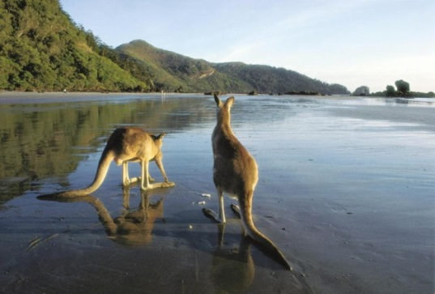

*Wildlife in Mackay*

**What is Mackay Harbour used for?**

Mackay Harbour is used by people as a place for living and recreation.

The following lists reasons for the Harbour’s use. Write why you think the location has been chosen.

When you have finished compare your list to the one I have completed which is located at the back of the module. *Complete your list first!* ☺

|  |  |
| --- | --- |
| **Reason** | **Why?** |
| **Residential** |  |
| **Recreational** |  |

**What is Mackay Harbour used for? continued**

|  |  |
| --- | --- |
| **Transport** |  |
| **Industrial and businesses** |  |

**How do people influence the characteristic of Mackay Harbour?**

From the photos you can see that there are many human features such as the marina, road, buildings, high rise buildings and port.

There are also natural features like the ocean, the beach, sand dunes, native animals and plants.

The natural features have always been there but they have human features have changed the harbour so people can enjoy it, live in it and work.

[](http://www.google.com.au/url?sa=i&source=images&cd=&cad=rja&uact=8&docid=zI_0oNIWw9ko4M&tbnid=ouYMvVDUiK53IM&ved=0CAgQjRw&url=http://www.clker.com/clipart-cartoon-eyes-looking-down-.html&ei=Lwz8U_zbGoLf8AWenoDoAQ&psig=AFQjCNGhbnvt9fewVMkRrLDG8bIduIiJbw&ust=1409113519515929)**Let’s take a closer look**

Investigate the photos below. Discuss with your supervisor have human features affect the natural environment.

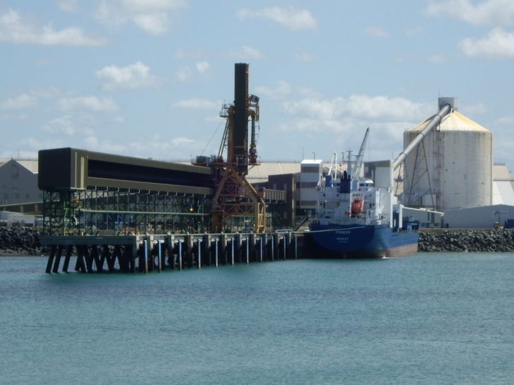

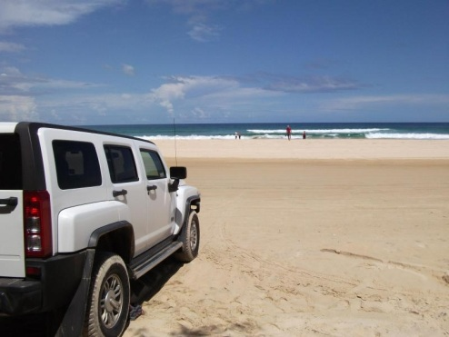

***4-wheel drives on beaches***

***Industry***

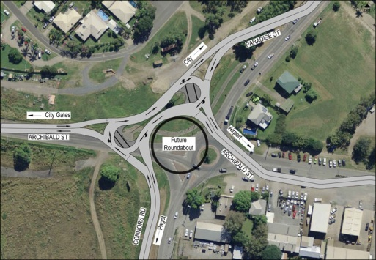

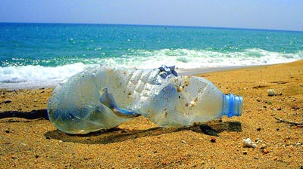

***Rubbish on the beach road and homes***

**For you to do** MCj04247880000[1]

Make a list of 3 human and natural features and briefly outline their advantages and disadvantages to Mackay Harbour.

**Human Features**

|  |  |  |
| --- | --- | --- |
| **Features** | **Positive influence** | **Negative influence** |
|  |  |  |
|  |  |  |

**Natural Features**

|  |  |  |
| --- | --- | --- |
| **Features** | **Positive Influence** | **Negative Influence** |
|  |  |  |
|  |  |  |

|  |
| --- |
| **Part 2**  Fieldtrip |

|  |
| --- |
| **Be a Geographer**  This week you will complete a report similar to Mackay Harbour on a location of your own choice. |

[](http://www.google.com.au/url?sa=i&rct=j&q=mother%20and%20child%20walking%20through%20the%20park&source=images&cd=&cad=rja&uact=8&docid=4vVtOxWfJBm_SM&tbnid=Rev1eZ2D0bz9rM:&ved=0CAUQjRw&url=http://www.fotosearch.com/clip-art/mother-child.html&ei=Q_aDU4HcF8O8kgXf-4DoBA&psig=AFQjCNFojZScfez1SBgJ0y-6xwUJP7dZtg&ust=1401243547785776)

**Important Note!**

You must be accompanied by an adult.

Much of this work can be completed from home if you are unable to go out.

MCj04247880000[1]

**For you to do—let’s get started!**

**Step 1**

Visit your local area; consider your neighbourhood, town centre or a place you have visited. It is your choice.

Alternatively, if this is not possible, research an area on the Internet or a place you have visited in the past.

**Step 2**

Discus what you already **know** about the area.



**Step 3**

You will **be looking** for human and physical features that explain its location. Discuss the following questions with your supervisor.

Why is it located here?

Are there any human features that explain the location?

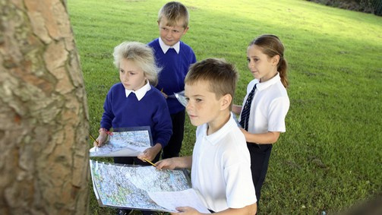

Is the land low lying? Can water be absorbed easily?

Are there any features that stop flooding?

You will record your observations on the following pages.

**Field Trip Report**

**Where is your chosen location?**

**Name:**

**Location:**

Map of

|  |
| --- |
|  |

**What are the characteristics of ?**

|  |  |
| --- | --- |
| **Physical (Natural) features** | **Human features** |
|  |  |

Include photos or images from the Internet. Alternatively, draw your own illustrations.

**What is your chosen location used for?**

List reasons for the location’s use. Write why you think the location has been chosen.

|  |  |
| --- | --- |
| **Reason** | **Why?** |
|  |  |

**How do people influence the characteristic of your chosen location?**

Make a list of 3 human and physical (natural) features in your chosen location and briefly outline the positive and negative influences.

**Human Features**

|  |  |  |
| --- | --- | --- |
| **Features** | **Positive influence** | **Negative influence** |
|  |  |  |
|  |  |  |

**Natural Features**

|  |  |  |
| --- | --- | --- |
| **Features** | **Positive influence** | **Negative influence** |
|  |  |  |
|  |  |  |

**Explore your location using**

**OPTIONAL CHALLENGE**

*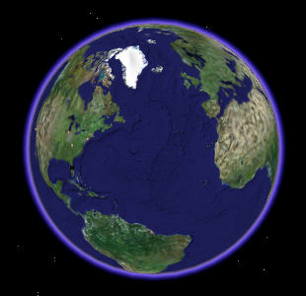***Google Maps**

Investigate your location using Google Maps.

Download images and describe its location from and aerial shot.

What can you see?

Does it explain why the location has been chosen?

What did you discover? Briefly list.

**Reflection**

**What have you learnt?**

Write three facts you learned about why physical and human features influence location of places.