**Mathematics**

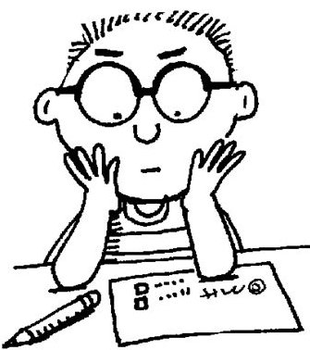

**How can I solve problems involving money?**

**Mathematics**

|  |  |
| --- | --- |
| **What you will need** | * Grey lead pencil, eraser and paper * A computer is useful if you have one, because there may be interactive activities in some lessons. * A calculator is sometimes used and is useful to check your answers. |
| **The activities** | * Learning tasks * Games * A fortnightly test * A fortnightly reflection |
| **Check your answers with your supervisor** | Check your answers after each activity to see how well you are going and how your skills are developing.  Checking your answers also prepares you for the tests and reflections. |
| **When to use your calculator** | Generally, you **won’t** need your calculator.  The Maths activities develop skills; ways of working with numbers, mental arithmetic, estimating and using times tables.  Please only use your calculator when it’s part of the activity. |
| **Asking for help…** | There may be times when you are not sure about an example or an exercise.  When this happens, ask for help from:   * Your supervisor/parent/carer * Your teacher |

**Guidelines for the Supervisor**

***Working with your child***

|  |  |
| --- | --- |
| **Assisting your child** | Please go through the explanation and examples of mathematical concepts and ensure that your child understands the tasks before beginning. Your child can work independently but you will need to monitor their progress and offer assistance if and when difficulties arise. Encourage your child to double- check his or her answers to each activity.  Please schedule time to **correct your child’s work** using the Maths Solutions booklet provided. If your child has made an error, discuss how and why the error was made and encourage him or her to have another go. Always provide **positive feedback** on progress made.  If your child experiences **difficulty,** c**ontact the teacher as soon as possible** for extra help. |
| **The fortnightly test** | We would like your child to complete the skills test **without any assistance** (although help with reading instructions may be required).This will allow the teacher to assess your child’s understanding and recall of the concepts taught in each lesson. |
| **Reflections** | There is an opportunity for students to reflect on their learning and whether or not they understood the concepts or need to consolidate their understanding further. |
| **Your feedback** | Please feel free to write comments on your child’s work in terms of their progress, attitude, difficulties etc. |
| **Your child’s teacher** | When the teacher receives your child’s work he or she will provide feedback, positive reinforcement and assistance.  If you have any questions it is important to contact your child’s teacher. The teacher can help you and adjust the work to best suit your child’s individual needs. |

***Learning Intention***

***Revise knowledge of Australian currency.***

**CURRENCY: DOLLARS AND CENTS**



|  |  |
| --- | --- |
| Description: Description: Screen bean character with a light bulb over its head | ***Currency means the money that a country uses.*** |

*Australian currency consists of dollars and cents.*

**100 cents = 1 Australian Dollar (AUD) or $1.00**

*We write the dollar sign on the left hand sign of the amount of money and the decimal point between the dollar amount and the cents.*

**$1.00**

*We write the abbreviation for cent on the right hand side of the amount of money.*

**50c**

*If there is a dollar symbol we don’t have to use the abbreviation for cents as well.*

**$0.50**

*Look carefully at the Australian dollar notes below.*

[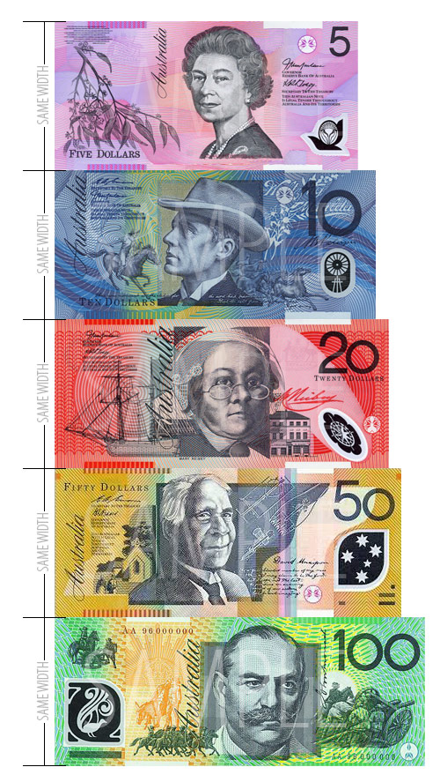](http://www.google.com.au/url?sa=i&source=images&cd=&cad=rja&docid=LfRxVQQDX-4GTM&tbnid=DdfAfm9K6WRKhM:&ved=0CAgQjRwwAA&url=http://designrevolutionaustralia.com/2010/07/11/australian-plastic-notes/&ei=OthhUt_MDO-ZiQfAvoHwCw&psig=AFQjCNHfiPrzaRBbnXx1s5_1D1zVI15jrA&ust=1382230458274234)

*Look carefully at the Australian coins below.*

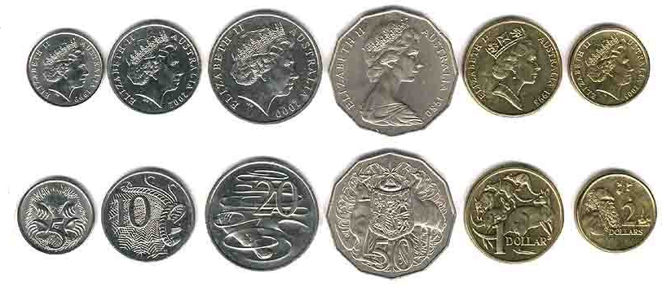

1. *List the Australian notes from the least to the greatest value.*

*\_\_\_\_\_\_\_\_\_\_\_\_\_\_\_\_\_\_\_\_\_\_\_\_\_\_\_\_\_\_\_\_\_\_\_\_\_\_\_\_\_\_\_\_\_\_\_\_\_\_\_\_\_\_\_\_\_\_\_\_*

1. *List the Australian coins from the least to the greatest value.*

*\_\_\_\_\_\_\_\_\_\_\_\_\_\_\_\_\_\_\_\_\_\_\_\_\_\_\_\_\_\_\_\_\_\_\_\_\_\_\_\_\_\_\_\_\_\_\_\_\_\_\_\_\_\_\_\_\_\_\_\_*

1. *Which note is the largest in size?*

*\_\_\_\_\_\_\_\_\_\_\_\_\_\_\_\_\_\_\_\_\_\_\_\_\_\_\_\_\_\_\_\_\_\_\_\_\_\_\_\_\_\_\_\_\_\_\_\_\_\_\_\_\_\_\_\_\_\_\_\_*

1. *Which note is the largest in value?*

*\_\_\_\_\_\_\_\_\_\_\_\_\_\_\_\_\_\_\_\_\_\_\_\_\_\_\_\_\_\_\_\_\_\_\_\_\_\_\_\_\_\_\_\_\_\_\_\_\_\_\_\_\_\_\_\_\_\_\_\_*

1. *Which coin is the largest in size? \_\_\_\_\_\_\_\_\_\_\_\_\_\_\_\_\_\_\_\_\_\_\_\_\_\_\_\_\_*
2. *Which coin is the largest in value? \_\_\_\_\_\_\_\_\_\_\_\_\_\_\_\_\_\_\_\_\_\_\_\_\_\_\_\_*
3. *Why do you think notes have different sizes?*

*\_\_\_\_\_\_\_\_\_\_\_\_\_\_\_\_\_\_\_\_\_\_\_\_\_\_\_\_\_\_\_\_\_\_\_\_\_\_\_\_\_\_\_\_\_\_\_\_\_\_\_\_\_\_\_\_\_\_\_\_*

*\_\_\_\_\_\_\_\_\_\_\_\_\_\_\_\_\_\_\_\_\_\_\_\_\_\_\_\_\_\_\_\_\_\_\_\_\_\_\_\_\_\_\_\_\_\_\_\_\_\_\_\_\_\_\_\_\_\_\_\_*

*\_\_\_\_\_\_\_\_\_\_\_\_\_\_\_\_\_\_\_\_\_\_\_\_\_\_\_\_\_\_\_\_\_\_\_\_\_\_\_\_\_\_\_\_\_\_\_\_\_\_\_\_\_\_\_\_\_\_\_\_*

1. *Write out each number sentence. The first one has been done for*

*you.*

1. *Two 20c coins and five 50c coins.*

*20c + 20c + 50c + 50c + 50c + 50c + 50c = $2.90*

1. *A five dollar note and a ten dollar note.*

*\_\_\_\_\_\_\_\_\_\_\_\_\_\_\_\_\_\_\_\_\_\_\_\_\_\_\_\_\_\_\_\_\_\_\_\_\_\_\_\_\_\_\_\_\_\_\_\_\_\_\_\_\_*

1. *Two 10c coins, two 5c coins and one 1 dollar coin.*

*\_\_\_\_\_\_\_\_\_\_\_\_\_\_\_\_\_\_\_\_\_\_\_\_\_\_\_\_\_\_\_\_\_\_\_\_\_\_\_\_\_\_\_\_\_\_\_\_\_\_\_\_\_*

*d. Seven 5c coins and four 2 dollar coins.*

*\_\_\_\_\_\_\_\_\_\_\_\_\_\_\_\_\_\_\_\_\_\_\_\_\_\_\_\_\_\_\_\_\_\_\_\_\_\_\_\_\_\_\_\_\_\_\_\_\_\_\_\_\_*

1. *Three 10 dollar notes.*

*\_\_\_\_\_\_\_\_\_\_\_\_\_\_\_\_\_\_\_\_\_\_\_\_\_\_\_\_\_\_\_\_\_\_\_\_\_\_\_\_\_\_\_\_\_\_\_\_\_\_\_\_\_*

1. *One 5 dollar note and three 20 dollar notes.*

*\_\_\_\_\_\_\_\_\_\_\_\_\_\_\_\_\_\_\_\_\_\_\_\_\_\_\_\_\_\_\_\_\_\_\_\_\_\_\_\_\_\_\_\_\_\_\_\_\_\_\_\_\_*

*9. Write these cents as dollars and then write them in words. The first one has been done for you. Hint: 100c = $1.00.*

|  |  |  |
| --- | --- | --- |
| ***a.*** *300c* | *$3.00* | *Three dollars* |
| ***b.*** *1000c* |  |  |
| ***c.*** *750c* |  |  |
| ***d.*** *93c* |  |  |
| ***e.*** *517c* |  |  |

1. *List the notes and coins that could be used to make these amounts.*

|  |  |
| --- | --- |
| *a.* | *65c \_\_\_\_\_\_\_\_\_\_\_\_\_\_\_\_\_\_\_\_\_\_\_\_\_\_\_\_\_\_\_\_\_\_\_\_\_\_\_\_\_\_\_\_\_\_\_\_\_\_\_* |
|  |  |
| *b.* | *$2.25 \_\_\_\_\_\_\_\_\_\_\_\_\_\_\_\_\_\_\_\_\_\_\_\_\_\_\_\_\_\_\_\_\_\_\_\_\_\_\_\_\_\_\_\_\_\_\_\_\_* |
|  |  |
| *c.* | *$10.15 \_\_\_\_\_\_\_\_\_\_\_\_\_\_\_\_\_\_\_\_\_\_\_\_\_\_\_\_\_\_\_\_\_\_\_\_\_\_\_\_\_\_\_\_\_\_\_\_* |
|  |  |
| *d.* | *$2.95 \_\_\_\_\_\_\_\_\_\_\_\_\_\_\_\_\_\_\_\_\_\_\_\_\_\_\_\_\_\_\_\_\_\_\_\_\_\_\_\_\_\_\_\_\_\_\_\_\_* |
|  |  |
| *e.* | *$0.35 \_\_\_\_\_\_\_\_\_\_\_\_\_\_\_\_\_\_\_\_\_\_\_\_\_\_\_\_\_\_\_\_\_\_\_\_\_\_\_\_\_\_\_\_\_\_\_\_\_* |
|  |  |
| *f.* | *$7.85 \_\_\_\_\_\_\_\_\_\_\_\_\_\_\_\_\_\_\_\_\_\_\_\_\_\_\_\_\_\_\_\_\_\_\_\_\_\_\_\_\_\_\_\_\_\_\_\_\_* |

Please ask your supervisor to correct today’s work with you.

Description: Description: C:\Users\Vicki\AppData\Local\Microsoft\Windows\Temporary Internet Files\Content.IE5\DBSL4CH0\MC900440410[1].wmf

*$1.40 is worth the same as 14 × 10c.*

*Count the coins below.*





*10 × 10c = $1.00*

*4 × 10c = 40c*

*$1.00 + 40c = $1.40*

1. *Write the amount of coins needed to make each statement true. Draw a picture to represent each answer.*
2. *$3 is worth the same as \_\_\_\_\_ × 10c.*

|  |
| --- |
|  |

1. *$0.70 is worth the same as \_\_\_\_\_ × 10c.*

|  |
| --- |
|  |

1. *\_\_\_\_\_ × 5c is worth the same as 95c.*
2. *$1.50 is worth the same as \_\_\_\_\_ × 10c.*
3. *$1 is worth the same as \_\_\_\_\_ × 50c.*
4. *$3.00 is worth the same as \_\_\_\_\_ × 50c.*
5. *$0.80 is worth the same as \_\_\_\_\_ × 5c.*
6. *Use a calculator to change these dollar amounts to cents by multiplying the decimal number by 100, e.g.*

*$2.27 × 100 = 227c*

|  |  |  |  |
| --- | --- | --- | --- |
| *a.* | $5.16 = \_\_\_\_\_\_\_\_\_\_\_\_\_\_\_\_\_\_\_ | *b.* | $2.48 = \_\_\_\_\_\_\_\_\_\_\_\_\_\_\_\_\_\_\_ |
| *c.* | $3.90 = \_\_\_\_\_\_\_\_\_\_\_\_\_\_\_\_\_\_\_ | *d.* | $4.05 = \_\_\_\_\_\_\_\_\_\_\_\_\_\_\_\_\_\_\_ |
| *e.* | $7.11 = \_\_\_\_\_\_\_\_\_\_\_\_\_\_\_\_\_\_\_ | *f.* | $0.65 = \_\_\_\_\_\_\_\_\_\_\_\_\_\_\_\_\_\_\_ |
| *g.* | $5.55 = \_\_\_\_\_\_\_\_\_\_\_\_\_\_\_\_\_\_\_ | *h.* | $8.00 = \_\_\_\_\_\_\_\_\_\_\_\_\_\_\_\_\_\_\_ |

1. *Use a calculator to change these to amounts to dollars and cents by dividing each number by 100, e.g.*

*227c ÷ 100 = $2.27*

|  |  |  |  |
| --- | --- | --- | --- |
| *a.* | 665c = \_\_\_\_\_\_\_\_\_\_\_\_\_\_\_\_\_\_\_\_ | *b.* | 708c = \_\_\_\_\_\_\_\_\_\_\_\_\_\_\_\_\_\_\_ |
| *c.* | 64c = \_\_\_\_\_\_\_\_\_\_\_\_\_\_\_\_\_\_\_\_\_ | *d.* | 990c = \_\_\_\_\_\_\_\_\_\_\_\_\_\_\_\_\_\_\_ |
| *e.* | 300c = \_\_\_\_\_\_\_\_\_\_\_\_\_\_\_\_\_\_\_\_ | *f.* | 112c = \_\_\_\_\_\_\_\_\_\_\_\_\_\_\_\_\_\_\_ |
| *g.* | 249c = \_\_\_\_\_\_\_\_\_\_\_\_\_\_\_\_\_\_\_\_ | *h.* | 506c = \_\_\_\_\_\_\_\_\_\_\_\_\_\_\_\_\_\_\_ |

1. *Circle the larger amount.*

|  |  |  |  |
| --- | --- | --- | --- |
| *a.* | $2.55 or 250c | *b.* | 506c or $6.05 |
| *c.* | $1.00 or 101c | *d.* | $7.70 or 708c |
| *e.* | $4.40 or 404c | *f.* | 171c or $7.11 |
| *g.* | $0.64 or 640c | *h.* | $0.10 or 21c |

1. *Write these cents as dollars and cents. The first one has been done for you.*

|  |  |  |  |  |  |
| --- | --- | --- | --- | --- | --- |
| *a.* | 2 006c  $20.06 | *b.* | 1 556c  \_\_\_\_\_\_\_\_\_\_\_\_\_ | *c.* | 206c  \_\_\_\_\_\_\_\_\_\_\_\_\_ |
| *d.* | 599c  \_\_\_\_\_\_\_\_\_\_\_\_\_ | *e.* | 64c  \_\_\_\_\_\_\_\_\_\_\_\_\_\_\_ | *f.* | 771c  \_\_\_\_\_\_\_\_\_\_\_\_\_ |
| *g.* | 519c  \_\_\_\_\_\_\_\_\_\_\_\_\_ | *h.* | 884c  \_\_\_\_\_\_\_\_\_\_\_\_\_\_ | *i.* | 700c  \_\_\_\_\_\_\_\_\_\_\_\_\_ |
| *j.* | 805c  \_\_\_\_\_\_\_\_\_\_\_\_\_ | *k.* | 440c  \_\_\_\_\_\_\_\_\_\_\_\_\_\_ | *l.* | 1c  \_\_\_\_\_\_\_\_\_\_\_\_\_\_\_ |

1. *Circle the largest amount and draw a line under the smallest amount.*
2. *four dollars sixty $0.40 $27.40 274c*
3. *$267 267c two dollars and sixty-seven cents $0.67*
4. *500c $0.50 five hundred and six cents $15.15*

*d. eighty-nine dollars seventy-two cents $0.15 27c*

Please ask your supervisor to correct today’s work with you.

Description: Description: C:\Users\Vicki\AppData\Local\Microsoft\Windows\Temporary Internet Files\Content.IE5\DBSL4CH0\MC900440410[1].wmf

***Learning Intention***

***Solve problems involving purchases.***

|  |  |  |  |  |
| --- | --- | --- | --- | --- |
| C:\Users\MGulati\AppData\Local\Microsoft\Windows\Temporary Internet Files\Content.IE5\JKS9YM5U\MC910216978[1].png10c | C:\Users\MGulati\AppData\Local\Microsoft\Windows\Temporary Internet Files\Content.IE5\FBOXAIML\MC900012990[1].wmf20c | C:\Users\MGulati\AppData\Local\Microsoft\Windows\Temporary Internet Files\Content.IE5\JKWAOEYT\MC900412518[1].wmf$1 | C:\Users\MGulati\AppData\Local\Microsoft\Windows\Temporary Internet Files\Content.IE5\JKS9YM5U\MC900047841[1].wmf50c | C:\Users\MGulati\AppData\Local\Microsoft\Windows\Temporary Internet Files\Content.IE5\JKS9YM5U\MP900422958[1].jpg15c |

1. *Solve the following problems.*
2. *How much will 3 bananas and one watermelon cost? \_\_\_\_\_\_\_\_\_\_\_\_\_\_\_\_\_\_\_\_\_\_\_\_\_\_\_\_\_\_\_\_\_\_\_\_\_\_\_\_\_\_\_\_\_\_\_\_\_\_\_\_\_*
3. *Which costs more: 5 apples or 3 bunches of grapes? \_\_\_\_\_\_\_\_\_\_\_\_\_\_\_\_\_\_\_\_\_\_\_\_\_\_\_\_\_\_\_\_\_\_\_\_\_\_\_\_\_\_\_\_\_\_\_\_\_\_\_\_\_*

*c. How much change from $1 if I bought 4 pears? \_\_\_\_\_\_\_\_\_\_\_\_\_\_\_\_\_\_\_\_\_\_\_\_\_\_\_\_\_\_\_\_\_\_\_\_\_\_\_\_\_\_\_\_\_\_\_\_\_\_\_\_\_*

1. *What exact coins would I give to the shopkeeper if I bought 2 bananas, 2 pears and 1 bunch of grapes?*

*\_\_\_\_\_\_\_\_\_\_\_\_\_\_\_\_\_\_\_\_\_\_\_\_\_\_\_\_\_\_\_\_\_\_\_\_\_\_\_\_\_\_\_\_\_\_\_\_\_\_\_\_\_*

1. *How many bananas can I buy for $1?*

*\_\_\_\_\_\_\_\_\_\_\_\_\_\_\_\_\_\_\_\_\_\_\_\_\_\_\_\_\_\_\_\_\_\_\_\_\_\_\_\_\_\_\_\_\_\_\_\_\_\_\_\_\_*

1. *How many bunches of grapes can I buy for $2?*

*\_\_\_\_\_\_\_\_\_\_\_\_\_\_\_\_\_\_\_\_\_\_\_\_\_\_\_\_\_\_\_\_\_\_\_\_\_\_\_\_\_\_\_\_\_\_\_\_\_\_\_\_\_*

1. *Calculate the total of each group of dollars and coins.*

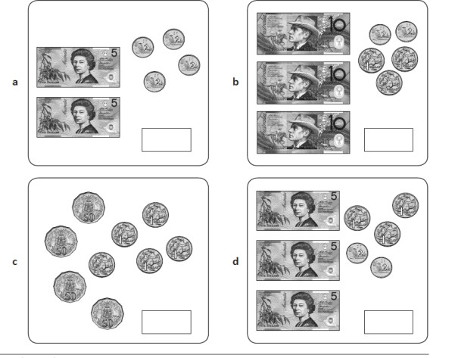

1. *Write or draw your answer.*

|  |  |  |
| --- | --- | --- |
| *a.* |  | = \_\_\_\_\_\_\_\_\_\_\_\_\_\_\_\_\_\_\_\_ |
| *b.* |  | = \_\_\_\_\_\_\_\_\_\_\_\_\_\_\_\_\_\_\_\_ |
| *c.* |  | = \_\_\_\_\_\_\_\_\_\_\_\_\_\_\_\_\_\_\_\_ |
| *d.* | |  |  |  |  |  |  | | --- | --- | --- | --- | --- | --- | |  | + |  | + |  |  | | = \_\_\_\_\_\_\_\_\_\_\_\_\_\_\_\_\_\_\_\_ |
| *e.* |  | = \_\_\_\_\_\_\_\_\_\_\_\_\_\_\_\_\_\_\_\_ |

1. *(a) Add the following coins.*

|  |
| --- |
| 1DOLLCOI1DOLLCOI1DOLLCOI2DOLLCOI2DOLLCOI2DOLLCOI20CCOIN20CCOIN20CCOIN20CCOIN5CCOIN  $ \_\_\_\_\_\_\_\_\_\_\_ |

*4. (b) The amount below was spent. How much money was left?*

|  |
| --- |
| 2DOLLCOI 20CCOIN 20CCOIN 5CCOIN  $ \_\_\_\_\_\_\_\_\_\_\_ |

1. *Choose the correct operation to solve these money problems.*

a. *Horse rides are $5.00 each. My sister and I had one ride each.*

*What was the total cost of the rides?*

*\_\_\_\_\_\_\_\_\_\_\_\_\_\_\_\_\_\_\_\_\_\_\_\_\_\_\_\_\_\_\_\_\_\_\_\_\_\_\_\_\_\_\_\_\_\_\_\_*

1. *Movie tickets are $10 each. How much for six tickets?*

*\_\_\_\_\_\_\_\_\_\_\_\_\_\_\_\_\_\_\_\_\_\_\_\_\_\_\_\_\_\_\_\_\_\_\_\_\_\_\_\_\_\_\_\_\_\_\_\_*

*c.* *Boxes of mangoes are $20 each. How much for three boxes?*

\_\_\_\_\_\_\_\_\_\_\_\_\_\_\_\_\_\_\_\_\_\_\_\_\_\_\_\_\_\_\_\_\_\_\_\_\_\_\_\_\_\_\_\_\_\_\_\_\_

1. *My dog has five puppies. Each one is worth $200. How much are they worth altogether?*

\_\_\_\_\_\_\_\_\_\_\_\_\_\_\_\_\_\_\_\_\_\_\_\_\_\_\_\_\_\_\_\_\_\_\_\_\_\_\_\_\_\_\_\_\_\_\_\_\_\_

1. *Books were on special for $10 each. I spent $120. How many books did I buy?*

*\_\_\_\_\_\_\_\_\_\_\_\_\_\_\_\_\_\_\_\_\_\_\_\_\_\_\_\_\_\_\_\_\_\_\_\_\_\_\_\_\_\_\_\_\_\_\_\_\_\_\_\_*

1. *Eight pies cost $48. How much did each pie cost?*

*\_\_\_\_\_\_\_\_\_\_\_\_\_\_\_\_\_\_\_\_\_\_\_\_\_\_\_\_\_\_\_\_\_\_\_\_\_\_\_\_\_\_\_\_\_\_\_\_\_\_\_\_*

1. *Grandpa paid $600 for four nights at a motel. How much did one night cost?*

\_\_\_\_\_\_\_\_\_\_\_\_\_\_\_\_\_\_\_\_\_\_\_\_\_\_\_\_\_\_\_\_\_\_\_\_\_\_\_\_\_\_\_\_\_\_\_\_\_\_\_\_

Please ask your supervisor to correct today’s work with you.

Description: Description: C:\Users\Vicki\AppData\Local\Microsoft\Windows\Temporary Internet Files\Content.IE5\DBSL4CH0\MC900440410[1].wmf

1. *Read the Canteen List below and answer the following question.*



|  |  |  |  |
| --- | --- | --- | --- |
| Canteen List | | | |
| Sandwich | $3.50 | Drink | $1.60 |
| Pie | $4.20 | Ice Block | $2.50 |
| Sausage Roll | $1.80 | Chips | $2.80 |
| Spaghetti | $5.00 | Pizza | $5.00 |

1. *Order these items from the least expensive to the most expensive.*

\_\_\_\_\_\_\_\_\_\_\_\_\_\_\_\_\_\_\_\_\_\_\_\_\_\_\_\_\_\_\_\_\_\_\_\_\_\_\_\_\_\_\_\_\_\_\_\_\_\_\_\_\_\_\_\_\_\_\_\_\_\_\_\_\_\_\_\_\_\_\_\_\_\_\_\_\_\_\_\_\_\_\_\_\_\_\_\_\_\_\_\_\_\_\_\_\_\_\_\_\_\_\_\_\_\_\_\_\_\_\_\_\_\_\_\_\_\_\_\_\_\_\_\_\_\_\_\_\_\_\_\_\_\_\_\_\_\_\_\_\_\_\_\_\_\_\_\_\_\_\_\_\_\_\_\_\_\_\_\_\_\_\_\_\_\_\_\_\_\_\_\_\_\_\_\_\_\_\_\_\_\_\_\_\_\_\_\_\_\_\_\_\_\_\_\_\_\_\_\_\_\_\_\_\_\_\_\_\_\_\_\_\_\_\_\_\_\_\_\_\_\_\_\_\_\_\_\_\_\_\_\_\_\_\_

*Now you are going to solve money using the strategies you learnt previously. When we add or subtract money we must make sure that we line up the decimal points in any money equation correctly so that we don’t muddle up the place value of each digit, e.g.*

|  |  |  |
| --- | --- | --- |
| $3.20 |  | $7.70 |
| + $4.50 |  | - $4.50 |
| $7.70 |  | $3.20 |

|  |  |
| --- | --- |
| Description: Description: Screen bean character with a light bulb over its head | ***In addition and subtraction problems the decimal point must be in a straight line.*** |

1. *Solve these money problems vertically.*
2. *How much would it cost you to buy a pie, a drink and an ice block? Show your working out below.*

|  |
| --- |
| $ |
| $ |
| + $ |
| $ |

1. *What change would you receive from $10.00? Show your working out below.*

|  |
| --- |
| $10.00 |
| - $ |
| $ |

*An amount of money can be made in different ways. We usually use the highest value notes and coins possible. For example, using the least number of dollar notes and coins $187.50 would be made this way:*

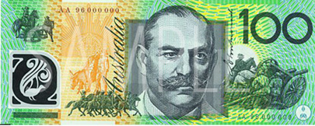

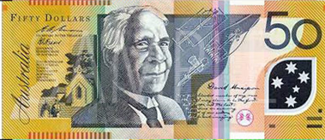

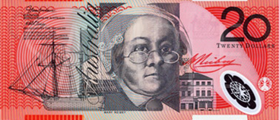

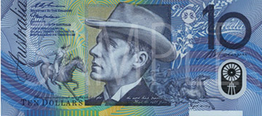

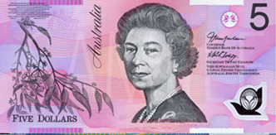

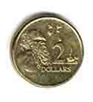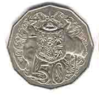

1. *Write another way you could make $187.50.*
2. *Use the play money on the following page to cut and paste the amounts of money and then complete the subtraction algorithms to work out the change.*
3. *Make $36.50 using the least amount of notes and coins. Find the change from $50.00.*

|  |
| --- |
|  |

|  |  |  |  |  |  |  |
| --- | --- | --- | --- | --- | --- | --- |
|  | $ | 5 | 0 | . | 0 | 0 |
| - | $ | 3 | 6 | . | 5 | 0 |
|  | $ |  |  |  |  |  |

1. *Make $9.20 using the least amount of notes and coins. Find the change from $50.00.*

|  |
| --- |
|  |

|  |  |  |  |  |  |  |
| --- | --- | --- | --- | --- | --- | --- |
|  | $ | 5 | 0 | . | 0 | 0 |
| - | $ |  | 9 | . | 2 | 0 |
|  | $ |  |  |  |  |  |

1. *Make $18.30 using the least amount of notes and coins. Find the change from $50.00.*

|  |
| --- |
|  |

|  |  |  |  |  |  |  |
| --- | --- | --- | --- | --- | --- | --- |
|  | $ | 5 | 0 | . | 0 | 0 |
| - | $ | 1 | 8 | . | 3 | 0 |
|  | $ |  |  |  |  |  |

    

 *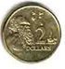* ** **  

 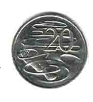  

Please ask your supervisor to correct today’s work with you.

Description: Description: C:\Users\Vicki\AppData\Local\Microsoft\Windows\Temporary Internet Files\Content.IE5\DBSL4CH0\MC900440410[1].wmf

1. *Work out this money problem.*

|  |  |  |  |  |  |  |
| --- | --- | --- | --- | --- | --- | --- |
|  | $ | 5 | 0 | . | 0 | 0 |
| - | $ | 4 | 1 | . | 9 | 5 |
|  | $ |  |  |  |  |  |

1. *Show three different ways of giving change from $50 if the cost is $41.95. Draw your answers.*

|  |
| --- |
| a. |

|  |
| --- |
| b. |

|  |
| --- |
| c. |

1. *Make each amount using the highest value of notes and coins possible. Write your answers.*

*a. $57.00*

*b $51.50*

*c $23.00*

*d $60.05*

1. *Use a calculator to calculate the change you would give in each situation. Remember to include the dollar sign.*
2. *$100.00 − $57.00 = \_\_\_\_\_\_\_\_\_\_\_\_*
3. *$70.00 − $51.50 = \_\_\_\_\_\_\_\_\_\_\_\_*
4. *$50.00 − $23.00 = \_\_\_\_\_\_\_\_\_\_\_\_*
5. *65.00 − $60.05 = \_\_\_\_\_\_\_\_\_\_\_\_*

*Hayley, Liz and Amy went to the Wild Kidz Clothing Company to buy some new clothes. Each girl had a different amount of money to spend.*

|  |  |  |  |  |  |
| --- | --- | --- | --- | --- | --- |
| *A.* | *B.* | *C.* | *D.* | *E.* | *F.* |
| C:\Users\MGulati\AppData\Local\Microsoft\Windows\Temporary Internet Files\Content.IE5\OCWK8EL3\MC900057021[1].wmf  **$19.99**  **$24.99**  **$29.99**  **$34.99**  **$13.99**  **$29.99** | C:\Users\MGulati\AppData\Local\Microsoft\Windows\Temporary Internet Files\Content.IE5\MZ4FD4IU\MC900057018[1].wmf | C:\Users\MGulati\AppData\Local\Microsoft\Windows\Temporary Internet Files\Content.IE5\JKS9YM5U\MC900232964[1].wmf | C:\Users\MGulati\AppData\Local\Microsoft\Windows\Temporary Internet Files\Content.IE5\E2N5VNY0\MC900013096[1].wmf | C:\Users\MGulati\AppData\Local\Microsoft\Windows\Temporary Internet Files\Content.IE5\NR28T655\MC900044904[1].wmf | C:\Users\MGulati\AppData\Local\Microsoft\Windows\Temporary Internet Files\Content.IE5\FBOXAIML\MC900057013[1].wmf |

1. *List some of the different items of clothing that each girl could buy with her money. Work out the amount of change that she would receive. The first one has been done for you. Hint: Remember to keep the decimal point in a straight line.*

|  |  |  |  |  |  |  |  |  |  |  |  |  |
| --- | --- | --- | --- | --- | --- | --- | --- | --- | --- | --- | --- | --- |
| C:\Users\MGulati\AppData\Local\Microsoft\Windows\Temporary Internet Files\Content.IE5\E2N5VNY0\MC900445222[1].wmf | Hayley  $50 | |  |  | | --- | --- | | *A* | $19.99 | | *B* | + $24.99 | |  | $44.98 | | |  | | --- | | $50.00 | | *−* $44.98 | | $ 5.02 | |
| C:\Users\MGulati\AppData\Local\Microsoft\Windows\Temporary Internet Files\Content.IE5\E2N5VNY0\MC900445220[1].wmf | Liz  $55 | |  |  | | --- | --- | | *\_\_* | $ | | *\_\_* | + $ | |  | $ | | |  | | --- | | $55.00 | | *−* $ | | $ | |
| C:\Users\MGulati\AppData\Local\Microsoft\Windows\Temporary Internet Files\Content.IE5\FBOXAIML\MC900445228[1].wmf | Amy  $60 | |  |  | | --- | --- | | *\_\_* | $ | | *\_\_* | $ | | *\_\_* | + $ | |  | $ | | |  | | --- | | $60.00 | | *−* $ | | $ | |

1. *Complete the money subtraction problems. Remember to use the dollar sign in your answers.*



1. *Use a calculator to check your answers. Tick those you got right and place a cross next to the ones you got wrong. Have another go at the ones you got wrong below.*

|  |
| --- |
|  |

Please ask your supervisor to correct today’s work with you.

Description: Description: C:\Users\Vicki\AppData\Local\Microsoft\Windows\Temporary Internet Files\Content.IE5\DBSL4CH0\MC900440410[1].wmf

**REFLECTION**

*How can I solve problems involving money?*

**Please think about what you’ve learnt. Place a tick or smiley face in each of the rows below.**

|  |  |  |
| --- | --- | --- |
| **LEARNING INTENTION** | **I CAN DO THIS** | **I NEED MORE PRACTICE** |
| *I know the value of Australian currency.* |  |  |
| *I can add and subtract money without a calculator.* |  |  |
| *I can add and subtract money with a calculator.* |  |  |

***Learning Intention***

***Round off money to the nearest five cents.***

**Rounding off money**

*Australian currency used to include 1 and 2 cent pieces. They were withdrawn from circulation in 1992.*

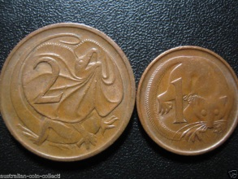

*As we no longer have these coins it is important for us to be able to round off money to the nearest 5 cents when we are paying with cash.*

*For example, if we are going to buy a bar of chocolate that costs $2.23 we cannot give the shopkeeper this exact amount, as we do not have 1 and 2 cent pieces. Therefore, this amount needs to be rounded off to $2.25.*

**The Rules**

*Sometimes money will be* ***rounded up*** *and sometimes it will be* ***rounded down****.*

1. ***Cash amounts ending in 0c or 5c do not change.*** *If you buy something that costs $1.10 or $6.25 there is no need to round off the money you are paying.*
2. ***If the number of cents ends in 1c or 2c it is rounded down******to 0.*** *Example: $2.52 is rounded down to $2.50.*
3. ***If the number of cents ends in 3c or 4c, it is rounded up to the nearest 5c.*** *Example: $7.63 is rounded up to $7.65.*
4. ***Cash amounts ending in 6c or 7c are rounded down******to the nearest 5c****. Example: $6.16 is rounded down to $6.15.*

|  |  |
| --- | --- |
| Description: Description: Screen bean character with a light bulb over its head | ***When paying by cash, the price is rounded up or down to the nearest 5 cents.*** |

1. ***Cash amounts ending in 8c or 9c, round up to the nearest 10c.*** *Example: $10.99 is rounded up to $11.00.*

|  |  |  |  |  |
| --- | --- | --- | --- | --- |
| 48c | 49c | 50c | 51c | 52c |

|  |  |  |  |  |
| --- | --- | --- | --- | --- |
| 53c | 54c | 55c | 56c | 57c |

|  |  |  |  |  |
| --- | --- | --- | --- | --- |
| 58c | 59c | 60c | 61c | 62c |

Cost

1. *Will you round these prices up or down? Write the price you will pay for each item.*
2. 

*$7.51 $\_\_\_\_\_\_\_\_\_\_\_\_*

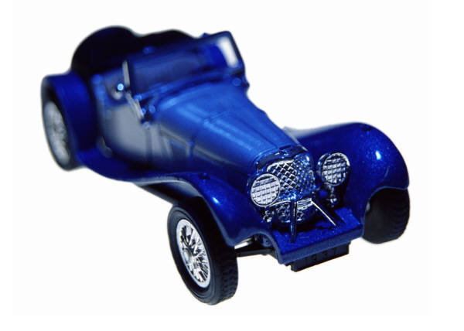

*$10.59 $\_\_\_\_\_\_\_\_\_\_\_\_*

1. *Round these amounts up or down to the nearest 5 cents*.

|  |  |  |  |  |  |
| --- | --- | --- | --- | --- | --- |
| *a.* | *$1.88 = \_\_\_\_\_\_\_* | *b.* | *$1.96 = \_\_\_\_\_\_\_\_* | *c.* | *$2.99 = \_\_\_\_\_\_\_* |
| *d.* | *$3.19 =\_\_\_\_\_\_\_* | *e.* | *$2.14 = \_\_\_\_\_\_\_\_* | *f.* | *$7.96 = \_\_\_\_\_\_\_* |
| *g.* | *$2.19 = \_\_\_\_\_\_\_* | *h.* | *$8.76 = \_\_\_\_\_\_\_* | *i.* | *$3.11 = \_\_\_\_\_\_\_* |
| *j.* | *$3.82= \_\_\_\_\_\_\_* | *k.* | *$4.98 = \_\_\_\_\_\_\_* | *l.* | *$2.01 = \_\_\_\_\_\_\_* |

1. *Round down each amount in the boxes by one cent. Rule a different coloured line to the correct answer.*



1. *Round each number up or down to the nearest 5 cents. The first one has been done for you.*

|  |  |  |  |  |  |
| --- | --- | --- | --- | --- | --- |
| *a.* | *$83.77* | *$83.80* | *b.* | *$82.81* | *$\_\_\_\_\_\_\_\_\_\_* |
| *c.* | *$12.44* | *$\_\_\_\_\_\_\_\_\_\_* | *d.* | *$44.58* | *$\_\_\_\_\_\_\_\_\_\_* |
| *e.* | *$79.71* | *$\_\_\_\_\_\_\_\_\_\_* | *f.* | *$83.16* | *$\_\_\_\_\_\_\_\_\_\_* |
| *g.* | *$94.29* | *$\_\_\_\_\_\_\_\_\_\_* | *h.* | *$16.21* | *$\_\_\_\_\_\_\_\_\_\_* |
| *i.* | *$15.52* | *$\_\_\_\_\_\_\_\_\_\_* | *j.* | *$95.53* | *$\_\_\_\_\_\_\_\_\_\_* |
| *k.* | *$866.43* | *$\_\_\_\_\_\_\_\_\_\_* | *l.* | *$312.25* | *$\_\_\_\_\_\_\_\_\_\_* |
| *m.* | *$628.47* | *$\_\_\_\_\_\_\_\_\_\_* | *n.* | *$569.87* | *$\_\_\_\_\_\_\_\_\_\_* |
| *o.* | *$666.53* | *$\_\_\_\_\_\_\_\_\_\_* | *p.* | *$866.98* | *$\_\_\_\_\_\_\_\_\_\_* |
| *q.* | *$989.93* | *$\_\_\_\_\_\_\_\_\_\_* | *r.* | *$865.16* | *$\_\_\_\_\_\_\_\_\_\_* |
| *s.* | *$167.19* | *$\_\_\_\_\_\_\_\_\_\_* | *t.* | *$293.97* | *$\_\_\_\_\_\_\_\_\_\_* |

1. *Round up or down to the nearest 5 cents and calculate the change each person would receive. Remember to use a dollar sign in your answer.*
2. *Jennifer had $20 but spent $14.99 on a magazine. \_\_\_\_\_\_\_\_*
3. *Michael had $40 and planned to buy a toy at Kmart advertised for $27.99. \_\_\_\_\_\_\_\_*
4. *Jessica had $50 but spent $34.49 on a board game. \_\_\_\_\_\_\_\_*
5. *Caleb spent $14.91 of $100 on a soft toy. \_\_\_\_\_\_\_\_\_*
6. *Dale spent $13.44 of $80 on hair gel. \_\_\_\_\_\_\_\_\_*

|  |  |  |  |  |  |  |  |
| --- | --- | --- | --- | --- | --- | --- | --- |
| C:\Users\MGulati\AppData\Local\Microsoft\Windows\Temporary Internet Files\Content.IE5\OCWK8EL3\MC910215894[1].jpg | Coffee $2.60 | C:\Users\MGulati\AppData\Local\Microsoft\Windows\Temporary Internet Files\Content.IE5\FBOXAIML\MP900314315[1].jpg | Milk $1.30 | C:\Users\MGulati\AppData\Local\Microsoft\Windows\Temporary Internet Files\Content.IE5\FBOXAIML\MC900293560[1].wmf | Jam $3.40 | C:\Users\MGulati\AppData\Local\Microsoft\Windows\Temporary Internet Files\Content.IE5\NR28T655\MC900264344[1].wmf | Honey $2.70 |
| 1. *Mrs Ramsden is in a huge hurry to get to the staffroom. On her way she has to buy coffee, milk, jam and honey. She only has $10 in her purse.* | | | | | | | |

1. Quickly estimate if $10 is enough to buy what she wants. \_\_\_\_\_\_\_\_\_\_\_\_\_\_\_\_\_\_\_\_\_\_\_\_\_\_\_\_\_\_\_\_\_\_\_\_\_\_\_\_\_\_\_\_\_\_\_\_\_\_\_\_\_\_\_
2. Explain your strategy.

\_\_\_\_\_\_\_\_\_\_\_\_\_\_\_\_\_\_\_\_\_\_\_\_\_\_\_\_\_\_\_\_\_\_\_\_\_\_\_\_\_\_\_\_\_\_\_\_\_\_\_\_\_\_\_

\_\_\_\_\_\_\_\_\_\_\_\_\_\_\_\_\_\_\_\_\_\_\_\_\_\_\_\_\_\_\_\_\_\_\_\_\_\_\_\_\_\_\_\_\_\_\_\_\_\_\_\_\_\_\_

Please ask your supervisor to correct today’s work with you.

Description: Description: C:\Users\Vicki\AppData\Local\Microsoft\Windows\Temporary Internet Files\Content.IE5\DBSL4CH0\MC900440410[1].wmf

**Using a Calculator**

*When you have difficult money problems or equations it is often a good idea to use a calculator. Using a calculator can make working out problems with large numbers easier. It is important though, to make sure you have entered each number correctly so that you get the correct answer.*

* *First, enter the first number of your equation and check that it is entered correctly.*
* *Then press the operation function e.g. +, −, × or ÷.*
* *Next, press the second number of your equation and check that it is the same as the one on the paper.*
* *Finally, press the = button.*
* *Write down your answer carefully.*

*\*\*If you make a mistake press the CLEAR button and start again.*

*Try these equations on your calculator:*

*$47 590 ÷ 2 = \_\_\_\_\_\_\_\_\_\_\_\_ $47 590 × 2 = \_\_\_\_\_\_\_\_\_\_\_\_*

1. *Use a calculator to find half of these amounts. To find half of the amount you will need to divide the number by 2. Remember to use the dollar sign in your answers.*
2. *Half of $52 288 = \_\_\_\_\_\_\_\_\_ b. Half of $96 708= \_\_\_\_\_\_\_\_\_\_*
3. *Half of $31 942= \_\_\_\_\_\_\_\_\_\_ d. Half of $76 345= \_\_\_\_\_\_\_\_\_\_*

*e. Half of $100 000 = \_\_\_\_\_\_\_\_\_ f. Half of $444 444= \_\_\_\_\_\_\_\_\_\_\_*

1. *Use a calculator to find double these amounts. To double the amount you will need to multiply the number by 2. Remember to use the dollar sign in your answers.*
2. *Double $52 288 = \_\_\_\_\_\_\_\_\_ b. Double $96 708= \_\_\_\_\_\_\_\_\_\_*
3. *Double $31 942= \_\_\_\_\_\_\_\_\_\_ d. Double $76 345= \_\_\_\_\_\_\_\_\_\_*

*e. Double $100 000 = \_\_\_\_\_\_\_\_\_ f. Double $444 444= \_\_\_\_\_\_\_\_\_\_*

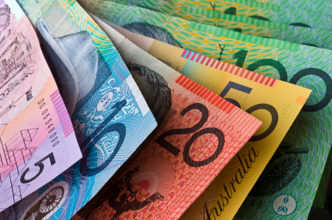

**Reading Spreadsheets**

*A spreadsheet is a tool for organising information. They are used to carry out lots of calculations quickly and to store large amounts of information for a range of purposes.*

*They are often used to keep track of how much money a group or business spends. Discuss Gympie Cricket Club’s spreadsheet with an adult.*

**Gympie Cricket Club**

|  |  |  |  |  |
| --- | --- | --- | --- | --- |
|  | **A** | **B** | **C** | **D** |
| **1** | **Date** | **Item** | **Cost** | **Balance** |
| **2** | May 1 | Opening balance |  | $900 |
| **3** | May 4 | Pads | $120 | $780 |
| **4** | May 7 | Helmets | $240 | $540 |
| **5** | May 19 | Bats | $300 | $240 |
| **6** | May 23 | Gloves | $60 | $180 |
| **7** | May 25 | Balls | $90 | $90 |
| **8** |  |  |  |  |

* *The spreadsheet has 1 column to record the date.*
* *Another column to record the item bought.*
* *Another column to record how much the item cost.*
* *Finally there is a balance column to keep track of how much money the group has left over after buying something.*

*\*\*To find the balance you need to subtract the cost of the last item bought from the previous balance.*

1. *How much money did Gympie Cricket Club spend on these items?*

|  |  |  |  |  |  |
| --- | --- | --- | --- | --- | --- |
| *a.* | *Pads*  *\_\_\_\_\_\_\_\_\_\_* | *b.* | *Balls*  *\_\_\_\_\_\_\_\_\_\_\_* | *c.* | *Bats*  *\_\_\_\_\_\_\_\_\_\_* |
| *d.* | *Helmets*  *\_\_\_\_\_\_\_\_\_\_\_* | *e.* | *Gloves*  *\_\_\_\_\_\_\_\_\_\_\_\_\_* |  |  |

1. *On May 30, Gympie Cricket Club spent $50 on insurance. Add this information to the spread sheet, including the final balance.*

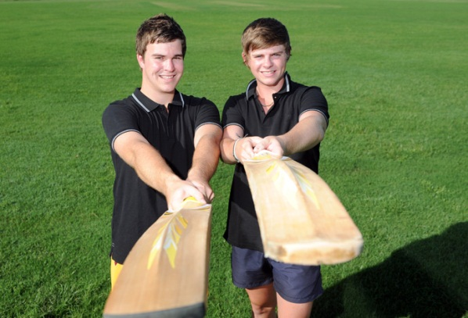

1. *Complete the balance column on the Baker family budget spreadsheet.*

|  |  |  |  |  |
| --- | --- | --- | --- | --- |
|  | **A** | **B** | **C** | **D** |
| **1** | Date | Item | Cost | Balance |
| **2** | Aug 3 | Opening Balance |  | $600 |
| **3** | Aug 4 | Groceries | $150 | $450 |
| **4** | Aug 5 | Fruit & Veg | $50 | $400 |
| **5** | Aug 8 | Bills | $100 | $ |
| **6** | Aug 12 | Meat | $80 | $ |
| **7** | Aug 16 | Car | $60 | $ |
| **8** | Aug 20 | Entertainment | $80 | $ |

*1. Imagine you are at a School Fete. You have been given $10.00 to spend on the items in the box below.*

|  |
| --- |
| j0127863j0215776bl00070_    sausage sizzle $1 jumping castle $3 face painting $1  hh01464_  j0290472j0273024  books/magazines 20c toys/games 50c cake stall 30c  (each piece)  j0290087hh00840_j0233680j0112652  drinks/ice-creams 60c lucky dips 40c electric car races $2  j0234255 (3 races)  j0237679an00802_  trash and treasure $1.50 fishing game 40c pancakes $1  (per box) |

*a. If you bought a sausage, a pancake and a drink how much money would you have spent? Write your answer as a number sentence.*

*Answer: \_\_\_\_\_\_\_\_\_\_\_\_\_\_\_\_\_\_\_\_\_\_\_\_\_\_\_\_\_\_\_\_\_\_\_\_\_\_\_\_\_\_\_\_\_\_\_\_\_*

1. *Would you have enough money left over to go on the jumping castle, have your face painted and buy 7 books? Show your working out. Circle the answer.*

*Answer: \_\_\_\_\_\_\_\_\_\_\_\_\_\_\_\_\_\_\_\_\_\_\_\_\_\_\_\_\_\_\_\_\_\_\_\_\_\_\_\_\_\_\_\_*

*Yes / No*

*c. You buy one trash and treasure box, play one fishing game, buy 5 cakes (for your family) and have an ice-cream? How much money have you spent? Write your answer as a number sentence.*

*Answer: \_\_\_\_\_\_\_\_\_\_\_\_\_\_\_\_\_\_\_\_\_\_\_\_\_\_\_\_\_\_\_\_\_\_\_\_\_\_\_\_\_\_\_\_\_\_\_\_\_*

*2. How would you spend the $10?*

\_\_\_\_\_\_\_\_\_\_\_\_\_\_\_\_\_\_\_\_\_\_\_\_\_\_\_\_\_\_\_\_\_\_\_\_\_\_\_\_\_\_\_\_\_\_\_\_\_\_\_\_\_\_\_\_\_

\_\_\_\_\_\_\_\_\_\_\_\_\_\_\_\_\_\_\_\_\_\_\_\_\_\_\_\_\_\_\_\_\_\_\_\_\_\_\_\_\_\_\_\_\_\_\_\_\_\_\_\_\_\_\_\_\_

*3. Answer the following questions. Write a number sentence where possible. The first one has been done for you.*

****

|  |  |  |
| --- | --- | --- |
| *a.* | How many candles could I buy for $2?  **4 × 50c = $2** | 4 |
| *b.* | How much would six toy aeroplanes cost? |  |
| *c.* | How much change from $5 would I get if I bought an ice-cream? |  |
| *d.* | Which is more expensive: 2 cricket bats or 2 mobile phones? |  |

|  |  |  |  |
| --- | --- | --- | --- |
| *e.* | How much would 2 mobile phones cost? | |  |
| *f.* | How much for 2 candles and one ice-cream? | |  |
| *g.* | Which 2 items added together would cost the least amount of money? | |  |
| *h.* | If I had a $1 coin, a $2 coin, two 20c coins and a 10c coin, which item could I buy? | |  |
| *i.* | If I bought every toy, would it cost more than $20? | |  |
| *j.* | If I was given a $10 note which toys could I buy? List them. | | |
| *k.* | Draw the exact notes and/or coins that you would you use to buy: | | |
|  | an ice-cream; |  | |

|  |  |  |  |
| --- | --- | --- | --- |
|  | a mobile phone; |  | |
|  | 3 aeroplanes; |  | |
|  | and a cricket bat. |  | |
| *l.* | List the items from **cheapest to the most expensive.** | | |
| ***ITEM*** | | | ***COST*** | |
|  | | |  | |
|  | | |  | |
|  | | |  | |
|  | | |  | |
|  | | |  | |

Please ask your supervisor to correct today’s work with you.

Description: Description: C:\Users\Vicki\AppData\Local\Microsoft\Windows\Temporary Internet Files\Content.IE5\DBSL4CH0\MC900440410[1].wmf

*When you need to solve number problems that are written in words or as a story, you need to:*

* *Read the problem carefully.*
* *Find the most important information.*
* *Identify the operation. Do you need to use addition, subtraction, multiplication or division?*
* *Create a number sentence*.

*Look at the examples in the table below.*

|  |  |  |  |
| --- | --- | --- | --- |
| **Problem** | **Key information** | **Operation** | **Number Sentence** |
| *How much did Sue spend if she bought 5 movie tickets costing $9 each?* | *5 tickets*  *$9 each* | *×*  *We know it is* × *because it is 5 lots of $9.* | *5 x $9 = $45* |
| *Charles spent $25 buying 5 cakes for afternoon tea. How much was each cake?* | *$25*  *5 cakes* | *We know it is*  *÷ because we need to divide the cost of 5 cakes into the total - $25.* | *$25 5 = $5* |

1. *Read each problem carefully to identify the key information and the operation required before creating a number sentence to solve the problem. The first one has been done for you.*

|  |  |  |  |  |
| --- | --- | --- | --- | --- |
|  | Problem | Key information | Operation | Number sentence |
| *a.* | How much did Tran spend if she bought 3 movie tickets costing $9 each? | 3 tickets  $9 each | × | 3  ×  9  =  27 |
| *b.* | How much did Sienna spend if she bought 4 magazines at $5 each? |  |  |  |
| *c.* | Charlie spent $36 buying 4 pizzas. How much was each pizza? |  |  |  |
| *d.* | How much was each ticket if Sara paid $24 for 3 tickets? |  |  |  |
| *e.* | Jason kicked 5 goals in the game. How many points did he score if a goal is worth 6 points? |  |  |  |
| *f.* | How many 4 litre containers can be filled from a 24-litre drum? |  |  |  |
| *g.* | How far did Madison run if she completed 7 laps of the 3-kilometre track? |  |  |  |
| *h.* | How many candles are there altogether if there are 6 packets with 8 candles in each packet? |  |  |  |

1. *Write your own problem to match this number sentence.*

8

×

5

=

\_\_\_\_\_\_\_\_\_\_\_\_\_\_\_\_\_\_\_\_\_\_\_\_\_\_\_\_\_\_\_\_\_\_\_\_\_\_\_\_\_\_\_\_\_\_\_\_\_\_\_\_\_\_\_\_\_\_\_\_\_\_\_\_\_\_\_\_\_\_\_\_\_\_\_\_\_\_\_\_\_\_\_\_\_\_\_\_\_\_\_\_\_\_\_\_\_\_\_\_\_\_\_\_\_\_\_\_\_\_\_\_\_\_\_\_\_\_\_\_\_\_\_\_\_\_\_\_\_\_\_\_\_\_\_\_\_\_\_\_\_\_\_\_\_\_\_\_\_\_\_\_\_\_\_\_\_\_\_\_\_\_\_\_\_\_\_\_\_\_\_\_\_\_\_\_\_\_\_\_\_\_\_\_\_\_\_\_\_\_\_\_\_\_\_\_\_\_\_\_\_\_\_\_\_\_\_\_\_\_\_\_\_\_\_\_\_\_\_\_\_\_\_\_\_\_\_\_\_\_\_\_\_\_\_\_\_\_\_\_\_\_\_\_\_\_\_\_\_\_\_\_\_\_\_\_\_\_\_\_\_\_\_\_\_\_\_\_\_\_\_\_\_\_\_\_\_\_\_\_\_\_\_\_\_\_\_\_\_\_\_\_\_\_\_\_\_\_\_\_\_\_\_\_\_\_\_\_\_\_

1. *Solve each of these word problems. Show all of your working out.*

***Hardly Normal Furniture and White Goods***

|  |  |  |  |  |
| --- | --- | --- | --- | --- |
| C:\Users\MGulati\AppData\Local\Microsoft\Windows\Temporary Internet Files\Content.IE5\OCWK8EL3\MC900286412[1].wmf | C:\Users\MGulati\AppData\Local\Microsoft\Windows\Temporary Internet Files\Content.IE5\MZ4FD4IU\MC900432517[1].wmf | C:\Users\MGulati\AppData\Local\Microsoft\Windows\Temporary Internet Files\Content.IE5\JKS9YM5U\MC900037184[1].wmf | C:\Users\MGulati\AppData\Local\Microsoft\Windows\Temporary Internet Files\Content.IE5\MZ4FD4IU\MC900320156[1].wmf | C:\Users\MGulati\AppData\Local\Microsoft\Windows\Temporary Internet Files\Content.IE5\VAEH14O1\MC900370700[1].wmf |
| $1 425 | $3 165 | $2 172 | $2 599 | $3 570 |

|  |  |  |
| --- | --- | --- |
| *a.* | How much would it cost Ben to buy a TV and a lounge? |  |
| *b.* | How much would it cost Erica to buy a refrigerator and a dishwasher? |  |
| *c.* | How much more does Ryan need to save if he wants the TV but only has $1 878? |  |

|  |  |  |
| --- | --- | --- |
| *d.* | How much did Hannah pay for the refrigerator if she was given a discount of $299? |  |
| *e.* | If Tom was given $199 cash back for his old TV, how much did he pay for a new one? |  |
| *f.* | How much would it cost Fiona to buy the dishwasher and the washing machine? |  |
| *g.* | What is the difference in price between the washing machine and the dishwasher? |  |
| *h.* | How much would it cost to buy the lounge, TV and refrigerator? |  |

Please ask your supervisor to correct today’s work with you.

Description: Description: C:\Users\Vicki\AppData\Local\Microsoft\Windows\Temporary Internet Files\Content.IE5\DBSL4CH0\MC900440410[1].wmf

**ASSESSMENT TASKS – MONEY**

***Students:*** *Please complete this section without looking back through the work or assistance from your supervisor. Please* ***only use a calculator for Question 6****.*

***Supervisors:*** *Please* ***do not*** *correct the student’s work.*

1. *How many more cents are needed to make a dollar?*

*a.* 95c \_\_\_\_\_\_\_\_ *b*. 80c \_\_\_\_\_\_\_\_ *c.* 60c \_\_\_\_\_\_\_\_

*d.* 15c \_\_\_\_\_\_\_\_ *e.* 25c \_\_\_\_\_\_\_\_ *f.* 40c \_\_\_\_\_\_\_\_

*g.* 70c \_\_\_\_\_\_\_\_ *h.* 30c \_\_\_\_\_\_\_\_ *i.* 35c \_\_\_\_\_\_\_\_

1. *How many more dollars are needed to make $10?*

*a.* $3 \_\_\_\_\_\_\_\_ *b.* $6 \_\_\_\_\_\_\_\_ *c.* $1 \_\_\_\_\_\_\_\_

*d.* $9 \_\_\_\_\_\_\_\_ *e.* $2 \_\_\_\_\_\_\_\_ *f.* $5 \_\_\_\_\_\_\_\_

1. *What coins would I receive as change from $2 if I spent:*

*a.* $1.95? \_\_\_\_\_\_\_\_\_\_\_\_\_\_\_\_\_ *b.* $1.00? \_\_\_\_\_\_\_\_\_\_\_\_\_\_\_\_\_

*c.* $0.50? \_\_\_\_\_\_\_\_\_\_\_\_\_\_\_\_\_ *d.* $1.30? \_\_\_\_\_\_\_\_\_\_\_\_\_\_\_\_\_

*e.* $1.65? \_\_\_\_\_\_\_\_\_\_\_\_\_\_\_\_\_ *f.* 45c? \_\_\_\_\_\_\_\_\_\_\_\_\_\_\_\_\_

1. *What change would you get from $2? Colour in the coins that you would receive.*
2. *$1.55 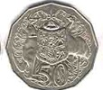 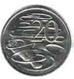  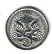 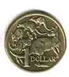 *
3. *$0.50     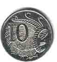 *
4. *$1.90      *
5. *$1.30      *
6. *$0.85   *
7. *What change will you receive? Show your working out.*

*a. You use $5 to pay for a birthday card that is $3.50. \_\_\_\_\_\_\_\_\_*

|  |
| --- |
|  |

*b. You use $10 to pay for glue that costs $6.50. \_\_\_\_\_\_\_\_\_*

|  |
| --- |
|  |

c. *You use $5 to pay for a drink that costs $2.80. \_\_\_\_\_\_\_\_\_*

|  |
| --- |
|  |

*d.* *You hand over a $10 note to pay for a magazine costing $7.80. \_\_\_\_\_\_\_\_\_*

|  |
| --- |
|  |

1. *Use a calculator to solve these money problems.*

*a.* $26.30 - $15.90 = \_\_\_\_\_\_\_\_\_\_\_\_\_\_

*b.* $15.00 + $3.50 + $0.90 + $1.25 = \_\_\_\_\_\_\_\_\_\_\_\_\_\_

*c.* $100 + $20 + $50 + $5 = \_\_\_\_\_\_\_\_\_\_\_\_\_\_

*d.* $359 - $127 = \_\_\_\_\_\_\_\_\_\_\_\_\_\_

1. *Work out this money problem.*

|  |
| --- |
| $50.00 |
| - $27.50 |
| $ |

1. *Show three different ways of giving change from $50 if the cost is $27.50. Draw your answers.*

|  |
| --- |
| a. |

|  |
| --- |
| b. |

|  |
| --- |
| c |

1. *Round these amounts up or down to the nearest 5 cents*.

|  |  |  |  |  |  |
| --- | --- | --- | --- | --- | --- |
| *a.* | *$1.38 = \_\_\_\_\_\_\_* | *b.* | *$1.66 = \_\_\_\_\_\_\_\_* | *c.* | *$9.99 = \_\_\_\_\_\_\_* |
| *d.* | *$3.29 =\_\_\_\_\_\_\_* | *e.* | *$2.74 = \_\_\_\_\_\_\_\_* | *f.* | *$7.06 = \_\_\_\_\_\_\_* |

|  |  |  |  |  |  |
| --- | --- | --- | --- | --- | --- |
| *g.* | *$2.49 = \_\_\_\_\_\_\_* | *h.* | *$8.86 = \_\_\_\_\_\_\_* | *i.* | *$3.11 = \_\_\_\_\_\_\_* |
|  |  |  |  |  |  |
| *j.* | *$3.52= \_\_\_\_\_\_\_* | *k.* | *$5.98 = \_\_\_\_\_\_\_* | *l.* | *$2.01 = \_\_\_\_\_\_\_* |

1. *Round up or down to the nearest 5 cents and calculate the change each person would receive. Write a number sentence and remember to use a dollar sign in your answer.*
2. *David had $20 but spent $17.99 on a magazine.*

*\_\_\_\_\_\_\_\_\_\_\_\_\_\_\_\_\_\_\_\_\_\_\_\_\_\_\_\_\_\_\_\_\_\_\_\_\_\_\_\_\_\_\_\_\_\_\_\_\_\_\_\_*

1. *Michael had $30 and planned to buy a toy at Kmart advertised for $21.99.*

*\_\_\_\_\_\_\_\_\_\_\_\_\_\_\_\_\_\_\_\_\_\_\_\_\_\_\_\_\_\_\_\_\_\_\_\_\_\_\_\_\_\_\_\_\_\_\_\_\_\_\_\_*

**REFLECTION**

*How can I solve problems involving money?*

Please think about what you’ve learnt. Place a tick or smiley face in each of the rows below.

|  |  |  |
| --- | --- | --- |
| **LEARNING INTENTION** | **I CAN DO THIS** | **I NEED MORE PRACTICE** |
| *I can round money up and down to the nearest 5 cents.* |  |  |
| *I can calculate the change I will receive from a purchase after rounding up or down.* |  |  |
| *I can figure out what I can and cannot afford.* |  |  |
| *I can figure out what operation to use in word problems about money and solve these correctly.* |  |  |

*In your own words, please explain what you have learned about solving problems with money. You may look back through the work to refresh your memory.*

|  |
| --- |
|  |
|  |
|  |
|  |
|  |
|  |
|  |
|  |
|  |
|  |
|  |
|  |
|  |
|  |
|  |
|  |
|  |
|  |
|  |
|  |
|  |
|  |
|  |
|  |
|  |
|  |
|  |
|  |
|  |
|  |

**TEACHER ASSESSMENT**

*How can I solve problems involving money?*

Student: \_\_\_\_\_\_\_\_\_\_\_\_\_\_\_\_\_\_\_\_\_\_\_\_\_\_ Date: \_\_\_\_\_\_\_\_\_\_\_\_\_\_\_\_

|  |  |  |
| --- | --- | --- |
| **Number and Algebra** | Demonstrated | Needs further opportunity |
| Solve problems involving purchases and the calculation of change to the nearest five cents with and without digital technologies. |  |  |