**Science**

C:\Users\lmarcon\AppData\Local\Microsoft\Windows\Temporary Internet Files\Content.IE5\XGYY5H84\MC900437511[1].wmf

**What does biodegradable mean?**

**Activities**

C:\Program Files\Microsoft Office\MEDIA\CAGCAT10\j0305257.wmf

* Make a prediction about an experiment.
* Safely perform an experiment.
* Describe some properties of plastics.
* Have a better understanding of what polymers are.

We are going to look more closely at one type of material – PLASTIC.

Many things around us are made of plastics. Write a list of some things in your household that are made of plastic.

C:\Users\lmarcon\AppData\Local\Microsoft\Windows\Temporary Internet Files\Content.IE5\XGYY5H84\MC900089026[1].wmf

**FOR YOU TO DO: Experiment 1 – A plastic bag party trick**

C:\Users\lmarcon\AppData\Local\Microsoft\Windows\Temporary Internet Files\Content.IE5\K975LXFD\MC900237945[1].wmfWhat you need:

* 1 zip lock bag
* Water
* Sharpened pencil

What to do:

* Fill the bag with water. Make sure you can still seal it.

Predict: What do you think will happen if you insert the sharpened pencil into the bag, right through to the other side?

________________________________________________________

* Carefully take the sharpened pencil and insert it into the plastic bag – Was your prediction correct? __________
* Continue moving your pencil through the plastic bag to the other side.

Predict: What do you think will happen if the pencil is removed?

________________________________________________________

* Now, making sure you are over a sink or outside in the garden, remove the pencil from the plastic bag. Was your prediction correct? ________

Results:

1. Draw a labelled picture of your experiment.

**C:\Users\lmarcon\AppData\Local\Microsoft\Windows\Temporary Internet Files\Content.IE5\JQ2551LD\MC900239195[1].wmfBut Why?**

C:\Users\lmarcon\AppData\Local\Microsoft\Windows\Temporary Internet Files\Content.IE5\JQ2551LD\MC900371374[1].wmfThere are many different types of plastics. The type used in plastic bags is very strong, but also stretchy. That’s because it’s made of long chains of repeating molecules called *polymers*. When the pencil pierces the plastic bag, the polymer chains simply slide around the pencil to seal it, stopping any water from leaking. Amazing!

**C:\Users\lmarcon\AppData\Local\Microsoft\Windows\Temporary Internet Files\Content.IE5\O1MM9CQ8\MC900140189[1].wmfDID YOU KNOW?**

Polymers can be naturally occurring or man-made. Some examples of man-made polymers include polyester, polystyrene (styrofoam) and polyurethane (all plastics). Did you know that your hair and nails are also polymers? These are natural polymers called proteins.

**For you to do – Evaluation**

Tick the box that describes your learning.

|  |  |  |  |
| --- | --- | --- | --- |
|  | I am good at this | I am nearly there | I need help with this |
| Make a prediction about an experiment. |  |  |  |
| Safely perform an experiment. |  |  |  |
| Describe some properties of plastics. |  |  |  |
| Have a better understanding of what polymers are. |  |  |  |

**Activities**

C:\Program Files\Microsoft Office\MEDIA\CAGCAT10\j0305257.wmf

* Define biodegradable
* Explain why pollution is a problem
* Learn about the properties of the early plastic, Bakelite

C:\Documents and Settings\x\Local Settings\Temporary Internet Files\Content.IE5\CISVT2XC\MC900057341[1].wmfC:\Documents and Settings\x\Local Settings\Temporary Internet Files\Content.IE5\36X8YEH4\MC900198175[1].wmfThink of an apple tree which has dropped some fruit onto the ground. After 2 or 3 weeks, all the apples that had dropped to the ground have disappeared! Animals like birds and worms and even mice probably came along and helped themselves to the fallen fruit. Other tiny creatures which live in the soil also come to feast on the rotting fruit. Pretty soon, there’s nothing left. We say the apple has *broken down* or *decomposed.* Because it decomposes so easily we say it’s **biodegradable.**

Think about plastics. They are in our toys, TVs, phones and of course, they package our foods. Plastics are all around us and we use them everyday. However, there is a problem. Unlike the apples, plastics take a long time to break down, sometimes hundreds of years. They are not very “biodegradable”. Biodegradable materials will decompose in nature.

**FOR YOU TO DO: Activity – You decide. Is it biodegradable or non-biodegradable?**

Shade the biodegradable items green and the non-biodegradable items red.

|  |  |  |  |
| --- | --- | --- | --- |
| Feather | Motor oil | Paper | Apple |
| Spaghetti | Tomato | Mobile phone | Wood |
| Detergent | Banana skin | Bark | Paint |
| Plastic bottles | Your faeces (poo) | Glass jar | Plastic bag |

Were there some that you had trouble deciding? Which ones?

Explain why.

Cut and paste each of the items along this scale. The most highly degradable items should be placed near 1 and the most poorly degradable should be near 10.

5

After some time, breaks down in nature (biodegradable)

1

Breaks down very easily in nature

(highly biodegradable)

10

Does not break down in nature

(highly non-biodegradable)

**FOR YOU TO DO: Activity – Website Interactive**

<http://tinyurl.com/ntrnrvm>

Watch the clip at the link above and list 3 things that you learnt from these funny characters!

1)

2)

3)

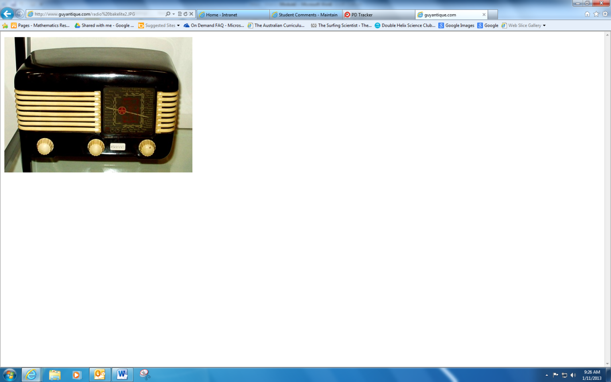**DID YOU KNOW…**

Bakelite is one of the first plastics ever made. It was invented in early 1900s by Dr Baekeland in New York. This invention meant that people could make different shapes quickly and cheaply instead of making them out of wood. One important property of Bakelite was that it was heat resistant (it wouldn’t melt easily). This made it a fantastic choice valve radios and in car parts. The other important property of Bakelite was that it would not conduct electricity. This meant it would was a safe choice to use for light switches. Today things made from Bakelite are collectible and some items like old fashioned radios and clocks are worth lots of money.

**For you to do – Evaluation**

Tick the box that describes your learning.

|  |  |  |  |
| --- | --- | --- | --- |
|  | I am good at this | I am nearly there | I need help with this |
| Define biodegradable. |  |  |  |
| Explain why pollution is a problem. |  |  |  |
| Learn about some properties of plastics, like Bakelite. |  |  |  |