## Families

Learning Booklet

## temp

## What is a family?

**Families**

**Background Information**

While family life differs from country to country and has differed at each period of history, the family has existed in every culture and every age. Children come into the world as members of a family, and it is the family which cares for them throughout their infancy and childhood years. There are many different family units. Some children live with both parents, some with just one. For others, their family unit is different again.

While every family has common needs, such as the need for food, clothing, shelter and safety, each family has characteristics that are unique to that family. This Booklet looks at the composition of your family and at others you know. It talks about relatives, explores ancestry, and identifies events and stages in family member’s lives. It recognises that there are various cultures in Australian society, and draws your child’s attention to various traditions people follow in both private and public celebrations.

**Essential Question**

* What is a family?

**Focus Questions**

* Who were the first families to live in Australia?
* How has time changed the composition (makeup) of the Australian population?
* How is my family the same/different to other families?
* Why are families important?

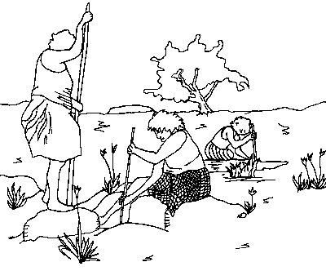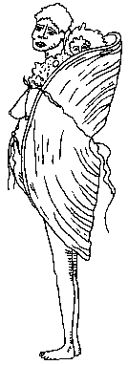

**Things you need for the activities in this booklet**

1. Books that you enjoy reading. There are also recommended books to view online..
2. A scrap book to glue your work into. (Optional)
3. Numeral, number word and number picture cards 1 to 9.
4. Art materials, such as crayons, wallpaper paste, paints, light card, thick card, Plasticine or play dough, buttons, used wool or fleece, pipe cleaners, glitter glue, old Christmas cards or birthday cards, wrapping paper, pictures of food, 10 sheets of card cut from cereal packets, etc.
5. Bottle for task 1
6. Ball and bat for task 1
7. Bingo Game, CUT OUT READY TO USE – task 1
8. Craft materials – task 3
9. A large potato, blue finger paint,sand, shells – task 4
10. Ingredients for the family’s favourite meal – task 7
11. Dress up clothes for playpurposes.
12. A skittle – can be made using a sand filled plastic bottle.
13. Equipment for obstacle course – task 9
14. A4-size pages of plain paper.

|  |  |
| --- | --- |
| **Task 1**  **The purpose of today’s work is to identify your child’s family and his or her place within it.** | |
| **Activity 1**  **Language** | **book** |

Read a story about a family. You could also listen to My Rotten Redheaded Older Brother on the following website.

<https://www.storylineonline.net/books/my-rotten-redheaded-older-brother/#Vimeo>

Do any members of your family share certain characteristics, hair or eye colour for instance? Do particular family members have certain habits? Are they talkative/quiet, keen sports people, etc? Talk about these things.

Read a selection of the poems *Hair, Our Family, Baby Brother, Older Brother* and *My Baby Brother.*

Read the following poems together. Can you hear the rhyming words. If you can, underline the rhyming words. Read the poems again, using expression and actions.

**Hair**

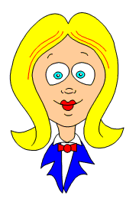

Sister has her hair

Piled on top.

Mummy says that my hair’s

Like a mop.

Daddy hasn’t got much,

Sally’s looks like string.

Don’t you think that hair’s

A rather funny thing?

Anon.

**My Baby Brother**

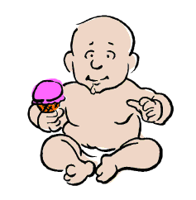

My baby brother is so sweet,

He has such tiny hands and feet,

Wee dinky, pinky, curled-up toes,

The dearest little button nose!

A smiley mouth, two big round eyes,

And ears of quite the smallest size,

When I go near he always coos,

As though to say ‘How do you do?’

I love him more and more each day

And I’m so glad he’s come to stay.

Anon.

**Older Brother**

Older brothers -



play ball

grow tall

ride bikes

like hikes

play rough

act tough

slam doors

slide on floors

throw sticks

play tricks

eat lots

get spots

have fun

make me run ...

Older brothers!

Alison Lawrie

**Our Family**

Baby cannot feed herself,

She slops her food about,

She gets it in her little spoon

And cannot find her mouth.

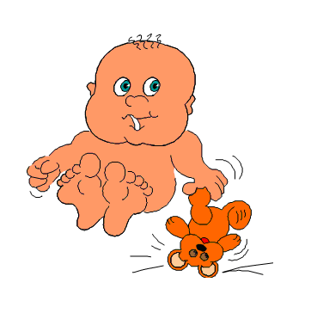

Annette is untidy,

She never shuts the doors,

She leaves the cupboards open

And pulls out all the drawers.

David is a fuss-pot,

He puts EVERYTHING away!

So when we want to find things

We have to search all day.

Mummy likes things spic ‘n’ span,

At times I must agree,

But I can never find things

If they’re not right there to see.

Dad keeps his tool shed tidy

With its nails and bolts and locks,

But almost every morning

We hear, ‘Mum, where are my socks?’

Joan M. Shilton

**Rhyming Pairs**

Can you find the rhyming words?

You could use colour to match the rhyming words or cut them out and find the rhyming pairs.

|  |  |
| --- | --- |
| **feet** | **day** |
| **tricks** | **sweet** |
| **fun** | **ball** |
| **tall** | **run** |
| **stay** | **sticks** |

**Step 2**

Write your full name, including your first name, your middle name and your **surname.** Use coloured textas to decorate your name.

Do people in your family have different surnames?

|  |
| --- |
| **First Name** |
| **Middle Name** |
| **Surname** |

**Step 3**

Discuss the make-up of your particular family:

How many children?

Who is the oldest?

Who is the youngest?

Where does your child fit into this order?

Read the poem, in the middle together.

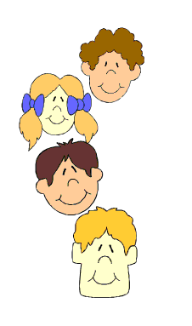**In the Middle**

Older brother, younger sister -

I’m always in between.

I’m always in the middle,

Don’t you think it’s mean?

Why couldn’t I be the eldest

And stay up till half past nine?

Why couldn’t I be the youngest?

That would be just fine.

Why am I in the middle?

Neither the bottom or the top,

Never the oldest, never the youngest -  
Why can’t somebody swap?

Leonne Leslie

Fill in the missing letters

|  |  |  |
| --- | --- | --- |
| brother | sister | family |
| _ rother | _ister | _ amily |
| _ _ other | _ _ ister | _ _ mily |
| _ _ _ ther | _ _ _ ter | _ _ _ ily |

**Step 4 – Bookmaking**

Count the number of people in your family.

Help your child complete the sentence below. Encourage them to write the number word rather than the numeral.

Draw a picture of your family. Don’t forget to include your pets.

There are _________  
people in my family.

What do you know about your family?

Ask your child to complete the simple family tree below by writing names in the circles. If he or she has brothers or sisters then add circles for them.

My Family Tree

Unjumble and finish the sentence with a number word.

|  |  |  |  |  |  |
| --- | --- | --- | --- | --- | --- |
| are | in | There | my | people | family. |

|  |  |
| --- | --- |
| **Activity 2**  **Health** | birdrun2 |

Feelings dominate young children’s lives.

Sometimes it is difficult for them to come to terms with the stresses and strains of communal life. (Difficult for their parents, at times, too!)

Ask your child about the things that make him or her annoyed. Talk about appropriate ways of dealing with these feelings.

Read the poem *My Little Sister*

You could also listen to A Bad Case of Stripes available on the following link: <https://www.storylineonline.net/books/a-bad-case-of-stripes/#Vimeo>

It’s healthy for children to know that they are not the only ones who get cross or have bad days. The important thing is that they learn to deal with their feelings in appropriate ways.

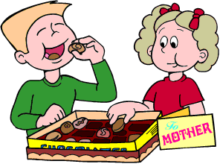

**My Little Sister**

My sister

and I

always

fight.

I’m sure she’s

wrong,

I think I’m

right.

She leaves her

clothes all over the

place.

If I

complain

she pulls a

face.

She plays with

my toys

when I’m not

there.

She cheats at

games.

She’s never

fair.

Every

morning

I have to

wait.

to take her to

school -

we’re always

late.

But however

naughty

she can

be

Nothing

must hurt her.

She’s smaller

than me.

Anon.

|  |  |
| --- | --- |
| **Activity 3**  **Language** | **book** |

**Step 1**

Play a game of *I Spy*, focusing in the following letters.

**s, b, m, f, t, a, h, w, c, qu** and **d.**

It is important to distinguish between the letter name, and the sound or sounds that each letter represents. Ask your child the name each letter and to make the sound that each letter represents.

Use the letter cards as a support, for example, say, “I spy with my little eye,” and hold up a letter card as your make the sound.

Colour in the picture cards. (Letter/picture match – 2)

Play games matching the letters to the pictures. (Letter/picture match - 1 and 2)

|  |  |  |
| --- | --- | --- |
| s | m | b |
| f | t | a |
| h | w | c |
| qu | d |  |

**Letter/picture match: 1**

**Letter/picture match: 2**

|  |  |  |
| --- | --- | --- |
|  |  |  |
|  |  |  |
|  |  |  |
|  |  |  |

**Make your own sound dictionary**

Draw a picture that begins with each sound.

Challenge: label your picture

|  |  |
| --- | --- |
| s | sun |
| m |  |
| b |  |
| f |  |
| t |  |
| a |  |
| h |  |
| w |  |
| c |  |
| qu |  |
| d |  |

**Step 3**

Give your child a sheet of paper, and have him or her write each of the sounds as you say them. Say: *Write the letter that makes the sound* **b** *as in* ***b****ed.*

Fill in the missing letters

|  |  |
| --- | --- |
|  | _ ake |
|  | _ able |
|  | _ pple |
|  | _onkey |
|  | _ at |

**Step 4**

Search the picture below. Use this picture to continue the game of ‘I Spy’. Colour in items to match particular sounds.

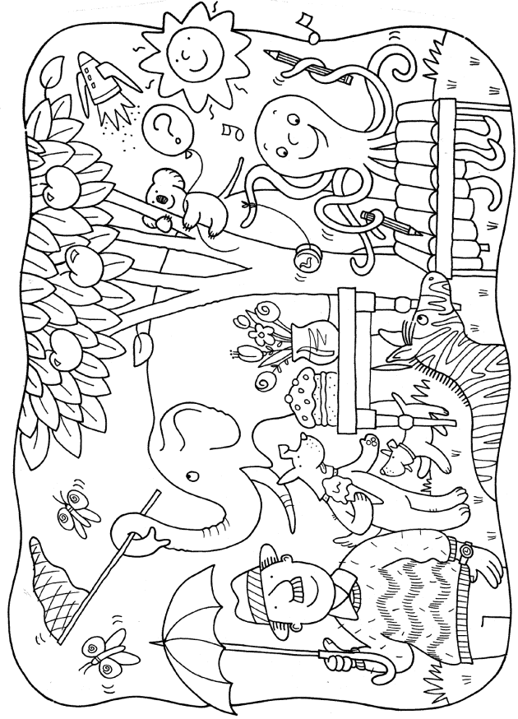

|  |  |
| --- | --- |
| **Activity 4**  **Creative Writing** | boywriting |

Encourage your child to write his or her own story. Ask him and her to think about what they are going to write before starting.

You may want to read a story first and use ideas from the story. Discuss the ideas your child and have them decide on a sentence that they would like to write. They can make up his or her own words, use the dictionary or copy sentences from books.

If your child is using invented spelling encourage him or her to read the work to you. You may like to write what he or she has written under the writing but DO NOT write on or over the work. If your child is genuinely frustrated in his or her attempts to complete the writing because he or she has no idea how to write a word you may model it on a separate piece of paper for him or her to copy from.

It would be great if your child drew a picture to accompany this work.

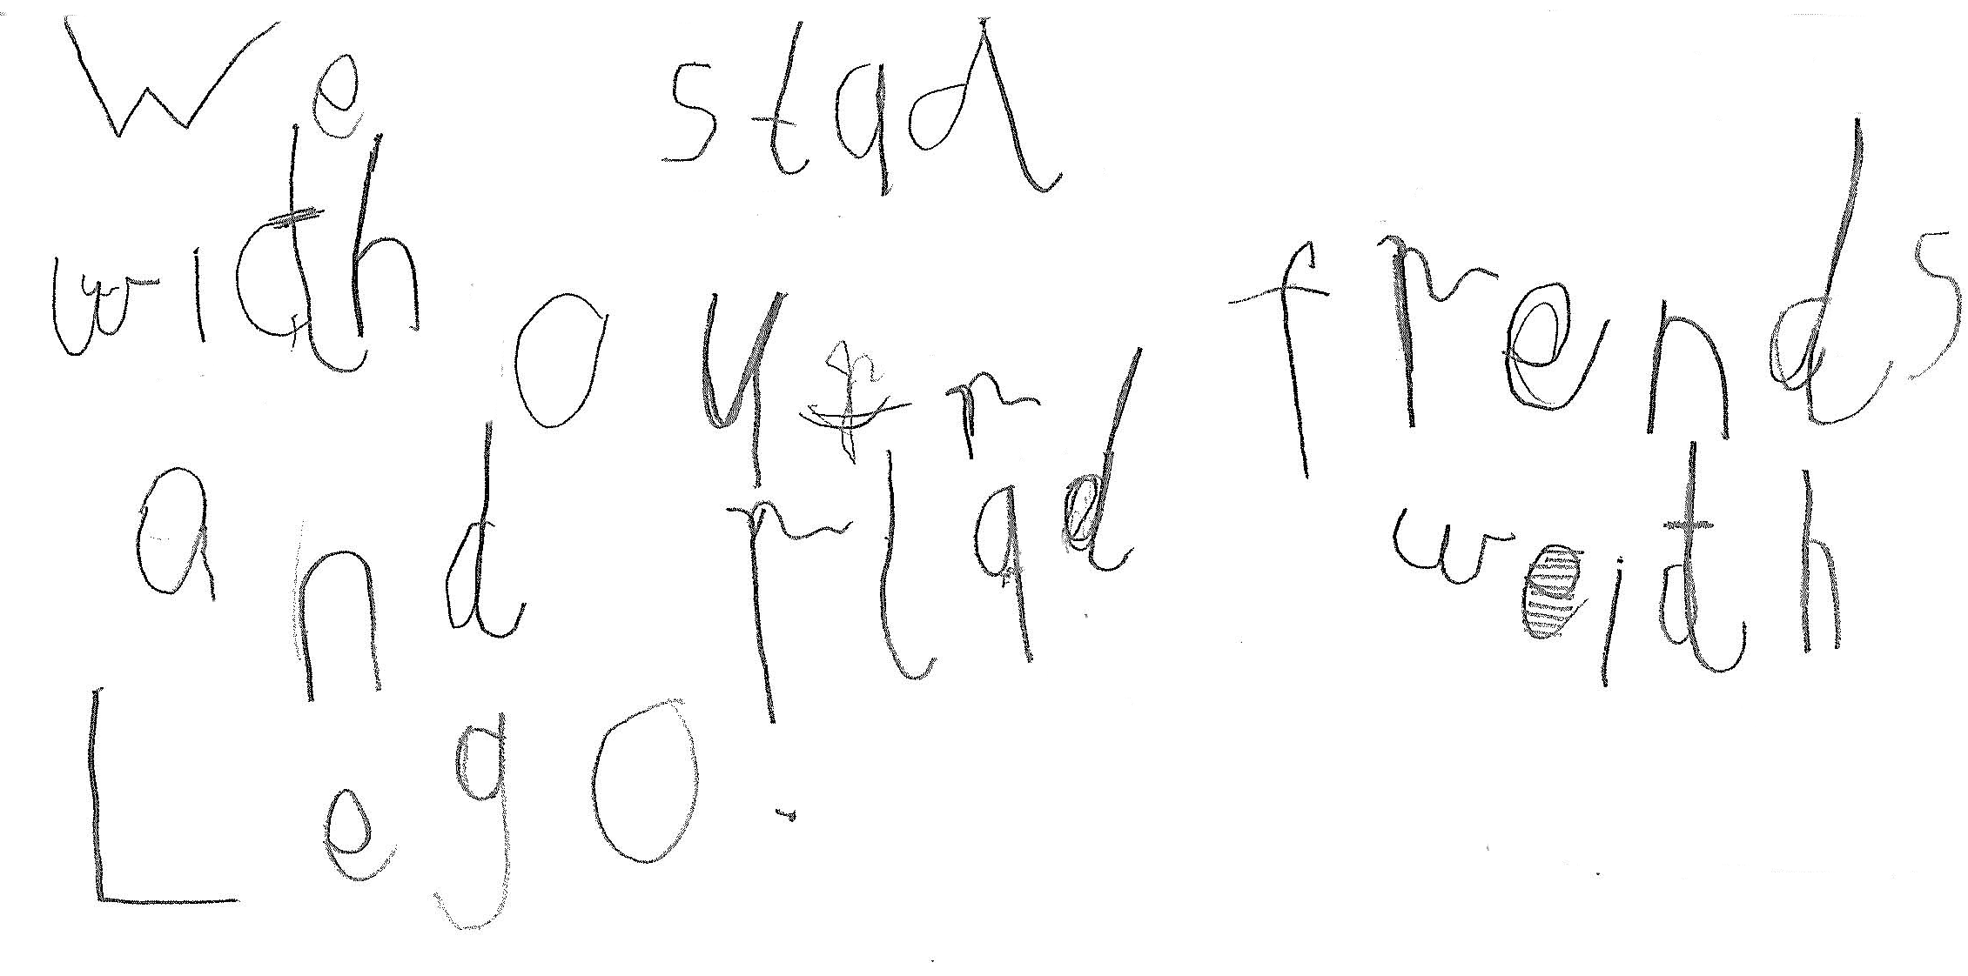

Here is an example of Callum’s writing, “We stayed with our friends and played with Lego.”

Callum’s mother modelled the entire correct sentence underneath his writing.

|  |  |
| --- | --- |
| **Activity 5**  **Art** | **crayon2** |

**Paint a Family Portrait**

Give your child a large sheet of paper and give him or her time to paint a large family portrait.

**or Optional Task**

|  |  |
| --- | --- |
| **Make a Bottle Family**  You need:   * enough bottles so that there is one for each member of your family * scrap paper * glue * scrap white paper * scraps of coloured material, paper and card * buttons, used wool or fleece, string, pipe cleaners * other odds and ends from the scrap box * paints. | **temp** |

1. Scrunch a sheet of newspaper into a ball, put masking tape over it a couple of times, and either tape it or tie it to a bottle to form a head.
2. Cover the newspaper with scraps of white paper and wallpaper paste.
3. When dry, paint and decorate to make a face.
4. Use fabrics, wool and pipe cleaners to make arms, clothes and hair for the bottle person.

Repeat the process using one bottle for each member of your family.

|  |  |
| --- | --- |
| **Activity 6** | **Families that work together** |

**Step 1**

Ask: Why are families important?

How do the people in your family help each other?

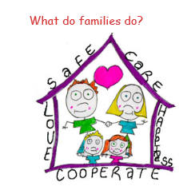

**Read**

They live together.  
They share.  
They care for each other.  
They keep each other safe.   
They love each other.   
They work together.   
They have fun together.  
They help each other in good times and bad times.

Make a list of the things you do to help your family.

Look at photographs of families around the world and talk about the different ways family members help each other.

Look at the photographs of families from all around the world. Talk about how their lives would be the same as yours and how they would be different

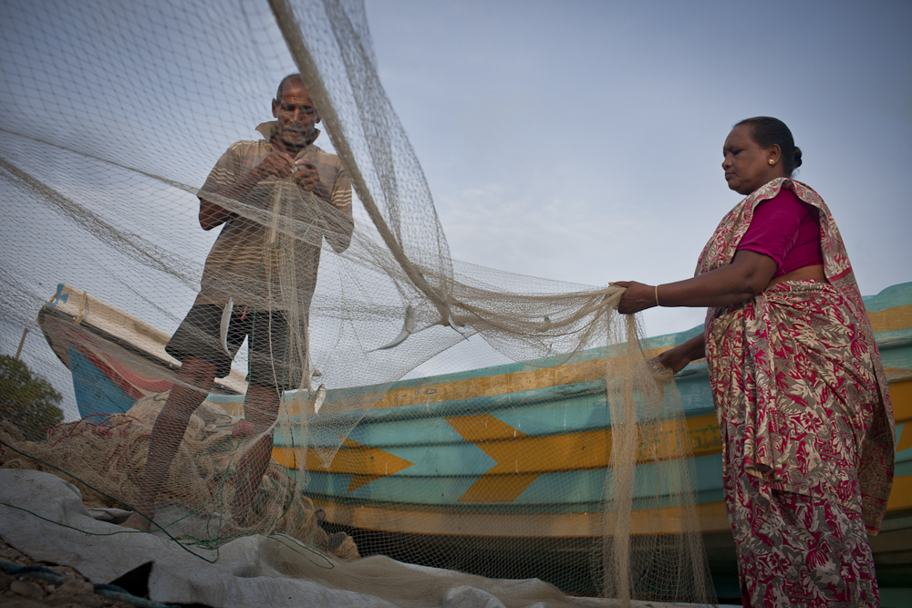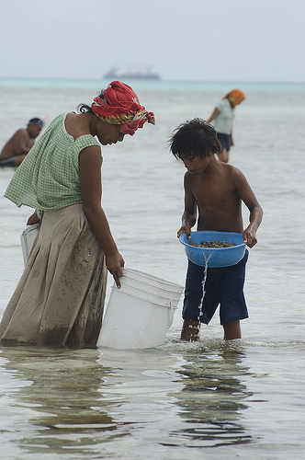

Find more photos of families around the world using this links:

<https://globaleducation.edu.au/teaching-activity/who-are-the-families-of-the-world-f-2.html#activity3>

Describe what work is happening in each photograph, why it is happening and who is doing it.

Encourage discussion by asking your child to complete the sentence: This family is …

|  |
| --- |
| **Women and children collect shellfish along the causeway, South Tarawa, Kiribati.** |
| Photo by Lorrie Graham for AusAID |

|  |
| --- |
| **Thiruchelvam and Nesam sort their catch of small fish in preparation for sale at the Mathagal market, Sri Lanka. photo by AusAid** |
|  |

**Jobs then and now T chart**

Talk to members of your family to find out how they helped their family when they were young. List the types of jobs or chores they did to help their family, and compare them to the way you help your family out today. How have things changed? How are they the same?

Today

Then

.

|  |  |
| --- | --- |
| **Activity 7**  **Handwriting** | birdpencil |
| * Fold two sheets of paper into three sections. * Demonstrate writing the following letters and phrases on one of the sheets. * Write one line at a time, as set out below. * Allow your child to copy each line on his or her own page before you write the next. * Watch that he or she starts the letters correctly and forms them properly.   **Hh Harry’s hat**  **Bb Bob’s ball**  **Tt Tim’s top**  Demonstrate these simple line illustrations for each letter so that your child can copy them. | |

**Task 2**

The purpose of today’s work is to define family relationships and talk about your child’s grandparents, aunts, uncles and cousins.



**Activity 1**

**History**

Talk about when and where your child was born, and any particular stories

connected with his or her birth or early childhood. (Children love hearing these stories. They confirm their place in a family and give them a sense of belonging). Look through baby photographs, or a baby record book if you have one.

|  |  |
| --- | --- |
| **Activity 2**  **Language** | **book** |

**Step 1**

Read the poems *Lost Spectacles* and *My Granny.*

**Lost Spectacles**

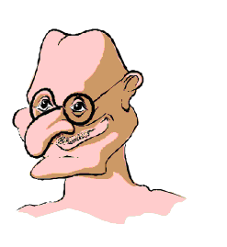

He hunted here, he hunted there.

The old man hunted everywhere.

He hunted everywhere with care,

But the precious spectacles were not there.

Then overcome with sheer despair,

Because he had no other pair,

He clutched his forehead near to where,

In younger days there had been hair,

And, well I never - they were there!

Anon

**My Granny**

Daddy’s Mum’s my Granny,

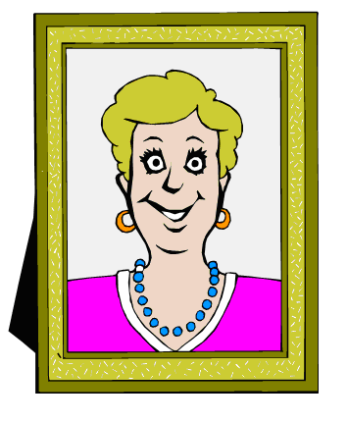

And I’m very glad she’s mine.

She tells me lots of stories

Of things about the time

When Daddy was quite little

And did the things I do.

She always smells of perfume

And she’s fashionable too.

She beats me playing Rummy

But Snap I am the winner;

Her cooking is delicious

Especially her roast dinner.

My Granny has her photos

All about the place.  
(In photographs of Daddy

I find it’s just my face!)

Round her neck her glasses

On a chain get in the way

When suddenly I hug her

Ten times or more a day.

She takes me driving sometimes

In her car that’s shiny-new.

I do love my Granny!

Do you love your Granny too?

Julia Norman

**Discuss:** Are your child’s grandparents still alive?

What does your child call them?

Can your child relate either of the poems to his grandparents?

Where do the grandparents live?

Does your child visit them often?

Does your child ever stay overnight?

Do they ever come to share a meal or to stay?

Does your child ever share special occasions with his or her grandparents, for instance, have treats or go on outings?

**Language continued**

|  |  |
| --- | --- |
| **Step 2**  Talk about your child’s uncles, aunts and cousins.  Check the photo album again, if this is possible.  Discuss your child’s mother’s surname, if your child doesn’t already know it.  Help your child sort out family members. Explain the relationship between parents, grandparents, aunts and uncles.  Write the names of aunts, uncles and cousins on slips of paper, and sort them according to families. Write the relationship on the back of the slip, for example: Dad’s brother, Mum’s sister. (Children of this age are often confused about the relationship of family members, and being able to move the slips around helps them work things out). | **j0250475[1]** |

**Writing**

Support your child to write sentences about their family members. They could make a small book with one page dedicated to each family member.

You could provide sentence starters. For example:

This is mother.

My mother likes to …

My mother has …

Display a list of family member names to support the writing task.

Children could use photographs or illustrate each sentence.

|  |
| --- |
| mother |
| father |
| sister |
| brother |
| baby |
| cousin |
| aunty |
| uncle |
| grandmother |
| grandfather |

|  |  |  |
| --- | --- | --- |
| **Activity 3**  **Art** | **crayon2** | **Make some finger puppets** |
| You need:   * thick card * stiff paper or thin card * crayons, felt-tipped pens * a stapler or glue. | | **image011** |

1. Make a template of the basic puppet from thick card.
2. Use the template to draw finger puppet shapes on the thick card.
3. Cut these out.
4. Use felt-tipped pens and/or crayons to make faces and clothes on the puppets.
5. Staple or glue the ends of the card to fit the child’s finger.

The finger puppets can be made to look like family members or families from around the world.

|  |
| --- |
| **image013** |

|  |  |
| --- | --- |
| **Activity 4**  **Creative Writing** | boywriting |

Encourage your child to write a letter to a relative today. Perhaps he or she could write to a grandparent or a cousin. Talk with him or her about what the relative would like to know, or what he or she would like to ask the relative. Let your child write this letter independently. Your child can make up his or her own words, use a dictionary, or lists to assist him or her to write. Your child might like to include a drawing in his or her letter.

Talk about the correct way to address the envelope. Write the address on a sheet of paper, and let your child copy it on an envelope or, if need be, assist him or her with the writing. Make sure your child posts the letter.

|  |  |
| --- | --- |
| This Foundation student writes a letter to his grandmother who he calls *Ma.* | Child writing |

**Writing an email**

This email was sent, by a five-year-old student, not to a family member but to the Perth Zoo. This is another form of writing you can explore with your child.

Your child may like to send an email to a family member or friend.

|  |
| --- |
| **From: To:**  **Date: Subject:** We look after our Zebra like most people look after their horses. They are fed oaten hay and horse pellets, they drink water and have one hoof on each foot just like a horse. They also receive apples and carrots 3 times a week.  Colin Wallbank Perth Zoo  ----Original Message---- From: Sent: To: Subject:  Hi Zoo I want to ask you about zebras. What do they drink? What do they eat? What sort of feet do they have?  From Tom. |
| **Activity 5**  **Physical Education** | birdrun2 |

**Step 1**

Your child will need a medium-sized ball and a small bat.

Let him or her play with it for a few minutes.

**Step 2**

Ask your child to:

1. Hold the ball at waist level and let it drop, then catch it with both hands. Repeat ten times.
2. Hold the ball at waist level and let it drop, then catch it with the right hand. Repeat ten times.
3. Hold the ball at waist level and let it drop, then catch it with both hands. Repeat ten times.
4. Pat bounce the ball on the spot, using the bat-tennis bat in the right hand then the left hand.
5. Walk to a line and pat bounce the ball using the bat-tennis bat.
6. Change hands and pat bounce the ball back again.
7. Hold an arm out straight, drop the ball and hit it with the bat.
8. How far did the ball go? Repeat ten times.

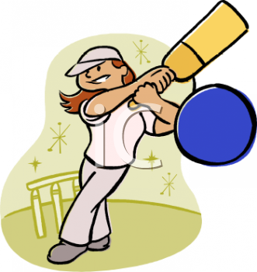**Step 3**

Mark out a target on a wall. Can your child hit the ball with the bat so that the ball hits the target?

Give your child plenty of time to practise.

Wind down afterwards.

|  |  |
| --- | --- |
| **Activity 6: Language** | **book** |

**Step 1**

Use the Letter/picture match: 1 and 2 cards.

Play a game of *Snap.* When a picture card and its matching sound card come out of the pile one after the other the first to put their hand over the pile and call Snap is the winner of that round. When all cards have gone to one player they are the winner.

|  |  |
| --- | --- |
| **Activity 7: Handwriting** | birdpencil |

Have your child write the numerals 1 to 10 on paper or a chalkboard.

Show your child how to copy over the letters Qq and Ff.

Talk about correct starting and end points, and where the letter sits on the line. **Handwriting Qq and Ff**

Talk about the difference between an upper case and lower case letter.

Give your child a sheet of paper folded in three lengthways.

Demonstrate writing the letters and words outlined below.

Allow your child to copy each line on the page before you write the next.

Watch that your child starts the letters correctly, and forms them properly.

**Qu qu Quack, quack.**

**Ff Fred’s family**

**Q Q Q Q**

**q q q q**

**F F F F**

**f f f f f**

Give your child a sheet of paper folded in three lengthways.

Demonstrate writing the letters and words outlined below.

Allow your child to copy each line on the page before you write the next.

Watch that your child starts the letters correctly and forms them properly.

**Qu qu Quack, quack.**

**Ff Fred’s family**

|  |  |
| --- | --- |
| **Task 3**  **.** | |
| **Activity 1: Language**  **Investigate your ancestry** | **book** |

**Step 1**

Ask your child to read a book to you today.

Read a selection of poems, choosing some of those introduced earlier in this booklet.

**Step 2**

**Discuss:**

Apart from Australian Aboriginals people, who have lived in Australia for tens of thousands of years, everybody else living in Australia now has either come here from another country or has been born to people whose **ancestors** came from another country. Because Australia has only been settled by people from overseas for under 250 years, most people know where their families migrated from originally.

Explore this online map of indigenous Australia and locate the name for the area where you live today.

<https://aiatsis.gov.au/explore/articles/aiatsis-map-indigenous-australia>

**Step 3**

Add the country of birth to the parents and grandparents included on the family tree you made earlier in the booklet. You may have to go back to great-grandparents, or even further, to discover who migrated to Australia and from what country. One line of the family may have been in Australia for a long time compared to the other. This is all interesting information for your child to consider.

**Step 4**

Talk about the reasons for emigration and the difficulties faced, both in the country of birth and on arrival in Australia. Did the family come to Australia by ship? Where did they first settle?

Check an atlas or globe to locate the countries of ancestors.



**Language continued**

Return to the writing or booklet that your child is making about the members of their family. They could add a sentence to a page, writing about where their family members may have come from. For example:  
“My Nono came from Italy.”

MC900232110[1]

|  |  |  |
| --- | --- | --- |
| **Activity 2**  **History** | **globe2** | |
| If you have any photographs or mementos of family events, bring them out and discuss these with your child. | | image006 | |

|  |  |  |
| --- | --- | --- |
| **Activity 3**  **Art** | **crayon2** | |
| **Make some hand puppets**  You need:   * squares of felt (7 cm x 10 cm) * scraps of felt or wool * ribbons, sequins, small buttons and * other odds and ends for decoration * PVA glue * needle and cotton. | | temp | |

Note: An A4 sheet of coloured paper, or even a paper bag could also be used instead.

Directions:

* Fold the felt/paper over and draw the puppet outline on it (as shown in the diagram). If using paper, draw or use collage material.
* Cut around the shape.
* Cut out the shape of a head from scrap felt and paste it on one side of the puppet.
* Glue on wool hair (perhaps you can plait it), button eyes and a mouth.
* Glue on suitable clothes made from the materials you have.
* Use a running stitch to sew around the doll.

|  |
| --- |
| **image023** |

|  |  |
| --- | --- |
| **Activity 4: Creative Writing** | boywriting |

Encourage your child to write his or her own story again today, or another letter. Ask him or her to think about what he or she is going to write before starting.   
your child can make up his or her own words, use a dictionary, or use any of the lists, etc., to assist him or her to write.

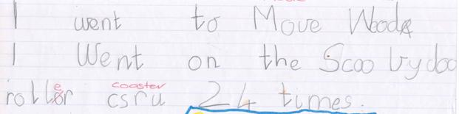

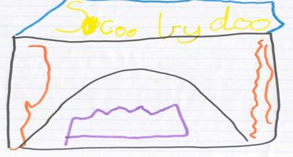

Jessie has written about one of her recent experiences. She has written down the letters she can hear in *Movie World* and *roller coaster.* Her mum will put the

correct written words in her personal dictionary in case she needs them for another day.

|  |  |
| --- | --- |
| **Activity 6: Handwriting** | birdpencil |

Continue revising writing the letters of the alphabet as you have for the past few days. Demonstrate how to write the letters before your child commences each new line of work.

**Gg Grandma and Grandpa**

**Aa Aunty’s apple**

|  |  |  |
| --- | --- | --- |
| **Activity 7: Physical Education** | | birdrun2 |
| Go outside and play a game, for example:  *What’s the time Mr Wolf?*  *Blind Man’s Bluff*  Wind down at the end of hectic games, with some stretches and gentle walking or swaying. | pinata | |

|  |  |
| --- | --- |
| **Activity 8: Language** | **book** |

**Step 1**

Using the letter cards from **Letter/picture match: 1**

play a game of *Tic Tac Toe,* asking your child to state the letter name and the sound when he or she turns over each card.

**Step 2**

Play the game where your child listens to three words then tells you the one that ends with a sound that you have working on. For example: “Listen for a word ending in the letter ‘s’. Which word ended in the sound ‘s’.

(glass, knife, fork) (hook, chess, coat) (when, grass, why)

Repeat for the letters ***m, b*** and ***t***.

**Step 3**

Your child could complete the following worksheet by cutting out the words and pasting them underneath each of the pictures

|  |  |  |  |
| --- | --- | --- | --- |
|  |  |  |  |
|  |  |  |  |
|  |  |  |  |
| **cup** | **Queensland** | **hand** | **six** |
| **fish** | **ambulance** | **box** | **horse** |
| **dog** | **television** | **dolphin** | **mouse** |

|  |
| --- |
| **Activity 1**  **Language** |
| **Step 1**  Listen to the story *Five Minutes Peace*.  <https://www.youtube.com/watch?v=kg1EcW_Pf98> | |

Discuss:

Why do you think Mrs Large wanted five minutes peace?

How did her children cooperate with her?

Did they do anything to stop Mrs Large from getting five minutes peace?

Talk about what ‘cooperation means and what it would look like when people are cooperating.

When people *cooperate*, life is so much more pleasant.

Cooperation means tasks get done more quickly so that there is more time for people to enjoy themselves.

Talk about ways different family members *cooperate* to get things done.

Talk about ways that children can *cooperate* so that family life is more enjoyable for everyone.

Read the poem and listen for the rhyming words.

**Five Minutes More**

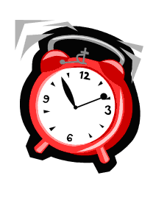Five minutes, five minutes more please!

Let me stay five minutes more.

Can’t I just finish the castle

I’m building here on the floor?

Can’t I just finish the story

I’m reading here in my book?

Can’t I just finish this bead chain

It almost is finished, look!

Can’t I just finish this game please?

When a game’s once begun

It’s a pity never to find out

Whether you’ve lost or won.

Can’t I just stay five minutes?

Well, can’t I just stay four?

Three minutes then? Two minutes?

Can’t I stay just one minute more?

Anon.

*.*

*Colour in the words that rhyme with* ***book***

|  |  |  |
| --- | --- | --- |
| hook | hop | hot |
| took | look | hood |

Sharing

Discuss: What is sharing?

Why might it be important to share?

Can you think of times when you or someone you know has shared something special?

Can you think of a time when you or someone you know hasn’t shared?

Sharing is a particular way of showing that you care.

Ask your child to suggest ways that various members in his or her family care for each other and share things. Write his or her suggestions on a list.

Read the book, Herbert and Harry, by Pamela Allen. (available on the link below)

<https://www.youtube.com/watch?v=V1I5WnKzig4>

Discuss the story with your child.

How could Herbert and Harry have acted differently?

Who might the story have been different if they had shared the treasure?

Ask your child to draw what they think the treasure might have been?

**Step 3 – Writing**

Have your child finish this page for his or her book by completing the sentence.

My family care for each other by

|  |  |  |
| --- | --- | --- |
| **Activity 2**  **Art** | **crayon2** | |
| Visit youtube to watch the story *Swimmy* by Leo <http://www.youtube.com/watch?v=ZUKJjVXT0Ko>  **Discuss:** | |  | |

Unfortunately, most fish have to look after themselves as soon as they are born.

Many of them are eaten by bigger fish or other sea creatures. Swimmy taught his friends how to cooperate, and that is how they were safe from the big fish who

wanted to eat them.

|  |  |  |
| --- | --- | --- |
| **Make a picture of Swimmy**  Creation of this picture can be a cooperative family effort! | | **image029** |
| You need:   * a large sheet of paper * blue finger paint * a potato * red and black paint * strips of paper for seaweed * sand and shells. | **image031** | |

1. Put some finger paint on the sheet of paper and swirl it round with your fingers

to make the sea.

1. Allow the paint to dry.
2. Cut a potato stamp in the shape of a fish.
3. Draw an outline of a big fish, in pencil, on the painted sheet.   
   Paint the potato stamp red, and print red fish within this shape so that it looks

like a big red fish. (Make sure that all the little potato print fish are pointing in

the same direction.)

1. When you have finished, paint the potato stamp black, and print it in the best

place to be the eye.

1. Decorate the picture with paper seaweed and glue on real sand and real shells.

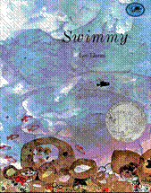 [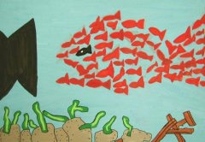](http://www.sunfield.ne.jp/~iwashaki/ED-graphics/swimmy-k-13.jpg)

|  |  |
| --- | --- |
| **Activity 3: Creative Writing** | boywriting |

Encourage your child to write his or her own story. Ask him or her to think about what he or she is going to write before starting. Your child can make up his or her own words, use a dictionary,or copy sentences from books.

If your child is having difficulty getting started, you could select three connected pictures and help them to write a sentence under each picture.

|  |  |
| --- | --- |
| **Activity 4: Handwriting** | birdpencil |

Continue revising the correct way of writing the letters of the alphabet as you have for the past few days. Demonstrate how to write the letters before your child commences each new line of work.

|  |
| --- |
| **Ss Swimmy Bb brother Ss sister** |

|  |  |
| --- | --- |
| **Activity 5: Science** | atom |
| Show your child a few pictures of birds and animals, and discuss ways each creature cares for its young.   * Do they provide shelter and food? * Do they teach their young? * Do they protect their young?   Compare this with the care given to children by their parents.  How is it the same?  How is it different?  Talk about the need for rules:   1. at home 2. on the road 3. in society   to ensure protection, provide guidance and encourage harmony. | |

|  |  |
| --- | --- |
| **Activity 6**  **Language** | **book** |
| **Step 1**  Ask: *What is the first sound in the word* ***hat****?*  *What is the last sound in the word* ***cap****?*  *What is the middle sound in the word* ***cap****?*  Repeat this procedure for the words ***jet, wig, box*** and ***sun.***  **Step 2**  Put out the letter cards to make the word bat.  Ask your child to read the word.  Change the middle letter so the word says bit.  Ask your child to read the new word.  Continue like this to make but and bet.  Repeat for *pot, pet, pat, pit.*  **Step 3**  Remove Activity sheet 4.3.  Your child is to complete the worksheet by writing a word for each picture. | |

|  |  |  |  |
| --- | --- | --- | --- |
| h_t | s_t | hand-held-fan-used-for-national-dance  f_n | v_n |
| r_g | p_n | c_b | cat-coloring-page-25  c_t |
| _og | 6-bat-coloring-page-l  b_t | _ed | _ a_ |

|  |  |
| --- | --- |
| **Task 5**  **Today your child will learn how a pet can be a part of your family too...** | |
| **Activity 1: Language** | **book** |

**Step 1**

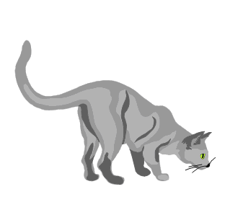Ask your child to read a book to you.

Read the following poems about pets.

**Kitty**

Kitty’s tongue is small and pink

She shows it when she has a drink.

She likes the milk and does not stop

Until she’s finished every drop.

Then kitty jumps upon my knee

She starts to purr and then licks me.

Although her coat’s like silky fluff,

Her tongue feels very strange and rough.

M. Long

As you read the poems with your child, emphasis the rhyme and rhythm. Ask your child to select a poem they enjoy an learn to recite a few lines or a stanza.

When reading familiar poems to your child, you could stop at the end of line. Ask your child to say the missing word. Emphasis the rhyme pattern to help them.

**Yappy**

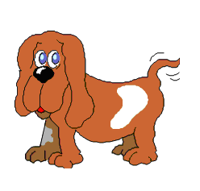

Yappy was a little dog,   
Young and full of fun.

Yappy liked to chase the kitten

Yappy liked to run.

Yappy was young Johnny’s puppy

John yells, ‘Come here!’

Yappy came, John whispered

‘Yap, you are a dear!’

Anon.

**No Pets Allowed**

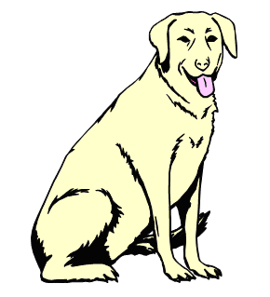

We have to move, for my Mum says

Our place is much too small,

For her and Dad, my dog and me,

Aunt Sue and Uncle Paul.

My Mum has found a place she likes -

It’s big, it has a view,

A brand new stove and dishwasher,

New blinds, new carpets too.

If we can get it, I know Mum

And Dad will feel so proud,

But I’m upset, for there’s a sign outside

Which says, ‘NO PETS ALLOWED’.

It’s fun to move to somewhere new

With lots of space, I’m sure,

But if I could only keep my dog,

I’d like it so much more.

Anita Posey

**The Goldfish**

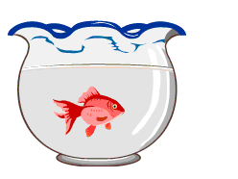

My darling little goldfish

Hasn’t any toes,

He swims around without a sound

And bumps his hungry nose.

He can’t get out and play with me,

Nor I get into him,

Although I say, ‘Come out and play’

And he, ‘Come in and swim.’

Anon.

**Puppy**

His nose is short and scrubby;

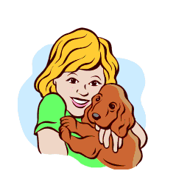

His ears hang rather low;

And he always brings the stick back,

No matter how far you throw.

He gets spanked rather often

For things he shouldn’t do,

Like lying on beds and barking,

And eating up shoes when they’re new.

He always wants to be going

Where he isn’t supposed to go.

He tracks up the house when it’s snowing.

Oh! Puppy! I love you so.

Anon.

**Step 2**

If you have a pet, talk about it.

* When did you get it?
* Was it bought for a particular family member, or is it a family pet?
* Is it older/younger than your child?
* Have you had it since it was new born?
* Are there any stories to be told about the pet?
* Does the pet have any favourite foods?
* Where does the pet sleep?
* If you go away on holidays, does the pet go too?
* Does the pet have any friends of its own kind?
* Is it ever naughty?
* What happens if it is?
* Does it have a favourite pastime?

**Step 3 – Writing**

Show your child how to write a sentence about a family pet on your own sheet of paper. Help your child construct a sentence about a pet that could be added to their *My Family* book.

The page can be illustrated in any suitable way.

**OR**

If you don’t have a pet, help your child make a list of all the animals that would make a good pet.

|  |
| --- |
| Listen to the story *Harry the Dirty Dog*  <https://www.youtube.com/watch?v=7j0OY3236jw>    **Ask your child to suggest how Harry was feeling throughout the story.** |

**Pet Portrait**

**Make a portrait of your pet (or the pet you would like)**

You need:

* a large sheet of heavy newsprint
* black oil pastels
* a tub of water
* paint
* odds and ends from the scrap box.

1. Use the black oil pastel to draw an outline of your pet on the paper.
2. Immerse the paper in the water, then hold it up to drain.
3. Use paint sparingly on the brush to fill in the picture. Use a dabbing motion if

you want to make your pet look furry.

1. Allow the paint to dry, then cut the picture out.
2. Add decorations, such as a paper collar, coloured feathers, or whatever you think will make your pet look special.

Eliza’s dog Matthew’s dog

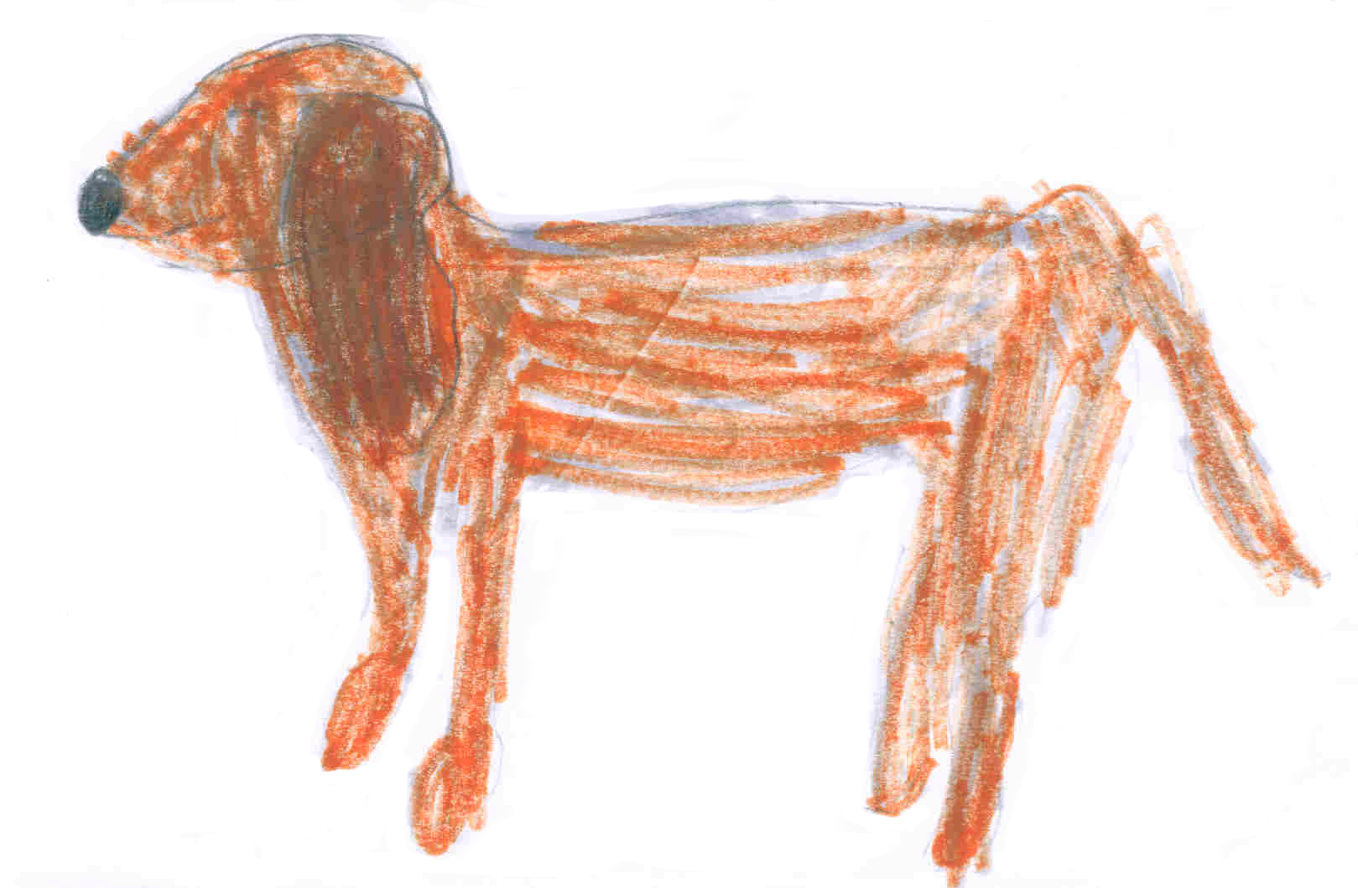 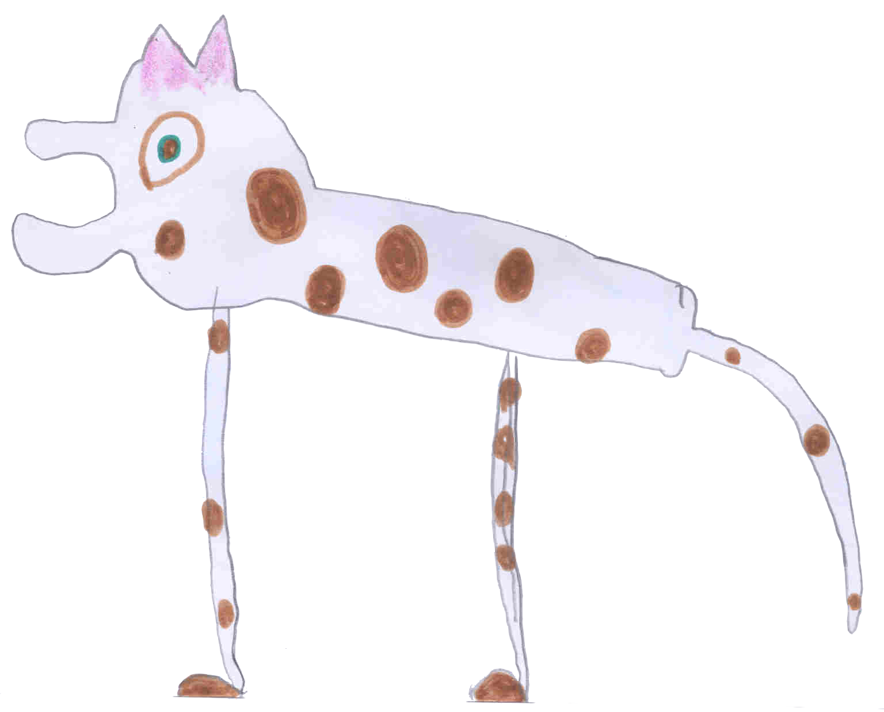

Gillian’s cat Hayden’s hens

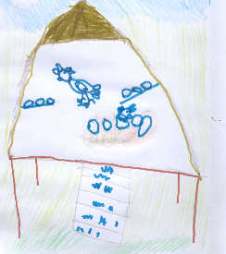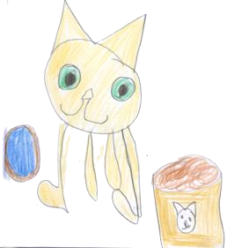

|  |  |
| --- | --- |
| **Activity 3**  **Creative Writing** | boywriting |

Encourage your child to write his or her own story (as you have in previous sessions). They might like to write and draw about a family pet. Ask them to draw three or four pictures that ‘tell’ their story in sequence before they start writing. Your child can make up his or her own words, use a dictionary to find words, or you could write the words for them.

|  |  |
| --- | --- |
| **Activity 4**  **Health** | birdrun2 |

Remember to remind your child to wash hands before eating and after playing with pets.

|  |  |
| --- | --- |
| **Activity 5** | **globe2** |

Talk about the responsibilities of being a pet owner.

You must:

* Provide food.
* Provide shelter.
* Provide health care.
* Make sure your pet gets sufficient exercise.
* Make sure that your pet is kept clean.
* Ensure that the pet is kept under control.

Talk about the pleasures of being a pet owner:

* Always have a friend.
* Fun to play with them.
* Can share activities with them.
* Never lonely.
* Can watch them grow.
* Can teach them tricks.

|  |  |
| --- | --- |
| **Activity 7**  **Language** | **book** |

Put out all the cards letter/picture match that you made earlier in the booklet*.*

Play a game of pairs or concentration finding a letter/picture match.

Fold a sheet of paper into eight sections, and ask your child to write the following words, one in each section. He or she is to draw a picture to match each word when   
he or she has written all of them.

**sat mat fat hat bat dam dab fab**

|  |  |  |
| --- | --- | --- |
| **Activity 3**  **Art** | **crayon2** | |
| **Make a supermarket scene**  You need:   * a large sheet of paper * two smaller sheets of paper * pictures of food from junk  mail advertising or magazine. * crayons, pencils or oil pastels. | | temp | |

1. Draw a supermarket background on the larger sheet of paper.
2. Make sure you include lots of shelves.
3. Cut out the pictures of food and paste them on the shelves.
4. Add some signs and prices.
5. Take one of the smaller pieces of paper, fold it in half, and cut it as in the  
   diagram.
6. Open it out and paste it on your sheet for a shopping trolley.
7. Use pieces of scrap paper to make the handle and wheels.
8. You may like to paste some food in your trolley.
9. Draw a picture of yourself on the other sheet of paper.
10. Cut it out and paste it on your picture.

|  |  |
| --- | --- |
| **Activity 4**  **Creative Writing** | boywriting |
|  |  |

Sometime this week, you will talk about food and, it is hoped that, together, you and your child will prepare a favourite family meal.

Ask your child to prepare a list of all the things you will need to make a meal.

Encourage your child to use his or her knowledge of sounds to write the list. If he or she is really stuck on a word, write it down or ask your child to draw a picture.

Make this a really meaningful experience for your child. We only write to get a message from the page. Making a shopping list is a purposeful reason for your child to write.

|  |  |
| --- | --- |
| **Activity 7**  **Physical Education** | birdrun2 |

* Set up a circuit training course.
* Explain to your child what has to be done at each station.
* Your child is to work at each activity for just one minute and then move on to the next.

**Stretch neck, shoulders, upper and lower body in a series of exercises**

**before you start.**

**Station 1. The Shuttle Run.**

Continual running from one point to another about 15 metres away.

**Station 2. Rolling.**

Roll in any way you like from one side of the mat to the other, then back again.

**Station 3. Step-ups.**

Use a bench or step, to step up and down.

**Station 4. Rocking.**

Rock in any way you like on the mat.

**Station 5. Hotplates.**

Jump in and out of a hoop.

**Station 6. Skipping.**

Jump over a rope. You do not have to be able turn the rope. You can jump over it as you swing it back and forth.

Go for a long slow walk after such hectic exercise.

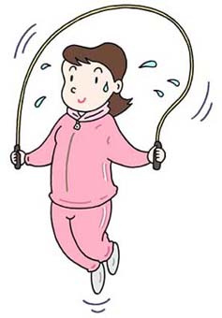

**Copyright**

*The Department of Education and Training (DET) encourages the dissemination and re-use of information provided in this document.*

Material on this website is provided under a Creative Commons Attribution 4.0 international licence, with the exception of:

* any images, photographs, trademarks or branding, including the Victorian Government logo and the DET logo; and
* content supplied by third parties.



For licence conditions, see: [Creative Commons Attribution 4.0 international licence](http://creativecommons.org/licenses/by/4.0/)

**Attribution**

Material to be attributed as:

© State of Victoria (Department of Education and Training)