**History Inquiry**

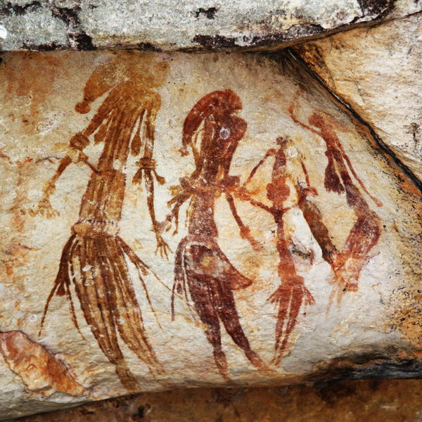

[*http://commons.wikimedia.org/wiki/File:Bradshaw_rock_paintings2.jpg*](http://commons.wikimedia.org/wiki/File:Bradshaw_rock_paintings2.jpg)

What are the differences between Aboriginal and Torres Strait Islander peoples?



**GETTING KNOWLEDGE READY**

1. Fill in some of the similarities, differences and commonalities that you already know, relating to Aboriginal and Torres Strait Islander peoples in the Venn diagram below.

**Aboriginal peoples Torres Strait**

**Islanders**

1. View the following video to learn more about the Torres Strait Islands:

<http://tinyurl.com/ozzeg7l>

1. What were you thinking whilst watching this video?

1. Read the information on the following page.

**Torres Strait Islander Peoples**

Torres Strait Islanders have unique traditions and cultures. Traditionally, Torres Strait Islander groups considered themselves separate from each other. They had their own languages, cultures and customs. They are thought to have migrated from Papua New Guinea and Melanesia.

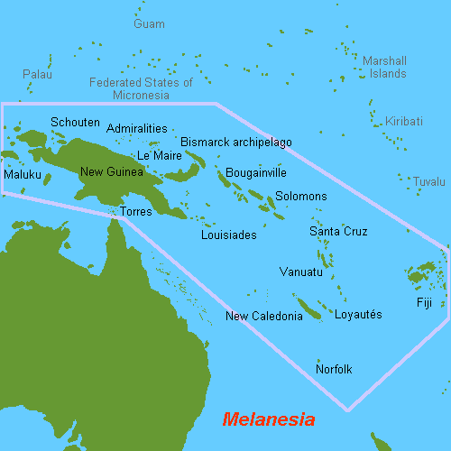

Archaeologists have found evidence of human occupation in the Torres Strait Islands from 2 500 years ago. People most likely settled there much earlier but the evidence may have been destroyed or hidden underneath rising seas.

**Traditional Life**

The population of the Torres Strait Islands has always been small compared to Aboriginal populations. The Islander’s lifestyles depended on the resources that were available. People on the western islands were hunter-gatherers.

1. What do you think ***hunter-gatherers*** means?

1. Check the meaning in a dictionary or online. Were you right?

**Yes** *or* **No**

People living on the central and eastern islands relied on the sea. They traded pearl shells, feathers, canoes and tools with other islanders and people in neighbouring countries.

Torres Strait Islander culture has a rich tradition of music, art and ceremony.

**What Nature Provides**

1. Use the mind map on the following page to summarise what nature provides for the traditional Torres Strait Islander way of life. You can use pictures as well as words.

*What nature provides*

***Source: Discovering History (Middle Primary) / Arrival and Lifestyle***

***– Jennifer Lawless and Kate Cameron* (PEARSON AUSTRALIA)**

**Aboriginal Societies**

Traditionally, Aboriginal culture varied throughout Australia. People from different regions had different languages, customs, Spirit Ancestors, tools, weapons, basketry and art styles.

**Social Groups**

Before European arrival, Aboriginal peoples lived in small family groupings. The most important social group was the clan. A clan is a group of [people](http://en.wikipedia.org/wiki/People) united by actual or perceived [kinship and descent](http://en.wikipedia.org/wiki/Kinship_and_descent). There many have been up to six or more clans living near each other. People in the clans spoke a familiar language and had similar cultural practices. People identified themselves by the clan they belonged to.

Clans that lived near each other and spoke the same language made up a larger group called a nation. The area where the clans lived was their Country. Members of different nations met for larger ceremonies and gatherings, which up to 1 000 people would attend.

Country, family and community were very important to traditional Aboriginal peoples.

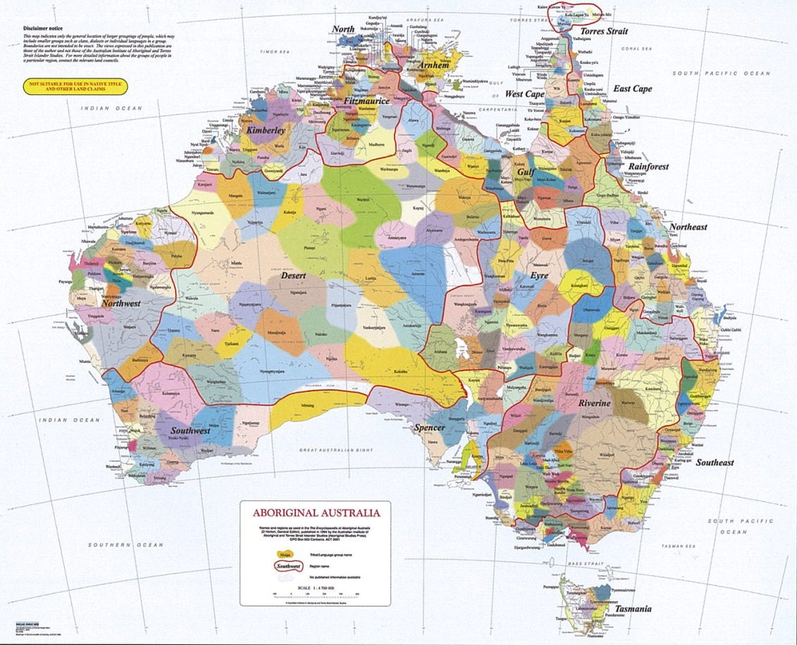

|  |
| --- |
| *This map shows the diversity of Aboriginal and Torres Strait Islander nation or language groups.* |

***Source: Discovering History (Middle Primary) / Arrival and Lifestyle***

***– Jennifer Lawless and Kate Cameron* (PEARSON AUSTRALIA)**

1. Draw your clan below. Label each member and their relationship to you.

|  |
| --- |
| *MY CLAN* |

1. What language/s do you speak with your clan?

1. Continue reading and discussing the information below with your supervisor.

**Elders**

Elder members of Aboriginal societies were very knowledgeable and treated with great respect. They would share important stories of the Dreaming. Stories were shared around the camp fire and formed the basis of the religion and behaviour of Aboriginal peoples and the law and order of their society.

**Religion**

Traditional Aboriginal peoples were very spiritual. Religion and ceremonies were an important part of their lives. Art and body decoration reflected spiritual beliefs. Different groups had different religious beliefs.

**Spirit Ancestors**

Each nation group shared stories about a being or beings that created people, animals and the land during the Creation time. These beings, or Spirit Ancestors, also gave the people the laws by which they were to live. The beings themselves then became part of the land, sea and sky.

1. View the following video to understand the Dreaming (also known as the Dreamtime):

<http://tinyurl.com/pgzxyk6>

**Moieties and Totems**

Some Aboriginal societies were divided into two groups called moieties (pronounced moi-i-tees). Each moiety had animals, plants or places that were spiritually important. Each person was connected to their own totem. A totem was an animal, plant or other object that was related to the person ancestrally. A totem may have been in the form of a large rock, such as Uluru, a tree or a hill.

1. What totem might you choose for yourself? Draw it below. Label your totem.

|  |
| --- |
| *MY TOTEM* |

1. Continue reading the information below.

**Country**

Aboriginal peoples were vey connected to their land, calling it their Country, because of their Dreaming stories and their totemic beliefs. People also believed that after their death, their spirit would return in human, animal or plant form.

**Lifestyles**

Lifestyles varied according to where Aboriginal peoples lived. Climate, resources and the type of food available were different all over the continent. Tools, such as spears and axes, and the materials they were made from, also varied in different areas of Australia.

**Tool Technology**

Aboriginal peoples were expert tool-makers, using what was available in their local environment. Stone tools have been used in Australia since Aboriginal people arrived. Flaked tools (an example of one is pictured below) were made by chipping a rock to make a sharp edge for cutting. The flaked tools were used to shape wooden weapons and implements.

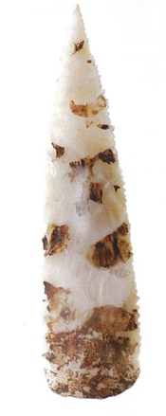

Ground-edge axes were also used in northern Australia from about 35 000 years ago.

Because Aboriginal peoples were very mobile, they needed to be able to carry their tools and weapons with them. For this reason, tools often had several uses, e.g. spear throwers were also used as a dish, a scoop and a saw.

**Boomerangs and Didgeridoos**

Hunting boomerangs of different shapes have been found all across Australia. Didgeridoos were used in ceremonies in the far north. Didgeridoo is an English word, which comes from the sound the instrument makes.

1. Log onto the following clip on YouTube. Close your eyes and listen to the didgeridoo being played. Where does your imagination take you? Go to:

<https://www.youtube.com/watch?v=yG9ZX1FS20A>

**Food**

Aboriginal peoples ate a wide variety of food depending on where they lived and what food was available at a particular time. Plants and animals, including birds, fish, insects and reptiles provided a healthy diet. Some plants were also used for medicine and healing.

Men and women worked together to provide food for the family. Men mostly hunted, while women gathered vegetables, nuts and seeds. Men and women both fished and ground up the nuts and seeds. Food was cooked on fires or in pits in the ground. Meals were eaten with family groups.

**Middens**

Ancient stone ovens, fishing traps, dams, ceremonial and ritual areas and middens have all been discovered throughout Australia. Middens are places where Aboriginal people ate their food and left the remains. They have survived over many years and can tell us about such things as what foods were eaten at particular times of the year.

Many walking tracks in Sydney’s national parks lead past or through Aboriginal middens, but only a trained eye is able to spot them. Cockle shells are among the most common shells found in middens.

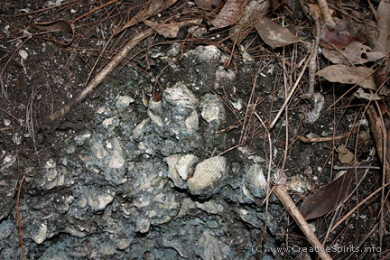

***Cockle shell in an Aboriginal midden.***

<http://www.creativespirits.info/aboriginalculture/land/guide-to-aboriginal-sites-and-places>

***Source: Discovering History (Middle Primary) / Arrival and Lifestyle***

***– Jennifer Lawless and Kate Cameron* (PEARSON AUSTRALIA)**

C:\Users\Vicki\AppData\Local\Microsoft\Windows\Temporary Internet Files\Content.IE5\OIEEH2C0\MC900186220[1].wmf

|  |
| --- |
| **Indigenous Australians Quiz** |
| ***Tick the correct answer.***   1. The word indigenous means: 2. people that have come to a new country. 3. originating or occurring naturally in a particular place; native.   c) old.   1. Who are Australia’s Indigenous peoples?   a) Greeks and Italians.  b) English and Irish.  c) Aboriginal and Torres Strait Islander peoples.  3. For approximately how long have Australia’s Indigenous peoples been in Australia?  a) 1 000 years.  b) 10 000 years.  c) At least 50 000 years.  4. Aboriginal and Torres Strait Islander peoples lived in the same places:  **True** *or* **False**  5. The population of Aboriginals has always been greater than that of Torres Strait Islander peoples:  **True** *or* **False**  6. How many different languages have been estimated to be spoken by Aboriginal groups across Australia before European arrival?  a) More than 10.  b) More than 100.  c) More than 250.  7. The word ‘aborigine’ means:  a) ‘from the beginning’.  b) ‘dark-skinned’.  c) ‘traveller’.  8. Aboriginal shelters were used for camping and meals.  **True** *or* **False**  9. Aboriginal artefacts include:  a) weapons.  b) musical instruments.  c) tools.  d) all of the above.  10. Torres Strait Islander people are thought to have migrated from:  a) China.  b) Indonesia.  c) Papua New Guinea and Melanesia.  11. What do Torres Strait Islanders rely on?  a) The sky.  b) The sea.  c) The desert.  12. Aboriginal people lived in small family groupings called:  a) clans.  b) nations.  c) teams.  13. What is the religion of Aboriginal and Torres Strait Islander peoples?  a) Buddhism.  b) Islam.  c) The Dreaming (also known as The Dreamtime).  14. Aboriginal and Torres Strait Islander peoples are very connected to Country and Place (land, sea, waterways and skies).  **True** *or* **False**  ___ /14 |

**REFLECTION**

Please think about what you’ve learnt in this module. In your own words please write your answer below.

1. *What has surprised you the most about the similarities and difference between Aboriginals and Torres Strait Islanders? Give an example.*