**History Inquiry**

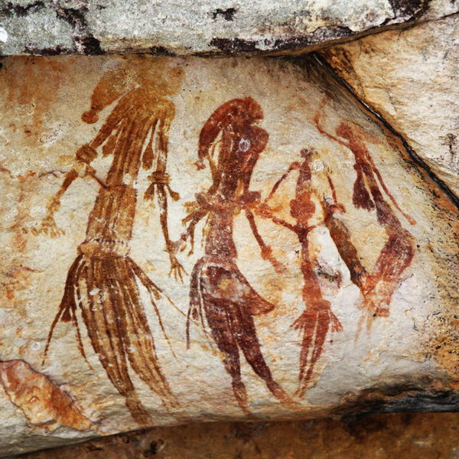

[*http://commons.wikimedia.org/wiki/File:Bradshaw_rock_paintings2.jpg*](http://commons.wikimedia.org/wiki/File:Bradshaw_rock_paintings2.jpg)

What was the effect of the First Fleet’s arrival on Aboriginal and Torres Strait Islander peoples?



**GETTING KNOWLEDGE READY**

1. Look at the picture below. Can you suggest **4 W** (**W**ho, **W**hat, **W**hen, **W**here) and **1 H** (**H**ow) questions that it might answer?

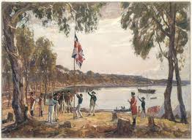

**W**ho ___________________________________________?

**W**hat __________________________________________?

**W**hen __________________________________________?

**W**here _________________________________________?

**H**ow ___________________________________________?

1. Read and discuss the following information with your supervisor.

**Meeting the Eora People**

The Indigenous people who lived around Sydney were called Eora. Governor Arthur Phillip was completely responsible for the new colony. He had been given strict instructions by the English government to get along with Eora and live in peace with them. The First Fleeters were surprised by how many Eora there were. Captain Cook and Joseph banks had reported that they had not seen many Aboriginals on their expedition to New Holland in 1770.

**The Eora**

Both the English and the Eora were very curious about each other. Indigenous people had lived in Australia for thousands of years, respecting the land and taking only what they needed from it. The Eora were shocked at how the English started clearing the land. They were also surprised at the harsh punishments given to the convicts.

**The Newcomers**

To the Eora, everything about the newcomers was strange and different, from how they looked and dressed to the way they cooked their food in a pot. At the start, there was no fighting between the English and the Eora. The English, however, felt superior to the Eora. This attitude would create enormous problems in the times ahead.

**Increasing Tension**

Relations between the local Eora people and the colonists worsened as time went on. They did not understand each other’s language, culture or needs.

**The Colonists and the Eora**

The colonists expected the Eora to live the way they did, including wearing clothing. The colonists took ownership of everything from land to food. They had no understanding of how to live with the land like the Eora did.

The colonists came with weapons that the Eora had no protection against. Although the government had instructed Governor Phillip that they were to live in peace, the Europeans used their muskets to warn and frighten the Eora people.

Some convicts stole tools, weapons and canoes from the Eora. Attacks from both sides started. The Eora were no longer friendly with the Europeans. Phillip tried to make peace with the Eora, but his dozen armed men were met with about 200 Eora men armed with spears.

After that incident, Phillip said that no one was to go into the bush alone and no one was to fire muskets at the Eora. Attacks from the Eora became more frequent though, and after spears were thrown at a convict, Phillip ordered his troops to shoot.

Clearly, the Aboriginal and British cultures were very different.

1. Fill in as much information as you can in the table below.

**Culture Clash**

|  |  |
| --- | --- |
| **Aboriginal Culture** | **British Culture** |
|  | Most people were poor, but some were very rich. |
|  | Many people lived in large towns and cities in unhealthy conditions. |
|  | Land was privately owned and fenced. Land could be bought and sold. |
|  | There was a single royal ruler, a king or queen. |
| Law came from the Dreaming. It told people how they should behave and how to take care of the natural world. | Parliament made the law. The main purpose of the law was to protect the rich and their property. |
|  | Most people believed in God and worshipped their God in churches. |

***Source: Discovering History (Middle Primary) / Life in the Colony***

***– Jennifer Lawless and Kate Cameron* (PEARSON AUSTRALIA)**

**Impact of the Colony on Aboriginal Peoples**

1. Write what you think would have been the effect on Aboriginal peoples and their environment in each scenario below.

|  |  |
| --- | --- |
| **Cause**  The arrival of the First Fleet meant that more than 1 300 extra people had to be fed. | **Effect** |

|  |  |
| --- | --- |
| **Cause**  Colonists brought diseases. Aboriginal people had no immunity to these diseases. | **Effect** |

|  |  |
| --- | --- |
| **Cause**  Convicts stole spears and other possessions from Aboriginal people. | **Effect** |

|  |  |
| --- | --- |
| **Cause**  Trees were cut down and land cleared for farming. | **Effect** |

***Source: Discovering History (Middle Primary)***

***– Jennifer Lawless and Kate Cameron* (PEARSON AUSTRALIA)**

1. Research and write an information report about the life of Bennelong, who lived during this time. Answer the 5Ws. Include a picture and the following subheadings:

* [Personal details](http://en.wikipedia.org/wiki/Bennelong#Personal_details)
* [Capture and life in the British settlement](http://en.wikipedia.org/wiki/Bennelong#Capture_and_life_in_the_British_settlement)
* [Visit to England](http://en.wikipedia.org/wiki/Bennelong#Visit_to_England)
* [Return to New South Wales](http://en.wikipedia.org/wiki/Bennelong#Return_to_New_South_Wales)
* [Death](http://en.wikipedia.org/wiki/Bennelong#Death)
* [Legacy](http://en.wikipedia.org/wiki/Bennelong#Legacy)

***BENNELONG* –** DRAFT

1. Proof-read and edit your information report.
2. Publish your work below or as a Word document or PowerPoint presentation.

***BENNELONG***

***BENNELONG***

**REFLECTION**

In your own words please explain three things you learned from completing this module.