Mathematics

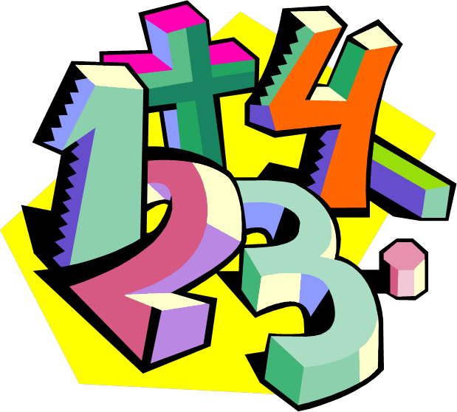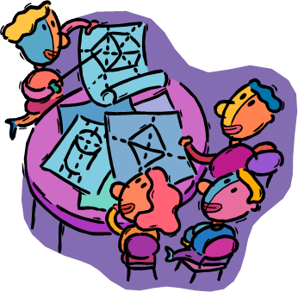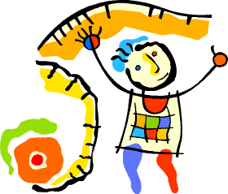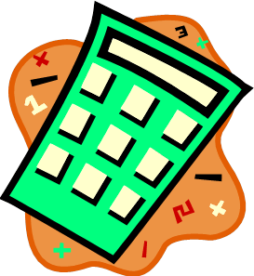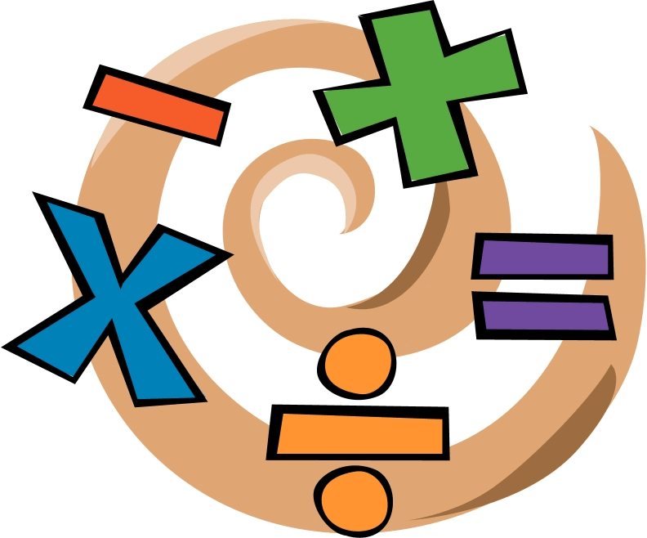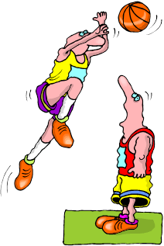

What strategies can be used to compare fractions and mixed numbers so we can solve problems?

Mathematics

What strategies can be used to compare fractions and mixed numbers so we can solve problems?

**Welcome to Mathematics.**

The theme of Mathematics is ***Maths skills for your world****.*

We hope you like the booklet and enjoy your learning.

|  |  |
| --- | --- |
| **What you will need** | * This booklet, pen and paper. * A computer is useful if you have one, because there are interactives in some lessons. * A calculator is sometimes used and useful to check your answers. |
| **The activities** | Each booklet contains a variety of activities:   * Skills exercises * Investigations * Interactives and games * A skills test |
| **When to use your calculator** | Most of the time you **won’t** need your calculator.  The maths activities develop skills; ways of working with numbers, mental arithmetic, estimating and using times tables.  Only use your calculator when it’s part of the activity. |
| **Asking for help…** | There may be times when you are not sure about an example or an exercise.  When this happens, know whom to ask for help:   * Your supervisor or parent: the person you work with each week. * Your teacher can answer your questions and adjust the work to best suit you. |

**Mathematics**

|  |
| --- |
| The activities in this booklet will help us to answer the question:  Description: C:\Users\CFord\Documents\MY Folders\CurricDev2012\images\essQ2.gif  **"What strategies can be used to compare fractions and mixed numbers so we can solve problems?"**  **Learning Intentions:**   * Revise number skills:   + - Find factors by estimating first, then using the calculator to test the estimate.     - Revise mixed numbers; writing them in words, figures, and diagrams.     - Revise division and number facts.     - Use mental strategies to solve divisions. * Order and compare mixed numbers:   + - Count by fractions and mixed numbers on a number line and in number sequences.     - Estimate fractional distances on a number line. * Calculate with fractions and mixed numbers:   + - Revise adding and subtracting fractions, in number sentences, diagrams and number stories.     - Develop skills using mixed numbers in maths problems. * Apply your skills:   + - Apply your skills with fractions to design a park. Prepare a plan to present to the park planners. |

**The topics in this booklet**

|  |  |
| --- | --- |
| **Learning Tasks** | |
| **Task 1** | * Number skills review: find factors by estimating and testing. |
| **Task 2** | * Revise mixed numbers in figures, words and diagrams. * Count by fractions on the number line. Estimate where mixed numbers should go. |
| **Task 3** | * Revise adding and subtracting fractions. * Consolidate your skills with workbook practise. |
| **Task 4** | * Apply your fraction skills to design a park. * Prepare your plan to present to the park planners. |
| **Task 5** | * Complete your park plan from Task 4. * Revise adding and subtracting fractions with different denominators. * Reflect on what you’ve learned in maths. |

**The topics in this booklet**

|  |  |
| --- | --- |
| **Learning Tasks** | |
| **Tasks 6 and 7** | * Revise mixed numbers. * Apply the skills already learned to solve problems with mixed numbers and fractions. * Consolidate your skills with workbook practice. |
| **Task 8** | * Review division by recalling number facts. * Explore mental strategies to divide numbers. * Revise setting out divisions with pen and paper. |
| **Task 9** | * Revise setting out short division with pen and paper. * Apply division skills to practical problems. * Consolidate your skills with workbook practice. |
| **Task 10** | **Progress Assessment**   * Reflect on what you’ve learned in maths. * Do a test. |

# Task 1 Number skills review:

# Finding factors…. a calculator activity



To do Maths we need number skills.

Knowing how to find **factors** helps you to do a lot of calculations…

especially multiplying and dividing,

Today we use a strategy called ‘**estimate, guess, check’** to find factors.

**Factors** are numbers that multiply together to give an answer (**product**).

Two **factors** of **360** are **24** and **15**  because **24** × **15** = **360**

In this activity we use the ‘***estimate, guess, check’*** strategy to find two factors.

Let’s see an example…

**Example 1 Find the missing factors**

Find the **two factors** that have -a difference of 4

and -a product of 621

|  |
| --- |
| **Think**… what does the question tell us?  We are looking for two numbers with…  *a difference of 4* ←When we subtract them the answer is 4  *a product of 621* ←When we multiply them the answer is 621 |

|  |
| --- |
| Estimate the factors…  The two **factors** **multiply** to give 621  If we **round to the nearest hundred**, we can **estimate** the **factors**:  621 rounds to 600, to the nearest hundred.  Possible factors of 600 are 6 × 100  12 × 50  20 × 30  Only factors between 20 and 30 could have a difference of 4.  We look for factors between 20 and 30 that subtract to give 4. |

List pairs of numbers between 20 and 30, which subtract to give 4

|  |  |  |
| --- | --- | --- |
| 21 and 25  22 and 26  23 and 27  24 and 28  25 and 29  26 and 30 |  | When we subtract each pair the answer is 4  Check which pair multiplies to give 621  C:\Users\CFord\Documents\MY Folders\CurricDev2012\images\module 4\calc1.gif23 × 27 = 621  Use your calculator to check the answer, or multiply by hand.  The factors are 23 and 27 |

|  |  |
| --- | --- |
|  | **Task 1 Activity 2:**  **Using estimation and a calculator to solve problems.** |
|  |

**Example:**

What two numbers have a difference of 2 and a product of 728?

**Strategy:**

Guess 1: 32 and 34. (*Pair of numbers that have difference of 2)*

Calculator check: 32 x 34 = 1 088 Too big.

Guess 2: 22 and 24 (*Pair of numbers that have difference of 2)*

Calculator check: 22 x 24 = 528 Too small.

Guess 3: 26 and 28 (*Pair of numbers that have difference of 2)*

Calculator Check: 26 x 28 = 728 Correct!

|  |  |  |  |
| --- | --- | --- | --- |
|  | Difference | Product (*answer to a multiplication)* | Numbers |
| **a** | 3 | 270 |  |
| **b** | 1 | 210 |  |
| **c** | 6 | 567 |  |
| **d** | 4 | 1 020 |  |
| **e** | 10 | 231 |  |
| **f** | 5 | 500 |  |
| **g** | 7 | 408 |  |
| **h** | 9 | 220 |  |
| **i** | 2 | 840 |  |

# Task 2 A bit left over… mixed numbers



Previous activities have looked at **fractions** and how useful they are. Today we revise what happens when we **share** things and there’s a **fraction** left over. Let’s start with an example…

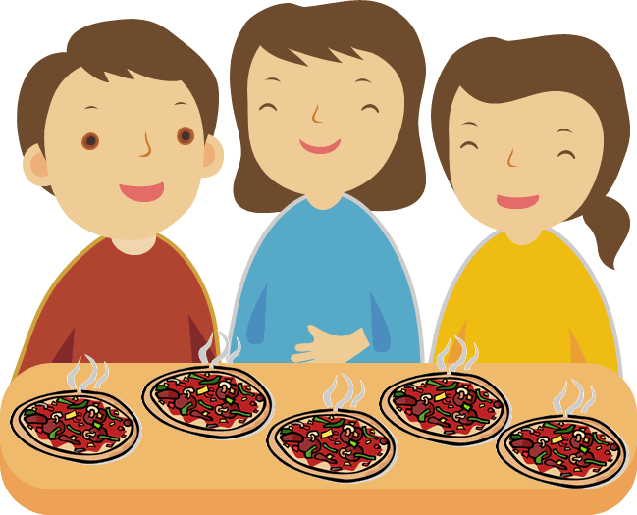

**Three** friends have **5** mini-pizzas to **share**.

Each friend receives **one** mini-pizza and there are **two** mini-pizzas **left over**.

By cutting **TWO** pizzas into **THIRDS**, we have six slices to **share equally** between the three friends.



|  |  |
| --- | --- |
|  | Each friend receives **one whole** pizza and **2 slices out of 3** from the left over pizzas.  As a number sentence:  5 shared between 3  5 ÷ 3 = 1 and  1  1is a **mixed number** |
| A **mixed number** is **part whole number** and **part fraction**. | |

|  |  |
| --- | --- |
| ***Description: j0229369*** |  |
| **Task 2 Activity 1: What’s the mixed number?** |
|  |

**Question 1** Write a mixed number to match each picture.

|  |  |
| --- | --- |
| **(a)** | **(b)** |
| **(c)** | **(d)** |
| **(e)** | **(f)** |

**Question 2 Shading mixed numbers**

Shade the shapes to match each mixed number.

|  |  |  |
| --- | --- | --- |
| **(a)** 1 |  | **(b)** 1 |
| **(c)** 2 |  | **(d)** 1 |
| **(e)** 2 |  | **(f)** 1 |

**Question 3 Mixed numbers and words**

|  |  |
| --- | --- |
| **(a)** | Write each **mixed number** in words. Draw a picture to show what it represents. The first one shows how. |

|  |  |  |
| --- | --- | --- |
|  | The mixed number in words | A picture of the mixed number |
|  | One and one half |  |
|  |  |  |
|  |  |  |
|  |  |  |
|  |  |  |

|  |  |
| --- | --- |
| **(b)** | Write each **mixed number** in **digits**. Draw a picture to show what it represents. |

|  |  |  |
| --- | --- | --- |
| The mixed number in words. | The mixed number in digits. | A picture of the mixed number. |
| two and one quarter |  |  |
| one and three fifths |  |  |
| three and one half |  |  |
| one and five sixths |  |  |
| two and three tenths |  |  |

**Question 4 Sharing equally**



I bought **5** pizzas. We have **four** people for lunch.

Each person receives **one full pizza**. There is **one pizza left over**.

To share it equally, I cut it into **quarters (1/4).**

|  |  |  |  |
| --- | --- | --- | --- |
| As a number sentence | **5** pizzas **shared between** **4** people is **5 ÷ 4** | | |
|  | | 5 ÷ 4  (4 + 1) ÷ 4  4 ÷ 4 plus 1 ÷ 4  1 plus  1 |  |

Complete the table below to show how things are shared. The first one is done for you.

|  |  |  |
| --- | --- | --- |
| How many are shared | As a number sentence | What amount does each person receive? |
| 11 shared between 3 | 11 ÷ 3  (9 + 2) ÷ 3  (9 ÷ 3) + (2 ÷ 3)  3 + | 1 whole pizza and of a pizza |
| 12 shared between 5 |  |  |
| 9 shared between 4 |  |  |
| 14 shared between 9 |  |  |
| 15 shared between 8 |  |  |
| 11 shared between 5 |  |  |

# Counting by fractions…. what comes next?

This number line below **starts at 10** and **finishes at 14.**

We **divided** the line into **eighths** (fractions of ).

This lets us show where different mixed numbers go.

10

11

12

13

14

10

10

10

10

10

10

10

10

11

10

12

10

10

13



13 is the same as 13

11 is the same as 11

12 is the same as 12



Notice the equivalent fractions

|  |  |
| --- | --- |
| ***Description: j0229369*** |  |
| **Task 2 Activity 2: Counting by fractions** |
|  |

**Question 1 Revising equivalent fractions**

Fill in the equivalent fractions below. Use the fractions shown the diagram if you need to.

|  |  |  |  |  |  |  |  |  |  |  |  |  |  |  |  |  |  |  |
| --- | --- | --- | --- | --- | --- | --- | --- | --- | --- | --- | --- | --- | --- | --- | --- | --- | --- | --- |
| **(a)** | = = = | 1 whole | | | | | | | | | | | | | | | | whole |
|  | |  | | | | | | | | | | | | | | | |  |
| **(b)** | = |  | | | | | | | |  | | | | | | | | halves |
|  | |  | | | | | | | | | | | | | | | |  |
| **(c)** | = |  | | | |  | | | |  | | | |  | | | | quarters |
|  | |  | | | | | | | | | | | | | | | |  |
| **(d)** | = |  | |  | |  | |  | |  | |  | |  | |  | | eighths |
|  | |  | | | | | | | | | | | | | | | |  |
| **(e)** | 1 =  = |  | | |  | | | |  | |  | | | |  | | | fifths |
|  | |  | | | | | | | | | | | | | | | |  |
| **(f)** | 1 =  = |  |  | |  | |  | |  |  |  | |  | |  | |  | tenths |



Remember  **>** means ‘is bigger than’

**<** means ‘is smaller than’

**Question 2 Revising comparing fractions**

Write **‘true’** or **false**’ beside each number sentence.

|  |  |  |  |  |  |  |  |  |
| --- | --- | --- | --- | --- | --- | --- | --- | --- |
| **(a)** | > |  | **(b)** | < |  | **(c)** | > |  |

|  |  |  |  |  |  |  |  |  |
| --- | --- | --- | --- | --- | --- | --- | --- | --- |
| **(d)** | < |  | **(e)** | > |  | **(f)** | < |  |

**Question 3 Find the equivalent fraction**

To make an **equivalent fraction**, we multiply the **numerator** (top number) and the **denominator** (bottom number) by the **same number**.

For example 

Fill in the missing equivalent fractions.

|  |  |  |  |  |  |  |  |
| --- | --- | --- | --- | --- | --- | --- | --- |
| **(a)** | = | **(b)** | = | **(c)** | = | **(d)** | = |
| **(e)** | = | **(f)** | = | **(g)** | = | **(h)** | = |
| **(i)** | = | **(j)** | = | **(k)** | = | **(l)** | = |
| **(m)** | = | **(n)** | = | **(o)** | = | **(p)** | = |

**Question 4 Counting by fractions**

Complete the missing mixed numbers on the number lines below.

**(a)**



1

2



1









0

**(b)**

0



1















**(c)**



0

1

2



1













**Question 5 Where on the number line**

Show where each **mixed number** is along each number line.

|  |
| --- |
| **(a)** 10, 10, 11, 11,11, 13 ,13  10  11  12  13  14 |

|  |
| --- |
| **(b)** , 1, 1, 2, 2, 3, 4, 4  1  2  3  4  5          0 |

**Question 6 Estimate where on the number line… quarters**

|  |
| --- |
| Sam has started to **divide** the following number line into **quarters**. |



10

11

12

13

To divide into quarters, halve, then halve again



|  |  |
| --- | --- |
| **(a)** | Finish dividing the line into **quarters.**  Estimate where each mark should go. |

|  |  |
| --- | --- |
| **(b)** | Mark in on your number line above where each mixed number should go  An eighth, , is  half of a quarter  10, 11, 12, 12, 11, 12 |

|  |  |
| --- | --- |
| **(c)** | Fill in the missing parts of these sentences:  12 is half way between ………… and …………  11 is half way between ………… and …………  12 is half way between ………… and ………… |

**Question 7 Estimate where on the number line… fifths**

|  |
| --- |
| Tina has started to **divide** the following number line into **fifths**. |



0

1

2

3

4



To divide into **fifths**, we need **4 equally spaced marks** between each number.

Estimate where each mark should go.

|  |  |
| --- | --- |
| **(a)** | Finish **dividing** the line into **fifths**.  Estimate where each mark should go. |

|  |  |
| --- | --- |
| **(b)** | Mark in on your number line above where each mixed number should go  A ten**th**, , is  half of a fif**th**,  , 1, 2, 3, 2, 3 |

|  |  |
| --- | --- |
| **(c)** | Fill in the missing parts of these sentences:  3 is half way between ………… and …………  2 is half way between ………… and …………  3 is half way between ………… and ………… |

**Question 8 Estimate where on the number line… mixed examples**

Estimate where each fraction or mixed number should go on the number line below: , , 1, 2, 3, 3

How should you divide the number line into fractions? Explain your reasons.



0

1

2

3

4

**Question 9 Counting on…fraction sequences**

For example, find the rule in each sequence

|  |  |  |  |
| --- | --- | --- | --- |
|  | , 1, 1, 1, 2, 2, …. Rule: Add |  |  |

|  |  |  |  |
| --- | --- | --- | --- |
|  | 8, 7, 7, 6, 6, 5, …. Rule: Subtract |  |  |

|  |  |  |  |  |  |  |  |  |  |  |
| --- | --- | --- | --- | --- | --- | --- | --- | --- | --- | --- |
| **(a)** | 2 | 2 | 2 |  |  |  |  |  | Rule |  |

|  |  |  |  |  |  |  |  |  |  |  |
| --- | --- | --- | --- | --- | --- | --- | --- | --- | --- | --- |
| **(b)** | 10 | 9 | 9 | 9 |  |  |  |  | Rule |  |

|  |  |  |  |  |  |  |  |  |  |  |
| --- | --- | --- | --- | --- | --- | --- | --- | --- | --- | --- |
| **(c)** | 7 | 7 | 7 |  |  |  |  |  | Rule |  |

|  |  |  |  |  |  |  |  |  |  |  |
| --- | --- | --- | --- | --- | --- | --- | --- | --- | --- | --- |
| **(d)** | 5 | 4 | 4 |  |  |  |  |  | Rule |  |

|  |  |  |  |  |  |  |  |  |  |  |
| --- | --- | --- | --- | --- | --- | --- | --- | --- | --- | --- |
| **(e)** | 8 | 8 | 8 |  |  |  |  |  | Rule |  |

|  |  |  |  |  |  |  |  |  |  |  |
| --- | --- | --- | --- | --- | --- | --- | --- | --- | --- | --- |
| **(f)** | 12 | 11 | 11 |  |  |  |  |  | Rule |  |

|  |  |  |  |  |  |  |  |  |  |  |
| --- | --- | --- | --- | --- | --- | --- | --- | --- | --- | --- |
| **(g)** | 3 | 3 | 3 |  |  |  |  |  | Rule |  |

|  |  |  |  |  |  |  |  |  |  |  |
| --- | --- | --- | --- | --- | --- | --- | --- | --- | --- | --- |
| **(h)** | 11 | 10 | 10 |  |  |  |  |  | Rule |  |

# Task 3 A bit more, a bit less…

# adding and subtracting fractions

**Example 1** **A bit more…**



I had **one fifth**, , of a loaf of bread with breakfast and another **fifth** with lunch.

The total fraction of the loaf I ate was **two fifths,** 

As a number sentence:  +  =  = 

Notice we **add the numerators.**

The fraction of the loaf **left over** was **three fifths**, 

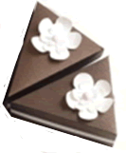

**Example 2** **A bit less…**

I had of a cake in the fridge; I ate 1 slice, or of the cake.

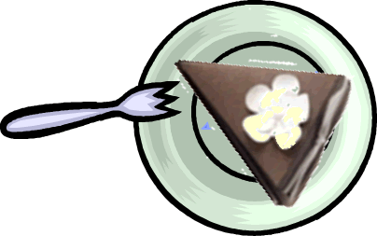There were 2 slices, or  of the cake left over

As a number sentence:  −  =  = 

Notice we subtract the **numerators.**

|  |  |
| --- | --- |
| C:\Users\CFord\Documents\MY Folders\CurricDev2012\images\exerrcise1.gif |  |
| **Task 3 Activity 1: Warm-up: add and subtract fractions** |
|  |

**Question 1** **Adding fractions**

Shade the shapes to work out these additions.

|  |  |  |  |  |  |  |
| --- | --- | --- | --- | --- | --- | --- |
| **(a)** |  | = |  | **(b)** |  | = |
| **(c)** |  | = |  | **(d)** |  | = |

**Question 2** Number **stories**

Think of a number story to match each addition. Then work out the answers.

|  |  |  |
| --- | --- | --- |
|  | The fraction addition | Think of a number story |
| **(a)** | +  = |  |
| **(b)** | +  = |  |
| **(c)** | +  = |  |
| **(d)** | +  + = |  |
| **(e)** | +  + = |  |

**Question 3** **Subtracting fractions**

|  |  |  |
| --- | --- | --- |
| Shade shapes to work out these subtractions. The first one is done as an example. |  | −  = |

|  |  |  |  |  |  |  |
| --- | --- | --- | --- | --- | --- | --- |
| **(a)** | −  = |  |  | **(b)** | −  = |  |
| **(c)** | −  = |  |  | **(d)** | −  = |  |

**Question 4** Number **stories**

Think of a number story to match each addition. Then work out the answers.

|  |  |  |
| --- | --- | --- |
|  | The fraction addition | Think of a number story |
| **(a)** | −  = |  |
| **(b)** | −  = |  |
| **(c)** | −  = |  |
| **(d)** | −  = |  |

**Question 5 Apply your skills**

|  |  |  |  |
| --- | --- | --- | --- |
| **(a)** | Tammy cut a loaf into **8 equal slices**, and ate 2 slices..  What **fraction** of the loaf was left?  The whole loaf weighed 500 grams. What amount was left? | | C:\Users\CFord\Documents\MY Folders\CurricDev2012\images\module5\dough_eighths.gif |
| **(b)** | Tom spent  of his money on a magazine, and another  on takeaway food. What fraction of his pocket money did he have left?  He started with $15. How much did he have left? |  | |
| **(c)** | In Tania’s last basketball game she played goal defence for **two fifths** of the game, and played forward for the rest of the game.  What fraction of the game did she spend playing forward? | | C:\Users\CFord\Documents\MY Folders\CurricDev2012\images\module5\clockface.gif |
|  | The match lasted **40 minutes.** How long did Tania play defence? | | |

|  |  |  |  |  |
| --- | --- | --- | --- | --- |
|  |  |  |  |  |
|  |  |
|  |  |
|  |  |
|  |  |
|  |  |

**Supervisors, please note:**

There are no ‘solutions’ to this activity.

When you add fractions with common denominators, the denominator stays the same. You are adding, 1/4s and 1/4s, the answer will be in 1/4s.



If you need help with adding simple fractions with common denominators, please call your teacher immediately.

|  |  |  |  |  |
| --- | --- | --- | --- | --- |
|  |  |  |  |  |
|  |  |
|  |  |
|  |  |
|  |  |
|  |  |

**Supervisors, please note:**

When you add fractions with common denominators, the denominator stays the same. You are adding, 1/4s and 1/4s, the answer will be in 1/4s.

**Try a challenge problem**

Maths is about solving problems. See how you go with this one.

|  |  |
| --- | --- |
|  |  |

|  |  |
| --- | --- |
| The makers of Trusty-Bite dog food conducted a survey of dog owners.  They say their survey shows that more than half of owners let their dogs sleep in their bedroom. Are they correct?  Here’s the story… | Trusty-Bite for dogs  More than half of pet dogs sleep with their owners…  so treat them well  with Trusty-Bite |

|  |
| --- |
| *A survey of* ***1200 dog owners*** *who buy ‘Trusty-Bite’ dog food found that* ***800*** *admitted to letting their dog sleep in their bedroom.*  ***One tenth*** *of everyone surveyed said they had to leave their dog in the kitchen overnight, because the dog’s snores kept them awake.*  *A spokesman said, “This survey shows that* ***three out of five*** *owners allow their dogs in the bedroom. Dogs are treated as one of the family.”* |

Let’s see if the story is true. Work through these questions to find out.

**Question 1**

1200 people were surveyed. 800 let their dog sleep in the bedroom. What fraction is this?

|  |
| --- |
|  |

**Question 2**

One tenth of the 1200 surveyed said they had to leave their dog in the kitchen overnight. How many owners is this?

|  |
| --- |
|  |

**Question 3**

The story says that three out of five owners surveyed let their dog sleep in the bedroom.

**(a)** What fraction is this?

|  |
| --- |
|  |

**(b)** How many people would this be?

|  |
| --- |
|  |

**(c)** Is it the same as the number of people mentioned in Question 1?

|  |
| --- |
|  |

**(d)** Is it more than ? How can you tell?

|  |
| --- |
|  |

**Question 4**

Based on your answers to the questions above, how would you rewrite the story?

|  |
| --- |
|  |

# Task 4 Apply your fraction skills

# C:\Users\cford\Documents\MY Folders\CurricDev2012\images\module5\park label.gif …design a park

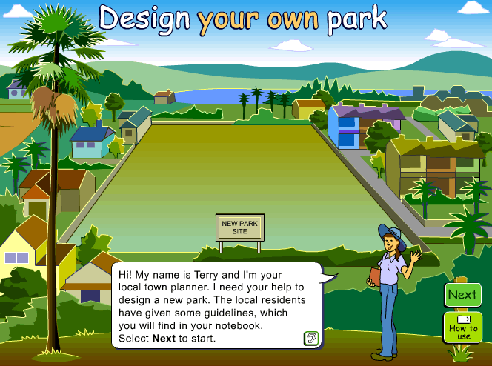**The new park:**

A new park is being built, and you have been asked to help design the layout of the grounds.

The park will have bushland, grassy areas and possibly gardens for people to enjoy. It could also have extras such as a bike track, swings or a pond.

You will be using a Maths Interactive to complete your design.

Let’s see an example.

|  |  |
| --- | --- |
| You must choose the grid for the park, from 1 to 6 rows and 1 to 6 columns.  C:\Users\cford\Documents\MY Folders\CurricDev2012\images\module5\park2c.gif | The grid you choose depends on the fractions the ranger gives you.  In this example the ranger has said  of the park is bushland  and  of the park is grass.  To make the most of the park area, choose the **biggest numbers** that can be **divided** in **halves** or into **fifths**.  I have chosen 5 rows (can be divided into fifths), and 6 columns (the largest number available that can be divided in half). |

|  |  |  |
| --- | --- | --- |
| **5 rows** and **6 columns** gives **30 squares** on the grid.  This grid will work for the fractions  and  because …  30 can be divided into fifths: 30 ÷ 5 = 6  30 can also be divided in half: 30 ÷ 2 = 15  Look at the ruler below the grid.  It shows equivalent fractions for  and . | C:\Users\cford\Documents\MY Folders\CurricDev2012\images\module5\park3a.gif | |
| is equivalent to and  is equivalent to  15 squares will be bushland and 6 squares will be grass. | | |
| Decide where each area will go.  **Half of the park** will be bushland. This is 15 squares.  Should it all be located in one place? Or would it be better to have pockets of bushland in different parts of the park?  Grass covers **one fifth of the park**. This is 6 squares.  Think of where you the grass could be located so that people who visit the park can enjoy it.  Also consider the other features of the park: the swings, the water pond, and the garden.  I started with the bushland and grass and tried two different arrangements.  To start again, I clicked ‘Clear grid’ | | Try some different arrangements:C:\Users\cford\Documents\MY Folders\CurricDev2012\images\module5\ex1.gif  C:\Users\cford\Documents\MY Folders\CurricDev2012\images\module5\ex2.gif |

|  |  |
| --- | --- |
| I used 15 + 6 = 21 squares on bushland and grass.  This left 9 squares for the other features of the park: the swings, a water pond and gardens.  I decided how many squares to allocate to each of these, and where they should go.  Finally, I input the fractions of each area, then checked the answer.  Notice the ruler shows the total fractions used. | C:\Users\cford\Documents\MY Folders\CurricDev2012\images\module5\ex3b.gif |



Your park will be different to this. Each time you start a new park the fractions will be different.

Let’s see an example.

You’re now ready to complete the activity… ***design a park***.

**Open this link:**

<http://www.scootle.edu.au/ec/pin/ROBSVG?userid=138808>

**OR**

<http://tinyurl.com/designpark>

**Part 1:** Open a new park. Look at the features your park will have.

Tick off the features given by the ranger.

Write the fractions the ranger has given you.

|  |  |  |  |  |  |  |  |
| --- | --- | --- | --- | --- | --- | --- | --- |
| Bushland |  | Garden |  | Grass |  | Swings |  |
| Bike track |  | Water |  | Bush regeneration |  |  |  |

**Part 2:** Choose a grid.

You can have up to 6 rows and 6 columns. Choose the largest number of rows and columns that lets you shade in the fractions the ranger gave you.

Complete the sentences below:

|  |
| --- |
| The grid I chose was …… rows and ….… columns  This grid provides …….. squares  My reasons for choosing this grid: …………………………………………………………………………………………………………………………………………………………………………………………………………………………………………………………………………………………………………………………………………………………………………………… |

**Part 3:** Shade in the fractions given by the ranger

The ranger gave you two fractions to start with. Before you decide how to shade them on your grid think of how the park will work.

Will you need to add gardens or a bike track later?

Where should things be located so that people can enjoy the park?

Try two different arrangements. You can use the grids on the next page or take screen shots from your computer.

Planning grids for the fractions given by the ranger.

Start with the fractions the ranger has given you. Use the grids below, or your computer, to try locating them in different ways.

Only shade the same number of rows and columns as your grid

Let’s see an example.



My grid has ……… rows and .………. columns

|  |  |  |  |  |  |  |
| --- | --- | --- | --- | --- | --- | --- |
|  | The first possible arrangement | | | | | |
| Which fractions did the ranger give you?  🞎 Bushland …………………….  🞎 Garden …………………….  🞎 Grass …………………….  🞎 Swings …………………….  🞎 Bike track …………………….  🞎 Water …………………….  🞎 Bush regeneration ……………. |  |  |  |  |  |  |
|  |  |  |  |  |  |
|  |  |  |  |  |  |
|  |  |  |  |  |  |
|  |  |  |  |  |  |
|  |  |  |  |  |  |

|  |  |  |  |  |  |  |
| --- | --- | --- | --- | --- | --- | --- |
|  | The second possible arrangement | | | | | |
|  |  |  |  |  |  |  |
|  |  |  |  |  |  |
|  |  |  |  |  |  |
|  |  |  |  |  |  |
|  |  |  |  |  |  |
|  |  |  |  |  |  |

Which arrangement do you prefer? Explain why.

|  |
| --- |
|  |

**Part 4:** The rest of the park.

Look at the other features in your park. How many squares should each feature have? Where should each area be located?

When you have decided, click shade the squares for each feature in the interactive.

**Part 5:** The fraction of each area.

Complete the fractions of each area on your plan.

Total the fractions to show they add up to one whole.

**Part 6:** Simplify the fractions.

Some of the fractions in your plan can be written in a simpler form.

For example shading 6 squares out of 30 gives a fraction of 

This fraction can be simplified. To simplify it, think of a number that will divide into the numerator and also the denominator.

|  |  |  |
| --- | --- | --- |
| The numerator, 6, can be divided by 6 →  The denominator, 30, can also be divided by 6 → | |  |
|  | ↑  The simplified fraction is | |

Tick the park features that appear on your plan. Write the shaded fractions.

Which fractions can be written in a simpler form?

|  |  |  |
| --- | --- | --- |
| The park feature | The shaded fraction | The fraction in a simpler form |
| 🞎 Bushland |  |  |
| 🞎 Garden |  |  |
| 🞎 Grass |  |  |
| 🞎 Swings |  |  |
| 🞎 Bike track |  |  |
| 🞎 Water |  |  |
| 🞎 Bush regeneration |  |  |
| Total |  |  |

Reflecting on your plan:

|  |  |
| --- | --- |
| **(a)** | How did you decide what area to give to each park feature; the swings, gardens, bike track and so on? |
|  | ……………………………………………………………………………………………………………………………………………………………………………………………………………………………………………………………………………………………………………………………………………………………… |
| **(b)** | How does the location of the different areas work for the people who use the park? Is there anything you would change?  ……………………………………………………………………………………………………………………………………………………………………………… ……………………………………………………………………………………………………………………………………………………………………………… ……………………………………………………………………………………… |

# Task 5 Fractions that add up to one whole

The park design project you did yesterday showed that when we divide an area into different parts, the fractions add up to one whole.

|  |  |  |
| --- | --- | --- |
| For example, my park design had a grid with 30 squares.  It was broken up into the areas shown in the table.  The areas added up to 30 squares:  =  The total  stands for the whole park. | My park plan | |
| Bushland |  |
| Grass |  |
| Swings |  |
| Water |  |
| Gardens |  |

Notice that to add up the fractions you add the numerators. This is because the numerator shows the parts of the whole that we are adding.

Let’s see an example.



|  |  |
| --- | --- |
| ***Description: j0229369*** |  |
| **Task 5 Activity 1: Adding and subtracting fractions** | |
|  |

**Question 1**  Revise adding and subtracting fractions

|  |  |  |  |
| --- | --- | --- | --- |
| **(a)** | +  = | **(b)** | −  = |
| **(c)** | +  = | **(d)** | +  = |
| **(e)** | −  = | **(f)** | −  = |
| **(g)** | +  = | **(h)** | −  = |
| **(i)** | 1 −  =  −  = | **(j)** | 1 −  =  −  = |

**Question 2**

(a) Circle the groups of fractions add up to **one whole**.

(b) For those that don’t add up to one whole, what fraction is missing?

|  |  |  |  |  |  |
| --- | --- | --- | --- | --- | --- |
| Group A |  | Group B |  | Group C |  |

|  |  |  |  |  |
| --- | --- | --- | --- | --- |
| Group D |  | Group E |  |  |

**½**

**¾**

**⅜**

**⅔**

# Fractions with different denominators



To add fractions, each fraction needs to have **the same denominator**. If fractions have **different denominators**, we need to **change** them into **equivalent fractions** so that they have **same denominator**.

|  |  |
| --- | --- |
| ***Description: j0229369*** |  |
| **Task 5 Activity 2: Fractions with different denominators** |
|  |

**Question 1** Adding fractions

Fraction bars are an easy way to revise adding fractions.

This fraction bar below is divided into eighths.

Each section is one eighth, , of the bar.

|  |  |  |  |  |  |  |  |  |  |  |  |  |
| --- | --- | --- | --- | --- | --- | --- | --- | --- | --- | --- | --- | --- |
|  |  |  |  | |  | |  |  |  |  |  | +  =  +  =  = |
|  |  | |  | | | | |  |  |  |  |
| 2 squares is one quarter of the bar.  = | | | |  | | 3 squares is  three eighths, , of the bar. | | | | | |

Shade each fraction in a different colour on the fraction bars.

Then add the fractions and complete the number sentences.

|  |  |  |  |  |  |  |  |  |  |  |  |  |  |  |  |  |  |
| --- | --- | --- | --- | --- | --- | --- | --- | --- | --- | --- | --- | --- | --- | --- | --- | --- | --- |
| **(a)** | +  = | | …………………………. | | | | | **(b)** | +  = | | | …………………………. | | | | | |
|  |  |  | |  |  |  |  |  |  |  |  | |  |  |  |  |  |

|  |  |  |  |  |  |  |  |  |  |  |  |  |  |  |  |  |  |  |  |  |  |  |  |
| --- | --- | --- | --- | --- | --- | --- | --- | --- | --- | --- | --- | --- | --- | --- | --- | --- | --- | --- | --- | --- | --- | --- | --- |
| **(c)** | +  = | | | | ………………………… | | | | | | | | | **(d)** | +  = | | | …………………………. | | | | | |
|  |  |  |  |  | |  |  |  |  |  |  |  |  |  |  |  |  | |  |  |  |  |  |

|  |  |  |  |  |  |  |  |  |  |  |  |  |  |  |  |  |  |  |  |  |  |  |  |
| --- | --- | --- | --- | --- | --- | --- | --- | --- | --- | --- | --- | --- | --- | --- | --- | --- | --- | --- | --- | --- | --- | --- | --- |
| **(e)** | +  = | | | | ………………………… | | | | | | | | | **(f)** | +  = | | | …………………………. | | | | | |
|  |  |  |  |  | |  |  |  |  |  |  |  |  |  |  |  |  | |  |  |  |  |  |

**Question 2** Subtracting from one

Shade the fraction we are taking away. Write the fraction that is left.

|  |  |  |  |  |  |  |  |  |  |  |  |  |  |  |  |  |  |  |  |  |  |  |  |
| --- | --- | --- | --- | --- | --- | --- | --- | --- | --- | --- | --- | --- | --- | --- | --- | --- | --- | --- | --- | --- | --- | --- | --- |
| **(a)** | 1 −  = | | | ………………………… | | | | | | **(b)** | 1 −  = | | | | …………………………. | | | | | | | | |
|  |  |  |  | |  |  |  |  |  |  |  |  |  |  | |  |  |  |  |  |  |  |  |

|  |  |  |  |  |  |  |  |  |  |  |  |  |  |  |  |  |  |  |  |
| --- | --- | --- | --- | --- | --- | --- | --- | --- | --- | --- | --- | --- | --- | --- | --- | --- | --- | --- | --- |
| **(c)** | 1 −  = | | ………………………… | | | | | **(d)** | 1 −  = | | | | …………………………. | | | | | | |
|  |  |  | |  |  |  |  |  |  |  |  |  | |  |  |  |  |  |  |

**Subtracting fractions from whole numbers.**

There are many ways to complete this subtraction problem. 9 - 4/5

* Start at 9 and count backwards by fifths (1/5)

or

* Take 1 away from 9, then take 4/5 away from that.

or

* Convert to common denominators 45/5 – 4/5 = 41/5 = 41 ÷5 = 81/5

Can you see that 45/5 is the same as 45 ÷5 = 9?

|  |  |  |  |  |
| --- | --- | --- | --- | --- |
|  |  |  |  |  |
|  |  |
|  |  |
|  |  |
|  |  |
|  |  |

|  |  |
| --- | --- |
| ***Description: j0229369*** |  |
| **Task 5 Activity 3: Apply your fraction skills** |
|  |

Based on an activity from Targeting Maths for Victoria, Year 6, Pascal Press

Harry’s Pizza Café lets customers select slices from the pizza menu.

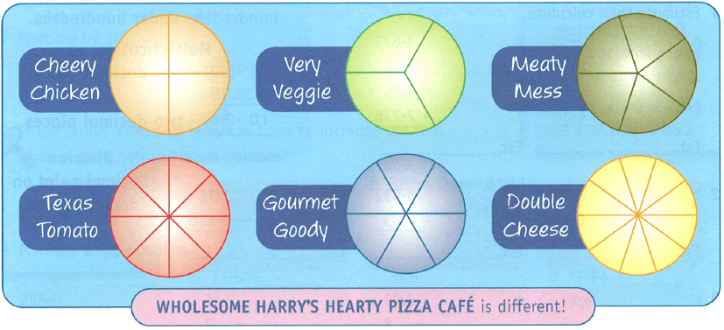

Targeting Maths for Victoria, Year 6, Pascal Press, p.20

|  |  |
| --- | --- |
| **(a)** | The pizzas are cut into different fractions.  Fill in the missing parts of the table. |

|  |  |  |
| --- | --- | --- |
| Cheery Chicken: | Very Veggie: | Meaty Mess: |
| Texas Tomato: | Gourmet Goody: | Double Cheese: |

|  |  |
| --- | --- |
| **(b)** | Customers can choose slices from the pizza menu.  Harry charges according to the total fraction they’ve eaten.  For example, Tonya ordered three slices of Double Cheese pizza, and a slice of Meaty Mess.  Each Double Cheese slice is  of the whole pizza.  Three slices is  of the pizza.  Each Meaty Mess slice is  of the whole pizza. |

|  |  |  |  |
| --- | --- | --- | --- |
|  | The total fraction Tonya ate was  Five tenths can be simplified | +  Change fifths into tenths before adding.    +        The total fraction eaten was half a pizza |  |

The table shows the orders from six customers. Work out the total fraction each person ate. Simplify your answer where you can. The first one is done as an example.

|  |  |  |
| --- | --- | --- |
| Customer’s order | The total fraction eaten | Can the answer be simplified? |
| 1 slices Double Cheese  2 slices Meaty Mess | =  = = | = |
| 1 slice Very Veggie  2 slices Gourmet Goody |  |  |
| 2 slices Cheery Chicken  1 slice Texas Tomato |  |  |
| 4 slices Double Cheese  1 slice Meaty Mess |  |  |
| 3 slices Texas Tomato  1 slice Cheery Chicken |  |  |
| 3 slices Gourmet Goody  1 slices Very Veggie |  |  |

|  |  |
| --- | --- |
| **(c)** | Harry has a special offer: Customers can have any combination of slices they like. If a customer’s order adds up to one whole pizza, it’s half price!  Which customers below will only pay half price? |

|  |  |  |
| --- | --- | --- |
| Sam | Trina | Josie |
| 2 slices Gourmet Goody  4 slices Texas Tomato | 4 slices Texas Tomato  1 slice Very Veggie  1 slice Gourmet Goody | 2 slices Cheery Chicken  3 slices Double Cheese  1 slice Meaty Mess |

# Task 6 Mixed numbers…

# part whole number and part fraction

We will be looking at mixed numbers, revising division skills, and applying these skills to solve problems



|  |  |
| --- | --- |
| C:\Users\CFord\Documents\MY Folders\CurricDev2012\images\exerrcise1.gif |  |
| **Task 6 Activity 1: Skills Warm-up…** |
|  |

**Question 1 Adding whole numbers to fractions**

Adding a fraction to a number creates a mixed number: part whole number, and part fraction:

|  |  |
| --- | --- |
| C:\Users\cford\Documents\MY Folders\CurricDev2012\images\module5\one-half.gif | One whole plus one half gives one and one half  1 +  = 1 |

Complete the missing parts of these number sentences:

|  |  |  |  |  |
| --- | --- | --- | --- | --- |
| **(a)** | 4 +  = |  | **(b)** | 2 +  = |
| **(c)** | + 3 = |  | **(d)** | + 5 = |
| **(e)** | +  = 5 |  | **(f)** | +  = 3 |
| **(g)** | 6 +  = 6 |  | **(h)** | + 3 = 3 |
| **(i)** | + 2 = 6 |  | **(j)** | − 5 = 1 |

**Question 2 ‘Improper fractions’ and mixed numbers**

A mixed number can sometimes be shown as a fraction,

called an ***improper fraction***.









**Improper fractions** are part **whole number and part fraction.** We can recognise them because the **numerator** is **bigger** than the **denominator**.

**(a) Thirds:** The number line below is divided into thirds.

Fill in the missing numbers on the line.



0

1



2

3

4





1









5

2

4



























Use your completed number line to fill in the missing parts of these number sentences:

|  |  |  |  |  |  |
| --- | --- | --- | --- | --- | --- |
| **(i)** | 2 = | **(ii)** | = | **(iii)** | = |

**(b) Quarters:** Fill in the missing numbers on the number line.



0

1

2

3

4











1

3



2

































Use your completed number line to fill in the missing parts of these number sentences:

|  |  |  |  |  |  |
| --- | --- | --- | --- | --- | --- |
| **(i)** | 3 = | **(ii)** | = | **(iii)** | = |

**(c) Fifths:** Fill in the missing numbers on the number line.



0

1

2

3













1

2































Use your completed number line to fill in the missing parts of these number sentences:

|  |  |  |  |  |  |
| --- | --- | --- | --- | --- | --- |
| **(i)** | 2 = | **(ii)** | = | **(iii)** | = |

# When the answer is a mixed number

A **mixed number** can shown as an **improper fraction**.

For example, Sammi served **two chocolate cakes** at her party; **each cake** was cut into **14 slices.**

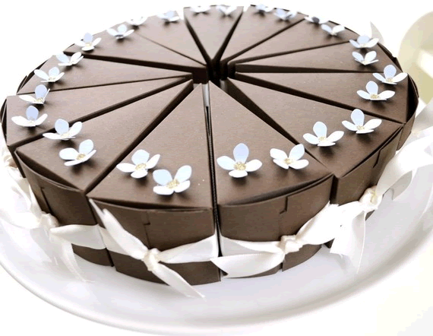

Her friends ate **9 slices** from one cake and **8** from the other.

The total fraction they ate was  +  =  = 

 is an improper fraction.

Convert it into a mixed number:  =  +  = 1

They ate one whole cake and 3 slices out of 14.

|  |  |
| --- | --- |
| ***Description: j0229369*** |  |
| **Task 6 Activity 2: Answers that are mixed numbers** |
|  |

**Question 1 Changing improper fractions to mixed numbers**

Add the fractions below, then convert the answer into a mixed number.

|  |  |  |  |
| --- | --- | --- | --- |
| **(a)** | +  = | **(b)** | +  = |
| **(c)** | +  = | **(d)** | +  +  = |
| **(e)** | +  +  = | **(f)** | +  +  = |
| **(g)** |  | **(h)** | +  +  = |
| **(i)** | +  +  = | **(j)** | +  +  = |

**Question 2 Change mixed numbers to improper fractions**

In the warm-up exercise you saw how to find **mixed numbers** and **improper fractions** on a number line.

Now let’s see how to change mixed numbers into improper fractions without the number line.

|  |  |  |  |
| --- | --- | --- | --- |
| 1 = 1 +  + |  | 3 = 3 +  Notice that  3 is the same as  +  +  =  Or just  =  +  + |  |

Change the following mixed numbers into improper fractions.

|  |  |  |  |
| --- | --- | --- | --- |
| **(a)** | 2 = | **(b)** | 1 = |
| **(c)** | 3 = | **(d)** | 4 = |
| **(e)** | 2 = | **(f)** | 2 = |
| **(g)** | 1 = | **(h)** | 3 = |

**Question 3 Crack the code**

Add the following fractions in each question below. Notice you will have to change one of them so both denominators are the same.

Write the letter above the correct answer and crack the code.

|  |  |  |  |
| --- | --- | --- | --- |
| A | +  =  +  = ……………….. | N | +  =  = ……………….. |
| O | +  =  +  = ……………….. | F | +  =  +  = ……………….. |
| C | +  =  +  = ……………….. | T | +  =  +  = ……………….. |
| M | +  = | P | +  = |
| I | +  = | U | +  = |
| S | + | H | +  = |

|  |  |  |  |  |  |  |  |  |  |  |  |  |  |  |  |  |  |  |  |  |
| --- | --- | --- | --- | --- | --- | --- | --- | --- | --- | --- | --- | --- | --- | --- | --- | --- | --- | --- | --- | --- |
|  |  | |  | |  | |  | |  | |  | |  | |  | |  |  |  | |
|  |  | |  | |  | |  | |  | |  | |  | |  | |  |  |  | |
|  | |  | |  | |  | |  | |  | |  | |  | | N | |  | |
|  | |  | |  | |  | |  | |  | |  | |  | |  | |  | |

**Question 4** **Apply your skills**:

Sam’s mother says he watches too much TV, but Sam says he doesn’t.

To prove it Sam timed how long he spent watching TV.

Last Friday he watched a show for  of an hour.

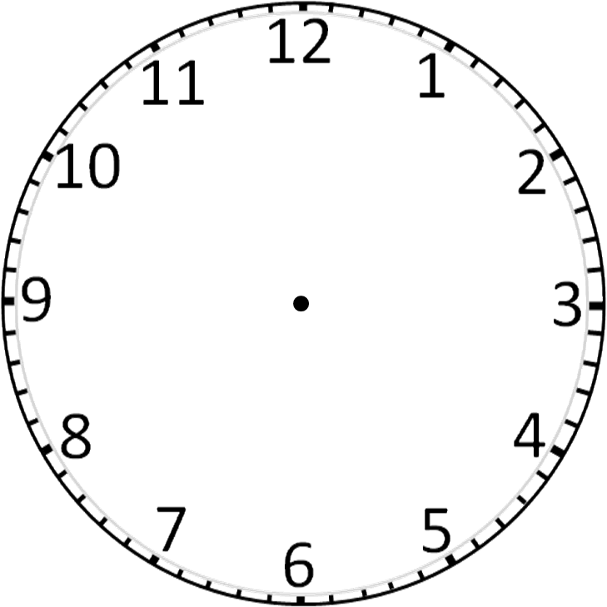

He had dinner, then watched TV for another  an hour.

The total time he spent watching TV was  of an hour plus  an hour.

|  |  |  |
| --- | --- | --- |
| Five quarters of an hour  equals  +  1 + | plus  Change one half, , into quarters so we can add the fractions.  plus      1 hours |  |



**Sam’s TV times:**

Sam kept a record of the hours he watched TV. He recorded the times as fractions of an hour instead of minutes.

Complete the table on the next page to work out how many hours of TV he watched each day.

If your answer is an improper fraction, change it into a mixed number.

|  |  |
| --- | --- |
| The TV programs watched | Total hours spent watching TV each day. |
| Monday: |  |
| Sports replay:  hour |
| Comedy:  hour |
| Tuesday: |  |
| Travel show:  hour |
| Movie:  hour |
| Wednesday: |  |
| Game show:  hour |
| Comedy:  hour |
| Thursday: |  |
| News:  hour |
| Sports match:  hour |

Sam’s mother asks Sam if he watches more than an hour of TV every day.

He says he doesn’t. Do his recorded times agree with this?

|  |
| --- |
| ……………………………………………………………………………………………………………………………………………………………………………………………………………………………………………………………………………………………………………………………………………………………………………………………………………………………………………………………………………………………………………………………………………….…………… |

# Task 7 Apply your skills….

# solving problems with mixed numbers

|  |  |
| --- | --- |
| C:\Users\CFord\Documents\MY Folders\CurricDev2012\images\exerrcise1.gif |  |
| **Task 7 Activity 1: Skills Warm-up** |
|  |

**Question 1 Subtracting a fraction from one whole**

To subtract a fraction from a whole, divide the whole into fractions.

For example, look at the problem 1 − 

←

→

←

How many thirds are in one whole?

There are three thirds, , in one whole.

This makes it easier to solve −  = 

Rename the wholes as fractions. Shade the diagrams to solve each problem.

|  |  |  |  |  |  |
| --- | --- | --- | --- | --- | --- |
| **(a)** | 1 −  −  = |  | **(b)** | 1 −  −  = |  |
| **(c)** | 2 −  −  =  = |  | **(d)** | 2 −  −  =  = |  |

**Question 2 Adding and subtracting mixed numbers**

When we add mixed numbers we add the numbers and fractions separately. Sometimes we can do the same when we subtract.

|  |  |  |
| --- | --- | --- |
| 1 +  1 + (  + )  1 +  1 +  +  ← =  1 + 1 +  = 2 |  | 7 − 4  Subtract the numbers and fractions separately  (7 − 4) (  − )  3  3 +  = 3 ←=  = 3 |

|  |  |  |  |
| --- | --- | --- | --- |
| **(a)** | 1 +  +  + | **(b)** | 6 − 1  −   − |

|  |  |  |  |
| --- | --- | --- | --- |
| **(c)** | 1 + 2  +  + | **(d)** | 3 − 1  −   − |

|  |  |  |  |
| --- | --- | --- | --- |
| **(e)** | + 1 = | **(f)** | 2 + 1 = |

|  |  |  |  |
| --- | --- | --- | --- |
| **(g)** | 1 +  = | **(h)** | 5 − 1 = |

# Mixed numbers in practical problems

**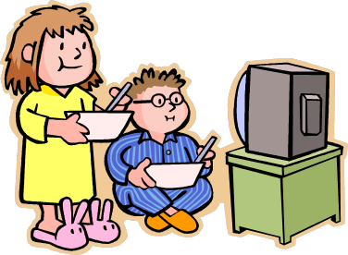Example 1: Movie marathon**

On Saturday we watched movies for 3 hours, and for 2 hours on Sunday.

The total number of hours we spent was 3 hours plus 2 hours.

|  |  |  |  |  |
| --- | --- | --- | --- | --- |
| Add the whole numbers →  3 + 2 = 5 |  | 3 + 2 plus  +  5 plus  +  5 plus |  | ←Add the fractions:  To add  +  we need to change them into fractions with the same denominator. |
|  |  |  |
|  |  |  |  |

|  |
| --- |
| ↑  Count by threes 3, 6, 9, **12**, ……  Count by fours 4, 8, **12** , ……  Stop when you reach the same number: 12  The new denominator will be 12 |

The answer is 5 hours.

Notice that  of an hour is 5 minutes.

 of an hour is 7 × 5 = 35 minutes.

So we watched movies over the weekend for 5 hours and 35 minutes.

**Example 2 What’s left?**

I had 2 boxes of chocolates. One friend ate of a box, another ate  a box, and a third friend ate another .

|  |  |  |
| --- | --- | --- |
| The total amount did they eat altogether was | +  +  +  +  =  = 1 |  |
| They ate one box in total → | C:\Users\CFord\Documents\MY Folders\CurricDev2012\images\module5\boxchocs.gif |

The amount of chocolates I had left was 2 − 1 = (2 − 1) + 

= 1boxes left.

|  |  |
| --- | --- |
| ***Description: j0229369*** |  |
| **Task 7 Activity 2: Solving problems with mixed numbers** |
|  |

**Question 1 Warm up: Adding fractions with different denominators**

Fill in the missing parts of these questions:

|  |  |  |
| --- | --- | --- |
| **(a)** | +  =  +  = | Think: 2 × …… = 10  5 × …… = 10 |

|  |  |  |
| --- | --- | --- |
| **(b)** | +  =  +  = | Think: 3 × …… = 15  5 × …… = 15 |

|  |  |  |
| --- | --- | --- |
| **(c)** | +  =  +  = | Think: 4 × …… = 12  6 × …… = 12 |

|  |  |  |
| --- | --- | --- |
| **(d)** | +  =  +  =  = | Think: 3 × …… = 6  2 × …… = 6 |

|  |  |  |
| --- | --- | --- |
| **(e)** | +  =  +  =  = | Think: 7 × …… = 14  2 × …… = 14 |

**Question 2 Skills practise: Find the new denominator**

* Use the multiples shown to find the first common number.
* Change each fraction to the same denominator, then add them together

The first one is done as an example:

|  |  |  |  |
| --- | --- | --- | --- |
|  | +  =  +  + | 3, 6, 9, 12, 15, 18, 21, ….  5, 10, 15, 20, 25, 30, …. |  |
|  |  |  |

|  |  |  |  |
| --- | --- | --- | --- |
| **(a)** | +  = | 5, 10, 15, 20, 25, 30, ….  6, 12, 18, 24, 30, 36 ….. |  |

|  |  |  |  |
| --- | --- | --- | --- |
| **(b)** | +  = | 4, 8, 12, 16, 20, 24, 28, 32, ….  7, 14, 21, 28, 35, 42, 49, 56, … |  |

|  |  |  |  |
| --- | --- | --- | --- |
| **(c)** | +  = | 4, 8, 12, 16, 20, 24, 28, 32, …  5, 10, 15, 20, 25, 30, …. |  |

|  |  |  |  |
| --- | --- | --- | --- |
| **(d)** | +  = | 4, 8, 12, 16, 20, 24, 28, 32, …  6, 12, 15, 18, 21, 24, 27, … |  |

|  |  |  |  |
| --- | --- | --- | --- |
| **(e)** | +  = | 3, 6, 9 12, 15, 18, 21, 24, …  8, 16, 24, 32, 40, 48, 56, … |  |

**Question 3 Solving problems**:

|  |  |
| --- | --- |
| **(a)** | Sally and Joe go to a market sale. Joe finds 3 boxes of scrap material, and Sally finds 1 boxes of scrap. How many boxes do they find in total? |
|  |  |
|  | In another visit to the market, Joe finds 2 boxes of scrap.  He gives 1 boxes to Sally. How many boxes does he have left? |
|  |  |
|  | Joe’s collection of scrap has grown over the years. He found 5 full boxes and decided to sell some of it. He was left with 1 boxes of scrap. How many boxes of scrap did he sell? |
|  |  |

|  |  |
| --- | --- |
| **(b)** | C:\Users\CFord\Documents\MY Folders\CurricDev2012\images\module5\tennis.gifBillie’s tennis practice included 2 hours on Tuesday and 1 hours on Friday. How many hours practice did she do altogether? |
|  |  |
|  |  |
|  |  |

**4.** Find possible fractions and mixed numbers to make these number sentences correct:

|  |  |  |  |
| --- | --- | --- | --- |
| **(a)** | + 1 = 5 | **(b)** | − 1 = 3 |

# Apply your skills….

# draw a diagram to solve problems

We use fractions in a lot in practical problems.

It often helps to draw a diagram to solve the question.



**Example 1**

|  |  |  |
| --- | --- | --- |
| C:\Users\CFord\Documents\MY Folders\CurricDev2012\images\module5\salami.gif | Mum bought  of a kilogram of salami.  The price was $12 per kilogram.  She paid  of $12  $12 divided into four equal amounts is  $12 ÷ 4 = $3  Mum paid $3 for the salami. |  |

**Example 2**

|  |  |  |
| --- | --- | --- |
| C:\Users\CFord\Documents\MY Folders\CurricDev2012\images\module5\deskcds.gif | I have 5 music CDs on my desk.  They are only one third of all my CDs.  5 CDs is one group out of three groups.  The total CDs would be 3 groups of 5 CDs.  3 × 5 CDs = 15 CDs altogether. |  |

|  |  |
| --- | --- |
|  |  |
| **Task 7 Activity 3: Consolidate your skills** |
|  |

Solve these fraction problems:

|  |  |  |
| --- | --- | --- |
| **1** | 18 players ate half an orange each at half time. How many oranges were eaten? | ……………… |
| **2** | Greg saved 3/10 in a money box, 6/10 in the bank and the rest was in his pocket. What fraction of his money was in his pocket? | ……………… |
| **3** | Maddy has 7 fish, 2 birds and 1 rabbit. What fraction of her pets are fish? | ……………… |
| **4** | My mum and dad have 5 children: 3 boys and 2 girls. What fraction of the children are boys? | ……………… |
| **5** | 122 students attended the sports day. This is exactly 1/3 of the whole school. How many students are at my school? | ……………… |
| **6** | Jack get $40 per month pocket money. He keeps 1/4 and puts the rest in a bank. How much money does he keep? | ……………… |
| **7** | Mum bought 1/4 kg of cheese. It cost $32 per kg. How much did she pay? | ……………… |
| **8** | A container holds 100 litres of water, If it’s 3/4 full , how many litres of water have been used? | ……………… |
| **9** | If 1/4 of my money is $3.15, how much money do I have altogether? | ……………… |
| **10** | If 1/10 of my footy cards is 23, how many cards do I have altogether? | ……………… |

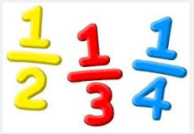

# Task 8 Ways of sharing…. revising division

|  |  |
| --- | --- |
| C:\Users\CFord\Documents\MY Folders\CurricDev2012\images\exerrcise1.gif |  |
| **Task 8 Activity 1: Warm-up: division facts recall** |
|  |

**Question 1 Multiplication and division facts**

Division facts come from multiplication facts.

Write a fact family for each set of numbers in the triangle, similar to this example.

|  |  |  |
| --- | --- | --- |
|  |  |  |
|  | 5  10  50 |  |
| Multiplication facts |  | Division facts |

|  |  |  |  |  |
| --- | --- | --- | --- | --- |
| **(a)** |  |  | 7  6  42 |  |
|  |  | Multiplication facts |  | Division facts |

|  |  |  |  |  |
| --- | --- | --- | --- | --- |
| **(b)** |  |  | 9  8  72 |  |
|  |  | Multiplication facts |  | Division facts |

|  |  |  |  |  |
| --- | --- | --- | --- | --- |
| **(c)** |  |  | 9  5  45 |  |
|  |  | Multiplication facts |  | Division facts |

|  |  |  |  |  |
| --- | --- | --- | --- | --- |
| **(d)** |  |  | 4  30  120 |  |
|  |  | Multiplication facts |  | Division facts |

|  |  |  |  |  |
| --- | --- | --- | --- | --- |
| **(e)** |  |  | 13  5  65 |  |
|  |  | Multiplication facts |  | Division facts |

**Question 2 Find the missing number**

|  |  |  |
| --- | --- | --- |
| Which numbers would complete the triangles? | | |
| 11  88  Think:    The missing number is 8 |  | 20  800  Think:  20 × 4 = 80  20 × 40 = 800  The missing number is 40 |

To find the missing numbers, use your knowledge of multiplication tables. To refresh your memory, look up the tables grid on **page 63**, or work it out with pen and paper.

|  |  |  |  |
| --- | --- | --- | --- |
| **(a)** | 7  42 | **(b)** | 54 |
|  | Division facts: |  | Division facts: |

|  |  |  |  |
| --- | --- | --- | --- |
| **(c)** | 81 | **(d)** | 63 |
|  | Division facts: |  | Division facts: |

|  |  |  |  |
| --- | --- | --- | --- |
| **(e)** | 20  600 | **(f)** | 70  140 |
|  | Division facts: |  | Division facts: |

|  |  |  |  |
| --- | --- | --- | --- |
| **(g)** | 50  200 | **(h)** | 4  320 |
|  | Division facts: |  | Division facts: |

**Question 3 Division facts to solve problems**

Think of a multiplication fact to help write the division fact and solve the problems.

|  |  |  |
| --- | --- | --- |
| **(a)** | $300 is shared equally between 5 people.  How much does each person receive? | |
|  | Multiplication fact: | Division fact: |
|  |  | |
| **(b)** | Four friends share the cost of a $2000 trip.  How much does each friend pay? | |
|  | Multiplication fact: | Division fact: |

# Mental division … what’s my strategy?



Mental division is easier when we have some strategies

**Example 1 The halving strategy**

Halve to divide in two

|  |  |  |  |  |  |
| --- | --- | --- | --- | --- | --- |
|  |  |  |  |  | |
|  |  | **Halve** |  |  |  |
|  | 20 | **→** | 10 | Half of 2 tens is one ten | 20 ÷ 2 = 10 |
|  | 120 | **→** | 60 | Half of 12 tens is 6 tens | 120 ÷ 2 = 60 |
|  | 50 | **→** | 25 | Half of 50 is 25 | 50 ÷ 2 = 25 |
|  |  |  |  |  | |

Use the twos number facts to halve.

For example, 2 groups of 6 is 12 2 × 6 = 12

Half of 12 is 6 12 ÷ 2 = 6

Dividing into four; halve, then halve again

|  |  |  |  |  |  |  |
| --- | --- | --- | --- | --- | --- | --- |
|  |  |  |  |  |  |  |
|  |  | **Halve** |  | **Halve** |  |  |
|  | 20 | **→** | 10 | **→** | 5 | 20 ÷ 4 = 5 |
|  | 120 | **→** | 60 | **→** | 30 | 120 ÷ 4 = 30 |
|  |  |  |  |  |  |  |

**Example 2 Dividing by tens strategy**

|  |  |  |  |  |
| --- | --- | --- | --- | --- |
|  |  |  |  | |
|  | 80 ÷ 20 | 8 tens ÷ 2 tens | 8 ÷ 2 = 4 |  |
|  | 630 ÷ 30 | 63 tens ÷ 3 tens | 63 ÷ 3 = 21 |  |
|  | 120 ÷ 40 | 12 tens ÷ 4 tens | 12 ÷ 4 = 3 |  |
|  |  |  |  | |

Use the tens number facts when dividing by tens.

For example, 4 groups of 20 is 80 4 × 20 = 80

80 ÷ 20 = 4

|  |  |
| --- | --- |
| ***Description: j0229369*** |  |
| **Task 8 Activity 2: The halving and tens strategies** |
|  |

**Question 1**

Complete the following divisions using the halving strategy.

|  |  |  |  |  |
| --- | --- | --- | --- | --- |
|  |  | **Halve** |  |  |
|  | 24 | **→** |  | ÷ 2 = |
|  |  |  |  |  |
|  | 30 | **→** |  |  |
|  |  |  |  |  |
|  | 140 | **→** |  |  |
|  |  |  |  |  |
|  | 160 | **→** |  |  |
|  |  |  |  |  |
|  | 800 | **→** |  |  |
|  |  |  |  |  |

**Question 2**

Complete the following divisions using the halve, then halve again strategy.

|  |  |  |  |  |  |  |
| --- | --- | --- | --- | --- | --- | --- |
|  |  | **Halve** |  | **Halve** |  |  |
|  | 80 | **→** |  | **→** |  | ÷ 4 = |
|  |  |  |  |  |  |  |
|  | 200 | **→** |  | **→** |  |  |
|  |  |  |  |  |  |  |
|  | 160 | **→** |  | **→** |  |  |
|  |  |  |  |  |  |  |
|  | 484 | **→** |  | **→** |  |  |
|  |  |  |  |  |  |  |
|  | 240 | **→** |  | **→** |  |  |
|  |  |  |  |  |  |  |
|  | 480 | **→** |  | **→** |  |  |
|  |  |  |  |  |  |  |

**Question 3**

Complete the following divisions using the divide-by-tens strategy.

|  |  |  |  |  |
| --- | --- | --- | --- | --- |
|  |  |  |  | |
|  | 400 ÷ 10 | tens ÷  tens | ÷  = |  |
|  | 450 ÷ 90 | tens ÷  tens | ÷  = |  |
|  | 350 ÷ 50 | tens ÷  tens | ÷  = |  |
|  | 600 ÷ 30 | tens ÷  tens | ÷  = |  |
|  | 500 ÷ 20 | tens ÷  tens | ÷  = |  |
|  | 420 ÷ 70 | tens ÷  tens | ÷  = |  |
|  | 1500 ÷ 50 | tens ÷  ten | ÷  = |  |
|  | 1800 ÷ 90 | tens ÷  ten | ÷  = |  |
|  | 3000 ÷ 60 | tens ÷  ten | ÷  = |  |
|  | 4600 ÷ 20 | tens ÷  ten | ÷  = |  |
|  |  |  |  | |

# Mental division … the split strategy



Mental division is easier if we can split a number into smaller numbers

|  |  |  |  |  |  |  |  |  |  |  |  |  |  |  |  |  |
| --- | --- | --- | --- | --- | --- | --- | --- | --- | --- | --- | --- | --- | --- | --- | --- | --- |
| Look at the problem 68 ÷ 2  Can we split 68 into smaller multiples of 2? | | | | | | | |  | Look at the problem 125 ÷ 5  Can we split 125 into smaller multiples of 5? | | | | | | | |
|  | | 68 ÷ 2 | | | |  |  |  |  | | 125 ÷ 5 | | | |  |  |
|  | |  | |  | |  |  |  |  | |  | |  | |  |  |
|  | 60  ÷ 2 | | + | | 8  ÷ 2 | |  |  |  | 100  ÷ 5 | | + | | 25  ÷ 5 | |  |
|  | 30 | | + | | 4 | |  |  |  | 20 | | + | | 5 | |  |
| 68 ÷ 2 = 30 + 4 = 34 | | | | | | | |  | 125 ÷ 5 = 20 + 5 = 25 | | | | | | | |

|  |  |
| --- | --- |
| ***Description: j0229369*** |  |
| **Task 8 Activity 3: The split strategy** |
|  |

Use the split strategy to complete the division questions.

|  |  |  |  |  |  |  |  |  |  |  |  |  |  |  |  |  |  |  |  |  |  |  |  |  |  |  |
| --- | --- | --- | --- | --- | --- | --- | --- | --- | --- | --- | --- | --- | --- | --- | --- | --- | --- | --- | --- | --- | --- | --- | --- | --- | --- | --- |
| **(a)** | |  | | | | | | | | | | | |  | **(b)** | |  | | | | | | | | | |
|  | | | 116 ÷ 2 | | | | | | |  | |  | |  |  | | | 135 ÷ 5 | | | | | |  |  | |
|  | | |  | | | |  | | |  | |  | |  |  | | |  | | |  | | |  |  | |
|  |  | | | | + | | |  | | | | |  |  |  |  | | | | + | |  | | | |  |
|  | ÷ 2 | | | |  | | | ÷ 2 | | | | |  |  |  | ÷ 5 | | | |  | | ÷ 5 | | | |  |
|  |  | | | |  | | |  | | | | |  |  |  |  | | | |  | |  | | | |  |
|  |  | | | | + | | |  | | | | |  |  |  |  | | | | + | |  | | | |  |
|  | | | | | | | | | | | | | |  |  | | | | | | | | | | | |
| 116 ÷ 2 = | | | |  | | | | |  | | | | |  | 135 ÷ 5 = | | | |  | | | |  | | | |
|  | | | | | |  | | | | |  | | |  |  | | | |  | | | |  | | | |

|  |  |  |  |  |  |  |  |  |  |  |  |  |  |  |  |  |  |  |  |  |  |  |  |  |  |  |
| --- | --- | --- | --- | --- | --- | --- | --- | --- | --- | --- | --- | --- | --- | --- | --- | --- | --- | --- | --- | --- | --- | --- | --- | --- | --- | --- |
| **(c)** | |  | | | | | | | | | | | |  | **(d)** | |  | | | | | | | | | |
|  | | | 128 ÷ 4 | | | | | | |  | |  | |  |  | | | 84 ÷ 3 | | | | | |  |  | |
|  | | |  | | | |  | | |  | |  | |  |  | | |  | | |  | | |  |  | |
|  |  | | | | + | | |  | | | | |  |  |  |  | | | | + | |  | | | |  |
|  | ÷ 4 | | | |  | | | ÷ 4 | | | | |  |  |  | ÷ 3 | | | |  | | ÷ 3 | | | |  |
|  |  | | | |  | | |  | | | | |  |  |  |  | | | |  | |  | | | |  |
|  |  | | | | + | | |  | | | | |  |  |  |  | | | | + | |  | | | |  |
|  | | | | | | | | | | | | | |  |  | | | | | | | | | | | |
| 128 ÷ 4 = | | | |  | | | | |  | | | | |  | 84 ÷ 3 = | | | |  | | | |  | | | |
|  | | | | | |  | | | | |  | | |  |  | | | |  | | | |  | | | |
| **(e)** | |  | | | | | | | | | | | |  | **(f)** | |  | | | | | | | | | |
|  | | | 85 ÷ 5 | | | | | | |  | |  | |  |  | | | 142 ÷ 2 | | | | | |  |  | |
|  | | |  | | | |  | | |  | |  | |  |  | | |  | | |  | | |  |  | |
|  |  | | | | + | | |  | | | | |  |  |  |  | | | | + | |  | | | |  |
|  | ÷ 5 | | | |  | | | ÷ 5 | | | | |  |  |  | ÷ 2 | | | |  | | ÷ 2 | | | |  |
|  |  | | | |  | | |  | | | | |  |  |  |  | | | |  | |  | | | |  |
|  |  | | | | + | | |  | | | | |  |  |  |  | | | | + | |  | | | |  |
|  | | | | | | | | | | | | | |  |  | | | | | | | | | | | |
| 85 ÷ 5 = | | | |  | | | | |  | | | | |  | 142 ÷ 2 = | | | |  | | | |  | | | |
|  | | | | | |  | | | | |  | | |  |  | | | |  | | | |  | | | |

|  |  |  |  |  |  |  |  |  |  |  |  |  |  |  |  |  |  |  |  |  |  |  |  |  |  |  |
| --- | --- | --- | --- | --- | --- | --- | --- | --- | --- | --- | --- | --- | --- | --- | --- | --- | --- | --- | --- | --- | --- | --- | --- | --- | --- | --- |
| **(g)** | |  | | | | | | | | | | | |  | **(h)** | |  | | | | | | | | | |
|  | | | 176 ÷ 4 | | | | | | |  | |  | |  |  | | | 654 ÷ 6 | | | | | |  |  | |
|  | | |  | | | |  | | |  | |  | |  |  | | |  | | |  | | |  |  | |
|  |  | | | | + | | |  | | | | |  |  |  |  | | | | + | |  | | | |  |
|  | ÷ 4 | | | |  | | | ÷ 4 | | | | |  |  |  | ÷ 6 | | | |  | | ÷ 6 | | | |  |
|  |  | | | |  | | |  | | | | |  |  |  |  | | | |  | |  | | | |  |
|  |  | | | | + | | |  | | | | |  |  |  |  | | | | + | |  | | | |  |
|  | | | | | | | | | | | | | |  |  | | | | | | | | | | | |
| 176 ÷ 4 = | | | |  | | | | |  | | | | |  | 654 ÷ 6 = | | | |  | | | |  | | | |
|  | | | | | |  | | | | |  | | |  |  | | | |  | | | |  | | | |

|  |  |  |  |  |  |  |  |  |  |  |  |  |  |  |  |  |  |  |  |  |  |  |  |  |  |  |
| --- | --- | --- | --- | --- | --- | --- | --- | --- | --- | --- | --- | --- | --- | --- | --- | --- | --- | --- | --- | --- | --- | --- | --- | --- | --- | --- |
| **(i)** | |  | | | | | | | | | | | |  | **(j)** | |  | | | | | | | | | |
|  | | | 105 ÷ 7 | | | | | | |  | |  | |  |  | | | 120 ÷ 8 | | | | | |  |  | |
|  | | |  | | | |  | | |  | |  | |  |  | | |  | | |  | | |  |  | |
|  |  | | | | + | | |  | | | | |  |  |  |  | | | | + | |  | | | |  |
|  | ÷ 7 | | | |  | | | ÷ 7 | | | | |  |  |  | ÷ 8 | | | |  | | ÷ 8 | | | |  |
|  |  | | | |  | | |  | | | | |  |  |  |  | | | |  | |  | | | |  |
|  |  | | | | + | | |  | | | | |  |  |  |  | | | | + | |  | | | |  |
|  | | | | | | | | | | | | | |  |  | | | | | | | | | | | |
| 105 ÷ 7 = | | | |  | | | | |  | | | | |  | 120 ÷ 8 = | | | |  | | | |  | | | |
|  | | | | | |  | | | | |  | | |  |  | | | |  | | | |  | | | |

# Mental division … splitting the divisor into factors

160 ÷ 5

🡭

In this example, the divisor is 5.

The number we divide by is called the **divisor**.

Sometimes we can split the divisor into factors to make division easier.

|  |  |  |  |  |  |  |  |  |
| --- | --- | --- | --- | --- | --- | --- | --- | --- |
|  |  |  | |  |  |  |  | |
|  |  | |  |  |  | 6 | 18 = 3 × 6  Two factors of 18 are 3 and 6  Notice that we could have split 18 into 2 × 9 instead of 6 × 3  Choose the factors that are easier to divide. | |
|  | 126 ÷ 18 | |  | 18 |  |  |
|  |
|  |  | |  |  |  | 3 |
| When we split a divisor into factors we do the division in two steps |  | |  | | | |  | |
|  | 126 ÷ 6 = 21 | | Divide by one factor | | | | |  |
|  |  | |  | | | | |  |
|  | 21 ÷ 3 = 7 | | Divide by the second factor | | | | |  |
|  |  | |  | | | | |  |
|  | 126 ÷ 18 = 7 | | Complete the number sentence | | | | |  |
|  |  |  | |  |  |  |  | |

|  |  |
| --- | --- |
| ***Description: j0229369*** |  |
| **Task 8 Activity 4: Splitting the divisor into factors** |
|  |

For each question, split the divisor into two factors.

Then do the division in two steps.

|  |  |  |  |  |  |
| --- | --- | --- | --- | --- | --- |
| **(a)** | 64 ÷ 16 |  |  |  |  |
|  |  |  |  |  | 16 =  × |
|  | 64 ÷  =  ÷  = | 16 |  |  |
|  |
|  |  |  |  |
|  |  |  |  |  |
|  | The number sentence: 64 ÷ 16 = | | | |  |

|  |  |  |  |  |  |
| --- | --- | --- | --- | --- | --- |
| **(b)** | 90 ÷ 15 |  |  |  |  |
|  |  |  |  |  | 15 =  × |
|  | 90 ÷  =  ÷  = | 15 |  |  |
|  |
|  |  |  |  |
|  |  |  |  |  |
|  | The number sentence: 90 ÷ 15 = | | | |  |

|  |  |  |  |  |  |
| --- | --- | --- | --- | --- | --- |
| **(c)** | 120 ÷ 8 |  |  |  |  |
|  |  |  |  |  | 8 =  × |
|  | 120 ÷  =  ÷  = | 8 |  |  |
|  |
|  |  |  |  |
|  |  |  |  |  |
|  | The number sentence: 120 ÷ 8 = | | | |  |

|  |  |  |  |  |  |
| --- | --- | --- | --- | --- | --- |
| **(d)** | 126 ÷ 14 |  |  |  |  |
|  |  |  |  |  | 14 =  × |
|  | 126 ÷  =  ÷  = | 14 |  |  |
|  |
|  |  |  |  |
|  |  |  |  |  |
|  | The number sentence: 126 ÷ 14 = | | | |  |

|  |  |  |  |  |  |
| --- | --- | --- | --- | --- | --- |
| **(e)** | 108 ÷ 18 |  |  |  |  |
|  |  |  |  |  | 18 =  × |
|  | 108 ÷  =  ÷  = | 18 |  |  |
|  |
|  |  |  |  |
|  |  |  |  |  |
|  | The number sentence: 108 ÷ 18 = | | | |  |

|  |  |  |  |  |  |
| --- | --- | --- | --- | --- | --- |
| **(f)** | 180 ÷ 12 |  |  |  |  |
|  |  |  |  |  | 12 =  × |
|  | 180 ÷  =  ÷  = | 12 |  |  |
|  |
|  |  |  |  |
|  |  |  |  |  |
|  | The number sentence: 180 ÷ 12 = | | | |  |

|  |  |  |  |  |  |
| --- | --- | --- | --- | --- | --- |
| **(g)** | 208 ÷ 16 |  |  |  |  |
|  |  |  |  |  | 16 =  × |
|  | 208 ÷  =  ÷  = | 16 |  |  |
|  |
|  |  |  |  |
|  |  |  |  |  |
|  | The number sentence: 208 ÷ 16 = | | | |  |

|  |  |  |  |  |  |
| --- | --- | --- | --- | --- | --- |
| **(h)** | 126 ÷ 18 |  |  |  |  |
|  |  |  |  |  | 18 =  × |
|  | 126 ÷  =  ÷  = | 18 |  |  |
|  |
|  |  |  |  |
|  |  |  |  |  |
|  | The number sentence: 126 ÷ 18 = | | | |  |

# Task 9 Short division…. revising how to set it out

So far we have revised division facts and mental strategies.

Now let’s revise how we set out divisions using pen and paper:

|  |  |
| --- | --- |
| C:\Users\CFord\Documents\MY Folders\CurricDev2012\images\exerrcise1.gif |  |
| **Task 9 Activity 1: Warm-up: setting out divisions** |
|  |

|  |  |  |
| --- | --- | --- |
| We say 42 divided by 7 equals 6, or 7 into 42 goes 6 times. |  | This is the same as 42 ÷ 7 = 6  The answer is 6 units, so it goes in the units column. |

**Question 1**

Use your division facts to answer the division questions. Write each division as a number sentence.

To refresh your memory of division facts you can use the times tables grid on **page 63.**

|  |  |  |  |  |  |
| --- | --- | --- | --- | --- | --- |
| **(a)** |  | ÷  = | **(b)** |  | ÷  = |

|  |  |  |  |  |  |
| --- | --- | --- | --- | --- | --- |
| **(c)** |  | ÷  = | **(d)** |  | ÷  = |

|  |  |  |  |  |  |
| --- | --- | --- | --- | --- | --- |
| **(e)** |  | ÷  = | **(f)** |  | ÷  = |

|  |  |  |  |  |  |
| --- | --- | --- | --- | --- | --- |
| **(g)** |  | ÷  = | **(h)** |  | ÷  = |

**Question 2**

In short division we use our knowledge of times tables and division strategies to help us.

|  |  |
| --- | --- |
| Divide 3 into 693 | 693 = 600 + 90 + 3  600 divided by 3 is 200, so we put a 2 in the hundreds place.  90 divided by 3 is 30, so we put a 3 in the tens place.  3 divided by 3 is 1, so we put a 1 in the units place.  As a number sentence: 693 ÷ 3 = 231 |

Fill in the missing parts of the following short divisions.

Write a number sentence below each answer.

|  |  |  |  |
| --- | --- | --- | --- |
| **(a)** |  | **(b)** |  |
|  | ÷  = |  | ÷  = |

|  |  |  |  |
| --- | --- | --- | --- |
| **(c)** |  | **(d)** |  |
|  | ÷  = |  | ÷  = |

**Question 3**

Solve each question with a short division.

|  |  |  |
| --- | --- | --- |
| **(a)** | 54 cookies were iced by 9 kids. They each iced the same number of cookies. How many would that have been? |  |
| **(b)** | I jog the same distance each day.  Over 6 days the total distance was 60 km.  What distance do I jog each day? |  |
| **(c)** | A packet of seeds contains 40 seeds.  If I plant 5 seeds in each pot, how many pots can I plant? |  |

# Division with zero in the number or in the answer

**Example 1**

|  |  |
| --- | --- |
| Sometimes we will have zero in the number we are dividing.  For example, to divide 840 by 4, we start by splitting 840 into 800 + 40  800 divided by 4 is 200, so we put a 2 in the hundreds place.  40 divided by 4 is 10, so we put an 1 in the units place and a zero in the units place.  The zero shows us there is nothing in the units place. |  |
| If we didn’t write a zero there would be a gap in the number. | |

**Example 2**

|  |  |
| --- | --- |
| Sometimes we will have zero in the answer.  For example, to divide 624 by 3, we start by splitting 624 into 600 + 24  600 divided by 3 is 200, so we put a 2 in the hundreds place.  24 divided by 3 is 8, so we put an 8 in the units place.  What goes in the tens place? A zero does.  The zero shows us there is nothing in the tens place. |  |
| If we didn’t write a zero there would be a gap in the number. | |

|  |  |
| --- | --- |
| ***Description: j0229369*** |  |
| **Task 9 Activity 2: Division with zeros in the question** |
|  |

Fill in the missing parts of the following short divisions.

Write a number sentence below each answer.

|  |  |  |  |
| --- | --- | --- | --- |
| **(a)** |  | **(b)** |  |
|  | ÷  = |  | ÷  = |

|  |  |  |  |
| --- | --- | --- | --- |
| **(c)** |  | **(d)** |  |
|  | ÷  = |  | ÷  = |
| **(e)** |  | **(f)** |  |
|  | ÷  = |  | ÷  = |

|  |  |  |  |  |  |  |  |
| --- | --- | --- | --- | --- | --- | --- | --- |
| **(g)** | ÷  = | **(h)** | |  |  | | --- | --- | |  |  | |  | ÷  = | |
|  |  |  |  |

# Task 10 Skills check-up.



We finish the booklet with a skills check-up.

**Multiplication Tables Grid**

Use this grid to look up multiplication or division facts.

With practice you will soon know them by heart.

|  |  |  |  |  |  |  |  |  |  |  |  |  |
| --- | --- | --- | --- | --- | --- | --- | --- | --- | --- | --- | --- | --- |
| x | **1** | **2** | **3** | **4** | **5** | **6** | **7** | **8** | **9** | **10** | **11** | **12** |
| **1** | 1 | 2 | 3 | 4 | 5 | 6 | 7 | 8 | 9 | 10 | 11 | 12 |
| **2** | 2 | 4 | 6 | 8 | 10 | 12 | 14 | 16 | 18 | 20 | 22 | 24 |
| **3** | 3 | 6 | 9 | 12 | 15 | 18 | 21 | 24 | 27 | 30 | 33 | 36 |
| **4** | 4 | 8 | 12 | 16 | 20 | 24 | 28 | 32 | 36 | 40 | 44 | 48 |
| **5** | 5 | 10 | 15 | 20 | 25 | 30 | 35 | 40 | 45 | 50 | 55 | 60 |
| **6** | 6 | 12 | 18 | 24 | 30 | 36 | 42 | 48 | 54 | 60 | 66 | 72 |
| **7** | 7 | 14 | 21 | 28 | 35 | 42 | 49 | 56 | 63 | 70 | 77 | 84 |
| **8** | 8 | 16 | 24 | 32 | 40 | 48 | 56 | 64 | 72 | 80 | 88 | 96 |
| **9** | 9 | 18 | 27 | 36 | 45 | 54 | 63 | 72 | 81 | 90 | 99 | 108 |
| **10** | 10 | 20 | 30 | 40 | 50 | 60 | 70 | 80 | 90 | 100 | 110 | 120 |
| **11** | 11 | 22 | 33 | 44 | 55 | 66 | 77 | 88 | 99 | 110 | 121 | 132 |
| **12** | 12 | 24 | 36 | 48 | 60 | 72 | 84 | 96 | 108 | 120 | 132 | 144 |

Each row gives the multiples of the number shown.

This row shows the multiples of 3: 3, 6, 9, 12 and so on…

|  |  |  |  |  |  |  |  |  |  |  |  |  |
| --- | --- | --- | --- | --- | --- | --- | --- | --- | --- | --- | --- | --- |
| x | **1** | **2** | **3** | **4** | **5** | **6** | **7** | **8** | **9** | **10** | **11** | **12** |
| **1** | 1 | 2 | 3 | 4 | 5 | 6 | 7 | 8 | 9 | 10 | 11 | 12 |
| **2** | 2 | 4 | 6 | 8 | 10 | 12 | 14 | 16 | 18  Some numbers have different factors:  24 = 3 x 8 or 2 x 12 or 6 x 4 | 20 | 22 | 24 |
| **3** | 3 | 6 | 9 | 12 | 15 | 18 | 21 | 24 | 27 | 30 | 33 | 36 |
| **4** | 4 | 8 | 12 | 16 | 20 | 24 | 28 | 32 | 36 | 40 | 44 | 48 |
| **5** | 5 | 10  To find two factors of a number read off the row and column.  For example, 55 = 5 × 11 | 15 | 20 | 25 | 30 | 35 | 40 | 45 | 50 | 55 | 60 |
| **6** | 6 | 12 | 18 | 24 | 30 | 36 | 42 | 48 | 54 | 60 | 66 | 72 |

|  |  |
| --- | --- |
| **Booklet F**  **Task 10 test** | Today you will complete a test.  The test covers the maths activities we have done during the booklet. |

* This test will enable your teacher to see how well you have understood the work in this booklet and whether you need any additional help in a particular area.
* **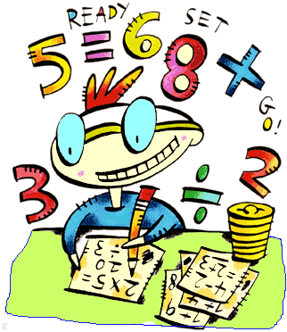**Please complete the exercises on these pages. Show your working out wherever possible.
* **You can use your notes to help you with these exercises, but no other assistance.**

**Activity 1 Number skills: fractions and mixed numbers**

**Question 1 Mixed numbers**

**(a)** Shade the shapes to match the mixed numbers

|  |  |  |
| --- | --- | --- |
| **(i)** 2 |  | **(ii)** 1 |

**(b)** Mixed numbers in digits, words and pictures:

Complete the missing parts of the table below.

|  |  |  |
| --- | --- | --- |
|  | The mixed number in words | A picture of the mixed number |
|  |  |  |
|  |  |  |
|  | Two and three fifths |  |

**(c)** Mixed numbers and sharing:

Complete the missing parts of the table below.

|  |  |  |
| --- | --- | --- |
| How many are shared | As a number sentence | What amount does each person receive? |
| 11 shared between 3 |  |  |
| 18 shared between 5 |  |  |

**Question 2 Counting by mixed numbers**

**(a)** Fill in the missing numbers on the number line.



0

1

2





1

1







2





















2





















Use your completed number line to fill in the missing parts of these number sentences:

|  |  |  |  |  |  |
| --- | --- | --- | --- | --- | --- |
| **(i)** | 2 = | **(ii)** | = | **(iii)** | = |

**(b)** Show where each mixed number is along the number line.

9, 10, 10, 11,



10

9

11

12

Fill in the missing parts of these sentences:

10 is slightly more than half way between ………… and …………

9 is exactly half way between ………… and …………

**(c)** Estimate where the mixed numbers should go.

You’ve been asked to place these mixed numbers on the number line below.

, 1, 2

1. What fraction should you divide the number line into? Explain your reasons.

……………………………………………………………………………………………………………………………………………………………………………………………………………………………………………………….………………………

……………………………………………………………………………………………………………………………………

1. Estimate where each fraction and mixed number is along the line.



**(d)** Counting by fractions.

Complete the terms in the number sequence.

Write the rule to find the next term.

|  |  |  |  |  |  |  |  |  |  |  |
| --- | --- | --- | --- | --- | --- | --- | --- | --- | --- | --- |
|  | 1 | 1 | 1 |  |  |  |  |  | Rule |  |

**Activity 2 Adding and subtracting fractions and mixed numbers**

**Question 1 Adding and subtracting fractions**

|  |  |  |
| --- | --- | --- |
| **(a)** | The fraction addition or subtraction | Think of a number story |
|  | +  + = |  |
|  | − |  |

|  |  |  |  |  |  |  |  |  |  |  |  |  |
| --- | --- | --- | --- | --- | --- | --- | --- | --- | --- | --- | --- | --- |
| **(b)** | Shade the fraction we are taking away.  Write the fraction that is left. |  | 1 \_ = | | | …………………………. | | | | | | |
|  |  |  |  |  | |  |  |  |  |  |  |

|  |  |  |
| --- | --- | --- |
| **(c)** | Rename the wholes as fractions.  Shade the diagram to solve the problem.  2 −  −  =  = |  |
|  |

**(d)** Complete each addition or subtraction.

|  |  |  |  |
| --- | --- | --- | --- |
|  | 1 + 3  +  + |  | 6 − 1  −   − |

|  |  |  |  |
| --- | --- | --- | --- |
|  | 2 + 1 = |  | 8 − 3 = |

**Question 2 Adding subtracting fractions with different denominators**

**(a)** Shade each fraction in a different colour on the fraction bars.

Then add the fractions and complete the number sentences.

|  |  |  |  |  |  |  |  |  |  |  |  |  |  |  |  |  |  |  |  |  |  |
| --- | --- | --- | --- | --- | --- | --- | --- | --- | --- | --- | --- | --- | --- | --- | --- | --- | --- | --- | --- | --- | --- |
|  | +  = | | …………………………. | | | | |  | +  = | | | | | ……………………… | | | | | | | |
|  |  |  | |  |  |  |  |  |  |  |  |  |  | |  |  |  |  |  |  |  |

**(b)** Complete:

|  |  |  |  |
| --- | --- | --- | --- |
|  | +  =  +  =  =  = |  | +  =  +  =  = |

**(c)** For each question below:

* Use the multiples shown to find the first common number.
* Change each fraction to the same denominator, then add them together

|  |  |  |  |
| --- | --- | --- | --- |
| **(i)** | +  = | 2, 4, 6, 8, 10, 12, ….  5, 10, 15, 20, 25, …. |  |

|  |  |  |  |
| --- | --- | --- | --- |
| **(ii)** | +  = | 4, 8, 12, 16, 20, 24, 28, 32, ….  10, 20, 30, 40, 50, 60, 70, … |  |

**Activity 3 Division facts and strategies**

**Question 1 Division facts**

|  |  |  |  |
| --- | --- | --- | --- |
| **(a)** | Find two factors to complete the triangle.  Complete two division facts. |  | 110 |
|  |  |  |

|  |  |  |
| --- | --- | --- |
| **(b)** | Think of a multiplication fact to help write the division fact and solve the problem.  $2000 is shared equally between 10 people.  How much does each person receive? | |
|  | Multiplication fact: | Division fact: |

**Question 2 Division strategies**

|  |  |
| --- | --- |
| **(a)** | Use the “halve, then halve again” strategy to complete |

|  |  |  |  |  |  |  |
| --- | --- | --- | --- | --- | --- | --- |
|  |  | **Halve** |  | **Halve** |  |  |
|  | 120 | **→** |  | **→** |  | , 120 ÷ 4 = |
|  |  |  |  |  |  |  |
|  | 440 | **→** |  | **→** |  | , |
|  |  |  |  |  |  |  |

|  |  |
| --- | --- |
| **(b)** | Complete the following divisions using the  ‘divide-by-tens’ strategy. |

|  |  |  |  |  |
| --- | --- | --- | --- | --- |
|  |  |  |  | |
|  | 700 ÷ 10 | tens ÷  tens | ÷  = |  |
|  | 350 ÷ 50 | tens ÷  tens | ÷  = |  |

|  |  |
| --- | --- |
| **(c)** | Use the ‘split strategy’ to complete the following divisions. |

|  |  |  |  |  |  |  |  |  |  |  |  |  |  |  |  |  |  |  |  |  |  |  |
| --- | --- | --- | --- | --- | --- | --- | --- | --- | --- | --- | --- | --- | --- | --- | --- | --- | --- | --- | --- | --- | --- | --- |
| **(i)** | | 84 ÷ 3 | | | | | |  |  | |  | **(ii)** | | 145 ÷ 5 | | | | | |  |  | |
|  | |  | | |  | | |  |  | |  |  | |  | | |  | | |  |  | |
|  |  | | | + | |  | | | |  |  |  |  | | | + | |  | | | |  |
|  | ÷ 3 | | |  | | ÷ 3 | | | |  |  |  | ÷ 5 | | |  | | ÷ 5 | | | |  |
|  |  | | |  | |  | | | |  |  |  |  | | |  | |  | | | |  |
|  |  | | | + | |  | | | |  |  |  |  | | | + | |  | | | |  |
|  | | | | | | | | | | |  |  | | | | | | | | | | |
| 84 ÷ 3 = | | |  | | | |  | | | |  | 145 ÷ 5 = | | |  | | | |  | | | |

|  |  |  |  |  |  |
| --- | --- | --- | --- | --- | --- |
| **(iii)** | 144 ÷ 18 |  |  |  |  |
|  |  |  |  |  | 18 =  × |
|  | 144 ÷  =  ÷  = | 18 |  |  |
|  |
|  |  |  |  |
|  |  |  |  |  |
|  | The number sentence: 144 ÷ 18 = | | | |  |

|  |  |
| --- | --- |
| **(d)** | Use division facts to answer each division question.  Write each division as a number sentence. |

|  |  |  |  |  |  |
| --- | --- | --- | --- | --- | --- |
| **(i)** |  | **(ii)** |  | **(iii)** |  |
| ÷  = | | ÷  = | | ÷  = | |

**Activity 4 Solve some problems**

**Question 1**

For each problem, write a number sentence and solve it.

|  |  |
| --- | --- |
| **(a)** | I have 4 games on my computer. This is one fifth of all my games.  How many games do I have in total? |
|  |  |

|  |  |
| --- | --- |
| **(b)** | A ship has 4 decks, with the same number of cabins on each deck. There are 268 cabins in total. How many cabins are on each deck? |
|  |  |

**Challenge question: Find the factors**

Two factors have a difference of 5 and a product of 234

**(a)** Estimate the factors: Find three possible pairs of factors for 200

200 =  ×  OR  ×  OR  × 

Which pair of factors is most close to solving the problem?

**(b)** Use your calculator and trial and error to find the factors that solve the problem. Show your working out.

|  |  |
| --- | --- |
|  |  |

|  |
| --- |
|  |

**Student Self Assessment:**

How confident am I with fractions?

Read the statements and give yourself a score for each description.

0 = I don’t understand at all, 5 = I am very confident.

|  |  |  |  |  |  |  |  |  |  |  |  |  |  |  |  |  |  |  |  |  |  |  |  |  |  |  |  |  |  |
| --- | --- | --- | --- | --- | --- | --- | --- | --- | --- | --- | --- | --- | --- | --- | --- | --- | --- | --- | --- | --- | --- | --- | --- | --- | --- | --- | --- | --- | --- |
| I can identify the different parts of fractions and what they mean. | | | | | | I know that there are different types of fractions. | | | | | | I can add and subtract fractions that have the same denominator. | | | | | | I can calculate and use equivalent fractions to solve problems. | | | | | | I can teach someone else how to solve a fraction addition with different denominators. | | | | | |
| 0 | 1 | 2 | 3 | 4 | 5 | 0 | 1 | 2 | 3 | 4 | 5 | 0 | 1 | 2 | 3 | 4 | 5 | 0 | 1 | 2 | 3 | 4 | 5 | 0 | 1 | 2 | 3 | 4 | 5 |

|  |
| --- |
| **THINKING ABOUT YOUR LEARNING**  Description: Description: Description: Description: http://t0.gstatic.com/images?q=tbn:ANd9GcTiyp1Q0EWVRSXlqyIMaG6be3rodf0nBbu2oBIY8JlYVh1iP8U7**I understand \_\_\_\_\_\_\_\_\_\_\_\_\_\_\_\_\_\_\_\_\_\_\_\_\_\_\_\_\_\_\_\_\_\_\_\_\_\_\_\_\_\_\_\_\_\_\_\_\_**  **\_\_\_\_\_\_\_\_\_\_\_\_\_\_\_\_\_\_\_\_\_\_\_\_\_\_\_\_\_\_\_\_\_\_\_\_\_\_\_\_\_\_\_\_\_\_\_\_\_\_\_\_\_\_\_\_\_\_\_\_\_\_\_\_\_\_\_\_\_\_\_\_\_\_\_**  **\_\_\_\_\_\_\_\_\_\_\_\_\_\_\_\_\_\_\_\_\_\_\_\_\_\_\_\_\_\_\_\_\_\_\_\_\_\_\_\_\_\_\_\_\_\_\_\_\_\_\_\_\_\_\_\_\_\_\_\_\_\_\_\_\_\_\_\_\_\_\_\_\_\_\_**  **\_\_\_\_\_\_\_\_\_\_\_\_\_\_\_\_\_\_\_\_\_\_\_\_\_\_\_\_\_\_\_\_\_\_\_\_\_\_\_\_\_\_\_\_\_\_\_\_\_\_\_\_\_\_\_\_\_\_\_\_\_\_\_\_\_\_\_\_\_\_\_\_\_\_\_**  **\_\_\_\_\_\_\_\_\_\_\_\_\_\_\_\_\_\_\_\_\_\_\_\_\_\_\_\_\_\_\_\_\_\_\_\_\_\_\_\_\_\_\_\_\_\_\_\_\_\_\_\_\_\_\_\_\_\_\_\_\_\_\_\_\_\_\_\_\_\_\_\_\_\_\_**  **Description: Description: Description: Description: http://t2.gstatic.com/images?q=tbn:ANd9GcQ72LH2Bxoxf3yTTP_t93kaIPDpv8jVzb20Dfacv1j6Jv1Vb43VI need help with\_\_\_\_\_\_\_\_\_\_\_\_\_\_\_\_\_\_\_\_\_\_\_\_\_\_\_\_\_\_\_\_\_\_\_\_\_\_\_\_\_\_\_\_\_\_\_\_**  **\_\_\_\_\_\_\_\_\_\_\_\_\_\_\_\_\_\_\_\_\_\_\_\_\_\_\_\_\_\_\_\_\_\_\_\_\_\_\_\_\_\_\_\_\_\_\_\_\_\_\_\_\_\_\_\_\_\_\_\_\_\_\_\_\_\_\_\_\_\_\_\_\_\_\_**  **\_\_\_\_\_\_\_\_\_\_\_\_\_\_\_\_\_\_\_\_\_\_\_\_\_\_\_\_\_\_\_\_\_\_\_\_\_\_\_\_\_\_\_\_\_\_\_\_\_\_\_\_\_\_\_\_\_\_\_\_\_\_\_\_\_\_\_\_\_\_\_\_\_\_\_**  **\_\_\_\_\_\_\_\_\_\_\_\_\_\_\_\_\_\_\_\_\_\_\_\_\_\_\_\_\_\_\_\_\_\_\_\_\_\_\_\_\_\_\_\_\_\_\_\_\_\_\_\_\_\_\_\_\_\_\_\_\_\_\_\_\_\_\_\_\_\_\_\_\_\_\_**  **\_\_\_\_\_\_\_\_\_\_\_\_\_\_\_\_\_\_\_\_\_\_\_\_\_\_\_\_\_\_\_\_\_\_\_\_\_\_\_\_\_\_\_\_\_\_\_\_\_\_\_\_\_\_\_\_\_\_\_\_\_\_\_\_\_\_\_\_\_\_\_\_\_\_\_** |

|  |
| --- |
| **YOUR QUESTIONS OR COMMENTS** |
| **TEACHER’S COMMENTS**  **Some great things about your work were:**  **Try to do the following next time:** |
|  |