**History Inquiry**

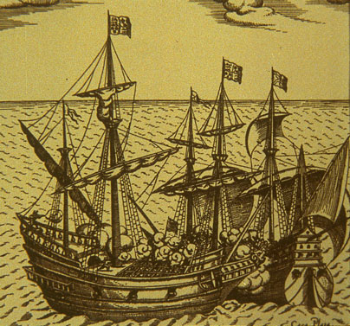

Who were the first Europeans to discover Australia?



Yo, ho, ho lads and lassies! It’s time to move closer to our home shores. Yes, today we are moving onto the European explorers whose adventures brought them to Australia.

When the European explorers came to Australia they came to a land that already belonged to the Aboriginals. No one knows exactly where the Aboriginals lived before they came to Australia but they have been here for at least 40,000 years. It is known that they came from somewhere in South-East Asia and that they left their homes and travelled to Australia in canoes or on rafts. Australian Aboriginal culture is the oldest living culture in the world.

In some of the later modules we will look at the first Australians in a lot more detail. This is an interesting and important topic. We’ll also look at how the explorers and the Aboriginal people got along together.

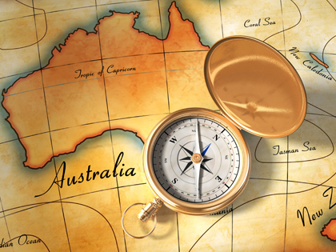

Recently you’ve been looking at explorers from various countries. Who do you think were the first Europeans to discover Australia? Write your answer down in the box below.

Have a look at the three maps below. What differences can you see? The first map is from 2007, the second from 1709 and the last one is from 1570.

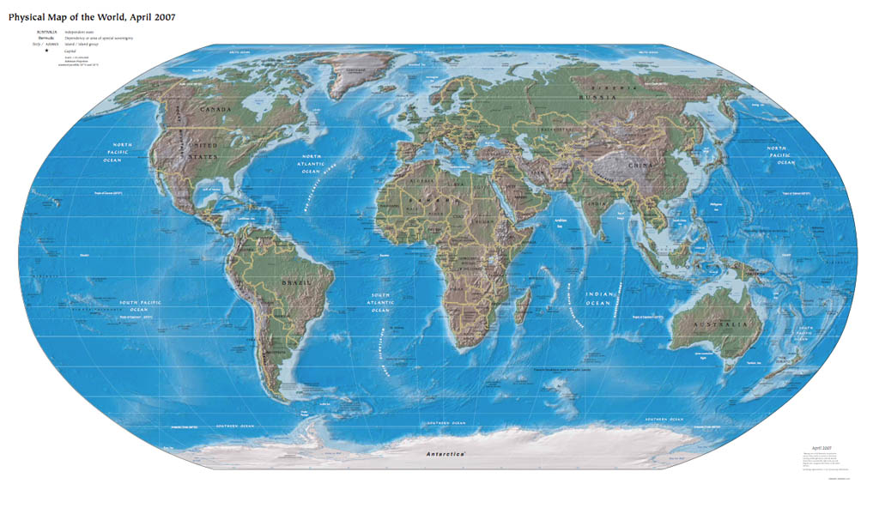

There’s Australia!

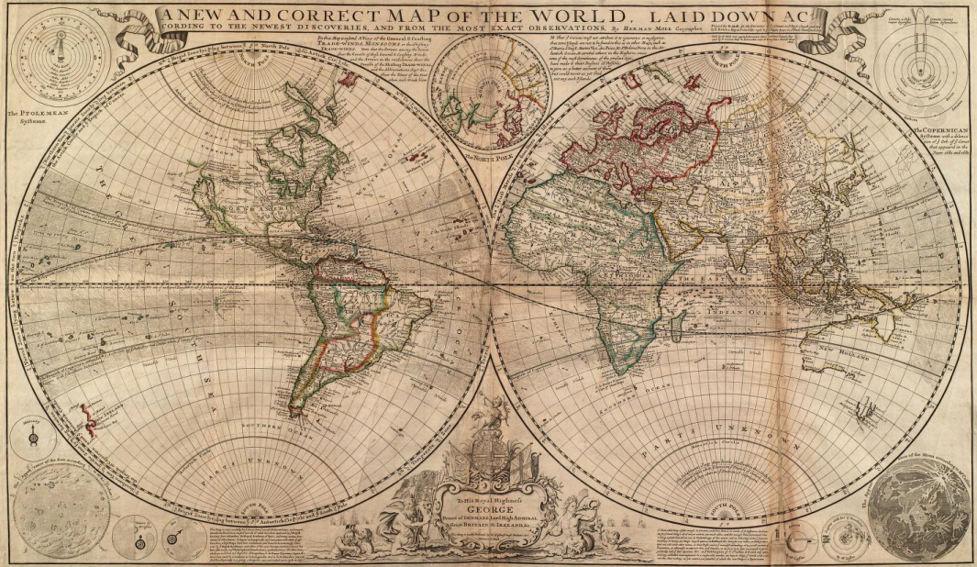

What’s happened to Australia? It’s only half there.

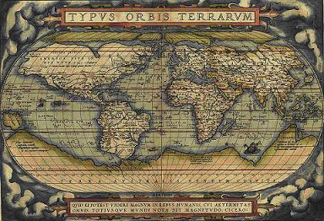

Where’s Australia gone? There’s nothing there.

Answer the questions below in full sentences. Remember to use capital letters and full stops.

* 1. What do you notice about Australia in the map from 1709?

|  |
| --- |
|  |
|  |
|  |
|  |
|  |
|  |
|  |
|  |
|  |

* 1. What do you notice about Australia in the map from 1570?

|  |
| --- |
|  |
|  |
|  |
|  |
|  |
|  |
|  |
|  |
|  |

* 1. What do you think might have happened in between 1570 and 1709 that has made these maps different?

|  |
| --- |
|  |
|  |
|  |
|  |
|  |
|  |
|  |
|  |
|  |
|  |
|  |
|  |

* 1. Many people think Captain Cook was the first European explorer to come to Australia. Captain Cook arrived in 1770. After looking at the map from 1709 do you think Captain Cook was the first? Why do you think this?

|  |
| --- |
|  |
|  |
|  |
|  |
|  |
|  |
|  |
|  |
|  |
|  |
|  |
|  |

**Terra Australis Incognita**

As far back as the first centuries of the modern age, the early Greeks and Romans wondered if there was a land that existed beyond the Indian Ocean. They called it *Terra Australis Incognita* - the unknown southern land. It took more than 1000 years before this mysterious continent was finally located by Europeans, charted and named *Australia*.

Many people think Captain Cook was the first European explorer to come to Australia. In fact, when I went to school that was what I was taught. However, it’s wrong. [Captain James Cook](http://gutenberg.net.au/pages/cook.html) claimed the whole of the east coast of Australia for Great Britain on 22 August 1770, naming eastern Australia 'New South Wales'. By that time Dutch sailors had been exploring Australian waters for more than 160 years but not along the east coast.

* 1. Look at the following list and rank it from the most likely reason the Dutch were in Australian waters to the least likely reason. Use the number 1 to show the most likely reason.

* They were looking for spices and gold.
* They got lost on their way to Indonesia.
* They were looking for the great southern land.

6. What is the reason for your number one choice?

|  |
| --- |
|  |
|  |
|  |
|  |
|  |
|  |
|  |
|  |
|  |
|  |
|  |
|  |

**The European Discovery of Australia**

The European discovery of Australia began when Dutch traders sailed east from Europe in search of spices and territory. Captained by [Willem Janszoon](http://pandora.nla.gov.au/pan/60542/20060914-0000/www.nla.gov.au/exhibitions/southland/Char-Willem_Janszoon.html), the voyage of the [*Duyfken*](http://pandora.nla.gov.au/pan/60542/20060914-0000/www.nla.gov.au/exhibitions/southland/Exp-The_Duyfken.html) in 1606 was the first voyage to the north of Australia. Captain Janszoon (sometimes known as Jansz) made the first recorded landing on the Australian continent in the Gulf of Carpentaria.

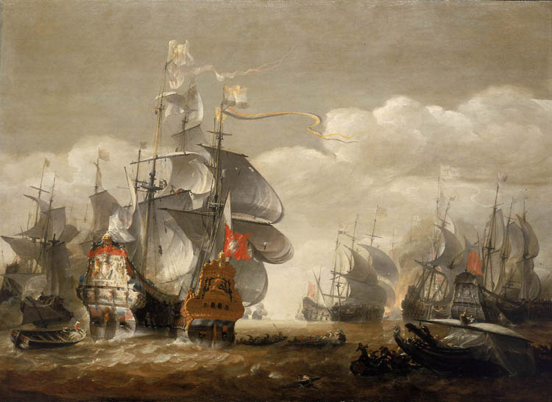

Some years later the Dutch landed on the west coast of Australia. This happened when they were trying a different way to sail to Indonesia. As you know, sailing ships need lots of wind and the Dutch sailors were told to use the very strong westerly winds known as the Roaring Forties to carry them to Batavia (now known as Jakarta) in a shorter time. One of these ships turned north too late and sighted new lands. The ship was the *Eendracht* and its captain was Dirk Hartog. The *Eendracht* landed near Shark Bay in 1616. Before he continued on his way he nailed a small pewter plate with his name on it to a tree.

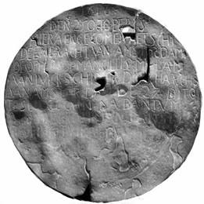

For this activity you will need an atlas or Google maps. You will also need your coloured pencils. The map of Australia on the following page lays out the routes that the Dutch ships travelled.

You can see an animation of this information at the following website:

<http://goo.gl/7ZNoC>

On the next page is a blank map of Australia. Let’s start by making it a real map using BOLTSS.

1. B - Rule a border around the edge of the page.
2. O - The top of Australia is north. Show the orientation of the map l with a capital N and an arrow head pointing up.
3. L - We’ll come back to the legend after Number 8.

1. T - Let’s give our map the title *Dutch Exploration of Australia*. Write the title at the top of the page.
2. S - The scale of this map: four centimetres represents one thousand kilometres.
3. S – The source of this map is <http://goo.gl/7ZNoC>. Write this on your map along with today’s date.
4. Use your map or Google Maps to find out the names of the oceans and seas around Australia. Label the oceans on the map and colour them in blue.
5. Colour each state and territory a different colour. Now you can make a legend showing which colour represents each state.
6. Write the name of each capital city in the correct place.
7. Look at some pictures of the places where the Dutch sailed. (Zoom in with Google Maps or search Google images.)Discuss with your supervisor any ideas you have about why the Dutch didn’t start towns in these places?

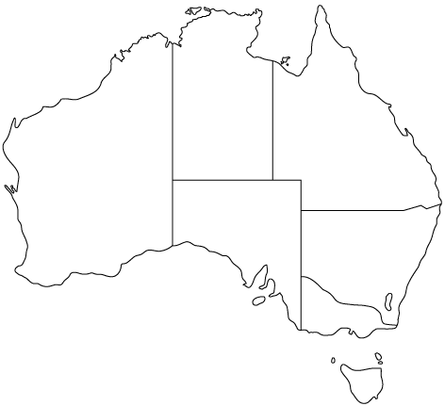

**REFLECTION**

Please think about what you’ve learnt in this module. In your own words please write your answers below.

***a***. ***Write 3 facts that you have learnt about the discovery of Australia.***

|  |
| --- |
|  |
|  |
|  |
|  |
|  |
|  |
|  |
|  |
|  |
|  |
|  |
|  |
|  |
|  |
|  |
|  |
|  |
|  |