**Geography**

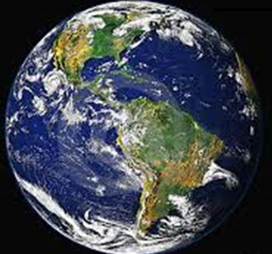

What are the main geographical characteristics and features of South America?



**GETTING KNOWLEDGE READY**

1. Draw pictures underneath the words that you think could be characteristics or features of South America in the table below.

**CHARACTERISTICS AND FEATURES**

|  |  |  |
| --- | --- | --- |
| ***deserts*** | ***rivers*** | ***lakes*** |
|  |  |  |
| ***size*** | ***mountains*** | ***rainforests*** |
|  |  |  |

1. View the following YouTube clip about South America with your supervisor. Write notes (dot points) as you view the clip. Go to:

[**http://tinyurl.com/l8nz7pk**](http://tinyurl.com/l8nz7pk)

**NOTES**

|  |
| --- |
|  |
|  |
|  |
|  |
|  |
|  |
|  |
|  |
|  |
|  |
|  |
|  |
|  |
|  |
|  |
|  |
|  |
|  |
|  |
|  |
|  |
|  |
|  |
|  |
|  |
|  |
|  |
|  |
|  |
|  |
|  |
|  |
|  |
|  |
|  |
|  |

|  |
| --- |
|  |
|  |
|  |
|  |
|  |
|  |
|  |
|  |
|  |
|  |
|  |
|  |
|  |
|  |
|  |
|  |
|  |
|  |
|  |
|  |
|  |
|  |
|  |
|  |
|  |
|  |
|  |
|  |
|  |
|  |
|  |
|  |
|  |
|  |
|  |
|  |
|  |
|  |
|  |
|  |
|  |
|  |
|  |
|  |
|  |

1. Choose one characteristic or feature of South America to research, that you found fascinating, e.g., rainforests or the Amazon River.
2. Draft, proof-read, edit and publish a mini-project about it. Present your work on the following page, as a Word document or PowerPoint. Include a title, photos, diagrams, maps and your source of information.

|  |
| --- |
| **MY IDEAS** |

_________________________________________________________________

|  |  |
| --- | --- |
|  | |
|  | |
|  | |
|  | |
|  | |
|  | |
|  | |
|  | |
|  | |
|  | |
|  | |
|  | |
|  | |
|  | |
|  | |
|  | |
|  | |
|  | |
|  | |
|  | |
|  | |
|  | |
|  | |
|  | |
|  | |
|  | |
|  | |
|  | |
|  | |
|  | |
|  | |
|  | |
|  | |
|  | |
|  | |
|  | |
|  |
|  |
|  |
|  |
|  |
|  |
|  |
|  |
|  |
|  |
|  |
|  |
|  |
|  |
|  |
|  |
|  |
|  |
|  |
|  |
|  |
|  |
|  |
|  |
|  |
|  |
|  |
|  |
|  |
|  |
|  |
|  |
|  |
|  |
|  |
|  |

SOURCE/S OF INFORMATION:

|  |
| --- |
|  |

**REFLECTION**

1. *List 3 facts about South America that fascinate you the most.*
2. *_________________________________________________________*
3. *_________________________________________________________*
4. *_________________________________________________________*