**English**

Read Write

Spell Publish



**Why advertise?**

|  |  |  |
| --- | --- | --- |
| Description: QRDistance | Description: logomedium_black_print  © State of Victoria, Department of Education and Training 2015 | **I**  **Course Code**  **5301** |

**Only for use for the purpose of education for the student(s) provided with the materials by DECV. Not to be reproduced, communicated or otherwise used except as permitted by the Copyright Act 1968 (Cth).**

Introduction

**Please Read Before You Begin!**

The **English**—*Read Write Spell Publish* Modules consist of 16 books for the year. Each Module consists of two weeks work where lessons and activities are divided into *Weeks 1 and 2.*

At the beginning of each week an outline of the week’s *Learning Intention* (tasks) and *Achievement Standards* (learning to be achieved)are outlined to assist you with your learning.

**Content and Layout of Each Module**

Each Module is structured into the following format:

 **Reading**

At the beginning of each Module you will **read** a short text based on one of the following text types such as personal recount, email, narrative, letter, persuasive etc…..

 **Exploring the Text**

Did you understand the text? In this section you will answer questions about your reading.

http://www.ignitumtoday.com/wp-content/uploads/2011/12/Idea.png **Writing Workshop**

Here, you will learn about the style and techniques used to write the different text types.

**Writing Project**

Finally you will be writing your own major piece of writing based on the given

text type.

 **Word Explorers**

To support and enhance your English work you will also study *Spelling, Punctuation* and *Grammar.* These topics are titled **Word Explorers.**

Each topic consists of:

**Spelling**—a list of 20 words will be studied each week.

They are grouped into:

- words from the text presented in the Module

- your own words from your writing, reading and listening.

**Punctuation**—lessons on punctuation are taught once a week. Application to these skills is applied to writing tasks.

**Grammar**—once a week you will be taught skills in this area and complete work for practice.

**Contact!**

It is important that you contact your teacher if you have any queries or problems with the work. Your teacher can adjust the work to best suit your individual needs.

Week 1



**Why Advertise?**

**Learning Intentions**

* Investigate the style and techniques used to write an *advertisement.*
* Explore various formats and study the writing technique used for creating an advertisement.
* Study given spelling words in preparation for test.
* Investigate *suffixes.*

Advertising

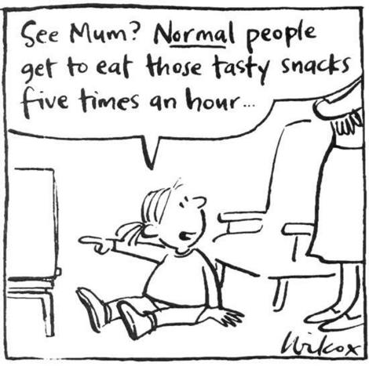

**It’s everywhere! You cannot avoid it!**

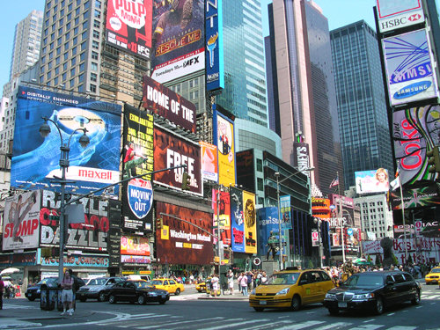

**Advertising** is a form of [communication](http://en.wikipedia.org/wiki/Communication) used to encourage or [persuade](http://en.wikipedia.org/wiki/Persuade) people (viewers, readers or listeners; to purchase their product or to convince of their ideas.

Advertising messages are usually paid for by [sponsors](http://en.wikipedia.org/wiki/Sponsor_(commercial)) (the owners of the products) and viewed via various means. Advertising can take the form of [**traditional media**](http://en.wikipedia.org/wiki/Traditional_media)**;** including [mass media](http://en.wikipedia.org/wiki/Mass_media) such as [newspaper](http://en.wikipedia.org/wiki/Newspaper), [magazines](http://en.wikipedia.org/wiki/Magazines), [television commercial](http://en.wikipedia.org/wiki/Television_commercial), [radio advertisement](http://en.wikipedia.org/wiki/Radio_advertisement), [outdoor advertising](http://en.wikipedia.org/wiki/Outdoor_advertising) or [direct mail](http://en.wikipedia.org/wiki/Direct_mail); or [**new media**](http://en.wikipedia.org/wiki/New_media) such as [blogs](http://en.wikipedia.org/wiki/Blog), [websites](http://en.wikipedia.org/wiki/Website) or [text messages](http://en.wikipedia.org/wiki/Text_messaging). *Turn over to read about some of the new and traditional advertising formats…*

|  |  |
| --- | --- |
| http://www.onlinemarketingdenver.net/wp-content/uploads/2011/05/modern-advertising-methods.jpg  **Website**  Advertising holidays to Queensland.  [www.queenslandholidays.com.au/](http://www.queenslandholidays.com.au/) | http://phillipjstone.com/wp-content/uploads/2012/01/MLM-Lead-Generation-with-Traditional-Advertising.jpg |
| **YouTube**  **A**dvertisementon travelling Australia.  [www.youtube.com/user/australia?v=m5\_\_vyZMdlg](http://www.youtube.com/user/australia?v=m5__vyZMdlg) | **Transport—**on transportation such as cars, buses, trains…  http://www.blogto.com/upload/2007/06/20070618_wiicar.jpg  http://rlv.zcache.com/advertising_t_shirt_tshirt-p235749887585590109bij6g_400.jpg  **Clothing!** |
| **Txt Message**  Advertising discounts via your mobile phone.  http://kellyannpope.com/wp-content/uploads/2011/12/sms-targeted-marketing-297x300.png | **Banners—**advertising on buildings.  http://www.abc.net.au/reslib/200708/r168409_628877.png |

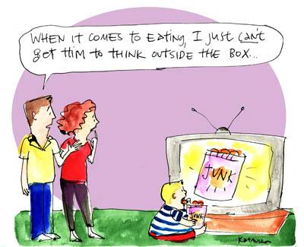Has advertising persuaded you to buy a product or convinced you about an idea?

Let’s find out!

Think about an advertisement that has convinced you. It can be a modern, traditional or both.

Write in dot point the **format, item, why** it persuaded you and **what** was the outcome.

*Now that you have had a quick look at some advertising formats and thought about what has influenced you, we will continue to look at the* ***TECHNIQUES*** *used* —ways in which advertisers try to convince you to Buy! Buy! Buy!

|  |
| --- |
| Description: Description: http://vivascriva.com/wp-content/uploads/2011/11/12065691681830256378johnny_automatic_Services_9.svg_.med_1.pngReading |

MCj04247880000[1] **For You to Do**

Read the advertisement below. Think about what they are selling and how you feel.

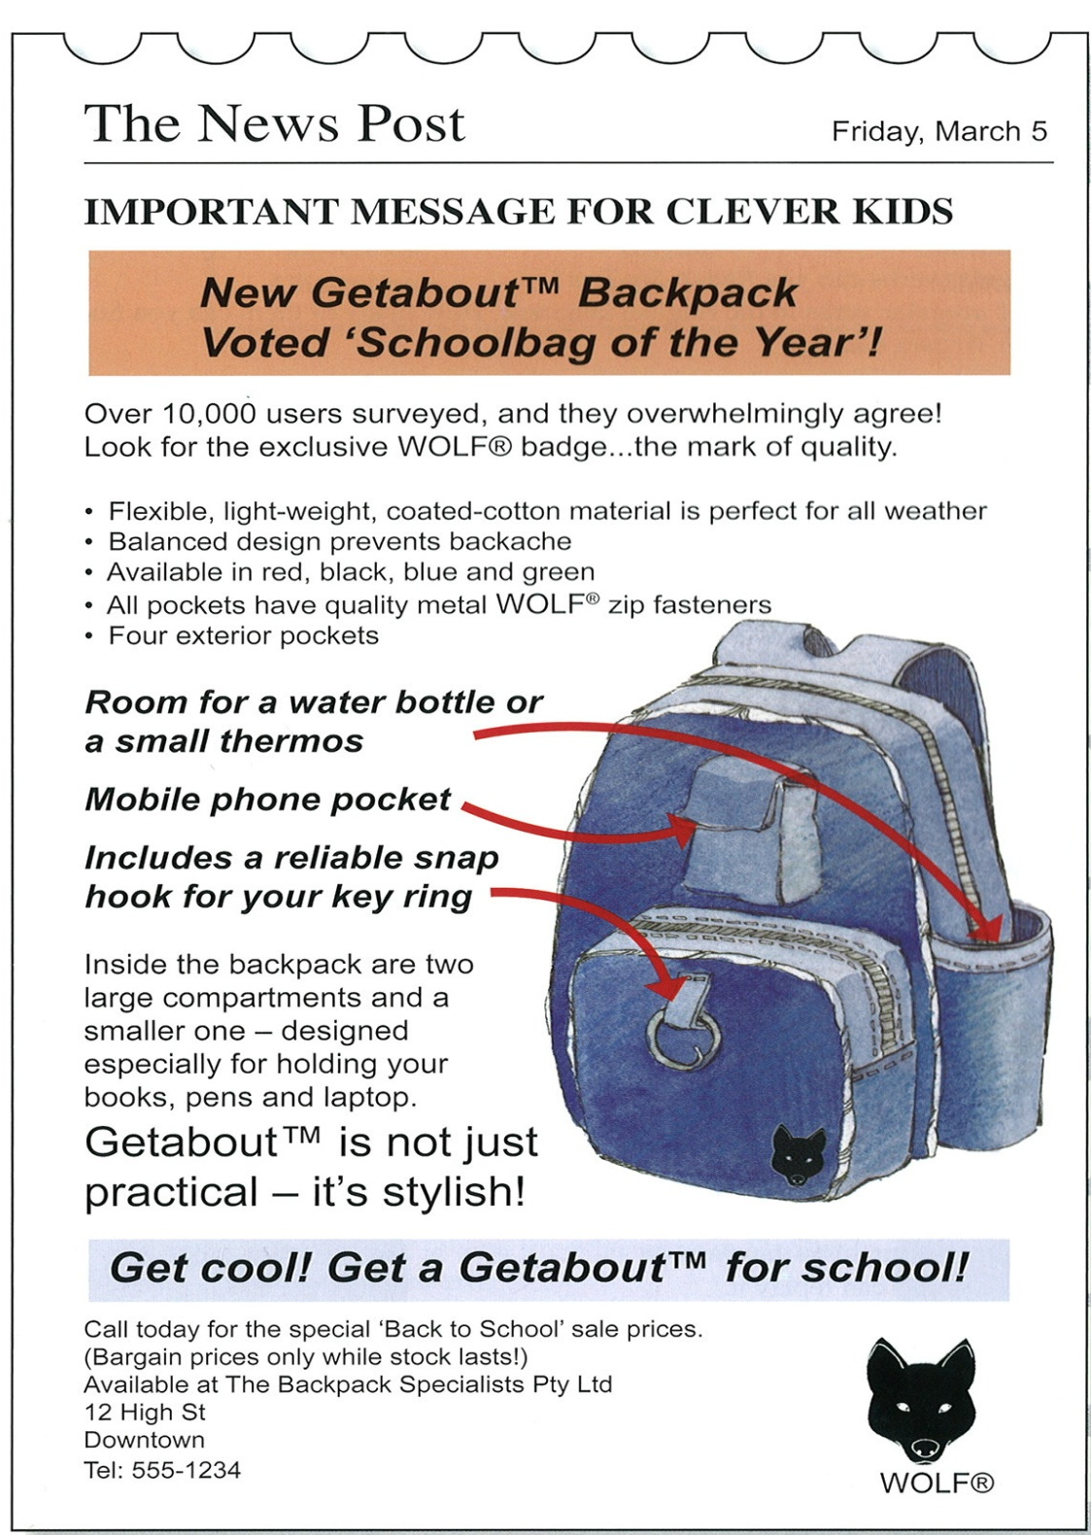

On the following page is the advertisement again but with information on the TECHNIQUES used to persuade you! *Read on…………*

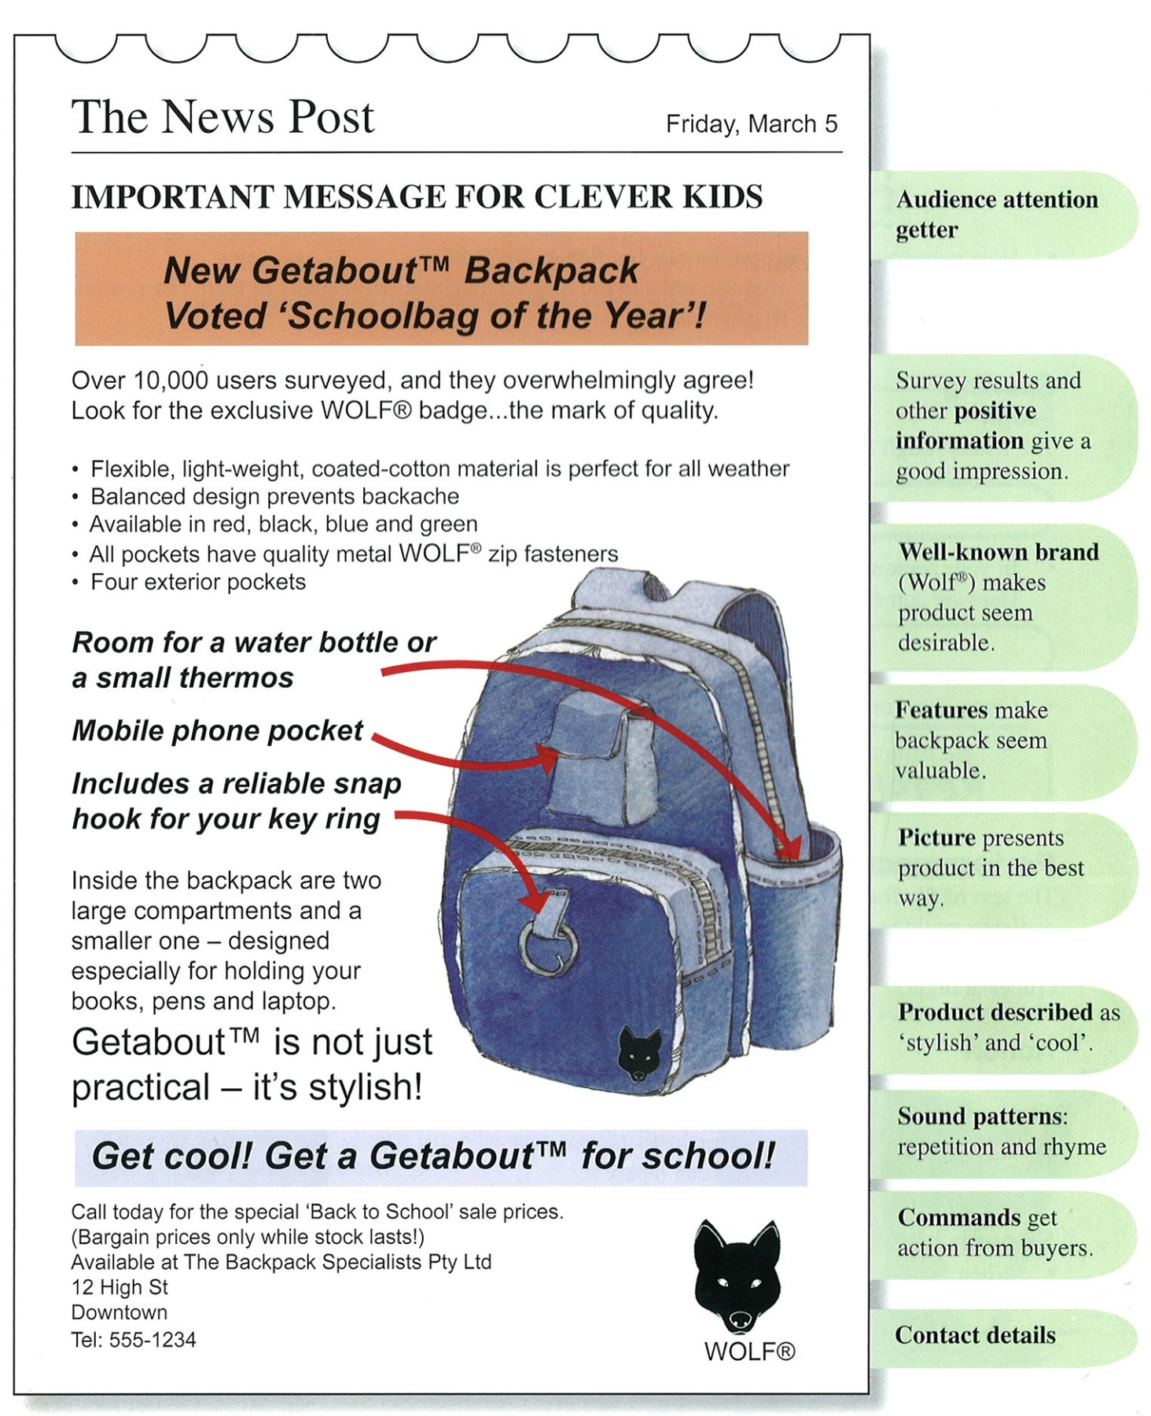

**Discussion**

Together with your Supervisor, discuss the *advertisement.* Talk about:

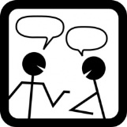

* Would you buy it? Why? Why not?
* What did you like best? Why? Why not?
* What would you add or delete to make it better. Why? Why not?

|  |  |
| --- | --- |
| http://www.oncoursesystems.com/images/user/10809/10705150/SCHOOL/Vocabulary%20-%201.gif | Word Explorer—Spelling  In today’s spelling lesson you will be given you  10 spelling words for the week.  Follow the spelling process from the previous English Modules. |

Located at the back of this Module are your 10 text words for this week.

MCj04247880000[1]

**For You to Do**

* Today I want you to choose words to be added into **My** **Own Words** list**.** These can be from your own writing, reading or memory. Write the ten words you have chosen, in the **My Own Words** column.
* Now it’s time to begin learning to spell the words in preparation for your test at the end of the week.

You will need your *Look, Cover, Write and Check* (LCWC) book and follow the process outlined in English Module A.

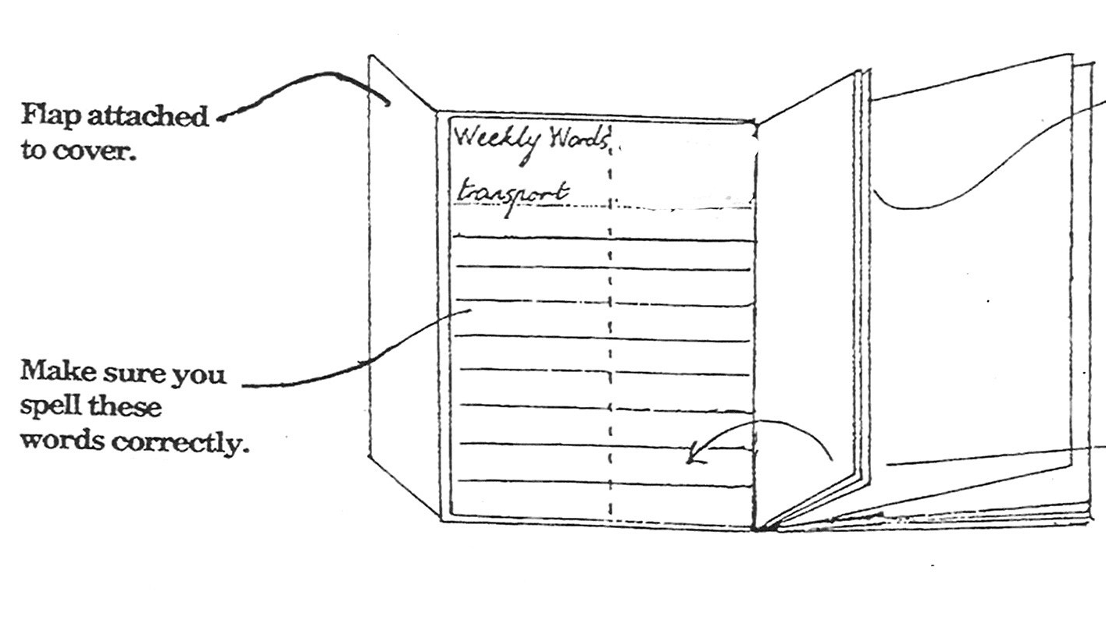

|  |  |
| --- | --- |
| *http://www.salleywags.com/wp-content/uploads/2012/02/important-note.jpg* | *For the rest of the week you should focus on learning the words using the LCWC method. On the last day of the week your Supervisor will test your knowledge. This will be your weekly routine for the rest of the year.* |

|  |
| --- |
| Description: Description: http://upload.wikimedia.org/wikipedia/commons/thumb/5/55/Magnifying_glass_icon.svg/489px-Magnifying_glass_icon.svg.pngExploring the Text |

MCj04247880000[1]

**For You to Do**

In this section you will answer questions about the advertisement on page 8*.*

There are four different types of questions, read the instructions and questions carefully highlighting or underlining key words.

Write your answers in **complete sentences**. Remember to use appropriate **punctuation** and **edit** your work at completion. Complete your answers on *Word* or write your responses in the lined spaces below. If you require further space attached lined paper.

1. *What does the story actually say—*
2. What colours does the backpack come in?

\_\_\_\_\_\_\_\_\_\_\_\_\_\_\_\_\_\_\_\_\_\_\_\_\_\_\_\_\_\_\_\_\_\_\_\_\_\_\_\_\_\_\_\_\_\_\_\_\_\_\_\_\_\_\_\_\_\_\_\_\_\_\_\_\_\_\_\_\_\_\_\_\_

\_\_\_\_\_\_\_\_\_\_\_\_\_\_\_\_\_\_\_\_\_\_\_\_\_\_\_\_\_\_\_\_\_\_\_\_\_\_\_\_\_\_\_\_\_\_\_\_\_\_\_\_\_\_\_\_\_\_\_\_\_\_\_\_\_\_\_\_\_\_\_\_\_

1. What objects can you put in the backpack (according to the advertisement?)

\_\_\_\_\_\_\_\_\_\_\_\_\_\_\_\_\_\_\_\_\_\_\_\_\_\_\_\_\_\_\_\_\_\_\_\_\_\_\_\_\_\_\_\_\_\_\_\_\_\_\_\_\_\_\_\_\_\_\_\_\_\_\_\_\_\_\_\_\_\_\_\_\_

\_\_\_\_\_\_\_\_\_\_\_\_\_\_\_\_\_\_\_\_\_\_\_\_\_\_\_\_\_\_\_\_\_\_\_\_\_\_\_\_\_\_\_\_\_\_\_\_\_\_\_\_\_\_\_\_\_\_\_\_\_\_\_\_\_\_\_\_\_\_\_\_\_

1. *What does the story suggest—*
2. Who do you think the advertisement is meant for?

\_\_\_\_\_\_\_\_\_\_\_\_\_\_\_\_\_\_\_\_\_\_\_\_\_\_\_\_\_\_\_\_\_\_\_\_\_\_\_\_\_\_\_\_\_\_\_\_\_\_\_\_\_\_\_\_\_\_\_\_\_\_\_\_\_\_\_\_\_\_\_\_\_

\_\_\_\_\_\_\_\_\_\_\_\_\_\_\_\_\_\_\_\_\_\_\_\_\_\_\_\_\_\_\_\_\_\_\_\_\_\_\_\_\_\_\_\_\_\_\_\_\_\_\_\_\_\_\_\_\_\_\_\_\_\_\_\_\_\_\_\_\_\_\_\_\_

\_\_\_\_\_\_\_\_\_\_\_\_\_\_\_\_\_\_\_\_\_\_\_\_\_\_\_\_\_\_\_\_\_\_\_\_\_\_\_\_\_\_\_\_\_\_\_\_\_\_\_\_\_\_\_\_\_\_\_\_\_\_\_\_\_\_\_\_\_\_\_\_\_

\_\_\_\_\_\_\_\_\_\_\_\_\_\_\_\_\_\_\_\_\_\_\_\_\_\_\_\_\_\_\_\_\_\_\_\_\_\_\_\_\_\_\_\_\_\_\_\_\_\_\_\_\_\_\_\_\_\_\_\_\_\_\_\_\_\_\_\_\_\_\_\_\_

**Explore the Text continued**

2 b. What does the advertisement suggest by saying “Bargain prices only while stock lasts”?

\_\_\_\_\_\_\_\_\_\_\_\_\_\_\_\_\_\_\_\_\_\_\_\_\_\_\_\_\_\_\_\_\_\_\_\_\_\_\_\_\_\_\_\_\_\_\_\_\_\_\_\_\_\_\_\_\_\_\_\_\_\_\_\_\_\_\_\_\_\_\_\_\_

\_\_\_\_\_\_\_\_\_\_\_\_\_\_\_\_\_\_\_\_\_\_\_\_\_\_\_\_\_\_\_\_\_\_\_\_\_\_\_\_\_\_\_\_\_\_\_\_\_\_\_\_\_\_\_\_\_\_\_\_\_\_\_\_\_\_\_\_\_\_\_\_\_

\_\_\_\_\_\_\_\_\_\_\_\_\_\_\_\_\_\_\_\_\_\_\_\_\_\_\_\_\_\_\_\_\_\_\_\_\_\_\_\_\_\_\_\_\_\_\_\_\_\_\_\_\_\_\_\_\_\_\_\_\_\_\_\_\_\_\_\_\_\_\_\_\_

\_\_\_\_\_\_\_\_\_\_\_\_\_\_\_\_\_\_\_\_\_\_\_\_\_\_\_\_\_\_\_\_\_\_\_\_\_\_\_\_\_\_\_\_\_\_\_\_\_\_\_\_\_\_\_\_\_\_\_\_\_\_\_\_\_\_\_\_\_\_\_\_\_

\_\_\_\_\_\_\_\_\_\_\_\_\_\_\_\_\_\_\_\_\_\_\_\_\_\_\_\_\_\_\_\_\_\_\_\_\_\_\_\_\_\_\_\_\_\_\_\_\_\_\_\_\_\_\_\_\_\_\_\_\_\_\_\_\_\_\_\_\_\_\_\_\_

\_\_\_\_\_\_\_\_\_\_\_\_\_\_\_\_\_\_\_\_\_\_\_\_\_\_\_\_\_\_\_\_\_\_\_\_\_\_\_\_\_\_\_\_\_\_\_\_\_\_\_\_\_\_\_\_\_\_\_\_\_\_\_\_\_\_\_\_\_\_\_\_\_

\_\_\_\_\_\_\_\_\_\_\_\_\_\_\_\_\_\_\_\_\_\_\_\_\_\_\_\_\_\_\_\_\_\_\_\_\_\_\_\_\_\_\_\_\_\_\_\_\_\_\_\_\_\_\_\_\_\_\_\_\_\_\_\_\_\_\_\_\_\_\_\_\_

2 c. Why does the advertisement say “10 000 users surveyed”? Does it prove

anything? What?

\_\_\_\_\_\_\_\_\_\_\_\_\_\_\_\_\_\_\_\_\_\_\_\_\_\_\_\_\_\_\_\_\_\_\_\_\_\_\_\_\_\_\_\_\_\_\_\_\_\_\_\_\_\_\_\_\_\_\_\_\_\_\_\_\_\_\_\_\_\_\_\_\_

\_\_\_\_\_\_\_\_\_\_\_\_\_\_\_\_\_\_\_\_\_\_\_\_\_\_\_\_\_\_\_\_\_\_\_\_\_\_\_\_\_\_\_\_\_\_\_\_\_\_\_\_\_\_\_\_\_\_\_\_\_\_\_\_\_\_\_\_\_\_\_\_\_

\_\_\_\_\_\_\_\_\_\_\_\_\_\_\_\_\_\_\_\_\_\_\_\_\_\_\_\_\_\_\_\_\_\_\_\_\_\_\_\_\_\_\_\_\_\_\_\_\_\_\_\_\_\_\_\_\_\_\_\_\_\_\_\_\_\_\_\_\_\_\_\_\_

\_\_\_\_\_\_\_\_\_\_\_\_\_\_\_\_\_\_\_\_\_\_\_\_\_\_\_\_\_\_\_\_\_\_\_\_\_\_\_\_\_\_\_\_\_\_\_\_\_\_\_\_\_\_\_\_\_\_\_\_\_\_\_\_\_\_\_\_\_\_\_\_\_

\_\_\_\_\_\_\_\_\_\_\_\_\_\_\_\_\_\_\_\_\_\_\_\_\_\_\_\_\_\_\_\_\_\_\_\_\_\_\_\_\_\_\_\_\_\_\_\_\_\_\_\_\_\_\_\_\_\_\_\_\_\_\_\_\_\_\_\_\_\_\_\_\_

\_\_\_\_\_\_\_\_\_\_\_\_\_\_\_\_\_\_\_\_\_\_\_\_\_\_\_\_\_\_\_\_\_\_\_\_\_\_\_\_\_\_\_\_\_\_\_\_\_\_\_\_\_\_\_\_\_\_\_\_\_\_\_\_\_\_\_\_\_\_\_\_\_

\_\_\_\_\_\_\_\_\_\_\_\_\_\_\_\_\_\_\_\_\_\_\_\_\_\_\_\_\_\_\_\_\_\_\_\_\_\_\_\_\_\_\_\_\_\_\_\_\_\_\_\_\_\_\_\_\_\_\_\_\_\_\_\_\_\_\_\_\_\_\_\_\_

**Explore the Text continued**

1. *From your experience, what could the recount mean?*

Which features of the backpack would make *you* want to buy it? Why?

\_\_\_\_\_\_\_\_\_\_\_\_\_\_\_\_\_\_\_\_\_\_\_\_\_\_\_\_\_\_\_\_\_\_\_\_\_\_\_\_\_\_\_\_\_\_\_\_\_\_\_\_\_\_\_\_\_\_\_\_\_\_\_\_\_\_\_\_\_\_\_\_\_

\_\_\_\_\_\_\_\_\_\_\_\_\_\_\_\_\_\_\_\_\_\_\_\_\_\_\_\_\_\_\_\_\_\_\_\_\_\_\_\_\_\_\_\_\_\_\_\_\_\_\_\_\_\_\_\_\_\_\_\_\_\_\_\_\_\_\_\_\_\_\_\_\_

\_\_\_\_\_\_\_\_\_\_\_\_\_\_\_\_\_\_\_\_\_\_\_\_\_\_\_\_\_\_\_\_\_\_\_\_\_\_\_\_\_\_\_\_\_\_\_\_\_\_\_\_\_\_\_\_\_\_\_\_\_\_\_\_\_\_\_\_\_\_\_\_\_

\_\_\_\_\_\_\_\_\_\_\_\_\_\_\_\_\_\_\_\_\_\_\_\_\_\_\_\_\_\_\_\_\_\_\_\_\_\_\_\_\_\_\_\_\_\_\_\_\_\_\_\_\_\_\_\_\_\_\_\_\_\_\_\_\_\_\_\_\_\_\_\_\_

\_\_\_\_\_\_\_\_\_\_\_\_\_\_\_\_\_\_\_\_\_\_\_\_\_\_\_\_\_\_\_\_\_\_\_\_\_\_\_\_\_\_\_\_\_\_\_\_\_\_\_\_\_\_\_\_\_\_\_\_\_\_\_\_\_\_\_\_\_\_\_\_\_

\_\_\_\_\_\_\_\_\_\_\_\_\_\_\_\_\_\_\_\_\_\_\_\_\_\_\_\_\_\_\_\_\_\_\_\_\_\_\_\_\_\_\_\_\_\_\_\_\_\_\_\_\_\_\_\_\_\_\_\_\_\_\_\_\_\_\_\_\_\_\_\_\_

\_\_\_\_\_\_\_\_\_\_\_\_\_\_\_\_\_\_\_\_\_\_\_\_\_\_\_\_\_\_\_\_\_\_\_\_\_\_\_\_\_\_\_\_\_\_\_\_\_\_\_\_\_\_\_\_\_\_\_\_\_\_\_\_\_\_\_\_\_\_\_\_\_

\_\_\_\_\_\_\_\_\_\_\_\_\_\_\_\_\_\_\_\_\_\_\_\_\_\_\_\_\_\_\_\_\_\_\_\_\_\_\_\_\_\_\_\_\_\_\_\_\_\_\_\_\_\_\_\_\_\_\_\_\_\_\_\_\_\_\_\_\_\_\_\_\_

\_\_\_\_\_\_\_\_\_\_\_\_\_\_\_\_\_\_\_\_\_\_\_\_\_\_\_\_\_\_\_\_\_\_\_\_\_\_\_\_\_\_\_\_\_\_\_\_\_\_\_\_\_\_\_\_\_\_\_\_\_\_\_\_\_\_\_\_\_\_\_\_\_

\_\_\_\_\_\_\_\_\_\_\_\_\_\_\_\_\_\_\_\_\_\_\_\_\_\_\_\_\_\_\_\_\_\_\_\_\_\_\_\_\_\_\_\_\_\_\_\_\_\_\_\_\_\_\_\_\_\_\_\_\_\_\_\_\_\_\_\_\_\_\_\_\_

1. *Do you agree with or trust the text?*
2. Which information in the advertisement is fact? Which is opinion?

\_\_\_\_\_\_\_\_\_\_\_\_\_\_\_\_\_\_\_\_\_\_\_\_\_\_\_\_\_\_\_\_\_\_\_\_\_\_\_\_\_\_\_\_\_\_\_\_\_\_\_\_\_\_\_\_\_\_\_\_\_\_\_\_\_\_\_\_\_\_\_\_\_

\_\_\_\_\_\_\_\_\_\_\_\_\_\_\_\_\_\_\_\_\_\_\_\_\_\_\_\_\_\_\_\_\_\_\_\_\_\_\_\_\_\_\_\_\_\_\_\_\_\_\_\_\_\_\_\_\_\_\_\_\_\_\_\_\_\_\_\_\_\_\_\_\_

\_\_\_\_\_\_\_\_\_\_\_\_\_\_\_\_\_\_\_\_\_\_\_\_\_\_\_\_\_\_\_\_\_\_\_\_\_\_\_\_\_\_\_\_\_\_\_\_\_\_\_\_\_\_\_\_\_\_\_\_\_\_\_\_\_\_\_\_\_\_\_\_\_

\_\_\_\_\_\_\_\_\_\_\_\_\_\_\_\_\_\_\_\_\_\_\_\_\_\_\_\_\_\_\_\_\_\_\_\_\_\_\_\_\_\_\_\_\_\_\_\_\_\_\_\_\_\_\_\_\_\_\_\_\_\_\_\_\_\_\_\_\_\_\_\_\_

\_\_\_\_\_\_\_\_\_\_\_\_\_\_\_\_\_\_\_\_\_\_\_\_\_\_\_\_\_\_\_\_\_\_\_\_\_\_\_\_\_\_\_\_\_\_\_\_\_\_\_\_\_\_\_\_\_\_\_\_\_\_\_\_\_\_\_\_\_\_\_\_\_

**Explore the Text continued**

4b. Which features of the backpack do you think are misleading? Why?

\_\_\_\_\_\_\_\_\_\_\_\_\_\_\_\_\_\_\_\_\_\_\_\_\_\_\_\_\_\_\_\_\_\_\_\_\_\_\_\_\_\_\_\_\_\_\_\_\_\_\_\_\_\_\_\_\_\_\_\_\_\_\_\_\_\_\_\_\_\_\_\_\_

\_\_\_\_\_\_\_\_\_\_\_\_\_\_\_\_\_\_\_\_\_\_\_\_\_\_\_\_\_\_\_\_\_\_\_\_\_\_\_\_\_\_\_\_\_\_\_\_\_\_\_\_\_\_\_\_\_\_\_\_\_\_\_\_\_\_\_\_\_\_\_\_\_

\_\_\_\_\_\_\_\_\_\_\_\_\_\_\_\_\_\_\_\_\_\_\_\_\_\_\_\_\_\_\_\_\_\_\_\_\_\_\_\_\_\_\_\_\_\_\_\_\_\_\_\_\_\_\_\_\_\_\_\_\_\_\_\_\_\_\_\_\_\_\_\_\_

\_\_\_\_\_\_\_\_\_\_\_\_\_\_\_\_\_\_\_\_\_\_\_\_\_\_\_\_\_\_\_\_\_\_\_\_\_\_\_\_\_\_\_\_\_\_\_\_\_\_\_\_\_\_\_\_\_\_\_\_\_\_\_\_\_\_\_\_\_\_\_\_\_

\_\_\_\_\_\_\_\_\_\_\_\_\_\_\_\_\_\_\_\_\_\_\_\_\_\_\_\_\_\_\_\_\_\_\_\_\_\_\_\_\_\_\_\_\_\_\_\_\_\_\_\_\_\_\_\_\_\_\_\_\_\_\_\_\_\_\_\_\_\_\_\_\_

\_\_\_\_\_\_\_\_\_\_\_\_\_\_\_\_\_\_\_\_\_\_\_\_\_\_\_\_\_\_\_\_\_\_\_\_\_\_\_\_\_\_\_\_\_\_\_\_\_\_\_\_\_\_\_\_\_\_\_\_\_\_\_\_\_\_\_\_\_\_\_\_\_

\_\_\_\_\_\_\_\_\_\_\_\_\_\_\_\_\_\_\_\_\_\_\_\_\_\_\_\_\_\_\_\_\_\_\_\_\_\_\_\_\_\_\_\_\_\_\_\_\_\_\_\_\_\_\_\_\_\_\_\_\_\_\_\_\_\_\_\_\_\_\_\_\_

\_\_\_\_\_\_\_\_\_\_\_\_\_\_\_\_\_\_\_\_\_\_\_\_\_\_\_\_\_\_\_\_\_\_\_\_\_\_\_\_\_\_\_\_\_\_\_\_\_\_\_\_\_\_\_\_\_\_\_\_\_\_\_\_\_\_\_\_\_\_\_\_\_

\_\_\_\_\_\_\_\_\_\_\_\_\_\_\_\_\_\_\_\_\_\_\_\_\_\_\_\_\_\_\_\_\_\_\_\_\_\_\_\_\_\_\_\_\_\_\_\_\_\_\_\_\_\_\_\_\_\_\_\_\_\_\_\_\_\_\_\_\_\_\_\_\_

\_\_\_\_\_\_\_\_\_\_\_\_\_\_\_\_\_\_\_\_\_\_\_\_\_\_\_\_\_\_\_\_\_\_\_\_\_\_\_\_\_\_\_\_\_\_\_\_\_\_\_\_\_\_\_\_\_\_\_\_\_\_\_\_\_\_\_\_\_\_\_\_\_

4c. Why do you think the advertisement mentions the Wolf ® brand?

\_\_\_\_\_\_\_\_\_\_\_\_\_\_\_\_\_\_\_\_\_\_\_\_\_\_\_\_\_\_\_\_\_\_\_\_\_\_\_\_\_\_\_\_\_\_\_\_\_\_\_\_\_\_\_\_\_\_\_\_\_\_\_\_\_\_\_\_\_\_\_\_\_

\_\_\_\_\_\_\_\_\_\_\_\_\_\_\_\_\_\_\_\_\_\_\_\_\_\_\_\_\_\_\_\_\_\_\_\_\_\_\_\_\_\_\_\_\_\_\_\_\_\_\_\_\_\_\_\_\_\_\_\_\_\_\_\_\_\_\_\_\_\_\_\_\_

\_\_\_\_\_\_\_\_\_\_\_\_\_\_\_\_\_\_\_\_\_\_\_\_\_\_\_\_\_\_\_\_\_\_\_\_\_\_\_\_\_\_\_\_\_\_\_\_\_\_\_\_\_\_\_\_\_\_\_\_\_\_\_\_\_\_\_\_\_\_\_\_\_

\_\_\_\_\_\_\_\_\_\_\_\_\_\_\_\_\_\_\_\_\_\_\_\_\_\_\_\_\_\_\_\_\_\_\_\_\_\_\_\_\_\_\_\_\_\_\_\_\_\_\_\_\_\_\_\_\_\_\_\_\_\_\_\_\_\_\_\_\_\_\_\_\_

|  |  |
| --- | --- |
| http://www.oncoursesystems.com/images/user/10809/10705150/SCHOOL/Vocabulary%20-%201.gif | Word Explorer—Suffixes  In this Module you will revise **suffixes.** |

## What are suffixes?

Letters added to the end of a main word are called suffixes. Common suffixes are: *'ed', 'ful', 'ly', 'ing', 'able', 'ance', 'ence', 'ness'.* Adding suffixes changes the meaning of the word. Examples:

harm + **less** = harm**less**

|  |  |  |
| --- | --- | --- |
| **word** | **suffix** | **new word** |
| child | -ish | childish |
| work | -er | worker |
| taste | -less | tasteless |
| idol | -ise | idolize/idolise |
| like | -able | likeable |

Adding a suffix changes a word from one word to another. In the table above, the verb *like* becomes the adjective *likeable,* the noun *idol* becomes the verb *idolize,* and the noun *child* becomes the adjective *childish*.

In this lesson you will be adding the suffix ***ish***and ***able*** to given words.

Here we go!

The suffix – **ish** can be used to form adjectives. Here is an example from the advertisement:

**style + ish = stylish**

Adding **ish** to a word often gives it a meaning of ***like a* or *sort of***. It can also mean *belonging to a certain culture, place or language.*

MCj04247880000[1] **For You to Do**

**-ish**

Change the following words into adjectives by using the suffix – **ish.**

Choose four other words which you could use with this ending.

|  |  |
| --- | --- |
| baby |  |
| boy |  |
| child |  |
| English |  |
| old |  |
| sheep |  |
| Spanish |  |
| Sweden |  |
| young |  |
|  |  |
|  |  |
|  |  |
|  |  |

**Challenge!**

Refer to the back of the Module for further examples. Remove the page and place in your *Vocabulary Folder (which is located in the Resource Pack).*

**The Suffix –able**

The suffix **–able** can be added to some words to make them into adjectives.

Here are examples from the advertisement:

**avail*able* reli*able***

MCj04247880000[1]

**For You to Do**

Change the following words into adjectives by using the suffix – **able.**

Choose four other words which you could use with this ending.

|  |  |
| --- | --- |
| rely |  |
| deny |  |
| apply |  |
| memory |  |
| stop |  |
| enjoyable |  |
| drink |  |
| do |  |
|  |  |
|  |  |
|  |  |
|  |  |

**Don’t forget!**

The Suffix example at the back of the Module! ☺

|  |
| --- |
| * Writing Workshop |

In the *Writing Workshop* you will continue your work on studying the techniques and styles used to write an advertisement. This will help you write your own advertisement in Week 2.

**MCj04247880000[1]**

**For You to Do SEND**

Carefully read the information on the style and techniques used for writing an *Advertisement* located on the following page.

Use a highlighter or underline key words and phrases to help you remember. In addition jot down notes (point form not sentences) from the reading to assist with your own planning.

**Advertisement – Techniques and Styles**

**Making You Pay Attention**

Advertisements use headlines which capture the audience’s attention. The sample advertisement uses a headline:

**IMPORTANT MESSAGE FOR CLEVER KIDS**

A headline suggests that the message is urgent and should be read immediately. The author also uses the word ‘important’ to emphasise.

**Making You Believe the Message**

The writer wrote *‘over 10 000 users were surveyed, and they overwhelmingly agree!”*

This statement tries to convince the reader as it sounds scientific and real!

The information in bullet points and the pictures shows that there are many benefits to the backpack. This makes the reader feel confident that it is a good product.

**Making You Want the Product**

Using the following words makes the reader feel that it’s cool to have the backpack!

*Clever kids* —suggests that if your own a GetaboutTM, then you are a clever kid.

*Stylish* —suggests that you will look good.

*Get cool! —*suggests that if you have one, you will be popular.

*Bargain prices—*suggests that you will save lots of money!

**Making You Do Something**

The writer tells the reader to take action. The sentences are **Commands** and **exclamations.**

*Get a Getabout TM for school! Call today…..*

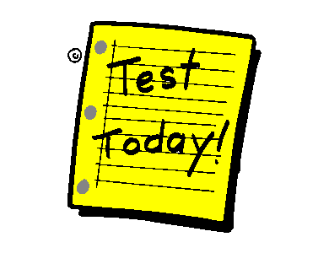 **Spelling and Dictation Test**

Today your Supervisor will test the twenty words you have been learning this week. Do the test on your lined paper and when you finish, you and your Supervisor can correct it together. I'm sure you'll give it your best shot.

Your Supervisor will read the whole extract to you and then **dictate** small sections or phrases. There are several commas in this extract. Read it through carefully and you should be able to tell where to place the commas.

Advertising is a form ∫ of communication for ∫ marketing a product. ∫ People who pay for advertising ∫ are called sponsors. ∫ Advertising can be presented ∫ via various traditional media ∫ such as newspaper, magazines, television commercial ∫ radio and mail. ∫ It can also be viewed ∫ by new media ∫ such as blogs, websites ∫ or text messages.

End of Week 1

****

**Checklist**

This week you should have completed the following tasks, please tick the tasks you have completed.

* **Reading***—*Traditional and modern advertising
* **Writing**—Own experiences
* **Reading**—Given advertisement
* **Spelling**—Own Words and LCWC
* **Suffixes**
* **Explore the text**—Comprehension
* **Reading and writing**—Advertising techniques
* **Test**—Spelling and Dictation

Week 2



**Learning Intentions for Week 2**

* Generate ideas and plans for creating your own advertisement.
* Write and present an advertisement.
* Study given spelling words in preparation for *test.*
* Investigate *prefixes.*

|  |
| --- |
| * Writing Project |

In the *Writing Project* section this week you will be creating your own advertisement. You have the whole week to complete your major writing task.

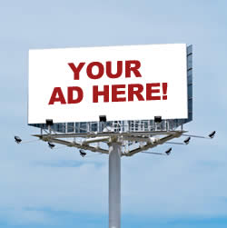

**How Will I Assess Your Advertisement?** 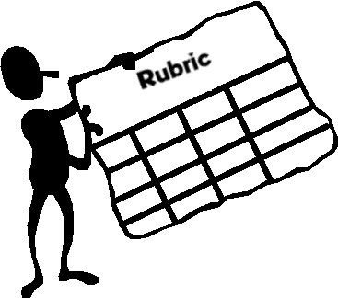

A **Rubric** (located at the back of this Module) will be used to assess your writing. It is a scoring guide with a range of criteria that will be used to score your work.

I suggest you read it carefully and use it as a working guide when planning and writing your work. Think about the criteria on which you will be judged and aim to complete your best work!

**Getting Started**

Read the following information carefully as it will help you with your **ideas, planning** and **drafting.** Remember you have all week to complete your final writing.

**What product will you advertise?** **The choice is yours!**

Begin by making a list of things – toys, clothes, books, games, etc…. Choose one of these things; this will be the product you will advertise. Remember you will need to convince other people that they should get one!

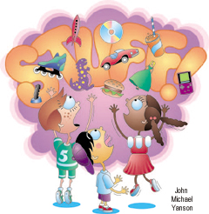

|  |
| --- |
| http://financialdivide.com/wp-content/uploads/2012/07/wpid-1341943961_question-mark-clip-art-010.jpg**How will you advertise – *traditional* or *modern advertising?***  http://www.onlinemarketingdenver.net/wp-content/uploads/2011/05/modern-advertising-methods.jpg**The choice is yours!**  *Think about your reading from Week 1* |

|  |
| --- |
| http://financialdivide.com/wp-content/uploads/2012/07/wpid-1341943961_question-mark-clip-art-010.jpg**Planning**  Organise your ideas in four boxes on the following page.  Remember to refer to the notes on A*dvertising Techniques* from  Week 1. Write down ideas in **point form.** |

**Planning**

**Get their attention.**

How will you make the reader stop and read your advertisement?

**Give them information.**

What facts will make the reader believe that you are giving them reliable information and that they can trust you?

**Tell them what to do.**

What action do you want them to take?

**Make them feel good about it.**

What can you say that will make the reader feel that they want to have the thing you are advertising?

**Helpful Hints!**

**Helpful Hint 1**

Choose words that will make the reader feel good about the product. Here are some examples:

*fantastic fun popular famous fabulous exclusive valuable*

Use a **thesaurus** to find interesting words.

**Helpful Hint 2**

Keep your message short!

Don’t write too much. People do not like to spend a lot of time reading an advertisement. Remember to keep them interested!

**Draft**

**How Do I Do This?**

Regardless of your choice of media I suggest you draft a rough copy of your advertisement. Share with a friend or family member. Ask their opinion.



Good luck!

**Final Advertisement**

**How Do I Do This?**

Depending on your choice of media complete your final advertisement on your chosen presentation.

Please contact your teacher if your require assistance of have any questions.



|  |  |
| --- | --- |
| http://www.oncoursesystems.com/images/user/10809/10705150/SCHOOL/Vocabulary%20-%201.gif | Word Explorer—Spelling |

This week you will follow the same process for spelling as in Week 1. Your spelling words for Week 2 are located at the back of the Module.

MCj04247880000[1]

**For You to Do**

1. Today I want you to choose 10 words to write in the column titled **My** **Own Words.**
2. Begin learning to spell the words in preparation for your test at the end of the week.
3. This week’s words are tricky so concentrate on the sound patterns and smaller words within each word e.g., *Conscience – on, science.*
4. Look up definitions if unsure.
5. You will need your *Look, Cover, Write and Check* (LCWC) book and follow the process outlined in English Module A.

|  |  |
| --- | --- |
| *http://www.salleywags.com/wp-content/uploads/2012/02/important-note.jpg* | *Test at the end of the week!* |

|  |  |
| --- | --- |
| http://www.oncoursesystems.com/images/user/10809/10705150/SCHOOL/Vocabulary%20-%201.gif | Word Explorer—Prefixes  Today we will be looking at the following punctuation marks:   * + colon   + semi-colon. |

## What are prefixes?

A prefix is a group of letters placed at the start of a root word to **change its meaning**. The list below highlights common prefixes and their meaning.

For example, the opposite of *clockwise* is *anticlockwise* as the prefix **anti** means opposite.

|  |  |  |  |  |  |  |  |  |  |  |  |  |  |  |  |  |  |  |  |  |  |  |  |  |  |  |  |  |  |  |  |  |  |  |  |  |  |  |  |  |  |  |  |  |  |  |  |  |  |  |  |  |  |  |
| --- | --- | --- | --- | --- | --- | --- | --- | --- | --- | --- | --- | --- | --- | --- | --- | --- | --- | --- | --- | --- | --- | --- | --- | --- | --- | --- | --- | --- | --- | --- | --- | --- | --- | --- | --- | --- | --- | --- | --- | --- | --- | --- | --- | --- | --- | --- | --- | --- | --- | --- | --- | --- | --- | --- |
| |  |  |  | | --- | --- | --- | | **PREFIX** | **MEANING** | **EXAMPLES** | | anti- | against or opposite to | anticlockwise | | auto- | self | autobiography, automat | | dis- | not, or away | dissimilar, disconnect | | in- | not | insane, inhuman | | il- | not | illogical, illegal | | im- | not | immature, improbable | | ir- | not | irrelevant, irregular | | inter- | between | international, | | mis- | wrong | misunderstand, misspell | | post- | after | postnatal, postscript | | pre- | before | prenatal, prehistoric | | pro- | for, or forward | propose, | | re- | again, or back | rewrite, reconsider | | sub- | under | submarine, substandard | | super- | above | supervisor, superhuman | | trans- | across | transport, transplant | | un- | not, or in reverse | unfinished, unarmed | |

MCj04247880000[1]

**For You to Do**

1. Use your dictionary to find the meaning of the following prefixes and write at least one word that begins with the given prefix.

|  |  |  |
| --- | --- | --- |
| **Prefix** | **Meaning** | **Word** |
| com- |  |  |
| con- |  |  |
| geo- |  |  |
| mal- |  |  |
| mega- |  |  |
| micro- |  |  |
| poly- |  |  |
| tele- |  |  |
| therm- |  |  |

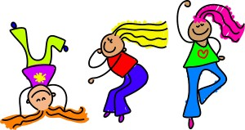

MCj04247880000[1] **For You to Do**

1. Use the bank of prefixes to complete each word. There may be more than one answer for some words.

**Bank of Prefixes:**

|  |  |  |  |  |  |  |
| --- | --- | --- | --- | --- | --- | --- |
| |  |  |  |  |  |  | | --- | --- | --- | --- | --- | --- | | de- dis- | ex- il- | im- in- | mis- non- | pre- re- | un- with- | |

|  |  |  |
| --- | --- | --- |
| \_\_\_\_ fix | \_\_\_\_ sense | \_\_\_\_ happy |
| \_\_\_\_ mind | \_\_\_\_ pert | \_\_\_\_ respect |
| \_\_\_\_ equal | \_\_\_\_ legal | \_\_\_\_ fiction |
| \_\_\_\_ prove | \_\_\_\_ frost | \_\_\_\_ ceed |
| \_\_\_\_ lucky | \_\_\_\_ lead | \_\_\_\_ appear |
| \_\_\_\_ fair | \_\_\_\_ gust | \_\_\_\_ hold |
| \_\_\_\_ place | \_\_\_\_ usual | \_\_\_ portant |
| \_\_\_\_ draw | \_\_\_ logical | \_\_\_\_ trieve |
| \_\_\_ visible | \_\_\_\_ play | \_\_\_\_ cellent |
| \_\_\_\_ view | \_\_\_\_ code | \_\_\_\_ flex |

MCj04247880000[1] **For You to Do**

**Suffix and Prefix**

**Challenge Activity (optional)**

Now that you have studied suffixes and prefixes add them to the root words below; if necessary use your dictionary.

|  |  |
| --- | --- |
| **Prefix - Root Word - Suffix** | **Prefix - Root Word - Suffix** |
| displacement | \_\_\_\_enforce\_\_\_\_ |
| \_\_\_\_law\_\_\_\_ | \_\_\_\_arrange\_\_\_\_ |
| \_\_\_\_legal\_\_\_\_ | \_\_\_\_develop\_\_\_\_ |
| \_\_\_\_mature\_\_\_\_ | \_\_\_\_taste\_\_\_\_ |
| \_\_\_\_taken\_\_\_\_ | \_\_\_\_finite\_\_\_\_ |
| \_\_\_\_humane\_\_\_\_ | \_\_\_\_act\_\_\_\_ |
| \_\_\_\_assign\_\_\_\_ | \_\_\_\_help\_\_\_\_ |
| \_\_\_\_health\_\_\_\_ | \_\_\_\_know\_\_\_\_ |
| \_\_\_\_account\_\_\_\_ | \_\_\_\_appear\_\_\_\_ |
| \_\_\_\_live\_\_\_\_ | \_\_\_\_avoid\_\_\_\_ |

|  |  |
| --- | --- |
| http://3.bp.blogspot.com/-qPoK5ahYCp4/TuuFpKg1zDI/AAAAAAAABKg/xPUigX_ZUkE/s400/clrtest.gif | **Spelling and Dictation Test** |

Today your Supervisor will test the twenty words you have been learning this week. Do the test on your lined paper and when you finish, you and your Supervisor can correct it together. I'm sure you'll give it your best shot.

Your Supervisor will read the whole extract to you and then **dictate** small sections or phrases. There are several commas in this extract. Read it through carefully and you should be able to tell where to place the commas.

Are you easily **∫** influenced by advertising? **∫** Do statements like **∫ ‘**Buy now!’ and **∫** ‘Try it free!’ **∫**  convince you to **∫** buy a product? **∫** What captures your attention? **∫** Is it the colour, **∫** discounts offered or **∫** pictures in an advertisement? **∫** Have you ever **∫** bought a product **∫** because you liked the advertisement **∫** and regretted it ∫ when you took it home?

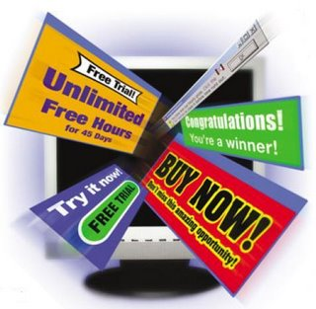

End of Week 2

****

**Checklist**

This week you should have completed the following tasks, please tick the tasks you have completed.

* **Writing Project**—Plan, draft, edit, final piece
* **Spelling**—LCWC and Own Words
* **Grammar**—Prefixes
* **Test**—Spelling and Dictation

**Spelling Module I**

|  |  |
| --- | --- |
| **Week 1** | **Week 2** |
| **Own words** | **Own words** |
|  |  |
|  |  |
|  |  |
|  |  |
|  |  |
|  |  |
|  |  |
|  |  |
|  |  |
|  |  |
| **Text words** | **Text words** |
| advertising | misunderstand |
| marketing | autobiography |
| products | prehistoric |
| persuade | supervision |
| media | unfinished |
| commercial | childish |
| websites | likeable |
| innovation | memorable |
| interactive | propose |
| consumer | unusual |

**Advertisement Rubric**

|  |  |  |  |  |
| --- | --- | --- | --- | --- |
| **CATEGORY** | **Exceeding Standards 4 pts** | **Meeting Standards 3 pts** | **Approaching Standards 2 pts** | **Below Standards 1 pts** |
| **Meaning and Originality** | Advertisement is creative and original. It is evident that the student put thought into their ad. which was both informative and appealing. | Advertisement is informative and creative. Some effort has been put into the information which provides important information. | Most of the ad is informative but appears to be rushed. | Ad appears to be confused and rushed. Work is very repetitive, and ideas are unoriginal. |
| **Sensory Details** | Captured the attention of the reader. Visually appealing and engaging | Images are used to portray information and some appeal. | Some use of pictures and appeal. | Difficult to stir any sense of conviction. |
| **Format** | The advertisement is complete and follows its intended form. | The ad. is written in its proper forms with a few mistakes. | The ad. is somewhat written in its proper form. | Ad. is not written in its proper form. |
| **Grammar** | Proper use of English spelling and grammar is used consistently throughout each poem. Punctuation is utilised when necessary. | A couple of spelling or grammar mistakes are evident, but do not diminish the meaning of the poem. Punctuation is utilised when necessary. | The student’s intended meaning is confusing by several spelling or grammar errors. Punctuation may be misused. | There are numerous spelling or grammar errors, making the ad. difficult to understand. Punctuation is used incorrectly. |

Teacher’s Self-Assessment Raw Score: **\_\_\_\_ / 16 points**

Final score: \_\_\_\_\_\_\_

|  |  |  |  |  |  |  |  |
| --- | --- | --- | --- | --- | --- | --- | --- |
| Description: Description: Description: Description: Description: Description: Description: Description: logoCAPS2**315 Clarendon Street, Thornbury 3071**  **Telephone (03) 8480 0000**  **FAX (03) 9416 8371 (Despatch)**  **Free call (1800) 133 511**   |  |  | | --- | --- | | |  | | --- | | **STUDENT NUMBER \_\_\_\_\_\_\_\_\_\_\_\_\_\_\_\_\_\_\_**  **STUDENT NAME \_\_\_\_\_\_\_\_\_\_\_\_\_\_\_\_\_\_\_\_\_\_**  **\_\_\_\_\_\_\_\_\_\_\_\_\_\_\_\_\_\_\_\_\_\_\_\_\_\_\_\_\_\_\_\_\_\_\_\_\_\_\_** | | | | | | | |  |
| Fix your student barcode  label over this space. |
|  |
| 5301  [5301] |
| **SUBJECT** | English | | | [ZX] |
| **COLOUR** | Blue | **MODULE** | I |
| **TEACHER** | \_\_\_\_\_\_\_\_\_\_\_\_\_\_\_\_\_\_\_\_\_\_\_\_\_\_\_ | | |

|  |
| --- |
| **THINKING ABOUT YOUR LEARNING**  Description: Description: Description: Description: http://t0.gstatic.com/images?q=tbn:ANd9GcTiyp1Q0EWVRSXlqyIMaG6be3rodf0nBbu2oBIY8JlYVh1iP8U7**I understand \_\_\_\_\_\_\_\_\_\_\_\_\_\_\_\_\_\_\_\_\_\_\_\_\_\_\_\_\_\_\_\_\_\_\_\_\_\_\_\_\_\_\_\_\_\_\_\_\_**  **\_\_\_\_\_\_\_\_\_\_\_\_\_\_\_\_\_\_\_\_\_\_\_\_\_\_\_\_\_\_\_\_\_\_\_\_\_\_\_\_\_\_\_\_\_\_\_\_\_\_\_\_\_\_\_\_\_\_\_\_\_\_\_\_\_\_\_\_\_\_\_\_\_\_\_**  **\_\_\_\_\_\_\_\_\_\_\_\_\_\_\_\_\_\_\_\_\_\_\_\_\_\_\_\_\_\_\_\_\_\_\_\_\_\_\_\_\_\_\_\_\_\_\_\_\_\_\_\_\_\_\_\_\_\_\_\_\_\_\_\_\_\_\_\_\_\_\_\_\_\_\_**  **\_\_\_\_\_\_\_\_\_\_\_\_\_\_\_\_\_\_\_\_\_\_\_\_\_\_\_\_\_\_\_\_\_\_\_\_\_\_\_\_\_\_\_\_\_\_\_\_\_\_\_\_\_\_\_\_\_\_\_\_\_\_\_\_\_\_\_\_\_\_\_\_\_\_\_**  **\_\_\_\_\_\_\_\_\_\_\_\_\_\_\_\_\_\_\_\_\_\_\_\_\_\_\_\_\_\_\_\_\_\_\_\_\_\_\_\_\_\_\_\_\_\_\_\_\_\_\_\_\_\_\_\_\_\_\_\_\_\_\_\_\_\_\_\_\_\_\_\_\_\_\_**  **Description: Description: Description: Description: http://t2.gstatic.com/images?q=tbn:ANd9GcQ72LH2Bxoxf3yTTP_t93kaIPDpv8jVzb20Dfacv1j6Jv1Vb43VI need help with\_\_\_\_\_\_\_\_\_\_\_\_\_\_\_\_\_\_\_\_\_\_\_\_\_\_\_\_\_\_\_\_\_\_\_\_\_\_\_\_\_\_\_\_\_\_\_\_**  **\_\_\_\_\_\_\_\_\_\_\_\_\_\_\_\_\_\_\_\_\_\_\_\_\_\_\_\_\_\_\_\_\_\_\_\_\_\_\_\_\_\_\_\_\_\_\_\_\_\_\_\_\_\_\_\_\_\_\_\_\_\_\_\_\_\_\_\_\_\_\_\_\_\_\_**  **\_\_\_\_\_\_\_\_\_\_\_\_\_\_\_\_\_\_\_\_\_\_\_\_\_\_\_\_\_\_\_\_\_\_\_\_\_\_\_\_\_\_\_\_\_\_\_\_\_\_\_\_\_\_\_\_\_\_\_\_\_\_\_\_\_\_\_\_\_\_\_\_\_\_\_**  **\_\_\_\_\_\_\_\_\_\_\_\_\_\_\_\_\_\_\_\_\_\_\_\_\_\_\_\_\_\_\_\_\_\_\_\_\_\_\_\_\_\_\_\_\_\_\_\_\_\_\_\_\_\_\_\_\_\_\_\_\_\_\_\_\_\_\_\_\_\_\_\_\_\_\_**  **\_\_\_\_\_\_\_\_\_\_\_\_\_\_\_\_\_\_\_\_\_\_\_\_\_\_\_\_\_\_\_\_\_\_\_\_\_\_\_\_\_\_\_\_\_\_\_\_\_\_\_\_\_\_\_\_\_\_\_\_\_\_\_\_\_\_\_\_\_\_\_\_\_\_\_** |

|  |
| --- |
| **YOUR QUESTIONS OR COMMENTS** |
| **TEACHER’S COMMENTS**  **Some great things about your work were:**  **Try to do the following next time:** |
|  |

