**Geography**

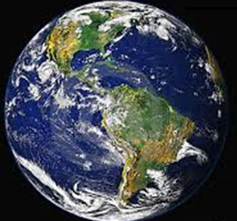

What is sustainability?



**GETTING KNOWLEDGE READY**

As you have previously investigated, humans and animals rely on many resources that the environment provides. Throughout this module, we are going to investigate the idea of **sustainability**.

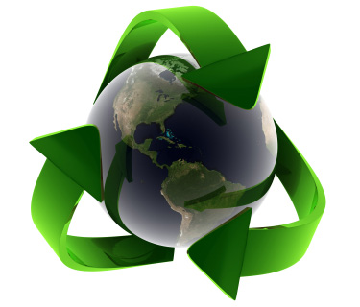

1. Find the word **sustainability** in the dictionary. Write the meaning.

|  |
| --- |
|  |
|  |
|  |
|  |
|  |
|  |
|  |
|  |
|  |

Sustainability is a long word that’s tricky to spell. It describes the ability for something to keep going at the same rate and in just as good condition as before. It is tempting for humans to think that we should be able to do anything we want. Unfortunately, nature does not work like this – our planet has limits. Every living system can only take so much use before it starts to weaken and decline. When this decline reaches a tipping point the living system slows down and can never reclaim its former glory.

Source: <http://www.coolaustralia.org/ca_topic/sustainability-2/>

1. Write some ways we can help the environment and support a sustainable future within our homes, at school and in the community.

|  |
| --- |
|  |
|  |
|  |
|  |
|  |
|  |
|  |
|  |
|  |
|  |
|  |
|  |
|  |
|  |
|  |
|  |
|  |
|  |
|  |
|  |
|  |
|  |
|  |
|  |
|  |
|  |
|  |
|  |

|  |
| --- |
|  |
|  |
|  |
|  |
|  |
|  |
|  |
|  |
|  |
|  |
|  |
|  |
|  |
|  |
|  |
|  |
|  |
|  |
|  |
|  |
|  |
|  |
|  |
|  |
|  |
|  |
|  |
|  |
|  |
|  |
|  |
|  |
|  |
|  |
|  |
|  |
|  |
|  |
|  |
|  |
|  |
|  |
|  |
|  |
|  |
|  |
|  |
|  |

1. Using your notes and the links below, create a poster advertising **sustainability** on the following page. If you need some more help for your poster, view one or two of the videos at the following link:

<https://www.youtube.com/watch?v=DZLbhuMiJXg>

|  |
| --- |
|  |

**REFLECTION**

1. What does **sustainability** mean?

|  |
| --- |
|  |
|  |
|  |
|  |
|  |
|  |
|  |
|  |
|  |
|  |
|  |
|  |
|  |
|  |
|  |

1. Why is it important to live sustainably?

|  |
| --- |
|  |
|  |
|  |
|  |
|  |
|  |
|  |
|  |
|  |
|  |
|  |
|  |
|  |
|  |
|  |