English



*How do I write an interesting recount?*



**Please read before you begin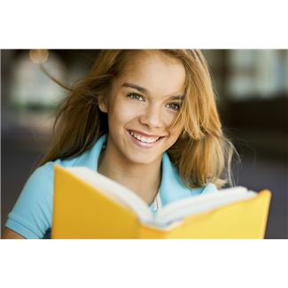**

‘How do I write an interesting recount?’

To help you answer this question, these are your learning intentions.

|  |  |
| --- | --- |
|  | Learning Intentions |
| Reading and Writing Workshop  Study the style and techniques used to write a Personal Recount.  Grammar and Punctuation  Learn about verb tense. Study capital letters, full stops and synonyms.  How Words Work  Add the suffix ‘ing’ to words and discover silent letters.    Spelling and Phonics  Study your ten given spelling words as well as your own ten words for your test at the end of the Set. In phonics, you will look at vowels and consonants as well as the magic e. | |

**Introduction**

|  |  |
| --- | --- |
| **Please read on to find out more**  Welcome. You will be learning about text types and how to write them, learning about grammar, punctuation and building on your spelling skills. |  |

This is what you will learning here.

|  |  |
| --- | --- |
| books,boys,childhood,children,concentration,educates,educations,Fotolia,homework,kids,knowledge,learning,learns,males,Photographs,readings,reads,schools,students,studies | Getting Knowledge Ready |

These activities will help you think about the ideas to use in your writing. It may include activities on what you know about a topic or what you might like to learn.

|  |  |
| --- | --- |
|  | Reading and Writing Workshop |

Each activity will have a different text type for you to work with. Firstly, you will read the text type and complete activities which will help you understand the way they are written.

|  |  |
| --- | --- |
|  | Spelling and How Words Work |

You will be given a list of ten spelling words for each set and you will also choose ten words you would like to learn. Someone at home can give you a spelling test on the words. How Words Work activities will teach you about the spelling patterns in words and show you the groups of letters that make same sound.

|  |  |
| --- | --- |
| C:\Users\jmiller\AppData\Local\Microsoft\Windows\Temporary Internet Files\Low\Content.IE5\O584SN30\MC900053962[1].WMF | Grammar and Punctuation |

In the Grammar and Punctuation activities you will learn about how sentences are put together and the important words that are in them and the order they should go in. Also there will be activities on how and when to use the correct punctuation in your written work.

|  |  |
| --- | --- |
|  | Daily Reading |
| First of all you should choose something to read that is enjoyable and not too difficult.  Take a few minutes to read aloud to someone at home. Then find yourself a comfortable spot and spend ten to fifteen minutes reading silently.  When you have finished reading, talk about what you have read with someone at home and check on any words that you had difficulty with. You might like to add these to your spelling list. | |

|  |  |
| --- | --- |
|  | Reflection |
| You will be asked to tick the activities you have completed on the checklist page on page 37. You will also be asked to do some activities about what you have learned. | |

|  |  |
| --- | --- |
|  | Completing your checklist |
| Don’t forget to tick off the checklist of activities you have completed. | |

|  |  |
| --- | --- |
| Contents | |
| Set One | Reading and Writing Workshop   * Exploring the Text - reading and learning about a Personal Recount * Complete activities about a Personal Recount   Spelling activities and Phonetics   * Ten given words and ten words of your own choice * The Magic e   Grammar and Punctuation   * Tense, capital letters and full stops   How words work   * The suffix ing   Spelling test   * Spell the words for this Set |
| Set 2 | Reading and Writing Workshop   * Write a Personal Recount   Spelling activities and Phonics   * Ten given words and ten words of your own choice * The ‘ale’ sound   Grammar and Punctuation   * Synonyms   How words work   * Silent letters   Spelling test   * Spell the words for this Set   Reflection   * True or false questions * Response log |

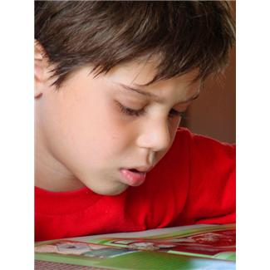

Getting Knowledge Ready

You will be learning all about writing a Daily Diary. Did you know that a diary is called a Personal Recount? This means that you are the person who is telling all about what you have been doing. A bit like writing a story of all of your adventures! Now please answer the following questions.

Do you already keep a diary? \_\_\_\_\_\_\_\_\_\_\_\_\_\_\_\_\_\_\_\_\_\_\_\_\_\_\_\_\_

When are some times that you think it would be a good idea to keep a diary?

\_\_\_\_\_\_\_\_\_\_\_\_\_\_\_\_\_\_\_\_\_\_\_\_\_\_\_\_\_\_\_\_\_\_\_\_\_\_\_\_\_\_\_\_\_\_\_\_\_\_\_\_\_\_\_\_\_\_\_\_\_\_

\_\_\_\_\_\_\_\_\_\_\_\_\_\_\_\_\_\_\_\_\_\_\_\_\_\_\_\_\_\_\_\_\_\_\_\_\_\_\_\_\_\_\_\_\_\_\_\_\_\_\_\_\_\_\_\_\_\_\_\_\_\_

Now write or draw some of the things you already know about a Daily Diary in each of the shapes.

**Daily Diary**

|  |
| --- |
| Set One |

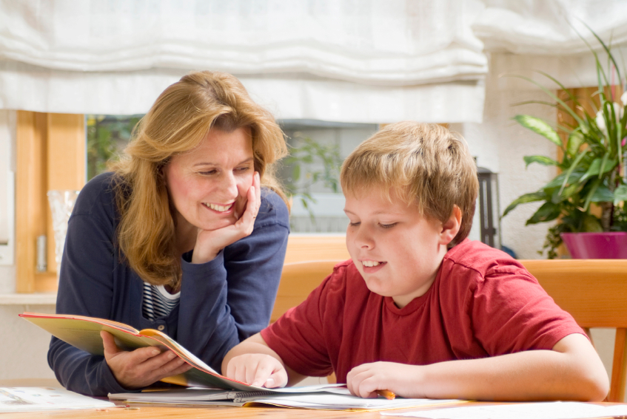

|  |  |
| --- | --- |
|  | Writing Workshop |

Personal Recount

Now that you have come up with some ideas about a Daily Diary, it’s time to look at all the things you need to put in your writing to make it interesting and exciting for you or someone else to read. It’s important to remember that a Daily Diary is a text type called a recount.

A recount has the following features:

* An orientation.
* A series of events.
* A re-orientation.

Read on to find out what each feature of a recount means.

**recount**

**Orientation**

This supplies the background information and usually answers the questions of: When? What? Where? Who? Why? (not always included)

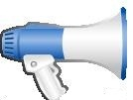

**Series of events**

This lists the details of the events. It usually describes them in the order that they happened.



**Re-orientation**

This is used at the end of the writing. It usually rounds off the series of events and finishes it.



As you read the following Diary, see if you can find where the following features are in the recount.

One. 2. 3. 

Re-orientation

Orientation

Series of events

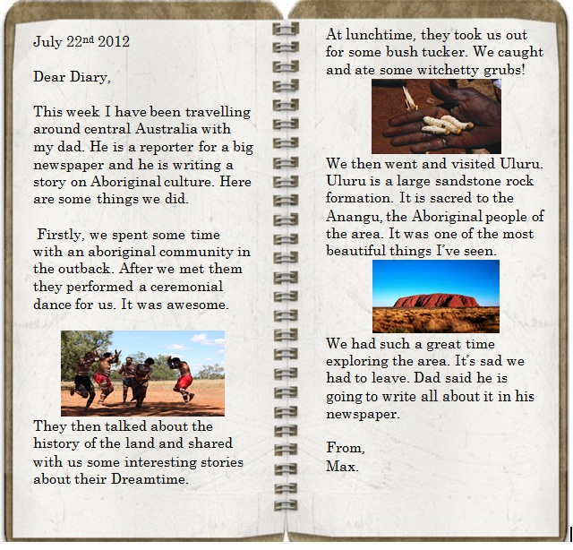

Discussion

Together with someone at home, discuss the Personal Recount.

* 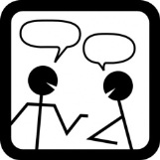What places did Max see?
* What would you like to know about the Aboriginal

community?

* Would you eat Witchetty Grubs? Why or why not?

\_\_\_\_\_\_\_\_\_\_\_\_\_\_\_\_\_\_\_\_\_\_\_\_\_\_\_\_\_\_\_\_\_\_\_\_\_\_\_\_\_\_\_\_\_\_\_\_\_\_\_\_\_\_\_\_\_\_\_

\_\_\_\_\_\_\_\_\_\_\_\_\_\_\_\_\_\_\_\_\_\_\_\_\_\_\_\_\_\_\_\_\_\_\_\_\_\_\_\_\_\_\_\_\_\_\_\_\_\_\_\_\_\_\_\_\_\_\_

\_\_\_\_\_\_\_\_\_\_\_\_\_\_\_\_\_\_\_\_\_\_\_\_\_\_\_\_\_\_\_\_\_\_\_\_\_\_\_\_\_\_\_\_\_\_\_\_\_\_\_\_\_\_\_\_\_\_\_

\_\_\_\_\_\_\_\_\_\_\_\_\_\_\_\_\_\_\_\_\_\_\_\_\_\_\_\_\_\_\_\_\_\_\_\_\_\_\_\_\_\_\_\_\_\_\_\_\_\_\_\_\_\_\_\_\_\_\_

\_\_\_\_\_\_\_\_\_\_\_\_\_\_\_\_\_\_\_\_\_\_\_\_\_\_\_\_\_\_\_\_\_\_\_\_\_\_\_\_\_\_\_\_\_\_\_\_\_\_\_\_\_\_\_\_\_\_\_

\_\_\_\_\_\_\_\_\_\_\_\_\_\_\_\_\_\_\_\_\_\_\_\_\_\_\_\_\_\_\_\_\_\_\_\_\_\_\_\_\_\_\_\_\_\_\_\_\_\_\_\_\_\_\_\_\_\_\_

Now use the timeline below to show the key events that happened in the diary. The first one is done for you.

The diary starts with Max describing his dad’s job.

The diary starts with the writer describing his trip to Central Australia.

The diary starts with the writer describing his trip to Central Australia.

Read through ‘My Diary’ again and answer the following questions in the recount outline below.

Orientation

When? \_\_\_\_\_\_\_\_\_\_\_\_\_\_\_\_\_\_\_\_\_\_\_\_\_\_\_\_\_\_\_\_\_\_\_\_\_\_\_\_\_\_\_\_\_\_\_\_\_\_\_\_\_\_\_\_\_

\_\_\_\_\_\_\_\_\_\_\_\_\_\_\_\_\_\_\_\_\_\_\_\_\_\_\_\_\_\_\_\_\_\_\_\_\_\_\_\_\_\_\_\_\_\_\_\_\_\_\_\_\_\_\_\_\_\_\_\_\_\_\_\_

What? \_\_\_\_\_\_\_\_\_\_\_\_\_\_\_\_\_\_\_\_\_\_\_\_\_\_\_\_\_\_\_\_\_\_\_\_\_\_\_\_\_\_\_\_\_\_\_\_\_\_\_\_\_\_\_\_\_

\_\_\_\_\_\_\_\_\_\_\_\_\_\_\_\_\_\_\_\_\_\_\_\_\_\_\_\_\_\_\_\_\_\_\_\_\_\_\_\_\_\_\_\_\_\_\_\_\_\_\_\_\_\_\_\_\_\_\_\_\_\_\_\_

Where? \_\_\_\_\_\_\_\_\_\_\_\_\_\_\_\_\_\_\_\_\_\_\_\_\_\_\_\_\_\_\_\_\_\_\_\_\_\_\_\_\_\_\_\_\_\_\_\_\_\_\_\_\_\_\_\_

\_\_\_\_\_\_\_\_\_\_\_\_\_\_\_\_\_\_\_\_\_\_\_\_\_\_\_\_\_\_\_\_\_\_\_\_\_\_\_\_\_\_\_\_\_\_\_\_\_\_\_\_\_\_\_\_\_\_\_\_\_\_\_\_

Who? \_\_\_\_\_\_\_\_\_\_\_\_\_\_\_\_\_\_\_\_\_\_\_\_\_\_\_\_\_\_\_\_\_\_\_\_\_\_\_\_\_\_\_\_\_\_\_\_\_\_\_\_\_\_\_\_\_\_

Why? (not always included) \_\_\_\_\_\_\_\_\_\_\_\_\_\_\_\_\_\_\_\_\_\_\_\_\_\_\_\_\_\_\_\_\_\_\_\_\_\_

\_\_\_\_\_\_\_\_\_\_\_\_\_\_\_\_\_\_\_\_\_\_\_\_\_\_\_\_\_\_\_\_\_\_\_\_\_\_\_\_\_\_\_\_\_\_\_\_\_\_\_\_\_\_\_\_\_\_\_\_\_\_\_\_

Series of Events

|  |  |
| --- | --- |
| List of events | Order of events |
|  |  |
|  |  |
|  |  |

Re-orientation

\_\_\_\_\_\_\_\_\_\_\_\_\_\_\_\_\_\_\_\_\_\_\_\_\_\_\_\_\_\_\_\_\_\_\_\_\_\_\_\_\_\_\_\_\_\_\_\_\_\_\_\_\_\_\_\_\_\_\_\_\_\_\_\_

\_\_\_\_\_\_\_\_\_\_\_\_\_\_\_\_\_\_\_\_\_\_\_\_\_\_\_\_\_\_\_\_\_\_\_\_\_\_\_\_\_\_\_\_\_\_\_\_\_\_\_\_\_\_\_\_\_\_\_\_\_\_\_\_

\_\_\_\_\_\_\_\_\_\_\_\_\_\_\_\_\_\_\_\_\_\_\_\_\_\_\_\_\_\_\_\_\_\_\_\_\_\_\_\_\_\_\_\_\_\_\_\_\_\_\_\_\_\_\_\_\_\_\_\_\_\_\_\_

|  |  |
| --- | --- |
|  | Spelling |

This is a spelling lesson. The spelling words which you will be studying are divided into two groups.

Spelling Words

These are words that are given to you in each set.

My Own Words

These are words which you choose that are of interest to you and/or words which you have misspelt in your writing.

What do I do to get started?

The spelling words are divided into Set One and Set 2. Set One’s words are located near the back of this booklet. There is also a column for you to write ten words which you would like to learn to spell.

For you to do first

Today I want you to choose your own words. These can be from:

* your own writing
* your reading
* your memory

Write the ten words you have chosen, in the My Own Words column.

Learn these and the ten words given to you for Set One.

Remember to use L.C.W.C to help you learn these. On the next page you will be reminded how to do this.

How do I learn my spelling words?

Look Cover Write Check

One of the ways to learn them is to use the Look, Cover, Write, Check method.

|  |  |  |  |
| --- | --- | --- | --- |
| WriteLook  Look | Cover  Cover |  | Check  Check |

Look Cover Write Check

How to use **Look**, **Cover**, **Write**, **Check.**

1. First read the words aloud to someone at home to check that you are saying them correctly.
2. Copy the words I have asked you to learn on some paper.
3. **Look** at the first word and then **cover** it with the flap.
4. **Write** the word.
5. Lift the flap and **Check** that you’ve spelt it correctly.
6. Do this with each of the words you’ve written.

Ten Spelling Words for Set One

birthday five hear brother time

wave brave flame page grade

For the rest of Set One you should focus on learning the words using the LCWC method. At the end of Set One someone at home can test your spelling.

Spelling Activities

|  |  |
| --- | --- |
| Here are some spelling activities to help you learn your words for Set One. |  |

Unjumble these list words:

rithbyad \_\_\_\_\_\_\_\_\_\_\_\_\_\_\_\_\_ evif \_\_\_\_\_\_\_\_\_\_\_\_\_\_\_\_\_

threbor \_\_\_\_\_\_\_\_\_\_\_\_\_\_\_\_\_ emit \_\_\_\_\_\_\_\_\_\_\_\_\_\_\_\_\_

meafl \_\_\_\_\_\_\_\_\_\_\_\_\_\_\_\_\_ egdra \_\_\_\_\_\_\_\_\_\_\_\_\_\_\_\_\_

1. Write the list words in alphabetical order:

\_\_\_\_\_\_\_\_\_\_\_\_\_\_\_\_\_\_\_\_\_\_\_\_\_\_\_\_\_\_\_\_\_\_\_\_\_\_\_\_\_\_\_\_\_\_\_\_\_\_\_\_\_\_\_\_\_\_\_

\_\_\_\_\_\_\_\_\_\_\_\_\_\_\_\_\_\_\_\_\_\_\_\_\_\_\_\_\_\_\_\_\_\_\_\_\_\_\_\_\_\_\_\_\_\_\_\_\_\_\_\_\_\_\_\_\_\_\_

\_\_\_\_\_\_\_\_\_\_\_\_\_\_\_\_\_\_\_\_\_\_\_\_\_\_\_\_\_\_\_\_\_\_\_\_\_\_\_\_\_\_\_\_\_\_\_\_\_\_\_\_\_\_\_\_\_\_\_

1. Which list word means

A relative \_\_\_\_\_\_\_\_\_\_\_\_\_\_\_\_\_\_\_\_\_\_\_\_\_\_\_\_\_\_\_\_\_\_\_\_\_\_\_\_\_\_\_\_\_\_\_\_\_\_

The day someone is born \_\_\_\_\_\_\_\_\_\_\_\_\_\_\_\_\_\_\_\_\_\_\_\_\_\_\_\_\_\_\_\_\_\_\_\_

The number after four \_\_\_\_\_\_\_\_\_\_\_\_\_\_\_\_\_\_\_\_\_\_\_\_\_\_\_\_\_\_\_\_\_\_\_\_\_\_

Fire \_\_\_\_\_\_\_\_\_\_\_\_\_\_\_\_\_\_\_\_\_\_\_\_\_\_\_\_\_\_\_\_\_\_\_\_\_\_\_\_\_\_\_\_\_\_\_\_\_\_\_\_\_\_\_

1. Write one interesting sentence using the words:

brave time flame

\_\_\_\_\_\_\_\_\_\_\_\_\_\_\_\_\_\_\_\_\_\_\_\_\_\_\_\_\_\_\_\_\_\_\_\_\_\_\_\_\_\_\_\_\_\_\_\_\_\_\_\_\_\_\_\_\_\_\_\_\_\_

\_\_\_\_\_\_\_\_\_\_\_\_\_\_\_\_\_\_\_\_\_\_\_\_\_\_\_\_\_\_\_\_\_\_\_\_\_\_\_\_\_\_\_\_\_\_\_\_\_\_\_\_\_\_\_\_\_\_\_\_\_\_

\_\_\_\_\_\_\_\_\_\_\_\_\_\_\_\_\_\_\_\_\_\_\_\_\_\_\_\_\_\_\_\_\_\_\_\_\_\_\_\_\_\_\_\_\_\_\_\_\_\_\_\_\_\_\_\_\_\_\_\_\_\_

\_\_\_\_\_\_\_\_\_\_\_\_\_\_\_\_\_\_\_\_\_\_\_\_\_\_\_\_\_\_\_\_\_\_\_\_\_\_\_\_\_\_\_\_\_\_\_\_\_\_\_\_\_\_\_\_\_\_\_\_\_\_

\_\_\_\_\_\_\_\_\_\_\_\_\_\_\_\_\_\_\_\_\_\_\_\_\_\_\_\_\_\_\_\_\_\_\_\_\_\_\_\_\_\_\_\_\_\_\_\_\_\_\_\_\_\_\_\_\_\_\_\_\_\_

1. Which list word fits into the gaps in these sentences?
2. It was \_\_\_ \_\_\_ \_\_\_ \_\_\_ to go to school.
3. I have one sister and one \_\_\_ \_\_\_ \_\_\_ \_\_\_ \_\_\_ \_\_\_ \_\_\_.
4. It’s my \_\_\_ \_\_\_ \_\_\_ \_\_\_ \_\_\_ \_\_\_ \_\_\_ \_\_\_ today!
5. I am in \_\_\_ \_\_\_ \_\_\_ \_\_\_ \_\_\_ three.

Draw a face in the box below that shows how you felt with your spelling activities today.

|  |
| --- |
| **Vowels and Consonants**  We will also be learning about how words sound in our spelling activities. This also means we need to know what vowels and consonants are.  Vowels  There are five vowel letters in the alphabet (a, e, i, o, u). The other twenty-one letters are called consonants. Some vowel sounds can be short, such as the o in hop. While other vowel sounds can be long such as the o in hope.  Consonants  There are also 2One consonant letters in the alphabet. They are:  b, c, d, f, g, h, j, k, l, m, n, p, q, r, s, t, v, w, x, y, z  Some consonant letters can have different sounds.   * In the word cat, the letter c has a/k/ sound as in kiss. * In the word cell, the letter c has a/s/ sound as in send. |

Now we are going to learn about a special vowel, one that sometimes gets called the **Magic e.**

The **Magic e** is the letter that remains silent in words like cak**e** and bon**e**. It also changes the sound of the vowel before it, just like magic!

For example: The word **tap** has a short vowel sound when you say it out loud. Try saying it now. When we add the Magic e to the end of tap it becomes **tape**. It now has a long vowel sound. Now you try saying these words out loud together.

Tap Tape

Notice how different they sound!

Now below are some examples of the words before and after the Magic e is added. Make sure you say the words out loud each time!

|  |  |
| --- | --- |
| Say the word without the Magic e | Say the word after the Magic e is added. |
| at  Tim  pet  not  cut | ate  time  Pete  note  cute |

Now that you have seen what the **Magic e** does, describe how different it makes the words sound.

\_\_\_\_\_\_\_\_\_\_\_\_\_\_\_\_\_\_\_\_\_\_\_\_\_\_\_\_\_\_\_\_\_\_\_\_\_\_\_\_\_\_\_\_\_\_\_\_\_\_\_\_\_\_\_\_\_\_\_

\_\_\_\_\_\_\_\_\_\_\_\_\_\_\_\_\_\_\_\_\_\_\_\_\_\_\_\_\_\_\_\_\_\_\_\_\_\_\_\_\_\_\_\_\_\_\_\_\_\_\_\_\_\_\_\_\_\_\_

Now have a go at filling these sentences in with words that have the Magic e. Choose the right word from the box.

Pete

tape

note

kite

1. You can not fix a **tap** with \_ \_ \_ \_.
2. The **pet** runs to \_ \_ \_ \_.
3. 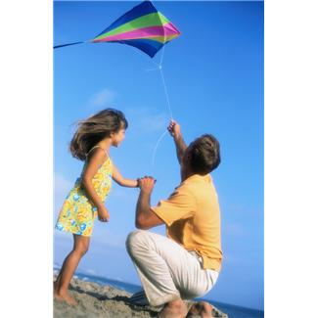This is a **kit** to make a \_ \_ \_ \_.
4. I can **not** sing a \_ \_ \_ \_.

|  |  |
| --- | --- |
|  | Daily Reading |

Also, remember to do your daily reading. Make sure you can find something enjoyable to read to someone at home for a couple of minutes each day.

|  |  |
| --- | --- |
| C:\Users\jmiller\AppData\Local\Microsoft\Windows\Temporary Internet Files\Low\Content.IE5\O584SN30\MC900053962[1].WMF | Grammar and Punctuation |

Now as you may have noticed when we write a recount, we use nouns and verbs in our writing.

What is a noun?

Nouns are words used to name people, places, things and ideas. Common nouns are the general names of people, places, things, feelings and ideas. Here is an example:

The **bird** flew over the **tree.**

In this sentence bird and tree are the nouns because **bird** and **tree** are the names of things.

What is a verb?

A verb is a word or a word group that shows what the subject of a sentence is doing, being, saying or thinking. Every sentence must have a verb. Here is an example.

“The lion **escaped**,” said the zookeeper.

In this sentence, the verb ‘escaped' shows what the lion did.

When you write a recount, you are describing things that have happened in the past. This means you have to think about the words that you use in your writing and what verbs you choose. Here is a little poem about how verbs can tell us when an action is taking place.

It takes only a little bit of sense

To understand how **verbs** change their tense.

If something is happening now, the verb is in the present tense.

An example of this is I stick pictures into my scrap book.

If the action has already happened, the verb is in the past tense.

This would be Yesterday I stuck pictures in my scrap book.

But what if the action hasn’t happened yet but will take place sometime in the future? This sentence would be: Tomorrow I will stick pictures into my scrap book. Now the verb stick is in the future tense.

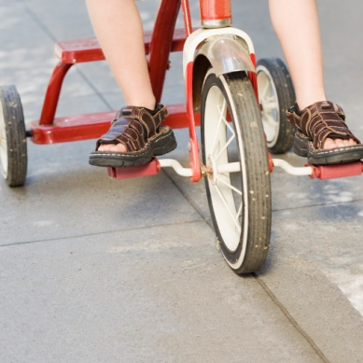

Add the present, past and future tense of the verb **ride**.

I like to \_\_\_\_\_\_\_\_\_\_\_\_ my bike. (ride/rode)

Yesterday I \_\_\_\_\_\_\_\_\_\_\_\_ my bike in the park. (ride/rode)

Tomorrow I will \_\_\_\_\_\_\_\_\_\_\_\_\_\_\_ to my friend’s house. (ride/rode)

Now write a sentence using past, present or future tense.

\_\_\_\_\_\_\_\_\_\_\_\_\_\_\_\_\_\_\_\_\_\_\_\_\_\_\_\_\_\_\_\_\_\_\_\_\_\_\_\_\_\_\_\_\_\_\_\_\_\_\_\_\_\_\_\_\_\_\_\_\_\_

\_\_\_\_\_\_\_\_\_\_\_\_\_\_\_\_\_\_\_\_\_\_\_\_\_\_\_\_\_\_\_\_\_\_\_\_\_\_\_\_\_\_\_\_\_\_\_\_\_\_\_\_\_\_\_\_\_\_\_\_\_\_

Capital Letters

It is very important to remember to use the correct punctuation when you write. Capital letters and full stops make it easier for others to understand your writing.

|  |  |
| --- | --- |
| A capital letter is used for |  |

* The first letter of a sentence.
* The first letter in names, books, plays, poems, films, songs, people, places, pets, days, months, countries, states, towns, mountains, rivers.
* The pronoun I.

Rewrite theses sentences using the correct capital letters. The first one has been done for you.

the cow drank the water in the tank.

The cow drank the water in the tank.

\_\_\_\_\_\_\_\_\_\_\_\_\_\_\_\_\_\_\_\_\_\_\_\_\_\_\_\_\_\_\_\_\_\_\_\_\_\_\_\_\_\_\_\_\_\_\_\_\_\_\_\_\_\_\_\_\_\_\_\_\_\_\_\_\_\_\_\_\_\_\_\_\_\_

last monday justin and suzanna went to a party.

\_\_\_\_\_\_\_\_\_\_\_\_\_\_\_\_\_\_\_\_\_\_\_\_\_\_\_\_\_\_\_\_\_\_\_\_\_\_\_\_\_\_\_\_\_\_\_\_\_\_\_\_\_\_\_\_\_\_\_\_\_\_\_\_\_\_\_\_\_\_\_\_\_\_

\_\_\_\_\_\_\_\_\_\_\_\_\_\_\_\_\_\_\_\_\_\_\_\_\_\_\_\_\_\_\_\_\_\_\_\_\_\_\_\_\_\_\_\_\_\_\_\_\_\_\_\_\_\_\_\_\_\_\_\_\_\_\_\_\_\_\_\_\_\_\_\_\_\_

next September nick is going to live in melbourne.

\_\_\_\_\_\_\_\_\_\_\_\_\_\_\_\_\_\_\_\_\_\_\_\_\_\_\_\_\_\_\_\_\_\_\_\_\_\_\_\_\_\_\_\_\_\_\_\_\_\_\_\_\_\_\_\_\_\_\_\_\_\_\_\_\_\_\_\_\_\_\_\_\_\_

\_\_\_\_\_\_\_\_\_\_\_\_\_\_\_\_\_\_\_\_\_\_\_\_\_\_\_\_\_\_\_\_\_\_\_\_\_\_\_\_\_\_\_\_\_\_\_\_\_\_\_\_\_\_\_\_\_\_\_\_\_\_\_\_\_\_\_\_\_\_\_\_\_\_

In your writing you also use statements and sometimes you ask questions.

* Statements are sentences that do not ask questions, give instructions or exclaim anything.
* Statements begin with a capital letter and end with a full stop.

Here are some examples.

Bees gather pollen from flowers.

The storm damaged many houses.

The weather tomorrow will be windy and wet.

* Questions are sentences that ask for information or action.
* Questions end with a question mark.
* You can also put a question mark at the end of a statement.

The question mark tells the reader to use his or her voice to make the sentence sound as if it is a question.

Here is an example.

Am I allowed to go**?** Are you sure of that**?**

So remember, a statement sentence ends with a full stop.

A question sentence ends with a question mark.



Punctuate each sentence correctly with capital letters, full stops or question marks. The first one has been done for you.

1. my cousin’s name is barry have you met him

My cousin’s name is Barry. Have you met him?

\_\_\_\_\_\_\_\_\_\_\_\_\_\_\_\_\_\_\_\_\_\_\_\_\_\_\_\_\_\_\_\_\_\_\_\_\_\_\_\_\_\_\_\_\_\_\_\_\_\_\_\_\_\_\_\_\_\_\_\_\_\_\_\_\_\_\_\_\_\_\_\_\_\_

\_\_\_\_\_\_\_\_\_\_\_\_\_\_\_\_\_\_\_\_\_\_\_\_\_\_\_\_\_\_\_\_\_\_\_\_\_\_\_\_\_\_\_\_\_\_\_\_\_\_\_\_\_\_\_\_\_\_\_\_\_\_\_\_\_\_\_\_\_\_\_\_\_\_

1. the largest city in victoria is melbourne

\_\_\_\_\_\_\_\_\_\_\_\_\_\_\_\_\_\_\_\_\_\_\_\_\_\_\_\_\_\_\_\_\_\_\_\_\_\_\_\_\_\_\_\_\_\_\_\_\_\_\_\_\_\_\_\_\_\_\_\_\_\_\_\_\_\_\_\_\_\_\_\_\_\_

\_\_\_\_\_\_\_\_\_\_\_\_\_\_\_\_\_\_\_\_\_\_\_\_\_\_\_\_\_\_\_\_\_\_\_\_\_\_\_\_\_\_\_\_\_\_\_\_\_\_\_\_\_\_\_\_\_\_\_\_\_\_\_\_\_\_\_\_\_\_\_\_\_\_

1. your dog buster is very large

\_\_\_\_\_\_\_\_\_\_\_\_\_\_\_\_\_\_\_\_\_\_\_\_\_\_\_\_\_\_\_\_\_\_\_\_\_\_\_\_\_\_\_\_\_\_\_\_\_\_\_\_\_\_\_\_\_\_\_\_\_\_\_\_\_\_\_\_\_\_\_\_\_\_

\_\_\_\_\_\_\_\_\_\_\_\_\_\_\_\_\_\_\_\_\_\_\_\_\_\_\_\_\_\_\_\_\_\_\_\_\_\_\_\_\_\_\_\_\_\_\_\_\_\_\_\_\_\_\_\_\_\_\_\_\_\_\_\_\_\_\_\_\_\_\_\_\_\_

1. have you read the book called ‘big home’?

\_\_\_\_\_\_\_\_\_\_\_\_\_\_\_\_\_\_\_\_\_\_\_\_\_\_\_\_\_\_\_\_\_\_\_\_\_\_\_\_\_\_\_\_\_\_\_\_\_\_\_\_\_\_\_\_\_\_\_\_\_\_\_\_\_\_\_\_\_\_\_\_\_\_

\_\_\_\_\_\_\_\_\_\_\_\_\_\_\_\_\_\_\_\_\_\_\_\_\_\_\_\_\_\_\_\_\_\_\_\_\_\_\_\_\_\_\_\_\_\_\_\_\_\_\_\_\_\_\_\_\_\_\_\_\_\_\_\_\_\_\_\_\_\_\_\_\_\_

1. is that george sitting over there

\_\_\_\_\_\_\_\_\_\_\_\_\_\_\_\_\_\_\_\_\_\_\_\_\_\_\_\_\_\_\_\_\_\_\_\_\_\_\_\_\_\_\_\_\_\_\_\_\_\_\_\_\_\_\_\_\_\_\_\_\_\_\_\_\_\_\_\_\_\_\_\_\_\_

\_\_\_\_\_\_\_\_\_\_\_\_\_\_\_\_\_\_\_\_\_\_\_\_\_\_\_\_\_\_\_\_\_\_\_\_\_\_\_\_\_\_\_\_\_\_\_\_\_\_\_\_\_\_\_\_\_\_\_\_\_\_\_\_\_\_\_\_\_\_\_\_\_\_

|  |  |
| --- | --- |
|  | How Words Work |

The Suffix: ing

Suffixes are word endings. For some verbs, you add ing to the end to change the word’s tense, for example *climb + ing = climbing*

Read theses sentences. Add ing and write the new word into the blank spaces. The first one has been done for you.

The happy kangaroos are jumping in the field. **(jump)**

The bowling ball was \_\_\_\_\_\_\_\_\_\_\_\_\_\_\_\_\_\_\_\_\_\_\_\_\_down the lane toward the pins. **(roll)**

My mum and dad are \_\_\_\_\_\_\_\_\_\_\_\_\_\_\_\_\_\_\_\_\_\_\_\_\_a salad for lunch. **(eat)**

The fans were \_\_\_\_\_\_\_\_\_\_\_\_\_\_\_\_\_\_\_\_\_\_\_\_\_for their favourite sports team. **(cheer)**

Write a sentence on the lines below, using a word with the suffix ‘ing’. Underline your chosen word.

**\_\_\_\_\_\_\_\_\_\_\_\_\_\_\_\_\_\_\_\_\_\_\_\_\_\_\_\_\_\_\_\_\_\_\_\_\_\_\_\_\_\_\_\_\_\_\_\_\_\_\_**

**\_\_\_\_\_\_\_\_\_\_\_\_\_\_\_\_\_\_\_\_\_\_\_\_\_\_\_\_\_\_\_\_\_\_\_\_\_\_\_\_\_\_\_\_\_\_\_\_\_\_\_**

**\_\_\_\_\_\_\_\_\_\_\_\_\_\_\_\_\_\_\_\_\_\_\_\_\_\_\_\_\_\_\_\_\_\_\_\_\_\_\_\_\_\_\_\_\_\_\_\_\_\_\_**

**\_\_\_\_\_\_\_\_\_\_\_\_\_\_\_\_\_\_\_\_\_\_\_\_\_\_\_\_\_\_\_\_\_\_\_\_\_\_\_\_\_\_\_\_\_\_\_\_\_\_\_**

It’s now time for your spelling test.

Give your sheet of words to someone at home. Ask them to test your spelling of the ten spelling words for this Set as well as the ten words of your own choice.

Take a sheet of lined paper, write Spelling Test Set One at the top and then write each word as it is given. At the end of the test correct your words together and record your score. Re-write any errors you may have three times each. This will help you to remember them correctly next time.

|  |  |
| --- | --- |
| Spelling Words for Set One | |
| Spelling Words | My Own Spelling Words |
| birthday |  |
| five |  |
| hear |  |
| brother |  |
| time |  |
| wave |  |
| brave |  |
| flame |  |
| page |  |
| grade |  |

****

**Checklist**

You should have completed the following tasks. Please tick the tasks you have completed.

* Reading and Writing workshop—Recount
* Spelling activities—LCWC and own Words
* Phonics—The Magic e
* Grammar and Punctuation— Tense, capital letters and full stops
* How Words Work—The suffix: ed
* Spelling

|  |
| --- |
| End of Set One |

|  |
| --- |
| Set Two |

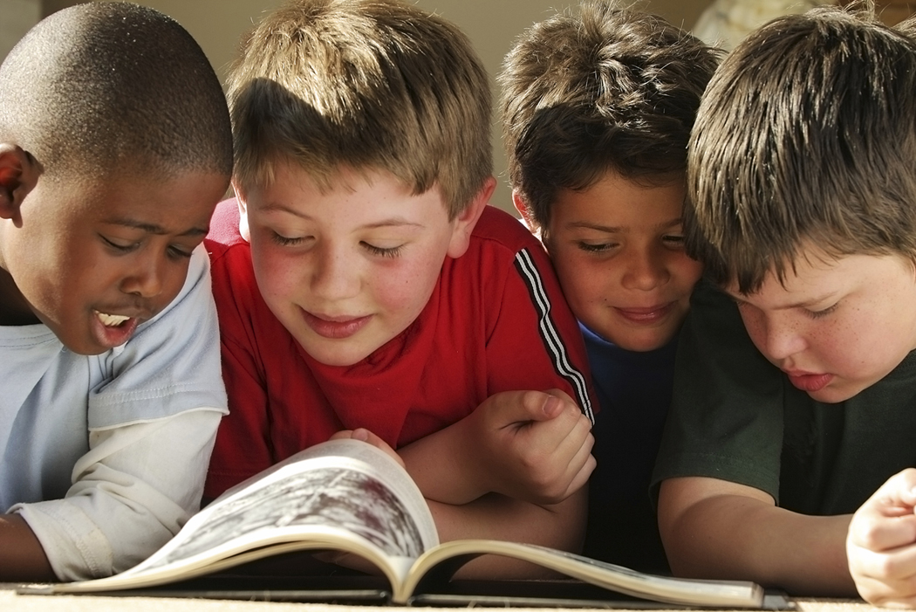

|  |  |
| --- | --- |
|  | Reading and Writing Workshop |

Earlier we looked at the text type of a recount and what features it has. Here is a reminder of what’s in a recount.

A recount tells what happened, in the order it happened. It has:

* An orientation that tells place, time, setting and who was involved.
* What happened retold in past tense
* Can have words such as before, now, later.
* A series of events in order.
* Re-orientation

**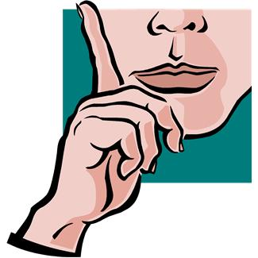**

Now it’s your turn to write a recount. Before we start, here are some topics you could write about for your recount.

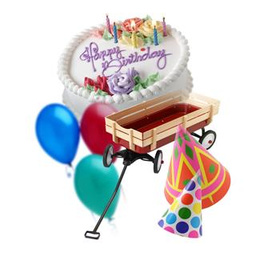

The last party you went to.

What you did on the school holidays.

A trip you have been on.

There are many ideas to choose from. These are just some examples. Try and pick something that you can write a lot about.

Recount Plan

Now it’s time to write your plan for your recount based on the idea you have chosen. Use this plan to list all the activities in your recount. Put them in order and write a comment about each one. Remember to write in the first person (I or we) and to use past tense.

Firstly, answer the following questions about your recount:

When did it happen?

\_\_\_\_\_\_\_\_\_\_\_\_\_\_\_\_\_\_\_\_\_\_\_\_\_\_\_\_\_\_\_\_\_\_\_\_\_\_\_\_\_\_\_\_\_\_\_\_\_\_\_\_\_\_\_\_\_\_\_\_\_\_\_\_

What happened?

\_\_\_\_\_\_\_\_\_\_\_\_\_\_\_\_\_\_\_\_\_\_\_\_\_\_\_\_\_\_\_\_\_\_\_\_\_\_\_\_\_\_\_\_\_\_\_\_\_\_\_\_\_\_\_\_\_\_\_\_\_\_\_\_

Where did it happen?

\_\_\_\_\_\_\_\_\_\_\_\_\_\_\_\_\_\_\_\_\_\_\_\_\_\_\_\_\_\_\_\_\_\_\_\_\_\_\_\_\_\_\_\_\_\_\_\_\_\_\_\_\_\_\_\_\_\_\_\_\_\_\_\_

Who was in it?

\_\_\_\_\_\_\_\_\_\_\_\_\_\_\_\_\_\_\_\_\_\_\_\_\_\_\_\_\_\_\_\_\_\_\_\_\_\_\_\_\_\_\_\_\_\_\_\_\_\_\_\_\_\_\_\_\_\_\_\_\_\_\_\_

Why did it happen?

\_\_\_\_\_\_\_\_\_\_\_\_\_\_\_\_\_\_\_\_\_\_\_\_\_\_\_\_\_\_\_\_\_\_\_\_\_\_\_\_\_\_\_\_\_\_\_\_\_\_\_\_\_\_\_\_\_\_\_\_\_\_\_\_

Now put the events in your recount in order and describe what each one is about below.

|  |  |
| --- | --- |
| Order | Event  Comment |
|  | Event  Comment |
|  | Event  Comment |
|  | Event  Comment |

Draft

Now start writing your recount based on the notes you took in Set One and your plan.

Remember the following:

- Group your ideas into paragraphs.

- Focus on punctuation such as capital letters, commas and full stops.

- Concentrate on spelling and don’t rush your work.

Use talking marks “ ” if characters speak within your recount.

Use the following page to write your draft recount.

Draft Recount

Title: \_\_\_\_\_\_\_\_\_\_\_\_\_\_\_\_\_\_\_\_\_\_\_\_\_\_\_\_\_\_\_\_\_\_\_\_\_\_\_\_\_

\_\_\_\_\_\_\_\_\_\_\_\_\_\_\_\_\_\_\_\_\_\_\_\_\_\_\_\_\_\_\_\_\_\_\_\_\_\_\_\_\_\_\_\_\_\_\_\_\_\_\_\_\_\_\_\_\_\_\_\_\_\_

\_\_\_\_\_\_\_\_\_\_\_\_\_\_\_\_\_\_\_\_\_\_\_\_\_\_\_\_\_\_\_\_\_\_\_\_\_\_\_\_\_\_\_\_\_\_\_\_\_\_\_\_\_\_\_\_\_\_\_\_\_\_

\_\_\_\_\_\_\_\_\_\_\_\_\_\_\_\_\_\_\_\_\_\_\_\_\_\_\_\_\_\_\_\_\_\_\_\_\_\_\_\_\_\_\_\_\_\_\_\_\_\_\_\_\_\_\_\_\_\_\_\_\_\_

\_\_\_\_\_\_\_\_\_\_\_\_\_\_\_\_\_\_\_\_\_\_\_\_\_\_\_\_\_\_\_\_\_\_\_\_\_\_\_\_\_\_\_\_\_\_\_\_\_\_\_\_\_\_\_\_\_\_\_\_\_\_

\_\_\_\_\_\_\_\_\_\_\_\_\_\_\_\_\_\_\_\_\_\_\_\_\_\_\_\_\_\_\_\_\_\_\_\_\_\_\_\_\_\_\_\_\_\_\_\_\_\_\_\_\_\_\_\_\_\_\_\_\_\_

\_\_\_\_\_\_\_\_\_\_\_\_\_\_\_\_\_\_\_\_\_\_\_\_\_\_\_\_\_\_\_\_\_\_\_\_\_\_\_\_\_\_\_\_\_\_\_\_\_\_\_\_\_\_\_\_\_\_\_\_\_\_

\_\_\_\_\_\_\_\_\_\_\_\_\_\_\_\_\_\_\_\_\_\_\_\_\_\_\_\_\_\_\_\_\_\_\_\_\_\_\_\_\_\_\_\_\_\_\_\_\_\_\_\_\_\_\_\_\_\_\_\_\_\_

\_\_\_\_\_\_\_\_\_\_\_\_\_\_\_\_\_\_\_\_\_\_\_\_\_\_\_\_\_\_\_\_\_\_\_\_\_\_\_\_\_\_\_\_\_\_\_\_\_\_\_\_\_\_\_\_\_\_\_\_\_\_

\_\_\_\_\_\_\_\_\_\_\_\_\_\_\_\_\_\_\_\_\_\_\_\_\_\_\_\_\_\_\_\_\_\_\_\_\_\_\_\_\_\_\_\_\_\_\_\_\_\_\_\_\_\_\_\_\_\_\_\_\_\_

\_\_\_\_\_\_\_\_\_\_\_\_\_\_\_\_\_\_\_\_\_\_\_\_\_\_\_\_\_\_\_\_\_\_\_\_\_\_\_\_\_\_\_\_\_\_\_\_\_\_\_\_\_\_\_\_\_\_\_\_\_\_

\_\_\_\_\_\_\_\_\_\_\_\_\_\_\_\_\_\_\_\_\_\_\_\_\_\_\_\_\_\_\_\_\_\_\_\_\_\_\_\_\_\_\_\_\_\_\_\_\_\_\_\_\_\_\_\_\_\_\_\_\_\_

\_\_\_\_\_\_\_\_\_\_\_\_\_\_\_\_\_\_\_\_\_\_\_\_\_\_\_\_\_\_\_\_\_\_\_\_\_\_\_\_\_\_\_\_\_\_\_\_\_\_\_\_\_\_\_\_\_\_\_\_\_\_

\_\_\_\_\_\_\_\_\_\_\_\_\_\_\_\_\_\_\_\_\_\_\_\_\_\_\_\_\_\_\_\_\_\_\_\_\_\_\_\_\_\_\_\_\_\_\_\_\_\_\_\_\_\_\_\_\_\_\_\_\_\_

\_\_\_\_\_\_\_\_\_\_\_\_\_\_\_\_\_\_\_\_\_\_\_\_\_\_\_\_\_\_\_\_\_\_\_\_\_\_\_\_\_\_\_\_\_\_\_\_\_\_\_\_\_\_\_\_\_\_\_\_\_\_

\_\_\_\_\_\_\_\_\_\_\_\_\_\_\_\_\_\_\_\_\_\_\_\_\_\_\_\_\_\_\_\_\_\_\_\_\_\_\_\_\_\_\_\_\_\_\_\_\_\_\_\_\_\_\_\_\_\_\_\_\_\_

\_\_\_\_\_\_\_\_\_\_\_\_\_\_\_\_\_\_\_\_\_\_\_\_\_\_\_\_\_\_\_\_\_\_\_\_\_\_\_\_\_\_\_\_\_\_\_\_\_\_\_\_\_\_\_\_\_\_\_\_\_\_

\_\_\_\_\_\_\_\_\_\_\_\_\_\_\_\_\_\_\_\_\_\_\_\_\_\_\_\_\_\_\_\_\_\_\_\_\_\_\_\_\_\_\_\_\_\_\_\_\_\_\_\_\_\_\_\_\_\_\_\_\_\_

Here is a checklist you can use to make sure you have covered all the parts of a recount in your draft. Tick off what you have done.



|  |  |
| --- | --- |
| **Title** | **Tick if included**  **✓** |
| Orientation |  |
| Series of events |  |
| Re-orientation |  |
| Use of words with past tense |  |
| Correct spelling |  |

Final Piece

Time to complete the final copy!

How will you do this?

You can use your computer or handwrite your final piece. Remember to make it neat and easy to read.



|  |  |
| --- | --- |
|  | Spelling, Phonics and How Words Work |

It’s time for you to learn your words for this Set. They are in your spelling activities and at the back of this Booklet. You also need to choose ten of your own Words. Choose these words now and add them to you spelling list**.**

Spelling Activities

1. Pale means of light colour. Pail means bucket. Write each word in a sentence.

\_\_\_\_\_\_\_\_\_\_\_\_\_\_\_\_\_\_\_\_\_\_\_\_\_\_\_\_\_\_\_\_\_\_\_\_\_\_\_\_\_\_\_\_\_\_\_\_\_\_\_\_\_\_\_\_\_\_\_

\_\_\_\_\_\_\_\_\_\_\_\_\_\_\_\_\_\_\_\_\_\_\_\_\_\_\_\_\_\_\_\_\_\_\_\_\_\_\_\_\_\_\_\_\_\_\_\_\_\_\_\_\_\_\_\_\_\_\_

\_\_\_\_\_\_\_\_\_\_\_\_\_\_\_\_\_\_\_\_\_\_\_\_\_\_\_\_\_\_\_\_\_\_\_\_\_\_\_\_\_\_\_\_\_\_\_\_\_\_\_\_\_\_\_\_\_\_\_

1. Tale means a story. Tail means the end of the backbone.

Write a sentence for each word.

\_\_\_\_\_\_\_\_\_\_\_\_\_\_\_\_\_\_\_\_\_\_\_\_\_\_\_\_\_\_\_\_\_\_\_\_\_\_\_\_\_\_\_\_\_\_\_\_\_\_\_\_\_\_\_\_\_\_\_

\_\_\_\_\_\_\_\_\_\_\_\_\_\_\_\_\_\_\_\_\_\_\_\_\_\_\_\_\_\_\_\_\_\_\_\_\_\_\_\_\_\_\_\_\_\_\_\_\_\_\_\_\_\_\_\_\_\_\_

1. Male means \_\_\_\_\_\_\_\_\_\_\_\_\_\_\_\_\_\_\_\_\_\_\_\_\_\_\_\_\_\_\_\_\_\_\_\_\_\_\_\_

Mail means \_\_\_\_\_\_\_\_\_\_\_\_\_\_\_\_\_\_\_\_\_\_\_\_\_\_\_\_\_\_\_\_\_\_\_\_\_\_\_\_

Word Building

Make new words by adding the words in Column A to those it matches in Column B. Then write the correct new word.

|  |  |  |
| --- | --- | --- |
| Column A | Plus | Column B |
| stale | + | mate |
| whole | + | sale |
| whale | + | bone |
| tell | + | tale |

|  |  |  |  |
| --- | --- | --- | --- |
| A | Plus | B | New Word |
| stale | + | mate |  |
| whole | + | sale |  |
| whale | + | bone |  |
| tell | + | tale |  |

Many of our spelling words have had the ‘ale’ sound in them.

That’s because this Set we will be looking at the ‘ale’ sound.

Now let’s look at the word ‘wh**ale**’. Read this sentence out loud:

The big **whale** swam in the ocean.

Does **whale** have a long a sound? Or is it a short a sound? Well, it actually has a long a sound.



ale

There are many words that have the ‘ale’ sound in them. Firstly I would like you to find all the ‘ale’ sound words in this Set’s spelling words and put them in the table above. When you have done this add three more of your own ‘ale’ sounding words.

|  |  |
| --- | --- |
|  | Daily Reading |

Also, remember to do your daily reading. Make sure you can find something interesting to read for a couple of minutes each day to someone at home.

Now use the letters below to fill in the blanks for the “ale” word family.

b

g

m

sc

wh

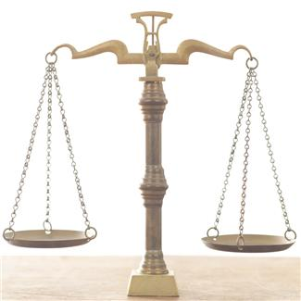p

\_\_ \_\_ ale

\_\_\_ ale

\_\_\_ ale

\_\_ \_\_ ale

\_\_\_ ale

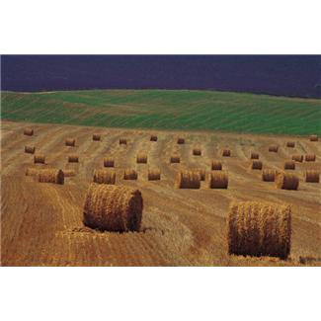

Silent Letters

Many words are spelled with letters that have no sound. These letters are called silent letters. Words with silent letters sometimes follow patterns. To discover the silent letter patterns, it is a good idea to study lists of words with the same silent letter. This Set we will be looking at letters that have the silent b.

Silent Letter B

The silent letter b comes after the letter m at word ends. For example in the word bom**b,** the b is a silent letter.

The list of words below all have silent letters. Say each word out loud as you copy it. Then circle the silent letter. The first one is done for you.

comb

comb \_\_\_\_\_\_\_\_\_\_\_\_\_\_\_\_\_\_\_\_\_\_\_\_\_\_

lamb \_\_\_\_\_\_\_\_\_\_\_\_\_\_\_\_\_\_\_\_\_\_\_\_\_\_

crumb \_\_\_\_\_\_\_\_\_\_\_\_\_\_\_\_\_\_\_\_\_\_\_\_\_\_

limb \_\_\_\_\_\_\_\_\_\_\_\_\_\_\_\_\_\_\_\_\_\_\_\_\_\_

numb \_\_\_\_\_\_\_\_\_\_\_\_\_\_\_\_\_\_\_\_\_\_\_\_\_\_

thumb \_\_\_\_\_\_\_\_\_\_\_\_\_\_\_\_\_\_\_\_\_\_\_\_\_\_

climb \_\_\_\_\_\_\_\_\_\_\_\_\_\_\_\_\_\_\_\_\_\_\_\_\_\_

Write a sentence using two of the words on the previous page. Underline the silent letter in the words you have chosen.

\_\_\_\_\_\_\_\_\_\_\_\_\_\_\_\_\_\_\_\_\_\_\_\_\_\_\_\_\_\_\_\_\_\_\_\_\_\_\_\_\_\_\_\_\_\_\_\_\_\_\_\_\_\_\_\_\_\_\_\_\_\_\_\_

\_\_\_\_\_\_\_\_\_\_\_\_\_\_\_\_\_\_\_\_\_\_\_\_\_\_\_\_\_\_\_\_\_\_\_\_\_\_\_\_\_\_\_\_\_\_\_\_\_\_\_\_\_\_\_\_\_\_\_\_\_\_\_\_

\_\_\_\_\_\_\_\_\_\_\_\_\_\_\_\_\_\_\_\_\_\_\_\_\_\_\_\_\_\_\_\_\_\_\_\_\_\_\_\_\_\_\_\_\_\_\_\_\_\_\_\_\_\_\_\_\_\_\_\_\_\_\_\_

\_\_\_\_\_\_\_\_\_\_\_\_\_\_\_\_\_\_\_\_\_\_\_\_\_\_\_\_\_\_\_\_\_\_\_\_\_\_\_\_\_\_\_\_\_\_\_\_\_\_\_\_\_\_\_\_\_\_\_\_\_\_\_\_

\_\_\_\_\_\_\_\_\_\_\_\_\_\_\_\_\_\_\_\_\_\_\_\_\_\_\_\_\_\_\_\_\_\_\_\_\_\_\_\_\_\_\_\_\_\_\_\_\_\_\_\_\_\_\_\_\_\_\_\_\_\_\_\_

\_\_\_\_\_\_\_\_\_\_\_\_\_\_\_\_\_\_\_\_\_\_\_\_\_\_\_\_\_\_\_\_\_\_\_\_\_\_\_\_\_\_\_\_\_\_\_\_\_\_\_\_\_\_\_\_\_\_\_\_\_\_\_\_

\_\_\_\_\_\_\_\_\_\_\_\_\_\_\_\_\_\_\_\_\_\_\_\_\_\_\_\_\_\_\_\_\_\_\_\_\_\_\_\_\_\_\_\_\_\_\_\_\_\_\_\_\_\_\_\_\_\_\_\_\_\_\_\_

\_\_\_\_\_\_\_\_\_\_\_\_\_\_\_\_\_\_\_\_\_\_\_\_\_\_\_\_\_\_\_\_\_\_\_\_\_\_\_\_\_\_\_\_\_\_\_\_\_\_\_\_\_\_\_\_\_\_\_\_\_\_\_\_

\_\_\_\_\_\_\_\_\_\_\_\_\_\_\_\_\_\_\_\_\_\_\_\_\_\_\_\_\_\_\_\_\_\_\_\_\_\_\_\_\_\_\_\_\_\_\_\_\_\_\_\_\_\_\_\_\_\_\_\_\_\_\_\_

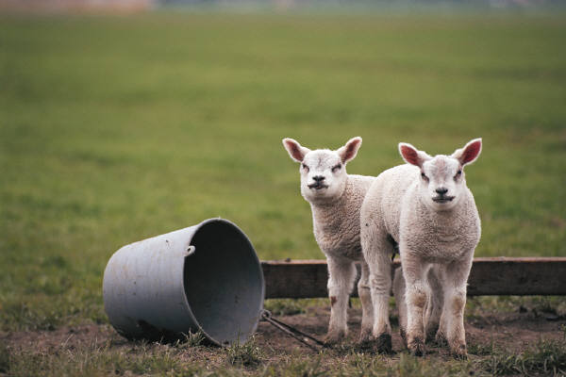

C:\Users\jmiller\AppData\Local\Microsoft\Windows\Temporary Internet Files\Low\Content.IE5\O584SN30\MC900053962[1].WMF

Grammar and Punctuation

What are synonyms?

Synonyms are words having the same, or nearly the same meaning as another word.

The words stones and rocks are synonyms.

|  |  |
| --- | --- |
| BL00052_ | Here are the two synonyms used in sentences:  The wall was made of rocks.  The wall was made of stones. |
| You can use *synonyms* in your writing to make the final piece more interesting. It gets very boring if you use the same word over and over again.  Here are some synonyms you might know:  above/over angry/cross baby/infant hard/rigid    Read each sentence. Circle the letter of the answer that has almost the same meaning as the **bold** word in the sentence.  For example:   |  |  | | --- | --- | | One. Let’s **build** a tower of blocks.  A. paint  B. make  C. buy | 2. What **things** will we use?  A. material  B. make  C. buy | | 3. It needs to be **strong**.  A. high  B. weak  C. solid | 4. **Transparent** glass lets in light.  A. clear  B. patterned  C. mirror | | |

**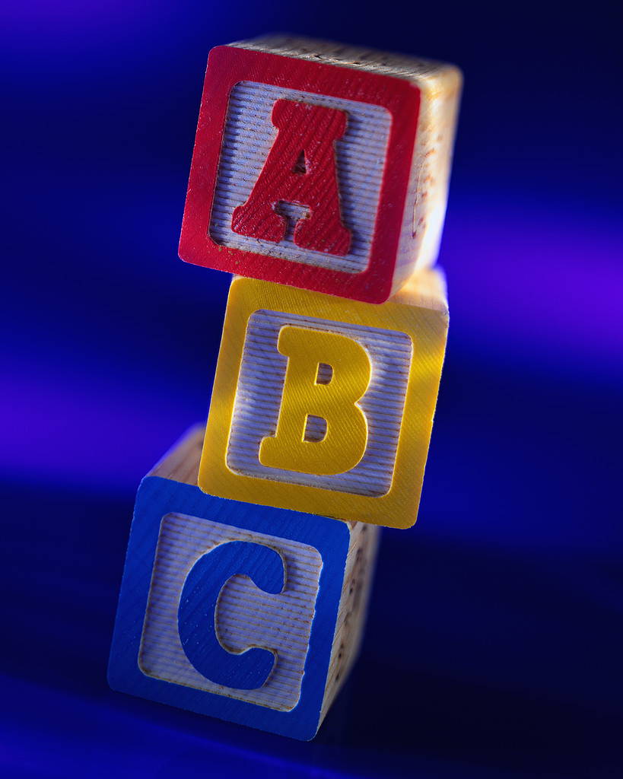**

j0226124It’s time for your spelling test

Give your sheet of words to someone at home. Ask them

to test your spelling of the ten words you were given to

learn this Set. You might even like to practise your

words once again before you have your test.

|  |  |
| --- | --- |
| Spelling Words for Set Two | |
| Spelling Words | My Own Spelling Words |
| tale |  |
| started |  |
| whale |  |
| friends |  |
| name |  |
| pale |  |
| whale |  |
| scale |  |
| once |  |
| female |  |

|  |  |
| --- | --- |
|  | Reflection |

Now it’s time to see how much you can remember about what you have learnt in this booklet. Please circle if the following questions are either true or false.

Text Type

A recount can be a Daily Diary. True or False

A recount has an orientation, series of events and a re-orientation.

True or False

Spelling and Phonics

Vowels have the letters a, e, i, o and u. True or False

Text and Grammar Skill

Tense tells you if a verb is in the past, present or future.

True or False

Synonyms are words having the same, or nearly the same meaning as another word.

True or False

How Words Work

Silent letters make a sound when you say the word. True or False

Response Log

Now it’s time for you to think about and write down what you have learned in this booklet.

**** What I learnt about in this Booklet was …

**\_\_\_\_\_\_\_\_\_\_\_\_\_\_\_\_\_\_\_\_\_\_\_\_\_\_\_\_\_\_\_\_\_\_\_\_\_\_\_\_\_\_\_\_\_\_\_\_\_\_\_\_\_\_\_\_\_\_\_\_\_\_\_\_**

**\_\_\_\_\_\_\_\_\_\_\_\_\_\_\_\_\_\_\_\_\_\_\_\_\_\_\_\_\_\_\_\_\_\_\_\_\_\_\_\_\_\_\_\_\_\_\_\_\_\_\_\_\_\_\_\_\_\_\_\_\_\_\_\_**

**\_\_\_\_\_\_\_\_\_\_\_\_\_\_\_\_\_\_\_\_\_\_\_\_\_\_\_\_\_\_\_\_\_\_\_\_\_\_\_\_\_\_\_\_\_\_\_\_\_\_\_\_\_\_\_\_\_\_\_\_\_\_\_\_**

****Was there anything you didn’t understand?

**\_\_\_\_\_\_\_\_\_\_\_\_\_\_\_\_\_\_\_\_\_\_\_\_\_\_\_\_\_\_\_\_\_\_\_\_\_\_\_\_\_\_\_\_\_\_\_\_\_\_\_\_\_\_\_\_\_\_\_\_\_\_\_\_**

**\_\_\_\_\_\_\_\_\_\_\_\_\_\_\_\_\_\_\_\_\_\_\_\_\_\_\_\_\_\_\_\_\_\_\_\_\_\_\_\_\_\_\_\_\_\_\_\_\_\_\_\_\_\_\_\_\_\_\_\_\_\_\_\_**

**\_\_\_\_\_\_\_\_\_\_\_\_\_\_\_\_\_\_\_\_\_\_\_\_\_\_\_\_\_\_\_\_\_\_\_\_\_\_\_\_\_\_\_\_\_\_\_\_\_\_\_\_\_\_\_\_\_\_\_\_\_\_\_\_**

Now draw a face which shows how well you feel you have done with this Booklet.

****

**Checklist**

This Set you should have completed the following tasks. Please tick the tasks you have completed.

* Reading and Writing workshop—Write your own recount
* Spelling activities—LCWC and own Words
* Phonics—The ‘ale’ sound
* Grammar and Punctuation—Synonyms
* How Words Work—Silent letters
* Spelling test

|  |
| --- |
| End of Set Two |

|  |
| --- |
| **References and Resources** |
| The following resources were used in the research of topics and the compilation of lessons for this booklet: |
| Woods, Andrew, *Spelling Matters Book 3,* Addison Wesley Longman Australia Pty Limited, One993  Rodney, Martin, *Junior Writers Guide,* Era Publications, 2006  Harrod, Jenni, *Literacy: Back to basics*, R.I.C Publications, 20One0  Barwick, John, Dobbie, Karen, Lloyd, Angela, Dalgleish, Sharon, Doherty Ann, Shapiro, Sharon, Dalgleish, Tanya, Faye, Michael, *Targeting Text: Middle Primary*, Blake Education, One998  <http://www.sciencekids.co.nz/pictures/illusions.html>  <http://www.socialmedium.co.uk/blog/social_media_sentiment/>  [http://wvde.state.wv.us/teach2One/](http://wvde.state.wv.us/teach21/)  <http://office.microsoft.com/en-au/images/> |

|  |
| --- |
| **YOUR QUESTIONS OR COMMENTS** |

English



*What makes a great narrative?*

**Please read before you begin**

In this Booklet

you will be asking yourself

‘What makes a great narrative?’

To help you answer this question,

these are your learning intentions.

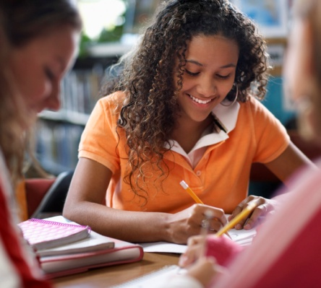

Learning Intentions for Booklet B

Writing Workshop

Study the style and techniques used to write a narrative.

Grammar and Punctuation

Learn about precise sentences. Study paragraph writing and prepositions.

How Words Work

Adding the suffix ‘ed’ to words and the plurals ‘s and es’.

Spelling and Phonetics

Study your One0 given spelling words as well as your own One0 words for your test at the end of the Set. In phonetics, you will look at the vowel sounds of ‘ee’ and ‘oo’.

|  |  |
| --- | --- |
| Contents | |
| Set One | Reading and Writing Workshop   * Exploring the Text - reading and learning about a Narrative * Read narrative texts and complete activities about a narrative   Spelling activities and Phonics   * Ten given words and ten words of your own choice. * The ‘ee’ sound   Grammar and Punctuation   * Precise sentences and paragraphs   How words work   * Adding ed   Spelling test   * Spell the words for this Set |

|  |  |
| --- | --- |
| Set Two | Reading and Writing Workshop   * Write a narrative   Spelling activities and Phonics   * Ten given words and ten words of your own choice. * The ‘oo’ sound   Grammar and Punctuation   * Prepositions   How words work   * Plurals adding s and es   Spelling test   * Spell the words for this Set   Reflection   * Cloze activities * Summary * Answer written questions about the topic |

|  |  |
| --- | --- |
| books,boys,childhood,children,concentration,educates,educations,Fotolia,homework,kids,knowledge,learning,learns,males,Photographs,readings,reads,schools,students,studies | Getting Knowledge Ready |

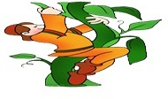This Set’s text type is called a narrative. A narrative is writing that tells a story in fiction, nonfiction or poetry. Here are images of some characters from narratives. Write one or two words to describe what you think each narrative is about.

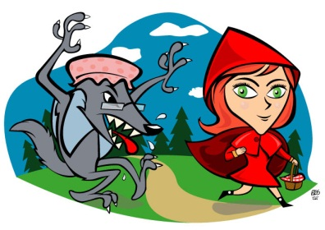

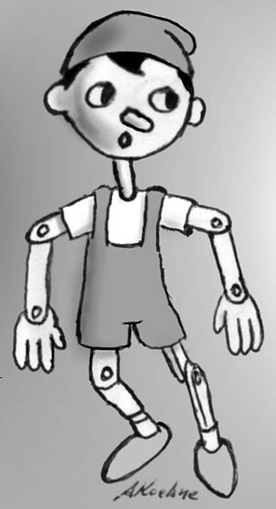

Narrative

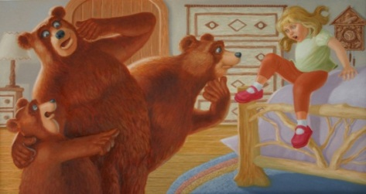

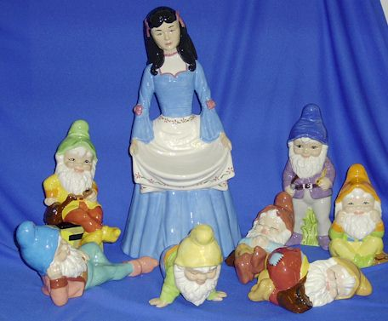

What is your favourite narrative and why?

|  |
| --- |
| Set One |

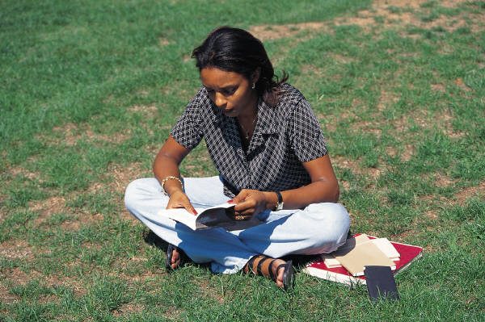

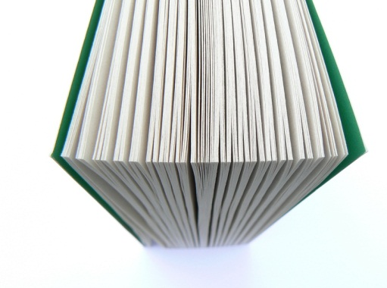Narratives usually include:

An orientation

A complication

A sequence of events

A resolution

**An Orientation**

This is the story beginning that that sets the scene, characters and tells where and when the story is happening.

**A Complication**

Is where a problem happens for one or more of the characters.

**A Sequence of Events**

These are things that happen in order because of the problem.

**A Resolution**

The way the problem is solved.

Read this story with someone at home. Tiddalik is well-known narrative from the Aboriginal dreamtime. Whilst reading it, look out for the features of a narrative.

What Made Tiddalik Laugh?

Long, long ago in the Dreamtime in Australia, there lived a giant frog called Tiddalik. Tiddalik had been sleeping for many nights and many days. When he woke up he yawned, stretched and said, “I’m thirsty. I need a drink.”

Now Tiddalik was not just a little bit thirsty. He was enormously thirsty. When he thought about it, he realised that he was absolutely parched. “I’m so thirsty that I could drink a lake.” he said. And that is exactly what he did.

He sat by the edge of a lake and drank it up, every drop. He moved on to a stream and drank that up, too. Every drop.He found a water hole and drained that, too. Every drop.As he drank, Tiddalik swelled and swelled, but he was still thirsty, and all through the day he searched for water. All through the day, slurping and gurgling, he drank every drop of water he found. With each drop of water inside him he swelled more and more until at last he was no longerthirsty.

Darkness fell and Tiddalik rested. He was completely full. “Now I can sleep.” He said. And he did.

The next morning, the sun rose. It was hot and strong. In its bright light it was clear that there was not one drop of water left anywhere. Where there had been

lakes, there was no water. Where rivers had once flowed, there were empty river beds. The streams and the water holes, even the puddles, were completely dry. All through the day the flowers and the grass withered. All through the day the leaves of the trees turned brown and began to fall.

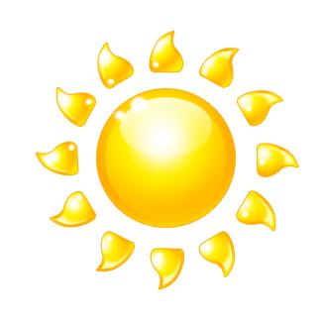

Orientation

Everywhere the birds and the animals were searching for water. In desperation they gathered together. “Tiddalik has drunk all the water, every last drop.” they said “Whatever shall we do? We will die without water.”

Different animals had different suggestions, but only the wise wombat had the answer. “We must make Tiddalik laugh,” he said. “When he laughs he must open his mouth and, when he does that, all the water will pour out. Every drop.”

The animals ran to where Tiddalik slept.They thought of all the things they could do to make Tiddalik laugh. The animal made silly faces. Rude faces, funny faces – they tried everything. But Tiddalik did not laugh. He did not even smile.Then the animals tried silly dances. Wild dances, mad dances – they tried everything.But Tiddalik did not laugh. He did not even smile.

Deep under the ground, the platypus heard the wild dances and raucous songs. Now, the platypus is soft and furry like a wombat, but has a duck’s bill and duck’s feet and it is a creature that keeps itself to itself. The platypus had been asleep. She did not know that Tiddalik had drunk up all the water, every drop.

Complication

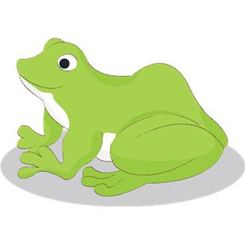

The platypus came out of her hole to find out what all the noise was about. She was sleepy, cross, and determined. She looked at Tiddalik lying on the ground. She went right up to him. “You have woken me up,” she said. “You have disturbed my sleep.” Tiddalik looked at this strange creature. He looked at her soft fur and her duck’s bill and her duck’s feet. He had never seen such an unusual animal before.

It was much funnier than all the old jokes, or the new jokes, far sillier than the rude faces or the funny faces, and far more entertaining than wild dances or raucous singing. Tidddalik smiled. A few drops of water fell from the sides of his mouth. He smiled more. A few more drops spilled out.

Suddenly Tiddalik laughed. He laughed and laughed and laughed. He roared and bellowed and hooted with laughter. He shrieked and howled and screamed with laughter. He giggled and gurgled and choked with laughter. And as he laughed, lakes and rivers and streams and water holes of water came streaming and pouring from his mouth.

Soon the lakes and rivers and streams and water holes were full again. The trees flourished and the grass grew. All the animals drank and drank. Everything was refreshed. “Thank you, Platypus,” the wise wombat said. “It was you who made Tiddalik laugh.”

Now the Dreamtime was a long, long time ago. There are still frogs in Australia who can fill themselves up with water and save it for a dry day, but they are only small ones. Never again will a giant frog be able to drink up all the water, not every drop.



Resolution

Discuss with someone at home about this narrative and some of the features it has. After you have done this answer the following questions.

Questions on ‘What Made Tiddalik Laugh?’

1. When does the story take place?

\_\_\_\_\_\_\_\_\_\_\_\_\_\_\_\_\_\_\_\_\_\_\_\_\_\_\_\_\_\_\_\_\_\_\_\_\_\_\_\_\_\_\_\_\_\_\_\_\_\_\_\_\_\_\_\_\_\_\_\_\_\_\_\_\_\_

\_\_\_\_\_\_\_\_\_\_\_\_\_\_\_\_\_\_\_\_\_\_\_\_\_\_\_\_\_\_\_\_\_\_\_\_\_\_\_\_\_\_\_\_\_\_\_\_\_\_\_\_\_\_\_\_\_\_\_\_\_\_\_\_\_\_

\_\_\_\_\_\_\_\_\_\_\_\_\_\_\_\_\_\_\_\_\_\_\_\_\_\_\_\_\_\_\_\_\_\_\_\_\_\_\_\_\_\_\_\_\_\_\_\_\_\_\_\_\_\_\_\_\_\_\_\_\_\_\_\_\_\_

1. What did Tiddalik do after he drank all the water?

\_\_\_\_\_\_\_\_\_\_\_\_\_\_\_\_\_\_\_\_\_\_\_\_\_\_\_\_\_\_\_\_\_\_\_\_\_\_\_\_\_\_\_\_\_\_\_\_\_\_\_\_\_\_\_\_\_\_\_\_\_\_\_\_\_\_

\_\_\_\_\_\_\_\_\_\_\_\_\_\_\_\_\_\_\_\_\_\_\_\_\_\_\_\_\_\_\_\_\_\_\_\_\_\_\_\_\_\_\_\_\_\_\_\_\_\_\_\_\_\_\_\_\_\_\_\_\_\_\_\_\_\_

\_\_\_\_\_\_\_\_\_\_\_\_\_\_\_\_\_\_\_\_\_\_\_\_\_\_\_\_\_\_\_\_\_\_\_\_\_\_\_\_\_\_\_\_\_\_\_\_\_\_\_\_\_\_\_\_\_\_\_\_\_\_\_\_\_\_

1. What did the animals try to do to make Tiddalik laugh?

\_\_\_\_\_\_\_\_\_\_\_\_\_\_\_\_\_\_\_\_\_\_\_\_\_\_\_\_\_\_\_\_\_\_\_\_\_\_\_\_\_\_\_\_\_\_\_\_\_\_\_\_\_\_\_\_\_\_\_\_\_\_\_\_\_\_

\_\_\_\_\_\_\_\_\_\_\_\_\_\_\_\_\_\_\_\_\_\_\_\_\_\_\_\_\_\_\_\_\_\_\_\_\_\_\_\_\_\_\_\_\_\_\_\_\_\_\_\_\_\_\_\_\_\_\_\_\_\_\_\_\_\_

\_\_\_\_\_\_\_\_\_\_\_\_\_\_\_\_\_\_\_\_\_\_\_\_\_\_\_\_\_\_\_\_\_\_\_\_\_\_\_\_\_\_\_\_\_\_\_\_\_\_\_\_\_\_\_\_\_\_\_\_\_\_\_\_\_\_

1. Which animal made Tiddalik laugh?

\_\_\_\_\_\_\_\_\_\_\_\_\_\_\_\_\_\_\_\_\_\_\_\_\_\_\_\_\_\_\_\_\_\_\_\_\_\_\_\_\_\_\_\_\_\_\_\_\_\_\_\_\_\_\_\_\_\_\_\_\_\_\_\_\_\_

\_\_\_\_\_\_\_\_\_\_\_\_\_\_\_\_\_\_\_\_\_\_\_\_\_\_\_\_\_\_\_\_\_\_\_\_\_\_\_\_\_\_\_\_\_\_\_\_\_\_\_\_\_\_\_\_\_\_\_\_\_\_\_\_\_\_

\_\_\_\_\_\_\_\_\_\_\_\_\_\_\_\_\_\_\_\_\_\_\_\_\_\_\_\_\_\_\_\_\_\_\_\_\_\_\_\_\_\_\_\_\_\_\_\_\_\_\_\_\_\_\_\_\_\_\_\_\_\_\_\_\_\_

Instructions

Fill in the boxes to explain what the narrative ‘What made Tiddalik laugh?’

is about.

**Story Map**

Who are the Characters?

\_\_\_\_\_\_\_\_\_\_\_\_\_\_\_\_\_\_\_\_\_\_\_\_

\_\_\_\_\_\_\_\_\_\_\_\_\_\_\_\_\_\_\_\_\_\_\_\_

\_\_\_\_\_\_\_\_\_\_\_\_\_\_\_\_\_\_\_\_\_\_\_\_

\_\_\_\_\_\_\_\_\_\_\_\_\_\_\_\_\_\_\_\_\_\_\_\_

\_\_\_\_\_\_\_\_\_\_\_\_\_\_\_\_\_\_\_\_\_\_\_\_\_\_

Where is the setting?

\_\_\_\_\_\_\_\_\_\_\_\_\_\_\_\_\_\_\_\_\_\_\_

\_\_\_\_\_\_\_\_\_\_\_\_\_\_\_\_\_\_\_\_\_\_\_

\_\_\_\_\_\_\_\_\_\_\_\_\_\_\_\_\_\_\_\_\_\_\_

\_\_\_\_\_\_\_\_\_\_\_\_\_\_\_\_\_\_\_\_\_\_\_

What is the problem?

\_\_\_\_\_\_\_\_\_\_\_\_\_\_\_\_\_\_\_\_\_\_\_\_

\_\_\_\_\_\_\_\_\_\_\_\_\_\_\_\_\_\_\_\_\_\_\_\_

\_\_\_\_\_\_\_\_\_\_\_\_\_\_\_\_\_\_\_\_\_\_\_\_

\_\_\_\_\_\_\_\_\_\_\_\_\_\_\_\_\_\_\_\_\_\_\_\_

Title:

\_\_\_\_\_\_\_\_\_\_\_\_\_\_\_\_\_\_\_\_\_\_\_\_\_\_\_

What is the solution?

\_\_\_\_\_\_\_\_\_\_\_\_\_\_\_\_\_\_\_\_\_\_\_\_\_\_\_\_

\_\_\_\_\_\_\_\_\_\_\_\_\_\_\_\_\_\_\_\_\_\_\_\_\_\_\_\_

\_\_\_\_\_\_\_\_\_\_\_\_\_\_\_\_\_\_\_\_\_\_\_\_\_\_\_\_

\_\_\_\_\_\_\_\_\_\_\_\_\_\_\_\_\_\_\_\_\_\_\_\_\_\_\_\_

\_\_\_\_\_\_\_\_\_\_\_\_\_\_\_\_\_\_\_\_\_\_\_\_\_\_\_\_

How did the characters try to solve the problem?

\_\_\_\_\_\_\_\_\_\_\_\_\_\_\_\_\_\_\_\_\_\_\_\_\_\_\_\_\_\_\_\_\_\_\_\_\_\_\_\_\_\_

\_\_\_\_\_\_\_\_\_\_\_\_\_\_\_\_\_\_\_\_\_\_\_\_\_\_\_\_\_\_\_\_\_\_\_\_\_\_\_\_\_\_

\_\_\_\_\_\_\_\_\_\_\_\_\_\_\_\_\_\_\_\_\_\_\_\_\_\_\_\_\_\_\_\_\_\_\_\_\_\_\_\_\_\_

\_\_\_\_\_\_\_\_\_\_\_\_\_\_\_\_\_\_\_\_\_\_\_\_\_\_\_\_\_\_\_\_\_\_\_\_\_\_\_\_\_\_

\_\_\_\_\_\_\_\_\_\_\_\_\_\_\_\_\_\_\_\_\_\_\_\_\_\_\_\_\_\_\_\_\_\_\_\_\_\_\_\_\_\_

C:\Users\jmiller\AppData\Local\Microsoft\Windows\Temporary Internet Files\Low\Content.IE5\O584SN30\MC900053962[1].WMF

Grammar and Punctuation

What is a precise sentence?

A sentence is a group of words that makes sense on its own. It needs to begin with a capital letter and end with a full stop, question mark or exclamation mark. All sentences need a subject and a verb.

Here is an example of this in a sentence:

The **bird** (subject) **flew** (verb).

Now it’s your turn. Underline the subject in each sentence and circle the verb. The first one has been done for you.

**Holly** **sat** on the chair. Aunt Lily made a cake.

The dog was sleeping outside. I read a boring book.

Dad drove his car to work. Pete and Lee washed the car.

Dale kicked two goals. They walked to school.

The phone was ringing. The plane flew over the city.

On the lines underneath these sentences, write if you think they are statements, questions or commands?

Don’t forget that:

**A Statement**

Tells you facts.

**A Question**

Asks you something and has a question mark at the end.

**A Command**

Is a sentence that tells you to do something.

Do you think you can help me with my homework?

\_\_\_\_\_\_\_\_\_\_\_\_\_\_\_\_\_\_\_\_\_\_\_\_\_\_\_\_\_\_\_\_\_\_\_\_\_\_\_\_\_\_\_\_\_\_\_\_\_\_\_\_\_\_\_\_\_\_\_\_\_\_

I’m having trouble finishing my homework.

\_\_\_\_\_\_\_\_\_\_\_\_\_\_\_\_\_\_\_\_\_\_\_\_\_\_\_\_\_\_\_\_\_\_\_\_\_\_\_\_\_\_\_\_\_\_\_\_\_\_\_\_\_\_\_\_\_\_\_\_\_\_

Finish your homework now!

\_\_\_\_\_\_\_\_\_\_\_\_\_\_\_\_\_\_\_\_\_\_\_\_\_\_\_\_\_\_\_\_\_\_\_\_\_\_\_\_\_\_\_\_\_\_\_\_\_\_\_\_\_\_\_\_\_\_\_\_\_\_

Do you like going swimming?

\_\_\_\_\_\_\_\_\_\_\_\_\_\_\_\_\_\_\_\_\_\_\_\_\_\_\_\_\_\_\_\_\_\_\_\_\_\_\_\_\_\_\_\_\_\_\_\_\_\_\_\_\_\_\_\_\_\_\_\_\_\_

Paragraphs

A paragraph is one or more sentences about the same topic.

Every time you start a new paragraph you begin on a new line.

Writers use new paragraphs when they have to change a topic, a new time or a new place.

Here is an example of how to write a paragraph about a topic.

|  |  |
| --- | --- |
| Topic | Let me tell you about my best friend Micheline. |
| Gives information about the topic  (supporting detail - One) | She lives next door to me. Her house is the white house with the daffodils in the garden. |
| Gives more information about the topic  (supporting detail - 2) | We always have fun together. |
| Gives even more information about the topic  (supporting detail - 3) | Best of all, she’s on my soccer team. Micheline always kicks the ball to me and helps our team to win. |
| How the story finishes  (closing sentence) | I think she is the best friend I’ve ever had. |

Write a few paragraphs about this topic.

Topic: What I know about bananas.

**Supporting detail One:** \_\_\_\_\_\_\_\_\_\_\_\_\_\_\_\_\_\_\_\_\_\_\_\_\_\_\_\_\_\_\_\_\_\_\_\_\_\_\_\_\_\_\_

\_\_\_\_\_\_\_\_\_\_\_\_\_\_\_\_\_\_\_\_\_\_\_\_\_\_\_\_\_\_\_\_\_\_\_\_\_\_\_\_\_\_\_\_\_\_\_\_\_\_\_\_\_\_\_\_\_\_\_\_\_\_\_\_

\_\_\_\_\_\_\_\_\_\_\_\_\_\_\_\_\_\_\_\_\_\_\_\_\_\_\_\_\_\_\_\_\_\_\_\_\_\_\_\_\_\_\_\_\_\_\_\_\_\_\_\_\_\_\_\_\_\_\_\_\_\_\_\_

\_\_\_\_\_\_\_\_\_\_\_\_\_\_\_\_\_\_\_\_\_\_\_\_\_\_\_\_\_\_\_\_\_\_\_\_\_\_\_\_\_\_\_\_\_\_\_\_\_\_\_\_\_\_\_\_\_\_\_\_\_\_\_\_

**Supporting detail 2:** \_\_\_\_\_\_\_\_\_\_\_\_\_\_\_\_\_\_\_\_\_\_\_\_\_\_\_\_\_\_\_\_\_\_\_\_\_\_\_\_\_\_

\_\_\_\_\_\_\_\_\_\_\_\_\_\_\_\_\_\_\_\_\_\_\_\_\_\_\_\_\_\_\_\_\_\_\_\_\_\_\_\_\_\_\_\_\_\_\_\_\_\_\_\_\_\_\_\_\_\_\_\_\_\_\_\_

\_\_\_\_\_\_\_\_\_\_\_\_\_\_\_\_\_\_\_\_\_\_\_\_\_\_\_\_\_\_\_\_\_\_\_\_\_\_\_\_\_\_\_\_\_\_\_\_\_\_\_\_\_\_\_\_\_\_\_\_\_\_\_\_

\_\_\_\_\_\_\_\_\_\_\_\_\_\_\_\_\_\_\_\_\_\_\_\_\_\_\_\_\_\_\_\_\_\_\_\_\_\_\_\_\_\_\_\_\_\_\_\_\_\_\_\_\_\_\_\_\_\_\_\_\_\_\_\_

**Supporting detail 3:** \_\_\_\_\_\_\_\_\_\_\_\_\_\_\_\_\_\_\_\_\_\_\_\_\_\_\_\_\_\_\_\_\_\_\_\_\_\_\_\_\_\_

\_\_\_\_\_\_\_\_\_\_\_\_\_\_\_\_\_\_\_\_\_\_\_\_\_\_\_\_\_\_\_\_\_\_\_\_\_\_\_\_\_\_\_\_\_\_\_\_\_\_\_\_\_\_\_\_\_\_\_\_\_\_\_\_

\_\_\_\_\_\_\_\_\_\_\_\_\_\_\_\_\_\_\_\_\_\_\_\_\_\_\_\_\_\_\_\_\_\_\_\_\_\_\_\_\_\_\_\_\_\_\_\_\_\_\_\_\_\_\_\_\_\_\_\_\_\_\_\_

\_\_\_\_\_\_\_\_\_\_\_\_\_\_\_\_\_\_\_\_\_\_\_\_\_\_\_\_\_\_\_\_\_\_\_\_\_\_\_\_\_\_\_\_\_\_\_\_\_\_\_\_\_\_\_\_\_\_\_\_\_\_\_\_

**Closing sentence:** \_\_\_\_\_\_\_\_\_\_\_\_\_\_\_\_\_\_\_\_\_\_\_\_\_\_\_\_\_\_\_\_\_\_\_\_\_\_\_\_\_\_\_\_\_

\_\_\_\_\_\_\_\_\_\_\_\_\_\_\_\_\_\_\_\_\_\_\_\_\_\_\_\_\_\_\_\_\_\_\_\_\_\_\_\_\_\_\_\_\_\_\_\_\_\_\_\_\_\_\_\_\_\_\_\_\_\_\_\_

\_\_\_\_\_\_\_\_\_\_\_\_\_\_\_\_\_\_\_\_\_\_\_\_\_\_\_\_\_\_\_\_\_\_\_\_\_\_\_\_\_\_\_\_\_\_\_\_\_\_\_\_\_\_\_\_\_\_\_\_\_\_\_\_

\_\_\_\_\_\_\_\_\_\_\_\_\_\_\_\_\_\_\_\_\_\_\_\_\_\_\_\_\_\_\_\_\_\_\_\_\_\_\_\_\_\_\_\_\_\_\_\_\_\_\_\_\_\_\_\_\_\_\_\_\_\_\_\_

\_\_\_\_\_\_\_\_\_\_\_\_\_\_\_\_\_\_\_\_\_\_\_\_\_\_\_\_\_\_\_\_\_\_\_\_\_\_\_\_\_\_\_\_\_\_\_\_\_\_\_\_\_\_\_\_\_\_\_\_\_\_\_\_

\_\_\_\_\_\_\_\_\_\_\_\_\_\_\_\_\_\_\_\_\_\_\_\_\_\_\_\_\_\_\_\_\_\_\_\_\_\_\_\_\_\_\_\_\_\_\_\_\_\_\_\_\_\_\_\_\_\_\_\_\_\_\_\_

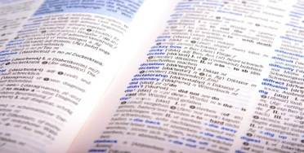

How Words Work

The suffix: ed

The suffix –ed is added to words to change their tense.

For example, ope**n** becomes opened after you add the **ed**

There are also other words which end in e, where you need to add the letter d to change the verb tense.

For example, telephon**e** becomes telephoned after you add the **d**.

Add ‘**d**’ or ‘**ed**’ to the following words. The first ones have been done

for you.

|  |  |  |  |  |
| --- | --- | --- | --- | --- |
| Words that end with –e, just add –d | | | | |
| chase | dive | graze | doze | include |
| chase**d** |  |  |  |  |

|  |  |  |  |  |
| --- | --- | --- | --- | --- |
| Most other words, just add –ed | | | | |
| jump | push | lift | follow | pack |
| jump**ed** |  |  |  |  |

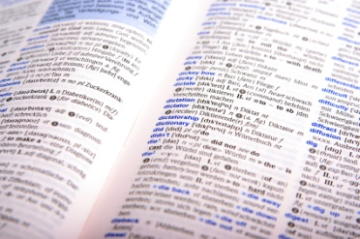

Spelling

Ten Spelling Words for Set One

free been deep seek tree

meet Set reed fee three

Write these list words in alphabetical order.

free been deep Set seek

\_\_\_\_\_\_\_\_\_\_\_\_\_\_\_\_\_\_\_\_\_\_\_\_\_\_\_\_\_\_\_\_\_\_\_\_\_\_\_\_\_\_\_\_\_\_\_\_\_\_\_\_\_\_\_\_\_\_\_\_\_\_\_\_

\_\_\_\_\_\_\_\_\_\_\_\_\_\_\_\_\_\_\_\_\_\_\_\_\_\_\_\_\_\_\_\_\_\_\_\_\_\_\_\_\_\_\_\_\_\_\_\_\_\_\_\_\_\_\_\_\_\_\_\_\_\_\_\_

Draw lines to match the homophones (words that sound the same but have a different spelling and meanings from your list words.

|  |  |  |
| --- | --- | --- |
| meat | bean | read |
| been | reed | meet |

Write an interesting sentence using one of your list words and its matching homophone.

\_\_\_\_\_\_\_\_\_\_\_\_\_\_\_\_\_\_\_\_\_\_\_\_\_\_\_\_\_\_\_\_\_\_\_\_\_\_\_\_\_\_\_\_\_\_\_\_\_\_\_\_\_\_\_\_\_\_\_\_\_\_\_\_

\_\_\_\_\_\_\_\_\_\_\_\_\_\_\_\_\_\_\_\_\_\_\_\_\_\_\_\_\_\_\_\_\_\_\_\_\_\_\_\_\_\_\_\_\_\_\_\_\_\_\_\_\_\_\_\_\_\_\_\_\_\_\_\_

\_\_\_\_\_\_\_\_\_\_\_\_\_\_\_\_\_\_\_\_\_\_\_\_\_\_\_\_\_\_\_\_\_\_\_\_\_\_\_\_\_\_\_\_\_\_\_\_\_\_\_\_\_\_\_\_\_\_\_\_\_\_\_\_

Look up these words in your dictionary and write their meanings on the lines below.

Set

\_\_\_\_\_\_\_\_\_\_\_\_\_\_\_\_\_\_\_\_\_\_\_\_\_\_\_\_\_\_\_\_\_\_\_\_\_\_\_\_\_\_\_\_\_\_\_\_\_\_\_\_\_\_\_\_\_\_\_\_\_\_\_\_

\_\_\_\_\_\_\_\_\_\_\_\_\_\_\_\_\_\_\_\_\_\_\_\_\_\_\_\_\_\_\_\_\_\_\_\_\_\_\_\_\_\_\_\_\_\_\_\_\_\_\_\_\_\_\_\_\_\_\_\_\_\_\_\_

fee

\_\_\_\_\_\_\_\_\_\_\_\_\_\_\_\_\_\_\_\_\_\_\_\_\_\_\_\_\_\_\_\_\_\_\_\_\_\_\_\_\_\_\_\_\_\_\_\_\_\_\_\_\_\_\_\_\_\_\_\_\_\_\_\_

\_\_\_\_\_\_\_\_\_\_\_\_\_\_\_\_\_\_\_\_\_\_\_\_\_\_\_\_\_\_\_\_\_\_\_\_\_\_\_\_\_\_\_\_\_\_\_\_\_\_\_\_\_\_\_\_\_\_\_\_\_\_\_\_

reed

\_\_\_\_\_\_\_\_\_\_\_\_\_\_\_\_\_\_\_\_\_\_\_\_\_\_\_\_\_\_\_\_\_\_\_\_\_\_\_\_\_\_\_\_\_\_\_\_\_\_\_\_\_\_\_\_\_\_\_\_\_\_\_\_

\_\_\_\_\_\_\_\_\_\_\_\_\_\_\_\_\_\_\_\_\_\_\_\_\_\_\_\_\_\_\_\_\_\_\_\_\_\_\_\_\_\_\_\_\_\_\_\_\_\_\_\_\_\_\_\_\_\_\_\_\_\_\_\_

Unjumble these list words

teme\_\_\_\_\_\_\_\_\_\_\_\_\_\_\_\_\_\_\_\_\_\_\_\_\_ pdee \_\_\_\_\_\_\_\_\_\_\_\_\_\_\_\_\_\_\_\_\_\_\_\_\_

eret \_\_\_\_\_\_\_\_\_\_\_\_\_\_\_\_\_\_\_\_\_\_\_\_\_ nebe\_\_\_\_\_\_\_\_\_\_\_\_\_\_\_\_\_\_\_\_\_\_\_\_\_

kees\_\_\_\_\_\_\_\_\_\_\_\_\_\_\_\_\_\_\_\_\_\_\_\_\_ rethe\_\_\_\_\_\_\_\_\_\_\_\_\_\_\_\_\_\_\_\_\_\_\_\_\_

Now you are going to look at the long ‘ee’ sound which is in all of your spelling words this Set.

The ‘ee’ letters is one of the vowel sounds and it makes words sound longer.

For example the word b**ee**p has the ‘**ee**’ sound in it. Now say

b**ee**p, b**ee**p, out loud listening for the long ee sound as you say it?

Now say this Set’s spelling words out loud and listen for the ‘ee’ sound. Read the words aloud and listen carefully again for the ‘ee’ sound.

After you have done this, underline the ‘ee’ sound in the list below. This first one has been done for you.

free been deep seek tree

meet Set reed fee three

Fill in the gaps of the words with the ‘ee’ sound.

m \_\_\_ \_\_\_ t w \_\_\_ \_\_\_ k r \_\_\_ \_\_\_ d

f \_\_\_ \_\_\_ thr \_\_\_ \_\_\_ d \_\_\_ \_\_\_ p

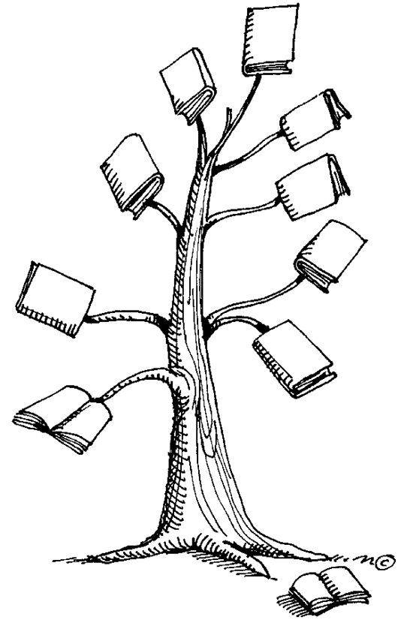

j0226124It’s time for your spelling test

Give your sheet of words to someone at home. Ask them

to test your spelling of the ten words you were given to

learn this Set. You might even like to practise your

words once again before you have your test.

|  |  |
| --- | --- |
| Spelling Words for Set One | |
| Spelling Words | My Own Spelling Words |
| free |  |
| been |  |
| deep |  |
| seek |  |
| meet |  |
| Set |  |
| reed |  |
| tree |  |
| fee |  |
| three |  |

****

**Checklist**

This Set you should have completed the following tasks. Please tick the tasks you have completed.

* Reading and Writing workshop—Narrative
* Spelling activities—LCWC and own Words
* Phonics—The ‘ee’ sound
* Grammar and Punctuation—Precise sentences and paragraphs
* How Words Work—The suffix: ed
* Spelling and Dictation test

|  |
| --- |
| End of Set One |

|  |
| --- |
| Set Two |

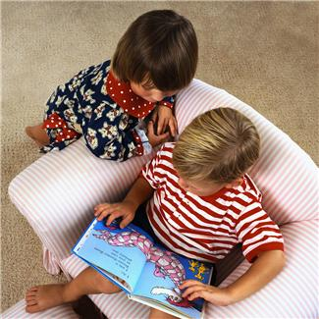

Last Set you looked at the text type of a narrative and what features it has. Please put the features from the box in the correct order.

|  |  |  |  |
| --- | --- | --- | --- |
| Resolution | Complication | Orientation | Sequence of Events |

Narrative

One.\_\_\_\_\_\_\_\_\_\_\_\_\_\_\_\_\_\_\_\_\_\_\_\_\_\_\_\_\_\_\_\_\_\_\_\_\_\_\_\_\_\_\_\_\_\_\_\_\_\_\_\_\_\_\_\_\_\_\_\_\_\_

2.\_\_\_\_\_\_\_\_\_\_\_\_\_\_\_\_\_\_\_\_\_\_\_\_\_\_\_\_\_\_\_\_\_\_\_\_\_\_\_\_\_\_\_\_\_\_\_\_\_\_\_\_\_\_\_\_\_\_\_\_\_\_

3.\_\_\_\_\_\_\_\_\_\_\_\_\_\_\_\_\_\_\_\_\_\_\_\_\_\_\_\_\_\_\_\_\_\_\_\_\_\_\_\_\_\_\_\_\_\_\_\_\_\_\_\_\_\_\_\_\_\_\_\_\_\_

4.\_\_\_\_\_\_\_\_\_\_\_\_\_\_\_\_\_\_\_\_\_\_\_\_\_\_\_\_\_\_\_\_\_\_\_\_\_\_\_\_\_\_\_\_\_\_\_\_\_\_\_\_\_\_\_\_\_\_\_\_\_\_

This Set you will plan and write a narrative. Here are some tips to think about when writing a narrative. Come back and read through them as you write your own narrative to help you remember what is going to make yours great!

One. Characters

Characters are the people, animals or things that the story is about. In a good narrative, the reader feels that they could really believe the characters are real.

2. Setting

The setting is the place and time that the story happens. In a good narrative, readers get a clear picture of where the story is happening.

3. Plot

The plot tells the reader all the things that happen to the characters and the order in which they happen. The plot must make sense. It would not make sense, for example, if the writer tells you the answer to a mystery but forgets to tell you the clues.

4. Style

Style is the way you use language to tell the story. You might write a poem, a play or a biography.

5. Theme

The theme is the idea that the narrative is all about. For example, in a fable, the moral of the story is the theme.

Now it’s time for you to plan and write a narrative. This Set you will be writing a narrative on the little puppy.

**The Little Puppy**

Write a narrative about the topic ‘The Little Puppy’. Use your imagination or write a story about a little puppy that you know who has some adventures.

Plan before you write

Use your lined paper to write down all of your planning ideas. Send this in with your draft and final narrative. Think about these ideas as you plan and check that you have included all of the ideas to make a fantastic narrative.

* Who are the people or animals in the story? Characters
* Where is the story taking place? Setting
* What happens to start the story? Introduction
* What happens to start the problems? Complication
* What are the next things that happen? Sequence of events
* How the problem is solved. Resolution

An important part of Narratives are the characters. I would like you to think about a character that is going to be in your narrative. Please use the plan on the next page to help you with your ideas.

**Character I.D**

What the character is like

Picture of your character

Likes

How is your character feeling…

At the beginning of the story

In the middle

Dislikes

By the end

How can someone at home assess your Narrative?

A rubric can be used to assess your narrative. It is a way to show you how your work will be scored.

What you need to do is read the Narrative Rubric carefully and use it to help you when you are planning and writing your work.

Narrative Rubric

|  |  |  |  |  |
| --- | --- | --- | --- | --- |
|  | High | Medium | Low | Not shown |
| Writes a plan and a draft. |  |  |  |  |
| Describes the characters. |  |  |  |  |
| Orientation. Introduces characters.  Tells where and when the story is happening. |  |  |  |  |
| Complication. Describes what happens to start the problem. |  |  |  |  |
| Sequence of events. Writes in order what events happened. |  |  |  |  |
| Resolution.  Describes how the problem is solved. |  |  |  |  |
| Makes correct use of paragraphs. |  |  |  |  |
| Uses capital letters and full stops. |  |  |  |  |
| Words spelt correctly. |  |  |  |  |

Now it’s time to write your Narrative draft. Complete this on your lined paper. Remember to give your narrative a title.

Now that you have completed your plan and your draft it is time to work on your narrative.

How will you do this?

You can use your computeror handwrite your final piece. Remember to make it neat and easy to read.

|  |  |
| --- | --- |
|  | Spelling, Phonics and How Words Work |

It’s time for you to learn your words for this Set. They are at the back of this Booklet. You also need to choose ten words for **My** **Own Words.**

These can be from:

* your own writing
* your reading
* your memory

1. Write the ten words you have chosen, in the My Own Wordscolumn on the page at the back of Set Two.

Learn these and the ten words given to you for this Set.

Remember to use L.C.W.C to help you learn these.

Ten Spelling Words for Set Two

outside scared world sleep things

moon boom pool noon soon

Spelling Activities

1. Write all the list words that have the oo sound:

\_\_\_\_\_\_\_\_\_\_\_\_\_\_\_\_ \_\_\_\_\_\_\_\_\_\_\_\_\_\_\_\_ \_\_\_\_\_\_\_\_\_\_\_\_\_\_\_\_

\_\_\_\_\_\_\_\_\_\_\_\_\_\_\_\_ \_\_\_\_\_\_\_\_\_\_\_\_\_\_\_\_ \_\_\_\_\_\_\_\_\_\_\_\_\_\_\_\_

1. Write an interesting sentence using the words pool and moon.

\_\_\_\_\_\_\_\_\_\_\_\_\_\_\_\_\_\_\_\_\_\_\_\_\_\_\_\_\_\_\_\_\_\_\_\_\_\_\_\_\_\_\_\_\_\_\_\_\_\_\_\_\_\_\_\_\_\_\_

\_\_\_\_\_\_\_\_\_\_\_\_\_\_\_\_\_\_\_\_\_\_\_\_\_\_\_\_\_\_\_\_\_\_\_\_\_\_\_\_\_\_\_\_\_\_\_\_\_\_\_\_\_\_\_\_\_\_\_

\_\_\_\_\_\_\_\_\_\_\_\_\_\_\_\_\_\_\_\_\_\_\_\_\_\_\_\_\_\_\_\_\_\_\_\_\_\_\_\_\_\_\_\_\_\_\_\_\_\_\_\_\_\_\_\_\_\_\_

\_\_\_\_\_\_\_\_\_\_\_\_\_\_\_\_\_\_\_\_\_\_\_\_\_\_\_\_\_\_\_\_\_\_\_\_\_\_\_\_\_\_\_\_\_\_\_\_\_\_\_\_\_\_\_\_\_\_\_

\_\_\_\_\_\_\_\_\_\_\_\_\_\_\_\_\_\_\_\_\_\_\_\_\_\_\_\_\_\_\_\_\_\_\_\_\_\_\_\_\_\_\_\_\_\_\_\_\_\_\_\_\_\_\_\_\_\_\_

\_\_\_\_\_\_\_\_\_\_\_\_\_\_\_\_\_\_\_\_\_\_\_\_\_\_\_\_\_\_\_\_\_\_\_\_\_\_\_\_\_\_\_\_\_\_\_\_\_\_\_\_\_\_\_\_\_\_\_

\_\_\_\_\_\_\_\_\_\_\_\_\_\_\_\_\_\_\_\_\_\_\_\_\_\_\_\_\_\_\_\_\_\_\_\_\_\_\_\_\_\_\_\_\_\_\_\_\_\_\_\_\_\_\_\_\_\_\_

1. Find the dictionary meanings for the words world and sleep and write these on the lines below.

\_\_\_\_\_\_\_\_\_\_\_\_\_\_\_\_\_\_\_\_\_\_\_\_\_\_\_\_\_\_\_\_\_\_\_\_\_\_\_\_\_\_\_\_\_\_\_\_\_\_\_\_\_\_\_\_\_

\_\_\_\_\_\_\_\_\_\_\_\_\_\_\_\_\_\_\_\_\_\_\_\_\_\_\_\_\_\_\_\_\_\_\_\_\_\_\_\_\_\_\_\_\_\_\_\_\_\_\_\_\_\_\_\_\_

\_\_\_\_\_\_\_\_\_\_\_\_\_\_\_\_\_\_\_\_\_\_\_\_\_\_\_\_\_\_\_\_\_\_\_\_\_\_\_\_\_\_\_\_\_\_\_\_\_\_\_\_\_\_\_\_\_

\_\_\_\_\_\_\_\_\_\_\_\_\_\_\_\_\_\_\_\_\_\_\_\_\_\_\_\_\_\_\_\_\_\_\_\_\_\_\_\_\_\_\_\_\_\_\_\_\_\_\_\_\_\_\_\_\_

\_\_\_\_\_\_\_\_\_\_\_\_\_\_\_\_\_\_\_\_\_\_\_\_\_\_\_\_\_\_\_\_\_\_\_\_\_\_\_\_\_\_\_\_\_\_\_\_\_\_\_\_\_\_\_\_\_

\_\_\_\_\_\_\_\_\_\_\_\_\_\_\_\_\_\_\_\_\_\_\_\_\_\_\_\_\_\_\_\_\_\_\_\_\_\_\_\_\_\_\_\_\_\_\_\_\_\_\_\_\_\_\_\_\_

1. Put this Set’s words in alphabetical order:

\_\_\_\_\_\_\_\_\_\_\_\_\_\_\_\_\_\_\_\_\_\_\_\_\_\_\_\_\_\_\_\_\_\_\_\_\_\_\_\_\_\_\_\_\_\_\_\_\_\_\_\_\_\_\_\_\_

\_\_\_\_\_\_\_\_\_\_\_\_\_\_\_\_\_\_\_\_\_\_\_\_\_\_\_\_\_\_\_\_\_\_\_\_\_\_\_\_\_\_\_\_\_\_\_\_\_\_\_\_\_\_\_\_\_

\_\_\_\_\_\_\_\_\_\_\_\_\_\_\_\_\_\_\_\_\_\_\_\_\_\_\_\_\_\_\_\_\_\_\_\_\_\_\_\_\_\_\_\_\_\_\_\_\_\_\_\_\_\_\_\_\_

\_\_\_\_\_\_\_\_\_\_\_\_\_\_\_\_\_\_\_\_\_\_\_\_\_\_\_\_\_\_\_\_\_\_\_\_\_\_\_\_\_\_\_\_\_\_\_\_\_\_\_\_\_\_\_\_\_

\_\_\_\_\_\_\_\_\_\_\_\_\_\_\_\_\_\_\_\_\_\_\_\_\_\_\_\_\_\_\_\_\_\_\_\_\_\_\_\_\_\_\_\_\_\_\_\_\_\_\_\_\_\_\_\_\_

\_\_\_\_\_\_\_\_\_\_\_\_\_\_\_\_\_\_\_\_\_\_\_\_\_\_\_\_\_\_\_\_\_\_\_\_\_\_\_\_\_\_\_\_\_\_\_\_\_\_\_\_\_\_\_\_\_

It’s time to look at the sounds of the Set. The ‘oo’ letters makes a long vowel sound. It is also in some of your spelling words this Set.

Say the word son out loud and then say the word soon.

Can you tell the difference in the sounds these words make? Read each word aloud slowly and listen to how each word sounds? How are they different?

It is the word soon which has a longer vowel sound rather than the word son because it has the oo letters in it.

Brainstorm how many other words you can think of that have the long oo sound pattern in them. Write them on the lines below.

\_\_\_\_\_\_\_\_\_\_\_\_\_\_\_\_\_\_\_\_\_\_\_\_\_\_\_\_\_\_\_\_\_\_\_\_\_\_\_\_\_\_\_\_\_\_\_\_\_\_\_\_\_\_\_\_\_\_\_\_\_\_\_\_

\_\_\_\_\_\_\_\_\_\_\_\_\_\_\_\_\_\_\_\_\_\_\_\_\_\_\_\_\_\_\_\_\_\_\_\_\_\_\_\_\_\_\_\_\_\_\_\_\_\_\_\_\_\_\_\_\_\_\_\_\_\_\_\_

\_\_\_\_\_\_\_\_\_\_\_\_\_\_\_\_\_\_\_\_\_\_\_\_\_\_\_\_\_\_\_\_\_\_\_\_\_\_\_\_\_\_\_\_\_\_\_\_\_\_\_\_\_\_\_\_\_\_\_\_\_\_\_\_

Now fill in the following spelling words with the ‘oo’ letters and then say them out loud.

|  |  |
| --- | --- |
| m \_\_\_ \_\_\_ n  b \_\_\_ \_\_\_ m  p \_\_\_ \_\_\_ l  n \_\_\_ \_\_\_ n  s \_\_\_ \_\_\_ n | C:\Users\jmiller\AppData\Local\Microsoft\Windows\Temporary Internet Files\Low\Content.IE5\5287MVCV\MC900389356[1].WMF  Draw a line to the word that  matches this picture. |

Write a short sentence using the following words:

pool

**\_\_\_\_\_\_\_\_\_\_\_\_\_\_\_\_\_\_\_\_\_\_\_\_\_\_\_\_\_\_\_\_\_\_\_\_\_\_\_\_\_\_\_\_\_\_\_\_\_\_\_\_\_\_\_\_\_\_\_\_\_**

**\_\_\_\_\_\_\_\_\_\_\_\_\_\_\_\_\_\_\_\_\_\_\_\_\_\_\_\_\_\_\_\_\_\_\_\_\_\_\_\_\_\_\_\_\_\_\_\_\_\_\_\_\_\_\_\_\_\_\_\_\_**

moon

**\_\_\_\_\_\_\_\_\_\_\_\_\_\_\_\_\_\_\_\_\_\_\_\_\_\_\_\_\_\_\_\_\_\_\_\_\_\_\_\_\_\_\_\_\_\_\_\_\_\_\_\_\_\_\_\_\_\_\_\_\_**

**\_\_\_\_\_\_\_\_\_\_\_\_\_\_\_\_\_\_\_\_\_\_\_\_\_\_\_\_\_\_\_\_\_\_\_\_\_\_\_\_\_\_\_\_\_\_\_\_\_\_\_\_\_\_\_\_\_\_\_\_\_**

boom

**\_\_\_\_\_\_\_\_\_\_\_\_\_\_\_\_\_\_\_\_\_\_\_\_\_\_\_\_\_\_\_\_\_\_\_\_\_\_\_\_\_\_\_\_\_\_\_\_\_\_\_\_\_\_\_\_\_\_\_\_\_**

**\_\_\_\_\_\_\_\_\_\_\_\_\_\_\_\_\_\_\_\_\_\_\_\_\_\_\_\_\_\_\_\_\_\_\_\_\_\_\_\_\_\_\_\_\_\_\_\_\_\_\_\_\_\_\_\_\_\_\_\_\_**

Write down two things that you can think of about the word

noon

**\_\_\_\_\_\_\_\_\_\_\_\_\_\_\_\_\_\_\_\_\_\_\_\_\_\_\_\_\_\_\_\_\_\_\_\_\_\_\_\_\_\_\_\_\_\_\_\_\_\_\_\_\_\_\_\_\_\_\_\_\_**

**\_\_\_\_\_\_\_\_\_\_\_\_\_\_\_\_\_\_\_\_\_\_\_\_\_\_\_\_\_\_\_\_\_\_\_\_\_\_\_\_\_\_\_\_\_\_\_\_\_\_\_\_\_\_\_\_\_\_\_\_\_**

**\_\_\_\_\_\_\_\_\_\_\_\_\_\_\_\_\_\_\_\_\_\_\_\_\_\_\_\_\_\_\_\_\_\_\_\_\_\_\_\_\_\_\_\_\_\_\_\_\_\_\_\_\_\_\_\_\_\_\_\_\_**

**\_\_\_\_\_\_\_\_\_\_\_\_\_\_\_\_\_\_\_\_\_\_\_\_\_\_\_\_\_\_\_\_\_\_\_\_\_\_\_\_\_\_\_\_\_\_\_\_\_\_\_\_\_\_\_\_\_\_\_\_\_**

**\_\_\_\_\_\_\_\_\_\_\_\_\_\_\_\_\_\_\_\_\_\_\_\_\_\_\_\_\_\_\_\_\_\_\_\_\_\_\_\_\_\_\_\_\_\_\_\_\_\_\_\_\_\_\_\_\_\_\_\_\_**

Plurals

Nouns are words used to name people, places, things and ideas. There are different types of nouns but here is something very interesting about nouns that you might not know. A single noun means just one. But plural nouns are a lot more fun. They are words that tell us two or more. Like six dogs or five cats with lots and lots of paws.

You can make the plural of most nouns simply by adding s. For example, the noun bird means one bird. But if we add an s to the word bird it becomes the plural noun birds, which means more than one bird. For nouns that end in ch, sh, s or x, you can make the plural by adding es. For example: dish becomes dishes and lunch becomes lunches.

Now it’s time for some jokes. Make the singular nouns in brackets into plural nouns to finish the joke. The first one has been done.

What kind of **glasses** do ghosts wear? (glass)

Spooktacles.

Why can’t you put \_\_\_\_\_\_\_\_\_\_\_\_\_\_\_\_\_\_\_ in \_\_\_\_\_\_\_\_\_\_\_\_\_\_\_\_\_\_\_\_?

(elephant) (sandwich)

Because they are too heavy to lift.

Why did the girls throw the \_\_\_\_\_\_\_\_\_\_\_\_\_\_\_\_\_\_\_\_ out of the

\_\_\_\_\_\_\_\_\_\_\_\_\_\_\_\_\_\_\_\_\_\_\_\_\_\_\_\_?

(clock) (window)

They wanted to see time fly.

Why aren’t \_\_\_\_\_\_\_\_\_\_\_\_\_\_\_\_\_\_\_\_\_\_\_\_\_\_\_\_\_ ever lonely?

(banana)

They always hang around in a bunch.

C:\Users\jmiller\AppData\Local\Microsoft\Windows\Temporary Internet Files\Low\Content.IE5\O584SN30\MC900053962[1].WMF

Grammar and Punctuation

What are prepositions?

Prepositions are words like *to, from, with, for, into* and *between*. They link nouns to other words in a sentence. They are a bit like glue!

In the sentence ‘The books are onthe shelf’, the preposition is on. This is because it tells where the booksare on the shelf.

Write the preposition in each sentence. The first one has been completed for you.

under

The dog was under the table. \_\_\_\_\_\_\_\_\_\_\_\_\_\_\_\_\_\_\_\_\_\_\_

The cup is near the sink. \_\_\_\_\_\_\_\_\_\_\_\_\_\_\_\_\_\_\_\_\_\_\_

The spider went up the wall. \_\_\_\_\_\_\_\_\_\_\_\_\_\_\_\_\_\_\_\_\_\_\_

She went into the garden. \_\_\_\_\_\_\_\_\_\_\_\_\_\_\_\_\_\_\_\_\_\_\_

She is in her room. \_\_\_\_\_\_\_\_\_\_\_\_\_\_\_\_\_\_\_\_\_\_\_

The cat sits by the chair. \_\_\_\_\_\_\_\_\_\_\_\_\_\_\_\_\_\_\_\_\_\_\_

The glass fell off the table. \_\_\_\_\_\_\_\_\_\_\_\_\_\_\_\_\_\_\_\_\_\_\_

It’s time for your spelling test

Before you give your sheet of words to someone in your house to test you on this Set’s words, take a moment to write down some of the things you have done this Set to help you learn your words.

\_\_\_\_\_\_\_\_\_\_\_\_\_\_\_\_\_\_\_\_\_\_\_\_\_\_\_\_\_\_\_\_\_\_\_\_\_\_\_\_\_\_\_\_\_\_\_\_\_\_\_\_\_\_\_\_\_\_\_\_\_\_\_\_

\_\_\_\_\_\_\_\_\_\_\_\_\_\_\_\_\_\_\_\_\_\_\_\_\_\_\_\_\_\_\_\_\_\_\_\_\_\_\_\_\_\_\_\_\_\_\_\_\_\_\_\_\_\_\_\_\_\_\_\_\_\_\_\_

\_\_\_\_\_\_\_\_\_\_\_\_\_\_\_\_\_\_\_\_\_\_\_\_\_\_\_\_\_\_\_\_\_\_\_\_\_\_\_\_\_\_\_\_\_\_\_\_\_\_\_\_\_\_\_\_\_\_\_\_\_\_\_\_

|  |  |
| --- | --- |
| Spelling Words for Set Two | |
| Spelling Words | Spelling Words |
| outside |  |
| scared |  |
| world |  |
| sleep |  |
| things |  |
| moon |  |
| boom |  |
| pool |  |
| noon |  |
| soon |  |

Reflection

It’s time to think about what you have learnt this Set. Please complete the following activities.

Text Type

Use these words about Narratives to fill in the sentences below.

|  |  |  |  |
| --- | --- | --- | --- |
| setting | complication | sequence of events | resolution |

A Narrative text usually starts with the \_\_\_\_\_\_\_\_\_\_\_\_\_\_\_\_\_\_\_\_\_\_\_\_\_.

The \_\_\_\_\_\_\_\_\_\_\_\_\_\_\_\_\_\_\_\_\_\_\_\_\_\_\_\_\_ explains the problem.

The series of \_\_\_\_\_\_\_\_\_\_\_\_\_\_\_\_\_\_\_\_\_\_\_ tells you what happened in the Narrative.

The \_\_\_\_\_\_\_\_\_\_\_\_\_\_\_\_\_\_\_\_\_\_\_\_\_\_\_\_\_\_\_\_\_\_ happens at the end.

Spelling and Phonics

Is the ‘oo’ sound a long or short vowel?

\_\_\_\_\_\_\_\_\_\_\_\_\_\_\_\_\_\_\_\_\_\_\_\_\_\_\_\_\_\_\_\_\_\_\_\_\_\_\_\_\_\_\_\_\_\_\_\_

\_\_\_\_\_\_\_\_\_\_\_\_\_\_\_\_\_\_\_\_\_\_\_\_\_\_\_\_\_\_\_\_\_\_\_\_\_\_\_\_\_\_\_\_\_\_\_\_

Text and Grammar Skill

What is a preposition?

\_\_\_\_\_\_\_\_\_\_\_\_\_\_\_\_\_\_\_\_\_\_\_\_\_\_\_\_\_\_\_\_\_\_\_\_\_\_\_\_\_\_\_\_\_\_\_\_\_\_\_\_\_\_\_\_\_\_\_\_\_\_\_\_

\_\_\_\_\_\_\_\_\_\_\_\_\_\_\_\_\_\_\_\_\_\_\_\_\_\_\_\_\_\_\_\_\_\_\_\_\_\_\_\_\_\_\_\_\_\_\_\_\_\_\_\_\_\_\_\_\_\_\_\_\_\_\_\_

How Words Work

Please write some words that you can add ed to.

\_\_\_\_\_\_\_\_\_\_\_\_\_\_\_\_\_\_\_\_\_\_\_\_\_\_\_\_\_\_\_\_\_\_\_\_\_\_\_\_\_\_\_\_\_\_\_\_\_\_\_\_\_\_\_\_\_\_\_\_\_\_\_\_

\_\_\_\_\_\_\_\_\_\_\_\_\_\_\_\_\_\_\_\_\_\_\_\_\_\_\_\_\_\_\_\_\_\_\_\_\_\_\_\_\_\_\_\_\_\_\_\_\_\_\_\_\_\_\_\_\_\_\_\_\_\_\_\_

\_\_\_\_\_\_\_\_\_\_\_\_\_\_\_\_\_\_\_\_\_\_\_\_\_\_\_\_\_\_\_\_\_\_\_\_\_\_\_\_\_\_\_\_\_\_\_\_\_\_\_\_\_\_\_\_\_\_\_\_\_\_\_\_

What I learnt the most about in this Booklet was

\_\_\_\_\_\_\_\_\_\_\_\_\_\_\_\_\_\_\_\_\_\_\_\_\_\_\_\_\_\_\_\_\_\_\_\_\_\_\_\_\_\_\_\_\_\_\_\_\_\_\_\_\_\_\_\_\_\_\_\_\_\_\_\_

\_\_\_\_\_\_\_\_\_\_\_\_\_\_\_\_\_\_\_\_\_\_\_\_\_\_\_\_\_\_\_\_\_\_\_\_\_\_\_\_\_\_\_\_\_\_\_\_\_\_\_\_\_\_\_\_\_\_\_\_\_\_\_\_

One thing I could improve with my work is \_\_\_\_\_\_\_\_\_\_\_\_\_\_\_\_\_\_\_\_\_\_\_\_

\_\_\_\_\_\_\_\_\_\_\_\_\_\_\_\_\_\_\_\_\_\_\_\_\_\_\_\_\_\_\_\_\_\_\_\_\_\_\_\_\_\_\_\_\_\_\_\_\_\_\_\_\_\_\_\_\_\_\_\_\_\_\_\_

\_\_\_\_\_\_\_\_\_\_\_\_\_\_\_\_\_\_\_\_\_\_\_\_\_\_\_\_\_\_\_\_\_\_\_\_\_\_\_\_\_\_\_\_\_\_\_\_\_\_\_\_\_\_\_\_\_\_\_\_\_\_\_\_

****

**Checklist**

This Set you should have completed the following tasks. Please tick the tasks you have completed.

* Writing—Narrative
* Spelling activities—LCWC and own Words
* Phonics—Long ‘oo’ sound
* Grammar and Punctuation—Prepositions
* How Words Work— Plurals
* Spelling test

|  |
| --- |
| End of Set Two |

|  |
| --- |
| **References and Resources** |
| The following resources were used in the research of topics and the compilation of lessons for this booklet: |

Woods, Andrew, *Spelling Matters Book 3,* Addison Wesley Longman Australia Pty Limited,One993

Rodney, Martin, *Junior Writers Guide,* Era Publications,2006

Harrod, Jenni, *Literacy: Back to basics*, R.I.C Publications, 20One0

Barwick, John, Dobbie, Karen, Lloyd, Angela, Dalgleish, Sharon, Doherty Ann, Shapiro, Sharon, Dalgleish, Tanya, Faye, Michael, *Targeting Text: Middle Primary*, Blake Education, One998

<http://www.sciencekids.co.nz/pictures/illusions.html>

<http://www.socialmedium.co.uk/blog/social_media_sentiment/>

[http://wvde.state.wv.us/teach2One/](http://wvde.state.wv.us/teach21/)

<http://office.microsoft.com/en-au/images/>

|  |
| --- |
| **YOUR QUESTIONS OR COMMENTS** |

English

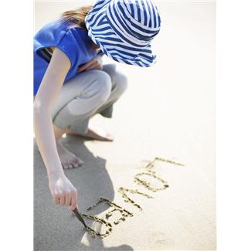

*How do I use research in my work?*

**Read before you begin**

|  |  |
| --- | --- |
| In this Booklet you will ask yourself:  ‘How do I use research in my work?’ | beaches,children,communications,girls,letters,people,sands,sticks,women,writings |

|  |  |
| --- | --- |
|  | Learning Intentions for Booklet C |

Writing Workshop

Study the style and techniques of doing research.

Grammar and Punctuation

Learn about expressing an opinion. Study modal adverbs.

How Words Work

Explore the use of homophones and the use of rhyming words.

Spelling and Phonics

Study your One0 given spelling words as well as your own One0 words for your test at the end of the Set. In phonetics, you will find out about the sounds of ‘ear’ and ‘ght’.

|  |  |
| --- | --- |
| Contents | |
| Set One | Reading and Writing Workshop   * Learn about different ways to do research * Talk to someone at home and complete internet research on a website (if you can)   Spelling activities and Phonetics   * Ten given words and ten words of your own choice * The ‘ear’ sound   Grammar and Punctuation   * Expressing opinion   How words work   * Homophones   Spelling test   * Spell the words for this Set |
| Set Two | Reading and Writing Workshop   * Write a book review   Spelling activities and Phonics   * Ten given words and ten words of your own choice * The ‘ght’ sound   Grammar and Punctuation   * Adverbs   How words work   * Rhyming words   Spelling test   * Spell the words for this Set   Reflection   * Know, Want To Know and Learn (KWL) chart * Answer written questions about the topic |



Getting Knowledge Ready

This Set you are going to learn about how to do some research. Before you begin we would like you to do a KWL Chart. You just need to complete the chart to show what you already know about research, what you would like to know and what you have learned after you have completed the booklet. Write some sentences in each box, except for the ‘What I have learnt’ section which you can fill in after you have finished Set two of the booklet.

|  |
| --- |
| Topic: Research  KWL Chart |

|  |  |  |
| --- | --- | --- |
| What I Already Know | What I Would Like to Know | What I have Learnt |
|  |  |  |

|  |
| --- |
| Set One |

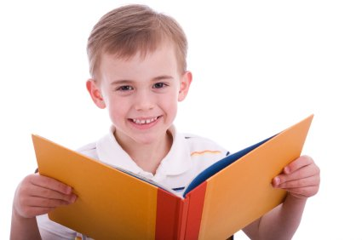

In this booklet you are going to do a reading and writing workshop. The topic that you are going to explore this Set is research.

Research is a big part of the writing process. It is when authors find the information they need for a writing project. Research includes interviewing, reading, note-taking and experimenting with ideas and methods (for example, testing recipes).

Research is done by writers for both fiction and nonfiction writing. Fiction is writing that is created from the writer’s imagination. The characters, the setting and what happens in the stories and poems are made up by the author. Fiction writers do research about places for their setting, people and animals they want to use as characters.

Nonfiction is writing that gives information or points of view. Nonfiction often has graphs, charts, diagrams, maps and photographs to help the reader understand the information or to read it in another way. Nonfiction writers find detailed information about their topic so their writing is accurate.

Some of the research types are:

* Library research (background reading of encyclopaedias, information reports, newspapers, etc.)
* Internet research (websites-check whether you can trust information)
* Interviews (experts on the topic, witnesses)
* Experiments (testing processes, recipes or activities to check that they work)

Are there any research types you have done so far?

\_\_\_\_\_\_\_\_\_\_\_\_\_\_\_\_\_\_\_\_\_\_\_\_\_\_\_\_\_\_\_\_\_\_\_\_\_\_\_\_\_\_\_\_\_\_\_\_\_\_\_\_\_\_\_\_\_\_\_\_\_\_\_\_

Which one do you prefer, Fiction or Non Fiction?

\_\_\_\_\_\_\_\_\_\_\_\_\_\_\_\_\_\_\_\_\_\_\_\_\_\_\_\_\_\_\_\_\_\_\_\_\_\_\_\_\_\_\_\_\_\_\_\_\_\_\_\_\_\_\_\_\_\_\_\_\_\_\_\_

The Internet allows people to connect to each other and to share information. Many areas of the Internet are made up of websites, which are places people can go to find information.

Write some websites you know.

Website One\_\_\_\_\_\_\_\_\_\_\_\_\_\_\_\_\_\_\_\_\_\_\_\_\_\_\_\_\_\_\_\_\_\_\_\_\_\_\_\_\_\_\_\_\_\_\_\_\_\_\_\_\_

Website 2\_\_\_\_\_\_\_\_\_\_\_\_\_\_\_\_\_\_\_\_\_\_\_\_\_\_\_\_\_\_\_\_\_\_\_\_\_\_\_\_\_\_\_\_\_\_\_\_\_\_\_\_\_

Website 3\_\_\_\_\_\_\_\_\_\_\_\_\_\_\_\_\_\_\_\_\_\_\_\_\_\_\_\_\_\_\_\_\_\_\_\_\_\_\_\_\_\_\_\_\_\_\_\_\_\_\_\_\_

As there is so much information on the Internet, a good way to do some research for your writing is a website review. This is what you will be learning to do this Set.

A website review is when someone goes to a website and looks at it closely to see how it works. They then write what they think of the website so others can read it.

A website review usually has the title and address of the website, a summary of what the website is about, a rating and a recommendation for others.



Here is an example of a website review:

Website Review

Website address:

\_\_\_\_\_\_\_\_\_\_\_\_\_\_\_\_\_\_\_\_\_\_\_\_\_\_\_\_\_\_\_\_\_\_\_\_\_\_\_\_\_\_\_\_\_\_\_\_\_\_\_\_\_\_\_\_\_\_\_\_

Website Title:

\_\_\_\_\_\_\_\_\_\_\_\_\_\_\_\_\_\_\_\_\_\_\_\_\_\_\_\_\_\_\_\_\_\_\_\_\_\_\_\_\_\_\_\_\_\_\_\_\_\_\_\_\_\_\_\_\_\_\_\_

Website Summary:

\_\_\_\_\_\_\_\_\_\_\_\_\_\_\_\_\_\_\_\_\_\_\_\_\_\_\_\_\_\_\_\_\_\_\_\_\_\_\_\_\_\_\_\_\_\_\_\_\_\_\_\_\_\_\_\_\_\_\_\_

\_\_\_\_\_\_\_\_\_\_\_\_\_\_\_\_\_\_\_\_\_\_\_\_\_\_\_\_\_\_\_\_\_\_\_\_\_\_\_\_\_\_\_\_\_\_\_\_\_\_\_\_\_\_\_\_\_\_\_\_

\_\_\_\_\_\_\_\_\_\_\_\_\_\_\_\_\_\_\_\_\_\_\_\_\_\_\_\_\_\_\_\_\_\_\_\_\_\_\_\_\_\_\_\_\_\_\_\_\_\_\_\_\_\_\_\_\_\_\_\_

\_\_\_\_\_\_\_\_\_\_\_\_\_\_\_\_\_\_\_\_\_\_\_\_\_\_\_\_\_\_\_\_\_\_\_\_\_\_\_\_\_\_\_\_\_\_\_\_\_\_\_\_\_\_\_\_\_\_\_\_

\_\_\_\_\_\_\_\_\_\_\_\_\_\_\_\_\_\_\_\_\_\_\_\_\_\_\_\_\_\_\_\_\_\_\_\_\_\_\_\_\_\_\_\_\_\_\_\_\_\_\_\_\_\_\_\_\_\_\_\_

\_\_\_\_\_\_\_\_\_\_\_\_\_\_\_\_\_\_\_\_\_\_\_\_\_\_\_\_\_\_\_\_\_\_\_\_\_\_\_\_\_\_\_\_\_\_\_\_\_\_\_\_\_\_\_\_\_\_\_\_

\_\_\_\_\_\_\_\_\_\_\_\_\_\_\_\_\_\_\_\_\_\_\_\_\_\_\_\_\_\_\_\_\_\_\_\_\_\_\_\_\_\_\_\_\_\_\_\_\_\_\_\_\_\_\_\_\_\_\_\_

\_\_\_\_\_\_\_\_\_\_\_\_\_\_\_\_\_\_\_\_\_\_\_\_\_\_\_\_\_\_\_\_\_\_\_\_\_\_\_\_\_\_\_\_\_\_\_\_\_\_\_\_\_\_\_\_\_\_\_\_

\_\_\_\_\_\_\_\_\_\_\_\_\_\_\_\_\_\_\_\_\_\_\_\_\_\_\_\_\_\_\_\_\_\_\_\_\_\_\_\_\_\_\_\_\_\_\_\_\_\_\_\_\_\_\_\_\_\_\_\_

\_\_\_\_\_\_\_\_\_\_\_\_\_\_\_\_\_\_\_\_\_\_\_\_\_\_\_\_\_\_\_\_\_\_\_\_\_\_\_\_\_\_\_\_\_\_\_\_\_\_\_\_\_\_\_\_\_\_\_\_

Rate how helpful the website’s information was out of ten.

One means not much, One0 means a great deal. Circle your rating.

1 2 3 4 5 6 7 8 9 10

Would you recommend this website to other students to help them learn about being safe online? Explain *why* or *why not*.

\_\_\_\_\_\_\_\_\_\_\_\_\_\_\_\_\_\_\_\_\_\_\_\_\_\_\_\_\_\_\_\_\_\_\_\_\_\_\_\_\_\_\_\_\_\_\_\_\_\_\_\_\_\_\_\_\_\_\_\_

\_\_\_\_\_\_\_\_\_\_\_\_\_\_\_\_\_\_\_\_\_\_\_\_\_\_\_\_\_\_\_\_\_\_\_\_\_\_\_\_\_\_\_\_\_\_\_\_\_\_\_\_\_\_\_\_\_\_\_\_

\_\_\_\_\_\_\_\_\_\_\_\_\_\_\_\_\_\_\_\_\_\_\_\_\_\_\_\_\_\_\_\_\_\_\_\_\_\_\_\_\_\_\_\_\_\_\_\_\_\_\_\_\_\_\_\_\_\_\_\_

\_\_\_\_\_\_\_\_\_\_\_\_\_\_\_\_\_\_\_\_\_\_\_\_\_\_\_\_\_\_\_\_\_\_\_\_\_\_\_\_\_\_\_\_\_\_\_\_\_\_\_\_\_\_\_\_\_\_\_\_

https://www.esafety.gov.au/kids

eSafetykids

eSafetykids has information about how to stay safe online, including how to behave online, how to be safe while you are gaming and what you can do if you are being bullied online.

It’s time to write your own website review. You can choose one website from the list below and write the review.

**ABCMe:**

ABC ME is a place for school-aged children to watch the best stories, news and cartoons from Australia and around the world that reflect and celebrate the lives of young Aussies.

Visit: <https://www.abc.net.au/abcme/about/>

**RollerMache:**

A do-it-yourself animation site filled with videos and animation tutorials.

Visit: <http://fuse.education.vic.gov.au/?F29P8P>

**Up To Ten.com:**

Hundreds of games and fun activities.

Visit: [www.uptoten.com](http://www.uptoten.com/)



Write your review here.

**Website Review**

Website address:

\_\_\_\_\_\_\_\_\_\_\_\_\_\_\_\_\_\_\_\_\_\_\_\_\_\_\_\_\_\_\_\_\_\_\_\_\_\_\_\_\_\_\_\_\_\_\_\_\_\_\_\_\_\_\_\_\_\_\_\_

Website Title:

\_\_\_\_\_\_\_\_\_\_\_\_\_\_\_\_\_\_\_\_\_\_\_\_\_\_\_\_\_\_\_\_\_\_\_\_\_\_\_\_\_\_\_\_\_\_\_\_\_\_\_\_\_\_\_\_\_\_\_\_

Website Summary:

\_\_\_\_\_\_\_\_\_\_\_\_\_\_\_\_\_\_\_\_\_\_\_\_\_\_\_\_\_\_\_\_\_\_\_\_\_\_\_\_\_\_\_\_\_\_\_\_\_\_\_\_\_\_\_\_\_\_\_\_

\_\_\_\_\_\_\_\_\_\_\_\_\_\_\_\_\_\_\_\_\_\_\_\_\_\_\_\_\_\_\_\_\_\_\_\_\_\_\_\_\_\_\_\_\_\_\_\_\_\_\_\_\_\_\_\_\_\_\_\_

\_\_\_\_\_\_\_\_\_\_\_\_\_\_\_\_\_\_\_\_\_\_\_\_\_\_\_\_\_\_\_\_\_\_\_\_\_\_\_\_\_\_\_\_\_\_\_\_\_\_\_\_\_\_\_\_\_\_\_\_

\_\_\_\_\_\_\_\_\_\_\_\_\_\_\_\_\_\_\_\_\_\_\_\_\_\_\_\_\_\_\_\_\_\_\_\_\_\_\_\_\_\_\_\_\_\_\_\_\_\_\_\_\_\_\_\_\_\_\_\_

\_\_\_\_\_\_\_\_\_\_\_\_\_\_\_\_\_\_\_\_\_\_\_\_\_\_\_\_\_\_\_\_\_\_\_\_\_\_\_\_\_\_\_\_\_\_\_\_\_\_\_\_\_\_\_\_\_\_\_\_

Rate how helpful the website’s information was, giving it a score out of ten. Circle your rating.

1 2 3 4 5 6 7 8 9 10

Would you recommend this website to other students?

Explain *why* or *why not*.

\_\_\_\_\_\_\_\_\_\_\_\_\_\_\_\_\_\_\_\_\_\_\_\_\_\_\_\_\_\_\_\_\_\_\_\_\_\_\_\_\_\_\_\_\_\_\_\_\_\_\_\_\_\_\_\_\_\_\_\_

\_\_\_\_\_\_\_\_\_\_\_\_\_\_\_\_\_\_\_\_\_\_\_\_\_\_\_\_\_\_\_\_\_\_\_\_\_\_\_\_\_\_\_\_\_\_\_\_\_\_\_\_\_\_\_\_\_\_\_\_

\_\_\_\_\_\_\_\_\_\_\_\_\_\_\_\_\_\_\_\_\_\_\_\_\_\_\_\_\_\_\_\_\_\_\_\_\_\_\_\_\_\_\_\_\_\_\_\_\_\_\_\_\_\_\_\_\_\_\_\_

\_\_\_\_\_\_\_\_\_\_\_\_\_\_\_\_\_\_\_\_\_\_\_\_\_\_\_\_\_\_\_\_\_\_\_\_\_\_\_\_\_\_\_\_\_\_\_\_\_\_\_\_\_\_\_\_\_\_\_\_

C:\Users\jmiller\AppData\Local\Microsoft\Windows\Temporary Internet Files\Low\Content.IE5\O584SN30\MC900053962[1].WMF

Grammar and Punctuation

What is an opinion?

An opinion is something someone believes. It does not have to be based on fact.

For example, two people look at the same photo of a flower.

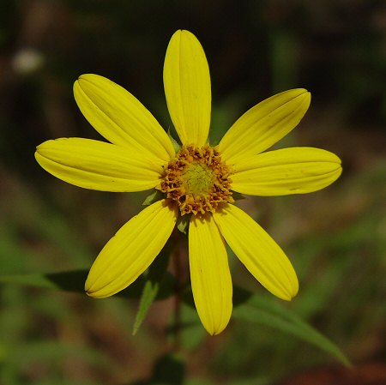

The first person thinks the flower photo is beautiful.

The second person thinks the flower photo doesn’t look nice.

What both these people think of the flower photo is their opinion, because it is what they believe.

What’s your opinion of the flower photo?

\_\_\_\_\_\_\_\_\_\_\_\_\_\_\_\_\_\_\_\_\_\_\_\_\_\_\_\_\_\_\_\_\_\_\_\_\_\_\_\_\_\_\_\_\_\_\_\_\_\_\_\_\_\_\_\_\_\_\_\_\_\_\_\_\_\_\_\_\_\_\_

\_\_\_\_\_\_\_\_\_\_\_\_\_\_\_\_\_\_\_\_\_\_\_\_\_\_\_\_\_\_\_\_\_\_\_\_\_\_\_\_\_\_\_\_\_\_\_\_\_\_\_\_\_\_\_\_\_\_\_\_\_\_\_\_\_\_\_\_\_\_\_

\_\_\_\_\_\_\_\_\_\_\_\_\_\_\_\_\_\_\_\_\_\_\_\_\_\_\_\_\_\_\_\_\_\_\_\_\_\_\_\_\_\_\_\_\_\_\_\_\_\_\_\_\_\_\_\_\_\_\_\_\_\_\_\_\_\_\_\_\_\_\_

People express their opinion on a number of topics. Now complete the sentences below to express your opinion.

My favourite book is \_\_\_\_\_\_\_\_\_\_\_\_\_\_\_\_\_\_\_\_\_\_\_\_\_\_\_\_\_\_\_\_\_\_\_\_\_\_\_\_\_\_\_\_\_\_\_\_\_\_

\_\_\_\_\_\_\_\_\_\_\_\_\_\_\_\_\_\_\_\_\_\_\_\_\_\_\_\_\_\_\_\_\_\_\_\_\_\_\_\_\_\_\_\_\_\_\_\_\_\_\_\_\_\_\_\_\_\_\_\_\_\_\_\_\_\_\_\_\_\_\_

I like it because \_\_\_\_\_\_\_\_\_\_\_\_\_\_\_\_\_\_\_\_\_\_\_\_\_\_\_\_\_\_\_\_\_\_\_\_\_\_\_\_\_\_\_\_\_\_\_\_\_\_\_\_\_\_\_

\_\_\_\_\_\_\_\_\_\_\_\_\_\_\_\_\_\_\_\_\_\_\_\_\_\_\_\_\_\_\_\_\_\_\_\_\_\_\_\_\_\_\_\_\_\_\_\_\_\_\_\_\_\_\_\_\_\_\_\_\_\_\_\_\_\_\_\_\_\_\_

\_\_\_\_\_\_\_\_\_\_\_\_\_\_\_\_\_\_\_\_\_\_\_\_\_\_\_\_\_\_\_\_\_\_\_\_\_\_\_\_\_\_\_\_\_\_\_\_\_\_\_\_\_\_\_\_\_\_\_\_\_\_\_\_\_\_\_\_\_\_\_

My favourite animal is \_\_\_\_\_\_\_\_\_\_\_\_\_\_\_\_\_\_\_\_\_\_\_\_\_\_\_\_\_\_\_\_\_\_\_\_\_\_\_\_\_\_\_\_\_\_\_

The best thing about it is \_\_\_\_\_\_\_\_\_\_\_\_\_\_\_\_\_\_\_\_\_\_\_\_\_\_\_\_\_\_\_\_\_\_\_\_\_\_\_\_\_\_\_\_\_

\_\_\_\_\_\_\_\_\_\_\_\_\_\_\_\_\_\_\_\_\_\_\_\_\_\_\_\_\_\_\_\_\_\_\_\_\_\_\_\_\_\_\_\_\_\_\_\_\_\_\_\_\_\_\_\_\_\_\_\_\_\_\_\_\_\_\_\_\_\_\_

\_\_\_\_\_\_\_\_\_\_\_\_\_\_\_\_\_\_\_\_\_\_\_\_\_\_\_\_\_\_\_\_\_\_\_\_\_\_\_\_\_\_\_\_\_\_\_\_\_\_\_\_\_\_\_\_\_\_\_\_\_\_\_\_\_\_\_\_\_\_\_

If I could be an animal I would like to be a\_\_\_\_\_\_\_\_\_\_\_\_\_\_\_\_\_\_\_\_\_\_\_\_\_\_\_\_

because\_\_\_\_\_\_\_\_\_\_\_\_\_\_\_\_\_\_\_\_\_\_\_\_\_\_\_\_\_\_\_\_\_\_\_\_\_\_\_\_\_\_\_\_\_\_\_\_\_\_\_\_\_\_\_\_\_\_\_\_\_\_\_

\_\_\_\_\_\_\_\_\_\_\_\_\_\_\_\_\_\_\_\_\_\_\_\_\_\_\_\_\_\_\_\_\_\_\_\_\_\_\_\_\_\_\_\_\_\_\_\_\_\_\_\_\_\_\_\_\_\_\_\_\_\_\_\_\_\_\_\_\_\_\_

\_\_\_\_\_\_\_\_\_\_\_\_\_\_\_\_\_\_\_\_\_\_\_\_\_\_\_\_\_\_\_\_\_\_\_\_\_\_\_\_\_\_\_\_\_\_\_\_\_\_\_\_\_\_\_\_\_\_\_\_\_\_\_\_\_\_\_\_\_\_\_

\_\_\_\_\_\_\_\_\_\_\_\_\_\_\_\_\_\_\_\_\_\_\_\_\_\_\_\_\_\_\_\_\_\_\_\_\_\_\_\_\_\_\_\_\_\_\_\_\_\_\_\_\_\_\_\_\_\_\_\_\_\_\_\_\_\_\_\_\_\_\_

 How Words Work

What are Homophones?

Homophones are words that sound alike. They have different spellings and different meanings.

Here are some examples of homophones:

**there**

**they’re**

**their**

Even though these words sound the same they mean different things. ‘**there’** means at a distance, ‘**they’r’e** means ‘they are’ and ‘**their’** means belonging to someone or something.

Here is another example:

**wear**

**we’re**

**where**

As before, these words sound the same but have different meanings.

**‘wear’** means to put something on, ‘**we’re’**  means ‘we are’ and ‘**where’** means being at a place.

Circle the correct homophone to complete the sentence. Then write the homophone on the line. The first one has been done for you.

eight

1. We usually go to bed at \_\_\_\_\_\_\_\_\_\_\_\_\_\_\_\_\_\_\_\_\_\_\_\_\_\_\_\_\_\_\_\_\_

(ate, eight)

1. My \_\_\_\_\_\_\_\_\_\_\_\_\_\_\_\_\_\_\_\_\_\_\_\_ let us stay up late last night.

(ant, aunt)

1. We \_\_\_\_\_\_\_\_\_\_\_\_\_\_\_\_\_\_\_\_ strawberries with chocolate sauce.

(ate, eight)

1. I have \_\_\_\_\_\_\_\_\_\_\_\_\_\_\_\_\_\_\_\_\_ lunch today.

(no, know)

1. There is a \_\_\_\_\_\_\_\_\_\_\_\_\_\_\_\_\_\_\_\_\_\_\_\_ in my jeans.

(hole, whole)

1. I won the game \_\_\_\_\_\_\_\_\_\_\_\_\_\_\_\_\_\_\_\_\_\_\_ two points.

(by, buy)

1. I would like \_\_\_\_\_\_\_\_\_\_\_\_\_\_\_\_\_\_\_\_ have cookies with my milk.

(to, two)

1. Billy \_\_\_\_\_\_\_\_\_\_\_\_\_\_\_\_\_\_\_\_\_ the race.

(one, won)

1. Please make sure to \_\_\_\_\_\_\_\_\_\_\_\_\_\_\_\_\_\_\_\_\_\_\_\_ a jacket outside.

(wear, where)

1. My favourite story is the “Tortoise and the\_\_\_\_\_\_\_\_\_\_\_\_\_\_”.

(hair, hare)



Spelling

Ten Spelling Words for Set One

Setend swimming chocolate nothing police

clear beard near year hear

1. Write the list words in these sentences.

a Claire went \_\_\_\_\_\_\_\_\_\_\_\_\_\_\_\_\_\_\_\_\_\_\_\_\_ in the river.

b The \_\_\_\_\_\_\_\_\_\_\_\_\_\_\_\_\_ put the siren on in their car.

c Justin loves the \_\_\_\_\_\_\_\_\_\_\_\_\_\_\_\_\_\_\_\_\_\_\_\_\_\_\_\_.

d Is it \_\_\_\_\_\_\_\_\_\_\_\_\_\_\_\_\_\_\_ your house?

1. Use a dictionary to find the meaning of these words:

year\_\_\_\_\_\_\_\_\_\_\_\_\_\_\_\_\_\_\_\_\_\_\_\_\_\_\_\_\_\_\_\_\_\_\_\_\_\_\_\_\_\_\_\_\_\_\_\_\_\_\_\_\_\_\_

\_\_\_\_\_\_\_\_\_\_\_\_\_\_\_\_\_\_\_\_\_\_\_\_\_\_\_\_\_\_\_\_\_\_\_\_\_\_\_\_\_\_\_\_\_\_\_\_\_\_\_\_\_\_\_\_\_\_\_

\_\_\_\_\_\_\_\_\_\_\_\_\_\_\_\_\_\_\_\_\_\_\_\_\_\_\_\_\_\_\_\_\_\_\_\_\_\_\_\_\_\_\_\_\_\_\_\_\_\_\_\_\_\_\_\_\_\_\_

clear\_\_\_\_\_\_\_\_\_\_\_\_\_\_\_\_\_\_\_\_\_\_\_\_\_\_\_\_\_\_\_\_\_\_\_\_\_\_\_\_\_\_\_\_\_\_\_\_\_\_\_\_\_\_

\_\_\_\_\_\_\_\_\_\_\_\_\_\_\_\_\_\_\_\_\_\_\_\_\_\_\_\_\_\_\_\_\_\_\_\_\_\_\_\_\_\_\_\_\_\_\_\_\_\_\_\_\_\_\_\_\_\_\_

\_\_\_\_\_\_\_\_\_\_\_\_\_\_\_\_\_\_\_\_\_\_\_\_\_\_\_\_\_\_\_\_\_\_\_\_\_\_\_\_\_\_\_\_\_\_\_\_\_\_\_\_\_\_\_\_\_\_\_

1. Write as many words as you know that rhyme with clear:

\_\_\_\_\_\_\_\_\_\_\_\_\_\_\_\_\_\_\_\_\_\_\_\_\_\_\_\_\_\_\_\_\_\_\_\_\_\_\_\_\_\_\_\_\_\_\_\_\_\_\_\_\_\_\_\_\_\_\_

\_\_\_\_\_\_\_\_\_\_\_\_\_\_\_\_\_\_\_\_\_\_\_\_\_\_\_\_\_\_\_\_\_\_\_\_\_\_\_\_\_\_\_\_\_\_\_\_\_\_\_\_\_\_\_\_\_\_\_

\_\_\_\_\_\_\_\_\_\_\_\_\_\_\_\_\_\_\_\_\_\_\_\_\_\_\_\_\_\_\_\_\_\_\_\_\_\_\_\_\_\_\_\_\_\_\_\_\_\_\_\_\_\_\_\_\_\_\_

1. Draw:

|  |  |
| --- | --- |
| a man with a beard | a piece of chocolate |
|  |  |

For the sounds of the Set you will look at the ‘**ear**’ sound. The **ear** sound makes a long vowel sound and it also has some vowels.

Circle the vowel sounds that are in **ear**.

Practise saying the word **ear** aloud. If you add the letter d to **ear** it becomes d**ear**. Say the word d**ear** out loud. Does it make the same sound?

\_\_\_\_\_\_\_\_\_\_\_\_\_\_\_\_\_\_\_\_\_\_\_\_\_\_\_\_\_\_\_\_\_\_\_\_\_\_\_\_\_\_\_\_\_\_\_\_\_\_\_\_\_\_\_\_\_\_\_\_

Here are some more **ear** sounding words. Circle all the **ear** sounds and write the words again.

|  |  |  |
| --- | --- | --- |
| **ear**  beard  \_\_\_\_\_\_\_\_\_\_\_\_\_\_\_\_\_\_  hear  \_\_\_\_\_\_\_\_\_\_\_\_\_\_\_\_\_\_  near  \_\_\_\_\_\_\_\_\_\_\_\_\_\_\_\_\_\_  clear  \_\_\_\_\_\_\_\_\_\_\_\_\_\_\_\_\_\_ |  | **ear**  tear  \_\_\_\_\_\_\_\_\_\_\_\_\_\_\_\_\_\_  spear  \_\_\_\_\_\_\_\_\_\_\_\_\_\_\_\_\_\_  fear  \_\_\_\_\_\_\_\_\_\_\_\_\_\_\_\_\_\_  year  \_\_\_\_\_\_\_\_\_\_\_\_\_\_\_\_\_\_ |

Draw a picture of an **ear**.

j0226124It’s time for your spelling test

Ask someone at home to test you on this Set’s spelling words.

You might like to practise these words before you have your test.

|  |  |
| --- | --- |
| Spelling Words for Set One | |
| Set One Booklet Words | Set One Own Words |
| Setend |  |
| swimming |  |
| chocolate |  |
| nothing |  |
| police |  |
| clear |  |
| beard |  |
| near |  |
| year |  |
| hear |  |

****

**Checklist**

This Set you should have completed the following tasks. Please tick the tasks you have completed.

* Reading and Writing workshop—Research Skills
* Spelling activities—LCWC and own Words
* Phonics—the ‘ear’ sound
* Grammar and Punctuation—Expressing an opinion
* How Words Work—Homophones
* Spelling and Dictation test

|  |
| --- |
| End of Set One |

|  |
| --- |
| Set Two |

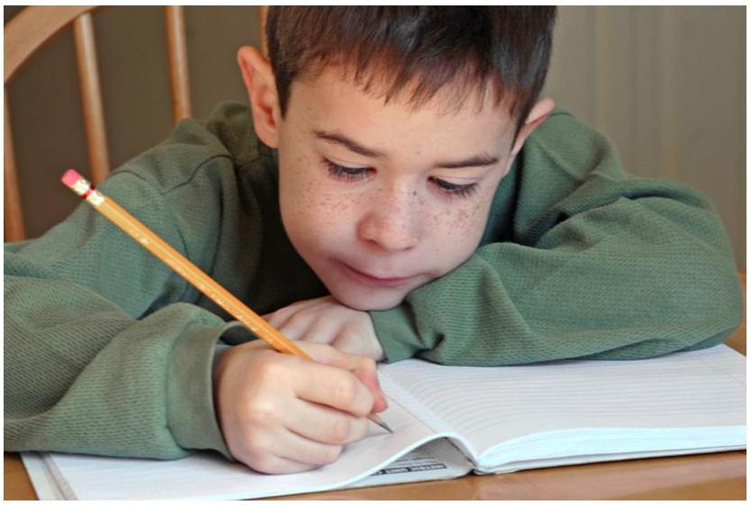

Book Review

A book review can let you know what a book is about and can give you an idea on whether you should read it or not. The book review you are going to do in this booklet is about fiction books. Fiction books are about stories that have been made up. A book review on fiction stories can have different parts:

Book Title:

This lets you know what the name of the book is.

Author:

This lets the reader know who wrote the book.

Setting:

This explains the place of the story.

Main characters:

This describes who is mainly in the story.

The story:

This describes the main story of the book.

Book comment**:**

This is where you let the reader know your opinion of the book.

You have already been reading some books daily. Write the title of one of these books on the lines below.

\_\_\_\_\_\_\_\_\_\_\_\_\_\_\_\_\_\_\_\_\_\_\_\_\_\_\_\_\_\_\_\_\_\_\_\_\_\_\_\_\_\_\_\_\_\_\_\_\_\_\_\_\_\_\_\_\_\_\_\_\_\_\_\_

\_\_\_\_\_\_\_\_\_\_\_\_\_\_\_\_\_\_\_\_\_\_\_\_\_\_\_\_\_\_\_\_\_\_\_\_\_\_\_\_\_\_\_\_\_\_\_\_\_\_\_\_\_\_\_\_\_\_\_\_\_\_\_\_

\_\_\_\_\_\_\_\_\_\_\_\_\_\_\_\_\_\_\_\_\_\_\_\_\_\_\_\_\_\_\_\_\_\_\_\_\_\_\_\_\_\_\_\_\_\_\_\_\_\_\_\_\_\_\_\_\_\_\_\_\_\_\_\_

An example of a book review:

**Book Title:**

I Hate Fridays

\_\_\_\_\_\_\_\_\_\_\_\_\_\_\_\_\_\_\_\_\_\_\_\_\_\_\_\_\_\_\_\_\_\_\_\_

Rachel Flyn

**Author:**  \_\_\_\_\_\_\_\_\_\_\_\_\_\_\_\_\_\_\_\_\_\_\_\_\_\_\_\_\_\_\_\_\_\_\_\_\_\_\_\_\_\_\_\_\_\_\_\_\_\_\_\_\_\_\_

The book is set at Koala Hills Primary School in Australia.

It is all about Miss Finley’s grade four class.

**Setting:** \_\_\_\_\_\_\_\_\_\_\_\_\_\_\_\_\_\_\_\_\_\_\_\_\_\_\_\_\_\_\_\_\_\_\_\_\_\_\_\_\_\_\_\_\_\_\_\_\_\_\_\_\_\_\_

\_\_\_\_\_\_\_\_\_\_\_\_\_\_\_\_\_\_\_\_\_\_\_\_\_\_\_\_\_\_\_\_\_\_\_\_\_\_\_\_\_\_\_\_\_\_\_\_\_\_\_\_\_\_\_\_\_\_\_\_\_\_\_\_

The main characters are in Miss Finley’s grade

four class. They include students like Peter Karlos, Katheryn

Chambers, Joan Smith and Martin Peters

**Main characters:** \_\_\_\_\_\_\_\_\_\_\_\_\_\_\_\_\_\_\_\_\_\_\_\_\_\_\_\_\_\_\_\_\_\_\_\_\_\_\_\_\_\_\_\_\_

\_\_\_\_\_\_\_\_\_\_\_\_\_\_\_\_\_\_\_\_\_\_\_\_\_\_\_\_\_\_\_\_\_\_\_\_\_\_\_\_\_\_\_\_\_\_\_\_\_\_\_\_\_\_\_\_\_\_\_\_\_\_\_\_

\_\_\_\_\_\_\_\_\_\_\_\_\_\_\_\_\_\_\_\_\_\_\_\_\_\_\_\_\_\_\_\_\_\_\_\_\_\_\_\_\_\_\_\_\_\_\_\_\_\_\_\_\_\_\_\_\_\_\_\_\_\_\_\_

The book has a lot of short stories written in it from the

different students. They are often about different things that

happened at the school. Some of the stories include ‘Best Friends’

and ‘I’d rather play football’. There are also some really cool photos

and drawings for the reader to look at as well.

**The story:** \_\_\_\_\_\_\_\_\_\_\_\_\_\_\_\_\_\_\_\_\_\_\_\_\_\_\_\_\_\_\_\_\_\_\_\_\_\_\_\_\_\_\_\_\_\_\_\_\_\_\_\_

\_\_\_\_\_\_\_\_\_\_\_\_\_\_\_\_\_\_\_\_\_\_\_\_\_\_\_\_\_\_\_\_\_\_\_\_\_\_\_\_\_\_\_\_\_\_\_\_\_\_\_\_\_\_\_\_\_\_\_\_\_\_\_\_

\_\_\_\_\_\_\_\_\_\_\_\_\_\_\_\_\_\_\_\_\_\_\_\_\_\_\_\_\_\_\_\_\_\_\_\_\_\_\_\_\_\_\_\_\_\_\_\_\_\_\_\_\_\_\_\_\_\_\_\_\_\_\_\_

\_\_\_\_\_\_\_\_\_\_\_\_\_\_\_\_\_\_\_\_\_\_\_\_\_\_\_\_\_\_\_\_\_\_\_\_\_\_\_\_\_\_\_\_\_\_\_\_\_\_\_\_\_\_\_\_\_\_\_\_\_\_\_\_

\_\_\_\_\_\_\_\_\_\_\_\_\_\_\_\_\_\_\_\_\_\_\_\_\_\_\_\_\_\_\_\_\_\_\_\_\_\_\_\_\_\_\_\_\_\_\_\_\_\_\_\_\_\_\_\_\_\_\_\_\_\_\_\_

**Book comment:**

I think the book is a really good read. It’s funny and a lot of the

stories are interesting to read. It really did make me laugh. I think

other people would like reading this book.

\_\_\_\_\_\_\_\_\_\_\_\_\_\_\_\_\_\_\_\_\_\_\_\_\_\_\_\_\_\_\_\_\_\_\_\_\_\_\_\_\_\_\_\_\_\_\_\_\_\_\_\_\_\_\_\_\_\_\_\_\_\_\_\_

\_\_\_\_\_\_\_\_\_\_\_\_\_\_\_\_\_\_\_\_\_\_\_\_\_\_\_\_\_\_\_\_\_\_\_\_\_\_\_\_\_\_\_\_\_\_\_\_\_\_\_\_\_\_\_\_\_\_\_\_\_\_\_\_

\_\_\_\_\_\_\_\_\_\_\_\_\_\_\_\_\_\_\_\_\_\_\_\_\_\_\_\_\_\_\_\_\_\_\_\_\_\_\_\_\_\_\_\_\_\_\_\_\_\_\_\_\_\_\_\_\_\_\_\_\_\_\_\_

Write your own fiction book summary.

**Book Title:**

\_\_\_\_\_\_\_\_\_\_\_\_\_\_\_\_\_\_\_\_\_\_\_\_\_\_\_\_\_\_\_\_\_\_\_\_

**Author:**  \_\_\_\_\_\_\_\_\_\_\_\_\_\_\_\_\_\_\_\_\_\_\_\_\_\_\_\_\_\_\_\_\_\_\_\_\_\_\_\_\_\_\_\_\_\_\_\_\_\_\_\_\_\_\_

**Setting:** \_\_\_\_\_\_\_\_\_\_\_\_\_\_\_\_\_\_\_\_\_\_\_\_\_\_\_\_\_\_\_\_\_\_\_\_\_\_\_\_\_\_\_\_\_\_\_\_\_\_\_\_\_\_\_

\_\_\_\_\_\_\_\_\_\_\_\_\_\_\_\_\_\_\_\_\_\_\_\_\_\_\_\_\_\_\_\_\_\_\_\_\_\_\_\_\_\_\_\_\_\_\_\_\_\_\_\_\_\_\_\_\_\_\_\_\_\_\_\_

**Main characters:** \_\_\_\_\_\_\_\_\_\_\_\_\_\_\_\_\_\_\_\_\_\_\_\_\_\_\_\_\_\_\_\_\_\_\_\_\_\_\_\_\_\_\_\_\_

\_\_\_\_\_\_\_\_\_\_\_\_\_\_\_\_\_\_\_\_\_\_\_\_\_\_\_\_\_\_\_\_\_\_\_\_\_\_\_\_\_\_\_\_\_\_\_\_\_\_\_\_\_\_\_\_\_\_\_\_\_\_\_\_

\_\_\_\_\_\_\_\_\_\_\_\_\_\_\_\_\_\_\_\_\_\_\_\_\_\_\_\_\_\_\_\_\_\_\_\_\_\_\_\_\_\_\_\_\_\_\_\_\_\_\_\_\_\_\_\_\_\_\_\_\_\_\_\_

**The story:** \_\_\_\_\_\_\_\_\_\_\_\_\_\_\_\_\_\_\_\_\_\_\_\_\_\_\_\_\_\_\_\_\_\_\_\_\_\_\_\_\_\_\_\_\_\_\_\_\_\_\_\_

\_\_\_\_\_\_\_\_\_\_\_\_\_\_\_\_\_\_\_\_\_\_\_\_\_\_\_\_\_\_\_\_\_\_\_\_\_\_\_\_\_\_\_\_\_\_\_\_\_\_\_\_\_\_\_\_\_\_\_\_\_\_\_\_

\_\_\_\_\_\_\_\_\_\_\_\_\_\_\_\_\_\_\_\_\_\_\_\_\_\_\_\_\_\_\_\_\_\_\_\_\_\_\_\_\_\_\_\_\_\_\_\_\_\_\_\_\_\_\_\_\_\_\_\_\_\_\_\_

\_\_\_\_\_\_\_\_\_\_\_\_\_\_\_\_\_\_\_\_\_\_\_\_\_\_\_\_\_\_\_\_\_\_\_\_\_\_\_\_\_\_\_\_\_\_\_\_\_\_\_\_\_\_\_\_\_\_\_\_\_\_\_\_

\_\_\_\_\_\_\_\_\_\_\_\_\_\_\_\_\_\_\_\_\_\_\_\_\_\_\_\_\_\_\_\_\_\_\_\_\_\_\_\_\_\_\_\_\_\_\_\_\_\_\_\_\_\_\_\_\_\_\_\_\_\_\_\_

**Book comment:**

\_\_\_\_\_\_\_\_\_\_\_\_\_\_\_\_\_\_\_\_\_\_\_\_\_\_\_\_\_\_\_\_\_\_\_\_\_\_\_\_\_\_\_\_\_\_\_\_\_\_\_\_\_\_\_\_\_\_\_\_\_\_\_\_

\_\_\_\_\_\_\_\_\_\_\_\_\_\_\_\_\_\_\_\_\_\_\_\_\_\_\_\_\_\_\_\_\_\_\_\_\_\_\_\_\_\_\_\_\_\_\_\_\_\_\_\_\_\_\_\_\_\_\_\_\_\_\_\_

\_\_\_\_\_\_\_\_\_\_\_\_\_\_\_\_\_\_\_\_\_\_\_\_\_\_\_\_\_\_\_\_\_\_\_\_\_\_\_\_\_\_\_\_\_\_\_\_\_\_\_\_\_\_\_\_\_\_\_\_\_\_\_\_



Spelling, Phonics and How Words Work

It’s time for you to learn your words for this Set. They are at the back of this Booklet. You also need to choose ten words for **My** **Own Words.**

These can be from:

* looking up word meanings from your dictionary
* writing word lists
* your memory

1. Write the ten words you have chosen in the My Own Wordscolumn on the page at the back of Set Two.

Learn these and the ten words given to you for this Set.

Remember to use L.C.W.C to help you learn these.

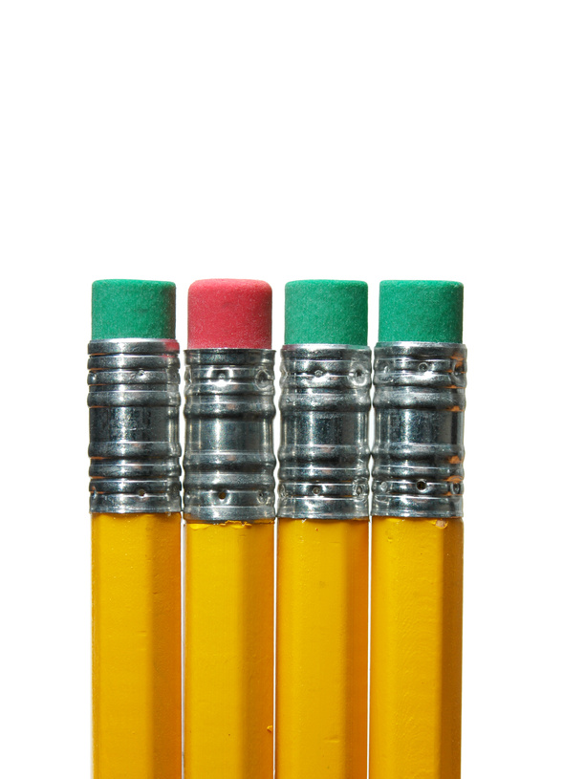

Ten Spelling Words for Set Two

parent forest window ground puppy

caught thought knight midnight moonlight

1. Add the missing vowels to each list word. Remember vowels are a, e, i, o and u.

p \_ r \_ nt f \_ rst m \_ dn \_ ght p \_ ppy

\_\_\_\_\_\_\_\_\_ \_\_\_\_\_\_\_\_\_ \_\_\_\_\_\_\_\_\_\_\_\_\_\_ \_\_\_\_\_\_\_\_\_\_\_

1. Use a dictionary to find the meaning of these words:

knight\_\_\_\_\_\_\_\_\_\_\_\_\_\_\_\_\_\_\_\_\_\_\_\_\_\_\_\_\_\_\_\_\_\_\_\_\_\_\_\_\_\_\_\_\_\_\_\_\_\_\_\_\_

forest\_\_\_\_\_\_\_\_\_\_\_\_\_\_\_\_\_\_\_\_\_\_\_\_\_\_\_\_\_\_\_\_\_\_\_\_\_\_\_\_\_\_\_\_\_\_\_\_\_\_\_\_\_

1. Write the smaller words hidden in each of these words.

moonlight

­­­­­­­­­­­­­­­\_\_\_\_\_\_\_\_\_\_\_\_\_\_\_\_\_\_\_\_\_\_\_\_\_\_\_\_\_\_\_\_\_\_\_\_\_\_\_\_\_\_\_\_\_\_\_\_\_\_\_\_\_\_\_\_\_\_

forest

\_\_\_\_\_\_\_\_\_\_\_\_\_\_\_\_\_\_\_\_\_\_\_\_\_\_\_\_\_\_\_\_\_\_\_\_\_\_\_\_\_\_\_\_\_\_\_\_\_\_\_\_\_\_\_\_\_\_

This Set you are studying the ‘**ght**’ letters. The ‘**ght**’ letters are a phonic blend. A phonic blend are a group of consonants whose sounds mix together Please remember consonants are 2One letters in the alphabet which are not vowels. The consonants are: b, c, d, f, g, h, j, k, l, m, n, p, q, r, s, t, v, w, x, y, z. The ‘**ght**’ letters is also known as an end blend because it is at the end of the word.

For example in the word knight the **ght** letters is at the end of the word.

With blends it’s a good habit to say the letters quickly so they mix together. Have another go at saying the word kni**ght**.

The **ght** letters can be found in many words.

Underline the **ght** letters in each of these words.

moonlight

midnight

thought

caught

Fill in the missing letters from those in the box.

flashli si mi ti ni

1. \_\_ \_\_ \_\_ \_\_ \_\_ \_\_ \_\_ ght
2. \_\_ \_\_ ght
3. \_\_ \_\_ ght
4. \_\_ \_\_ ght
5. \_\_ \_\_ ght

Draw a picture of a flashlight shining in the night.

What are rhyming words?

Rhyming words have the same or similar end sounds. The following sets of words rhyme.

you two few blue do

chair stare pear where their

Rhyming words are often used in poems like this one:

**Rhyming can be fun to do,**

**especially when words come to you.**

Circle the pictures that rhyme with each other.

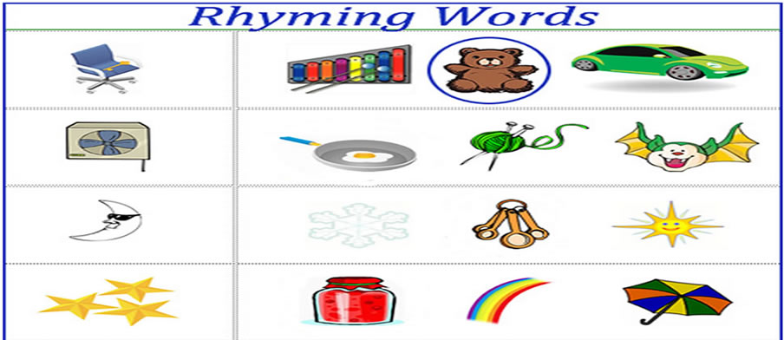

Write two words that rhyme with each word below.

goat true

\_\_\_\_\_\_\_\_\_\_\_\_\_\_\_\_\_\_\_\_\_ \_\_\_\_\_\_\_\_\_\_\_\_\_\_\_\_\_\_\_\_\_

\_\_\_\_\_\_\_\_\_\_\_\_\_\_\_\_\_\_\_\_\_ \_\_\_\_\_\_\_\_\_\_\_\_\_\_\_\_\_\_\_\_\_

star

\_\_\_\_\_\_\_\_\_\_\_\_\_\_\_\_\_\_\_\_\_

\_\_\_\_\_\_\_\_\_\_\_\_\_\_\_\_\_\_\_\_\_

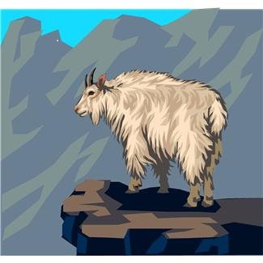

C:\Users\jmiller\AppData\Local\Microsoft\Windows\Temporary Internet Files\Low\Content.IE5\O584SN30\MC900053962[1].WMF

Grammar and Punctuation

What is an adverb?

An adverb is a word that adds meaning to a verb, an adjective or another adverb. Adverbs of manner show how something happened.

For example: He worked **quietly**.

**quietly** is the **adverb** because it tells us more about how he worked.

1. Choose an adverb of manner from the box to complete each sentence. These words tell us how something is done.

quickly easily silently

1. The starving dog ate the meat \_\_\_\_\_\_\_\_\_\_\_\_\_\_\_\_\_\_\_\_\_\_.
2. The cat crept \_\_\_\_\_\_\_\_\_\_\_\_\_\_\_\_\_\_\_\_\_\_\_\_\_\_\_ after the mouse.
3. The fastest runner \_\_\_\_\_\_\_\_\_\_\_\_\_\_\_\_\_\_\_\_\_\_\_ won the race.
4. Write a sentence of your own using the word ‘quickly’ as an adverb of manner.

\_\_\_\_\_\_\_\_\_\_\_\_\_\_\_\_\_\_\_\_\_\_\_\_\_\_\_\_\_\_\_\_\_\_\_\_\_\_\_\_\_\_\_\_\_\_\_\_\_\_\_\_\_\_\_\_\_\_\_\_\_\_\_\_\_\_\_\_\_\_\_\_\_\_

\_\_\_\_\_\_\_\_\_\_\_\_\_\_\_\_\_\_\_\_\_\_\_\_\_\_\_\_\_\_\_\_\_\_\_\_\_\_\_\_\_\_\_\_\_\_\_\_\_\_\_\_\_\_\_\_\_\_\_\_\_\_\_\_\_\_\_\_\_\_\_\_\_\_

\_\_\_\_\_\_\_\_\_\_\_\_\_\_\_\_\_\_\_\_\_\_\_\_\_\_\_\_\_\_\_\_\_\_\_\_\_\_\_\_\_\_\_\_\_\_\_\_\_\_\_\_\_\_\_\_\_\_\_\_\_\_\_\_\_\_\_\_\_\_\_\_\_\_

It’s time for your spelling test

Before you give your sheet of words to someone at home to test you on this Set’s words, take a moment to write some of the things you have done to help you learn your words.

\_\_\_\_\_\_\_\_\_\_\_\_\_\_\_\_\_\_\_\_\_\_\_\_\_\_\_\_\_\_\_\_\_\_\_\_\_\_\_\_\_\_\_\_\_\_\_\_\_\_\_\_\_\_\_\_\_\_\_\_\_\_\_\_\_

\_\_\_\_\_\_\_\_\_\_\_\_\_\_\_\_\_\_\_\_\_\_\_\_\_\_\_\_\_\_\_\_\_\_\_\_\_\_\_\_\_\_\_\_\_\_\_\_\_\_\_\_\_\_\_\_\_\_\_\_\_\_\_\_\_

\_\_\_\_\_\_\_\_\_\_\_\_\_\_\_\_\_\_\_\_\_\_\_\_\_\_\_\_\_\_\_\_\_\_\_\_\_\_\_\_\_\_\_\_\_\_\_\_\_\_\_\_\_\_\_\_\_\_\_\_\_\_\_\_\_

|  |  |
| --- | --- |
| Spelling Words for Set Two | |
| Set Two Booklet Words | Set Two Own Words |
| parent |  |
| forest |  |
| window |  |
| ground |  |
| puppy |  |
| caught |  |
| thought |  |
| knight |  |
| midnight |  |
| moonlight |  |

Reflection

Look back on what you have learnt in this booklet and answer the following questions.

1. What are some ways you can do research?

\_\_\_\_\_\_\_\_\_\_\_\_\_\_\_\_\_\_\_\_\_\_\_\_\_\_\_\_\_\_\_\_\_\_\_\_\_\_\_\_\_\_\_\_\_\_\_\_\_\_\_\_\_\_\_\_\_\_\_\_\_\_\_\_\_\_\_\_

\_\_\_\_\_\_\_\_\_\_\_\_\_\_\_\_\_\_\_\_\_\_\_\_\_\_\_\_\_\_\_\_\_\_\_\_\_\_\_\_\_\_\_\_\_\_\_\_\_\_\_\_\_\_\_\_\_\_\_\_\_\_\_\_\_\_\_\_

1. What is a website review?

\_\_\_\_\_\_\_\_\_\_\_\_\_\_\_\_\_\_\_\_\_\_\_\_\_\_\_\_\_\_\_\_\_\_\_\_\_\_\_\_\_\_\_\_\_\_\_\_\_\_\_\_\_\_\_\_\_\_\_\_\_\_\_\_\_\_\_\_

\_\_\_\_\_\_\_\_\_\_\_\_\_\_\_\_\_\_\_\_\_\_\_\_\_\_\_\_\_\_\_\_\_\_\_\_\_\_\_\_\_\_\_\_\_\_\_\_\_\_\_\_\_\_\_\_\_\_\_\_\_\_\_\_\_\_\_\_

1. What does ‘having an opinion’ mean?

\_\_\_\_\_\_\_\_\_\_\_\_\_\_\_\_\_\_\_\_\_\_\_\_\_\_\_\_\_\_\_\_\_\_\_\_\_\_\_\_\_\_\_\_\_\_\_\_\_\_\_\_\_\_\_\_\_\_\_\_\_\_\_\_\_\_\_\_

\_\_\_\_\_\_\_\_\_\_\_\_\_\_\_\_\_\_\_\_\_\_\_\_\_\_\_\_\_\_\_\_\_\_\_\_\_\_\_\_\_\_\_\_\_\_\_\_\_\_\_\_\_\_\_\_\_\_\_\_\_\_\_\_\_\_\_\_

1. Write some homophones.

\_\_\_\_\_\_\_\_\_\_\_\_\_\_\_\_\_\_\_\_\_\_\_\_\_\_\_\_\_\_\_\_\_\_\_\_\_\_\_\_\_\_\_\_\_\_\_\_\_\_\_\_\_\_\_\_\_\_\_\_\_\_\_\_\_\_\_\_

\_\_\_\_\_\_\_\_\_\_\_\_\_\_\_\_\_\_\_\_\_\_\_\_\_\_\_\_\_\_\_\_\_\_\_\_\_\_\_\_\_\_\_\_\_\_\_\_\_\_\_\_\_\_\_\_\_\_\_\_\_\_\_\_\_\_\_\_

1. Write some words that rhyme with book.

\_\_\_\_\_\_\_\_\_\_\_\_\_\_\_\_\_\_\_\_\_\_\_\_\_\_\_\_\_\_\_\_\_\_\_\_\_\_\_\_\_\_\_\_\_\_\_\_\_\_\_\_\_\_\_\_\_\_\_\_\_\_\_\_\_\_\_\_

\_\_\_\_\_\_\_\_\_\_\_\_\_\_\_\_\_\_\_\_\_\_\_\_\_\_\_\_\_\_\_\_\_\_\_\_\_\_\_\_\_\_\_\_\_\_\_\_\_\_\_\_\_\_\_\_\_\_\_\_\_\_\_\_\_\_\_\_

****

**Checklist**

This Set you should have completed the following tasks. Please tick the tasks you have completed.

* Reading and Writing workshop—Book review
* Spelling activities—LCWC and own Words
* Phonics—‘ght’ sound
* Grammar and Punctuation—Modal adverbs
* How Words Work—Rhyming words
* Spelling test

|  |
| --- |
| End of Set Two |

|  |
| --- |
| **YOUR QUESTIONS OR COMMENTS** |