Geography Inquiry



What is the impact of floods?



|  |
| --- |
| **Learning Intentions**  - Understand the impact of floods on environments and communities.   * Identify actions to be taken to prepare for and minimize the effect of floods. |

|  |
| --- |
| What is the impact of floods? |

**Introduction**

In this activity you will study:

- the impact of floods on people and communities

- people’s response to floods

**What are the impacts of floods?**

To answer this question you will begin by viewing *YouTube* clips which show the impacts of floods on people, animals and property in both city and rural areas.

<https://www.youtube.com/watch?v=zPwwTKT9-Gs>



**Important note to adults**

Please view the YouTube clips before you present them. If you feel they may be distressing leave it out and view pictures located at the back of the module.

**For you to do—Activity 1**

Complete the following:

Step 1: Discussion

Discuss and note down: —*What is a flood? What causes floods?*

**Step 2—First view**

View each clip (outlined below). After each view discuss and record your thoughs.

Think about the following in preparation for Step 3:

* Population in the cities
* Roads, high density living and housing

**Step 3—Second view and Worksheet**

In this step you will complete a worksheet using information from the clips. Read the information on the worksheets on page 5-7.

View the clips and complete.

**YouTube 1: Impact on People**

<http://www.youtube.com/watch?v=P1JxXzVMdyE>

Uploaded on Jan 10, 2011- Toowoomba Queensland.

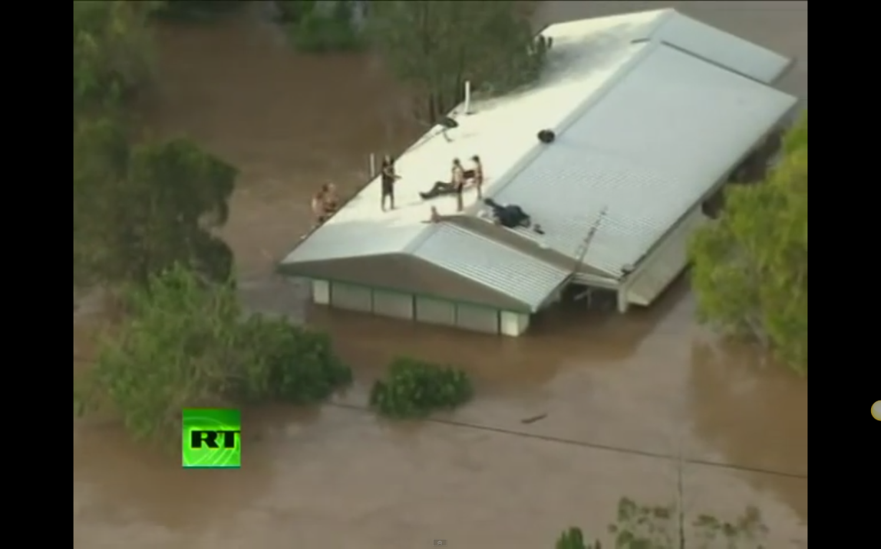

**YouTube Clip**

**YouTube 2: Impact on a city**

<https://www.youtube.com/watch?v=zPwwTKT9-Gs>

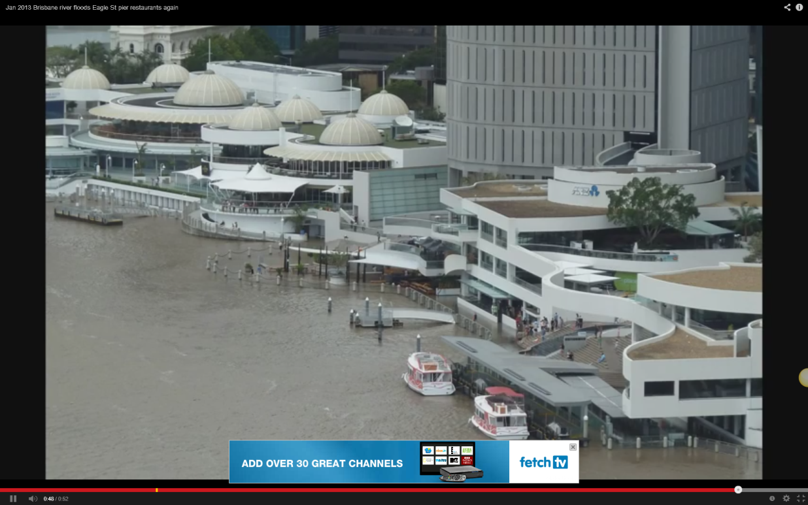

**YouTube 3: Impact on a rural area NSW**

<http://www.youtube.com/watch?v=H8ytR_A7Vb8>

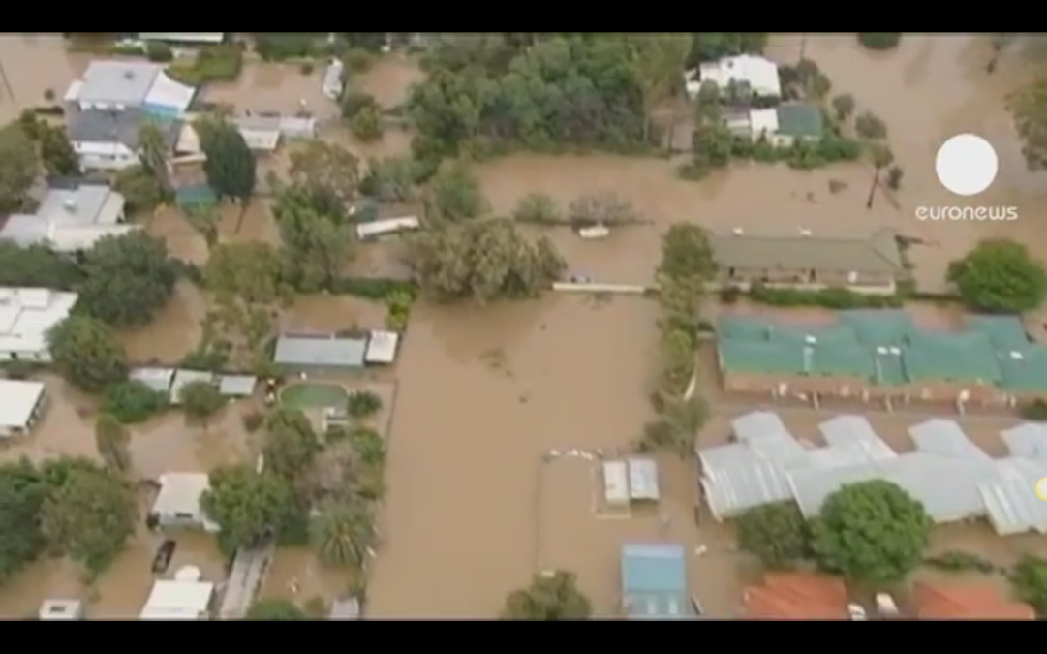**Published on Feb 3, 2012**

# MCj04247880000[1]How are people affected by floods?

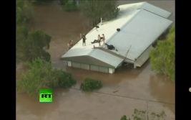

Write four facts learned from viewing the YouTube clip 1.

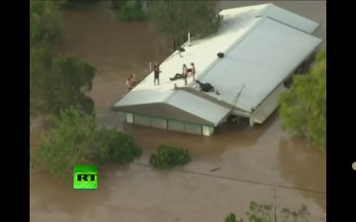

# How are cities affected by floods?

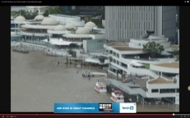

Write four facts learned from viewing YouTube 2.

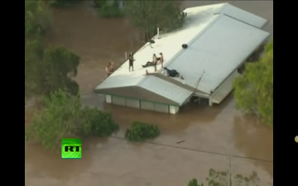

# How are rural areas affected by floods?

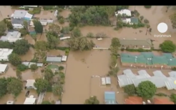

Write four facts learned from viewing YouTube 2.



Briefly explain the reason for each warning below.

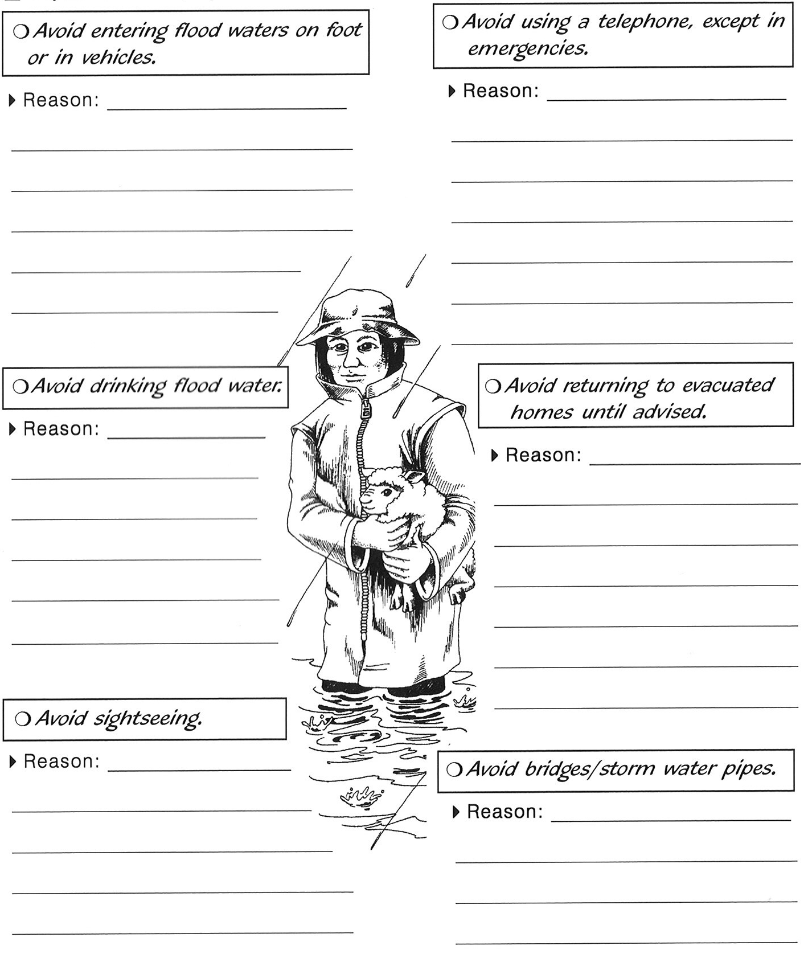

|  |
| --- |
| Preventing and reducing the risk of floods. |

**Introduction**

In this activity you will:

- identify how floods can be prevented or reduced

- develop an Action Plan

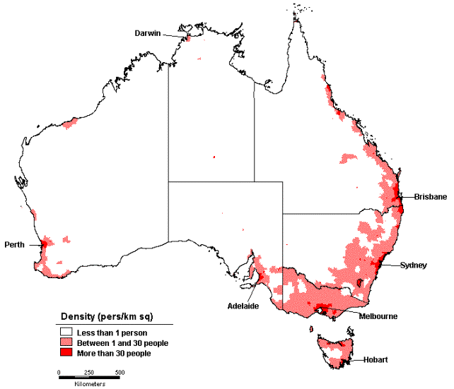The majority of people in Australia live in low lying coastal areas where floods are most common. The map below shows the most populated areas in Australia (red most populated areas and pink less populated. Refer to the key.

How does this relate to the areas where flooding is most common?

Look closely at the map on the following page which show areas where flooding is most common.

**Introduction continued**

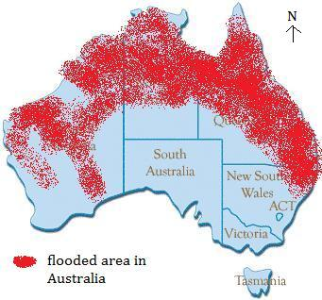

**Discuss and note the following**

Referring to the maps, discuss and record your thoughts on…

* Does flooding occur in high populated areas? Discuss and write down the effects on people and property.
* Does flooding occur in the desert and rural areas? Discuss and write down the effects on people and the land.
* What may be some actions people can do to avoid flooding? Choose an area and write down your thoughts .

**How can we prevent or reduce the risk of flooding?**

People living in flood prone areas must have an ACTION PLAN.

This may not stop a flood but will likely reduce its damage and loss of life.

Read and discuss the following actions to reduce the risks.

**Background Information continued**

|  |  |
| --- | --- |
| **Planting—**plant more trees grasses and bushes in better absorb water. |  |
| **Reduce developments—**reduce development in low lying areas which are prone to flooding. |  |
| **Levees—** build levees around rivers and low lying areas. Levees can be created by placing boulders (large rocks) |  |
| **Dams—**Build Dams to catch overflow of water and release when water rises.  **Sandbagging** areas when flood waters rise. |  |
| Build up the land around the coast and rivers for development. | [http://www.kingcounty.gov/~/media/environment/wlr/river_floodplain_unit/cedar_rapids_levee_repair_2012_diagram.ashx?w=688&h=306&as=1](http://www.google.com.au/url?sa=i&rct=j&q=levees&source=images&cd=&cad=rja&uact=8&docid=WcoyT2xdAdsHAM&tbnid=kwzpTOrOzBVdmM:&ved=0CAUQjRw&url=http://www.kingcounty.gov/environment/wlr/sections-programs/river-floodplain-section/capital-projects/cedar-rapids.aspx&ei=d1PPU7GdMIje8AXY7YH4CA&bvm=bv.71667212,d.dGc&psig=AFQjCNGRWyIp9aj21KaNQeYLYWuzxPDHXw&ust=1406182628150823) |

MCj04247880000[1]

**For you to do**

**Activity 1—**Can you think of another action which may help reduce flooding?

Briefly write your idea/s or draw and label.

|  |
| --- |
|  |

**What should you do if you were caught in a flood?**

During and immediately after a flood, people must take action to keep safe.

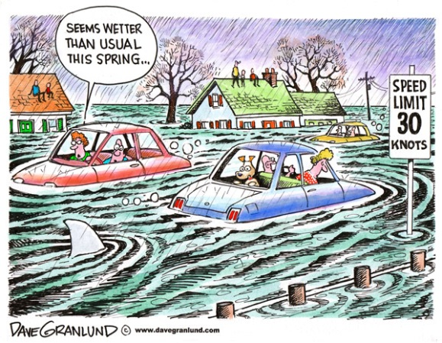Read the list below and discuss the reasons for these actions with your family.

List to consider:

* Avoid entering flood water on foot or vehicles.
* Avoid using a telephone, except in emergencies.
* Drink bottled water only not flood water.
* Only go back home when advised.
* Avoid sightseeing.
* Avoid bridges and storm water pipes.
* Be informed, listen carefully to news reports (if possible).
* 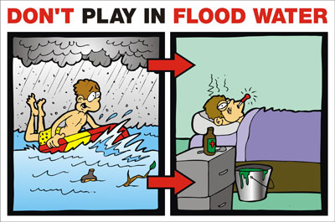Find out where evacuation centres are located.

**Activity 2**

**HELP!**

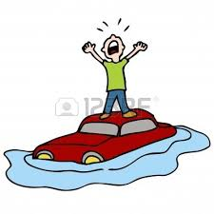

Disaster is about to happen.

You have been given the tasks to develop an action plan.

Write an action plan for each given situation below.

Refer to the **Background Information.**

Good luck!

**City Flood**

You live in the city of Brisbane in Queensland. Your home is on the banks of the Brisbane River. It has been raining heavily and the river is rising.

Write a list of actions you would do/avoid and explain why.

Consider the following*— media, family, property, pets, condition of roads, transport…*

**Farmer**

You have a dairy farm near Shepparton in Victoria. The river banks are rising. You need your Action Plan Checklist. What does it consist of?

Write a list of actions you would do/avoid and explain why.

Consider the following—*family, road, land, animals, roads, media*

**Activity 3**

*Complete and attach page or type on computer using Word.*

|  |
| --- |
| **Think like a geographer.**  A new city in planned for Victoria. It will be in a low lying area and next to a river.  As a world renowned authority you have been asked to develop a list of actions to prevent flooding.    Write a checklist of recommendations and give reasons.  Consider the following:   * weather conditions (tropical, temperate), * location—city, country, desert * geographical features – rives, ocean, mountains, roads etc. |

**Reflection**

**What have you learnt?**

Write three facts you learned about floods. You may use the videos you viewed.

