**Geography**

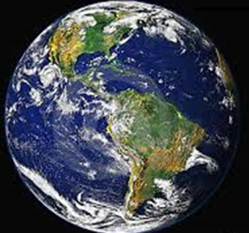

How can we use natural resources sustainably?



What are some of the ways we can use our natural resources more sustainably?

1. Watch the clips at the links below and complete the table to show ways we can **Reduce, Reuse and Recycle**.

[**http://tinyurl.com/oun24bk**](http://tinyurl.com/oun24bk)

[**http://tinyurl.com/lkbsdhx**](http://tinyurl.com/lkbsdhx)

|  |  |  |  |  |
| --- | --- | --- | --- | --- |
| Living Sustainably | What? | Why? | How? | When? |
| **Reduce** |  |  |  |  |
| **Reuse** |  |  |  |  |
| **Recycle** |  |  |  |  |

1. Place a tick in the What? column to show the way/s your family lives by **Reduce, Reuse and Recycle**.
2. We can use our natural resources more sustainably if we **Reduce, Reuse and Recycle**. What are your thoughts about this? Fill in the Plus, Minus, Interesting (PMI) chart to record your conclusions.

|  |  |  |
| --- | --- | --- |
| **Reduce, Reuse and Recycle** | | |
| Plus  (good/positive) | Minus  (bad/negatives) | Interesting  (new things that I found out) |
|  |  |  |

**REFLECTION**

1. Reducing my rubbish is important because:

|  |
| --- |
|  |
|  |
|  |
|  |
|  |
|  |
|  |
|  |
|  |
|  |
|  |
|  |
|  |
|  |
|  |