**English**

Read Write

Spell Publish



How do I use a Play Script?

|  |  |  |
| --- | --- | --- |
| Description: QRDistance | Description: logomedium_black_print  © State of Victoria, Department of Education and Training 2015 | **L**  **Course Code**  **5304** |

**Only for use for the purpose of education for the student(s) provided with the materials by DECV. Not to be reproduced, communicated or otherwise used except as permitted by the Copyright Act 1968 (Cth).**

Introduction

**Please Read Before You Begin!**

The **English**—*Read Write Spell Publish* Modules is made up of 16 books for the year. Each Module consists of two weeks work where lessons and activities are divided into *Weeks 1 and 2.*

At the beginning of each week an outline of the week’s *Learning Intention* (tasks) and *Achievement Standards* (learning to be achieved) are outlined to assist you with your learning.

**Content and Layout of Each Module**

Each Module is structured into the following format:

 **Reading/Watching**

At the beginning of each Module you will **read or watch** a short text.

 **Exploring the text**

Did you understand the text? In this section you will answer questions about your reading.

http://www.ignitumtoday.com/wp-content/uploads/2011/12/Idea.png**Writing Workshop**

Here, you will learn about the style and techniques used to write the different text types.

**Writing Project**

Finally you will be writing your own major piece of writing based on the given

text type.

**Word Explorers**

To support and enhance your English work you will also study *Spelling, Punctuation* and *Grammar.* These topics are titled **Word Explorers.**

Each topic consists of:

**Spelling**—a list of 20 words will be studied each week.

They are grouped into:

- Words from the text presented in the Module.

- Your own words from your writing, reading and listening activities.

**Punctuation**— lessons on punctuation are taught once a week. Application to these skills is applied to writing tasks.

**Grammar**—once a week you will be taught skills in this area and complete work for practice.

**Contact!**

It is important that you contact your teacher if you have any queries or problems with the work. Your teacher can adjust the work to best suit your individual needs.

Week 1



**Learning Intentions**

* Write your own Play Script.
* Study given spelling words in preparation for *test.*
* Study and complete tasks on the use of *adjectives.*

**Achievement Standards**

* Plan, draft and publish imaginative, print and [multimodal texts](http://www.australiancurriculum.edu.au/Glossary?a=E&t=multimodal+texts), choosing [text structures](http://www.australiancurriculum.edu.au/Glossary?a=E&t=text+structures), [language features](http://www.australiancurriculum.edu.au/Glossary?a=E&t=language+features), images and sound appropriate to purpose and [audience](http://www.australiancurriculum.edu.au/Glossary?a=E&t=audience).
* Reread and edit own work using agreed criteria for [text structures](http://www.australiancurriculum.edu.au/Glossary?a=E&t=text+structures) and [language features](http://www.australiancurriculum.edu.au/Glossary?a=E&t=language+features).

|  |  |  |  |  |  |  |  |  |  |  |  |  |  |  |
| --- | --- | --- | --- | --- | --- | --- | --- | --- | --- | --- | --- | --- | --- | --- |
| |  |  | | --- | --- | | http://www.oncoursesystems.com/images/user/10809/10705150/SCHOOL/Vocabulary%20-%201.gif | Word Explorer—Spelling  In today’s spelling lesson you will be given your  10 spelling words for the week.  Follow the spelling process from *English Module A & B.* |   Located at the back of this Module are your 10 text words for this week.  MCj04247880000[1]  **For You to Do**   * Today I want you to choose words for the **My Own Words** list**.** These can be from your own writing, reading or memory. Write the ten words you have chosen, in the **My Own Words** column. * Now it’s time to begin learning to spell the words in preparation for your test at the end of the week.   You will need your *Look, Cover, Write and Check* (LCWC) book and follow the process outlined in the English Module A book.     |  |  | | --- | --- | | *http://www.salleywags.com/wp-content/uploads/2012/02/important-note.jpg* | *For the rest of the week you should focus on learning the words using the LCWC method. On the last day of the week your Supervisor will test your knowledge. This will be your weekly routine for the rest of the year.* |  |  | | --- | | Description: Description: http://upload.wikimedia.org/wikipedia/commons/thumb/5/55/Magnifying_glass_icon.svg/489px-Magnifying_glass_icon.svg.png Exploring the Text |   MCj04247880000[1]  **For You to Do SEND**   |  | | --- | | **Draft**  http://www.school-clipart.com/school_clipart_images/pencil_and_paper_coloring_page_0071-1002-2401-4136_SMU.jpg**This week you will write a draft and final copy of your Play Script using your ideas from the storyboard task in Module K. You will have the whole week to complete this task!**  Be as creative as you can. Use Word, Publisher, or a piece of poster paper. Remember to include all of the important information about the movements and actions of your characters!  Write a draft of your script using the template provided on the following page or a separate piece of paper. |  |  | | --- | | **Helpful Hints** Remember to include all of the script elements outlined in the previous Module. (For help, look at page 14 for a final checklist.)  Use vivid, colourful and descriptive language –  refer to your list of **adjectives** and **adverbs** at the back of this Module.  In the following grammar lesson you will be studying **adjectives.** The activities will help you with your vocabulary for this task!  http://agirlonthego.files.wordpress.com/2011/03/thinkingcap.gif  **Script Tips!**  When writing your own script consider the following tips:  **Layout**   * Set the scene (as a short paragraph). * Set the scene as to where the action is taking place. * Start a new line each time a new character speaks. * Put the name of the speaker in a left-hand margin, followed by a colon (:).   **Example - Peter:**   * Give instructions to the character in brackets (often in italics too).   (Opening the door to let the King in.) The words in brackets are not spoken.  **Remember punctuation … !!! ??? ,,,** | | Here is an example of a Script. Look at how the text has been set out. |   http://www.school-clipart.com/school_clipart_images/pencil_and_paper_coloring_page_0071-1002-2401-4136_SMU.jpg  Write your Play Script draft on a **separate piece of paper**. Look at the template example below if you are stuck!   |  |  |  |  |  | | --- | --- | --- | --- | --- | | PLAY SCRIPT TEMPLATE  TITLE OF PLAYSCRIPT:\_\_\_\_\_\_\_\_\_\_\_\_\_\_\_\_\_\_\_\_  CAST LIST:\_\_\_\_\_\_\_\_\_\_\_\_\_\_\_\_\_\_\_\_\_\_\_\_\_\_\_\_\_  Act:  Scene:  Stage directions  (\_\_\_\_\_\_\_\_\_\_\_\_\_\_\_\_\_\_\_\_\_\_\_\_\_\_\_\_\_\_\_\_\_\_\_\_\_\_\_\_\_\_\_\_\_\_\_\_\_\_\_\_\_\_\_\_\_\_\_\_\_\_  \_\_\_\_\_\_\_\_\_\_\_\_\_\_\_\_\_\_\_\_\_\_\_\_\_\_\_\_\_\_\_\_\_\_\_\_\_\_\_\_\_\_\_\_\_\_\_\_\_\_\_\_\_\_\_\_\_\_\_\_\_\_\_\_\_\_\_\_\_\_\_\_\_\_\_\_\_\_\_\_\_\_\_\_\_\_\_\_\_\_\_\_\_\_\_\_\_\_\_\_\_\_\_\_\_\_\_\_\_\_\_\_\_\_\_\_\_\_\_\_\_\_\_\_\_\_\_\_\_\_\_\_\_\_\_\_\_\_\_\_\_\_\_\_\_\_\_\_\_\_\_\_\_\_\_\_\_\_\_\_\_\_\_\_\_\_\_\_\_\_\_\_\_\_\_\_\_\_\_\_\_\_\_\_\_\_\_\_\_\_\_\_\_\_\_\_\_\_\_\_\_\_\_\_\_\_\_\_\_\_\_\_\_\_\_\_\_\_\_\_\_\_\_\_\_\_\_\_\_\_\_\_\_\_\_\_\_\_\_\_\_\_\_\_\_\_\_\_\_\_\_\_\_\_\_\_\_\_\_\_\_\_\_\_\_\_\_\_\_\_\_ )   |  |  | | --- | --- | | Character | Dialogue | |  |  | |  |  | | --- | | **Editing** http://www.school-clipart.com/school_clipart_images/pencil_and_paper_coloring_page_0071-1002-2401-4136_SMU.jpg  **Editing your writing is an important process as it allows you to check for grammar, spelling, punctuation and clarity of writing.**  **Here are some tips for what to look for when editing your script:**   * Read the draft script as if you were acting out a play. Make notes at places where the script does not seem to make sense. Think about the other words you should have the characters say so that the dialogue feels right to you. * Read your draft carefully to see if you need to write any more prompts to tell the actors what to do or how to say the dialogue. * Share your draft with someone else. Ask if your ideas are clear and you have made your script engaging to read.   After discussing your draft make changes to your text to improve its quality. |   http://3.bp.blogspot.com/-Ij_2CuvX8eI/T-otVVUmx0I/AAAAAAAAAMg/esEUxe0ek5A/s1600/find-an-editor1.png |

|  |  |
| --- | --- |
| http://www.oncoursesystems.com/images/user/10809/10705150/SCHOOL/Vocabulary%20-%201.gif | Word Explorer— Grammar  Each week you will be studying the *rules of language* and *how we use them* to write and communicate.  Today you will be working on **descriptive language—adjectives**. |

What are adjectives?

Adjectives are describing words. Adjectives add description and detail to your writing and help to make your sentences more interesting.

Below are two examples of how adjectives are used to describe the noun (object).

The **big** dog jumped over the fence.

The **delicious** meal was enjoyed by the whole family.

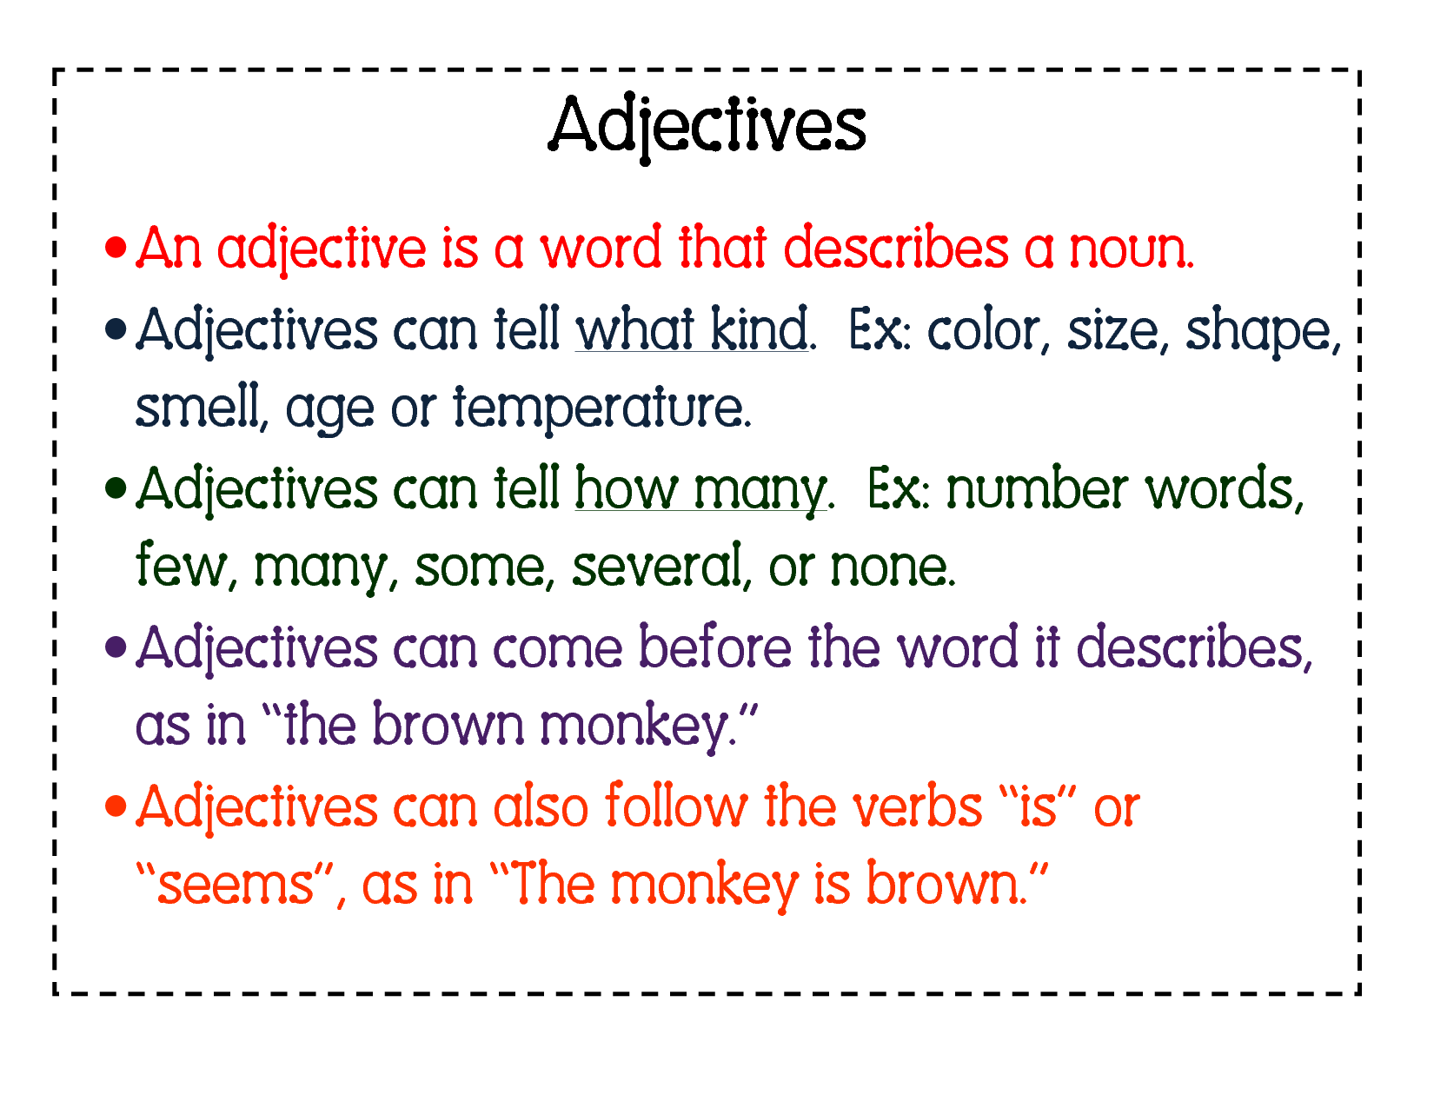

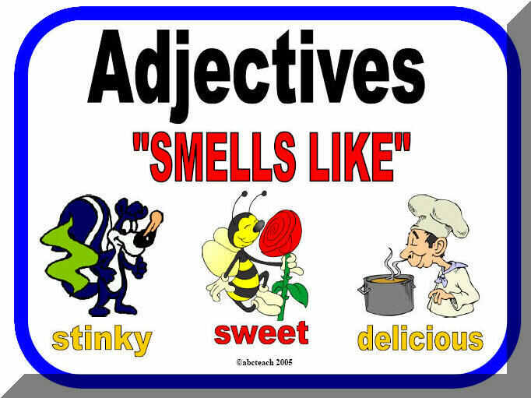

**Adjectives continued**

**MCj04247880000[1] For You to Do SEND**

**Activity 1 – Adjectives**

|  |
| --- |
| Complete the sentences adding in adjectives to make the sentence more interesting.   1. The \_\_\_\_\_\_\_\_\_\_\_\_\_\_\_\_\_\_ man sat on his \_\_\_\_\_\_\_\_\_\_\_\_\_\_\_\_\_\_\_chair. 2. Janet put on her \_\_\_\_\_\_\_\_\_\_\_\_\_\_\_\_\_\_\_\_\_\_\_ jumper. 3. Laura sat on the \_\_\_\_\_\_\_\_\_\_\_\_\_\_, \_\_\_\_\_\_\_\_\_\_\_\_\_\_\_\_\_\_ grass and read   her \_\_\_\_\_\_\_\_\_\_\_\_\_\_\_\_\_\_\_\_\_\_ book. 4. The \_\_\_\_\_\_\_\_\_\_\_\_\_\_\_\_\_\_\_\_\_\_, \_\_\_\_\_\_\_\_\_\_\_\_\_\_\_\_\_\_\_\_ kitten played with   a \_\_\_\_\_\_\_\_\_\_\_\_\_\_\_\_\_\_\_\_\_ ball of string. 5. A \_\_\_\_\_\_\_\_\_\_\_\_\_\_\_\_\_\_\_\_, \_\_\_\_\_\_\_\_\_\_\_\_\_\_\_\_\_\_\_\_\_ alien landed in my   \_\_\_\_\_\_\_\_\_\_\_\_\_\_\_\_\_\_\_\_\_\_ garden. 6. Granny’s \_\_\_\_\_\_\_\_\_\_\_\_\_ hair looked like a \_\_\_\_\_\_\_\_\_\_\_\_\_\_\_\_ birds nest. 7. The \_\_\_\_\_\_\_\_\_\_\_\_\_, \_\_\_\_\_\_\_\_\_\_\_\_\_\_\_\_ dog growled at the   \_\_\_\_\_\_\_\_\_\_\_\_\_\_\_\_, \_\_\_\_\_\_\_\_\_\_\_\_\_\_\_\_\_\_\_\_ postman. 8. The sunlight shone through the \_\_\_\_\_\_\_\_\_\_\_\_\_\_\_\_, \_\_\_\_\_\_\_\_\_\_\_\_\_\_\_\_\_ windows. |

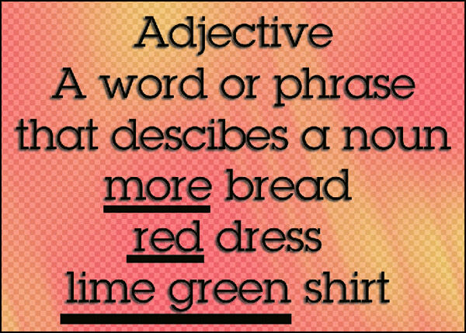

**Activity 2 – Adjectives continued**

|  |
| --- |
| Write down 5 adjectives to describe the following things:  (use interesting adjectives to capture the readers imagination)   1. racing car   \_\_\_\_\_\_\_\_\_\_\_\_\_\_\_\_\_\_\_\_\_\_\_\_\_\_\_\_\_\_\_\_\_\_\_\_\_\_\_\_\_\_\_\_\_\_\_\_\_\_\_\_\_\_\_\_\_\_\_\_\_\_\_\_\_\_   1. tomato  \_\_\_\_\_\_\_\_\_\_\_\_\_\_\_\_\_\_\_\_\_\_\_\_\_\_\_\_\_\_\_\_\_\_\_\_\_\_\_\_\_\_\_\_\_\_\_\_\_\_\_\_\_\_\_\_\_\_\_\_\_\_\_\_\_\_ 2. teddy bear  \_\_\_\_\_\_\_\_\_\_\_\_\_\_\_\_\_\_\_\_\_\_\_\_\_\_\_\_\_\_\_\_\_\_\_\_\_\_\_\_\_\_\_\_\_\_\_\_\_\_\_\_\_\_\_\_\_\_\_\_\_\_\_\_\_\_ 3. sword  \_\_\_\_\_\_\_\_\_\_\_\_\_\_\_\_\_\_\_\_\_\_\_\_\_\_\_\_\_\_\_\_\_\_\_\_\_\_\_\_\_\_\_\_\_\_\_\_\_\_\_\_\_\_\_\_\_\_\_\_\_\_\_\_\_\_ 4. teapot  \_\_\_\_\_\_\_\_\_\_\_\_\_\_\_\_\_\_\_\_\_\_\_\_\_\_\_\_\_\_\_\_\_\_\_\_\_\_\_\_\_\_\_\_\_\_\_\_\_\_\_\_\_\_\_\_\_\_\_\_\_\_\_\_\_\_ 5. cottage  \_\_\_\_\_\_\_\_\_\_\_\_\_\_\_\_\_\_\_\_\_\_\_\_\_\_\_\_\_\_\_\_\_\_\_\_\_\_\_\_\_\_\_\_\_\_\_\_\_\_\_\_\_\_\_\_\_\_\_\_\_\_\_\_\_\_ 6. necklace  \_\_\_\_\_\_\_\_\_\_\_\_\_\_\_\_\_\_\_\_\_\_\_\_\_\_\_\_\_\_\_\_\_\_\_\_\_\_\_\_\_\_\_\_\_\_\_\_\_\_\_\_\_\_\_\_\_\_\_\_\_\_\_\_\_\_ 7. horse  \_\_\_\_\_\_\_\_\_\_\_\_\_\_\_\_\_\_\_\_\_\_\_\_\_\_\_\_\_\_\_\_\_\_\_\_\_\_\_\_\_\_\_\_\_\_\_\_\_\_\_\_\_\_\_\_\_\_\_\_\_\_\_\_\_\_ |

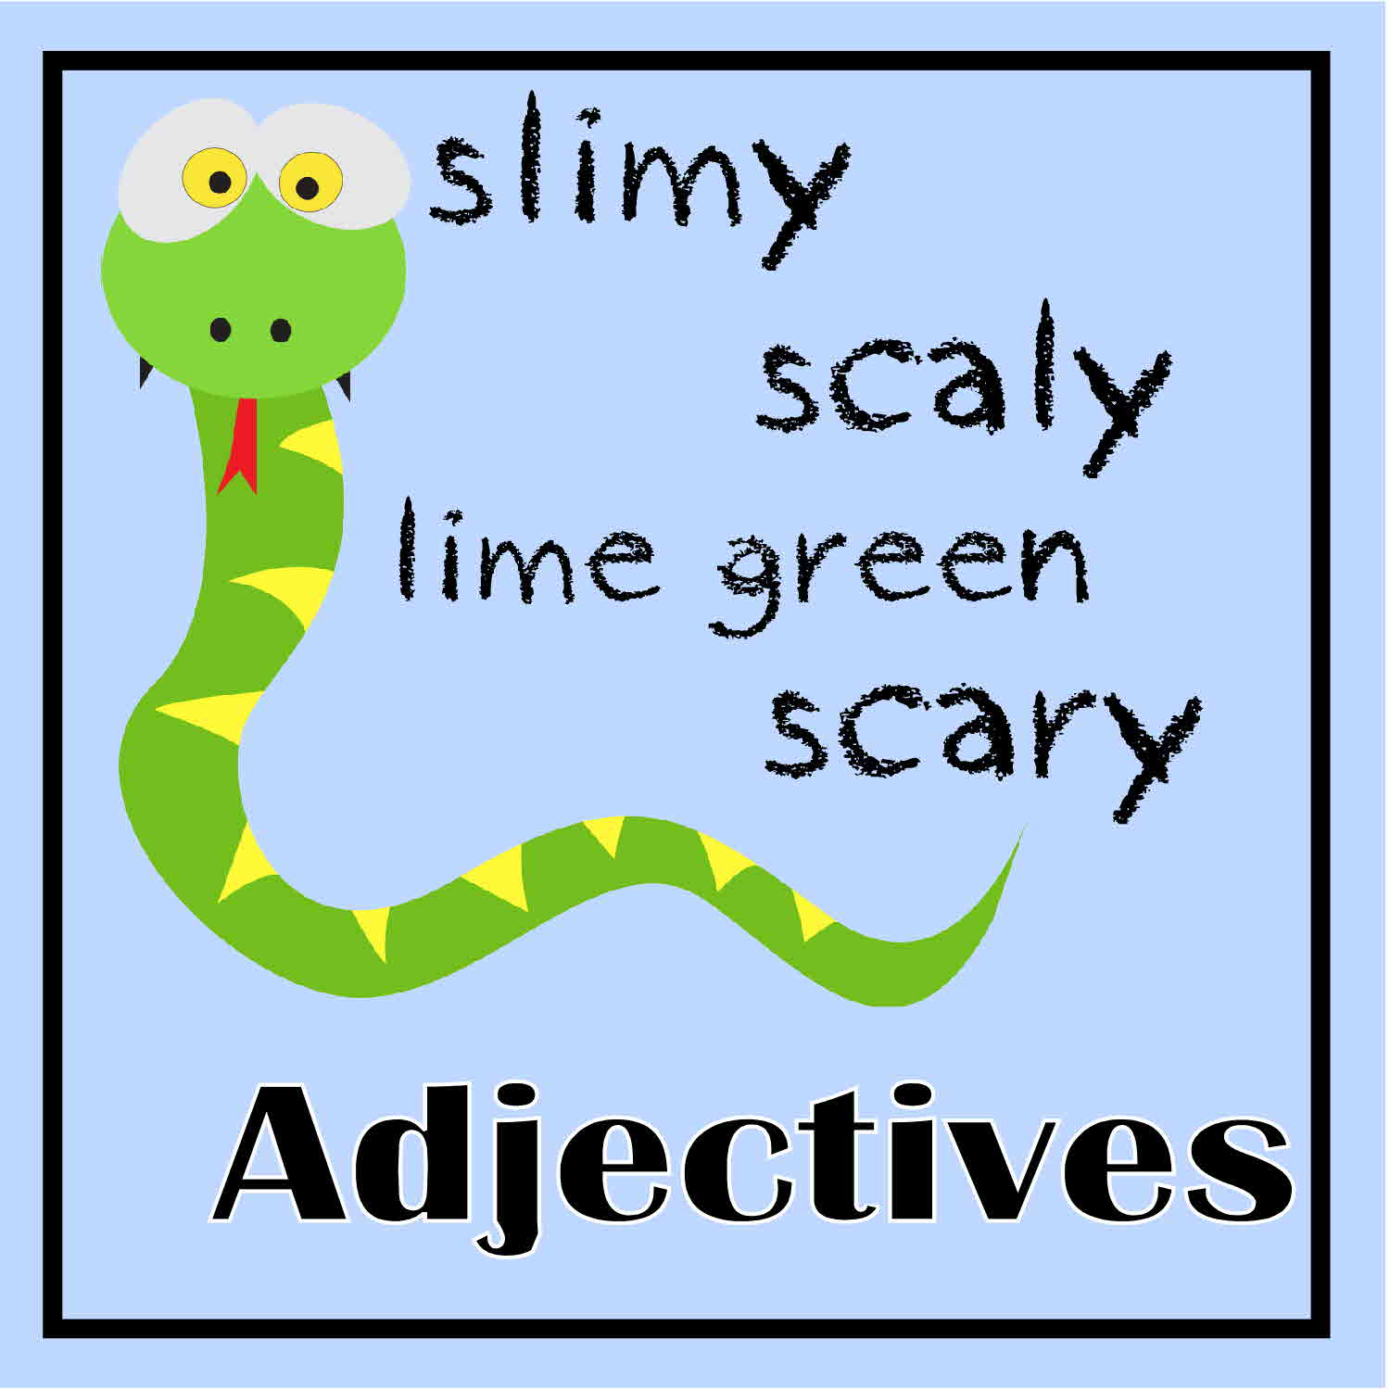

|  |
| --- |
| * Writing Workshop |

In *Writing Workshop* you will continue your work on your Play Script.

**MCj04247880000[1] For You to Do SEND**

|  |
| --- |
| **Final Piece**  Time to complete the final copy!  How will you do this?  You can use *Word* on the computer or handwrite your final piece.  Remember to make it neat and easy to read. I’m looking forward to reading it!  http://image1.masterfile.com/em_w/04/64/17/400-04641755w.jpg  Use the checklist on page 14 to ensure you have included all the necessary features in your script.  [http://gastricbypasstruth.com/wp-content/uploads/2008/07/checklist.jpg](http://www.google.com.au/url?sa=i&rct=j&q=checklist&source=images&cd=&cad=rja&docid=PNIxinPWDwpwhM&tbnid=ezTGSy5i5ux08M:&ved=0CAUQjRw&url=http://gastricbypasstruth.com/before-gastric-bypass-surgery/pre-gastric-bypass-surgery-checklist/&ei=dpM-UfSMFqbymAW2w4GwBg&bvm=bv.43287494,d.dGY&psig=AFQjCNFpCGaqvL4YdrvHiJdw00-HWcNO-Q&ust=1363141857335527)  Make sure to submit a draft and final copy to your teacher!  **Do not send of your script until you have completed all of the Week 2 work.**  Good luck :-) |

|  |  |
| --- | --- |
| **Play Script Features** | ***I used it!*** |
| My play has a title |  |
| I have listed the characters at the beginning |  |
| I have introduced and described the scene *(where/where)* |  |
| Characters’ names are written on the left |  |
| Characters’ names have a colon after them |  |
| I have started a new line for every new speaker |  |
| My stage directions are in brackets ( ) |  |
| My stage directions are written in the present tense |  |
| MCj02807030000[1]I have stage directions for how the actors must **speak** |  |
| I have stage directions for how the actors must **move** |  |
| Every time the setting changes *(changes place or time)* I have started a new scene |  |
| I have used … to show a character is thinking or stuttering |  |
| I have used CAPITALS or *italics* to emphasise words |  |
| My Play Script has 1–3 Acts  *(Act 1 beginning, Act 2 middle, Act 3 end)* |  |
| There are NO speech marks |  |

|  |  |
| --- | --- |
| http://www.oncoursesystems.com/images/user/10809/10705150/SCHOOL/Vocabulary%20-%201.gif | Word Explorer—  adjectives continued! |



**Adjectives continued**

#### MCj04247880000[1]For You to Do SEND

**Activity 1**

|  |
| --- |
| Change these boring sentences into interesting ones.  (Remember adjectives are used to make a sentences come alive!)   1. The cat sat on the mat.   \_\_\_\_\_\_\_\_\_\_\_\_\_\_\_\_\_\_\_\_\_\_\_\_\_\_\_\_\_\_\_\_\_\_\_\_\_\_\_\_\_\_\_\_\_\_\_\_\_\_\_\_\_\_\_\_\_\_\_\_\_\_\_\_\_\_   1. The dog ate a bone.   \_\_\_\_\_\_\_\_\_\_\_\_\_\_\_\_\_\_\_\_\_\_\_\_\_\_\_\_\_\_\_\_\_\_\_\_\_\_\_\_\_\_\_\_\_\_\_\_\_\_\_\_\_\_\_\_\_\_\_\_\_\_\_\_\_\_   1. The man drove the car down the street.  \_\_\_\_\_\_\_\_\_\_\_\_\_\_\_\_\_\_\_\_\_\_\_\_\_\_\_\_\_\_\_\_\_\_\_\_\_\_\_\_\_\_\_\_\_\_\_\_\_\_\_\_\_\_\_\_\_\_\_\_\_\_\_\_\_\_ 2. Natalie ate an ice cream.  \_\_\_\_\_\_\_\_\_\_\_\_\_\_\_\_\_\_\_\_\_\_\_\_\_\_\_\_\_\_\_\_\_\_\_\_\_\_\_\_\_\_\_\_\_\_\_\_\_\_\_\_\_\_\_\_\_\_\_\_\_\_\_\_\_\_ 3. Tommy sat on his bed.  \_\_\_\_\_\_\_\_\_\_\_\_\_\_\_\_\_\_\_\_\_\_\_\_\_\_\_\_\_\_\_\_\_\_\_\_\_\_\_\_\_\_\_\_\_\_\_\_\_\_\_\_\_\_\_\_\_\_\_\_\_\_\_\_\_\_ |



**Adjectives continued**

**Activity 2**

|  |
| --- |
| Use each of these adjectives in a sentence.   1. beautiful   \_\_\_\_\_\_\_\_\_\_\_\_\_\_\_\_\_\_\_\_\_\_\_\_\_\_\_\_\_\_\_\_\_\_\_\_\_\_\_\_\_\_\_\_\_\_\_\_\_\_\_\_\_\_\_\_\_\_\_\_\_\_\_\_\_\_  \_\_\_\_\_\_\_\_\_\_\_\_\_\_\_\_\_\_\_\_\_\_\_\_\_\_\_\_\_\_\_\_\_\_\_\_\_\_\_\_\_\_\_\_\_\_\_\_\_\_\_\_\_\_\_\_\_\_\_\_\_\_\_\_\_\_   1. horrible   \_\_\_\_\_\_\_\_\_\_\_\_\_\_\_\_\_\_\_\_\_\_\_\_\_\_\_\_\_\_\_\_\_\_\_\_\_\_\_\_\_\_\_\_\_\_\_\_\_\_\_\_\_\_\_\_\_\_\_\_\_\_\_\_\_\_  \_\_\_\_\_\_\_\_\_\_\_\_\_\_\_\_\_\_\_\_\_\_\_\_\_\_\_\_\_\_\_\_\_\_\_\_\_\_\_\_\_\_\_\_\_\_\_\_\_\_\_\_\_\_\_\_\_\_\_\_\_\_\_\_\_\_   1. delicious   \_\_\_\_\_\_\_\_\_\_\_\_\_\_\_\_\_\_\_\_\_\_\_\_\_\_\_\_\_\_\_\_\_\_\_\_\_\_\_\_\_\_\_\_\_\_\_\_\_\_\_\_\_\_\_\_\_\_\_\_\_\_\_\_\_\_  \_\_\_\_\_\_\_\_\_\_\_\_\_\_\_\_\_\_\_\_\_\_\_\_\_\_\_\_\_\_\_\_\_\_\_\_\_\_\_\_\_\_\_\_\_\_\_\_\_\_\_\_\_\_\_\_\_\_\_\_\_\_\_\_\_\_   1. sleek, red   \_\_\_\_\_\_\_\_\_\_\_\_\_\_\_\_\_\_\_\_\_\_\_\_\_\_\_\_\_\_\_\_\_\_\_\_\_\_\_\_\_\_\_\_\_\_\_\_\_\_\_\_\_\_\_\_\_\_\_\_\_\_\_\_\_\_  \_\_\_\_\_\_\_\_\_\_\_\_\_\_\_\_\_\_\_\_\_\_\_\_\_\_\_\_\_\_\_\_\_\_\_\_\_\_\_\_\_\_\_\_\_\_\_\_\_\_\_\_\_\_\_\_\_\_\_\_\_\_\_\_\_\_   1. crumbling, old   \_\_\_\_\_\_\_\_\_\_\_\_\_\_\_\_\_\_\_\_\_\_\_\_\_\_\_\_\_\_\_\_\_\_\_\_\_\_\_\_\_\_\_\_\_\_\_\_\_\_\_\_\_\_\_\_\_\_\_\_\_\_\_\_\_\_  \_\_\_\_\_\_\_\_\_\_\_\_\_\_\_\_\_\_\_\_\_\_\_\_\_\_\_\_\_\_\_\_\_\_\_\_\_\_\_\_\_\_\_\_\_\_\_\_\_\_\_\_\_\_\_\_\_\_\_\_\_\_\_\_\_\_ |



End of Week 1

****

**Checklist**

This week you should have completed the following tasks, please tick the tasks you have completed.

* **Writing Workshop***—*Draft of script
* **Spelling***—*LCWC and Own Words
* **Writing Workshop**—Good copy of script
* **Grammar***—*Adjectives
* **Writing Workshop***—*Your own Lost Thing
* **Grammar***—*Adjectives continued!
* **Test***—*Spelling and Dictation

**Week 2**



**Learning Intentions**

* Practice and perform your Play Script*.* This is your major task for the week. You have all week to complete it.
* Study given spelling words in preparation for test.
* Study and complete tasks relating to the use of adverbs.

**Achievement Standards**

* Understand the use of vocabulary to express greater precision of meaning.
* Use [comprehension strategies](http://www.australiancurriculum.edu.au/Glossary?a=E&t=comprehension+strategies) to analyse information.
* Plan, draft and publish imaginative and informative print and [multimodal texts](http://www.australiancurriculum.edu.au/Glossary?a=E&t=multimodal+texts), choosing [text structures](http://www.australiancurriculum.edu.au/Glossary?a=E&t=text+structures), [language features](http://www.australiancurriculum.edu.au/Glossary?a=E&t=language+features), images to purpose and [audience](http://www.australiancurriculum.edu.au/Glossary?a=E&t=audience).
* Reread and edit own work using agreed criteria.

|  |
| --- |
| * Writing Project |

This week you will finish off the script writing double Module by performing your script! You will have the whole week to complete this task.

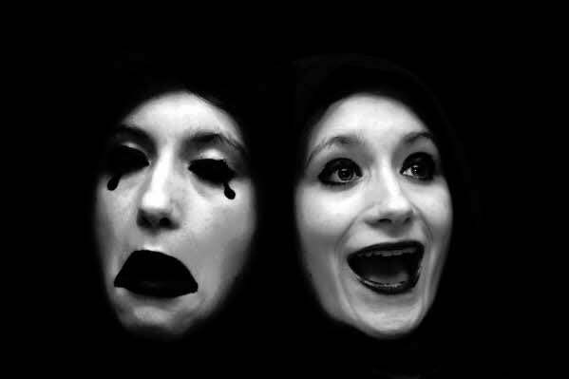

|  |
| --- |
| **Play Script Performance!**  Choose one of the following options.  **Option 1**: Get a friend or family member to film a performance of your Play Script.      This can be simply a recording of you reading your play with a family member or friend. Or, if you would like to get creative, you can perform your script as a full play with costumes and props!  You can be as creative as you like with this task, it’s up to you!    This can be done using a smartphone, iPod, iPad, still camera, or video camera. If you have done some filming before, use the same equipment. If this is your first time, ask a friend or family member for assistance :-)  **Option 2:** Turn your script into a radio play.  A radio play is a performance of a play recorded for a radio station. This means, that only the sound of the performance is recorded.    Record your Play Script using a phone, iPad computer or other recording device. Remember where possible to add sounds effects and music to help tell your story and make your play come to life!  **Tips For Your Performance:**  **Consider the following;**   * Form a small group of players to act the characters in your Play Script. * Practise the Play Script until you each know your parts * Rehearse your play so you can act the parts and use expression in your voice and on your face. * Set up a time with your team members to record your Play Script. * Edit and send your final product to your teacher.   **Speech hints:**   * Take special note of the prompts in your Play Script and practise behaving like you think your character would behave. Don’t just say words. For example, if you are supposed to say something angrily, then you need to act as if you are angry. * Always speak towards the recording device you are using so your voice is picked up clearly. * Project your voice; make sure you are speaking loudly and clearly when you record your play.   **Submitting your performance to your teacher!**  **Hard copy:**  Burn your presentation to a DVD or place your file on a USB drive and send it into your teacher via snail mail.  http://www.npengage.com/wp-content/uploads/2012/07/Submit.jpeg  Or  **Submit online:**  If the file is small, email your Play Script performance into your teacher.  For large files use a file sending program such as Drop Box [www.dropbox.com](http://www.dropbox.com)  Or Google drive [www.drive.google.com](http://www.drive.google.com). Ask your Supervisor for assistance.  Call your teacher if you require some help! |

|  |  |
| --- | --- |
| http://www.oncoursesystems.com/images/user/10809/10705150/SCHOOL/Vocabulary%20-%201.gif | Word Explorer—Spelling  In today’s spelling lesson you will be given your  10 spelling words for the week.  Follow the spelling process from *English Module 1& 2.* |

Located at the back of this Module are your 10 text words for this week.

MCj04247880000[1]

**For You to Do**

* Today I want you to choose words for the **My Own Words** list**.** These can be from your own writing, reading or memory. Write the ten words you have chosen, in the **My Own Words** column.
* Now it’s time to begin learning to spell the words in preparation for your test at the end of the week.

You will need your *Look, Cover, Write and Check* (LCWC) book and follow the process outlined in English Module A.

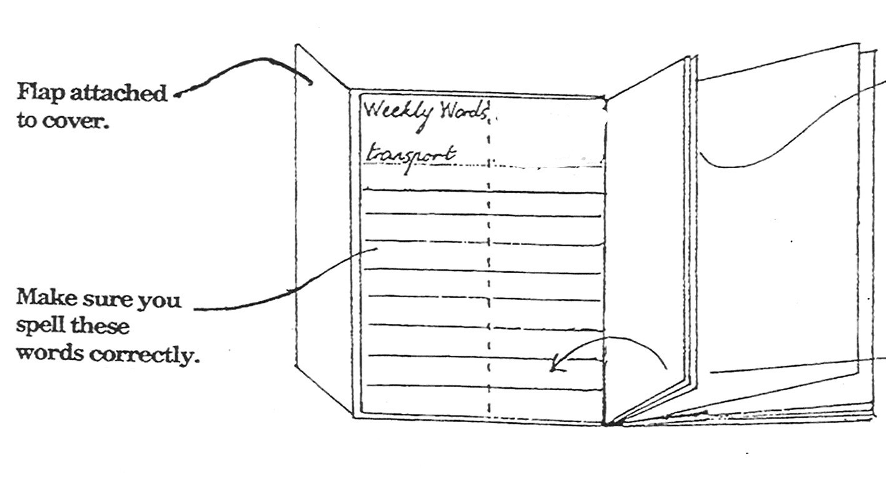

|  |  |
| --- | --- |
| *http://www.salleywags.com/wp-content/uploads/2012/02/important-note.jpg* | *For the rest of the week you should focus on learning the words using the LCWC method. On the last day of the week your Supervisor will test your knowledge. This will be your weekly routine for the rest of the year.* |

|  |  |
| --- | --- |
| http://www.oncoursesystems.com/images/user/10809/10705150/SCHOOL/Vocabulary%20-%201.gif | Word Explorer—Punctuation  This week you will study **adverbs**. |

**MCj04247880000[1]For You to Do**  **SEND**

|  |  |  |  |  |  |
| --- | --- | --- | --- | --- | --- |
| **What is an Adverb?**  It is a word that tells us more about verbs.  Many adverbs tell us how something is done.  When answering the question 'how', adverbs are usually created from adjectives with an added ‘ly’ ending. E.g. quick becomes quickly.  Similar to adjectives, adverbs add detail and more description to your writing!  **Activity 1 – Adverbs**   |  | | --- | | Make a list of adverbs under each heading. Think of different ways that people might do these things.  **The people play.                            The people walk.**  Happily   Quickly    **The people talk.                               The people wait.**  Loudly                                               Patiently |   **Adverbs continued**  **Activity 2 – Adverbs**   |  | | --- | | Change these adjectives into adverbs.  Quick becomes quickly    Neat  Careful  Loud  Excited  Brave |   **Activity 3 – Adverbs**   |  | | --- | | Certain words change when they become adverbs. If an adjective ends in a y, you need to change the y to an I before adding the ly!  Show me you can do that by changing these adjectives in adverbs.  Funny becomes funnily    Angry  Happy  Heavy  Noisy  Steady  Clumsy |   **Adverbs continued**  **Activity 4 – Adverbs**   |  | | --- | | You have now got a number of adverbs listed in your books. Use some of them in this activity to complete the sentences.  a.     The girl completed her handwriting \_\_\_\_\_\_\_\_\_\_\_\_\_\_\_\_\_\_.  b.     They all sat \_\_\_\_\_\_\_\_\_\_\_\_\_\_\_\_ on the edge of the bench.  c.     The rhinoceros stamped \_\_\_\_\_\_\_\_\_\_\_\_\_\_\_ across the dusty landscape.  d.     The red table chattered \_\_\_\_\_\_\_\_\_\_\_\_\_\_\_\_\_\_\_ .  e.     The teacher spoke \_\_\_\_\_\_\_\_\_\_\_\_\_\_\_\_\_\_\_ to the group of children.  f.       The acrobat walked \_\_\_\_\_\_\_\_\_\_\_\_\_\_\_\_\_ across the tightrope. |   **Activity 5 – Adverbs**   |  | | --- | | Write one sentence for each adverb.  Slightly  \_\_\_\_\_\_\_\_\_\_\_\_\_\_\_\_\_\_\_\_\_\_\_\_\_\_\_\_\_\_\_\_\_\_\_\_\_\_\_\_\_\_\_\_\_\_\_\_\_\_\_\_\_\_\_\_\_\_\_\_\_\_\_\_\_\_\_\_  Dangerously  \_\_\_\_\_\_\_\_\_\_\_\_\_\_\_\_\_\_\_\_\_\_\_\_\_\_\_\_\_\_\_\_\_\_\_\_\_\_\_\_\_\_\_\_\_\_\_\_\_\_\_\_\_\_\_\_\_\_\_\_\_\_\_\_\_\_\_\_  Slowly  \_\_\_\_\_\_\_\_\_\_\_\_\_\_\_\_\_\_\_\_\_\_\_\_\_\_\_\_\_\_\_\_\_\_\_\_\_\_\_\_\_\_\_\_\_\_\_\_\_\_\_\_\_\_\_\_\_\_\_\_\_\_\_\_\_\_\_\_  Brightly  \_\_\_\_\_\_\_\_\_\_\_\_\_\_\_\_\_\_\_\_\_\_\_\_\_\_\_\_\_\_\_\_\_\_\_\_\_\_\_\_\_\_\_\_\_\_\_\_\_\_\_\_\_\_\_\_\_\_\_\_\_\_\_\_\_\_\_\_  Cheekily  \_\_\_\_\_\_\_\_\_\_\_\_\_\_\_\_\_\_\_\_\_\_\_\_\_\_\_\_\_\_\_\_\_\_\_\_\_\_\_\_\_\_\_\_\_\_\_\_\_\_\_\_\_\_\_\_\_\_\_\_\_\_\_\_\_\_\_\_ | |

|  |  |
| --- | --- |
| http://3.bp.blogspot.com/-qPoK5ahYCp4/TuuFpKg1zDI/AAAAAAAABKg/xPUigX_ZUkE/s400/clrtest.gif | **Spelling and Dictation Test** |

Today your Supervisor will test the twenty words you have been learning this week. Do the test on your lined paper and when you finish, you and your Supervisor can correct it together. I'm sure you'll give it your best shot.

Your Supervisor will read the whole extract to you and then **dictate** small sections or phrases. There are several commas in this extract. Read it through after you have finished and you should be able to tell where to place the commas.

First step in writing **∫** anything at all **∫** is to get to know the form. **∫** If you want to be a poet **∫** you have to read poetry. **∫**In the case of Play Script writing, **∫** you should not only read plays, **∫** but also see them in performance. **∫** This is important **∫** in order to write plays **∫** that will work on the stage. **∫**

End of Week 2

****

**Checklist**

This week you should have completed the following tasks, please tick the tasks you have completed.

* **Writing Project**—Record a performance of your final piece
* **Spelling**—LCWC and own Words
* **Punctuation**—Verbs & adjectives
* **Test**—Spelling and Dictation

**Spelling Module L**

|  |  |
| --- | --- |
| **Week 1** | **Week 2** |
| **Own words** | **Own words** |
|  |  |
|  |  |
|  |  |
|  |  |
|  |  |
|  |  |
|  |  |
|  |  |
|  |  |
|  |  |
| **Text words** | **Text words** |
| theme | theatre |
| record | audience |
| perform | present |
| practise | carefully |
| voice | expression |
| reading | action |
| players | angrily |
| sound | crowd |
| slowly | replayed |
| watch | something |

## The Top 100 Most Common Adjectives

|  |  |  |
| --- | --- | --- |
| 1. other 2. new 3. good 4. high 5. old 6. great 7. big 8. American 9. small 10. large 11. national 12. young 13. different 14. black 15. long 16. little 17. important 18. political 19. bad 20. white 21. real 22. best 23. right 24. social 25. only 26. public 27. sure 28. low 29. early 30. able 31. human 32. local 33. late 34. hard | 35. major 36. better 37. economic 38. strong 39. possible 40. whole 41. free 42. military 43. true 44. federal 45. international 46. full 47. special 48. easy 49. clear 50. recent 51. certain 52. personal 53. open 54. red 55. difficult 56. available 57. likely 58. short 59. single 60. medical 61. current 62. wrong 63. private 64. past 65. foreign 66. fine 67. common 68. poor | 69. natural 70. significant 71. similar 72. hot 73. dead 74. central 75. happy 76. serious 77. ready 78. simple 79. left 80. physical 81. general 82. environmental 83. financial 84. blue 85. democratic 86. dark 87. various 88. entire 89. close 90. legal 91. religious 92. cold 93. final 94. main 95. green 96. nice 97. huge 98. popular 99. traditional 100. cultural |

## The Top 100 Most Common Adverbs

|  |  |  |
| --- | --- | --- |
| 1. up 2. so 3. out 4. just 5. now 6. how 7. then 8. more 9. also 10. here 11. well 12. only 13. very 14. even 15. back 16. there 17. down 18. still 19. in 20. as 21. to 22. when 23. never 24. really 25. most 26. on 27. why 28. about 29. over 30. again 31. where 32. right 33. off 34. always | 35. today 36. all 37. far 38. long 39. away 40. yet 41. often 42. ever 43. however 44. almost 45. later 46. much 47. once 48. least 49. ago 50. together 51. around 52. already 53. enough 54. both 55. maybe 56. actually 57. probably 58. home 59. of course 60. perhaps 61. little 62. else 63. sometimes 64. finally 65. less 66. better 67. early 68. especially | 69. either 70. quite 71. simply 72. nearly 73. soon 74. certainly 75. quickly 76. no 77. recently 78. before 79. usually 80. thus 81. exactly 82. hard 83. particularly 84. pretty 85. forward 86. ok 87. clearly 88. indeed 89. rather 90. that 91. tonight 92. close 93. suddenly 94. best 95. instead 96. ahead 97. fast 98. alone 99. eventually 100. directly |

Student’s Name: \_\_\_\_\_\_\_\_\_\_\_\_\_\_\_\_\_\_\_\_ Final copy of Play Script and performance Date: \_\_\_\_\_

***Rating****: 4 – excellent 3 – very good 2 – good 1 – needs work*

|  |  |  |  |  |  |  |
| --- | --- | --- | --- | --- | --- | --- |
| *Skills and Behaviours* | **PRODUCTIVITY** | **DRAFTING** | **SCRIPT ELEMENTS** | **PUBLISHED PIECE** | **PEROFRMANCE** | **CREATIVITY** |
| *Expectation(s)* | Student devotes a lot of time and effort to the creative process (ideas, planning, drafting, final piece & performance). Has worked well to make the play and performance authentic & interesting. | A complete first draft has been submitted: spelling and punctuation has been considered. | The final piece includes all elements in the script checklist. | The published piece is readable, clean, and attractive. It looks like the author took great pride in creating the finished product. | Evidence the script has been rehearsed. The reading of the script is creative and with emotion. A clear voice has been used. | Student has thought about the plot, setting and characters in their play. They have come up with an original idea for a story. |
| *Teacher Assessment*  Circle the number that accurately reflects how you think you did in this area: | 4 3 2 1 | 4 3 2 1 | 4 3 2 1 | 4 3 2 1 | 4 3 2 1 | 4 3 2 1 |

Teacher’s Self-Assessment Raw Score: **\_\_\_\_ / 24 points** Final score: \_\_\_\_\_\_\_\_\_**%**

|  |  |  |  |  |  |  |  |
| --- | --- | --- | --- | --- | --- | --- | --- |
| Description: Description: Description: Description: Description: Description: Description: Description: logoCAPS2**315 Clarendon Street, Thornbury 3071**  **Telephone (03) 8480 0000**  **FAX (03) 9416 8371 (Despatch)**  **Free call (1800) 133 511**   |  |  | | --- | --- | | |  | | --- | | **STUDENT NUMBER \_\_\_\_\_\_\_\_\_\_\_\_\_\_\_\_\_\_\_**  **STUDENT NAME \_\_\_\_\_\_\_\_\_\_\_\_\_\_\_\_\_\_\_\_\_\_**  **\_\_\_\_\_\_\_\_\_\_\_\_\_\_\_\_\_\_\_\_\_\_\_\_\_\_\_\_\_\_\_\_\_\_\_\_\_\_\_** | | | | | | | |  |
| Fix your student barcode  label over this space. |
|  |
| 5304  [5304] |
| **SUBJECT** | English | | | [ZX] |
| **COLOUR** | Blue | **MODULE** | L |
| **TEACHER** | \_\_\_\_\_\_\_\_\_\_\_\_\_\_\_\_\_\_\_\_\_\_\_\_\_\_\_ | | |

|  |
| --- |
| **THINKING ABOUT YOUR LEARNING**  Description: Description: Description: Description: http://t0.gstatic.com/images?q=tbn:ANd9GcTiyp1Q0EWVRSXlqyIMaG6be3rodf0nBbu2oBIY8JlYVh1iP8U7**I understand \_\_\_\_\_\_\_\_\_\_\_\_\_\_\_\_\_\_\_\_\_\_\_\_\_\_\_\_\_\_\_\_\_\_\_\_\_\_\_\_\_\_\_\_\_\_\_\_\_**  **\_\_\_\_\_\_\_\_\_\_\_\_\_\_\_\_\_\_\_\_\_\_\_\_\_\_\_\_\_\_\_\_\_\_\_\_\_\_\_\_\_\_\_\_\_\_\_\_\_\_\_\_\_\_\_\_\_\_\_\_\_\_\_\_\_\_\_\_\_\_\_\_\_\_\_**  **\_\_\_\_\_\_\_\_\_\_\_\_\_\_\_\_\_\_\_\_\_\_\_\_\_\_\_\_\_\_\_\_\_\_\_\_\_\_\_\_\_\_\_\_\_\_\_\_\_\_\_\_\_\_\_\_\_\_\_\_\_\_\_\_\_\_\_\_\_\_\_\_\_\_\_**  **\_\_\_\_\_\_\_\_\_\_\_\_\_\_\_\_\_\_\_\_\_\_\_\_\_\_\_\_\_\_\_\_\_\_\_\_\_\_\_\_\_\_\_\_\_\_\_\_\_\_\_\_\_\_\_\_\_\_\_\_\_\_\_\_\_\_\_\_\_\_\_\_\_\_\_**  **\_\_\_\_\_\_\_\_\_\_\_\_\_\_\_\_\_\_\_\_\_\_\_\_\_\_\_\_\_\_\_\_\_\_\_\_\_\_\_\_\_\_\_\_\_\_\_\_\_\_\_\_\_\_\_\_\_\_\_\_\_\_\_\_\_\_\_\_\_\_\_\_\_\_\_**  **Description: Description: Description: Description: http://t2.gstatic.com/images?q=tbn:ANd9GcQ72LH2Bxoxf3yTTP_t93kaIPDpv8jVzb20Dfacv1j6Jv1Vb43VI need help with\_\_\_\_\_\_\_\_\_\_\_\_\_\_\_\_\_\_\_\_\_\_\_\_\_\_\_\_\_\_\_\_\_\_\_\_\_\_\_\_\_\_\_\_\_\_\_\_**  **\_\_\_\_\_\_\_\_\_\_\_\_\_\_\_\_\_\_\_\_\_\_\_\_\_\_\_\_\_\_\_\_\_\_\_\_\_\_\_\_\_\_\_\_\_\_\_\_\_\_\_\_\_\_\_\_\_\_\_\_\_\_\_\_\_\_\_\_\_\_\_\_\_\_\_**  **\_\_\_\_\_\_\_\_\_\_\_\_\_\_\_\_\_\_\_\_\_\_\_\_\_\_\_\_\_\_\_\_\_\_\_\_\_\_\_\_\_\_\_\_\_\_\_\_\_\_\_\_\_\_\_\_\_\_\_\_\_\_\_\_\_\_\_\_\_\_\_\_\_\_\_**  **\_\_\_\_\_\_\_\_\_\_\_\_\_\_\_\_\_\_\_\_\_\_\_\_\_\_\_\_\_\_\_\_\_\_\_\_\_\_\_\_\_\_\_\_\_\_\_\_\_\_\_\_\_\_\_\_\_\_\_\_\_\_\_\_\_\_\_\_\_\_\_\_\_\_\_**  **\_\_\_\_\_\_\_\_\_\_\_\_\_\_\_\_\_\_\_\_\_\_\_\_\_\_\_\_\_\_\_\_\_\_\_\_\_\_\_\_\_\_\_\_\_\_\_\_\_\_\_\_\_\_\_\_\_\_\_\_\_\_\_\_\_\_\_\_\_\_\_\_\_\_\_** |

|  |
| --- |
| **YOUR QUESTIONS OR COMMENTS** |
| **TEACHER’S COMMENTS**  **Some great things about your work were:**  **Try to do the following next time:** |
|  |

