**History Inquiry**

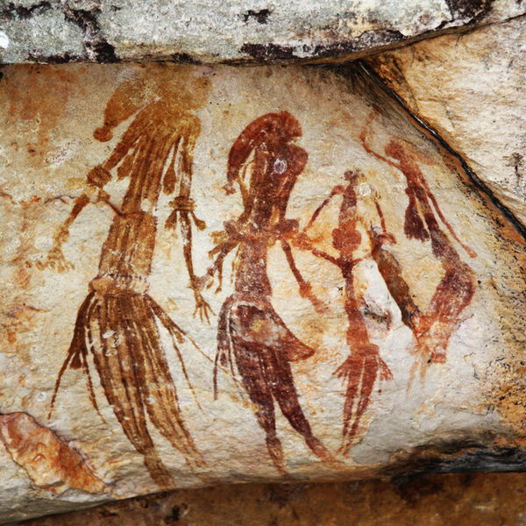

[*http://commons.wikimedia.org/wiki/File:Bradshaw_rock_paintings2.jpg*](http://commons.wikimedia.org/wiki/File:Bradshaw_rock_paintings2.jpg)

What contact did the Aboriginal and Torres Strait Islander peoples have with the Macassans before the arrival of the Europeans?



**GETTING KNOWLEDGE READY**

1. Who do you think the Aboriginal and Torres Strait Islander peoples could have had contact with before the Europeans arrived? Write a sentence a draw a picture.
2. Read the following information.

**Early Contact**

For hundreds of years before Europeans discovered Australia, Aboriginal peoples living in northern Australia, as well as Torres Strait Islanders, were trading with the Macassans and people of southern Java.

**Trading Partners**

The Macassans are thought to be the first people to have had contact with Aboriginal peoples.

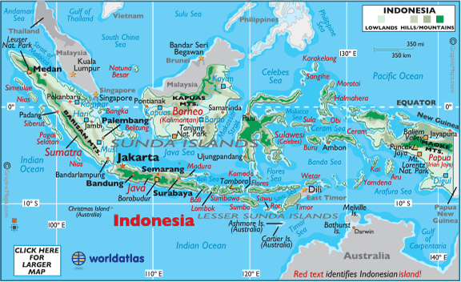

\**From 1971 to 1999, the Indonesian city* ***Makassar*** *was named* ***Ujungpandang****. They are now used interchangeably.*

The fishermen traders of Makassar in Indonesia left their homeland with the north-west monsoon in December each year. (Monsoons are strong winds in and near the Indian Ocean that bring heavy rain in summer.) They camped in sheltered bays along the Northern Territory coast and the Kimberley coast of Western Australia.

The Macassans collected animals such as sea slugs and sea cucumbers (also called trepang) as well as turtle shells, pearls and timber. The Macassans traded goods such as cloth, tobacco, rice and knives with the local Aboriginal peoples. Some aboriginal women married the traders and returned with them to Makassar.

Aboriginal peoples allowed the fishermen to set up camp to clean and cook their sea slugs and cucumbers. The Macassans used the monsoon winds to return to their country in March or April of the following year.

Relationships between the Aboriginal peoples and the Macassans were most likely based on friendship and respect as the Macassans lived with them for up to four months each year.

***Source: Discovering History (Middle Primary) / Early Contact***

***– Jennifer Lawless and Kate Cameron* (PEARSON AUSTRALIA)**

1. You are going to create a comic strip about an Aboriginal or Torres Strait Islander’s dealings with a Macassan. Today you are going to brainstorm your ideas and write a draft on the following pages. Next week, you will publish and illustrate your comic strip.

|  |
| --- |
| *BRAINSTORM* |

*COMIC STRIP DRAFT*

*COMIC STRIP DRAFT*

|  |  |
| --- | --- |
|  |  |
|  |  |
|  |  |
|  |  |

1. Proof-read and edit the comic strip you drafted. Publish it on the following page. Alternatively, you can complete your work online using Word or PowerPoint. Remember to include a title.

|  |  |
| --- | --- |
|  |  |
|  |  |
|  |  |
|  |  |

**REFLECTION**

Please think about what you’ve learnt in this module. In your own words please write your answer below.

1. *What do you think the advantages and disadvantages may have been for the Aboriginal and Torres Strait Islanders in their dealings with the Macassans?*

|  |  |
| --- | --- |
| ***ADVANTAGES*** | ***DISADVANTAGES*** |
|  |  |
|  |  |
|  |  |
|  |  |
|  |  |
|  |  |