**Mathematics**

|  |
| --- |
| Double Up |

**What are angles?**

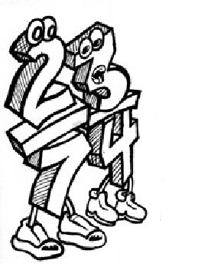**!**

**Welcome to**

**Angles!**

**About the Topic**

|  |  |  |  |
| --- | --- | --- | --- |
| Each section begins with the topic for each lesson. It lets you know which maths dimension and topic you will be studying for each day. For example:   |  |  | | --- | --- | | **Number** | Today you will continue your work on analogue and digital TIME. | |  |

**Introduction**

The introduction begins with *Getting Knowledge Ready,* that is, what you already

know about the topic. It introduces new concepts focusing on the *how, why,*

and *what* of the maths topic for the day.

**Activities**

The activities develop math’s skills, so even if you understand an example the activities helps you learn and remember the skill.

Complete all the activities in the booklet and if more space is required complete on lined paper. Show all calculations as it can also show your teacher where you need additional help.

**Section 10** consists of a *Progress Assessment.* It assesses work covered in the booklet and enables your teacher to see whether you have fully understood the work and provide appropriate feedback. It must be completed without assistance.

Read through the *Contents* Page to find out about the math’s topics for this work.

**Contents**

|  |  |
| --- | --- |
| **Section 1** | **Measurement and Space**   * Introduction to angles and protractor * Recognising and naming types of angles |
| **Section 2** | **Measurement, Space and Number**   * Lines and angles * Revision: Counting Patterns |
| **Section 3** | **Measurement, Space and Number**   * Identifying types of lines * Number patterns and Multiples of 3s, 4s, 6s, 7s and 8s |
| **Section 4** | **Number**   * Mental strategies with number * Compensation strategies * practice with 3s and 4s and Factors |
| **Section 5** | **Maths Project**   * creating a picture focusing on angles |
| **Section 6** | **Number**   * Split strategy * Expanded Form and place value * Adding 2- and 3-digit numbers |
| **Section 7** | **Number**   * Adding 2- and 3- digit numbers without regrouping * Adding 2- and 3-digit numbers with regrouping |
| **Section 8** | **Number**   * Subtracting 2- digit numbers without regrouping * Subtracting 2- digit numbers with regrouping |
| **Section 9** | **Number**   * Subtracting 3- digit numbers without regrouping * Subtracting 3- digit numbers with regrouping |
| **Section 10** | **Revision—Assessment** |

|  |  |
| --- | --- |
| **Measurement**  **And Space** | Identify and measure obtuse, acute, reflex and straight angles. |

**Introduction**

Where have you seen angles?

**Activity 1—**Draw some angles around you and name them.

|  |  |  |
| --- | --- | --- |
|  |  |  |
|  |  |  |

Angles can be classified as right, acute, obtuse, reflex and straight.

**Activity 2—Angles**

Study this circle and the angles below. Tell your supervisor what you noticed and tick the checklist on the following page.

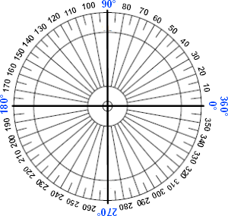

Checklist

|  |  |
| --- | --- |
| □ circles  □ lines radiating from the centre  □ counting by tens  □ right angles  □ lines coming from the centre  □ long and short lines  *other*  □  □ | □ lines intersect at the centre  □ degrees 0  □ cut into 4 equal segments  □ 00 and 3600 together  □ 900 1800  2700 are in bold  □ lines intersect at the centre  *other*  □  □ |

**Activity 2 continued**

Here is a circle showing the **360 degrees** 360° in a complete circle.

Find these features and draw an arrow to show the following:

* Vertex
* Degree 800
* Find other features

Use a ruler to draw lines to show a right angle, acute angle and obtuse angle.

If you had to measure the magnitude of the angles you created how would you do it? Discuss.

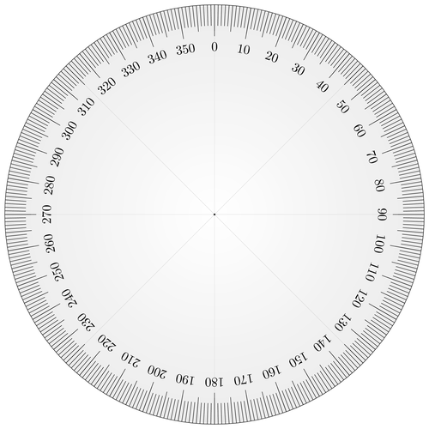

Measuring Angles

We use a protractor to measure angles accurately. A protractor can be made from a full circle showing 360 degrees or like the one below which shows 180 degrees. All of our angles can be measured using a protractor.

**Place this point where the two angles meet. This is called the Vertex.**

Read the angle size here

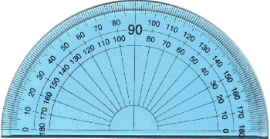

**Start at 0°**

**Activity 3—On-line**

Go to the website below, measure ten angles.

**To the supervisor**!

Please describe how well your student measured angles with a protractor.

<https://fuse.education.vic.gov.au/Resource/LandingPage?ObjectId=6b59d561-dcb3-4e35-ba43-babcafa15512>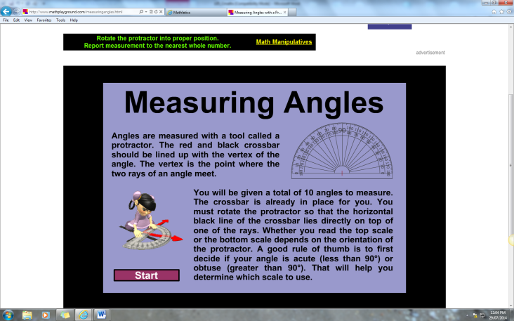

*If you can’t get it online please complete the following.*

**Activity 3**

1. Angles are classified according to the amount of turn on a circle.

|  |  |
| --- | --- |
| **Right Angle**  Square corner  which measures  at 90° | This line shows the angle we are measuring. |
| **Obtuse Angle**  Larger than a right angle; greater than 90°and less than 1800 |  |
| **Acute Angle**  Smaller than a right angle; less than 90° |  |
| **Straight Angle**  Can be made from 2 right angles; 180° |  |
| **Reflex Angle**  Larger than a straight angle; greater than 180°and less than 3600 |  |

**Activity 3 continued**

1. Use your protractor to measure these angles. Remember when you measure angles you need to **place the base line** of the **protractor** **along the lower arm of the angle**, and place the **centre point of the protractor** on the **vertex** (corner).

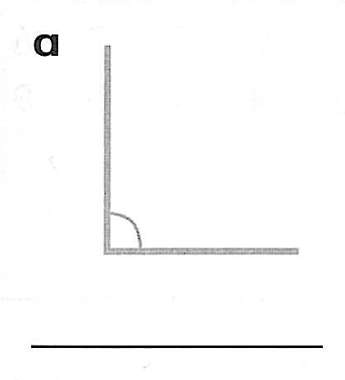 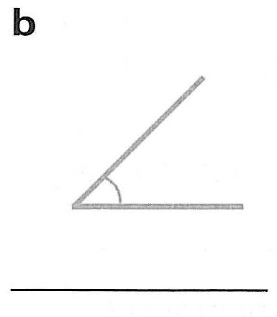 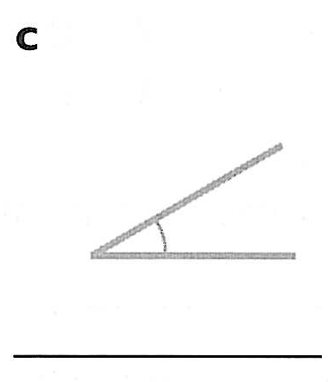 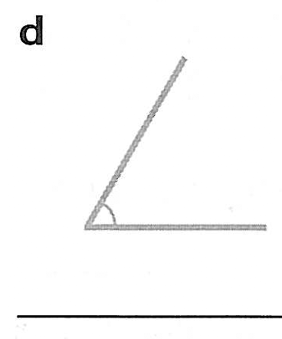

1. Label the angles **right angle**, **obtuse**, **acute**, **reflex** or **straight**.

|  |  |
| --- | --- |
| —————————— | ———————— |
| —————————— | —————————— |
| —————————— |  |

**Activity 4**

Using a ruler draw these angles:

* Right angles
* Obtuse
* Acute
* Reflex

In your own words state an explanation on each

|  |  |
| --- | --- |
| Straight angle | Obtuse angle |
| Acute angle | Reflex angle |

|  |  |
| --- | --- |
| **Measurement** | Learn about **lines** and identify some of their features. |



**Introduction**

How would you describe the lines below? We see lines every day and we are able to describe them because they each have a name.

**Activity 1**

Match these representations of lines with one of the following words: ***diagonal, straight, horizontal, vertical, perpendicular, parallel* and *zigzag.***

**Introduction continued**

|  |  |
| --- | --- |
| **Remember these facts about lines**. | **Horizontal** means parallel to the horizon. For example the top of your desk is the same as the horizon.  **Vertical** means perpendicular or at right angles to the horizon.  For example.    Vertical Perpendicular: joined at a right angle  **Parallel lines** are those that always remain the same distance apart but run at the same angle. |

Take a moment now to think about how you would describe the lines in the path shown below?



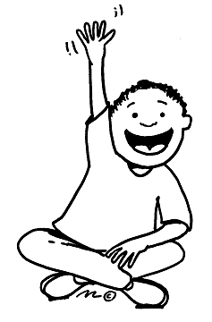

I would describe the lines in the path as zigzag, horizontal, vertical, and then diagonal.

**Activity 2**

1. Look carefully at the frame below and then classify the labelled parts of the frame as **horizontal, vertical or sloping.**

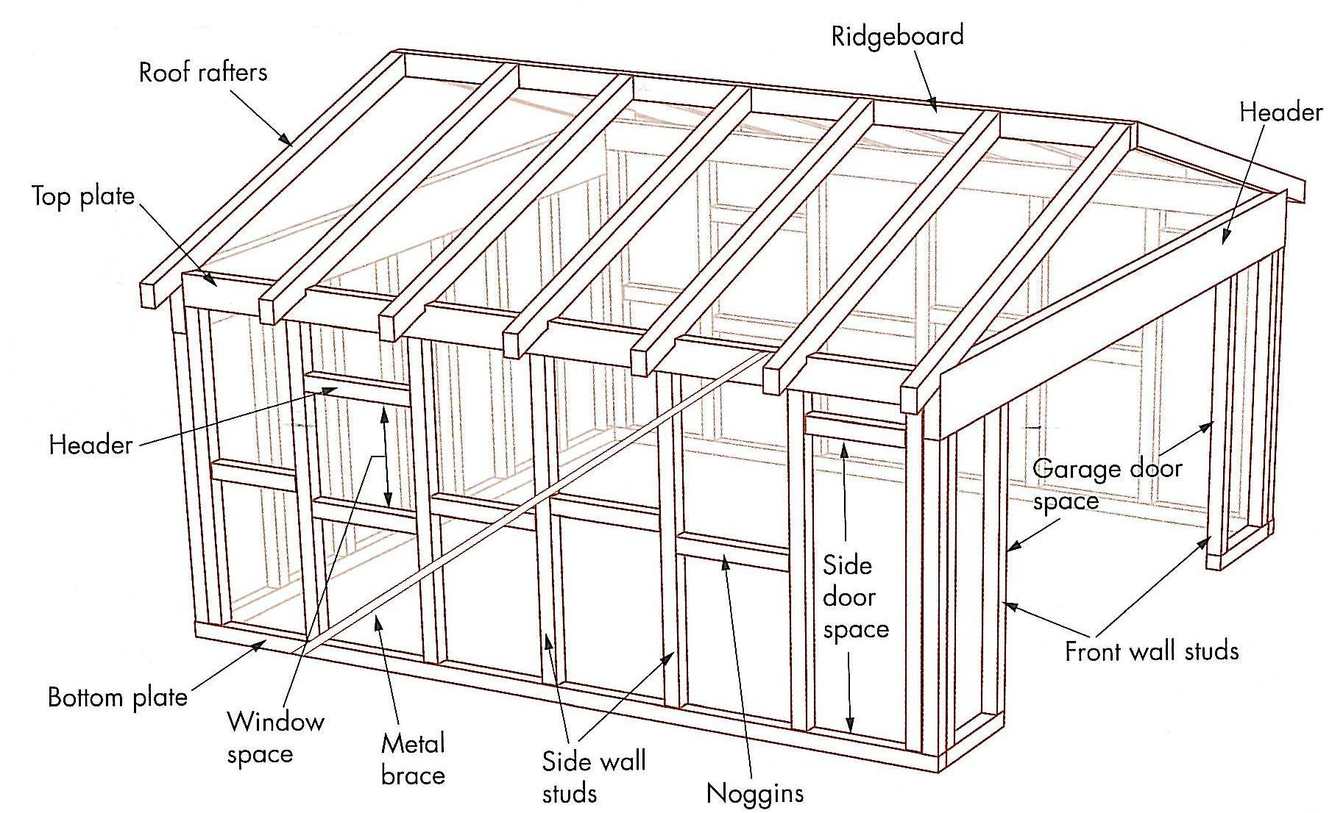

|  |  |  |
| --- | --- | --- |
| Horizontal | Vertical | Sloping |
|  |  |  |
|  |  |  |
|  |  |  |
|  |  |  |
|  |  |  |

**Activity 3**

Parallel or not parallel? Answer **Yes** or **No** to the following about the building frame.

1. Are all the studs on the garage parallel? —————
2. Are all the roof rafters parallel? —————
3. Are the top and bottom plates parallel? —————
4. Are the studs parallel to the plates? —————
5. Are the roof rafters parallel to the metal bracing? —————
6. Are the noggins parallel to the bottom plate? —————

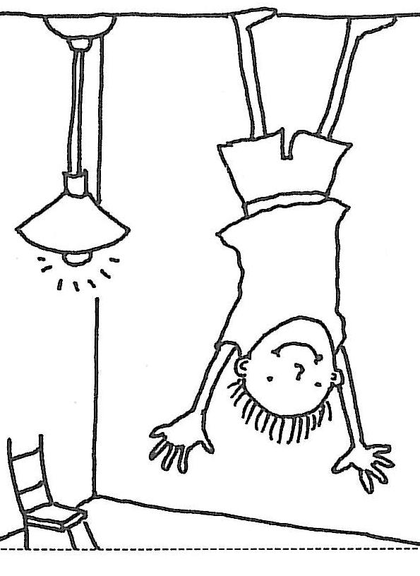

I hope you are having as much fun learning about lines as I am!

**Activity 4**

Look at the picture below and complete the following:

* Colour the horizontal lines green
* Colour the vertical lines red
* Colour the diagonal lines blue
* Find **four pairs** of **parallel lines** to colour purple and **four perpendicular** lines to colour orange.

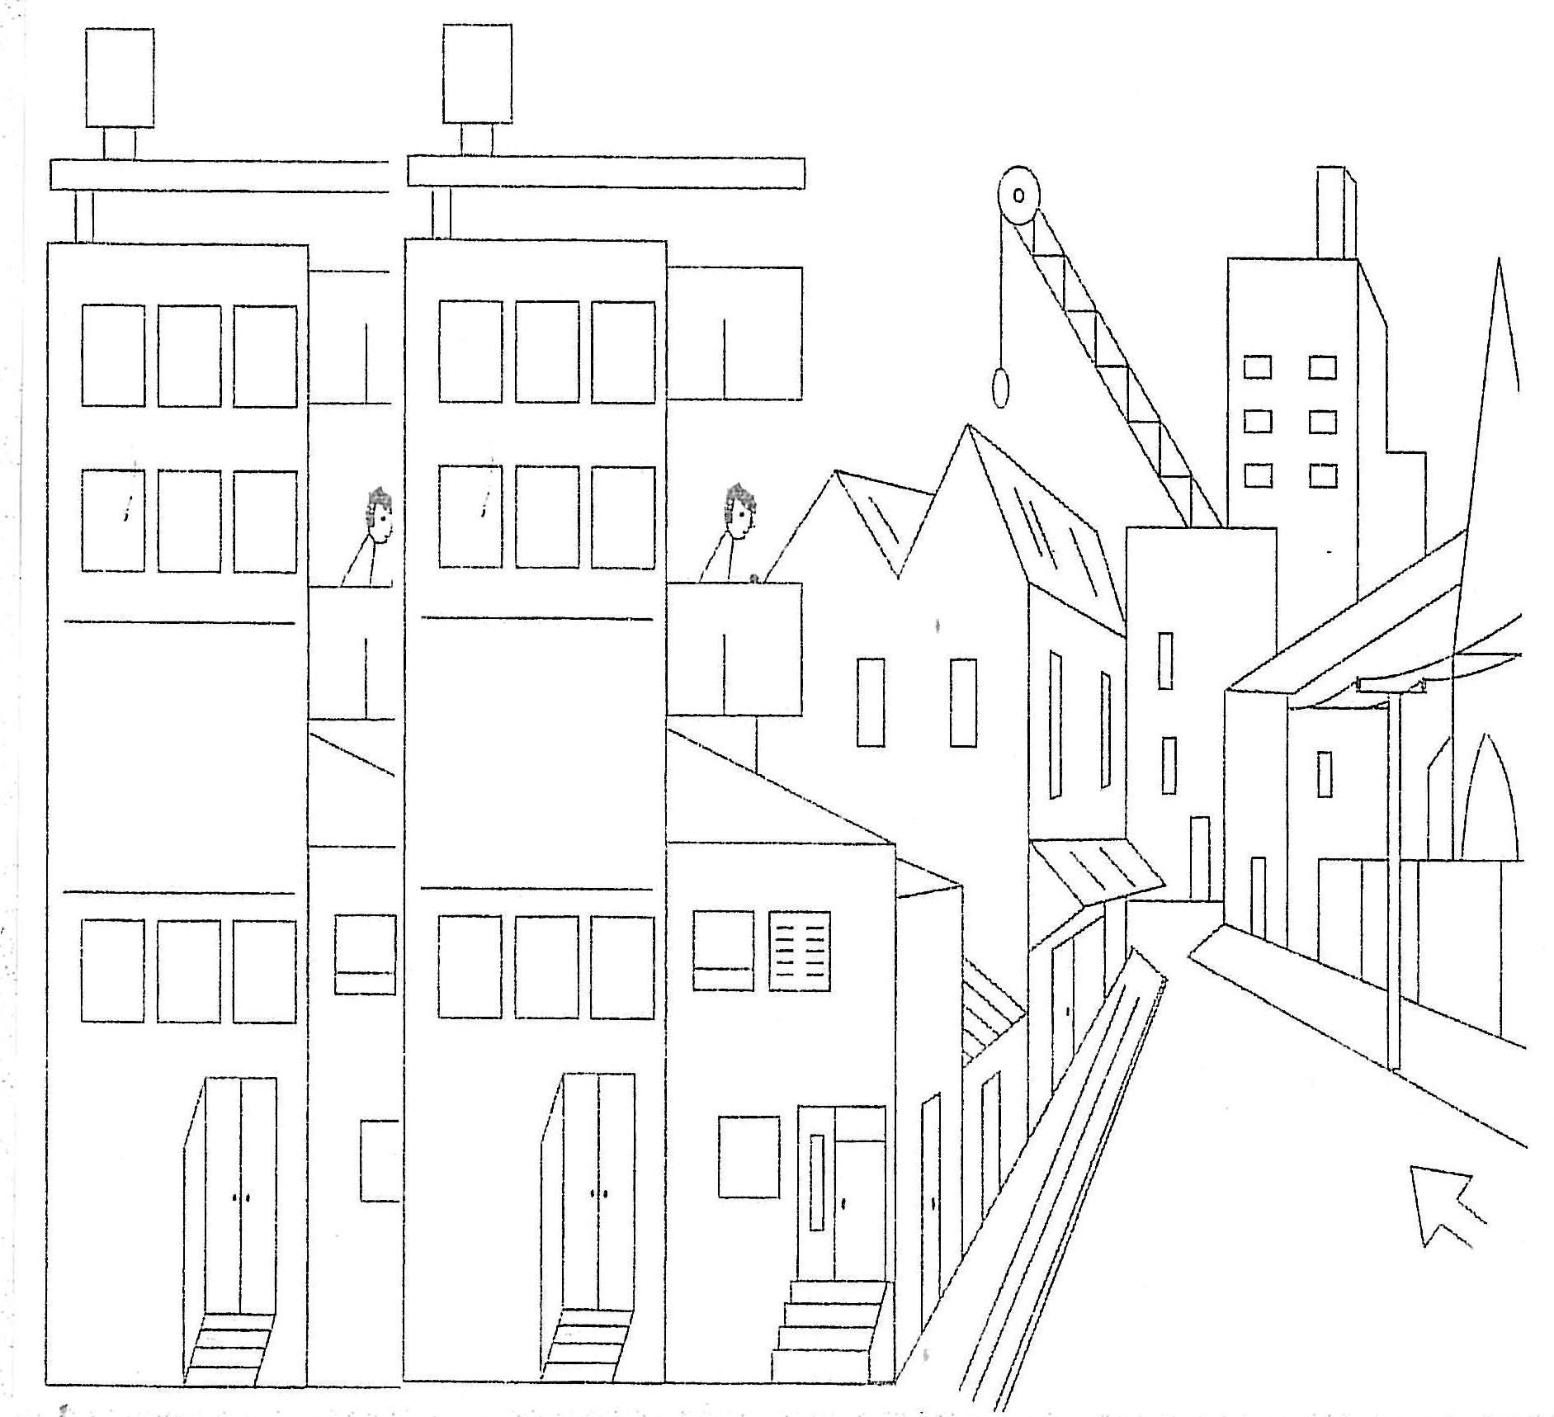

**REVISION: COUNTING PATTERNS WITH WHOLE NUMBERS**

**What are multiples?**



When we think of multiplication, it is important to know what a **multiple** means

|  |  |  |
| --- | --- | --- |
| Can you count by threes? | 3, 6, 9, 12, 15, 18, . . . and so on  These numbers are the ***multiples of 3*** |  |
| Can you count by fours? | 4, 8, 12, 16, 20, 24 . . . and so on  These numbers are the ***multiples of 4*** | |

Multiples of 4 as multiplication equations:

|  |
| --- |
| 1 × 4 = 4 2 × 4 = 8 |
| 3 × 4 = 12 4 × 4 = 16  5 × 4 = 20 6 × 4 = 24  7 × 4 = 28 8 × 4 = 32  9 × 4 = 36 10 × 4 = 40  11 × 4 = 44 12 × 4 = 48 |

Can you count by sixes? 6, 12, 16, 24, 30…and so on

These numbers are the ***multiples of 6***

Can you count by sevens? 7, 14, 21, 28, 35…and so on

These numbers are the ***multiples of 7***

Can you count by eights? 8, 16, 24, 32, 40…and so on

These numbers are the ***multiples of 8***

**Activity 5: revision of 3s, 4s and 6s times tables**



You can easily create **multiplications number facts** from the hundreds chart. For example you might choose 12 and you could know that 6 x 2 = 12.

Can you think of 3 other multiplication number facts?

Write them on the lines below.

|  |  |  |  |  |  |  |  |  |  |  |
| --- | --- | --- | --- | --- | --- | --- | --- | --- | --- | --- |
| 1 | | 2 | 3 | 4 | 5 | 6 | 7 | 8 | 9 | 10 |
| 11 | | **12** | 13 | 14 | 15 | 16 | 17 | 18 | 19 | 20 |
| 21 | | 22 | 23 | 24 | 25 | 26 | 27 | 28 | 29 | 30 |
| 31 | | 32 | 33 | 34 | 35 | 36 | 37 | 38 | 39 | 40 |
| 41 | | 42 | 43 | 44 | 45 | 46 | 47 | 48 | 49 | 50 |
| 51 | | 52 | 53 | 54 | 55 | 56 | 57 | 58 | 59 | 60 |
| 61 | | 62 | 63 | 64 | 65 | 66 | 67 | 68 | 69 | 70 |
| 71 | | 72 | 73 | 74 | 75 | 76 | 77 | 78 | 79 | 80 |
| 81 | | 82 | 83 | 84 | 85 | 86 | 87 | 88 | 89 | 90 |
| 91 | 92 | 93 | 94 | 95 | 96 | 97 | 98 | 99 | 100 |

_________________________________________________________

_________________________________________________________

**Activity 5 revision continued**

|  |
| --- |
| Below are eight facts for 12 that I discovered.  Were they similar to your facts? |



















**Let’s count by 3s.**

Starting at 30, circle every **third number** on the grid.

|  |  |  |  |  |  |  |  |  |  |
| --- | --- | --- | --- | --- | --- | --- | --- | --- | --- |
| 30 | 29 | 28 | 27 | 26 | 25 | 24 | 23 | 22 | 21 |
| 20 | 19 | 18 | 17 | 16 | 15 | 14 | 13 | 12 | 11 |
| 10 | 9 | 8 | 7 | 6 | 5 | 4 | 3 | 2 | 1 |

Continue the pattern:

30, 27, 24, 21, _____, _____, _____, _____, _____, _____,

_____, _____, _____

**Activity 5 revision continued**

**Let’s revise counting by 4s.**

Starting at 40, circle every **fourth number** on the grid.

|  |  |  |  |  |  |  |  |  |  |
| --- | --- | --- | --- | --- | --- | --- | --- | --- | --- |
| 40 | 39 | 38 | 37 | 36 | 35 | 34 | 33 | 32 | 31 |
| 30 | 29 | 28 | 27 | 26 | 25 | 24 | 23 | 22 | 21 |
| 20 | 19 | 18 | 17 | 16 | 15 | 14 | 13 | 12 | 11 |
| 10 | 9 | 8 | 7 | 6 | 5 | 4 | 3 | 2 | 1 |

Spot on

Continue the pattern,

4, 8, 16, _____, _____, _____, _____, _____, _____,



**Let’s revise counting by 6s.**

Starting at 60, circle every **sixth number** on the grid.

|  |  |  |  |  |  |  |  |  |  |
| --- | --- | --- | --- | --- | --- | --- | --- | --- | --- |
| 60 | 59 | 58 | 57 | 56 | 55 | 54 | 53 | 52 | 51 |
| 50 | 49 | 48 | 47 | 46 | 45 | 44 | 43 | 42 | 41 |
| 40 | 39 | 38 | 37 | 36 | 35 | 34 | 33 | 32 | 31 |
| 30 | 29 | 28 | 27 | 26 | 25 | 24 | 23 | 22 | 21 |
| 20 | 19 | 18 | 17 | 16 | 15 | 14 | 13 | 12 | 11 |
| 10 | 9 | 8 | 7 | 6 | 5 | 4 | 3 | 2 | 1 |

|  |  |
| --- | --- |
| **Number** | **Revise** some **mental calculation strategies** we use to **add numbers**. |

**Introduction**

Which of the number sentences below are easy for you to do in your head? Why? Discuss with your supervisor.

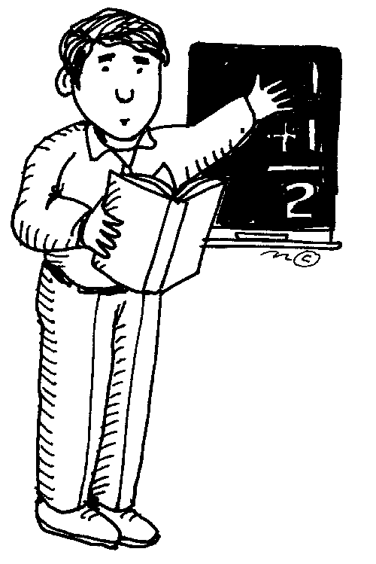

1. 430 + 50 2. 750 + 250

3. 800 + 900 4. 100 – 36

5. 6000 + 6000 6. 1000 - 499

**Tick** which number sentences you can solve in your head for your teacher to see.

**Activity 1**

Choose 2 problems you solved. Show me (draw or write) how you did it in your head.

|  |
| --- |
|  |

**Activity 2: Mental strategies – number complements for 20, 50 and 100.**

What do you need to do to increase the numbers below to 20, 50 or 100.

When you put two numbers together to make a round number it’s called a complement. Complement is a useful mental strategy.

Let’s take a look at the image below. The blue number is the complement to make 10. Can you see how your can work this out in yor head?

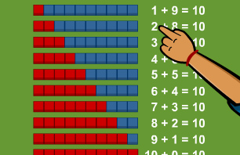

It is now time for you to create a similar version of the above image using number complements to 20. The first one has been completed.

|  |  |
| --- | --- |
| Number | Complement to 20 |
| 13 | 7 |
| 17 |  |
| 14 |  |
| 12 |  |
| 18 |  |
| 11 |  |

**Activity 3: The Practice of counting by threes, eights and nines**

From the hundreds chart below you can create many multiplication and division number sentences because these two operations are ***inverse operations*** or opposite operations.

For example: 3 x 8 = 24, 24 ÷ 8 = 3 and 24 3 = 8, 8 x 6 = 48, 48 ÷ 6 = 8, 48 ÷ 8 = 6, 48 ÷ 3 = 16 and 48 ÷ 16 = 3.

|  |  |  |  |  |  |  |  |  |  |
| --- | --- | --- | --- | --- | --- | --- | --- | --- | --- |
| 1 | 2 | 3 | 4 | 5 | 6 | 7 | 8 | 9 | 10 |
| 11 | 12 | 13 | 14 | 15 | 16 | 17 | 18 | 19 | 20 |
| 21 | 22 | 23 | 24 | 25 | 26 | 27 | 28 | 29 | 30 |
| 31 | 32 | 33 | 34 | 35 | 36 | 37 | 38 | 39 | 40 |
| 41 | 42 | 43 | 44 | 45 | 46 | 47 | 48 | 49 | 50 |
| 51 | 52 | 53 | 54 | 55 | 56 | 57 | 58 | 59 | 60 |
| 61 | 62 | 63 | 64 | 65 | 66 | 67 | 68 | 69 | 70 |
| 71 | 72 | 73 | 74 | 75 | 76 | 77 | 78 | 79 | 80 |
| 81 | 82 | 83 | 84 | 85 | 86 | 87 | 88 | 89 | 90 |
| 91 | 92 | 93 | 94 | 95 | 96 | 97 | 98 | 99 | 100 |

**Activity 3 continued**

The teacher gave three students eight jellybeans each. How many jellybeans altogether? There are: **3 x 8 = 24** jellybeans altogether. We can also write this as a division fact. How can 24 jellybeans be shared equally among three students? Answer **24 ÷ 3 = 8.** How can 24 jellybeans be shared equally among eight students? Answer **24 ÷ 8 = 3.**



**Let’s count by 8s.**

Without looking at the number grid count by ***eights*** and see how far you can count. Then look at the number grid and circle ***every eighth number.***

Continue the pattern

8, 16, 24, 32, ____, ____, ____, ____, ____, ____, ____, ____, ____



**Let’s count by 9’s.**

Without looking at the number grid count by ***nines*** and see how far you can count. Then look at the number grid and lightly shade ***every ninth number.***

**Activity 3 continued**

Continue the pattern

9, 18, 27, 36, ____, ____, ____, ____, ____, ____, ____, ____

How many numbers are there between 1 and 100 that are multiples of both 8 and 4. Can you identify these numbers on the number grid?

|  |  |  |  |  |  |  |  |  |  |
| --- | --- | --- | --- | --- | --- | --- | --- | --- | --- |
| 1 | 2 | 3 | 4 | 5 | 6 | 7 | 8 | 9 | 10 |
| 11 | 12 | 13 | 14 | 15 | 16 | 17 | 18 | 19 | 20 |
| 21 | 22 | 23 | 24 | 25 | 26 | 27 | 28 | 29 | 30 |
| 31 | 32 | 33 | 34 | 35 | 36 | 37 | 38 | 39 | 40 |
| 41 | 42 | 43 | 44 | 45 | 46 | 47 | 48 | 49 | 50 |
| 51 | 52 | 53 | 54 | 55 | 56 | 57 | 58 | 59 | 60 |
| 61 | 62 | 63 | 64 | 65 | 66 | 67 | 68 | 69 | 70 |
| 71 | 72 | 73 | 74 | 75 | 76 | 77 | 78 | 79 | 80 |
| 81 | 82 | 83 | 84 | 85 | 86 | 87 | 88 | 89 | 90 |
| 91 | 92 | 93 | 94 | 95 | 96 | 97 | 98 | 99 | 100 |

|  |  |
| --- | --- |
| **Measurement** | **Mini Project** |

**Activity 2—**Your tasks for today is to create a presentation to explain angles.

It can be presented as a drawing or PowerPoint. For example the drawing on page 17 shows a variety of angles.

You must include the following:

* right angles
* acute angles
* obtuse
* reflex
* degrees
* measure
* Arc

Refer to your study earlier in the module.

Contact your teacher if you need any help! ☺

|  |  |
| --- | --- |
| **Measurement** | You will learn **the split strategy** for adding two-digit and three-digit numbers. |

**Activity 1**—**Revising Complement strategy**

Complement the following to 50

|  |  |
| --- | --- |
| Number | Complement to 50 |
| 42 |  |
| 30 |  |
| 15 |  |
| 46 |  |
| 29 |  |
| 11 |  |

**Split Strategy**

Split strategy is another method of working out equations in your head.

The strategy involves splitting the number into parts to make the addition easier. The number 68 is the same as 6 tens (60) and 8 units (8).

Here’s another example:

73 + 49 = (7 tens + 4 tens) + (3 units + 9 units)

= 11 tens + 12 units

= 11 tens + 1 tens + 2 units

= 12 tens + 2 units

= 122

**Activity 2—**Consider some ways to SPLIT these numbers in different ways:

|  |  |  |
| --- | --- | --- |
| **Number** | **Split 1** | **Split 2** |
| 408 | 400 + 8 | 300 + 18 |
| 397 |  |  |
| 701 |  |  |
| 9005 |  |  |

**Activity 3: split strategy with addition of two-digit numbers**

Use the split strategy to add the following:

|  |  |
| --- | --- |
| 87 + 64 | 80 + 7 + 60 + 4  80 + 60 + 7 + 4  140 + 11  151 |
| 91 + 77 |  |
| 58 + 63 |  |
| 89 + 32 |  |
| 66 + 95 |  |

**Activity 5:** Expanded form using understanding of place value and the split strategy with larger numbers.

|  |  |  |  |  |
| --- | --- | --- | --- | --- |
| In digits | The numberexpanded |  | **Say** the number supervisor check | |
| 1 327 | 1 000 + 300 + 20 + 7 |  | One thousand three hundred and  twenty seven | |
|  |  |  | Three thousand six hundred and  forty nine | |
| 6 588 |  |  |  | |
|  | 8 000 + 400 + 80 + 4 |  | |  |
|  | 7 000 + 50 + 9 |  | |  |

|  |  |
| --- | --- |
| **Number** | Add two-digit and thee-digit without regrouping. |

**Activity 1: Complete the two-digit addition without regrouping**

Look carefully at **column** **addition** **example (a)** and then complete the other additions.

|  |  |  |  |  |  |  |  |  |  |  |  |  |  |  |  |  |
| --- | --- | --- | --- | --- | --- | --- | --- | --- | --- | --- | --- | --- | --- | --- | --- | --- |
| **(a)** |  |  | | Th | | H | T | U |  | **(b)** |  |  | Th | H | T | U |
|  |  |  | |  | |  | 5 | 6 | 6 + 3 = 9  units. Write 9 in the units column. |  |  |  |  |  | 5 | 1 |
| 5 + 3 = 8  8 tens |  | + | |  | |  | 3 | 3 |  |  |  | + |  |  | 7 | 6 |
|  |  |  | |  | |  | 8 | 9 |  |  |  |  |  |  |  |  |
|  |  |  |  | |
|  |  |  |  | |
|  |

|  |  |  |  |  |  |  |  |  |  |  |  |  |  |  |
| --- | --- | --- | --- | --- | --- | --- | --- | --- | --- | --- | --- | --- | --- | --- |
| **(c)** |  |  | Th | H | T | U |  | **(d)** |  |  | Th | H | T | U |
|  |  |  |  |  | 4 | 7 |  |  |  |  |  |  | 1 | 5 |
|  |  | + |  |  | 3 | 2 |  |  |  | + |  |  | 8 | 4 |
|  |  |  |  |  |  |  |  |  |  |  |  |  |  |  |

**Activity 2: Two-digit addition with regrouping**

|  |  |  |  |  |  |  |  |  |  |  |  |  |  |  |
| --- | --- | --- | --- | --- | --- | --- | --- | --- | --- | --- | --- | --- | --- | --- |
| **(a)**  We write 6 in the Units column and carry the 1 ten to the Tens column. |  |  | Th | H | T | U |  | **(b)** |  |  | Th | H | T | U |
|  |  |  |  |  | 6 | 7 | 7 units + 9 units = 16 units which is the same as 1 ten and 6 units. |  |  |  |  |  | 5 | 8 |
|  |  | + |  |  | **1**2 | 9 |  |  |  | + |  |  | 3 | 9 |
| 6 tens + 2 tens + 1 ten = 9 Tens |  |  |  |  | **9** | **6** |  |  |  |  |  |  |  |  |

|  |  |  |  |  |  |  |  |  |  |  |  |  |  |  |
| --- | --- | --- | --- | --- | --- | --- | --- | --- | --- | --- | --- | --- | --- | --- |
| **(c)** |  |  | Th | H | T | U |  | **(d)** |  |  | Th | H | T | U |
|  |  |  |  |  | 3 | 6 |  |  |  |  |  |  | 4 | 9 |
|  |  | + |  |  | 4 | 7 |  |  |  | + |  |  | 5 | 6 |
|  |  |  |  |  |  |  |  |  |  |  |  |  |  |  |

**Activity 3: Three-digit addition without regrouping**

Complete the following s-digit additions that do not involve regrouping

|  |  |  |  |  |  |  |  |  |  |  |  |  |  |  |
| --- | --- | --- | --- | --- | --- | --- | --- | --- | --- | --- | --- | --- | --- | --- |
| **(a)** |  |  | Th | H | T | U |  | **(b)** |  |  | Th | H | T | U |
|  |  |  |  | 3 | 2 | 6 |  |  |  |  |  | 5 | 6 | 5 |
|  |  | + |  | 4 | 6 | 2 |  |  |  | + |  | 2 | 3 | 3 |
|  |  |  |  |  |  |  |  |  |  |  |  |  |  |  |

**Activity 4: Three-digit addition with regrouping**

Check your answers after you have added the numbers with an approximation.

|  |  |  |  |  |  |  |  |  |  |  |  |  |  |  |
| --- | --- | --- | --- | --- | --- | --- | --- | --- | --- | --- | --- | --- | --- | --- |
| **(a)**  Add 2 + 9 + 4 + 1 = 16 hundreds. Write 6 in the Hundreds column and write the 1 thousand in the Thousands since there are no more thousands to add together. |  |  | Th | H | T | U |  | **(b)** |  |  | Th | H | T | U |
|  |  |  |  | 2 | 8 | 7 |  |  |  |  |  | 2 | 5 | 7 |
|  |  |  |  | 9 | 6 | 9 |  |  |  |  |  | 2 | 8 | 5 |
|  |  | + |  | **1**4 | **1**1 | 3 |  |  |  | + |  | 7 | 3 | 9 |
|  |  |  | **1** | **6** | **6** | **9** |  |  |  |  |  |  |  |  |
|  |  |

We write 6 in the Units column and carry the 1 ten to the Tens column. Then add the tens: 8 + 6 + 1 + 1 = 16 tens which is 1 hundred and 6 tens. Write 6 in the tens column and carry the 1 hundred to the Hundreds column.

7 units + 9 units + 3 units = 19 units which is 1 ten and 9 units. Write 9 in the Units column and carry the 1 ten and add to the other tens.

|  |  |  |  |  |  |  |  |  |  |  |  |  |  |  |
| --- | --- | --- | --- | --- | --- | --- | --- | --- | --- | --- | --- | --- | --- | --- |
| **(c)** |  |  | Th | H | T | U |  | **(d)** |  |  | Th | H | T | U |
|  |  |  |  | 6 | 4 | 7 |  |  |  |  |  | 2 | 9 | 7 |
|  |  |  |  | 8 | 3 | 2 |  |  |  |  |  | 6 | 3 | 6 |
|  |  | + |  | 4 | 7 | 6 |  |  |  | + |  | 5 | 5 | 9 |
|  |  |  |  |  |  |  |  |  |  |  |  |  |  |  |

# Day 8

|  |  |
| --- | --- |
| **Number** | Today you will **revise** some **mental processes** we use to **subtract** **numbers,** and **learn** the method of **regrouping.** |

**Activity 1: Subtraction**

Complete the two-digit subtraction without regrouping

The first has been done for you.

Remember you start with the larger number—**subtract** the **number** in the ***second row from*** the **number** in the ***first row***.

|  |  |  |  |  |  |  |  |  |  |  |  |  |  |  |  |  |  |  |
| --- | --- | --- | --- | --- | --- | --- | --- | --- | --- | --- | --- | --- | --- | --- | --- | --- | --- | --- |
| **(a)** |  |  | | | Th | | H | T | U |  | **(b)** |  |  | | Th | H | T | U |
|  |  |  | | |  | |  | 5 | 6 | 6 - 3 = 3  3 units |  |  |  | |  |  | 5 | 1 |
| 50 - 30 = 20  2 tens |  | **-** | | |  | |  | 3 | 3 |  |  |  | **-** | |  |  | 3 | 0 |
|  |  |  | | |  | |  | 2 | 3 |  |  |  |  | |  |  |  |  |
|  |  |  | |  | |
|  |  |  | |  | |
|  |
| **c)** |  | |  | | Th | | H | T | U |  | **(d)** |  | |  | Th | H | T | U |
|  |  | |  | |  | |  | 4 | 7 |  |  |  | |  |  |  | 6 | 5 |
|  |  | | **-** | |  | |  | 3 | 2 |  |  |  | | **-** |  |  | 2 | 4 |
|  |  | |  | |  | |  |  |  |  |  |  | |  |  |  |  |  |

**Activity 1 continued**

|  |  |  |  |  |  |  |  |  |  |  |  |  |  |  |
| --- | --- | --- | --- | --- | --- | --- | --- | --- | --- | --- | --- | --- | --- | --- |
| **(e)** |  |  | Th | H | T | U |  | **(f)** |  |  | Th | H | T | U |
|  |  |  |  |  | 9 | 8 |  |  |  |  |  |  | 8 | 9 |
|  |  | **-** |  |  | 3 | 7 |  |  |  | **-** |  |  | 7 | 2 |
|  |  |  |  |  |  |  |  |  |  |  |  |  |  |  |

**Activity 2:** Complete the two-digit subtraction with regrouping. The first has been done for you.

|  |  |  |  |  |  |  |  |
| --- | --- | --- | --- | --- | --- | --- | --- |
| **(a)**  We borrow one tens from the 6 tens which now makes 17 units and 5 tens. |  |  | Th | H | T  5~~6~~ | U  17  We cannot subtract 9 units from 7 units, so we need to borrow a ten from the 6 tens. Now we have 5 tens and 17 units, Subtracting 9 units from 17 units gives 8 units. |  |
|  |  |  |  |  |
| Then 2 tens subtracted from 5 tens gives 3 tens. |  |  |  | **-** | 2 | 9 |  |
|  |  | **3** | **8** |
| Answer: **3** Tens and **8** units, that is, 38. | | | | |  |

**Reminder to Supervisors**

The re-grouping process may need to be supervised and explained to your child. Let your teacher know if you have any queries.

**Activity 5 continued**

|  |  |  |  |  |  |  |  |  |  |  |  |  |  |  |
| --- | --- | --- | --- | --- | --- | --- | --- | --- | --- | --- | --- | --- | --- | --- |
| **(b)** |  |  | Th | H | T | U |  | **(c)** |  |  | Th | H | T | U |
|  |  |  |  |  | 8 | 6 |  |  |  |  |  |  | 9 | 8 |
|  |  | **_** |  |  | 4 | 7 |  |  |  | **_** |  |  | 6 | 9 |
|  |  |  |  |  |  |  |  |  |  |  |  |  |  |  |

|  |  |  |  |  |  |  |  |  |  |  |  |  |  |  |
| --- | --- | --- | --- | --- | --- | --- | --- | --- | --- | --- | --- | --- | --- | --- |
| **(d)** |  |  | Th | H | T | U |  | **(e)** |  |  | Th | H | T | U |
|  |  |  |  |  | 7 | 6 |  |  |  |  |  |  | 4 | 7 |
|  |  | **_** |  |  | 1 | 7 |  |  |  | **_** |  |  | 2 | 8 |
|  |  |  |  |  |  |  |  |  |  |  |  |  |  |  |

Remember you **subtract** the **number** in the ***second row from*** the **number** in the ***first row***.

|  |  |
| --- | --- |
| **Number** | Use **regrouping** to **subtract three-digit numbers**. In some cases you may be asked to use your calculator for checking your solutions. |

In Module B you studied the place value chart. You will need to refer to your learning to complete today’s tasks in re-grouping.

Begin by studying the place value chart below:

   1 1

100000 10000 1000 100 10 1 10 100

|  |  |  |  |  |  |  |  |  |
| --- | --- | --- | --- | --- | --- | --- | --- | --- |
| Hundreds of thousands | Tens  of thousands | Thousands | Hundreds | Tens | Ones | Decimal | tenths | Hundreds\th |
|  |  |  |  | 2 | 5 | **.** | 9 | 0 |
| 3 | 0 | 9 | 1 | 0 | 0 | **.** | 5 | 1 |
|  |  |  |  |  | 1 | **.** | 0 | 9 |

**Re-grouping**

Study the example below:

|  |  |  |  |  |  |  |  |
| --- | --- | --- | --- | --- | --- | --- | --- |
| **(a)**  3 hundreds subtracted from 5 hundreds gives 2 hundreds.  500 -300 = 200 |  |  | Th | H  5 | T  2~~3~~ | U  14  We cannot subtract 9 units from 4 units, so we need to borrow a ten from the 3 tens. Now we have 2 tens and 14 units, Subtracting 9 units from 14 units results in 5 units.  14 – 9 = 5 |  |
|  |  |  |  |  |
| 1 ten subtracted from 2 tens gives 1 tens.  20 – 10 = 10 |  |  | **-** | 3 | 1 | 9 |  |
|  | **2** | **1** | **5** |
| Answer: 2 Hundreds and **1** Ten and **5** units, that is, 215. | | | | |  |

**Activity 1:** Complete the three-digit subtraction with regrouping.

|  |  |  |  |  |  |  |  |  |  |  |  |  |  |  |  |  |  |  |  |  |  |  |
| --- | --- | --- | --- | --- | --- | --- | --- | --- | --- | --- | --- | --- | --- | --- | --- | --- | --- | --- | --- | --- | --- | --- |
| **(a)** | |  | |  | | | Th | | H | | T | | U | |  | **(b)** |  |  | Th | H | T | U |
|  | |  | |  | | |  | | 3 | | 8 | | 6 | |  |  |  |  |  | 8 | 9 | 8 |
|  | |  | | **_** | | |  | | 1 | | 4 | | 9 | |  |  |  | **_** |  | 6 | 6 | 9 |
|  | |  | |  | | |  | |  | |  | |  | |  |  |  |  |  |  |  |  |
|  | |  | | |
|  | |  | | |
| **(c)** |  | |  | | | Th | | H | | T | | U | |  | | **(d)** |  |  | Th | H | T | U |
|  |  | |  | | |  | | 7 | | 7 | | 3 | |  | |  |  |  |  | 6 | 9 | 2 |
|  |  | | **_** | | |  | | 3 | | 4 | | 8 | |  | |  |  | **_** |  | 4 | 7 | 7 |
|  |  | |  | | |  | |  | |  | |  | |  | |  |  |  |  |  |  |  |
|  |  | | | |

|  |  |  |  |  |  |  |  |  |  |  |  |  |  |  |
| --- | --- | --- | --- | --- | --- | --- | --- | --- | --- | --- | --- | --- | --- | --- |
| **(e)** |  |  | Th | H | T | U |  | **(f)** |  |  | Th | H | T | U |
|  |  |  |  | 1 | 9 | 1 |  |  |  |  |  | 5 | 6 | 5 |
|  |  | **_** |  | 1 | 5 | 8 |  |  |  | **_** |  | 2 | 4 | 9 |
|  |  |  |  |  |  |  |  |  |  |  |  |  |  |  |

|  |  |
| --- | --- |
| **Progress Assessment** | Today you will be **undertaking assessment** tasks on maths activities you have completed during this module. |

|  |
| --- |
| **Note to student** |

The following exercises are to be completed by you without assistance.

This short progress assessment will enable your teacher to see whether you have fully understood the work in this and whether you need any additional help in a particular area.

Please complete the exercises on these pages, with full working out shown wherever possible

**You may use your notes to help you with these exercises.**

1. **Complementary Strategy**

Add numbers so that the total is:

47 + ______ = 50 _______ + 36 + 50

1. **Addition - Regrouping**

Regroup to find the answer



______________________________________________________________________



______________________________________________________________________

1. **Subtraction – regroup to find the answer**



_____________________________________________________________________



_____________________________________________________________________

1. Using your preferred method for adding numbers complete the addition of these two numbers:

**62 479 and 468 437**

Record your workings out in the space below.

|  |
| --- |
|  |

1. **Split strategy with addition of two-digit numbers**

Use the split strategy to add the following:

|  |  |
| --- | --- |
| 80 + 65 |  |
| 108 + 7 |  |

1. **Add** the following three-digit numbers ***without*** regrouping.

|  |  |  |  |  |  |  |  |
| --- | --- | --- | --- | --- | --- | --- | --- |
| **(a)** |  |  | Th | H | T | U | U |
|  |  |  |  | 4 | 2 | 8 | 5 |
|  |  | + |  | 1 | 5 | 1 | 3 |
|  |  |  |  |  |  |  |  |

1. **Add** the following three-digit numbers ***with*** regrouping and then round your answer to the **nearest ten.**

|  |  |  |  |  |  |  |  |  |  |
| --- | --- | --- | --- | --- | --- | --- | --- | --- | --- |
| **(a)** |  |  | Th | H | T | U |  |  |  |
|  |  |  |  | 3 | 5 | 7 |  |  |  |
|  |  |  |  | 5 | 6 | 8 |  |  |  |
|  |  | + |  | 4 | 9 | 2 |  |  |  |
|  |  |  |  |  |  |  |  |  |  |

**Subtraction without regrouping**

1. Round your answers to the **nearest ten** for the following:

|  |  |  |  |  |  |  |  |  |
| --- | --- | --- | --- | --- | --- | --- | --- | --- |
| **(a)** |  |  | Th | H | T | U |  |  |
|  |  |  |  |  | 9 | 6 |  |  |
|  |  | **_** |  |  | 8 | 1 |  |  |
|  |  |  |  |  |  |  |  |  |

|  |  |  |  |  |  |  |  |  |  |
| --- | --- | --- | --- | --- | --- | --- | --- | --- | --- |
| **(b)** |  |  | Th | H | T | U |  |  |  |
|  |  |  |  | 8 | 9 | 7 |  |  |  |
|  |  | **_** |  | 5 | 8 | 6 |  |  |  |
|  |  |  |  |  |  |  |  |  |  |

References and Websites

The following resources were used in the research of these lessons and activities C:

Feely, J., *Nelson Maths 5, Teacher Resource, Book* Nelson Australia 2007

Feely, J., *Nelson Maths 5, Student task Book,* Nelson Australia 2007

Hazell, V., Purcell, G., O’Brien H., *Maths Plus for Victoria, Student Book,* Oxford 2006

Lannen, B. & Dusting, M., *Remedial Mathematics Table strategies Levels3/4,* Heinman Australia, 2004.

Leigh, T., *Maths Tracks for Victoria Book 5, Teacher’s Resource Book*, Rigby 2005

Mcintosh, A., Reys, B.,Reys, R., & Hope. J., *Number SENSE Grades 4-6,*

Dale Seymour Publications, 1997.

Vingehoots, R. *Maths on the Go Books 1and 2,* Macmillan, 2007.

**Websites:**

Additional activities and ideas can be accessed through the Mathematics Curriculum Companion at <https://fuse.education.vic.gov.au/MCC>

|  |  |  |  |  |  |  |  |
| --- | --- | --- | --- | --- | --- | --- | --- |
| Description: Description: Description: Description: Description: Description: Description: Description: logoCAPS2**315 Clarendon Street, Thornbury 3071**  **Telephone (03) 8480 0000**  **FAX (03) 9416 8371 (Despatch)**  **Free call(1800) 133 511**   |  |  | | --- | --- | | |  | | --- | | **STUDENT NUMBER ___________________**  **STUDENT NAME ______________________**  **_______________________________________** | | | | | | | |  |
| Fix your student barcode  label over this space. |
|  |
| 5403  [5403] |
| **SUBJECT** | Maths | | | [ZX] |
| **COLOUR** | Blue | **MODULE** | C |
| **TEACHER** | ___________________________ | | |

|  |
| --- |
| **THINKING ABOUT YOUR LEARNING**  Description: Description: Description: Description: http://t0.gstatic.com/images?q=tbn:ANd9GcTiyp1Q0EWVRSXlqyIMaG6be3rodf0nBbu2oBIY8JlYVh1iP8U7I understand _______________________________________________________  _________________________________________________________________________________  _________________________________________________________________________________  _________________________________________________________________________________  _________________________________________________________________________________  Description: Description: Description: Description: http://t2.gstatic.com/images?q=tbn:ANd9GcQ72LH2Bxoxf3yTTP_t93kaIPDpv8jVzb20Dfacv1j6Jv1Vb43VI need help with_______________________________________________________  _________________________________________________________________________________  _________________________________________________________________________________  _________________________________________________________________________________  _________________________________________________________________________________ |

|  |
| --- |
| **YOUR QUESTIONS OR COMMENTS** |
| **TEACHER’S COMMENTS**  **Some great things about your work were:**  **Try to do the following next time:** |
|  |