**Geography**

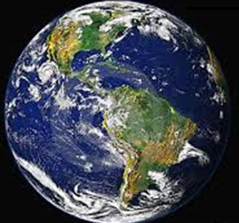

How can we protect the environment for people and animals?



**GETTING KNOWLEDGE READY**

In this module you will explore how the environment can be protected for people and animals. Firstly, let us explore some of the problems that are occurring to prevent some animals from thriving. One of the problems is that people and animals compete for the environment.

How do people and animals compete for the environment? List your thoughts and ideas below.

|  |  |
| --- | --- |
|  | How do people and animals compete for the environment? |
| 1. |  |
| 2. |  |
| 3. |  |
| 4. |  |

1. There are many examples where humans have caused animal numbers to decline or even become extinct. However, the following graph shows how the Siberian (also known as Amur) Tiger population in Russia has *increased*.

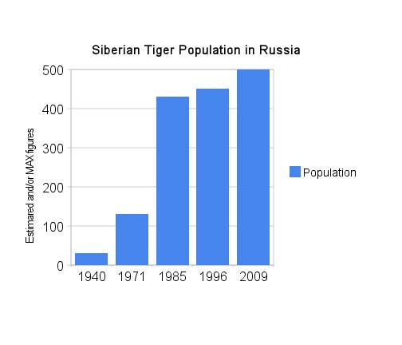

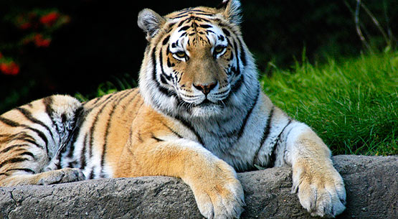

1. What do you think could be one reason that the population of Siberian tigers has *increased* in Russia?

|  |
| --- |
|  |
|  |
|  |
|  |
|  |
|  |
|  |
|  |
|  |
|  |
|  |
|  |
|  |
|  |
|  |

1. Visit the following website for more information about this incredible phenomenon.

[**http://tinyurl.com/npd4azh**](http://tinyurl.com/npd4azh)

Now let’s explore how our precious environment can be protected.

1. Find out the effects of garbage and oil pollution on marine environments through the games and puzzles at:

[**http://tinyurl.com/lgxdnar**](http://tinyurl.com/lgxdnar)

1. Now that you have an understanding of how to protect our oceans, record how people can help to protect the other environments listed. Write or draw your ideas on the following page.

|  |  |
| --- | --- |
| **Environment** | **How can it be protected?** |
| Tropical Rainforest |  |
| Deserts |  |
| Forests |  |

**REFLECTION**

1. What is the most interesting thing that you learned about protecting the environment?

|  |
| --- |
|  |
|  |
|  |
|  |
|  |
|  |
|  |
|  |
|  |
|  |
|  |
|  |
|  |
|  |
|  |