English Skills



*How can I write a clear explanation?*



**Please read before you begin**



Welcome to Module K. In this Module you will be asking yourself

‘How can I write a clear explanation?’

To help you answer this question, these are your learning intentions.

|  |  |
| --- | --- |
|  | Learning Intentions for Module K |
| Reading and Writing Workshop  Study the style and techniques used to write an explanation.  Grammar and Punctuation  Learn about nouns, verbs and adjectives.  How Words Work  Antonyms and adverbs.    Spelling and Phonics  Study your ten given spelling words as well as your own ten words for your test at the end of the Set. In phonics, you will look at the soft c and ay sound. | |

|  |  |
| --- | --- |
| Contents | |
| Set One | Reading and Writing Workshop   * Exploring the text - reading and learning about an explanation * Talk to someone at home and complete activities about an explanation   Spelling activities and Phonics   * Ten given words and ten words of your own choice * The soft c   Grammar and Punctuation   * Nouns, verbs and adjectives   How words work   * Antonyms   Spelling test   * Spell the words for this Set |
| Set Two | Reading and Writing Workshop   * Write an explanation   Spelling activities and Phonics   * Ten given words and ten words of your own choice * The ‘ay’ sound   Grammar and Punctuation   * Nouns, verbs and adjectives   How words work   * Adverbs   Spelling test   * Spell the words for this Set   Reflection   * True or false questions * Response log |

|  |  |
| --- | --- |
| books,boys,childhood,children,concentration,educates,educations,Fotolia,homework,kids,knowledge,learning,learns,males,Photographs,readings,reads,schools,students,studies | Getting Knowledge Ready |

Over the next two Sets you will be learning all about the explanation text type. This type of writing explains something to the reader. In an explanation, a lot of adjectives are used.

This is a picture of a television. In the circles describe the parts of the television the lines are pointing to.

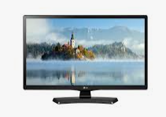



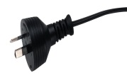

|  |
| --- |
| Set One |

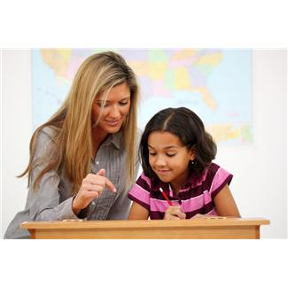

|  |  |
| --- | --- |
|  | Writing Workshop |

Explanation

An explanation text is non-fiction writing that explains how something works or happens. For example, it might explain how machines work or why storms happen.

There are two main parts to an explanation:

**The introduction to the topic.**

The details of the explanation-beginning with what happens first and ending with what happens last.

An explanation text often has diagrams that tell you the names of things that are part of the explanation. These diagrams can also have arrows to show how and where these parts move.

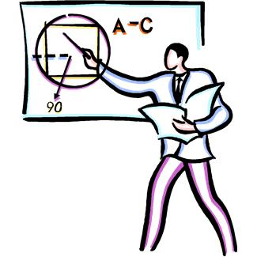

**Explanation - Mountain Climbing**

Mountain climbing is an interesting hobby for many people. However if you are considering climbing a mountain there are some things you need to know.

**What happens when you climb a tall mountain?**

The higher you climb the less oxygen there is. Climbers need to breathe deeper as they go up a mountain. It also gets colder as you climb. The path up the mountain can also become more difficult with many obstacles in the way.

**What you should remember when climbing a mountain?**

Always wear sunscreen and make sure you drink plenty of water. It’s also important to wear the right clothes. This includes clothes for warm, cold and rainy weather. Proper shoes such as hiking boots are also a good choice.

**Some recommended mountains to climb**

People have climbed many mountains around the world. Some of the most popular mountains to climb in Australia include Mt Kosciuszko, Mt Feathertop and Mt Barney.

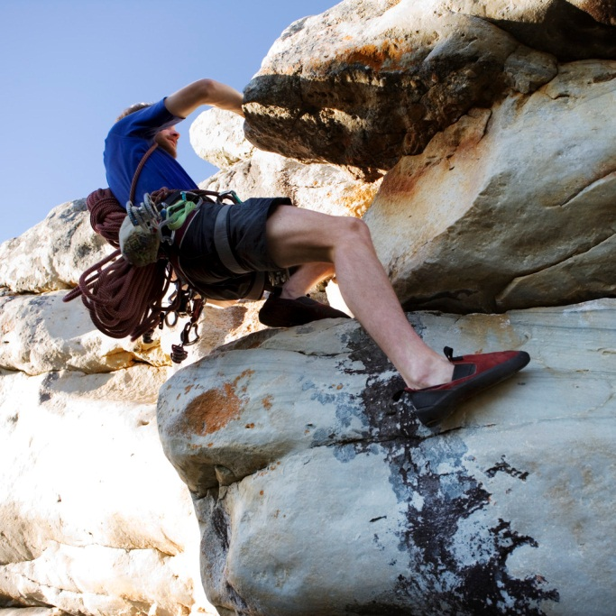

Now answer the following questions regarding this explanation.

Why do people climb mountains?

___________________________________________________________

___________________________________________________________

What happens when people get closer to the top of a mountain?

___________________________________________________________

___________________________________________________________

What type of clothes should people wear?

___________________________________________________________

___________________________________________________________

What are some names of mountains that people climb?

___________________________________________________________

___________________________________________________________

Was the explanation easy to follow?

___________________________________________________________

___________________________________________________________

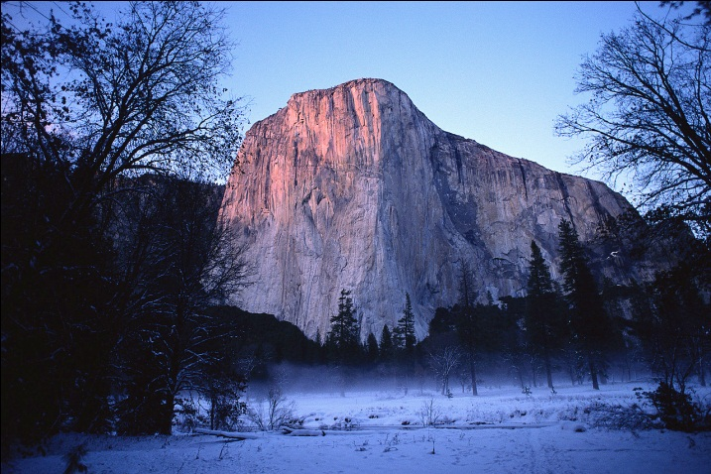

|  |  |
| --- | --- |
|  | Spelling |

Ten Spelling Words for Set One

something every believe together coming

place bounce pencil chance twice

Spelling Activities

Here are some spelling activities to help you learn your words for this Set.

1. Write the list words in alphabetical order:

___________________________________________________________

___________________________________________________________

___________________________________________________________

1. Add the missing vowels to each list word. Remember vowels are a,e,i,o and u.

s__m__th__ng __v__ry b__l__ __v__ tw__c__

1. Use a dictionary to find the meaning of these words:

pencil________________________________________________________

_____________________________________________________________

believe_______________________________________________________

_____________________________________________________________

1. Which list words go into the gaps in these sentences?
2. Billy had a ___ ___ ___ ___ ___ ___ and a paper.
3. They went to the cinema ___ ___ ___ ___ ___ ___ ___ ___.
4. The ball will ___ ___ ___ ___ ___ ___ if you throw it.
5. There is no ___ ___ ___ ___ ___ like home.



This Set we are going to be looking at the soft **c** sound. When the letter **c** is followed by ‘e’, ‘i’ or ‘y’ it usually makes an s sound as in “sing”.

Now say the word ‘city’ out loud. The ‘c’ in the word city makes a soft **c** sound and it does sound like an ‘s’!

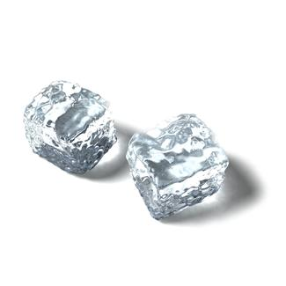

Now circle the soft **c’s** in the following words.

i c e i c i n g i c y

Read the words in the box below and write out the ones with a soft **c** sound.

|  |
| --- |
| mice take centre face  night trace bike rice |

________________ ________________ ________________

_______________ _______________

Draw a picture of the following words with the soft **c** sound.

police fence lace

|  |  |  |
| --- | --- | --- |
|  |  |  |

|  |  |
| --- | --- |
|  | Daily Reading |

Remember to do your daily reading to someone at home. Make sure you can find something enjoyable to read for a couple of minutes each day.

|  |  |
| --- | --- |
| C:\Users\jmiller\AppData\Local\Microsoft\Windows\Temporary Internet Files\Low\Content.IE5\O584SN30\MC900053962[1].WMF | Grammar and Punctuation |

Nouns and verbs are a big part of our reading and writing in English. This is why it’s important to remember what they mean and their different uses.

What is a noun?

Nouns are words used to name people, places, things and ideas. Common nouns are the general names of people, places, things, feelings and ideas. Here is an example:

The **apple** is red**.**

In this sentence ‘**apple’** is a **noun** because it is the name of a thing. Nouns are the names of many things, like bananas and apples and pieces of string.

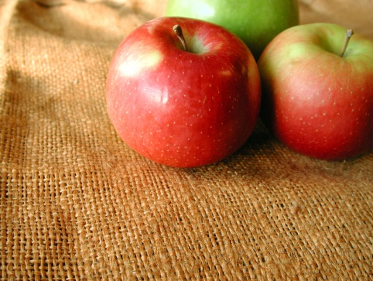

In the jokes below, circle the nouns that match the definitions in brackets. The first one is done for you.

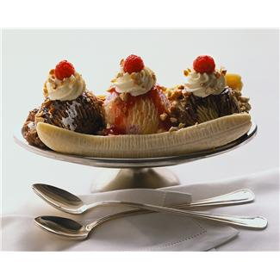

1. (a piece of fruit)

How do you make a banana split?

Cut it in half!

1. (an Australian animal)

What did the kangaroo say on New Year’s Eve?

Hoppy New Year

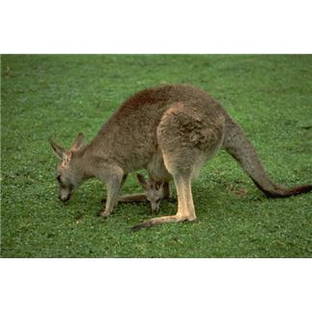

1. (a piece of clothing)

What did the hat say to the scarf?

You hang around and I’ll go on ahead!

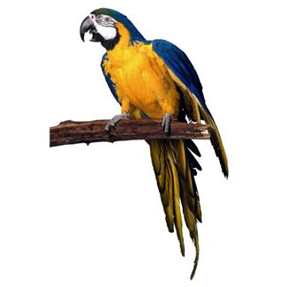

1. (a multi-legged creature) (a bird)

What do you get if you cross a centipede with a parrot?

A walkie-talkie!

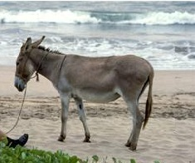

1. (an animal)

What do you call a donkey with three legs?

A wonkey!

1. (an animal) (a part of the body)

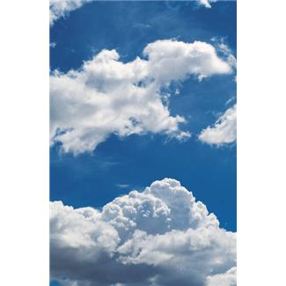

What do you call a sheep with no head and no legs?

A cloud!

1. (a vegetable)

What do you call two rows of cabbages?

A dual cabbage way!

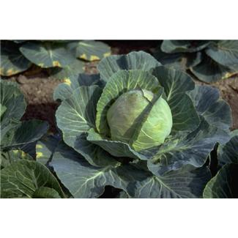

What is a verb?

Every sentence must have a verb. A verb is a word or a word group that shows what the subject of a sentence is doing, being, saying or thinking. There are many different types of verbs.

In this module we will be studying action verbs. Action verbs describe an action you can see, like kicking a ball or climbing a tree.

Use a verb pair from the box to complete each rhyme

|  |
| --- |
| pushing scratching burying cleaning riding  feeding running chatting doing came |

1. Mike was ………………. along the road, when he …………….

upon a large green toad.

1. Tommy was busy ………………. his gums, while his brother

Sam was …………………. his sums.

1. Old Rover the dog was ………………….. a bone, while his

mistress was …………………… on the telephone.

1. Mrs Snuyen was tired from …………………….. the pram,

while Suzie was happy ………………………. the lamb.

1. Fido was busy ………………… his fleas, while his master was

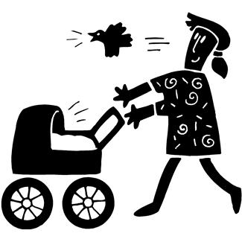

……………. away from the bees.

|  |  |
| --- | --- |
|  | How Words Work |

Antonyms are words that are opposite in meaning. They are often used to compare and contrast things. Here are some examples of antonyms.

Black and white. Hot or cold. High or down low.

1. Choose an antonym from the list to match each word.

different never early bought answer arrive

1. always _______ (b) question ________ (c) leave _____

(d) sold ________ (e) same __________ (f) late ______

Circle the two antonyms in each list

(b)

run

cake

stand

sleep

big

tree

small

snail

night

train

day

flower

eat

drink

television

grass

(d)

(c)

|  |  |  |  |
| --- | --- | --- | --- |
| It’s time for your spelling test  Give your sheet of words to your someone at home. Ask them to test your spelling of the ten words you were given to learn this Set. You might even like to practise your words once again before you have your test. | | j0226124 | |
| Spelling Words for Set One | | |
| Set One Module Words | Set One Own Words | |
| something |  | |
| every |  | |
| believe |  | |
| together |  | |
| coming |  | |
| place |  | |
| bounce |  | |
| pencil |  | |
| chance |  | |
| twice |  | |



Checklist

Please tick the tasks you have completed this Set.

* Reading and Writing workshop*—*Explanation
* Spelling activities—LCWC and own Words
* Phonics- The soft c sound
* Grammar and Punctuation —Nouns, verbs, adjectives
* How Words Work— Antonyms
* Spelling

|  |
| --- |
| End of Set One |

|  |
| --- |
| Set Two |

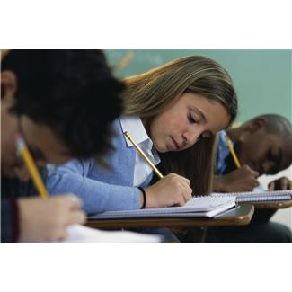

Last Set we looked at the text type of an explanation and what features it has. Here is a reminder of what’s in an explanation.

Explanation

Purpose:

To explain why things are or how they happen.

Organisation:

A statement regarding what is to be explained.

A sequence of events to state how or why it happens.

An optional concluding statement which refers back to the original statement or purpose.

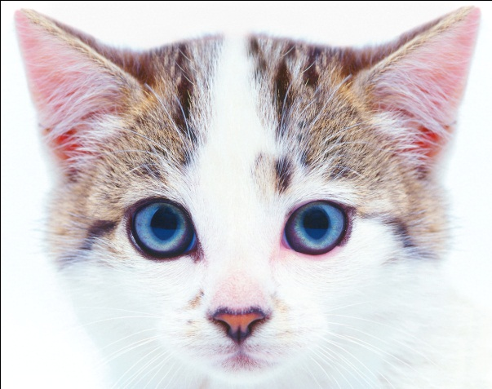

Here is another example of an explanation:

|  |
| --- |
| How Clouds Form  Introduction  You can often see clouds in the sky, but where do they come from? This text tells you.  Water Enters the Air  Water in places such as seas, lakes, rivers and ponds is always turning into a gas called water vapour. This is helped by the sun and the wind. Water vapour is invisible as it enters the air, so you cannot see it.  Warm Air Rises  If the water vapour is in warm air, it rises. You can see this with a hot-air balloon. The warm air in the balloon rises and takes the balloon with it. In nature, warm air rises and so the water vapour rises with it.  Cool Air  Air that is high in the sky is usually cooler than air near the ground. The air gets very cold where planes fly. As the warm air rises, it too gradually gets cooler which causes the water vapour to turn from a gas into very small droplets of water. This is like mist. When the water vapour does this, you begin to see it as clouds. |

Notes on style:

This explanation text has:

* The introduction, telling you what the topic is about.
* Verbs in the present tense (is helped, enters, rises).
* Words that tell the order things happen (as, when).
* Words that link causes to things that happen (so, which causes).

Now it’s your turn to write an explanation. For your explanation the topic is going to be how a computer works. You will need to include the followings things in your explanation.



Title:

What the topic of the explanation is.

Introduction:

First, you need to write a sentence about the machine and what it is used for.

Diagram:

Draw a picture of a computer and label some of the parts.

The details of the explanation:

Write a couple of sentences about how a computer works.

Conclusion: An interesting fact about a computer.

To help you in your research for your explanation, using an online kid’s search engine is recommended.

Kids.Net.Au is a safe search engine for students to use when looking for information on the internet. It has a directory of kid’s safe websites, dictionary and thesaurus as well as an encyclopaedia.

The website address is: <http://www.kids.net.au/>

|  |  |
| --- | --- |
|  | Daily Reading |

Also, remember to do your daily reading. Make sure you can find something interesting to read to someone at home for a couple of minutes each day.

Now it’s time for you to write your draft. Use the following headings and boxes to help you write your explanation.

Title:________________________________________

Introduction:

________________________________________________________________

________________________________________________________________

________________________________________________________________

________________________________________________________________

|  |
| --- |
| Diagram: |

Explanation details:

________________________________________________________________

________________________________________________________________

________________________________________________________________

________________________________________________________________

Interesting fact:

________________________________________________________________

________________________________________________________________

Now it’s time to write your final copy. You could use a Word document or PowerPoint, or write it on paper.

|  |  |
| --- | --- |
|  | Spelling, Phonics and How Words Work |

It’s time for you to learn your words for this Set. They are in your spelling activities and at the back of this Module. You also need to choose ten of your own words. Choose these words and add them to you spelling list**.**

Ten Spelling Words for Set Two

tired many knew would bought

play today holiday tray hooray

Spelling Activities

1. Write in one sentence: play holiday

___________________________________________________________

___________________________________________________________

___________________________________________________________

1. These words are written backwards. Write them correctly.

derit __ __ __ __ __ yadiloh __ __ __ __ __ __ __ wenk __ __ __ __

ynam __ __ __ __ thgoub __ __ __ __ __ __ yalp __ __ __ __

1. Go to this online kids dictionary: <http://dictionary.kids.net.au> In the search dictionary section, type in the following words below and write their meanings.

holiday__________________________________________________

_________________________________________________________

_________________________________________________________

_________________________________________________________

tired____________________________________________________

_________________________________________________________

_________________________________________________________

_________________________________________________________

1. Find smaller words in each of the list words.

many would tray play

___________ ____________ ___________ ____________

___________ ___________ ___________ ___________

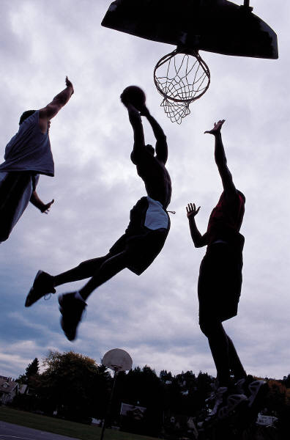

|  |  |  |  |  |  |  |
| --- | --- | --- | --- | --- | --- | --- |
| Many of our spelling words have had the **ay** sound in them.  That’s because this Set we will be looking at the **ay** sound.  Now let’s look at the word ‘pl**ay**’. If you say it out loud you will notice **ay** has a long a sound. Now let’s try putting it in a sentence.  The children like to pl**ay** the ball game.  If you say the words ‘pl**ay’** and ‘s**a**t’ , you will notice that ‘play’ has a long a sound and ‘sat’ has a short a sound.  Use the **ay** words from the box to finish the sentences.  holiday  today  tray  play  1. Let’s have a _ _ _ _ _ _ _.  2. _ _ _ _ _ is Ann’s birthday.  3. Bring the _ _ _ _ please.  4.Billy went to _ _ _ _ in the park.  Underline all the **ay** sounds in the following words:  C:\Users\jselim\Desktop\MH900384668.JPG  bay say may clay pray ray  Adverbs  What is an adverb?  An adverb gives more exact information usually about a verb and sometimes about an adjective or another adverb. Many adverbs end in ly and most answer the questions when? (time), how? (manner) or where? (place). For example: She is walking quickly (how) to arrive here (where) soon (when).   1. Write the adverb by adding ly to each adjective; e.g. slow-slowly. 2. strange ___________ (b) bright __________ (c) large ____________   (d) soft _______________ (e) final____________ (f)slow____________  early above today quickly up fast now tomorrow here happily  below sleepily soon there sadly down never often busily   1. Sort the words into three groups. Adverbs that tell how, where and when.  |  |  | | --- | --- | | How |  | | Where |  | | When |  | |

|  |  |  |  |  |
| --- | --- | --- | --- | --- |
| |  |  | | --- | --- | | C:\Users\jmiller\AppData\Local\Microsoft\Windows\Temporary Internet Files\Low\Content.IE5\O584SN30\MC900053962[1].WMF | Grammar and Punctuation |   What are adjectives?  Adjectives are describing words. They describe nouns. Adjectives can tell us about colour, size, shape, number and who owns something.  Here are some examples of adjectives: | | |
| Adjectives | What it is describing |
| black | colour |
| six | number (how many) |
| tiny | size |
| long | shape |
| my | possession |
| this | pointing |



Circle the correct adjective in brackets to complete the jokes.

1. How do you get a (baby adult) astronaut to sleep?

You rock-et.

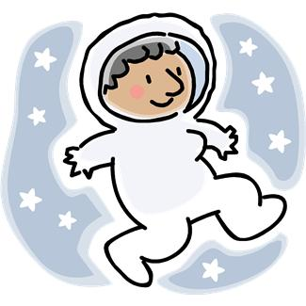

1. Why is history like a (fruit chocolate) cake?

It’s full of dates!

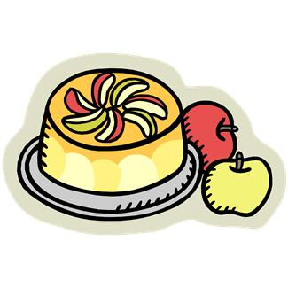

1. What did the (rubber stone) balloons say to the drawing pins?

Hiyah, busters!

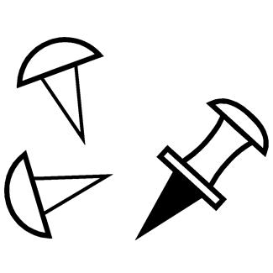

1. What do you call a girl with a (big old) tortoise on her head?

Shelley!

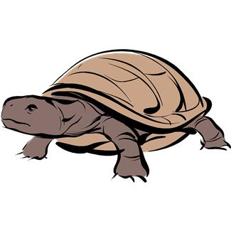

1. What do you call a cat with scratches on its nose?

Claude!

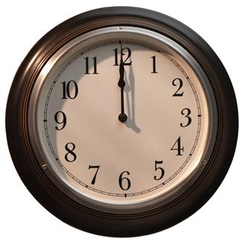

1. Why was the (dog watch) salesman bored?

He had too much time on his hands!

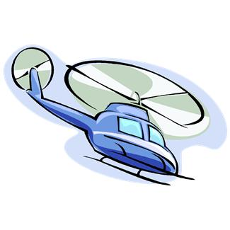

1. What’s (big tiny) grey and flies?

An elephant in a helicopter.

1. What’s tall, (yellow angry) and comes out in spring?

A giraffe-odil!

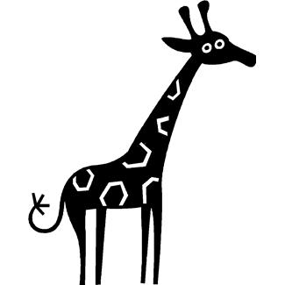

It’s time for your spelling test

Before you give your sheet of words to someone at home to test you on this Set’s words, write down some of the things you have done this Set to help you learn your words.

________________________________________________________________

________________________________________________________________

________________________________________________________________

|  |  |
| --- | --- |
| Spelling Words for Set Two | |
| Set Two Module Words | Set Two Own Words |
| tired |  |
| many |  |
| knew |  |
| would |  |
| bought |  |
| play |  |
| today |  |
| holiday |  |
| tray |  |
| hooray |  |

Reflection

|  |  |
| --- | --- |
| Text Type |  |
| An explanation sometimes has diagrams in it. | True or False |
| An explanation has an introduction and a sequence of events. | True or False |
| Spelling and Phonics |  |
| The **ay** sound is a long vowel sound. | True or False |
| Text and Grammar Skill |  |
| Adjectives are describing words. | True or False |
| Verbs are doing words. | True or False |
| How Words Work |  |
| Antonyms are words that have the opposite meaning. | True or False |

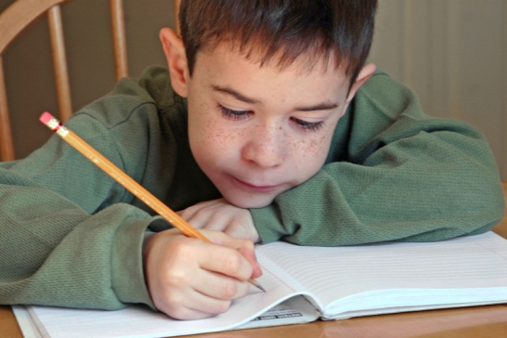

Response Log

Think about what you have learned in this module.

 What I learnt about in this module was…

**________________________________________________________________**

**________________________________________________________________**

**________________________________________________________________**

****Something that I found challenging was…..

**________________________________________________________________**

**________________________________________________________________**

**________________________________________________________________**

Draw a face which shows how well you feel you have done with this module.

Checklist

Please tick the tasks you have completed this Set.

* Reading and Writing workshop*—*Write your own Explanation
* Spelling activities—LCWC and own Words
* Phonics- The ‘ay’ sound
* Grammar and Punctuation —Nouns, verbs and adjectives
* How Words Work— Adverbs
* Spelling test

|  |
| --- |
| End of Set 2 |

|  |
| --- |
| **YOUR QUESTIONS OR COMMENTS** |