Mathematics



*How are fractions helpful?*

**

**About Mathematics**

1. **Focus**

|  |  |
| --- | --- |
| This is when I tell you what you will be doing! | S21570467708050209410 |

2. **Introduction**

|  |
| --- |
| During the discussion you will learn the how, why, what and when of the maths topic.  S21570467708050209430000000 |

**Did you know?**

|  |  |
| --- | --- |
| Find out interesting facts about the topic you are studying! You will find this located at the end of each day. | DidYouKnow |

To the supervisor

**Correcting your child’s work**

It is recommended for the supervisor to check and correct a student’s maths work. There are advantages in doing this.

* It provides positive reinforcement on the spot.
* If there is a difficulty with some of the work, it can be explained whilst fresh in your child's mind.
* Useful and positive discussion will take place on certain aspects of the work.

# How to go about it

1. Always ✓ things that are correct as this gives positive feedback to your student. Be generous with both spoken and written comments praising fine effort, showing calculations and progress.
2. If your child has made an error, discuss how and why the error was made and encourage him or her to have another go. (Rather than cross out and go over incorrect calculations it is often best to make a fresh start.)

|  |  |
| --- | --- |
| Contents | |
| 1 | Learn the language of fractions.  Place fractions on a number line.  Identify halves, quarters, thirds and fifths. |
| 2 | Writing whole numbers as fractions.  Working out the order of fractions with different denominators. |
| 3 | Reading, writing and ordering numerals to 5 digits.  Placing 5 digit numerals on a number line. |
| 4 | Identifying different counting patterns.  Finding missing numerals in a counting pattern.  Making up counting patterns. |
| 5 | Revision of concepts. |

|  |  |
| --- | --- |
| 6 | Labelling 3 dimensional objects showing length, width and depth.  Counting the number of faces and vertices on 3 dimensional objects. |
| 7 | Identifying the rule in a counting pattern and using it in everyday life examples. |
| 8 | Using different strategies for addition and subtraction.  Turning addition equations into subtraction equations using the same numbers. |
| 9 | Ordering numerals up to 5 place values.  Adding and subtracting different place value amounts. |
| 10 | Revision of concepts. |

**Mathematics**

***“How are fractions helpful?"***

**You will learn to:**

**Fractions**

* Review the language associated with fractions.
* Place fractions on a given number line.
* Write whole number as fractions.
* Write fractions in order from smallest to largest.

**Number**

* Recognise numbers with place value to 5 digits.
* Identify the value of a digit in a 5 digit numeral.
* Place different size numbers on a number line.
* Identify and create different counting pattern.
* Find the rule of a counting pattern.
* Apply mathematical rules to problems with number words.
* Identify strategies that can be used to solve addition and subtraction problems.

**Shapes**

* Find the length, width and depth of 3 D objects.
* Identify the faces and vertices of a 3 D object.

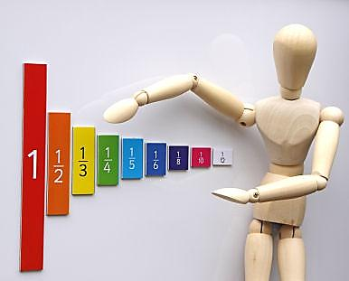

# 1

## Focus

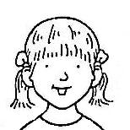

You will learn about fractions.

What is a fraction?

**Introduction**

Fractions are ***equal*** parts of a whole.

A fraction is a part of something whole. In maths it is a number.

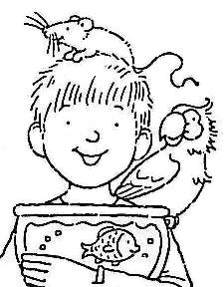

Can you name some fractions? Here is one fraction that you will know.

|  |  |  |
| --- | --- | --- |
| Look at the circle. |  | 1 part out of 2 parts has been shaded.  We say that **one half** of the circle is shaded. The part of the circle shaded is a fraction. The fraction is **one half**.  We write one half like this: |

**How do we write a fraction?**

Look at some examples:

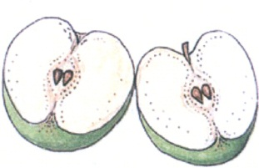

|  |  |  |  |  |
| --- | --- | --- | --- | --- |
| appleIf you cut an apple in two, each part of the apple is | 1 apple | an apple  an apple |  | This number is called the **numerator**. |
| This number is called the **denominator**. |

The word for  is **one-half**.

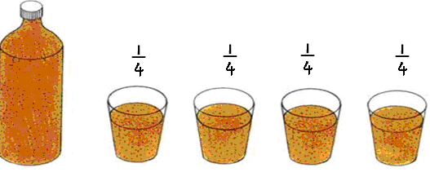

|  |  |
| --- | --- |
| If you pour a bottle of drink equally into four glasses, each glass will contain  of the bottle. |  |

Source: Macquarie Net



## This number is called the numerator.

## 

## This number is called the denominator.

## The word for is one-quarter.

|  |  |
| --- | --- |
| MC900001265[1] | Here is a pizza that needs to be divided amongst 3 people. Each person will get **one third** of the pizza.  It is written like this: |

## Activity 1

**bd06121_**

**For you to do**

You have learned that two halves make one whole and that four

quarters make one whole.

Write on the line below whether each shape is cut into **halves** or **quarters**.

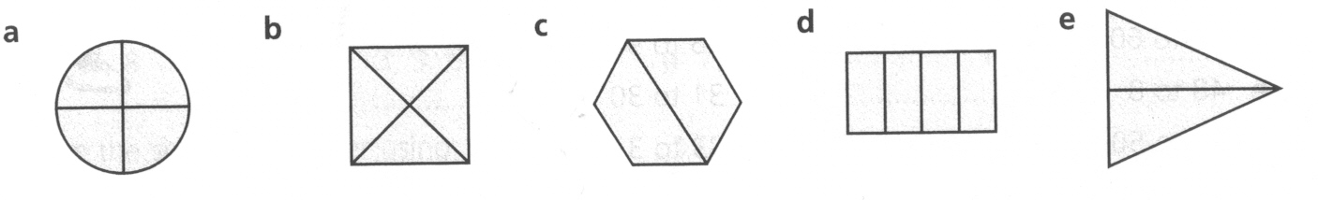

\_\_\_\_\_\_\_\_\_\_\_\_\_ \_\_\_\_\_\_\_\_\_\_\_\_ \_\_\_\_\_\_\_\_\_\_\_ \_\_\_\_\_\_\_\_\_\_\_ \_\_\_\_\_\_\_\_\_\_\_

|  |
| --- |
| Colour in **one- half** of each shape.  day1  Colour in **one-quarter** of each shape.  day1 |

|  |
| --- |
| How much of each shape is shaded? Write  or  under each shape.  day1 |

## Activity 2

**bd06121_**

**For you to do**

You will need:

* Counters (e.g. buttons or shells or pasta)
* *Maths Activity Book*

Now you are going to do some “pizza” fractions. Remove the sheet headed *Day 1 – Pizza maths* in your *Maths Activity Book.* Cut out the pizza and place on your desk. Put the counters next to the pizza. The counters will be the pepperoni. Look at the example below.

Fred and Tina cut their pizza in **half.** Put **10 pepperoni** on the pizza so that each side has the same amount.

**What is half of 10?**

|  |  |
| --- | --- |
|  | Now count how many pepperoni on each **half**. What is **half** of 10? |

**Now it is your turn.**

1. Bob and Pam cut their pizza in half. Put 8 pepperoni on so that they each have the same amount.

**What is half of 8?** \_\_\_\_\_\_\_\_\_\_\_\_\_\_\_\_\_\_\_\_\_\_\_\_\_\_\_

1. Bob and Pam cut their pizza in half. Put 12 pepperoni on so that they each have the same amount.

**What is half of 12?** \_\_\_\_\_\_\_\_\_\_\_\_\_\_\_\_\_\_\_\_\_\_\_\_\_\_\_

1. Bob and Pam cut their pizza in half. Put 20 pepperoni on so that they each have the same amount.

**What is half of 20?** \_\_\_\_\_\_\_\_\_\_\_\_\_\_\_\_\_\_\_\_\_\_\_\_\_\_\_

**Activity 2 continued**

1. Bob and Pam cut their pizza in half. Put 6 pepperoni on so that they each have the same amount.

**What is half of 6?** \_\_\_\_\_\_\_\_\_\_\_\_\_\_\_\_\_\_\_\_\_\_\_\_\_\_\_

1. Bob and Pam cut their pizza in half. Put 4 pepperoni on so that they each have the same amount.

**What is half of 4?** \_\_\_\_\_\_\_\_\_\_\_\_\_\_\_\_\_\_\_\_\_\_\_\_\_\_\_

## Activity 3

**bd06121_**

**For you to do**

Below is a number line for fractions less than 1. It has been divided up into \_\_\_\_\_\_ equal sized groups. Write the correct fraction that each letter stands for by choosing from these: , , ,

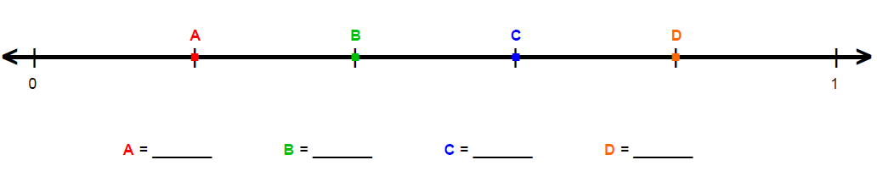

**Activity 3 continued**

Here are some fraction puzzles for you to solve.

1. Which would be the larger piece,  or  of the pizza?

Look at the picture and explain your answer on the lines below.

|  |  |
| --- | --- |
| pp | \_\_\_\_\_\_\_\_\_\_\_\_\_\_\_\_\_\_\_\_\_\_\_\_\_\_\_\_\_\_\_\_\_\_\_\_\_\_\_\_\_\_\_\_\_  \_\_\_\_\_\_\_\_\_\_\_\_\_\_\_\_\_\_\_\_\_\_\_\_\_\_\_\_\_\_\_\_\_\_\_\_\_\_\_\_\_\_\_\_\_  \_\_\_\_\_\_\_\_\_\_\_\_\_\_\_\_\_\_\_\_\_\_\_\_\_\_\_\_\_\_\_\_\_\_\_\_\_\_\_\_\_\_\_\_\_ |

1. In the fraction  the numerator is \_\_\_\_\_\_\_\_\_ and the denominator is \_\_\_\_\_\_\_\_\_.
2. Write a fraction in which 6 is the numerator and 10 is the

denominator. \_\_\_\_\_\_\_\_\_ .

1. This pizza is cut into 8 pieces. Which would be a larger piece,  or  of the pizza? Explain your answer on the lines below.

|  |  |
| --- | --- |
| p | \_\_\_\_\_\_\_\_\_\_\_\_\_\_\_\_\_\_\_\_\_\_\_\_\_\_\_\_\_\_\_\_\_\_\_\_\_\_\_\_\_\_\_\_\_\_  \_\_\_\_\_\_\_\_\_\_\_\_\_\_\_\_\_\_\_\_\_\_\_\_\_\_\_\_\_\_\_\_\_\_\_\_\_\_\_\_\_\_\_\_\_\_  \_\_\_\_\_\_\_\_\_\_\_\_\_\_\_\_\_\_\_\_\_\_\_\_\_\_\_\_\_\_\_\_\_\_\_\_\_\_\_\_\_\_\_\_\_\_ |

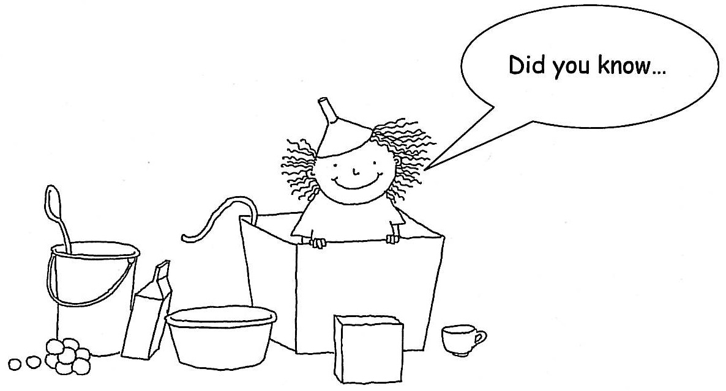

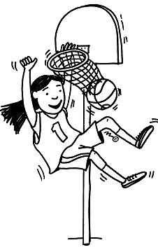

|  |  |
| --- | --- |
| …when you play sport, time is divided into fractions. Games such as football and basketball have time or time. |  |

**2**

## Focus

You will explore **fractions** further.

## 1

Any part of a group can be written as a fraction of the **whole** group.

## Introduction

Two equal parts out of nine. You can write this as .

Three quarters means **three** out of **four equal parts.**



What fraction (part) of this hexagon is shaded?

**6** pieces out of **6** pieces are shaded.

We can write this as .

This is a whole hexagon not a part so we can also write it as 1.

So  is the same as 1, or  = 1.

*When the numerator equals the denominator it is 1 whole.*

## Activity 1

**bd06121_**

**For you to do**

Can you write two more whole numbers in the same way?

I have done some for you.

   \_\_\_\_\_ \_\_\_\_\_

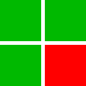

Look at this square.

It is divided into **4** parts.

The red part is **1** piece out of **4**.

Here’s how we write it: .

How would you write the green part of the square? \_\_\_\_\_\_

## Which is bigger? or \_\_\_\_\_\_\_\_\_\_\_\_\_

Put these fractions in order from biggest to smallest:  ,, 

\_\_\_\_\_\_\_ \_\_\_\_\_\_\_\_ \_\_\_\_\_\_\_\_

## Activity 2

**bd06121_**

**For you to do**

**Make some fractions.**

You will need: coloured strips of paper

**Step 1**

Take a strip of coloured paper. Fold it in half.

|  |  |
| --- | --- |
|  |  |

**Step 2**

With another piece of paper fold it into quarters.

|  |  |  |  |
| --- | --- | --- | --- |
|  |  |  |  |

**Step 3**

Fold another strip of paper into 3 equal parts. Each part is called a **third.** We write a third like this 

|  |  |  |
| --- | --- | --- |
|  |  |  |

**Step 4**

Fold another strip of paper into 5 equal parts. Each part is called a **fifth.** We write a fifth like this

|  |  |  |  |  |
| --- | --- | --- | --- | --- |
|  |  |  |  |  |

**Step 5**

Lay your strips out on a table under each other. Use them to answer these questions.

1. Look at the half and quarter strips. Is one half larger or smaller than one quarter? \_\_\_\_\_\_\_\_\_\_\_\_\_\_\_\_\_\_\_\_

2. How many quarters in one half? \_\_\_\_\_\_\_\_\_\_\_\_\_\_\_\_\_\_\_\_\_\_\_\_\_\_\_\_\_\_\_\_\_\_

3. Circle the bigger fraction: **** or

4. Circle the bigger fraction: or

5. Circle the bigger fraction: or 

## Activity 3

**bd06121_**

**For you to do**

Finish off the day with a game of **Snap.**

**You will need:**

Fraction cards in your *Maths Activity Book* and a partner.

**Setting up:**

* remove the sheet headed *Day 2 – Fractions SNAP* from your *Maths Activity Book.*
* share the cards equally between each player, making sure you place them face down
* Each player places their cards into a pack in front of them.
* The object of the game is to win all the cards.

**Instructions:**

* The first player lifts the card from the top of his pack placing it **face up** on the table in front of him.
* The next player does the same.
* At anytime during the game that a player sees two cards that are the same he calls “SNAP”.

**For example:**

These two cards are the same say “SNAP”.

|  |  |  |
| --- | --- | --- |
| one half |  |  |

These two cards are the same so “SNAP “.

|  |  |  |  |  |  |  |
| --- | --- | --- | --- | --- | --- | --- |
|  |  | |  |  | | --- | --- | |  |  | |  |  | |

* The first player to call SNAP takes all the cards in the pile and places them face down under his own pack.
* When a player has no more cards he is out of the game but the remaining players continue to play.
* The winner is the player with all the cards at the end.



…that the **horizontal fraction bar** was introduced by the Arabs. Fibonacci (c.1175-1250) was the first European mathematician to use the fraction bar as it is used today. Fibonacci used the Latin word *virga* for the horizontal fraction bar

Horizontal fraction bar / vinculum 

# 3

**Focus**

You will learn about whole numbers up to 5 digits and place value.

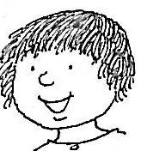

What is place value?

## Introduction

Digits are grouped together to make smaller or larger numbers.



The numbers have a place according to their value.

**Look at the placing of numbers.**

**Revise!**

Look at the number 41. It has 2 digits. It is made up of 4 lots of 10 and 1 left over.

|  |  |  |
| --- | --- | --- |
| The 4 lots of 10 are called 4 *tens*. | **41** | We call the 1 left over a *unit*. |
| So what is the value of the 4 in 41? It is 4 × 10 which equals 40. | So what is the value of the 1 in 41? It is 1 × 1 which equals 1. |

**Introduction continued**

Now look at a *5 digit* number in the same way.

**12364**

|  |  |  |  |  |
| --- | --- | --- | --- | --- |
| What is the value of the  1? It is  1 × 10000 which equals 10000. | What is the value of the  2? It is  2 × 1000 which equals 2000. | What is the value of the  3? It is  3 × 100 which equals 300. | What is the value of the  6? It is 6 × 10 which equals 60. | What is the value of the 4? It is 4× 1 which is 4. |

Now look at the number 12364 in a different way. What is each digit worth? We read the numbers from left to right. In this activity you will be looking at each part of the number from right to left.

|  |  |  |  |
| --- | --- | --- | --- |
| 1 digit | 4 | 4 units |  |
|  |  |  |  |
| 2 digits | 64 | 6 tens  4 units | tens2tens2tens2 |
|  |  |  |  |
| 3 digits | 364 | 3 hundreds  6 tens  4 units | MAB%20100MAB%20100MAB%20100tens2tens2tens2 |

|  |  |  |  |
| --- | --- | --- | --- |
| **Introduction continued** | | | |
| 4 digits | 2364 | 2 thousands  3 hundreds  6 tens  4 units | MAB%201000  MAB%20100  MAB%20100MAB%20100  MAB%201000  **tens2tens2tens2** |
|  | | | |
| 5 digits | 12364 | 1 ten thousand  2 thousands    3 hundreds  6 tens  4 units | MAB%201000  MAB%201000MAB%201000MAB%201000MAB%201000MAB%201000MAB%201000MAB%201000MAB%201000MAB%201000MAB%201000MAB%201000  MAB%20100MAB%20100MAB%20100  **tens2tens2tens2** |
|  | | | |
| digitday3Activity 1 **bd06121_**  **For you to do**  Source: Victorian  How many digits in each?  423 \_\_\_\_\_\_\_ 50 \_\_\_\_\_\_\_ 3115 \_\_\_\_\_\_\_  Write the largest number using:  3, 7, 5 \_\_\_\_\_ 2, 8, 1 \_\_\_\_\_ 9, 0, 2 \_\_\_\_\_  Write the smallest number using:  4, 2, 7 \_\_\_\_\_ 6, 1, 0 \_\_\_\_\_ 8, 4, 2 \_\_\_\_\_  Write **3** possible numbers using these 5 digits **once each:**  1, 3, 6, 4, 2  For example 63124:  \_\_\_\_\_\_\_\_\_\_\_\_\_\_\_\_\_\_\_ \_\_\_\_\_\_\_\_\_\_\_\_\_\_\_\_\_\_\_\_ \_\_\_\_\_\_\_\_\_\_\_\_\_\_\_\_\_\_\_  Order the following numbers from smallest to largest:  324, 51, 19, 5, 767, 23612, 1042  \_\_\_\_\_\_\_\_\_\_\_\_\_\_\_\_\_\_\_\_\_\_\_\_\_\_\_\_\_\_\_\_\_\_\_\_\_\_\_\_\_\_\_\_\_\_\_\_\_\_\_\_\_\_\_\_\_\_\_\_\_\_\_\_\_  Rule lines to show where these numbers sit on the number line below.  One has already been done for you.   |  |  |  |  |  | | --- | --- | --- | --- | --- | | 2000 | 3100 | 3900 | 1250 | 4800 | | | | |
| Complete the table by writing in the spaces.   |  |  |  | | --- | --- | --- | | **Number** | **Words** | **Value of the underlined digit** | | 2940 |  | 40 | | 6954 |  |  | | 25091 | Twenty-five thousand and ninety one |  | |  | Ninety-seven thousand six hundred and eight | 7 000 |   MC900441498[1]  **Can you guess the number?**  I am an even number between 3000 and 4000. All of my digits are different. The digits in the hundreds and tens place value are both odd. I am less than three thousand seven hundred and fifty four but more than three thousand seven hundred and fifty. My number is: \_\_\_\_\_\_\_\_\_\_  **Optional**   |  | | --- | | Practise what you have learned today using a computer.  <http://www.teachers.ash.org.au/jeather/maths/dictionary.html>  Click on: **Pp** then **Place value** |   Look through the newspaper and junk mail catalogues and find some 4 or 5 digit numbers. Cut and paste them onto paper and send them to your teacher.  DidYouKnow  …the place value system was developed in India in 100 BC. They introduced zero and the base 10 system.  Place value is the idea that, where the digit sits in a number says something about its value. It makes addition easy as you can line up the numbers so that their place values line up too. | | | |

# 4

|  |  |  |  |  |  |  |  |  |  |  |  |  |  |  |  |  |  |  |  |  |  |  |  |  |  |  |  |  |  |  |  |  |  |  |  |  |  |  |  |  |  |  |  |  |  |  |  |  |  |  |  |
| --- | --- | --- | --- | --- | --- | --- | --- | --- | --- | --- | --- | --- | --- | --- | --- | --- | --- | --- | --- | --- | --- | --- | --- | --- | --- | --- | --- | --- | --- | --- | --- | --- | --- | --- | --- | --- | --- | --- | --- | --- | --- | --- | --- | --- | --- | --- | --- | --- | --- | --- | --- |
| Focus S21570467708050209402  You will be skip-counting by numbers of increasing size.  Skip counting is counting forwards or backwards in multiples or intervals of a given number.  Look back at skip counting by 2 in Module A on Day 6. Introduction Skip counting makes a pattern.    Here is an example of counting by 2’s.  Now you finish the pattern.   |  |  |  |  |  |  |  |  |  |  | | --- | --- | --- | --- | --- | --- | --- | --- | --- | --- | | 1 | 2 | 3 | 4 | 5 | 6 | 7 | 8 | 9 | 10 | | 11 | 12 | 13 | 14 | 15 | 16 | 17 | 18 | 19 | 20 | | 21 | 22 | 23 | 24 | 25 | 26 | 27 | 28 | 29 | 30 | | 31 | 32 | 33 | 34 | 35 | 36 | 37 | 38 | 39 | 40 | | 41 | 42 | 43 | 44 | 45 | 46 | 47 | 48 | 49 | 50 | | |
|  |  |
| **Activity 1**  **bd06121_ For you to do**  Skip count by 3. Start with 3 and colour in the squares. It has been started for you. Can you see a pattern?   |  |  |  |  |  |  |  |  |  |  | | --- | --- | --- | --- | --- | --- | --- | --- | --- | --- | | **1** | **2** | **3** | **4** | **5** | **6** | **7** | **8** | **9** | **10** | | **11** | **12** | **13** | **14** | **15** | **16** | **17** | **18** | **19** | **20** | | **21** | **22** | **23** | **24** | **25** | **26** | **27** | **28** | **29** | **30** | | **31** | **32** | **33** | **34** | **35** | **36** | **37** | **38** | **39** | **40** | | **41** | **42** | **43** | **44** | **45** | **46** | **47** | **48** | **49** | **50** | | **51** | **52** | **53** | **54** | **55** | **56** | **57** | **58** | **59** | **60** | | **61** | **62** | **63** | **64** | **65** | **66** | **67** | **68** | **69** | **70** | | **71** | **72** | **73** | **74** | **75** | **76** | **77** | **78** | **79** | **80** | | **81** | **82** | **83** | **84** | **85** | **86** | **87** | **88** | **89** | **90** | | **91** | **92** | **93** | **94** | **95** | **96** | **97** | **98** | **99** | **100** | | |
| **Activity 1 continued**   |  |  |  |  |  |  |  |  |  |  | | --- | --- | --- | --- | --- | --- | --- | --- | --- | --- | | **1** | **2** | **3** | **4** | **5** | **6** | **7** | **8** | **9** | **10** | | **11** | **12** | **13** | **14** | **15** | **16** | **17** | **18** | **19** | **20** | | **21** | **22** | **23** | **24** | **25** | **26** | **27** | **28** | **29** | **30** | | **31** | **32** | **33** | **34** | **35** | **36** | **37** | **38** | **39** | **40** | | **41** | **42** | **43** | **44** | **45** | **46** | **47** | **48** | **49** | **50** | | **51** | **52** | **53** | **54** | **55** | **56** | **57** | **58** | **59** | **60** | | **61** | **62** | **63** | **64** | **65** | **66** | **67** | **68** | **69** | **70** | | **71** | **72** | **73** | **74** | **75** | **76** | **77** | **78** | **79** | **80** | | **81** | **82** | **83** | **84** | **85** | **86** | **87** | **88** | **89** | **90** | | **91** | **92** | **93** | **94** | **95** | **96** | **97** | **98** | **99** | **100** |   Make your own skip counting pattern. Fill in this sentence before you begin to cross out the squares.  I am skip counting by \_\_\_\_\_\_\_\_\_\_\_\_on the hundreds chart below.  I am starting with number \_\_\_\_\_\_\_\_\_\_\_\_.  **Activity 2**  **bd06121_ For you to do**  Remove the sheet headed *Day 4 – Number chart* from your *Maths Activity Book* or use the number chart above.  Count by three.  4, 7, 10, \_\_\_\_\_\_\_\_\_\_\_ , \_\_\_\_\_\_\_\_\_\_\_ , \_\_\_\_\_\_\_\_\_\_\_  52, 55, 58, \_\_\_\_\_\_\_\_\_\_\_ , \_\_\_\_\_\_\_\_\_\_\_ , \_\_\_\_\_\_\_\_\_\_\_\_ Activity 2 continued What number are you counting by each time? The first one has been done for you.  39, 42, 45, 48, 51 by 3  21, 25, 29, 33, 37; \_\_\_\_\_\_\_\_  33, 38, 43, 48, 53; \_\_\_\_\_\_\_\_  Count backwards by 2  72, 70, 68, 66, \_\_\_\_, \_\_\_\_, \_\_\_\_, 58  136, 134, 132, \_\_\_\_, \_\_\_\_, \_\_\_\_, 124  Count forwards by 2  81, 83, 85, 87, \_\_\_\_, \_\_\_\_, \_\_\_\_, 95  56, 58, 60, 62, \_\_\_\_, \_\_\_\_, \_\_\_\_, 70  Complete each counting pattern.  42, 45, 48, \_\_\_\_, 54, 57, \_\_\_\_, \_\_\_\_  71, 75, 79, \_\_\_\_, 87, \_\_\_, \_\_\_\_, 99  **Activity 3**  **bd06121_ For you to do**   |  |  |  |  |  |  | | --- | --- | --- | --- | --- | --- | |  |  |  |  |  |  |  |  |  |  |  |  |  | | --- | --- | --- | --- | --- | --- | |  |  |  |  |  |  |   Use what you have learnt with skip counting and the dice above to answer these facts. Remember “x” means multiply / times or “lots of”. So 5 lots of 3 is 5 x 3 = 15  6 x 3 = \_\_\_\_\_\_\_ 1 x 3 = \_\_\_\_\_\_\_ 4 x 3 = \_\_\_\_\_\_\_  10 x 3 = \_\_\_\_\_\_\_ 2 x 3 = \_\_\_\_\_\_\_ 11 x 3 = \_\_\_\_\_\_\_  5 x 3 = \_\_\_\_\_\_\_ 7 x 3 = \_\_\_\_\_\_\_ 9 x 3 = \_\_\_\_\_\_\_  12 x 3 = \_\_\_\_\_\_\_ 8 x 3 = \_\_\_\_\_\_\_ 3 x 3 = \_\_\_\_\_\_\_  **Activity 4**  **bd06121_Patterns with sticks**  You will need about 40 icy-pole sticks or toothpicks  Step 1: Make a square from your sticks. How many sticks did you need to make 1 square? \_\_\_\_\_\_  Step 2: Join another square onto the first square. How many sticks in total did you need to make the 2nd square? \_\_\_\_\_\_  Step 3: Continue the square pattern. Count up the number of sticks as you go and record your answers in the table on the next page.  Fill in the table   |  |  |  |  |  |  |  |  |  | | --- | --- | --- | --- | --- | --- | --- | --- | --- | | Square | 1st | 2nd | 3rd | 4th | 5th | 6th | 7th | 8th | | Total sticks used | 4 |  |  |  |  |  |  |  |   Can you work out the rule for the pattern?  **Hint:** it involves 2 different mathematical operations!  **Challenge:**  How many sticks would be needed so 12 squares had been constructed.  **Optional**  Test yourself  How fast can you count? Skip counting is much quicker than by 1s.  **You will need**   * a ball   **Instructions**   * Skip count to the bounce of the ball. See if you can get to 100. * Count by 2s and time yourself * Count by 5s, 10s and as many other patterns as you can   DidYouKnow  …learning about patterns starts when you are very young? There are the physical patterns, such as clap, clap, stomp, and there are repetitive actions in songs, such as "Hokey Pokey”.  Skip counting is also used in playground chants such as “*2, 4, 6, 8, Who do we appreciate*?” | |

# 5

MC900078748[1]

## Focus

You will revisethework covered.

**Completing the work**

|  |
| --- |
| **Looking Back**  Test your knowledge on work covered.  Complete without the assistance of your supervisor.  When you have completed your work ask your supervisor to correct your work and discuss any problems. |

|  |
| --- |
| Comments Did you have any problems? yes/no  Did you find the work easy? yes/no  What do you need help with? |

1. Order the following numbers from smallest to largest.

15302, 5317, 925, 384, 47211

\_\_\_\_\_\_\_\_\_\_\_\_\_\_\_\_\_\_\_\_\_\_\_\_\_\_\_\_\_\_\_\_\_\_\_\_\_\_\_\_

\_\_\_\_\_\_\_\_\_\_\_\_\_\_\_\_\_\_\_\_\_\_\_\_\_\_\_\_\_\_\_\_\_\_\_\_\_\_\_\_

1. Circle the *hundreds* and underline the *tens* in the

following numbers.

53821, 362, 2790, 101, 28, 80297

1. What is the value of 4 in the following numbers? I have completed the first one for you.

2497 four hundred 400

94211 \_\_\_\_\_\_\_\_\_\_\_\_\_\_\_\_ \_\_\_\_\_\_\_\_\_

214 \_\_\_\_\_\_\_\_\_\_\_\_\_\_\_\_ \_\_\_\_\_\_\_\_\_

3146 \_\_\_\_\_\_\_\_\_\_\_\_\_\_\_\_ \_\_\_\_\_\_\_\_\_

1. Write the numeral for the number shown on each abacus.

Each hoop stands for one. The first one has been done.

|  |  |  |
| --- | --- | --- |
| abc1a  1 59 4 | abc2a \_\_\_\_\_\_\_\_\_\_\_\_\_\_ | abc3a \_\_\_\_\_\_\_\_\_\_\_\_\_\_ |
| abc4a  \_\_\_\_\_\_\_\_\_\_\_\_\_\_\_ | abc5a \_\_\_\_\_\_\_\_\_\_\_\_\_\_\_ | abc6a \_\_\_\_\_\_\_\_\_\_\_\_\_\_\_ |

1. How many tens and how many units. The first one has been done

|  |  |  |  |  |
| --- | --- | --- | --- | --- |
| 256 | 5 | tens | 6 | units |
|  | | | | |
| 590 |  | tens |  | units |
|  | | | | |
| 477 |  | tens |  | units |
|  | | | | |
| 305 |  | tens |  | units |

Complete the following skip counting.

2, 4, 6, \_\_\_\_\_ \_\_\_\_\_ \_\_\_\_\_

7, 9, 11, \_\_\_\_\_ \_\_\_\_\_\_ \_\_\_\_\_\_

108, 110, 112, \_\_\_\_\_ \_\_\_\_\_ \_\_\_\_\_

1951, 1953, 1955, \_\_\_\_\_ \_\_\_\_ \_\_\_\_

1097, 1099, \_\_\_\_\_ \_\_\_\_ \_\_\_\_ \_\_\_\_

1. How can you tell if a number is even or odd? Draw a picture or write a sentence to explain. You can make up your own example.

**Pizza maths**

How many pieces of pizza? \_\_\_\_\_\_\_\_\_\_\_\_\_

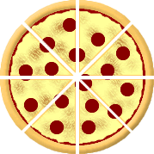

Write it as a fraction using a numerator and a denominator.

\_\_\_\_\_\_\_\_\_\_\_\_\_\_

What fraction of the pizza is 2 pieces? \_\_\_\_\_\_\_\_\_\_\_\_\_\_\_

What fraction of the pizza is 4 pieces? \_\_\_\_\_\_\_\_\_\_\_\_\_\_\_

If you ate 2 pieces what fraction would be left? \_\_\_\_\_\_\_\_\_\_\_\_\_\_\_

Divide this shape into 3 equal Divide this shape into 6 equal

parts and colour **** parts and colour 

## Comments

Did you have any difficulties? Was it too easy? Did you need assistance? Were the instructions easy to follow? I’d like to know how you managed with your Week 1 work.

**\_\_\_\_\_\_\_\_\_\_\_\_\_\_\_\_\_\_\_\_\_\_\_\_\_\_\_\_\_\_\_\_\_\_\_\_\_\_\_\_\_\_\_\_\_\_\_\_\_\_\_\_\_\_\_\_\_\_\_\_\_\_\_\_\_\_**

**\_\_\_\_\_\_\_\_\_\_\_\_\_\_\_\_\_\_\_\_\_\_\_\_\_\_\_\_\_\_\_\_\_\_\_\_\_\_\_\_\_\_\_\_\_\_\_\_\_\_\_\_\_\_\_\_\_\_\_\_\_\_\_\_\_\_**

**\_\_\_\_\_\_\_\_\_\_\_\_\_\_\_\_\_\_\_\_\_\_\_\_\_\_\_\_\_\_\_\_\_\_\_\_\_\_\_\_\_\_\_\_\_\_\_\_\_\_\_\_\_\_\_\_\_\_\_\_\_\_\_\_\_\_**

**\_\_\_\_\_\_\_\_\_\_\_\_\_\_\_\_\_\_\_\_\_\_\_\_\_\_\_\_\_\_\_\_\_\_\_\_\_\_\_\_\_\_\_\_\_\_\_\_\_\_\_\_\_\_\_\_\_\_\_\_\_\_\_\_\_\_**

**\_\_\_\_\_\_\_\_\_\_\_\_\_\_\_\_\_\_\_\_\_\_\_\_\_\_\_\_\_\_\_\_\_\_\_\_\_\_\_\_\_\_\_\_\_\_\_\_\_\_\_\_\_\_\_\_\_\_\_\_\_\_\_\_\_\_**

**\_\_\_\_\_\_\_\_\_\_\_\_\_\_\_\_\_\_\_\_\_\_\_\_\_\_\_\_\_\_\_\_\_\_\_\_\_\_\_\_\_\_\_\_\_\_\_\_\_\_\_\_\_\_\_\_\_\_\_\_\_\_\_\_\_\_**

**\_\_\_\_\_\_\_\_\_\_\_\_\_\_\_\_\_\_\_\_\_\_\_\_\_\_\_\_\_\_\_\_\_\_\_\_\_\_\_\_\_\_\_\_\_\_\_\_\_\_\_\_\_\_\_\_\_\_\_\_\_\_\_\_\_\_**

**\_\_\_\_\_\_\_\_\_\_\_\_\_\_\_\_\_\_\_\_\_\_\_\_\_\_\_\_\_\_\_\_\_\_\_\_\_\_\_\_\_\_\_\_\_\_\_\_\_\_\_\_\_\_\_\_\_\_\_\_\_\_\_\_\_\_**

**\_\_\_\_\_\_\_\_\_\_\_\_\_\_\_\_\_\_\_\_\_\_\_\_\_\_\_\_\_\_\_\_\_\_\_\_\_\_\_\_\_\_\_\_\_\_\_\_\_\_\_\_\_\_\_\_\_\_\_\_\_\_\_\_\_\_**

**\_\_\_\_\_\_\_\_\_\_\_\_\_\_\_\_\_\_\_\_\_\_\_\_\_\_\_\_\_\_\_\_\_\_\_\_\_\_\_\_\_\_\_\_\_\_\_\_\_\_\_\_\_\_\_\_\_\_\_\_\_\_\_\_\_\_**

You have completed

Week 1 of Module C.

That was fun!

****

# 6

## Focus

Today you will learn about **2D** shapesand **3D** objects.

Learn the meaning of **length**, **width**, **depth** and **dimension.**

How are they different?

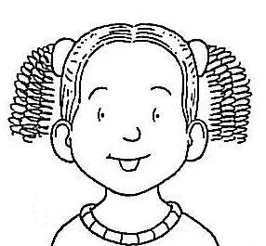

## Introduction

**What does *dimension* mean?**

You can talk about one dimension which is **length**.

\_\_\_\_\_\_\_\_\_



A shape with length and width is called **2D** or a **plane**. It is flat.

You can add another dimension, **depth**.

## Introduction continued

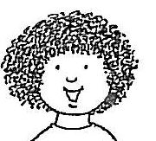

When you add **depth** to a **2D** shape it is called a **3D** object**.** This **3D** object can also be called a **solid**.

Here are some examples of 2D shapes and 3D objects.

Can you see the difference?

|  |  |
| --- | --- |
| squar**2D shapes**  triangle | http://www.icteachers.co.uk/children/sats/images/3d_cone_1.gif3d_cuboid_1  **3D objects** |

## Activity 1

**bd06121_**

**For you to do**

Write 2D or 3D underneath the following shapes. Remember to look at the *length, width* and *depth* before you write your answer.

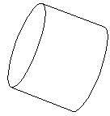

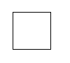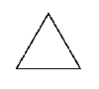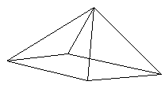

\_\_\_\_\_\_\_\_\_\_ \_\_\_\_\_\_\_\_\_\_ \_\_\_\_\_\_\_\_\_\_ \_\_\_\_\_\_\_\_\_\_

**Activity 1 continued**

**Look at the properties of 2D shapes**

2D shapes are flat. They are made up of a number of sides and corners.

I have described this 2D shape for you.



|  |  |
| --- | --- |
|  | Shape: square  Number of sides: 4  Number of corners: 4 |

|  |  |
| --- | --- |
| **Now you draw these 2D shapes.**   1. A 2D shape with 3 sides and 3 corners. 2. A 2D shape with 4 sides, all the same length. |  |
|  |
|  |

1. What shapes did you draw?
2. \_\_\_\_\_\_\_\_\_\_\_\_\_\_\_\_\_\_\_\_\_\_\_\_\_\_\_\_\_\_\_\_\_\_\_\_\_\_
3. \_\_\_\_\_\_\_\_\_\_\_\_\_\_\_\_\_\_\_\_\_\_\_\_\_\_\_\_\_\_\_\_\_\_\_\_\_\_

## Activity 2

**bd06121_**

**For you to do**

**Look at the properties of 3D objects**

3D objects are made up of *faces* and *vertices*. Faces are the flat surfaces of 3D objects. Vertices are the corners or the point where the lines meet. Now you are going to learn how to describe a 3D object.

Look at the shape below.



vertices

face

|  |  |  |  |
| --- | --- | --- | --- |
| **3D object** | **Shape of faces** | **Number of faces** | **Number of vertices** |
| pyramid | triangles and  rectangle | 5 | 5 |
| cube | squares | 6 | 8 |

**Do you know this shape?**

Fill in the table for each shape.

|  |  |  |  |
| --- | --- | --- | --- |
| **3D object** | **Shape of faces** | **Number of faces** | **Number of vertices** |
| http://www.icteachers.co.uk/children/sats/images/3d_cube.gifcube |  |  |  |
| triangular  http://www.icteachers.co.uk/children/sats/images/3d_prism.gifprism |  |  |  |
| rectangular  http://www.icteachers.co.uk/children/sats/images/3d_cuboid.gifprism |  |  |  |
| square  3d_pyramidpyramid |  |  |  |

**Activity 2 continued**

**Now look around your house at all the solids (3D objects).**

Draw a picture of where you might see each of these objects in everyday life. Use the drawings in the previous table to help.

|  |  |
| --- | --- |
| cube | rectangular prism |
| triangular prism | square pyramid |



…there are about eighty pyramids known today from ancient Egypt. The three largest and best-preserved of these were built at Giza. The most well-known of these pyramids was built for the pharaoh Khufu. It is known as the 'Great Pyramid'. It was built over 20 years and used millions of tons of stone blocks.

Go to: <http://www.ancientegypt.co.uk/pyramids/home.html> and click on *story* if you would like to know more.

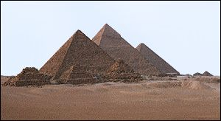

# 7

## Focus

You will identify number

rules involving *addition, subtraction*

and *multiplication* to devise, describe,

extend and test **number patterns.**

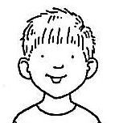

## Introduction

Look back at Module A, Day 7 and revise these number rules.

## Step 1 – Rule for addition

Begin by looking at the following number pattern:

11, 17, 23, 29, 35

Look carefully at the first two numbers in the pattern 11 and 17.

What is the difference between the two numbers? *The difference is 6, because 17 is 6 more than 11.*

Does this apply to the second and third numbers? The third and fourth numbers? The fourth and fifth numbers?

You can now work out that the **rule** for the above number pattern is **add 6.**

Now that you know the rule, continue the number pattern below.

2, 8, 14, 20, \_\_\_\_\_, \_\_\_\_\_, \_\_\_\_\_, \_\_\_\_.

Here’s another number pattern written a different way. This is called a number line.

4

10

16

Use the addition rule to fill in the missing numbers on the number line.

**Introduction continued**

**Step 2 – Rule for subtraction**

Begin by looking at the following number pattern:

|  |
| --- |
| 9, 7, 5, 3, 1 |

Look carefully at the first two numbers in the pattern 9 and 7.

What is the difference between the two numbers? *The difference is* ***2****.*

Does this apply to the second and third numbers? The third and fourth numbers? The fourth and fifth numbers?

Now you can work out that the rule for the above number pattern

is **subtract 2**.

**Look at:**

18, 16, 14, 12, 10, 8, 6, 4.

-2 -2 -2 -2 -2 -2 -2

Now that you know the rule, continue the number line below.

15

13

11

9

7

**Step 3 ­– Rule for multiplication**

**Rule:** *Look at the number pattern using the 2 times table.*

**Look at:**

3, 6, 12, 24, 48, 96

× 2 ×2 ×2 ×2 ×2

## Activity 1

**bd06121_**

**For you to do**

Look at this number pattern:

|  |
| --- |
| 2, 4, 8, 16, 32, 64 |

Does it follow any of the adding rules? Check with + 2

2 + 2 = 4 ✓

4 + 2 ≠ 8 …… so our rule of + 2 will not work here.

The number s are getting bigger so try doubling each number to see if it gives the next one

2 + 2 = 4✓

4 + 4 = 8✓

8 + 8 = 16✓

16 + 16 = 32✓

32 + 32 = 64✓

Doubling each number gives the next number in the pattern! Now you can continue the pattern. You may use a calculator to help you.

2, 4, 8, 16, 32, 64 \_\_\_\_, \_\_\_\_, \_\_\_\_, \_\_\_\_ .

What operation (+ , - , x, ÷ ) is doubling ? \_\_\_\_\_\_\_\_

Write a rule for doubling. \_\_\_\_\_\_\_\_

**Activity 1 continued**

Write one rule for each number line below and complete the number pattern. The first one has been done for you.

|  |
| --- |
| **Rule**: ***−* 4**  32  28  24  20  16  12  8  4 |

|  |
| --- |
| **Rule:** \_\_\_\_\_\_\_\_\_\_\_\_  2  5  8  11 |

|  |
| --- |
| **Rule:** \_\_\_\_\_\_\_\_\_\_\_  10  15  20  25 |

|  |
| --- |
|  |
| **Rule:** \_\_\_\_\_\_\_\_\_\_\_ |
| 62  58  54  50 |
|  |
|  |
|  |

**Activity 1 continued**

|  |
| --- |
|  |
| **Rule:** \_\_\_\_\_\_\_\_\_\_\_ |
| 1  11  21 |
|  |
|  |
|  |

|  |
| --- |
|  |
| **Rule:** \_\_\_\_\_\_\_\_\_\_\_ |
| 48  45  42  39 |
|  |
|  |
|  |

**Activity 2**

bd06121_ **For you to do**

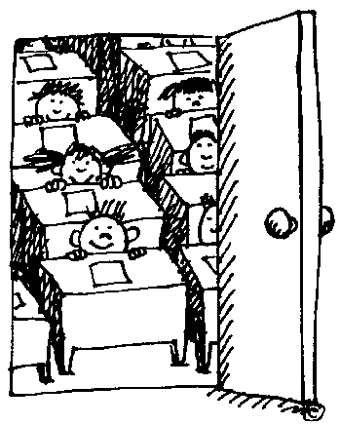

Create your own number lines and write the rule for each pattern.

**Rule**: \_\_\_\_\_\_\_\_\_

## Activity 2 continued

**Rule**:\_\_\_\_\_\_\_\_\_\_

## Activity 3

**bd06121_ For you to do**

Work out the counting patterns.

a) 247, 347, 447, 547

This pattern is **increasing** by \_\_\_\_\_\_\_\_\_\_\_\_

The next 3 numbers in this pattern are \_\_\_\_\_\_\_\_\_, \_\_\_\_\_\_\_\_, \_\_\_\_\_\_\_\_

b) 274, 264, 254,

This pattern is **decreasing** by \_\_\_\_\_\_\_\_\_\_\_\_\_

The next 3 numbers in the pattern are \_\_\_\_\_\_\_\_\_, \_\_\_\_\_\_\_\_, \_\_\_\_\_\_\_\_

c) Make a skip counting pattern that begins at 325

325, \_\_\_\_\_ \_\_\_\_\_ \_\_\_\_\_ \_\_\_\_\_ \_\_\_\_\_

What was the rule for your skip counting pattern? \_\_\_\_\_\_\_\_\_\_\_\_\_\_\_\_\_

## Activity 4

**bd06121_ For you to do – Applying rules**

Write an equation, then solve it for these problems.

|  |
| --- |
| Problem 1: Michael invited 5 friends to his house to watch the AFL Grand Final on TV. How many meat pies will he need to buy if he wants each child to eat 2? Don’t forget Michael. |
| Problem 2: Michael goes to the bakery to buy the pies. They cost $2 each. How much money will he spend? |
| Problem 3: Michael’s dad only has a $50 note. How much change will he get from the cashier? |

Write a problem for each equation. The first one has been done for you.

|  |  |
| --- | --- |
| EQUATION | PROBLEM IN WORDS |
| 7 x 3 = 21 | Marianna ate 3 lollies a day. How many lollies did she eat in a week? |
| 68 + 22 = 90 |  |
| $250 - $100 = $150 |  |

# 8

## Focus

You will investigate numbers up to 5 digits and shop for furniture.

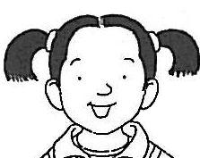

## Introduction

It is important to remember that numbers are placed according to their value.

In the number below:

The value of 8 is 800.

The value of 7 is 70.

The value of 9 is 9.



**879**

Let us look further at 879. The numbers have been placed in the columns according to their value. (You know that *Units* means *Ones*.)

|  |  |  |  |
| --- | --- | --- | --- |
| Thousands | Hundreds | Tens | Units |
| 0 | 8 | 0 | 0 |
|  |  | 7 | 0 |
|  |  |  | 9 |

800 + 70 + 9 added together equals 879 in total.

**Activity 1**

**bd06121_ For you to do**

On Day 3 you looked at place value. Today you will continue to look at numbers up to 9999. Look at the following numbers and write the new number if you take away only the tens. The first one has been completed for you.

375 take away the 7 tens 305

925 \_\_\_\_\_\_\_\_\_\_\_\_\_\_

614 \_\_\_\_\_\_\_\_\_\_\_\_\_\_

260 \_\_\_\_\_\_\_\_\_\_\_\_\_\_

Take away only the hundreds and make a new number. The first one has been completed for you.

753 53

289 \_\_\_\_\_\_\_\_\_\_\_\_\_\_

406 \_\_\_\_\_\_\_\_\_\_\_\_\_\_

Write a new number, 10 more than the given number. The first one has been completed for you.

352 362

740 \_\_\_\_\_\_\_\_\_\_\_\_\_\_

891 \_\_\_\_\_\_\_\_\_\_\_\_\_\_\_

**Activity 2**

**bd06121_ Connecting Addition with Subtraction**

*Giacomo has 38 toys in his toy box.*

*If he took out 32 how many will he have left?*

This problem can be solved using addition or subtraction.

You can find the *difference* by starting at 38 and *counting back* 32.

Make sure you do not count the number you begin with.



You land on 6, so 38 – 32 = 6

OR

you could ask, “starting at 32 how many more do I need to reach 38?” If you do this, you are using a strategy called *counting on*

**+ 6**



Complete the table to show that you understand that addition equations can be made into subtraction equations and vice versa. The first one has been done for you.

|  |  |
| --- | --- |
| **ADDITION** | **SUBTRACTION** |
| 20 + 5 = 25 | 25 – 5 = 20 |
| 17 + 9 = 26 |  |
|  | 18 - 12 = 6 |
|  | 60 – 14 = 46 |

**Activity 3**

**bd06121_ For you to do**

**MCj02376650000[1]You will need:**

* Maths Activity Book
* paper
* scissors

**Step 1**

Look at the page headed *Day 8-Furniture (Activity 3)* in your *Maths Activity Book.*

**Step 2**

Choose one of each item to furnish a bedroom.

Cut them out.

**Step 3**

Now I want you to put these items in order from **least expensive** to **most expensive**.

**Step 4**

Paste them onto a sheet of paper and send them in for your teacher

to see.

For example:

|  |  |  |
| --- | --- | --- |
| j0290938  **$76** | j0301514  **$189** | HH01495_  **$299** |

**Activity 4**

**bd06121_ For you to do**

Furnish your bedroom. Look at the page headed *Day 8-Furniture (Activity 4)* in your *Maths Activity Book.* Imagine you have $1000 to buy furniture for your bedroom. Choose from the pictures provided or from a catalogue. Paste your selection below.

|  |
| --- |
|  |

## Activity 4 continued

How much will the furniture cost altogether? $\_\_\_\_\_\_\_\_\_\_\_\_\_\_\_\_\_\_\_\_\_\_

How much will you have left from $1000? $\_\_\_\_\_\_\_\_\_\_\_\_\_\_\_\_\_\_\_\_\_\_\_\_\_\_

What else could you buy with the change? \_\_\_\_\_\_\_\_\_\_\_\_\_\_\_\_\_\_\_\_\_\_\_\_\_\_

\_\_\_\_\_\_\_\_\_\_\_\_\_\_\_\_\_\_\_\_\_\_\_\_\_\_\_\_\_\_\_\_\_\_\_\_\_\_\_\_\_\_\_\_\_\_\_\_\_\_\_\_\_\_\_\_\_\_\_\_\_\_\_\_\_\_

\_\_\_\_\_\_\_\_\_\_\_\_\_\_\_\_\_\_\_\_\_\_\_\_\_\_\_\_\_\_\_\_\_\_\_\_\_\_\_\_\_\_\_\_\_\_\_\_\_\_\_\_\_\_\_\_\_\_\_\_\_\_\_\_\_\_

\_\_\_\_\_\_\_\_\_\_\_\_\_\_\_\_\_\_\_\_\_\_\_\_\_\_\_\_\_\_\_\_\_\_\_\_\_\_\_\_\_\_\_\_\_\_\_\_\_\_\_\_\_\_\_\_\_\_\_\_\_\_\_\_\_\_

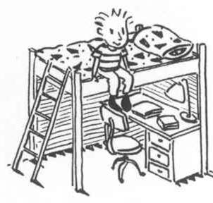

**Optional**

You could do this activity by looking at the website for *Freedom Furniture*, [www.freedom.com.au](http://www.freedom.com.au), and clicking on *catalogue*.

# 9

## Focus

You will learn more about place value and whole numbers up to 5 digits.

## S21570467708050209411

**Introduction**

You learned in Module A that digits are grouped together to make larger numbers. You looked at 1, 2 and 3 digit numbers.

4 digit whole numbers are greater than 1, 2 and 3 digit numbers. They include numbers in the *thousands.*



5 digit whole numbers are greater than 1, 2, 3 and 4 digit whole numbers.

They include numbers in the *ten thousands.*

**Activity 1**

**bd06121_ For you to do**

**Look at ordering numbers by place value.**

Here are some examples for you.

They are ordered from the smallest (bottom) to largest (top).

|  |  |  |
| --- | --- | --- |
| 42135 |  | 60671 |
| 4306 |  | 60492 |
| 379 |  | 7893 |

**Play a game and order the numbers.**

**You will need:**

* a partner
* a ladder each ( from your *Maths Activity Book* )
* 5 dice

**Step 1**

Turn to the page headed *Day 9 – Ladder Game* in your *Maths Activity Book*. Throw the 5 dice. Use the digits thrown to make a 5-digit number.

**Step 2**

Decide which rung of the ladder to put the number on.

**Step 3**

The numbers on the ladder must be in order, from **smallest** (bottom) to **largest** (top).

A number **cannot** be moved once it is written.

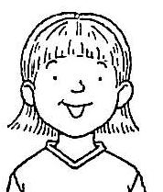

**Step 4**

Continue until each player has filled their ladder. If the numbers are in order from smallest to largest, score 1 point. The player with the most points after 5 rounds wins. **Activity 2**

**bd06121_ For you to do**

1. Use the digits 6**,** 2**,** 3**,** 9**,** 1 to write:

a) the largest number \_\_\_\_\_\_\_\_\_\_\_\_\_\_\_\_\_\_\_\_\_\_\_\_

b) the smallest number \_\_\_\_\_\_\_\_\_\_\_\_\_\_\_\_\_\_\_\_\_\_\_\_

1. Use 7 in three different numbers so that the 7 has a different place value each time.

\_\_\_\_\_\_\_\_\_\_\_\_\_\_\_\_\_\_ \_\_\_\_\_\_\_\_\_\_\_\_\_\_\_\_\_\_\_ \_\_\_\_\_\_\_\_\_\_\_\_\_\_\_\_\_\_\_

1. This number comes after 9999. What might the number be?

\_\_\_\_\_\_\_\_\_\_\_\_\_\_\_\_\_\_\_\_\_\_\_\_\_\_\_\_\_\_\_\_\_\_\_\_\_\_\_\_\_\_\_\_\_\_\_\_\_\_\_\_\_\_\_\_\_\_\_\_\_\_

1. What numbers can you make that are below 100 and have 6 in the tens place?

\_\_\_\_\_\_\_\_\_\_\_\_\_\_\_\_\_\_\_\_\_\_\_\_\_\_\_\_\_\_\_\_\_\_\_\_\_\_\_\_\_\_\_\_\_\_\_\_\_\_\_\_\_\_\_\_\_\_\_\_\_

1. 59230 Which digit is in the tens place? \_\_\_\_\_\_\_\_\_\_\_\_\_\_\_\_\_\_\_\_\_\_\_

**Activity 3**

**bd06121_ For you to do**

Look at the number 79403 and answer these questions.

1. Which numeral is on the far right? \_\_\_\_\_\_\_\_\_\_\_\_\_\_\_\_
2. Which numeral is on the far left? \_\_\_\_\_\_\_\_\_\_\_\_\_\_\_\_
3. Which digit is in the thousands place? \_\_\_\_\_\_\_\_\_\_\_\_\_\_\_\_
4. Change over the positions of the 9 and 3.

Write down the new number. \_\_\_\_\_\_\_\_\_\_\_\_\_\_\_\_

1. Make the number 1more. What is the new number?

\_\_\_\_\_\_\_\_\_\_\_\_\_\_\_\_

1. Now make this number 10more. What is the new number?

\_\_\_\_\_\_\_\_\_\_\_\_\_\_\_\_

1. Subtract 100from the number. What is the new number?

\_\_\_\_\_\_\_\_\_\_\_\_\_\_\_\_

1. Add 10,000 to the number. What is the new number?

\_\_\_\_\_\_\_\_\_\_\_\_\_\_\_\_

…the modern system of numbers is based on place value.

There are only **9** symbols for numbers. The same symbol,

such as **4,** takes on a different meaning (**4, 40, 400**, etc.)

depending where it is placed within the number. The modern

place value system was invented by Hindu mathematicians

in India, probably by the sixth century.

# 10

## Focus

MC900383572[1]

Ready to revise work covered!

**Completing the work**

|  |
| --- |
| **Looking Back**  Test your knowledge on work covered in days 6 – 9.  Complete without the assistance of your supervisor.  When you have completed your work ask your supervisor to correct your work and discuss any problems. |

|  |
| --- |
| Comments Did you have any problems? yes/no  Did you find the work easy? Yes/no  What do you need help with?  Write your responses in the comments section *- pink page.* |

## Fill in the missing numbers.

5, 9, 13, \_\_\_\_\_\_, \_\_\_\_\_\_, \_\_\_\_\_\_, \_\_\_\_\_\_, \_\_\_\_\_\_, \_\_\_\_\_\_.

29, 24, 19, \_\_\_\_\_\_, \_\_\_\_\_\_, \_\_\_\_\_\_.

\_\_\_\_\_\_, \_\_\_\_\_\_, \_\_\_\_\_\_, \_\_\_\_\_\_, 15, 14, 13, 12, 11

1, 3, 6, 10, \_\_\_\_\_\_, \_\_\_\_\_\_, \_\_\_\_\_\_, \_\_\_\_\_\_, \_\_\_\_\_\_, \_\_\_\_\_\_.

1. Write a number pattern with the rule given.

Rule: + 3

Rule: + 6

3. How many numbers can you make using the digits 1, 2, 3 and 4? You can only use each digit once in each number.

\_\_\_\_\_\_\_\_\_\_\_\_\_\_\_\_\_\_\_\_\_\_\_\_\_\_\_\_\_\_\_\_\_\_\_\_\_\_\_\_\_\_\_\_\_\_\_\_\_\_\_\_\_\_\_\_\_\_\_\_\_\_\_\_\_\_

\_\_\_\_\_\_\_\_\_\_\_\_\_\_\_\_\_\_\_\_\_\_\_\_\_\_\_\_\_\_\_\_\_\_\_\_\_\_\_\_\_\_\_\_\_\_\_\_\_\_\_\_\_\_\_\_\_\_\_\_\_\_\_\_\_\_

4.

This mystery number has 4 digits. Every digit is an odd number.

None of the digits is a 9. Every digit in the number is different. The smallest digit is in the thousands place. The greatest digit is in the units place. The preceding describes two possible numbers. The mystery number is the greater of those two numbers. What is the mystery number?

\_\_\_\_\_\_\_\_\_\_\_\_\_\_\_\_\_\_\_\_\_\_\_\_\_\_\_\_\_\_\_\_\_\_\_\_\_\_\_\_\_\_\_\_\_\_\_\_\_\_\_\_\_\_\_\_\_\_\_\_\_\_\_\_\_\_

5.

Write down everything you know and everything you can find out about this square.

\_\_\_\_\_\_\_\_\_\_\_\_\_\_\_\_\_\_\_\_\_\_\_\_\_\_\_\_\_\_\_\_\_\_\_\_\_\_\_\_

\_\_\_\_\_\_\_\_\_\_\_\_\_\_\_\_\_\_\_\_\_\_\_\_\_\_\_\_\_\_\_\_\_\_\_\_\_\_\_\_

\_\_\_\_\_\_\_\_\_\_\_\_\_\_\_\_\_\_\_\_\_\_\_\_\_\_\_\_\_\_\_\_\_\_\_\_\_\_\_\_

\_\_\_\_\_\_\_\_\_\_\_\_\_\_\_\_\_\_\_\_\_\_\_\_\_\_\_\_\_\_\_\_\_\_\_\_\_\_\_\_\_\_\_\_\_\_\_\_\_\_\_\_\_\_\_\_\_\_\_\_\_\_\_

\_\_\_\_\_\_\_\_\_\_\_\_\_\_\_\_\_\_\_\_\_\_\_\_\_\_\_\_\_\_\_\_\_\_\_\_\_\_\_\_\_\_\_\_\_\_\_\_\_\_\_\_\_\_\_\_\_\_\_\_\_\_\_

\_\_\_\_\_\_\_\_\_\_\_\_\_\_\_\_\_\_\_\_\_\_\_\_\_\_\_\_\_\_\_\_\_\_\_\_\_\_\_\_\_\_\_\_\_\_\_\_\_\_\_\_\_\_\_\_\_\_\_\_\_\_\_

\_\_\_\_\_\_\_\_\_\_\_\_\_\_\_\_\_\_\_\_\_\_\_\_\_\_\_\_\_\_\_\_\_\_\_\_\_\_\_\_\_\_\_\_\_\_\_\_\_\_\_\_\_\_\_\_\_\_\_\_\_\_\_

1. What is it that makes these shapes triangles?

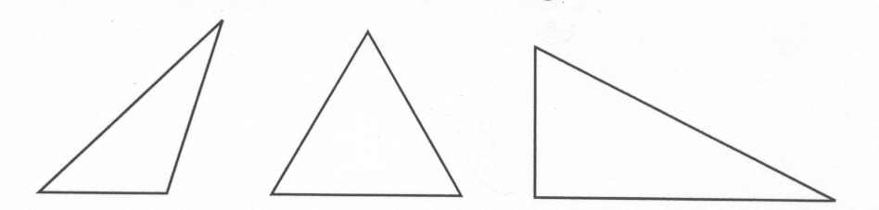

\_\_\_\_\_\_\_\_\_\_\_\_\_\_\_\_\_\_\_\_\_\_\_\_\_\_\_\_\_\_\_\_\_\_\_\_\_\_\_\_\_\_\_\_\_\_\_\_\_\_\_\_\_\_\_\_\_\_\_\_\_\_\_\_\_\_

\_\_\_\_\_\_\_\_\_\_\_\_\_\_\_\_\_\_\_\_\_\_\_\_\_\_\_\_\_\_\_\_\_\_\_\_\_\_\_\_\_\_\_\_\_\_\_\_\_\_\_\_\_\_\_\_\_\_\_\_\_\_\_\_\_\_

7. Draw a picture below using only circles and squares.

**Optional**

Remove the sheet headed *Day 10 - Square Pyramid Net* from your *Maths Activity Book*. Follow the instructions to make a square pyramid.

## Comments

Did you have any difficulties? Was it too easy? Did you need assistance? Were the instructions easy to follow?

\_\_\_\_\_\_\_\_\_\_\_\_\_\_\_\_\_\_\_\_\_\_\_\_\_\_\_\_\_\_\_\_\_\_\_\_\_\_\_\_\_\_\_\_\_\_\_\_\_\_\_\_\_\_\_\_\_\_\_\_\_\_\_\_\_\_

\_\_\_\_\_\_\_\_\_\_\_\_\_\_\_\_\_\_\_\_\_\_\_\_\_\_\_\_\_\_\_\_\_\_\_\_\_\_\_\_\_\_\_\_\_\_\_\_\_\_\_\_\_\_\_\_\_\_\_\_\_\_\_\_\_\_

\_\_\_\_\_\_\_\_\_\_\_\_\_\_\_\_\_\_\_\_\_\_\_\_\_\_\_\_\_\_\_\_\_\_\_\_\_\_\_\_\_\_\_\_\_\_\_\_\_\_\_\_\_\_\_\_\_\_\_\_\_\_\_\_\_\_

\_\_\_\_\_\_\_\_\_\_\_\_\_\_\_\_\_\_\_\_\_\_\_\_\_\_\_\_\_\_\_\_\_\_\_\_\_\_\_\_\_\_\_\_\_\_\_\_\_\_\_\_\_\_\_\_\_\_\_\_\_\_\_\_\_\_

\_\_\_\_\_\_\_\_\_\_\_\_\_\_\_\_\_\_\_\_\_\_\_\_\_\_\_\_\_\_\_\_\_\_\_\_\_\_\_\_\_\_\_\_\_\_\_\_\_\_\_\_\_\_\_\_\_\_\_\_\_\_\_\_\_\_

\_\_\_\_\_\_\_\_\_\_\_\_\_\_\_\_\_\_\_\_\_\_\_\_\_\_\_\_\_\_\_\_\_\_\_\_\_\_\_\_\_\_\_\_\_\_\_\_\_\_\_\_\_\_\_\_\_\_\_\_\_\_\_\_\_\_

j0078837

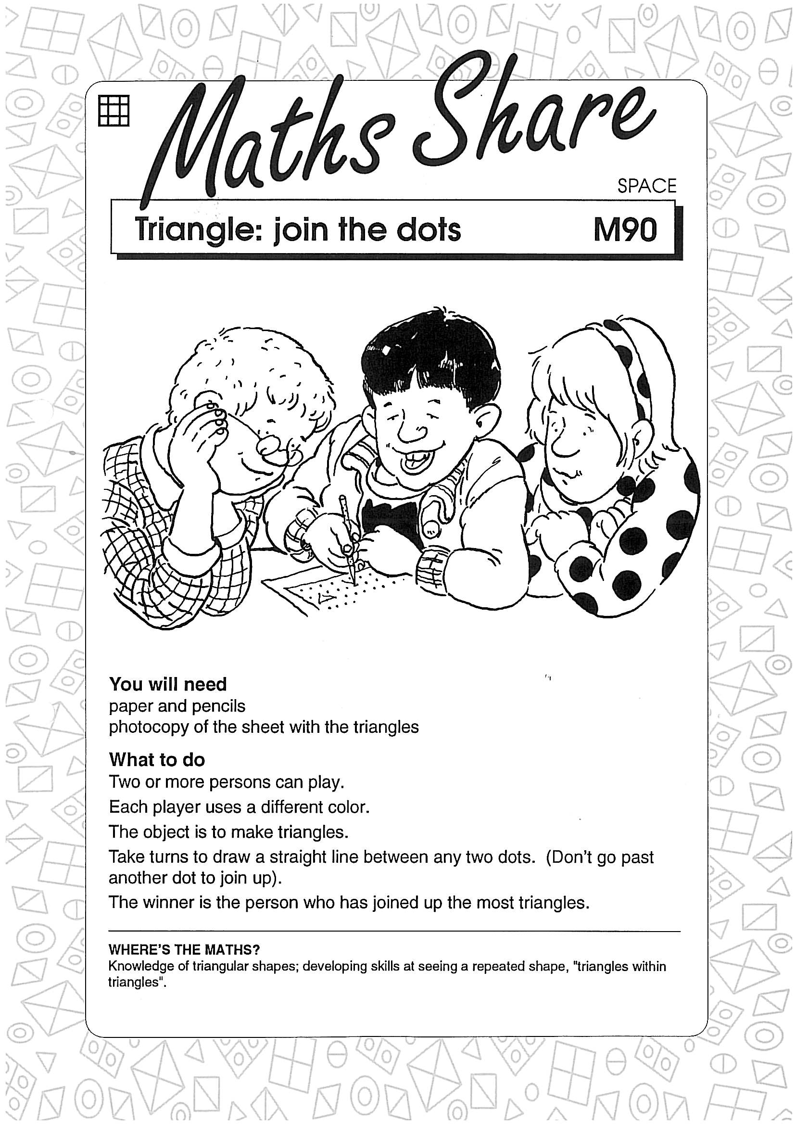

**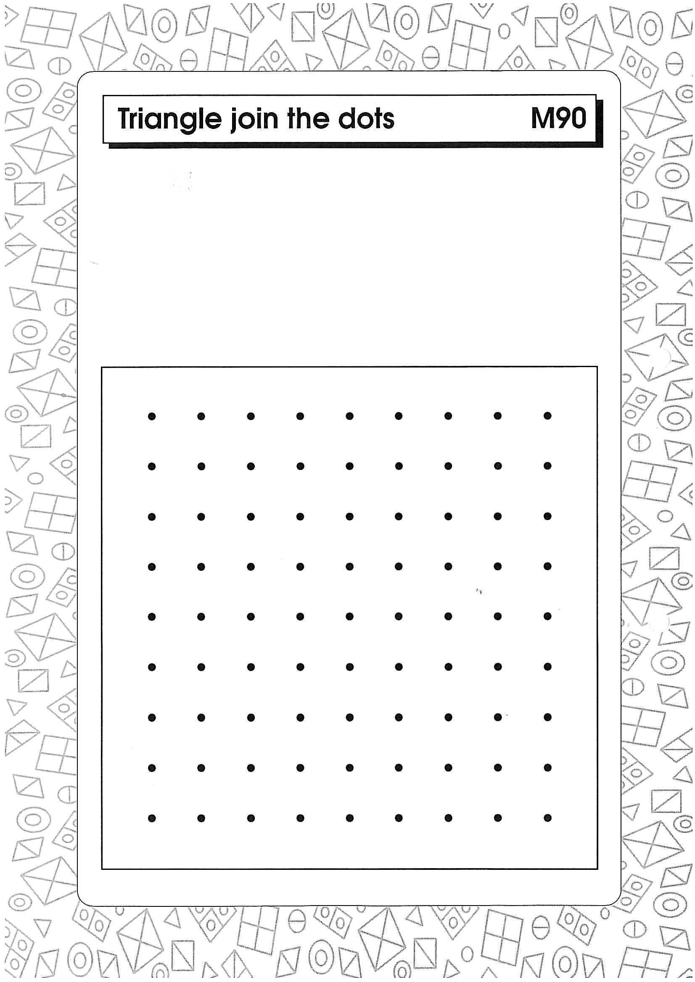**

|  |
| --- |
| **Maths Activity—Triangle join the dots** |

## How many team members were involved in this activity?

—————————————————————————————————

## In your own words, explain the purpose of this activity.

—————————————————————————————————

—————————————————————————————————

—————————————————————————————————

—————————————————————————————————

## Describe how you organised your team members for this activity.

—————————————————————————————————

—————————————————————————————————

—————————————————————————————————

—————————————————————————————————

**Supervisor report** (Please briefly comment on your student’s strategies, planning and organisation for this project.)

—————————————————————————————————

—————————————————————————————————

—————————————————————————————————

**TEACHER ASSESSMENT**

*How are fractions helpful?*

Student: \_\_\_\_\_\_\_\_\_\_\_\_\_\_\_\_\_\_\_\_\_\_\_\_\_\_ Date: \_\_\_\_\_\_\_\_\_\_\_\_\_\_\_\_

|  |  |  |
| --- | --- | --- |
| Description | Demonstrated | Needs further opportunity |
| Model and represent unit fractions including 1/2, 1/4, 1/3, 1/5 and their multiples to a complete whole |  |  |
| Apply place value to partition, rearrange and regroup numbers to at least 10 000 to assist calculations and solve problems |  |  |
| Recognise, model, represent and order numbers to at least  10 000 |  |  |
| Recall multiplication facts of two, three, five and ten and related division facts |  |  |
| Describe, continue, and create number patterns resulting from performing addition or subtraction |  |  |
| Make models of three-dimensional objects and describe key features |  |  |
| Recall addition facts for single-digit numbers and related subtraction facts to develop increasingly efficient mental strategies for computation |  |  |
| Recognise and explain the connection between addition and subtraction |  |  |

|  |
| --- |
| **YOUR QUESTIONS OR COMMENTS** |