**Arts Inquiry**

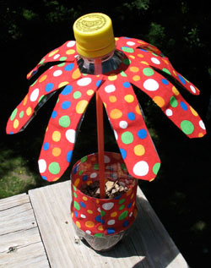



**Learning Intentions:**

In this Arts Inquiry this semester you will:

* Create and present works in a range of art forms that communicate experiences, ideas, concepts, observations and feelings.
* Select and combine a range of art elements.
* Use a range of skills, techniques and processes, media, materials, equipment and technologies.
* Reflect on your own visual arts.
* Respond to the visual arts of others.

**Water Bottle Flowers**

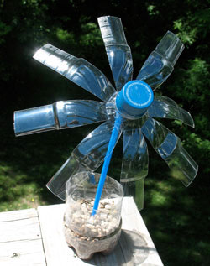

[**http://www.kinderart.com/camp/waterbottleflowers.shtml**](http://www.kinderart.com/camp/waterbottleflowers.shtml)

**You will need:**

* Plastic single serve water bottle with lid
* PVA glue
* Scissors
* Sand or soil
* Pebbles or rocks
* Drinking straw or twig

**Method:**

1. Remove labels and lids, but don’t throw them away. We will be using the entire water bottle! If your water bottle does not have a label, have a bit of scrap paper nearby to use instead.
2. Ask an adult to help you cut the water bottle in half, and put the bottom half aside. Cut slits, about 2.5cm or so wide, in the top half of the bottle. You should end up with 8 “petals”. Bend the petals outward.
3. Put the lid on the bottle top. Squeeze some white glue into the lid and insert the straw or twig into the glue. Next, wad up the bottle wrapper and surround the straw with it, to help give the straw stability.
4. Put some sand or soil into the bottom half of the water bottle, about 3-5 centimetres in depth. Pack it down a bit and insert the bottom end of the straw into it. Add pebbles or stones on top of the sand to help stabilize the straw (stem).

**Optional**: If you like, cut strips of fabric to decorate the flower petals and the flowerpot. You can also round the petals by trimming the ends with scissors.

**\*Please take a photo of your work**

**REFLECTION**

Think about the piece of art that you created and complete the table below.

|  |  |
| --- | --- |
| **I DID THIS WELL…** | **WHAT DIDN’T WORK…** |
| **IDEAS FOR NEXT TIME…** | **HOW I FELT ABOUT THIS TASK…**  **(Circle or colour in your answer.)**    **C:\Users\vhajisav\AppData\Local\Microsoft\Windows\Temporary Internet Files\Content.IE5\9X399F1B\MC900433822[1].png C:\Users\vhajisav\AppData\Local\Microsoft\Windows\Temporary Internet Files\Content.IE5\2DPE174P\MC900433821[1].png**  **C:\Users\vhajisav\AppData\Local\Microsoft\Windows\Temporary Internet Files\Content.IE5\2DPE174P\MC900433818[1].png C:\Users\vhajisav\AppData\Local\Microsoft\Windows\Temporary Internet Files\Content.IE5\NTEZZOT2\MC900434379[1].wmf** |

**Desk Tidy**

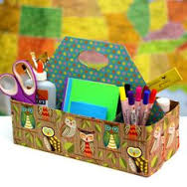

[**http://recyclingweek.planetark.org/kids-teachers/kids.cfm**](http://recyclingweek.planetark.org/kids-teachers/kids.cfm)

**You will need:**

* a clean milk or juice carton or a plastic container with a stable base
* scissors
* glue
* assortment craft materials, e.g. paint, crayons, scraps of fabric, pictures from a magazine or catalogue, buttons, cardboard, paper etc.

**Method:**

1. Cut the top off the carton or plastic container so that you are left with an open-top container.
2. Decorate the outside of the carton any way you choose, using the materials at hand.
3. Use your desk tidy to store your pens, stationery or other odds and ends at your desk.

**\*Please take a photo of your work.**

**REFLECTION**

Think about the piece of art that you created this week and complete the table below.

|  |  |
| --- | --- |
| **I DID THIS WELL…** | **WHAT DIDN’T WORK…** |
| **IDEAS FOR NEXT TIME…** | **HOW I FELT ABOUT THIS TASK…**  **(Circle or colour in your answer.)**    **C:\Users\vhajisav\AppData\Local\Microsoft\Windows\Temporary Internet Files\Content.IE5\9X399F1B\MC900433822[1].png C:\Users\vhajisav\AppData\Local\Microsoft\Windows\Temporary Internet Files\Content.IE5\2DPE174P\MC900433821[1].png**  **C:\Users\vhajisav\AppData\Local\Microsoft\Windows\Temporary Internet Files\Content.IE5\2DPE174P\MC900433818[1].png C:\Users\vhajisav\AppData\Local\Microsoft\Windows\Temporary Internet Files\Content.IE5\NTEZZOT2\MC900434379[1].wmf** |