FarmAnimals

Student’s Workbook

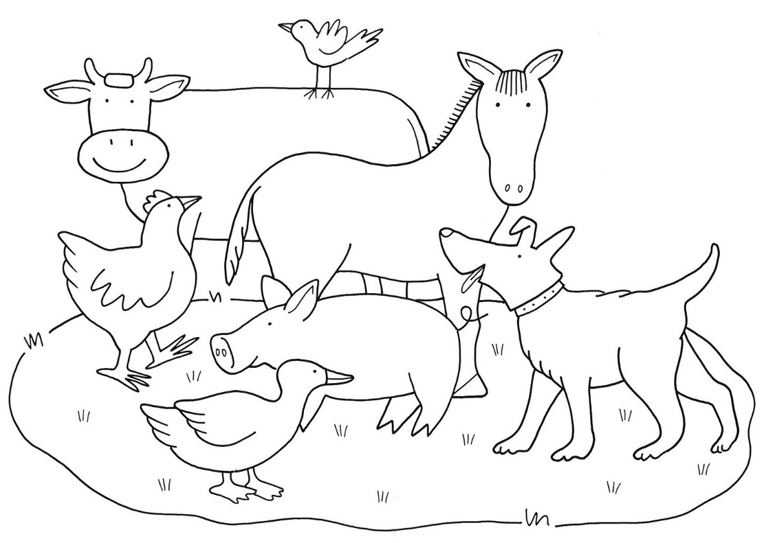

Why are farm animals important?

What do you know about farm animals?

Parent or carer, ask your child to look at the pictures below and tell you which animals they think might live on a farm and why or why not. Ask your child to circle the farm animals.

|  |  |  |
| --- | --- | --- |
| bat | dog | gorilla |
| donkey | whale | flamingo |
| worm | turkey | deer |
| goat | camel | crab |

**Parent or carer, ask your child to say the words and circle the farm animals.**

|  |  |
| --- | --- |
| **teddy** | **cow** |
| **hen** | **joey** |
| **cat** | **lion** |
| **duck** | **horse** |
| **tiger** | **pig** |
| **sheep** | **elephant** |
| **wombat** | **dog** |
| **goat** | **bear** |

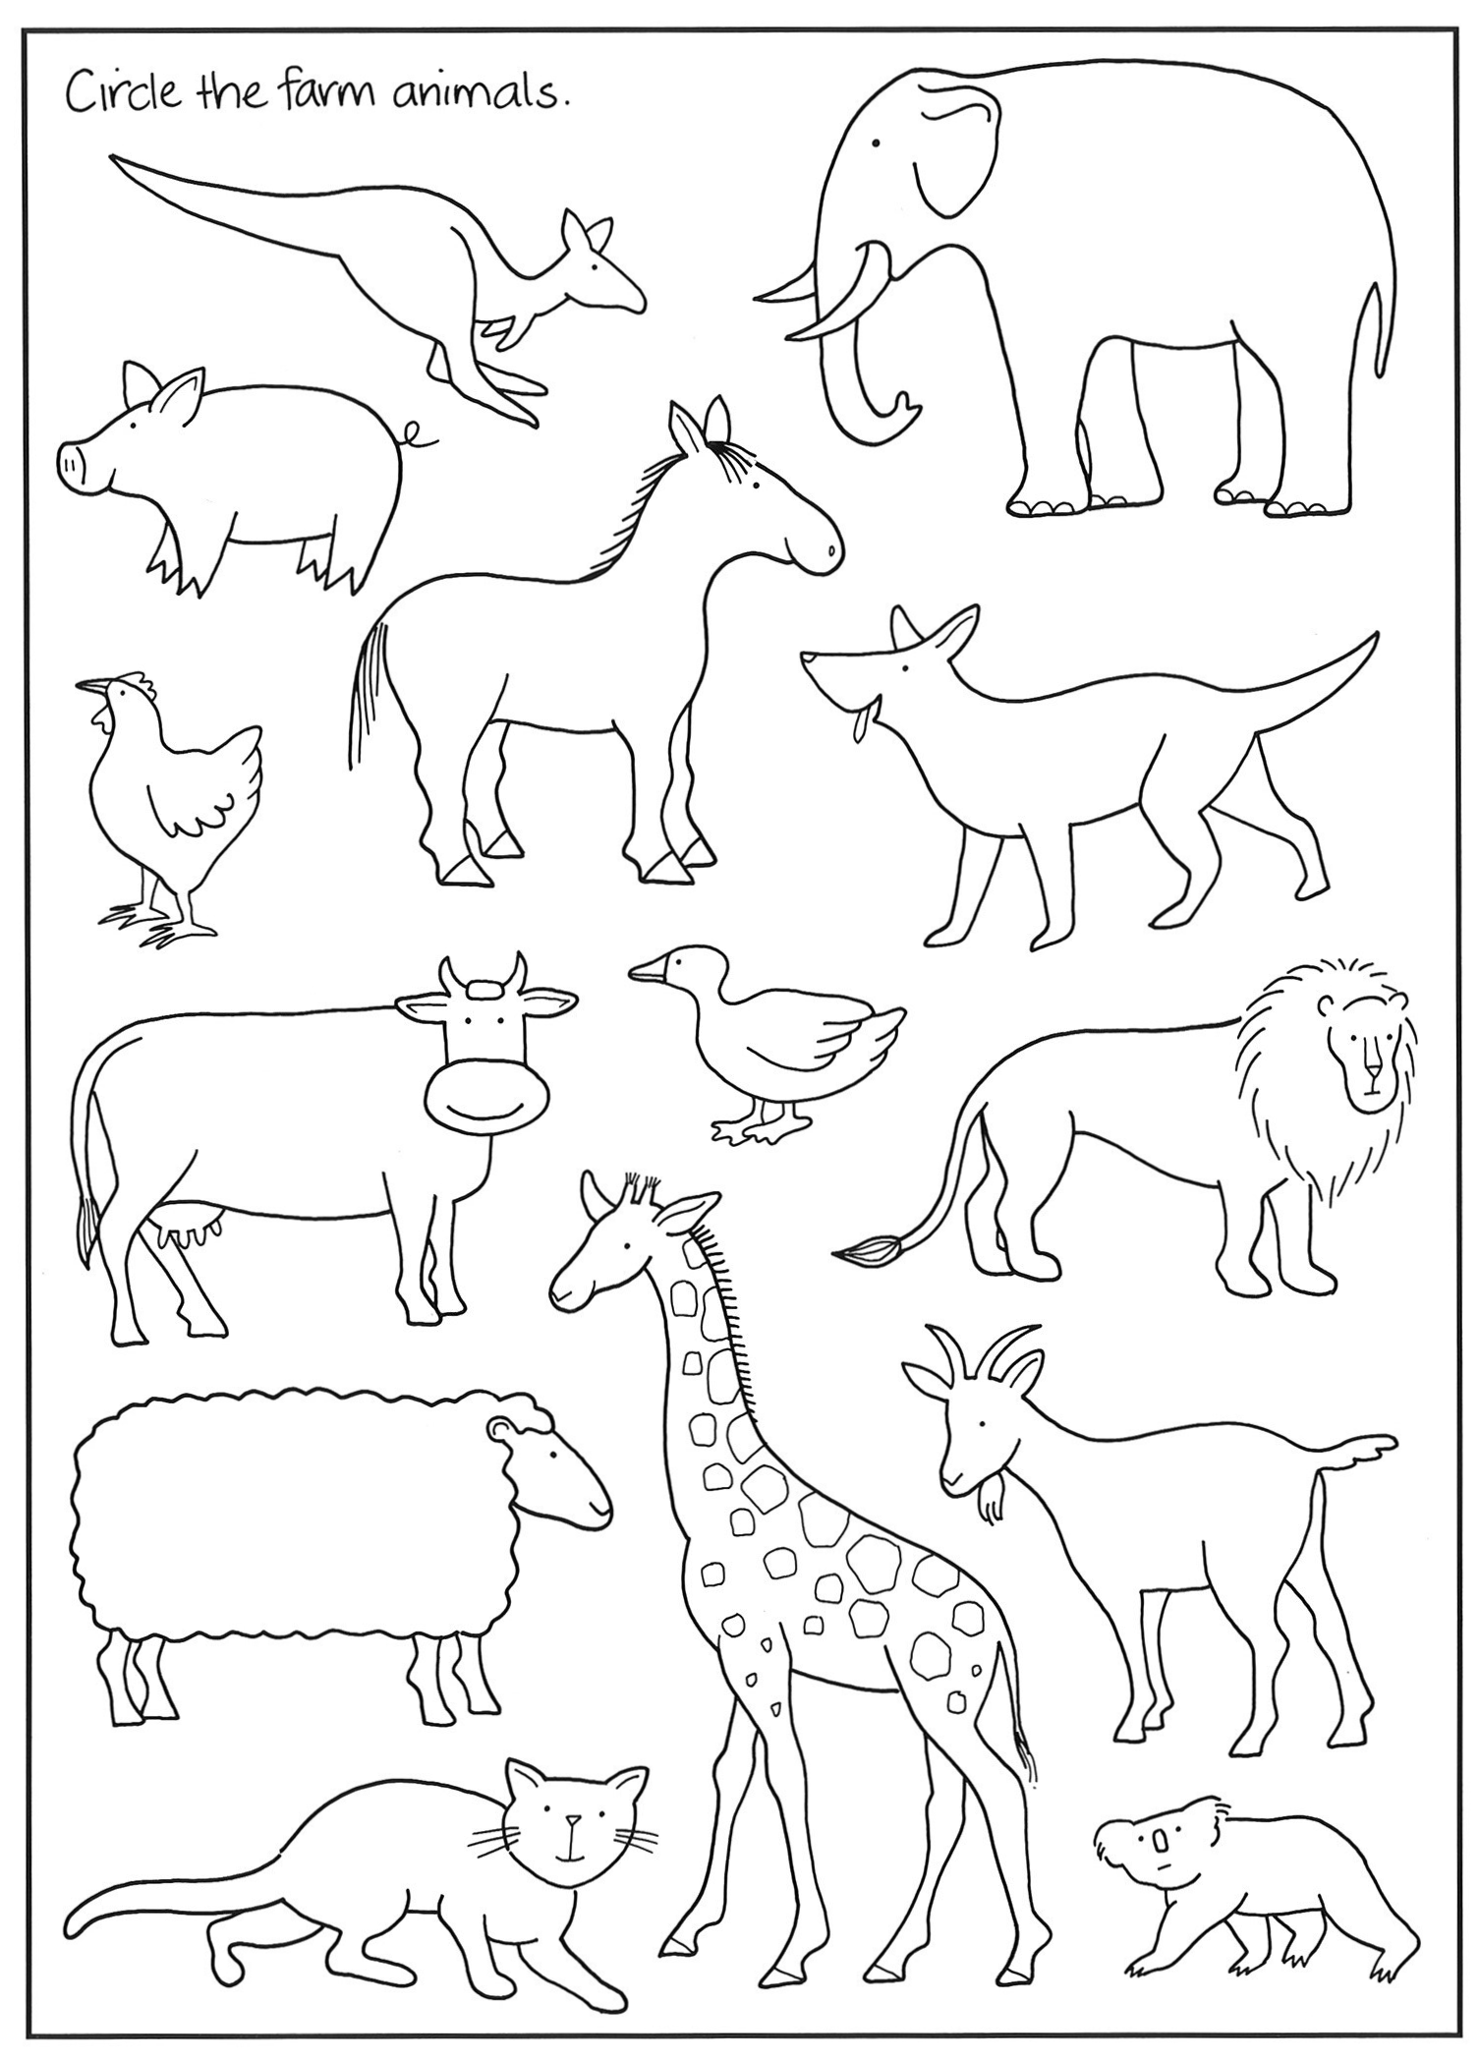

|  |
| --- |
|  |

|  |
| --- |
|  |

|  |  |  |  |
| --- | --- | --- | --- |
| a | b | c | d |
| _ | _ | _ | _ |
| e | f | g | h |
| _ | _ | _ | _ |
| i | j | k | l |
| _ | _ | _ | _ |
| m | n | o | p |
| _ | _ | _ | _ |
| q | r | s | t |
| _ | _ | _ | _ |

|  |  |  |  |  |  |
| --- | --- | --- | --- | --- | --- |
| u | v | | w | | x |
| _ | _ | | _ | | _ |
| y | z | |  | |  |
| _ | _ | |  | |  |
| 1 2 | 3 4 | | 5 6 | | 7 8 |
| _ _ | _ _ | | _ _ | | _ _ |
| 9 | 10 | |  | |  |
| _ | __ | |  | |  |
| six | | eight | | seven | | |
| nine | | ten | | one | | |
| two | | three | | four | | |
| one | |  | |  | | |

Write the words in the correct order

_________, _________, _________, _________,

_________, _________, _________, _________,

_________, _________

|  |  |  |  |  |  |  |
| --- | --- | --- | --- | --- | --- | --- |
| **Copy the letter to the end of the line.** | **t** | **T** | **6** | **5** | **a** | **A** |

|  |  |
| --- | --- |
| **s** |  |
| **f** |
| **b** |
| **a** |

**Student reads words from this sheet.**

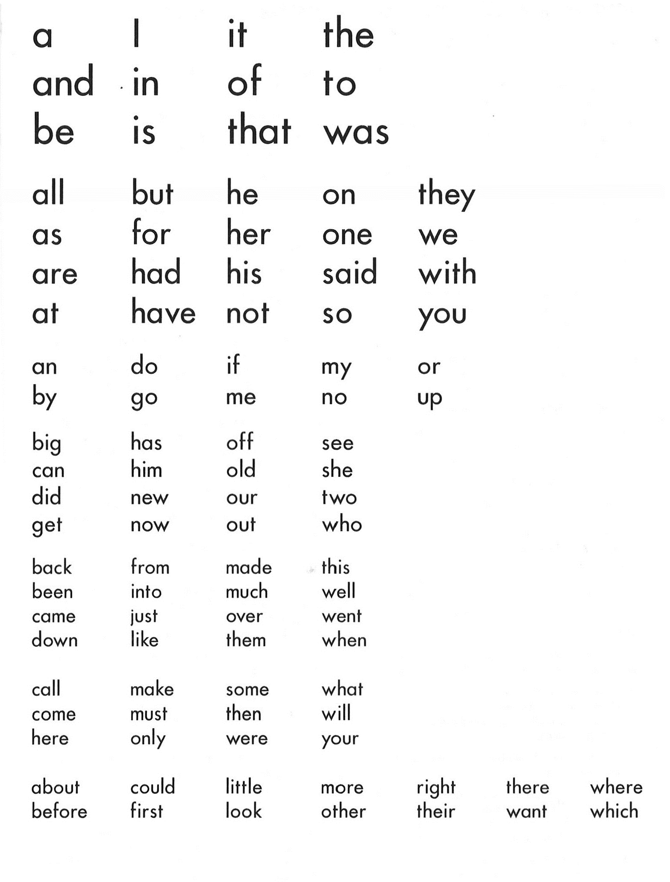

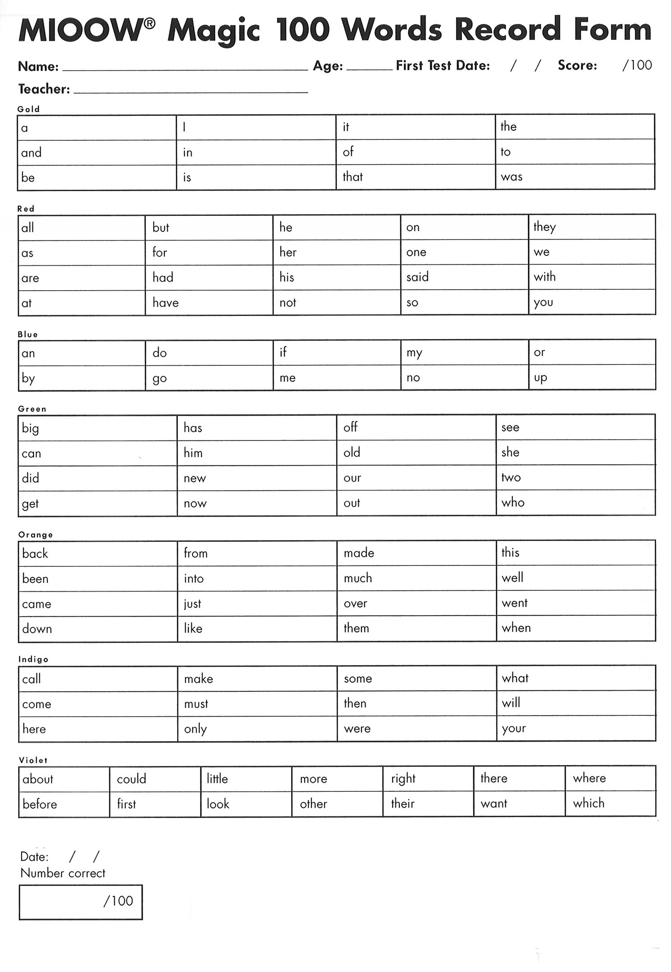

**Write the names of the items that start with the letter ‘a’**

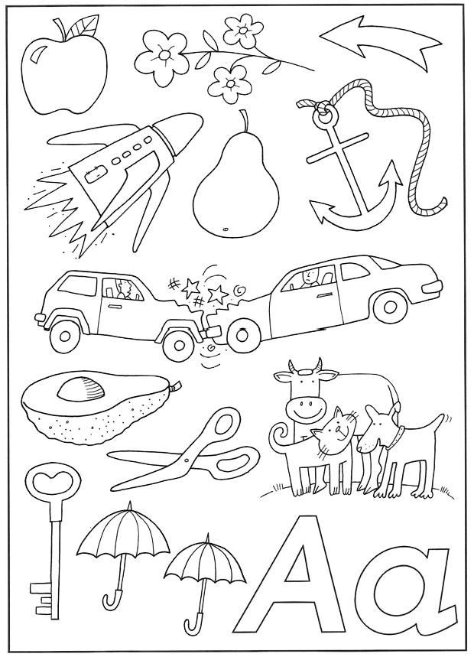

**Circle the beginning sound for each picture.**

|  |  |
| --- | --- |
| a m s b t f | t s f m b a |
| s b a t m f | a t m f s b |
| b a f s t m | m f s t a b |
| f s t m b a | b s t m a f |

Help the mothers find their babies.

Can you draw your line along the path

without touching the sides?

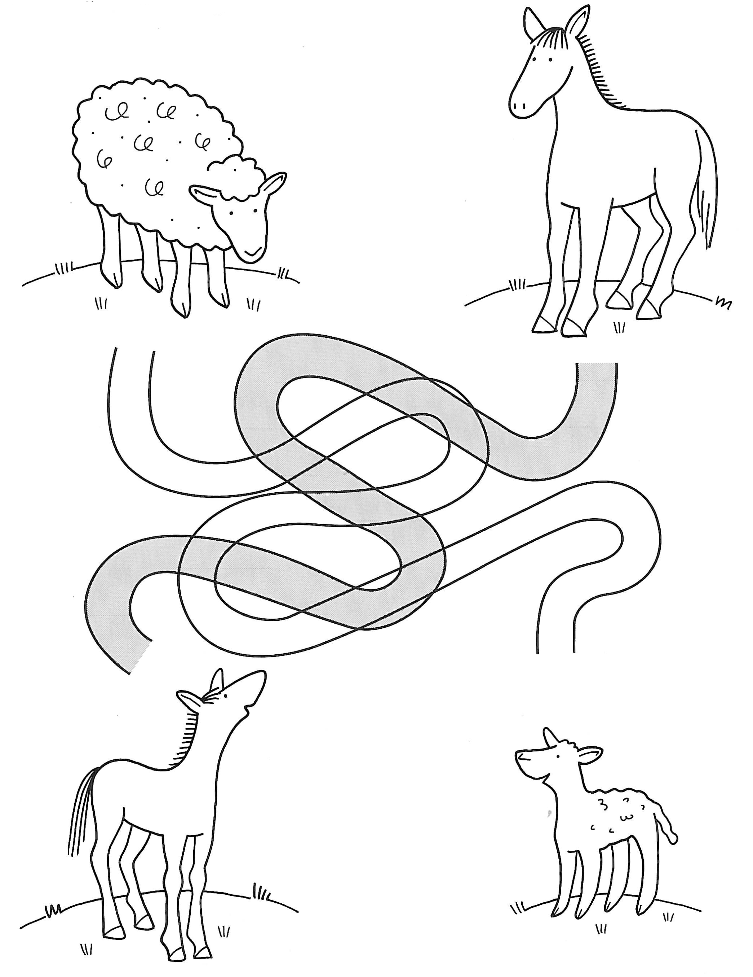

**Match the adult animal with the baby animal.**

|  |  |
| --- | --- |
| **cow** | **lamb** |
| **sheep** | **piglet** |
| **duck** | **calf** |
| **horse** | **kid** |
| **cat** | **duckling** |
| **pig** | **chicken** |
| **goat** | **foal** |
| **hen** | **kitten** |

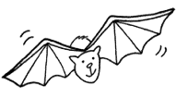 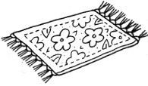 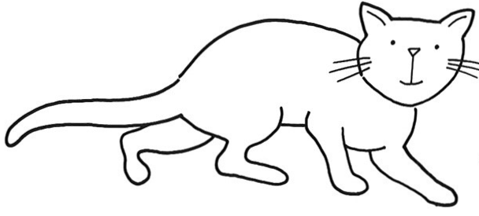

|  |  |
| --- | --- |
| _at _at _ at | |
| Draw a picture for each letter. | |
| b | m |
| a | f |
| s | t |

|  |  |  |  |  |  |  |  |  |
| --- | --- | --- | --- | --- | --- | --- | --- | --- |
| And got back home in time for breakfast. | Charlie the farm cat woke up and stretched. | around the duck pond, | He went through the door and out into the yard. | over the farm-yard fence, | Charlie went across the yard, | behind the barn, | Charlie decided to go for a walk. | He climbed out of his basket. |

**Cut out the sentences and put them in the right order.**

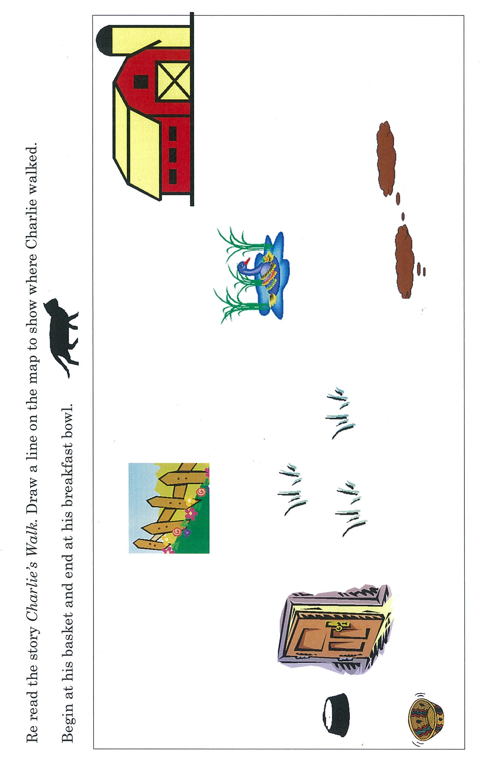

**Songs and poems**

|  |  |
| --- | --- |
| Newborn Down behind the thistles  In the gully, near the creek,  Lies something wet and shining,  Something very weak.  It’s legs are rather wobbly,  It’s very, very shy,  It’s nuzzling for it’s first meal,  Though it’s not yet dry.  It’s got a velvet nose,  But a rough little tongue.  It’s a newborn calf  With its proud cow-mum.  Gayle Sweeney | temp |

|  |  |
| --- | --- |
| The Sheep Dog My little collie pup  Works silently and wide;  You’ll see her climbing up  Along the mountain side.  As silent as a fox  You’ll see her come and go,  A shadow through the rocks  Where ash and messmate grow.  Then, lost to sight and sound  Behind some rugged steep  She works her way around  And gathers up the sheep.  A .B. Paterson |  |

|  |  |
| --- | --- |
| The First Lamb Take a bit of woolly stuff  Kiss it till it’s warm enough,  Roll it up with play and fun;  That’s a lamb ... a little one.  Christine Rosetti |  |
| **The Big Brown Hen**  The big brown hen and Mrs Duck  Went walking out together.  They talked about all sorts of things,  The farmyard and the weather.  But all I heard was “Cluck! Cluck! Cluck!”  And “Quack! Quack! Quack !” from Mrs Duck. | image052 | |

|  |  |
| --- | --- |
| Foal Come trotting up  Beside your mother,  Little skinny.  Lay your neck across  Her back, and whinny,  Little foal.  You think you’re a horse  Because you can trot-  But you’re not.  Your eyes are so wild,  And each leg is tall  As a pole;  And you’re only a skittish  Child, after all,  Little foal.  Mary Britton Miller |  |

|  |  |
| --- | --- |
| The Farmyard One black horse standing by this gate.  Two plump cats eating from a plate.  Three big goats kicking up their heels.  Four pink pigs full of grunts and squeals.  Five white cows coming slowly home.  Six small chickens starting off to roam.  Seven fine pigeons perched in the shed.  Eight grey geese eager to be fed.  Nine young lambs full of frisky fun.  Ten brown bees buzzing in the sun.  Anonymous. |  |

|  |  |  |  |  |
| --- | --- | --- | --- | --- |
| Tiger Cat Tim  Timothy Tim was a very small cat  Who looked like a tiger the size of a rat.  There were little black stripes running all over him  With just enough white on his feet for a trim  On tiger cat Tim.  Timothy Tim had a little pink tongue  That was spoon, comb and washcloth all made into one,  He lapped up his milk, washed and combed all his fur,  And then he sat down in the sunshine to purr,  Full little Tim.  Timothy Tim had a queer little way  Of always pretending at things in his play,  He caught pretend mice in the grass and the sand  And fought pretend cats when he played with your hand,  Fierce little Tim.  He drank all his milk, and he grew and he grew.  He ate all his meat and his vegetables too,  He grew very big and he grew very fat,  And now he’s a lazy old, sleepy old cat;  Timothy Tim.  Edith H. N | | |  | |
| Farmyard  Little hen  feathered and red  pecking round for scraps of bread.  Little goat  fierce and white  thinks his rope is much too tight.  Little calf  soft and shy  peeking out with one brown eye.  Little cat  black and lean  crouching so he won’t be seen.  Little pig  muddy and stout  trying hard to wriggle out.  Gail Gregory | image060 | | |
| Piggy Wig and Piggy Wee  Piggy Wig (1) and Piggy Wee (2)  Hungry pigs as pigs could be  For their dinner had to wait  Down behind the barnyard gate. (3)  Piggy Wig (4) and Piggy Wee (5)  Climbed the barnyard gate (6) to see.  Peeping through the bars so high (7)  But no dinner could they spy. (8)  Piggy Wig (9) and Piggy Wee (10)  Climbed down as sad as pigs could be (11)  But the gates soon opened wide (12)  And they scampered through, outside. (13)  Piggy Wig (14) and Piggy Wee (15)  What was their delight to see  Dinner ready not far off  Such a full and tempting trough. (16)  Piggy Wig (17) and Piggy Wee (18)  Greedy pigs as pigs could be  For their dinner ran pelmel (19)  Into the trough both piggies fell. (20) | | image064 | |
| 1. Right thumb up.  2. Left thumb up.  3. Make gates with hands, tips of fingers touching, thumbs inside.  4. and 5. as 1. and 2.  6. Climb thumbs up fingers.  7. Peep thumbs between first and second fingers.  8. Shake head.  9. and 10. as 1. and 2.  11. Climb hands forward.  12. Open hands as gates.  13. Scamper both hands forward.  14. and 15. as 1. and 2.  16. Hands together for trough.  17. and 18. as 1. and 2.  19. Runs hands forward.  20. Dive hands towards floor. | | | |

|  |
| --- |
| Six Little Ducks Six little ducks, that I once knew (1)  Fat ones, skinny ones, fair ones too. (2)  But the one little duck with the feather on his back, (3)  He led the others with a “Quack! Quack! Quack! (4)  Quack! Quack! Quack! Quack! Quack! Quack!”  He led the others with a “Quack! Quack! Quack!”  1. Five fingers up on one hand, thumb up on the other.  2. Make outlines of shapes with hands  3. Curl hand up, wiggle on back.   1. Make hand that had thumb up, move in a ‘quacking’ motion as it leads the other fingers around. |

|  |  |  |  |  |  |
| --- | --- | --- | --- | --- | --- |
|  |  |  |  |  |  |

|  |  |
| --- | --- |
| Peas  **Five little peas in a pea-pod pressed, (1)**  **One grew, two grew and so did all the rest. (2)**  **They grew and grew and did not stop (3)**  **Until one day, the pod went POP. (4)**  1. Clench fingers on one hand.  2. Raise fingers slowly.  3. Stretch fingers wide.  4. Clap loudly on POP.  **Ten little peas in a pea-pod pressed,**  **Two grew, four grew and so did all the rest.**  **They grew and grew and did not stop,**  **Until one day, the pods went POP.**  Actions as above using two hands. | image078 |

|  |
| --- |
| Flowers Round and round and petals go,  image080  Pretty flowers in a row.  image082  Complete work will look like this:  image084  **The Fence**  Down and down the palings go,  image086  image090As I make a fence you know.  image088  Complete work will look like this: |

**Drawing activities**

|  |
| --- |
| **YOUR QUESTIONS OR COMMENTS**  **Copyright**  *The Department of Education and Training (DET) encourages the dissemination and re-use of information provided in this document.*  Material on this website is provided under a Creative Commons Attribution 4.0 international licence, with the exception of:   * any images, photographs, trademarks or branding, including the Victorian Government logo and the DET logo; and * content supplied by third parties.     For licence conditions, see: [Creative Commons Attribution 4.0 international licence](http://creativecommons.org/licenses/by/4.0/)  **Attribution**  Material to be attributed as:  © State of Victoria (Department of Education and Training) |