English



**Think**

**Analyse**

**Understand**

**Communicate**

***How can I use English to develop***

***and express my ideas?***

|  |  |  |
| --- | --- | --- |
| Description: QRDistance | Description: logomedium_black_print  © State of Victoria DEECD 2015 | **C Course Code**  **6103** |

**Only for use for the purpose of education for the student(s) provided with the materials by DECV. Not to be reproduced, communicated or otherwise used except as permitted by the Copyright Act 1968 (Cth).**

English Introduction

Each module contains activities for your child to complete over two weeks.

About 2 hours per day is allocated to English activities. These activities may consist of:

|  |  |  |
| --- | --- | --- |
| *Discussing: Speaking & Listening* | *Thinking, Analysing, Evaluating* | *Reading* |
| *Writing* |  | *Researching* |
| *Vocabulary* | *Viewing / Observing* |
| *Spelling* | *Punctuation* | *Grammar* |

When students use English skills in other subjects, such as Science or Humanities, they are using their English skills in practical ways. Using English skills in other learning areas is sometimes called “Integrated Studies” or “English Across the Curriculum”.

Teachers will expect to see your student applying these English skills in all learning areas.



Independent reading time is a part of the daily English lesson. Students are expected to read books, newspapers or magazines for at least 30 minutes every day. Travelling students may include tourist brochures and other literature that occurs in their travels.



Each Module will have a simple sheet to record your independent reading activities. Your child’s teacher will use this information, in conjunction with the regular English work, to report on your child’s reading.

The completed sheet should be signed and returned to your teacher. By seeing your completed reading sheet, teachers will be able to track and monitor your child’s reading progress. This will give teachers information to put into your school report.

|  |  |  |  |  |  |  |  |  |  |
| --- | --- | --- | --- | --- | --- | --- | --- | --- | --- |
| **Reading Log Week 1: Color** or tick the minutes you read each day: | | | **Minutes I read for each day:** | | | | | | |
| **School** | | | | **Personal** | | |
| **Good** | | **Excellent** | | | **Superior** | |
| **Day** | **What Did You Read?** | **Interest Meter.** | **15 min** | **30 nm** | **45 min** | **1hr** | | **15 min** | **30 min** |
| **1** |  |  |  |  |  |  | |  |  |
| **2** |  |  |  |  |  |  | |  |  |
| **3** |  |  |  |  |  |  | |  |  |
| **4** |  |  |  |  |  |  | |  |  |
| **5** |  |  |  |  |  |  | |  |  |

Dear Reader,

Tick or highlight the statement/s that best describe your reading this week.

\*I don’t like to read. \*I didn’t read much at all. \*It was difficult to find the time to read. \*I sometimes struggle to understand what I read.

\*I enjoyed reading this week. \*I couldn’t stop reading. \*I was able to talk about what I read. \*I am able to work out the meaning of new words.

I verify *(student)* ……………………………………………………………’s  **ID**: ……………………………… **Reading Record**.

**Supervisor’s Signature**:……………………………………………………………………..…

*Please note: these comments will enable teachers to assess your student’s reading progress for writing reports, so it is very important to complete and submit this page.*

|  |  |  |  |  |  |  |  |  |  |
| --- | --- | --- | --- | --- | --- | --- | --- | --- | --- |
| **Reading Log Week 2: Color** or tick the minutes you read each day: | | | **Minutes I read for each day:** | | | | | | |
| **School** | | | | **Personal** | | |
| **Good** | | **Excellent** | | | **Superior** | |
| **Day** | **What Did You Read?** | **Interest Meter.** | **15 min** | **30 nm** | **45 min** | **1hr** | | **15 min** | **30 min** |
| **6** |  |  |  |  |  |  | |  |  |
| **7** |  |  |  |  |  |  | |  |  |
| **8** |  |  |  |  |  |  | |  |  |
| **9** |  |  |  |  |  |  | |  |  |
| **10** |  |  |  |  |  |  | |  |  |

Dear Reader,

Tick or highlight the statement/s that best describe your reading this week.

\*I don’t like to read. \*I didn’t read much at all. \*It was difficult to find the time to read. \*I sometimes struggle to understand what I read.

\*I enjoyed reading this week. \*I couldn’t stop reading. \*I was able to talk about what I read. \*I am able to work out the meaning of new words.

I verify *(student)* …………………………………………………….…’s  **ID**: ……………… **Reading Record**.

**Supervisor’s Signature**:……………………………………………………………….……..…

*Please note: these comments will enable teachers to assess your student’s reading progress for writing reports, so it is very important to complete and submit this page.*

English Introduction

DECV’s AusVELS based Curriculum focuses on Year 6 students developing:

* interest and independence in Reading, Viewing and Writing,
* effective Speaking and Listening skills
* critical thinking skills
* interest and competence in exploring a range of literature and a variety of text types.

English is organised into 16 Modules. Each module will focus on developing skills described in the AusVELS English Curriculum: <http://tinyurl.com/red6English>

Speaking and Listening, Reading and Viewing and writing are the core elements of the English curriculum. It is expected that two hours per day is allocated for Literacy: Speaking & Listening, Reading & Viewing and Writing. This includes a daily independent reading session of 30 minutes, which is recorded in your Reading Log.

*Learning Intentions* are provided for each day to help you direct your activities.

Content and layout of each module

Your will find symbols in each module. Below is an explanation for each symbol.

**For you to SEND**



This symbol indicates that you need to complete a task and send it in to your teacher. These are generally the tasks that the teacher uses to assess your child’s progress.

Reading



In each module you will read text based on a text type such as a personal recount, narrative, letter, or non-fiction. Some activities are designed to develop specific literacy skills

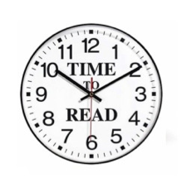**Reading Log**:

It is expected that you read at least for **30 minutes every day.** To help us assess your progress in reading, it is **essential** that the reading log is completed at each reading session. The completed page should be returned with your fortnightly work. This **30 minutes of daily reading** is part of the two hours allocated daily for Literacy activities. **The information in your Reading Log is an important element of assessment for Reading.**



You might be able to download a free Kindle App to your Mac or Windows computer or other device:

[**http://kindle-for-pc.en.softonic.com/**](http://kindle-for-pc.en.softonic.com/)

Create a free account, find a book and get a sample of the first few pages to see if you like the book:

**http://www.lovereading4kids.co.uk**

If you are not sure what to read, look at any of the titles from the Victorian Premier’s Reading Challenge.

[**http://www.education.vic.gov.au/prc/books/**](http://www.education.vic.gov.au/prc/books/)

Wherever you are, you will be able to download books from your local library – make sure you are a member.



You will examine a range of reading materials to analyse features of different text types. This will help you develop understandings of how authors use words, phrases, sentence structure and grammar, so you can use these strategies in your own writing.

**Analysing the text**



**Words** – vocabulary and spelling



You will be studying words, where they come from, how they are constructed and how they are spelt. You will select interesting words to create particular meanings in sentences and paragraphs.

You will have a list of interesting words each week. These words will be based on a pattern or idea to help you learn about words and how they are constructed. You can use your Literacy Planet Log In to play games and learn more about these words.

**Contact! Contact! Contact!**

It is important that you contact your teacher by phone, email or letter if you have any queries or problems with the work. Your teacher can adjust the work to best suit your individual needs.

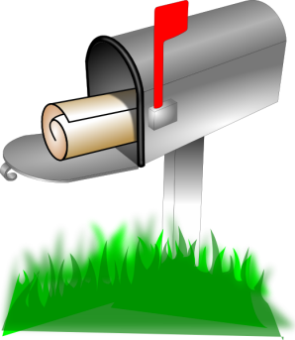

**DAY 1**

|  |
| --- |
| **Learning Intention:**  Develop awareness of vocabulary and selecting words to convey precise meanings to make writing interesting for the reader. |

**There’s a Word for That?**

**Fun Words about Words.**

Do you like browsing through dictionaries? Does discovering a new word make you feel excited? You might be a logophile – a ‘lover of words.” Take your chance to discover some new words from Dictionary.com. If you are obsessed with words, you might belong to an epeolatry group – people who worship words.

Aussie, Yankee, Melburnian, Sydneysider, Taswegian and Kiwi may sound like strange words. Can you see the pattern? These words are called “demonyms’. “Demo” comes from the Greek word for ‘people’ with “-nym” a Greek term for word or name. Demonyms are words used for people who live in a particular locality, state or country. Based on where you are now, what would your ‘demonym’ be?

Do you like short words, or do you like long words? May words in between are your favorites. If you have “sesquipedalian” tendencies, you might have trouble writing a Complete Twitter message in 140 characters. The six syllable word ses/quip/e/dal/i/am means you are prone to using long words!

*Dictionary.com*

Look in your **dictionary** and find unusual, obscure and interesting words that appeal to you. Can you find 10? If you can – great! Choose three interesting words to do the next step. If not, choose your three words from the list on the next page.

You will use a strategy called “**WIRM** word” to think about the **structure**, **meaning** and **usage** of words.

|  |  |  |  |
| --- | --- | --- | --- |
| **W**ord: | | **I**mportant idea | **R**emember **M**e |
| *Write the main word you want to learn.* | | *Find the important idea about the word. Sometimes a picture is better than an explanation.* | *What is it about this word that will help you remember it?* |
| In a sentence, example or picture: | *Use the word so it makes sense to someone else.* | | |

I like the word:. syzygy. Here is how I use the “**WIRM**” word strategy to help me learn about syzygy.

**Example:**

|  |  |  |  |
| --- | --- | --- | --- |
| **W**ord: | | **I**mportant idea | **R**emember **M**e |
| syzygy  *say it like: siz-i-gee*” | | Astronomers call it a syzygy when three or more celestial objects line up: the Sun, Earth, moon or any of the planets. | Unusual word because there are no vowels. The ‘y’ makes the ‘ee’ sound. |
| *In a sentence, example or picture:* | When the Sun, Earth and Moon line up in space, it is called a ‘syzygy’ | | |

|  |  |  |
| --- | --- | --- |
| **W**ord: | **I**mportant idea | **R**emember **M**e |
|  |  |  |
| *In a sentence, example or picture:* |  | |

|  |  |  |
| --- | --- | --- |
| **W**ord: | **I**mportant idea | **R**emember **M**e |
|  |  |  |
| *In a sentence, example or picture:* |  | |

|  |  |  |
| --- | --- | --- |
| **W**ord: | **I**mportant idea | **R**emember **M**e |
|  |  |  |
| *In a sentence, example or picture:* |  | |

Read the words below. Write the word pattern that is common to all the words:

**Words** – vocabulary and spelling



……………………………

Write the **base word** for each word. You MAY need to use your dictionary to find the base words for those marked with \*. Say each word carefully and show its syllables.

|  |  |  |
| --- | --- | --- |
| **List Word:** | **Base word:** | **Syllables.** |
| acceptance | *accept* | *ac/cept/ance* |
| annoyance |  |  |
| appearance |  |  |
| ascendance |  |  |
| continuance\* |  |  |
| exuberance\* |  |  |
| fragrance\* |  |  |
| guidance\* |  |  |
| inheritance |  |  |
| radiance\* |  |  |
| remembrance\* |  |  |
| resistance |  |  |
| significance\* |  |  |
| variance\* |  |  |

**DAY 2**

|  |
| --- |
| **Learning Intention:**  Develop skills in planning, writing and editing a short story using a set of precise words. |

**Words** – vocabulary and spelling



Review your “-ance” words from yesterday. Write five ‘-ance” words that appealed to you.



|  |
| --- |
|  |
|  |
| 1. |
|  |
|  |
| 2. |
|  |
|  |
| 3. |
|  |
|  |
| 4. |
|  |
|  |
| 5. |
|  |

Write a short story – of about 150 – 200 words. Think of interesting ways to include your **five favourite “-ance” words** – even better if you can include more list words.

The final sentence in your story must be*:*

*“At last, the evil genius got her (his) comeuppance!”\**

The explanation is on the next page; your writing paper is after that.

**What does “comeuppance” mean?**

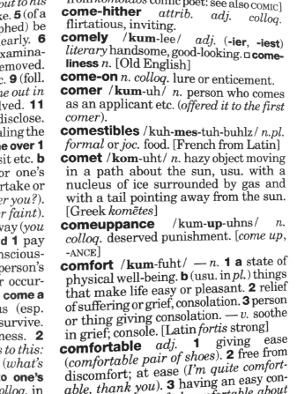This is how I found out if ‘ance’ was a **suffix** and not part of a word.

In words such as: chance, enhance, distance, prance and dance, ‘ance’ is **PART** of the word – not an added **SUFFIX** that **changes** the **meaning** or the **function** of the base word (to a noun, verb, adjective or adverb)

Firstly, I looked in *The Australian Pocket Oxford Dictionary*:

I could see that the ‘’-ance’ IS a suffix and not part of the word. The *come up* + -ANCE clearly shows that comeuppance is a word with a suffix.

I still wanted to know more about this word, so I looked at my smart phone/iPad app: Word Web. I clicked the ‘X=reference” (Cross reference) and found this Wikitionary entry that explained ‘comeuppance’.

Now I feel I know enough about ‘comeuppance’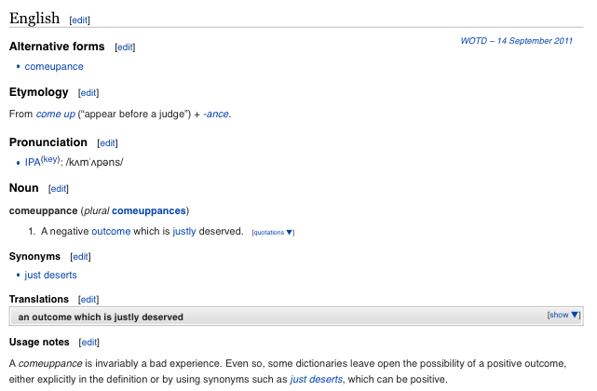 to write a story with –ance words.

Macintosh HD:Users:all:Desktop:DECV Logo.jpg

ID: ………………….Name:………………………………..……………Date………………

|  |  |
| --- | --- |
| **TITLE of your WORK:** |  |
|  | |
|  | |
|  | |
|  | |
|  | |
|  | |
|  | |
|  | |
|  | |
|  | |
|  | |
|  | |
|  | |
|  | |
|  | |
|  | |
|  | |
|  | |
|  | |
|  | |
|  | |

|  |
| --- |
|  |
|  |
|  |
|  |
|  |
|  |
|  |
|  |
|  |
|  |
|  |
|  |
|  |
|  |
|  |
|  |
|  |
|  |
|  |
|  |
|  |
|  |
|  |

****

**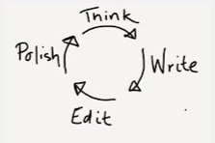**

**Do It Yourself Writing Guide:**

Use this guide to check your work before you send it in.

|  |  |  |  |  |  |
| --- | --- | --- | --- | --- | --- |
| Story Title:…………………………………………………  Name::……………………………………………………… | *Indicate how well you addressed each of the items that make a good story:* | | | | |
| These elements will make an interesting story: | 0% | 25% | 50% | 75% | 100% |
| Followed instructions: |  |  |  |  |  |
| Brainstormed ideas – planned my story before I wrote it: |  |  |  |  |  |
| Discussed ideas for my story with someone else: |  |  |  |  |  |
| Thought of a very interesting beginning for my story: |  |  |  |  |  |
| Used the list words correctly in context: |  |  |  |  |  |
| Wrote good sentences with interesting words: |  |  |  |  |  |
| Sentences are varied in length and structure: |  |  |  |  |  |
| Punctuated sentences correctly– capital letters + full stops, question or exclamation marks: |  |  |  |  |  |
| Meaning is clear: |  |  |  |  |  |
| Organised ideas into paragraphs: |  |  |  |  |  |
| Story has a clear beginning, middle and ending: |  |  |  |  |  |
| The ending is interesting or surprising: |  |  |  |  |  |
| Read the diary aloud to my supervisor: |  |  |  |  |  |
| Checked and edited my diary: |  |  |  |  |  |
| * correct spelling |  |  |  |  |  |
| * correct grammar |  |  |  |  |  |
| * correct punctuation |  |  |  |  |  |
| Handwriting is neat, clear and easy to read **OR**  Neatly typed, with appropriate fonts for easy reading. |  |  |  |  |  |
| I am proud of the story I have written: |  |  |  |  |  |

****

Reading



**Choose** something to read.

**Enjoy** reading it.

**Complete** your **Reading Log** at the front of this booklet.

**Read** something for at least **30 minutes** everyday.



**Handy hint #3 to help you learn English:**  **INTERACT**

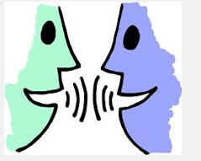

Talk with friends and family. Discuss your work and your ideas.

Start or join conversations that make you think.

Read newspapers or watch the news ask questions, discuss opinions/

Engage with other DECV students on the class Blog or on Google+.



**Day 3**

**Learning Intention:**

Understand structure, rhyme and rhythm of poetry and use this knowledge to write a poem.

## Literature study ⎯ Poetry

**Think** about a **POEM –** what are the features of a poem that are **different** from a story? What are the features that are the **same and**

**Poem Features: Story Features**

**Poem & Story**

Imagine a dinosaur race! Think of words that could be connected to dinosaurs and to racing. Find the horse racing words in the poem.

1. Quickly scan the poem. Highlight words that are unusual or difficult to say. Practise saying the word. Listen for the rhythm of the word. Find the meaning of the word and see how it fits into the sentence.
2. Read the poem silently to familiarise yourself with the **rhythm**, **rhyme** and **tone** of the words and phrases. Highlight the **rhyming** words.
3. Rehearse your poem – focusing on the rhythm of the words and tone of the voice. Is your voice telling the story in an interesting way?
4. Time to read your poem aloud.
5. Record yourself reading the poem and email it to your teacher.
6. Listen to your recording. Complete this self-evaluation.

|  |  |  |  |
| --- | --- | --- | --- |
| What I need to do to read this poem well: | **Low** | **Medium** | **High** |
| Practise, say and know the challenging words |  |  |  |
| Understand what the poem is about. |  |  |  |
| Plan and rehearse poem |  |  |  |
| Include appropriate emphasis on words |  |  |  |
| Use pauses for effect |  |  |  |
| Enunciate words clearly |  |  |  |
|  voice (tone, pitch, pace) to add interest |  |  |  |
| Read poem with appropriate rhythm and expression |  |  |  |
| Speak clearly and loudly |  |  |  |

Analysing Text - Poetry



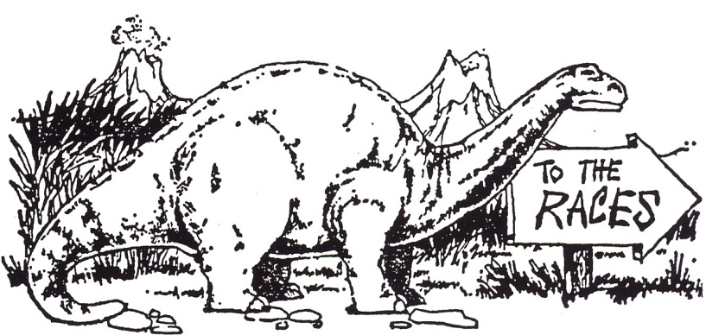

***Brontosaurus***

The Brontosaurus, as you know,

Lived many, many years ago,

Roaming the prehistoric swamp,

Rheumaticky because of damp,

Sleeping by night, hunting by day,

Eating whatever came his way.

Some sixty feet from nose to tail;

His hide was like a coat of mail.

He thought about the situation

And after much deliberation

Decided that his steady pace

Was best for a long-distance race.

‘The Dinosauric Leger might

Turn out,’ he said, ‘exactly right.

The Guineas is too fast for me;

The Derby’s not my cup of tea.’

Each day in every kind of weather

He and his trainer got together

And galloped round the countryside

From early morn till eventide.

His speed increased with every pace

And, confident he’d win the race,

He said, ‘If I maintain this, I’ll Achieve the fifteen-minute mile!’

And then at length the great day came

When he set out to make his name

In Doncaster, a northern town

Of grand and glorious renown,

Where the first Leger had its birth

In the beginnings of the earth.

Almost two miles had to be run

To find the annual champion.

Huge dinosaurs of every sort,

All eager to enjoy the sport,

To Doncaster had made their way

Upon this memorable day.

The inns were full; all stables booked;

Great dinosauric meals were cooked,

For every pleasure-loving beast

Turned up for this historic feast.

All entrants for the Leger Place

Assembled at the starting gate,

The Brontosaurus looked around

And then began to paw the ground.

No brontosauri were in sight.

Iguanodons to left and right

Made up the field, with just one grey

Diplodocus from the USA

Down went the starter’s flag at last

And off they galloped, very fast,

Thundering along at breakneck speed.

(Diplodocus was in the lead.)

With seven furlongs still to go

The race was clearly touch and go.

Diplodocus would win, they reckoned,

With Brontosaurus lying second.

With less than fifty yards to run,

Diplodocus was almost done.

The Brontosaurus, slightly fresher,

Decided to put on the pressure,

And suddenly gave such a bound

That like a bird he left the ground.

He closed his eyes and swelled with pride;

He’d never had a smoother ride.

His take-off had been really tops;

His landing was the worst of flops,

Flat on his belly, legs a-sprawl;

Never did pride have such a fall.

But he was luckier than most;

He did this near the winning post,

And when he crashed down on the deck,

The judges yelled, ‘Won by a neck’?

Having achieved his one ambition,

He withdrew from all competition.

His fellow dinosaurs agreed

They had no further use for speed.

They found that life was too complex,

Degenerated into wrecks,

And long before the Cave Man blinked

They gradually became extinct.

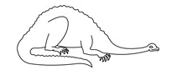

In your own words, state the main idea of this poem. How well did you read it? What could you have done better?

|  |
| --- |
|  |
|  |
|  |
|  |
|  |
|  |
|  |
|  |
|  |
|  |
|  |

**Poetry Writing ⎯ Your turn!**

1. Investigate the poems on a poetry website:

<http://www.fizzyfunnyfuzzy.com/poems>

<http://www.gigglepoetry.com/>

<http://www.familyfriendpoems.com/funny/>

1. Find an online rhyming dictionary, such as:

<http://www.poetry4kids.com/rhymes>

1. Think of a topic that you want to write a poem about.
2. Decide the style of poem you would like to write.
3. Visit **Spellodrome** on the **Mathletics** website. Click on **Writing is Fun** and then click on **Poetry** under **Text Types** to give you ideas to write your poem.
4. Poetry writing isn't always easy! Use the box to brainstorm ideas for your poem and the lines to draft your poem on the following pages before publishing your final piece.
5. Think of a title for your poem.
6. Create an illustration for your poem.
7. How will you present your poem? Think of an engaging way in which to present your poem/
8. Rehearse before you record your poem. Record the poem and email it to your teacher.

****

Writing Workshop — Poetry

You can use your **Thinking Book** to work out your ideas for your poem.

My Poem Ideas:

My poem will be about:

The main point of my poem will be to:

These are some rhyming words which I would like to use in my poem:

(You might like to look at <http://www.poetry4kids.com/rhymes> to find some rhyming words for your ideas.)

Writing Workshop — Poetry



Write the draft of your poem:

|  |
| --- |
|  |
|  |
|  |
|  |
|  |
|  |
|  |
|  |
|  |
|  |
|  |
|  |
|  |
|  |
|  |
|  |
|  |
|  |
|  |

****Use your **draft poem** to create an attractive page with your edited and finished poem and illustration.

**DAY 4**

**Learning Intention:**

Understand the nature and function of adverbs, to create clearer, more precise writing

**Words** – vocabulary and spelling



**What is an adverb?**

**Adverbs** are words that work with **verbs** (ad+verb) to:

* tell you **how,** **where**, or **when** something is done
* describe the **manner, place, or time** of an action (verb)
* an **adverb** usually answers the questions:

**How? Where? When? Why?**

Consider this sentence: *Tim returned.*

*Noun + verb*

This sentence makes complete sense but we don't know **how,** **when**, **where** or

**why** Tim returned.

We can say more about Tim's return by using **adverbs** (or groups of words

called adverbial phrases or adverbial clauses which can be used instead of an

adverb).

For example: *Tim returned* ***excitedly****.*  (How?)

*Tim returned* ***home****.*  (Where?)

*Tim returned* ***yesterday.*** (When?)

*Tim returned* ***to have dinner****.*  (Why?)

Visit the following website to learn more about adverbs:

<http://tinyurl.com/redcadverbs>

or

<http://www.kidsknowit.com/interactive-educational-movies/free-online-movies.php?movie=Adverbs>

These **adverbs** that tell us *how* something was done:

|  |  |  |
| --- | --- | --- |
| hesitantly  excitedly  extravagantly  hungrily | groggily  instinctively  angrily  uncertainly | contentedly  roughly  urgently  briefly |

1. Read these adverbs to your supervisor and discuss their meanings. Did you notice that many **adverbs** that tell *how* end in ‘ly’?
2. Write a short paragraph using five adverbs used from the above list.
3. *Underline* the **adverbs** you have used and *circle* the **verbs** they are connected to.

|  |
| --- |
|  |
|  |
|  |
|  |
|  |
|  |
|  |
|  |
|  |
|  |
|  |
|  |
|  |
|  |
|  |

Highlight or underline the **nine adverbs** in the following passage.

Draw an arrow to the verb the adverb is connected to.

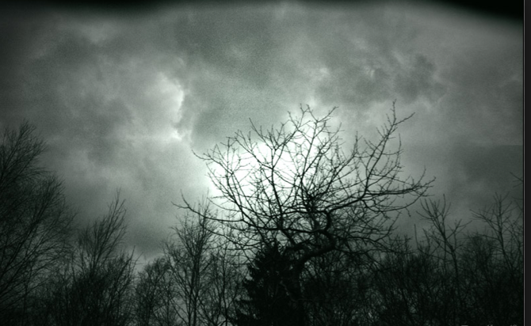As she crept stealthily into the room, the wind whistled eerily in the trees. Her flashlight played nervously on the pieces of furniture until she caught some movement behind the couch. "Who's there?" she asked fearfully. "Surprise!" the group shouted excitedly as they suddenly burst from their hiding places. She grinned sheepishly and immediately collapsed into a chair.

*Find the solution at the end of this module.*

Read more of the book you read earlier, a newspaper or a magazine. Try to find six adverbs with their verbs and write them here:

|  |  |  |  |
| --- | --- | --- | --- |
| **Adverb** | **Verb** | **Adverb** | **Verb** |
|  |  |  |  |
|  |  |  |  |
|  |  |  |  |

Help this student who spelt ALL the words incorrectly. Write the word correctly:

**Words** – vocabulary and spelling



|  |  |
| --- | --- |
| **Misspelt Words** | **Correctly spelt words:** |
| *varience* |  |
| *transmitance* |  |
| *acceptence* |  |
| *ascendanse* |  |
| *apearance* |  |
| *anoyance* |  |
| *gidance* |  |
| *continuants* |  |
| *signeficance* |  |
| *raddiance* |  |
| *inheritence* |  |
| *fragrence* |  |
| *rememberance* |  |

Reading



**Choose** something to read.

**Enjoy** reading it.

**Complete** your **Reading Log** at the front of this booklet.

**Read** something for at least **30 minutes** everyday.

Think about what you are reading. Write a short persuasive text to convince others to read what you are reading.

|  |
| --- |
|  |
|  |
|  |
|  |
|  |
|  |
|  |
|  |
|  |
|  |



Please see the next page for your reading activity.

**Visualise** your reading: draw what you imagined when you were reading today.

|  |
| --- |
|  |

**Words to use instead of ‘*said’***

**Words** – vocabulary and spelling



You can make your writing more interesting by using words which are more precise and give the reader a clearer idea of the action.

1. Read these words, which can be used instead of ‘said’. Try to say these words in the TONE of the word. For example, **S**HOUT the word ‘shout’; **ROAR** the word ‘roared’.

**Alternatives to the word *said***

suggested stammered answered protested

called cried asked rumbled

shouted blurted roared croaked

bellowed shrieked pronounced murmured

1. Use a Thesaurus to find other words for ‘said’. Write them here:

|  |  |  |
| --- | --- | --- |
|  |  |  |
|  |  |  |
|  |  |  |
|  |  |  |
|  |  |  |
|  |  |  |

Tick the sentences you think create an interesting picture:

*“Get out of the way,” said Mum. “Get out of the way,” shrieked Mum.*

*“Get out of the way,” murmured Mum****. “****Get out of the way,” whispered Mum****.***

Choose five words that can be used instead of ‘said’.

Imagine a scenario and create interesting sentences to show how the word is used effectively. Write them here:

|  |
| --- |
|  |
|  |
|  |
|  |
|  |
|  |
|  |
|  |
|  |
|  |
|  |
|  |
|  |
|  |
|  |
|  |
|  |
|  |

**For you to SEND**



**DAY 5**

|  |
| --- |
| **Learning Intention:**  Understand the structure and features of recounts; use this knowledge to write a recount according to the success criteria. |

Reading



**Choose** something to read.

**Enjoy** reading it.

**Complete** your **Reading Log** at the front of this booklet.

**Read** something for at least **30 minutes** everyday.



Did you notice any interesting adverbs in what you read? If you did, write them here:

|  |  |  |  |
| --- | --- | --- | --- |
| **Adverb** | **Verb** | **Adverb** | **Verb** |
|  |  |  |  |
|  |  |  |  |
|  |  |  |  |

Your supervisor will test you on your spelling words for Week One.

**Words** – vocabulary and spelling



Supervisors please encourage your student to review his or her own work and identify their own errors. Do not use a cross for an incorrect word – instead highlight or underline the **error** and ask the student to write the word correctly.

|  |  |
| --- | --- |
|  |  |
|  |  |
|  |  |
|  |  |
|  |  |
|  |  |
|  |  |
|  |  |
|  |  |
|  |  |

**To the student:** Congratulations if you spelt every word correctly!

If you wrote some words incorrectly, look at the word and try to work out why you made that error – tick the statements that apply to you.

*I was careless. I didn’t listen to the word properly. It sounded like something else.*

*I didn’t understand. I got it mixed up with another word. I didn’t pay attention.*

**What is a recount?**

**Writing Workshop — Recount**



A recount tells about something that happened in the past. The details in a recount may include:

* **what** happened,
* **who** was involved,
* **where** it took place,
* **when** it happened
* **why** it occurred.

A writer uses a recount to tell us about a story or an event. Recounts are usually written in the order that the event occurred. Recounts can be:

* **factual**, such as a news story
* **procedural**, such as telling someone how you built something
* **personal**, such as a family holiday or your opinion on a subject.

**Examples of a recount**

Recounts can be either written or spoken. Examples of recounts include:

* biographies and autobiographies
* newspapers or the television news
* magazine articles
* letters and postcards
* textbooks
* conversations with friends

A **RECOUNT** Planner:

Before you write your recount, you need to **think of ideas** and **plan your writing.**

**What do you want to write? Here are some ideas:**

|  |  |  |
| --- | --- | --- |
| **Recount**  **Type** | **Description** | **My Ideas – what I would write about.** |
| **Personal** | telling about something that happened to you. |  |
| **Factual** | retelling an event that occurred in the past. |  |
| **Imaginative** | putting yourself in the place of someone and retelling the story from their point of view. |  |
| **Procedural** | telling how you did something |  |
| **Literary** | retell an imaginative story, or an event to entertain the reader. |  |

Use this chart to organise your ideas to write a recount:

Who?....................................................... Where?........................................................

What? ...................................................... When? ......................................................

Why? ...................................................... How? ......................................................….

Think of a title for your recount:…………………………………………………………..

|  |  |  |
| --- | --- | --- |
| Recount | Ideas, words or pictures to support your event | Notes. |
| Introduction. |  | *Think of your first idea, then think of a better idea to create a starting sentence that captures reader interest.* |
| Event 1 |  | *Describe or explain your events and ideas in detail. Use interesting words, like adjectives and adverbs.*  *You are writing for someone who is not there, so you have to explain and describe in detail, with precise words and language.*  *Use ‘connecting words’ (connectives) such as, so, when, then, next, after, before to link your ideas.* |
| Event 2 |  |
| Event 3 |  |
| Event 4 |  |
| Event 5 |  |
| Event 6 |  |
| Conclusion |  | *The conclusion is a statement which summarises the main ideas, provides an opinion or thought about the events or makes a point. It ‘finalises’ your recount and signals to the reader that this is the end.* |

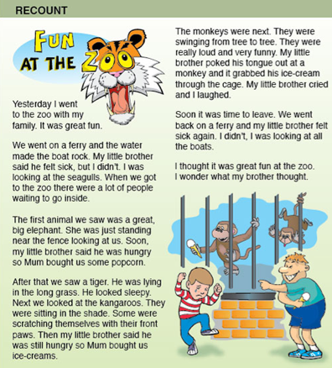

http://www.teachers4teachers.com.au/img/bb\_2\_front.jpg

Put “**T”** next to the title.

Put “**O”** next to the orientation / introduction.

Put **“C”** next to the conclusion.

Put “**E”** next to each event or idea.

Find and highlight all the **connecting words** (connectives.)

Find words and groups of words that made the recount **interesting to read**.

Use your ideas and plans to write a recount

Macintosh HD:Users:all:Desktop:DECV Logo.jpg ID: …………………..…… Name:………………………………..…Date………………

Module: …………... Day: …………………

|  |  |
| --- | --- |
| **TITLE of your WORK:** |  |
|  | | |
|  | | |
|  | | |
|  | | |
|  | | |
|  | | |
|  | | |
|  | | |
|  | | |
|  | | |
|  | | |
|  | | |
|  | | |
|  | | |
|  | | |
|  | | |
|  | | |
|  | | |
|  | | |
|  | | |
|  | | |
|  | | |
|  | | |
|  | | |
|  | | |
|  | | |
|  | | |
|  | | |
|  | | |
|  | | |
|  | | |

|  |  |  |  |  |  |
| --- | --- | --- | --- | --- | --- |
| How do I know my recount is well written? Review your recount and tick the boxes that apply to your recount. | I tried. | Very Good! | Extra Good! | Brilliant! | Genius! |
| It tells the reader about an event or experience. |  |  |  |  |  |
| It has an interesting introduction to capture reader interest. |  |  |  |  |  |
| Events are told in detail. |  |  |  |  |  |
| My recount makes sense to the reader. |  |  |  |  |  |
| I have used interesting words to tell my story. |  |  |  |  |  |
| I put capital letters, full stops (or other marks) into my sentences. |  |  |  |  |  |
| I have checked and edited my work to make sure it makes sense. |  |  |  |  |  |
| My spelling is correct. |  |  |  |  |  |
| My punctuation is correct, with capital letters for proper nouns. |  |  |  |  |  |
| My recount is attractively presented and easy to read. |  |  |  |  |  |
| My recount has a clear conclusion / ending. |  |  |  |  |  |

**For you to SEND**



**DAY 6**

**Learning Intention:**

Apply knowledge of the structures and features of recount to revise/rewrite a recount.

Reading



**Choose** something to read.

**Enjoy** reading it.

**Complete** your **Reading Log** at the front of this booklet.

**Read** something for at least **30 minutes** everyday.



**Answer these questions:**

What did you read? ………………………………………………………………………………………….

Who wrote it? ……………………………………………………………………………………..….

What was the author trying to tell you? …………………………………………………………..

………………………………………………………………………………………………………………………..

………………………………………………………………………………………………………………………..

………………………………………………………………………………………………………………………..

………………………………………………………………………………………………………………………..

………………………………………………………………………………………………………………………..

………………………………………………………………………………………………………………………..

To do this activity, you will need to review what you have learnt about writing recounts and using interesting words.

**Writing Workshop — Recount**



Your task is to take a very ordinary recount, give some feedback about how to improve it and rewrite the recount to make it more interesting for the reader.

**Recount draft:**

**My Holiday in Queensland**

*We woke up.*



*We got in the car.*

*It was a long drive.*

*We went to Queensland.*

*We went to Dreamworld and Movie World.*

*I liked the beach.*

*We came home.*

|  |  |  |  |  |  |
| --- | --- | --- | --- | --- | --- |
| Imagine you are the teacher. Rate the recount above. | A little | Fair | Good | Very Good | Excellent |
| The recount tells the reader about an event or experience. |  |  |  |  |  |
| It has an interesting introduction to capture reader interest. |  |  |  |  |  |
| Events are told in detail, so the reader can imagine the holiday. |  |  |  |  |  |
| The recount makes sense to the reader. |  |  |  |  |  |
| Interesting words describe people, places and events. |  |  |  |  |  |
| Sentences are interesting and explain events in detail. |  |  |  |  |  |
| There is a good conclusion. |  |  |  |  |  |

*You can look at the Internet to find out about “Queensland Holidays” to find ideas about how to improve this recount.*

Help the writer to improve this recount – give him or her some suggestions about what s/he can do to make the story more interesting.

*Dear Writer,*

*Here are some suggestions you could use to improve your recount:*

|  |
| --- |
|  |
|  |
|  |
|  |
|  |
|  |
|  |
|  |
|  |
|  |
|  |
|  |
|  |
|  |
|  |
|  |
|  |
|  |
|  |

|  |
| --- |
|  |
|  |
|  |
|  |
|  |
|  |
|  |
|  |
|  |
|  |
|  |
|  |
|  |
|  |
|  |
|  |
|  |

Use what you know about recounts: ask good questions, get as many ideas as you can. Look for interesting adverbs and adjectives. Rewrite this recount as a more detailed, interesting and exciting piece of writing. Use your imagination. Do some research on the Internet.

When you have written your recount, use the scale above to evaluate your work.

**For you to SEND**



Macintosh HD:Users:all:Desktop:DECV Logo.jpg ID: …………………..…… Name:………………………………..Date………………

Module: …………... Day: …………………

|  |  |
| --- | --- |
| **TITLE of your WORK:** |  |
|  | |
|  | |
|  | |
|  | |
|  | |
|  | |
|  | |
|  | |
|  | |
|  | |
|  | |
|  | |
|  | |
|  | |
|  | |
|  | |
|  | |
|  | |
|  | |
|  | |
|  | |

|  |
| --- |
|  |
|  |
|  |
|  |
|  |
|  |
|  |
|  |
|  |
|  |
|  |
|  |
|  |
|  |
|  |
|  |
|  |
|  |
|  |
|  |
|  |

**For you to SEND**



**DAY 7**

**Learning Intention**:

Understand that quotation marks designate direct speech; recognise instances where quotation marks should be used in writing.

**Words** – vocabulary and spelling



|  |  |  |
| --- | --- | --- |
| Read the words below. Write the word pattern that is common to all the words: …………. | | |
| **List Word:** | **Syllables.** | **Meaning In a Nutshell** |
| ancient | *an/cient* | *very very old* |
| audience |  |  |
| besiege |  |  |
| deficient |  |  |
| grief |  |  |
| grieve |  |  |
| niece |  |  |
| proficient |  |  |
| proficiency |  |  |
| relief |  |  |
| relieve |  |  |
| reliever |  |  |

|  |  |  |
| --- | --- | --- |
| **List Word:** | **Syllables.** | **Meaning In a Nutshell** |
| resilient |  |  |
| resilience |  |  |
| retrieve |  |  |
| retriever |  |  |
| science |  |  |
| scientific |  |  |
| shriek |  |  |
| siege |  |  |

Even though the **‘ie’** pattern is common to all the words, these letters make different sounds when spoken.

Write some words with the ‘short ie’ sound (resilient).

……………………….………………….…………………….…………………….…………………….……………

……………………….………………….…………………….…………………….…………………….……………

Write some words with the ‘long ie’ sound (believe.)

……………………….………………….…………………….…………………….…………………….……………

Sometimes, the “c+ie” make the “sh” sound. Write those words (quotient.)

……………………….………………….…………………….…………………….…………………….……………

**Using quotation marks to show direct speech.**

**Writing Workshop — Dialogue**



Read the comic strip. Lily and Bud are the main characters. They are brother and sister. Read what this comic strip might be when it’s written in a story.

|  |  |
| --- | --- |
| **The Conversation:** | **The Dialogue** |
|  | “I’m hungry!” *exclained Bud.* “Get me breakfast!” *he demanded.*  “There’s the cereal. There’s the milk,” *Lily gestured.* “Get it yourself!” *she contined in a stern voice.*  “I’m not THAT hungry,” *Bud replied as he left the room.* |

*Can you see how this conversation was written as dialogue? Read the dialogue. Notice where the quotation marks and other punctuation are.*

“I’m hungry!” *exclaimed Bud.* “Get me breakfast!” *he demanded.*

“There’s the cereal. There’s the milk,” *Lily gestured.* “Get it yourself!” *she contined in a stern voice.*

“I’m not THAT hungry,” *Bud replied as he left the room.*

Here are two comic strips for you to punctuate with quotation marks, commas, full stops, exclamation marks or question marks as necessary.

The big sister is Lil and the little brother is Bud.

**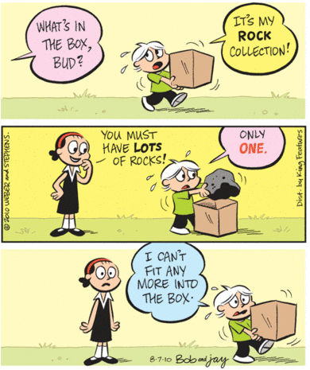**

**For you to SEND**



|  |
| --- |
|  |
|  |
|  |
|  |
|  |
|  |
|  |
|  |



**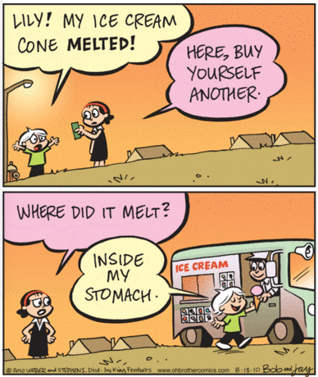**

**For you to SEND**



|  |
| --- |
|  |
|  |
|  |
|  |
|  |
|  |
|  |
|  |
|  |

**DAY 8**

|  |
| --- |
| **Learning Intention:**  Understand that there are rules and exceptions to English Spelling. |

Reading



**Choose** something to read.

**Enjoy** reading it.

**Complete** your **Reading Log** at the front of this booklet.

**Read** something for at least **30 minutes** everyday.

Choose a character or an idea from your reading. Draw what you imagine when you read:



|  |
| --- |
|  |

**Spelling ‘rules’**

**Words** – vocabulary and spelling



The English language has a history of including words from many different languages: Latin, French, German, Greek and other European languages.

As English is a mixture of languages, it has some very unusual and unpredictable spelling patterns. Here is an example of a word made up of English letter patterns:

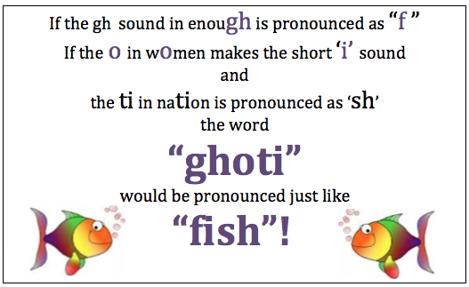

However, most of English spelling follows predictable rules, such as ’i’ before ‘e’ except after ‘c’. There are exceptions such as ‘weird, weigh, neighbor, science and neither.’ The best advice is *‘know the rule, but be aware of the exceptions!’*

**Drop the e to add ‘-ing’**

In most cases if a word ends in **e**, drop the **e** before adding –**ing**.

For example: lov**e** ⎯ lov**ing**

Add ‘ing’ to these words and write the word:

*amaze +ing ……….……….……….……….……….……….……….……….……….……….*

*excite +ing ……….……….……….……….……….……….……….……….……….……….*

*notice +ing ……….……….……….……….……….……….……….……….……….……….*

Find and write other words where this same rule applies.

*……….……….……….……….……….……….……….……….……….…………………………………………………..*

*……….……….……….……….……….……….……….……….……….…………………………………………………..*

*……….……….……….……….……….……….……….……….……….…………………………………………………..*

*……….……….……….……….……….……….……….……….……….…………………………………………………..*

*……….……….……….……….……….……….……….……….……….………………………………………………….*

**Another rule is change the ‘y’ to ‘i’**

Also if you have a word ending in **y**, as in plent**y**, you change

the **y** into **i** before adding the ending.

For example: plenty+ful = plent**i**ful.

Beauty+ful = beautiful.

Find out about spelling rules in English:

<http://www.mourass.eq.edu.au/spelling.htm>

<http://www.spellmasters.com.au/spelling_basics.asp>

<http://grammar.about.com/od/words/tp/spellrules.htm>

<http://www.riggsinst.org/28rules.aspx>

If you do not have Internet, use a dictionary. Find common English spelling rules.

Find as many words as you can to show this rule; try to find words that are not spelt according to the rule.

Create a colorful poster to show your spelling rules. These are some examples – you can be creative with your own poster.

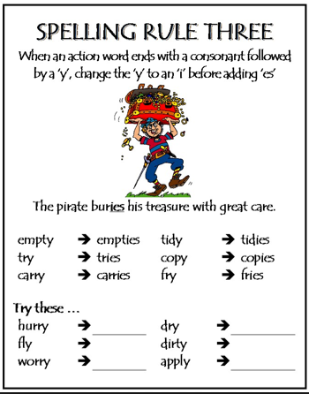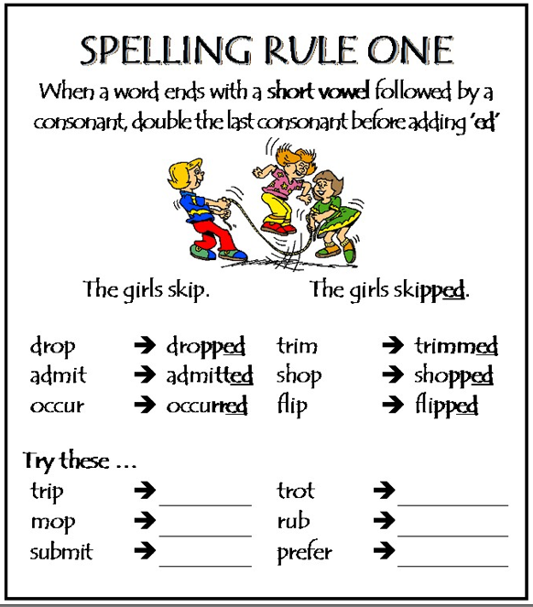

Create your A4 poster with an interesting rule and some examples to show the rule.

Make sure your poster is bold, neat, clear and colorful, with a strong focus on your spelling rule.

**For you to SEND**



**DAY 9**

|  |
| --- |
| **Learning Intention:**  Understand that English has a variety of patterns and structures in words and sentences that can be applied to writing. |

**Words** – vocabulary and spelling



Other *“ie”* and *“ei”* words have been added to this week’s basic list.

Say each word aloud. Listen for the sounds the ie / ei combination makes.

Say the syllables clearly.

|  |  |  |  |  |
| --- | --- | --- | --- | --- |
| weird | audience | hygiene | deficient | grief |
| foreign | niece | proficient siege | deceitful | science |
| either | reliever | beige | conscience | shriek |
| heist | forfeit | freight | society | heir |
| sovereign | neighbour | neither | weight | retriever |
| receipt | believe | resilient | relieve | grieve |
| vein | receive | s cientific | weir | eight |
| neigh | ancient | relief | height | seize |
| resilience | retrieve | proficiency | alien | achieve |

**Highlight** the basic list words you learnt in Day 6.

Put a **circle** around the words that meet the “*i before e except after c”* rule.

Write the words that are the **EXCEPTION** to the i before e except after c” rule.

|  |  |  |  |  |  |
| --- | --- | --- | --- | --- | --- |
| *w \_\_ \_\_ rd* | | *aud \_\_ \_\_ nce* | | *hyg \_\_ \_\_ ne* | |
| *for \_\_ \_\_ gn* | | *n \_\_ \_\_ ce* | | *profic \_\_ \_\_ nt* | |
| *\_\_ \_\_ ther* | | *rel \_\_ \_\_ ver* | | *b \_\_ \_\_ ge* | |
| *h \_\_ \_\_ st* | | *forf \_\_ \_\_ t* | | *fr \_\_ \_\_ ght* | |
| *sover \_\_ \_\_ gn* | | *n \_\_ \_\_ ghbour* | | *n \_\_ \_\_ ther* | |
| *rec \_\_ \_\_ pt* | | *bel \_\_ \_\_ ve* | | *resil \_\_ \_\_ nt* | |
| *v \_\_ \_\_ n* | | *rec \_\_ \_\_ ve* | | *sc \_\_ \_\_ ntific* | |
| *n \_\_ \_\_ gh* | | *anc \_\_ \_\_ nt* | | *rel \_\_ \_\_ f* | |
| *resil \_\_ \_\_ nce* | | *retr \_\_ \_\_ ve* | | *profic \_\_ \_\_ ncy* | |
| *defic \_\_ \_\_ nt* | *gr \_\_ \_\_ f* | | *ach \_\_ \_\_ ve* | |
| *dec \_\_ \_\_ tful* | *sc \_\_ \_\_ nce* | | *al \_\_ \_\_ n* | |
| *consc \_\_ \_\_ nce* | *shr \_\_ \_\_ k* | | *s \_\_ \_\_ ze* | |
| *soc \_\_ \_\_ ty* | *h \_\_ \_\_ r* | | *h \_\_ \_\_ ght* | |
| *w \_\_ \_\_ ght* | *retr \_\_ \_\_ ver* | | *\_\_ \_\_ ght* | |
| *rel \_\_ \_\_ ve* | *g r\_\_ \_\_ ve* | | *w \_\_ \_\_ r* | |

*Check your words with those in the list on the previous page. Score: ……./45.*

Reading



**Choose** something to read.

**Enjoy** reading it.

**Complete** your **Reading Log** at the front of this booklet.

**Read** something for at least **30 minutes** everyday.



Look at the book, magazine or newspaper you have just read. Find some “ie” and “ei” words and write them here:

……………………………..……………………………..……………………………..……………………………..………………………

……………………………..……………………………..……………………………..……………………………..………………………

……………………………..……………………………..……………………………..……………………………..………………………

……………………………..……………………………..……………………………..……………………………..………………………

……………………………..……………………………..……………………………..……………………………..………………………

……………………………..……………………………..……………………………..……………………………..………………………

……………………………..……………………………..……………………………..……………………………..………………………

……………………………..……………………………..……………………………..……………………………..………………………

**Words** – vocabulary and spelling



**Syllables**

A syllable is a complete **sound** in a word. For example ***and*** has only one syllable but ***reading*** has two syllables — ***read***and ***ing***and ***motoring***has three syllables — ***mo-tor-ing****.*

Some dictionaries will show how words are broken into syllables. There will be marks to show which syllable to stress when you are speaking.

**Here are some facts about syllables:**

1. ****A syllable is the sound of a vowel (a, e, i, o, u) that is created when pronouncing a word.
2. The letter 'y' can be counted as a vowel, only if it creates the sound of a vowel (a, e, i, o, u). For example: fry, try, cry, & dry
3. The number of times that you hear the sound of a vowel (a, e, i, o, u) is equal to the number of syllables the word has.
4. Syllables are useful to help you spell unfamiliar words.
5. When you say a word in parts, you should hear a **vowel** for each **syllable.**

**You can find out more about syllables from these websites.**

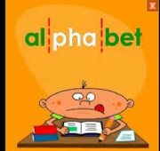

<http://www.howmanysyllables.com/howtocountsyllables.html>

<http://www.wordcalc.com/>

Show the syllables in these sentences. The first one has been done as an example.

|  |  |
| --- | --- |
|  | Number of Syllables: |
| To/day/ is / Thurs/day. | 5 |
| Once upon a time Goldilocks went into the forest. |  |
| I like to go swimming when it is a summer’s day. |  |
| I didn’t realise the significance of the fragrance until the appearance of the spring blossoms. |  |
| It was a relief to discover that I was still proficient in my spelling. |  |
| My neighbor likes to take her golden retriever for a walk every day. |  |
| Sometimes I like to eat the vegetables my grandmother grows in her garden. |  |

*Look at the back of the Module to compare your answers to the solution.*

**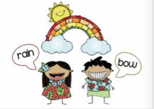**

**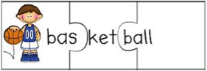**



Writing Workshop — Sentences



|  |
| --- |
| A ***sentence*** consists of:   * words correctly arranged to form a **complete statement or idea.** * a **subject** (who or what) and a **verb** (doing or action word). * a capital letter at the **start** and a full stop, question mark or exclamation mark at the **end**. |

**Sentences can be used in these ways:**

**Statements**

Sentences that make statements end with full stops:

*I will look forward to receiving your project.*

**Questions**

Sentences that ask a question end with a question mark:

*Have you been working on your project each day?*

**Exclamations**

Sentences that show excitement (string commands, exclamations and interjections) ending with an exclamation mark:

*I didn't see that coming! I'm lost!*

**Commands**

Sentences that are an order or a command and end with a full stop:

*Come here, Kate. Do up your seat belt Matthew.*

*Read this extract. Find at least ONE of each of the different sentences: statements, questions, exclamations and commands.*

Writing Workshop — Sentences



*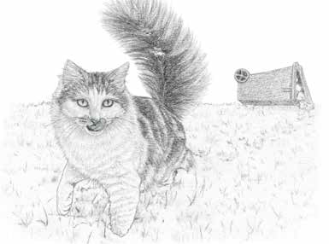*The little cat picked her feet up high as she stepped gingerly through the snow. As she licked the last trace of gravy from her whiskers, she flicked her magnificent tail back and forth across her back. Cat was unaware of the story that the tipped-overdustbin lying behind her seemed to tell and as she sauntered close to a line of parked cars, the memory of the snatched feast she had just eaten made her huff out a sigh of contentment.

‘Oi – you!’ A man’s voice boomed across the street. ‘Yes – YOU! I’m talking to you, you little toe-rag! What d’you think you’re doing?’ And with that the man started to run straight at her. ‘You filthy little scavenger, you’re no better than a rat.’ The cat stood still, frozen in fear, her happiness gone. What would this aggressive monster do once he reached her? And why was he shouting? She cowered down, put her ears back and spat at him to show him how fierce she was. It didn’t work. As he lunged out to grab her she gave a drawn-out hiss of fear, and, snakelike, she slunk down low, crawling under the car parked next to her. From there, she crept along to the next car and then the next. Cat felt safe close to the warm metal hulk.

She liked cars. Ones that weren’t moving at least. The ones that raced past on the road definitely didn’t make her feel safe. She could see the man’s feet two cars away. He had stopped walking. One boot was tapping up and down impatiently and

her keen hearing picked up the sound of his fingers drumming on the roof of the car.

Extract from: Magnificat *by Marilyn Edwards*

<http://www.lovereading4kids.co.uk>

Did you find an example of each sentence in “Magnificat’? Neatly write each sentence here. Make sure you have the correct punctuation.

|  |  |
| --- | --- |
| **Statement** |  |
|  |
|  |
|  |
| **Question** |  |
|  |
|  |
|  |
| **Exclamation** |  |
|  |
|  |
|  |
| **Command** |  |
|  |
|  |
|  |

**For you to SEND**



**Words** – vocabulary and spelling



**Word building – suffixes and prefixes.**

We can build new words from ‘base’ words by using different beginnings and endings (prefixes and suffixes).

|  |  |  |  |  |
| --- | --- | --- | --- | --- |
| **Prefix** | **BASE WORD** | **Suffix** |  | **FINAL WORD** |
|  | answer | s |  |
| answer | ed |  |
| answer | ing |  |
| answer | able |  |
| un | answer | ed |  |
| un | answer | able |  |

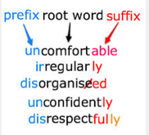

Build new words from the following two base words. Use a dictionary to help you.

|  |  |  |
| --- | --- | --- |
| suggest | pronounce | agree |
|  |  |  |
|  |  |  |
|  |  |  |
|  |  |  |
|  |  |  |
|  |  |  |
|  |  |  |

For more practice working with base words, prefixes and suffixes, go to:

<http://www.bbc.co.uk/schools/spellits/activities_y6/activity4.shtml> or

<http://tinyurl.com/decvvocab>

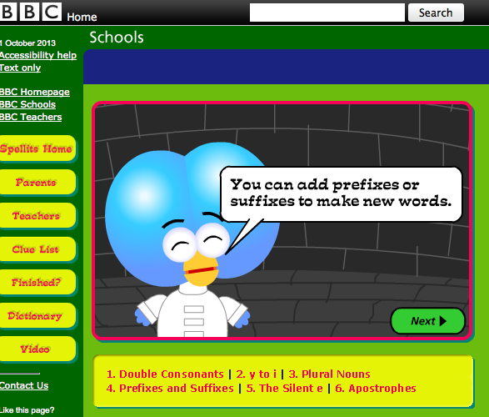

## Building words

Word Explorer - Vocabulary



In your word building today you will be using **base words** from which some of your unit words were derived.

The diagram below clearly shows the **base word,** the **prefixes, suffixes** and other endings that can be used to make new words from that base word.

|  |  |  |  |  |
| --- | --- | --- | --- | --- |
| **Prefix** | **BASE WORD** | **Suffix** |  | **FINAL WORD** |
| re  de  en | sign | s |  |
| ed |  |
| ing |  |
| ature |  |
| ify |  |
| icant |  |
| er |  |
| ation |  |

*There will be at least 26 words which you can make from this base word, prefixes and suffixes. Use another piece of paper to write extra words you make. Check the possible words at the end of the module.*

**DAY 10**

|  |
| --- |
| **Learning Intention:**  Understand that a diary is a form of recount that serves a variety of purposes. |

**Words** – vocabulary and spelling



Your supervisor will test you on your spelling words for Week Two. Choose 20 ‘ie’ words to test.

Supervisors please encourage your student to review his or her own work and identify their own errors. Do not use a cross for an incorrect word – instead highlight or **underline** the **error** and ask the student to write the word correctly.

|  |  |
| --- | --- |
|  |  |
|  |  |
|  |  |
|  |  |
|  |  |
|  |  |
|  |  |
|  |  |
|  |  |
|  |  |

**To the student:** Congratulations if you spelt every word correctly!

If you wrote some words incorrectly, look at the words and try to work out why you made that error – tick the statements that apply to you.

*•I was careless. • I didn’t listen to the word properly. •It sounded like something else.*

*•I didn’t understand. •I got it mixed up with another word. • I didn’t pay attention.*

Writing Workshop — Diary

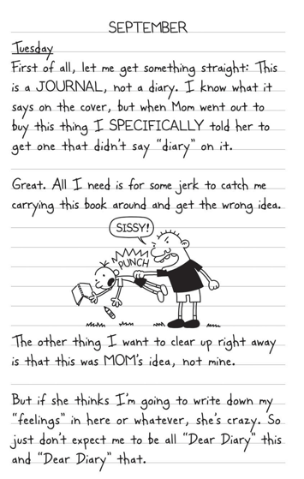

**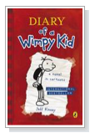**

<http://www.npr.org/books/titles/138258754/diary-of-a-wimpy-kid#excerpt> or

<http://tinyurl.com/decvdiary>

**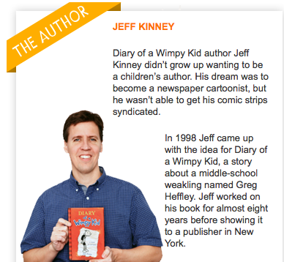**

Read more about this diary at: http://www.wimpykid.com

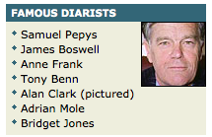

Discuss thee ideas with others:

*Why do people write diaries?*

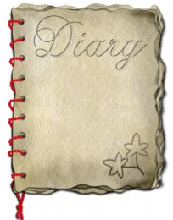*What do you know about diaries?*

*How can diaries be useful?*

*Who do you know who writes a diary or Blog?*

During World War 2, Anne Frank (14 Years old) her family hid in a small room than two years, to escape from being sent to a concentration camp. During this time Anne Frank wrote a diary about what happened to her and how she felt about the events in her life.

In August 1944 the Frank family was found, arrested and sent to a concentration camp. Anne, her mother and sister died from starvation and typhus. Anne’s diary was published. Her diary has become one of the best known books in history. Anne Frank’s diary helped the world understand how World War 2 affected ordinary people.

These are pictures are of Anne Frank and her diary. Anne’s diary was translated into many languages. Here is an entry from Anne Frank’s diary:

*October 20th 1942: “My hands still shaking, though it’s been two hours since we had the scare… The office staff stupidly forgot to warn us that the carpenter, or whatever he’s called, was coming to fill the extinguishers… After working for about fifteen minutes, he laid his hammer and some other tools on our bookcase (or so we thought!) and banged on our door. We turned white with fear. Had he heard something after all and did he now want to check out this mysterious looking bookcase? It seemed so, since he kept knocking, pulling, pushing and jerking on it. I was so scared I nearly fainted at the thought of this total stranger managing to discover our wonderful hiding place…”*

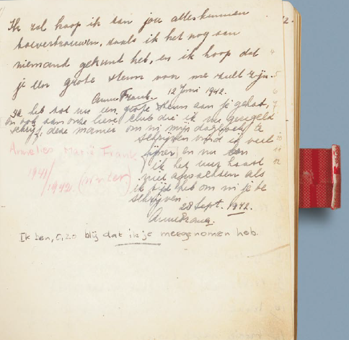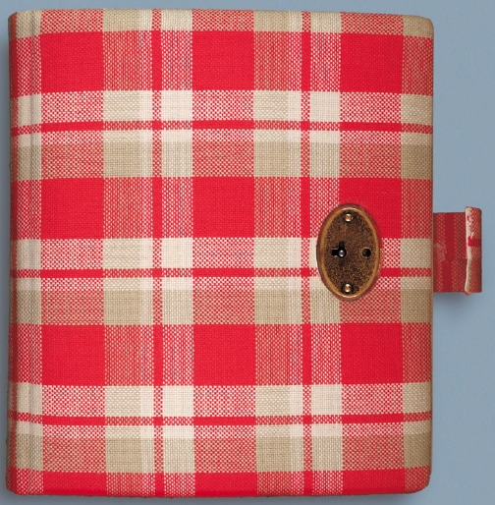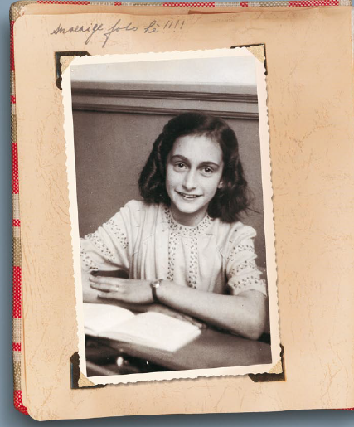

Think about an idea or a topic you would like to write as your diary entry.

Do you have an opinion? Is there something you want to change in your life? Is there something you want to remember?

Plan and write your diary entry on the next page.

Writing Workshop — Diary



Macintosh HD:Users:all:Desktop:DECV Logo.jpg ID: …………………….. Name:………………………………..……Date………………

Module: …………... Day: …………………

|  |  |
| --- | --- |
| **TITLE of your WORK:** |  |
|  | | |
|  | | |
|  | | |
|  | | |
|  | | |
|  | | |
|  | | |
|  | | |
|  | | |
|  | | |
|  | | |
|  | | |
|  | | |
|  | | |
|  | | |
|  | | |
|  | | |
|  | | |

|  |
| --- |
|  |
|  |
|  |
|  |
|  |
|  |
|  |
|  |
|  |
|  |
|  |
|  |
|  |
|  |
|  |
|  |
|  |
|  |
|  |
|  |

Use the “Do It Yourself” writing guide on the next page to check the quality of your diary entry.

**For you to SEND**



****

**Do It Yourself Writing Guide - Diary**

Use this guide to check your work before you send it in.

|  |  |  |  |  |  |
| --- | --- | --- | --- | --- | --- |
| Diary Date: ………………………………………………………  Name:…………………………………………………………………. | *Indicate how well you addressed each of the items that make an interesting diary:* | | | | |
| These elements will make an interesting story: | 0% | 25% | 50% | 75% | 100% |
| I had a good idea. |  |  |  |  |  |
| I planned what I would write |  |  |  |  |  |
| Thought of a very interesting beginning for my diary |  |  |  |  |  |
| I added some creative details to make my diary interesting |  |  |  |  |  |
| I wrote good sentences with interesting words |  |  |  |  |  |
| Sentences are varied in length and structure |  |  |  |  |  |
| I punctuated sentences correctly |  |  |  |  |  |
| My intended meaning is clear |  |  |  |  |  |
| I organised my sentences into paragraphs |  |  |  |  |  |
| My diary has a clear beginning, middle and ending |  |  |  |  |  |
| I read my diary aloud and listened if it made sense |  |  |  |  |  |
| I checked and edited my diary: |  |  |  |  |  |
| * correct spelling |  |  |  |  |  |
| * correct grammar |  |  |  |  |  |
| * correct punctuation |  |  |  |  |  |
| Handwriting is neat, clear and easy to read **OR**  Neatly typed, with appropriate fonts for easy reading. |  |  |  |  |  |
| I am proud of the diary I have written: |  |  |  |  |  |

**For you to SEND**



**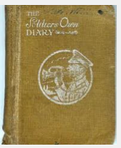**

**OTHER PEOPLE’S DIARIES:**

Here are some ‘diaries’ you might like to read.

You can sign up for a free account to download and read the first few pages from: <http://www.lovereading4kids.co.uk>

Alexie Sherman The Absolutely True Diary of a Part-Time Indian

Benton Jim Dear Dumb Diary Series

Blackman Malorie Deadly Dare Mysteries

Cottrell Frank Framed

Cabot Meg The Princess Diaries

Carman Patrick Ryan’s Journal Series

Collins Tim Diary of a Wimpy Vampire

Creech Sharon Love that Dog

Cronin Doreen Diary of a Spider

Donaldson Julia The Dinosaur's Diary

Fine Anne Diary of a Killer Cat

Hest Amy The Private Notebook of Katie Roberts, Age 11

Kinney Jeff Diary of a Wimpy Kid Series

James Simon Dear Greenpeace

Morpurgo Michael Kensuke’s Kingdom

Russell Rachel Dork Diaries

Smith Jenny Diary of a Parent Trainer

Wilson Jacqueline Buried Alive

Wilson Jacqueline Double Act

Wilson Jacqueline Lottie Project

Wilson Jacqueline Secrets

Wilson Jacqueline Tracy Beaker

**SOLUTIONS:**

**Solution to “Find the Adverbs”**

As she *crept* stealthily1 into the room, the wind *whistled* eerily1 in the trees. Her flashlight *played* nervously1 on the pieces of furniture until she caught some *movement* behind2 the couch. "Who's there?" she *asked* fearfully1. "Surprise!" the group *shouted* excitedly1 as they suddenly1 *burst* from their hiding places. She *grinned* sheepishly1 and immediately3 *collapsed* into a chair.

1 These adverbs tell us **HOW** something was done.

2 These adverbs tell us **WHERE** something (movement) happened.

3 These adverbs tell use **WHEN** something (collapsed) happened.

**Solutions for Syllables**

|  |  |
| --- | --- |
|  | Number of Syllables: |
| To/day / is / Thurs/day. | 5 |
| Once up/on a time Gold/i/locks went in/to the fo/rest. | 14 |
| I /like/ to /go /swim/ming /when/ it/ is /a /sum/mer’s /day. | 13 |
| I /did/n’t rea/lise / the / sig/ ni/ fi/ cance / of / the / fra/ grance un/ til /the / ap/pear/ance / of / the / spring / blos/soms. | 25 |
| It / was/ a / re/ lief /to /dis/ cov /er / that /I / was /still / pro/ fi/ cient /in / my / spell/ ing. | 20 |
| My / neigh/ bour / likes / to / take/ her / gold/ en re/triev/er /for /a /walk / ev/ery /day. | 18 |
| Some / times / I / like / to /eat / the / ve / ge / tables / my / grand/ moth / er /grows / in / her / gar / den. | 19 |

**Word building with prefixes and suffixes:**

|  |  |  |  |  |  |  |
| --- | --- | --- | --- | --- | --- | --- |
| ensign, |  | resign, |  | resigning, |  | resigned, |
| design, |  | designing, |  | designation, |  | designed, |
| signing, |  | signed, |  | signature, |  | signify, |
| designer |  | significant |  | resignation |  |  |

|  |  |  |  |  |  |  |  |  |
| --- | --- | --- | --- | --- | --- | --- | --- | --- |
| |  |  |  |  | | --- | --- | --- | --- | | **Student Name**: |  | **Student ID**: |  | | **Date:** | | | \_ \_ \_ / \_ \_ \_ /\_ \_ \_ |   **ENGLISH** |

|  |  |  |  |  |
| --- | --- | --- | --- | --- |
| **Level** | **SPEAKING & LISTENING** | **Demonstrated** | **Needs further opportunity** | **Teacher assessment** |
| 6 | Plan, rehearse and deliver presentations, selecting appropriate content for defined purposes. |  |  |  |
| 6 | Participate in discussions, clarify ideas, ask questions, develop and support arguments, with reason and evidence. |  |  |  |
| 6 | Use interaction skills, varying voice, volume, tone, pitch and pace. |  |  |  |
|  | **READING & VIEWING** | | | |
| 6 | Analyse strategies authors use to influence readers. |  |  |  |
| 6 | Understand how to use banks of known words, as well as word origins, prefixes and suffixes, to learn and spell new words . |  |  |  |
| 6 | Use comprehension strategies to interpret and analyse information and ideas. |  |  |  |
| 6 | Analyse how text structures and language features work together to meet the purpose of a text. (Grammar, Vocabulary,) |  |  |  |
|  | **WRITING** | | | |
| 6 | Experiment with text structures and language features and their effects in creating literary texts. |  |  |  |
| 6 | Use banks of known words, word origins, base words, prefixes, suffixes and spelling patterns to learn and spell new words. |  |  |  |
| 6 | Plan, draft and publish texts (Recount / Diary) |  |  |  |
| 6 | Investigate how vocabulary choices, including evaluative language can express shades of meaning, feeling and opinion. |  |  |  |
| 6 | Understand how to use banks of known words, word origins, base words, suffixes and prefixes, morphemes, spelling patterns and generalisations to learn and spell new words. |  |  |  |

|  |  |  |  |  |  |  |  |
| --- | --- | --- | --- | --- | --- | --- | --- |
| logoCAPS2**315 Clarendon Street, Thornbury 3071**  **Telephone (03) 8480 0000**  **FAX (03) 9416 8371 (Despatch)**  **Free call (1800) 133 511**   |  |  | | --- | --- | | |  | | --- | | **STUDENT NUMBER \_\_\_\_\_\_\_\_\_\_\_\_\_\_\_\_\_\_\_**  **STUDENT NAME \_\_\_\_\_\_\_\_\_\_\_\_\_\_\_\_\_\_\_\_\_\_**  **\_\_\_\_\_\_\_\_\_\_\_\_\_\_\_\_\_\_\_\_\_\_\_\_\_\_\_\_\_\_\_\_\_\_\_\_\_\_\_** | | | | | | | |  |
| Fix your student barcode  label over this space. |
|  |
| 6103  [6103] |
| **SUBJECT** | English | | | [ZX] |
| **COLOUR** | Red | **MODULE** | C |
| **TEACHER** | \_\_\_\_\_\_\_\_\_\_\_\_\_\_\_\_\_\_\_\_\_\_\_\_\_\_\_ | | |

|  |
| --- |
| **THINKING ABOUT YOUR LEARNING**  **This is what I have learnt well:**  **\_\_\_\_\_\_\_\_\_\_\_\_\_\_\_\_\_\_\_\_\_\_\_\_\_\_\_\_\_\_\_\_\_\_\_\_\_\_\_\_\_\_\_\_\_\_\_\_\_\_\_\_\_\_\_\_\_\_\_\_\_\_\_\_\_\_\_\_\_\_\_\_\_\_\_**  **\_\_\_\_\_\_\_\_\_\_\_\_\_\_\_\_\_\_\_\_\_\_\_\_\_\_\_\_\_\_\_\_\_\_\_\_\_\_\_\_\_\_\_\_\_\_\_\_\_\_\_\_\_\_\_\_\_\_\_\_\_\_\_\_\_\_\_\_\_\_\_\_\_\_\_**  **\_\_\_\_\_\_\_\_\_\_\_\_\_\_\_\_\_\_\_\_\_\_\_\_\_\_\_\_\_\_\_\_\_\_\_\_\_\_\_\_\_\_\_\_\_\_\_\_\_\_\_\_\_\_\_\_\_\_\_\_\_\_\_\_\_\_\_\_\_\_\_\_\_\_\_**  **\_\_\_\_\_\_\_\_\_\_\_\_\_\_\_\_\_\_\_\_\_\_\_\_\_\_\_\_\_\_\_\_\_\_\_\_\_\_\_\_\_\_\_\_\_\_\_\_\_\_\_\_\_\_\_\_\_\_\_\_\_\_\_\_\_\_\_\_\_\_\_\_\_\_\_**  **I still need help to understand:**  \_\_\_\_\_\_\_\_\_\_\_\_\_\_\_\_\_\_\_\_\_\_\_\_\_\_\_\_\_\_\_\_\_\_\_\_\_\_\_\_\_\_\_\_\_\_\_\_\_\_\_\_\_\_\_\_\_\_\_\_\_\_\_\_\_\_\_\_\_\_\_\_\_\_\_\_    \_\_\_\_\_\_\_\_\_\_\_\_\_\_\_\_\_\_\_\_\_\_\_\_\_\_\_\_\_\_\_\_\_\_\_\_\_\_\_\_\_\_\_\_\_\_\_\_\_\_\_\_\_\_\_\_\_\_\_\_\_\_\_\_\_\_\_\_\_\_\_\_\_\_\_\_  \_\_\_\_\_\_\_\_\_\_\_\_\_\_\_\_\_\_\_\_\_\_\_\_\_\_\_\_\_\_\_\_\_\_\_\_\_\_\_\_\_\_\_\_\_\_\_\_\_\_\_\_\_\_\_\_\_\_\_\_\_\_\_\_\_\_\_\_\_\_\_\_\_\_\_\_  \_\_\_\_\_\_\_\_\_\_\_\_\_\_\_\_\_\_\_\_\_\_\_\_\_\_\_\_\_\_\_\_\_\_\_\_\_\_\_\_\_\_\_\_\_\_\_\_\_\_\_\_\_\_\_\_\_\_\_\_\_\_\_\_\_\_\_\_\_\_\_\_\_\_\_\_ |

|  |
| --- |
| **YOUR QUESTIONS OR COMMENTS** |
| **TEACHER’S COMMENTS**  **Some great things about your work were:**  **This is what you need to focus on to improve your work:** |

