**Science Inquiry**

C:\Users\lmarcon\AppData\Local\Microsoft\Windows\Temporary Internet Files\Content.IE5\JQ2551LD\MC900334070[1].wmf

**Why do scientists perform experiments?**

A Note for the Adult…

Students might need an adult to support them to read through the material, check their understanding of unfamiliar terms and guide them in completing the activities / experiments.

Some activities require materials and equipment in order to perform the experiments.

C:\Program Files\Microsoft Office\MEDIA\CAGCAT10\j0305257.wmfSCIENCE

|  |
| --- |
| By the end of these activities you will:   * Create a mind map about Science. * Understand the meanings of new words: experiment, materials, method, results. * Safely use equipment to perform an experiment. * Make observations of your findings and record them. |

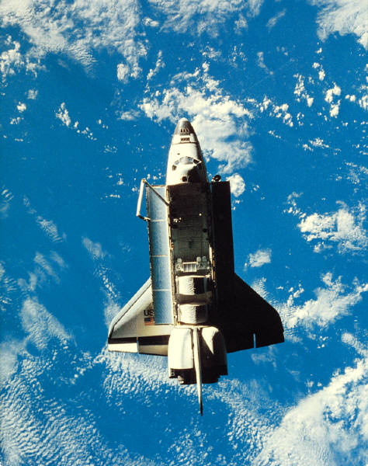

You are about to embark on a world of discovery, investigation, inventions and new ideas…

*Welcome to the fascinating World of Science.*

Here are some images of Science.

|  |  |  |
| --- | --- | --- |
| C:\Users\crt\AppData\Local\Microsoft\Windows\Temporary Internet Files\Content.IE5\K975LXFD\MP900144487[1].jpg | C:\Users\crt\AppData\Local\Microsoft\Windows\Temporary Internet Files\Content.IE5\JQ2551LD\MC900089724[1].wmf | C:\Users\crt\AppData\Local\Microsoft\Windows\Temporary Internet Files\Content.IE5\XGYY5H84\MC900379063[1].wmf |
| C:\Users\crt\AppData\Local\Microsoft\Windows\Temporary Internet Files\Content.IE5\O1MM9CQ8\MP900180462[1].jpg | C:\Users\crt\AppData\Local\Microsoft\Windows\Temporary Internet Files\Content.IE5\O1MM9CQ8\MP900425340[1].jpg | C:\Users\crt\AppData\Local\Microsoft\Windows\Temporary Internet Files\Content.IE5\XGYY5H84\MP900091159[1].jpg |
| C:\Users\crt\AppData\Local\Microsoft\Windows\Temporary Internet Files\Content.IE5\O1MM9CQ8\MP900426563[1].jpg | C:\Users\crt\AppData\Local\Microsoft\Windows\Temporary Internet Files\Content.IE5\K975LXFD\MC900413628[1].wmf | C:\Users\crt\AppData\Local\Microsoft\Windows\Temporary Internet Files\Content.IE5\XGYY5H84\MC900160552[1].wmf |

**For you to do – Activity: Mind mapping**

When you hear the word *Science*, of what do you immediately think?

Fill in the mind map with your ideas. I have done one example for you. If you are unsure, use the pictures on the previous page to help you.

|  |
| --- |
|  |

The word “Science” comes from the ancient language, Latin. In Latin it means knowledge.

How do we get this knowledge? How do you learn new things? Have a chat with an adult about the things you do to improve your knowledge.

Scientists are curious people. They wonder about the world around them and try to find answers. Often, they need to perform *experiments* to test their scientific *ideas*.

Time for you to be a scientist!

**For you to do – Activity: “A Peppery Paradox”**

|  |
| --- |
| C:\Users\crt\AppData\Local\Microsoft\Windows\Temporary Internet Files\Content.IE5\XGYY5H84\MC900389374[1].wmfYou will need (*Materials*):   * 2 small, clean bowls * pepper in a shaker * 2 toothpicks * dishwashing detergent * water.   What to do *(Method):*   * Pour some water into your bowls so that the bases are fully covered. * When the water is still, carefully sprinkle some pepper over the water in both. DO NOT MIX. * Take one toothpick and dip the tip into some clean water. Then lightly touch this to the peppery water in one of the bowls. Watch carefully for any changes. * Now take the other toothpick and dip the tip into some detergent. Then lightly touch this to the peppery water in the other bowl. Watch carefully for changes. Think about you’re you have seen. Discuss your thinking with an adult. |

|  |  |
| --- | --- |
| *(Results)*  Draw a picture of your experiment - | |
| …when toothpick dipped in clean water add to peppery water | …when toothpick dipped in detergent added to peppery water |
|  |  |
| Write a sentence describing what happened. | |
| What do you think caused this change? | |

Well done! You have just completed an experiment! I hope you made an interesting discovery.

C:\Users\crt\AppData\Local\Microsoft\Windows\Temporary Internet Files\Content.IE5\K975LXFD\MC900379071[1].wmf

**For you to do – Evaluation**

Put a tick the box that describes your learning.

|  |  |  |  |
| --- | --- | --- | --- |
|  | I am good at this | I am nearly there | I need help with this |
| I could create a mind map about Science. |  |  |  |
| I understand meanings of new words: experiment, materials, method, results. |  |  |  |
| I can safely use equipment to perform an experiment. |  |  |  |
| I can make observations of my findings and record my results. |  |  |  |

**Did you know:**

C:\Users\crt\AppData\Local\Microsoft\Windows\Temporary Internet Files\Content.IE5\O1MM9CQ8\MC900389226[1].wmfHave you ever had to take antibiotics when you were ill? Antibiotics are made by living things called fungi. They prevent the growth of bacteria. The Australian Scientist, **Howard Florey** and his clever team helped to work out a way of getting this disease fighting champion from the fungus, *Penicillium*. Today, penicillin is used to help fight infections around the world.

Howard Florey is a lifesaver. Find out some more about him and other lifesaving scientists at the website below.

<http://www.scienceheroes.com/>