**Geography**

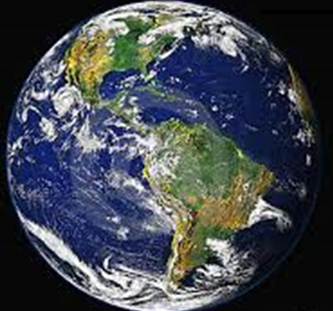

How do the countries of Africa and South America compare?



Rainforests and Deserts of the World

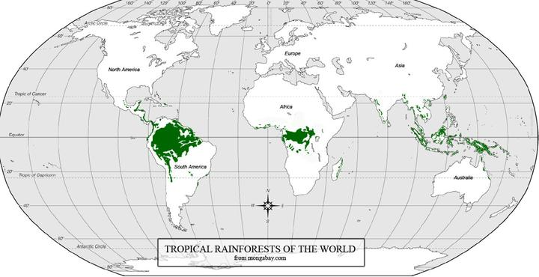

1. The map above shows us where the world’s **rainforests** are located. Describe their location.

|  |
| --- |
|  |
|  |
|  |
|  |
|  |
|  |
|  |
|  |
|  |
|  |
|  |
|  |
|  |
|  |
|  |

1. Visit <http://www.mapsofworld.com/world-desert-map.htm>. Colour the deserts of the world in yellow pencil on the map above.

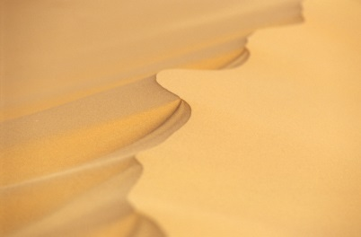

1. Describe where the world’s hot deserts are located.

|  |
| --- |
|  |
|  |
|  |
|  |
|  |
|  |
|  |
|  |
|  |
|  |
|  |
|  |
|  |
|  |
|  |
|  |
|  |
|  |

1. Using an online atlas, find two countries in Africa, one that is mostly rainforest and one that is mostly hot desert. List them.

|  |
| --- |
|  |
|  |
|  |
|  |
|  |
|  |

1. Using an online atlas, find two countries in South America, one that is mostly rainforest and one that is mostly hot desert. List them.

|  |
| --- |
|  |
|  |
|  |
|  |
|  |
|  |

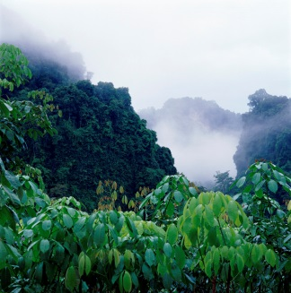

1. Choose one country on each continent and describe their location in relation to Australia and surrounding countries.

|  |
| --- |
|  |
|  |
|  |
|  |
|  |
|  |
|  |
|  |
|  |
|  |
|  |
|  |
|  |
|  |
|  |
|  |
|  |
|  |
|  |
|  |
|  |
|  |
|  |
|  |
|  |
|  |
|  |
|  |
|  |
|  |
|  |
|  |
|  |
|  |
|  |
|  |

1. Use an atlas or the internet to find what the climate is like in one place in each of these countries, e.g. Aziziya in Libya and Santarem in South America. When you have located your information, complete the following tables.



|  |  |
| --- | --- |
| Name of country: ___________________________ | Name of place: ___________________________ |

|  |  |  |  |  |  |  |  |  |  |  |  |  |
| --- | --- | --- | --- | --- | --- | --- | --- | --- | --- | --- | --- | --- |
|  | J | F | M | A | M | J | J | A | S | O | N | D |
| Rainfall  (mm) |  |  |  |  |  |  |  |  |  |  |  |  |
| Temperature  (Celsius) |  |  |  |  |  |  |  |  |  |  |  |  |

**SOUTH AMERICA**

|  |  |
| --- | --- |
| Name of country: ___________________________ | Name of place: ___________________________ |

|  |  |  |  |  |  |  |  |  |  |  |  |  |
| --- | --- | --- | --- | --- | --- | --- | --- | --- | --- | --- | --- | --- |
|  | J | F | M | A | M | J | J | A | S | O | N | D |
| Rainfall  (mm) |  |  |  |  |  |  |  |  |  |  |  |  |
| Temperature  (Celsius) |  |  |  |  |  |  |  |  |  |  |  |  |

1. Using the information on the previous page, describe the similarities and differences between the climates of these two places.

|  |
| --- |
|  |
|  |
|  |
|  |
|  |
|  |
|  |
|  |
|  |
|  |
|  |
|  |
|  |
|  |
|  |
|  |
|  |
|  |
|  |
|  |
|  |
|  |
|  |
|  |
|  |
|  |
|  |
|  |
|  |
|  |
|  |
|  |
|  |
|  |
|  |
|  |
|  |
|  |
|  |
|  |
|  |
|  |

**REFLECTION**

1. *List the similarities and differences you discovered about Africa and South America in the Venn diagram.*