**History Inquiry**

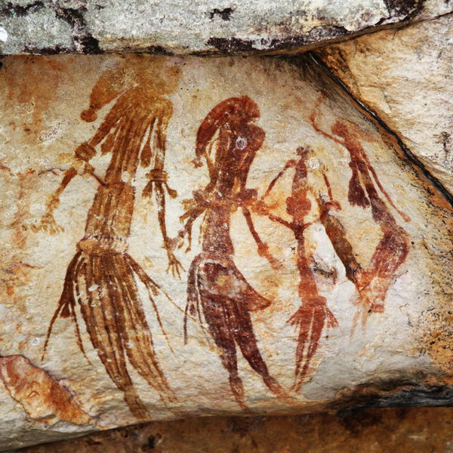

[*http://commons.wikimedia.org/wiki/File:Bradshaw_rock_paintings2.jpg*](http://commons.wikimedia.org/wiki/File:Bradshaw_rock_paintings2.jpg)

What contact did the Aboriginal and Torres Strait Islander peoples have with European explorers before the arrival of Captain Cook?



**GETTING KNOWLEDGE READY**

1. List some words you think would describe the feelings of Aboriginal and Torres Strait Islander peoples on sighting large ships from the shore and/or new people on their land.
2. Read the following information.

**Early Explorers**

Ancestors of today’s Aboriginal peoples were isolated on the continent of Australia. However, people from other areas in Asia began following the Macassans in exploring the oceans around their countries. They too may have met Aboriginal people, but the Dutch were the first to record their contact.

**Willem Janszoon**

The Dutch were keen explorers and wanted to find any unknown lands in the southern hemisphere. In 1606, Captain Willem Janszoon was instructed by the Dutch government to search the South Seas for such land. Captain Janszoon, on board a small ship called the *Duyfken*, found New Guinea.

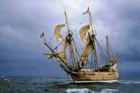

**Making Contact**

Janszoon then sailed along the western coast of Cape York Peninsula on the northern tip of Australia. Janszoon thought Australia was part of New Guinea because he never saw the Torres Strait that separates the countries.

The Dutch are thought to be the first Europeans to have come into contact with Australia’s Aboriginal peoples. The Aboriginal people were alarmed at the ship’s arrival. This may have been the first time they had seen Europeans or a large ship.

The Dutch chartered over 300 kilometres of Australia’s coastline. This was the first time Australia had been mapped through actual observation, and not guesswork.

***Source: Discovering History (Middle Primary) / Early Contact***

***– Jennifer Lawless and Kate Cameron* (PEARSON AUSTRALIA)**

1. View the following YouTube clip to learn more about Willem Janszoon:

<http://tinyurl.com/otknnuy>

|  |
| --- |
| *When European sailors began entering ‘Australian' waters in the early 1600s, they called it ‘Terra Australis Incognita’ (unknown land of the South). Between 1606 and 1770 more than 50 European ships made* [*landfall*](http://www.australiaonthemap.org.au/landings-list/) *on Australian soil.* |

1. Research two other explorers who discovered Australia and complete the following table. An example has been provided for you.

|  |  |  |  |
| --- | --- | --- | --- |
| **YEAR** | **NAME OF EXPLORER** | **SHIP** | **NATIONALITY** |
| 1606 | Willem Janszoon | Duyfken | Dutch |
| **NATURE OF CONTACT** | | | |
| The Dutch are thought to be the first Europeans to have come into contact with Australia’s Aboriginal peoples. This may have been the first time they had seen Europeans or a large ship.  The Dutch chartered over 300 kilometres of Australia’s coastline. This was the first time Australia had been mapped through actual observation, and not guesswork. | | | |

|  |  |  |  |
| --- | --- | --- | --- |
| **YEAR** | **NAME OF EXPLORER** | **SHIP** | **NATIONALITY** |
|  |  |  |  |
| **NATURE OF CONTACT** | | | |

|  |  |  |  |
| --- | --- | --- | --- |
| **YEAR** | **NAME OF EXPLORER** | **SHIP** | **NATIONALITY** |
|  |  |  |  |
| **NATURE OF CONTACT** | | | |

1. Write a newspaper article about one of the European explorers that discovered Australia before Captain Cook arrived.
2. Brainstorm your ideas.
3. Write a draft. Remember to include the 5Ws.
4. Proof-read and edit your writing.
5. Publish your article for ‘The Herald’.
6. Include an illustration.

|  |
| --- |
| *BRAINSTORM* |

*NEWSPAPER ARTICLE DRAFT*

*THE HERALD*

|  |
| --- |
|  |

**REFLECTION**

Please think about what you’ve learnt in this module. In your own words please write your answer below.

1. *What do you think the Aboriginal and/or Torres Strait Islander peoples would have thought about the explorers they may have come into contact with?*