**Mathematics**

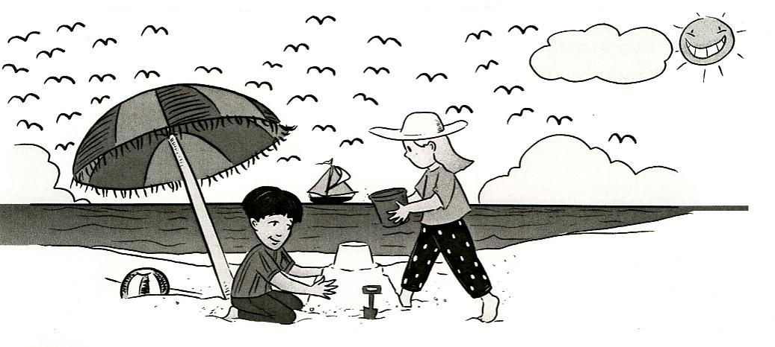

Learning Booklet 2

**Copyright**

*The Department of Education and Training (DET) encourages the dissemination and re-use of information provided in this document.*

Material on this website is provided under a Creative Commons Attribution 4.0 international licence, with the exception of:

* any images, photographs, trademarks or branding, including the Victorian Government logo and the DET logo; and
* content supplied by third parties.



For licence conditions, see: [Creative Commons Attribution 4.0 international licence](http://creativecommons.org/licenses/by/4.0/)

**Attribution**

Material to be attributed as:

© State of Victoria (Department of Education and Training)

**Program**

|  |  |  |  |  |
| --- | --- | --- | --- | --- |
| Task 1 | **Task 2** | **Task 3** | **Task 4** | **Task 5** |
| **Addition**   * Addition using tens frames * Write addition number sentences (equations) and word problems | Analogue Clocks  * Features of an analogue clock * Read and represent o’clock and half past times * Write or draw activities for given times | **Two Digit Numbers**   * Place value – tens and ones * Write and order two digit numbers * Represent two digit numbers using MAB * Use a number expander | **2D Shapes**   * Identify and draw 2D shapes * Identify number of corners and sides of 2D shapes | **Revision Activities**   * 2D shapes * Two digit numbers * Analogue clocks  !  * Extension activity |
| **Task 6** | **Task 7** | **Task 8** | **Task 9** | **Task 10** |
| **Addition**   * Addition number sentences * Addition grids * Game—*Gotcha!* | **Chance**   * Certain, possible and impossible * Impossible, most likely and possible * Possible, unlikely and impossible * Possible and impossible | **Estimate and Check**   * Estimate total number * Count groups using partitioning * Addition | **2D shapes -hexagons**   * Regular and irregular hexagons * 2D shapes | **Revision Activities**   * Estimate and check * Chance * 2D shapes |

Learning Intentions

* to solve addition equations and word problems using a variety of strategies;
* to estimate the total number of items in a group;
* to use an analogue clock to read and represent o’clock and half past times;
* to develop an understanding of place value of two digit numbers;
* to name and identify features of 2D shapes;
* to determine chance events.

**Task 1**

**Focus: Number**

|  |
| --- |
| Adding numbers to 20 using tens frames. |

Introduction

You can use pictures, objects or diagrams to solve problems.

j0078711

Here is an example:

**j0078733**

I have 7 chocolate bars and my friend has 6 chocolate bars.

How many do we have altogether?

**j0078711**

How can you solve the word problem?

**You will need:**

20 counters (shells or beads)

Tens frames

**Step 1**

Count 7 and then continue by counting the next 6.

**Step 2**

How many counters do you have?

**7 + 6 = 13**

**Activity 1**

Solve and record addition problems using tens frames.

For example:

|  |  |  |  |  |
| --- | --- | --- | --- | --- |
| ⚫ | ⚫ |  | ⭘ |  |
| ⚫ | ⚫ |  | ⭘ |  |
| ⚫ | ⭘ |  | ⭘ |  |
| ⚫ | ⭘ |  |  |  |
| ⚫ | ⭘ |  |  |  |

7

5

12

+ =

**Activity 1 continued**

1. Use the tens frames to complete and solve the addition equations.

**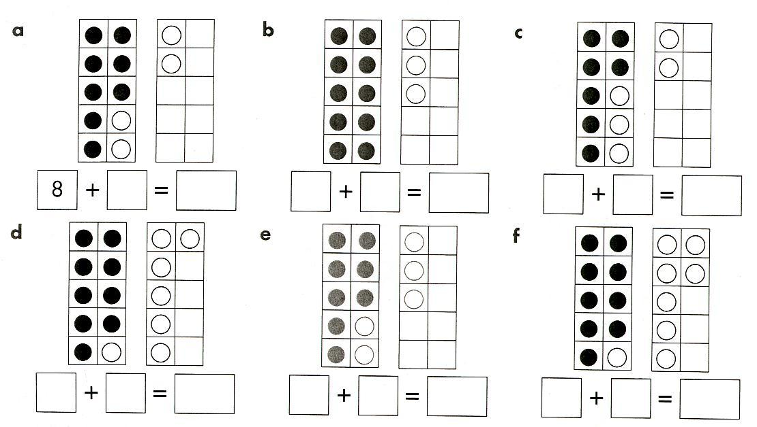**

2. Draw circles in the tens frames to complete and solve the addition equations.

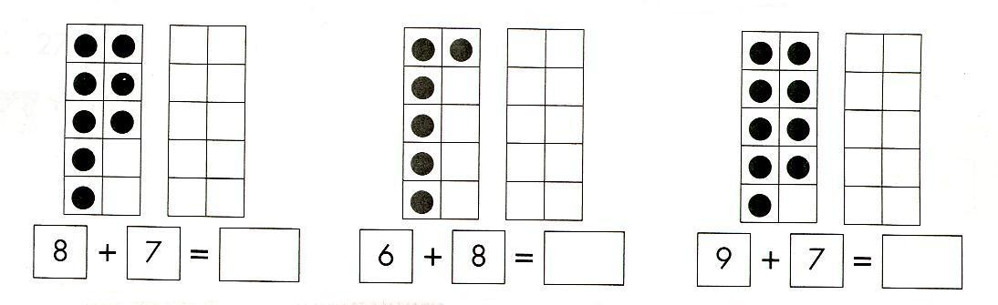

**Activity 2**

Make your own addition equations by drawing circles in two different colours on these tens frames. Remember to fill the first tens frame before starting on the second one.

Record your addition equation (number sentence) below each frame.

|  |  |  |  |  |  |  |  |  |  |  |  |  |  |  |  |  |  |  |  |  |  |  |  |  |  |  |  |  |  |  |  |  |  |  |  |  |  |  |  |  |  |  |  |  |  |  |  |  |  |  |  |
| --- | --- | --- | --- | --- | --- | --- | --- | --- | --- | --- | --- | --- | --- | --- | --- | --- | --- | --- | --- | --- | --- | --- | --- | --- | --- | --- | --- | --- | --- | --- | --- | --- | --- | --- | --- | --- | --- | --- | --- | --- | --- | --- | --- | --- | --- | --- | --- | --- | --- | --- | --- |
| |  |  |  |  |  | | --- | --- | --- | --- | --- | |  |  |  |  |  | |  |  |  |  |  | |  |  |  |  |  | |  |  |  |  |  | |  |  |  |  |  | | |  |  |  |  |  | | --- | --- | --- | --- | --- | |  |  |  |  |  | |  |  |  |  |  | |  |  |  |  |  | |  |  |  |  |  | |  |  |  |  |  | |
| + = | + = |
| |  |  |  |  |  | | --- | --- | --- | --- | --- | |  |  |  |  |  | |  |  |  |  |  | |  |  |  |  |  | |  |  |  |  |  | |  |  |  |  |  | | |  |  |  |  |  | | --- | --- | --- | --- | --- | |  |  |  |  |  | |  |  |  |  |  | |  |  |  |  |  | |  |  |  |  |  | |  |  |  |  |  | |
| + = | + = |

**Activity 3**

Create an addition word problem based on an equation.

**Step 1**

Choose one of the addition equations from the tens frames on the previous page. For example:

7 + 5 = 12

**Step 2**

Create an addition word problem to match the equation.

**For example:**

Kathy has 7 chocolate bars and Peter gave her 5 more. How many does she have altogether?

D:\Users\02408583\AppData\Local\Microsoft\Windows\Temporary Internet Files\Content.IE5\Q1X2XHAV\MC900264234[1].wmf

**Step 3**

Choose addition equations from the tens frames on the previous page and create an addition word problem on the next page.

**Activity 3 continued**

Write your addition equation (number sentence) in these boxes.

+ =

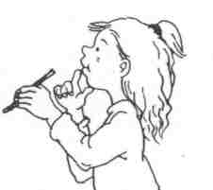

Write your addition word problem on these lines.

……………………………………………………………………………………..

……………………………………………………………………………………..

\_\_\_\_\_\_\_\_\_\_\_\_\_\_\_\_\_\_\_\_\_\_\_\_\_\_\_\_\_\_\_\_\_\_\_\_\_\_\_\_\_\_\_\_\_\_\_\_\_\_\_\_\_\_\_\_\_\_\_\_\_\_\_\_\_

……………………………………………………………………………………..

……………………………………………………………………………………..

\_\_\_\_\_\_\_\_\_\_\_\_\_\_\_\_\_\_\_\_\_\_\_\_\_\_\_\_\_\_\_\_\_\_\_\_\_\_\_\_\_\_\_\_\_\_\_\_\_\_\_\_\_\_\_\_\_\_\_\_\_\_\_\_\_

……………………………………………………………………………………..

……………………………………………………………………………………..

\_\_\_\_\_\_\_\_\_\_\_\_\_\_\_\_\_\_\_\_\_\_\_\_\_\_\_\_\_\_\_\_\_\_\_\_\_\_\_\_\_\_\_\_\_\_\_\_\_\_\_\_\_\_\_\_\_\_\_\_\_\_\_\_\_

……………………………………………………………………………………..

……………………………………………………………………………………..

\_\_\_\_\_\_\_\_\_\_\_\_\_\_\_\_\_\_\_\_\_\_\_\_\_\_\_\_\_\_\_\_\_\_\_\_\_\_\_\_\_\_\_\_\_\_\_\_\_\_\_\_\_\_\_\_\_\_\_\_\_\_\_\_\_

……………………………………………………………………………………..

……………………………………………………………………………………..

\_\_\_\_\_\_\_\_\_\_\_\_\_\_\_\_\_\_\_\_\_\_\_\_\_\_\_\_\_\_\_\_\_\_\_\_\_\_\_\_\_\_\_\_\_\_\_\_\_\_\_\_\_\_\_\_\_\_\_\_\_\_\_\_\_

……………………………………………………………………………………..

**Task 2**

Focus: Measurement

|  |
| --- |
| j0078842  Tell the time using an **analogue clock**. Revise o’clock and half past times. |

Introduction

|  |
| --- |
| The *minute hand* is longand the *hour hand* is short.  j0304847  An analogue clock has a *minute hand* and an *hour hand.* |

|  |  |
| --- | --- |
| When the long hand is pointing to the 12 the time is *o’clock.* | When the long hand is pointing to the 6 the time is *half past.* |
| *Untitled - 2*  The time is 3 o’clock. | *Untitled - 2*  The time is half past 3. |

**Introduction continued**

The face of an analogue clock.

|  |  |
| --- | --- |
| The numbers 1 to 12 are shown on an analogue clock face. | j0384768 |
| The 12, 3, 6 and 9 divide the clock face into quarters.  The hands travel round the clock face *clockwise,* moving through the numbers 1 to 12. | ***j0187319*** |

**Activity 1**

|  |  |
| --- | --- |
| *Untitled - 2* | Draw the minute hand on the 12.  Draw the hour hand on the 10.  What is the time? \_\_\_\_\_\_\_\_\_\_\_\_\_\_\_\_\_\_\_\_ |
| *Untitled - 2* | Draw the minute hand on the 6.  Draw the hour hand **halfway** between 7 and 8.  What is the time? \_\_\_\_\_\_\_\_\_\_\_\_\_\_\_\_\_\_\_\_ |

**Activity 2**

What time is it?

|  |  |  |  |
| --- | --- | --- | --- |
| *Untitled - 2* | *Untitled - 2* | *Untitled - 2* | *Untitled - 2* |
| o’clock | o o’clock | o’clo o’clock | o’clock |
| *Untitled - 2* | *Untitled - 2* | *Untitled - 2* | *Untitled - 2* |
| half past | half past | half past | half past |

[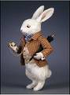](http://images.google.com.au/imgres?imgurl=http://www.dollfriends.com/images/wright%20white%20rabbit.jpg&imgrefurl=http://board.flashkit.com/board/showthread.php?t=691378&page=1&h=360&w=264&sz=22&hl=en&start=8&tbnid=-1YN7I57jg71zM:&tbnh=121&tbnw=89&prev=/images?q=the+white+rabbit&ndsp=20&svnum=10&hl=en&lr=&sa=N)

**Activity 3**

Draw hands on these clock faces to show the time.

|  |  |  |
| --- | --- | --- |
| *Untitled - 2* | *Untitled - 2* | *Untitled - 2* |
| Half past 5 | 7 o’clock | 12 o’clock |
| *Untitled - 2* | *Untitled - 2* | *Untitled - 2* |
| Half past 2 | Half past 10 | 3 o’clock |
| *Untitled - 2* | *Untitled - 2* | *Untitled - 2* |
| 11 o’clock | Half past 6 | Half past 9 |

**Activity 4**

Draw or write what you might be doing at the following times.

|  |  |  |
| --- | --- | --- |
| [saturnsilver](http://www.brgprecision.com/image2/saturnsilver.jpg)  in the morning |  |  |
| j0384768  in the afternoon |  |  |
| w31  in the evening |  |  |

**Task 3**

**Focus: Number**

|  |
| --- |
| Read, write and order numbers with two **digits**. |

Introduction

The numbers 0 to 9 are called digits.

j0078731

Digits are grouped together to make numbers.

Here are some examples of two digit numbers; 15, 75, 29, 98.

**Introduction continued**

What is the value of each digit in a number?

For example:

|  |  |  |  |
| --- | --- | --- | --- |
| one digit | 3 | 3 ones | [http://ts4.mm.bing.net/th?id=H.4580764110882015&pid=1.7&w=164&h=148&c=7&rs=1&url=http%3a%2f%2fwww.learnnc.org%2flp%2feditions%2fmapping%2f6412http://ts4.mm.bing.net/th?id=H.4580764110882015&pid=1.7&w=164&h=148&c=7&rs=1&url=http%3a%2f%2fwww.learnnc.org%2flp%2feditions%2fmapping%2f6412http://ts4.mm.bing.net/th?id=H.4580764110882015&pid=1.7&w=164&h=148&c=7&rs=1&url=http%3a%2f%2fwww.learnnc.org%2flp%2feditions%2fmapping%2f6412](http://www.bing.com/images/search?q=THREE+DIMENSIONAL+CUBE&qs=n&form=QBIR&pq=three+dimensional+cube&sc=0-0&sp=-1&sk=&adlt=strict#view=detail&id=6E7B6D49880B9BCAFDF69D730F60915E7A1B2A41&selectedIndex=0) |
| two digits | 46 | 4 tens  and  6 ones | ones  MAB 10MAB 10MAB 10MAB 10 |

**Important Facts:**

* A digit is: 0 1 2 3 4 5 6 7 8 9.
* Digits are used to write numbers (much like letters are used to make words).
* Numbers between 10 and 99 are two digit numbers.
* For example, the number 46 has two digits. It is made up of 4 tens and 6 ones.

**Activity 1**

Write some two-digit numbers in the box below.

|  |
| --- |
| Two digit numbers -  more than 57 and less than 83 |
| 68  **\_\_\_\_\_\_\_\_\_\_\_\_\_\_\_**  **\_\_\_\_\_\_\_\_\_\_\_\_\_\_\_**  **\_\_\_\_\_\_\_\_\_\_\_\_\_\_\_** |

## Using the above numbers, order them from smallest to largest.

## \_\_\_\_\_\_\_\_\_\_\_\_, \_\_\_\_\_\_\_\_\_\_\_\_\_, \_\_\_\_\_\_\_\_\_\_\_\_, \_\_\_\_\_\_\_\_\_\_\_\_

## Show their value using MAB Blocks which are found at the end of this task*.* Cut out the MAB blocks and paste them next to each number on the following page.

**Activity 1 continued**

|  |  |  |
| --- | --- | --- |
| **Number** | **MAB Blocks** | |
| **Tens** | **Ones** |
| 68 |  |  |
|  |  |  |

**Activity 1 continued**

|  |  |  |
| --- | --- | --- |
| **Number** | **MAB Blocks** | |
| **Tens** | **Ones** |
|  |  |  |
|  |  |  |

**Activity 2**

Another way to record two digit numbers is on a number expander.

Complete the number expander and number box. The first one is done for you.

MAB 10MAB 10MAB 10

34

tens

4

oness

3

**a)**

**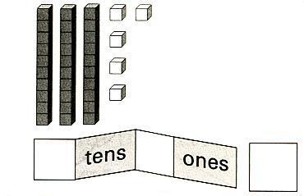**

**b)**

**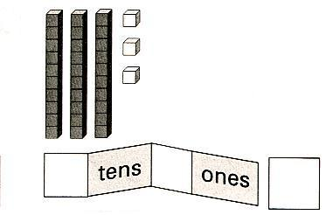**

**Activity 2 continued**

**c)**

**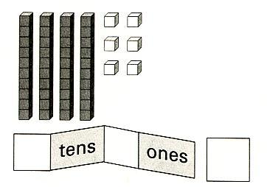**

**d)**

**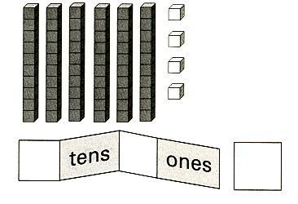**

**e)**

**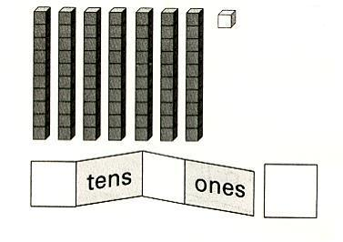**

**Activity 2 continued**

**f)**

**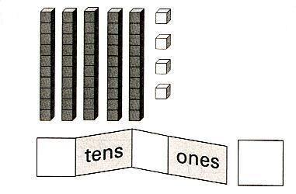**

**Activity 3**

Write the number that comes **before** and **after** the two-digit numbers below.

\_\_\_\_\_\_\_\_\_\_, 27, \_\_\_\_\_\_\_\_\_\_

\_\_\_\_\_\_\_\_\_\_, 14, \_\_\_\_\_\_\_\_\_\_

\_\_\_\_\_\_\_\_\_\_, 39, \_\_\_\_\_\_\_\_\_\_

\_\_\_\_\_\_\_\_\_\_, 51, \_\_\_\_\_\_\_\_\_\_

**Activity 4**

Order the numbers from smallest to largest.

|  |  |  |  |  |
| --- | --- | --- | --- | --- |
| 28 | 72 | 27 | 49 |  |
|  | | | | |
| 35 | 38 | 23 | 64 |  |
|  | | | | |
| 43 | 51 | 66 | 21 |  |
|  | | | | |
| 26 | 63 | 47 | 29 |  |

Write the number that comes after:

24 54

72 35

Write the number that comes before:

23 62

38 89

**MAB blocks**



**Task 4**

**Focus: Space**

**2D** shapes.

|  |
| --- |
| 2D shapes have length and width; and usually sides and corners.  What are the features of 2D shapes?  j0078812 |

**Introduction**

j0078790**What does *2D* mean?**

D represents ***Dimension.***

*A 2D shape has two dimensions.*

A 2D shape has two dimensions: length and width.

It is flat.

Most 2D shapes have sides and corners. For example; a triangle has 3 sides and 3 corners.

**Introduction continued**

Examples of 2D shapes.

Look at the number of sides and corners.

|  |
| --- |
| squar**2D shapes**  triangle |

**The features of 2D shapes**

2D shapes are flat and they usually have sides and corners.

This is a description of a 2D shape:

|  |  |
| --- | --- |
| squar | Name of shape: square  Number of sides: 4  Number of corners: 4 |

**Activity 1**

Draw 2D shapes.

|  |  |
| --- | --- |
| 1. A 2D shape with 3 sides and 3 corners. 2. A 2D shape with 4 sides,   all the same length. |  |
|  |
|  |

Which shapes did you draw?

1. \_\_\_\_\_\_\_\_\_\_\_\_\_\_\_\_\_\_\_\_\_\_\_\_\_\_\_\_
2. \_\_\_\_\_\_\_\_\_\_\_\_\_\_\_\_\_\_\_\_\_\_\_\_\_\_\_\_

**Activity 1 continued**

Draw some more 2D shapes.

|  |  |
| --- | --- |
| 1. A 2D shape with 5 sides and 5 corners. 2. A 2D shape with 4 sides   and 4 corners. It has 2  pairs of equal sides. One pair  is longer than the other  pair. |  |
|  |
|  |

Which shapes did you draw?

3. \_\_\_\_\_\_\_\_\_\_\_\_\_\_\_\_\_\_\_\_\_\_\_\_\_\_\_\_

4. \_\_\_\_\_\_\_\_\_\_\_\_\_\_\_\_\_\_\_\_\_\_\_\_\_\_\_\_\_

**Activity 2**

Identify these shapes.

1. Colour the pentagon blue. It has 5 corners.
2. Circle the shape that has the same number of sides as a square. It is a rectangle.
3. The hexagon has 6 sides. Write the name under the shape.
4. Write the name under the shape that has 3 sides and 3 corners.
5. Colour red the shape that has 4 equal sides and 4 corners.

|  |
| --- |
|  |

**Optional Activity**

**Use the following website to**

**practise things you have learned about shapes.**

|  |  |
| --- | --- |
|  | Look at Dimension and watch the shapes grow on *Maths Dictionary for Kids!*  If you have access to the Internet go to: |
| [www.amathsdictionaryforkids.com](http://www.amathsdictionaryforkids.com)  Click on: **Dd** then **dimension** | |

This is an excellent interactive website so you may also like to go to these links.

Click on: **Ss** then **shapes**

Click on: **Ss** then **side**

Click on: **Cc** then **corner**

**Task 5**

|  |
| --- |
|  |

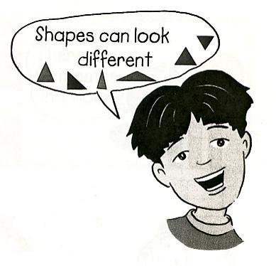

**Activity 1**

*Revision of 2D shapes.*

Colour all shapes with 3 sides and 3 corners red.

Colour all shapes with 4 sides and 4 corners yellow.

Put dots on all shapes with 6 sides and 6 corners.

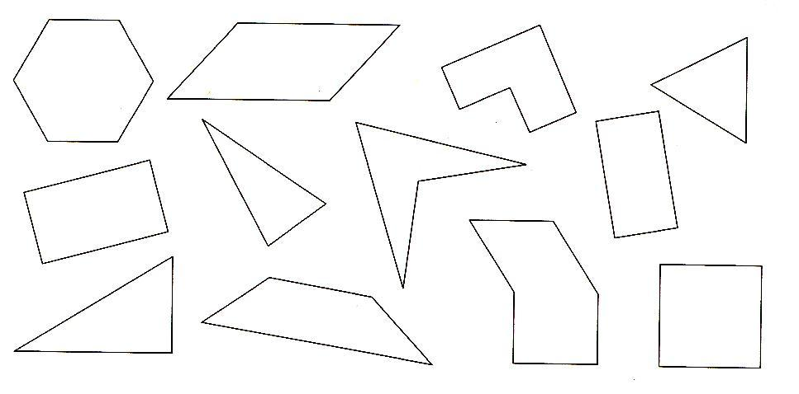

Draw a shape to match each description in the boxes below and write the name of the shape. Use the shapes and words in the cloud to help you.

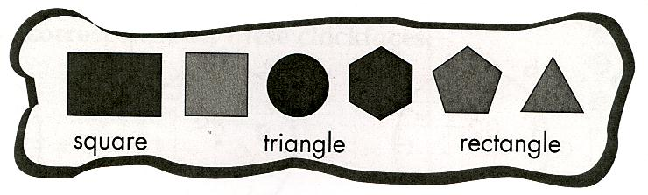

|  |  |  |
| --- | --- | --- |
| a) I have 4 sides of  the same length. | b) I have 4 sides with  2 pairs of equal  sides. | c) I have 3 sides and  3 corners. |

**Activity 2**

Revision of numbers to 100.

Draw more blocks to make 23.

|  |  |  |  |  |  |  |  |  |  |  |  |  |  |  |  |
| --- | --- | --- | --- | --- | --- | --- | --- | --- | --- | --- | --- | --- | --- | --- | --- |
|  |  |  |  |  |  |  |  |  |  |  |  |  |  |  |  |

Draw more blocks to make 29.

|  |  |  |  |  |  |  |  |  |  |  |  |  |  |  |  |
| --- | --- | --- | --- | --- | --- | --- | --- | --- | --- | --- | --- | --- | --- | --- | --- |
|  |  |  |  |  |  |  |  |  |  |  |  |  |  |  |  |

|  |  |  |  |  |  |  |  |  |  |  |  |  |  |  |  |
| --- | --- | --- | --- | --- | --- | --- | --- | --- | --- | --- | --- | --- | --- | --- | --- |
|  |  |  |  |  |  |  |  |  |  |  |  |  |  |  |  |

Draw more blocks to make 15.

|  |  |  |  |  |  |  |  |  |  |  |  |  |  |  |  |
| --- | --- | --- | --- | --- | --- | --- | --- | --- | --- | --- | --- | --- | --- | --- | --- |
|  |  |  |  |  |  |  |  |  |  |  |  |  |  |  |  |

**Activity 2 continued**

Cut out MAB blocks to show the number 48.

|  |
| --- |
|  |

**Activity 2 continued**

Order these numbers from smallest to largest.

27, 72, 81, 22, 65, 66.

\_\_\_\_\_\_, \_\_\_\_\_\_, \_\_\_\_\_\_, \_\_\_\_\_\_, \_\_\_\_\_\_, \_\_\_\_\_\_.

Order these numbers from largest to smallest.

34, 61, 94, 17, 37, 75.

\_\_\_\_\_\_, \_\_\_\_\_\_, \_\_\_\_\_\_, \_\_\_\_\_\_, \_\_\_\_\_\_, \_\_\_\_\_\_.

Write an addition equation (number sentence) and word problem to show the total 16.

……………………………………………………………………………………..

……………………………………………………………………………………..

\_\_\_\_\_\_\_\_\_\_\_\_\_\_\_\_\_\_\_\_\_\_\_\_\_\_\_\_\_\_\_\_\_\_\_\_\_\_\_\_\_\_\_\_\_\_\_\_\_\_\_\_\_\_\_\_\_\_\_\_\_\_\_\_\_

……………………………………………………………………………………..

……………………………………………………………………………………..

\_\_\_\_\_\_\_\_\_\_\_\_\_\_\_\_\_\_\_\_\_\_\_\_\_\_\_\_\_\_\_\_\_\_\_\_\_\_\_\_\_\_\_\_\_\_\_\_\_\_\_\_\_\_\_\_\_\_\_\_\_\_\_\_\_

……………………………………………………………………………………..

……………………………………………………………………………………..

\_\_\_\_\_\_\_\_\_\_\_\_\_\_\_\_\_\_\_\_\_\_\_\_\_\_\_\_\_\_\_\_\_\_\_\_\_\_\_\_\_\_\_\_\_\_\_\_\_\_\_\_\_\_\_\_\_\_\_\_\_\_\_\_\_

……………………………………………………………………………………..

……………………………………………………………………………………..

\_\_\_\_\_\_\_\_\_\_\_\_\_\_\_\_\_\_\_\_\_\_\_\_\_\_\_\_\_\_\_\_\_\_\_\_\_\_\_\_\_\_\_\_\_\_\_\_\_\_\_\_\_\_\_\_\_\_\_\_\_\_\_\_\_

……………………………………………………………………………………..

……………………………………………………………………………………..

\_\_\_\_\_\_\_\_\_\_\_\_\_\_\_\_\_\_\_\_\_\_\_\_\_\_\_\_\_\_\_\_\_\_\_\_\_\_\_\_\_\_\_\_\_\_\_\_\_\_\_\_\_\_\_\_\_\_\_\_\_\_\_\_\_

……………………………………………………………………………………..

**Activity 3**

Revision of telling the time using an analogue clock.

Colour the clock that shows the time you would most likely be doing the activity shown.

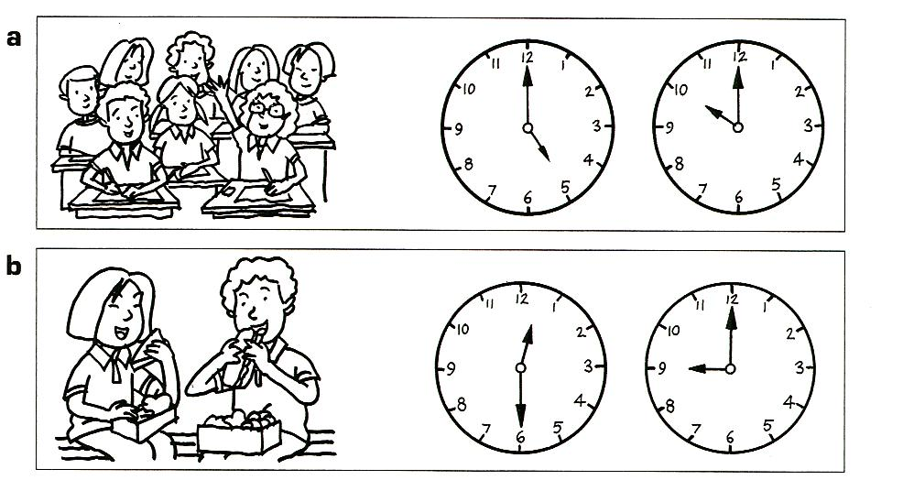

**c** Draw hands on the clock to show the time you eat breakfast.

## clock 222

## Extension Activity.

## Research:

## There are many types of analogue clocks.

## Draw or paste different analogue clocks in the boxes:

|  |  |  |
| --- | --- | --- |
|  |  |  |
|  |  |  |

Where are some of the biggest clocks in the world? Draw and write below.

|  |  |  |
| --- | --- | --- |
|  |  |  |
|  |  |  |

**Task 6**

**Focus: Number**

|  |
| --- |
| Add numbers to 20 using grouping and grids and write number sentences. |

**Introduction**

Write a true number sentence using given numbers.

|  |  |  |  |  |  |  |  |  |
| --- | --- | --- | --- | --- | --- | --- | --- | --- |
| **For example**:   |  |  |  | | --- | --- | --- | | 5 | 5 | 10 |   Using these numbers…   |  |  |  |  |  | | --- | --- | --- | --- | --- | | 5 | + | 5 | = | 10 |   …you can make this true number sentence: |

1. Complete the number sentence, putting one number or sign in each box.
2. Use one of each of these signs in the number sentence:

|  |  |
| --- | --- |
| + | ­= |

1. You will need to check your answers. You may use counters to check your answers.

**Activity 1**

Write a number sentence using these numbers:

|  |  |  |  |  |  |  |  |  |  |  |  |  |  |  |  |  |  |
| --- | --- | --- | --- | --- | --- | --- | --- | --- | --- | --- | --- | --- | --- | --- | --- | --- | --- |
| 1.   |  |  |  | | --- | --- | --- | | 3 | 4 | 7 |  |  |  |  |  |  | | --- | --- | --- | --- | --- | |  |  |  |  |  | | 2.   |  |  |  | | --- | --- | --- | | 11 | 14 | 3 |  |  |  |  |  |  | | --- | --- | --- | --- | --- | |  |  |  |  |  | |

|  |  |  |  |  |  |  |  |  |  |  |  |  |  |  |  |  |  |
| --- | --- | --- | --- | --- | --- | --- | --- | --- | --- | --- | --- | --- | --- | --- | --- | --- | --- |
| 3.   |  |  |  | | --- | --- | --- | | 7 | 15 | 8 |  |  |  |  |  |  | | --- | --- | --- | --- | --- | |  |  |  |  |  | | 4.   |  |  |  | | --- | --- | --- | | 20 | 12 | 8 |  |  |  |  |  |  | | --- | --- | --- | --- | --- | |  |  |  |  |  | |

|  |  |  |  |  |  |  |  |  |  |  |  |  |  |  |  |  |  |
| --- | --- | --- | --- | --- | --- | --- | --- | --- | --- | --- | --- | --- | --- | --- | --- | --- | --- |
| 5.   |  |  |  | | --- | --- | --- | | 17 | 5 | 12 |  |  |  |  |  |  | | --- | --- | --- | --- | --- | |  |  |  |  |  | | 6.   |  |  |  | | --- | --- | --- | | 18 | 9 | 9 |  |  |  |  |  |  | | --- | --- | --- | --- | --- | |  |  |  |  |  | |

**Interesting fact**

The largest number is the answer to the number sentence.

Why is this so?

|  |
| --- |
|  |

**Activity 2**

Addition grid.

The numbers 1 to 10 are written in the top row and the first column. The addition sign is written in the top left-hand corner.

If you draw an imaginary line down from the 3 and across from the 2 the answer to the equation 3 + 2 is 5.

|  |  |  |  |  |  |
| --- | --- | --- | --- | --- | --- |
| **+** | **6** | **3** | **0** | **9** | **5** |
| **8** | 14 | 11 | 8 | 17 | 13 |
| **2** | 8 | 5 | 2 | 11 | 7 |
| **7** | 13 | 10 | 7 | 16 | 12 |
| **4** | 10 | 7 | 4 | 13 | 9 |
| **1** | 7 | 4 | 1 | 10 | 6 |

**Activity 2 continued**

Complete this addition grid.

|  |  |  |  |  |  |
| --- | --- | --- | --- | --- | --- |
| **+** | **5** | **0** | **2** | **8** | **3** |
| **7** |  |  |  |  |  |
| **1** |  |  |  |  |  |
| **3** |  |  |  |  |  |
| **4** |  |  |  |  |  |
| **9** |  |  |  |  |  |

Create your own addition grid.

|  |  |  |  |  |  |
| --- | --- | --- | --- | --- | --- |
| **+** |  |  |  |  |  |
|  |  |  |  |  |  |
|  |  |  |  |  |  |
|  |  |  |  |  |  |
|  |  |  |  |  |  |
|  |  |  |  |  |  |

|  |
| --- |
| j0078737**Activity 3**  **bd06121_Gotcha!** |

|  |
| --- |
| **You will need:**   * a 3x3 grid from the next page * a partner * two dice * coloured pencils |
|  |
| **Instructions:**   * Remove the sheet from the next page. * Cut or tear the sheet in half and give one grid to each player. * In each square write a number from 2 to 12. You may repeat a number. * Each player rolls the two dice and adds the numbers together. If the solution is a number the player has in a square they may colour it. * The first one to colour a row vertically, horizontally or diagonally calls **Gotcha!** and is the winner. |

|  |  |  |
| --- | --- | --- |
|  |  |  |
|  |  |  |
|  |  |  |

|  |  |  |
| --- | --- | --- |
|  |  |  |
|  |  |  |
|  |  |  |

**Task 7**

**Focus — Chance**

Today you will look at the probability of whether things happen or not. This is called ***chance***.

|  |
| --- |
| j0078769 |

Introduction

|  |  |
| --- | --- |
| Have you heard of the phrase, ‘*Pigs might fly!’* or the phrase *‘Fat chance!’?* When you hear those phrases it means there is very little or no chance of it happening.  For example:   * The sun rising each day is certain to happen. * Raining cats and dogs is never going to happen (impossible).  |  | | --- | | Some of the words we use for chance are  **certain, impossible,** **possible, likely** and **unlikely**. |   Some things are ***certain*** to happen.  Some things will ***never*** happen; they are ***impossible****.*  Some things ***could*** happen; they are ***possible***. |

**Activity 1**

Colour one of the chance cards to label these pictures.

|  |  |  |  |  |  |  |
| --- | --- | --- | --- | --- | --- | --- |
| Scan10009 | | |  | Scan10008 | | |
| certain | possible | impossible |  | certain | possible | impossible |

Draw your own pictures to match the chance cards.

|  |  |  |  |  |  |  |
| --- | --- | --- | --- | --- | --- | --- |
|  | | |  |  | | |
|  | possible |  |  |  | impossible |  |

**Activity 1 continued**

Answer *yes* or *no* to these questions about chance.

Josh picks out one marble from his bag of 13 marbles.

|  |
| --- |
| Scan10016 |

|  |
| --- |
| 1. Is it possible for him to pick a green marble out of the bag?  \_\_\_\_\_\_\_\_\_\_  2. Is it certain that he would pick a red marble out of the bag?  \_\_\_\_\_\_\_\_\_\_  3. Is it possible that he would pick a blue marble out of the  bag? \_\_\_\_\_\_\_\_\_\_  4. Is it impossible for him to pick a yellow marble out of the  bag? \_\_\_\_\_\_\_\_\_\_  5. Is it certain that a green marble will be picked out of the  bag? \_\_\_\_\_\_\_\_\_\_ |

**Activity 2**

Label the socks that **could** be taken from the washing machine. Use the words *impossible*, *most likely* and *possible*.

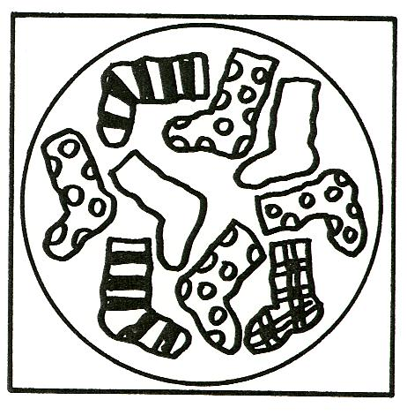

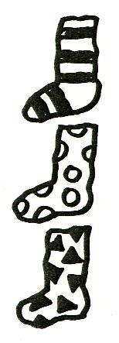

\_\_\_\_\_\_\_\_\_\_\_\_\_\_\_\_\_\_\_\_\_\_\_\_\_\_\_\_\_\_\_\_\_\_\_\_\_\_\_

\_\_\_\_\_\_\_\_\_\_\_\_\_\_\_\_\_\_\_\_\_\_\_\_\_\_\_\_\_\_\_\_\_\_\_\_\_\_\_

\_\_\_\_\_\_\_\_\_\_\_\_\_\_\_\_\_\_\_\_\_\_\_\_\_\_\_\_\_\_\_\_\_\_\_\_\_\_\_

Draw another sock that it is also possible to take out.

**Activity 2 continued**

Draw your own pictures.

|  |  |  |  |  |
| --- | --- | --- | --- | --- |
|  |  |  |  |  |

Possible Unlikely Impossible

Which shapes could be taken from the bag below. Label the shapes *possible* or *impossible*.

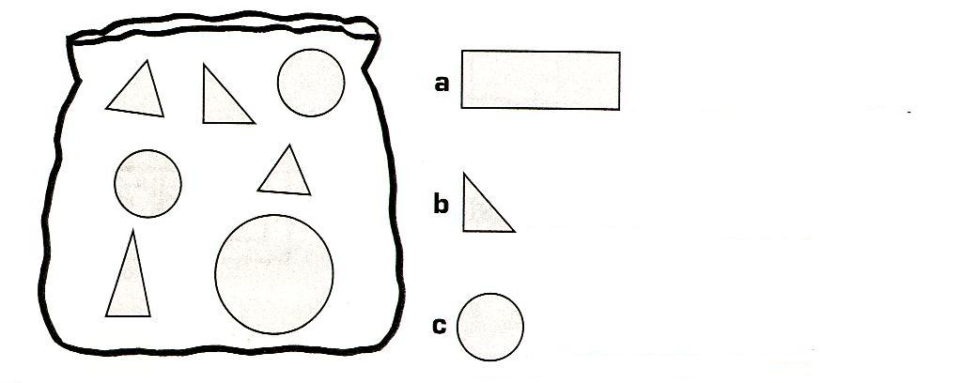

a \_\_\_\_\_\_\_\_\_\_\_\_\_\_\_\_\_\_\_\_\_\_\_\_\_\_\_\_\_\_

b \_\_\_\_\_\_\_\_\_\_\_\_\_\_\_\_\_\_\_\_\_\_\_\_\_\_\_\_\_\_

c \_\_\_\_\_\_\_\_\_\_\_\_\_\_\_\_\_\_\_\_\_\_\_\_\_\_\_\_\_\_

**Activity 3**

Write the words impossible or possible under each picture.

|  |  |  |
| --- | --- | --- |
| Scan10003 | Scan10004 | Scan10005 |

\_\_\_\_\_\_\_\_\_\_\_\_\_\_\_\_ \_\_\_\_\_\_\_\_\_\_\_\_\_\_\_\_ \_\_\_\_\_\_\_\_\_\_\_\_\_\_\_\_\_

Draw a picture of a **possible** and an **impossible** way to go to school:

|  |  |  |
| --- | --- | --- |
|  |  |  |

Possible Impossible

**Task 8**

**Focus: Number**

Addition, estimating and using partitioning.

|  |
| --- |
| **5**  **5**  **5** |

**Introduction**

To count large collections of objects it is often easier to group the items in groups of 5 or 10 and then calculate the total number.

This strategy is called ***partitioning***.

Collect 50 shells, buttons or beads.

Take a large group from the pile and estimate (guess) how many.

Now bundle them into groups of 10.

Find out how many tens and how many ones there are.

|  |
| --- |
| Draw what you did: |

**Activity 1**

Estimate (guess) the size of each group then circle the shapes in groups of 5 to calculate the total number.

**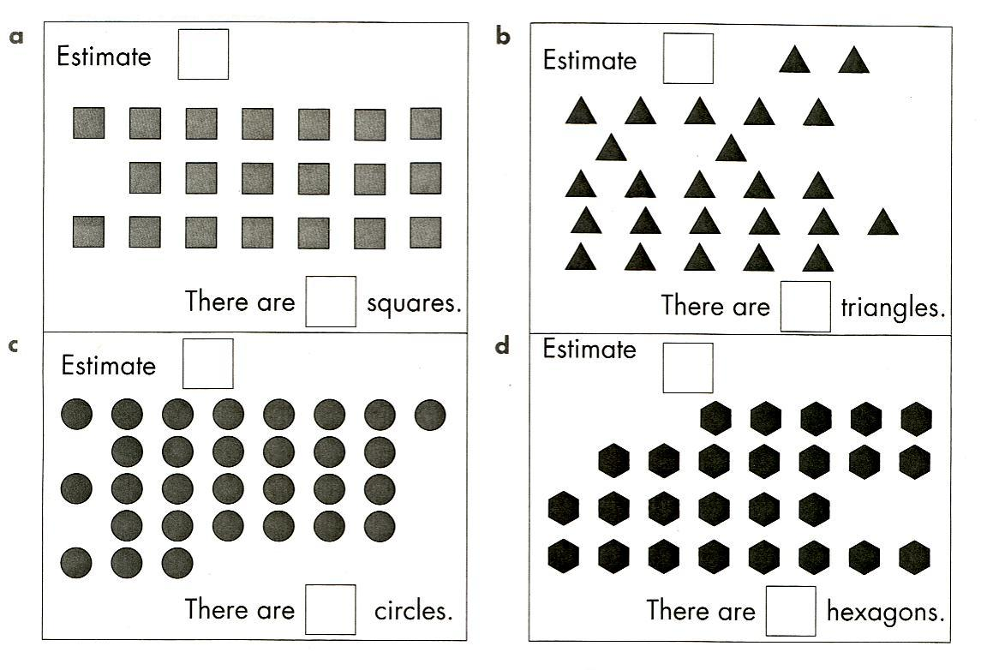**

**Activity 2**

1. Look at the picture below and estimate of the number of birds.

2. Now circle the birds in groups of 10 to check your estimate.

****

There are birds.

**Activity 3**

1. Use the numbers on each butterfly to write a number sentence (equation).

**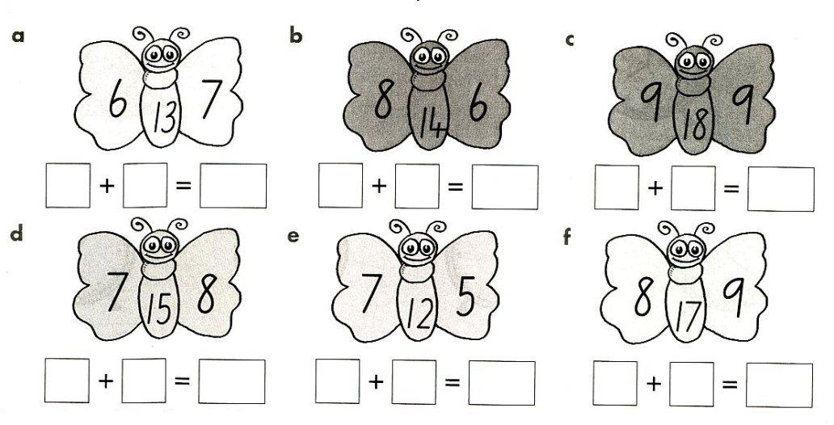**

2. Complete the addition grid. The first one is done for you.

**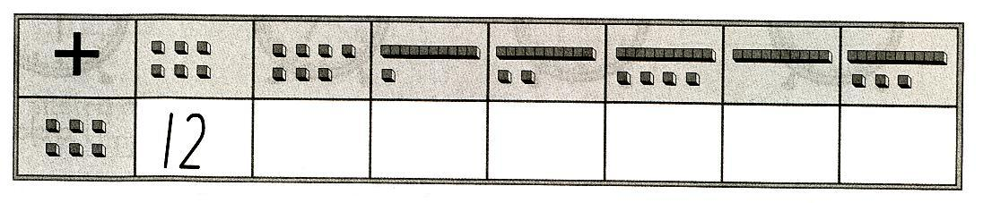**

**Activity 4**

Add the numbers on the dice, and cross off the answers on the bingo cards to discover the winning card. Colour the winning card red.

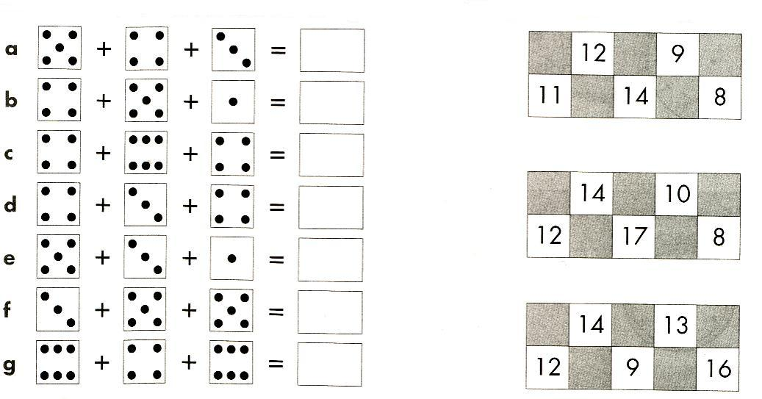

j0336154

**Task 9**

**Focus: Space**

|  |
| --- |
| Hexagon - 2D shape. |

Introduction

|  |
| --- |
| **Hexagon – *six sided shape.***  *Hexa* is Greek for six and *gon* means sides. |

|  |  |
| --- | --- |
| **Regular hexagons** have six straight sides of equal length. | **Irregular hexagons** have six straight sides of different lengths. |

|  |
| --- |
|  |

Go to the online maths dictionary and click on *Hh* and *hexagon* to see a colourful explanation of hexagons.

[**www.amathsdictionaryforkids.com**](http://www.amathsdictionaryforkids.com)

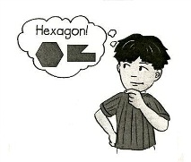**Activity 1**

Join the dots to form the hexagons.

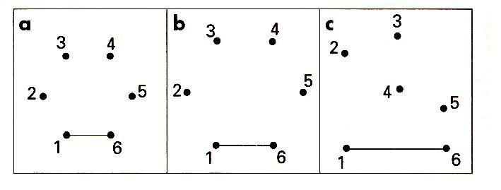

Draw two hexagons.

Regular hexagon Irregular hexagon

|  |  |
| --- | --- |
| a  . . . . . . . .  . . . . . . . .  . . . . . . . .  . . . . . . . .  . . . . . . . .  . . . . . . . . | b  . . . . . . . .  . . . . . . . .  . . . . . . . .  . . . . . . . .  . . . . . . . .  . . . . . . . . |

**Activity 2**

1. Draw a line to match each shape with its name. There may be more than one of the same shape.

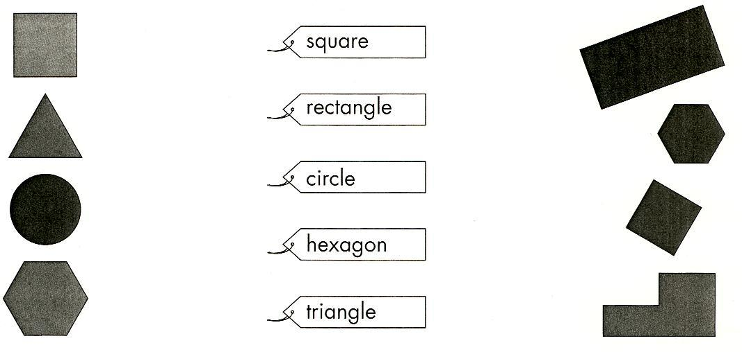

2. Find out how many craft sticks you would need to make three of each shape joined together. The first one has been done for you.

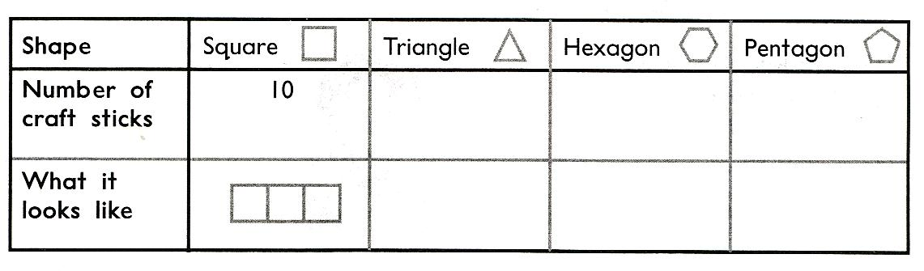

**Activity 3**

Complete the table. Use craft sticks to help you.

|  |  |  |  |
| --- | --- | --- | --- |
| 1. **Draw the shape** |  |  |  |
| 2. **Name the shape** | square |  |  |
| 3. **Describe the shape** |  | 6 straight sides of equal length |  |
| 4. **Things that are this shape** |  |  | rings,  hoops,  wheels |

**Task 10**

**Activity 1**

***Adding and estimating numbers to 50****.*

Look at the picture of the Pied Piper of Hamlin. Estimate how many mice.

Circle groups of 10 mice. After grouping some of the mice estimate the number of mice again.

Continue to circle the groups of 10 and count the mice in tens.

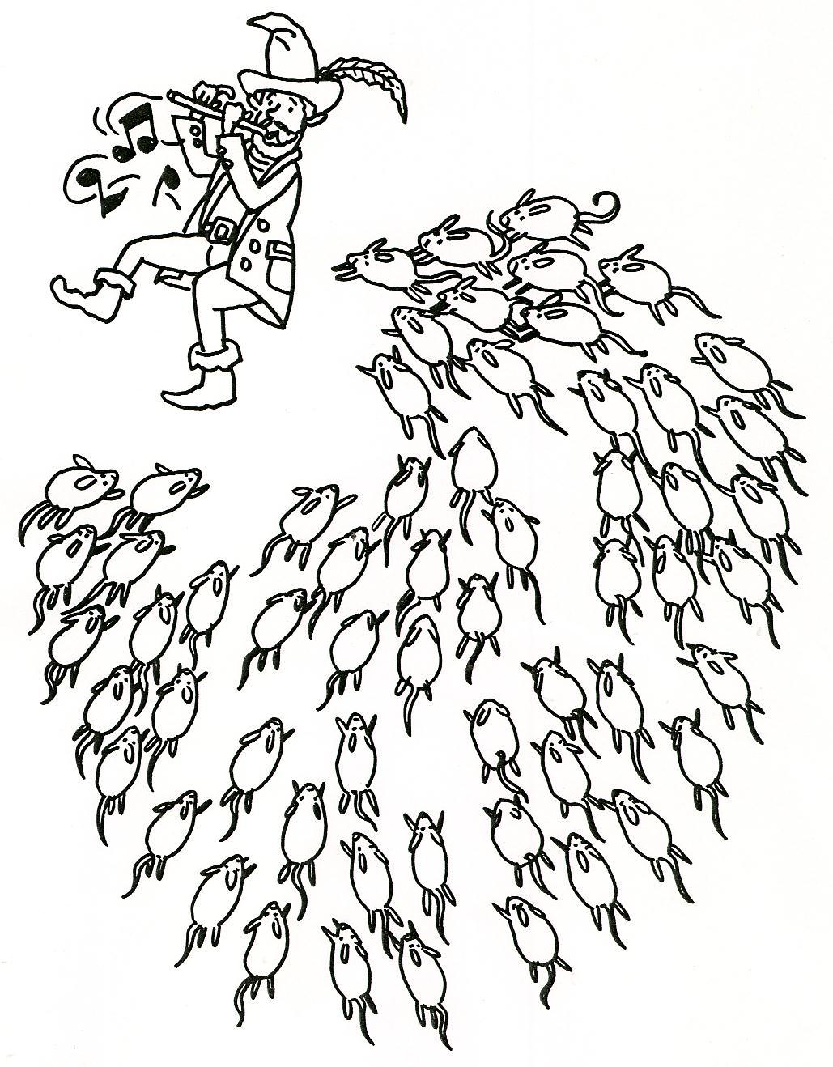

How many groups of 10?

How many mice altogether?

**Activity 2**

***Chance****.*

**What’s the chance?**

*Discuss with an adult:*

What is something that you **will** do today? (Certain)

What is something that you **might** do today? (Likely)

What is something you **couldn’t possibly** do today? (Impossible)

Record below:

|  |  |  |
| --- | --- | --- |
| **Impossible** | **Likely** | **Certain** |
| Ride in a moon rocket | Eat ice-cream | Have breakfast |
|  |  |  |

**Activity 2 continued**

What chance do you have of doing these things? Write the word in the space below the picture.

|  |  |  |
| --- | --- | --- |
| **No chance (impossible)** | **Even chance** | **Complete chance (certain)** |

|  |  |
| --- | --- |
| I will fly to the moon today. | If I go to the North Pole, I will feel cold. |
| j0324824 | j0090891 |
|  |  |
| If I roll a dice, I will get a 1,2 or 3. | If I fall asleep, I will close my eyes. |
| j0307793 | j0308596 |
|  |  |
| I will drive the fastest car in  the world today. | If I flip a coin, I will get heads. |
| j0398547 | j0402542 |
|  |  |

**Activity 3**

***2D shapes****.*

* Find all the shapes in the web.
* Colour the shapes and match the name to the shape.
* Copy the name of the shape.

