**English**

Read Write

Spell Publish

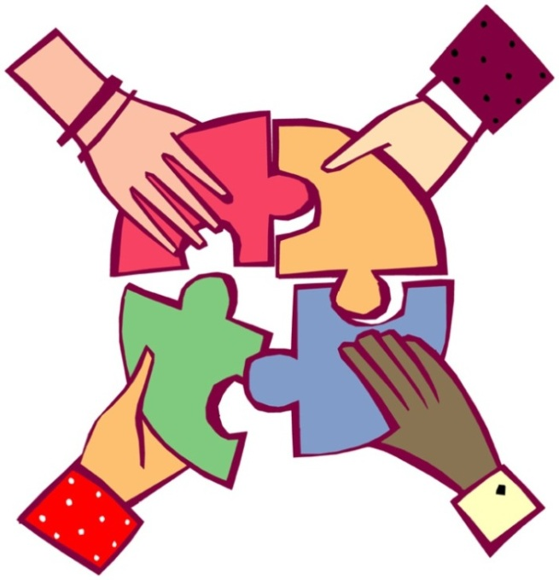

How does a news recount differ from a personal recount?

|  |  |  |
| --- | --- | --- |
| Description: QRDistance | Description: logomedium_black_print  © State of Victoria, Department of Education and Training 2015 | **N**  **Course Code**  **5306** |

**Only for use for the purpose of education for the student(s) provided with the materials by DECV. Not to be reproduced, communicated or otherwise used except as permitted by the Copyright Act 1968 (Cth).**

Introduction

**Please read the following before you begin!**

The **English**—*Read Write Spell Publish* Modules consist of 16 books for the year. Each Module consists of two weeks work where lessons and activities are divided into *Weeks 1 and 2.*

At the beginning of each week an outline of the week’s *Learning Intention* (tasks) and *Achievement Standards* (learning to be achieved)are outlined to assist you with your learning.

**Content and Layout of Each Module**

Each Module is structured into the following format:

 **Reading**

At the beginning of each Module you will **read** a short text type including a news recount, email, narrative, letter, persuasive etc…..

 **Exploring the Text**

Did you understand the text? In this section you will answer questions about the text you have read.

http://www.ignitumtoday.com/wp-content/uploads/2011/12/Idea.png **Writing Workshop**

Here, you will learn about the style and techniques used to write the different text types.

**Writing Project**

Finally you will be writing your own major piece of writing based on the given

text type.

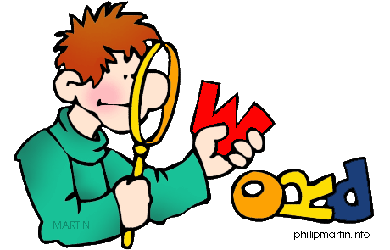 **Word Explorers**

To support and enhance your English work you will also study *Spelling, Punctuation* and *Grammar.* These topics are titled **Word Explorers.**

Each topic consists of:

**Spelling**—a list of 20 words will be studied each week.

They are grouped into:

- words from the text presented in the Module.

- your own words from your writing, reading and listening.

**Punctuation**— lessons on punctuation are taught once a week. Application to these skills is applied to writing tasks.

**Grammar**—once a week you will be taught skills in this area and complete work for practice.

**Contact!**

It is important that you contact your teacher if you have any queries or problems with the work. Your teacher can adjust the work to best suit your individual needs.

Week 1

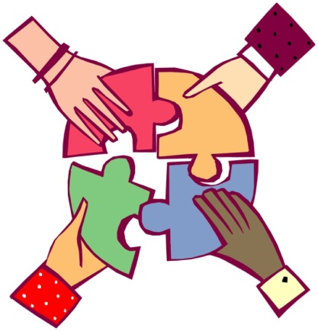

**Learning Intentions**

* Study the style and techniques used to write a *News Recount.*
* Learn about words of authority.
* Learn about synonyms and homonyms.
* Learn about words with silent consonants or vowels.
* Learn spelling words related to text and own words.

**Achievement Standards**

* Using text to give information about cultural elements and symbols.
* Using text to show the diverse cultural aspects of Australians.
* Choosing vocabulary for a particular purpose including formal and informal contexts.
* Selecting the right text structure for the writing purpose and following a sequence.

** Reading**

**What is a *News Recount*?**

This is a story which a journalist is recounting or retelling. A journalist can

report on many different topics and some journalists even specialise in an

area of reporting such as politics, sport or crime.

A **news recount** is different from a **personal recount** in which the author

retells a personal experience. Look at Module A to remind you about a

personal recount.

Begin by reading the *News Recount* below*.*

**Indigenous leaders want rules changed – Year 5 Version**

Adapted from original article by Samantha Lane and Chris Barrett

Indigenous leaders say the Olympic Rules that outlaw Aboriginal flags at the Games should change. They have called on the Australian Olympic Committee to lobby for the longstanding protocol to be overturned.

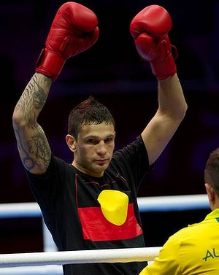On Monday, 30th July, Damien Hooper, the 20-year-old gold medal contender who breached the International Olympic Committee (IOC) rules by wearing a T-shirt with the Aboriginal flag on it at the competition in London.

Former politician and activist Phil Cleary said that recognising both flags at the Games would “affirm our real history and be a major act of reconciliation”. While dual Olympian 110-metre hurdler, Kyle van der Kuyp and former world champion boxer Anthony Mundine led their voices in support of Hooper’s actions.

The Australian Olympic team boss, Nick Green, said that Hooper has told him he was “very remorseful” and “extremely apologetic” about his actions. Hooper said that he had worn the T-shirt to provide “extra motivation because he was fighting a very strong opponent”.

The AOC would not take further action against the 20-year-old heavyweight, who has a gold medal chance for Australia.

Figure 1 Breaking the rules ... Damien Hooper says he wore the T-shirt for extra motivation because he was fighting a very strong opponent. Photo: Jason South

“We recognise his indigenous culture, and he is very proud of his indigenous culture, but in this instance the IOC has rule 50, which he is now well aware of … and he’s learnt a lesson and he won’t do that again,” Green said.

Van der Kuyp said yesterday he completely understood Hooper’s desire to represent his indigenous heritage. He recalled how he knowingly flouted the rules at the 1994 Commonwealth Games. He was caught with an Aboriginal flag stitched into his uniform before racing in heats.

“I would love to see the whole country embrace the flag more,” van der Kuyp said. “It’s not just something for indigenous athletes and indigenous people to embrace. All Australians can embrace it. We’re not there yet, but we’re on the way. And I reckon we’re on the way to sporting teams saying ‘You know what? We’re proud of it’.”

Cleary said the AOC should lobby for the Aboriginal flag to be recognised at the Olympics “out of respect and because it is not a symbol of conquest”.

Have you noticed that this news article is written in 2 columns? This is because newspapers are written in columns as opposed to continuous sentences running the width of the newspaper pages.

Why do you think newspapers use columns? Study the picture below.

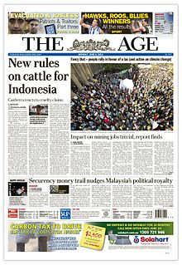

Write your thoughts about why newspapers are written in columns.

Turn over the page to find out if you are correct.

**REASONS for Newspapers Using Columns**

1. Your eyes do not have to follow a single line across the 40 centimetres (cm) of the page. Instead, the width of a column in *The Age* newspaper, for instance, is just over 4 centimetres.
2. We read from left to right. When the font type is smaller, it becomes more difficult to read. This is because the eye can’t follow the type across a broad page easily. Without columns, it would be difficult to read line after line of small type all the way across a broad newspaper page.
3. Columns are easy to locate and gives the papers a structure.
4. It is the most effective way to organise the information.

**Discussion**

Together with your Supervisor, discuss the *News Recount.*

Talk about:

* 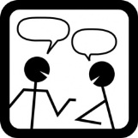Do you think that Damien Hooper did the right thing? Why?
* What would you have done if you were of Aboriginal descent and representing Australia at the Olympics?
* Would you be remorseful? Why?

How does this paper-based news recount compare to the digital version?

Is it easier to read? Is it more engaging to read an article on line? (Click on the link below to read the article and also listen to the song ‘*Mr Hooper’*  by Razzy Mak.)

Article: <http://www.couriermail.com.au/questnews/east/support-flows-in-for-olympic-boxer-damien-hooper/story-fn8m0sve-1226442100709>

Song: <http://www.youtube.com/watch?v=WCITwt9KGfw>





Word Explorer—Spelling

The spelling words which you will be studying this year are divided into two groups.

They are:

1. **Text words**—words located in the **text** for each week.
2. **My Own Words**—words which **you choose** that are of interest to you and/or words which you have misspelt in your writing.

**What Do I Do to Get Started?**

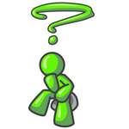

This week’s words are located on the yellow page at the back of this Module.

The spelling words are divided into **Week 1** and **Week 2.** There is a column for you to write **ten** words which you would like to learn to spell, write it in the Week 1 column.

MCj04247880000[1]

**For You to Do**

1. Today I would like you to choose words from **My** **Own Words** list**.**

These can be from:

* your own writing
* your reading
* your memory.

1. Write the ten words you have chosen, in the **My Own Words** column.

**Spelling continued**

**How Do I Learn the Words?**

You will need:

* *Look, Cover, Write and Check* (LCWC) book
* yellow spelling page for this Module.

**Process:**

1. *Say* all the words *aloud* to your Supervisor. Make sure that you know what they mean and how to pronounce them. If in doubt consult your dictionary.
2. Write **all** the words for this week in your *Look, Cover, Write, Check* book saying the words as you write. Make sure you write the words down the left hand column of the page.

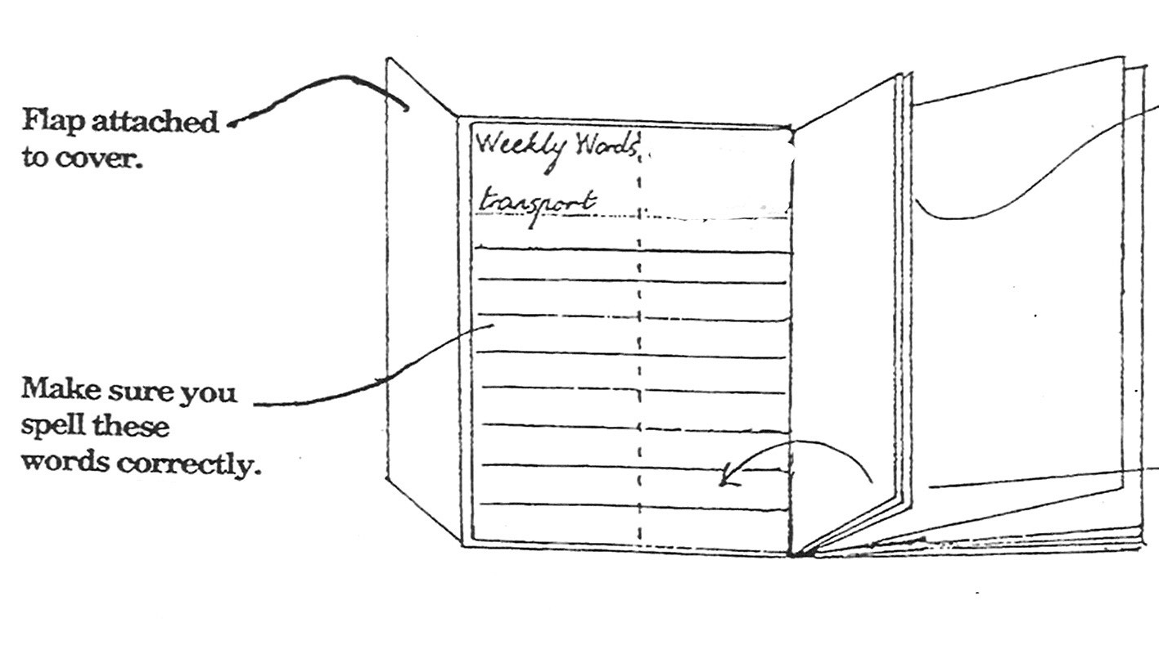

1. You will notice that there is a yellow flap attached to the left cover which when pulled down **Covers** the words you have just written. To practise learning your words you need to:

* **LOOK** carefully at each word, read it aloud slowly.
* Look for smaller words within a word, sound patterns and shape.
* Pull down the yellow cover which will **COVER** the word.
* **WRITE** the word in the exposed right-hand column.
* **CHECK** your spelling.
* Continue this process with each of the 20 words.

**Spelling continued**

**How Do I Learn the Words?**

1. There are three half pages which follow. This allows you to continue the process three times over the week in preparation for your spelling test at the end of the week.

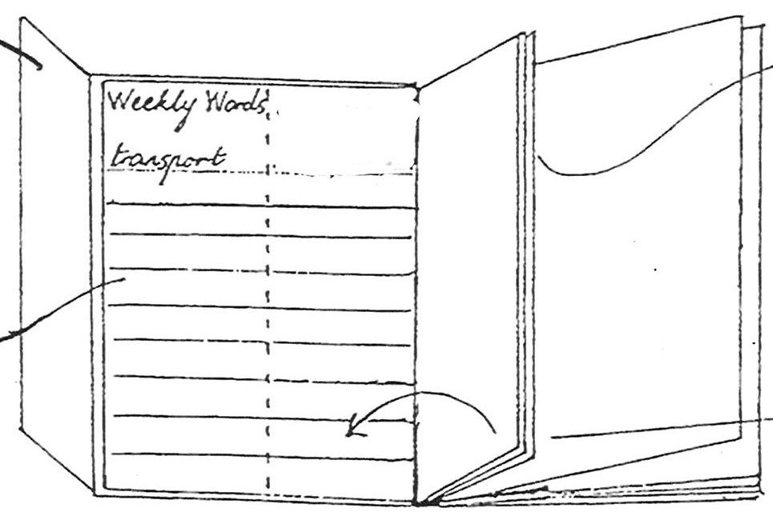

**

*For the rest of the week you should focus on learning the words using the LCWC method. On the last day of the week your Supervisor will test your knowledge. This will be your weekly routine for the rest of the year.*

*In addition there is a dictation test for further challenge!*

Exploring the Text



MCj04247880000[1]MCj04247880000[1] **For You to Do *SEND***

In this section you will answer questions about the newspaper article *Indigenous leaders want rules changed*.

There are four different types of questions, read the instructions and questions carefully highlighting or underlining key words.

Write your answers in **complete sentences**. Remember to use appropriate **punctuation** and **edit** your work at completion. Complete on *Word* or write your answers in the space below. If you require further space attached lined paper.

1. *What does the article actually say—*
2. How did Damien Hooper break the IOC rules?

\_\_\_\_\_\_\_\_\_\_\_\_\_\_\_\_\_\_\_\_\_\_\_\_\_\_\_\_\_\_\_\_\_\_\_\_\_\_\_\_\_\_\_\_\_\_\_\_\_\_\_\_\_\_\_\_\_\_\_\_\_\_\_\_\_\_\_\_\_\_\_\_

\_\_\_\_\_\_\_\_\_\_\_\_\_\_\_\_\_\_\_\_\_\_\_\_\_\_\_\_\_\_\_\_\_\_\_\_\_\_\_\_\_\_\_\_\_\_\_\_\_\_\_\_\_\_\_\_\_\_\_\_\_\_\_\_\_\_\_\_\_\_\_\_

1. Why did Damien Hooper wear the T-shirt?

\_\_\_\_\_\_\_\_\_\_\_\_\_\_\_\_\_\_\_\_\_\_\_\_\_\_\_\_\_\_\_\_\_\_\_\_\_\_\_\_\_\_\_\_\_\_\_\_\_\_\_\_\_\_\_\_\_\_\_\_\_\_\_\_\_\_\_\_\_\_\_\_

\_\_\_\_\_\_\_\_\_\_\_\_\_\_\_\_\_\_\_\_\_\_\_\_\_\_\_\_\_\_\_\_\_\_\_\_\_\_\_\_\_\_\_\_\_\_\_\_\_\_\_\_\_\_\_\_\_\_\_\_\_\_\_\_\_\_\_\_\_\_\_\_

1. *What does the story suggest—*
2. Which Olympic Rules do the Indigenous leaders suggest should change? Who do they suggest must seek to have the rule overturned?

\_\_\_\_\_\_\_\_\_\_\_\_\_\_\_\_\_\_\_\_\_\_\_\_\_\_\_\_\_\_\_\_\_\_\_\_\_\_\_\_\_\_\_\_\_\_\_\_\_\_\_\_\_\_\_\_\_\_\_\_\_\_\_\_\_\_\_\_\_\_\_\_

\_\_\_\_\_\_\_\_\_\_\_\_\_\_\_\_\_\_\_\_\_\_\_\_\_\_\_\_\_\_\_\_\_\_\_\_\_\_\_\_\_\_\_\_\_\_\_\_\_\_\_\_\_\_\_\_\_\_\_\_\_\_\_\_\_\_\_\_\_\_\_\_

\_\_\_\_\_\_\_\_\_\_\_\_\_\_\_\_\_\_\_\_\_\_\_\_\_\_\_\_\_\_\_\_\_\_\_\_\_\_\_\_\_\_\_\_\_\_\_\_\_\_\_\_\_\_\_\_\_\_\_\_\_\_\_\_\_\_\_\_\_\_\_\_

\_\_\_\_\_\_\_\_\_\_\_\_\_\_\_\_\_\_\_\_\_\_\_\_\_\_\_\_\_\_\_\_\_\_\_\_\_\_\_\_\_\_\_\_\_\_\_\_\_\_\_\_\_\_\_\_\_\_\_\_\_\_\_\_\_\_\_\_\_\_\_\_

**Explore the text continued**

b. From the article, who understood Hooper’s action? What evidence supports his understanding?

\_\_\_\_\_\_\_\_\_\_\_\_\_\_\_\_\_\_\_\_\_\_\_\_\_\_\_\_\_\_\_\_\_\_\_\_\_\_\_\_\_\_\_\_\_\_\_\_\_\_\_\_\_\_\_\_\_\_\_\_\_\_\_\_\_\_\_\_\_\_\_\_

\_\_\_\_\_\_\_\_\_\_\_\_\_\_\_\_\_\_\_\_\_\_\_\_\_\_\_\_\_\_\_\_\_\_\_\_\_\_\_\_\_\_\_\_\_\_\_\_\_\_\_\_\_\_\_\_\_\_\_\_\_\_\_\_\_\_\_\_\_\_\_\_

\_\_\_\_\_\_\_\_\_\_\_\_\_\_\_\_\_\_\_\_\_\_\_\_\_\_\_\_\_\_\_\_\_\_\_\_\_\_\_\_\_\_\_\_\_\_\_\_\_\_\_\_\_\_\_\_\_\_\_\_\_\_\_\_\_\_\_\_\_\_\_\_

\_\_\_\_\_\_\_\_\_\_\_\_\_\_\_\_\_\_\_\_\_\_\_\_\_\_\_\_\_\_\_\_\_\_\_\_\_\_\_\_\_\_\_\_\_\_\_\_\_\_\_\_\_\_\_\_\_\_\_\_\_\_\_\_\_\_\_\_\_\_\_\_

\_\_\_\_\_\_\_­\_\_\_\_\_\_\_\_\_\_\_\_\_\_\_\_\_\_\_\_\_\_\_\_\_\_\_\_\_\_\_\_\_\_\_\_\_\_\_\_\_\_\_\_\_\_\_\_\_\_\_\_\_\_\_\_\_\_\_\_\_\_\_\_\_

\_\_\_\_\_\_\_\_\_\_\_\_\_\_\_\_\_\_\_\_\_\_\_\_\_\_\_\_\_\_\_\_\_\_\_\_\_\_\_\_\_\_\_\_\_\_\_\_\_\_\_\_\_\_\_\_\_\_\_\_\_\_\_\_\_\_\_\_\_\_\_\_

\_\_\_\_\_\_\_\_\_\_\_\_\_\_\_\_\_\_\_\_\_\_\_\_\_\_\_\_\_\_\_\_\_\_\_\_\_\_\_\_\_\_\_\_\_\_\_\_\_\_\_\_\_\_\_\_\_\_\_\_\_\_\_\_\_\_\_\_\_\_\_\_

1. *From your experience, what could the news recount mean?*
2. Do you believe that the article is a true reflection of the events reported? Explain your reasons.

\_\_\_\_\_\_\_\_\_\_\_\_\_\_\_\_\_\_\_\_\_\_\_\_\_\_\_\_\_\_\_\_\_\_\_\_\_\_\_\_\_\_\_\_\_\_\_\_\_\_\_\_\_\_\_\_\_\_\_\_\_\_\_\_\_\_\_\_\_\_\_\_

\_\_\_\_\_\_\_\_\_\_\_\_\_\_\_\_\_\_\_\_\_\_\_\_\_\_\_\_\_\_\_\_\_\_\_\_\_\_\_\_\_\_\_\_\_\_\_\_\_\_\_\_\_\_\_\_\_\_\_\_\_\_\_\_\_\_\_\_\_\_\_\_

\_\_\_\_\_\_\_\_\_\_\_\_\_\_\_\_\_\_\_\_\_\_\_\_\_\_\_\_\_\_\_\_\_\_\_\_\_\_\_\_\_\_\_\_\_\_\_\_\_\_\_\_\_\_\_\_\_\_\_\_\_\_\_\_\_\_\_\_\_\_\_\_

\_\_\_\_\_\_\_\_\_\_\_\_\_\_\_\_\_\_\_\_\_\_\_\_\_\_\_\_\_\_\_\_\_\_\_\_\_\_\_\_\_\_\_\_\_\_\_\_\_\_\_\_\_\_\_\_\_\_\_\_\_\_\_\_\_\_\_\_\_\_\_\_

\_\_\_\_\_\_\_\_\_\_\_\_\_\_\_\_\_\_\_\_\_\_\_\_\_\_\_\_\_\_\_\_\_\_\_\_\_\_\_\_\_\_\_\_\_\_\_\_\_\_\_\_\_\_\_\_\_\_\_\_\_\_\_\_\_\_\_\_\_\_\_\_

\_\_\_\_\_\_\_\_\_\_\_\_\_\_\_\_\_\_\_\_\_\_\_\_\_\_\_\_\_\_\_\_\_\_\_\_\_\_\_\_\_\_\_\_\_\_\_\_\_\_\_\_\_\_\_\_\_\_\_\_\_\_\_\_\_\_\_\_\_\_\_\_

\_\_\_\_\_\_\_\_\_\_\_\_\_\_\_\_\_\_\_\_\_\_\_\_\_\_\_\_\_\_\_\_\_\_\_\_\_\_\_\_\_\_\_\_\_\_\_\_\_\_\_\_\_\_\_\_\_\_\_\_\_\_\_\_\_\_\_\_\_\_\_\_

\_\_\_\_\_\_\_\_\_\_\_\_\_\_\_\_\_\_\_\_\_\_\_\_\_\_\_\_\_\_\_\_\_\_\_\_\_\_\_\_\_\_\_\_\_\_\_\_\_\_\_\_\_\_\_\_\_\_\_\_\_\_\_\_\_\_\_\_\_\_\_\_

\_\_\_\_\_\_\_\_\_\_\_\_\_\_\_\_\_\_\_\_\_\_\_\_\_\_\_\_\_\_\_\_\_\_\_\_\_\_\_\_\_\_\_\_\_\_\_\_\_\_\_\_\_\_\_\_\_\_\_\_\_\_\_\_\_\_\_\_\_\_\_\_

\_\_\_\_\_\_\_\_\_\_\_\_\_\_\_\_\_\_\_\_\_\_\_\_\_\_\_\_\_\_\_\_\_\_\_\_\_\_\_\_\_\_\_\_\_\_\_\_\_\_\_\_\_\_\_\_\_\_\_\_\_\_\_\_\_\_\_\_\_\_\_\_

**Explore the text continued**

b. If Damien was called before the sports tribunal to explain his actions and you were Damien’s lawyer, what would you say to defend him?

\_\_\_\_\_\_\_\_\_\_\_\_\_\_\_\_\_\_\_\_\_\_\_\_\_\_\_\_\_\_\_\_\_\_\_\_\_\_\_\_\_\_\_\_\_\_\_\_\_\_\_\_\_\_\_\_\_\_\_\_\_\_\_\_\_\_\_\_\_\_\_\_

\_\_\_\_\_\_\_\_\_\_\_\_\_\_\_\_\_\_\_\_\_\_\_\_\_\_\_\_\_\_\_\_\_\_\_\_\_\_\_\_\_\_\_\_\_\_\_\_\_\_\_\_\_\_\_\_\_\_\_\_\_\_\_\_\_\_\_\_\_\_\_\_

\_\_\_\_\_\_\_\_\_\_\_\_\_\_\_\_\_\_\_\_\_\_\_\_\_\_\_\_\_\_\_\_\_\_\_\_\_\_\_\_\_\_\_\_\_\_\_\_\_\_\_\_\_\_\_\_\_\_\_\_\_\_\_\_\_\_\_\_\_\_\_\_

\_\_\_\_\_\_\_\_\_\_\_\_\_\_\_\_\_\_\_\_\_\_\_\_\_\_\_\_\_\_\_\_\_\_\_\_\_\_\_\_\_\_\_\_\_\_\_\_\_\_\_\_\_\_\_\_\_\_\_\_\_\_\_\_\_\_\_\_\_\_\_\_

\_\_\_\_\_\_\_\_\_\_\_\_\_\_\_\_\_\_\_\_\_\_\_\_\_\_\_\_\_\_\_\_\_\_\_\_\_\_\_\_\_\_\_\_\_\_\_\_\_\_\_\_\_\_\_\_\_\_\_\_\_\_\_\_\_\_\_\_\_\_\_\_

\_\_\_\_\_\_\_\_\_\_\_\_\_\_\_\_\_\_\_\_\_\_\_\_\_\_\_\_\_\_\_\_\_\_\_\_\_\_\_\_\_\_\_\_\_\_\_\_\_\_\_\_\_\_\_\_\_\_\_\_\_\_\_\_\_\_\_\_\_\_\_\_

c. Do you believe the Aboriginal flag should also be included at major sporting events? Explain why or why not it should be included.

\_\_\_\_\_\_\_\_\_\_\_\_\_\_\_\_\_\_\_\_\_\_\_\_\_\_\_\_\_\_\_\_\_\_\_\_\_\_\_\_\_\_\_\_\_\_\_\_\_\_\_\_\_\_\_\_\_\_\_\_\_\_\_\_\_\_\_\_\_\_\_\_

\_\_\_\_\_\_\_\_\_\_\_\_\_\_\_\_\_\_\_\_\_\_\_\_\_\_\_\_\_\_\_\_\_\_\_\_\_\_\_\_\_\_\_\_\_\_\_\_\_\_\_\_\_\_\_\_\_\_\_\_\_\_\_\_\_\_\_\_\_\_\_\_

\_\_\_\_\_\_\_\_\_\_\_\_\_\_\_\_\_\_\_\_\_\_\_\_\_\_\_\_\_\_\_\_\_\_\_\_\_\_\_\_\_\_\_\_\_\_\_\_\_\_\_\_\_\_\_\_\_\_\_\_\_\_\_\_\_\_\_\_\_\_\_\_

\_\_\_\_\_\_\_\_\_\_\_\_\_\_\_\_\_\_\_\_\_\_\_\_\_\_\_\_\_\_\_\_\_\_\_\_\_\_\_\_\_\_\_\_\_\_\_\_\_\_\_\_\_\_\_\_\_\_\_\_\_\_\_\_\_\_\_\_\_\_\_\_

\_\_\_\_\_\_\_\_\_\_\_\_\_\_\_\_\_\_\_\_\_\_\_\_\_\_\_\_\_\_\_\_\_\_\_\_\_\_\_\_\_\_\_\_\_\_\_\_\_\_\_\_\_\_\_\_\_\_\_\_\_\_\_\_\_\_\_\_\_\_\_\_

\_\_\_\_\_\_\_\_\_\_\_\_\_\_\_\_\_\_\_\_\_\_\_\_\_\_\_\_\_\_\_\_\_\_\_\_\_\_\_\_\_\_\_\_\_\_\_\_\_\_\_\_\_\_\_\_\_\_\_\_\_\_\_\_\_\_\_\_\_\_\_\_

\_\_\_\_\_\_\_\_\_\_\_\_\_\_\_\_\_\_\_\_\_\_\_\_\_\_\_\_\_\_\_\_\_\_\_\_\_\_\_\_\_\_\_\_\_\_\_\_\_\_\_\_\_\_\_\_\_\_\_\_\_\_\_\_\_\_\_\_\_\_\_\_

\_\_\_\_\_\_\_\_\_\_\_\_\_\_\_\_\_\_\_\_\_\_\_\_\_\_\_\_\_\_\_\_\_\_\_\_\_\_\_\_\_\_\_\_\_\_\_\_\_\_\_\_\_\_\_\_\_\_\_\_\_\_\_\_\_\_\_\_\_\_\_\_

**Explore the text continued**

1. *Do you agree with or trust the text?*
2. What information in the article is hearsay (information the witness did not see or hear himself)? How might this give the wrong idea about the facts

\_\_\_\_\_\_\_\_\_\_\_\_\_\_\_\_\_\_\_\_\_\_\_\_\_\_\_\_\_\_\_\_\_\_\_\_\_\_\_\_\_\_\_\_\_\_\_\_\_\_\_\_\_\_\_\_\_\_\_\_\_\_\_\_\_\_\_\_\_\_\_\_

\_\_\_\_\_\_\_\_\_\_\_\_\_\_\_\_\_\_\_\_\_\_\_\_\_\_\_\_\_\_\_\_\_\_\_\_\_\_\_\_\_\_\_\_\_\_\_\_\_\_\_\_\_\_\_\_\_\_\_\_\_\_\_\_\_\_\_\_\_\_\_\_

\_\_\_\_\_\_\_\_\_\_\_\_\_\_\_\_\_\_\_\_\_\_\_\_\_\_\_\_\_\_\_\_\_\_\_\_\_\_\_\_\_\_\_\_\_\_\_\_\_\_\_\_\_\_\_\_\_\_\_\_\_\_\_\_\_\_\_\_\_\_\_\_

\_\_\_\_\_\_\_\_\_\_\_\_\_\_\_\_\_\_\_\_\_\_\_\_\_\_\_\_\_\_\_\_\_\_\_\_\_\_\_\_\_\_\_\_\_\_\_\_\_\_\_\_\_\_\_\_\_\_\_\_\_\_\_\_\_\_\_\_\_\_\_\_

\_\_\_\_\_\_\_\_\_\_\_\_\_\_\_\_\_\_\_\_\_\_\_\_\_\_\_\_\_\_\_\_\_\_\_\_\_\_\_\_\_\_\_\_\_\_\_\_\_\_\_\_\_\_\_\_\_\_\_\_\_\_\_\_\_\_\_\_\_\_\_\_

1. Imagine that you were a spectator at the boxing match that Damien wore the T-shirt. What information do you believe is missing from the article? For example, do you think they should have interviewed spectators attending the match? What would you have said if you were interviewed?

\_\_\_\_\_\_\_\_\_\_\_\_\_\_\_\_\_\_\_\_\_\_\_\_\_\_\_\_\_\_\_\_\_\_\_\_\_\_\_\_\_\_\_\_\_\_\_\_\_\_\_\_\_\_\_\_\_\_\_\_\_\_\_\_\_\_\_\_\_\_\_\_

\_\_\_\_\_\_\_\_\_\_\_\_\_\_\_\_\_\_\_\_\_\_\_\_\_\_\_\_\_\_\_\_\_\_\_\_\_\_\_\_\_\_\_\_\_\_\_\_\_\_\_\_\_\_\_\_\_\_\_\_\_\_\_\_\_\_\_\_\_\_\_\_

\_\_\_\_\_\_\_\_\_\_\_\_\_\_\_\_\_\_\_\_\_\_\_\_\_\_\_\_\_\_\_\_\_\_\_\_\_\_\_\_\_\_\_\_\_\_\_\_\_\_\_\_\_\_\_\_\_\_\_\_\_\_\_\_\_\_\_\_\_\_\_\_

\_\_\_\_\_\_\_\_\_\_\_\_\_\_\_\_\_\_\_\_\_\_\_\_\_\_\_\_\_\_\_\_\_\_\_\_\_\_\_\_\_\_\_\_\_\_\_\_\_\_\_\_\_\_\_\_\_\_\_\_\_\_\_\_\_\_\_\_\_\_\_\_

\_\_\_\_\_\_\_\_\_\_\_\_\_\_\_\_\_\_\_\_\_\_\_\_\_\_\_\_\_\_\_\_\_\_\_\_\_\_\_\_\_\_\_\_\_\_\_\_\_\_\_\_\_\_\_\_\_\_\_\_\_\_\_\_\_\_\_\_\_\_\_\_

\_\_\_\_\_\_\_\_\_\_\_\_\_\_\_\_\_\_\_\_\_\_\_\_\_\_\_\_\_\_\_\_\_\_\_\_\_\_\_\_\_\_\_\_\_\_\_\_\_\_\_\_\_\_\_\_\_\_\_\_\_\_\_\_\_\_\_\_\_\_\_\_

\_\_\_\_\_\_\_\_\_\_\_\_\_\_\_\_\_\_\_\_\_\_\_\_\_\_\_\_\_\_\_\_\_\_\_\_\_\_\_\_\_\_\_\_\_\_\_\_\_\_\_\_\_\_\_\_\_\_\_\_\_\_\_\_\_\_\_\_\_\_\_\_

\_\_\_\_\_\_\_\_\_\_\_\_\_\_\_\_\_\_\_\_\_\_\_\_\_\_\_\_\_\_\_\_\_\_\_\_\_\_\_\_\_\_\_\_\_\_\_\_\_\_\_\_\_\_\_\_\_\_\_\_\_\_\_\_\_\_\_\_\_\_\_\_

Word Explorer—Grammar



Each week you will be studying the *rules of language* and *how we use them* to write and communicate.

Today you will be working on **words of authority** and **homonyms**.

|  |
| --- |
| **Words of Authority**  People in authority (police officers, politicians, public officials, journalists) often use big words to explain things. Big words can give them a sound of authority and importance. However, the best communication is often with simple words that are clear and easily understood.  The in the newspaper article, the journalist and people interviewed used the following words:  protocol reconciliation remorseful former  flouted apologetic contender affirm  There are simpler words in English that have the same or similar meanings (synonyms).   * Use a thesaurus to find words that could make the article easier to understand. |

**Grammar continued**

MCj04247880000[1]**For You to Do *SEND***

**Homonyms**

Many words sound the same as other words but are spelled differently. They are called homonyms. When words have homonyms, writers need to be careful that they have used the right word. Here are some examples of homonyms.

right/write guest/guessed caught/court draw/drawer

There are at least 5 homonyms in the text *Indigenous leaders want rules changed*.

**Can you find them?**

**1.**

**2.**

**3.**

**4.**

**5.**

**Grammar continued**

MCj04247880000[1]

**For You to Do** ***SEND***

There are some words in the text *Indigenous leaders want rules changed* that are spelt with silent letters. There are other words in English that follow the same spelling patterns

|  |
| --- |
| ***Say*** the words below aloud to your Supervisor. ***Listen*** to the sound of the word. What consonant or vowel is silent?  Label each column below, with the silent letter. ***Write*** the words that fit under the column headings. |

|  |  |  |  |  |  |
| --- | --- | --- | --- | --- | --- |
| knife | guitar | write | **know** | wrap | guest |
| wrestle | knee | guard | **wrist** | **knot** | guide |

|  |  |  |
| --- | --- | --- |
| **Silent ...** | **Silent ...** | **Silent ...** |
|  |  |  |

|  |  |
| --- | --- |
| Writing  Workshop |  |

In *Writing Workshop* you will begin your work on a *News Article Recount.*  Study the **techniques** and **styles** used by the writer as you will be writing your own recount in Week 2.

Carefully read the information on the style and techniques used for writing a *News Article Recount* located on the following page.

Use a highlighter or underline key words and phrases to help you remember. In addition jot down notes (point form not sentences) from your reading to assist with your planning of your *News Article Recount.*

**News Article Recount – Techniques and Styles**

**Getting Attention**

The **headline** has two purposes—to say what the article is about and to attract the reader’s attention. The headline is generally the last thing to be written in a newspaper article. Writing a good headline means finding the words that best summarise the events and at the same time attract attention. Notice how the journalist used dramatic words –

***Indigenous Leaders***

**Hooking the Reader**

The text of an article almost always beings with an introduction called a **lead,** in newspaper lingo. The lead is brief and summarises the most important information that explains where, who, what, when and why. The lead should be interesting to hook the reader into reading the rest of the article.

In the article, this is identified by explaining **‘what should of happened’** i.e. ‘the Olympic rules should be changed’ and the **‘why it should happen’** i.e. ‘because Aboriginal flags are outlawed’.

**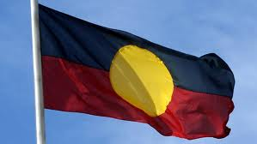**

**Story Details**

The **body text** is the text that follows the introduction. It gives details about the incident—**what** has happened, **where, when** and **why** it happened and **who** was involved. In the body text, the reporter can also say what are the results or consequences.

In a news article, the most important facts are placed first, other background information and details follow. Each piece of information is usually written in one sentence and each paragraph has no more than one or two sentences.

Have a look at the second paragraph of the article *Indigenous leaders want rules changed—*it is only onesentence and explains one fact*—*

**Damien Hooper wore a T-shirt with the Aboriginal flag on it at the competition.**

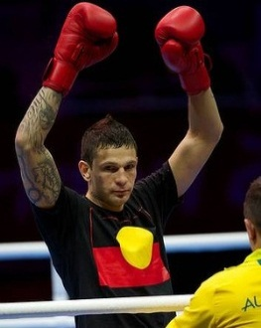

**Using Witnesses**

There are often witnesses to what has happened. If one of them gives a view of what has happened, it makes the events more realistic or authentic to the reader.

Words and sentences that report what someone has said are called **quotations.** They give the article life and believability. Either a witness or someone who has been affected by the incident is often quoted.

Some of the evidence in quotations is from people who did not actually witness an event. For example, the writer did not actually hear Damien Hooper apologise. The team boss, Nick Green, is recalling what Hooper had said to him. This kind of information is called **hearsay.** It does not prove that he actually apologised.

Hearsay may be true, but depending on the source, it may also be false or misleading.

**Recounting Events**

Newspapers report events that have already happened. So the journalist writes in the **past tense.**

|  |  |
| --- | --- |
| http://www.oncoursesystems.com/images/user/10809/10705150/SCHOOL/Vocabulary%20-%201.gif | Word Explorer—Synonyms  Synonyms are **words that are similar in meaning to other words.** |

Below is a Wordle with some words from the text we have been studying as well as synonyms for those words.

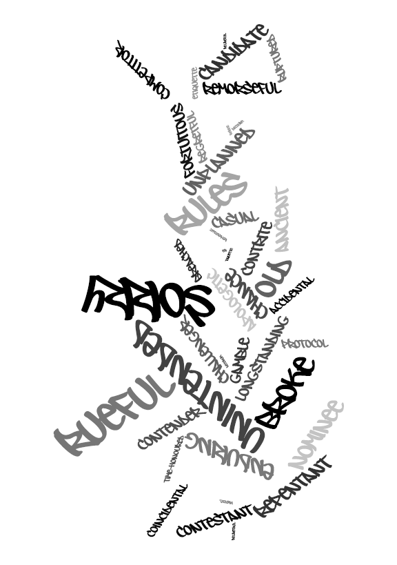

Let’s look at the second sentence in the first paragraph:

“They have called on the Australian Olympic Committee to lobby for the longstanding protocol to be overturned.”

This sentence could have been written using different words—have a look at the sentence below:

“They have called on the Australian Olympic Committee to ***ask*** for the ***old rule*** to be reversed.”

Does this make the sentence easier to read?

Does the sentence still mean the same?

**Synonyms continued**

|  |  |
| --- | --- |
| MCj04247880000[1] For You to Do SEND |  |

1. Look at the sentences below. Circle, underline or highlight the complex words:
2. The 20-year-old gold medal contender breached the rules by wearing a T-Shirt with the Aboriginal flag on it.
3. Recognising both flags would affirm our history and be a major act of reconciliation.
4. He was “very remorseful” and “extremely apologetic” about his actions.
5. We recognise his indigenous culture and his desire to represent his heritage.
6. Rewrite the sentences using synonyms to replace the underlined words.

1.\_\_\_\_\_\_\_\_\_\_\_\_\_\_\_\_\_\_\_\_\_\_\_\_\_\_\_\_\_\_\_\_\_\_\_\_\_\_\_\_\_\_\_\_\_\_\_\_\_\_\_\_\_\_\_\_\_\_\_\_\_\_\_\_\_\_\_\_\_\_

\_\_\_\_\_\_\_\_\_\_\_\_\_\_\_\_\_\_\_\_\_\_\_\_\_\_\_\_\_\_\_\_\_\_\_\_\_\_\_\_\_\_\_\_\_\_\_\_\_\_\_\_\_\_\_\_\_\_\_\_\_\_\_\_\_\_\_\_\_\_\_\_

\_\_\_\_\_\_\_\_\_\_\_\_\_\_\_\_\_\_\_\_\_\_\_\_\_\_\_\_\_\_\_\_\_\_\_\_\_\_\_\_\_\_\_\_\_\_\_\_\_\_\_\_\_\_\_\_\_\_\_\_\_\_\_\_\_\_\_\_\_\_\_\_

\_\_\_\_\_\_\_\_\_\_\_\_\_\_\_\_\_\_\_\_\_\_\_\_\_\_\_\_\_\_\_\_\_\_\_\_\_\_\_\_\_\_\_\_\_\_\_\_\_\_\_\_\_\_\_\_\_\_\_\_\_\_\_\_\_\_\_\_\_\_\_\_

2.\_\_\_\_\_\_\_\_\_\_\_\_\_\_\_\_\_\_\_\_\_\_\_\_\_\_\_\_\_\_\_\_\_\_\_\_\_\_\_\_\_\_\_\_\_\_\_\_\_\_\_\_\_\_\_\_\_\_\_\_\_\_\_\_\_\_\_\_\_\_

\_\_\_\_\_\_\_\_\_\_\_\_\_\_\_\_\_\_\_\_\_\_\_\_\_\_\_\_\_\_\_\_\_\_\_\_\_\_\_\_\_\_\_\_\_\_\_\_\_\_\_\_\_\_\_\_\_\_\_\_\_\_\_\_\_\_\_\_\_\_\_\_

\_\_\_\_\_\_\_\_\_\_\_\_\_\_\_\_\_\_\_\_\_\_\_\_\_\_\_\_\_\_\_\_\_\_\_\_\_\_\_\_\_\_\_\_\_\_\_\_\_\_\_\_\_\_\_\_\_\_\_\_\_\_\_\_\_\_\_\_\_\_\_\_

\_\_\_\_\_\_\_\_\_\_\_\_\_\_\_\_\_\_\_\_\_\_\_\_\_\_\_\_\_\_\_\_\_\_\_\_\_\_\_\_\_\_\_\_\_\_\_\_\_\_\_\_\_\_\_\_\_\_\_\_\_\_\_\_\_\_\_\_\_\_\_\_

3.\_\_\_\_\_\_\_\_\_\_\_\_\_\_\_\_\_\_\_\_\_\_\_\_\_\_\_\_\_\_\_\_\_\_\_\_\_\_\_\_\_\_\_\_\_\_\_\_\_\_\_\_\_\_\_\_\_\_\_\_\_\_\_\_\_\_\_\_\_\_

\_\_\_\_\_\_\_\_\_\_\_\_\_\_\_\_\_\_\_\_\_\_\_\_\_\_\_\_\_\_\_\_\_\_\_\_\_\_\_\_\_\_\_\_\_\_\_\_\_\_\_\_\_\_\_\_\_\_\_\_\_\_\_\_\_\_\_\_\_\_\_\_

\_\_\_\_\_\_\_\_\_\_\_\_\_\_\_\_\_\_\_\_\_\_\_\_\_\_\_\_\_\_\_\_\_\_\_\_\_\_\_\_\_\_\_\_\_\_\_\_\_\_\_\_\_\_\_\_\_\_\_\_\_\_\_\_\_\_\_\_\_\_\_\_

**Synonyms continued**

MCj04247880000[1]

**For You to Do SEND**

We have looked at synonyms for words in the text, ***Indigenous leaders want rules changed.*** Some of these words also have antonyms. An antonym is the opposite meaning of the words.

Eg. Major – one synonym ***main***, the antonym would be ***minor.***

In the table below, find synonyms and antonyms for the following words:

|  |  |  |
| --- | --- | --- |
| **noun** | **synonym** | **antonym** |
| uniform |  |  |
| action |  |  |
| more |  |  |
| recall |  |  |
| history |  |  |
| aware |  |  |
| outlaw |  |  |
| change |  |  |
| former |  |  |
| strong |  |  |

|  |  |
| --- | --- |
| http://3.bp.blogspot.com/-qPoK5ahYCp4/TuuFpKg1zDI/AAAAAAAABKg/xPUigX_ZUkE/s400/clrtest.gif | **Spelling and Dictation Test** |

Today your Supervisor will test the twenty words you have been learning this week. Do the test on your lined paper and when you finish, you and your Supervisor can correct it together. I'm sure you'll give it your best shot.

Your Supervisor will read the whole extract to you and then **dictate** small sections or phrases. There are several commas in this extract. Read it through after you have finished and you should be able to tell where to place the commas.

There was an unpleasant **∫** smell and something sticking **∫** out of the ground. **∫** The 11-year-old boy **∫** from a

Nomadic family **∫** in Russia’s north had **∫** stumbled upon a massive,**∫** well-preserved woolly **∫** mammoth, in what **∫** scientists describe as the **∫** best such discovery **∫** since 1901.

End of Week 1

**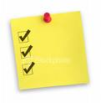**

**Checklist**

This week you should have completed the following tasks, please tick the tasks you have completed.

* **Reading**—*Indigenous leaders want rules changed*
* **Spelling**—LCWC and own Words
* **Explore the text**—Comprehension
* **Grammar**—Words of authority and homonyms
* **Writing Workshop**—Styles and techniques
* **Grammar**—Synonyms and antonyms
* **Test**—Spelling and Dictation

Week 2



**Learning Intentions**

* To plan and write your own news article recount*.* This is your major task for the week. You have all week to complete it.
* Study given spelling words in preparation for test.
* Complete work on the use of contractions.

**Achievement Standards**

* Draft and publish imaginative, informative and persuasive text, choosing [text structures](http://www.australiancurriculum.edu.au/Glossary?a=E&t=text+structures), [language features](http://www.australiancurriculum.edu.au/Glossary?a=E&t=language+features), appropriate to purpose and [audience](http://www.australiancurriculum.edu.au/Glossary?a=E&t=audience).
* Reread and edit own work using agreed criteria.
* Use a range of software including word processing programs with fluency to construct, edit and publish written articles.

|  |
| --- |
| * Writing Project |

In the *Writing Project* sectionyou will write your **News Article Recount** using the information and the picture blow. Use the information that you learned about technique and style. Follow the steps below to help you plan, draft and write your article.

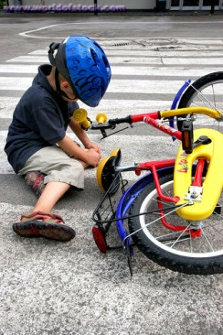

**Plan**

|  |
| --- |
| http://ktonthemove.files.wordpress.com/2012/01/notepad.gif Firstly plan your recount. Jot down notes and ideas.  The following will help you get started!  **Ideas**  Use this information and the picture to draft ideas for a newspaper article:   * Injured child found on pedestrian crossing next to broken bicycle. * Witness heard car tyres screech. * No car driver stayed at the scene. * Ambulance attended.   **Planning**   * To write the article, begin with the most important facts and then give more background. * Include a quotation from a witness. * Make sure that your article has a **lead** and **body text.** * Finally, write a **headline** that shows what the article is about. Use a few words as possible but make sure that you catch the reader’s interest.   **Drafting**   * Copy the bicycle accident photo or find a suitable photo. Use a word processor to type your draft and create your news article for publication.   **Editor’s Hints**   * Headline   Check your headline to make sure it means what you think it does. It might mean something you do not intend, because there are so few words in a headline. This is called ‘ambiguity’. For example:  **POLICE TO STOP SPEEDING**   * Does this mean that the police will stop *t****hemselves***from speeding, or that the police will stop ***others***from speeding? * Some headings are clever and play on words. Look at these examples   **Government decides what’s in a name.com**  **Or**  **Cadel suited to cycling in suit**  **Or**  **Global warming reveals mammoth find**  In this article mammoth could mean big, huge and also the body of a well-preserved woolly mammoth.  **Or**  **Pricing Paintings slashed**  Here the use of **alliteration** has been used to make it sound ‘catchy’ – Priceless Paintings. |

**Planning continued**

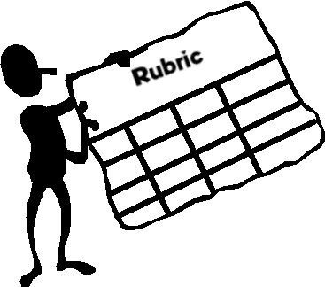**How will I Assess Your Writing?**

A **Rubric** (located at the back of this Module) will be used to assess your writing. It is a scoring guide with a range of criteria that will be used to score your work.

I suggest you read it carefully and use it as a working guide when planning and writing your work. Think about the criteria on which you will be judged and aim to complete your best work.

**Getting started:**

Read the following information carefully as it will help you **plan**, **draft**, **edit** and complete your **final piece**. In your recount, make sure you include all that you have studied and learnt in Week 1.

Remember you have all week to complete your final writing.

|  |
| --- |
| **Draft**  http://www.school-clipart.com/school_clipart_images/pencil_and_paper_coloring_page_0071-1002-2401-4136_SMU.jpg Start writing your recount based on the notes you took in Week 1 and your plan.  Remember the following:   * Group your ideas into paragraphs. * Focus on punctuation such as capital letters, commas and full stops. * Concentrate on spelling; do not rush as you can make careless errors. * Use talking marks “ ” if characters speak within your recount. |

**Planning continued**

**Helpful hints:**

Get to the point! People often spot stories by taking too long to tell them. So:

* don’t write too much in the introduction
* write a catchy headline
* use only a few sentences to tell each part of the story.

|  |
| --- |
| **Editing**  When you have finished writing your draft you need to edit it before you complete the final copy. Here’s what you need to do:   1. Read your writing preferably out loud and to another person. Make sure you pause at commas and full stops.   Ask:  *Does it make sense? Are sentences too long or too short?*  *Does it sound confusing? Is it too repetitive? Do I need to add or delete information?*   1. Now read again quietly and with a bright coloured pen highlight and correct spelling errors, punctuation and grammatical errors. Correct if you know the answer and ask your Supervisor for help if necessary.   http://www.bold-type.com.au/wp-content/uploads/2010/07/dreamstime_14649214.jpg |

**Planning continued**

|  |
| --- |
| **Final Piece**  Time to complete the final copy!  **How will you do this?**  You can use Word on the computer or handwrite your final piece.  Remember to make it neat and easy to read. I’m looking forward to reading your recount.  http://www.coronapubliclibrary.org/CoronaPublicLibrary/media/Logos/writtenbylogo_FINAL-copy.png |

|  |  |
| --- | --- |
| http://www.oncoursesystems.com/images/user/10809/10705150/SCHOOL/Vocabulary%20-%201.gif | Word Explorer—Spelling |

This week you will follow the same process for spelling as in Week 1. Your spelling words for Week 2 are located at the back of the Module. Complete the following and learn your words using the *Look Cover Write Check* method.

MCj04247880000[1]

**For You to Do**

* + 1. Today I want you to choose words for **My** **Own Words.**

These can be from:

|  |  |
| --- | --- |
|  | * your own writing |
|  | * your reading |
|  | * your memory. |

* + 1. Complete the *Look Cover Write Check* process for this week’s 20 words.

**Remember!**

At the end of the week you will be tested on the topic words and your own words.

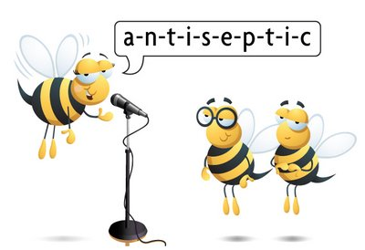

|  |  |
| --- | --- |
| http://www.oncoursesystems.com/images/user/10809/10705150/SCHOOL/Vocabulary%20-%201.gif | Word Explorer—Contractions  This week you will study **contractions.** |

We often ‘contract’ or shorten words in English. For example, we may say ‘he's’ instead of ‘he is’. Note that we usually insert an apostrophe (') in place of the missing letter or letters in writing. Here are some example sentences:

* I haven't seen him. (I have not seen him.)
* Who's calling? (Who is calling?)
* They're coming. (They are coming.)

We do this especially when we speak. We do not contract words so much in writing.

Log on to the following website:

<http://www.englishclub.com/vocabulary/contractions-positive.htm>

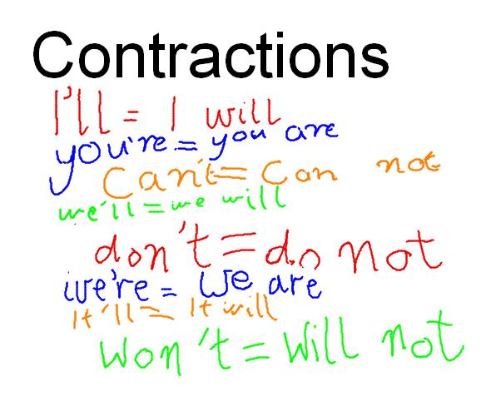

**Contractions – When Do We Use Them?**

Be careful. Some contractions can have two or three meanings. For example, **he'd** can be **he had** or **he would**. It depends on the rest of the sentence. Look at these examples:

* He'd like to go. (He would like to go.)
* He'd finished when I arrived. (He had finished when I arrived.)

The contraction **'s** (= is or has) is not used only with pronouns. (Remember, a pronoun replaces a noun. Example of a pronoun are ‘I’, ‘we’, ‘they’, etc.) It can also be used with nouns, names, question words and words like ‘here’ and ‘there’, for example: The train's late. John's arrived. Where's the dog? Here's your pocket money. There's the beach.

|  |  |  |  |
| --- | --- | --- | --- |
| **Short form** | **Long form** | **Short form** | **Long form** |
| I'm | I am | we’re | we are |
| I've | I have | we’ve | we have |
| I'll | I will/I shall | we’ll | we will |
| I'd | I would/I should/I had | we’d | we had |
| you're | you are | we’d | we would |
| you've | you have | they’re | they are |
| you'll | you will | they’ve | they have |
| you'd | you had/you would | they’ll | they will |
| he's | he has/he is | they’d | they had |
| he'll | he will | they’d | they would |
| he'd | he had/he would | it’s | it is |
| she's | she has/she is | it’s | it has |
| she'll | she will | it’ll | it will |
| she'd | she had | she’d | she would |

**More Contractions**

|  |  |  |  |  |  |  |  |  |  |  |  |  |  |  |  |  |  |  |  |  |  |  |  |  |  |  |  |  |  |  |  |  |  |  |  |  |  |  |  |  |  |  |  |  |  |  |  |  |
| --- | --- | --- | --- | --- | --- | --- | --- | --- | --- | --- | --- | --- | --- | --- | --- | --- | --- | --- | --- | --- | --- | --- | --- | --- | --- | --- | --- | --- | --- | --- | --- | --- | --- | --- | --- | --- | --- | --- | --- | --- | --- | --- | --- | --- | --- | --- | --- | --- |
| Contractions are also used in a negative form, for example **we aren't** or **we're not**. A positive form is when someone says “I can”, while a negative form is the opposite and someone says “I can’t”.  In questions, **am not** is contracted to **aren't**, for example: I'm late, aren't I?   |  |  |  |  | | --- | --- | --- | --- | | **Short form** | **Long form** | **Short form** | **Long form** | | aren't | are not | wouldn’t | would not | | can't | cannot, can not | won’t | will not | | couldn't | could not | weren’t | were not | | daren't | dare not | wasn’t | was not | | didn't | did not | shan’t | shall not | | doesn't | does not | shouldn’t | should not | | don't | do not | oughtn’t | ought not | | hasn't | has not | needn’t | need not | | haven't | have not | mustn’t | must not | | hadn't | had not | mightn’t | might not | | isn't | is not | mayn’t | may not | |
|  |

**Contractions continued**

MCj04247880000[1]

**For You to Do**

1. In the following sentences, use **contractions** where appropriate:
   * 1. Damien Hooper did not wear the correct clothing for the boxing competition.

\_\_\_\_\_\_\_\_\_\_\_\_\_\_\_\_\_\_\_\_\_\_\_\_\_\_\_\_\_\_\_\_\_\_\_\_\_\_\_\_\_\_\_\_\_\_\_\_\_\_\_\_\_\_\_\_\_\_\_\_\_\_\_\_\_\_\_\_\_\_\_

\_\_\_\_\_\_\_\_\_\_\_\_\_\_\_\_\_\_\_\_\_\_\_\_\_\_\_\_\_\_\_\_\_\_\_\_\_\_\_\_\_\_\_\_\_\_\_\_\_\_\_\_\_\_\_\_\_\_\_\_\_\_\_\_\_\_\_\_\_\_\_

* + 1. We are going to the Australian Open. Are you not coming too?

\_\_\_\_\_\_\_\_\_\_\_\_\_\_\_\_\_\_\_\_\_\_\_\_\_\_\_\_\_\_\_\_\_\_\_\_\_\_\_\_\_\_\_\_\_\_\_\_\_\_\_\_\_\_\_\_\_\_\_\_\_\_\_\_\_\_\_\_\_\_\_

\_\_\_\_\_\_\_\_\_\_\_\_\_\_\_\_\_\_\_\_\_\_\_\_\_\_\_\_\_\_\_\_\_\_\_\_\_\_\_\_\_\_\_\_\_\_\_\_\_\_\_\_\_\_\_\_\_\_\_\_\_\_\_\_\_\_\_\_\_\_\_

* + 1. You will need to fertilize your vegetable garden if you want to grow cucumbers and tomatoes.

\_\_\_\_\_\_\_\_\_\_\_\_\_\_\_\_\_\_\_\_\_\_\_\_\_\_\_\_\_\_\_\_\_\_\_\_\_\_\_\_\_\_\_\_\_\_\_\_\_\_\_\_\_\_\_\_\_\_\_\_\_\_\_\_\_\_\_\_\_\_\_

\_\_\_\_\_\_\_\_\_\_\_\_\_\_\_\_\_\_\_\_\_\_\_\_\_\_\_\_\_\_\_\_\_\_\_\_\_\_\_\_\_\_\_\_\_\_\_\_\_\_\_\_\_\_\_\_\_\_\_\_\_\_\_\_\_\_\_\_\_\_\_

* + 1. They have gone to Sorrento where they will stay for the summer holiday.

\_\_\_\_\_\_\_\_\_\_\_\_\_\_\_\_\_\_\_\_\_\_\_\_\_\_\_\_\_\_\_\_\_\_\_\_\_\_\_\_\_\_\_\_\_\_\_\_\_\_\_\_\_\_\_\_\_\_\_\_\_\_\_\_\_\_\_\_\_\_\_

\_\_\_\_\_\_\_\_\_\_\_\_\_\_\_\_\_\_\_\_\_\_\_\_\_\_\_\_\_\_\_\_\_\_\_\_\_\_\_\_\_\_\_\_\_\_\_\_\_\_\_\_\_\_\_\_\_\_\_\_\_\_\_\_\_\_\_\_\_\_\_

* + 1. Since the expansion of the internet, there has been much more information easily available.

**\_\_\_\_\_\_\_\_\_\_\_\_\_\_\_\_\_\_\_\_\_\_\_\_\_\_\_\_\_\_\_\_\_\_\_\_\_\_\_\_\_\_\_\_\_\_\_\_\_\_\_\_\_\_\_\_\_\_\_\_\_\_\_\_\_\_\_\_\_\_\_**

**\_\_\_\_\_\_\_\_\_\_\_\_\_\_\_\_\_\_\_\_\_\_\_\_\_\_\_\_\_\_\_\_\_\_\_\_\_\_\_\_\_\_\_\_\_\_\_\_\_\_\_\_\_\_\_\_\_\_\_\_\_\_\_\_\_\_\_\_\_\_\_**

**Contractions continued**

* + 1. I have advised you that you should have done the right action to begin with.

\_\_\_\_\_\_\_\_\_\_\_\_\_\_\_\_\_\_\_\_\_\_\_\_\_\_\_\_\_\_\_\_\_\_\_\_\_\_\_\_\_\_\_\_\_\_\_\_\_\_\_\_\_\_\_\_\_\_\_\_\_\_\_\_\_\_\_\_\_\_\_

\_\_\_\_\_\_\_\_\_\_\_\_\_\_\_\_\_\_\_\_\_\_\_\_\_\_\_\_\_\_\_\_\_\_\_\_\_\_\_\_\_\_\_\_\_\_\_\_\_\_\_\_\_\_\_\_\_\_\_\_\_\_\_\_\_\_\_\_\_\_\_

MCj04247880000[1]

**For You to Do**

### Identify three places in the text *Indigenous leaders want rules changed,* where contractions could have been used. Rewrite the sentences in the space below, using the contraction

\_\_\_\_\_\_\_\_\_\_\_\_\_\_\_\_\_\_\_\_\_\_\_\_\_\_\_\_\_\_\_\_\_\_\_\_\_\_\_\_\_\_\_\_\_\_\_\_\_\_\_\_\_\_\_\_

\_\_\_\_\_\_\_\_\_\_\_\_\_\_\_\_\_\_\_\_\_\_\_\_\_\_\_\_\_\_\_\_\_\_\_\_\_\_\_\_\_\_\_\_\_\_\_\_\_\_\_\_\_\_\_\_

\_\_\_\_\_\_\_\_\_\_\_\_\_\_\_\_\_\_\_\_\_\_\_\_\_\_\_\_\_\_\_\_\_\_\_\_\_\_\_\_\_\_\_\_\_\_\_\_\_\_\_\_\_\_\_\_

\_\_\_\_\_\_\_\_\_\_\_\_\_\_\_\_\_\_\_\_\_\_\_\_\_\_\_\_\_\_\_\_\_\_\_\_\_\_\_\_\_\_\_\_\_\_\_\_\_\_\_\_\_\_\_\_

\_\_\_\_\_\_\_\_\_\_\_\_\_\_\_\_\_\_\_\_\_\_\_\_\_\_\_\_\_\_\_\_\_\_\_\_\_\_\_\_\_\_\_\_\_\_\_\_\_\_\_\_\_\_\_\_

\_\_\_\_\_\_\_\_\_\_\_\_\_\_\_\_\_\_\_\_\_\_\_\_\_\_\_\_\_\_\_\_\_\_\_\_\_\_\_\_\_\_\_\_\_\_\_\_\_\_\_\_\_\_\_\_

\_\_\_\_\_\_\_\_\_\_\_\_\_\_\_\_\_\_\_\_\_\_\_\_\_\_\_\_\_\_\_\_\_\_\_\_\_\_\_\_\_\_\_\_\_\_\_\_\_\_\_\_\_\_\_\_

\_\_\_\_\_\_\_\_\_\_\_\_\_\_\_\_\_\_\_\_\_\_\_\_\_\_\_\_\_\_\_\_\_\_\_\_\_\_\_\_\_\_\_\_\_\_\_\_\_\_\_\_\_\_\_\_

\_\_\_\_\_\_\_\_\_\_\_\_\_\_\_\_\_\_\_\_\_\_\_\_\_\_\_\_\_\_\_\_\_\_\_\_\_\_\_\_\_\_\_\_\_\_\_\_\_\_\_\_\_\_\_\_

\_\_\_\_\_\_\_\_\_\_\_\_\_\_\_\_\_\_\_\_\_\_\_\_\_\_\_\_\_\_\_\_\_\_\_\_\_\_\_\_\_\_\_\_\_\_\_\_\_\_\_\_\_\_\_\_

\_\_\_\_\_\_\_\_\_\_\_\_\_\_\_\_\_\_\_\_\_\_\_\_\_\_\_\_\_\_\_\_\_\_\_\_\_\_\_\_\_\_\_\_\_\_\_\_\_\_\_\_\_\_\_\_

|  |  |
| --- | --- |
| http://3.bp.blogspot.com/-qPoK5ahYCp4/TuuFpKg1zDI/AAAAAAAABKg/xPUigX_ZUkE/s400/clrtest.gif | **Spelling and Dictation Test** |

Today your Supervisor will test the twenty words you have been learning this week. Do the test on your lined paper and when you finish, you and your Supervisor can correct it together. I'm sure you'll give it your best shot.

Your Supervisor will read the whole extract to you and then **dictate** small sections or phrases. There are several commas in this extract. Read it through after you have finished and you should be able to tell where to place the commas.

Clouds around the world **∫** may be falling in **∫** response to rising global **∫** temperatures. This is having **∫** a cooling effect on global **∫**  warming. The first ten ∫ years of data from **∫** the NASA satellite, shows **∫** their average height has **∫** lowered by about thirty **∫** to forty metres. Most **∫** of the reductionwas **∫** due to fewer clouds **∫** occurring at very high **∫** altitudes.

End of Week 2

****

**Checklist**

This week you should have completed the following tasks, please tick the tasks you have completed.

* **Writing Project**—Plan, draft, edit, final piece
* **Spelling**—LCWC and Own Words
* **Punctuation**—Contractions
* **Test**—Spelling and Dictation

**Spelling Module N**

|  |  |
| --- | --- |
| **Week 1** | **Week 2** |
| **Own words** | **Own words** |
|  |  |
|  |  |
|  |  |
|  |  |
|  |  |
|  |  |
|  |  |
|  |  |
|  |  |
|  |  |
| **Text words** | **Text words** |
| protocol | reconciliation |
| contender | champion |
| committee | remorseful |
| competition | motivation |
| affirm | opponent |
| culture | heritage |
| embrace | uniform |
| lobby | former |
| actions | fighting |
| apologetic | learnt |

**Adjectives**

|  |  |  |  |  |  |
| --- | --- | --- | --- | --- | --- |
| **Appearance**      adorable  adventurous  aggressive  alert  attractive  average  beautiful  blue-eyed  bloody  blushing  bright  clean  clear  cloudy  colourful  crowded  cute  dark  drab  distinct  dull  elegant  excited  fancy  filthy | **Appearance**    glamorous  gleaming  gorgeous  graceful  grotesque  handsome  homely  light  long  magnificent  misty  motionless  muddy  old-fashioned  plain  poised  precious  quaint  shiny  smoggy  sparkling  spotless  stormy  strange  ugly  ugliest  unsightly  unusual  wide-eyed | **Condition**      alive  annoying  bad  better  beautiful  brainy  breakable  busy  careful  cautious  clever  clumsy  concerned  crazy  curious  dead  different  difficult  doubtful  easy  expensive  famous  fragile  frail  gifted  helpful  helpless  horrible  important | **Condition**    impossible  inexpensive  innocent  inquisitive  modern  mushy  odd  open  outstanding  poor  powerful  prickly  puzzled  real  rich  shy  sleepy  stupid  super  talented  tame  tender  tough  uninterested  vast  wandering  wild  wrong | **Feelings (Bad)**    angry  annoyed  anxious  arrogant  ashamed  awful  bad  bewildered  black  blue  bored  clumsy  combative  condemned  confused  crazy, flipped-out  creepy  cruel  dangerous  defeated  defiant  depressed  disgusted  disturbed  dizzy  dull  embarrassed  envious  evil  fierce  foolish  frantic  frightened  grieving | **Feelings (Bad)**  *Cont.*  grumpy  helpless  homeless  hungry  hurt  ill  itchy  jealous  jittery  lazy  lonely  mysterious  nasty  naughty  nervous  nutty  obnoxious  outrageous  panicky  repulsive  scary  selfish  sore  tense  terrible  testy  thoughtless  tired  troubled  upset  uptight  weary  wicked  worried |
| **Feelings (Good)**    agreeable  amused  brave  calm  charming  cheerful  comfortable  cooperative  courageous  delightful  determined  eager  elated  enchanting  encouraging  energetic  enthusiastic  excited  exuberant  fair  faithful  fantastic  fine  friendly  funny  gentle  glorious  good | **Feelings (Good)**  *Cont.*  happy  healthy  helpful  hilarious  jolly  joyous  kind  lively  lovely  lucky  nice  obedient  perfect  pleasant  proud  relieved  silly  smiling  splendid  successful  thankful  thoughtful  victorious  vivacious  witty  wonderful  zealous  zany | **Shape**      broad  chubby  crooked  curved  deep  flat  high  hollow  low  narrow  round  shallow  skinny  square  steep  straight  wide | **Size**      big  colossal  fat  gigantic  great  huge  immense  large  little  mammoth  massive  miniature  petite  puny  scrawny  short  small  tall  teeny  teeny-tiny  tiny | **Sound**      cooing  deafening  faint  harsh  high-pitched  hissing  hushed  husky  loud  melodic  moaning  mute  noisy  purring  quiet  raspy  resonant  screeching  shrill  silent  soft  squealing  thundering  voiceless  whispering | **Time**      ancient  brief  Early  fast  late  long  modern  old  old-fashioned  quick  rapid  short  slow  swift  young |
| **Taste/Touch**      bitter  delicious  fresh  juicy  ripe  rotten  salty  sour  spicy  stale  sticky  strong  sweet  tart  tasteless  tasty  thirsty  fluttering  fuzzy  greasy  grubby  hard  hot  icy  loose | **Taste/Touch**  *Cont.*    melted  nutritious  plastic  prickly  rainy  rough  scattered  shaggy  shaky  sharp  shivering  silky  slimy  slippery  smooth  soft  solid  steady  sticky  tender  tight  uneven  weak  wet  wooden  yummy | **Touch**      boiling  breezy  broken  bumpy  chilly  cold  cool  creepy  crooked  cuddly  curly  damaged  damp  dirty  dry  dusty  filthy  flaky  fluffy  freezing  hot  warm  wet | **Quantity**      abundant  empty  few  heavy  light  many  numerous  substantial |  |  |

**NEWS RECOUNT RUBRIC**

|  |  |  |  |  |
| --- | --- | --- | --- | --- |
| **CATEGORY** | **0** | **1** | **2** | **3** |
| **Writing Process** | Student devotes little time and effort to the writing process. Doesn't seem to care. | Student devotes some time and effort to the writing process but was not very thorough. Does enough to get by. | Student devotes sufficient time and effort to the writing process (prewriting, drafting, reviewing, and editing). Works and gets the job done. | Student devotes a lot of time and effort to the writing process (planning drafting, reviewing, and editing). Works hard to make the story wonderful. |
| **Introduction** | No attempt was made to catch the reader's attention in the first paragraph. | A catchy beginning was attempted but was confusing rather than catchy. | First paragraph has a weak ‘grabber’. | First paragraph has a ‘grabber’ or catchy beginning. |
| **Organisation** | Ideas and scenes seem to be randomly arranged. | The story is a little hard to follow. The transitions are sometimes not clear. | The story is pretty well organised. One idea or scene may seem out of place. Clear transitions are used. | The story is very well organised. One idea or scene follows another in a logical sequence with clear transitions. |
| **Spelling and Punctuation** | The final draft has more than 3 spelling and punctuation errors. | There are 2–3 spelling and punctuation errors in the final draft. | There is one spelling or punctuation error in the final draft. | There are no spelling or punctuation errors in the final draft. |
| **Plot/Situation** | It is not clear what problem the main characters face. | It is fairly easy for the reader to understand the problem the main characters face but it is not clear why it is a problem. | It is fairly easy for the reader to understand the situation the main characters face and why it is a problem. | It is very easy for the reader to understand the plot and situation faced by the main characters and why it is happening. |
| **Characters** | It is hard to tell who the main characters are. | The main characters are named. The reader knows very little about the characters. | The main characters are named and described. Most readers would have some idea of what the characters looked like. | The main characters are named and clearly described in text. Most readers could describe the characters accurately. |
| **Neatness** | The final draft is not neat or attractive. It looks like the student just wanted to get it done and didn't care what it looked like. | The final draft of the story is readable and some of the pages are attractive. It looks like parts of it might have been done in a hurry. | The final draft of the story is readable, neat and attractive. It may have one or two erasures, but they are not distracting. It looks like the author took some pride in it. | The final draft of the story is readable, clean, neat and attractive. It is free of erasures and crossed-out words. It looks like the author took great pride in it. |

**Score:** \_\_\_\_ out of 21 \_\_\_\_\_\_\_ **%**

|  |  |  |  |  |  |  |  |
| --- | --- | --- | --- | --- | --- | --- | --- |
| Description: Description: Description: Description: Description: Description: Description: Description: logoCAPS2**315 Clarendon Street, Thornbury 3071**  **Telephone (03) 8480 0000**  **FAX (03) 9416 8371 (Despatch)**  **Free call (1800) 133 511**   |  |  | | --- | --- | | |  | | --- | | **STUDENT NUMBER \_\_\_\_\_\_\_\_\_\_\_\_\_\_\_\_\_\_\_**  **STUDENT NAME \_\_\_\_\_\_\_\_\_\_\_\_\_\_\_\_\_\_\_\_\_\_**  **\_\_\_\_\_\_\_\_\_\_\_\_\_\_\_\_\_\_\_\_\_\_\_\_\_\_\_\_\_\_\_\_\_\_\_\_\_\_\_** | | | | | | | |  |
| Fix your student barcode  label over this space. |
|  |
| 5306  [5306] |
| **SUBJECT** | English | | | [ZX] |
| **COLOUR** | Blue | **MODULE** | N |
| **TEACHER** | \_\_\_\_\_\_\_\_\_\_\_\_\_\_\_\_\_\_\_\_\_\_\_\_\_\_\_ | | |

|  |
| --- |
| **THINKING ABOUT YOUR LEARNING**  Description: Description: Description: Description: http://t0.gstatic.com/images?q=tbn:ANd9GcTiyp1Q0EWVRSXlqyIMaG6be3rodf0nBbu2oBIY8JlYVh1iP8U7**I understand \_\_\_\_\_\_\_\_\_\_\_\_\_\_\_\_\_\_\_\_\_\_\_\_\_\_\_\_\_\_\_\_\_\_\_\_\_\_\_\_\_\_\_\_\_\_\_\_\_**  **\_\_\_\_\_\_\_\_\_\_\_\_\_\_\_\_\_\_\_\_\_\_\_\_\_\_\_\_\_\_\_\_\_\_\_\_\_\_\_\_\_\_\_\_\_\_\_\_\_\_\_\_\_\_\_\_\_\_\_\_\_\_\_\_\_\_\_\_\_\_\_\_\_\_\_**  **\_\_\_\_\_\_\_\_\_\_\_\_\_\_\_\_\_\_\_\_\_\_\_\_\_\_\_\_\_\_\_\_\_\_\_\_\_\_\_\_\_\_\_\_\_\_\_\_\_\_\_\_\_\_\_\_\_\_\_\_\_\_\_\_\_\_\_\_\_\_\_\_\_\_\_**  **\_\_\_\_\_\_\_\_\_\_\_\_\_\_\_\_\_\_\_\_\_\_\_\_\_\_\_\_\_\_\_\_\_\_\_\_\_\_\_\_\_\_\_\_\_\_\_\_\_\_\_\_\_\_\_\_\_\_\_\_\_\_\_\_\_\_\_\_\_\_\_\_\_\_\_**  **\_\_\_\_\_\_\_\_\_\_\_\_\_\_\_\_\_\_\_\_\_\_\_\_\_\_\_\_\_\_\_\_\_\_\_\_\_\_\_\_\_\_\_\_\_\_\_\_\_\_\_\_\_\_\_\_\_\_\_\_\_\_\_\_\_\_\_\_\_\_\_\_\_\_\_**  **Description: Description: Description: Description: http://t2.gstatic.com/images?q=tbn:ANd9GcQ72LH2Bxoxf3yTTP_t93kaIPDpv8jVzb20Dfacv1j6Jv1Vb43VI need help with\_\_\_\_\_\_\_\_\_\_\_\_\_\_\_\_\_\_\_\_\_\_\_\_\_\_\_\_\_\_\_\_\_\_\_\_\_\_\_\_\_\_\_\_\_\_\_\_**  **\_\_\_\_\_\_\_\_\_\_\_\_\_\_\_\_\_\_\_\_\_\_\_\_\_\_\_\_\_\_\_\_\_\_\_\_\_\_\_\_\_\_\_\_\_\_\_\_\_\_\_\_\_\_\_\_\_\_\_\_\_\_\_\_\_\_\_\_\_\_\_\_\_\_\_**  **\_\_\_\_\_\_\_\_\_\_\_\_\_\_\_\_\_\_\_\_\_\_\_\_\_\_\_\_\_\_\_\_\_\_\_\_\_\_\_\_\_\_\_\_\_\_\_\_\_\_\_\_\_\_\_\_\_\_\_\_\_\_\_\_\_\_\_\_\_\_\_\_\_\_\_**  **\_\_\_\_\_\_\_\_\_\_\_\_\_\_\_\_\_\_\_\_\_\_\_\_\_\_\_\_\_\_\_\_\_\_\_\_\_\_\_\_\_\_\_\_\_\_\_\_\_\_\_\_\_\_\_\_\_\_\_\_\_\_\_\_\_\_\_\_\_\_\_\_\_\_\_**  **\_\_\_\_\_\_\_\_\_\_\_\_\_\_\_\_\_\_\_\_\_\_\_\_\_\_\_\_\_\_\_\_\_\_\_\_\_\_\_\_\_\_\_\_\_\_\_\_\_\_\_\_\_\_\_\_\_\_\_\_\_\_\_\_\_\_\_\_\_\_\_\_\_\_\_** |

|  |
| --- |
| **YOUR QUESTIONS OR COMMENTS** |
| **TEACHER’S COMMENTS**  **Some great things about your work were:**  **Try to do the following next time:** |
|  |

