**Mathematics**

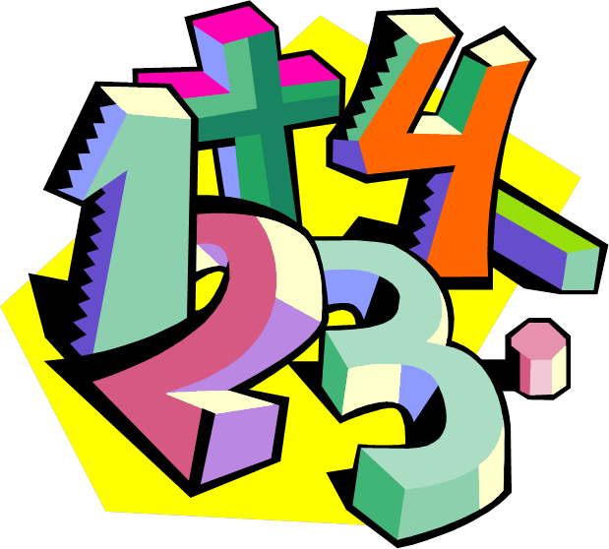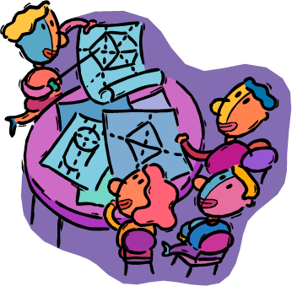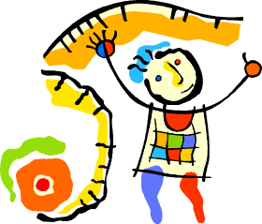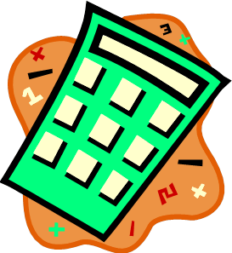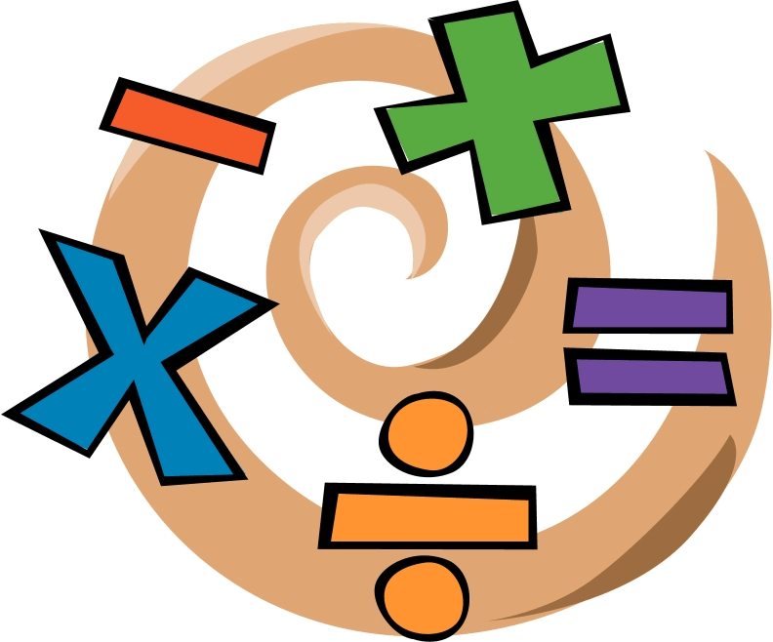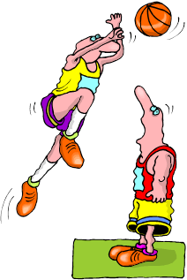

**How are angles used and measured?**

**Mathematics**

**Introduction**



**Welcome!**

***Maths skills for your world****.*

|  |  |
| --- | --- |
|  |  |
| **What you will need** | * Pen and paper. You will also need a protractor. * A computer is useful if you have one, because there are interactives in some lessons. * A calculator is sometimes used and is useful to check your answers. |
| **The activities** | * Skills exercises * Investigations * Interactives and games * A skills test |
| **Check your answers with your supervisor** | Check your answers after each activity to see how well you are going and how your skills are developing.  Checking your answers also prepares you for the tests and reflections.  If you are having difficulty, talk with your supervisor. |
| **When to use your calculator** | Most of the time you **won’t** need your calculator.  The maths activities develop skills; ways of working with numbers, mental arithmetic, estimating and using times tables.  Only use your calculator when it’s part of the activity. |
| **Asking for help…** | There may be times when you are not sure about an example or an exercise.  When this happens, ask for help: |

**Guidelines for the Supervisor**

**Working with your child**

|  |  |
| --- | --- |
| **Checking your child’s progress** | Encourage your child to check his or her answers to each activity. Initially, your child may need assistance to do this. |
| **Assisting your child** | Provide feedback as soon as difficulty arises and while the task is still fresh. If your child makes an error, ask the child to explain what s/he was thinking. Encourage him or her to solve the problem again, using **prompts, pictures, materials** and **direct feedback.**  Always provide **positive feedback** on progress made. |
| **Tests** | Encourage your child to complete these **without any assistance.** You may read instructions if this is what your child needs. |
| **Your feedback** | Some tasks ask for your feedback on your child’s progress. Please record a comment about how your child managed the work. |
|  |  |

**Mathematics**

|  |
| --- |
| The activities will help us to answer the question:  Description: C:\Users\CFord\Documents\MY Folders\CurricDev2012\images\essQ2.gif  ***“Why is measuring angles important?"***  **Learning Intentions:**     * Revise some number skills:   + - Count by threes and fours, find missing factors and identify numbers from clues.     - Explore strategies for multiplying and dividing.     - Extend multiplication and division facts.     - Explore number line jumps in arithmetic. * Investigate angles   + - Recognise, measure and work out different types of angles.     - Explore angles in real life. * Revise place value and rounding:   + - Rewrite and round thousands and tens of thousands.     - Explore strategies for adding, subtracting, doubling and trebling. |

**Mathematics**

|  |  |
| --- | --- |
| **Activities** | |
| **Task 1** | * Revise counting by threes. * Find multiples of three. * Identify numbers from clues. |
| **Task 2** | * Revise number fact recall. * Extend number facts to tens of thousands. * Investigate doubling strategies. |
| **Task 3** | * Identify and name different types of angles. * Estimate and measure angles up to 180 degrees. |
| **Task 4** | * Measure angles greater than 180 degrees. * Explore complementary angles, supplementary angles and conjugate angles. |
| **Task 5** | * Investigate angles in real life. * Apply angle skills to solve problems. * Reflect on what you’ve learned in maths * Do a test. |

**Mathematics**

|  |  |
| --- | --- |
| **Activities** | |
| **Task 6** | * Revise counting by fours. Extend number facts. * Explore multiplication strategies. * Relate division facts to multiplication facts. * Create number stories to match number facts. |
| **Task 7** | * Recall division facts. Extend division facts to tens of thousands. * Explore division strategies. * Consolidate your skills with an interactive. |
| **Task 8** | * Revise the place value of thousands and tens of thousands. * Explore different ways of expanding a number. * Round numbers to the nearest thousand, hundred and ten. * Explore strategies for adding and subtracting different amounts. |
| **Task 9** | * Double and treble distances travelled. * Explore more strategies for adding and subtracting different amounts. * Use number line jumps to add and subtract whole numbers. |
| **Task 10** | **Progress Assessment**   * Reflect on what you’ve learned in maths. * Do a test. |

# 1 Number skills review: multiples and factors

**Learning Intention:** Identify patterns in numbers to help us calculate more efficiently.



To do Maths we need number skills.

Some of these skills include skip counting.

Knowing how to skip count helps you to do a lot of calculations…

especially multiplying and dividing.

Skip counting also helps you to remember your times tables.

Let’s revise counting by threes.

|  |  |
| --- | --- |
| C:\Users\CFord\Documents\MY Folders\CurricDev2012\images\exerrcise1.gif |  |
| **Activity 1: Review counting by threes** |
| reporter1  Circle every third number on the number grid. |

|  |  |  |  |  |  |  |  |  |  |  |  |
| --- | --- | --- | --- | --- | --- | --- | --- | --- | --- | --- | --- |
|  | 1 | 2 | 3 | 4 | 5 | 6 | 7 | 8 | 9 | 10 |  |
|  | 11 | 12 | 13 | 14 | 15 | 16 | 17 | 18 | 19 | 20 |  |
|  | 21 | 22 | 23 | 24 | 25 | 26 | 27 | 28 | 29 | 30 |  |
|  | 31 | 32 | 33 | 34 | 35 | 36 | 37 | 38 | 39 | 40 |  |
|  | 41 | 42 | 43 | 44 | 45 | 46 | 47 | 48 | 49 | 50 |  |
|  | 51 | 52 | 53 | 54 | 55 | 56 | 57 | 58 | 59 | 60 |  |
|  | 61 | 62 | 63 | 64 | 65 | 66 | 67 | 68 | 69 | 70 |  |
|  | 71 | 72 | 73 | 74 | 75 | 76 | 77 | 78 | 79 | 80 |  |
|  | 81 | 82 | 83 | 84 | 85 | 86 | 87 | 88 | 89 | 90 |  |

1. Practise counting by threes…

|  |  |  |
| --- | --- | --- |
| up to 30 | up to 60 | up to 90 |

2. Practise counting by threes backwards…

|  |  |  |
| --- | --- | --- |
| from 30 | from 60 | from 90 |

Practise your counting out loud; walk as you count; ask your supervisor or buddy to hear you.



# Multiples of 3

|  |  |  |
| --- | --- | --- |
| A multiple of 3 is a number that has been multiplied by 3  5 × 3 = 15 so 15 is a multiple of 3  7 × 3 = 21, so 21 is a multiple of 3  52 × 3 = 156, so 156 is a multiple of 3 |  | 1 × 3 = 3  2 × 3 = 6  3 × 3 = 9  4 × 3 = 12  5 × 3 = 15  6 × 3 = 18  7 × 3 = 21  8 × 3 = 24  9 × 3 = 27  10 × 3 = 30  11 × 3 = 33  12 × 3 = 36 |
| How can we tell if a number is a multiple of 3?  By looking for a pattern!  A number is a multiple of 3 if its digits add up to 3, 6 or 9 | |

|  |  |  |  |
| --- | --- | --- | --- |
| *Add the digits* 1 + 2 = 3 1 + 5 = 6 1 + 8 = 9 | | |  |
|  |  |  | |
| Multiples of 3 | 3 6 9 12 15 18 21 24 27 30 | |  |
|  |  | |  |
| *Add the digits* 2 + 1 = 32 + 4 = 6 2 + 7 = 9 | | | |
|  |  |  | |

**Example 1** Checking for multiples of 3

|  |
| --- |
| Show that 72 is a **multiple** of 3  The digits in **multiples** of 3 add up to 3, 6 or 9  72 is a **multiple** of 3 because its digits add up to 7 + 2 = 9 |

|  |
| --- |
| Show that 84 is a **multiple** of 3  The digits in **multiples** of 3 add up to 3, 6 or 9  84 is a **multiple** of 3 because its digits add up to 8 + 4 = 12 and 1 + 2 = 3 |

**Example 2** Finding missing factors:

Find the missing **factor** to solve 72 = ……. × 3

↑

*the missing factor.*

|  |  |  |
| --- | --- | --- |
| We know that  20 × 3 = 2 **tens** × 3 = 6 **tens** = 60  and we know  30 × 3 = 3 **tens** × 3 = 9 **tens** = 90 |  | 72 is somewhere between  20 × 3 and 30 × 3 |
|  |

Try 25 25 × 3 = (2 **tens** plus 5 **ones**) × 3

= 2 **tens** × 3 plus 5 **ones** × 3

= 6 **tens** plus 15 **ones**

= 60 + 15 = 75 *75 is too high*

Try 24 24 × 3 = (2 **tens** plus 4 **ones**) × 3

= 2 **tens** × 3 plus 4 **ones** × 3

= 6 **tens** plus 12 **ones**

= 60 + 12 = 72 *Correct!*

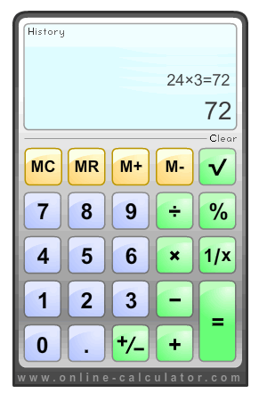

Our missing **factor** is 24 72 = 24 × 3

Check the answer on the calculator: It checks!

|  |  |
| --- | --- |
| ***Description: j0229369*** |  |
| **Activity 2: Find the missing factor** |
|  |

Complete the missing parts of these questions.

|  |  |  |  |  |  |  |
| --- | --- | --- | --- | --- | --- | --- |
| **(a)** | 78 is a **multiple** of 3 because ………………………………………………….. | | | | | |
|  | 78 is somewhere between 20 × 3 and 30 × 3  Try 26  26 × 3 = (…….. **tens** plus …….. **ones**) × 3  = ……. **tens** plus …….. **ones**  = …….. | | 20 × 3 = 60  30 × 3 = 90 | |  | |
|  |  | |  | |
|  | The **factors** are: 78 = …….. × 3 | Calculator check: 🞎 | |  | | |
| **(b)** | 42 is a **multiple** of 3 because ………………………………………………….. | | | | | |
|  | 42 is somewhere between 10 × 3 and 20 × 3  Try 14  14 × 3 = (…….. **ten** plus …….. **ones**) × 3  = ……. **tens** plus …….. **ones**  = …….. | | 10 × 3 = 30  20 × 3 = 60 | |  | |
|  |  | |  | |
|  | The **factors** are: 42 = …….. × 3 | Calculator check: 🞎 | |  | | |
| **(c)** | 105 is a **multiple** of 3 because …………………………………………….. | | | | | |
|  | 105 is somewhere between 30 × 3 and 40 × 3  Try 35  35 × 3 = (…….. **tens** plus …….. **ones**) × 3  = ……. **tens** plus …….. **ones**  = …….. | | 30 × 3 = 90  40 × 3 = 120 | | |  |
|  |  | | |  |
|  | The **factors** are: 105 = …….. × 3 | Calculator check: 🞎 | |  | | |

|  |  |  |  |  |  |  |  |  |  |
| --- | --- | --- | --- | --- | --- | --- | --- | --- | --- |
| **(d)** | | 81 is a **multiple** of 3 because ………………………………………………….. | | | | | | | |
|  | | 81 is somewhere between 20 × 3 and 30 × 3  Choose a **factor** between 20 and 30 to try  …….. × 3 = (…….. **tens** plus …….. **ones**) × 3    = ……. **tens** plus …….. **ones**  = …….. | | | | 20 × 3 = 60  30 × 3 = 90 | | |  |
|  | |  | | |  |
|  | | The **factors** are: 81 = …….. × 3 | | Calculator check: 🞎 | | |  | | |
| **(e)** | 57 is a **multiple** of 3 because ………………………………………………….. | | | | | | | | |
|  | 57 is somewhere between 10 × 3 and 20 × 3  Choose a **factor** between 30 and 60 to try  …….. × 3 = (…….. **tens** plus …….. **ones**) × 3  = ……. **tens** plus …….. **ones**  = …….. | | | | 10 × 3 = 30  20 × 3 = 60 | | |  | |
|  |  | | |  | |
|  | The **factors** are: 57 = …….. × 3 | | Calculator check: 🞎 | | | |  | | |

|  |  |
| --- | --- |
| Description: C:\Users\CFord\Documents\MY Folders\CurricDev2012\images\essQ.gif |  |
| **Who am I? Find the unknown numbers** |
|  |

|  |  |  |
| --- | --- | --- |
| **Who am I?**  I am a **multiple** of 3, and also a **multiple** of 5.  I am less than 50.  My units digit is one more than my tens digit.  I am ………………………………………… |  | **Who am I?**  I am a **multiple** of ten.  I have three digits.  My hundreds digit and tens digit add up to 5.  I am less than 200.  I am ………………………………………… |

# 2 Number fact skills

**Learning Intention:** Identify patterns in multiplication, division and place value to make it easier to solve problems.



Number facts are things you know by heart, like your times tables.

Times tables are multiplication number facts.

For example 10 × 2 = 20 means 10 groups of two equals 20.

If we know a multiplication fact we also know two division facts.

Let’s see an example.

|  |  |  |  |  |
| --- | --- | --- | --- | --- |
|  | **We have 10 pairs of stars** | | |  |
|  | | **⍟⍟ ⍟⍟**  **⍟⍟ ⍟⍟**  **⍟⍟ ⍟⍟**  **⍟⍟ ⍟⍟**  **⍟⍟ ⍟⍟** | **The multiplication fact**  10 groups of 2 equals 20  10 × 2 = 20  **The division fact**  20 divided into 10 groups  equals 2 in each group  20 ÷ 10 = 2 | |
|  | |  |

|  |  |
| --- | --- |
| **Another division fact:**  20 divided into 2 groups  equals 10 in each group  20 ÷ 2 = 10 | **⍟⍟⍟⍟⍟⍟⍟⍟⍟⍟**  **⍟⍟⍟⍟⍟⍟⍟⍟⍟⍟** |
|  |

|  |  |
| --- | --- |
| C:\Users\CFord\Documents\MY Folders\CurricDev2012\images\exerrcise1.gif |  |
| **Activity: Number facts warm-up** |
|  |

The table below shows multiplication facts.

* Recall the answer to each multiplication from your times tables.
* Then write two division facts.
* Think of a number story for any one of the number facts.

The first one is done for you.

|  |  |  |  |
| --- | --- | --- | --- |
| **Multiplication fact** | **One division fact** | **Another division fact** | **A number story** |
| 11 × 9 = **99** | 99 ÷ 9 = 11 | 99 ÷ 11 = 9 | **99** coloured pencils **shared** among **11** people gave **9** pencils each. |

|  |  |  |  |  |  |  |  |
| --- | --- | --- | --- | --- | --- | --- | --- |
| **Multiplication fact** | | **One division fact** | | **Another division fact** | | **A number story** | |
| 7 × 2 = ……. | |  | |  | |  | |
| 9 × 5 = ……. | |  | |  | |  | |
| 3 × 11 = ……. | |  | |  | |  | |
| 6 × 10 = ……. | |  | |  | |  | |
| 8 × 3 = ……. | |  | |  | |  | |

# Extended number facts



Knowing one number fact helps you with other number facts.

|  |  |
| --- | --- |
| If I know 6 × 2 = 12  I also know 6 × 20 = 120 | because 6 × 2 tens  12 tens  120 |

|  |  |
| --- | --- |
| ***Description: j0229369*** |  |
| **Activity 2: Extended number facts** |
|  |

**Question 1** Fill in the missing number facts below.

|  |  |  |
| --- | --- | --- |
| 9 × 2 = ………….…..  9 × 20 = ………….…..  9 × 200 = ………….…..  9 × 2 000 = …………….. |  | 8 × 5 = ………….…..  8 × 50 = ………….…..  8 × 500 = ……….……..  8 × 5 000 = ……………... |

|  |  |  |
| --- | --- | --- |
| 7 × 3 = …………....  7 × 30 = ………….....  7 × 300 = ……………..  7 × 3 000 = …………….. |  | 6 × 11 = ………….…..  6 × 110 = ………….…..  6 × 1100 = ……………..  6 × 11 000 = ………...….. |

**Question 2** More extended number facts

If I know 21 × 3 = 63

I also know ….

|  |
| --- |
| 21 × 30 = 630 because 21 × 3 tens  63 tens or 630 |
| 21 × 300 = 6 300 because 21 × 3 hundred  63 hundred or 6 300 |
| 21 × 3000 = 63 000 because 21 × 3 thousand  63 thousand or 63 000 |

Fill in the missing number facts.

|  |
| --- |
| If I know 16 × 2 = 32  I also know 16 × 20 = ……… because 16 × 2 ………….. = 32 ……..…….  16 × 200 = ……… because 16 × 2 ………….. = 32 ……..…….  16 × 2 000 = ……… because 16 × 2 …….……. = 32 ……..……. |

|  |
| --- |
| If I know 32 × 3 = 96  I also know 32 × 30 = ……… because 32 × 3 …….……. = 96 ……..…….  32 × 300 = ……… because 32 × 3 …….……. = 96 ……..…….  32 × 3 000 = ……… because 32 × 3 ………….. = 96 ……..……. |

|  |
| --- |
| If I know 18 × 5 = 90  I also know 18 × 50 = ……… because 18 × 5 ………….. = 90 ……..…….  18 × 500 = ……… because 18 × 5 …….……. = 90 ……..…….  18 × 5 000 = ……… because 18 × 5 …….……. = 90 ……..……. |

# Doubles: strategies for doubling numbers

|  |  |  |
| --- | --- | --- |
| Double 41  Double (4 tens and 1 unit)  8 tens and 2 units  80 + 2  82 |  | Double 37  Double (3 tens and 7 units)  6 tens and 14 units  6 tens and 1 ten and 4 units  60 + 10 + 4  70 + 4 = 74 |
|  |  |

|  |  |
| --- | --- |
| ***Description: j0229369*** |  |
| **Activity 3: Strategies for doubling** |
|  |

**Question 1** Fill in the missing parts to double the numbers.

|  |  |
| --- | --- |
| Double 32 | Double (…….. **tens** and …… **units)**  …….. **tens** and …… **units**  equals …………. |

|  |  |
| --- | --- |
| Double 26 | Double (…….. **tens** and …… **units**)  …….. **tens** and …… **units**  equals ………….. |

|  |  |
| --- | --- |
| Double 51 | Double (…….. **tens** and …… **units**)  …….. **tens** and …… **units**  equals ……….….. |

|  |  |
| --- | --- |
| Double 72 | Double (…….. **tens** and …… **units**)  …….. **tens** and …… **units**  equals …………… |

**Question 2**

Write your own number sentences to double these numbers:

|  |  |
| --- | --- |
| Double 64 |  |

|  |  |
| --- | --- |
| Double 57 |  |

**Question 3** Extending doubles.

|  |  |
| --- | --- |
| Double 230 | Double (**2 hundreds** and **3 tens**)  **4 hundreds** and **6 tens**  400 + 60  460 |

|  |  |  |  |
| --- | --- | --- | --- |
| Double 180 | Double (1 **hundred** and 8 **tens**)  2 **hundred** and 16 **tens**  2 **hundred** and 1 **hundred** and 6 **tens**  200 + 100 + 60  300 + 60 = 360 |  |  |
| 16 tens  160  100 + 60 |  |
|  |  |  |

Fill in the missing parts to double the numbers

|  |  |
| --- | --- |
| Double 410 | Double (…….. **hundred** and …… **ten**)  …….. **hundred** and …… **tens**  equals ……….….. |

|  |  |
| --- | --- |
| Double 320 | Double (…….. **hundred** and …… **ten**)  …….. **hundred** and …… **tens**  equals ……….….. |

|  |  |
| --- | --- |
| Double 170 | Double (…….. **hundred** and …… **ten**)  …….. **hundred** and …… **tens**  equals ……….….. |

|  |  |
| --- | --- |
| Double 260 | Double (…….. **hundred** and …… **ten**)  …….. **hundred** and …… **tens**  equals ……….….. |

**Question 4**

Write your own number sentences to double these numbers.

|  |  |
| --- | --- |
| Double 530 |  |

|  |  |
| --- | --- |
| Double 370 |  |

**Question 5**  Other doubles.

|  |  |  |  |
| --- | --- | --- | --- |
| Double 104 | Double (1 **hundred** and **4 ones**)  2 **hundred** and 8 **ones**  200 + 8  208 |  |  |
| 2 0 0  + 8 |  |
|  | 2 0 8 |  |
|  |  |  |  |

|  |  |  |  |
| --- | --- | --- | --- |
| Double 206 | Double (2 **hundred** and 6 **ones**)  4 **hundred** and 12 **ones**  400 + 12  412 |  |  |
| 4 0 0  + 1 2 |  |
|  | 4 1 2 |  |
|  |  |  |  |

Fill in the missing parts below to double the numbers.

|  |  |
| --- | --- |
| Double 304 | Double (…….. **hundred** and …… **ones**)  …….. **hundred** and …… **ones**  equals ……….….. |

|  |  |
| --- | --- |
| Double 407 | Double (…….. **hundred** and …… **ones**)  …….. **hundred** and …… **ones**  equals ……….….. |

|  |  |
| --- | --- |
| Double 509 | Double (…….. **hundred** and …… **ones**)  …….. **hundred** and …… **ones**  equals ……….….. |

|  |  |
| --- | --- |
| Double 604 | Double (…….. **hundred** and …… **ones**)  …….. **hundred** and …… **ones**  equals ……….….. |

**Question 6**

Write your own number sentences to double these numbers.

|  |  |
| --- | --- |
| Double 308 |  |

|  |  |
| --- | --- |
| Double 702 |  |

# 3 Angles around us

**Learning Intention:** Identify, describe, estimate and measure different types of angles.

If we look around we see angles everywhere…

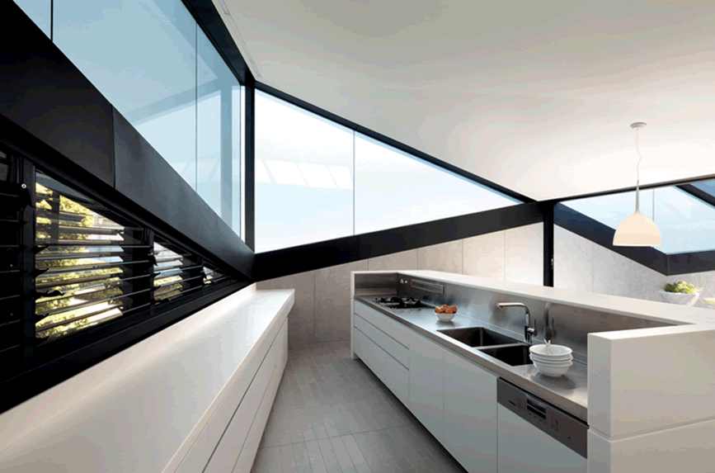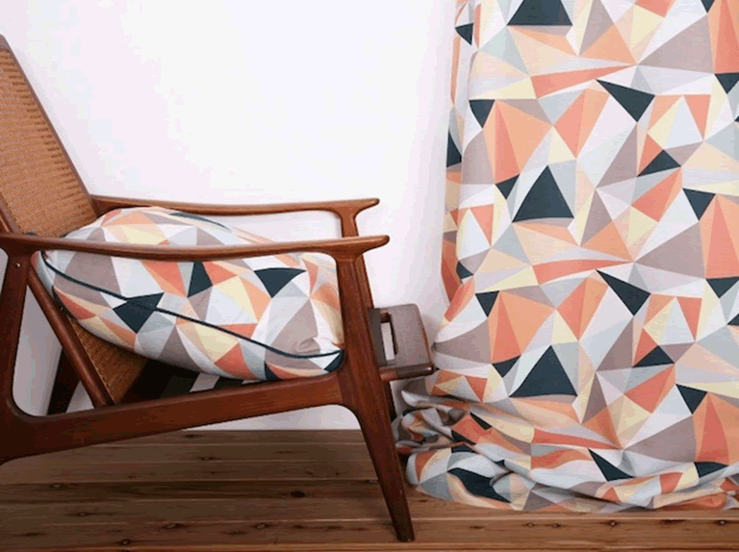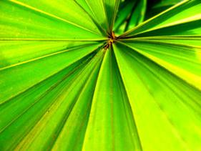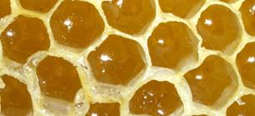

Builders use angles to work out the shapes of buildings

Designers use angles in their designs

Angles also occur in nature

# What makes an angle?

|  |  |
| --- | --- |
| The roof truss shown below forms an angle… | …but the Syney Operra house roof does not. |
|  | <http://commons.wikimedia.org/wiki/Image:Sydney_Opera_House_Sails.jpg> |
| The trusses in a roof are straight beams that meet at a point, so we can measure the angle between them. | The roof of the Sydney Opera house meets at a point, but the roof is made of curved arches, not straight lines, so we cannot measure the angle between them. |

|  |  |
| --- | --- |
| Description: j0229369 |  |
| **Activity 1: What makes an angle?** |
|  |

|  |
| --- |
| 1. Look at the pictures below.   Which connections shown form angles and which do not? |

|  |  |  |
| --- | --- | --- |
|  |  | |
|  | |  |

|  |
| --- |
| 1. What angles can you see around you?   Look around you. Draw two real-life examples of angles you can see. |

|  |  |
| --- | --- |
|  |  |

# Different types of angles

The name we give an angle depends on its size.

**Acute angles**

|  |  |
| --- | --- |
| An **acute angle** is less than a quarter turn.  A quarter turn is called a **right angle**. | Quarter  turn  Acute  angle |

**Obtuse angles**

|  |  |
| --- | --- |
| An **obtuse angle** is between a quarter turn and a half turn.  A half turn is called a **straight angle**. | Obtuse  angle  Half  turn |

**Reflex angles**

|  |  |
| --- | --- |
| A **reflex angle** is between a half turn and a full turn.  A full turn is called a **perigon**, or a **complete revolution**. | Full  turn  Reflex  angle |

|  |  |
| --- | --- |
| j0229369 |  |
| **Activity 2: Name the angle** |
|  |

|  |
| --- |
| 1. Identify the types of angles shown in the diagrams below:   acute, obtuse or reflex? |
| **1**  **2**  **3**  **4**  **5**  Sources:  http://i.treehugger.com/images/2007/10/24/seriesx-which-end1.jpg http://www.vivavi.com/catalog/images/res/PIE_The_Fold.jpg |

|  |  |  |  |
| --- | --- | --- | --- |
| 1. The Vodafone building in Portugal is shown below. It has many different angles. Find an example of | | | |
|  | (i) an acute angle | (ii) an obtuse angle | (iii) a reflex angle. |
| Label the angles you find. Can you find a straight angle? | | | |
| C:\Users\CFord\Documents\MY Folders\CurricDev2012\images\module2\bldgangle.jpg  http://www.businessinteriors.co.uk/modern-office-design-worlds-best-office-interiors-vodafone-portugal/ | | | |

# Measuring angles

|  |
| --- |
| **Every angle has two ‘arms’ and a vertex.**  **The ‘arms’ of the angle**  **The angle**  **The vertex is the point where the ‘arms’ meet.** |

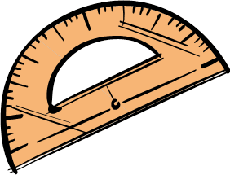



To measure angles accurately we use a protractor.

|  |  |
| --- | --- |
|  |  |
| A **quarter turn** measures **90 degrees** | A **half turn** measures **180 degrees** |

**To measure an angle**

**Always start at zero!**

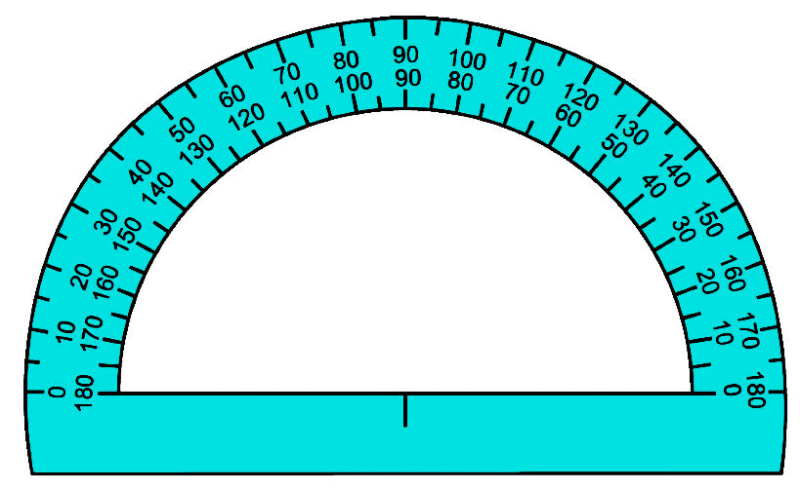

1. **Place the centre on the vertex.**
2. **Line up one arm at zero.**
3. **Start at zero and read off the angle.**

**155°**

|  |  |
| --- | --- |
| C:\Users\CFord\Documents\MY Folders\CurricDev2012\images\thinking3.gif | |
| **Quick check in your head!**  ***Does this answer make sense?***  We see that the angle lies between a quarter turn (90°) and a half turn (180°)  It is an **obtuse angle** and our answer of 155° makes sense. | **Start at 0°**  Quarter turn  90°  Half turn  180°  0° |

|  |  |
| --- | --- |
| j0229369 |  |
| **Activity 3: Protractor practice** |
|  |

|  |
| --- |
| 1. Use your protractor to measure the following angles.   Name each angle correctly: acute or obtuse. |

|  |  |  |  |  |
| --- | --- | --- | --- | --- |
|  | **(a)** |  | **(b)** |  |
|  | **(c)** |  | **(d)** |  |

**More ways to measure angles**

We need to turn the protractor around to measure some angles……

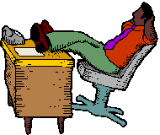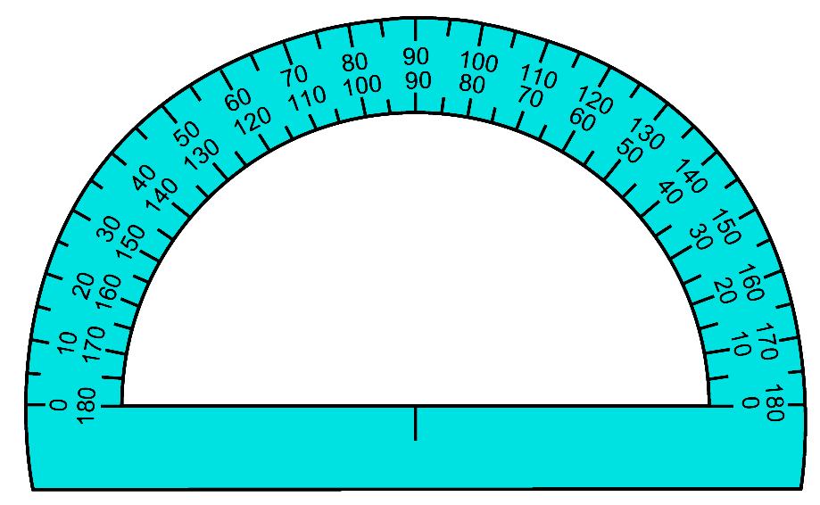

1. **Place the centre on the vertex.**
2. **Line up one arm at zero.**

**3. Start at zero and read off the angle.**

**The angle measures approximately 96 degrees.**

|  |  |
| --- | --- |
| j0229369 |  |
| **Activity 3 continued: Protractor practice** |
|  |

|  |  |  |
| --- | --- | --- |
| **2.** For each picture below: | | |
|  | **(a)** | identify whether the angle is acute or obtuse. |
|  | **(b)** | estimate (do not measure) the number of degrees. |
|  | **(c)** | check your estimate by measuring with your protractor. |

|  |  |  |
| --- | --- | --- |
| **(i)** |  | <http://www.agr.state.il.us/programs/bees> |

|  |  |  |  |
| --- | --- | --- | --- |
| **(ii)** |  | **(iii)** | <http://dalenet.com/~delmar/sell_jamis.jpg> |
| **(iv)** |  | **(v)** |  |
|  |  | Are fruit segments all identical? Measure the angles and compare. | |

|  |  |  |
| --- | --- | --- |
|  |  |  |
|  |

# 4 Larger angles and missing angles

**Learning Intention:** Calculate the magnitude of different sized angles, using a variety of strategies.

So far we’ve seen how to measure acute and obtuse angles. But what about reflex angles… angles that are bigger than a half turn.

|  |  |  |
| --- | --- | --- |
| Half  turn  180°  A half turn measures  180 degrees. | Full  turn  360°  A full turn is two half turns.  It measures twice 180 degrees, or 360 degrees. | Reflex  angle  180°  360°  A reflex angle is between a half turn and a full turn, so it is between 180 degrees and 360 degrees. |
|  |
|  |  |



A protractor only goes up to 180 degrees.

How can we measure angles bigger than 180 degrees? Let’s see an example…

|  |  |  |
| --- | --- | --- |
| **How to measure a reflex angle** | | |
| Measure the reflex angle shown in the picture. |  | |
|  | |  |
| Reflex angles measure more than 180 degrees.  The protractor only goes up to 180 degrees, so we can’t measure it directly.  Instead, we measure the smaller angle, then subtract it from 360 degrees. | | 30°  360°  − 30°  330° |

|  |  |
| --- | --- |
| j0229369 |  |
| **Activity 1: Measuring reflex angles** |
|  |

|  |
| --- |
| **1.** Work out the following reflex angles, by measuring the smaller angle first. |

|  |  |  |
| --- | --- | --- |
| **(a)** |  | Size of smaller angle: ………..  Size of reflex angle:  360 – …………… = …………….. |
| **(b)** |  | Size of smaller angle: ………..  Size of reflex angle:  360 – …………… = …………….. |
| **(c)** |  | Size of smaller angle: ………..  Size of reflex angle:  360 – …………… = …………….. |
| **(d)** |  | Size of smaller angle: ………..  Size of reflex angle:  360 – …………… = …………….. |
| **(e)** |  | Size of smaller angle: ………..  Size of reflex angle:  360 – …………… = …………….. |
| **(f)** |  | Size of smaller angle: ………..  Size of reflex angle:  360 – …………… = …………….. |

|  |  |  |
| --- | --- | --- |
| **2.** Angles around us. For each picture below: | | |
|  | * estimate (do not measure) the size each reflex angle |
|  | * check your estimate by measuring with your protractor. |

|  |  |  |  |
| --- | --- | --- | --- |
| **(a)** |  | **(b)** |  |
| **Sources:**  <http://bambooworld.com/bamboo%20furniture.htm> <http://i.treehugger.com/images/2007/10/24/seriesx-which-end1.jpg> | | | |

Look around where you are. Find the angles. Take a picture, or draw the angles you see in your environment.

|  |  |
| --- | --- |
|  |  |
|  |  |

# Finding missing angles

|  |
| --- |
| **Complementary angles…. angles that add up to 90 degrees**  *Com-plee-men-terry* |

|  |  |  |
| --- | --- | --- |
| Mum cuts up sandwiches at different angles. | | |
| **90°** |  | **40°**  **90° – 40°**  **= 50°** |
| The angles at each corner add up to 90 degrees.  That’s because each corner is a right angle. |  | So if we know one angle, we can work out the other one.  The missing piece made an angle of 50 degrees. |

|  |  |
| --- | --- |
| j0229369 | C:\Users\CFord\Documents\MY Folders\CurricDev2012\images\module2\sand2.gif |
| **Activity 2: Complementary angles** |
|  |

**Question 1** Angles that add up to a right angle (90 degrees) are called complementary angles. Find the complementary angle in each picture below.

|  |  |  |  |  |  |
| --- | --- | --- | --- | --- | --- |
| **(a)** | **C:\Users\CFord\Documents\MY Folders\CurricDev2012\images\module2\qa.gif** | **(b)** | **C:\Users\CFord\Documents\MY Folders\CurricDev2012\images\module2\qb.gif** | **(c)** | **C:\Users\CFord\Documents\MY Folders\CurricDev2012\images\module2\qc.gif** |

**Question 2** Complementary angles are often found in building, such as the gates shown below. Find the complementary angle in each gate shown.

|  |  |  |  |  |
| --- | --- | --- | --- | --- |
| **(a)** | **62°**  **?** | **(b)** | **58°**  **?** | **(c)**  **27°**  **?** |

|  |
| --- |
| **Supplementary angles…. angles that add up to 180 degrees**  *Sup-le-men-terry* |

When we have pizza we start by cutting it in half.

Then we cut our slices at different angles, depending on how hungry we are.



The angles made on a straight line add up to 180 degrees.

So if we know one angle, we can work out the other one.

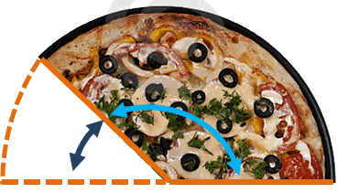

**135°**

**180° – 135°**

**45°**

|  |  |
| --- | --- |
| C:\Users\CFord\Documents\MY Folders\CurricDev2012\images\module2\cutpizza.gifj0229369 |  |
| **Activity 3: Supplementary angles** |
|  |

**Question 1** Angles that add up to a straight angle (180 degrees) are called supplementary angles.

Find the supplementary angle in each picture below.

|  |  |  |  |
| --- | --- | --- | --- |
| **(a)** | **47°**  **?** | **(c)** | **62°**  **?** |
|  |  |  |
| **(b)** | **78°**  **?** |  |

**Question 2** Supplementary angles are often found in building. Work out the supplementary angle in each picture shown.

|  |  |
| --- | --- |
| **(a)**  **50°**  **?** | **(b)**  **140°**  **?** |
| **(c)**  **48°**  **?** |

Sources: <http://www.pavingexpert.com/news175.htm>

<http://www.asandow.co.uk/Sheffield-Builder-Reports/Architect-Reports/georgian%20house%20essay%20-%202%20albemarle%20villas.htm>

<http://www.masters.com.au/product/100024675/rubber-coir-doormat-rmcn-0026-45cm-x-75cm>

|  |
| --- |
| **Conjugate angles…. angles that add up to 360 degrees**  *Con-joo-gat* |

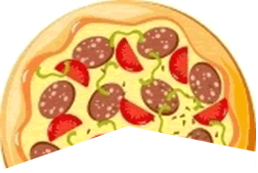

**205°**

360°

– 205°

155°

Left over pizza… what’s the missing angle?

Angles that make a circle add up to 360 degrees.

So if we know one angle, we can work out the other one.



|  |  |
| --- | --- |
| j0229369 |  |
| **Activity 4: Conjugate angles** |
|  |

**Question 1** Angles that add up to make a circle (360 degrees) are called conjugate angles.

Find the conjugate angle in each picture below.

|  |  |  |  |
| --- | --- | --- | --- |
| **(a)** | **125°**  **?** | **(b)** | **200°**  **?** |
| **(c)** | **225°**  **?** | **(d)** | **70°**  **?** |

**Question 2** Angle Match!

|  |  |  |
| --- | --- | --- |
| **(a)** | Circle a pair of angles that are   * complementary * supplementary * conjugate | 140°  40°  50°  220°  55°  35°  125°  235°  25°  65°  155°  205°  80°  100°  10°  260° |
|  | Use each angle only once. Cross them off as you go.  For each pair of angles, write a number sentence to show what they add up to. |

|  |  |
| --- | --- |
| **(b)** | An extra challenge…  Try and find some other pairs from the angles that are left.  How many more pairs can you find?  Will there be any angles left over? |



**Challenge question.**

|  |  |
| --- | --- |
| The window shown here is made up of sections.  The angle of one section has been measured.  Knowing one angle is enough information to work out the other angles. Show how you can work out angles 2 and 3.  What do you need to assume? | **45°**  **Angle 2**  **Angle 3** |

# 5 Revision

**Learning Intention: Revise and assess knowledge of angles and mental computation strategies.**

* Investigate angles in real life
* Do a mini-test
* Complete your reflection on what you learned.

# Investigating real-life angles

|  |  |
| --- | --- |
| In this lesson we will take a look at angles that form when we **cross brace**.  Cross bracing is when two rods cross each other.  Cross bracing makes things stronger.  It is used in a lot of furniture and building. | A cross braced gate.  The bracing makes the gate stronger.  <http://www.wlwest.co.uk/profencing/gates/> |

|  |  |
| --- | --- |
| Description: C:\Users\CFord\Documents\MY Folders\CurricDev2012\images\find.gif |  |
| **Activity 1: Investigating angles** |
|  |

|  |  |
| --- | --- |
| This table has been **cross braced** to make it sturdier.  <http://freshfurniture.net/rustic-desk-for-your-office> |  |
| The cross brace is made from the two rods that cross each other. Let’s investigate the angles that form around the cross brace. |
|  |

|  |
| --- |
| When two rods cross each other, four angles are created. |
| Angle 1  Angle 4  Angle 2  Angle 3 |

|  |  |
| --- | --- |
| Angles on opposite sides are called **vertically opposite angles** | |
| These two angles are **vertically opposite angles** | These two angles are **vertically opposite angles** |

|  |  |
| --- | --- |
| Q1. Using your protractor, measure the vertically opposite angles.  What do you notice? | |
| Angle 1  Angle 2  Angle 1 ………….. degrees  Angle 2 ………….. degrees | Angle 4  Angle 3  Angle 3 ………….. degrees  Angle 4 ………….. degrees |
| Q2. Add up all four angles. What do you notice? | |

# Apply what we’ve discovered about angles

The investigation above showed us two things about angles:

|  |  |
| --- | --- |
| 130°  130°  Vertically opposite angles are equal  50°  50° | 130°  130°  50°  50°  Angles that form a circle add up to 360 degrees.  130° + 130° + 50° + 50°  = 360° |

|  |  |
| --- | --- |
| We can use these rules in practical problems. Let’s see an example…  The hay barn shown has been cross braced.  One angle has been measured.  What are the other three angles? | **130°** |

|  |  |  |
| --- | --- | --- |
| **130°**  **130°** | 130°  180°  − 130°  50° | **130°**  **130°**  **50°**  **50°** |
| ***Step 1:***  We know that vertically opposite angles are equal.  The angle oppposite 130 degrees is also 130 degrees. | ***Step 2:***  Angles on a straight line add up to 180 degrees.  Work out the supplementary angle by subtracting: 180° − 130° | ***Step 3:***  The angle vertically opposite 50 degrees is equal to 50 degrees.  We now have the four angles. |

|  |  |
| --- | --- |
| j0229369 |  |
| **Activity 2: Cross brace angles** |
|  |

Each picture below shows cross bracing. One angle has been measured. Find the other three angles.

|  |  |
| --- | --- |
| **78°**  **127°** | **←** Cross bracing in a straw bale house |
| **82°**  **↑** Cross bracing on a farm gate |
| **←** Cross brace feature on a building**.** |

Sources:

[**http://www.mcveighparker.com/mcvp_store/index.php?_a=viewProd&productId=426**](http://www.mcveighparker.com/mcvp_store/index.php?_a=viewProd&productId=426)

[**http://builtenvironmentblog.blogspot.com.au/2007_06_01_archive.html**](http://builtenvironmentblog.blogspot.com.au/2007_06_01_archive.html)

# Your reflection and test

|  |  |
| --- | --- |
| **Reflection time**  • how well you learned the main ideas.  • some of the skills you learned   * An opportunity to show what you understand about the topic. | C:\Users\CFord\Documents\MY Folders\CurricDev2012\images\refl2.gif |

|  |  |
| --- | --- |
| **The test**  Go to the test pages at the end and do the test. | C:\Users\CFord\Documents\MY Folders\CurricDev2012\images\test.gif |

# Let’s review some number skills

**Learning** Intention: Use a of range strategies to manipulate numbers to solve problems.

|  |  |
| --- | --- |
| C:\Users\CFord\Documents\MY Folders\CurricDev2012\images\exerrcise1.gif |  |
| **Activity 1: Review counting by fours** |
|  |



Circle every fourth number on the number grid.

|  |  |  |  |  |  |  |  |  |  |  |  |
| --- | --- | --- | --- | --- | --- | --- | --- | --- | --- | --- | --- |
|  | 1 | 2 | 3 | 4 | 5 | 6 | 7 | 8 | 9 | 10 |  |
|  | 11 | 12 | 13 | 14 | 15 | 16 | 17 | 18 | 19 | 20 |  |
|  | 21 | 22 | 23 | 24 | 25 | 26 | 27 | 28 | 29 | 30 |  |
|  | 31 | 32 | 33 | 34 | 35 | 36 | 37 | 38 | 39 | 40 |  |
|  | 41 | 42 | 43 | 44 | 45 | 46 | 47 | 48 | 49 | 50 |  |
|  | 51 | 52 | 53 | 54 | 55 | 56 | 57 | 58 | 59 | 60 |  |
|  | 61 | 62 | 63 | 64 | 65 | 66 | 67 | 68 | 69 | 70 |  |
|  | 71 | 72 | 73 | 74 | 75 | 76 | 77 | 78 | 79 | 80 |  |
|  | 81 | 82 | 83 | 84 | 85 | 86 | 87 | 88 | 89 | 90 |  |
|  | 91 | 92 | 93 | 94 | 95 | 96 | 97 | 98 | 99 | 100 |  |

**1.** Practise counting by fours…

|  |  |  |
| --- | --- | --- |
| up to 40 | up to 80 | up to 100 |

Practise your counting out loud; walk as you count; ask your supervisor or buddy to hear you.



**2.** Practise counting by four backwards…

|  |  |  |
| --- | --- | --- |
| from 40 | from 80 | from 100 |

# Extended number facts

Knowing one number fact helps you with other number facts.

|  |  |
| --- | --- |
| If I know 7 × 3 = 21  I also know 7 × 30 = 210 | because 7 × 3 tens  21 tens  210 |

|  |  |
| --- | --- |
| ***Description: j0229369*** |  |
| **Activity 2: Extended number facts** |
|  |

Fill in the missing parts of these number facts

|  |  |  |
| --- | --- | --- |
| 9 × 3 = ……………...  9 × 30 = ……………...  9 × 300 =……………...  9 × 3 000 =……………... |  | 7 × 4 = ………….…..  7 × 40 = ……………..  7 × 400 = ……………..  7 × 4 000 = …………….. |
|  |  |  |
| 8 × 3 = ……………....  8 × 30 = ……………...  8 × 300 =………….…..  8 × 3 000 = …………….. |  | 6 × 4 = ………………..  6 × 40 = ………………..  6 × 400 = ………………..  6 × 4 000 = …………….... |

# What’s my strategy? Multiplying by splitting into tens and ones

**Example 1**

|  |
| --- |
| Find 3 × 52 by splitting 52 into tens and ones  3 × 52 becomes 3 × 50 plus 3 × 2  150 plus 6  156  3 × 5 **tens**  15 **tens**  150 |
|
|
|

**Example 2**

|  |  |  |  |  |
| --- | --- | --- | --- | --- |
| Find 4 × 307 by splitting 307 into hundreds and ones. | | |  | |
| 307 equals 3 hundred and 7 ones  4 × 307 becomes 4 × 300 plus 4 × 7  1200 plus 28  1228  4 × 3 **hundred**  12 **hundred**  1200 |  | | | |
|  |  | |  |
| 1200  + 28 | |  |
|  | 1228 | |  |

|  |  |
| --- | --- |
| ***Description: j0229369*** |  |
| **Activity 3: Multiplication strategy** |
|  |

**Question 1**  Complete the following multiplications.

|  |
| --- |
| 3 × 76 becomes 3 × …… **tens** plus 3 × ……**ones**  equals …… plus ……  equals ……… |

|  |
| --- |
| 3 × 506 becomes 3 × …… **hundred**  plus 3 × ……**ones**  equals …… plus ……  equals ……… |

|  |
| --- |
| 4 × 92 becomes 4 × …… **tens** plus 4 × ……**ones**  equals …… plus ……  equals ……… |

|  |
| --- |
| 4 × 709 becomes 4 × …… **hundred** plus 4 × ……**ones**  equals …… plus ……  equals ……… |

**Question 2**

Use your own setting out to work out the following multiplications.

|  |
| --- |
| 3 × 58 |

|  |
| --- |
| 4 × 39 |

|  |
| --- |
| 3 × 704 |

|  |
| --- |
| 4 × 803 |

**Question 3**

Use your number skills to solve these problems. Write a number sentence for each one.

|  |  |
| --- | --- |
| **(a)** | Sam bought a selection of comic books. Each one cost $4 and he purchased a box of them. There were 76 comics in the box.  What was the total cost? |
|  |  |

|  |  |
| --- | --- |
| **(b)** | A greengrocer sold 30 large bags of potatoes for $6 a bag.  **How much** did he receive? |
|  |  |

|  |  |
| --- | --- |
| **(c)** | The local petrol station sold $3300 worth of petrol in the first hour.  If they sell the same amount each hour, how much would be sold for the whole morning (4 hours)? |
|  |  |

|  |  |
| --- | --- |
| **(d)** | My new curtain material is going to cost $11 per metre. I have measured and I will need 32 metres.  What will be the approximate cost? |
|  |  |

# Take three numbers

Take three numbers…..4, 15 and 60

With these numbers we can make

* a multiplication fact
* two division facts
* some number stories

CG16

|  |  |
| --- | --- |
| A multiplication fact  **15 groups of 4 = 60 in total**  15 × 4 = 60  A multiplication turnaround  **4 groups of 15 = 60 in total**  4 × 15 = 60  **4, 15, 60** | A division fact  **60 shared between 15 = 4 each**  60 ÷ 15 = 4  Another division fact  **60 shared between 4 = 15 each**  60 ÷ 4 = 15 |
| A multiplication number story:  *There were 15 customers in a shop. Each person bought 4 CDs. The total number of CDs sold was 15 × 4 = 60* | A division number story:  *A tray of 60 sausages was shared between 15 people.*  *Each person had 60 ÷ 15 = 4 sausages*. |

|  |  |
| --- | --- |
| ***Description: j0229369*** |  |
| **Activity 4: Take three numbers** |
|  |

|  |  |
| --- | --- |
| A multiplication fact    A multiplication turnaround    **3, 21, 63** | A division fact  Another division fact |
| A multiplication number story: | A division number story: |
| A multiplication fact    A multiplication turnaround    **4, 32, 128** | A division fact  Another division fact |
| A multiplication number story: | A division number story: |

|  |  |
| --- | --- |
| A multiplication fact    A multiplication turnaround    **3, 65, 195** | A division fact  Another division fact |
| A multiplication number story: | A division number story: |

|  |  |
| --- | --- |
| A multiplication fact    A multiplication turnaround    **4, 73, 292** | A division fact  Another division fact |
| A multiplication number story: | A division number story: |

# Number facts and dividing

**Learning Intention:**



Number facts are things you know by heart, like your times tables.

Times tables are multiplication number facts.

If we know a multiplication fact we also know two division facts.

.

|  |  |  |  |  |
| --- | --- | --- | --- | --- |
|  | **We have 7 groups of coins** | | |  |
|  | | **⊕⊕⊕ ⊕⊕⊕**  **⊕⊕⊕ ⊕⊕⊕**  **⊕⊕⊕ ⊕⊕⊕**  **⊕⊕⊕** | **The multiplication fact**  7 **groups** of 3 equals 21  7 × 3 = 21  **The division fact**  21 divided into 7 **groups**  equals 3 in each **group**  21 ÷ 3 = 7 | |
|  | |  |

|  |  |
| --- | --- |
| **Another division fact:**  21 divided into 3 groups  equals 7 in each group  21 ÷ 3 = 7 | **⊕⊕⊕⊕⊕⊕⊕**  **⊕⊕⊕⊕⊕⊕⊕**  **⊕⊕⊕⊕⊕⊕⊕** |



Division facts come from multiplication facts.

|  |  |  |
| --- | --- | --- |
| **Example 1** | 36 ÷ 4 = ? | Think… What number × 4 = 36 (? x 4 = 36)  9 × 4 = 36  Therefore 36 ÷ 4 = 9 |
| **Example 2** | 88 ÷ 11 = ? | Think… What number × 11 = 88 (? x 11 = 88)  8 × 11 = 88  Therefore 88 ÷ 11 = 8 |

|  |  |
| --- | --- |
| ***Description: j0229369*** |  |
| **Activity 1: Revising division facts** |
|  |

**Question 1**  Division facts recall.

Use your knowledge of times tables to recall these division facts.

|  |  |  |
| --- | --- | --- |
| 18 ÷ 2 = …………….. | 27 ÷ 3 = ……….……. | 24 ÷ 4 = …………,…. |
| 55 ÷ 5 = ………….…. | 36 ÷ 3 = ……….….…. | 44 ÷ 4 = ………….…. |
| 22 ÷ 2 = …………..…. | 16 ÷ 2 = …………..…. | 33 ÷ 11 = ……………. |
| 24 ÷ 3 = …………..…. | 28 ÷ 4 = ……………... | 35 ÷ 5 = ……………... |
| 32 ÷ 4 = ……………... | 40 ÷ 5 = …………..…. | 20 ÷ 4 = ……………... |

**Question 2** Extended division facts:

|  |  |
| --- | --- |
| If I know 60 ÷ 5 = 12  I also know 600 ÷ 5 = 120 | because 60 **tens**  ÷ 5  12 **tens**  120 |

Fill in the missing parts of these number facts.

|  |  |  |
| --- | --- | --- |
| 14 ÷ 2 = …………………..  140 ÷ 2 = …………………..  1400 ÷ 2 = …………………..  14 000 ÷ 2 = ………………….. |  | 27 ÷ 9 = …………………..  270 ÷ 9 = …………………..  2700 ÷ 9 = …………………..  27 000 ÷ 9 = ………………….. |

|  |  |  |
| --- | --- | --- |
| 20 ÷ 5 = …………………..  200 ÷ 5 = …………………..  2000 ÷ 5 =……………....…..  20 000 ÷ 5 =………………….. |  | 24 ÷ 8 = ……………….……..  240 ÷ 8 = ………………….…..  2400 ÷ 8 = ………………….…..  24 000 ÷ 8 = ………………….….. |

|  |  |  |
| --- | --- | --- |
| 33 ÷ 3 = ……………….…..  330 ÷ 3 = ………….…...…..  3300 ÷ 3 =………….………...  33 000 ÷ 3 =……………….….. |  | 55 ÷ 11 = …………………....  550 ÷ 11 = …………… ……..  5500 ÷ 11 = ……..………..…..  55 000 ÷ 11 = ……………....….. |

# What’s my strategy…ways to divide larger numbers



A useful strategy for dividing larger numbers is to break them down into smaller ones.

**Example 1**

|  |  |
| --- | --- |
| Find 126 ÷ 3 by splitting 126 into smaller numbers. |  |

Think…

12 can be divided by 3

Therefore 120 can be divided by 3

|  |  |
| --- | --- |
| Split 126 into smaller numbers  126 equals 120 plus 6  126 ÷ 3 equals (120 ÷ 3) plus (6 ÷ 3)  12 tens ÷ 3 = 4 tens  = 40  40 plus 2  42  The number sentence: 126 ÷ 3 = 42 |  |

**Example 2**

|  |  |
| --- | --- |
| Find 420 ÷ 4 by splitting 420 into smaller numbers. |  |

Think…

40 can be divided by 4

Therefore 400 can be divided by 4

|  |  |
| --- | --- |
| Split 420 into smaller numbers  420 equals 400 plus 20  420 ÷ 4 equals (400 ÷ 4) plus (20 ÷ 4)  40 tens ÷ 4 =10 tens  = 100  100 plus 5  105  The number sentence: 420 ÷ 4 = 105 |  |

|  |  |
| --- | --- |
| ***Description: j0229369*** |  |
| **Activity 2: Division strategy** |
|  |

Complete the missing parts of these division sentences.

|  |
| --- |
| 132 ÷ 3 becomes (120 ÷ ………) plus ( ……… ÷ 3)    ……….. plus ………..  ……….. |

|  |
| --- |
| 460 ÷ 5 becomes (400 ÷ ………) plus ( ……… ÷ 5)    ……….. plus ………..  ……….. |

|  |
| --- |
| 228 ÷ 4 becomes (200 ÷ ………) plus ( ……… ÷ 4)    ……….. plus ………..  ……….. |

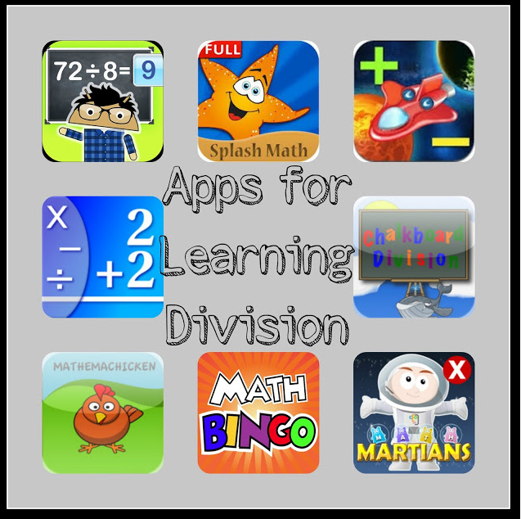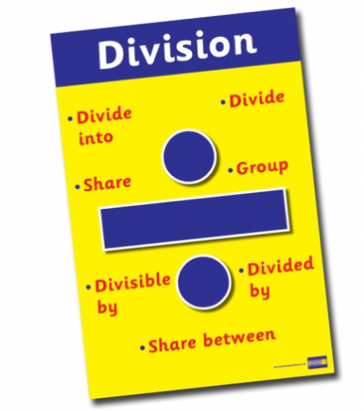

To be confident with division, it’s very helpful to know your TABLES and NUMBER FACTS,

|  |  |
| --- | --- |
| ***Description: j0229369*** |  |
| **Activity: Solving real life problems** |
|  |

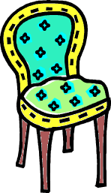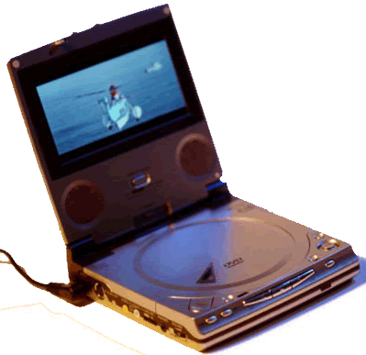

Super special!

4 chairs for $328

Book 3 tickets and pay $915

DVD recorders.

$538 for the pair

|  |  |  |  |
| --- | --- | --- | --- |
|  | Calculate the cost of each chair. | How much does each person pay for their ticket? | What does each DVD recorder cost? |

# 8 What’s in a number?

# ….the place value of thousands

# …and tens of thousands

**Learning Intention:** Identify the different ways numbers can be organisedwith place value**.**

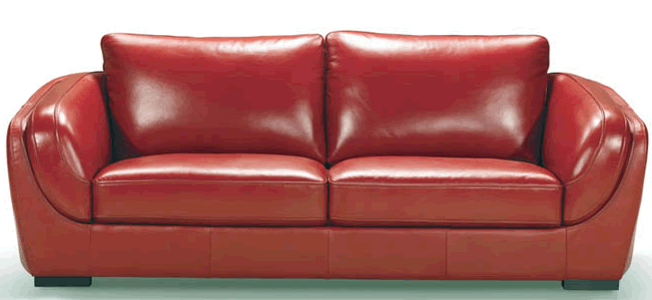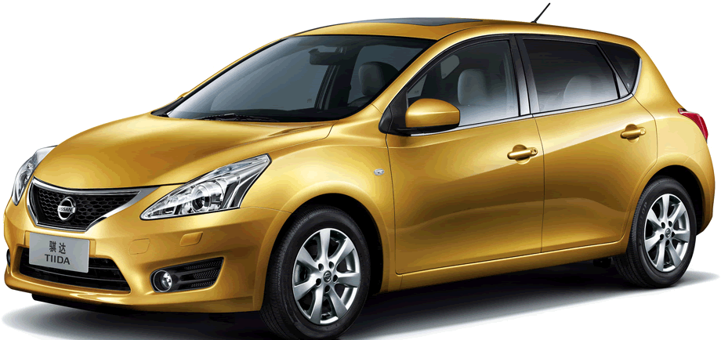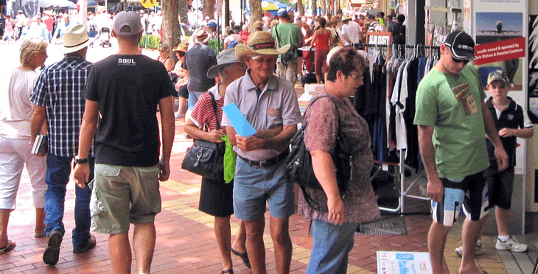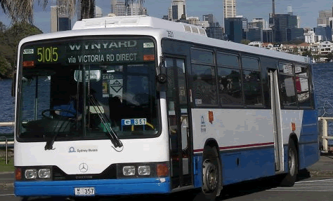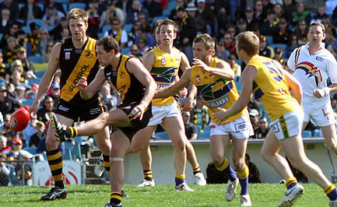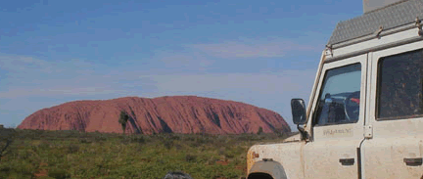

Travelling distance from Melbourne to Uluru is 2 321 km

New furniture costs $2 975

A racing bicycle costs $4 730

The local football match attracted 3 896 people.

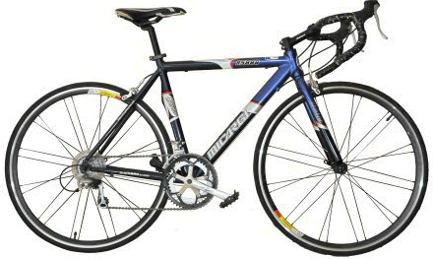

An AFL football game attracts 47 850 people

on average

The population of Tamworth is about 58 351 people.

The population of Roma is about 7 994 people.

The number of buses on the road in Australia is about 91 500

A new car costs $27 975

|  |  |
| --- | --- |
| j0229369 |  |
| **Activity 1: Thousands and tens of thousands** |
|  |

|  |
| --- |
| See if you can find a real life example of:   * one or two things measured in thousands * one or two things measured in tens of thousands   Useful places to look are newspapers or the internet. |

# What’s in a number?

In every number each digit in a number has a value depending on the column it is in.

**Example 1** Expanding a number.

|  |  |  |  |  |  |  |  |  |
| --- | --- | --- | --- | --- | --- | --- | --- | --- |
| A trip from Melbourne to Perth  is 3 275 kilometres. | | | |  | The turnout at the club’s last footy match was 12 907 people. | | | |
|  | 3 275 is made up of | |  |  |  | 12 907 is made up of | |  |
|  | 3 **thousand**  2 **hundred**  7 **tens**  5 **ones** | 3000  200  70  5 |  |  |  | 1 ten **thousand**  2 **thousand**  9 **hundred**  0 tens  7 ones | 10 000  2 000  900  0  7 |  |
|  |  |  |  |  |  |  |
|  |  |  |  |  |  |  |  |  |

**Example 2** Numbers in words and digits.

|  |  |  |  |  |  |  |  |  |  |  |  |  |
| --- | --- | --- | --- | --- | --- | --- | --- | --- | --- | --- | --- | --- |
| Four **thousand**, three **hundred** and thirty. | | | | | |  | Sixteen **thousand** and forty two. | | | | | |
|  | 4 **thousand**  3 **hundred**  3 **tens** | | 4000  300  30 | |  |  |  | 16 **thousand**  0 **hundreds**  4 **tens**  2 **ones** | | 16 000  0  40  2 | |  |
| The number in digits 4 330 | | | | | |  |  |  |
|  | |  |  |  | |  | The number in digits 16 042 | | | | | |
|  | |  |  |  | |  |  | |  |  |  | |

|  |  |
| --- | --- |
| C:\Users\CFord\Documents\MY Folders\CurricDev2012\images\exerrcise1.gif | **Activity 2**  **Warm-up activity… What’s in a number?** |

|  |  |  |
| --- | --- | --- |
| What is the value of the 5 in these numbers?  9 1**5**7  24 **5**46  9**5** 244  76 28**5**  **5**6749  2**5** 319 |  | What is the value of the digit in bold?  4**9** 157  **6**7 849  10 **1**34  9 5**4**4  12 **7**06  **2**7135 |

|  |  |
| --- | --- |
| C:\Users\CFord\Documents\MY Folders\CurricDev2012\images\exerrcise1.gif | **Activity 2 continued…**  **Warm-up activity… What’s in a number?** |

Fill in the missing parts of the table below. Expand the numbers and write them in words. The first one is done for you.

|  |  |  |
| --- | --- | --- |
| **In digits:** | | **The number expanded:** |
| **1 709** | | **1 000 + 700 + 9** |
| ***The number in words*** | | *one thousand, seven hundred and nine* |
|  | | |
| **?** | **?** | |
|  | | |
| **7 841** | **?** | |
| ***?*** | | |
|  | | |
|  | **6 000+300+20+1** | |
| ***?*** | | |
|  | | |
| **?** | **4 000 + 20 + 3** | |
| ***?*** | | |
|  | | |
| **12 885** | **?** | |
| ***?*** | | |
|  | | |
| **?** | **10 000 + 2 000 +7** | |
| **?** | | |
|  | **?** | |
| *nineteen thousand, two hundred and four* | | |
|  | | |
| **? 13 075** |  | |
| **?** | | |
|  | | |
| **?** | **?** | |
| *Twenty-nine thousand, one hundred and seventy-six* | | |
|  | | |
| **?** | **20 000 + 6 000 + 300+ 6** | |
| **?** | | |
|  | | |
| **?** | **?** | |
| *eighty-one thousand, seven hundred and twelve* | | |
|  | | |
| **79 842** | **?** | |
| **?** | | |
|  | | |
| **?** | **90 000 + 20+ 7** | |
| **?** | | |
|  | | |

Check your answers in **WORDS.** Do you have a hyphen (-) for numbers between twenty**-**one and ninety**-**nine?

Different ways to expand a number

There are different ways to expand a number. Let’s see an example…

**Example 1**

The small town of Cloncurry has a population of 3 428 people.

3 428 means 3 **thousand** 4 **hundred** 2 **tens** and 8 **ones**.

There are other ways of expanding this number:

|  |  |  |  |  |  |  |  |  |  |  |  |  |  |  |  |  |  |  |  |
| --- | --- | --- | --- | --- | --- | --- | --- | --- | --- | --- | --- | --- | --- | --- | --- | --- | --- | --- | --- |
|  | **Thousands** | Hundreds | Tens | Ones |  |  |  |  | **Hundreds** |  | Ones |  |  |  |  |  | **Tens** | Ones |  |
|  | **3** | 4 | 2 | 8 |  |  |  | **3** | **4** | 2 | 8 |  |  |  | **3** | **4** | **2** | 8 |  |
| **3 thousand** **4 hundred**  20 and 8 | | | | | |  | **34 hundred** and 28 ones | | | | | |  | **342 tens** and 8 ones | | | | | |

**Example 2**

The town of Broken Hill has a population of 21 314 people.

21 314 means 21 thousand 3 hundred 1 ten and 4 ones.

There are other ways of expanding this number:

|  |  |  |  |  |  |  |  |  |  |  |  |  |  |  |  |  |  |  |  |  |  |  |
| --- | --- | --- | --- | --- | --- | --- | --- | --- | --- | --- | --- | --- | --- | --- | --- | --- | --- | --- | --- | --- | --- | --- |
|  |  | **Thousands** | Hundreds | Tens | Ones |  |  |  |  |  | **Hundreds** |  | Ones |  |  |  |  |  |  | **Tens** | Ones |  |
|  | **2** | **1** | 3 | 1 | 4 |  |  |  | **2** | **1** | **3** | 1 | 4 |  |  |  | **2** | **1** | **3** | **1** | 4 |  |
| **21 thousand** 3 hundred  10 and 4 | | | | | | |  | **213 hundred** and 14 ones | | | | | | |  | **2131 tens and** 4 ones | | | | | | |

|  |  |
| --- | --- |
| ***Description: j0229369*** |  |
| **Activity 3: Expanding numbers** |
|  |

**Question 1**  Fill in the names of these numbers.

|  |  |  |  |  |  |  |  |  |  |  |  |  |  |  |  |  |  |  |  |
| --- | --- | --- | --- | --- | --- | --- | --- | --- | --- | --- | --- | --- | --- | --- | --- | --- | --- | --- | --- |
|  | Thousand | Hundreds | Tens | Ones |  |  |  |  | Hundreds |  | Ones |  |  |  |  |  | Tens | Ones |  |
|  | 6 | 8 | 5 | 1 |  |  |  | 6 | 8 | 5 | 1 |  |  |  | 6 | 8 | 5 | 1 |  |
|  | | | | | |  |  | | | | | |  |  | | | | | |

|  |  |  |  |  |  |  |  |  |  |  |  |  |  |  |  |  |  |  |  |
| --- | --- | --- | --- | --- | --- | --- | --- | --- | --- | --- | --- | --- | --- | --- | --- | --- | --- | --- | --- |
|  | Thousand | Hundreds | Tens | Ones |  |  |  |  | Hundreds |  | Ones |  |  |  |  |  | Tens | Ones |  |
|  | 7 | 3 | 5 | 9 |  |  |  | 7 | 3 | 5 | 9 |  |  |  | 7 | 3 | 5 | 9 |  |
|  | | | | | |  |  | | | | | |  |  | | | | | |

|  |  |  |  |  |  |  |  |  |  |  |  |  |  |  |  |  |  |  |  |
| --- | --- | --- | --- | --- | --- | --- | --- | --- | --- | --- | --- | --- | --- | --- | --- | --- | --- | --- | --- |
|  | Thousand | Hundreds | Tens | Ones |  |  |  |  | Hundreds |  | Ones |  |  |  |  |  | Tens | Ones |  |
|  | 2 | 0 | 9 | 4 |  |  |  | 2 | 0 | 9 | 4 |  |  |  | 2 | 0 | 9 | 4 |  |
|  | | | | | |  |  | | | | | |  |  | | | | | |

|  |  |  |  |  |  |  |  |  |  |  |  |  |  |  |  |  |  |  |  |
| --- | --- | --- | --- | --- | --- | --- | --- | --- | --- | --- | --- | --- | --- | --- | --- | --- | --- | --- | --- |
|  | Thousand | Hundreds | Tens | Ones |  |  |  |  | Hundreds |  | Ones |  |  |  |  |  | Tens | Ones |  |
|  | 6 | 2 | 0 | 5 |  |  |  | 6 | 2 | 0 | 5 |  |  |  | 6 | 2 | 0 | 5 |  |
|  | | | | | |  |  | | | | | |  |  | | | | | |

**Question 2**  Fill in the names of these numbers.

|  |  |  |  |  |  |  |  |  |  |  |  |  |  |  |  |  |  |  |  |  |  |  |
| --- | --- | --- | --- | --- | --- | --- | --- | --- | --- | --- | --- | --- | --- | --- | --- | --- | --- | --- | --- | --- | --- | --- |
|  |  | Thousands | Hundreds | Tens | Ones |  |  |  |  |  | Hundreds |  | Ones |  |  |  |  |  |  | Tens | Ones |  |
|  | 2 | 1 | 3 | 7 | 4 |  |  |  |  |  |  |  |  |  |  |  |  |  |  |  |  |  |
|  | | | | | | |  |  | | | | | | |  |  | | | | | | |

|  |  |  |  |  |  |  |  |  |  |  |  |  |  |  |  |  |  |  |  |  |  |  |
| --- | --- | --- | --- | --- | --- | --- | --- | --- | --- | --- | --- | --- | --- | --- | --- | --- | --- | --- | --- | --- | --- | --- |
|  |  | Thousands | Hundreds | Tens | Ones |  |  |  |  |  | Hundreds |  | Ones |  |  |  |  |  |  | Tens | Ones |  |
|  | 6 | 0 | 8 | 1 | 9 |  |  |  |  |  |  |  |  |  |  |  |  |  |  |  |  |  |
|  | | | | | | |  |  | | | | | | |  |  | | | | | | |

|  |  |  |  |  |  |  |  |  |  |  |  |  |  |  |  |  |  |  |  |  |  |  |
| --- | --- | --- | --- | --- | --- | --- | --- | --- | --- | --- | --- | --- | --- | --- | --- | --- | --- | --- | --- | --- | --- | --- |
|  |  | Thousands | Hundreds | Tens | Ones |  |  |  |  |  | Hundreds |  | Ones |  |  |  |  |  |  | Tens | Ones |  |
|  | 1 | 4 | 3 | 7 | 0 |  |  |  |  |  |  |  |  |  |  |  |  |  |  |  |  |  |
|  | | | | | | |  |  | | | | | | |  |  | | | | | | |

|  |  |  |  |  |  |  |  |  |  |  |  |  |  |  |  |  |  |  |  |  |  |  |
| --- | --- | --- | --- | --- | --- | --- | --- | --- | --- | --- | --- | --- | --- | --- | --- | --- | --- | --- | --- | --- | --- | --- |
|  |  | Thousands | Hundreds | Tens | Ones |  |  |  |  |  | Hundreds |  | Ones |  |  |  |  |  |  | Tens | Ones |  |
|  | 9 | 3 | 0 | 5 | 2 |  |  |  |  |  |  |  |  |  |  |  |  |  |  |  |  |  |
|  | | | | | | |  |  | | | | | | |  |  | | | | | | |

**Question 3**  What’s my number?

|  |  |  |  |  |  |  |
| --- | --- | --- | --- | --- | --- | --- |
| 352 tens and 16 units | |  |  | 142 thousand 30 hundred | |  |
| 352 tens →  16 units → | 3520  16 |  |  | 142 thousand →  30 hundred → | 142 000  3 000 |
|  | 3536 |  |  |  | 145 000 |
| Three thousand five hundred and thirty-six | |  |  | One hundred and forty-five thousand. | |

Work out each number from the clues in the table below.

Write the number in words.

Remember the hyphens in the right places **21** – **99**.

|  |  |  |
| --- | --- | --- |
|  | The number is…. | Write it in words |
| 50 tens and 200 units.  *which is the same as:*  (50 x 10 + 200 x 1) |  |  |
| 185 tens and 15 units  *which is the same as:*  (185 x 10 + 15 x 1 ) |  |  |
| 162 thousand, and 25 tens  *which is the same as:*  (162 x 1 000 + 25 x 10) |  |  |
| 24 hundred, 36 tens and 23 units.  *which is the same as:*  (24 x 100 +36 x 10 + 23 x 1) |  |  |
| 146 hundred and 20 tens.  *which is the same as:*  (146 x 100 + 20 x 10) |  |  |
| 84 thousand, 31 tens and 50 units  *which is the same as:*  (84 x 1 000 + 31 x 10 + 50 x 1) |  |  |

# Renaming a number



There are different ways of naming the same number. Let’s see some examples

**Example 1**

|  |  |  |  |  |  |  |  |  |
| --- | --- | --- | --- | --- | --- | --- | --- | --- |
| Rename 45 **hundred** and 15 **units** as units. | | | | | | | | |
| 45 hundred →  15 units → | 4500  15 |  |  |  |  |  | ones |  |
|  | 4515 |  |  | 4 | 5 | 1 | 5 |  |
| 45 hundred and 15 units = 4515 units | | | | | | | | |
|  | |  |  |  | | | |  |

**Example 2**

|  |  |  |  |  |  |  |  |  |
| --- | --- | --- | --- | --- | --- | --- | --- | --- |
| Rename 32 **tens** and 50 **units** as tens. | | | | | | | | |
| 32 tens →  50 units → | 320  50 |  |  |  |  | Tens | ones |  |
|  | 370 |  |  |  | 3 | 7 | 0 |  |
| 32 tens and 50 units = 37 tens | | | | | | | | |
|  | |  |  |  | | | |  |

**Example 3**

|  |  |  |  |  |  |  |  |  |  |
| --- | --- | --- | --- | --- | --- | --- | --- | --- | --- |
| Rename 26 **thousand** and 3 **hundred** as hundreds. | | | | | | | | | |
|  |  |  |  |  |  | Hundreds | tens | ones |  |
| 26 thousand →  3 hundred → | 26 000  300 |  |  |  |
|  | 26 300 |  |  | 2 | 6 | 3 | 0 | 0 |  |
| 26 **thousand** and 3 **hundred** = 263 hundreds | | | | | | | | | |
|  | |  |  | |  | | | |  |

|  |  |
| --- | --- |
| ***Description: j0229369*** |  |
| **Activity 4: Renaming numbers** |
|  |

**Question 1**  Rename the following numbers

|  |  |  |
| --- | --- | --- |
| Rename 26 **tens** and 6 **units**  as units (ones). |  | Rename 20 **tens** and 200 **units**  as hundreds (ones). |
|  |  |  |

|  |  |  |
| --- | --- | --- |
| Rename 6 **thousand** and 20 **tens**  as hundreds (ones) |  | Rename 90 **tens** and 100 **units**  as tens (ones). |
|  |  |  |

|  |  |  |
| --- | --- | --- |
| Rename 26 **tens** 6 **units**  as units (ones). |  | Rename 37 **hundred** 5 **tens** 8 units  as units. (ones) |
|  |  |  |

|  |  |  |
| --- | --- | --- |
| Rename 53 **thousand** and 54 **hundred** as hundreds. |  | Rename 41 **thousand** 70 **tens** and 200 **units** as hundreds. |
|  |  |  |

|  |  |  |
| --- | --- | --- |
| Rename 75 **tens** and 50 **units**  as hundreds. |  | Rename 36 **hundreds** and 20 **tens**  as tens. |
|  |  |  |

**Question 2**  Find the new number.

|  |  |  |  |  |  |  |
| --- | --- | --- | --- | --- | --- | --- |
| 65 tens add 11 units. | |  |  | 678 hundred takeaway 60 tens | |  |
| 65 tens →  11 units → | 650  + 11 |  |  | 678 hundred →  60 tens → | 67 800  – 600 |
|  | 661 |  |  |  | 67 200 |
|  | |  |  |  | |

|  |  |  |  |  |  |  |  |  |  |
| --- | --- | --- | --- | --- | --- | --- | --- | --- | --- |
| 84 **tens**, add 16 **tens** | | | | 13 **hundred**, add 12 **tens** | | | 162 **tens,** add 18 **units** | | |
|  |  | |  |  |  |  |  |  |  |
|  |  |  | |  |  |  |  |  |  |
|  |  |  | |  |  |  |  |  |  |

|  |  |  |  |  |  |  |  |  |
| --- | --- | --- | --- | --- | --- | --- | --- | --- |
| 37 **tens,** take away 11 **tens**. | | | 184 **hundred** take way 32 **hundre**d. | | | 384 **hundred** take away 40 **tens.** | | |
|  |  |  |  |  |  |  |  |  |
|  |  |  |  |  |  |  |  |  |
|  |  |  |  |  |  |  |  |  |

# What’s the nearest amount?

|  |  |
| --- | --- |
| There were 4352 people at last week’s match, and 26 430 the week before.  The news headlines said the turnouts were 4000 and 26 000.  They rounded off each number to the nearest thousand. Let’s see how. | *Only 4 000 turn out!*  *Club under pressure*  A record crowd!  26 000  Standing room only! |

**Example 1**

|  |  |  |  |  |  |  |  |  |
| --- | --- | --- | --- | --- | --- | --- | --- | --- |
| Rounding off 4352 | | | | | | | | |
| … to the nearest thousand  4352 is between 4000 and 5000 | | | |  | …. to the nearest hundred  352 is between 300 and 400 | | | |
|  | 4 | 352 |  |  |  | 43 | 52 |  |
| ↑  4000 | | ↑  300 |  |  | ↑  300 | | ↑  50 |  |
| The place next to 4000 is 300 | | | |  | The place next to 300 is 50 | | | |
| **4000**  **5000**  **4300** | | | |  | **300**  **400**  **350** | | | |
| 4300 is closer to 4000.  Rounding to the nearest thousand is 4000 | | | |  | 350 is half way between 300 and 400.  When a number is half way, we round up to the next amount, 400.  Rounding to the nearest hundred is 4400 | | | |
|  | | | |  |

**Example 2**

|  |  |  |  |  |  |  |  |  |  |
| --- | --- | --- | --- | --- | --- | --- | --- | --- | --- |
| Rounding off 26 430 | | | | | | | | | |
| … to the nearest ten thousand  26 000 is between 20 000 and 30 000 | | | | |  | …. to the nearest hundred  430 is between 400 and 500 | | | |
|  | 2 | 6 | 430 | |  |  | 26 4 | 30 |  |
| ↑  20 000 | | ↑  6000 | |  |  | ↑  400 | | ↑  30 |  |
| The place next to 20 000 is 6000 | | | | |  | The place next to 400 is 30 | | | |
| **20 000**  **30 000**  **26 000** | | | | |  | **400**  **500**  **430** | | | |
| 430 is closer 400.  Rounding to the nearest hundred  is 26 400 | | | |
| 26 000 is closer to 30 000  Rounding to the nearest ten thousand  is 30 000 | | | | |  |

|  |  |
| --- | --- |
| ***Description: j0229369*** |  |
| **Activity 5: Rounding numbers** |
|  |

**Question 1** Rounding to the nearest ten thousand:

|  |  |  |
| --- | --- | --- |
| **(a)** | Round 37 391 |  |
|  | The **ten thousands** part of 37 391 is  between 30 000 and 40 000.  It is closer to …… thousand  The rounded number is …………… | **30 000**  **40 000** |

|  |  |  |
| --- | --- | --- |
| **(b)** | Round 42 750 |  |
|  | The **ten thousands** part of 42 750 is  between 40 000 and 50 000.  It is closer to …… thousand  The rounded number is …………… | **40 000**  **50 000** |

|  |  |  |
| --- | --- | --- |
| **(c)** | Round 85 320 |  |
|  | The **ten thousands** part of 85 320 is  between 80 000 and 90 000.  It is half way between.  The rounded number is …………… | **80 000**  **90 000** |

**Question 2** Rounding to the nearest thousand:

|  |  |  |
| --- | --- | --- |
| **(a)** | Round 7483 |  |
|  | The **thousands** part of 7483 is between 7000 and 8000.  It is closer to …… thousand  The rounded number is …………… | **7000**  **8000** |

|  |  |  |
| --- | --- | --- |
| **(b)** | Round 3518 |  |
|  | The **thousands** part of 3518 is between 3000 and 4000.  It is closer to …… thousand  The rounded number is …………… | **3000**  **4000** |

|  |  |  |
| --- | --- | --- |
| **(c)** | Round 32 612 |  |
|  | The **thousands** part of 32 612 is between 2000 and 3000.  It is closer to …… thousand  The rounded number is …………… | **2000**  **3000** |

|  |  |  |
| --- | --- | --- |
| **(d)** | Round 64 571 |  |
|  | The **thousands** part of 64 571 is between 4000 and 5000.  It is closer to …… thousand  The rounded number is …………… | **4000**  **5000** |

**Question 3** Rounding to the nearest hundred:

|  |  |  |
| --- | --- | --- |
| **(a)** | Round 6587 |  |
|  | The **hundreds** part of 6587 is between 500 and 600.  It is closer to …… hundred  The rounded number to the nearest hundred  is …………… | **500**  **600** |

|  |  |  |
| --- | --- | --- |
| **(b)** | Round 2719 |  |
|  | The **hundreds** part of 2719 is between 700 and 800.  It is closer to …… hundred  The rounded number to the nearest hundred  is …………… | **700**  **800** |

|  |  |  |
| --- | --- | --- |
| **(c)** | Round 64 571 |  |
|  | The **hundreds** part of 64 571 is between 500 and 600.  It is closer to …… hundred  The rounded number is …………… | **500**  **600** |

|  |  |  |
| --- | --- | --- |
| **(d)** | Round 32 109 |  |
|  | The **hundreds** part of 32 109 is between 100 and 200.  It is closer to …… hundred  The rounded number is …………… | **500**  **600** |

**Question 4** Rounding to the nearest ten:

|  |  |  |
| --- | --- | --- |
| **(a)** | Round 3794 |  |
|  | The **tens** part of 3794 is between 90 and 100.  It is closer to ……  The rounded number to the nearest ten  is …………… | **90**  **100** |

|  |  |  |
| --- | --- | --- |
| **(b)** | Round 8569 |  |
|  | The **tens** part of 8569 is between 60 and 70.  It is closer to ……  The rounded number to the nearest ten  is …………… | **60**  **70** |

|  |  |  |
| --- | --- | --- |
| **(c)** | Round 17 847 |  |
|  | The **tens** part of 17 847 is between 40 and 50.  It is closer to ……  The rounded number to the nearest ten  is …………… | **40**  **50** |

|  |  |  |
| --- | --- | --- |
| **(d)** | Round 22 584 |  |
|  | The **tens** part of 22 584 is between 80 and 90.  It is closer to ……  The rounded number to the nearest ten  is …………… | **80**  **90** |

# C:\Users\CFord\Documents\MY Folders\CurricDev2012\images\car1a.gifMore or less…

|  |  |
| --- | --- |
| It’s 3275 km from Melbourne to Perth. | |
| If we travelled 100 km more | 3275 add one to the hundreds place |
|  | 3**3**75  ↑  2 hundred + 1 hundred  3 hundred |
|  | |
| If we travelled 60 km less | 3275 take away six from the tens place |
|  | 33**1**5  ↑  7 tens − 6 tens  1 ten |
|  | |

|  |  |
| --- | --- |
| ***Description: j0229369*** |  |
| **Activity 6: More or less** |
|  |

**Question 1** Work out the new distance travelled.

|  |  |  |  |  |
| --- | --- | --- | --- | --- |
| 4178 km | |  | 8679 km | |
| 200 km more | 50 km less |  | 20 km more | 300 km less |

|  |  |  |  |  |
| --- | --- | --- | --- | --- |
| 12 325 km | |  | 6275 km | |
| 300 km more | 1000 km less |  | 300 km more | 60 km less |

|  |  |  |  |  |
| --- | --- | --- | --- | --- |
| 7347 km | |  | 37 400 km | |
| 50 km more | 200 km less |  | 2 000 km more | 1 000 km less |

|  |  |  |  |  |
| --- | --- | --- | --- | --- |
| 17 865 km | |  | 19 412 km | |
| 2 000 km more | 700 km less |  | 30 km more | 6 000 km less |

|  |  |  |  |  |
| --- | --- | --- | --- | --- |
| 24 750 km | |  | 39 781 km | |
| 20 000 km more | 10 000 km less |  | 40 000 km more | 2 000 km less |

|  |  |  |  |  |
| --- | --- | --- | --- | --- |
| 75 392 km | |  | 63 821 km | |
| 10 000 km more | 30 000 km less |  | 30 000 km more | 4 000 km less |

**Question 2** Add or subtract to change the number.

|  |  |  |  |
| --- | --- | --- | --- |
|  |  |  |  |
| Change 567 to 507 by taking away one number.  As a number sentence:  567 – 60 = 507 |  | 567  – 60 |  |
|  | 507 |  |
|  |  |  |  |

|  |  |
| --- | --- |
| **(a)** | Change 470 to 70 by taking away one number.  Complete the number sentence: 470 – ……… = 70 |

|  |  |
| --- | --- |
| **(b)** | Change 2 093 to 2 100 by adding one number.  Complete the number sentence: 2 093 + ……… = 2 100 |

Count on from 2093 till you reach 2100

|  |  |
| --- | --- |
| **(c)** | Change 975 to 1 075 by adding one number.  Complete the number sentence: 975 + ……… = 1 075 |

|  |  |
| --- | --- |
| **(d)** | Change 934 to 1 234 by adding one number.  Complete the number sentence: 934 + ……… = 1 234 |

|  |  |
| --- | --- |
| **(e)** | Change 3 760 to 2 760 by taking away one number.  Complete the number sentence: 3 760 – ……… = 2 760 |

|  |  |
| --- | --- |
| **(f)** | Change 997 into a 4 digit number.  Write a number sentence to show the calculation  …………………………………………………………………………………… |

|  |  |
| --- | --- |
| **(g)** | Change 9 988 into a 5 digit number.  Write a number sentence to show the calculation  …………………………………………………………………………………… |

**Question 3** Solve some problems

|  |  |  |
| --- | --- | --- |
| Find the missing amounts | | |
| Start with 5 hundred more than 5290  Add 10 units.  Make it to 6000.  What amount do you add? |  | Start with 4 hundred more than 4268  Add 2 units, then 30 units.  Make it to the next thousand.  What amount do you add?  What is the final number? |

# 9 Doubles and trebles

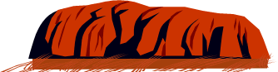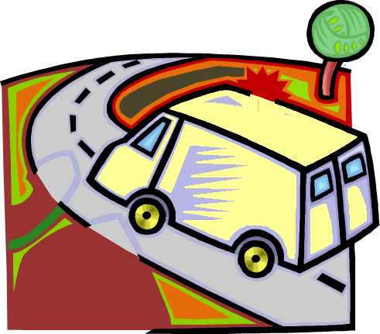

**Learning Intention**:

Driving from Melbourne to Uluru was 2325 kilometres.

Driving back to Melbourne **doubled** the distance.

|  |  |  |  |  |
| --- | --- | --- | --- | --- |
| 2325 equals | **Doubling** the distance | 2325  **× 2** | | |
| 2 thousand 3 hundred 2 tens 5 ones | **5 ones x 2**  = 10 ones  **2 tens x 2**  = 4 tens →  **3 hundreds × 2** = 6 hundreds  **2 thousands × 2** = 4 thousands |  | 10  40  600  4000 |  |
|  | **Total distance** → |  | 4650 | **km** |

|  |  |  |  |  |
| --- | --- | --- | --- | --- |
| Driving from Melbourne back to Uluru **trebled** the distance. | **Trebling** the distance | 2325  **× 3** | | |
| **5 ones × 3** = 15 ones  **2 tens × 3** 6 tens  **3 hundred × 3** = 9 hundreds  **2 thousand × 3** = 6 thousands |  | 15  60  900  6000 |  |
|  | Total distance → |  | 6975 | km |

|  |  |
| --- | --- |
| ***Description: j0229369*** |  |
| **Activity 1: Doubles and trebles** |
|  |

**Question 1**  Double the following distances.

|  |  |  |  |  |
| --- | --- | --- | --- | --- |
|  | **4 3 7 1**  **× 2** |  |  | **3 0 6 5**  **× 2** |
| …… ones × 2 →  …… tens × 2 →  … hundreds × 2 →  … thousands × 2 → | ……..………  ………..……  ………..……  ____________ |  | …… ones × 2  …… tens × 2 →  ……hundreds × 2 →  …… thousands× 2 → | ……….…………  ……….…………  ………….………  ______________ |

**Question 2**  Treble the following distances

|  |  |  |  |  |
| --- | --- | --- | --- | --- |
|  | 2 5 1 6  × 3 |  |  | 4 6 0 2  × 3 |
| …… ones × 3 →  …… tens × 3 →  …… hundreds × 3 →  …… thousands × 3→ | …………  …………  …………  ………… |  | …… ones × 3→  …… tens × 3 →  …… hundreds × 3→  …… thousands × 3→ | …………  …………  …………  ………… |
| Total distance → | ………… |  | Total distance → | ………… |

**Question 3**

Use your own multiplication method to find the distance travelled

|  |  |  |  |  |  |  |  |  |  |  |
| --- | --- | --- | --- | --- | --- | --- | --- | --- | --- | --- |
| 3 0 8 6  x 2 | | | |  |  | | 4 3 0 5  x 3 |  | 7 5 0 6  x 3 | |
|  |  | |  |  |  | |  | |  | |
|  | |  | |  | |
|  | |  | |  | |
|  |  | km | | km | | |  | km | | |

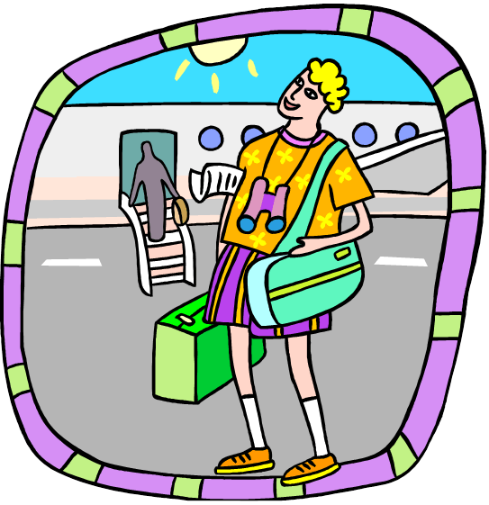

# Doubling and trebling longer distances

Flying from Melbourne to Athens was 14 945 kilometres.

Flying back to Melbourne doubled the distance.

|  |  |  |  |  |
| --- | --- | --- | --- | --- |
| 14 945 **equals** | **Doubling** the distance | 14 945  × 2 | | |
| 14 **thousand -** the same as: **10 000**+**4 000**  9 **hundred**  4 **tens**  5 **ones** | 5 **ones** × **2** = 10 **ones** →  4 **tens** × **2** = 8 **tens**→  9 **hundred** × **2** = 18 **hundred**→  4 **thousand** × **2** = 8 **thousand** →  10 **thousand** × **2** = 20 **thousand** → |  | 10  80  1 800  8 000  20 000 |  |
|  | Total distance → |  | 29 890 | km |

|  |  |  |  |  |
| --- | --- | --- | --- | --- |
| Flying from Melbourne back to Athens **trebled** the distance | **Trebling** the distance | 14 945  × 3 | | |
| 5 **ones** × **3** = 15 **ones** →→  4 **tens** × **3** = 12 **tens** →  9 **hundred** × **3** = 27 **hundred** →  4 **thousand** × **3** = 12 **thousand** →  10 **thousand** × **3** = 30 **thousan**d |  | 45  120  2 700  12 000  + 30 000 |  |
|  | Total distance → |  | 44 835 | km |

|  |  |
| --- | --- |
| ***Description: j0229369*** |  |
| **Activity 2: Doubling and trebling larger distances** |
|  |

**Question 1** Double the following distances

|  |  |  |  |  |
| --- | --- | --- | --- | --- |
|  | 1 4 3 6 2  × 2 |  |  | 1 7 4 0 5  × 2 |
| …..ones × 2→  …..tens × 2 →  … hundreds × 2 →  … 1 thousands ×2 →  ….10 thousand x 2→ | ……..……………  ……..……………  ……..……………  ……..……………  ……..……………. |  | …… ones × 2→ …………….  …… tens × 2→ ……………...  …… hundred × 2→..……………..  …… thousand × 2→………………  10 thousand × 2→……………… | |
| Total distance → |  |  | Total distance → |  | |

|  |  |  |  |  |
| --- | --- | --- | --- | --- |
|  | 1 3 7 2 4  × 2 |  |  | 2 3 0 8 1  × 2 |
| …… ones × 2 →  …… tens × 2 →  … hundred × 2 →  … 1 thousand × 2 →  …10 thousand × 2 → | …...…………  …...…………  …...…………  …...…………  …...………… |  | …… ones × 2 →  …… tens × 2 →  …… hundred × 2 →  …… thousand × 2 →  20 thousand × 2 → | ……...…………  ..…....…………  ……...…………  ……...…………  ……...………… |
| Total distance → |  |  | Total distance → |  |

**Question 2**

Treble the following distances..

|  |  |  |  |  |
| --- | --- | --- | --- | --- |
|  | 1 2 8 9 5  × 3 |  |  | 2 3 2 1 4  × 3 |
| …… ones × 3 →  …… tens × 3 →  …… hundred × 3 →  … 1 thousand × 3 →  …10 thousand × 3 → | ……………...  ……………...  ……...………  …...…………  ……...……… |  | …… ones × 3 →  …… tens × 3 →  …… hundred × 3 →  ……1 thousand × 3 →  10 thousand × 3 → | ……………………  ……………….……  ……………….……  ………………….…  ………………….… |
| Total distance → |  |  | Total distance → |  |

**Question 3**

Use your own multiplication method to find the distances travelled.

|  |  |  |  |  |  |  |  |
| --- | --- | --- | --- | --- | --- | --- | --- |
| 13 1 8 2  x 2 | | | |  |  | | 2 4 3 1 5  x 3 |
|  |  | |  |  |  | |
|  | |  | |
|  | |  | |
|  |  | km | | km | | |

|  |  |  |  |  |  |  |  |
| --- | --- | --- | --- | --- | --- | --- | --- |
| 1 2 4 8 5  x 3 | | | |  |  | | 1 8 2 1 7  x 3 |
|  |  | |  |  |  | |
|  | |  | |
|  | |  | |
|  |  | km | | km | | |



# More or less… what’s my strategy?

|  |  |  |  |  |  |  |  |  |
| --- | --- | --- | --- | --- | --- | --- | --- | --- |
| We drove 2 953 km on our last trip. | | | | | | | | |
| If we travelled 100 km more | |  | 2 953  + 100 | |  | Hundreds | Ones |  |
| 3 053 | |  |
|  | |  | | |  | **29** | 53 |  |
|  |  | | | ↑  29 hundred plus 1 hundred  30 hundred | | | | |

|  |  |  |  |  |  |  |  |  |
| --- | --- | --- | --- | --- | --- | --- | --- | --- |
| We flew 15 916 km on our last trip. | | | | | | | | |
| If we travelled 100 km more | |  | 15 916  + 100 | |  | Hundreds | Ones |  |
| 16 016 | |  |
|  | |  | | |  | **159** | 16 |  |
| ***Description: j0229369*** |  | | | ↑  159 hundred plus 1 hundred  160 hundred | | | | |

**Activity 3: More or less …what’s my strategy?**

**Question 1** Add 100 km to each distance.

|  |  |  |  |  |  |  |  |  |  |  |  |
| --- | --- | --- | --- | --- | --- | --- | --- | --- | --- | --- | --- |
|  | | |  | | |  | | |  | | |
| 3 9 8 1  + 1 0 0 | | | 2 9 0 5  + 1 0 0 | | | 7 9 9 5  + 1 0 0 | | | 9 9 1 6  + 1 0 0 | | |
|  |  |  |  |  |  |  |  |  |  |  |  |
|  | | |  | | |  | | |  | | |

|  |  |  |  |  |  |  |  |  |  |  |  |
| --- | --- | --- | --- | --- | --- | --- | --- | --- | --- | --- | --- |
|  | | |  | | |  | | |  | | |
| 1 4 9 2 8  + 1 0 0 | | | 1 7 9 8 4  + 1 0 0 | | | 1 3 9 1 7  + 1 0 0 | | | 1 9 9 7 5  + 1 0 0 | | |
|  |  |  |  |  |  |  |  |  |  |  |  |
|  | | |  | | |  | | |  | | |

**Question 2** Add 1000 km more to each distance.

|  |  |  |  |  |  |  |  |  |  |  |  |
| --- | --- | --- | --- | --- | --- | --- | --- | --- | --- | --- | --- |
|  | | |  | | |  | | |  | | |
| 3 9 5 0 3  + 1 0 0 0 | | | 2 9 8 1 4  + 1 0 0 0 | | | 5 9 9 1 2  + 1 0 0 0 | | | 4 9 9 0 4  + 1 0 0 0 | | |
|  |  |  |  |  |  |  |  |  |  |  |  |
|  | | |  | | |  | | |  | | |

# Number line jumps

|  |  |  |  |
| --- | --- | --- | --- |
| We drove 1 454 km on our last trip.  If we drove 60 km less, how far would we have travelled? | | | |
|  | 1 454  − 60 | 1 454  1 400  54  6  1 394 | * Start at 1 454 * Jump back 54 to reach 1 400 * The next jump is 60 − 54 = 6 * 1 400 take away 6 gives 1 394 |
|  | 1 394 |
|  |  |
|  |  |  |  |

Counting back from 1400

1399, 1398, 1397, 1396, 1395, 1394

|  |  |
| --- | --- |
| ***Description: j0229369*** |  |
| **Activity 4: Number line jumps** |

**Question 1** Jumping forward

How much further to the next ten, then to the next hundred?

The first one is done for you: 532

|  |  |
| --- | --- |
| 600  540  60  8  532 | From 532 jump 8 to reach 540  From 540 jump 60 to reach 600 |

|  |  |
| --- | --- |
| 500  440    437 | 200  180    172 |

|  |  |
| --- | --- |
| 700  650    641 | 1 500  1 480    1 473 |

|  |  |
| --- | --- |
| 2 900  2 840    2 835 | 3 800  3 730    3 724 |

**Question 2**

Fill in the boxes: jump to the next ten, then to the next hundred.

|  |  |
| --- | --- |
| 774 | 352 |

|  |  |
| --- | --- |
| 1 537 | 4 263 |

**Question 3** Jumping back.

Finish these number line jumps to work out the subtraction. The first one is done as an example.

|  |  |  |  |
| --- | --- | --- | --- |
|  |  |  |  |
|  | 732  − 50 | 732  700  32  Takeaway 50 32 + 10 + 8 = 50  690  10  8  682  732 − 50 = 682 | |
|  | 682 |
|  |  |
|  |  |  |  |

|  |  |  |  |
| --- | --- | --- | --- |
|  |  |  |  |
|  | 736  − 50 | 736  700 | |
|  |  |
|  |  |
|  |  |  |  |

|  |  |  |  |
| --- | --- | --- | --- |
|  |  |  |  |
|  | 823  − 60 | 823  800 | |
|  |  |
|  |  |
|  |  |  |  |

|  |  |  |  |
| --- | --- | --- | --- |
|  |  |  |  |
|  | 1 349  − 60 | 1 349  1 300 | |
|  |  |
|  |  |
|  |  |  |  |

|  |  |  |  |
| --- | --- | --- | --- |
|  |  |  |  |
|  | 1 427  − 50 | 1 427  1 400 | |
|  |  |
|  |  |
|  |  |  |  |

|  |  |  |  |
| --- | --- | --- | --- |
|  |  |  |  |
|  | 1 643  − 60 | 1 643  1 600 | |
|  |  |
|  |  |
|  |  |  |  |

**Question 4**

Decide which strategy to use to work out these subtractions.

|  |  |  |  |  |
| --- | --- | --- | --- | --- |
|  |  |  |  |  |
|  | 3 4 5  − 7 0 |  | 1 4 3 9  − 6 0 |  |
|  |  |  |  |  |
|  |  |  |  |  |

# 10

# Time for a skills check-up



Complete a skills check-up on what you have learned.

|  |  |
| --- | --- |
| **The test**  Go to the test pages at the end.  This test covers the activities. | C:\Users\CFord\Documents\MY Folders\CurricDev2012\images\test.gif |

|  |
| --- |
| The test covers the maths activities you have done. |

# C:\Users\CFord\Documents\MY Folders\CurricDev2012\images\test.gifPlease complete the exercises on these pages. Show your working out wherever possible.

# You can use your notes to help you with these exercises, but no other assistance.

**Activity 1 Number facts and skills**

**(a)** The table below shows multiplication facts.

* Recall the answer to each multiplication from your times tables.
* Then write two division facts.
* Think of a number story for any one of the number facts.

|  |  |  |  |  |
| --- | --- | --- | --- | --- |
| **Multiplication Fact** | **One division fact** | | **Another division fact** | |
| 7 × 11 = ……. |  | |  | |
| *Write a story using one of these facts:*  ………………………………………………………………………………………….  …………………………………………………………………………………………. | | | | |
| 9 × 3 = ……. | |  | |  |
| *Write a story using one of these facts:*  ………………………………………………………………………………………….  …………………………………………………………………………………………. | | | | |

**(b)** Fill in the missing number facts below.

|  |  |  |
| --- | --- | --- |
| 8 × 3 = …………………………..  8 × 30 = ………………………….  8 × 300 =………………………….  8 × 3 000 = ………………………. |  | If I know **13 × 5 = 65** I also know  13 × 50 = ………………………….  13 × 500 = ………………………..  13 × 5 000 = ………………………. |

**(c)** Strategies for doubling. Complete the following questions

|  |  |
| --- | --- |
| Double 83 | Double (………….... **tens** and …………… **units)**  ……….... **tens** and …………… **units**  **equals** ……………….... |

|  |  |
| --- | --- |
| Double 620 | Double (……..….. **hundred** and ……….… **tens**)  ……….... **hundred** and ……..…… **tens**  **equals** ………….... |

|  |
| --- |
| Write your own number sentences to double 67 |

|  |
| --- |
| Write your own number sentences to double 703 |

**Activity 2 The different types of angles and their measurements**

**Question 1**

**(a)** The Art Gallery in Alberta Canada is a modern building of curves and straight lines.

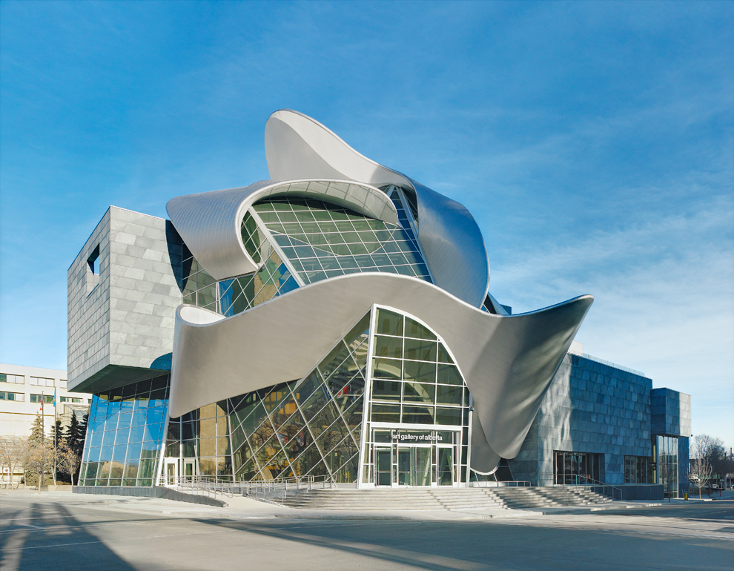

1

**2**

<http://gracefulspoon.com/blog/2009/02/01/art-gallery-of-alberta/>

Look at the connections shown in the picture.

Do both connections form angles? Why or why not?

……………………………………………………………………………………………

……………………………………………………………………………………………

|  |  |
| --- | --- |
| **(b)**  The new sporting arena in Perth was built in 2012. It can seat up to 15 500 people and will host sporting events and concerts. It is an angular building with many faces. | Description: C:\Users\CFord\Documents\MY Folders\CurricDev2012\images\module2\arenaperth.gif<http://www.appiangroup.com.au/perth-arena-project/> |

The picture below shows the arena while it was being built.

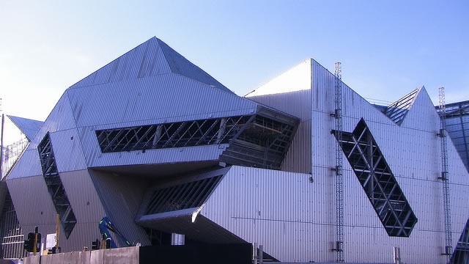

<http://www.abc.net.au/news/2012-03-08/perth-arena-exterior/3877278>

Find and label

|  |  |  |
| --- | --- | --- |
| * an acute angle | * a right angle | * an obtuse angle |
| * a straight angle | * a reflex angle |  |

**(c)** Reflex angles are found by measuring the smaller angle with your protractor.

|  |  |
| --- | --- |
| Work out the reflex angle shown in the diagram by measuring the smaller angle first. |  |

**Question 2 Calculating angles**

Find the missing angle in each picture. Which angles are supplementary, complementary, conjugate or vertically opposite?

|  |  |  |  |
| --- | --- | --- | --- |
| **(a)** | **42°**  **?** | **(b)** | **150°**  **?** |
| Tick the correct box. The angles shown in this diagram are:  🞎 supplementary  🞎 complementary  🞎 conjugate  🞎 vertically opposite | | Tick the correct box. The angles shown in this diagram are:  🞎 supplementary  🞎 complementary  🞎 conjugate  🞎 vertically opposite | |

|  |  |  |  |
| --- | --- | --- | --- |
| **(c)** | **?**  **124°** | **(d)** | **55°**  **?**  **?**  [**http://gatebuilderkits.com/**](http://gatebuilderkits.com/) |
| Tick the correct box. The angles shown in this diagram are:  🞎 supplementary  🞎 complementary  🞎 conjugate  🞎 vertically opposite | | Tick the correct boxes. The angles shown in this diagram are:  🞎 supplementary  🞎 complementary  🞎 conjugate  🞎 vertically opposite | |

**Question 3 Angle match**

|  |  |  |
| --- | --- | --- |
| **(a)** | Circle a pair of angles that are   * complementary * supplementary * conjugate   Use each angle only once. Cross them off as you go. | 30°  255°  105°  15°  35°  55°  235°  125°  75°  300°  240°  60°  120° |
|  | For each pair of angles, write a number sentence to show what they add up to. |
| **(b)** | **An extra challenge (this is optional)**  Try and find some other pairs from the angles that are left.  How many more pairs can you find?  Will there be any angles left over? |
|  |  |



**Challenge questions. Questions 4 and 5 are optional.**

**Question 4 Challenge question: Window angles.**

|  |  |
| --- | --- |
| The window shown here is made up of sections. The angle of one section has been measured. Knowing one angle is enough information to work out the other angles.  Show how you can work out angles 1, 2 and 3. | **30°**  **Angle 1**  **Angle 2**  **Angle3** |

**Question 5 Challenge question: Angles that meet at a point.**

|  |  |
| --- | --- |
| The Beijing Water Cube was the aquatic centre during the 2008 Olympics held in China.  The steel frame is covered with plastic ‘pillows’. They are filled with air to look like water bubbles.  After the Olympics it was converted into an indoor water park for everyone to use. | **Description: J:\backup\MyNewFolders\CurricDev2012\images\module2\watercube2.gif** |

The picture below shows a section of the frame.

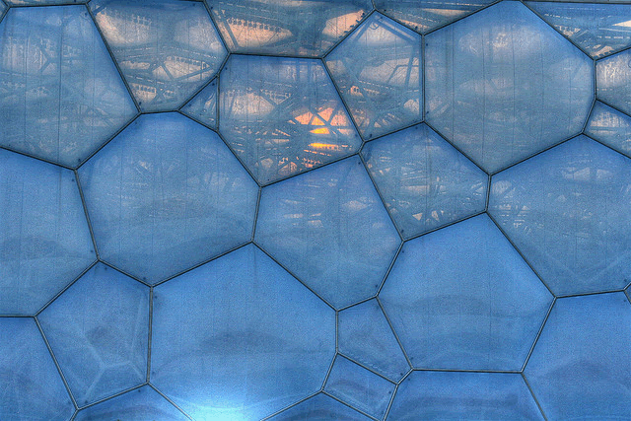

<http://www.flickr.com/photos/26738898@N02/favorites/?view=lg>

|  |  |  |
| --- | --- | --- |
| **(a)** | Pick a joint in the frame and measure the angles around it. Show the measurements on the picture. | |
|  | Add up the angles.  Do they add up to approximately 360 degrees? |  |

|  |  |  |
| --- | --- | --- |
| **(b)** | Pick another joint in the frame and measure the angles around it. Show the measurements on the picture. | |
|  | Add up the angles.  Do they add up to approximately 360 degrees? |  |

|  |  |  |
| --- | --- | --- |
| **(c)** | Write one important idea about angles:   |  | | --- | |  | |

|  |  |
| --- | --- |
|  | Test.  The test covers the maths activities you have done. |

# C:\Users\CFord\Documents\MY Folders\CurricDev2012\images\test.gifPlease complete the exercises on these pages. Show your working out wherever possible.

# You can use your notes to help you with these exercises, but no other assistance.

**Activity 1 Number facts and skills**

**Question 1 Multiplication skills**

**(a)** Complete the following multiplications.

|  |
| --- |
| **3 × 87** becomes 3 × …….… tens plus 3 × …….…ones  equals …….… plus ……………  equals ……….… |

|  |
| --- |
| **4 × 305** becomes 4 × …….… hundreds plus 4 × ….……ones  equals …….… plus ……..…  equals …………… |

**(b)** Use your own setting out to work out the following multiplications.

|  |
| --- |
| **3 × 78**  ………………………………………………………………………………………….  ………………………………………………………………………………………….  …………………………………………………………………………………………. |

|  |
| --- |
| 4 × 309  ………………………………………………………………………………………….  ………………………………………………………………………………………….  …………………………………………………………………………………………. |

**(c)** Apply your skills.

There are 138 blueberries in a punnet. Each blueberry has an average mass of 4 grams. What is the mass of the whole punnet? Show your working out:

|  |
| --- |
| ………………………………………………………………………………………….  ………………………………………………………………………………………….  …………………………………………………………………………………………. |

**Question 2 Division skills**

|  |  |
| --- | --- |
| **(a)** | Division facts come from multiplication facts.  Show two division facts for the multiplication fact.  Think of a number story to match one number fact. |

|  |  |  |
| --- | --- | --- |
| **Multiplication Fact** | **One division fact** | **Another division fact** |
| 76 x 4 =304 |  |  |
| *Write a number story problem using one of these facts:*  ………………………………………………………………………………………….  ………………………………………………………………………………………….  ………………………………………………………………………………………… | | |

(b) Extended division facts.

Fill in the missing parts of these division facts.

|  |  |  |
| --- | --- | --- |
| 44 ÷ 11 = ……………….…..  440 ÷ 11 = …………………..  4400 ÷ 11 =…………………...  44 000 ÷ 11 =…………………... |  | 24 ÷ 8 = ………………………..  240 ÷ 8 = …………………….....  2400 ÷ 8 = …………………..…..  24 000 ÷ 8 = ……………………... |

Complete the missing parts of these division sentences.

|  |
| --- |
| 147 ÷ 3 becomes (120 ÷ …………) plus ( ……..…… ÷ 3)  …………….. plus ………..…..  equals…………………….. |

|  |
| --- |
| 832 ÷ 4 becomes (800 ÷ …………) plus ( ………… ÷ 4)  …………... . plus ………..…..  equals ……….…….. |

**Activity 2 Expanding and renaming numbers**

**Question 3 Expanding numbers**

Write the total VALUE of the numbers in the shaded columns.

|  |  |  |  |  |  |  |  |  |  |  |  |  |  |  |  |  |  |  |  |
| --- | --- | --- | --- | --- | --- | --- | --- | --- | --- | --- | --- | --- | --- | --- | --- | --- | --- | --- | --- |
|  | Thousand | Hundreds | Tens | Ones |  |  |  |  | Hundreds |  | Ones |  |  |  |  |  | Tens | Ones |  |
|  | 7 | 1 | 5 | 2 |  |  |  | 7 | 1 | 5 | 2 |  |  |  | 7 | 1 | 5 | 2 |  |
|  | | | | | |  |  | | | | | |  |  | | | | | |

|  |  |  |  |  |  |  |  |  |  |  |  |  |  |  |  |  |  |  |  |  |  |  |
| --- | --- | --- | --- | --- | --- | --- | --- | --- | --- | --- | --- | --- | --- | --- | --- | --- | --- | --- | --- | --- | --- | --- |
|  |  | Thousands | Hundreds | Tens | Ones |  |  |  |  |  | Hundreds |  | Ones |  |  |  |  |  |  | Tens | Ones |  |
|  | 8 | 2 | 3 | 0 | 5 |  |  |  | 8 | 2 | 3 | 0 | 5 |  |  |  | 8 | 2 | 3 | 0 | 5 |  |
|  | | | | | | |  |  | | | | | | |  |  | | | | | | |

**Question 4 Renaming numbers**

|  |  |
| --- | --- |
| **(a)** | What’s my number? Write the following numbers as digits. |
|  | 80 tens and 76 units …………………………………….. |
|  | 35 hundreds, 12 tens and 16 units …………………………………….. |
|  | 62 thousand, and 14 hundreds …………………………………….. |

|  |  |
| --- | --- |
| **(b)** | Rename the following numbers |
|  | 19 tens 8 units = ……… units |
|  | 23 hundreds 15 tens = ………. tens |
|  | 7 thousand 30 tens = ……… hundreds |
|  | 32 thousand 400 units = ……… hundreds |
| **(c)** | Find the new number: |

|  |  |  |  |
| --- | --- | --- | --- |
|  | 16 hundreds, add 23 tens |  | 345 tens, add 225 units |

|  |  |  |  |
| --- | --- | --- | --- |
|  | 57 tens, take away 2 hundreds |  | 235 hundred, take away 30 tens |

|  |  |
| --- | --- |
| **(d)** | Explain what the zero means.  What does the zero mean when it is in the middle of a number?  For example, 7 049 contains a zero. If the zero has no value, why can’t we just leave it out? |

|  |
| --- |
| ……………………………………………………………………………………………  ……………………………………………………………………………………………  ……………………………………………………………………………………………  …………………………………………………………………………………………… |

**Question 5 Rounding numbers**

|  |  |  |
| --- | --- | --- |
| **(a)** | Round **47 356** to the nearest **ten thousand**. |  |
|  | The ten thousands part of **4**7 356 is  between 40 000 and 50 000.  It is closer to ………………… thousand  The rounded number is ………………………… | **40 000**  **50 000** |

|  |  |  |
| --- | --- | --- |
| **(b)** | Round **47 356** to the nearest **thousand.** |  |
|  | The thousands part of 4**7 356** is between 7000 and 8000.  It is closer to ………………………. thousand  The rounded number is ……………….…………… | **7000**  **8000** |

|  |  |  |
| --- | --- | --- |
| **(c)** | Round 47 356 to the nearest hundred. |  |
|  | The hundreds part of 47 **356** is between 300 and 400.  It is closer to ………………….… hundred  The rounded number is ………………………… | **300**  **400** |

|  |  |  |
| --- | --- | --- |
| **(d)** | Round 47 356 to the nearest ten |  |
|  | The tens part of 47 3**56** is between 50 and 60.  It is closer to …………………………………  The rounded number to the nearest ten is  …………….…………… | **50**  **60** |

**Question 6 Travelling more or less**

|  |  |  |
| --- | --- | --- |
| **(a)** | Work out the new distance travelled |  |

|  |  |  |
| --- | --- | --- |
|  | 8493 km | |
|  | 300 km more | 60 km less |

|  |  |  |
| --- | --- | --- |
|  | 19 362 km | |
|  | 50 000 km more | 4 000 km less |

|  |  |
| --- | --- |
| **(b)** | Change 875 to 805 by taking away one number.  Complete the subtraction sentence below.  875 – ………… = 805 |
|  |
|  |

|  |  |
| --- | --- |
| **(c)** | Change 1670 to 1070 by taking away one number.  Complete the subtraction sentence below.  1670 – ………… = 1070 |
|  |

|  |  |
| --- | --- |
| **(d)** | Change 11 580 to 11 080 by taking away one number.  Complete the subtraction sentence below.  11 580 – ………… = 11 080 |

|  |  |
| --- | --- |
| **(e)** | Change 987 to a four digit number by adding one number.  Complete an addition sentence below.  987 + ………… = ………… |

|  |  |
| --- | --- |
| **C:\Users\CFord\Documents\MY Folders\CurricDev2012\images\challengeQ2.gif(f)** | Change 987 to 1187 by adding one number.  Complete an addition sentence below.  987 + ………… = 1187 |

**Challenge problem.**

Use your number skills to find the missing amount:

|  |
| --- |
| Start with 3 hundred more than 2 579 ……………………  Make it 1 000 more ……………………  Add 1 unit then 20 units ……………………  Now add an amount to make this number 4 000 ……………………  What did you add? …………………… |

|  |
| --- |
| **THINKING ABOUT YOUR LEARNING**  **This is what I feel I have learnt well:**  **____________________________________________________**  **___________________________________________________________________________**  **___________________________________________________________________________**  **___________________________________________________________________________**  **___________________________________________________________________________**  **I still need help to understand:**    **___________________________________________________________________________**  **___________________________________________________________________________**  **___________________________________________________________________________**  **___________________________________________________________________________** |

|  |
| --- |
| **YOUR QUESTIONS OR COMMENTS** |
| **SUPERVISOR’S COMMENTS**  **Some great things about your work were:**  **Things you can do to improve your learning:** |
|  |