Maths

Learning Booklet 1

# flowers

**Copyright**

*The Department of Education and Training (DET) encourages the dissemination and re-use of information provided in this document.*

Material on this website is provided under a Creative Commons Attribution 4.0 international licence, with the exception of:

* any images, photographs, trademarks or branding, including the Victorian Government logo and the DET logo; and
* content supplied by third parties.



For licence conditions, see: [Creative Commons Attribution 4.0 international licence](http://creativecommons.org/licenses/by/4.0/)

**Attribution**

Material to be attributed as:

© State of Victoria (Department of Education and Training)

|  |  |
| --- | --- |
|  | **Topics** |
| **TASK 1** | NUMBER AND ALGEBRA – Recognise numerals 1–20  Count and sequence numbers 1–20  Order numbers from smallest to biggest and biggest to smallest. |
| **TASK 2** | NUMBER AND ALGEBRA – Addition |
| **TASK 3** | MEASUREMENT AND GEOMETRY – compare, order and measure the lengths of different objects using informal and formal units. |
| **TASK 4** | NUMBER AND ALGEBRA – use of interactive learning object to practise recognising and sequencing numbers. |
| **TASK 5** | MEASUREMENT AND GEOMETRY – Name, make and explore the properties of 2D shapes.  –Sort shapes according to attributes.  –Classify shapes and find similarities and differences between given shapes. |
| **TASK 6** | NUMBER AND ALGEBRA – make models of numbers up to 20  –Count forwards and backwards from various starting points.  –Count on from 10 to 20. |
| **TASK 7** | NUMBER AND ALGEBRA – introduce concept of place value and terms Tens and Ones. |
| **TASK 8** | STATISTICS AND PROBABILITY –use the vocabulary of chance to describe and compare the likelihood of different events. |
| **TASK 9** | STATISTICS AND PROBABILITY –use the vocabulary of chance to describe and compare the likelihood of different events. |
| **TASK 10** | REVIEW |

Note: Activity sheets are numbered and provided at the back of this resource

**Task 1**

**Focus: Number**

**Getting Knowledge Ready**

|  |  |
| --- | --- |
| **Step 1**  Use Activity Sheets 1 and 2  Hold up each number card in order and ask your child to tell you what it says.  Does your child know the numbers 1–20 when they are in order?  Jumble the number cards up and ask your child to tell you what each one says.  Does your child know the numbers from 1–20 when they are out of order? |  |

**Step 2**

Create a mind map to show what you know about numbers.

|  |  |
| --- | --- |
|  | You may need to prompt your child by asking questions like:  What are numbers?  Where have you seen numbers used?  What do you use numbers for? |

|  |  |
| --- | --- |
|  | **Step 3**  Use Activity Sheets 1 and 2  Suspend a string clothes line.  Put all the number cards in a bag.  Have your child pull one number out of the bag at a time.  When your child pulls the number card out of the bag ask to peg or clip it on the line. |

Ask: *If it is a low number where will it go on the line?* (beginning of the line)

*If the number is close to 20 where will it go on the line?* (end of the line)

*If the number is 10 or 11 or 12 where will it go?* (in the middle of the line)

Your child is to continue pegging the numbers on the line until they are all used.

Note: Your child may need to move some of the numbers pegged on, in order to fit all number cards in the right order.

**Application**

**Step 1**

Use Activity sheet 3.

Tell your child that the diagrams on these sheets are called ***ten frames.***

Cut the ten frames out so they are single as shown here.

Show the ten frames to your child.

Ask: *Why do you think this is called a ten frame?*

|  |  |  |  |  |  |  |  |  |  |  |
| --- | --- | --- | --- | --- | --- | --- | --- | --- | --- | --- |
|  |  |  |  |  |  |  |  |  |  |  |
|  |  |  |  |  |  |  |  |  |  |  |

**Step 2**

Ask your child to place the number cards in a column (one underneath the other) in order from 11 to 20.

Have your child use counters/beans/sultanas on the empty ten frames to model each number. They must fill one ten frame first.

Ask: *What parts is your number made up of?*

For example, your child may say: *13 is made up of 1* ***full*** *ten frame and 1 ten frame with 3 counters in it.*

**Step 3**

Use Activity sheets 4 and 5.

Have your child draw a dot in each square of the ten frame to model each of the numbers between 11 and 20.

For example, the number 16 has been modelled with the dots in the two ten frames below.

|  |  |  |  |  |  |  |  |  |  |  |
| --- | --- | --- | --- | --- | --- | --- | --- | --- | --- | --- |
| **●** | **●** | **●** | **●** | **●** |  | **●** | **●** | **●** |  |  |
| **●** | **●** | **●** | **●** | **●** |  | **●** | **●** | **●** |  |  |

|  |  |
| --- | --- |
| **j0286532[1]** | Remember to always fill in one ten frame entirely before adding objects to the other. This will assist your child in developing the concept of teens being numbers that are one complete ten and an additional number of units. |

**Task 2**

**Focus: Number**

|  |  |
| --- | --- |
|  |  |

**Getting Knowledge Ready**

**Step 1**

Use Activity sheets 6 and 7

Cut out a ten block and leave it in the strip of ten.

Cut out ten single blocks

These must be single so your child can ***count on*** from 10 to make other numbers.

**Step 2**

Have your child make numbers up to 20 using the block of 10 in one colour and the loose ones in another colour. Encourage your child to ***count on*** from 10.

For example, your child would point to the ten and say ***ten*** then point to the single blocks as they say: *eleven, twelve, thirteen, fourteen* and so forth.

**Application**

**Step 1**

**A**sk your child to write the numbers 11–20 down the side of a piece of large paper. If your child can’t write the numbers independently lay out the number cards, from task 1, and let your child copy the numbers from these.

**Step 2**

Use Activity sheet 8 with the ten frames cut separately

Have your child paste the ten frames against the corresponding numbers he/she has written, on the large sheet of paper.

For example, these ten frames would be used for the number 14:

|  |  |  |  |  |  |  |  |  |  |  |  |  |
| --- | --- | --- | --- | --- | --- | --- | --- | --- | --- | --- | --- | --- |
| **14** | **●** | **●** | **●** | **●** | **●** |  |  | **●** | **●** |  |  |  |
| **●** | **●** | **●** | **●** | **●** |  |  | **●** | **●** |  |  |  |

**Task 3**

**Focus: Measurement** *.*

|  |  |
| --- | --- |
| **Getting Knowledge Ready** |  |
| **Step 1**  Ask:  *Can you think of times when we need to measure the length of something?*  Your child may have seen you measure your waist.  Your child may be able to remember having a dress or trousers shortened.  Your child may have seen you measure a piece of furniture or seen a carpenter measure a piece of timber. |

**Step 2**

Show your child a streamer or a length of string or ribbon cut into two different lengths.

Ask your child to compare the two items.

Encourage the use of words such as *longer, shorter, wider* and *narrower.*

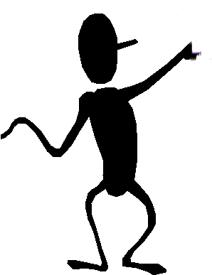

|  |  |
| --- | --- |
| **Step 3**  Give your child a bag that contains 10 different lengths of streamers, string or ribbon.  Ask: *How can you put these streamers so that you know which one is longer?*  Discuss the need to lay them out *straight.*  Discuss the need to have a ***base line*** from which to compare the lengths.  Talk with your child about what they are doing as they arranges the streamers. |  |

**Application**

**Step 1**

Discuss the terms ***height, width*** and ***length.*** Show your child the ***height*** of a table, the ***length*** of a table and the ***width*** of a table by having your child run his/her hand over the different measurements.

**Step 2**

Ask your child to demonstrate understanding of this language by showing you the ***length, width*** and ***height*** of other objects around the home or your environment.



|  |  |
| --- | --- |
| **Step 3**  Stretch out your hand to show your child your ***hand-span***- (the distance between your outstretched thumb and the tip of the little finger.) | **handspan** |

**Step 4**

Use Activity sheet 9

Measure the table.

1. Demonstrate measuring the length of the table using your hand span and record your measurements on the sheet.
2. Ask your child to measure the length of the table using their hand-span.
3. Your child is to record their measurements on the Activity sheet.
4. Complete the measuring activities for height and width as well.

**Step 5**

Measure the table again but this time use an object such as an icypole stick to measure. Record your information on the sheet.

Let your child measure the table with the icypole sticks.

Ask your child to record his/her measurements on the Activity sheet

Ask your child: *What do we have to remember when measuring to get accurate results?*

|  |  |
| --- | --- |
| **j0286532[1]** | Encourage your child to recognise the need for standard units of measurement. |

**Task 4**

**Focus: Number**

**Getting Knowledge Ready**

**Step 1**

Shuffle the number cards.

Flash the cards one at a time and have your child say each number aloud.

The aim is for instant recall of the numerals between 1–20.

**Step 2**

If your child is very confident with the numbers ask him/her to call out the number **after** and **before** the one that you have shown. For example, if you hold up a *13* then ask your child to tell you the number ***before*** or ***after.***

Note: If your child is **not** confident then continue to show him/her the numbers and encourage your child to say them aloud to facilitate instant recognition

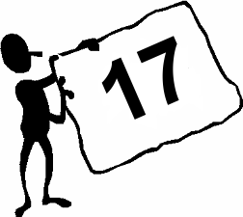 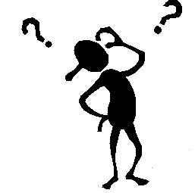

What number comes after this one?

**Application**

**11**

**Step 1** .

|  |  |
| --- | --- |
| Make a number train.  Use Activity sheet 10  Cut out the carriages of the train.  **Step 2** |  |

Paste the carriages in order from 1 to 20 on a long strip of paper.

Draw the right number of people in each carriage. (For ease your child could just draw smiley faces as in the picture above.)

**Step 3**

Use Activity sheet 11.

Complete the *before* and *after* activity.

**Step 4**

**Stepping Stones**

Lay the jumbled number cards out in a line to pretend that they are stepping stones to cross the river.

Have your child jump alongside each one and say the number.

(Pretend your child will fall in the river and have to start again if he/she reads one incorrectly.)

**Step 5**

**Tic Tac Toe**

Place the number cards face down.

Take it in turns with a partner to say:

*Tic Tac Toe*

*Here I go*

*Where I stop I do not know.*

As you say each word in the rhyme point to a different card. When you finish the rhyme, turn over the card you are pointing to and ask your child to say   
the number.

**Activity 5**

**Whack a Mole**

If you have access to a computer your child can play the *Whack a Mole* game.

<http://www.ictgames.com/whackAMole/index.html>

Adjust the slider so that the numbers are set between 1 and 20.

Adjust the second slider so the numbers go up in increments of 1 only.

Whack the mole with the next number in the sequence as it pops up from the hole.



In the example shown your child would need to click on (whack) the mole with the number 3 on it, because the number 2 has come up.

**Activity 6**

**Counting caterpillar**

1. Go to: <http://www.ictgames.com/caterpillar_slider.html>

2. Move the sliders in the green circles so that the minimum number is 0 and the maximum number is 20 as shown here.

3. Encourage your child to use this interactive to sequence random numbers between 0 and 20.

|  |  |
| --- | --- |
|  |  |

**Task 5**

**Focus: Space**

**Getting Knowledge Ready**

**Step 1**

Use Activity sheet 12

Read each shape word to your child.

Ask your child to draw the shape in each box.

**Application**

**Step 1**

UseActivity sheets 13 and 14.

Help your child look for objects that are formed from different shapes.

Ask your child to complete the Activity sheets.

*How did you know the shape was a triangle?*

*What other shapes did you find?*

*Can you describe them?*

*Do you know their names?*

|  |  |
| --- | --- |
|  |  |

**Task 6****Focus: Number**

**Getting Knowledge Ready**

**Step 1**

Place the number cards from Task 1 and put them in a bag. Have your child take a lucky dip into the bag and pull out one number card.

**Step 2**

Ask your child to say the number on the card and then ***count on*** to 20 from this number.

**Step 3**

Have your child pull another number out of the bag.

Ask your child to say the number on the card and then count *backwards* to 0

from this number.

**Step 4**

Continue to have your child pull numbers out of the bag so he/she can practise *counting on* and *backwards* from different starting points.

**Application**

**Step 1**

Use Activity Sheets 15 and 16.

Your child will complete the pictures to make numbers to 20.

**Step 2**

Use Activity Sheet 17.

Draw the matches to show the numbers shown.

The first is done for you.

**Task 7**

**Focus: Number**

**Getting Knowledge Ready**

**Step 1**

Use icypole sticks to model numbers.

Your child will need to physically count ten icypole sticks and then bundle them together with a band. This will help your child to remember that the bundle of ten sticks makes one group of ten.

The other sticks should be kept as separate ones/units.

**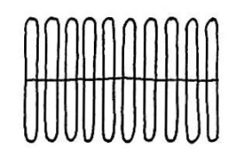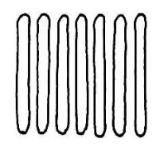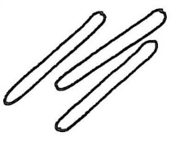**

**Step 2**

Have your child model different numbers by physically counting the sticks. He/she should be able to confidently *count on* from 10 by saying *ten* as he/she points to the bundle of ten sticks.

**Application**

**Step 1**

Use Activity sheet 18.  
Introduce the Place Value chart.

The bundle of tens sit in the tens column and the single sticks are placed in the ones column. Below is a model of the number thirteen. Model this on the Place Value chart.

|  |  |
| --- | --- |
| **Tens** | **Ones** |
| **tend**  **1** bundle of  **10** sticks | **threes**  **3** sticks |

**Step 2**

Have your child model different teen numbers using the sticks and the place value chart.   
Say a number and see if your child can model it with the sticks.

**Step 3**

Use Activity sheet 19.

Ask your child to write the number for each stick model shown.

Encourage your child to explain that he/she is putting one ten in the tens column.

.

**Task 8**

**Focus: Chance and Data**

**Getting Knowledge Ready**

**Step 1**

Say statements to your child such as:

*You will eat dinner tomorrow.*

*You will get dressed tomorrow.*

*I will have purple hair tomorrow.*

After each statement, ask: *What is the chance of this happening?*

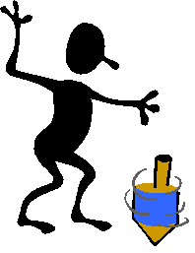 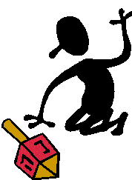

Maybe!

Do you think I will throw a six?

**Step 2**

Ask your child to brainstorm to show what he or she already knows about ***Chance***.

|  |  |
| --- | --- |
| j0078711[1] | What words do I already know about *Chance* ?  You may have to prompt your child if necessary. |
| **Step 3**  On top of a piece of paper write the heading *Chance Words*.  List words describing the likelihood of different events, such as *impossible, possible, will never happen, may happen, will happen, certain, likely, unlikely.*  Discuss the meaning of each word listed. You can add to the chart as your child develops more *Chance* vocabulary. | |

**Application**

**Step 1**

Have your child fold a second sheet of paper into three sections and write these headings at the top of each column: *Impossible, Possible* and *Certain.*

**Step 2**

Ask your child to write or draw an event that fits into each category. You may have to think of something under each heading to provide an example for your child. For example:

|  |  |  |
| --- | --- | --- |
| **Impossible** | **Possible** | **Certain** |
| j0115920[1]  A cat playing the fiddle | j0116106[1]  A lady in the garden | j0116018[1]  Night time |

If your child has done drawings encourage labelling them to describe the events your child has drawn.

**Task 9**

**impossible**

**Focus — Chance and Data**

**Getting Knowledge Ready**

**possible**

**Step 1**

Use Activity sheet 20.

Use the template to make the die with the words impossible, possible, certain etc on each face. Ask your child to suggest other words of chance and write one on each of the empty faces of the die. Your child may refer to the *Chance Words* that were listed in Task 8.

**Step 2**

When all faces of the die have a chance word written on them take turns with your child to throw the die.

Players then relate an event that they believe corresponds to that word or phrase.

For example, if they roll the word *impossible*, they must describe an impossible event.   
For example, *I will see a live dinosaur today.*

**Application**

**Step 1**

Use Activity sheet 21

Discuss each of the pictures with your child.

**Step 2**

Cut out the squares

Ask your child to lay them out in a line in order from ***most likely*** ***to occur*** to ***least likely to occur.***

Have your child paste the cards onto a long strip of paper starting with the most likely and finishing with the least likely.

Encourage your child to discuss why he/she is placing a picture in a certain spot.

.****

**Step 3**

Use Activity sheets 22 and 23 (note sheet 22 is the same as sheet 21 so there is a set that hasn’t been stuck down to play the game with).

Play the game, *Will it happen today?* with your child.

The instructions are on Activity sheet 23

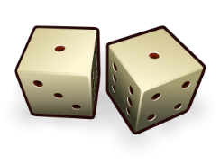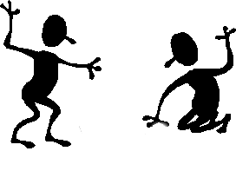

**Task 10**

**Focus: Review**

1. Ask your child to count from 1 to 20 by 1s.

\_\_\_\_\_\_\_\_\_\_\_\_\_\_\_\_\_\_\_\_\_\_\_\_\_\_\_\_\_\_\_\_\_\_\_\_\_\_\_\_\_\_\_\_\_\_\_\_\_\_\_\_\_\_\_\_\_\_

\_\_\_\_\_\_\_\_\_\_\_\_\_\_\_\_\_\_\_\_\_\_\_\_\_\_\_\_\_\_\_\_\_\_\_\_\_\_\_\_\_\_\_\_\_\_\_\_\_\_\_\_\_\_\_\_\_\_

1. Say: *Start counting by 1s.*   
     
   from 9 \_\_\_\_\_\_\_\_\_\_\_\_\_\_\_\_\_\_\_\_\_\_\_\_\_\_\_\_\_\_\_\_\_\_\_\_\_\_\_\_\_\_\_  
     
   from 11 \_\_\_\_\_\_\_\_\_\_\_\_\_\_\_\_\_\_\_\_\_\_\_\_\_\_\_\_\_\_\_\_\_\_\_\_\_\_\_\_\_\_\_  
     
   from 15 \_\_\_\_\_\_\_\_\_\_\_\_\_\_\_\_\_\_\_\_\_\_\_\_\_\_\_\_\_\_\_\_\_\_\_\_\_\_\_\_\_\_\_
2. Ask:

What number comes after 11? \_\_\_\_\_ 14\_\_\_\_\_ 18 \_\_\_\_\_\_

1. Ask:

What number comes before 12? \_\_\_\_\_ 15\_\_\_\_\_ 17 \_\_\_\_\_\_

1. Ask your child to write these numbers in order from smallest to largest.

5, 3, 17, 12.

\_\_, \_\_, \_\_, \_\_.

1. Ask your child to write these numbers in order from largest to smallest.

16, 8, 15, 19.

\_\_, \_\_, \_\_, \_\_.

1. Ask your child to identify the shapes seen below and write the responses on the line below.

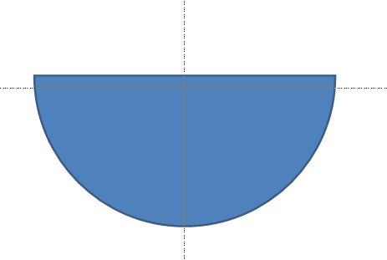

\_\_\_\_\_\_\_\_ \_\_\_\_\_\_\_\_ \_\_\_\_\_\_\_\_ \_\_\_\_\_\_\_\_ \_\_\_\_\_\_\_\_\_

Tick each shape name if your child can find objects in the room that have the following shapes:

|  |  |
| --- | --- |
| triangle |  |
| square |  |
| rectangle |  |
| semi-circle |  |
| diamond (rhombus) |  |
| circle |  |

1. Write the number for each of the ten frames.

|  |  |  |  |  |  |  |  |  |  |  |  |  |
| --- | --- | --- | --- | --- | --- | --- | --- | --- | --- | --- | --- | --- |
| **●** | **●** | **●** | **●** | **●** |  | **●** | **●** | **●** |  |  |  |  |
| **●** | **●** | **●** | **●** | **●** |  | **●** | **●** | **●** |  |  |  |

|  |  |  |  |  |  |  |  |  |  |  |  |  |
| --- | --- | --- | --- | --- | --- | --- | --- | --- | --- | --- | --- | --- |
| **●** | **●** | **●** | **●** | **●** |  | **●** | **●** |  |  |  |  |  |
| **●** | **●** | **●** | **●** | **●** |  | **●** | **●** |  |  |  |  |

|  |  |  |  |  |  |  |  |  |  |  |  |  |
| --- | --- | --- | --- | --- | --- | --- | --- | --- | --- | --- | --- | --- |
| **●** | **●** | **●** | **●** | **●** |  | **●** | **●** | **●** | **●** |  |  |  |
| **●** | **●** | **●** | **●** | **●** |  | **●** | **●** | **●** | **●** |  |  |

Draw dots in the ten frames to match the number.

|  |  |  |  |  |  |  |  |  |  |  |  |  |
| --- | --- | --- | --- | --- | --- | --- | --- | --- | --- | --- | --- | --- |
|  |  |  |  |  |  |  |  |  |  |  |  | **15** |
|  |  |  |  |  |  |  |  |  |  |  |  |

|  |  |  |  |  |  |  |  |  |  |  |  |  |
| --- | --- | --- | --- | --- | --- | --- | --- | --- | --- | --- | --- | --- |
|  |  |  |  |  |  |  |  |  |  |  |  | **19** |
|  |  |  |  |  |  |  |  |  |  |  |  |

|  |  |  |  |  |  |  |  |  |  |  |  |  |
| --- | --- | --- | --- | --- | --- | --- | --- | --- | --- | --- | --- | --- |
|  |  |  |  |  |  |  |  |  |  |  |  | **11** |
|  |  |  |  |  |  |  |  |  |  |  |  |

\_\_\_\_\_\_\_\_\_\_\_\_\_\_\_\_\_\_\_\_\_\_\_\_\_\_\_\_\_\_\_\_\_\_\_\_\_\_\_\_\_\_\_\_\_\_\_\_\_\_\_\_\_\_\_\_\_\_

1. Ask your child to draw a line from the picture to the word that best describes his chance of seeing that thing today.

|  |  |
| --- | --- |
| possible | j0367430[1] |
| impossible | j0433902[1] |
| likely | j0368410[1] |
| unlikely | j0215502[1] |

**Activity Pages**

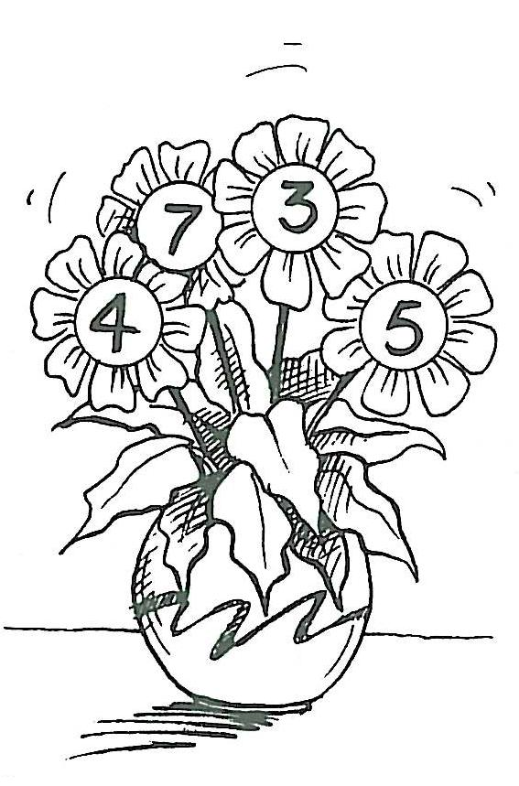

|  |  |  |
| --- | --- | --- |
| **Maths Activity Sheet 1**  **Number Cards 0–10** | | |
| **0** | **1** | **2** |
| **3** | **4** | **5** |
| **6** | **7** | **8** |
| **9** | **10** |  |

|  |  |  |
| --- | --- | --- |
| **Maths Activity Sheet 2**  **Number Cards 11–20** | | |
|  | **11** | **12** |
| **13** | **14** | **15** |
| **16** | **17** | **18** |
| **19** | **20** |  |

**Maths Activity Sheet 3**

|  |  |  |  |  |
| --- | --- | --- | --- | --- |
|  |  |  |  |  |
|  |  |  |  |  |

|  |  |  |  |  |
| --- | --- | --- | --- | --- |
|  |  |  |  |  |
|  |  |  |  |  |

|  |  |  |  |  |
| --- | --- | --- | --- | --- |
|  |  |  |  |  |
|  |  |  |  |  |

|  |  |  |  |  |
| --- | --- | --- | --- | --- |
|  |  |  |  |  |
|  |  |  |  |  |

**Maths Activity Sheet 4**

Draw a dot in each square of the ten frames to model each of the numbers between 11 and 20.

|  |  |  |  |  |  |  |  |  |  |  |  |  |
| --- | --- | --- | --- | --- | --- | --- | --- | --- | --- | --- | --- | --- |
| **12** |  |  |  |  |  |  |  |  |  |  |  |  |
|  |  |  |  |  |  |  |  |  |  |  |

|  |  |  |  |  |  |  |  |  |  |  |  |  |
| --- | --- | --- | --- | --- | --- | --- | --- | --- | --- | --- | --- | --- |
| **15** |  |  |  |  |  |  |  |  |  |  |  |  |
|  |  |  |  |  |  |  |  |  |  |  |

|  |  |  |  |  |  |  |  |  |  |  |  |  |
| --- | --- | --- | --- | --- | --- | --- | --- | --- | --- | --- | --- | --- |
| **17** |  |  |  |  |  |  |  |  |  |  |  |  |
|  |  |  |  |  |  |  |  |  |  |  |

|  |  |  |  |  |  |  |  |  |  |  |  |  |
| --- | --- | --- | --- | --- | --- | --- | --- | --- | --- | --- | --- | --- |
| **19** |  |  |  |  |  |  |  |  |  |  |  |  |
|  |  |  |  |  |  |  |  |  |  |  |

|  |  |  |  |  |  |  |  |  |  |  |  |  |
| --- | --- | --- | --- | --- | --- | --- | --- | --- | --- | --- | --- | --- |
| **11** |  |  |  |  |  |  |  |  |  |  |  |  |
|  |  |  |  |  |  |  |  |  |  |  |

**Maths Activity Sheet 5**

Draw a dot in each square of the ten frames to model each of the numbers between 11 and 20.

|  |  |  |  |  |  |  |  |  |  |  |  |  |
| --- | --- | --- | --- | --- | --- | --- | --- | --- | --- | --- | --- | --- |
| **13** |  |  |  |  |  |  |  |  |  |  |  |  |
|  |  |  |  |  |  |  |  |  |  |  |

|  |  |  |  |  |  |  |  |  |  |  |  |  |
| --- | --- | --- | --- | --- | --- | --- | --- | --- | --- | --- | --- | --- |
| **16** |  |  |  |  |  |  |  |  |  |  |  |  |
|  |  |  |  |  |  |  |  |  |  |  |

|  |  |  |  |  |  |  |  |  |  |  |  |  |
| --- | --- | --- | --- | --- | --- | --- | --- | --- | --- | --- | --- | --- |
| **20** |  |  |  |  |  |  |  |  |  |  |  |  |
|  |  |  |  |  |  |  |  |  |  |  |

|  |  |  |  |  |  |  |  |  |  |  |  |  |
| --- | --- | --- | --- | --- | --- | --- | --- | --- | --- | --- | --- | --- |
| **14** |  |  |  |  |  |  |  |  |  |  |  |  |
|  |  |  |  |  |  |  |  |  |  |  |

|  |  |  |  |  |  |  |  |  |  |  |  |  |
| --- | --- | --- | --- | --- | --- | --- | --- | --- | --- | --- | --- | --- |
| **18** |  |  |  |  |  |  |  |  |  |  |  |  |
|  |  |  |  |  |  |  |  |  |  |  |

**Maths Activity Sheet 6**

|  |  |  |  |  |  |
| --- | --- | --- | --- | --- | --- |
|  |  |  |  |  |  |
|  |  |  |  |  |  |
|  |  |  |  |  |  |
|  |  |  |  |  |  |
|  |  |  |  |  |  |
|  |  |  |  |  |  |
|  |  |  |  |  |  |
|  |  |  |  |  |  |
|  |  |  |  |  |  |
|  |  |  |  |  |  |

**Maths Activity Sheet 7**

|  |  |  |  |  |  |
| --- | --- | --- | --- | --- | --- |
|  |  |  |  |  |  |
|  |  |  |  |  |  |
|  |  |  |  |  |  |
|  |  |  |  |  |  |
|  |  |  |  |  |  |
|  |  |  |  |  |  |
|  |  |  |  |  |  |
|  |  |  |  |  |  |
|  |  |  |  |  |  |
|  |  |  |  |  |  |

**Maths Activity Sheet 8**

Cut out these ten frames for your child to paste beside the numbers he/she has written.

|  |  |  |  |  |  |  |  |  |  |  |
| --- | --- | --- | --- | --- | --- | --- | --- | --- | --- | --- |
| **●** | **●** | **●** | **●** | **●** |  | **●** | **●** | **●** | **●** | **●** |
| **●** | **●** | **●** | **●** | **●** |  | **●** | **●** | **●** |  |  |

|  |  |  |  |  |  |  |  |  |  |  |
| --- | --- | --- | --- | --- | --- | --- | --- | --- | --- | --- |
| **●** | **●** | **●** | **●** | **●** |  | **●** | **●** |  |  |  |
| **●** | **●** | **●** | **●** | **●** |  | **●** | **●** |  |  |  |

|  |  |  |  |  |  |  |  |  |  |  |
| --- | --- | --- | --- | --- | --- | --- | --- | --- | --- | --- |
| **●** | **●** | **●** | **●** | **●** |  | **●** | **●** | **●** | **●** |  |
| **●** | **●** | **●** | **●** | **●** |  | **●** | **●** | **●** | **●** |  |

|  |  |  |  |  |  |  |  |  |  |  |
| --- | --- | --- | --- | --- | --- | --- | --- | --- | --- | --- |
| **●** | **●** | **●** | **●** | **●** |  | **●** |  |  |  |  |
| **●** | **●** | **●** | **●** | **●** |  | **●** |  |  |  |  |

|  |  |  |  |  |  |  |  |  |  |  |
| --- | --- | --- | --- | --- | --- | --- | --- | --- | --- | --- |
| **●** | **●** | **●** | **●** | **●** |  | **●** | **●** | **●** | **●** | **●** |
| **●** | **●** | **●** | **●** | **●** |  | **●** | **●** | **●** | **●** |  |

|  |  |  |  |  |  |  |  |  |  |  |
| --- | --- | --- | --- | --- | --- | --- | --- | --- | --- | --- |
| **●** | **●** | **●** | **●** | **●** |  | **●** |  |  |  |  |
| **●** | **●** | **●** | **●** | **●** |  |  |  |  |  |  |

|  |  |  |  |  |  |  |  |  |  |  |
| --- | --- | --- | --- | --- | --- | --- | --- | --- | --- | --- |
| **●** | **●** | **●** | **●** | **●** |  | **●** | **●** | **●** |  |  |
| **●** | **●** | **●** | **●** | **●** |  | **●** | **●** |  |  |  |

|  |  |  |  |  |  |  |  |  |  |  |
| --- | --- | --- | --- | --- | --- | --- | --- | --- | --- | --- |
| **●** | **●** | **●** | **●** | **●** |  | **●** | **●** |  |  |  |
| **●** | **●** | **●** | **●** | **●** |  | **●** |  |  |  |  |

|  |  |  |  |  |  |  |  |  |  |  |
| --- | --- | --- | --- | --- | --- | --- | --- | --- | --- | --- |
| **●** | **●** | **●** | **●** | **●** |  | **●** | **●** | **●** | **●** | **●** |
| **●** | **●** | **●** | **●** | **●** |  | **●** | **●** | **●** | **●** | **●** |

|  |  |  |  |  |  |  |  |  |  |  |
| --- | --- | --- | --- | --- | --- | --- | --- | --- | --- | --- |
| **●** | **●** | **●** | **●** | **●** |  | **●** | **●** | **●** | **●** |  |
| **●** | **●** | **●** | **●** | **●** |  | **●** | **●** | **●** |  |  |

**Maths Activity Sheet 9**

hh01600_[1]

Height

Length

Width

|  |  |  |
| --- | --- | --- |
| **Using hand-spans** | **Adult** | **Student** |
| The width of the table |  |  |
| The length of the table |  |  |
| The height of the table |  |  |

|  |  |  |
| --- | --- | --- |
| **Using icypole sticks** | **Adult** | **Student** |
| The width of the table |  |  |
| The length of the table |  |  |
| The height of the table |  |  |

**Maths Activity Sheet 10**

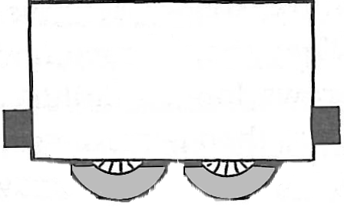

**20**

**11**

**14**

**19**



**9**

**5**

**16**

**2**



**12**

**10**

**3**

**1**



**6**

**18**

**13**

**7**



**8**

**17**

**15**

**4**

1. Cut the carriages and paste each one on a long strip of paper in order from 1 to 20. Draw an engine to pull the carriages.
2. Draw the right number of people ( ) in each carriage.

**Maths Activity Sheet 11**

Write the numbers before and after:

|  |  |  |  |  |
| --- | --- | --- | --- | --- |
|  |  | **14** |  |  |
|  |  |  |  |  |
|  |  | **9** |  |  |
|  |  |  |  |  |
|  |  | **16** |  |  |
|  |  |  |  |  |
|  |  | **2** |  |  |
|  |  |  |  |  |
|  |  | **6** |  |  |

Write 8 numbers in order. You can start at any number.

|  |  |  |  |  |  |  |  |
| --- | --- | --- | --- | --- | --- | --- | --- |
|  |  |  |  |  |  |  |  |

**Maths Activity Sheet 12**

Read the word to your child and draw the right shape in   
each box.

|  |  |  |
| --- | --- | --- |
| circle | triangle | rectangle |
| square | diamond (rhombus) | oval |

**Maths Activity Sheet 13**

**Shape Hunt**

Look around you.

Look for things that are the shape of circles, triangles and rectangles.

Draw them in the columns below.

|  |  |  |
| --- | --- | --- |
| **Circles**  **ed00277_[1]** | **Triangles**  **ed00281_[1]** | **Rectangles**  **ed00279_[1]** |
|  |  |  |

**Maths Activity Sheet 14**

|  |  |  |
| --- | --- | --- |
| **Rhombus**  **ed00282_[1]** | **Squares**  **ed00278_[1]** | **Ovals** |
|  |  |  |

**Maths Activity Sheet 15**

**Making numbers to 20**

Complete these ten frames.

|  |  |  |  |  |  |  |  |  |  |  |
| --- | --- | --- | --- | --- | --- | --- | --- | --- | --- | --- |
|  |  |  |  | **Tens** |  | **Ones** |  |  |  |  |
| **1** | | | | |  | **4** | | | | |
| **●** | **●** | **●** | **●** | **●** |  |  |  |  |  |  |
| **●** | **●** | **●** | **●** | **●** |  |  |  |  |  |  |

|  |  |  |  |  |  |  |  |  |  |  |
| --- | --- | --- | --- | --- | --- | --- | --- | --- | --- | --- |
|  |  |  |  | **Tens** |  | **Ones** |  |  |  |  |
| **1** | | | | |  | **6** | | | | |
| **●** | **●** | **●** | **●** | **●** |  |  |  |  |  |  |
| **●** | **●** | **●** | **●** | **●** |  |  |  |  |  |  |

|  |  |  |  |  |  |  |  |  |  |  |
| --- | --- | --- | --- | --- | --- | --- | --- | --- | --- | --- |
|  |  |  |  | **Tens** |  | **Ones** |  |  |  |  |
| **2** | | | | |  | **0** | | | | |
| **●** | **●** | **●** | **●** | **●** |  |  |  |  |  |  |
| **●** | **●** | **●** | **●** | **●** |  |  |  |  |  |  |

|  |  |  |  |  |  |  |  |  |  |  |
| --- | --- | --- | --- | --- | --- | --- | --- | --- | --- | --- |
|  |  |  |  | **Tens** |  | **Ones** |  |  |  |  |
| **1** | | | | |  | **5** | | | | |
| **●** | **●** | **●** | **●** | **●** |  |  |  |  |  |  |
| **●** | **●** | **●** | **●** | **●** |  |  |  |  |  |  |

**Maths Activity Sheet 16**

|  |  |  |  |  |  |  |  |  |  |  |
| --- | --- | --- | --- | --- | --- | --- | --- | --- | --- | --- |
|  |  |  |  | **Tens** |  | **Ones** |  |  |  |  |
| **1** | | | | |  | **2** | | | | |
| **●** | **●** | **●** | **●** | **●** |  |  |  |  |  |  |
| **●** | **●** | **●** | **●** | **●** |  |  |  |  |  |  |

|  |  |  |  |  |  |  |  |  |  |  |
| --- | --- | --- | --- | --- | --- | --- | --- | --- | --- | --- |
|  |  |  |  | **Tens** |  | **Ones** |  |  |  |  |
| **1** | | | | |  | **9** | | | | |
| **●** | **●** | **●** | **●** | **●** |  |  |  |  |  |  |
| **●** | **●** | **●** | **●** | **●** |  |  |  |  |  |  |

|  |  |  |  |  |  |  |  |  |  |  |
| --- | --- | --- | --- | --- | --- | --- | --- | --- | --- | --- |
|  |  |  |  | **Tens** |  | **Ones** |  |  |  |  |
| **1** | | | | |  | **7** | | | | |
| **●** | **●** | **●** | **●** | **●** |  |  |  |  |  |  |
| **●** | **●** | **●** | **●** | **●** |  |  |  |  |  |  |

|  |  |  |  |  |  |  |  |  |  |  |
| --- | --- | --- | --- | --- | --- | --- | --- | --- | --- | --- |
|  |  |  |  | **Tens** |  | **Ones** |  |  |  |  |
| **1** | | | | |  | **3** | | | | |
| **●** | **●** | **●** | **●** | **●** |  |  |  |  |  |  |
| **●** | **●** | **●** | **●** | **●** |  |  |  |  |  |  |

**Maths Activity Sheet 17**

***Count on*** from 10 to add the right number of matches for each number shown. The first one has been done for you.

|  |  |  |
| --- | --- | --- |
| 17 | matchsticks | matchstick7matchstickbox |
| 11 | matchsticks | matchstickbox |
| 20 | matchsticks | matchstickbox |
| 13 | matchsticks | matchstickbox |
| 19 | matchsticks | matchstickbox |
| 12 | matchsticks | matchstickbox |

**Maths Activity Sheet 18**

**Place Value Chart**

|  |  |
| --- | --- |
| **Tens** | **Ones** |
|  |  |

**Maths Activity Sheet 19**

**Write the number for each model of sticks.**

**Count on from ten.**

|  |  |
| --- | --- |
| **bundle of tenfour units** |  |
| **bundle of tenfive units** |  |
| **bundle of ten3units** |  |
| **bundle of tennine units** |  |
| **bundle of tenfour unitsfour units** |  |
| **bundle of ten3units3units** |  |

**Maths Activity Sheet 20**

***Chance* words die**

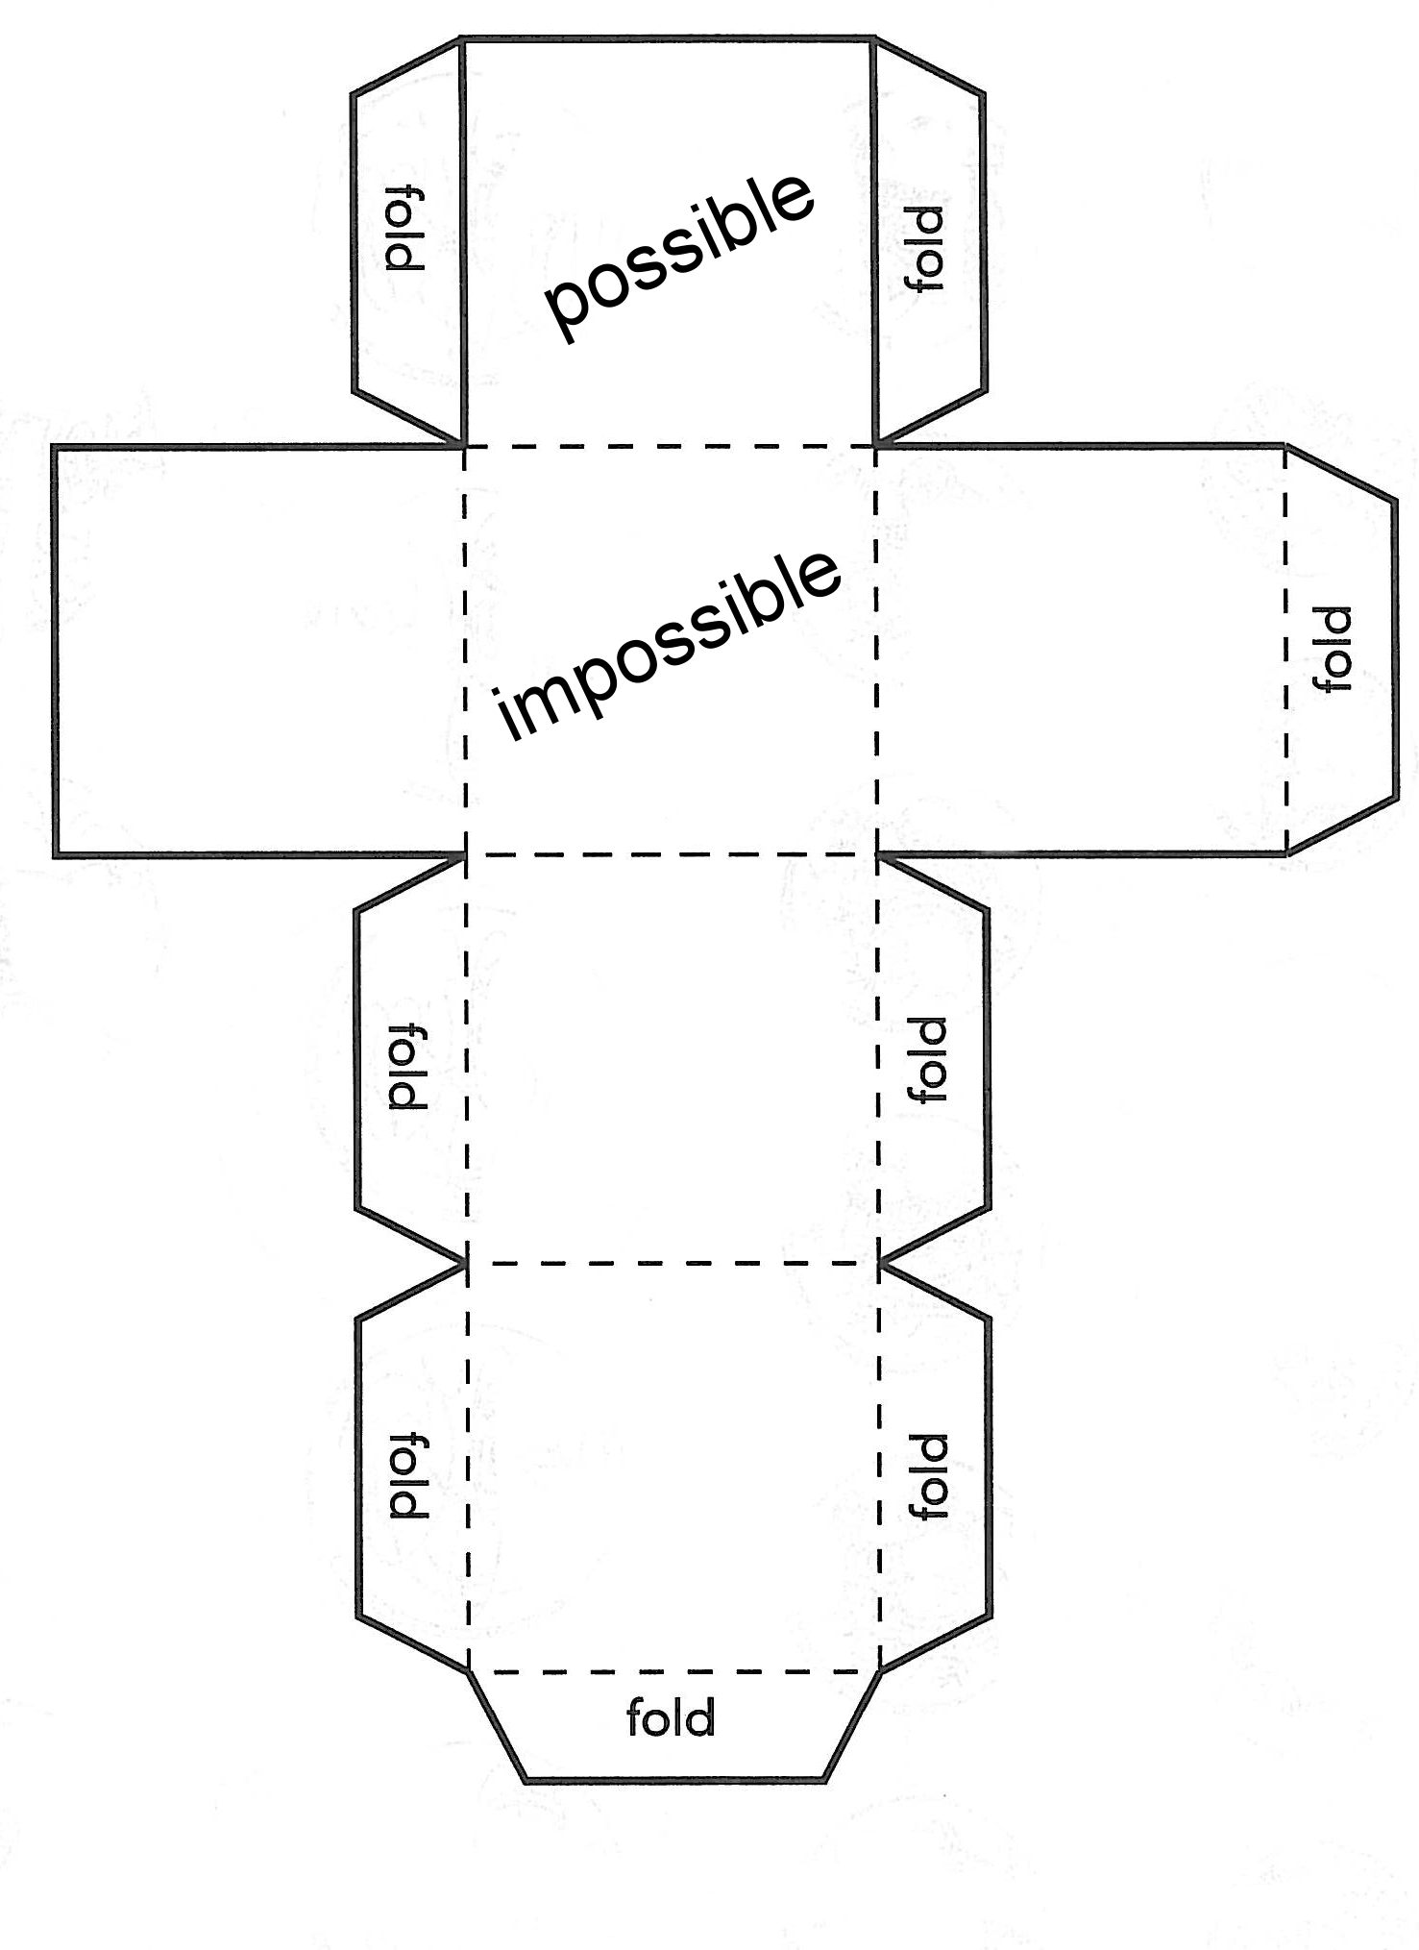

**Maths Activity Sheet 21** 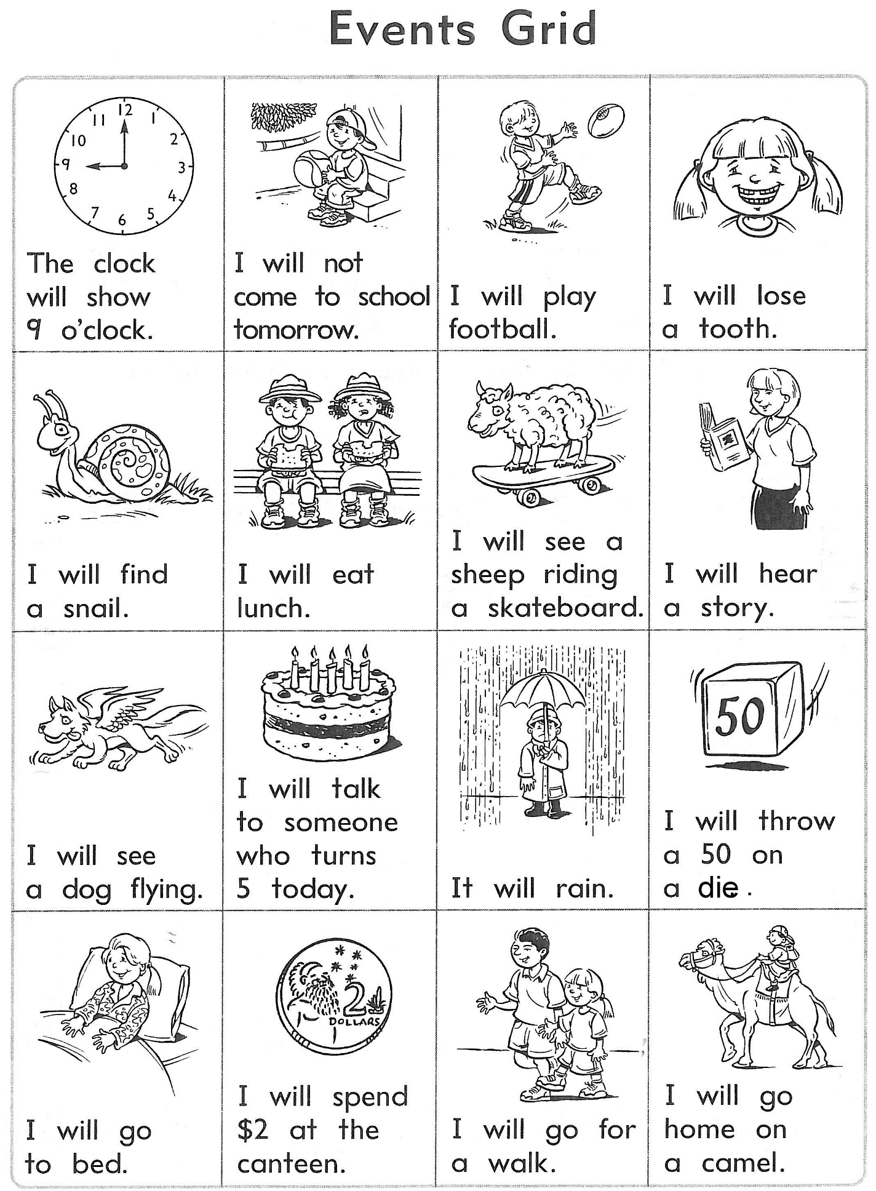

**Maths Activity Sheet 22**

**Maths Activity Sheet 23**

**Will It Happen Today?**

|  |  |
| --- | --- |
| **Materials**   * A die * counters * Activity sheets 9.2 and 9.3 (Events Grids) |  |

**Instructions**

1. Play with a friend. Each player puts a counter on “Start.”
2. In turn, roll the die and move that number of places.
3. Read out what is written.
4. Now put one of your coloured counters on a matching event on the Events Grid. You must say why you put your counter there.
5. If you can’t place a counter, miss a turn.
6. First to get 4 of their counters in a line wins.

