|  |
| --- |
| **Visual Arts** |

|  |
| --- |
| image002 |

How can we create images from poems?



|  |
| --- |
| **Visual Arts**  How can we create images from poems? |

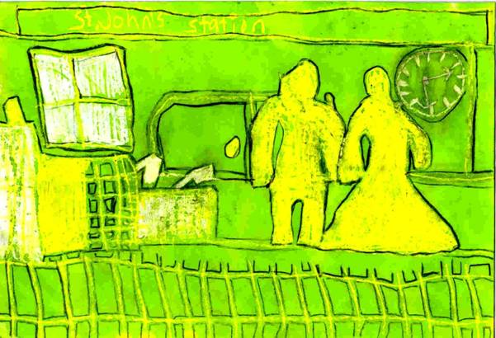

***Train Travel* by Samuel**

**Learning Intentions**

**To be able to:**

* listen and read two poems and use imagery that comes to mind to influence

your art work.

* create two wax resist art works.

|  |
| --- |
|  |

|  |
| --- |
| Wax Resist and Charcoal Activity 1 |

|  |  |
| --- | --- |
| You may have worked with the wax resist technique before.  The wax in the crayon resists water-based colours in the same way that both oil and fat resist mixing with water.  I would like you to visualise the pictures created through poetry. | image004 |

**MATERIALS NEEDED**

|  |  |
| --- | --- |
| * White or yellow crayon. * Coloured food dyes (simply mix the powder   with water). | * Charcoal or black texta or pencil * Cartridge (plain white) paper. * Brushes and water. |

**Step 1** *Listening to the poems*

Have you travelled on or seen a train at night? These two poetry extracts are about night trains. Read the two poetry extracts yourself. Shut your eyes and try to create a picture in your mind as you hear the words.

|  |
| --- |
|  |
| ***On the Night Train* by Henry Lawson** |
|  |
| Have you seen the bush by moonlight, from the train go running by, |
| Here a patch of glassy water, there a glimpse of mystic days? |
|  |

|  |
| --- |
|  |
| ***The Night Ride* by Kenneth Slessor** |
|  |
| Black, sinister travellers lumbering up the station, |
| One moment in the window, hooked over bags; |
| Hurrying, unknown faces—boxes with strange labels— |
| All groping clumsily to mysterious ends. |
|  |

**Step 2** *Selecting a poetry picture to illustrate*

Select the poetic image that you like most. You can use it as your inspiration when creating your wax resist and charcoal picture.

|  |
| --- |
| **Wax Resist and Charcoal** **Activity 1** |

**Step 3** *Drawing the picture*

Using your white or yellow crayon, draw the picture that you have visualised after listening to the poem.

**Step 4** *Painting over the picture*

Now it is time to paint over the wax picture with the coloured food dyes of your choice.

**Step 5** *Outline*

When your picture has dried out, outine the crayon lines with black texta, pencil or charcoal

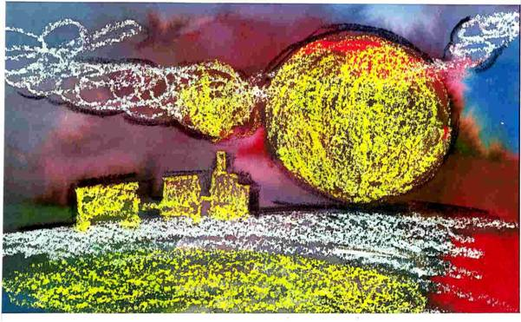

**This is student William's *Train by Moonlight***

**Step 6** *Reflect on your work*

Display your artwork in a prominent place. Are you pleased with your creation? Invite others to admire your work

Did you have any problems? Would you do something differently next time?

|  |
| --- |
| Wax Resist – Cyclone Activity 2 |

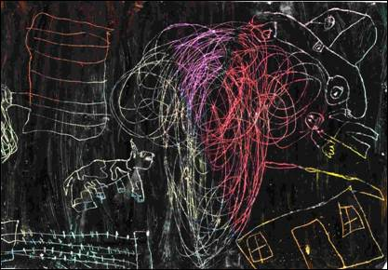

**Cyclone—artwork by Samuel**

When travelling to the far north of Australia you are moving into the tropic regions. This part of Australia often experiences turbulent weather including cyclones. You may have heard mention of some of these cyclones on TV or radio news. They are usually given a name in alphabetical order. e.g. Cyclone **B**etsy, Cyclone **C**larice, Cyclone **D**avid, Cyclone **E**va . . . and so on. You might recall that in 2005 Cyclone **Katrina** caused a lot of devastation in the USA.

Many of our students have written about their experiences when they've been travelling in areas of turbulent or cyclone activity. Perhaps you too have

experienced a cyclone. I'm sure that it is an unforgettably frightening experience!

According to the dictionary a cyclone is a storm 80 to 1500 kilometres in diameter, moving at 30 to 60 kilometres an hour, with winds (often violent in the tropics) and much rain. The winds rotate at 150 to 200 kilometres an hour around a calm centre of low pressure. Other terms used are hurricane and typhoon.

|  |
| --- |
| Wax Resist – Cyclone Activity 2 |

**I'd like you to have a go at creating a cyclone picture.**

**MATERIALS NEEDED**

|  |  |
| --- | --- |
| * Black paint thickened with a bit of soap powder. * Instrument to use for scraping for example chopsticks, teaspoon, penci;ll or stick. * Newspaper. | * Oil pastels. * Cartridge (plain white) paper. * Paint brush. |

**Step 1** *Oil pastels*

Using oil pastels cover the paper with thick areas of colour. There should be no areas of white left showing.

**Step 2** *Black paint*

Over the pastel layer, apply a thick coat of soapy black paint.

**Step 3** *Thinking about cyclone movement*

You will be using something to scratch and create your cyclone effect. Before you start, think about the sort of lines and shapes that you will need to use to create strong movement.

**Helpful Hints**

* Try a variety of tools for different effects.
* The more paint you scratch away then the more colour will be revealed.

**Step 4** *Scratching cyclone picture*

When the paint is dry scratch your cyclone picture into the surface of the black paint. Take care not to scratch too deeply as this will make a hole in your paper.

**Step 5** *Reflect on your work*

Reflect and admire your dynamic cyclone picture.

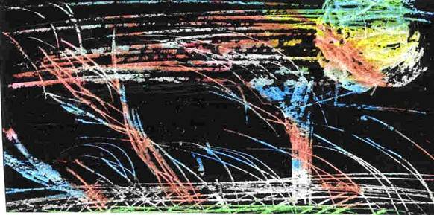

**Cyclone—artwork by William**

|  |
| --- |
| **THINKING ABOUT YOUR LEARNING**  Description: Description: Description: Description: Description: http://t0.gstatic.com/images?q=tbn:ANd9GcTiyp1Q0EWVRSXlqyIMaG6be3rodf0nBbu2oBIY8JlYVh1iP8U7**I understand ______________________________________________**  **___________________________________________________________________________**  **___________________________________________________________________________**  **___________________________________________________________________________**  **___________________________________________________________________________**  **I would like to improve on_____________________________________________**  **___________________________________________________________________________**  **___________________________________________________________________________**  **___________________________________________________________________________**  **___________________________________________________________________________**  **___________________________________________________________________________**  **___________________________________________________________________________** |

|  |
| --- |
| **YOUR QUESTIONS OR COMMENTS** |
|  |