English

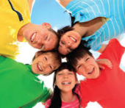

**Think**

**Analyse**

**Understand**

**Communicate**

***How do I write a narrative that will engage readers?***

|  |  |  |
| --- | --- | --- |
| Description: Description: Description: Description: QRDistance | Description: Description: Description: Description: logomedium_black_print  © State of Victoria, Department of Education and Training 2015 | **N Course Code**  **6206** |

**Only for use for the purpose of education for the student(s) provided with the materials by DECV. Not to be reproduced, communicated or otherwise used except as permitted by the Copyright Act 1968**

|  |  |  |  |  |  |  |  |  |  |
| --- | --- | --- | --- | --- | --- | --- | --- | --- | --- |
| **Reading Log Week 1: Colour** or tick the minutes you read each day: | | | **Minutes I read for each day:** | | | | | | |
| **School** | | | | **Personal** | | |
| **Good** | | **Excellent** | | | **Superior** | |
| **Day** | **What Did You Read?** | **Interest Meter.** | **15 min** | **30 nm** | **45 min** | **1hr** | | **15 min** | **30 min** |
| **1** |  |  |  |  |  |  | |  |  |
| **2** |  |  |  |  |  |  | |  |  |
| **3** |  |  |  |  |  |  | |  |  |
| **4** |  |  |  |  |  |  | |  |  |
| **5** |  |  |  |  |  |  | |  |  |

Dear Reader,

Tick or highlight the statement/s that best describe your reading this week.

I don’t like to read. I didn’t read much at all. It was difficult to find the time to read. I sometimes struggle to understand what I read.

I enjoyed reading this week. I couldn’t stop reading. I was able to talk about what I read. I am able to work out the meaning of new words.

I verify *(student)*……………………………………………………………’s **ID**: ……………………………… **Reading Record**. **Supervisor’s Signature**:……………………………………………………………………..…

*Please note: these comments will enable teachers to assess your student’s reading progress for writing reports, so it is very important to complete and submit this page.*

|  |  |  |  |  |  |  |  |  |  |
| --- | --- | --- | --- | --- | --- | --- | --- | --- | --- |
| **Reading Log Week 2: Colour** or tick the minutes you read each day: | | | **Minutes I read for each day:** | | | | | | |
| **School** | | | | **Personal** | | |
| **Good** | | **Excellent** | | | **Superior** | |
| **Day** | **What Did You Read?** | **Interest Meter.** | **15 min** | **30 nm** | **45 min** | **1hr** | | **15 min** | **30 min** |
| **6** |  |  |  |  |  |  | |  |  |
| **7** |  |  |  |  |  |  | |  |  |
| **8** |  |  |  |  |  |  | |  |  |
| **9** |  |  |  |  |  |  | |  |  |
| **10** |  |  |  |  |  |  | |  |  |

Dear Reader,

Tick or highlight the statement/s that best describe your reading this week.

I don’t like to read. I didn’t read much at all. It was difficult to find the time to read. I sometimes struggle to understand what I read.

I enjoyed reading this week. I couldn’t stop reading. I was able to talk about what I read. I am able to work out the meaning of new words.

I verify *(student)*…………………………………………………….…’s  **ID**: ……………………………………… **Reading Record**. **Supervisor’s Signature**:……………………………………………………………….……..…

*Please note: these comments will enable teachers to assess your student’s reading progress for writing reports, so it is very important to complete and submit this page.*

English Introduction

This Curriculum focuses on Year 6 students developing:

* interest and independence in Reading, Viewing and Writing,
* effective Speaking and Listening skills
* critical thinking skills
* interest and competence in exploring a range of literature and a variety of text types.

English is organised into 16 Modules.

Speaking and Listening, Reading and Viewing and writing are the core elements of the English curriculum. It is expected that two hours per day is allocated for Literacy: Speaking & Listening, Reading & Viewing and Writing. This includes a daily independent reading session of 30 minutes, which is recorded in your Reading Log.

*Learning Intentions* are provided for each day to help you direct your activities.

Content and layout of each module

Your will find symbols in each module. Below is an explanation for each symbol.



This symbol indicates that you need to complete a task and send it in to your teacher. These are generally the tasks that the teacher uses to assess your child’s progress.

In each module you will read text based on a text type such as a personal recount, narrative, letter, or non-fiction. Some activities are designed to develop specific literacy skills

Reading



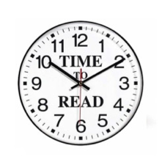**Reading Log**:

It is expected that you read at least for **30 minutes every day.** To help us assess your progress in reading, it is **essential** that the reading log is completed at each reading session. The completed page should be returned with your fortnightly work. This **30 minutes of daily reading** is part of the two hours allocated daily for Literacy activities. **The information in your Reading Log is an important element of assessment for Reading.**

You might be able to download a free Kindle App to your Mac or Windows computer or other device:

[**https://play.google.com/store/apps/details?id=com.amazon.kindle&hl=en**](https://play.google.com/store/apps/details?id=com.amazon.kindle&hl=en)

Create a free account, find a book and get a sample of the first few pages to see if you like the book:

[**http://www.lovereading4kids.co.uk**](http://www.lovereading4kids.co.uk)

Wherever you are, you will be able to download books from your **local library** – make sure you are a member. It’s easy to join.

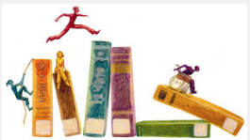

You will examine a range of reading materials to analyse features of different text types. This will help you develop understandings of how authors use words, phrases, sentence structure and grammar, so you can use these strategies in your own writing.

**Analysing the text**



**Words** – vocabulary and spelling

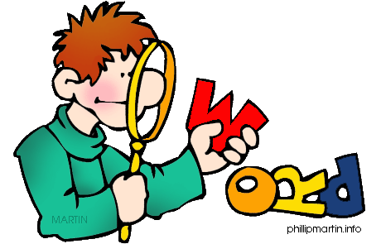

You will be studying words, where they come from, how they are constructed and how they are spelt. You will select interesting words to create particular meanings in sentences and paragraphs.

You will have a list of interesting words each week. These words will be based on a pattern or idea to help you learn about words and how they are constructed. You can use your Literacy Planet Log In to play games and learn more about these words.

**Contact! Contact! Contact!**

It is important that you contact your teacher by phone, email or letter if you have any queries or problems with the work. Your teacher can adjust the work to best suit your individual needs.

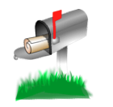

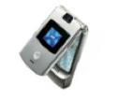

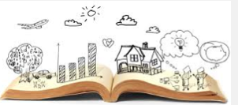**Module N – Learning Intentions**

Students will understand how ***narratives*** are constructed so that they:

* recognise the key features of ***narrative texts***
* understand the differences between the different ***narrative*** genres
* increase awareness of the genres in which ***narratives*** can be written
* analyse the features of ***narrative texts*** to understand how authors write stories to engage readers
* use understanding of ***narrative texts*** to create their own ***narrative,*** in a genre of their choice
* plan, draft write, review, edit and publish a ***narrative***, with the appropriate text features, to engage readers.

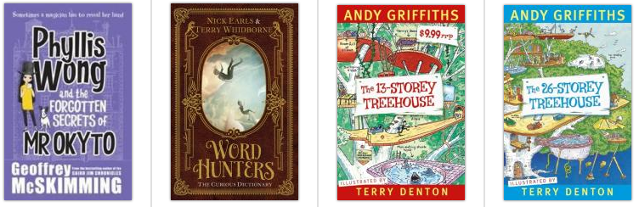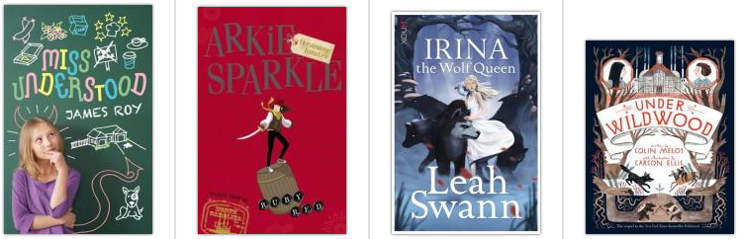

*To complete this module, you will create* and publish a**narrative***. You will be able to choose the genre.*

*You will be able to publish your narrative as a book or as an eBook (if you have an eBook app.)*

*You should spend at least* ***one hour*** *per day reading published narratives, drafting and experimenting with your narrative. Make sure you put your reading time into your reading log and send it to your teacher.*

*Your final copy of your narrative should be uploaded or added to your portfolio.*

***Day 10****: A final published copy is to be sent to your teacher for assessment.*

**Day 1**

**What is a narrative?**

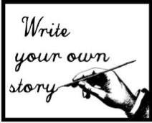

|  |  |
| --- | --- |
| Have you heard a story? ………………….. | Have you watched a story? ………………….. |
| Have you read a story? ………………….. | Have you told someone else a story? …………… |

If you answered “**YES”** to any of these questions, you have experienced a ***narrative*.**

***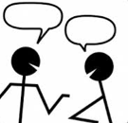***With your supervisor, **THINK** about the different narratives you have seen, heard or read in your life.

Write the title of your favorite narratives here. If you know what the *genre* is (what ‘type’ – fairy tales, myth, fantasy), add that to the list too. Whether it’s a book or a movie, all titles must have ***capital letters*** for the main words. *(Try to add* ***more books*** *than movies to this list, please.)*

|  |  |  |
| --- | --- | --- |
| **Narrative (Story)** | **Genre** | **Media** |
| *Little Red Riding Hood* | *Fairy Tale* | *Book* |
| *The Bad Beginning – A Series of Unfortunate Events* | *Tall Stories or Humour* | *Book* |
| *Star Wars* | *Science Fiction* | *Movie* |
|  |  |  |
|  |  |  |
|  |  |  |
|  |  |  |
|  |  |  |
|  |  |  |
|  |  |  |
|  |  |  |
|  |  |  |

Choose one narrative you added to the list. Write the title here:

My narrative is …………….…………….…………….…………….…………….…………….…………….……

*It would probably be more helpful if you have the narrative with you so you can complete this task.*

*Who are the main* ***characters*** *in your story? Describe each character with one adjective.*

***Setting****: Where does your story happen. Briefly describe the place and the time of your story.*

*What is the* ***plot*** *of your story? Make sure you tell me about the* ***problems*** *your characters had to solve. (Complication.)*

*What is the ‘point’ of the story? What is the ‘lesson’ that we can learn from reading this story?*

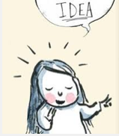Think about what ***you*** know of ***narrative texts*** (stories.)

Write some questions you have about ***narratives***.

*(Remember to use “Who? What? Why? Where? When How?” to help you ask questions.)*

1.

|  |
| --- |
|  |
| 2. |
|  |
| 3. |
|  |
| 4. |
|  |
| 5. |
|  |

Write 5 ideas, facts or opinions about narratives:

1.

|  |
| --- |
|  |
| 2. |
|  |
| 3. |
|  |
| 4. |
|  |
| 5. |
|  |

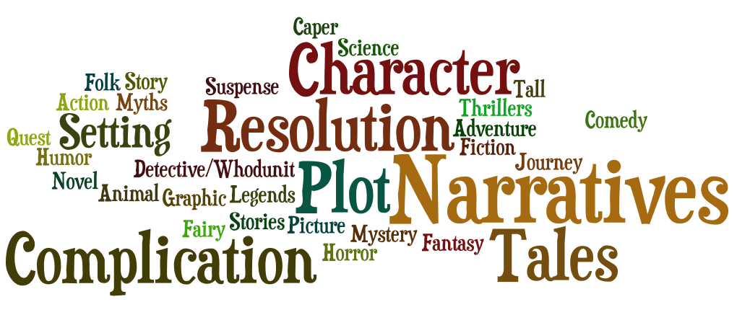This Wordle contains some words that are related to reading and writing ***narratives.*** Find the words that are related to narratives and write them in two groups: the features of a narrative and the genres of a narrative.

|  |  |  |
| --- | --- | --- |
| **Features of a Narrative** |  | **Narrative Genres (**Types of stories) |
|  |  |
|  |  |
|  |  |
|  |  |
|  |  |
|  |  |  |
|  |  |  |
|  |  |  |
|  |  |  |
|  |  |  |
|  |  |  |
|  |  |  |
|  |  |  |
|  |  |  |

*(If you find more words than there are lines, you might be able to write two words on one line.)*

**Words** – vocabulary and spelling



Put the missing letters into the spaces. All the words are to do with ***narratives.***

|  |  |  |  |  |  |
| --- | --- | --- | --- | --- | --- |
| au\_\_\_\_\_\_\_\_or |  | cap\_\_\_\_\_\_\_\_ |  | \_\_\_\_\_\_\_\_der |  |
| \_\_\_\_\_\_\_\_aracter |  | co\_\_\_\_\_\_\_\_dy |  | \_\_\_\_\_\_\_\_ience |  |
| complica\_\_\_\_\_\_\_\_\_\_\_ |  | descrip\_\_\_\_\_\_\_\_\_\_\_ |  | st\_\_\_\_\_\_\_\_y |  |
| detect\_\_\_\_\_\_\_\_\_\_\_ |  | dile\_\_\_\_\_\_\_\_a |  | thri\_\_\_\_\_\_\_\_ers |  |
| edit\_\_\_\_\_\_\_\_ |  | f\_\_\_\_\_\_\_\_ry |  | \_\_\_\_\_\_\_\_est |  |
| fanta\_\_\_\_\_\_\_\_ |  | fic\_\_\_\_\_\_\_\_ |  | resolu\_\_\_\_\_\_\_\_ |  |
| f\_\_\_\_\_\_lk |  | gra\_\_\_\_\_\_\_\_ic |  | se\_\_\_\_\_\_\_\_ing |  |
| ho\_\_\_\_\_\_\_\_or |  | hum\_\_\_\_\_\_\_\_ |  | suspen\_\_\_\_\_\_\_\_ |  |
| journ\_\_\_\_\_\_\_\_ |  | le\_\_\_\_\_\_\_\_nds |  | \_\_\_\_\_\_\_\_iter |  |
| m\_\_\_\_\_\_\_\_tery |  | m\_\_\_\_\_\_\_\_\_\_\_s |  | \_\_\_\_\_\_\_\_enario |  |
| na\_\_\_\_\_\_\_\_ative |  | nov\_\_\_\_\_\_\_\_ |  | st\_\_\_\_\_\_\_\_yline |  |
| pict\_\_\_\_\_\_\_\_\_\_ |  | p\_\_\_\_\_\_\_\_t |  | obsta\_\_\_\_\_\_\_\_ |  |
| ac\_\_\_\_\_\_\_\_ |  | advent\_\_\_\_\_\_\_\_ |  | publish\_\_\_\_\_\_\_\_ |  |

Say these words aloud to your supervisor. Your supervisor will tick the word when you say it correctly.

*Check your answers from the back of the module.*

**Day 2**

Reading



Think about what you know of this traditional story.

|  |  |
| --- | --- |
| \*Who are the characters? | \*What is the setting? |
| \*What is the plot? | \*What is the problem? |
| \*How is the problem (complication) solved? | \*What is the message? |
|  | \*What is the genre? |

Read Little Red Riding Hood. Read one or two paragraphs aloud to your supervisor.

**Little Red Riding Hood**

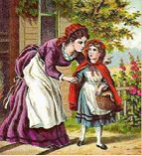*A traditional fairy tale*

Once upon a time there was a little girl who was loved by everyone, but most of all by her grandmother. The girl’s grandmother gave her a cloak made of red velvet, which suited her well. The little girl loved the cloak so much that she wore it all the time. Because she always wore the red cloak with the hood, everyone called her 'Little Red Riding Hood.'

One day Little Red Riding Hood’s mother said, “Here is some cake and a bottle of homemade lemon cordial; take these to your grandmother, she is ill and weak. The food will do her good. Go before it gets too hot, walk nicely and quietly and do not leave the path, so you don’t get lost in the forest and

'I will take great care,' said Little Red Riding Hood to her mother, and shook hands on it.

The grandmother lived out in the woods, about a kilometre from the village. Just as Little Red Riding Hood entered the woods, a wolf crossed her path. Red Riding Hood did not know that this wolf was wicked creature, and she was not at all afraid of him.

'Good day, Little Red Riding Hood,' he said, with a friendly, but slightly sneaky.

'Thank you kindly, Wolf,' said Little Red Riding Hood.

“Why are you in the woods so early, Little Red Riding Hood?' inquired the Wolf.

'I’m going to see my grandmother,' said Little Red Riding Hood.

'What have you got in your basket?' asked the Wolf.

'Cake and cordial. My poor sick grandmother needs to have something good, to make her feel better,” explained Red Riding Hood.

'Where does your grandmother live, Little Red Riding Hood?'

'About a kilometre into the woods; her house stands under the three large oak-trees, the nut-trees are just below; you surely must know it,' replied Little Red Riding Hood.

The wolf thought to himself: 'Hmm! This child might be a tasty snack for me!”

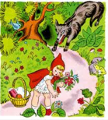So, the Wolf walked alongside Little Red Riding Hood for a short while, then he said:

'See, Little Red Riding Hood, how pretty the flowers - why don’t you stop and pick some nice ones for your Grandmother?

Little Red Riding Hood raised her eyes, and when she saw the sunbeams dancing here and there through the trees, and pretty flowers growing everywhere, she thought, “I am early, and I have plenty of time. I will pick some lovely flowers for my Grandmother to cheer her up.”

So she ran from the path into the wood to look for some lovely flowers. Whenever she picked one, she thought that she saw a still prettier one further on, and ran after it. Without realising it, Little Red Riding Hood wandered deeper and deeper into the woods.

Meanwhile the wolf ran straight to the grandmother's house and knocked at the door.

'Who is there?' asked Grandma

'Little Red Riding Hood,' replied the Wolf. “With cake and cordial for you; open the door.'

'Lift the latch,' called out the grandmother, 'I am too weak, and cannot get up.'

The wolf lifted the latch and the door sprang open. Without saying a word, the Wolf went straight to Grandma's bedroom. Straight away, Grandma knew she was in danger and jumped into the wardrobe and held the door tightly.

The Wolf, slightly annoyed with Grandma’s quick thinking, put on her dressing gown and her night cap. He closed the curtains to darken the room, and put himself into Grandma’s bed.

Little Red Riding Hood had been running around in the woods picking flowers. When she had picked so many that she couldn’t carry any more, she remembered her grandmother, and set out on the path to her house.

Little Red Riding Hood was surprised to find her Grandma’s cottage-door open. When she went into the room, Little Red Riding Hood had such a strange feeling that she said to herself: 'Oh dear! It feels strange in here today.

Little Red Riding Hood called out: 'Good morning,' but there was no answer; so she went to Grandma’s bed. She saw her grandmother with her cap pulled far over her face, and looking very strange.

'Oh! Grandmother,' she said, 'what big ears you have!'

'All the better to hear you with, my child,' was the reply.

'But, grandmother, what big eyes you have!' she said.

'All the better to see you with, my dear,' came the response.

'But, grandmother, what large hands you have!' exclaimed Little Red Riding Hood.

'All the better to hug you with,' the wolf smirked.

'Oh! But, grandmother, what a terrible big mouth you have!' exclaimed Little Red Riding Hood.

'All the better to eat you with!' retorted the figure in the bed.

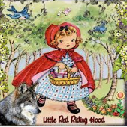As soon as Little Red Riding Hood heard this, she jumped out of the window and ran away as fast as she could. She met a woodsman in the forest. When the woodcutter heard what Little Red Riding Hood told him, he went straight into Grandma’s house. When he saw the Wolf in grandma’s bed, he said, “At last! I have been looking for you everywhere! I need a wolf-skin rug!”

When the wolf heard this, he jumped out of bed, threw down Grandma’s clothes and fled through the window, never to be seen again.

Grandma, Little Red Riding Hood and the Woodcutter were so happy to see the Big Bad Wolf gone. The grandmother ate the cake and drank the cordial that Little Red Riding Hood gave her. Grandma felt much better.

Red Riding Hood thought to herself: 'As long as I live, I will never leave the path by myself to run into the woods and I won’t speak to strangers.’

Little Red Riding Hood, her mother and Grandmother lived happily ever after.

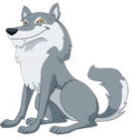       

Thinking about “Little Red Riding Hood” – what is your opinion of this story?

|  |  |  |  |
| --- | --- | --- | --- |
| The ***narrative*** of Little Red Riding Hood: | not much | a bit | a lot |
| * entertains me. |  |  |  |
| * engages me (keeps me interested) |  |  |  |
| * activates my imagination |  |  |  |
| * creates ‘pictures in my mind’ to tell the story |  |  |  |
| * teaches me a lesson or it has a ‘moral to the story’. |  |  |  |

In your own words, briefly retell the story of Little Red Riding Hood. Your answer should include the introduction, the setting, the complication, the events and the resolution, in as few words as possible.

**A Summary of “Little Red Riding Hood.”**

|  |
| --- |
|  |
|  |
|  |
|  |
|  |
|  |
|  |

Find these ***text features***of a ***narrative*** in ***“***Little Red Riding Hood.” Write a few words from the story to show this.

|  |  |  |
| --- | --- | --- |
| ***Narrative Text*** Features: | *Can you see this?* | Write a few words to show this ***narrative text*** feature. |
| Introduction/ Orientation |  |  |
| Setting – Place |  |  |
| Setting – Time |  |  |
| Events |  |  |
| Complications / Problems |  |  |
| Resolution / Conclusion |  |  |
| Characters |  |  |
| Descriptive Language |  |  |
| Dialogue / Talking |  |  |
| A lesson or moral |  |  |
| Illustrations |  |  |

****

*Find this week’s narrative words in this puzzle. You need to look in ALL directions.* *(Degree of difficulty is high – many words in reverse. Solution at the end of this module.)*

**Words** – vocabulary and spelling



* *author*
* *caper*
* *reader*
* *character*
* *comedy*
* *science*
* *complication*
* *description*
* *story*
* *detective*
* *dilemma*
* *thrillers*
* *editor*
* *fairy*
* *quest*
* *fantasy*
* *fiction*
* *resolution*
* *folk*
* *graphic*
* *setting*
* *horror*
* *humor*
* *suspense*
* *journey*
* *legends*
* *writer*
* *mystery*
* *myths*
* *scenario*
* *narrative*
* *novel*
* *storyline*
* *picture*
* *plot*
* *obstacle*
* *action*
* *adventure*
* *publisher*
* *hero*
* *heroine*

|  |  |  |  |  |  |  |  |  |  |  |  |  |  |  |  |  |  |  |  |
| --- | --- | --- | --- | --- | --- | --- | --- | --- | --- | --- | --- | --- | --- | --- | --- | --- | --- | --- | --- |
| Q | G | C | H | P | E | Q | O | S | B | V | N | X | C | H | L | U | B | E | K |
| J | U | A | U | Z | B | H | O | R | R | O | R | M | H | K | M | D | N | T | K |
| D | A | P | S | T | E | L | E | G | E | N | D | S | I | L | G | E | Y | D | H |
| G | O | E | B | H | T | L | R | N | G | H | Q | O | S | Y | Z | F | S | B | N |
| Z | M | R | Q | Z | E | J | D | M | V | J | Q | U | M | X | B | B | H | Z | J |
| V | K | A | I | S | T | O | R | Y | L | I | N | E | Q | Q | X | J | T | O | X |
| R | O | M | U | H | P | Q | K | O | C | A | N | H | K | Q | T | G | Y | A | C |
| K | B | N | I | C | O | H | M | J | R | E | A | D | E | R | S | M | M | O | D |
| S | I | D | S | C | I | E | N | C | E | P | T | S | S | N | I | I | M | E | X |
| W | R | O | H | T | U | A | L | X | J | S | I | H | A | L | P | P | T | A | W |
| Q | N | E | T | C | L | F | G | M | D | S | E | M | R | V | L | E | U | P | F |
| N | H | H | N | W | E | R | Y | S | A | T | N | A | F | I | C | J | I | H | C |
| T | Z | E | L | U | A | K | A | U | G | R | I | K | C | T | L | C | K | L | W |
| Q | X | A | R | P | I | C | M | E | X | S | R | A | I | F | T | L | F | N | K |
| P | U | M | H | O | I | Q | U | E | S | T | T | V | T | U | C | Y | E | C | E |
| Z | X | I | L | Q | I | G | W | B | R | I | E | S | R | R | O | P | T | R | A |
| R | C | F | E | P | Y | N | W | U | O | D | K | E | E | S | M | F | R | B | S |
| Z | P | E | D | A | D | V | E | N | T | U | R | E | O | C | E | P | F | J | L |
| G | B | E | Y | Q | X | F | Y | I | D | D | X | B | Z | S | D | F | A | J | W |
| X | P | N | Z | O | A | D | E | S | S | G | H | X | Q | T | Y | D | M | R | X |
| B | H | V | A | I | Q | Y | D | O | S | A | D | G | F | N | C | D | M | C | Q |
| C | R | T | R | G | N | I | T | T | E | S | H | J | L | O | R | I | E | E | K |
| L | M | Y | V | I | O | D | O | E | O | Y | R | E | T | S | Y | M | L | T | D |
| S | E | H | D | V | N | R | N | O | I | T | U | L | O | S | E | R | I | I | I |
| Q | L | V | L | G | Y | O | C | Z | V | M | L | J | T | O | L | P | D | D | D |
| U | N | O | O | G | I | E | V | I | T | A | R | R | A | N | X | U | L | E | B |
| J | F | E | C | N | M | H | X | A | Q | G | Q | B | R | X | Q | U | S | X | L |
| E | L | C | A | T | S | B | O | G | I | V | K | C | I | Y | E | C | J | R | R |
| W | E | D | X | N | F | I | C | Q | V | F | O | L | K | D | R | K | N | V | E |
| A | U | O | M | C | I | M | J | S | G | G | E | R | I | I | N | P | Z | X | T |
| R | H | I | W | B | C | Z | S | A | F | C | E | T | P | Q | T | L | S | J | C |
| E | H | R | C | X | T | D | D | C | R | H | O | T | P | F | D | Z | Y | K | A |
| S | G | A | C | X | I | V | B | T | S | R | I | V | N | J | S | O | Y | I | R |
| N | K | N | T | L | O | B | N | I | X | O | T | W | E | W | T | H | E | A | A |
| E | L | E | X | G | N | P | L | O | N | W | E | Z | D | H | X | Y | N | I | H |
| P | T | C | L | S | L | B | Z | N | A | W | T | M | X | G | J | R | R | D | C |
| S | O | S | O | X | U | V | O | J | T | U | Y | Q | Z | Y | T | G | U | V | S |
| U | P | P | D | P | H | A | D | I | X | X | U | U | E | E | M | I | O | S | A |
| S | F | O | O | P | I | J | N | Y | I | L | S | P | H | K | E | W | J | O | L |
| X | R | T | U | P | O | P | T | W | R | I | T | E | R | S | B | B | L | B | H |

**Day 3**

**What is a genre?**



**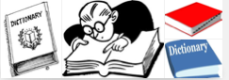**

*For this task, you will need a dictionary, or someone who loves reading. Write e short explanation for each genre in the list below. If you have read a book like this, put a tick in the last column.*

|  |  |  |
| --- | --- | --- |
| **Narrative Genre** | **What type of story is this?** | |
| action | *lots of exciting action happens very quickly* |  |
| adventure |  |  |
| caper |  |  |
| comedy |  |  |
| detective |  |  |
| fairy tale |  |  |
| fantasy |  |  |
| fiction |  |  |
| folk tales |  |  |
| graphic novel |  |  |
| humour |  |  |

|  |  |  |
| --- | --- | --- |
| **Narrative Genre** | **What type of story is this?** | |
| journey |  |  |
| legend |  |  |
| mystery |  |  |
| myth |  |  |
| novel |  |  |
| picture story book |  |  |
| quest |  |  |
| science fiction |  |  |
| suspense |  |  |
| thriller |  |  |

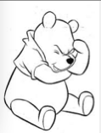You will start **drafting** your own ***narrative.***

Think! What ***genre*** would you like your narrative to be?

Choose five ***genres*** that you would like to write your ***narrative*** in.

Highlight or circle these genres in the list.

Write or draw some ideas for your narrative.

Choose any TEN **genres** from the list above. Find a book that is written in that genre. You might need access to a library website (maybe your local library) or either of these two websites, to help you match books with the genre

[*http://www.lovereading4kids.co.uk*](http://www.lovereading4kids.co.uk)

[*http://tinyurl.com/decvgenre*](http://tinyurl.com/decvgenre)

***OR***

[*http://www.booktopia.com.au/books-online/children-teenagers-young-adults-ya-/kids-reading-guide-2012-2013/cYK-p1.html*](http://www.booktopia.com.au/books-online/children-teenagers-young-adults-ya-/kids-reading-guide-2012-2013/cYK-p1.html)

|  |  |
| --- | --- |
| **Genre** | **Book Title** |
|  |  |
|  |  |
|  |  |
|  |  |
|  |  |
|  |  |
|  |  |
|  |  |
|  |  |
|  |  |
|  |  |

****

**Day 4**

**Planning a Narrative**



Discuss this with your supervisor. Use this framework to help you gather ideas for your narrative. It doesn’t mean you have to use all the ideas, so put is as many different ideas as you can. You can then choose the ones you like the most.

You can write, draw or use diagrams to write your ideas.

|  |  |  |
| --- | --- | --- |
| ***Narrative Text*** Features: | Write a few words to show this ***narrative text*** feature.  **Genre**:…………………….…………………………………………. | Interesting words you could use. |
| **Characters** | *Who will be in our story? What will your characters look like or act like? How will they speak? What kind of people are they?* |  |
| **Introduction/ Orientation** | *How will you start your story to capture reader’s interest?* |  |
| **Setting – Place** | *Where will your story take place? Where will you characters go?* |  |
| **Setting – Time** | *When is your story happening?* |  |
| **Events** | *What are some key events that might happen in your story?* |  |

|  |  |  |
| --- | --- | --- |
| ***Narrative Text*** Features: | Write a few words to show this ***narrative text*** feature. | Interesting words or phrases you could use. |
| **Complications / Problems** | *What complications, dilemmas or problems will your characters face?* |  |
| **Descriptive Language** | *Briefly describe your places, settings or characters.* |  |
| **Dialogue / Talking** | *How will your characters speak to each other? What might they say?* |  |
| **Resolution / Conclusion** | *How will your characters solve their problems?* |  |
| **A lesson or moral** | *Will there be a point to your story?* |  |
| **Illustrations** | *What kids of illustrations would you use with your story?* |  |

**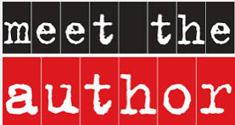** That’s you!

|  |  |
| --- | --- |
| **Here are some ideas to help you write your interesting narrative.**  **Read** and **think** about each of these suggestions to help you write a story that other people would enjoy reading.  **Tick or highlight the ideas** you ***might*** use in your draft.  You have to be selective, so you should not tick too many options – maybe one or two in each section. | *Sounds like a good idea****.*** |
| **Opening/setting scene or introducing characters** |  |
| **Some possible options for opening a story ‘to grab the reader’** |  |
| * use dialogue, e.g. a warning given by one character to another |  |
| * ask the reader a question |  |
| * describe some strange behaviour of one of the characters |  |
| * use a dramatic exclamation (Help!) or dramatic event |  |
| * introduce something intriguing, surprising, mysterious or unusual |  |
| * put the main character in a situation that will make readers curious |  |
|  |  |
| **Techniques for introducing characters** |  |
| * use interesting names |  |
| * show the character’s personality by his or her actions and discussions, show how the character feels: sad, lonely, angry or what they are, e.g. bossy, shy |  |
| * show characters through actions and dialogues |  |
| * use powerful verbs to show how a character feels and behaves, e.g. muttered, ambled. Look for words that are strong and interesting. |  |
| * write the thoughts and reactions of other characters |  |
| * reveal the characters’ own thoughts and ideas |  |
|  |  |
| **Build-up/creating the setting** |  |
| * make the characters do interesting things |  |
| * create details based on sense impressions – what can be **seen**, **heard**, **smelt,** **touched** or **tasted** |  |
| * choose settings you know, then add some invented details |  |
| * use real or invented names to bring places alive – to help to make the setting more real and more believable |  |
| * create atmosphere, e.g. what is hidden, what is dangerous, what looks unusual, what is out of place |  |
| * use the weather, time of day and season as well as place |  |
| * lull the reader into a false sense of security that all is well, then add a surprise |  |

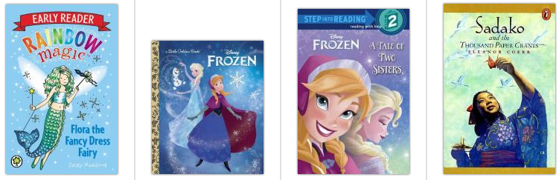

|  |  |
| --- | --- |
|  | *Sounds like a good idea****.*** |
| **Dilemma / Complication** |  |
| * introduce a problem |  |
| * use ‘empty’ words, e.g. ‘someone’ to create suspense |  |
| * use short sentences to be dramatic |  |
| * strengthen nouns and verbs |  |
| * add adjectives and adverbs where they are appropriate and effective |  |
| * use suspense words such as ‘suddenly’, ‘without warning’ |  |
| * draw the reader in by asking a question |  |
| * occasionally break the sentence rule by using a fragment to emphasise a point, e.g. ‘Silence!’ |  |
| * varying sentence openings by sometimes starting with an adverb, e.g. ‘Carefully’; a prepositional phrase, e.g. ‘At the end of the street’; a subordinate clause, e.g. ‘Although she was tired, Vanya….’ Or ‘Swinging his stick in the air, he….’ |  |
| * delay revealing the ‘monster’ by using shadows, sounds, etc. |  |
| * use ominous sounds, darkness or cold to build the tension |  |
|  |  |
| **Reaction/events** |  |
| * build on many of the techniques already used in the earlier part of the story |  |
| * vary sentences structures by using longer sentences to get a rhythm going to describe the increasing tension as events unfold |  |
| * use alliteration and short sentences to portray sounds within the action |  |
| * use metaphor (using an unusual word to mean something else) and simile (comparing to unlike things) to help paint the scene and describe the feelings of the characters |  |
| * introduce further possible complications, using connecting words and phrases such as ‘unfortunately……’ or ‘what he hadn’t noticed was…..’ |  |

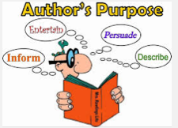

|  |  |
| --- | --- |
|  | *Sounds like a good idea****.*** |
| **Resolution and ending** |  |
| *Techniques for resolving the dilemma* |  |
| * allow help to arrive in an unexpected form, such as ‘It was at that moment that …..’ |  |
| * make the character(s) do something unexpected |  |
| * show that the problem/dilemma was only in the characters’ minds and not real |  |
| * allow the character some extra effort to overcome the problem |  |
| * only resolve a part of the dilemma so the characters learn a lesson for the future |  |
|  |  |
| P***ossible options for closing a story*** |  |
| * make a comment about the resolution |  |
| * use dialogue – a comment from one of the characters |  |
| * ask a question |  |
| * make a mysterious remark |  |
| * tell the reader to remember or do something |  |
| * show how a character has changed |  |
| * use one word or an exclamation |  |
| * avoid clichés such as ‘The end’ or ‘They all lived happily ever after’ unless it is a fabrication of a traditional story |  |
| * reflect on events and perhaps providing a moral |  |
| * allow the main character to think aloud |  |
| * introduce an element of mystery, e.g. ‘Vanya would never know how lucky she was |  |
| * look to the future |  |
| * revisit where the story began |  |
| * finish with a question, such as “Who wouldn’t be happy with that?” |  |

*Adapted from: National Literacy Strategy: http://dera.ioe.ac.uk/4825/5/nls\_y6t1exunits075202narr1.pdf*

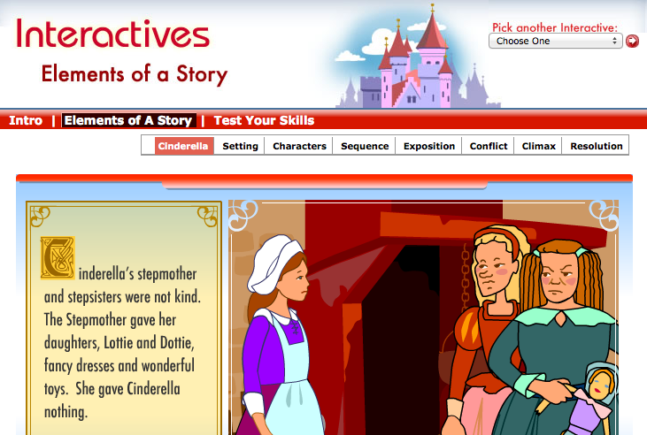

*Find out more about how* ***narratives*** *are constructed. Listen to the story, complete the activities and take the quiz! I found this to be both an interesting and enjoyable way to learn about how* ***narratives*** *are constructed.*

<http://www.learner.org/interactives/story/cinderella.html>

**OR**  
https://tinyurl.com/decvnt2

You can visit the “Elements of a Story” interactive as many times as you like.

Try to do the quiz – it’s fun to test your knowledge.

After you’ve completed each section of “Elements of a Story” complete the chart below.

|  |  |  |  |
| --- | --- | --- | --- |
| **Story Elements** | *I know this* | *I’m not sure* | ***Supervisor’s Note:***  *Please tell me how well your student worked through each section of the interactive “Elements of a Story”:* |
| Settings |  |  |
| Characters |  |  |
| Sequence |  |  |
| Exposition |  |  |
| Conflict |  |  |
| Climax |  |  |
| Resolution |  |  |

|  |  |  |  |
| --- | --- | --- | --- |
| Tick the ideas that you have learnt about narratives so far.  Tick, color or draw a ‘smiley’ face in the column that applies to your learning.  ***I understand……*** | Great! | Good! | Not sure |
| what a narrative is |  |  |  |
| features (elements) of a narrative |  |  |  |
| introduction |  |  |  |
| settings |  |  |  |
| characters |  |  |  |
| complication/problems/dilemmas to solve |  |  |  |
| resolution |  |  |  |
| conclusion |  |  |  |
| genres for narratives |  |  |  |
| some ideas for writing a story (narrative) |  |  |  |
| vocabulary (words) associated with narratives |  |  |  |

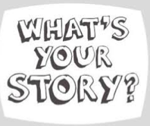

Have you been thinking about the type of story you would like to write? You should have been collecting and organising ideas to write your narrative / story.

****Get ready to be an author and write your story!

**Day 5**

**Words** – vocabulary and spelling



Your supervisor will choose 20 words to test you on your spelling words for Week One.

Supervisors please encourage your student to review his or her own work and identify their own errors. Do not use a cross for an incorrect word – instead highlight or underline the **error** and ask the student to write the word correctly.

|  |  |
| --- | --- |
|  |  |
|  |  |
|  |  |
|  |  |
|  |  |
|  |  |
|  |  |
|  |  |
|  |  |
|  |  |

**To the student:** Congratulations if you spelt every word correctly!

If you wrote some words incorrectly, look at the word and try to work out why you made that error – tick the statements that apply to you.

*I was careless. I didn’t listen to the word properly. It sounded like something else.*

*I didn’t understand. I got it mixed up with another word. I didn’t pay attention.*

**How to Write a Narrative**



Think about how you write a story. Describe how you go about writing a story from the time you have the idea until you ‘publish’ your work for others to read.

………………..………………..………………..………………..………………..………………..

………………..………………..………………..………………..………………..………………..

………………..………………..………………..………………..………………..…………………………………………….

………………..………………..………………..………………..………………..………………..……………….……..……

………………..………………..………………..………………..………………..………………..………………..….………

………………..………………..………………..………………..………………..………………..………….……..…………

………………..………………..………………..………………..………………..………………..………….……..…………

………………..………………..………………..………………..………………..………………..………….……..…………

………………..………………..………………..………………..………………..………………..………….……..…………

………………..………………..………………..………………..………………..………………..………….……..…………

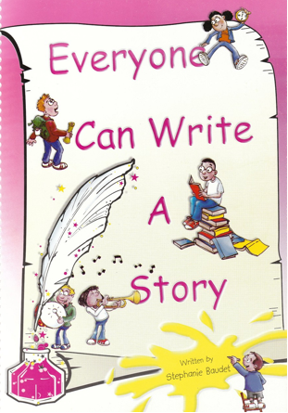

***This is how I have written stories in the past:***

I saw a picture, or a situation, read a book or watched a movie that gave me an idea. Sometimes, something happened to me, which I wanted to tell others about, so I wrote a story (narrative.)

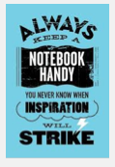

I have a ‘thinking book’ with me. When I think of words or ideas, I quickly note them in my thinking book, so I can remember them later. Sometimes, this is called “Writer’s Notebook.

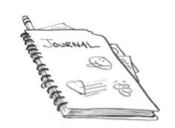When I am ready to write, I start to organise all the ideas I have in my thinking book.

I do a **plan** that helps me organise ideas in a logical order.

**Introduction:** How can I start my narrative so that the reader is interested and wants to keep reading? I think of my first idea, then I think of a second idea.

**Setting:** I never say it directly, but I like to give the reader some clues about where or when my story is set. See if you can guess the setting for this story:

*“I couldn’t hear a thing, except the silence. Can you hear silence? My craft floated gently in a black void. The lights on the instrument panel flashed steadily, to assure me that all was well – for now. Below me, I could see bright blue Earth. Behind me, the bright orb of the Moon beckoned me towards it.”*

I think the setting is: …………………………..……………………………………………………………...

The words that gave me the clues to the setting are:

…………………………..……………………………………………………………...…………………………..………………

…………………………………………...…………………………..……………………………………………………………...

…………………………..……………………………………………………………...…………………………..………………

……………………………………………...…………………………..…………………………………………………………

…………………………..……………………………………………………………...…………………………..………………

……………………………………………...…………………………..…………………………………………………………

…………………………..……………………………………………………………...…………………………..………………

……………………………………………...…………………………..…………………………………………………………

*Please see the back of the module for answers.*

**Characters:** I imagine what my characters look like, how they speak, what kind of people they are in my story. Are they kind, resourceful, adventurous (hero or heroine) or are they sneaky, mean and nasty (villain)? How will my characters interact with each other? What kind of relationships will they have?

**Exposition:** I write some background into the setting and the characters, to give my reader a sense of what the story is about. It’s always important to choose words that can communicate to your reader the ideas that are in your imagination.

**Complication /Dilemma /Conflict**:

After setting the scene, I would introduce a problem or complication. What is the ***problem*** that my characters have to solve? How will they solve it? Maybe in my “space” story, the main character will need to rescue someone, or avoid a danger. I haven’t decided yet, but I like the idea of my character finding an ancient alien civilisation on the other side of the moon.

**Resolution:** The problem, dilemma or conflict is solved. In this story, I would imagine a few scenarios for a resolution: my main character joins the aliens and decides to live with them, or she is sworn to secrecy. Maybe the aliens have evil plans for Earth and my character can save the day. In any case, I would write all my ideas into my ‘thinking book’ and keep thinking about which resolution would best fir my story.

**Conclusion**: My ending would be words that clearly show the story is at an end, without saying “The End”. It might include a moral or a lesson to learn from the story. In this case, it could be my character saying: *“I miss life on Earth very much, but these are my friends now and this is my home.”*

**Publishing**: Sometimes I want other people to read my story, so I prepare the story to make it easy and enjoyable for others to read:

* + - write or type my story neatly
    - re-read it a few times to make sure it makes sense
    - ask others to review my story and tell me how to improve it
    - fix all spelling errors
    - include the correct punctuation
    - make sure my sentences are correct: grammar, tense etc.
    - ensure that my sentences are in well organised paragraphs
    - find or draw pictures to support my story
    - think of a good title for my story
    - create a nice design for a heading or a front cover (if I am making a book.)
    - do a good copy that I can share with others.

Use this **outline** to plan the story that you will write and publish. This is just for your ideas. You might like to use the ‘story maps’ on the next pages instead.

|  |  |
| --- | --- |
| **Title:** |  |
| **Author:** |  |
| **Characters:**   * *Names* * *Personal qualities* * *Appearance* |  |
| **Setting**:  *Where or when is your story set?*  *What words will you use to tell your reader about the setting?* |  |
| **Complication**  *What happens in your story?*  *What problems will your characters need to solve?* |  |
| **Events:**  *Describe the events in your story that help your characters solve their problems.* |  |
| **Resolution:**  *How did your characters resolve their problems?* |  |
| **Conclusion:** *How will your reader know that your story is finished?*  *Is there a lesson or a moral to the story.* |  |

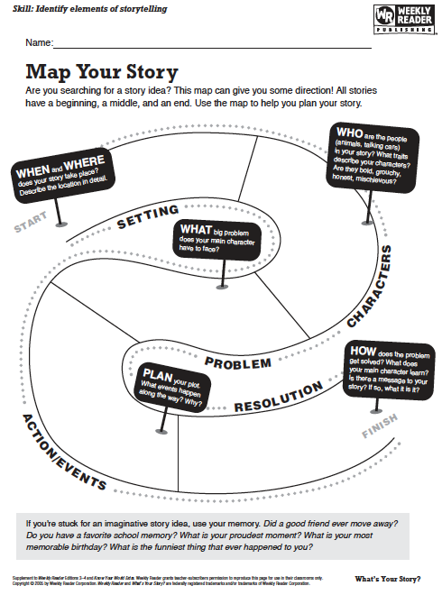

Check out the ‘Story Planning Map”: <https://tinyurl.com/decvnt4> **OR** <http://www.readwritethink.org/files/resources/interactives/essaymap/>

You can complete your story plan on line and print it when you have finished.

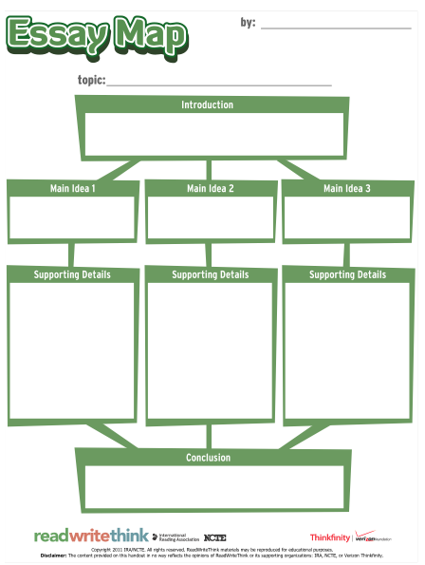

**Day 6**

**Words** – vocabulary and spelling



*This week it is YOUR opportunity to identify your spelling words. Have your thesaurus and dictionary handy to help you search for the ‘perfect words.’ Start finding alternatives to words such as ‘said’ or ‘went’.*

*You will need to use interesting words in the narrative that you will write this week, so lookout for interesting nouns, adjectives, verbs and adverbs that will make your writing more interesting for your reader. As you find that ‘perfect word’ to tell your story, add it to the list*. (Look to the back of the module to find some interesting words for writing.)

|  |  |
| --- | --- |
|  |  |
|  |  |
|  |  |
|  |  |
|  |  |
|  |  |
|  |  |
|  |  |
|  |  |
|  |  |

**How to Write a Narrative**



We’re doing things a little differently this week. You will need time to:

|  |  |
| --- | --- |
|  | *be an author* |
|  | *create your narrative* |
|  | *edit and revise your narrative* |
|  | *prepare your story for others to read – publish it.* |

The focus for the whole week is to help you create the best narrative (story) you can and publish it for others to read.

If you have completed the Day1 – Day 5 activities, you will be familiar with:

* elements that are part of a well written narrative
* structure of a narrative
* planning for writing a narrative
* strategies for writing a story.

Take your pen & notebook, your computer or any other things you like to write with. Take the advice on the next page to write your story.

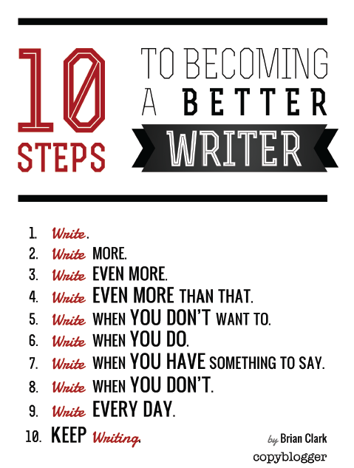

*http://www.copyblogger.com/10-steps-to-better-writing/*

You can remove this page and display it to remind you how to become a good writer.

**Narrative Checklist**



|  |  |  |
| --- | --- | --- |
| *Use these hints to help you write your narrative:* | | **Checked** |
| **Audience** | I have a clear idea of **WHO** I am writing this for. |  |
| **Genre** | I know **WHAT** I am writing: picture story book, personal narrative, adventure, mystery, science fiction, fantasy, animal story… |  |
| **Text structure** | I know **HOW** I will write: I will include an orientation, a complication and a resolution into a story that is easy to follow. |  |
| **Ideas** | I have some interesting and creative ideas. I think of my FIRST idea, then I think of a SECOND idea, and choose the best one. |  |
| I try to choose words and phrases that make my story interesting to read. |  |
| **Character** | I have made my characters interesting and different from one another. I have given them some quirks and they say and do interesting things. |  |
| **Dialogue / Speech** | The story moves by what the characters say. My characters say interesting things and it’s clear who said what. I have correctly punctuated speech. |  |
| **Setting** | I have created a sense of time and place, by giving appropriate details to my reader. |  |
| **Vocabulary** | I have thought carefully about choosing the best words to communicate my meaning, my ideas and my tone. |  |
| **Cohesion** | When I read my draft to someone, it is easy for me to read and for my listener to follow the story. (Why not tape yourself reading your story and listening to it, to help you improve it?) |  |
| **Paragraphing** | I have organised my sentences into paragraphs to make it easier for my reader to understand my story. |  |
| **Sentence structure** | I mix up my sentences: short ones for action and pace, longer ones for explaining and describing. My sentences are correctly written. |  |
| **Punctuation** | I used punctuation that made it easy for others to read my story. I used a variety of punctuation. |  |
| **Spelling** | I made sure words are spelled correctly by looking at a word list, asking for help or checking in a dictionary. |  |

**Publishing Ideas**



Think about your publishing options:

1. A booklet with an attractive front cover and illustrations.
2. An eBook / iBook (if you have the appropriate technology).
3. Publish to one of these book publishing sites – you can type directly into these sites.

**Note:** if you use the shared login:

username: **56DECV** and

password: **3071**

you will be able to **share** your work with everyone in the class. You can read their stories and they can read yours.

With your **parents’ permission,** you may create **your own account**, with your own username and password – make sure you write the username and password somewhere where you can find it or remember it. Both sites are free to join and to use.

|  |  |  |
| --- | --- | --- |
| <https://www.scribblitt.com/>  **Username:** 56DECV  **Password:** 3071 |  | **Notes:**  *if you create a story you are really proud of, you can have it published at a small cost and sent to you. Postage could be expensive ($US)* |
|  |  |  |
| <http://bookbuilder.cast.org/>  **Username:** 56DECV  **Password:** 3071 |  | *This site looks interesting for publishing your story.*  *You might be able to print copy of your narrative as a book.* |



Investigate publishing options for your narrative.

You can type your story, write it in your thinking book or use the lined paper at the end of this module.

**Publishing Ideas**



*Choose the most appropriate response for your writing:*

|  |  |
| --- | --- |
| *How is your narrative writing going?* | *Great! Good OK Writer’s Block* |
| *Have you made a decision about how you will publish your narrative?* | *Yes Not Sure Not yet.* |
| *If you answered “yes” how have you decided to publish your narrative?* | *……………………………………………………* |
| *Are you writing your story according to the plans you made?* | *Yes No* |
| *Are you changing your ideas as you write?* | *Yes No* |
| *Are you re-reading, reviewing and improving what you have written?* | *Yes No* |
| *Are you using a dictionary, thesaurus or word lists to help you find and spell interesting words?* | *Yes No* |
| *Are you pleased with how your narrative is progressing?* | *Yes Not sure No* |
| *Did you start your story with a beginning to capture the reader’s interests?* | *Yes Not sure No* |
| *Are you adding interesting words to this week’s spelling list?* | *Yes No* |

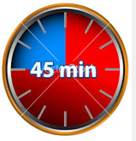Set your clock or a timer to 45 minutes.

Write without interruptions.

Focus telling your story.

Whatever is in your imagination needs the right words to get on your page.

Read this excerpt. Notice how the author starts “A Series of Unfortunate Events - The Bad Beginning”:

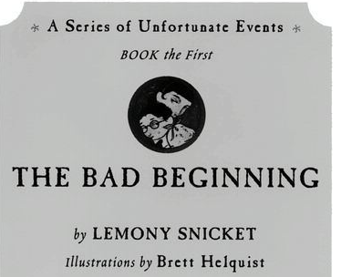

*Harper Collins Publishers, 1999*

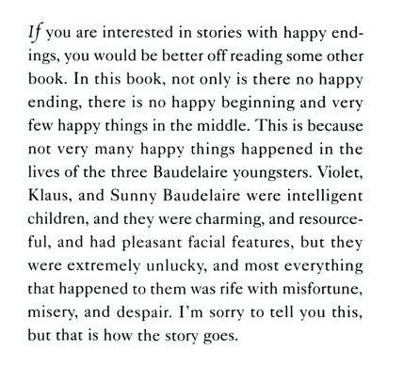

Write a short paragraph to tell me your opinion of how the author started this story. Are the first few sentences written in such a way that you want to read more?

|  |
| --- |
|  |
|  |
|  |
|  |

**Day 7**

**Writing a Narrative**



* Review what you wrote yesterday.
* If you can see improvements, make them.
* Check your story to see if you can use words that will be more precise or interesting in telling your reader your ideas.
* Your narrative draft should nearly be finished.
* Start thinking about how you will publish your good copy.

*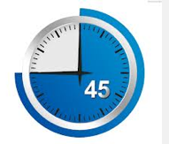*Set your clock or a timer to 45 minutes.

Write without interruptions.

Focus telling your story.

Whatever is in your imagination needs the right words to get on your page.

Write a short paragraph to tell me how your narrative story is going.

What are you finding easy? Enjoyable? Challenging?

|  |
| --- |
|  |
|  |
|  |
|  |
|  |
|  |

**Day 8**

**Writing a Narrative**



Your draft narrative should be ready to publish soon – as your ‘good copy’.

Even at this late stage, it is not too late to review and improve your work.

Look at the checklist on page 37. Use about 30-40 minutes improving your work.

|  |  |
| --- | --- |
| *How is your narrative writing going?* | *Great! Good OK Writer’s Block* |
| *Have you made a decision about how you will publish your narrative?* | *Yes Not Sure Not yet.* |
| *If you answered “yes” how have you decided to publish your narrative?* | *……………………………………………………* |
| *Are you writing your story according to the plans you made?* | *Yes No* |
| *Are you changing your ideas as you write?* | *Yes No* |
| *Are you re-reading, reviewing and improving what you have written?* | *Yes No* |
| *Are you using a dictionary, thesaurus or word lists to help you find and spell interesting words?* | *Yes No* |
| *Are you pleased with how your narrative is progressing?* | *Yes Not sure No* |
| *Did you start your story with a beginning to capture the reader’s interests?* | *Yes Not sure No* |
| *Are you adding interesting words to this week’s spelling list?* | *Yes No* |
| *Is your story finished?* | *Yes Nearly* |
| *How satisfied are you with the writing you have done so far?* | *Love it! I did a good job. I’m not sure.* |

**Day 9**

**Writing a Narrative**



* You should be finishing your draft of your story so you can create your good copy.
* Is your story organised into chapters? (If it is long enough.)
* How will you arrange you text on your page?
* Will you include pictures to support your story?
* Is it a handwritten or typed story?
* Consider adding your story to your Blog and ask other students for their comments.
* Ask an ‘editor’ (it could be a supervisor, or your teacher) to review your story and make suggestions for improvements before you finalise your work.

Use your time today to:

* to put the finishing touches on your narrative
* review the words you added to your spelling list
* read some published. Narratives to get ideas.

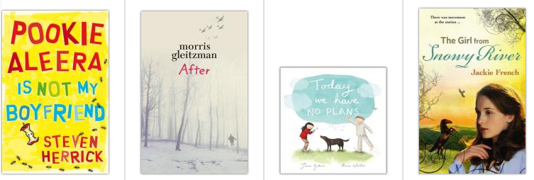

**Day 10**

**Words** – vocabulary and spelling



Your supervisor will test you on the 20 interesting words you identified for your narrative.

Supervisors please encourage your student to review his or her own work and identify their own errors. Do not use a cross for an incorrect word – instead highlight or underline the **error** and ask the student to write the word correctly.

|  |  |
| --- | --- |
|  |  |
|  |  |
|  |  |
|  |  |
|  |  |
|  |  |
|  |  |
|  |  |
|  |  |
|  |  |

**To the student:** Congratulations if you spelt every word correctly!

If you wrote some words incorrectly, look at the word and try to work out why you made that error – tick the statements that apply to you.

*I was careless. I didn’t listen to the wourd properly. It sounded like something else.*

*I didn’t understand. I got it mixed up with another wourd. I didn’t pay attention.*

**Publishing a Narrative**



You have worked hard to create your narrative, to tell your story.

You have had many opportunities to review and improve your story.

Now is the time to publish it.

However you decide to publish your story:

* As a book with a front and back cover
* As an eBook or iBook
* On Scribblit or Bookbuilder
* On your Blog

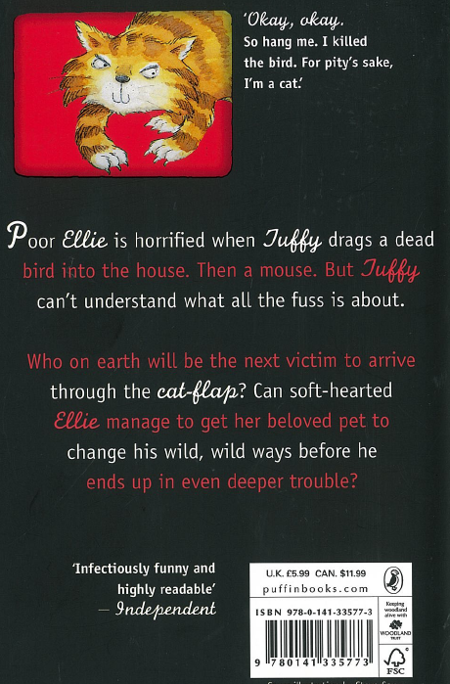

To finalise the publication of your narrative, you need to write a

**BLURB**

and a

**REVIEW**

of your story.

A review is usually written by another person, to tell reader what he or she thought of your story.

This is an example of a **BLURB.** It is designed to generate the reader’s interest to read the book.

Write a BLURB for your book. The blurb is a brief summary that entices a person to read your book.

Here is a **BLURB** from The Bad Beginning, Lemony Snicket: How well does this blurb make you want to read the book?

|  |
| --- |
| Dear Reader  I’m sorry to say that the book you are holding in your hands is extremely unpleasant. It tells an unhappy tale about three very unlucky children. Even though they are charming and clever the Baudelaire siblings lead lives filled with misery and woe. From the very first page of this book when the children receive terrible news continuing on through the entire story disaster lurks at their heels. One might say they are magnets for misfortune… |

*A* ***blurb*** *for my narrative:*

**Title of the story:** ……………………………………………………………………………………..

**Author:** (that’s you!) ……………………………………………………………………………

|  |
| --- |
|  |
|  |
|  |
|  |
|  |
|  |
|  |

|  |
| --- |
|  |
|  |
|  |
|  |
|  |
|  |

A review is someone’s opinion of your book. Here is a review of “The Bad Beginning:”

“*It’s not Disney,” explained one child upon being asked why he liked Lemony Snickett’s dark and dismal* [*Series of Unfortunate Events*](http://www.amazon.com/exec/obidos/ASIN/006029809X/elisecom)*.*

*Kids seem to love this book series about the three Baudelaire children – Violet, Klaus, and Sunny – whose parents died tragically in a fire and who spend most of their time trying to evade the evil Count Olaf, a master of disguises who plots to steal the orphan’s fortune.*

*Violet is the oldest with a knack for inventing, Klaus the younger boy who loves to read and study, and Sunny, the baby with 4 exceptionally strong and sharp teeth. The books in the series have predictable plots. In each, Mr. Poe, the Baudelaire’s hapless executor, appoints a guardian who is often a distant relative of the children who proves to be incapable of keeping Count Olaf away.*

*The adults in the stories are all fooled by the Count’s disguises and don’t listen to the children who are never fooled. It’s up to Violet, Klaus, and Sunny to figure out the Count’s nefarious plan before he can implement it and abscond with the children. It always takes the three kids working together to foil the Count’s plans.*

http://www.elise.com/reviews/a\_series\_of\_unfortunate\_events\_-\_lemony\_snicket

*A r****eview*** *of my narrative:*

**Title of the story:** ……………………………………………………………………………………..

**Author:** (that’s you!) ……………………………………………………………………………

Reviewed by: ……………………………………………………………………………………..

|  |
| --- |
|  |
|  |
|  |
|  |
|  |
|  |
|  |
|  |
|  |
|  |
|  |
|  |
|  |
|  |

Send your finished narrative to your teacher. IF you have published on line, send the link.

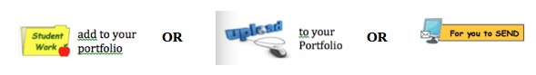Add your finished narrative to your portfolio.

Writing paper for writing your narrative – draft or good copy.

Macintosh HD:Users:all:Desktop:DECV Logo.jpg ID: …………………….. Name:………………………………..…… Date………………

|  |  |
| --- | --- |
| **TITLE of your WORK:** |  |

|  |
| --- |
|  |
|  |
|  |
|  |
|  |
|  |
|  |
|  |
|  |
|  |
|  |
|  |
|  |
|  |
|  |
|  |
|  |
|  |
|  |

|  |
| --- |
|  |
|  |
|  |
|  |
|  |
|  |
|  |
|  |
|  |
|  |
|  |
|  |
|  |
|  |
|  |
|  |
|  |
|  |
|  |
|  |
|  |
|  |
|  |
|  |
|  |

|  |
| --- |
|  |
|  |
|  |
|  |
|  |
|  |
|  |
|  |
|  |
|  |
|  |
|  |
|  |
|  |
|  |
|  |
|  |
|  |
|  |
|  |
|  |
|  |
|  |
|  |
|  |

|  |
| --- |
|  |
|  |
|  |
|  |
|  |
|  |
|  |
|  |
|  |
|  |
|  |
|  |
|  |
|  |
|  |
|  |
|  |
|  |
|  |
|  |
|  |
|  |
|  |

**Appendices & Solutions:**

Author, Stephanie Baudet shared her ideas for writing narratives. She advises:

*“Feel free to use any of these ideas. Even if a hundred people used them, there wouldn't be any stories that are the same. Have fun!”*

|  |  |
| --- | --- |
| * What if you stripped off your wallpaper and found something underneath: an article from an old newspaper, or a clue to a treasure, or a secret spell? | * What if you were in the middle of a lake and your boat began to leak? |
| * What if your dog or cat ran off and disappeared down a hole in the ground? What would happen? | * Some children find a time capsule in the garden of their new house. It holds some scary information. |
| * An under-sea quake disturbs something which has being lying dormant, and now it's on its way to the surface……. | * Opening the door a crack, she saw ... |
| * I knew I was trapped. | * She stared disbelievingly at the words on the screen. |
| * Jack ran fast. His legs pumped and he pushed himself past the point of pain. He had to get away. | * The creature had escaped from its cage. Now it travelled under cover of darkness, looking.... |

*http://www.stephaniebaudet.co.uk/page19.htm*

|  |  |  |  |  |  |
| --- | --- | --- | --- | --- | --- |
| **In other words: “SAID”** | | | | | |
| accused | choked | echoed | maintained | ranted | sobbed |
| acknowledged | chortled | ended | marveled | reasoned | speculated |
| added | chorused | exclaimed | mentioned | reassured | spoke |
| addressed | chuckled | explained | mimicked |  | sputtered |
| admitted | claimed |  | moaned | recalled | squeaked |
| advised | clucked | finished | mumbled | reckoned | stammered |
| affirmed | coaxed | fretted | murmured | related | started |
| agreed | commanded |  | mused | remarked | stated |
| announced | commented | gasped | muttered | remembered | stormed |
| answered | complained | gibed |  | reminded | stuttered |
| apologized | conceded | giggled | nagged | repeated | suggested |
| approved | concluded | greeted | nodded | replied | surmised |
| argued | confessed | groaned | noted | reported |  |
| asked | confided | growled |  | requested | taunted |
| asserted | congratulated | grunted | objected | responded | teased |
| assured | continued | grumbled | observed | retorted | tempted |
| avowed | convinced | guessed | offered | revealed | tested |
| babbled | corrected | gulped | ordered | roared | theorized |
| barked | coughed | gurgled |  |  | threatened |
| bawled | countered |  | panted | sang | told |
| beamed | cried | hinted | piped | sassed | trilled |
| began | croaked | hissed | pleaded | screamed |  |
| begged | crowed | hollered | pled | scoffed | urged |
| bellowed | dared | hypothesized | pointed out | scolded | uttered |
| bet | decided |  | pondered | shot |  |
| bleated | declared | imitated | praised | shouted | volunteered |
| blurted | demanded | implied | prayed | shrieked | vowed |
| boasted | denied | informed | proclaimed | shrilled |  |
| boomed | described | inquired | promised | sighed | wailed |
| bragged | disagreed | insisted | proposed | smiled | warned |
| broke in | disclosed | interjected | protested |  | went on |
| bubbled | divulged | interrupted | purred | smirked | wept |
| bugged | doubted | intoned | put in | snapped | whimpered |
| burst out | drawled | jeered | puzzled | snarled | whined |
| called |  | jested |  | sneered | whispered |
| cautioned | echoed | joked | quavered | sneezed | wondered |
| chatted | ended |  | queried | snickered | worried |
| chattered | exclaimed | laughed | questioned | sniffed |  |
| cheered | explained | lied | quipped | sniffled | yawned |
| chided | finished | lisped | quoted | snorted | yakked |
| chimed in | fretted |  |  |  |  |

Go to this website to find other interesting things about words: *http://www.spwickstrom.com/said/*

**In Other Words: “WENT”**

|  |  |  |  |
| --- | --- | --- | --- |
| **Kind of Movement** | **Words** | | |
| **Slow Movement** | * **climbed** * **crawled** * **crept** * **dawdled** * **drifted** | * **dilly-dallied** * **floated** * **hobbled** * **leisurely left** * **poked along** | * **prowled** * **rambled** * **wandered** |
| **Regular Movement** | * **approached** * **biked** * **danced** * **drove** * **hiked** * **hitchhiked** * **hopped** * **marched** * **migrated** | * **moved** * **paraded** * **pranced** * **rode** * **rolled** * **sailed** * **scrambled** * **shifted** | * **slid** * **strolled** * **traveled** * **trespassed** * **trotted** * **walked** * **visited** * **voyaged** |
| **Fast Movement** | * **bounced** * **crashed** * **dashed** * **darted** * **flew** * **flipped** * **galloped** | * **hastened** * **hurried** * **jogged** * **jumped** * **raced** * **roller-skated** * **rushed** | * **skied** * **skipped** * **sped** * **sprinted** * **swooped** * **thundered** * **tore** |

http://www.cyberspaces.net/6traits/went.html

**Day 1 Solutions Spelling**

|  |  |  |
| --- | --- | --- |
| author | caper | reader |
| character | comedy | science |
| complication | description | story |
| detective | dilemma | thrillers |
| editor | fairy | quest |
| fantasy | fiction | resolution |
| folk | graphic | setting |
| horror | humour | suspense |
| journey | legends | writer |
| mystery | myths | scenario |
| narrative | novel | storyline |
| picture | plot | obstacle |
| action | adventure | publisher |

**Day 3: Narrative Words Answer Key:**

|  |  |  |  |  |  |  |  |  |  |  |  |  |  |  |  |  |  |  |  |
| --- | --- | --- | --- | --- | --- | --- | --- | --- | --- | --- | --- | --- | --- | --- | --- | --- | --- | --- | --- |
| \_ | \_ | C | \_ | \_ | \_ | \_ | O | \_ | \_ | \_ | \_ | \_ | \_ | \_ | \_ | \_ | \_ | \_ | \_ |
| \_ | \_ | A | \_ | \_ | \_ | H | O | R | R | O | R | \_ | \_ | \_ | \_ | \_ | \_ | \_ | \_ |
| \_ | \_ | P | \_ | \_ | \_ | L | E | G | E | N | D | S | \_ | \_ | \_ | \_ | \_ | \_ | \_ |
| \_ | \_ | E | \_ | \_ | \_ | \_ | \_ | \_ | \_ | H | \_ | \_ | \_ | \_ | \_ | \_ | S | \_ | \_ |
| \_ | \_ | R | \_ | \_ | \_ | \_ | \_ | \_ | \_ | \_ | \_ | \_ | \_ | \_ | \_ | \_ | H | \_ | \_ |
| \_ | \_ | \_ | \_ | S | T | O | R | Y | L | I | N | E | \_ | \_ | \_ | \_ | T | \_ | \_ |
| R | O | M | U | H | \_ | \_ | \_ | \_ | \_ | \_ | \_ | \_ | \_ | \_ | \_ | \_ | Y | \_ | C |
| \_ | \_ | \_ | \_ | \_ | \_ | \_ | \_ | \_ | R | E | A | D | E | R | \_ | \_ | M | O | D |
| \_ | \_ | \_ | S | C | I | E | N | C | E | \_ | T | \_ | \_ | \_ | \_ | \_ | M | E | \_ |
| \_ | R | O | H | T | U | A | \_ | \_ | \_ | \_ | \_ | H | \_ | \_ | \_ | P | T | \_ | \_ |
| \_ | \_ | \_ | \_ | \_ | \_ | \_ | G | \_ | \_ | \_ | \_ | \_ | R | \_ | L | E | \_ | P | \_ |
| \_ | H | \_ | \_ | \_ | \_ | R | Y | S | A | T | N | A | F | I | C | \_ | I | \_ | \_ |
| \_ | \_ | E | \_ | \_ | A | \_ | \_ | \_ | \_ | \_ | \_ | \_ | C | T | L | C | \_ | \_ | \_ |
| \_ | \_ | \_ | R | P | \_ | \_ | \_ | \_ | \_ | \_ | \_ | A | I | \_ | T | L | \_ | \_ | \_ |
| \_ | \_ | \_ | H | O | \_ | Q | U | E | S | T | T | V | \_ | U | C | \_ | E | \_ | \_ |
| \_ | \_ | I | \_ | \_ | I | \_ | \_ | \_ | \_ | I | E | \_ | R | \_ | O | \_ | \_ | R | \_ |
| \_ | C | \_ | \_ | \_ | \_ | N | \_ | \_ | O | \_ | \_ | E | \_ | \_ | M | \_ | \_ | \_ | S |
| \_ | \_ | \_ | \_ | A | D | V | E | N | T | U | R | E | \_ | \_ | E | \_ | \_ | \_ | \_ |
| \_ | \_ | \_ | \_ | \_ | \_ | F | \_ | \_ | \_ | \_ | \_ | \_ | \_ | \_ | D | \_ | A | \_ | \_ |
| \_ | \_ | \_ | \_ | \_ | A | \_ | \_ | \_ | \_ | \_ | \_ | \_ | \_ | \_ | Y | \_ | M | \_ | \_ |
| \_ | \_ | \_ | \_ | I | \_ | \_ | \_ | \_ | S | \_ | \_ | \_ | \_ | \_ | \_ | \_ | M | \_ | \_ |
| \_ | \_ | \_ | R | G | N | I | T | T | E | S | \_ | \_ | \_ | \_ | \_ | \_ | E | \_ | \_ |
| L | \_ | Y | \_ | \_ | \_ | \_ | O | \_ | \_ | Y | R | E | T | S | Y | M | L | \_ | \_ |
| \_ | E | \_ | \_ | \_ | \_ | R | N | O | I | T | U | L | O | S | E | R | I | \_ | \_ |
| \_ | \_ | V | \_ | \_ | Y | \_ | \_ | \_ | \_ | \_ | \_ | \_ | T | O | L | P | D | \_ | D |
| \_ | \_ | \_ | O | \_ | \_ | E | V | I | T | A | R | R | A | N | \_ | \_ | \_ | E | \_ |
| \_ | \_ | \_ | \_ | N | \_ | \_ | \_ | \_ | \_ | \_ | \_ | \_ | \_ | \_ | \_ | \_ | S | \_ | \_ |
| E | L | C | A | T | S | B | O | \_ | \_ | \_ | \_ | \_ | \_ | \_ | E | C | \_ | \_ | R |
| \_ | \_ | \_ | \_ | \_ | F | \_ | \_ | \_ | \_ | F | O | L | K | D | R | \_ | \_ | \_ | E |
| \_ | \_ | O | \_ | \_ | I | \_ | \_ | \_ | \_ | \_ | \_ | R | I | I | \_ | \_ | \_ | \_ | T |
| \_ | \_ | I | \_ | \_ | C | \_ | \_ | A | \_ | \_ | E | T | P | \_ | \_ | \_ | \_ | \_ | C |
| E | \_ | R | \_ | \_ | T | \_ | \_ | C | \_ | H | O | T | \_ | \_ | \_ | \_ | \_ | \_ | A |
| S | \_ | A | \_ | \_ | I | \_ | \_ | T | S | R | I | \_ | \_ | \_ | \_ | \_ | Y | \_ | R |
| N | \_ | N | \_ | \_ | O | \_ | \_ | I | \_ | O | \_ | \_ | \_ | \_ | \_ | \_ | E | \_ | A |
| E | \_ | E | \_ | \_ | N | \_ | L | O | N | \_ | \_ | \_ | \_ | \_ | \_ | \_ | N | \_ | H |
| P | \_ | C | \_ | \_ | \_ | B | \_ | N | \_ | \_ | \_ | \_ | \_ | \_ | \_ | \_ | R | \_ | C |
| S | \_ | S | \_ | \_ | U | \_ | \_ | \_ | \_ | \_ | \_ | \_ | \_ | \_ | \_ | \_ | U | \_ | \_ |
| U | \_ | \_ | \_ | P | \_ | \_ | \_ | \_ | \_ | \_ | \_ | \_ | \_ | \_ | \_ | \_ | O | \_ | \_ |
| S | \_ | \_ | \_ | \_ | \_ | \_ | \_ | \_ | \_ | \_ | \_ | \_ | \_ | \_ | \_ | \_ | J | \_ | \_ |
| \_ | \_ | \_ | \_ | \_ | \_ | \_ | \_ | W | R | I | T | E | R | \_ | \_ | \_ | \_ | \_ | \_ |

**Day 5: Setting**

*“I couldn’t hear a thing, except the silence. Can you hear silence? My craft floated gently in a black void. The lights on the instrument panel flashed steadily, to assure me that all was well – for now. Below me, I could see bright blue Earth. Behind me, the bright orb of the Moon beckoned me towards it.”*

I think the setting is: *Space, somewhere between the Earth and the Moon*

The words that gave me the clues to the setting are:

*Silence (as there is no atmosphere in space, there is no sound.)*

*Craft floated gently* (it could have been a boat on a lake, so you need to read the rest of the clues.)

*The lights on the instrument panel* (something hi tech.)

*Black void* (it could have been a deep dark cave, but you need to read the rest of the clues.)

*Below me I could see Earth…behind me the moon* (now we know for sure that our setting is in space.)

**Did you notice?** In writing my introduction to the narrative, I used some ‘**senses’** to tell the story: hearing – it was silent; seeing – I described what I was looking at. Using ‘senses; to write helps your reader get a ‘feel’ for your story.

|  |  |  |  |  |
| --- | --- | --- | --- | --- |
| **Student Name**: |  | **Student ID**: |  | |
| **Date:** | | | | \_ \_ \_ / \_ \_ \_ /\_ \_ \_ |

|  |  |  |  |  |  |  |
| --- | --- | --- | --- | --- | --- | --- |
| ***A note to supervisors:*** *please review your student’s work and make your ‘best assessment’ of*  *how well your student understands the work s/he has completed.*  **ENGLISH** | | | | | | |
| **Level** |  | | **Demonstrated** | **Needs further opportunity** | | | **Teacher assessment** |
|  | **READING & VIEWING** | | | | | | |
| 6 | Use comprehension strategies to interpret and analyse information and ideas, comparing content from a variety of textual sources including media and digital texts | |  | |  |  | |
|  | Analyse and evaluate similarities and differences in texts on similar topics, themes or plots | |  | |  |  | |
|  | Identify the relationship between words, sounds, imagery and language patterns in narratives | |  | |  |  | |
|  | **WRITING** | | | | | | |
| 6 | Understand how ideas can be expanded and sharpened through careful choice of verbs, elaborated tenses and a range of adverb groups/phrases | |  | |  |  | |
| 6 | Plan, draft and publish imaginative, informative and persuasive texts, choosing and experimenting with text structures, language features, images and digital resources appropriate to purpose and audience | |  | |  |  | |
| 6 | Investigate how vocabulary choices, including evaluative language can express shades of meaning, feeling and opinion | |  | |  |  | |
| 6 | Create literary texts that adapt or combine aspects of texts students have experienced in innovative ways | |  | |  |  | |
| 6 | Reread and edit students’ own and others’ work using agreed criteria and explaining editing choices | |  | |  |  | |
| 6 | Use a range of software, including word processing programs, learning new functions as required to create texts | |  | |  |  | |

|  |  |  |  |  |  |  |  |
| --- | --- | --- | --- | --- | --- | --- | --- |
| Description: Description: Description: Description: Description: Description: Description: Description: logoCAPS2**315 Clarendon Street, Thornbury 3071**  **Telephone (03) 8480 0000**  **FAX (03) 9416 8371 (Despatch)**  **Free call (1800) 133 511**   |  |  | | --- | --- | | |  | | --- | | **STUDENT NUMBER \_\_\_\_\_\_\_\_\_\_\_\_\_\_\_\_\_\_\_**  **STUDENT NAME \_\_\_\_\_\_\_\_\_\_\_\_\_\_\_\_\_\_\_\_\_\_**  **\_\_\_\_\_\_\_\_\_\_\_\_\_\_\_\_\_\_\_\_\_\_\_\_\_\_\_\_\_\_\_\_\_\_\_\_\_\_\_** | | | | | | | |  |
| Fix your student barcode  label over this space. |
|  |
| 6206  [6206] |
| **SUBJECT** | English | | | [ZX] |
| **COLOUR** | Red | **MODULE** | N |
| **TEACHER** | \_\_\_\_\_\_\_\_\_\_\_\_\_\_\_\_\_\_\_\_\_\_\_\_\_\_\_ | | |

|  |
| --- |
| **THINKING ABOUT YOUR LEARNING**  Description: Description: Description: Description: http://t0.gstatic.com/images?q=tbn:ANd9GcTiyp1Q0EWVRSXlqyIMaG6be3rodf0nBbu2oBIY8JlYVh1iP8U7**I understand \_\_\_\_\_\_\_\_\_\_\_\_\_\_\_\_\_\_\_\_\_\_\_\_\_\_\_\_\_\_\_\_\_\_\_\_\_\_\_\_\_\_\_\_\_\_\_\_\_**  **\_\_\_\_\_\_\_\_\_\_\_\_\_\_\_\_\_\_\_\_\_\_\_\_\_\_\_\_\_\_\_\_\_\_\_\_\_\_\_\_\_\_\_\_\_\_\_\_\_\_\_\_\_\_\_\_\_\_\_\_\_\_\_\_\_\_\_\_\_\_\_\_\_\_\_**  **\_\_\_\_\_\_\_\_\_\_\_\_\_\_\_\_\_\_\_\_\_\_\_\_\_\_\_\_\_\_\_\_\_\_\_\_\_\_\_\_\_\_\_\_\_\_\_\_\_\_\_\_\_\_\_\_\_\_\_\_\_\_\_\_\_\_\_\_\_\_\_\_\_\_\_**  **\_\_\_\_\_\_\_\_\_\_\_\_\_\_\_\_\_\_\_\_\_\_\_\_\_\_\_\_\_\_\_\_\_\_\_\_\_\_\_\_\_\_\_\_\_\_\_\_\_\_\_\_\_\_\_\_\_\_\_\_\_\_\_\_\_\_\_\_\_\_\_\_\_\_\_**  **\_\_\_\_\_\_\_\_\_\_\_\_\_\_\_\_\_\_\_\_\_\_\_\_\_\_\_\_\_\_\_\_\_\_\_\_\_\_\_\_\_\_\_\_\_\_\_\_\_\_\_\_\_\_\_\_\_\_\_\_\_\_\_\_\_\_\_\_\_\_\_\_\_\_\_**  **Description: Description: Description: Description: http://t2.gstatic.com/images?q=tbn:ANd9GcQ72LH2Bxoxf3yTTP_t93kaIPDpv8jVzb20Dfacv1j6Jv1Vb43VI need help with \_\_\_\_\_\_\_\_\_\_\_\_\_\_\_\_\_\_\_\_\_\_\_\_\_\_\_\_\_\_\_\_\_\_\_\_\_\_\_\_\_\_\_\_\_\_\_\_**  **\_\_\_\_\_\_\_\_\_\_\_\_\_\_\_\_\_\_\_\_\_\_\_\_\_\_\_\_\_\_\_\_\_\_\_\_\_\_\_\_\_\_\_\_\_\_\_\_\_\_\_\_\_\_\_\_\_\_\_\_\_\_\_\_\_\_\_\_\_\_\_\_\_\_\_**  **\_\_\_\_\_\_\_\_\_\_\_\_\_\_\_\_\_\_\_\_\_\_\_\_\_\_\_\_\_\_\_\_\_\_\_\_\_\_\_\_\_\_\_\_\_\_\_\_\_\_\_\_\_\_\_\_\_\_\_\_\_\_\_\_\_\_\_\_\_\_\_\_\_\_\_**  **\_\_\_\_\_\_\_\_\_\_\_\_\_\_\_\_\_\_\_\_\_\_\_\_\_\_\_\_\_\_\_\_\_\_\_\_\_\_\_\_\_\_\_\_\_\_\_\_\_\_\_\_\_\_\_\_\_\_\_\_\_\_\_\_\_\_\_\_\_\_\_\_\_\_\_**  **\_\_\_\_\_\_\_\_\_\_\_\_\_\_\_\_\_\_\_\_\_\_\_\_\_\_\_\_\_\_\_\_\_\_\_\_\_\_\_\_\_\_\_\_\_\_\_\_\_\_\_\_\_\_\_\_\_\_\_\_\_\_\_\_\_\_\_\_\_\_\_\_\_\_\_** |

|  |
| --- |
| **YOUR QUESTIONS OR COMMENTS** |
| **TEACHER’S COMMENTS**  **Some great things about your work were:**  **Try to do the following next time:** |
|  |

