**Geography**

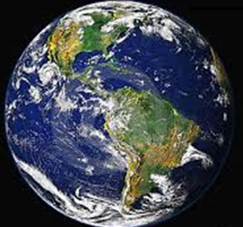

Where is Africa located in relation to Australia?

**Learning Intentions:**

In Geography this semester you will:

* Describe and compare the characteristics of places in different locations.
* Identify and describe the interconnections between people and the environment.
* Describe the location of selected countries.
* Identify simple patterns in the distribution of features of places.
* Recognise the importance of the environment and identify different views on how to respond to geographical challenges.
* Develop geographical questions to investigate and collect and record information and data from different sources to answer these questions.
* Represent data and the location of places and their characteristics in simple graphic forms, including large-scale maps that use the cartographic (mapping) conventions of scale, legend, title and north point.
* Describe the location of places and their features using simple grid references, compass, direction and distance.
* Interpret data to identify spatial distributions and simple patterns and draw conclusions.
* Present findings using geographical terminology in a range of texts.
* Propose individual action in response to a local geographical challenge and identify the expected effects of your proposed action.

**GETTING KNOWLEDGE READY**

1. Discuss with those around you and record what you know about Africa in the mind map below.

AFRICA

1. A ***continent*** is any of the world's main continuous expanses of land (Europe, Asia, Africa, North and South America, Australia, Antarctica). Visit the following link to view a map of the world’s continents:

<http://www.nationsonline.org/oneworld/continents_map.htm>

1. On the blank world map below, outline Australia and Africa in two different coloured textas. Colour in and rule a line to the name of each continent.

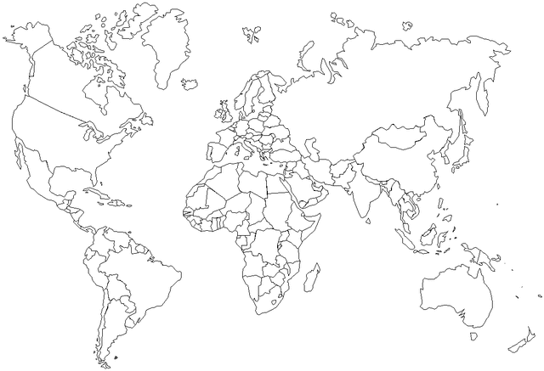

*AFRICA AUSTRALIA*

1. Earth is divided into two ***hemispheres*** – the Northern and Southern Hemispheres. These two hemispheres meet at the ***equator***.

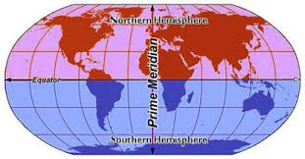

1. Rule a line to show the equator on the world map on page 5. Use the map above as a guide.
2. What is similar about where Australia and Africa are located in the world? Write your answer below.

|  |
| --- |
|  |
|  |
|  |
|  |
|  |
|  |
|  |
|  |
|  |
|  |
|  |
|  |
|  |
|  |
|  |
|  |
|  |
|  |

1. Visit the following website at:

<http://www.distancefromto.net/>

1. Measure the distance ***From*** Australia ***To*** Africa.
2. What is the air distance between these two continents?

________________________________ km

1. The air distance is between which two specific points in Australia and Africa?

__________________________________________________________________

1. What ocean is between Australia and Africa?

__________________________________________________________________

1. Where are you in the world currently?

__________________________________________________________________

1. Mark your location on the map below. Label your location in the box beneath the map.



|  |
| --- |
|  |

1. Using <http://www.distancefromto.net/> measure the distance from where you are in the world to Africa, e.g. Melbourne to Africa or Italy to Africa.
2. How far away are you from Africa?

________________________________ km

1. Rule a line from your current location in the world to Africa on the map above.

**GEOGRAPHY QUIZ**

1. Circle the correct answer. A ***continent*** is any of the world's main continuous expanses of land.

***TRUE*** or ***FALSE***

1. Circle the correct answer. Melbourne, Italy, London, Western Australia and Greece are examples of continents.

***TRUE*** or ***FALSE***

1. Circle the correct answer. Earth is divided into two ***hemispheres*** – the Northern and Southern Hemispheres.

***TRUE*** or ***FALSE***

1. Circle the correct answer. The Northern and Southern Hemispheres meet at the equator.

***TRUE*** or ***FALSE***

1. Circle the correct answer. The air distance between Central Australia and Tanzania, Africa, is:
2. 1 000km.
3. 10 521.31km.
4. 6 554.01km.
5. Circle the correct answer. The ocean between Australia and Africa is the:
6. Indian Ocean.
7. North Pacific Ocean.
8. South Atlantic Ocean.

**Score: __ / 6**

**REFLECTION**

1. *In your own words, briefly explain where Africa is located in relation to Australia?*

|  |
| --- |
|  |
|  |
|  |
|  |
|  |
|  |
|  |
|  |
|  |
|  |
|  |
|  |
|  |
|  |
|  |

