Geography Inquiry



**How have bushfires impacted the way people live?**

|  |
| --- |
| **Learning Intentions**  - You will learn to develop knowledge and understanding of the complex place of  bushfires in Australia  - You will learn to build on this learning by evaluating how bushfires impact the  way people live |

|  |
| --- |
| Understanding bushfires  http://home.iprimus.com.au/foo7/bfc20.gif |



What is a bushfire?

Discuss with your supervisor and make notes below.

*_______________________________________________________________________*

*_______________________________________________________________________*

*_______________________________________________________________________*

*_______________________________________________________________________*

*_______________________________________________________________________*

On the map of Australia colour in where you think bushfires occur.

[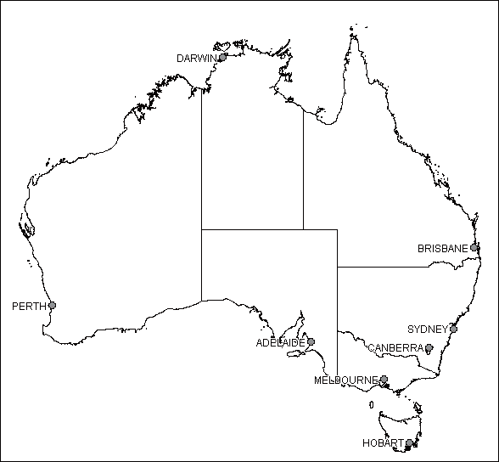](http://www.google.com.au/url?sa=i&rct=j&q=line+map+of+australia+with+capitla+cities&source=images&cd=&docid=G2lmTfy_309f1M&tbnid=_Jrib_pN8uEXWM:&ved=0CAUQjRw&url=http://www.lib.unimelb.edu.au/collections/maps/digital/outline-maps/&ei=jGerU7O1GYKOkwXzsoDYDg&bvm=bv.69837884,d.dGI&psig=AFQjCNFRSLkrecOJH2HaIvw_g6Bo0fq5AQ&ust=1403828481927883)

|  |
| --- |
| **Introduction**  Bushfires are natural disasters. Australians have learned to live  with them. |

**For you to do**

**Activity 1**

Why do you think bushfires occur where they do? Discuss with your supervisor.

Things to consider in your discussion:

* The most severe bushfires happen between Adelaide and Sydney.
* Eucalyptus trees are one of the most flammable trees because their leaves contain oil.
* Bushfires occur during the fire season. Dry winds provide oxygen which fuels the fire.

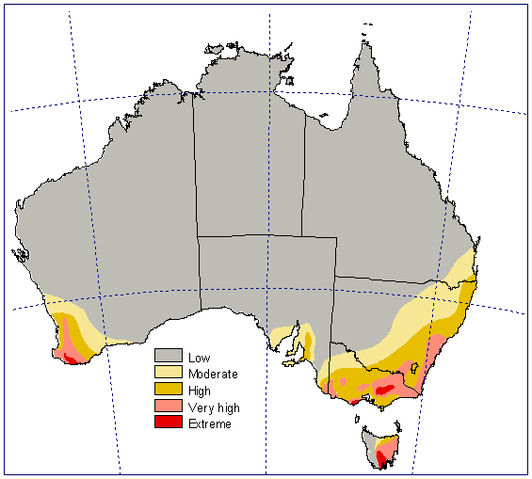

<http://australianbushfires.yolasite.com/maps-of-bushfire-affected-areas.php>

**Activity 2—Investigate what is a bushfire**

**Step 1**

Watch the following interactive.

<http://www.bushfireeducation.vic.edu.au/DLOs/OpenExplorer/index.html>

**Step 2**

A bushfire is an unplanned fire. Write 3 elements or factors that influence the size and intensity of a bushfire by looking at [-+/](https://esa.act.gov.au/community-information/bushfires/what-is-a-bushfire/) or by finding the information on the interactive. Discuss with an adult if you are unable to access the internet.

1. _______________________________________________________
2. _______________________________________________________
3. _______________________________________________________

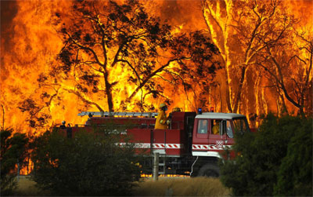

<http://www.femail.com.au/melbourne-bushfire-devastation-help-victims.htm>

**Activity 3**

Look at the map of fire seasons around Australia. You can see that northern Australia's bushfire season is during winter and spring, for central Australia it is spring and summer, and for southern Australia it is summer and autumn.

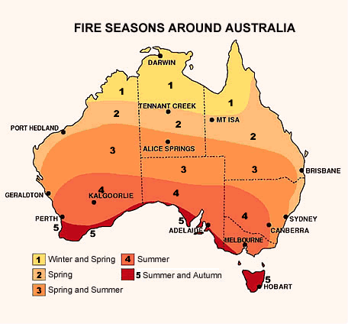

Discuss with your supervisor and jot down your answer on the line provided.

* Which areas are more prone to bushfires? (city centre or countryside)
* Why?

_____________________________________________________________________________________________

* In which season is a bushfire most likely to occur?
* Why?

______________________________________________________________________________________________

**Activity 4**

Look at this map of Victoria before and after the major bushfires in 2009.

|  |  |
| --- | --- |
| Before Victoria Bushfires | After Victoria Bushfires |
| Before:  February 14th 2009 | After:  February 17th 2009 |

<http://www.ga.gov.au/>

What do you notice about the area affected by bushfire?

______________________________________________________________________________________________

Look back to page 4. How did the bushfires start? What caused them to spread?

_______________________________________________________________________________________________

**Activity 5**

The Black Saturday bushfires were a series of bushfires burning across Victoria that caused the highest ever loss of life from a bushfire. Look at the column graph below and work out which day the Black Saturday fires were on. Write your answer on the line below and how you found your answer. You may choose to use the internet as well as the bar graph below.

_____________________________________________________________________________________________

*_____________________________________________________________________________________________*

*_____________________________________________________________________________________________*

[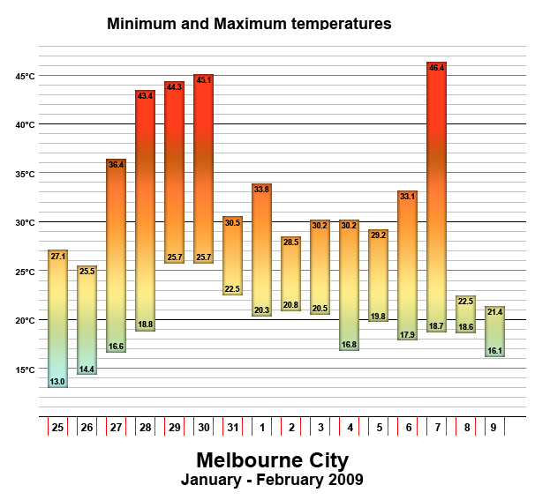](http://www.google.com.au/url?sa=i&rct=j&q=data%20victorian%20bushfires&source=images&cd=&cad=rja&uact=8&docid=DMI-7CrqzE3ViM&tbnid=YIA4enxdM-oWTM:&ved=0CAUQjRw&url=http://simple.wikipedia.org/wiki/2009_Victorian_bushfires&ei=BrSnU5HvNYaulAXd9IGIDQ&bvm=bv.69411363,d.dGI&psig=AFQjCNHJlx8d6CY8sdIvd2oBii3n1vpS1Q&ust=1403585895207670)

|  |
| --- |
| The impact of bushfires  Aerial (bird’s eye view) of aftermath of Victorian bushfires.  [*http://www.smh.com.au/ftimages/2009/02/09/1234027901521.html*](http://www.smh.com.au/ftimages/2009/02/09/1234027901521.html)  Although bushfires can be destructive, people, communities and the natural environment are resilient and can recover from a bushfire with the help of organised support. |

Bushfires affect the natural environment, the built environment and peoples’ lives.

**The natural environment**

In Victoria, the eucalypts are often left with blackened trunks and no leaves or branches. Some animals are killed during fires. Others are left without protection from predators and shelter. Wombats and echidnas can shelter in burrows. Insects and birds are able to fly away but they lose their habitat and often have nowhere to come back to.

Soil and water can be affected by major fires. Heavy rain after fires will flush affected soil into streams and rivers.

[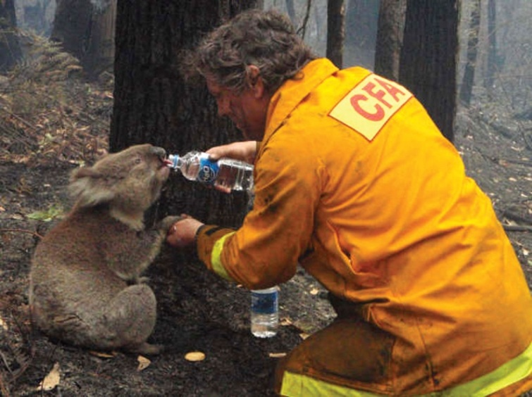](http://www.google.com.au/url?sa=i&rct=j&q=bushfires+impact&source=images&cd=&docid=aD1rCkbaI29ngM&tbnid=D2UCJJL3LHqyzM:&ved=0CAUQjRw&url=http://advocacy.britannica.com/blog/advocacy/2009/11/the-australian-%E2%80%9Cblack-saturday%E2%80%9D-bushfires-of-2009/&ei=ySSqU6KOKY7HlAWesYHQBg&bvm=bv.69620078,d.dGI&psig=AFQjCNEpStjCuF7FvzZ9YLwGUm48zCGLzA&ust=1403745813110277)

**The built environment and peoples’ lives**

Bushfires cause major destruction of telephone wires, water tanks, farm animals peoples’ homes and workplaces. People lose their homes, communities lose their schools and sadly, some people die in major bushfires. Businesses lose their customers if people can no longer live in their community. Farmers may lose their animals, crops and homes.

[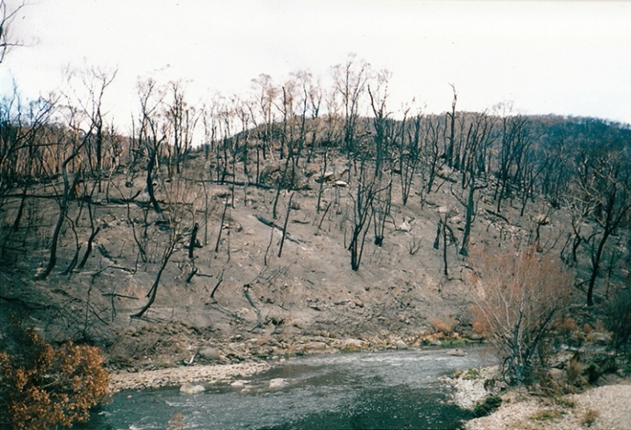](http://www.google.com.au/url?sa=i&rct=j&q=bushfires+impact&source=images&cd=&docid=PQfRSKOkXZgTcM&tbnid=xJXN4CSQ0uz-CM:&ved=0CAUQjRw&url=http://en.wikipedia.org/wiki/Bushfires_in_Australia&ei=oCSqU6ScJM6HkQWSkoGYAg&bvm=bv.69620078,d.dGI&psig=AFQjCNEpStjCuF7FvzZ9YLwGUm48zCGLzA&ust=1403745813110277)

**For you to do**

 Look at the table below and fill in your ideas on the impact of bushfires.

You may research your ideas or talk to adults about your ideas.

|  |  |  |
| --- | --- | --- |
| Impact on… | Immediate impacts of fire | What can we do to prevent fire |
| People |  |  |
| Native animals |  |  |
| Vegetation |  |  |
| Farms |  |  |
| Businesses |  |  |

Regeneration

Although bushfires cause major destruction, vegetation and the natural environment recover after the devastation of bushfires.

Look at this website to learn how the land recovers after a bushfire. It is called regeneration.

<http://www.bushfireeducation.vic.edu.au/>

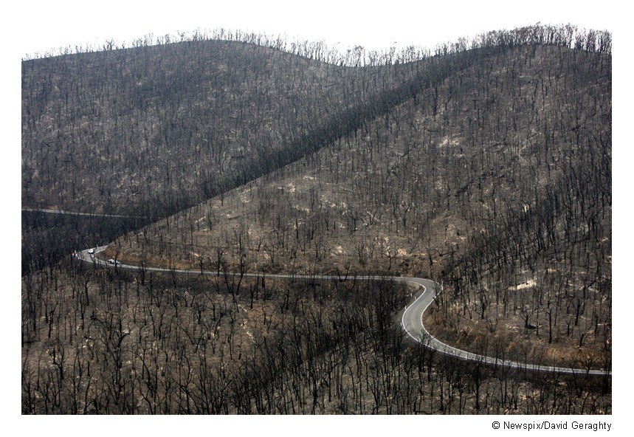

Draw what you think the picture above will look like in a year’s time.

|  |
| --- |
|  |

**Regeneration continued**

Find out how these native plants regenerate. Is it from seed or existing roots or some other way? Use the internet to research your answers.

Write your answers on the lines provided. The first one is an example.

[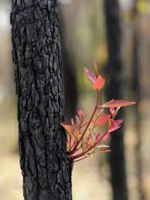](http://www.google.com.au/imgres?imgurl=http://www.sca.nsw.gov.au/__data/assets/image/0014/40064/varieties/banner_699x365.jpg&imgrefurl=http://www.sca.nsw.gov.au/pubs-and-galleries/galleries/exhibitions/secrets-of-the-special-areas-exhibition&h=365&w=274&tbnid=FJ-TIUipzWkDfM:&zoom=1&q=blackened%20trees%20regenerating&docid=NE33faKLhGfk3M&hl=en&ei=_JKrU_jAO4eIkwW6qYAQ&tbm=isch&ved=0CCEQMygBMAE&iact=rc&uact=3&dur=332&page=1&start=0&ndsp=30)

New growth soon sprouts from blackened trunks

[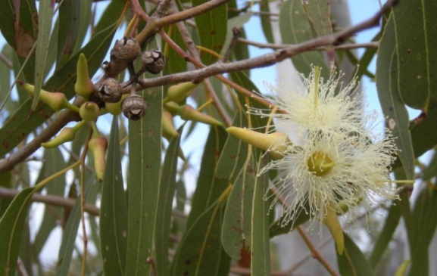](http://www.google.com.au/url?sa=i&rct=j&q=eucalyptus%20flowers%20and%20seeds&source=images&cd=&cad=rja&uact=8&docid=5ou-IsKT905sdM&tbnid=VjAFgbclCCztuM:&ved=0CAUQjRw&url=http://en.wikipedia.org/wiki/Eucalyptus&ei=V6GnU4_-GMmkkwXCiIC4Cw&bvm=bv.69411363,d.dGc&psig=AFQjCNFNNEjdw9at_bNVOhe9VPUIFpHHAQ&ust=1403581109767036)

[www.sca.nsw.gov.au](http://www.google.com.au/url?sa=i&rct=j&q=blackened+trees+regenrating&source=images&cd=&cad=rja&uact=8&docid=NE33faKLhGfk3M&tbnid=FJ-TIUipzWkDfM:&ved=0CAQQjB0&url=http%3A%2F%2Fwww.sca.nsw.gov.au%2Fpubs-and-galleries%2Fgalleries%2Fexhibitions%2Fsecrets-of-the-special-areas-exhibition&ei=BpOrU5ixFMP7kgW69YGwBA&bvm=bv.69837884,d.dGI&psig=AFQjCNFdpvjLZlPRM0jUXbXc3fLAhPKn8g&ust=1403839613066708)

__________________________________________________________________

__________________________________________________________________

Eucalyptus

[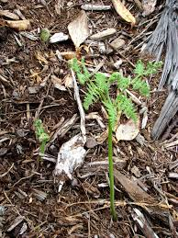](http://www.google.com.au/url?sa=i&rct=j&q=bracken+fern&source=images&cd=&docid=eAp0n2k4NyRTiM&tbnid=uHHyvinqrp7MuM:&ved=0CAUQjRw&url=http://www.eskimo.com/~enumclaw/Tips/Pocket%20Gardens/Natives/Bracken%20Fern.html&ei=EaCnU7S2BI3OkQX23oHIDg&bvm=bv.69411363,d.dGI&psig=AFQjCNEEzp_qUQYfTxomgRRCGqRnzDHWdA&ust=1403580805662539)

__________________________________________________________________________

__________________________________________________________________________

Bracken

Rebuilding

Protection from bushfire is very important when rebuilding. Planning rules change as knowledge is increased about safety and prevention methods.

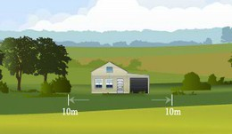

Clearing and maintaining a defendable space around buildings can increase the chances of a building surviving a bushfire.

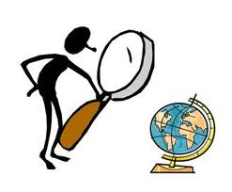

What do you think would be important if your home was being rebuilt in a bushfire area? You may like to research your ideas. Use the lines below to jot down your ideas. Write your final copy on a separate piece of paper.

_______________________________________________________________

_______________________________________________________________

_______________________________________________________________

_______________________________________________________________

_______________________________________________________________

_______________________________________________________________

_______________________________________________________________

_______________________________________________________________

**Reflection**

**What have you learned?**

Think about what you have learned about the impact of bushfires. Write one fact in each square to show what you learned in this module.

|  |  |
| --- | --- |
|  |  |
|  |  |