Mathematics

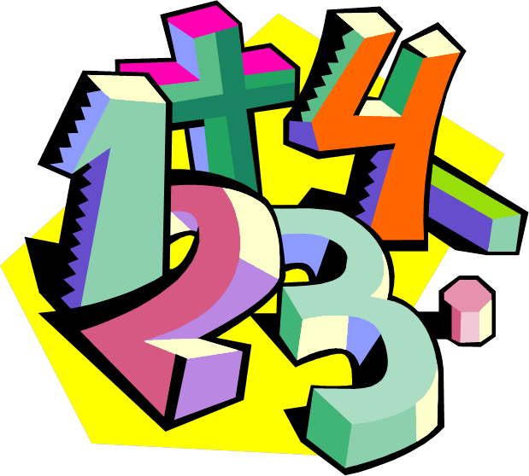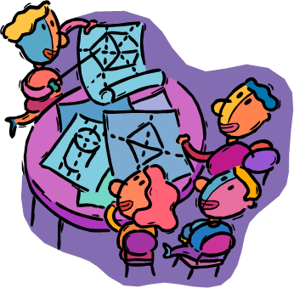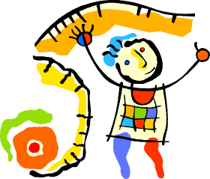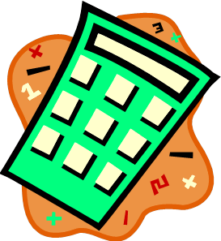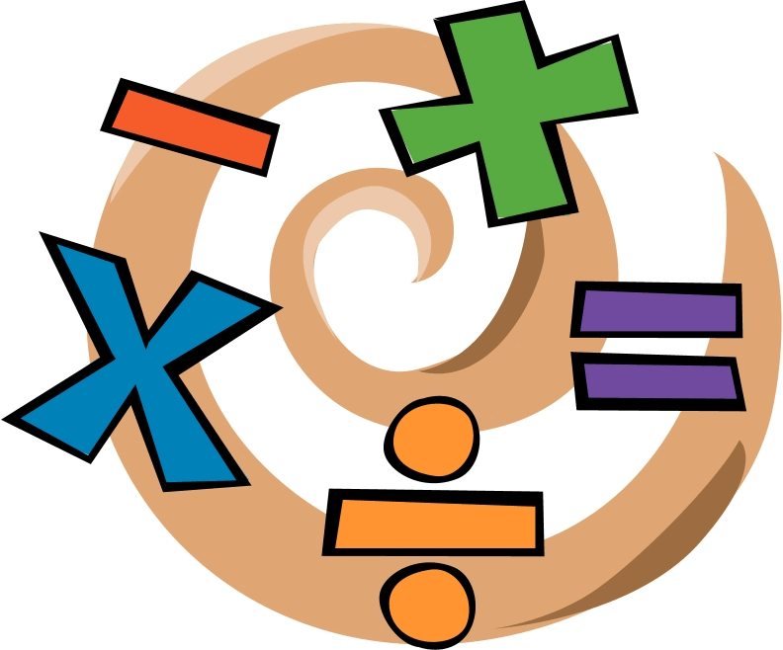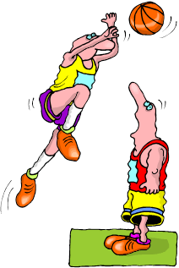

What does a fraction tell us about

the whole thing?



Mathematics

What does a fraction tell us about

the whole thing?

**Welcome to Mathematics.**

The theme of mathematics is **Maths *skills for your world****.*

We hope you like the booklet and enjoy your learning

|  |  |
| --- | --- |
| **What you will need** | * This booklet, pen and paper. You will also need a protractor. * A computer is useful if you have one, because there are interactives in some lessons. * A calculator is sometimes used and is useful to check your answers. |
| **The activities** | Each booklet contains a variety of activities:   * Skills exercises * Investigations * Interactives and games * A skills test |
| **When to use your calculator** | Most of the time you **won’t** need your calculator.  The maths activities develop skills; ways of working with numbers, mental arithmetic, estimating and using times tables.  Only use your calculator when it’s part of the activity. |
| **Asking for help…** | There may be times when you are not sure about an example or an exercise.  When this happens, know whom to ask for help:   * Your supervisor or parent * Your teacher can answer your questions and adjust the work to best suit you. |

**Mathematics**

What does a fraction tell us about

*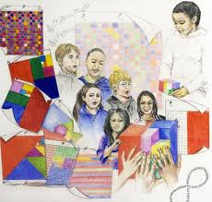*the whole thing?

|  |
| --- |
| The activities in this booklet will help us to answer the question:  Description: C:\Users\CFord\Documents\MY Folders\CurricDev2012\images\essQ2.gif  **"What does a fraction tell us about**  **the whole thing?"**  **Learning Intentions:**   * Revise some number skills:   + - Count by nines and sevens and recall division facts.     - Explore divisibility rules and use them to find factors of numbers     - Find rules that describe patterns. * Explore fractions:   + - Review how we read, write, draw and estimate fractions.     - Compare fractions and write number sentences     - Reduce fractions to simpler forms, and find equivalent fractions     - Apply fractions to find amounts and to solve problems * Investigate percentages:   + - Explore percentages as fractions out of 100     - Reduce percentages to simpler fractions     - Apply percentages to find discounts and to solve problems   *We strongly recommend that in this Booklet, you and your student routinely use ‘hands on’ materials and look for real life examples that represent the various forms of fractions.* |

**Mathematics**

**The topics in this booklet**

|  |  |
| --- | --- |
| **Learning Tasks** | |
| **Task 1** | * Revise counting by nines. * Recall division facts. * Explore divisibility rules. * Complete workbook practise. |
| **Task 2** | * Revise fractions: in words, digits and diagrams. * Estimate fractions of various things. * Use fractions to solve problems. |
| **Task 3** | * Compare fractions and write number sentences. * Develop strategies for comparing the size of fractions. * Investigate equivalent fractions. |
| **Task 4** | * Consolidate your skills in finding equivalent fractions. |
| **Task 5** | * Complete a review of the fractions topics covered. * Do a test. |

**Mathematics**

**The topics in this booklet**

|  |  |
| --- | --- |
| **Learning Tasks** | |
| **Task 6** | * Revise counting by sevens and finding rules of patterns. * Consolidate your skills with workbook practise. |
| **Task 7** | * Review divisibility rules and finding factors. * Apply factor skills to reduce fractions. * Solve problems by reducing fractions. * Explore ways to compare fractions * Investigate clock fractions: fractions of an hour. |
| **Task 8** | * Revise finding fractions of a collection. * Consolidate your skills with workbook practise. * Apply your skills to solve problems. |
| **Task 9** | * Investigate percentages as fractions out of 100. * Reduce percentages to simpler fractions. * Apply percentages to work out amounts such as discounts. * Complete an investigation: using percentages to designing school grounds. |
| **Task 10** | **Progress Assessment**   * Do a test. |

# Task 1 Number skills review: multiples and factors



Being confident with your tables and other number facts enables you to calculate problems quickly and efficiently.

What strategies do you use to help you remember tables and number facts?

Check this site to see if you use any of the strategies:

<http://www.mathsisfun.com/tables.html>

“Skip counting” is counting in groups – usually using tables facts.

|  |  |
| --- | --- |
| C:\Users\CFord\Documents\MY Folders\CurricDev2012\images\exerrcise1.gif |  |
| **Task 1 Activity 1: Review counting by nines** |
| Circle every ninth number on the number grid. |

|  |  |  |  |  |  |  |  |  |  |  |  |
| --- | --- | --- | --- | --- | --- | --- | --- | --- | --- | --- | --- |
|  | 1 | 2 | 3 | 4 | 5 | 6 | 7 | 8 | 9 | 10 |  |
|  | 11 | 12 | 13 | 14 | 15 | 16 | 17 | 18 | 19 | 20 |  |
|  | 21 | 22 | 23 | 24 | 25 | 26 | 27 | 28 | 29 | 30 |  |
|  | 31 | 32 | 33 | 34 | 35 | 36 | 37 | 38 | 39 | 40 |  |
|  | 41 | 42 | 43 | 44 | 45 | 46 | 47 | 48 | 49 | 50 |  |
|  | 51 | 52 | 53 | 54 | 55 | 56 | 57 | 58 | 59 | 60 |  |
|  | 61 | 62 | 63 | 64 | 65 | 66 | 67 | 68 | 69 | 70 |  |
|  | 71 | 72 | 73 | 74 | 75 | 76 | 77 | 78 | 79 | 80 |  |
|  | 81 | 82 | 83 | 84 | 85 | 86 | 87 | 88 | 89 | 90 |  |
|  | 91 | 92 | 93 | 94 | 95 | 96 | 97 | 98 | 99 | 100 |  |
|  | 101 | 102 | 103 | 104 | 105 | 106 | 107 | 108 | 109 | 110 |  |
|  | 111 | 112 | 113 | 114 | 115 | 116 | 117 | 118 | 119 | 120 |  |

|  |  |  |
| --- | --- | --- |
| 1. Practise counting by nines… | up to 90 | up to 120 |

2. Practise counting by nines **backwards**…

|  |  |  |
| --- | --- | --- |
| from 45 | from 81 | from 117 |

A counting tip: 9 equals 10 minus 1

|  |  |
| --- | --- |
| To count up by 9  Add 10 and take away 1  **18** + 10 → 28 – 1 → **27** | To count down by 9  Take away 10 and add 1  **81** – 10 → 71 + 1 → **72** |

**Look closely at these 9 times tables:**

|  |  |  |  |  |  |  |
| --- | --- | --- | --- | --- | --- | --- |
| 9 | × | 0 | = | **0** |  | Find the **number patterns** in the answer column:  What do you notice?  **Tick the patterns you saw:**   * The units column **decreased by one**↓, the tens column **increased by 10**↑**.** * When the **DIGITS** in the answers are added, they **add up to 9**. (1+8 = 9; 2+7 = 9; 3+6 = 9; 4+5 = 9*). Try other 9 multiplication equations to see if the digits in the answer equal 9: 314 X 9.* * Did you see how the digits reversed after 9 x5? Eg **27** (9x3) vs **72** (9 x 8); **18** (9x2) vs **81** (9x9).   Can you solve 9 x13, 9 x 14, 9 x15, 9 x 16, 9 x17, 9 x18, and 9 X 19 using the pattern in the answers?   * Did you start to look at OTHER tables to find patterns? |
| 9 | × | 1 | = | **9** |
| 9 | × | 2 | = | **18** |
| 9 | × | 3 | = | **27** |
| 9 | × | 4 | = | **36** |
| 9 | × | 5 | = | **45** |
| 9 | × | 6 | = | **54** |
| 9 | × | 7 | = | **63** |
| 9 | × | 8 | = | **72** |
| 9 | × | 9 | = | **81** |
| 9 | × | 10 | = | **90** |
| 9 | × | 11 | = | **99** |
| 9 | × | 12 | = | **108** |

# Extended division facts

Division facts and multiplication facts are **connected.**

To multiply, we count equal groups together to calculate the PRODUCT. (Answer to a multiplication problem.)

To divide, we **SHARE EQUALLY** to calculate the QUOTIENT. (Answer to a division problem.)

|  |  |
| --- | --- |
| **54 ÷ 9 =**  **Think….** *(imagine your tables.)*  What number ⬜ × 9 = 54?  6 × 9 = 54  54 ÷ 9 = 6 | Think of other possible connections for the number family of 54, 6, 9. |

Think in terms of sharing…  
54 things shared equally between 9 people, gives 6 to each person.

|  |  |
| --- | --- |
| ***Description: j0229369*** |  |
| **Task 1 Activity 2: Extended division facts** |
|  |

Use your knowledge of times tables to recall these division facts.

|  |  |  |
| --- | --- | --- |
| 550 ÷ 11 = ……….…. | 340 ÷ 10 = ……….…. | 108 ÷ 9 = ……….…. |
| 4500 ÷ 5 = ……….…. | 8100 ÷ 9 = ……….…. | 36 000 ÷ 6 = ……….…. |
| 50 000 ÷ 5 = ……….…. | 72 000 ÷ 8 = ……….…. | 7 700 ÷ 11 = ……….…. |
| 1 800 ÷ 9 = ……….…. | 25 000 ÷ 10 = ……….…. | 2 400 ÷ 2 = ……….…. |

# How to tell if a number is divisible by another number



**Look for the basic tables groups and patterns associated with the numbers that you want to divide.**

**Divisibility and factors:**

|  |  |
| --- | --- |
| ***Description: j0229369*** |  |
| **Task 1 Activity 3: Divisibility Rules** |

|  |  |  |  |  |  |
| --- | --- | --- | --- | --- | --- |
|  |  |  |  |  |  |
| Divide by… | | Break the number into divisible parts, using TABLES you already know. | | | |
| ***2*** | **Numbers that end in 0, 2, 4, 6 or 8 can be divided by 2**  Example: 3 574 is divisible by 2  Check: 3 574 ends in 4  *The number is broken into parts (3574= 3000 + 500 + 70 + 4) that are divisible by 2.* | 3 574 ÷ 2  = 1787 |  | 3 000 ÷ 2→  500 ÷ 2→  70 ÷ 2→  4 ÷ 2→ | 1500  250  35  2 |
|  |  |  | 1787 |
|  |  |  |  |  |  |
| ***3*** | **Numbers with digits that add up to a multiple of 3**  Example: 372 is divisible by 3  Check: Add digits 3 + 7 + 2 = 12  12 is a multiple of 3 | 372 ÷ 3  = 124 |  | 300 ÷ 3→  60 ÷ 3→  12 ÷ 3→ | 100  20  4 |
|  |  |  | 124 |
|  |  |  |  |
|  |  |  |  |  |  |
| ***5*** | **Numbers that end in 5 or 0 can be divided by 5.**  Example: 8 430 is divisible by 5  Check: 8 430 ends in zero | 8 430 ÷ 5  = 1686 |  | 8 000 ÷ 5→  400 ÷ 5→  30 ÷ 5→ | 1 600  80  6 |
|  |  |  | 1686 |
|  |  |  |  |  |
|  |  |  |  |  |  |
| ***10*** | **If the number ends on 0, the number can be divided by 10** | 3 570 ÷ 10  = 357 |  | 3570  357 |  |
|  |  |  |  |  |  |



We first saw the rules above in Booklet A.

There are three more divisibility rules…..

|  |  |  |  |  |  |
| --- | --- | --- | --- | --- | --- |
|  |  |  |  |  |  |
| Divided by… | | Break the number into divisible parts | | | |
| ***4*** | **If the last two digits are a multiple of 4, the number can be divided by 4**  Example: 524 is divisible by 4  Check: Last two digits are 24  24 is a multiple of 4 | 524 ÷ 4  = 131 |  | 400 ÷ 4→  100 ÷ 4→  24 ÷ 4→ | 100  25  6 |
|  |  |  | 131 |
|  |  |  |  |  |
|  |  |  |  |  |  |
| ***6*** | **If the number can be divided by 2 and by 3, it can be divided by 6**  Example: 714 is divisible by 6  Check: 714 is divisible by 2  714 is divisible by 3:  digits add to 7 + 1 + 4 = 12  12 is a multiple of 3 | 714 ÷ 6  = 119 |  | 600 ÷ 6→  60 ÷ 6→  54 ÷ 6→ | 100  10  9 |
|  |  |  | 119 |
|  |  |  |  |
|  |  |  |  |  |  |
| ***9*** | **If the digits add up to 9, the number is divisible by 9**  Example: 2 853 is divisible by 9  Check: digits add to  2 + 8 + 5 + 3 = 18  1 + 8 = 9 | 2 853 ÷ 9  = 317 |  | 2 700 ÷ 9→  90 ÷ 9→  63 ÷ 9→ | 300  10  7 |
|  |  |  | 317 |
|  |  |  |  |  |
|  |  |  |  |  |  |

|  |  |
| --- | --- |
| ***Description: j0229369*** |  |
| **Task 1 Activity 4: Skip Counting** |

Skip Count by 2 – look for the pattern.

|  |  |  |  |  |  |  |  |  |  |
| --- | --- | --- | --- | --- | --- | --- | --- | --- | --- |
| 122 | 124 | 126 |  |  | 132 |  |  | 138 |  |

Skip Count by 3 – look for the pattern.

|  |  |  |  |  |  |  |  |  |  |
| --- | --- | --- | --- | --- | --- | --- | --- | --- | --- |
| 633 | 636 | 639 |  |  | 648 |  |  | 657 |  |

Skip Count by 4 – look for the pattern.

|  |  |  |  |  |  |  |  |  |  |
| --- | --- | --- | --- | --- | --- | --- | --- | --- | --- |
| 364 | 368 | 372 |  |  | 384 |  |  | 396 |  |

Skip Count by 5 – look for the pattern.

|  |  |  |  |  |  |  |  |  |  |
| --- | --- | --- | --- | --- | --- | --- | --- | --- | --- |
| 965 | 970 | 975 |  |  | 990 |  |  | 1005 |  |

Skip Count by 6 – look for the pattern.

|  |  |  |  |  |  |  |  |  |  |
| --- | --- | --- | --- | --- | --- | --- | --- | --- | --- |
| 936 | 942 | 948 |  |  | 966 |  |  | 984 |  |

Skip Count by 7 – look for the pattern.

|  |  |  |  |  |  |  |  |  |  |
| --- | --- | --- | --- | --- | --- | --- | --- | --- | --- |
| 749 | 756 | 763 |  |  | 784 |  |  | 805 |  |

Skip Count by 8 – look for the pattern.

|  |  |  |  |  |  |  |  |  |  |
| --- | --- | --- | --- | --- | --- | --- | --- | --- | --- |
| 848 | 856 | 864 |  |  | 888 |  |  | 912 |  |

Skip Count by 9 – look for the pattern.

|  |  |  |  |  |  |  |  |  |  |
| --- | --- | --- | --- | --- | --- | --- | --- | --- | --- |
| 963 | 972 | 981 |  |  | 1008 |  |  | 1035 |  |

Skip Count by 10 – look for the pattern.

|  |  |  |  |  |  |  |  |  |  |
| --- | --- | --- | --- | --- | --- | --- | --- | --- | --- |
| 980 | 990 | 1000 |  |  | 1030 |  |  | 1060 |  |

|  |  |
| --- | --- |
| ***Description: j0229369*** |  |
| **Task 1 Activity 5: Using Divisibility Rules** |

Study the divisibility rules on Pages 9 and 10. Test those rules on some random numbers. (*Divisibility* means how easy it is to divide a number evenly by another number.) For example:

Is 349 evenly divisible by 3?

* Do the digits, when added, (3+4+9) make a multiple (group) of 3?
* 3+4+9 = 16. 16 is NOT an answer in the 3s multiplication table, so 349 is NOT equally divisible by 3. Use your calculator to check: 349÷3 =116.3333. There is a remainder (.3333), so 349 is not equally divisible by 3.

Use divisibility rules to tick or color the numbers that are:

|  |  |  |  |  |  |  |
| --- | --- | --- | --- | --- | --- | --- |
| **divisible by 2:\*** | 156 | 397 | 6 661 | 47 902 | 69 366 | 25 619 |
| **divisible by 3:\*\*** | 194 | 732 | 1092 | 36 308 | 57 515 | 111 111 |
| **divisible by 4:\*#** | 614 | 812 | 4 308 | 19 224 | 85 096 | 111 110 |
| **divisible by 5:** | 509 | 625 | 9700 | 62 781 | 76 045 | 111 110 |
| **divisible by 6:\*\*** | 194 | 732 | 1092 | 36 308 | 57 515 | 111 111 |
| **divisible by 8:#** | 11 008 | 23 000 | 65 832 | 614 016 | 821 104 | 7 184 |
| **divisible by 9:** | 10 070 | 14 031 | 38 246 | 91 422 | 128 700 | 66 811 |
| **divisible by 10:** | 37 015 | 38 400 | 75 850 | 31002 | 515 007 | 111 010 |

Look for the patterns and connections:

* 2 is double 4 If you can divide by 4, you should also be able to divide by 2.
* \*\* 6 is double 3, if you can divide by 6, you night be able to divide by 3 too.
* # 4 is double 8 – if you can divide by 4, you might be able to divide by 8.

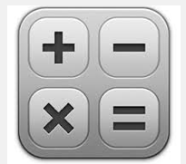

Check your answers with a calculator. Eg: 136 ÷2 =68 is divisible by 2 because there is no remainder.

259 ÷2 =129.5 is NOT divisible by 2 because there is a decimal point which shows a leftover fraction. 259 cannot be evenly divided by 2.

|  |  |
| --- | --- |
| ***Description: j0229369*** |  |
| **Task 1 Activity 5: Finding Factors** |

**Factor**

1. any number that divides evenly into another number.
2. the question part of a multiplication problem: 3 x 6 = 18:  **3** and **6** are **factors** of **18**.

**Multiple.**

1. the total that is made from numbers that are multiplied.

2. answer to a multiplication equation. 18 is a **multiple** of 3 and 6.

Here are examples of **factors** and **multiples**.

|  |  |  |  |  |  |  |  |  |  |  |
| --- | --- | --- | --- | --- | --- | --- | --- | --- | --- | --- |
| **Factor** | | **Factor** |  | **Multiple** |  | **Factor** | | **Factor** |  | **Multiple** |
| 1 | x | 8 | = | **8** |  | 3 | x | 9 | = | **27** |
| 2 | x | 8 | = | **16** |  | 7 | x | 4 | = | **28** |
| 3 | x | 8 | = | **24** |  | 9 | x | 5 | = | **45** |
| 4 | x | 8 | = | **32** |  | 4 | x | 6 | = | **24** |
| 5 | x | 8 | = | **40** |  | 6 | x | 9 | = | **54** |
| 6 | x | 8 | = | **48** |  | 2 | x | 7 | = | **14** |
| 7 | x | 8 | = | **56** |  | 11 | x | 9 | = | **99** |
| 8 | x | 8 | = | **64** |  | 30 | x | 8 | = | **240** |
| 9 | x | 8 | = | **72** |  | 53 | x | 79 | = | **4 187** |
| 10 | x | 8 | = | **80** |  | 76 | x | 47 | = | **3 572** |

Write ALL the factors for:

24: ………. , ………. , ………. , ………. , ………. , ………. , ………. , ………. ,

40: ………. , ………. , ………. , ………. , ………. , ………. , ………. , ………. ,

81: ………. , ………. , ………. , ………. , ………. ,

105: ………. , ………. , ………. , ………. , ………. , ………. , ………. , ………. ,

120: ………. , ………. , ………. , ………. , ………. , ………. , ………. , ………. ,

………. , ………. , ………. , ………. , ………. , ………. , ………. , ………. ,

# Task 2 What’s the fraction?

**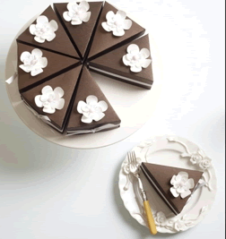**

A fraction is one part out of a number of equal parts.

The cake shown here has been cut into 8 equal parts.

**Each slice** is **one part** out of **eight equal parts.**

.



|  |  |  |  |
| --- | --- | --- | --- |
|  | |  | |
| I had 1 slice 🡪  The whole cake is 8 slices 🡪 |  | There are 7 slices left 🡪  The whole cake is 8 slices 🡪 |  |

The **top number** tells us how **many equal parts we have taken** … or how many **equal**  **parts are left**

The **bottom number** tells us the **total number of equal parts.**

The **top number** is the **numerator** *(new-mer-ator***) how many equal parts we are using.**

**The bottom number** is often called the **denominator (***dee-nom-in-ator). This tells us how many equal parts there are in total.*

|  |  |
| --- | --- |
| C:\Users\CFord\Documents\MY Folders\CurricDev2012\images\downloads\slicecake.PNG***Description: j0229369*** |  |
| **Task 2 Activity 1: What’s the fraction?** |
|  |

**Question 1**

Write each fraction in words. Draw a picture to show what it represents.

The first two show how.

|  |  |  |
| --- | --- | --- |
|  | The fraction in words: | A picture of the fraction |
|  | One half |  |
|  | Three seven**ths** |  |
|  |  |  |
|  |  |  |
|  |  |  |
|  |  |  |
|  |  |  |

**Question 2**

Write each fraction in digits. Draw a picture to show what it represents.

|  |  |  |
| --- | --- | --- |
| The fraction in words. | The fraction in digits. | A picture of the fraction. |
| Four fif**ths** |  |  |
| Two thirds |  |  |
| Three quarters |  |  |
| Five ten**ths** |  |  |
| Four seven**ths** |  |  |

**Question 3**

|  |  |
| --- | --- |
| **(a)** | Each pizza is cut into 6 equal slices. What fraction was eaten? What fraction was left? |

|  |  |  |
| --- | --- | --- |
| **(i)** | **(ii)** | **(iii)** |
| Fraction eaten  Fraction left | Fraction eaten  Fraction left | Fraction eaten  Fraction left |

|  |  |
| --- | --- |
| **(b)** | The chocolate bar has 9 pieces. What fraction of each chocolate bar has been eaten? What fraction is left? |

|  |  |  |  |
| --- | --- | --- | --- |
| **(i)** |  | **(ii)** |  |
| Fraction eaten  Fraction left | | Fraction eaten  Fraction left | |

**Question 4 Shade the fraction of each shape.**

|  |  |
| --- | --- |
| **(a)** | Each shape below has been divided into **equal parts.**  What fraction of each shape is **shaded**? What fraction is **unshaded**? |

|  |  |  |  |
| --- | --- | --- | --- |
| Shape 1 | Shape 2 | Shape 3 | Shape 4 |

|  |  |  |  |  |
| --- | --- | --- | --- | --- |
|  | Shape 1 | Shape 2 | Shape 3 | Shape 4 |
| Fraction  shaded |  |  |  |  |
| Fraction  unshaded |  |  |  |  |

|  |  |
| --- | --- |
| **(b)** | These shapes take a bit more thinking….  What fraction of each shape is shaded? What fraction is unshaded? |

|  |  |  |
| --- | --- | --- |
| Shape 1 | Shape 2 | Shape 3 |

|  |  |  |  |
| --- | --- | --- | --- |
|  | Shape 1 | Shape 2 | Shape 3 |
| Fraction  shaded |  |  |  |
| Fraction  unshaded |  |  |  |

**Question 5** What would the whole shape look like?

|  |  |
| --- | --- |
|  | If this is  what could the whole shape look like? |

|  |  |
| --- | --- |
| All we know is that the rectangle is one quarter of a larger shape.  Here are some examples of how the whole shape might look. |  |

|  |  |  |
| --- | --- | --- |
| **(a)** | If this shape is  what could the whole shape look like? |  |
|  |  | |

|  |  |  |
| --- | --- | --- |
| **(b)** | If this shape is  what could the whole shape look like? |  |
|  |  | |

|  |  |  |
| --- | --- | --- |
| **(c)** | If this shape is  what could the whole shape look like? |  |
|  |  | |

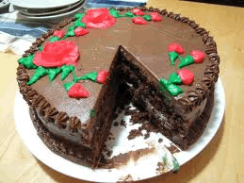

# Approximately what fraction?



Sometimes we need to estimate fractions.

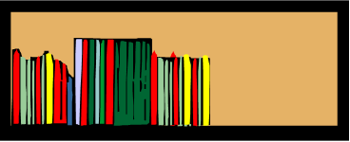

**Example 1**

Approximately what fraction of the bookshelf is filled?

Think…. how can I divide the bookshelf into equal parts?

|  |  |  |
| --- | --- | --- |
| **Try quarters** |  | **Try fifths** |
|  |  | ↑  The bookshelf is about three fifths full. |
|  |  |

**Example 2**

Approximately what fraction of the cake has been eaten?



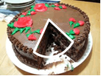



Think… the missing piece is one fraction.



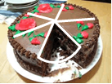

How many more pieces of the same size could I cut from the cake?

I could cut another 5 pieces.

The fraction eaten is approximately one piece out of six, or 

|  |  |
| --- | --- |
| ***Description: j0229369*** |  |
| **Task 2 Activity 2: Approximately what fraction?** |
|  |

**Question 1** Divide each shape into **quarters,** then shade **one quarter**.

|  |  |  |  |
| --- | --- | --- | --- |
|  |  |  |  |

**Question 2** Shade one half of each shape in two different ways.

|  |  |  |  |
| --- | --- | --- | --- |
| **(a)** |  |  |  |

|  |  |  |  |
| --- | --- | --- | --- |
| **(b)** |  |  |  |

**Question 3** Approximately what fraction?

|  |  |  |
| --- | --- | --- |
| **(a)** | Approximately what fraction of the bookshelf has been filled?  Think… how many equal spaces should the bookshelf be divided? | C:\Users\CFord\Documents\MY Folders\CurricDev2012\images\module 4\shelf fractions\3quarters.gif |

|  |  |  |
| --- | --- | --- |
| **(b)** | Approximately what fraction of the cake has been eaten?  Think… how many more pieces of the same size could be cut from the cake | C:\Users\CFord\Documents\MY Folders\CurricDev2012\images\module 4\cakeslice9.gif |

|  |  |  |  |  |
| --- | --- | --- | --- | --- |
| **(c)** | **(i)** | What fraction of the jug is full? | **(ii)** | Estimate the fraction of drink in the jug. |
|  |  | C:\Users\CFord\Documents\MY Folders\CurricDev2012\images\module 4\jug fractions\1.gif | C:\Users\CFord\Documents\MY Folders\CurricDev2012\images\module 4\jug fractions\6.gif | |

|  |
| --- |
| **Solve a problem Which glass belongs to whom**?  There were six glasses of cordial sitting on the kitchen table. They all belonged to different people. Can you tell which glass belongs to whom from the clues given? |
| C:\Users\CFord\Documents\MY Folders\CurricDev2012\images\module 4\glasses\5.gifC:\Users\CFord\Documents\MY Folders\CurricDev2012\images\module 4\glasses\4.gifC:\Users\CFord\Documents\MY Folders\CurricDev2012\images\module 4\glasses\6.gifC:\Users\CFord\Documents\MY Folders\CurricDev2012\images\module 4\glasses\2.gifC:\Users\CFord\Documents\MY Folders\CurricDev2012\images\module 4\glasses\3.gifC:\Users\CFord\Documents\MY Folders\CurricDev2012\images\module 4\glasses\1.gif |

Frank drank **seven-eighths** of his milk.

John left a **third** of his drink.

Tania drank about a **quarter** of her drink.

William didn’t drink any of his drink.

Bree left nothing of her drink.

Miranda’s glass was the one remaining. What fraction had she drunk?

# Task 3 Bigger, smaller or the same?



How can you tell whether a fraction is bigger or smaller than another fraction?  
Let’s see an example.

|  |  |  |  |  |  |  |  |  |  |  |  |  |  |  |  |  |  |  |  |  |  |  |  |  |  |  |  |  |
| --- | --- | --- | --- | --- | --- | --- | --- | --- | --- | --- | --- | --- | --- | --- | --- | --- | --- | --- | --- | --- | --- | --- | --- | --- | --- | --- | --- | --- |
|  |  | | | | | |  | | | | | | |  | | | | | |  | | | | | | *one quarter* | means | *divide a block into 4 equal parts and take one part* |
|  |  |  |  |  |  |  | |  |  |  |  |  |  | |  |  |  |  |  | |  |  |  |  |  |

|  |  |  |  |  |  |  |  |  |  |  |  |  |  |  |  |  |  |  |  |  |  |  |  |  |  |  |  |  |  |  |  |  |  |
| --- | --- | --- | --- | --- | --- | --- | --- | --- | --- | --- | --- | --- | --- | --- | --- | --- | --- | --- | --- | --- | --- | --- | --- | --- | --- | --- | --- | --- | --- | --- | --- | --- | --- |
|  |  | | |  | | |  | | | |  | | |  | | | |  | | |  | | | |  | | |  | | | *one ninth* | means | *divide a block into 9 equal parts and take one part* |
|  |  |  |  | |  |  | |  |  |  | |  |  | |  |  |  | |  |  | |  |  |  | |  |  | |  |  |

|  |  |  |  |  |  |  |  |  |  |  |  |  |  |  |  |  |  |  |  |  |  |  |  |  |  |  |  |  |  |  |  |  |  |  |  |  |  |  |
| --- | --- | --- | --- | --- | --- | --- | --- | --- | --- | --- | --- | --- | --- | --- | --- | --- | --- | --- | --- | --- | --- | --- | --- | --- | --- | --- | --- | --- | --- | --- | --- | --- | --- | --- | --- | --- | --- | --- |
|  |  | |  | |  | |  | |  | | |  | |  | | |  | |  | | |  | |  | | |  | |  | | |  | |  | | *one fifteenth* | means | *divide a block into 15 equal parts and take one part* |
|  |  |  | |  |  |  | |  | |  |  | |  | |  |  | |  | |  |  | |  | |  |  | |  | |  |  | |  | |  |

What do you notice about the denominator when you divide the shape into smaller **equal** parts?

**The more we divide the block, the smaller the fractions become.**

|  |  |
| --- | --- |
| ***Description: j0229369*** |  |
| **Task 3 Activity 1: Bigger or smaller** |
|  |

**Question 1**

Arrange the following fractions in order from smallest to largest.

Use the fraction strips on page **34** to help compare the fractions.

|  |  |  |  |  |  |  |  |
| --- | --- | --- | --- | --- | --- | --- | --- |
|  |  |  |  |  |  |  |  |
| Smallest fractio Largest fractions | | | | | | |

# Comparing fractions

|  |  |  |  |  |  |  |
| --- | --- | --- | --- | --- | --- | --- |
|  | |  |  |  | | |
| One half is greater than one quarter | |  |  | One third is smaller than one half | | |
| As a number sentence: |  |  |  | As a number sentence: |  |  |
|  |  |  |  |  |  | |



We use the symbols **>** and **<** to compare the size of numbers and fractions.

.

The symbol **>** means ‘is greater than’

The symbol **<** means ‘is less than’

To remember which is which, think of bigger or smaller…

|  |  |  |
| --- | --- | --- |
|  |  |  |
| is bigger than  One half is bigger than one quarter. |  | is smaller than  One third is smaller than one half. |

|  |  |
| --- | --- |
| ***Description: j0229369*** |  |
| **Task 3 Activity 2: Comparing fractions** |
|  |

**Question 1**  Use **>** or **<** to complete these number sentences:

|  |  |  |  |  |  |  |  |  |  |  |  |
| --- | --- | --- | --- | --- | --- | --- | --- | --- | --- | --- | --- |
|  |  |  |  |  |  |  |  |  |  |  |  |

|  |  |  |  |  |  |  |  |  |  |  |  |
| --- | --- | --- | --- | --- | --- | --- | --- | --- | --- | --- | --- |
|  |  |  |  |  |  |  |  |  |  |  |  |

**Question 2** Bigger than some, smaller than others.

|  |  |  |  |  |  |  |  |  |  |  |  |  |  |  |  |  |  |  |  |  |  |  |  |  |  |  |  |  |  |  |  |  |  |  |  |  |
| --- | --- | --- | --- | --- | --- | --- | --- | --- | --- | --- | --- | --- | --- | --- | --- | --- | --- | --- | --- | --- | --- | --- | --- | --- | --- | --- | --- | --- | --- | --- | --- | --- | --- | --- | --- | --- |
|  |  | | | | | | | | | | |  | | | | | | | | | | | | |  | | | | | | | | | | | If we divide a block in different ways we can compare the fractions.  The fraction  is smaller than  but bigger than |
|  |  |  |  | |  |  | |  | |  |  | |  | | |  |  |  | |  |  | | |  | |  |  | |  | |  |  | |  |  |
|  |  | | | | | |  | | | | | | | |  | | | | | | |  | | | | | | | |  | | | | | |
|  |  |  |  | |  |  | |  | |  |  | |  | | |  |  |  | |  |  | | |  | |  |  | |  | |  |  | |  |  |
|  |  | | |  | | | | |  | | | | |  | | | | |  | | | |  | | | | |  | | | | |  | | |
|  |  | | |  | | | | |  | | | | |  | | | | |  | | | |  | | | | |  | | | | |  | | |

Look at the fraction strips on page **32.** Find a fraction that would fall between each pair below.

|  |  |  |
| --- | --- | --- |
| **(a)** | Smaller than  bigger than | ………………………….. |

|  |  |  |
| --- | --- | --- |
| **(b)** | Smaller than  bigger than | ………………………….. |

|  |  |  |
| --- | --- | --- |
| **(c)** | Smaller than  bigger than | ………………………….. |

|  |  |  |
| --- | --- | --- |
| **(d)** | Smaller than  bigger than | ………………………….. |

|  |  |  |
| --- | --- | --- |
| **(e)** | Smaller than  bigger than | ………………………….. |

**Question 3** Comparing other fractions

How would you compare  with?

|  |  |  |  |  |  |  |  |  |  |  |  |  |  |  |  |  |  |  |  |  |  |  |  |  |  |
| --- | --- | --- | --- | --- | --- | --- | --- | --- | --- | --- | --- | --- | --- | --- | --- | --- | --- | --- | --- | --- | --- | --- | --- | --- | --- |
|  |  |  |  |  |  |  |  |  |  |  |  |  |  |  |  |  |  |  |  |  |  |  |  | means | *divide a block into 23 equal parts and take one part* |
|  |  |  |  |  |  |  |  |  |  |  |  |  |  |  |  |  |  |  |  |  |  |  |

|  |  |  |  |  |  |  |  |  |  |  |  |  |  |  |  |  |  |  |  |  |  |  |  |  |  |  |  |  |  |  |  |  |
| --- | --- | --- | --- | --- | --- | --- | --- | --- | --- | --- | --- | --- | --- | --- | --- | --- | --- | --- | --- | --- | --- | --- | --- | --- | --- | --- | --- | --- | --- | --- | --- | --- |
|  |  |  |  |  |  |  |  |  |  |  |  |  |  |  |  |  |  |  |  |  |  |  |  |  |  |  |  |  |  |  | means | *divide a block into 30 equal parts and take one part* |
|  |  |  |  |  |  |  |  |  |  |  |  |  |  |  |  |  |  |  |  |  |  |  |  |  |  |  |  |  |  |

 is bigger than 

As a number sentence: 

Use **>** or **<** to complete these number sentences:

|  |  |  |  |  |  |  |  |  |  |  |  |
| --- | --- | --- | --- | --- | --- | --- | --- | --- | --- | --- | --- |
|  |  |  |  |  |  |  |  |  |  |  |  |

**Question 4** Bigger than some, smaller than others.

Think of a fraction that would fall between the pairs below.

|  |  |  |
| --- | --- | --- |
| **(a)** | Smaller than  bigger than | ………………………….. |

|  |  |  |
| --- | --- | --- |
| **(b)** | Smaller than  bigger than | ………………………….. |

|  |  |  |
| --- | --- | --- |
| **(c)** | Smaller than  bigger than | ………………………….. |

|  |  |  |
| --- | --- | --- |
| **(d)** | Smaller than  bigger than | ………………………….. |

|  |  |  |
| --- | --- | --- |
| **(e)** | Smaller than  bigger than | ………………………….. |

# More ways to compare

|  |  |  |  |  |  |  |  |  |  |  |  |  |  |  |  |  |  |  |  |  |  |  |  |  |  |  |  |  |  |  |  |  |  |  |  |  |  |  |  |  |  |  |  |  |
| --- | --- | --- | --- | --- | --- | --- | --- | --- | --- | --- | --- | --- | --- | --- | --- | --- | --- | --- | --- | --- | --- | --- | --- | --- | --- | --- | --- | --- | --- | --- | --- | --- | --- | --- | --- | --- | --- | --- | --- | --- | --- | --- | --- | --- |
|  |  | | | | | | | | | | | | |  |  |  | | | | | | | | | | | | |  |  |  | | | | | | | | | | | | |  |
|  |  | |  | | |  | | |  | | |  | |  |  |  | |  | | |  | | |  | | |  | |  |  |  | |  | | |  | | |  | | |  | |  |
|  |  | | | | | | | | | | | | |  |  |  | | | | | | | | | | | | |  |  |  | | | | | | | | | | | | |  |
|  |  |  | |  |  | |  |  | |  |  | |  |  |  |  |  | |  |  | |  |  | |  |  | |  |  |  |  |  | |  |  | |  |  | |  |  | |  |  |
|  | is bigger than | | | | | | | | | | | | |  |  | is bigger than | | | | | | | | | | | | |  |  | is bigger than | | | | | | | | | | | | |  |
|  | As a number sentence: | | | | | | | | | | | | |  |  | As a number sentence: | | | | | | | | | | | | |  |  | As a number sentence: | | | | | | | | | | | | |  |
|  |  | | | | | | | | | | | | |  |  |  | | | | | | | | | | | | |  |  |  | | | | | | | | | | | | |  |



When the numerator is the same we can compare the size of fractions.

|  |  |
| --- | --- |
| ***Description: j0229369*** |  |
| **Task 3 Activity 3: More ways to compare** |
|  |

**Question 1**

Look at the fraction strips on page **32.** Use the strips to compare the following pairs of fractions.

Use **>** or **<** to complete the number sentences:

|  |  |  |  |  |  |  |  |  |  |  |  |
| --- | --- | --- | --- | --- | --- | --- | --- | --- | --- | --- | --- |
|  |  |  |  |  |  |  |  |  |  |  |  |

|  |  |  |  |  |  |  |  |  |  |  |  |
| --- | --- | --- | --- | --- | --- | --- | --- | --- | --- | --- | --- |
|  |  |  |  |  |  |  |  |  |  |  |  |

|  |  |  |  |  |  |  |  |  |  |  |  |
| --- | --- | --- | --- | --- | --- | --- | --- | --- | --- | --- | --- |
|  |  |  |  |  |  |  |  |  |  |  |  |

**Question 2**

Follow the pattern in Question 1 above to predict which fraction is bigger.

For example, compare  with 

|  |  |  |  |  |  |  |  |  |  |  |  |  |  |  |  |  |
| --- | --- | --- | --- | --- | --- | --- | --- | --- | --- | --- | --- | --- | --- | --- | --- | --- |
| |  |  |  |  |  |  |  |  |  |  |  |  |  |  |  | | --- | --- | --- | --- | --- | --- | --- | --- | --- | --- | --- | --- | --- | --- | --- | |  |  |  |  |  |  |  |  |  |  |  |  |  |  |  | | Think…  1 part out of 15 is bigger than  1 part out of 19  Therefore,  2 parts our of 15 will be bigger than  2 parts out of 19  As a number sentence: |
|  |
| |  |  |  |  |  |  |  |  |  |  |  |  |  |  |  |  |  |  |  | | --- | --- | --- | --- | --- | --- | --- | --- | --- | --- | --- | --- | --- | --- | --- | --- | --- | --- | --- | |  |  |  |  |  |  |  |  |  |  |  |  |  |  |  |  |  |  |  | |

Use the symbols **>** or **<** to complete these numbers sentences:

|  |  |  |  |  |  |  |  |  |  |  |  |
| --- | --- | --- | --- | --- | --- | --- | --- | --- | --- | --- | --- |
|  |  |  |  |  |  |  |  |  |  |  |  |

|  |  |  |  |  |  |  |  |  |  |  |  |
| --- | --- | --- | --- | --- | --- | --- | --- | --- | --- | --- | --- |
|  |  |  |  |  |  |  |  |  |  |  |  |

|  |  |  |  |  |  |  |  |  |  |  |  |
| --- | --- | --- | --- | --- | --- | --- | --- | --- | --- | --- | --- |
|  |  |  |  |  |  |  |  |  |  |  |  |

**Question 3** Shade and compare

Each block below is the same size, but each one has been divided in a different way. By shading each fraction we can compare them.

|  |  |  |  |  |  |  |  |  |  |  |  |  |  |  |  |  |  |  |  |  |  |  |
| --- | --- | --- | --- | --- | --- | --- | --- | --- | --- | --- | --- | --- | --- | --- | --- | --- | --- | --- | --- | --- | --- | --- |
|  |  | | | | | | | | | | | | | | | | | | | |  |  |
|  |  | |  | | |  | | |  | |  | |  | | |  | | |  | |  | The biggest fraction shaded is  The smallest fraction shaded is  From the smallest fraction to the largest fraction:  <  <  <  < |
|  | |  | | |  | | |  | |  | |  | | |  | | |  | |  |
|  |  | | | | | | | | | | | | | | | | | | | |  |
|  |  | | | | | | |  | | | | | |  | | | | | | |  |
|  | | | | | | |  | | | | | |  | | | | | | |  |
|  |  | | | | | | | | | | | | | | | | | | | |  |
|  |  | | |  | | | |  | | |  | | |  | | | |  | | |  |
|  | | |  | | | |  | | |  | | |  | | | |  | | |  |
|  |  | | | | | | | | | | | | | | | | | | | |  |
|  |  |  | | |  | |  | | |  |  |  | | |  | |  | | |  |  |
|  |  | | |  | |  | | |  |  |  | | |  | |  | | |  |  |
|  |  | | | | | | | | | | | | | | | | | | | |  |
|  |  | | | |  | | | | |  | |  | | | | |  | | | |  |
|  | | | |  | | | | |  | |  | | | | |  | | | |  |

Shade each fraction and compare them. Use the symbols **<** or **>** to complete the number sentences.

|  |  |  |  |  |  |  |  |  |  |  |  |  |  |  |  |  |  |  |  |  |  |  |  |  |  |  |  |  |  |
| --- | --- | --- | --- | --- | --- | --- | --- | --- | --- | --- | --- | --- | --- | --- | --- | --- | --- | --- | --- | --- | --- | --- | --- | --- | --- | --- | --- | --- | --- |
|  | |  | | |  | | |  | | |  | |  |  | |  | |  | |  | |  | |  | |  | |  | |
|  | | | | | | | | | | | | |  |  | | | | | | | | | | | | | | | |
|  |  | |  |  | |  |  | |  |  | |  |  |  |  | |  |  |  | |  |  |  | |  |  |  | |  |
|  | | | | | | | | | | | | |  |  | | | | | | | | | | | | | | | |
|  | | | | | | | | | | | | |  |  | | | | | | | | | | | | | | | |

|  |  |  |  |  |  |  |  |  |  |  |  |  |  |  |  |  |  |  |  |  |  |  |  |  |  |  |  |  |  |
| --- | --- | --- | --- | --- | --- | --- | --- | --- | --- | --- | --- | --- | --- | --- | --- | --- | --- | --- | --- | --- | --- | --- | --- | --- | --- | --- | --- | --- | --- |
|  | | |  | | |  | | |  |  | |  | |  | |  | |  | |  | |  | |  | |  | |  | |
|  | | | | | | | | |  |  | | | | | | | | | | | | | | | | | | | |
|  |  |  |  |  |  |  |  |  |  |  |  | |  | |  | |  | |  |  |  | |  | |  | |  | |  |
|  | | | | | | | | |  |  | | | | | | | | | | | | | | | | | | | |
|  | | | | | | | | |  |  | | | | | | | | | | | | | | | | | | | |

|  |  |  |  |  |  |  |  |  |  |  |  |  |  |  |  |  |  |  |  |  |
| --- | --- | --- | --- | --- | --- | --- | --- | --- | --- | --- | --- | --- | --- | --- | --- | --- | --- | --- | --- | --- |
|  | |  | | |  | |  | |  | | |  | |  |  | | |  | | |
|  | | | | | | | | | | | | | |  |  | | | | | |
|  |  | |  |  | |  |  |  | |  |  | |  |  |  |  |  | |  |  |
|  | | | | | | | | | | | | | |  |  | | | | | |
|  | | | | | | | | | | | | | |  |  | | | | | |

|  |  |  |  |  |  |  |  |  |  |  |  |  |  |  |  |  |  |  |  |  |  |  |  |  |  |  |  |  |
| --- | --- | --- | --- | --- | --- | --- | --- | --- | --- | --- | --- | --- | --- | --- | --- | --- | --- | --- | --- | --- | --- | --- | --- | --- | --- | --- | --- | --- |
|  | | |  | | |  | | |  |  | |  | |  | |  | |  | | |  | |  | |  | |  | |
|  | | | | | | | | |  |  | | | | | | | | | | | | | | | | | | |
|  |  |  | |  |  | |  |  |  |  |  | |  | |  | |  | |  |  | |  | |  | |  | |  |
|  | | | | | | | | |  |  | | | | | | | | | | | | | | | | | | |
|  | | | | | | | | |  |  | | | | | | | | | | | | | | | | | | |

# Fractions that look different but are the same



We can divide a shape into equal parts in different ways.

We can also shade fractions of shapes in different ways.

Sometimes the shadings give us the same fraction.

This circle has been divided into **quarters** and into **eighths**.

|  |  |  |
| --- | --- | --- |
| One quarter |  | Two eighths |

Shading one quarter () gives the same fraction as shading two eighths ()

One quarter, , and two eighths, , are equivalent fractions

They both give the same fraction of an object.



**Equivalent** (*ee-kwiv-a-lent)* **fractions** show the **same fraction** which is divided into different denominators.

|  |  |
| --- | --- |
| ***Description: j0229369*** |  |
| **Task 3 Activity 4: Equivalent fractions** |
|  |

**Question 1**

Each shape has been divided in two different ways. Write the equivalent fraction for each shape.

|  |  |  |  |
| --- | --- | --- | --- |
| **(a)** |  | **(b)** |  |
|  |  |  |  |

|  |  |  |  |
| --- | --- | --- | --- |
| **(c)** |  | **(d)** |  |
|  |  |  |  |

|  |  |  |  |
| --- | --- | --- | --- |
| **(e)** |  |  |  |
|  |  |  |  |

|  |  |
| --- | --- |
| **(f)** |  |
|  |  |

**Question 2**

|  |  |  |
| --- | --- | --- |
| Find an equivalent fraction for each shaded shape below.  Divide the shapes to create a different number of equal parts.  Here is an example. |  |  |

|  |  |  |  |  |  |
| --- | --- | --- | --- | --- | --- |
| **(a)** |  |  | **(b)** |  |  |

|  |  |  |  |  |  |
| --- | --- | --- | --- | --- | --- |
| **(c)** |  |  | **(d)** |  |  |

**Question 3** Are these equivalent?

|  |  |
| --- | --- |
| **(a)** | Is  equivalent to ? Use diagrams to explain your reasoning. |

|  |  |
| --- | --- |
| **(b)** | Is  equivalent to ? Use diagrams to explain your reasoning. |

**Question 4** Look at the fraction strips on page **32.**

Use the strips to find equivalent fractions.

|  |  |  |
| --- | --- | --- |
| **(a)** | Find three fractions that are the same as | =  =  = |

|  |  |  |
| --- | --- | --- |
| **(b)** | Find three fractions that are the same as | =  =  = |

|  |  |  |
| --- | --- | --- |
| **(c)** | Find the fraction that is greater than  but less than | <  < |

**Question 4** **True or false?**

**Some of the answers below contain mistakes.** Find which answers are incorrect. Show what the correct answers should be.

|  |  |  |
| --- | --- | --- |
| **(a)** |  | True or False? |

What do you think? Explain why:

|  |  |  |
| --- | --- | --- |
| **(b)** |  | True or False? |

|  |
| --- |
| What do you think? Explain why:  **(c)**  True or False?  2/3 = 6/9 |

What do you think? Explain why:

# Task 4 Develop your skills

Yesterday we saw how to compare fractions by shading shapes and comparing fraction strips.

If we make the fraction strips really thin, we have a line.

Marking fractions along a line is another way to compare them.

|  |  |
| --- | --- |
| C:\Users\CFord\Documents\MY Folders\CurricDev2012\images\exerrcise1.gif |  |
| **Task 4 Activity 1: Warm-up; fractions along a line.** |
|  |

**Question 1** Complete the missing parts of these fraction lines.

|  |  |  |  |  |  |  |  |  |  |  |  |  |  |  |  |  |  |  |  |  |  |  |  |  |  |  |  |  |  |  |
| --- | --- | --- | --- | --- | --- | --- | --- | --- | --- | --- | --- | --- | --- | --- | --- | --- | --- | --- | --- | --- | --- | --- | --- | --- | --- | --- | --- | --- | --- | --- |
|  | | **0** | |  | |  | |  | |  | |  | |  | |  | |  | |  | |  | |  | | | **1** | |  | |
|  | | |  | |  | |  | |  | |  | |  | |  | |  | |  | |  | |  | |  | | |  | | |
|  |  | | |  | |  | |  | |  | |  | |  | |  | |  | |  | |  | |  | |  | | | |  |

|  |  |  |  |  |  |  |  |  |  |  |  |  |  |  |  |  |  |  |  |  |  |  |  |  |  |  |  |  |  |  |
| --- | --- | --- | --- | --- | --- | --- | --- | --- | --- | --- | --- | --- | --- | --- | --- | --- | --- | --- | --- | --- | --- | --- | --- | --- | --- | --- | --- | --- | --- | --- |
|  | | **0** | |  | |  | |  | |  | |  | |  | |  | |  | |  | |  | |  | | | **1** | |  | |
|  | | |  | |  | |  | |  | |  | |  | |  | |  | |  | |  | |  | |  | | |  | | |
|  |  | | |  | |  | |  | |  | |  | |  | |  | |  | |  | |  | |  | |  | | | |  |

|  |  |  |  |  |  |  |  |  |  |  |  |  |  |  |  |  |  |  |  |  |  |  |  |  |  |  |  |  |  |  |
| --- | --- | --- | --- | --- | --- | --- | --- | --- | --- | --- | --- | --- | --- | --- | --- | --- | --- | --- | --- | --- | --- | --- | --- | --- | --- | --- | --- | --- | --- | --- |
|  | | **0** | |  | |  | |  | |  | |  | |  | |  | |  | |  | |  | |  | | | **1** | |  | |
|  | | |  | |  | |  | |  | |  | |  | |  | |  | |  | |  | |  | |  | | |  | | |
|  |  | | |  | |  | |  | |  | |  | |  | |  | |  | |  | |  | |  | |  | | | |  |

|  |  |  |  |  |  |  |  |  |  |  |  |  |  |  |  |  |  |  |  |  |  |  |  |  |  |  |  |  |  |  |
| --- | --- | --- | --- | --- | --- | --- | --- | --- | --- | --- | --- | --- | --- | --- | --- | --- | --- | --- | --- | --- | --- | --- | --- | --- | --- | --- | --- | --- | --- | --- |
|  | | **0** | |  | |  | |  | |  | |  | |  | |  | |  | |  | |  | |  | | | **1** | |  | |
|  | | |  | |  | |  | |  | |  | |  | |  | |  | |  | |  | |  | |  | | |  | | |
|  |  | | |  | |  | |  | |  | |  | |  | |  | |  | |  | |  | |  | |  | | | |  |

|  |  |  |  |  |  |  |  |  |  |  |  |  |  |  |  |  |  |  |  |  |  |  |  |  |  |  |  |  |  |  |
| --- | --- | --- | --- | --- | --- | --- | --- | --- | --- | --- | --- | --- | --- | --- | --- | --- | --- | --- | --- | --- | --- | --- | --- | --- | --- | --- | --- | --- | --- | --- |
|  | | **0** | |  | |  | |  | |  | |  | |  | |  | |  | |  | |  | |  | | | **1** | |  | |
|  | | |  | |  | |  | |  | |  | |  | |  | |  | |  | |  | |  | |  | | |  | | |
|  |  | | |  | |  | |  | |  | |  | |  | |  | |  | |  | |  | |  | |  | | | |  |

**Question 2**

Use your fractions lines from Question1 above to decide if the number sentences below are true or false.

|  |
| --- |
| For example is the number sentence  true or false?  says  *is bigger than*  This is **false**.  is **not** **bigger** than  **is** **smaller** than  It should be  *is smaller than*  This is *True* |

True of False?

|  |  |  |  |  |  |
| --- | --- | --- | --- | --- | --- |
| **(a)** | 🞎 True 🞎 False | **(b)** | 🞎 True 🞎 False | **(c)** | 🞎 True 🞎 False |

|  |  |  |  |  |  |
| --- | --- | --- | --- | --- | --- |
| **(d)** | 🞎 True 🞎 False | **(e)** | 🞎 True 🞎 False | **(f)** | 🞎 True 🞎 False |

**Question 3** From smallest to largest.

Use your number lines from Question1 to help you arrange the fractions from **smallest** to **largest**.

|  |  |  |  |  |  |
| --- | --- | --- | --- | --- | --- |
| **(a)** |  |  | **(b)** |  |  |

|  |  |  |  |  |  |
| --- | --- | --- | --- | --- | --- |
| **(c)** |  |  | **(d)** |  |  |

Choose some of these games to play to learn about equivalent fractions.

Use the fraction diagram on the next page.

If you do not have internet access, complete the exercise on Page 35.

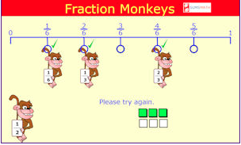

<http://www.fractionmonkeys.co.uk/>

(Play **free** on the computer. You are not obligated to buy.)

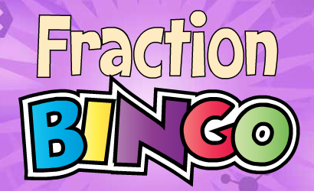<http://www.abcya.com/equivalent_fractions_bingo.htm>

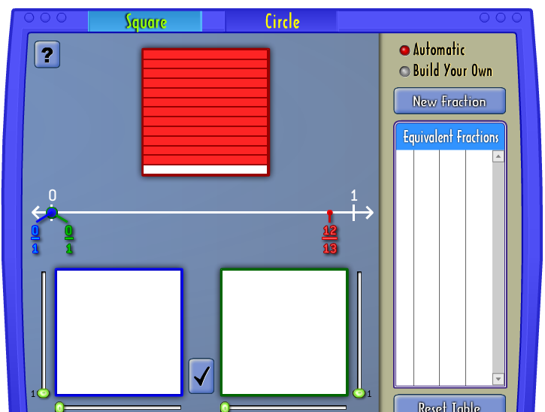<http://illuminations.nctm.org/Activity.aspx?id=3510>

Answer these questions:

Which was you favourite equivalent fraction activity? ……………………………………………..

Explain one main idea you learnt about equivalent fractions:

…………………………………………..…………………………………………..………………………………………………..

…………………………………………..…………………………………………..………………………………………………..

…………………………………………..…………………………………………..………………………………………………..

…………………………………………..…………………………………………..………………………………………………..

Fraction strips: Use these strips to compare fractions.

|  |  |
| --- | --- |
|  |  |

|  |  |  |
| --- | --- | --- |
|  |  |  |

|  |  |  |  |
| --- | --- | --- | --- |
|  |  |  |  |

|  |  |  |  |  |
| --- | --- | --- | --- | --- |
|  |  |  |  |  |

|  |  |  |  |  |  |
| --- | --- | --- | --- | --- | --- |
|  |  |  |  |  |  |

|  |  |  |  |  |  |  |
| --- | --- | --- | --- | --- | --- | --- |
|  |  |  |  |  |  |  |

|  |  |  |  |  |  |  |  |
| --- | --- | --- | --- | --- | --- | --- | --- |
|  |  |  |  |  |  |  |  |

|  |  |  |  |  |  |  |  |  |
| --- | --- | --- | --- | --- | --- | --- | --- | --- |
|  |  |  |  |  |  |  |  |  |

|  |  |  |  |  |  |  |  |  |  |
| --- | --- | --- | --- | --- | --- | --- | --- | --- | --- |
|  |  |  |  |  |  |  |  |  |  |

|  |  |  |  |  |  |  |  |  |  |  |
| --- | --- | --- | --- | --- | --- | --- | --- | --- | --- | --- |
|  |  |  |  |  |  |  |  |  |  |  |

|  |  |  |  |  |  |  |  |  |  |  |  |
| --- | --- | --- | --- | --- | --- | --- | --- | --- | --- | --- | --- |
|  |  |  |  |  |  |  |  |  |  |  |  |

|  |  |  |  |  |  |  |  |  |  |  |  |  |
| --- | --- | --- | --- | --- | --- | --- | --- | --- | --- | --- | --- | --- |
|  |  |  |  |  |  |  |  |  |  |  |  |  |

|  |  |  |  |  |  |  |  |  |  |  |  |  |  |
| --- | --- | --- | --- | --- | --- | --- | --- | --- | --- | --- | --- | --- | --- |
|  |  |  |  |  |  |  |  |  |  |  |  |  |  |

|  |  |  |  |  |  |  |  |  |  |  |  |  |  |  |
| --- | --- | --- | --- | --- | --- | --- | --- | --- | --- | --- | --- | --- | --- | --- |
|  |  |  |  |  |  |  |  |  |  |  |  |  |  |  |

|  |  |  |  |  |  |  |  |  |  |  |  |  |  |  |  |
| --- | --- | --- | --- | --- | --- | --- | --- | --- | --- | --- | --- | --- | --- | --- | --- |
|  |  |  |  |  |  |  |  |  |  |  |  |  |  |  |  |

|  |  |
| --- | --- |
| C:\Users\CFord\Documents\MY Folders\CurricDev2012\images\exerrcise1.gif |  |
| **Task 4 Activity 2: Equivalent Fractions** |
|  |

Study these fractions. Tell your supervisor or parent what you notice about them.

1/2, 2/4, 3/6, 4/8, 5/10, 25/50, 50/100,

Did you notice that the top number (numerator) is exactly **HALF** of the denominator in every fraction? ……………………….

Did you notice that every fraction has the same VALUE -that every fraction is equivalent to 1/2? ……………………

Did you know that 1/2 is the same as 1÷ 2? ………………….

Take your calculator and press the buttons. Write your answer in the box.

|  |  |  |  |  |  |  |  |  |
| --- | --- | --- | --- | --- | --- | --- | --- | --- |
| 1 |  | ÷ |  | 2 |  | = |  |  |

Do the same operation for all the other fractions. Explain what you noticed:

……….……….……….……….……….……….……….……….……….……….……….……….……….……….……….……

……….……….……….……….……….……….……….……….……….……….……….……….……….……….……….……

……….……….……….……….……….……….……….……….……….……….……….……….……….……….……….….

Did you that for each fraction, even though the numerators and denominators are different, the **VALUE** is the **same** - 1/2 or 0.5. That is because the numerator (top) is exactly **HALF** of the denominator (bottom.)

Every time a fraction has a numerator which half of the denominator, it is equivalent to **HALF** (1/2)

What does equivalent mean? It means that one thing is the **same as the other** – it is equal.

1/2 is the same as 2/4, which is the same value as 3/6, 4/8, 5/10 and 6/12.

To quickly work out equivalent fractions, you need to know the multiplication tables very well. If you don’t know multiplication tables, make sure you have these handy to help you with equivalent fractions.

Look at the fraction ?/4. What do we need to do to? /4 to make it equivalent to 8/16?

Start with what we know is a FACT. What did we to “4” to change it “16” (changing quarters to sixteenths)?

If we multiply the denominator 4 by 4, we will get 16. What is? X 4 =8? (This is where tables are very helpful.)

|  |  |  |  |  |  |  |  |  |
| --- | --- | --- | --- | --- | --- | --- | --- | --- |
| ? | X4 | = | 8 |  | 2 | X4 | = | 8 |
| 4 | X4 | 16 |  | 4 | X4 |  | 16 |

Use multiplication tables to find the equivalent fractions. Remember: what you do to the top, do exactly the same to the bottom! Use your calculator to do the division (2 ÷4 =0.5 AND 8 ÷16 =0.5.) If each pair of fractions has the same answer they are equivalent.

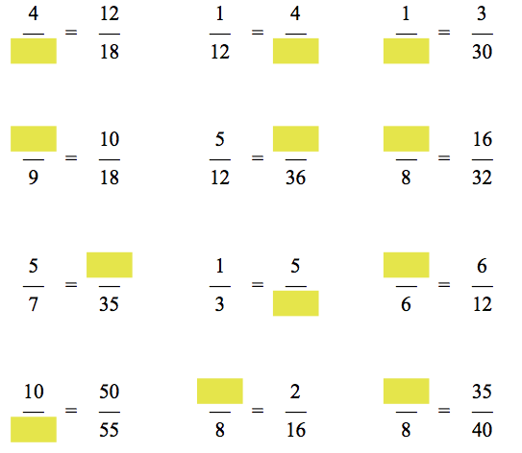

You can be the teacher today!

Some of the fractions below ARE equivalent and some are not equivalent at all.

Use your knowledge of equivalent fractions to find the ‘true’ statements.

Tick the correct ones and cross the incorrect ones. Here is an example:

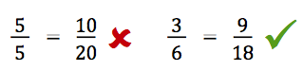

Discuss with your supervisor or parent WHY the first one is NOT equivalent and why the second one IS equivalent.

Remember: use your knowledge of tables.

Check what was done to the fraction to change it. Make sure the same operation is done to the other part of the fraction.

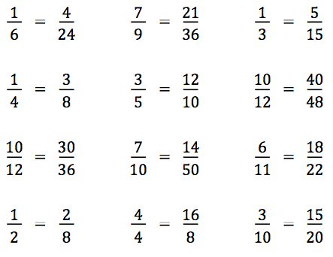

If you would like to practise working out **equivalent fractions,** you can do more at:

[*http://www.math-drills.com/fractions/fractions\_equivalent\_test\_0205\_008.pdf*](http://www.math-drills.com/fractions/fractions_equivalent_test_0205_008.pdf)

|  |  |
| --- | --- |
| **Booklet E**  **Task 5 Test** | Today you will answer questions to assess what you have learnt. |

* This test will enable your teacher to see how well you have understood the work and whether you need any additional help in a particular area.

# C:\Users\CFord\Documents\MY Folders\CurricDev2012\images\test.gifPlease complete the exercises on these pages. Show your working out wherever possible.

# You can use your notes to help you with these exercises, but no other assistance.

**Activity 1 What’s the fraction?**

**Question 1 Fractions in digits, words and pictures**

* **Complete the table**

|  |  |  |
| --- | --- | --- |
| The fraction in digits. | The fraction in words. | A picture to represent the fraction. |
|  | three eighths |  |
|  |  |  |
|  |  |  |
|  | two sevenths |  |

**Question 2 Find the fraction**

|  |  |  |
| --- | --- | --- |
| **(a)** | The pizza is cut into 8 equal slices.  What fraction was eaten?  What fraction was left?  Fraction eaten  Fraction left | C:\Users\CFord\Documents\MY Folders\CurricDev2012\images\module 4\pizz_send1.gif |

|  |  |  |  |  |
| --- | --- | --- | --- | --- |
| **(b)** | These take a bit of thinking…  What fraction of each shape is shaded?  What fraction is unshaded? | | |  |
|  | **(i)** |  | Fraction shaded  Fraction unshaded | |
|  | **(ii)** |  | Fraction shaded  Fraction unshaded | |

|  |  |  |
| --- | --- | --- |
| **(c)** | Divide the shape into quarters, and shade one quarter |  |

|  |  |  |
| --- | --- | --- |
| **(d)** | Shade one half of this shape in two different ways. |  |

**Question 3 What could the whole shape look like?**

|  |  |
| --- | --- |
|  | If this is  what could the whole shape look like? |

**Question 4 Approximately what fraction?**

|  |  |  |  |  |
| --- | --- | --- | --- | --- |
| **(a)** | **(i)** | What fraction of the jug is full? | **(ii)** | Estimate the fraction of drink in the jug. |
|  |  | Description: C:\Users\CFord\Documents\MY Folders\CurricDev2012\images\module 4\jug fractions\2.gif | Description: C:\Users\CFord\Documents\MY Folders\CurricDev2012\images\module 4\jug fractions\7.gif | |
| **(b)** | Approximately what fraction of the bookshelf has been filled?  Think… how many equal spaces should the bookshelf be divided? | | | Description: C:\Users\CFord\Documents\MY Folders\CurricDev2012\images\module 4\shelf fractions\half.gif | |
| **(c)** | Approximately what fraction of the cake has been eaten?  Think… how many more pieces of the same size could be cut from the cake?  Show the cutting lines on the picture. | | | Description: C:\Users\CFord\Documents\MY Folders\CurricDev2012\images\module 4\mudcake_sliced.gif | |

**Challenge question:**

**Use your fraction skills to solve this problem**

|  |  |  |
| --- | --- | --- |
| The picture shows a block of chocolate.  Part of the block is white chocolate.  The other part is caramel chocolate. | |  |
| **(a)** | What fraction of the block is white chocolate? |
| **(b)** | What fraction of the block is caramel chocolate? |
| **(c)** | If I ate any 12 pieces of chocolate what fraction of the whole block would this be? | |
| **(d)** | Description: C:\Users\CFord\Documents\MY Folders\CurricDev2012\images\module 4\chocolate.gifIf I shared  of the chocolate block with my friends Kelly and Terri, how many pieces would they get? | |
| **(e)** | How many pieces of chocolate would be left?  What fraction would I have left? | |

**Activity 2 Comparing fractions**

**Question 1**

|  |  |  |  |  |  |  |  |  |
| --- | --- | --- | --- | --- | --- | --- | --- | --- |
| **(a)** | Arrange the following fractions in order from smallest to largest. Use the fraction strips on page **73** to help you if you need to. | | | | | | | |
|  | |  |  |  |  |  |  |  | |
| Smallest Largest | | | | | | | |

|  |  |
| --- | --- |
| **(b)** | Use **>** *(bigger than)* or **<** *(smaller than)* to complete these number sentences. |

|  |  |  |  |  |  |  |  |  |  |  |
| --- | --- | --- | --- | --- | --- | --- | --- | --- | --- | --- |
|  |  |  |  |  |  |  |  |  |  |  |

|  |  |
| --- | --- |
| **(c)** | Look at the fraction strips on page **73**.  Find a fraction that is smaller than  but bigger than |

|  |  |
| --- | --- |
| **(d)** | Shade each fraction and compare them. Use the symbols **<** or **>** to complete the number sentences. |

|  |  |  |  |  |  |  |  |  |  |  |  |  |  |  |  |  |  |  |  |  |  |  |  |  |  |  |  |  |  |  |
| --- | --- | --- | --- | --- | --- | --- | --- | --- | --- | --- | --- | --- | --- | --- | --- | --- | --- | --- | --- | --- | --- | --- | --- | --- | --- | --- | --- | --- | --- | --- |
|  | |  | |  | |  | |  | |  | |  | |  |  | | |  | | |  | | | |  | | |  | | |
|  | | | | | | | | | | | | | |  |  | | | | | | | | | | | | | | | |
|  |  | |  | |  | |  | |  | |  | |  |  |  |  |  | |  |  | |  |  |  | |  |  | |  |  |
|  | | | | | | | | | | | | | |  |  | | | | | | | | | | | | | | | |
|  | | | | | | | | | | | | | |  |  | | | | | | | | | | | | | | | |

**Activity 3 Equivalent fractions**

**Question 1**

|  |
| --- |
| Each shape below has been divided in two different ways.  Write the equivalent fraction for each shape. |

|  |  |
| --- | --- |
| **(a)** | **(b)** |
|  |  |

**Question 2**

























|  |  |
| --- | --- |
| This triangle has been divided into smaller triangles. | |
| **(a)** | **(i)** How many smaller triangles has it been divided into?    **(ii)** Shade  of this shape. |

|  |  |
| --- | --- |
| **(b)** | Find another way to shade  of this shape. |

**Question 3**

The line below measures approximately 12 cm.

|  |  |
| --- | --- |
| **(a)** | Use a ruler to divide the line into 12 equal parts. |

|  |  |
| --- | --- |
| **(b)** | Show where  appears on the line. |

|  |  |
| --- | --- |
| **(c)** | Express  as an equivalent fraction: = |

**Question 4**

Look at the fraction strips on page **34**.

|  |  |
| --- | --- |
| **(a)** | Find two fractions that are the same as |

|  |  |
| --- | --- |
| **(b)** | Is  equivalent to ?  Use diagrams to explain your reasoning. |

# Task 6 Number skills review: multiples and factors



To solve maths problems, we need good number skills.

Knowing how to skip count helps you to do a lot of calculations…

especially multiplying and dividing,

Skip counting also helps you to remember your multiplication tables.

Today we revise counting by **sevens. Look for the patterns.**

|  |  |
| --- | --- |
| C:\Users\CFord\Documents\MY Folders\CurricDev2012\images\exerrcise1.gif |  |
| **Task 6 Activity 1: Review counting by sevens** |
| reporter1  Circle every **seventh** number on the number grid. |

|  |  |  |  |  |  |  |  |  |  |  |  |
| --- | --- | --- | --- | --- | --- | --- | --- | --- | --- | --- | --- |
|  | 1 | 2 | 3 | 4 | 5 | 6 | 7 | 8 | 9 | 10 |  |
|  | 11 | 12 | 13 | 14 | 15 | 16 | 17 | 18 | 19 | 20 |  |
|  | 21 | 22 | 23 | 24 | 25 | 26 | 27 | 28 | 29 | 30 |  |
|  | 31 | 32 | 33 | 34 | 35 | 36 | 37 | 38 | 39 | 40 |  |
|  | 41 | 42 | 43 | 44 | 45 | 46 | 47 | 48 | 49 | 50 |  |
|  | 51 | 52 | 53 | 54 | 55 | 56 | 57 | 58 | 59 | 60 |  |
|  | 61 | 62 | 63 | 64 | 65 | 66 | 67 | 68 | 69 | 70 |  |
|  | 71 | 72 | 73 | 74 | 75 | 76 | 77 | 78 | 79 | 80 |  |
|  | 81 | 82 | 83 | 84 | 85 | 86 | 87 | 88 | 89 | 90 |  |
|  | 91 | 92 | 93 | 94 | 95 | 96 | 97 | 98 | 99 | 100 |  |
|  | 101 | 102 | 103 | 104 | 105 | 106 | 107 | 108 | 109 | 110 |  |

|  |  |  |
| --- | --- | --- |
| 1. Practise counting by sevens | up to 70 | up to 110 |

2. Practise counting by sevens backwards…

|  |  |  |
| --- | --- | --- |
| from 35 | from 70 | from 98 |

Practise your counting out loud; walk as you count; ask your supervisor or parent or buddy to hear you.

A counting tip: 7 equals 10 minus 3

|  |  |
| --- | --- |
| To count **up** by 7  Add 10 and take away 3  **28** + 10 → 38 – 3 → **35** | To count **down** by 7  Take away 10 and add 3  **85** – 10 → 75 + 3 → **78** |



|  |  |  |
| --- | --- | --- |
| Invest a lot of time in becoming confident, quick and accurate with your multiplication tables. Complete the tables below.   |  |  | | --- | --- | | *Use your Mathletics username and password to listen to multiplication tables songs:* | Go to:  [*http://www.multiplication.com/games/all-games*](http://www.multiplication.com/games/all-games) or to:    [*http://www.math-play.com/multiplication-games.html*](http://www.math-play.com/multiplication-games.html) | |

|  |  |  |  |  |  |  |
| --- | --- | --- | --- | --- | --- | --- |
|  |  | 7 times tables |  | 9 times tables |  |  |
|  |  | 1 × 7 = \_\_\_\_\_\_\_\_\_  2 × 7 = \_\_\_\_\_\_\_\_\_  3 × 7 = \_\_\_\_\_\_\_\_\_  4 × 7 = \_\_\_\_\_\_\_\_\_  5 × 7 = \_\_\_\_\_\_\_\_\_  6 × 7 = \_\_\_\_\_\_\_\_\_  7 × 7 = \_\_\_\_\_\_\_\_\_  8 × 7 = \_\_\_\_\_\_\_\_\_  9 × 7 = \_\_\_\_\_\_\_\_\_  10 × 7 = \_\_\_\_\_\_\_\_\_  11 × 7 = \_\_\_\_\_\_\_\_\_  12 × 7 = \_\_\_\_\_\_\_\_\_ |  | 1 × 9 = \_\_\_\_\_\_\_\_\_  2 × 9 = \_\_\_\_\_\_\_\_\_  3 × 9 = \_\_\_\_\_\_\_\_\_  4 × 9 = \_\_\_\_\_\_\_\_\_  5 × 9 = \_\_\_\_\_\_\_\_\_  6 × 9 = \_\_\_\_\_\_\_\_\_  7 × 9 = \_\_\_\_\_\_\_\_\_  8 × 9 = \_\_\_\_\_\_\_\_\_  9 × 9 = \_\_\_\_\_\_\_\_\_  10 × 9 = \_\_\_\_\_\_\_\_\_  11 × 9 = \_\_\_\_\_\_\_\_\_  12 × 9 = \_\_\_\_\_\_\_\_\_ |  |  |

|  |  |
| --- | --- |
|  |  |
| **Task 6 Become a ‘Multiplication Superstar”. Practise tables.** |
|  |



Knowing your tables straight away will help you with fractions, multiplication and division.

**Activity 1:** One way to practise your tables is to find some games you to play.

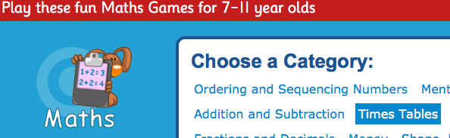<http://www.topmarks.co.uk/maths-games/7-11-years/times-tables>

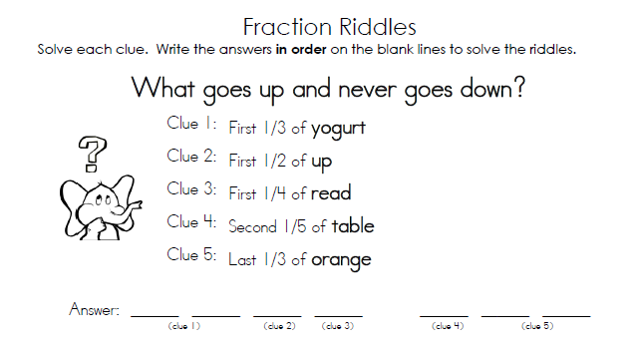 <http://www.tlsbooks.com/fractionriddle1.pdf>

# Task 7 Reducing fractions



To reduce fractions to their most simple form, you need to know your tables and the division facts associated with those tables.

|  |  |
| --- | --- |
| C:\Users\CFord\Documents\MY Folders\CurricDev2012\images\exerrcise1.gif |  |
| **Task 7 Activity 1: Warm-up: division facts** |
|  |



Division facts are the inverse of multiplication facts.

**Question 1** Division facts recall.

|  |  |  |
| --- | --- | --- |
| 88 ÷ 11 | Think….  What number ? × 11 = 88  8 **×** 11 = 88  88 **÷** 11 = 8 | Think in terms of sharing… 88 things shared between 11 people, gives 8 to each person. |

`

Use your knowledge of multiplication tables to recall these division facts.

|  |  |  |
| --- | --- | --- |
| 20 ÷ 4 = ……………… | 42 ÷ 7 = ……………… | 110 ÷ 11 = ……………… |
| 60 ÷ 6 = ……………… | 20 ÷ 10 = ……………… | 40 ÷ 8 = ……………… |
| 72 ÷ 8 = ……………… | 35 ÷ 7 = ……………… | 20 ÷ 2 = ……………… |
| 48 ÷ 6 = ……………… | 99 ÷ 9 = ……………… | 32 ÷ 4 = ……………… |
| 30 ÷ 5 = ……………… | 24 ÷ 8 = ……………… | 90 ÷ 10 = ……………… |

# Divisibility rules

# … how to tell if we can divide one number by another

|  |  |  |
| --- | --- | --- |
| Divisibility rules – look for these patterns in the **ANSWERS:** |  | Think back to the divisibility rules we covered in Task 1.  These rules showed us how we can tell whether a number can be divided by 2, 3, 4 ,5, 6, 9 or 10  Let’s see another way of using these rules. |
| **÷ 2**  The number ends in  **0, 2, 4, 6, 8** |  |
| **÷ 3**  The digits add up to **multiple of 3** |  | **Example 1**  Which number can be divided evenly into **15** and into **20?**  Think… 15 ends in ‘5’ and 20 ends in ‘0’.  Both numbers can be divided by 5:  15 ÷ 5 = 3 and 20 ÷ 5 = 4  Notice that 20 can be divided by 2, 4, 5 and 10, but 15 can only be divided by 5. |
| **÷ 4**  the last two digits are a **multiple** **of 4** |  |
| **÷ 5**  The number **ends in 0 or 5** |  |
| **÷ 6**  The number can be divided **by 2 and by 3** |  |  |
| **Example 2**  Which number can be divided evenly into 34 and into 16?  Think… 34 ends in ‘4’ and 16 ends in ‘6’  Both numbers can be divided by 2:  34 ÷ 2 = 17 and 16 ÷ 2 = 8  Notice that 16 can be divided by 2, 4, and 8, but 34 can only be divided by 2. |
| **÷ 9**  The **digits add up to 9** or a **multiple of 9** |  |
| **÷ 10**  **The number ends in 0** |  |

Observing and finding rules and patterns in number is very helpful to quickly estimate and check answers to maths problems.

Create equations to test some of these divisibility rules.

|  |  |
| --- | --- |
| ***Description: j0229369*** |  |
| **Task 7 Activity 2: Divisibility** |
|  |

**Question 1**

Use the divisibility rules to help you answer these questions.

Find the numbers that will divide evenly into each set of numbers. Write each division sentence:

|  |  |  |
| --- | --- | --- |
| **(a)** | Which number can be divided evenly into 9 and 30? ………………. | |
|  | 9 ÷  = | 30 ÷  = |

|  |  |  |
| --- | --- | --- |
| **(b)** | Which number can be divided into 14 and 20? ………………. | |
|  | 14 ÷  = | 20 ÷  = |

|  |  |  |
| --- | --- | --- |
| **(c)** | Which number can be divided into 15 and 24? ………………. | |
|  | 15 ÷  = | 24 ÷  = |

|  |  |  |
| --- | --- | --- |
| **(d)** | Which number can be divided into 35 and 50? ………………. | |
|  | 35 ÷  = | 50 ÷  = |

|  |  |  |
| --- | --- | --- |
| **(e)** | Which number can be divided into 44 and 77? ………………. | |
|  | 44 ÷  = | 77 ÷  = |

**Question 2** What’s the largest number we can divide by?

|  |
| --- |
| **Example 1** Find the largest number that will divide evenly into 12 and 20  Think… 12 and 20 can be divided by 2  can also be divided by 4 ←The largest number is 4  12 ÷ 4 = 3  and 20 ÷ 4 = 5 |

|  |
| --- |
| **Example 2** Find the largest number that will divide equally into 30 and 48  Think… 30 and 48 can be divided by 2  can also be divided by 4  can also be divided by 6 ←The largest number is 6  30 ÷ 6 = 5  and 48 ÷ 6 = 8 |

Find the **largest** number that will divide evenly into each pair:

|  |  |  |  |
| --- | --- | --- | --- |
| **(a)** | 16 and 28 ………………….. | **(b)** | 32 and 44 ………………….. |
| **(c)** | 18 and 42 ………………….. | **(d)** | 27 and 45 ………………….. |
| **(e)** | 20 and 50 ………………….. | **(f)** | 45 and 63 ………………….. |

# Reducing fractions



Sometimes we need to reduce a fraction to its most simple form.

|  |  |  |
| --- | --- | --- |
| These fractions are **equivalent** to  Look closely at these fractions. Can you see that the **NUMERATOR** is **exactly** **HALF** of the **DENOMINATOR**? | ….. and so on | |
|  |  |  |
|  | The simplest fraction is | |



To find the simplest fraction divide the numerator and denominator by the same number.

**Example 1**

|  |  |  |  |  |
| --- | --- | --- | --- | --- |
| Simplify the fraction  Think….  **5** will divide into **20** **and** into **25** |  | 20 ÷ 5 = 4 |  |  |
|  |  |  |
|  |
| 25 ÷ 5 = 5 |
|  |  |  |
|  |  |  |  |  |

**Example 2**

|  |  |  |  |  |  |
| --- | --- | --- | --- | --- | --- |
| Simplify the fraction  Think….  **10** will divide into **20 and** into **40** |  | 20 ÷ 10 = 2 |  | 2 ÷ 2 = 1 |  |
|  |  |  |
|  |  |
| 40 ÷ 10 = 4 | 4 ÷ 2 = 2 |
|  |  |  |
| Divide again by 2 to simplify to |  |  |  |  |  |
|  | | | | |

|  |  |
| --- | --- |
| ***Description: j0229369*** |  |
| **Task 7 Activity 3: Simplest fractions** |
|  |

**Question 1** Calculate the simplest fraction; use repeated division.

|  |  |  |  |
| --- | --- | --- | --- |
| **(a)** | = | **(b)** | = |
| **(c)** | = | **(d)** | = |
| **(e)** | = | **(f)** | = |

**Question 2** Complete these patterns of equivalent fractions.

|  |  |  |  |
| --- | --- | --- | --- |
| **(a)** | = = =  = | **(b)** | = = =  = |
| **(c)** | = = =  = | **(d)** | =  = =  = |

**Question 3**

For each fraction below:

* Divide to find as **many equivalent fractions** as you can
* Write the number that you used as a divisor.

|  |
| --- |
| For example:  =  (divide by 2) or  (divide by 3) or  (divide by 4) or  (divide by 12) |

**(a)** = ………………………………………………………………………………………

**(b)**  = ………………………………………………………………………………………

**Question 4**

Sam says he has simplified (brought to lowest terms) these fractions as far as he can. Is he right? If not, find the simplest fraction.

|  |  |  |  |
| --- | --- | --- | --- |
| **(a)** | → | **(b)** | →  → |
| **(c)** | → | **(d)** | → |

**Question 5** Apply your skills

Use equivalent fractions to solve these problems:

|  |  |
| --- | --- |
| **(a)** | A cake recipe needs cup of sugar. You have  of a cup.  Do you have enough sugar? |
| **(b)** | The recipe also needs  cup of milk. You have of a cup.  Do you have enough milk? |
| **(c)** | The recipe also needs  cup cocoa. You have  of a cup.  Do you have enough cocoa? |

# Comparing fractions… what’s my strategy

# ..more than half or less than half?



Sometimes we can compare fractions by checking whether they are **more** or **less than** **one half.**

Is  bigger or smaller than ?

|  |  |  |  |  |  |  |  |  |  |  |  |  |  |  |  |  |  |  |  |  |  |  |  |  |  |  |  |  |  |  |  |  |  |  |  |  |
| --- | --- | --- | --- | --- | --- | --- | --- | --- | --- | --- | --- | --- | --- | --- | --- | --- | --- | --- | --- | --- | --- | --- | --- | --- | --- | --- | --- | --- | --- | --- | --- | --- | --- | --- | --- | --- |
| If we divide a shape into 14 equal parts, half of it would be | | | | | | | | | | | | | | |  | If we divided a shape into 20 equal parts, half of it would be | | | | | | | | | | | | | | | | | | | | |
|  | | | | | | | |  | | | | | | |  |  | | | | | | | | | |  | | | | | | | | | | |
|  | | | | | | | |  |  |  |  |  |  |  |  |  | | | | | | | | | |  |  |  |  | |  |  |  |  |  |  |
|  |  |  |  |  |  | |  |  |  |  |  |  |  |  |  |  |  |  |  |  |  |  |  |  |  |  |  |  |  | |  |  |  |  |  |  |
|  | | | | | |  | | | | | | | | |  |  | | | | | | | | | | | | | |  | | | | | | |
|  | | | | | |  | | | | | | | | |  |  | | | | | | | | | | | | | |  | | | | | | |
|  | | | | | | | | | | | | | | |  |  | | | | | | | | | | | | | | | | | | | | |
| is less than  is less than one half. | | | | | | | | | | | | | | |  | is more than  is more than one half. | | | | | | | | | | | | | | | | | | | | |
|  | | | | | | | | | | | | | | |  |  | | | | | | | | | | | | | | | | | | | | |
| is smaller than | | | | | | | | | | | | | | | | | | | | | | | | | | | | | | | | | | | | |

|  |  |
| --- | --- |
| ***Description: j0229369*** |  |
| **Task 7 Activity 4: Comparing fractions** |
|  |

Complete the missing parts below to compare the fractions.

|  |  |
| --- | --- |
| **(a)** | Compare  with  by completing the following steps: |

|  |  |  |  |  |  |  |  |  |  |  |  |  |  |  |  |  |  |  |  |  |  |  |  |  |  |  |  |  |  |  |  |  |  |  |  |  |  |  |  |  |  |  |  |  |  |  |  |  |  |  |  |  |  |  |  |  |  |  |  |  |
| --- | --- | --- | --- | --- | --- | --- | --- | --- | --- | --- | --- | --- | --- | --- | --- | --- | --- | --- | --- | --- | --- | --- | --- | --- | --- | --- | --- | --- | --- | --- | --- | --- | --- | --- | --- | --- | --- | --- | --- | --- | --- | --- | --- | --- | --- | --- | --- | --- | --- | --- | --- | --- | --- | --- | --- | --- | --- | --- | --- | --- |
| Shade half of each block below. | | | | | | | | | | | | | | | | | | | | | | | | | | | | | | | | | | | | | | | | | | | | | | | | | | | | | | | | | | | | |
| Twelfths  = | | | | | | | | | | | | | | | | | | | | | | | |  | Eighteenths  = | | | | | | | | | | | | | | | | | | | | | | | | | | | | | | | | | | | |
|  |  | |  | |  | |  | |  | |  |  |  | |  | |  | |  | |  | |  |  |  |  | |  | |  | |  | |  | |  | |  | |  | |  |  |  | |  | |  | |  | |  | |  | |  | |  | |  |
|  | |  | |  | |  | |  | |  | |  | |  | |  | |  | |  | |  | |  |  | |  | |  | |  | |  | |  | |  | |  | |  | |  | |  | |  | |  | |  | |  | |  | |  | |  | |
| Is  bigger or smaller than ? | | | | | | | | | | | | | | | | | | | | | | | |  | Is  bigger or smaller than ? | | | | | | | | | | | | | | | | | | | | | | | | | | | | | | | | | | | |
| Is  bigger or smaller than ? | | | | | | | | | | | | | | | | | | | | | | | | | | | | | | | | | | | | | | | | | | | | | | | | | | | | | | | | | | | | |

|  |  |
| --- | --- |
| **(b)** | Compare  with  by completing the following steps: |

|  |  |  |  |  |  |  |  |  |  |  |  |  |  |  |  |  |  |  |  |  |  |  |  |  |  |  |  |  |  |  |  |  |  |  |  |  |
| --- | --- | --- | --- | --- | --- | --- | --- | --- | --- | --- | --- | --- | --- | --- | --- | --- | --- | --- | --- | --- | --- | --- | --- | --- | --- | --- | --- | --- | --- | --- | --- | --- | --- | --- | --- | --- |
| Shade half of each block below. | | | | | | | | | | | | | | | | | | | | | | | | | | | | | | | | | | | | |
| Twentieths  = | | | | | | | | | | | | | | | | | | | |  | Sixteenths  = | | | | | | | | | | | | | | | |
|  |  |  |  |  |  |  |  |  |  |  |  |  |  |  |  |  |  |  |  |  |  |  |  |  |  |  |  |  |  |  |  |  |  |  |  |  |
|  |  |  |  |  |  |  |  |  |  |  |  |  |  |  |  |  |  |  |  |  |  |  |  |  |  |  |  |  |  |  |  |  |  |  |  |  |
| Is  bigger or smaller than ? | | | | | | | | | | | | | | | | | | | |  | Is  bigger or smaller than ? | | | | | | | | | | | | | | | |
| Is  bigger or smaller than ? | | | | | | | | | | | | | | | | | | | | | | | | | | | | | | | | | | | | |

|  |  |
| --- | --- |
| **(c)** | Compare  with  by completing the following steps: |

|  |  |  |  |  |  |  |  |  |  |  |  |  |  |  |  |  |  |  |  |  |  |  |  |  |  |  |  |  |  |  |  |  |  |  |
| --- | --- | --- | --- | --- | --- | --- | --- | --- | --- | --- | --- | --- | --- | --- | --- | --- | --- | --- | --- | --- | --- | --- | --- | --- | --- | --- | --- | --- | --- | --- | --- | --- | --- | --- |
| Shade half of each block below. | | | | | | | | | | | | | | | | | | | | | | | | | | | | | | | | | | |
| Fourteenths  = | | | | | | | | | | | | | |  | Twentieths  = | | | | | | | | | | | | | | | | | | | |
|  | | | | | | | | | | | | | |  |  | | | | | | | | | | | | | | | | | | | |
|  |  |  |  |  |  |  |  |  |  |  |  |  |  |  |  |  |  |  |  |  |  |  |  |  |  |  |  |  |  |  |  |  |  |  |
| Is  bigger or smaller than ? | | | | | | | | | | | | | |  | Is  bigger or smaller than ? | | | | | | | | | | | | | | | | | | | |
| Is  bigger or smaller than ? | | | | | | | | | | | | | | | | | | | | | | | | | | | | | | | | | | |

|  |  |
| --- | --- |
| **(d)** | Compare  with  by completing the following steps: |

|  |  |  |  |  |  |  |  |  |  |  |  |  |  |  |  |  |  |  |  |  |  |  |  |  |  |  |  |  |  |  |  |  |  |  |  |  |  |  |  |  |
| --- | --- | --- | --- | --- | --- | --- | --- | --- | --- | --- | --- | --- | --- | --- | --- | --- | --- | --- | --- | --- | --- | --- | --- | --- | --- | --- | --- | --- | --- | --- | --- | --- | --- | --- | --- | --- | --- | --- | --- | --- |
| Shade half of each block below. | | | | | | | | | | | | | | | | | | | | | | | | | | | | | | | | | | | | | | | | |
| Sixteenths  = | | | | | | | | | | | | | | | |  | Twenty-fourths  = | | | | | | | | | | | | | | | | | | | | | | | |
|  | | | | | | | | | | | | | | | |  |  | | | | | | | | | | | | | | | | | | | | | | | |
|  |  |  |  |  |  |  |  |  |  |  |  |  |  |  |  |  |  |  |  |  |  |  |  |  |  |  |  |  |  |  |  |  |  |  |  |  |  |  |  |  |
| Is  bigger or smaller than ? | | | | | | | | | | | | | | | |  | Is  bigger or smaller than ? | | | | | | | | | | | | | | | | | | | | | | | |
| Is  bigger or smaller than ? | | | | | | | | | | | | | | | | | | | | | | | | | | | | | | | | | | | | | | | | |

# Clock fractions

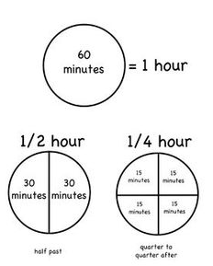

We often use fractions of time in our daily lives.

For example, 15 minutes is one quarter of an hour.

There are 60 minutes in one hour.

As a fraction…

15 minutes in one hour (60 minutes) = 

Simplify  by repeated division:

|  |  |  |
| --- | --- | --- |
| =  and   = | ← | =  15 minutes is one quarter of an hour.  We can see that 15 minutes is one quarter of an hour. It’s 15/60. What number will divide evenly into 15 and 60? |

|  |  |
| --- | --- |
| ***Description: j0229369*** |  |
| **Task 7 Activity 5: Clock fractions** |
|  |

**Question 1**

Use repeated division to show that:

|  |  |  |
| --- | --- | --- |
| **(a)** | 30 minutes is half an hour  = | ………………………….. |
| **(b)** | 45 minutes is three quarters of an hour  = | …………………………… |
| **(c)** | 20 minutes is one third of an hour  = | …………………………… |

**Question 2** Time intervals as fractions.

Tomleft at 8:10 in the morning to catch the train.

He reached the station at 8:32

The time he took to walk to the station was 32 – 10 = 22 minutes.



The fraction of an hour is 

  = 

Work out the time taken, and the fraction of an hour for each time interval:

|  |  |  |
| --- | --- | --- |
| Start/Finish | Time taken | Fraction of an hour |
| Start: 8:15  Finish: 8:45 |  |  |
| Start: 10:10  Finish: 10:38 |  |  |
| Start: 8:30  Finish: 8:56 |  |  |
| Start: 6:24  Finish: 6:39 |  |  |
| Start: 11:20  Finish: 11:53 |  |  |

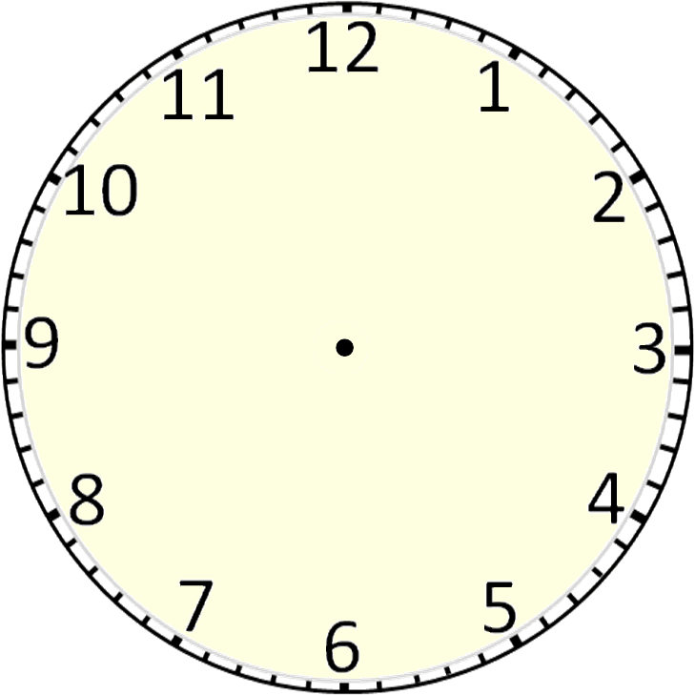**Question 3** Find some possible intervals.

20 minutes is  of an hour.

Find two time intervals that take  of an hour.

From ……………….. to ………………..

From ……………….. to ………………..

# Task 8 Fractions of a collection



So far we have looked at dividing shapes into equal parts.

Another way we use fractions is to divide collections of things into groups.

|  |  |  |  |
| --- | --- | --- | --- |
| **C:\Users\CFord\Documents\MY Folders\CurricDev2012\images\module 4\shell1.gif C:\Users\CFord\Documents\MY Folders\CurricDev2012\images\module 4\shell1.gif C:\Users\CFord\Documents\MY Folders\CurricDev2012\images\module 4\shell1.gif C:\Users\CFord\Documents\MY Folders\CurricDev2012\images\module 4\shell1.gif**  **C:\Users\CFord\Documents\MY Folders\CurricDev2012\images\module 4\shell1.gif C:\Users\CFord\Documents\MY Folders\CurricDev2012\images\module 4\shell1.gif C:\Users\CFord\Documents\MY Folders\CurricDev2012\images\module 4\shell1.gif C:\Users\CFord\Documents\MY Folders\CurricDev2012\images\module 4\shell1.gif**  **C:\Users\CFord\Documents\MY Folders\CurricDev2012\images\module 4\shell1.gif C:\Users\CFord\Documents\MY Folders\CurricDev2012\images\module 4\shell1.gif C:\Users\CFord\Documents\MY Folders\CurricDev2012\images\module 4\shell1.gif C:\Users\CFord\Documents\MY Folders\CurricDev2012\images\module 4\shell1.gif** | There are 12 shells.  5 of the 12 have been grouped. | | |
| The fraction grouped is | | |
|  |  | ←The number of shells grouped (numerator.)  ←The total number of shells (denominator.) |

|  |  |
| --- | --- |
| C:\Users\CFord\Documents\MY Folders\CurricDev2012\images\exerrcise1.gif |  |
| **Task 8 Activity 1: Fractions of a group** |
|  |

**Question1** The fraction of a collection.

What fraction of each collection has been circled?

|  |  |  |  |
| --- | --- | --- | --- |
| **(a)** | Fraction circled: | **(b)** | Fraction circled: |

|  |  |  |  |
| --- | --- | --- | --- |
| **(c)** | Fraction circled: | **(d)** | Fraction circled: |

**Question 2** Finding the fraction.

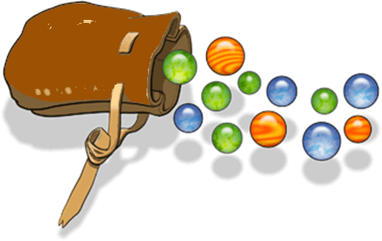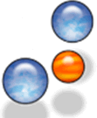

We have a bag of 15 marbles.

How many marbles is two thirds of the bag?

|  |  |
| --- | --- |
|  | of 15 marbles |
| C:\Users\CFord\Documents\MY Folders\CurricDev2012\images\module 4\marble.gif C:\Users\CFord\Documents\MY Folders\CurricDev2012\images\module 4\marble.gif C:\Users\CFord\Documents\MY Folders\CurricDev2012\images\module 4\marble.gif  C:\Users\CFord\Documents\MY Folders\CurricDev2012\images\module 4\marble.gif C:\Users\CFord\Documents\MY Folders\CurricDev2012\images\module 4\marble.gif C:\Users\CFord\Documents\MY Folders\CurricDev2012\images\module 4\marble.gif  C:\Users\CFord\Documents\MY Folders\CurricDev2012\images\module 4\marble.gif C:\Users\CFord\Documents\MY Folders\CurricDev2012\images\module 4\marble.gif C:\Users\CFord\Documents\MY Folders\CurricDev2012\images\module 4\marble.gif  C:\Users\CFord\Documents\MY Folders\CurricDev2012\images\module 4\marble.gif C:\Users\CFord\Documents\MY Folders\CurricDev2012\images\module 4\marble.gif C:\Users\CFord\Documents\MY Folders\CurricDev2012\images\module 4\marble.gif  C:\Users\CFord\Documents\MY Folders\CurricDev2012\images\module 4\marble.gif C:\Users\CFord\Documents\MY Folders\CurricDev2012\images\module 4\marble.gif C:\Users\CFord\Documents\MY Folders\CurricDev2012\images\module 4\marble.gif |
| Divide the marbles into three equal groups.  One third of the group is 5 marbles  Two thirds of the group is 10 marbles.  As a number sentence:  of 15 marbles = 10 marbles |
|  |
|  |

|  |  |  |  |
| --- | --- | --- | --- |
| **(a)** | We have a collection of marbles shown below. | | |
|  | **(i)** | How many marbles are in the collection? | |
|  | **(ii)** | Find the fractions asked for, and complete the number sentences. | |
|  | C:\Users\CFord\Documents\MY Folders\CurricDev2012\images\module 4\marbles2.gif C:\Users\CFord\Documents\MY Folders\CurricDev2012\images\module 4\marbles2.gif C:\Users\CFord\Documents\MY Folders\CurricDev2012\images\module 4\marbles2.gif C:\Users\CFord\Documents\MY Folders\CurricDev2012\images\module 4\marbles2.gif C:\Users\CFord\Documents\MY Folders\CurricDev2012\images\module 4\marbles2.gif C:\Users\CFord\Documents\MY Folders\CurricDev2012\images\module 4\marbles2.gif  C:\Users\CFord\Documents\MY Folders\CurricDev2012\images\module 4\marbles2.gif C:\Users\CFord\Documents\MY Folders\CurricDev2012\images\module 4\marbles2.gif C:\Users\CFord\Documents\MY Folders\CurricDev2012\images\module 4\marbles2.gif C:\Users\CFord\Documents\MY Folders\CurricDev2012\images\module 4\marbles2.gif C:\Users\CFord\Documents\MY Folders\CurricDev2012\images\module 4\marbles2.gif C:\Users\CFord\Documents\MY Folders\CurricDev2012\images\module 4\marbles2.gif  C:\Users\CFord\Documents\MY Folders\CurricDev2012\images\module 4\marbles2.gif C:\Users\CFord\Documents\MY Folders\CurricDev2012\images\module 4\marbles2.gif C:\Users\CFord\Documents\MY Folders\CurricDev2012\images\module 4\marbles2.gif C:\Users\CFord\Documents\MY Folders\CurricDev2012\images\module 4\marbles2.gif C:\Users\CFord\Documents\MY Folders\CurricDev2012\images\module 4\marbles2.gif C:\Users\CFord\Documents\MY Folders\CurricDev2012\images\module 4\marbles2.gif  C:\Users\CFord\Documents\MY Folders\CurricDev2012\images\module 4\marbles2.gif C:\Users\CFord\Documents\MY Folders\CurricDev2012\images\module 4\marbles2.gif C:\Users\CFord\Documents\MY Folders\CurricDev2012\images\module 4\marbles2.gif C:\Users\CFord\Documents\MY Folders\CurricDev2012\images\module 4\marbles2.gif C:\Users\CFord\Documents\MY Folders\CurricDev2012\images\module 4\marbles2.gif C:\Users\CFord\Documents\MY Folders\CurricDev2012\images\module 4\marbles2.gif | | of ……….. marbles = ……….. marbles  of ……….. marbles = ……….. marbles  of ……….. marbles = ……….. marbles  of ……….. marbles = ……….. marbles |
|  |  | |

|  |  |  |  |
| --- | --- | --- | --- |
| **(b)** | We have a collection of coins shown below. | | |
|  | **(i)** | How many coins are in the collection? | |
|  | **(ii)** | Find the fractions asked for, and complete the number sentences. | |
|  | C:\Users\CFord\Documents\MY Folders\CurricDev2012\images\module 4\coin.gifC:\Users\CFord\Documents\MY Folders\CurricDev2012\images\module 4\coin.gifC:\Users\CFord\Documents\MY Folders\CurricDev2012\images\module 4\coin.gifC:\Users\CFord\Documents\MY Folders\CurricDev2012\images\module 4\coin.gif  C:\Users\CFord\Documents\MY Folders\CurricDev2012\images\module 4\coin.gifC:\Users\CFord\Documents\MY Folders\CurricDev2012\images\module 4\coin.gifC:\Users\CFord\Documents\MY Folders\CurricDev2012\images\module 4\coin.gifC:\Users\CFord\Documents\MY Folders\CurricDev2012\images\module 4\coin.gif  C:\Users\CFord\Documents\MY Folders\CurricDev2012\images\module 4\coin.gifC:\Users\CFord\Documents\MY Folders\CurricDev2012\images\module 4\coin.gifC:\Users\CFord\Documents\MY Folders\CurricDev2012\images\module 4\coin.gifC:\Users\CFord\Documents\MY Folders\CurricDev2012\images\module 4\coin.gif  C:\Users\CFord\Documents\MY Folders\CurricDev2012\images\module 4\coin.gifC:\Users\CFord\Documents\MY Folders\CurricDev2012\images\module 4\coin.gifC:\Users\CFord\Documents\MY Folders\CurricDev2012\images\module 4\coin.gifC:\Users\CFord\Documents\MY Folders\CurricDev2012\images\module 4\coin.gif  C:\Users\CFord\Documents\MY Folders\CurricDev2012\images\module 4\coin.gifC:\Users\CFord\Documents\MY Folders\CurricDev2012\images\module 4\coin.gifC:\Users\CFord\Documents\MY Folders\CurricDev2012\images\module 4\coin.gifC:\Users\CFord\Documents\MY Folders\CurricDev2012\images\module 4\coin.gif  Description: C:\Users\CFord\Documents\MY Folders\CurricDev2012\images\module 4\coin.gifC:\Users\CFord\Documents\MY Folders\CurricDev2012\images\module 4\coin.gifC:\Users\CFord\Documents\MY Folders\CurricDev2012\images\module 4\coin.gifC:\Users\CFord\Documents\MY Folders\CurricDev2012\images\module 4\coin.gif  Description: C:\Users\CFord\Documents\MY Folders\CurricDev2012\images\module 4\coin.gifC:\Users\CFord\Documents\MY Folders\CurricDev2012\images\module 4\coin.gifC:\Users\CFord\Documents\MY Folders\CurricDev2012\images\module 4\coin.gifC:\Users\CFord\Documents\MY Folders\CurricDev2012\images\module 4\coin.gif  C:\Users\CFord\Documents\MY Folders\CurricDev2012\images\module 4\coin.gifC:\Users\CFord\Documents\MY Folders\CurricDev2012\images\module 4\coin.gifC:\Users\CFord\Documents\MY Folders\CurricDev2012\images\module 4\coin.gifC:\Users\CFord\Documents\MY Folders\CurricDev2012\images\module 4\coin.gif  Description: C:\Users\CFord\Documents\MY Folders\CurricDev2012\images\module 4\coin.gifC:\Users\CFord\Documents\MY Folders\CurricDev2012\images\module 4\coin.gifC:\Users\CFord\Documents\MY Folders\CurricDev2012\images\module 4\coin.gifC:\Users\CFord\Documents\MY Folders\CurricDev2012\images\module 4\coin.gif  C:\Users\CFord\Documents\MY Folders\CurricDev2012\images\module 4\coin.gifC:\Users\CFord\Documents\MY Folders\CurricDev2012\images\module 4\coin.gifC:\Users\CFord\Documents\MY Folders\CurricDev2012\images\module 4\coin.gifC:\Users\CFord\Documents\MY Folders\CurricDev2012\images\module 4\coin.gif | | of ……….. coins = ……….. coins  of ……….. coins = ……….. coins  of ……….. coins = ……….. coins  of ……….. coins = ……….. coins  of ……….. coins = ……….. coins  of ……….. coins = ……….. coins |
|  |

|  |
| --- |
| **Task 8 Activity 2: Fractions of a group** |

# Other ways to find fractions of groups of things

 of 8 = 2. This can be also written as  x 8 = 2.

This is exactly the same as 8 ÷ 4 = 2.

   

   

We have 8 keys.  of these keys is ‘**1** out of every **4**’.

Or it can be: 8 keys shared evenly into 4 groups. There are 2 keys in each group.

   

   

Show the fraction for each group.

|  |  |  |  |
| --- | --- | --- | --- |
|  | of 12 = | of 12 = | of 12 = |
|  | of 20 = | of 20 = | of 20 = |
|  | of 24 = | of 24 = | of 24 = |
| of 24 = | of 24 = | of 24 = |

To fin**d**  of a group, first you find  then multiply the answer by 3.

 means “3 out of every 4.”





How many cup cakes if you took  of 8? ………......... This is the same as x 8.

To calculate fractions like  , , ,  or  you can count “2 for every 5”.

Fill the gaps. Circle the correct number of objects to show the fraction of the group.

|  |  |  |
| --- | --- | --- |
| is the same as ………. for every …….. | ☺ ☺ ☺ | |
| is the same as ………. for every …….. |  | |
| is the same as ………. for every …….. |           | |
| is the same as ………. for every …….. | ✈ ✈ ✈ ✈ ✈ ✈ ✈ ✈ ✈ ✈ ✈  | |
| What happens when you have more things than the *denominator*? (The bottom of the fraction that shows how many equal parts there are.)  Use “ ……. out of every ……….” and continue the pattern. | | |
| is the same as ………. for every ….. .  of 12 = ………… | |              |

|  |  |
| --- | --- |
| is the same as ………. for every ….. .  of 18 = ………… |                     |
| is the same as ………. for every ……..  of 14 = ………… |                 |
| is the same as ………. for every ……..  of 33 = ………… | ☼☼☼☼☼☼☼☼☼☼☼  ☼☼☼☼☼☼☼☼☼☼☼  ☼☼☼☼☼☼☼☼☼☼☼ |
| Here are some groups of objects. Create some fraction problems for each group. | |
|  |               |
|  |                  |
|  | ☼☼☼☼☼☼☼☼  ☼☼☼☼☼☼☼☼  ☼☼☼☼☼☼☼☼ |

Another way of calculating fractions of a group, such as 4/5 of 15:

|  |  |  |  |
| --- | --- | --- | --- |
|                  | Find 1/5 of 15. 1/5 of 15 is 3.  4/5 of 15 is 4 times 1/5 (which is 3).  So, 4/5 of 15 = 12.  A *fraction is also a ‘sharing’ or division problem.)*  15 ÷ 5 = 3 (This gives us 1/5; we need 4/5, so we multiply the answer by 4.)  3 x 4 = 12, so 4/5 of 15 = 12. | | |
| 1/5 of 15 = 3  *Calculate these fractional parts: “of” does the same job as “x”.* | **Step 1** | **Step 2** | **Answer** |
| divide by the denominator (bottom) by 5 to find 1/5:  15 ÷ 5 = 3 | multiply by the numerator (top): 4 lots of 1/5 of 15;  3 x 4 | 4/5 of 15 = 12  12 |
| 2/9 of 36 |  |  |  |
| 3/7 of 28 |  |  |  |
| 2/3 of 30 |  |  |  |
| 4/5 of 20 |  |  |  |
| 7/8 of 32 |  |  |  |
| 3/4 x 24 |  |  |  |
| 5/6 x 42 |  |  |  |
| 2/5 of 40 |  |  |  |
| 4/11 of 77 |  |  |  |

Answer these. If you are not confident with multiplication tables, have them next to you as you work. **Example:** 7/10 of 20: Find **1/10** first, then multiply by 7.

|  |  |  |  |  |  |  |  |  |  |  |  |
| --- | --- | --- | --- | --- | --- | --- | --- | --- | --- | --- | --- |
| ❄ | ❄ | ❄ | ❄ | ❄ | | ❄ | ❄ | ❄ | | ❄ | ❄ |
| ❄ | ❄ | ❄ | ❄ | ❄ | | ❄ | ❄ | ❄ | | ❄ | ❄ |
|  | | | | | ………………. | | | |  | | |  | ………………. |
| ………………. | | | | ………………. |
| ………………. | | | | ………………. |
| ………………. | | | | ………………. |

[*http://www.math-aids.com/Fractions*](http://www.math-aids.com/Fractions)

# Apply your skills … solve some problems

|  |  |
| --- | --- |
| ***Description: j0229369*** |  |
| **Task 8 Activity 3: Apply your skills** |
|  |

|  |  |
| --- | --- |
| **1.** | Jess spent half of her pocket money on a magazine.  If she gets $10 pocket money, how much was the magazine? |

|  |  |  |
| --- | --- | --- |
| **2.** | Sam ate most of a pack of lollies, and left 8 lollies, or one quarter of the pack. If 8 lollies is one quarter of the pack: | |
|  | **(a)** | How many lollies are in half a pack? |
|  | **(b)** | How many lollies are in a full pack? |

|  |  |  |  |
| --- | --- | --- | --- |
| **3.** | Tim and Sandy shared a pizza that had been cut into 8 pieces.  Tim ate  of the pizza and Sandy ate | | C:\Users\CFord\Documents\MY Folders\CurricDev2012\images\module 4\pizza82.gif |
|  | **(a)** | How many pieces did Tim eat? |
|  | **(b)** | How many pieces did Sandy eat? |
|  | **(c)** | How many pieces were left over? |

|  |  |  |  |
| --- | --- | --- | --- |
| **4.** | Amy made 24 cupcakes.  She iced  of them pink,  of them blue and left the rest plain | |  |
|  | **(a)** | How many were iced pink? |
|  | **(b)** | How many were iced blue? |
|  | **(c)** | How many were left plain? |

****

****

# Task 9 Fractions out of 100 ….. percentages



A percentage is just a fraction out of 100. Let’s see some examples….

|  |  |  |  |  |  |  |  |  |  |  |
| --- | --- | --- | --- | --- | --- | --- | --- | --- | --- | --- |
|  | 10  ↓ | 10  ↓ | 10  ↓ | 6  ↓ |  |  |  |  |  |  |
| This grid shows one unit equally divided into 100 squares: 10 squares across and 10 squares down.  Shading this grid shows percentages.  For example, the shaded amount is  (10 + 10 + 10 + 6) squares out of 100  36 squares out of 100 as a fraction is |  |  |  |  |  |  |  |  |  |  |
|  |  |  |  |  |  |  |  |  |  |
|  |  |  |  |  |  |  |  |  |  |
|  |  |  |  |  |  |  |  |  |  |
|  |  |  |  |  |  |  |  |  |  |
|  |  |  |  |  |  |  |  |  |  |
|  |  |  |  |  |  |  |  |  |  |
|  |  |  |  |  |  |  |  |  |  |
|  |  |  |  |  |  |  |  |  |  |
|  |  |  |  |  |  |  |  |  |  |
| is the same as 36 per cent. We write is as 36% . The symbol **%** means **per cent.** Per cent means ‘for every 100. | | | | | | | | | | |

|  |
| --- |
| Notice that  can be simplified:   =  So, 36 per cent is the same as  36 % = |

Discuss with your supervisor or parent:

1. Where do you see percentages?
2. When would percentages be useful?
3. What do you know about percentages?

|  |  |
| --- | --- |
| ***Description: j0229369*** |  |
| **Task 9 Activity 1: What’s the percentage?** |
|  |

Find the percentages and complete the missing parts of the table.

The first one is done as an example.

|  |  |  |  |
| --- | --- | --- | --- |
| Shaded grid | Fraction out of 100 | Simplified fraction | Number sentence |
|  |  |  |  |
| |  |  |  |  |  |  |  |  |  |  | | --- | --- | --- | --- | --- | --- | --- | --- | --- | --- | |  |  |  |  |  |  |  |  |  |  | |  |  |  |  |  |  |  |  |  |  | |  |  |  |  |  |  |  |  |  |  | |  |  |  |  |  |  |  |  |  |  | |  |  |  |  |  |  |  |  |  |  | |  |  |  |  |  |  |  |  |  |  | |  |  |  |  |  |  |  |  |  |  | |  |  |  |  |  |  |  |  |  |  | |  |  |  |  |  |  |  |  |  |  | |  |  |  |  |  |  |  |  |  |  | |  |  |  |  |  |  |  |  |  |  | | 25 squares shaded.  Fraction shaded  = | =  = | 25% =  = |
|  |  |  |  |

|  |  |  |  |  |
| --- | --- | --- | --- | --- |
| **(a)** | Shaded grid | Fraction out of 100 | Simplified fraction | Number sentence |
|  |  |  |  |  |
|  | |  |  |  |  |  |  |  |  |  |  | | --- | --- | --- | --- | --- | --- | --- | --- | --- | --- | |  |  |  |  |  |  |  |  |  |  | |  |  |  |  |  |  |  |  |  |  | |  |  |  |  |  |  |  |  |  |  | |  |  |  |  |  |  |  |  |  |  | |  |  |  |  |  |  |  |  |  |  | |  |  |  |  |  |  |  |  |  |  | |  |  |  |  |  |  |  |  |  |  | |  |  |  |  |  |  |  |  |  |  | |  |  |  |  |  |  |  |  |  |  | |  |  |  |  |  |  |  |  |  |  | |  |  |  |  |  |  |  |  |  |  | | How many squares shaded  ……………………  Fraction shaded | = | %  =  = |
|  |  |  |  |  |

|  |  |  |  |  |
| --- | --- | --- | --- | --- |
| **(b)** | Shaded grid | Fraction out of 100 | Simplified fraction | Number sentence |
|  |  |  |  |  |
|  | |  |  |  |  |  |  |  |  |  |  | | --- | --- | --- | --- | --- | --- | --- | --- | --- | --- | |  |  |  |  |  |  |  |  |  |  | |  |  |  |  |  |  |  |  |  |  | |  |  |  |  |  |  |  |  |  |  | |  |  |  |  |  |  |  |  |  |  | |  |  |  |  |  |  |  |  |  |  | |  |  |  |  |  |  |  |  |  |  | |  |  |  |  |  |  |  |  |  |  | |  |  |  |  |  |  |  |  |  |  | |  |  |  |  |  |  |  |  |  |  | |  |  |  |  |  |  |  |  |  |  | |  |  |  |  |  |  |  |  |  |  | | How many squares shaded  ……………………  Fraction shaded | = | %  =  = |
|  |  |  |  |  |

|  |  |  |  |  |
| --- | --- | --- | --- | --- |
| **(c)** | Shaded grid | Fraction out of 100 | Simplified fraction | Number sentence |
|  |  |  |  |  |
|  | |  |  |  |  |  |  |  |  |  |  | | --- | --- | --- | --- | --- | --- | --- | --- | --- | --- | |  |  |  |  |  |  |  |  |  |  | |  |  |  |  |  |  |  |  |  |  | |  |  |  |  |  |  |  |  |  |  | |  |  |  |  |  |  |  |  |  |  | |  |  |  |  |  |  |  |  |  |  | |  |  |  |  |  |  |  |  |  |  | |  |  |  |  |  |  |  |  |  |  | |  |  |  |  |  |  |  |  |  |  | |  |  |  |  |  |  |  |  |  |  | |  |  |  |  |  |  |  |  |  |  | |  |  |  |  |  |  |  |  |  |  | | How many squares shaded  ……………………  Fraction shaded | = | %  =  = |
|  |  |  |  |  |
| **(d)** | Shaded grid | Fraction out of 100 | Simplified fraction | Number sentence |
|  |  |  |  |  |
|  | |  |  |  |  |  |  |  |  |  |  | | --- | --- | --- | --- | --- | --- | --- | --- | --- | --- | |  |  |  |  |  |  |  |  |  |  | |  |  |  |  |  |  |  |  |  |  | |  |  |  |  |  |  |  |  |  |  | |  |  |  |  |  |  |  |  |  |  | |  |  |  |  |  |  |  |  |  |  | |  |  |  |  |  |  |  |  |  |  | |  |  |  |  |  |  |  |  |  |  | |  |  |  |  |  |  |  |  |  |  | |  |  |  |  |  |  |  |  |  |  | |  |  |  |  |  |  |  |  |  |  | |  |  |  |  |  |  |  |  |  |  | | How many squares shaded  ……………………  Fraction shaded | = | %  =  = |
|  |  |  |  |  |

|  |  |  |  |  |
| --- | --- | --- | --- | --- |
| **(e)** | Shaded grid | Fraction out of 100 | Simplified fraction | Number sentence |
|  |  |  |  |  |
|  | |  |  |  |  |  |  |  |  |  |  | | --- | --- | --- | --- | --- | --- | --- | --- | --- | --- | |  |  |  |  |  |  |  |  |  |  | |  |  |  |  |  |  |  |  |  |  | |  |  |  |  |  |  |  |  |  |  | |  |  |  |  |  |  |  |  |  |  | |  |  |  |  |  |  |  |  |  |  | |  |  |  |  |  |  |  |  |  |  | |  |  |  |  |  |  |  |  |  |  | |  |  |  |  |  |  |  |  |  |  | |  |  |  |  |  |  |  |  |  |  | |  |  |  |  |  |  |  |  |  |  | |  |  |  |  |  |  |  |  |  |  | | How many squares shaded  ……………………  Fraction shaded | = | %  =  = |
|  |  |  |  |  |

|  |  |  |  |  |
| --- | --- | --- | --- | --- |
| **(f)** | Shaded grid | Fraction out of 100 | Simplified fraction | Number sentence |
|  |  |  |  |  |
|  | |  |  |  |  |  |  |  |  |  |  | | --- | --- | --- | --- | --- | --- | --- | --- | --- | --- | |  |  |  |  |  |  |  |  |  |  | |  |  |  |  |  |  |  |  |  |  | |  |  |  |  |  |  |  |  |  |  | |  |  |  |  |  |  |  |  |  |  | |  |  |  |  |  |  |  |  |  |  | |  |  |  |  |  |  |  |  |  |  | |  |  |  |  |  |  |  |  |  |  | |  |  |  |  |  |  |  |  |  |  | |  |  |  |  |  |  |  |  |  |  | |  |  |  |  |  |  |  |  |  |  | |  |  |  |  |  |  |  |  |  |  | | How many squares shaded  ……………………  Fraction shaded | = | %  =  = |
|  |  |  |  |  |

|  |  |  |  |  |
| --- | --- | --- | --- | --- |
| **(g)** | Shaded grid | Fraction out of 100 | Simplified fraction | Number sentence |
|  |  |  |  |  |
|  | |  |  |  |  |  |  |  |  |  |  | | --- | --- | --- | --- | --- | --- | --- | --- | --- | --- | |  |  |  |  |  |  |  |  |  |  | |  |  |  |  |  |  |  |  |  |  | |  |  |  |  |  |  |  |  |  |  | |  |  |  |  |  |  |  |  |  |  | |  |  |  |  |  |  |  |  |  |  | |  |  |  |  |  |  |  |  |  |  | |  |  |  |  |  |  |  |  |  |  | |  |  |  |  |  |  |  |  |  |  | |  |  |  |  |  |  |  |  |  |  | |  |  |  |  |  |  |  |  |  |  | |  |  |  |  |  |  |  |  |  |  | | How many squares shaded  ……………………  Fraction shaded | = | %  =  = |
|  |  |  |  |  |

What is ‘per cent”? Per cent is any fraction that is expressed as ‘out of one hundred.”

Any fraction can be converted to a percentage – you need to find its equivalent ‘out of 100.’

Find the patterns in this table to discover how to convert common fractions to percentages.

|  |  |  |  |
| --- | --- | --- | --- |
| **Fraction** | **Conversion** | **Out of 100** | **Percentage** |
| 1/10 | 1÷ 10 = 0.10 | 10/100 | 10% |
| 2/10 (1/5) | 2÷ 10 = 0.20 | 20/100 | 20% |
| 3/10 | 3÷ 10 = 0.30 | 30/100 | 30% |
| 4/10  (2/5) | 4÷ 10 = 0.40 | 40/100 | 40% |
| 5/10 (1/2) | 5÷ 10 = 0.50 | 50/100 | 50% |
| 6/10  (3/5) | 6÷ 10 = 0.60 | 60/100 | 60% |
| 7/10 | 7÷ 10 = 0.70 | 70/100 | 70% |
| 8/10 (4/5) | 8÷ 10 = 0.80 | 80/100 | 80% |
| 9/10 | 9÷ 10 = 0.90 | 90/100 | 90% |
| 10/10 | 10÷ 10 - 1 | 100/100 | 100% |
| 1/4 | 1÷ 4 =0.25 | 25/100 | 25% |
| 3/4 | 3÷ 4 =0.75 | 75/100 | 75% |

# Create and solve your own percentage problems:

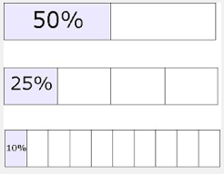With your supervisor or parent, create some ‘percentage problems’. Estimate your answer using these steps:

Example: What is 10% of 50?

Think: 10% is a 1/10 of 50

Which is the same as: 50 ÷10 = 5 10% of 50 = 5.

Use this online percentage calculator to check your estimation.

<http://www.math.com/students/calculators/source/3percent.htm>

You can use a calculator to check percentages:

10% of 50:       

Mentally estimate these percentages, then use a calculator to check:

|  |  |  |
| --- | --- | --- |
| Problem: | Calculate *(mentally or pen & paper)* | Calculator Check: |
| 10% of 40 |  |  |
| 15% of 80 |  |  |
| 25% of 24 |  |  |
| 20% of 60 |  |  |
| 30% of 50 |  |  |
| 40% of 80 |  |  |
| 50% of 30 |  |  |
| 10% of 110 |  |  |
| 20% of 70 |  |  |

Choose some computer game to learn more about percentages:

**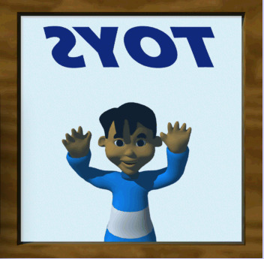**

<http://www.mathplayground.com/percent_shopping.html>

Choose a game from those offered here:

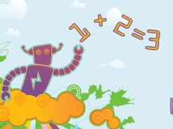

<http://www.maths-games.org/percentage-games.html>

# Apply your skills

# ….use percentages to design the school grounds

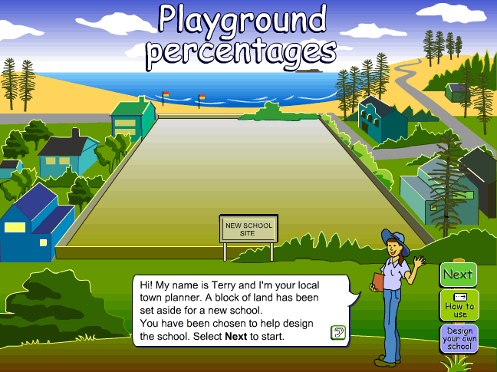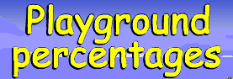

**The new school:**

A new school is being built, and you have been asked to help design the layout of the grounds. Go to “Playground Percentages”.

<http://www.scootle.edu.au/ec/pin/NFCCTK?userid=138808>

or

<http://tinyurl.com/playpercent>

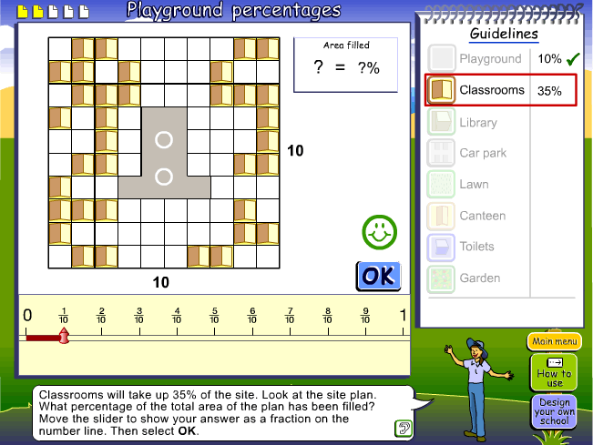The map of the school grounds is 10 squares across and 10 squares down.

The playground and the classrooms are given on the plan taken from the interactive that you will use→

Your job will be to add the following things to the plan:

* The library
* The car park (or car parks; there may be more than one)
* The lawn (or lawns there may be more than one lawn area)
* 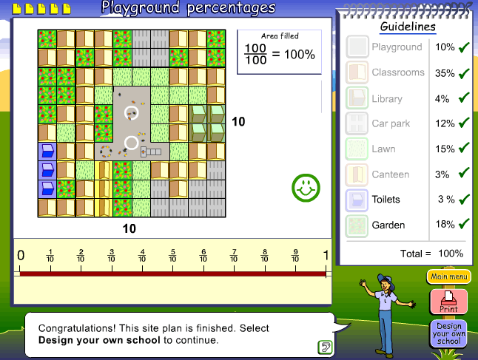The canteen

See a completed example on the right→

You can decide how many squares to allocate to toilets and gardens.

You will also add up the percentage of the squares covered when you finish the plan. The total needs to be 100%.

**Placing things on the plan**

You can locate the buildings, lawn and gardens wherever you like, BUT, the school grounds need to work. For example, it would be silly to place the canteen in the middle of the car park.

Before you decide where the buildings, lawns and gardens should go, here are some things to keep in mind:

* Can people walk from the car parks to the buildings and from one building to another?
* Where would be the best location for the canteen and the library?
* Where should the toilets be located?

|  |  |  |
| --- | --- | --- |
| Description: Description: C:\Users\CFord\Documents\MY Folders\CurricDev2012\images\cd4.gif |  | ***C:\Users\CFord\Documents\MY Folders\CurricDev2012\images\module 4\playground\hi2.gif*** |
| **Task 9 Activity 3:**  **Complete a plan for the new school grounds** |

Go to this link: <http://www.scootle.edu.au/ec/pin/NFCCTK?userid=138808>

Or

<http://tinyurl.com/playpercent>

* Complete a plan of the school grounds.
* Answer the percentage questions as you go.
* If you want to change your plan, start the interactive again.
* Print your plan or take a screenshot to send your teacher.

Reflecting on your plan:

|  |  |  |
| --- | --- | --- |
| **(a)** | How did you decide where to locate | * the library * the car park, or car parks * the canteen? |
|  | ……………………………………………………………………………………………………………………………………………………………………………………………………………………………………………………………………………………………………………………………………………………………… | |
| **(b)** | How does the location of the lawns work for the students and teachers?  ……………………………………………………………………………………………………………………………………………………………………………… | |
| **(c)** | Placing the toilets and gardens came last. How did you allow for these in your plan?  ……………………………………………………………………………………………………………………………………………………………………………… ……………………………………………………………………………………… | |

**Try a few things out.**

Use the grids on **the next page** to try out some different ways of locating things.

Planning grids for completing the school grounds.

Use these grids to try to place things in different ways.

|  |  |  |  |  |  |  |  |  |  |  |  |
| --- | --- | --- | --- | --- | --- | --- | --- | --- | --- | --- | --- |
|  | C:\Users\CFord\Documents\MY Folders\CurricDev2012\images\module 4\playground\room.gif | C:\Users\CFord\Documents\MY Folders\CurricDev2012\images\module 4\playground\room.gif |  |  | |  | |  |  | C:\Users\CFord\Documents\MY Folders\CurricDev2012\images\module 4\playground\room.gif | C:\Users\CFord\Documents\MY Folders\CurricDev2012\images\module 4\playground\room.gif |
| C:\Users\CFord\Documents\MY Folders\CurricDev2012\images\module 4\playground\room.gif | C:\Users\CFord\Documents\MY Folders\CurricDev2012\images\module 4\playground\room.gif |  | C:\Users\CFord\Documents\MY Folders\CurricDev2012\images\module 4\playground\room.gif |  | |  | |  | C:\Users\CFord\Documents\MY Folders\CurricDev2012\images\module 4\playground\room.gif |  |  |
|  | C:\Users\CFord\Documents\MY Folders\CurricDev2012\images\module 4\playground\room.gif | C:\Users\CFord\Documents\MY Folders\CurricDev2012\images\module 4\playground\room.gif | C:\Users\CFord\Documents\MY Folders\CurricDev2012\images\module 4\playground\room.gif |  | |  | |  | C:\Users\CFord\Documents\MY Folders\CurricDev2012\images\module 4\playground\room.gif | C:\Users\CFord\Documents\MY Folders\CurricDev2012\images\module 4\playground\room.gif | C:\Users\CFord\Documents\MY Folders\CurricDev2012\images\module 4\playground\room.gif |
| C:\Users\CFord\Documents\MY Folders\CurricDev2012\images\module 4\playground\room.gif |  | C:\Users\CFord\Documents\MY Folders\CurricDev2012\images\module 4\playground\room.gif |  |  |  | |  |  |  |  | C:\Users\CFord\Documents\MY Folders\CurricDev2012\images\module 4\playground\room.gif |
|  |  | C:\Users\CFord\Documents\MY Folders\CurricDev2012\images\module 4\playground\room.gif |  |  |  |  |  |  | C:\Users\CFord\Documents\MY Folders\CurricDev2012\images\module 4\playground\room.gif |
|  | C:\Users\CFord\Documents\MY Folders\CurricDev2012\images\module 4\playground\room.gif | C:\Users\CFord\Documents\MY Folders\CurricDev2012\images\module 4\playground\room.gif |  |  |  |  |  | C:\Users\CFord\Documents\MY Folders\CurricDev2012\images\module 4\playground\room.gif | C:\Users\CFord\Documents\MY Folders\CurricDev2012\images\module 4\playground\room.gif |
| C:\Users\CFord\Documents\MY Folders\CurricDev2012\images\module 4\playground\room.gif |  |  |  | Playground | | | |  |  |  |  |
| C:\Users\CFord\Documents\MY Folders\CurricDev2012\images\module 4\playground\room.gif | C:\Users\CFord\Documents\MY Folders\CurricDev2012\images\module 4\playground\room.gif | C:\Users\CFord\Documents\MY Folders\CurricDev2012\images\module 4\playground\room.gif |  |  | |  | |  |  | C:\Users\CFord\Documents\MY Folders\CurricDev2012\images\module 4\playground\room.gif |  |
| C:\Users\CFord\Documents\MY Folders\CurricDev2012\images\module 4\playground\room.gif |  |  |  |  | |  | |  |  | C:\Users\CFord\Documents\MY Folders\CurricDev2012\images\module 4\playground\room.gif | C:\Users\CFord\Documents\MY Folders\CurricDev2012\images\module 4\playground\room.gif |
|  | C:\Users\CFord\Documents\MY Folders\CurricDev2012\images\module 4\playground\room.gif | C:\Users\CFord\Documents\MY Folders\CurricDev2012\images\module 4\playground\room.gif |  |  | |  | | C:\Users\CFord\Documents\MY Folders\CurricDev2012\images\module 4\playground\room.gif | C:\Users\CFord\Documents\MY Folders\CurricDev2012\images\module 4\playground\room.gif |  |  |

|  |  |  |  |  |  |  |  |  |  |
| --- | --- | --- | --- | --- | --- | --- | --- | --- | --- |
|  | C:\Users\CFord\Documents\MY Folders\CurricDev2012\images\module 4\playground\room.gif | C:\Users\CFord\Documents\MY Folders\CurricDev2012\images\module 4\playground\room.gif |  |  |  |  |  | C:\Users\CFord\Documents\MY Folders\CurricDev2012\images\module 4\playground\room.gif | C:\Users\CFord\Documents\MY Folders\CurricDev2012\images\module 4\playground\room.gif |
| C:\Users\CFord\Documents\MY Folders\CurricDev2012\images\module 4\playground\room.gif | C:\Users\CFord\Documents\MY Folders\CurricDev2012\images\module 4\playground\room.gif |  | C:\Users\CFord\Documents\MY Folders\CurricDev2012\images\module 4\playground\room.gif |  |  |  | C:\Users\CFord\Documents\MY Folders\CurricDev2012\images\module 4\playground\room.gif |  |  |
|  | C:\Users\CFord\Documents\MY Folders\CurricDev2012\images\module 4\playground\room.gif | C:\Users\CFord\Documents\MY Folders\CurricDev2012\images\module 4\playground\room.gif | C:\Users\CFord\Documents\MY Folders\CurricDev2012\images\module 4\playground\room.gif |  |  |  | C:\Users\CFord\Documents\MY Folders\CurricDev2012\images\module 4\playground\room.gif | C:\Users\CFord\Documents\MY Folders\CurricDev2012\images\module 4\playground\room.gif | C:\Users\CFord\Documents\MY Folders\CurricDev2012\images\module 4\playground\room.gif |
| C:\Users\CFord\Documents\MY Folders\CurricDev2012\images\module 4\playground\room.gif |  | C:\Users\CFord\Documents\MY Folders\CurricDev2012\images\module 4\playground\room.gif |  |  |  |  |  |  | C:\Users\CFord\Documents\MY Folders\CurricDev2012\images\module 4\playground\room.gif |
|  |  | C:\Users\CFord\Documents\MY Folders\CurricDev2012\images\module 4\playground\room.gif |  |  |  |  |  |  | C:\Users\CFord\Documents\MY Folders\CurricDev2012\images\module 4\playground\room.gif |
|  | C:\Users\CFord\Documents\MY Folders\CurricDev2012\images\module 4\playground\room.gif | C:\Users\CFord\Documents\MY Folders\CurricDev2012\images\module 4\playground\room.gif |  |  |  |  |  | C:\Users\CFord\Documents\MY Folders\CurricDev2012\images\module 4\playground\room.gif | C:\Users\CFord\Documents\MY Folders\CurricDev2012\images\module 4\playground\room.gif |
| C:\Users\CFord\Documents\MY Folders\CurricDev2012\images\module 4\playground\room.gif |  |  |  | Playground | |  |  |  |  |
| C:\Users\CFord\Documents\MY Folders\CurricDev2012\images\module 4\playground\room.gif | C:\Users\CFord\Documents\MY Folders\CurricDev2012\images\module 4\playground\room.gif | C:\Users\CFord\Documents\MY Folders\CurricDev2012\images\module 4\playground\room.gif |  |  |  |  |  | C:\Users\CFord\Documents\MY Folders\CurricDev2012\images\module 4\playground\room.gif |  |
| C:\Users\CFord\Documents\MY Folders\CurricDev2012\images\module 4\playground\room.gif |  |  |  |  |  |  |  | C:\Users\CFord\Documents\MY Folders\CurricDev2012\images\module 4\playground\room.gif | C:\Users\CFord\Documents\MY Folders\CurricDev2012\images\module 4\playground\room.gif |
|  | C:\Users\CFord\Documents\MY Folders\CurricDev2012\images\module 4\playground\room.gif | C:\Users\CFord\Documents\MY Folders\CurricDev2012\images\module 4\playground\room.gif |  |  |  | C:\Users\CFord\Documents\MY Folders\CurricDev2012\images\module 4\playground\room.gif | C:\Users\CFord\Documents\MY Folders\CurricDev2012\images\module 4\playground\room.gif |  |  |

# Task 10: Skills check-up



We finish the booklet with a skills check-up on what you have learnt.

|  |  |
| --- | --- |
| The test  Go to the test pages at the end of this booklet and do the Task 10 test.  This test covers the activities you did. | C:\Users\CFord\Documents\MY Folders\CurricDev2012\images\test.gif |

Fraction strips: Use these strips to compare fractions.

|  |  |
| --- | --- |
|  |  |

|  |  |  |
| --- | --- | --- |
|  |  |  |

|  |  |  |  |
| --- | --- | --- | --- |
|  |  |  |  |

|  |  |  |  |  |
| --- | --- | --- | --- | --- |
|  |  |  |  |  |

|  |  |  |  |  |  |
| --- | --- | --- | --- | --- | --- |
|  |  |  |  |  |  |

|  |  |  |  |  |  |  |
| --- | --- | --- | --- | --- | --- | --- |
|  |  |  |  |  |  |  |

|  |  |  |  |  |  |  |  |
| --- | --- | --- | --- | --- | --- | --- | --- |
|  |  |  |  |  |  |  |  |

|  |  |  |  |  |  |  |  |  |
| --- | --- | --- | --- | --- | --- | --- | --- | --- |
|  |  |  |  |  |  |  |  |  |

|  |  |  |  |  |  |  |  |  |  |
| --- | --- | --- | --- | --- | --- | --- | --- | --- | --- |
|  |  |  |  |  |  |  |  |  |  |

|  |  |  |  |  |  |  |  |  |  |  |
| --- | --- | --- | --- | --- | --- | --- | --- | --- | --- | --- |
|  |  |  |  |  |  |  |  |  |  |  |

|  |  |  |  |  |  |  |  |  |  |  |  |
| --- | --- | --- | --- | --- | --- | --- | --- | --- | --- | --- | --- |
|  |  |  |  |  |  |  |  |  |  |  |  |

|  |  |  |  |  |  |  |  |  |  |  |  |  |
| --- | --- | --- | --- | --- | --- | --- | --- | --- | --- | --- | --- | --- |
|  |  |  |  |  |  |  |  |  |  |  |  |  |

|  |  |  |  |  |  |  |  |  |  |  |  |  |  |
| --- | --- | --- | --- | --- | --- | --- | --- | --- | --- | --- | --- | --- | --- |
|  |  |  |  |  |  |  |  |  |  |  |  |  |  |

|  |  |  |  |  |  |  |  |  |  |  |  |  |  |  |
| --- | --- | --- | --- | --- | --- | --- | --- | --- | --- | --- | --- | --- | --- | --- |
|  |  |  |  |  |  |  |  |  |  |  |  |  |  |  |

|  |  |  |  |  |  |  |  |  |  |  |  |  |  |  |  |
| --- | --- | --- | --- | --- | --- | --- | --- | --- | --- | --- | --- | --- | --- | --- | --- |
|  |  |  |  |  |  |  |  |  |  |  |  |  |  |  |  |

|  |  |
| --- | --- |
| **Booklet E**  **Task 10 Test** | Today you will answer questions to assess what you have learnt. |

* This test will enable your teacher to see how well you have understood the work and whether you need any additional help in a particular area.

# C:\Users\CFord\Documents\MY Folders\CurricDev2012\images\test.gifPlease complete the exercises on these pages. Show your working out wherever possible.

# You can use your notes to help you with these exercises, but no other assistance.

**Activity 1 Divisibility and reducing fractions**

**Question 1 Divisibility rules**

|  |  |  |
| --- | --- | --- |
| **(a)** | Which number can be divided equally into 21 and 24? ………………. | |
|  | Show each division sentence: | |
|  | 21 ÷  = | 24 ÷  = |

|  |  |  |
| --- | --- | --- |
| **(b)** | Find the largest number that will divide into 42 and 54  Show each division sentence: | |
|  | 42 ÷  = | 54 ÷  = |

**Question 2 Reducing fractions to lowest terms:**

|  |  |  |
| --- | --- | --- |
| **(a)** | Complete these patterns of equivalent fractions. | |
|  | **(i)** | = =  =  = |
|  | **(ii)** | =  = = = |

|  |  |
| --- | --- |
| **(b)** | For the fraction  below, divide to find as many equivalent fractions as you can.  = ……………………………………………………………………………………… |

|  |  |
| --- | --- |
| **(c)** | A recipe calls for  cup of milk. You have  of a cup.  Do you have enough milk?  Explain your answer. |

|  |  |
| --- | --- |
| **(d)** | Compare  with  by completing the following steps: |

|  |  |  |  |  |  |  |  |  |  |  |  |  |  |  |  |  |  |  |  |  |  |  |  |  |  |  |  |  |  |  |  |  |  |  |  |  |
| --- | --- | --- | --- | --- | --- | --- | --- | --- | --- | --- | --- | --- | --- | --- | --- | --- | --- | --- | --- | --- | --- | --- | --- | --- | --- | --- | --- | --- | --- | --- | --- | --- | --- | --- | --- | --- |
| Shade half of each block below. | | | | | | | | | | | | | | | | | | | | | | | | | | | | | | | | | | | | |
| Twentieths  = | | | | | | | | | | | | | | | | | | | |  | Sixteenths  = | | | | | | | | | | | | | | | |
|  |  |  |  |  |  |  |  |  |  |  |  |  |  |  |  |  |  |  |  |  |  |  |  |  |  |  |  |  |  |  |  |  |  |  |  |  |
|  |  |  |  |  |  |  |  |  |  |  |  |  |  |  |  |  |  |  |  |  |  |  |  |  |  |  |  |  |  |  |  |  |  |  |  |  |
| Is  bigger or smaller than? | | | | | | | | | | | | | | | | | | | |  | Is  bigger or smaller than? | | | | | | | | | | | | | | | |
| Is  bigger or smaller than? | | | | | | | | | | | | | | | | | | | | | | | | | | | | | | | | | | | | |

**Question 3 Fractions of an hour**

|  |  |  |
| --- | --- | --- |
| **(a)** | Use repeated division to show that 40 minutes is two thirds of an hour. | =  ………………………….. |



|  |  |
| --- | --- |
| **(b)** | Tomleft the house at 12:05 to walk the dog.  He returned at 12.50. |
|  | How long did he take? |
|  | What fraction of an hour is this interval? |

|  |  |
| --- | --- |
| **(c)** | Find your own time intervals: 15 minutes is  of an hour.  C:\Users\CFord\Documents\MY Folders\CurricDev2012\images\module 4\clockface.gifFind two time intervals that take  of an hour.  From ……………….. to ………………..  From ……………….. to ……………….. |

**Activity 2 Solving maths problems**

****

|  |  |
| --- | --- |
|  | C:\Users\CFord\Documents\MY Folders\CurricDev2012\images\module 4\party.gif |
| **Joe’s party** |
| Joe is having a birthday party and he has invited 24 guests. |

**Question 1 Travelling to the party**

|  |  |
| --- | --- |
| Joe is expecting 24 guests. Half of the guests walk to the party, a quarter travel by bus and the rest use a taxi. | |
| **(a)** | What fraction use taxis? |
| **(b)** | How many guests use taxis? |
| **(c)** | Label how the guests travelled as fractions on the circle. |

**Question 2 Birthday presents, food and drink**

|  |  |
| --- | --- |
| **(a)** | Two thirds of Joe’s guests bring him a birthday present.  How many presents does he receive? |
|  |  |

|  |  |
| --- | --- |
| **(b)** | Joe has four birthday cakes to share between his 24 guests.  Joe doesn’t eat cake, but wants to cut them up so that each guest gets an equal piece. |
|  | How should Joe cut up each cake?  What fraction of a cake will each guest have? |
|  | **C:\Users\CFord\Documents\MY Folders\CurricDev2012\images\module 4\cake5.gif** **C:\Users\CFord\Documents\MY Folders\CurricDev2012\images\module 4\cake5.gif** **C:\Users\CFord\Documents\MY Folders\CurricDev2012\images\module 4\cake5.gif** **C:\Users\CFord\Documents\MY Folders\CurricDev2012\images\module 4\cake5.gif** |

|  |  |
| --- | --- |
| **(c)** | Each guest drinks half a litre carton of juice.  How many cartons of orange juice do Joe’s guests drink in total? |

|  |  |
| --- | --- |
|  | C:\Users\CFord\Documents\MY Folders\CurricDev2012\images\module 4\drinks.gif |

**Question 3 Going home**

Natalia, Jennie, Nick and Geoff shared a taxi home.

The taxi fare paid was $30

They shared this equally between them.

How much did they each pay?

|  |
| --- |
|  |

**Activity 3 Percentages**

**Question 1 What’s the percentage?**

Find the percentages and complete the missing parts of the table.

|  |  |  |  |  |
| --- | --- | --- | --- | --- |
| **(a)** | Shaded grid | Fraction out of 100 | Simplified fraction | Number sentence |
|  |  |  |  |  |
|  | |  |  |  |  |  |  |  |  |  |  | | --- | --- | --- | --- | --- | --- | --- | --- | --- | --- | |  |  |  |  |  |  |  |  |  |  | |  |  |  |  |  |  |  |  |  |  | |  |  |  |  |  |  |  |  |  |  | |  |  |  |  |  |  |  |  |  |  | |  |  |  |  |  |  |  |  |  |  | |  |  |  |  |  |  |  |  |  |  | |  |  |  |  |  |  |  |  |  |  | |  |  |  |  |  |  |  |  |  |  | |  |  |  |  |  |  |  |  |  |  | |  |  |  |  |  |  |  |  |  |  | |  |  |  |  |  |  |  |  |  |  | | How many squares shaded  ……………………  Fraction shaded | = | %  =  = |
|  |  |  |  |  |

|  |  |  |  |  |
| --- | --- | --- | --- | --- |
| **(b)** | Shaded grid | Fraction out of 100 | Simplified fraction | Number sentence |
|  |  |  |  |  |
|  | |  |  |  |  |  |  |  |  |  |  | | --- | --- | --- | --- | --- | --- | --- | --- | --- | --- | |  |  |  |  |  |  |  |  |  |  | |  |  |  |  |  |  |  |  |  |  | | |  |  |  |  |  |  |  |  |  |  | | |  |  |  |  |  |  |  |  |  |  | | |  |  |  |  |  |  |  |  |  |  | | |  |  |  |  |  |  |  |  |  |  | | |  |  |  |  |  |  |  |  |  |  | | |  |  |  |  |  |  |  |  |  |  | | |  |  |  |  |  |  |  |  |  |  | | |  |  |  |  |  |  |  |  |  |  | | |  |  |  |  |  |  |  |  |  |  | | | How many squares shaded  ……………………  Fraction shaded | = | %  =  = |
|  |  |  |  |  |

**Question 2 Discounts and sales**

Find the discount on each item. Then work out the sale price.

|  |  |  |  |  |  |
| --- | --- | --- | --- | --- | --- |
| Item | Price | Discount | Sale price | | |
| Jacket | $110 | 50% of 110  of 110 = | $110  – ………. | | |
|  |  |  |
|  |  |  |  |  |  |
| Jeans |  |  |  | | |
| Table |  |  |  | | |
| Chair |  |  |  | | |
| Lamp |  |  |  | | |

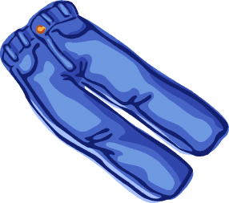

**25%**



**50%**



**$110**



**$90**

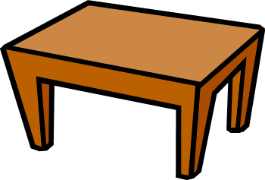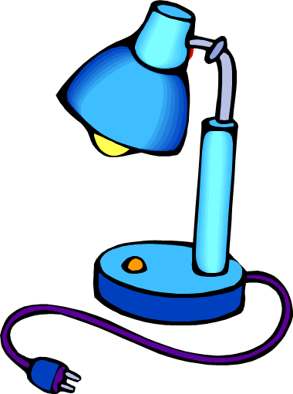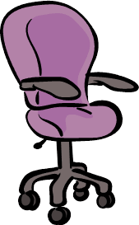

**40%**



**10%**



**30%**



**$60**



**$200**



**$180**

**Student Self Assessment:**

How confident am I with my multiplication tables? **Color** the statement that you think is **MOSTLY** true for you.

|  |  |  |  |  |
| --- | --- | --- | --- | --- |
| I have a few more tables to learn. | I am becoming more confident with my tables. | I am progressing steadily with my tables. | I am very quick and accurate with 7s, 8s and 9s. | I can teach someone else how to be quick and accurate with tables. |

How well do I understand patterns of divisibility? **Color** the statement that you think is **MOSTLY** true for you.

|  |  |  |  |  |
| --- | --- | --- | --- | --- |
| I don’t understand divisibility patterns. | I did the work, but I’m not sure how I solved the problems. | I think divisibility patterns are interesting. | I could see how divisibility patterns would be useful to solve maths problems. | I want to find out more about divisibility patterns. |

How well do I understand comparing fractions? **Color** the statement that you think is **MOSTLY** true for you.

|  |  |  |  |  |
| --- | --- | --- | --- | --- |
| Fractions were tricky for me. | I did the work, but I’m not sure how I solved the problems. | I understood SOME of the work about fractions. | I know how to compare fractions to find which is bigger or smaller. | I can show someone else how to compare fractions. |

|  |
| --- |
| **THINKING ABOUT YOUR LEARNING**  Description: Description: Description: Description: http://t0.gstatic.com/images?q=tbn:ANd9GcTiyp1Q0EWVRSXlqyIMaG6be3rodf0nBbu2oBIY8JlYVh1iP8U7**I understand \_\_\_\_\_\_\_\_\_\_\_\_\_\_\_\_\_\_\_\_\_\_\_\_\_\_\_\_\_\_\_\_\_\_\_\_\_\_\_\_\_\_\_\_\_\_\_\_\_**  **\_\_\_\_\_\_\_\_\_\_\_\_\_\_\_\_\_\_\_\_\_\_\_\_\_\_\_\_\_\_\_\_\_\_\_\_\_\_\_\_\_\_\_\_\_\_\_\_\_\_\_\_\_\_\_\_\_\_\_\_\_\_\_\_\_\_\_\_\_\_\_\_\_\_\_**  **\_\_\_\_\_\_\_\_\_\_\_\_\_\_\_\_\_\_\_\_\_\_\_\_\_\_\_\_\_\_\_\_\_\_\_\_\_\_\_\_\_\_\_\_\_\_\_\_\_\_\_\_\_\_\_\_\_\_\_\_\_\_\_\_\_\_\_\_\_\_\_\_\_\_\_**  **\_\_\_\_\_\_\_\_\_\_\_\_\_\_\_\_\_\_\_\_\_\_\_\_\_\_\_\_\_\_\_\_\_\_\_\_\_\_\_\_\_\_\_\_\_\_\_\_\_\_\_\_\_\_\_\_\_\_\_\_\_\_\_\_\_\_\_\_\_\_\_\_\_\_\_**  **\_\_\_\_\_\_\_\_\_\_\_\_\_\_\_\_\_\_\_\_\_\_\_\_\_\_\_\_\_\_\_\_\_\_\_\_\_\_\_\_\_\_\_\_\_\_\_\_\_\_\_\_\_\_\_\_\_\_\_\_\_\_\_\_\_\_\_\_\_\_\_\_\_\_\_**  **Description: Description: Description: Description: http://t2.gstatic.com/images?q=tbn:ANd9GcQ72LH2Bxoxf3yTTP_t93kaIPDpv8jVzb20Dfacv1j6Jv1Vb43VI need help with\_\_\_\_\_\_\_\_\_\_\_\_\_\_\_\_\_\_\_\_\_\_\_\_\_\_\_\_\_\_\_\_\_\_\_\_\_\_\_\_\_\_\_\_\_\_\_\_**  **\_\_\_\_\_\_\_\_\_\_\_\_\_\_\_\_\_\_\_\_\_\_\_\_\_\_\_\_\_\_\_\_\_\_\_\_\_\_\_\_\_\_\_\_\_\_\_\_\_\_\_\_\_\_\_\_\_\_\_\_\_\_\_\_\_\_\_\_\_\_\_\_\_\_\_**  **\_\_\_\_\_\_\_\_\_\_\_\_\_\_\_\_\_\_\_\_\_\_\_\_\_\_\_\_\_\_\_\_\_\_\_\_\_\_\_\_\_\_\_\_\_\_\_\_\_\_\_\_\_\_\_\_\_\_\_\_\_\_\_\_\_\_\_\_\_\_\_\_\_\_\_**  **\_\_\_\_\_\_\_\_\_\_\_\_\_\_\_\_\_\_\_\_\_\_\_\_\_\_\_\_\_\_\_\_\_\_\_\_\_\_\_\_\_\_\_\_\_\_\_\_\_\_\_\_\_\_\_\_\_\_\_\_\_\_\_\_\_\_\_\_\_\_\_\_\_\_\_**  **\_\_\_\_\_\_\_\_\_\_\_\_\_\_\_\_\_\_\_\_\_\_\_\_\_\_\_\_\_\_\_\_\_\_\_\_\_\_\_\_\_\_\_\_\_\_\_\_\_\_\_\_\_\_\_\_\_\_\_\_\_\_\_\_\_\_\_\_\_\_\_\_\_\_\_** |

|  |
| --- |
| **YOUR QUESTIONS OR COMMENTS** |
| **TEACHER’S COMMENTS**  **Some great things about your work were:**  **Try to do the following next time:** |
|  |