Mathematics

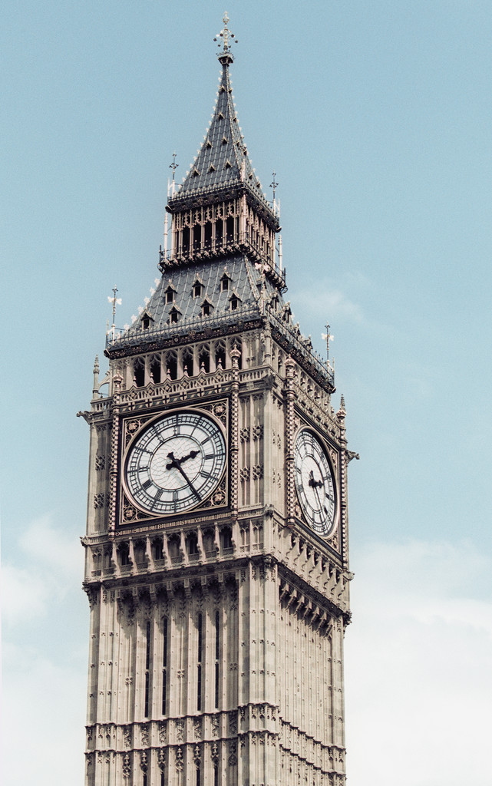

*What’s the time, Mr. Wolf?*

**

|  |
| --- |
| Contents |
| Reading, writing and ordering numbers to thousands.  Identifying odd and even numbers. |
| Defining straight, curved, vertical horizontal and diagonal lines in every day surroundings. |
| Reading the time on an analogue clock face.  Saying and writing the time on an analogue clock face.  Explaining the difference between the two clock hands. |
| Ordering money to three digits.  Exploring the different currencies used in other countries. |
| Revision of concepts from Days 1 – 4. |

|  |
| --- |
| Using a chart or number line to describe counting patterns.  Identifying the rule used in a counting pattern. |
| Predicting the next numbers in a number sequence and identifying the rule to use. |
| Using clocks and calendars to work out the time between 2 or more dates. |
| Solving simple equations and recognising the operations needed to solve them. |
| Revision of concepts. |

**Mathematics**

The activities will help us to answer the question:

***“What’s the time, Mr Wolf?"***

**You will be learning to:**

**Number**

* Read, write and order numbers to 4 thousands.
* Identify odd and even numbers.
* Use a ‘100 chart’ or number line to describe counting patterns.
* Find the rule of a counting pattern.
* Solve equations

**Money**

* The different words related to money
* Recognise different countries have different types of money.
* Order and work with money to 3 digits.

Shapes

* Find straight, curved, vertical, horizontal and diagonal lines.

Time

* Read the time on an analogue clock face to the minute.
* Identify the words related to time, clocks and calendars.

**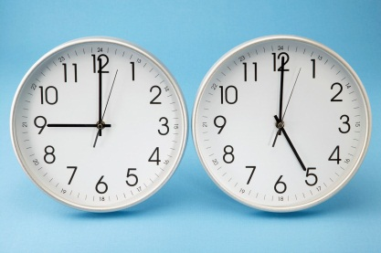**

***Learning Intentions***

*To recognise, model, represent and order numbers to at least 10 000*

*To investigate the conditions required for a number to be odd or even and identify odd and even numbers*

## Focus

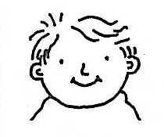

You will be reading, writing and ordering numbers with **4 digits**.

## Introduction

***What is a digit?***

Numbers 0–9 are called digits. It is pronounced di-jits. Can you say it?

Have a look at the examples below.

## 

Digits are grouped together to make numbers of different values.

Here are some examples:

1 digit numbers – 0, 1, 2, 3, 4, 5, 6, 7, 8, 9

2 digit numbers – 14, 85, 39, 27, 88, 64, 99

3 digit numbers – 759, 100, 567, 999, 357

4 digit numbers – 1000, 1500, 2573, 6999, 3857

## What’s a digit worth?

Let’s have a look at some examples:

|  |  |  |  |
| --- | --- | --- | --- |
| 1 digit | 3 | 3 units |  |
| 2 digits | 46 | 4 tens  6 units | tens2tens2  ones |
| 3 digits | 689 | 6 hundreds  8 tens  9 units |  |
| 4 digits | 2673 | 2 thousands  6 hundreds  7 tens  3 units | Description: http://www.icoachmath.com/image_md/MAB%20Blocks1.jpgDescription: http://www.icoachmath.com/image_md/MAB%20Blocks1.jpg |

From the table on the previous page you can see that:

* A 1 digit number is a number that’s less than 10. For example 3 is less than 10. It is called 3 **ones**, or **units**.
* 2 digit whole numbers include numbers in the tens. Numbers between 10 and 99 have 2 digits. For example the number 46 has 2 digits. It is made up of 4 tens and 6 ones.
* 3 digit whole numbers include numbers in the *hundreds.* The number 689 has 3 digits. It has 6 hundreds, 8 tens and 9 ones.
* 4 digit whole numbers are greater than 3 digit whole numbers. They include numbers in the thousands. The number 2673 has 4 digits. It has 2 thousands, 6 hundreds, 7 tens and 3 ones.
* From the numbers shown in the table on the previous page, you can see that 2673 is the largest number and 3 is the smallest number.



## Activity 1

**bd06121_**

### Numbers in books and newspapers

## You will need:

* a magazine, newspaper, and a thick telephone book.

Using a newspaper or magazine find:

🖎 four 3 digit numbers and write them in order from **smallest** to **largest i**n the spaces below

Using a telephone book find:

🖎 four 4 digit numbers and write them in order from **smallest** to **largest**

## Now write these ordered four digit numbers in the following table. Cut and paste MAB into your table to match your numbers.

|  |  |
| --- | --- |
| **Number** | **MAB** |
|  |  |
|  |  |
|  |  |
|  |  |

**Activity 2**



bd06121_

### Number lines

These numbers are lost. Help them find their way back onto their correct number line. One has been done for you.

27✓ 95 1015 221 890 1099

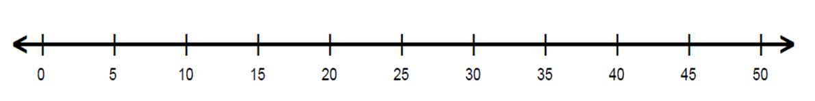

27 is here because it is 2 more than 25 and 3 less than 30







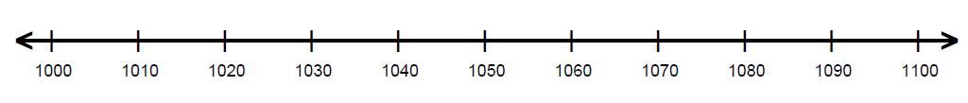

## Activity 3

bd06121_

### Odd and Even Numbers

|  |  |  |
| --- | --- | --- |
| Description: C:\Users\Family\AppData\Local\Microsoft\Windows\Temporary Internet Files\Content.IE5\0CSDSM16\MC900006744[1].wmfDescription: C:\Users\Family\AppData\Local\Microsoft\Windows\Temporary Internet Files\Content.IE5\0CSDSM16\MC900006744[1].wmf  Description: C:\Users\Family\AppData\Local\Microsoft\Windows\Temporary Internet Files\Content.IE5\0CSDSM16\MC900006744[1].wmfDescription: C:\Users\Family\AppData\Local\Microsoft\Windows\Temporary Internet Files\Content.IE5\0CSDSM16\MC900006744[1].wmf | Description: C:\Users\Family\AppData\Local\Microsoft\Windows\Temporary Internet Files\Content.IE5\0CSDSM16\MC900006744[1].wmfDescription: C:\Users\Family\AppData\Local\Microsoft\Windows\Temporary Internet Files\Content.IE5\0CSDSM16\MC900006744[1].wmf  Description: C:\Users\Family\AppData\Local\Microsoft\Windows\Temporary Internet Files\Content.IE5\0CSDSM16\MC900006744[1].wmf | Description: C:\Users\Family\AppData\Local\Microsoft\Windows\Temporary Internet Files\Content.IE5\0CSDSM16\MC900006744[1].wmfDescription: C:\Users\Family\AppData\Local\Microsoft\Windows\Temporary Internet Files\Content.IE5\0CSDSM16\MC900006744[1].wmfDescription: C:\Users\Family\AppData\Local\Microsoft\Windows\Temporary Internet Files\Content.IE5\0CSDSM16\MC900006744[1].wmfDescription: C:\Users\Family\AppData\Local\Microsoft\Windows\Temporary Internet Files\Content.IE5\0CSDSM16\MC900006744[1].wmfDescription: C:\Users\Family\AppData\Local\Microsoft\Windows\Temporary Internet Files\Content.IE5\0CSDSM16\MC900006744[1].wmf  Description: C:\Users\Family\AppData\Local\Microsoft\Windows\Temporary Internet Files\Content.IE5\0CSDSM16\MC900006744[1].wmfDescription: C:\Users\Family\AppData\Local\Microsoft\Windows\Temporary Internet Files\Content.IE5\0CSDSM16\MC900006744[1].wmfDescription: C:\Users\Family\AppData\Local\Microsoft\Windows\Temporary Internet Files\Content.IE5\0CSDSM16\MC900006744[1].wmfDescription: C:\Users\Family\AppData\Local\Microsoft\Windows\Temporary Internet Files\Content.IE5\0CSDSM16\MC900006744[1].wmf |
| How many cars? | How many cars? | How many cars? |
| Odd or even? | Odd or even? | Odd or even? |

|  |  |  |
| --- | --- | --- |
| Description: C:\Users\Family\AppData\Local\Microsoft\Windows\Temporary Internet Files\Content.IE5\0CSDSM16\MC900006744[1].wmfDescription: C:\Users\Family\AppData\Local\Microsoft\Windows\Temporary Internet Files\Content.IE5\0CSDSM16\MC900006744[1].wmfDescription: C:\Users\Family\AppData\Local\Microsoft\Windows\Temporary Internet Files\Content.IE5\0CSDSM16\MC900006744[1].wmf  Description: C:\Users\Family\AppData\Local\Microsoft\Windows\Temporary Internet Files\Content.IE5\0CSDSM16\MC900006744[1].wmfDescription: C:\Users\Family\AppData\Local\Microsoft\Windows\Temporary Internet Files\Content.IE5\0CSDSM16\MC900006744[1].wmf | Description: C:\Users\Family\AppData\Local\Microsoft\Windows\Temporary Internet Files\Content.IE5\0CSDSM16\MC900006744[1].wmfDescription: C:\Users\Family\AppData\Local\Microsoft\Windows\Temporary Internet Files\Content.IE5\0CSDSM16\MC900006744[1].wmf  Description: C:\Users\Family\AppData\Local\Microsoft\Windows\Temporary Internet Files\Content.IE5\0CSDSM16\MC900006744[1].wmfDescription: C:\Users\Family\AppData\Local\Microsoft\Windows\Temporary Internet Files\Content.IE5\0CSDSM16\MC900006744[1].wmf  Description: C:\Users\Family\AppData\Local\Microsoft\Windows\Temporary Internet Files\Content.IE5\0CSDSM16\MC900006744[1].wmfDescription: C:\Users\Family\AppData\Local\Microsoft\Windows\Temporary Internet Files\Content.IE5\0CSDSM16\MC900006744[1].wmf | Description: C:\Users\Family\AppData\Local\Microsoft\Windows\Temporary Internet Files\Content.IE5\0CSDSM16\MC900006744[1].wmfDescription: C:\Users\Family\AppData\Local\Microsoft\Windows\Temporary Internet Files\Content.IE5\0CSDSM16\MC900006744[1].wmfDescription: C:\Users\Family\AppData\Local\Microsoft\Windows\Temporary Internet Files\Content.IE5\0CSDSM16\MC900006744[1].wmfDescription: C:\Users\Family\AppData\Local\Microsoft\Windows\Temporary Internet Files\Content.IE5\0CSDSM16\MC900006744[1].wmf  Description: C:\Users\Family\AppData\Local\Microsoft\Windows\Temporary Internet Files\Content.IE5\0CSDSM16\MC900006744[1].wmfDescription: C:\Users\Family\AppData\Local\Microsoft\Windows\Temporary Internet Files\Content.IE5\0CSDSM16\MC900006744[1].wmfDescription: C:\Users\Family\AppData\Local\Microsoft\Windows\Temporary Internet Files\Content.IE5\0CSDSM16\MC900006744[1].wmfDescription: C:\Users\Family\AppData\Local\Microsoft\Windows\Temporary Internet Files\Content.IE5\0CSDSM16\MC900006744[1].wmf |
| How many cars? | How many cars? | How many cars? |
| Odd or even? | Odd or even? | Odd or even? |

**Fill in the gaps:**

Even numbers end in \_\_\_\_\_\_, \_\_\_\_\_\_, \_\_\_\_\_\_, \_\_\_\_\_\_, \_\_\_\_\_\_\_.

Examples include 12, 14, 16, 18 and 20.

Odd numbers end in \_\_\_\_\_\_, \_\_\_\_\_\_, \_\_\_\_\_\_, \_\_\_\_\_\_, \_\_\_\_\_\_\_.

Examples include 21, 23, 25, 27 and 29.

**NUMBER EXPANDERS**

A useful way of learning about numbers is to break them up into their place values. Number expanders are a great way of learning about the value of each digit. By folding strips of paper (like when making fans) you can learn more about the value of each number. 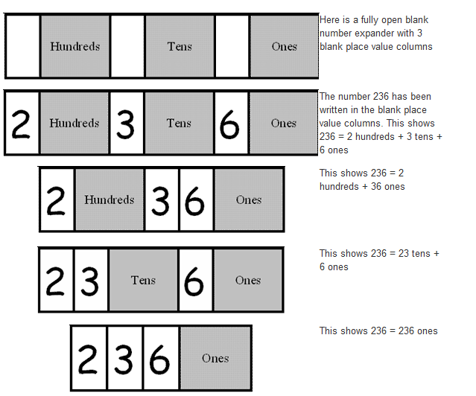

For example 2345 is

2 thousands, 3 hundreds, 4 tens and 5 ones OR

23 hundreds 4 tens and 5 ones OR

234 tens and 5 ones OR

2345 ones.

## Activity 4



bd06121_

### For you to do – Number Expanders

Now it’s time to do 3 of your own. Cut each number expander out, write in some digits in the blank sections (eg 236 – making sure you put them in the correct place value) then fold them up like a fan. An example has been done for you. Paperclip your 3 completed number expanders to this page.

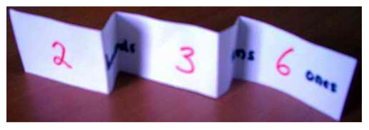

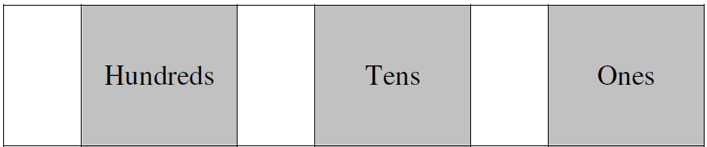

6

3

2

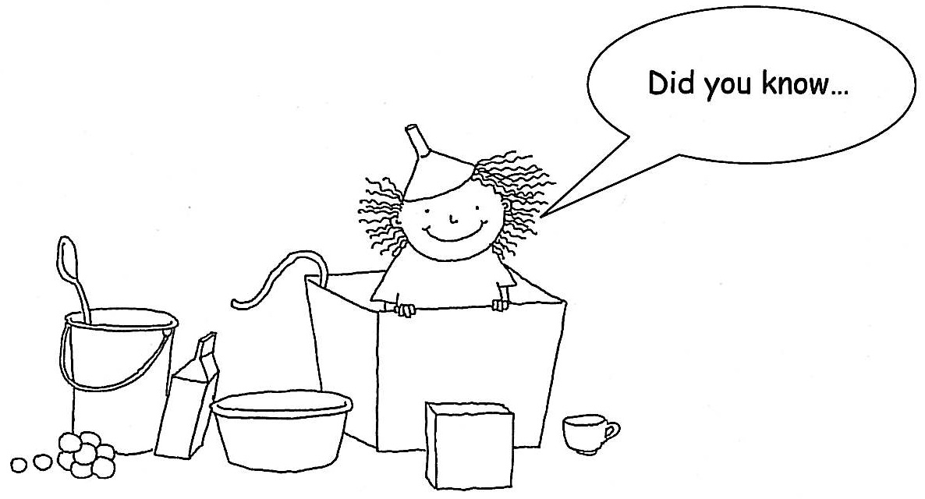

...that the ancient Greeks did not use digits (0 – 9)? Instead they used the letters of their alphabet.

For example, the first letter of the Greek alphabet is  (its name is *alpha),* which stood for the number**1**.

Some of these symbols are still used today in science and maths.

Read through more examples:

|  |  |  |
| --- | --- | --- |
| Name | Symbol | Digit |
| Alpha |  | 1 |
| Beta |  | 2 |
| Gamma |  | 3 |
| Delta |  | 4 |

To explore **lines** and look for them in numbers and in places around you.

## Focus

**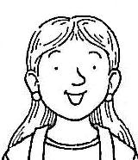**

Did you know that lines come in many shapes and lengths?

## Introduction

There are **straight**, **curved** and **diagonal** lines.

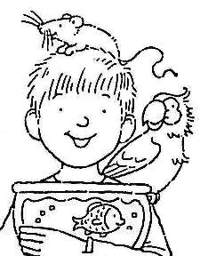

There are also **vertical** and **horizontal** lines.

Look around your room. Each object is made up of many types of lines. Can you locate the **straight lines** on a door or table? Maybe you can see the **curved** line on a clock?

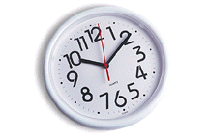

If you drew a curved line and ended at the starting point you would form a *circle.*

Straight lines form shapes with *corners,* such as squares and triangles.

## Introduction continued

Now let’s have a look at *horizontal*, *vertical* and *diagonal* lines.

A **horizontal**line runs **across** from either left to right or right to left.

It comes from the word *horizon* (where the earth and sky appear to meet).

A **vertical** line runs straight up or down. For example the line of a wall is *vertical.*

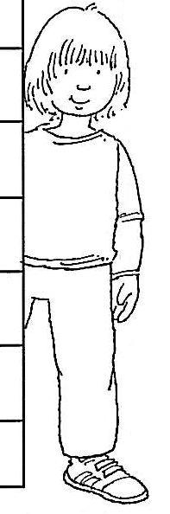

## Now let’s have a look at diagonal lines.

## Below I have drawn a square. Within the square I have drawn a

## line from one corner to the other. This line is called a diagonal.

## Below is a shape with many corners. In this shape I have drawn many

## diagonal lines.

## Diagonal lines run

## on a slant or angle.

## Introduction continued

You can also have a straight or curved horizontal, vertical or diagonal line.

*Curved horizontal line*

Curved vertical line

Curved diagonal line

Have a look at the following web-site for more examples of the lines we have discussed.

## Activity 1

**bd06121_**

### For you to do

Stand up and walk around your room. How many different lines can you see? Most windows and doors have horizontal and vertical lines.

On the following page draw four items from your room and label the lines. I have completed one below. Don’t forget to use a ruler if you need to draw a straight line.

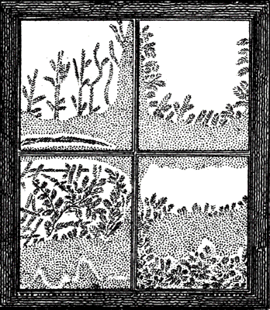

vertical line

horizontal line

## Activity 1 continued

|  |  |
| --- | --- |
| 1. | 2. |
| 3. | 4. |

## Activity 2

## bd06121_

## For you to do

Using digits 0 – 9, I would like you to tell me the name of each line and how many of them are used to form each number. I have completed one for you. To help, you might like to trace over each number first.

|  |  |
| --- | --- |
| 0 | 1 |
| 2 1 curved line  1 horizontal line | 3 |

## Activity 2 continued

|  |  |
| --- | --- |
| 4 | 5 |
| 6 | 7 |
| 8 | 9 |

## Optional

Work out how many different types of lines you have in your first name.

\_\_\_\_\_\_\_\_\_\_ horizontal lines

\_\_\_\_\_\_\_\_\_\_ vertical lines

\_\_\_\_\_\_\_\_\_\_ diagonal lines

\_\_\_\_\_\_\_\_\_\_ curved lines



…that the tallest building in the world is the *Burj Khalifa* in Dubai, United Arab Emirates?

It is over 828 metres tall with 160 storeys and has a tall spire.

bl00311_

***Learning Intentions***

*To tell time to the minute and investigate the relationship between units of time*

## Focus

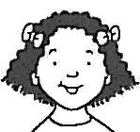

You will be telling the time using **analogue clocks**.

## Introduction

How is a clock used to tell time?

Why does the clock face have numbers and different sized hands?



What do we need clocks for?

Let’s have a look at the clock face.

1

2

3

6

12

4

5

7

9

8

10

11

minute hand

hour hand

The short hand tells you the **hour** and the long hand tells you how many **minutes** past the hour it is.

## Introduction continued

When the minute hand is on the number **12** a new hour begins so we call it **o’clock**. The hour hand is on 4.

The time below is **4 o’clock**.

1

2

3

6

12

4

5

7

9

8

10

11

When the minute hand is on **6** we can see that the hand has moved **half way** around the clock, we call this **half past**.

The time below is **half past 4**.

1

2

3

6

12

4

5

7

9

8

10

11

*Have you noticed a change in the hour hand? Yes, it has moved*

***half way*** *towards 5.*

## Introduction continued

Now let’s look at dividing the clock into **quarters**. This is made by drawing horizontal and vertical lines.

*o’clock*

1

2

3

6

12

4

5

7

9

8

10

11

*half past*

When the minute hand is on **3** we can see that the hand has moved **a quarter** past the hour, we call this **quarter past**,

The time below is **quarter past 4**.

1

2

3

6

12

4

5

7

9

8

10

11

*Have you noticed that the hour hand has moved a quarter of the way towards* ***5****?*

## Introduction continued

When the minute hand is on **9** we can see that it is only **one quarter** away from a new hour. We call this **quarter to** – the word *to* tell us that it is heading **to**wards **o’clock**.

The time below is **quarter to 5.**

1

2

3

6

12

4

5

7

9

8

10

11

*Can you see that the hour hand is almost on 5? This is because the time is close to approaching 5 o’clock.*

**Activity 1**

### bd06121_

### For you to do

It is time for you to make your own analogue clock. Remove the cardboard sheet on page 4 in your *Maths Activity Book.* Cut out the clock face, minute and hour hands. Pin the hands onto the clock face using a paper clip or split pin.

Once you have made your clock, complete the following:

1. Move the hands to show **6 o’clock.** Which number on the clock face is the minute hand on?

\_\_\_\_\_\_\_\_\_\_\_\_\_\_\_\_

1. Show **half past 10.** On which number is the minute hand?

\_\_\_\_\_\_\_\_\_\_\_\_\_\_\_\_

Between which two numbers is the hour hand? \_\_\_\_\_\_\_\_\_\_\_\_\_\_

## Activity 1 continued

1. Show **quarter past 7** on your clock. On which number is the minute hand?

\_\_\_\_\_\_\_\_\_\_\_\_

Which number is the hour hand closest to? \_\_\_\_\_\_\_\_\_\_\_\_

1. Now show **quarter to 3**.On which number is the minute hand?

\_\_\_\_\_\_\_\_\_\_\_\_

Which number is the hour hand approaching? \_\_\_\_\_\_\_\_\_\_\_\_

## Activity 2

**bd06121_**

**For you to do**

1. Draw the missing hands on each clock.

12

1

2

3

4

5

6

7

8

9

10

11

12

1

2

3

4

5

6

7

8

9

10

11

12

1

2

3

4

5

6

7

8

9

10

11

12

1

2

3

4

5

6

7

8

9

10

11

12

1

2

3

4

5

6

7

8

9

10

11

12

1

2

3

4

5

6

7

8

9

10

11

9 o’clock half past 12 quarter to 11

quarter past 3 half past 2 quarter to 4

1. Cut out the clocks. Beginning at 9 o’clock, paste them in order from **earliest to latest time** on the following page.

## Activity 2 continued

|  |  |  |
| --- | --- | --- |
|  |  |  |
|  |  |  |

## Activity 3

bd06121_

## For you to do

Have you ever been late for a train or a plane? Public transport runs to a very tight timetable – and every minute matters!

*Telling the time – to the minute!*

Fill in the blanks below.

There are 60 minutes in one \_\_\_\_\_\_\_.

There are 24 hours in a \_\_\_\_\_\_\_\_. When the long hand is on the 12 it is the beginning of a new hour or an “o’clock.”

Look at the following clock.

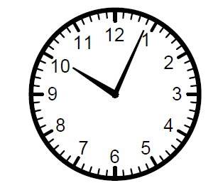

Can you see the markings around the outside? Count them all up. You should find that there are 60. Each marking = 1 minute.

* Did you find a shorter way to count all these minutes? What was it?

\_\_\_\_\_\_\_\_\_\_\_\_\_\_\_\_\_\_\_\_\_\_\_\_\_\_\_\_\_\_\_\_\_\_\_\_\_\_\_\_\_\_\_\_\_\_\_\_\_\_\_\_\_\_\_\_

\_\_\_\_\_\_\_\_\_\_\_\_\_\_\_\_\_\_\_\_\_\_\_\_\_\_\_\_\_\_\_\_\_\_\_\_\_\_\_\_\_\_\_\_\_\_\_\_\_\_\_\_\_\_\_\_

Now look at the hands.

Remember that the short hand is the hour hand and the long hand is the minute hand (I remember it because minute is a longer word than hour, so it has the longer hand.)

* The hour hand is just past 10, so we know it is just after 10 o’clock.
* Now look at the minute hand. Count how many markings (minutes) it has moved past the o’clock. You should find it’s 4.

So the time is 4 minutes past 10.

A digital clock would read 10:04.

*The minutes are on this side of the* ***:***

*The hours are on this side of the* ***:***

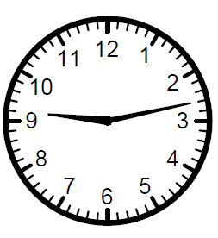

Let’s try another:

The hour (short) hand is just past the 9. The minute (long) hand has moved 13 minutes past the o’clock so the time is 13 minutes past 9 or 9:13.

This one’s a little tricky.

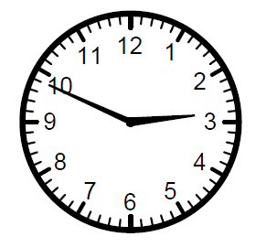

Look closely and you can see that the hour hand is a long way past the 2. Count up how many minutes past the 2 the minutes (long) hand has moved. Remember to use your shortcut for counting. What did you find?

There are 2 ways of saying this time.

* It is 49 minutes **past** 2 o’clock OR
* It is 11 minutes **TO** 3 o’clock

The digital time is 2:49.

Now you can try some of your own on the next page. Write the time underneath each clock. You can write the digital time, or you can use words.

|  |  |
| --- | --- |
|  |  |
|  |  |
|  |  |

## Activity 3

## bd06121_

## clock characterGame

## Clock Bingo

Let’s finish off the day with a game of *Clock Bingo.*

You will find the instructions and material for the game on pages 5-9 in your *Maths Activity Book.* Enjoy!

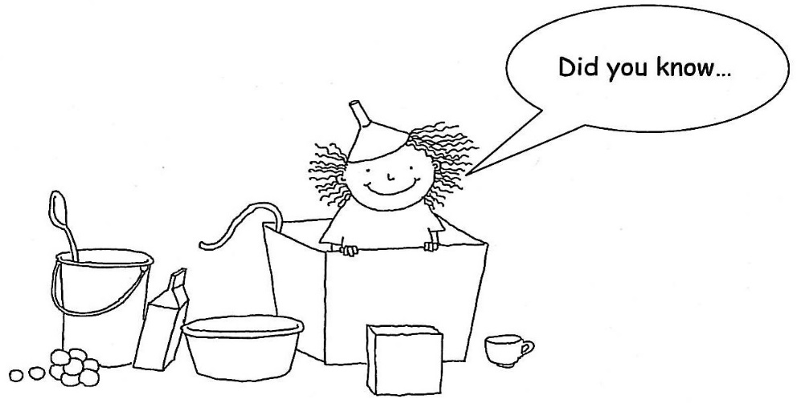

…that people had alarm clocks thousands of years ago? Candles were used to tell time by writing numbers on them. A nail was put into the wax, when the candle wax melted down to the nail, the nail would fall into a tin plate and make a noise and wake them up!

***Learning Intention:*** *Represent money values in multiple ways and count the change required for simple transactions to the nearest five cents*

## Focus

You will be ordering 3 digit numbers using money.

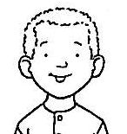

You will also explore different money from around the world!

## Introduction

Where in Australia would you like to visit? How much would it cost to get there? Below is a list of airfares to three cities in Australia and a map showing you how far they are from Melbourne.

Darwin – $334

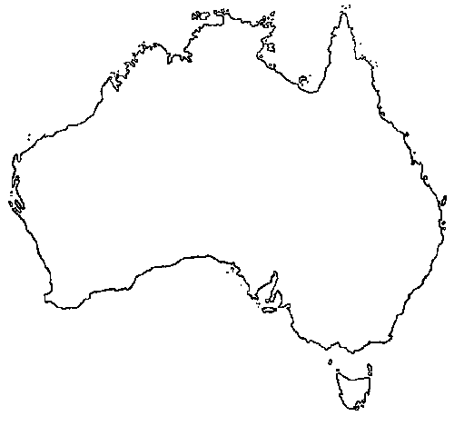Canberra – $ 89

Melbourne

Darwin

Brisbane

Canberra

Brisbane – $139

The information in the table gives us the cost of each flight. The map shows us **where** the cities are located and **how far** they are from Melbourne.

Think about why it is cheaper to travel to Canberra than it is to travel to Darwin. *The further the distance the higher the cost.*

*Airfare prices can vary according to distance and popularity.*

*In today’s lesson we will assume that distance will determine prices.*

**Activity 1**

**bd06121_**

**For you to do**

To complete the following activity, look closely at the value of numbers in the *units, tens* and *hundreds* columns under the heading

*One Way Fares*. For example, $923 is *greater than* $844 as 900 is greater than 800.

*One Way Fares*

|  |  |
| --- | --- |
| Alice Springs | $340 |
| Auckland | $433 |
| Ayers Rock | $234 |
| Darwin | $334 |
| Gold Coast | $134 |
| Hobart | $100 |
| Hong Kong | $923 |
| Perth | $230 |
| Sydney | $120 |
| Wellington | $844 |

1. List the airfares in order from *lowest* to *highest.*

\_\_\_\_\_\_\_\_\_\_ \_\_\_\_\_\_\_\_\_\_ \_\_\_\_\_\_\_\_\_\_ \_\_\_\_\_\_\_\_\_\_ \_\_\_\_\_\_\_\_\_\_

*Lowest*

\_\_\_\_\_\_\_\_\_\_ \_\_\_\_\_\_\_\_\_\_ \_\_\_\_\_\_\_\_\_\_ \_\_\_\_\_\_\_\_\_\_ \_\_\_\_\_\_\_\_\_\_

*Highest*

1. Which 3 places would you like to visit?

\_\_\_\_\_\_\_\_\_\_\_\_\_\_\_\_\_\_\_\_ \_\_\_\_\_\_\_\_\_\_\_\_\_\_\_\_\_\_\_\_ \_\_\_\_\_\_\_\_\_\_\_\_\_\_\_\_\_\_\_\_

1. Turn to pages 10 and 11 in your *Maths Activity Book* and cut out the coins and notes. Paste the correct money to show the value of the 3 places you have chosen. I have completed one for you.

## Activity 1 continued

I would like to visit Auckland; it’s going to cost me $433. I need to start saving now.

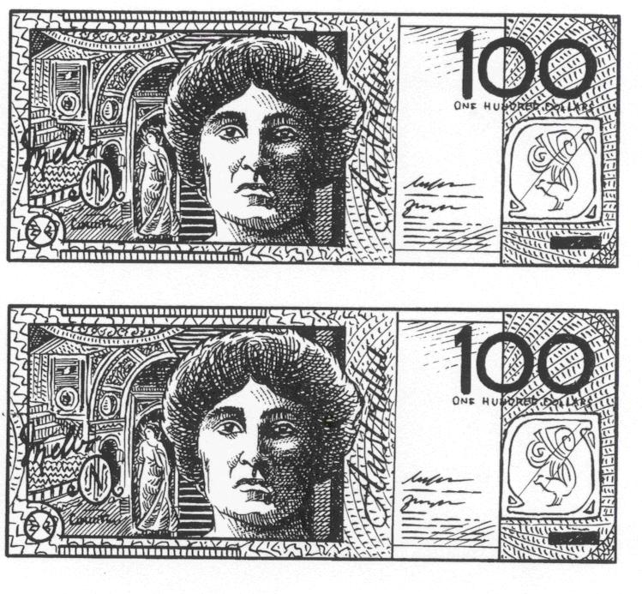

My favourite destination is **Auckland** the airfare is $433.

****

**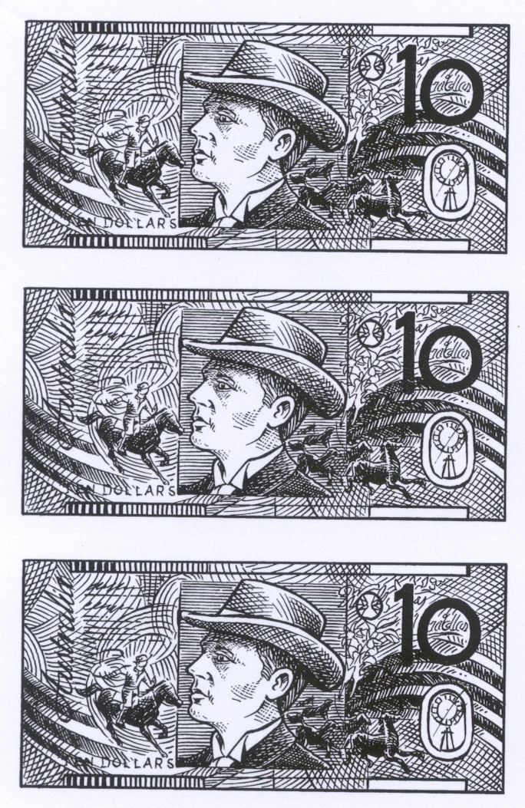**

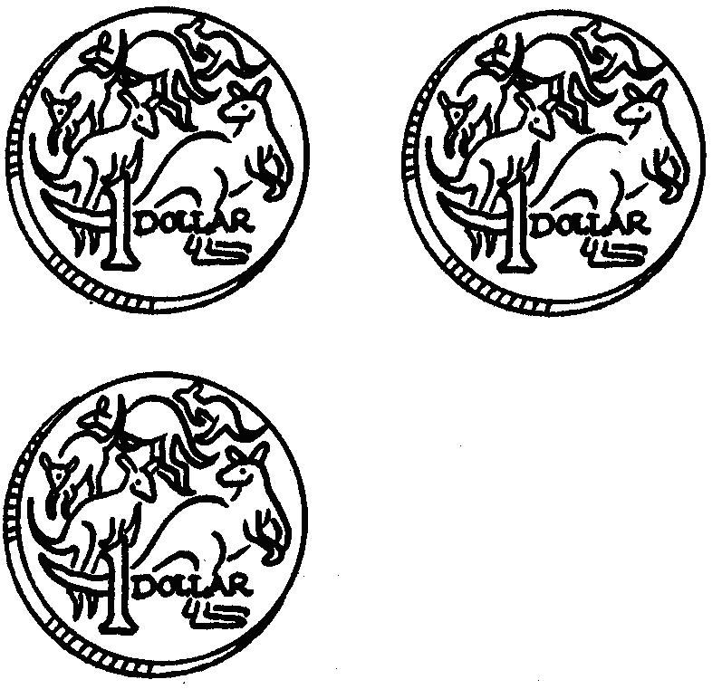

*Turn the page to complete your chosen destinations.*

*Remember to cut out the notes and coins and paste the appropriate amount of money to show the value of the airfare.*

## Activity 1 continued

|  |
| --- |
| Destination:  \_\_\_\_\_\_\_\_\_\_\_\_\_\_\_\_\_\_\_\_\_\_\_\_\_\_\_\_\_\_\_\_\_\_\_\_\_\_\_\_\_\_\_\_\_\_\_\_\_\_\_\_\_\_  Airfare:  \_\_\_\_\_\_\_\_\_\_\_\_\_\_\_\_\_\_\_\_\_\_\_\_\_\_\_\_\_\_\_\_\_\_\_\_\_\_\_\_\_\_\_\_\_\_\_\_\_\_\_\_\_\_ |

## Activity 1 continued

|  |
| --- |
| Destination:  \_\_\_\_\_\_\_\_\_\_\_\_\_\_\_\_\_\_\_\_\_\_\_\_\_\_\_\_\_\_\_\_\_\_\_\_\_\_\_\_\_\_\_\_\_\_\_\_\_\_\_\_\_\_  Airfare:  \_\_\_\_\_\_\_\_\_\_\_\_\_\_\_\_\_\_\_\_\_\_\_\_\_\_\_\_\_\_\_\_\_\_\_\_\_\_\_\_\_\_\_\_\_\_\_\_\_\_\_\_\_\_ |

## Activity 1 continued

|  |
| --- |
| Destination:  \_\_\_\_\_\_\_\_\_\_\_\_\_\_\_\_\_\_\_\_\_\_\_\_\_\_\_\_\_\_\_\_\_\_\_\_\_\_\_\_\_\_\_\_\_\_\_\_\_\_\_\_\_\_  Airfare:  \_\_\_\_\_\_\_\_\_\_\_\_\_\_\_\_\_\_\_\_\_\_\_\_\_\_\_\_\_\_\_\_\_\_\_\_\_\_\_\_\_\_\_\_\_\_\_\_\_\_\_\_\_\_ |

## Activity 2

**bd06121_**

### Find these money words in the word search.

|  |  |  |  |  |  |  |  |  |  |  |  |  |  |  |  |
| --- | --- | --- | --- | --- | --- | --- | --- | --- | --- | --- | --- | --- | --- | --- | --- |
|  | Word list:   |  |  | | --- | --- | | BUY | CASH | | COST | EURO | | COINS | SELL | | CURRENCY | MONEY | | CENTS | VALUE | | DOLLAR | YEN | | NOTES |  | |

* What is “$” the symbol for? \_\_\_\_\_\_\_
* Which of these is the currency / money of Japan? \_\_\_\_\_\_
* Can you find out the names of 3 countries that use the currency Euro (€)? \_\_\_\_\_\_\_ \_\_\_\_\_\_\_ \_\_\_\_\_\_\_

(Hint: many of these countries are a part of the continent that begins with this word)

## Activity 3

**bd06121_**

### For you to do – optional – challenge activity

The airfares given to you are for a one-way trip. Should you want to return from your visit you will need a *return airfare.* **The return airfare is twice the price listed.**

Calculate the return airfare of the following destinations.

Show all workings out in the box.

There are 2 ways you can do this.

1. Multiply the airfare by 2
2. Add the airfare with itself

Read the examples below.

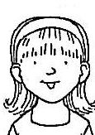

Return airfare to **Alice Springs.**

$340 (one way fare)

|  |  |
| --- | --- |
| *add together* | *multiply by 2* |
| 340 | 340 |
| + 340 | **×** 2 |
| 680 | 680 |

Answer the following:

1. Return airfare to **Hong Kong**.

$923 (one way fare)

## Activity 2 continued

1. Return airfare to **Gold Coast**.

$134 (one way fare)

1. Return airfare to **Perth**.

$230 (one way fare)

1. Return airfare to **Hobart**.

$100 (one way fare)



…if you want a holiday with a difference you can be a *Space Tourist* and travel into outer space.

There is only one problem. It costs about 20 million dollars!

Dennis Tito was the first Space Tourist in 2001.

bd05713_

## Focus

You will be **revising** work covered this week.

|  |
| --- |
| MCj00787170000[1] |

### Completing the work

|  |
| --- |
| **Looking Back**  Test your knowledge on work covered so far.  Complete without the assistance of your supervisor.  When you have completed your work ask your supervisor to correct your work and discuss any problems. |

|  |
| --- |
| Comments Did you have any problems?  Did you find the work easy?  How can I help you? |

*Turn the page and begin. Good luck!*

1. Order the following numbers from smallest to largest.

252 1225 5525

205 502 550

\_\_\_\_\_\_\_\_\_\_\_\_\_\_\_\_\_\_\_\_\_\_\_\_\_\_\_\_\_\_\_\_\_\_\_\_\_\_\_\_

\_\_\_\_\_\_\_\_\_\_\_\_\_\_\_\_\_\_\_\_\_\_\_\_\_\_\_\_\_\_\_\_\_\_\_\_\_\_\_\_

1. Circle the *tens* and underline the *hundreds* in the

following numbers.

741, 444, 309, 10, 1

1. Unjumble the numbers. I have completed the first one for you.

|  |  |
| --- | --- |
| 4 tens, 1unit, 7 hundreds | 741 |
| 8 units, 6 hundreds, 0 tens |  |
| 0 hundreds, 1 thousand, 0 units, 2 tens |  |
| 9 tens, 1 hundred, 9 units, 2 thousands |  |

1. Colour the odd numbers blue and even numbers red:

|  |  |  |  |  |
| --- | --- | --- | --- | --- |
| 29 | 12 | 19 | 43 | 100 |
| 144 | 1052 | 2226 | 4380 | 601 |

1. How many horizontal lines are there in the picture below? \_\_\_\_\_\_



1. How many vertical lines in the picture? \_\_\_\_\_\_\_\_\_\_
2. Circle the *diagonal* arrows.

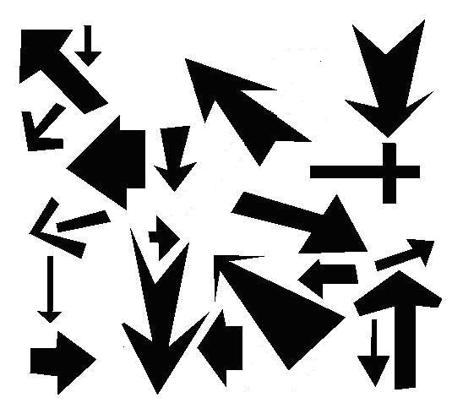

1. How many diagonal arrows did you find? \_\_\_\_\_\_\_\_\_\_
2. Tell me the time on these clock faces.

**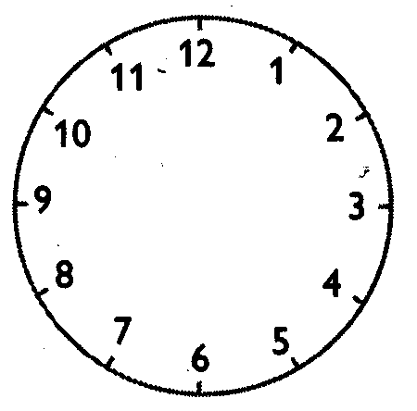**

\_\_\_\_\_\_\_\_\_\_\_\_\_\_\_\_\_\_\_\_ \_\_\_\_\_\_\_\_\_\_\_\_\_\_\_\_\_\_\_\_ \_\_\_\_\_\_\_\_\_\_\_\_\_\_\_\_\_\_\_\_

1. Show the time. Use a ruler and pencil to draw the minute and hour hands.

****

|  |  |  |
| --- | --- | --- |
| 10 minutes past 6 o’clock | 25 minutes past 3 o’clock | A quarter to 12 o’clock |

****

|  |  |  |
| --- | --- | --- |
| 9 o’clock | 20 minutes to 4 o’clock | 1 minute past 7 o’clock |

## 23-313492258

**Problem Solving**

|  |
| --- |
| It cost Peter $942 to fly to London. How much for a return airfare?  \_\_\_\_\_\_\_\_\_\_\_\_\_\_\_\_ |

|  |
| --- |
| It cost Kate $430 to fly to Tokyo. How much for a return airfare?  \_\_\_\_\_\_\_\_\_\_\_\_\_\_\_\_ |

|  |
| --- |
| How much did Peter and Kate spend **altogether** on flying?  \_\_\_\_\_\_\_\_\_\_\_\_\_\_\_\_ |

## Comments

Did you have any difficulties? Was it too easy? Did you need assistance? Were the instructions easy to follow?

**\_\_\_\_\_\_\_\_\_\_\_\_\_\_\_\_\_\_\_\_\_\_\_\_\_\_\_\_\_\_\_\_\_\_\_\_\_\_\_\_\_\_\_\_\_\_\_\_\_\_\_\_\_\_\_\_\_\_\_\_\_\_\_\_\_\_**

**\_\_\_\_\_\_\_\_\_\_\_\_\_\_\_\_\_\_\_\_\_\_\_\_\_\_\_\_\_\_\_\_\_\_\_\_\_\_\_\_\_\_\_\_\_\_\_\_\_\_\_\_\_\_\_\_\_\_\_\_\_\_\_\_\_\_**

**\_\_\_\_\_\_\_\_\_\_\_\_\_\_\_\_\_\_\_\_\_\_\_\_\_\_\_\_\_\_\_\_\_\_\_\_\_\_\_\_\_\_\_\_\_\_\_\_\_\_\_\_\_\_\_\_\_\_\_\_\_\_\_\_\_\_**

**\_\_\_\_\_\_\_\_\_\_\_\_\_\_\_\_\_\_\_\_\_\_\_\_\_\_\_\_\_\_\_\_\_\_\_\_\_\_\_\_\_\_\_\_\_\_\_\_\_\_\_\_\_\_\_\_\_\_\_\_\_\_\_\_\_\_**

**\_\_\_\_\_\_\_\_\_\_\_\_\_\_\_\_\_\_\_\_\_\_\_\_\_\_\_\_\_\_\_\_\_\_\_\_\_\_\_\_\_\_\_\_\_\_\_\_\_\_\_\_\_\_\_\_\_\_\_\_\_\_\_\_\_\_**

**\_\_\_\_\_\_\_\_\_\_\_\_\_\_\_\_\_\_\_\_\_\_\_\_\_\_\_\_\_\_\_\_\_\_\_\_\_\_\_\_\_\_\_\_\_\_\_\_\_\_\_\_\_\_\_\_\_\_\_\_\_\_\_\_\_\_**

**\_\_\_\_\_\_\_\_\_\_\_\_\_\_\_\_\_\_\_\_\_\_\_\_\_\_\_\_\_\_\_\_\_\_\_\_\_\_\_\_\_\_\_\_\_\_\_\_\_\_\_\_\_\_\_\_\_\_\_\_\_\_\_\_\_\_**

**\_\_\_\_\_\_\_\_\_\_\_\_\_\_\_\_\_\_\_\_\_\_\_\_\_\_\_\_\_\_\_\_\_\_\_\_\_\_\_\_\_\_\_\_\_\_\_\_\_\_\_\_\_\_\_\_\_\_\_\_\_\_\_\_\_\_**

**\_\_\_\_\_\_\_\_\_\_\_\_\_\_\_\_\_\_\_\_\_\_\_\_\_\_\_\_\_\_\_\_\_\_\_\_\_\_\_\_\_\_\_\_\_\_\_\_\_\_\_\_\_\_\_\_\_\_\_\_\_\_\_\_\_\_**

**\_\_\_\_\_\_\_\_\_\_\_\_\_\_\_\_\_\_\_\_\_\_\_\_\_\_\_\_\_\_\_\_\_\_\_\_\_\_\_\_\_\_\_\_\_\_\_\_\_\_\_\_\_\_\_\_\_\_\_\_\_\_\_\_\_\_**

***Learning Intention:***

*To describe, continue, and create number patterns resulting from performing addition or subtraction*

## Focus

You will be looking at **patterns** in **number counting** including odd and even numbers.

and revising tables **2s, 5s, 10s, 100s** and learning **4s**.

You will be using the **100 Chart**

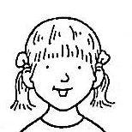

## Introduction

## Step 1 – Patterns

Let’s begin by looking at the chart below. I have begun by colouring

in some squares. Think about the pattern I have made? Can you see that every 2nd square is filled in? Continue the pattern to the end of

the chart.

|  |  |  |  |  |  |  |  |  |
| --- | --- | --- | --- | --- | --- | --- | --- | --- |
|  |  |  |  |  |  |  |  |  |
|  |  |  |  |  |  |  |  |  |
|  |  |  |  |  |  |  |  |  |

Make up your own pattern by colouring in squares on the chart below. Explain your pattern.

|  |  |  |  |  |  |  |  |  |  |
| --- | --- | --- | --- | --- | --- | --- | --- | --- | --- |
|  |  |  |  |  |  |  |  |  |  |
|  |  |  |  |  |  |  |  |  |  |
|  |  |  |  |  |  |  |  |  |  |

Pattern \_\_\_\_\_\_\_\_\_\_\_\_\_\_\_\_\_\_\_\_\_\_\_\_\_\_\_\_\_\_\_\_\_\_\_\_\_\_\_\_\_\_\_\_\_\_\_\_\_\_\_\_\_\_

## Step 2 – Patterns in Number Counting

Now let’s have a look at patterns in number. On the number chart below I have coloured in every 2nd space. Can you predict what the next number will be? \_\_\_\_\_\_\_\_ . The next number? \_\_\_\_\_\_\_\_\_ .

Complete the pattern to 40.

|  |  |  |  |  |  |  |  |  |  |
| --- | --- | --- | --- | --- | --- | --- | --- | --- | --- |
| 1 | 2 | 3 | 4 | 5 | 6 | 7 | 8 | 9 | 10 |
| 11 | 12 | 13 | 14 | 15 | 16 | 17 | 18 | 19 | 20 |
| 21 | 22 | 23 | 24 | 25 | 26 | 27 | 28 | 29 | 30 |
| 31 | 32 | 33 | 34 | 35 | 36 | 37 | 38 | 39 | 40 |

* All of these numbers are EVEN.

What digits do even numbers end in? \_\_\_\_\_\_\_\_\_\_\_\_\_\_\_\_\_\_\_\_\_\_\_\_\_\_

## Step 3 – Rules

When counting there are *rules* you need to follow. When counting by **2s** – as you have completed on the previous page – the rule is:

Can you see this pattern as these numbers are repeated over and over in the units column? The rule helps you continue the number pattern and remember the count.

Now let’s have a look at the rule for skip counting by **4s**

2 4 6 8 0

|  |  |  |  |  |  |  |  |  |  |
| --- | --- | --- | --- | --- | --- | --- | --- | --- | --- |
| 1 | 2 | 3 | 4 | 5 | 6 | 7 | 8 | 9 | 10 |
| 11 | 12 | 13 | 14 | 15 | 16 | 17 | 18 | 19 | 20 |
| 21 | 22 | 23 | 24 | 25 | 26 | 27 | 28 | 29 | 30 |
| 31 | 32 | 33 | 34 | 35 | 36 | 37 | 38 | 39 | 40 |

Look carefully at the units in each number and write down the rule.

\_\_\_\_\_\_\_\_\_\_\_\_\_\_\_\_\_\_\_\_\_\_\_\_\_\_\_\_\_\_\_\_\_\_\_\_\_\_\_\_\_\_.

Complete counting by 4s by putting a cross in the correct squares on the chart.

Using the rule, continue counting by 4s from:

**44**, \_\_\_\_\_\_\_\_ , \_\_\_\_\_\_\_\_ , \_\_\_\_\_\_\_\_ , \_\_\_\_\_\_\_\_ , \_\_\_\_\_\_\_\_ , **68**.

## Rules continued

Let’s look at the counting rule for **5s** and **10s**.

1. Beginning on 5 count by 5s by colouring the squares in red.
2. What is the pattern / rule for 5s? \_\_\_\_\_\_\_\_\_\_\_\_\_\_\_\_\_\_\_\_\_\_\_\_\_\_\_\_.
3. Beginning on 10, count by 10s by colouring the squares in blue.
4. What is the pattern / rule for 10s? \_\_\_\_\_\_\_\_\_\_\_\_\_\_\_\_\_\_\_\_\_\_\_\_\_\_\_ .

|  |  |  |  |  |  |  |  |  |  |
| --- | --- | --- | --- | --- | --- | --- | --- | --- | --- |
| **1** | **2** | **3** | **4** | **5** | **6** | **7** | **8** | **9** | **10** |
| **11** | **12** | **13** | **14** | **15** | **16** | **17** | **18** | **19** | **20** |
| **21** | **22** | **23** | **24** | **25** | **26** | **27** | **28** | **29** | **30** |
| **31** | **32** | **33** | **34** | **35** | **36** | **37** | **38** | **39** | **40** |
| **41** | **42** | **43** | **44** | **45** | **46** | **47** | **48** | **49** | **50** |
| **51** | **52** | **53** | **54** | **55** | **56** | **57** | **58** | **59** | **60** |
| **61** | **62** | **63** | **64** | **65** | **66** | **67** | **68** | **69** | **70** |
| **71** | **72** | **73** | **74** | **75** | **76** | **77** | **78** | **79** | **80** |
| **81** | **82** | **83** | **84** | **85** | **86** | **87** | **88** | **89** | **90** |
| **91** | **92** | **93** | **94** | **95** | **96** | **97** | **98** | **99** | **100** |

Find one other pattern on the grid. Colour it green and write the rule below:

\_\_\_\_\_\_\_\_\_\_\_\_\_\_\_\_\_\_\_\_\_\_\_\_\_\_\_\_\_\_\_\_\_\_\_\_\_\_\_\_\_\_\_\_\_\_\_\_\_\_\_\_\_\_\_\_\_\_\_\_\_\_\_\_\_\_

## Step 4 – Identifying patterns

Fill in the table below. The first one has been done for you.

|  |  |  |
| --- | --- | --- |
| Pattern | Next two numbers | Rule |
| 21, 23, 25, 27, 29… | 31, 33 | + 2 |
| 100, 95, 90, 85, 80… |  |  |
| 1000, 900, 800, 700… |  |  |
| 465, 470, 475, 480 … |  |  |
| 800, 790, 780, 770, 760… |  |  |
| 1222, 1224, 1226, 1228… |  |  |
| 333, 323, 313, 303….. |  |  |

## Making your own pattern.

Today’s magic number is 24. You need to make 5 number patterns that include the number 24. You need to also state the what the rule is. Fill in your work in the table below.

|  |  |
| --- | --- |
|  | Rule |
|  |  |
|  |  |
|  |  |
|  |  |
|  |  |

Did you use the *100s Chart* to help you make your own pattern?

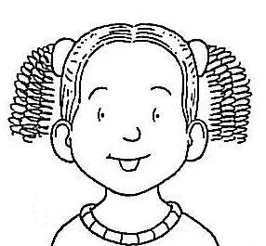

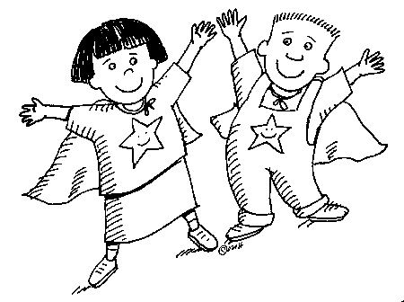

You will be looking for number rules using *addition and subtraction* to create and extend **number patterns.**

## Focus

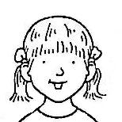

## Introduction

## Step 1 – Rules

Let’s begin by looking at the following number pattern:

2, 5, 8, 11, 14

Look carefully at the first two numbers in the pattern 2 and 5.

What is the difference between the two numbers?

*The difference is* 3*.*

Does this apply to the second and third numbers? The third and fourth numbers? The fourth and fifth numbers?

|  |
| --- |
| We can now work out that the **rule** for the above  number pattern is **add 3.** |

Now that you know the rule continue the number pattern below.

2, 5, 8, 11, 14, \_\_\_\_\_, \_\_\_\_\_, \_\_\_\_\_, \_\_\_\_\_

Here’s a tricky number pattern that I have made up. Can you work out the rule? Here’s a helpful hint – *skip count* **2***s.*

2, 4, 8, 14, 22, \_\_\_\_\_, \_\_\_\_\_, \_\_\_\_\_

*Answer is on the following page.*

## Introduction continued

**Answer:**

|  |
| --- |
| 2, 4, 8, 14, 22 32, 44, 58.  *+2 +4 +6 +8 +10 +12 +14* |

**Rule:** *Add numbers using the* 2 *times tables.*

Can you continue the number pattern further? Have-a-go!

2, 4, 8, 14, 22, 32, 44, 58, \_\_\_\_\_, \_\_\_\_\_ .

**Activity 1**

bd06121_

**For you to do**

Write the rule for each and complete the number pattern. I have completed the first one for you.

|  |
| --- |
| **Rule**: −3  26, 23, 20, 17, 14, 11, 8, 5, 2. |

|  |
| --- |
| **Rule**: \_\_\_\_\_\_\_\_\_\_\_\_  110, 100, 90, 80, \_\_\_\_\_, \_\_\_\_\_, \_\_\_\_\_, \_\_\_\_\_. |

|  |
| --- |
| **Rule**: \_\_\_\_\_\_\_\_\_\_\_\_  2, 4, 8, 16, 32, \_\_\_\_\_, \_\_\_\_\_, \_\_\_\_\_, \_\_\_\_\_. |

## Activity 1 continued

|  |
| --- |
| **Rule: \_\_\_\_\_\_\_\_\_\_\_**  100, 99, 97, 94, 90, \_\_\_\_\_, \_\_\_\_\_, \_\_\_\_\_, \_\_\_\_\_ |

|  |
| --- |
| **Rule: \_\_\_\_\_\_\_\_\_\_\_**  140, 136, 132, 128, \_\_\_\_\_, \_\_\_\_\_, \_\_\_\_\_, \_\_\_\_\_, \_\_\_\_\_ |

|  |
| --- |
| **Rule: \_\_\_\_\_\_\_\_\_\_\_**  1 030, 1 025, 1 020, \_\_\_\_\_, \_\_\_\_\_, \_\_\_\_\_, \_\_\_\_\_ |

|  |
| --- |
| **Rule: \_\_\_\_\_\_\_\_\_\_\_**  10,000, 9 990, 9 980, 9 970, \_\_\_\_\_, \_\_\_\_\_, \_\_\_\_\_ |

**Activity 2**

bd06121_

## For you to do – Doubles practise

Now we will look at patterns with doubles and near doubles

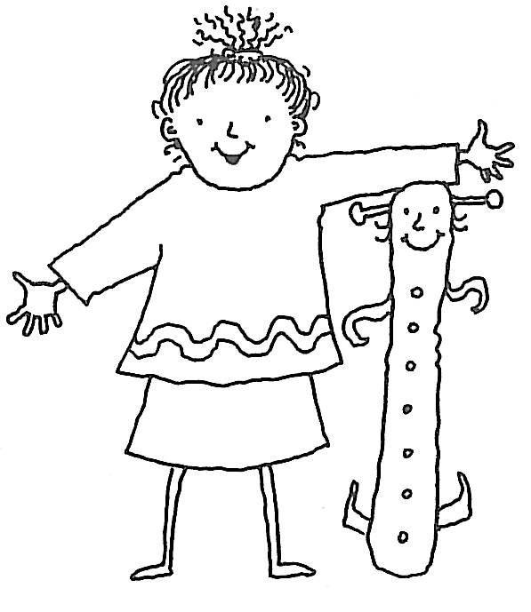

..and take a closer look at the 100 chart to find patterns hidden in it.

Write the doubles of the numbers in the table.

|  |  |  |  |  |  |  |  |  |  |  |  |  |
| --- | --- | --- | --- | --- | --- | --- | --- | --- | --- | --- | --- | --- |
|  | 1 | 2 | 3 | 4 | 5 | 6 | 7 | 8 | 9 | 10 | 11 | 12 |
| x 2 |  |  |  |  |  |  |  |  |  |  |  |  |

Use this information to write the answers to these near doubles.

|  |  |  |  |  |  |  |  |  |  |
| --- | --- | --- | --- | --- | --- | --- | --- | --- | --- |
| 6 | + | 7 | = |  | 5 | + | 6 | = |  |
| 8 | + | 9 | = |  | 10 | + | 9 | = |  |
| 50 | + | 51 | = |  | 50 | + | 49 | = |  |
| 70 | + | 72 | = |  | 30 | + | 40 | = |  |

How did you work out 50 + 51?

\_\_\_\_\_\_\_\_\_\_\_\_\_\_\_\_\_\_\_\_\_\_\_\_\_\_\_\_\_\_\_\_\_\_\_\_\_\_\_\_\_\_\_\_\_\_\_\_\_\_\_\_\_\_\_\_

How did you work out 30 + 40?

\_\_\_\_\_\_\_\_\_\_\_\_\_\_\_\_\_\_\_\_\_\_\_\_\_\_\_\_\_\_\_\_\_\_\_\_\_\_\_\_\_\_\_\_\_\_\_\_\_\_\_\_\_\_\_\_

Patterns in the 100 number chart:

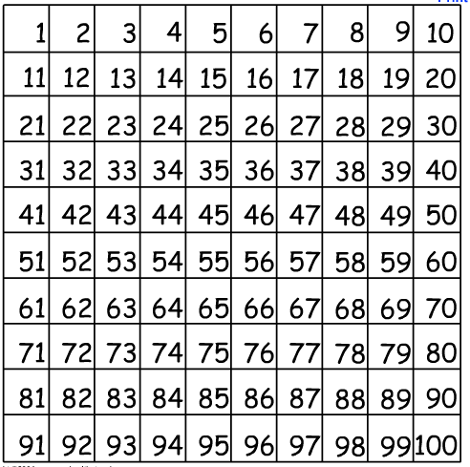

Find a yellow or another light coloured pencil. Colour in these numbers on the number chart:

1, 12, 23, 34, 45, 56, 67, 78, 89.

Describe the pattern they make?

\_\_\_\_\_\_\_\_\_\_\_\_\_\_\_\_\_\_\_\_\_\_\_\_\_\_\_\_\_\_\_\_\_\_\_\_\_\_\_\_\_\_\_\_\_\_\_\_\_\_\_\_\_\_\_\_\_\_\_\_\_\_\_\_\_\_

Now add up the digits in each number.

What do you find? \_\_\_\_\_\_\_\_\_\_\_\_\_\_\_\_\_\_\_\_\_\_\_\_\_\_\_\_\_\_\_\_\_\_\_\_\_\_\_\_\_\_\_\_\_\_\_\_

What is special about these numbers? \_\_\_\_\_\_\_\_\_\_\_\_\_\_\_\_\_\_\_\_\_\_\_\_\_\_\_\_\_\_

Find another number pattern in the chart and colour it a different colour. Describe your pattern on the line below.

\_\_\_\_\_\_\_\_\_\_\_\_\_\_\_\_\_\_\_\_\_\_\_\_\_\_\_\_\_\_\_\_\_\_\_\_\_\_\_\_\_\_\_\_\_\_\_\_\_\_\_\_\_\_\_\_\_\_\_\_\_\_\_\_\_\_



…to double any number all you have to do is multiply it by 2.

5, 10, 20, 40, 80, 160, 320.

## Focus

You will be looking at a yearly calendar. bs00057_

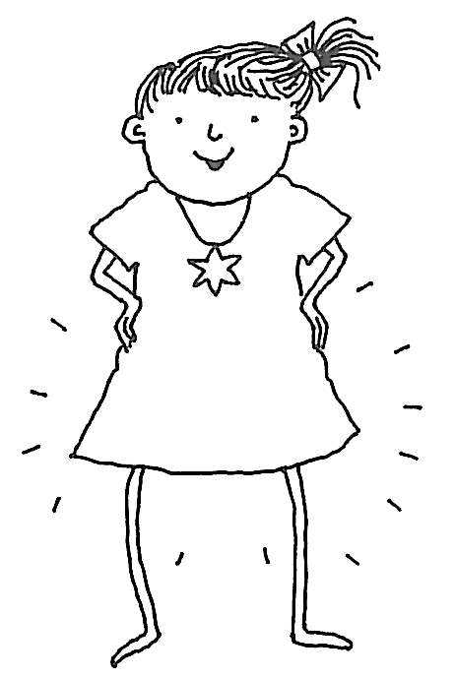

## Introduction

A yearly calendar is set out like this:

1. Grouped into the 12 months of the year.
2. Each month is divided into weeks.
3. Weeks are divided into 7 days - *weekdays* Monday – Friday and *weekends* Saturday and Sunday.

## Activity 1

bd06121_

### For you to do – “It’s about TIME!”

Here is a list of words about time. Write them under the correct heading in the table below. Check a calendar or clock to help you.

|  |  |  |  |
| --- | --- | --- | --- |
| seconds | months | days | hours |
| minutes | year | weeks | fortnight |

|  |  |
| --- | --- |
| CALENDAR | CLOCK / WATCH |
|  |  |

A calendar helps us locate days, months and weeks. This is important so we don’t miss special events like birthdays, appointments and school holidays which occur over a **long** period of time. Clocks help us work out time only over a **short** period of time – within 1 day or 24 hours.

## Activity 2

bd06121_

## For you to do – All about calendars

Answer the following using the calendar in your *Activity Book.*

1. Write the date of your birthday. \_\_\_\_\_\_\_\_\_\_\_\_\_\_\_\_\_\_\_\_\_\_\_\_\_\_\_\_\_
2. How many Fridays in your birth month? \_\_\_\_\_\_\_\_\_\_\_\_\_\_\_\_\_\_\_\_\_
3. What is the date one week **before** your birthday? \_\_\_\_\_\_\_\_\_\_\_\_\_\_
4. What is the date two weeks **after** your birthday?

\_\_\_\_\_\_\_\_\_\_\_\_\_\_\_\_\_\_\_\_\_\_\_\_\_\_\_\_\_\_\_\_\_\_\_\_\_\_\_\_\_\_\_\_\_\_\_\_\_\_\_\_\_\_\_\_\_\_\_\_

1. Which month has the **least** number of days? \_\_\_\_\_\_\_\_\_\_\_\_\_\_\_\_\_
2. Name a special event and write the day and date.

\_\_\_\_\_\_\_\_\_\_\_\_\_\_\_\_\_\_\_\_\_\_\_\_\_\_\_\_\_\_\_\_\_\_\_\_\_\_\_\_\_\_\_\_\_\_\_\_\_\_\_\_\_\_\_\_\_\_\_\_

**Solve this Birthday Problem!**

Peter’s 9th birthday is on Friday 18th February. He wants to have his party on the following Sunday but his mum will be busy and has asked him to have his party one week after his birthday.

What is the day and date of Peter’s party? \_\_\_\_\_\_\_\_\_\_\_\_\_\_\_\_\_\_\_\_\_\_\_\_\_\_

## Activity 3

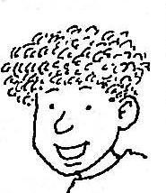

Did you know that you can work out how much time there is to special events by using a calendar?

Here’s how!

You can **count on in days, weeks or months** from today’s date to work out how much time you have before a special date. Look at the example below using the calendar month for June.

**June**

|  |  |  |  |  |  |  |
| --- | --- | --- | --- | --- | --- | --- |
| **M** | **T** | **W** | **T** | **F** | **S** | **S** |
|  |  | 1 | 2 | 3 | 4 | 5 |
| 6 | 7 | 8 | 9 | 10 | 11 | 12 |
| 13 | 14 | 15 | 16 | 17 | 18 | 19 |
| 20 | 21 | 22 | 23 | 24 | 25 | 26 |
| 27 | 28 | 29 | 30 |  |  |  |

If today was the 2nd of June and your birthday was on the 30th June you could **count on** from the 3rd to the 30th and calculate there are **28** days to your birthday.

**Activity 3**

**bd06121_**

**For you to do**

Using the calendar in your *Activity Book* work out the following:

1. How many weeks between the 4th February and the 4th March?

\_\_\_\_\_\_\_\_\_\_\_\_\_\_\_\_\_\_\_

1. If today is the 6th August and you have an appointment on the

20th August how many days must you wait?

\_\_\_\_\_\_\_\_\_\_\_\_\_\_\_\_\_\_\_

1. How many weeks or months between your birthday and your mum’s?

\_\_\_\_\_\_\_\_\_\_\_\_\_\_\_\_\_\_\_



…that February has 29 days every 4 years (leap year).

To remember how many days there are in each month learn to recite the following rhyme.

30 days has September,

April, June and November.

All the rest have 31

except February which has

but 28 days clear and

29 in each leap year.

***Learning Intention:*** *To recognise and explain the connection between addition and subtraction*

## Focus

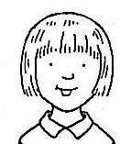

You will look at the similarities and differences between the symbols + - x

## Introduction

## Did you know that you can use *addition, subtraction* or *multiplication* to get the same answer?

## Let’s look at the number 36. If this were the answer to a problem, what might the question be? Below is a list of expressions using *addition,* *subtraction* and *multiplication.*

***Addition***

|  |  |  |  |  |  |
| --- | --- | --- | --- | --- | --- |
| 30+6 | 6+30 | 31+5 | 20+16 | 36+0 | 0+36 |

***Subtraction***

|  |  |  |  |  |
| --- | --- | --- | --- | --- |
| 40 − 4 | 37 − 1 | 100 − 64 | 50 − 14 | 90 − 54 |

***Multiplication***

|  |  |  |  |
| --- | --- | --- | --- |
| 3 × 12 | 12 × 3 | 2 × 18 | 18 × 2 |

Can you see any patterns, similarities or differences between the different operations?

Read on to explore **three** **important facts** about *addition*, *subtraction* and *multiplication.*

## Introduction continued

## CHANGING ORDER

If I changed the **order** of an ***addition*** and ***multiplication*** sum would the answer stay the **same**? Let’s have a look.

30 + 6 = 36 and 6 + 30 = 36

3 **×** 12 = 36 and 12 **×** 3 = 36

## Important Fact

|  |
| --- |
| *Addition* and *multiplication* sums are **commutative**, that means that the numbers in the equations can be changed around and the answer remains the **same**. |

bd06111_

Is *subtraction commutative?*

1. − 1 = 36

1 − 37 = *You cannot take away 37 from 1 as there are not enough*

*numbers to count back from 1.*

## 2. Important Fact!

|  |
| --- |
| *Subtraction* is **not commutative**, the answer **changes**. |

## USING ZERO

When you add or subtract zero from a number, the number doesn’t get bigger or smaller. It remains the same.

For example, **36** + 0 = **36** **36** – 0 = **36**

## 3. Important Fact!

|  |
| --- |
| When using zero in multiplication the answer is always zero.  For example,  0 **×** 36 = 0 |

## Activity 1

bd06121_

**For you to do**

1. Using the symbols = (equal) and (not equal) complete the statements below. Refer to the 3 rules to help you complete the activity. I have completed the first one for you.

0 + 22 = 22 + 0 0 ×5  5 – 5

3 ×4 4 × 3 25 – 5 5 – 25

0 + 9 0 ×92 × 1010 × 2

2. Colour the stars that equal 28 in yellow.

|  |  |  |
| --- | --- | --- |
| 20+6+2 | 2+20+6 | 30 − 2 |
| 5  4 × 7 | 31− 3 | 7 × 4 |
| 28 × 0 | 0 + 28 | 28 − 0 |

## Activity 1 continued

3. Write your own sums that equal **24**.

|  |  |  |
| --- | --- | --- |
|  |  |  |
|  |  |  |

Look at this number line. Sally had 15 metres of skipping rope. How could she cut it up so that she had 8 metres to skip with?

7 m left over

8 m skipping

15 m rope



Now let’s look at some equations for this information.

8 + 7 = 15 *metres* OR 15 – 8 = 7 *metres* OR 15 – 7 = 8 *metres*

Can you see how we have used an addition equation to make 2 subtraction equations?

See if you can try it with these:

8 + 7 = 15 15 - 8 = 7 15 - 7 = 8

18 + 6 = 24 \_\_\_\_\_\_\_\_\_\_\_\_\_\_\_ \_\_\_\_\_\_\_\_\_\_\_\_\_\_\_\_

12 + 15 = 27 \_\_\_\_\_\_\_\_\_\_\_\_\_\_\_ \_\_\_\_\_\_\_\_\_\_\_\_\_\_\_\_

28 + 11 = 39 \_\_\_\_\_\_\_\_\_\_\_\_\_\_\_ \_\_\_\_\_\_\_\_\_\_\_\_\_\_\_\_

38 + 8 = 46 \_\_\_\_\_\_\_\_\_\_\_\_\_\_\_ \_\_\_\_\_\_\_\_\_\_\_\_\_\_\_\_

63 + 7 = 70 \_\_\_\_\_\_\_\_\_\_\_\_\_\_\_ \_\_\_\_\_\_\_\_\_\_\_\_\_\_\_\_

Your calculator has a broken – (minus) button but you need to check

your answer to 1987 – 826 = 1161. Which calculator buttons would you press?

**20 + 40 = 60**

4. List 5 different ways using × + – to get 60.

(You can use different numbers to get the answer 60 in your sums.)

1. \_\_\_\_\_\_\_\_\_\_\_\_\_\_\_\_\_\_\_\_\_\_\_\_\_\_\_\_\_\_\_\_\_\_\_\_\_\_\_\_\_\_\_\_
2. \_\_\_\_\_\_\_\_\_\_\_\_\_\_\_\_\_\_\_\_\_\_\_\_\_\_\_\_\_\_\_\_\_\_\_\_\_\_\_\_\_\_\_\_
3. \_\_\_\_\_\_\_\_\_\_\_\_\_\_\_\_\_\_\_\_\_\_\_\_\_\_\_\_\_\_\_\_\_\_\_\_\_\_\_\_\_\_\_\_
4. \_\_\_\_\_\_\_\_\_\_\_\_\_\_\_\_\_\_\_\_\_\_\_\_\_\_\_\_\_\_\_\_\_\_\_\_\_\_\_\_\_\_\_\_\_

Finally check your answers above with a calculator.

## Focus

MC900078628[1]

Today you **revise** what you learned in Week 2.

### Completing the work

|  |
| --- |
| **Looking Back**  Tests your knowledge on work covered so far.  Complete without the assistance of your supervisor.  When you have completed your work ask your supervisor to correct your work and discuss any problems. |

|  |
| --- |
| Comments Did you have any problems?  Did you find the work easy?  How can I help you? |

*Turn the page and begin. Good luck!*

## Fill in the missing numbers.

4, 8, 12, \_\_\_\_\_\_, \_\_\_\_\_\_, \_\_\_\_\_\_, \_\_\_\_\_\_, \_\_\_\_\_\_ .

2, 4, 6, 8, \_\_\_\_\_\_, \_\_\_\_\_\_, \_\_\_\_\_\_, \_\_\_\_\_\_, \_\_\_\_\_\_ .

\_\_\_\_\_\_, \_\_\_\_\_\_, \_\_\_\_\_\_, 20, 25, 30, \_\_\_\_\_\_, \_\_\_\_\_\_.

\_\_\_\_\_\_, \_\_\_\_\_\_, 30 \_\_\_\_\_\_ \_\_\_\_\_\_, \_\_\_\_\_\_ 50, 55, \_\_\_\_\_\_.

1. Fill in the missing number and write the rule.

Rule: \_\_\_\_\_\_\_\_\_\_\_\_\_\_\_\_\_\_\_\_\_\_\_

120, 115, 110, 105, \_\_\_\_\_\_, \_\_\_\_\_\_, \_\_\_\_\_\_, \_\_\_\_\_\_, \_\_\_\_\_\_.

Rule: \_\_\_\_\_\_\_\_\_\_\_\_\_\_\_\_\_\_\_\_\_\_\_

99, 98, 96, 93, 89, \_\_\_\_\_\_, \_\_\_\_\_\_, \_\_\_\_\_\_, \_\_\_\_\_\_.

1. Answer the following questions.

**August**

|  |  |  |  |  |  |  |
| --- | --- | --- | --- | --- | --- | --- |
| **M** | **T** | **W** | **T** | **F** | **S** | **S** |
|  |  | 1 | 2 | 3 | 4 | 5 |
| 6 | 7 | 8 | 9 | 10 | 11 | 12 |
| 13 | 14 | 15 | 16 | 17 | 18 | 19 |
| 20 | 21 | 22 | 23 | 24 | 25 | 26 |
| 27 | 28 | 29 | 30 | 31 |  |  |

1. How many Saturdays in the month of August? \_\_\_\_\_\_\_\_\_\_\_\_\_\_
2. What is the date 2 weeks after the 3rd August? \_\_\_\_\_\_\_\_\_\_\_\_\_\_
3. How many weeks between the 1st and 29th? \_\_\_\_\_\_\_\_\_\_\_\_\_\_
4. How many weeks and days between the 6th and the 30th August?

\_\_\_\_\_\_\_\_\_\_\_\_\_\_

1. If today was the 15th August how long before your birthday?

\_\_\_\_\_\_\_\_\_\_\_\_\_\_\_\_\_

1. To save water, the town mayor has decided that people can only water their gardens on odd days. Colour all the odd days in yellow on the calendar above.

4. Complete the following.

* Join the equations to the correct amount of money. One has been completed for you.
* Four equations do not fit. Cross them out. One has been completed for you.

|  |
| --- |
| maths day 1 |

|  |  |  |  |
| --- | --- | --- | --- |
| 4 × $12 | $70 + 8 | 0 × $97 | $19 + 0 |

|  |  |  |  |  |  |  |
| --- | --- | --- | --- | --- | --- | --- |
| $ 90 + 7 | $1300 − $3 | | | $700 + $80 + $9 | | |
|  | | | | | | |
| $19 × 0 | | $40 + $49 | | $1860 − $6 | | $500 − $2 |
|  | | | | | | |
| $500 − $3 | | | $3 − $500 | | $80 − $1 | |
|  | | | | | | |

## shpo sale

**Comments**

Did you have any difficulties? Was it too easy? Did you need assistance? Were the instructions easy to follow?

I’d like to know how you managed with your Week 2 work.

Do you feel like you know how to tell the time?

**\_\_\_\_\_\_\_\_\_\_\_\_\_\_\_\_\_\_\_\_\_\_\_\_\_\_\_\_\_\_\_\_\_\_\_\_\_\_\_\_\_\_\_\_\_\_\_\_\_\_\_\_\_\_\_\_\_\_\_\_\_\_\_\_\_\_**

**\_\_\_\_\_\_\_\_\_\_\_\_\_\_\_\_\_\_\_\_\_\_\_\_\_\_\_\_\_\_\_\_\_\_\_\_\_\_\_\_\_\_\_\_\_\_\_\_\_\_\_\_\_\_\_\_\_\_\_\_\_\_\_\_\_\_**

**\_\_\_\_\_\_\_\_\_\_\_\_\_\_\_\_\_\_\_\_\_\_\_\_\_\_\_\_\_\_\_\_\_\_\_\_\_\_\_\_\_\_\_\_\_\_\_\_\_\_\_\_\_\_\_\_\_\_\_\_\_\_\_\_\_\_**

**\_\_\_\_\_\_\_\_\_\_\_\_\_\_\_\_\_\_\_\_\_\_\_\_\_\_\_\_\_\_\_\_\_\_\_\_\_\_\_\_\_\_\_\_\_\_\_\_\_\_\_\_\_\_\_\_\_\_\_\_\_\_\_\_\_\_**

**\_\_\_\_\_\_\_\_\_\_\_\_\_\_\_\_\_\_\_\_\_\_\_\_\_\_\_\_\_\_\_\_\_\_\_\_\_\_\_\_\_\_\_\_\_\_\_\_\_\_\_\_\_\_\_\_\_\_\_\_\_\_\_\_\_\_**

**\_\_\_\_\_\_\_\_\_\_\_\_\_\_\_\_\_\_\_\_\_\_\_\_\_\_\_\_\_\_\_\_\_\_\_\_\_\_\_\_\_\_\_\_\_\_\_\_\_\_\_\_\_\_\_\_\_\_\_\_\_\_\_\_\_\_**

**\_\_\_\_\_\_\_\_\_\_\_\_\_\_\_\_\_\_\_\_\_\_\_\_\_\_\_\_\_\_\_\_\_\_\_\_\_\_\_\_\_\_\_\_\_\_\_\_\_\_\_\_\_\_\_\_\_\_\_\_\_\_\_\_\_\_**

**\_\_\_\_\_\_\_\_\_\_\_\_\_\_\_\_\_\_\_\_\_\_\_\_\_\_\_\_\_\_\_\_\_\_\_\_\_\_\_\_\_\_\_\_\_\_\_\_\_\_\_\_\_\_\_\_\_\_\_\_\_\_\_\_\_\_**

**\_\_\_\_\_\_\_\_\_\_\_\_\_\_\_\_\_\_\_\_\_\_\_\_\_\_\_\_\_\_\_\_\_\_\_\_\_\_\_\_\_\_\_\_\_\_\_\_\_\_\_\_\_\_\_\_\_\_\_\_\_\_\_\_\_\_**

**\_\_\_\_\_\_\_\_\_\_\_\_\_\_\_\_\_\_\_\_\_\_\_\_\_\_\_\_\_\_\_\_\_\_\_\_\_\_\_\_\_\_\_\_\_\_\_\_\_\_\_\_\_\_\_\_\_\_\_\_\_\_\_\_\_\_**

j0078837

|  |
| --- |
| 1C MaSh 62 Mystery Coin |

|  |
| --- |
| **Maths Activity—Mystery Coin** |

**Who joined you for this activity?**

\_\_\_\_\_\_\_\_\_\_\_\_\_\_\_\_\_\_\_\_\_\_\_\_\_\_\_\_\_\_\_\_\_\_\_\_\_\_\_\_\_\_\_\_\_\_\_\_\_\_\_\_\_\_\_\_\_\_\_

**What did you and your partner learn from this activity?**

\_\_\_\_\_\_\_\_\_\_\_\_\_\_\_\_\_\_\_\_\_\_\_\_\_\_\_\_\_\_\_\_\_\_\_\_\_\_\_\_\_\_\_\_\_\_\_\_\_\_\_\_\_\_\_\_\_\_\_

\_\_\_\_\_\_\_\_\_\_\_\_\_\_\_\_\_\_\_\_\_\_\_\_\_\_\_\_\_\_\_\_\_\_\_\_\_\_\_\_\_\_\_\_\_\_\_\_\_\_\_\_\_\_\_\_\_\_\_

\_\_\_\_\_\_\_\_\_\_\_\_\_\_\_\_\_\_\_\_\_\_\_\_\_\_\_\_\_\_\_\_\_\_\_\_\_\_\_\_\_\_\_\_\_\_\_\_\_\_\_\_\_\_\_\_\_\_\_

\_\_\_\_\_\_\_\_\_\_\_\_\_\_\_\_\_\_\_\_\_\_\_\_\_\_\_\_\_\_\_\_\_\_\_\_\_\_\_\_\_\_\_\_\_\_\_\_\_\_\_\_\_\_\_\_\_\_\_

\_\_\_\_\_\_\_\_\_\_\_\_\_\_\_\_\_\_\_\_\_\_\_\_\_\_\_\_\_\_\_\_\_\_\_\_\_\_\_\_\_\_\_\_\_\_\_\_\_\_\_\_\_\_\_\_\_\_\_

\_\_\_\_\_\_\_\_\_\_\_\_\_\_\_\_\_\_\_\_\_\_\_\_\_\_\_\_\_\_\_\_\_\_\_\_\_\_\_\_\_\_\_\_\_\_\_\_\_\_\_\_\_\_\_\_\_\_\_

**Did you or your partner experience any difficulties? What did you both enjoy about this activity?**

\_\_\_\_\_\_\_\_\_\_\_\_\_\_\_\_\_\_\_\_\_\_\_\_\_\_\_\_\_\_\_\_\_\_\_\_\_\_\_\_\_\_\_\_\_\_\_\_\_\_\_\_\_\_\_\_\_\_\_

\_\_\_\_\_\_\_\_\_\_\_\_\_\_\_\_\_\_\_\_\_\_\_\_\_\_\_\_\_\_\_\_\_\_\_\_\_\_\_\_\_\_\_\_\_\_\_\_\_\_\_\_\_\_\_\_\_\_\_

\_\_\_\_\_\_\_\_\_\_\_\_\_\_\_\_\_\_\_\_\_\_\_\_\_\_\_\_\_\_\_\_\_\_\_\_\_\_\_\_\_\_\_\_\_\_\_\_\_\_\_\_\_\_\_\_\_\_\_

\_\_\_\_\_\_\_\_\_\_\_\_\_\_\_\_\_\_\_\_\_\_\_\_\_\_\_\_\_\_\_\_\_\_\_\_\_\_\_\_\_\_\_\_\_\_\_\_\_\_\_\_\_\_\_\_\_\_\_

\_\_\_\_\_\_\_\_\_\_\_\_\_\_\_\_\_\_\_\_\_\_\_\_\_\_\_\_\_\_\_\_\_\_\_\_\_\_\_\_\_\_\_\_\_\_\_\_\_\_\_\_\_\_\_\_\_\_\_

\_\_\_\_\_\_\_\_\_\_\_\_\_\_\_\_\_\_\_\_\_\_\_\_\_\_\_\_\_\_\_\_\_\_\_\_\_\_\_\_\_\_\_\_\_\_\_\_\_\_\_\_\_\_\_\_\_\_\_

**Supervisor report** (Please briefly comment on your student’s leadership, planning and organisation for this activity).

\_\_\_\_\_\_\_\_\_\_\_\_\_\_\_\_\_\_\_\_\_\_\_\_\_\_\_\_\_\_\_\_\_\_\_\_\_\_\_\_\_\_\_\_\_\_\_\_\_\_\_\_\_\_\_\_\_\_\_

\_\_\_\_\_\_\_\_\_\_\_\_\_\_\_\_\_\_\_\_\_\_\_\_\_\_\_\_\_\_\_\_\_\_\_\_\_\_\_\_\_\_\_\_\_\_\_\_\_\_\_\_\_\_\_\_\_\_\_

\_\_\_\_\_\_\_\_\_\_\_\_\_\_\_\_\_\_\_\_\_\_\_\_\_\_\_\_\_\_\_\_\_\_\_\_\_\_\_\_\_\_\_\_\_\_\_\_\_\_\_\_\_\_\_\_\_\_\_

\_\_\_\_\_\_\_\_\_\_\_\_\_\_\_\_\_\_\_\_\_\_\_\_\_\_\_\_\_\_\_\_\_\_\_\_\_\_\_\_\_\_\_\_\_\_\_\_\_\_\_\_\_\_\_\_\_\_\_

***What’s the time Mr. Wolf?***

Student: \_\_\_\_\_\_\_\_\_\_\_\_\_\_\_\_\_\_\_\_\_\_\_\_\_\_ Date: \_\_\_\_\_\_\_\_\_\_\_\_\_\_\_\_

|  |  |  |
| --- | --- | --- |
| Description | Demonstrated | Needs further opportunity |
| Recognise, model, represent and order numbers to at least 10 000 |  |  |
| Investigate the conditions required for a number to be odd or even and identify odd and even numbers |  |  |
| Tell time to the minute and investigate the relationship between units of time |  |  |
| Represent money values in multiple ways and count the change required for simple transactions to the nearest five cents |  |  |
| Describe, continue, and create number patterns resulting from performing addition or subtraction |  |  |
| Recognise and explain the connection between addition and subtraction |  |  |

|  |
| --- |
| **YOUR QUESTIONS OR COMMENTS** |