**Science Inquiry**

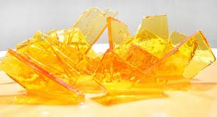

*Can we reverse the change?*

*Projects to do at home*



The activities contained in this booklet can be conducted at home if there is a responsible adult able to supervise.

Make sure to get your parent’s permission before starting or planning any of these activities. They are not compulsory.

**Materials you will need:**

* String
* Wide-mouth jar or solid glass
* White pipe cleaners
* Blue food colouring (optional)
* Boiling water
* Borax
* Small wooden rod or pencil
* Camera to document your process
* A small but deep saucepan
* wooden spoon
* stove
* a baking tray lined with silicon baking paper
* 1 cup of sugar and
* ¼ cup of water



**MAKE A CRYSTAL SNOWFLAKE**

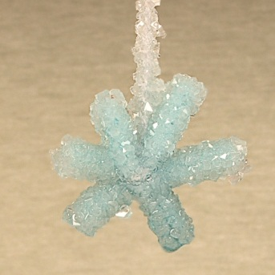

Find out how crystals are formed in this fun experiment.

You can keep your finished crystal snowflake as a great looking decoration!

** *Read the following information***

**What are crystals?**

*Crystals are made up of particles arranged in a repeating pattern that extends in all three dimensions (directions)*.

Borax is also known as sodium borate, it is usually found in the form of a white powder made up of colourless crystals that are easily dissolved in water to give a solution.

When you add the borax to the boiling water, you can dissolve more than you could if you were adding it to cold water. This is because warmer water particles move around faster and are more spread apart, allowing more room for the borax crystals to dissolve. You saw the same effect last week when you dissolved salt and sugar crystals into water.

When the solution cools, the water particles move closer together and it can't hold as much of the borax solution. Crystals begin to form on top of each other and before you know it, solid borax appears out of the solution.

This week you will use this process to make a decorative snow flake made out of borax crystals!

**Description: MCj02921160000[1]Description: MCj04247880000[1]Making crystals – experiment**

**Materials you will need:**

* String
* Wide-mouth jar or solid glass
* White pipe cleaners
* Blue food colouring (optional)
* Boiling water
* Borax
* Small wooden rod or pencil
* Camera to document your process

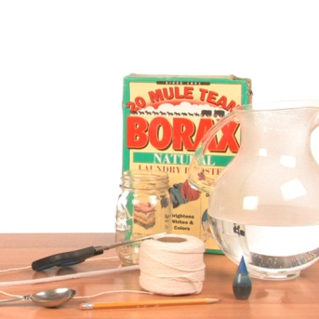

**Method:**

What precautions should you take when handling boiling water? And why?

_______________________________________________________________________________________________________________________________________________________________________________________________________________________________________

Have your camera ready to document your process as you follow the method below:

1. Grab a white pipe cleaner and cut it into three sections of the same size.

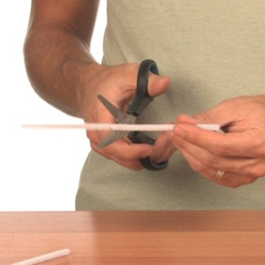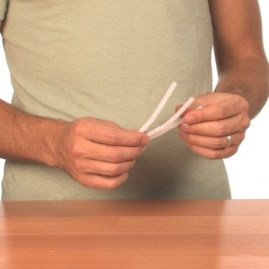

1. Twist these sections together in the centre so that you now have a shape that looks something like a six-sided star. Make sure the points of your shape are even by trimming them to the same length. Then check that the star can fit into your jar. Trim it if you need to.

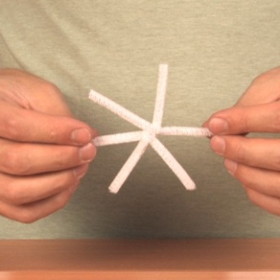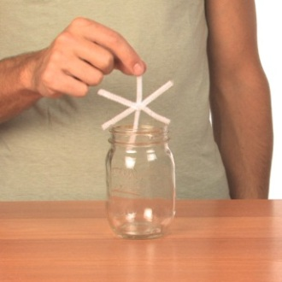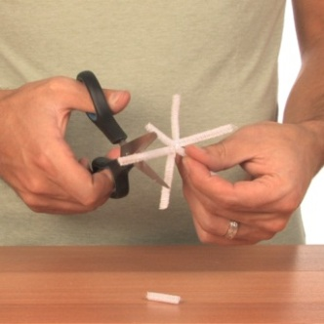

1. Take the top of one of the pipe cleaners and attach a piece of string to it. Tie the opposite end to your small wooden rod or pencil. You will use this to hang your completed snowflake.

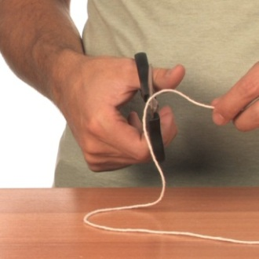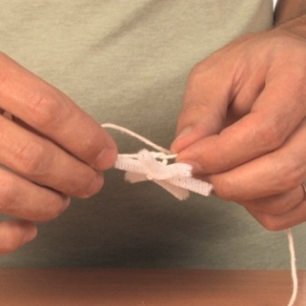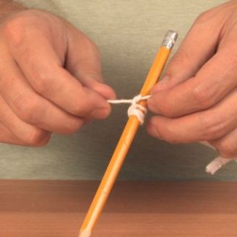

Check that the length of the string allows the star to hang half way down into the jar.

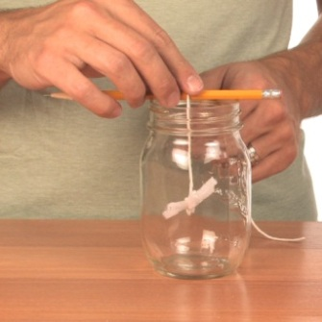

1. Carefully fill the jar with boiling water (you might want to get an adult to help with this part). Then remove the star once it is wet. Set aside for the moment.

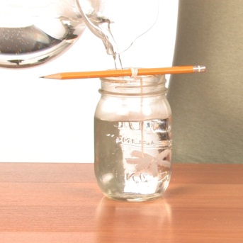

1. For **each** **cup of hot water** in the jar (how much water is in the jar will depend on the size of the jar), **add three tablespoons of borax** to the jar. Add one tablespoon of borax at a time. Stir until the mixture is dissolved but don’t worry if some of the borax settle at the base of the jar.

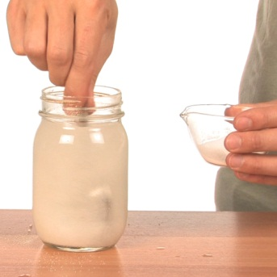

1. OPTIONAL STEP

Add some of the blue food colouring if you'd like to give your snowflake a nice bluish tinge.

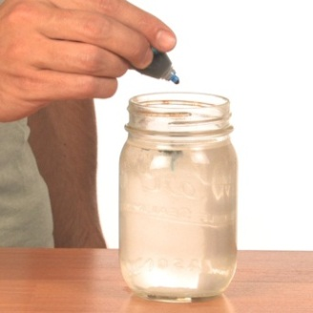

1. Put the pipe cleaner snowflake back into the jar so that the small wooden rod or pencil is resting on the edge of the jar and the snowflake is sitting freely in the borax solution.

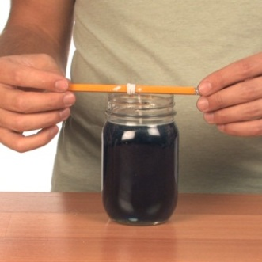

1. Leave the **snowflake overnight** undisturbed and when you return in the morning you will find the snowflake covered in crystals! The longer you leave the jar undisturbed, the larger the crystals on the star will become.

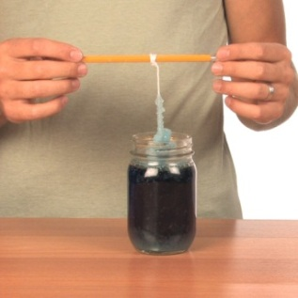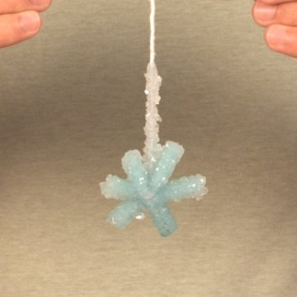

**Results**

Photographs of your process:

|  |  |
| --- | --- |
|  |  |
|  |  |
|  |  |

**Answer the following questions:**

Were you successful in making your star? ______________________

If you had trouble, what could have gone wrong?

_______________________________________________________________________________________________________________________________________________________________________________________________________________________________________

Look at the crystals of borax on the star and in the original box you used to make up the solution. Are the crystals the same size and shape? (The colour will be different if you have added some food colouring.) In what ways are they similar and different?

___________________________________________________________________________________________________________________________________________________________________________________________________________________________________________________________________________________________________________________

Explain why the borax had to be dissolved in hot water in order for the crystals to form on the pipe cleaners.

**____________________________________________________________**_______________________________________________________________________________________________________________________________________________________________________________________________________________________________________________________

**SCIENCE AND COOKING**

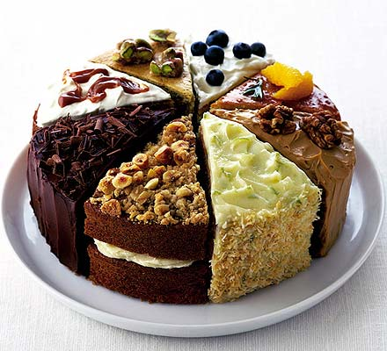

Cooking is all about science. It involves both **physical** and **chemical** changes. The term ‘chemical change’ means that somehow we have changed a substance into a completely new one. A ***chemical change cannot be reversed.***

A cake smells, looks and tastes nothing like the raw eggs, sugar, milk, butter and the flour that went into making it in the first place! *All those substances undergo chemical change in order to create a new substance called a cake.*

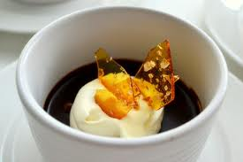This week you will see chemical change demonstrated as you make toffee by chemically changing sugar and water.

Toffee tastes great with ice cream!

**Description: MCj02921160000[1]Description: MCj04247880000[1]Making toffee – experiment**



Follow the procedure below to make toffee. You will need an adult to help you as the toffee mix gets very hot.

**Aim:**

To observe physical and chemical changes while making toffee.

**Ingredients:**

A small but deep saucepan, wooden spoon, stove, a baking tray lined with silicon baking paper, 1 cup of sugar and ¼ cup of water.

You will also need a camera to record your process and product.

**Method:**

What precautions will you take when cooking the toffee?

____________________________________________________________________________________________________________________________________________________________________________________________________________________________________________________________________________________________________________________

Have your camera ready to take photographs of the process as you follow the procedure below.

**Procedure to make toffee**

**Step 1**

Place the sugar and the water into the small saucepan.

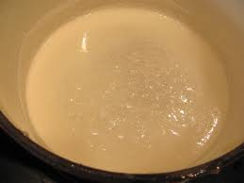

**Step 2**

Stir water and sugar in a saucepan over low heat until the sugar dissolves.

**DO NOT let it boil yet! Keep stirring until all the sugar is dissolved.**

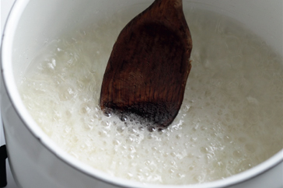

**Step 3**

To dissolve any sugar left on the side of the pan, brush down with a wet pastry brush.

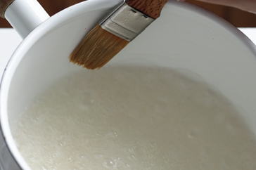

Turn up the heat now and bring it to the boil. **Do not stir it any longer.**

**Step 4**

Cook until nearly all of the mixture is a golden colour—**don’t let it become dark and burn or it will become bitter.** Remove from heat at this stage as the residual heat in the pan will continue to colour and cook toffee.

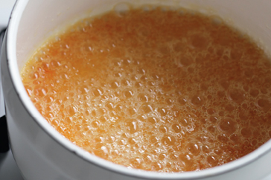

**Step 5**

Very carefully pour the liquid toffee onto the silicon paper on the baking tray, spreading it around to make a thin layer on the paper. Allow to cool.

**Step 6**

When the toffee is cool, it becomes a solid. Since it is brittle, you can crack it into shapes.

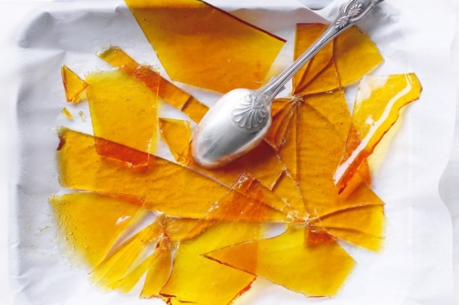

**Your results:**

Photograph of your sugar and water mixture before you heat it.

|  |
| --- |
|  |

Photograph of your sugar and water mixture as it starts to boil.

|  |
| --- |
|  |

Photograph of your toffee at the end.

|  |
| --- |
|  |

**Answer the following questions:**

Were you successful at making toffee? _________________________

If you were not, what went wrong and how do you think you could improve your method?____________________________________________________________________________________________________________________________________________________________________________________________________________________________________________________________________________________________________________

Identify which step(s) in the method involve a **physical change in state**.

__________________________________________________________________________________________________________________________________________________________

Which step(s) has a change in state that is **reversible**? _____________________________________________________________________________

Identify the step that involves a change in state that is **not** reversible. _____________________________________________________________________________

Identify which step or steps involve a **chemical change**.

_____________________________________________________________________________

Is chemical change a reversible or an irreversible change?