**English**



**Think**

**Analyse**

**Understand**

**Communicate**

***How can we use technology to communicate and collaborate?***

|  |  |  |
| --- | --- | --- |
| Description: QRDistance | Description: logomedium_black_print  © State of Victoria DEECD 2015 | **G Course Code**  **6107** |

**Only for use for the purpose of education for the student(s) provided with the materials by DECV. Not to be reproduced, communicated or otherwise used except as permitted by the Copyright Act 1968 (Cth).**

**English Introduction**

Each module contains activities for your child to complete over two weeks.

About **2 hours per day** is allocated to English activities. These activities may consist of:

|  |  |  |
| --- | --- | --- |
| ***Discussing: Speaking & Listening*** | ***Thinking, Analysing, Evaluating*** | ***Reading*** |
| ***Writing*** |  | ***Researching*** |
| ***Vocabulary*** | ***Viewing / Observing*** |
| ***Spelling*** | ***Punctuation*** | ***Grammar*** |

When students use English skills in other subjects, such as Science or Humanities, they are using their English skills in practical ways. Using English skills in other learning areas is sometimes called “Integrated Studies” or “English Across the Curriculum”.

Teachers will expect to see your student applying these English skills in all learning areas.



Independent reading time is a part of the daily English lesson. Students are expected to read books, newspapers or magazines for at least 30 minutes every day. Travelling students may include tourist brochures and other literature that occurs in their travels.

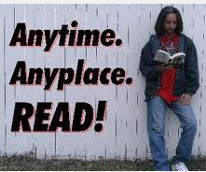

Each Module will have a simple sheet to record your independent reading activities. Your child’s teacher will use this information, in conjunction with the regular English work, to report on your child’s reading.

The completed sheet should be signed and returned to your teacher. By seeing your completed reading sheet, teachers will be able to track and monitor your child’s reading progress. This will give teachers information to put into your school report.

|  |  |  |  |  |  |  |  |  |  |
| --- | --- | --- | --- | --- | --- | --- | --- | --- | --- |
| **Reading Log Week 1: Color** or tick the minutes you read each day: | | | **Minutes I read for each day:** | | | | | | |
| **School** | | | | **Personal** | | |
| **Good** | | **Excellent** | | | **Superior** | |
| **Day** | **What Did You Read?** | **Interest Meter.** | **15 min** | **30 nm** | **45 min** | **1hr** | | **15 min** | **30 min** |
| **1** |  |  |  |  |  |  | |  |  |
| **2** |  |  |  |  |  |  | |  |  |
| **3** |  |  |  |  |  |  | |  |  |
| **4** |  |  |  |  |  |  | |  |  |
| **5** |  |  |  |  |  |  | |  |  |

Dear Reader,

Tick or highlight the statement/s that best describe your reading this week.

\*I don’t like to read. \*I didn’t read much at all. \*It was difficult to find the time to read. \*I sometimes struggle to understand what I read.

\*I enjoyed reading this week. \*I couldn’t stop reading. \*I was able to talk about what I read. \*I am able to work out the meaning of new words.

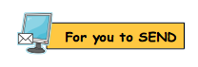I verify *(student)* ……………………………………………………………’s  **ID**: ……………………………… **Reading Record**.

**Supervisor’s Signature**:……………………………………………………………………..…

*Please note: these comments will enable teachers to assess your student’s reading progress for writing reports, so it is very important to complete and submit this page.*

|  |  |  |  |  |  |  |  |  |  |
| --- | --- | --- | --- | --- | --- | --- | --- | --- | --- |
| **Reading Log Week 2: Color** or tick the minutes you read each day: | | | **Minutes I read for each day:** | | | | | | |
| **School** | | | | **Personal** | | |
| **Good** | | **Excellent** | | | **Superior** | |
| **Day** | **What Did You Read?** | **Interest Meter.** | **15 min** | **30 nm** | **45 min** | **1hr** | | **15 min** | **30 min** |
| **6** |  |  |  |  |  |  | |  |  |
| **7** |  |  |  |  |  |  | |  |  |
| **8** |  |  |  |  |  |  | |  |  |
| **9** |  |  |  |  |  |  | |  |  |
| **10** |  |  |  |  |  |  | |  |  |

Dear Reader,

Tick or highlight the statement/s that best describe your reading this week.

\*I don’t like to read. \*I didn’t read much at all. \*It was difficult to find the time to read. \*I sometimes struggle to understand what I read.

\*I enjoyed reading this week. \*I couldn’t stop reading. \*I was able to talk about what I read. \*I am able to work out the meaning of new words.



I verify *(student)* …………………………………………………….…’s  **ID**: ……………………………………… **Reading Record**.

**Supervisor’s Signature**:……………………………………………………………….……..…

*Please note: these comments will enable teachers to assess your student’s reading progress for writing reports, so it is very important to complete and submit this*

*page*

**DAY 1**

**Learning Intention:**

Use a range of reading strategies to investigate Wikis and how to use them.

**What is a wiki?**

Use your computer or other technology device. Use the Internet to find out about Wikis.

Type in ‘wiki’ into your search engine and start searching.

|  |  |  |
| --- | --- | --- |
| What is a wiki?  Jot notes in the boxes below and/or do some illustrations. | | |
|  |  |  |
|  |  |  |
| Wiki questions I ask or would like to investigate. | | |
|  | | |
|  | | |
|  | | |
|  | | |
|  | | |

****

*Please answer the questions on the next page.*

Which device/s did you use to search the Internet?

………………………………………………………………………………………………………………………………………….

………………………………………………………………………………………………………………………………………….

Which search engines did you use to find out about Wikis?

………………………………………………………………………………………………………………………………………….

………………………………………………………………………………………………………………………………………….

Recommend three interesting websites that told you about Wikis.

………………………………………………………………………………………………………………………………………….

………………………………………………………………………………………………………………………………………….

Did you find the same information as I did?

|  |  |
| --- | --- |
|  |  |
| <http://www.wikiforkids.ws> | <http://en.wikipedia.org/wiki/Wikipedia:Introduction>  *This space has a video tutorial you can watch.* |
|  | https://en.wikipedia.org/wiki/Piki |

There are many different Wiki spaces and Wikipedias for different purposes.

This is the home page of one Wikipedia. Choose a Wikipedia or a Wiki space and explore it for a few minutes to find out about what a Wiki is.

If you find this Wiki, you will be able to see the video tutorial which is on the wiki:

<http://en.wikipedia.org/wiki/Wikipedia:Introduction>

With your supervisor, discuss what each element on a wiki page is. Please look at different wikis.



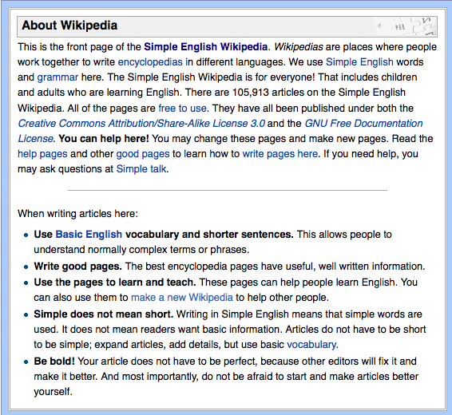

Tick the elements you and your supervisor discussed:

* search bar – where you type the words for your search.
* search icon / button that activates your search.
* ‘links” (in blue text). These links take you to other pages with more information about that topic.
* speaker icon that opens a sound file
* phonetic help to pronounce words
* numbers (in Wikipedia pages) – these are ‘references’ which tell you other places where the information written is verifies.
* Please tell me about any other wiki idea you found out about.

Macintosh HD:Users:all:Desktop:DECV Logo.jpg

ID: …………………….. Name:………………………………..……Date………………

You need to **share your knowledge** of a Wikispace. Imagine you are explaining Wikis to your grandparents – who still use a landline telephone, read books and send letters with stamps on them.

In your own words, explain to your grandparents:

|  |  |
| --- | --- |
| * *what a wiki is and its purpose* | * *some positive things about a wiki* |
| * *what you can do with a Wiki* | * *some things to be wary about with a Wiki* |
| * *who can use a wiki,* | * *suggest some interesting Wiki spaces* |
| * *suggest some good ways to learn about Wikis* | * *any other interesting ideas about a Wiki.* |

|  |
| --- |
| What grandparents need to know about Wikis\*  *\* We know that there are grandparents out there who are better at Wikis than we are!* |
|  |
|  |
|  |
|  |
|  |
|  |
|  |
|  |
|  |
|  |
|  |
|  |
|  |
|  |

|  |
| --- |
|  |
|  |
|  |
|  |
|  |
|  |
|  |
|  |
|  |
|  |
|  |
|  |
|  |
|  |
|  |
|  |
|  |
|  |
|  |
|  |
|  |
|  |
|  |
|  |
|  |

****

**DAY 2**

**Wiki Words.** These words are associated with internet, wikis and other online environments. Say each word clearly. Discuss the meaning of unfamiliar words.

|  |  |
| --- | --- |
| browser | hypertext |
| click | World Wide Web |
| collaborate | avatar |
| connect | internet |
| cybersafety | format |
| cyberspace | address |
| edit | embedded |
| editing | formatting |
| embed | communicate |
| homepage | download |
| modem | link |
| search | discuss |
| search engine | communication |
| upload | browsing |
| username | password |
| web page | collaboration |
| wiki | collaboratively |
| Wikipedia | discussion |
| device | home page |
| wikispaces | widget |

Dear Supervisor: How well did your student read these words – please circle all that applies:

*read confidently; learnt a few new words, needed some help, needed much help*

*Find the words from the list that match the meanings:*

|  |  |
| --- | --- |
| A series of interconnected computers and databases around the world – |  |
| A piece of equipment that is used to send information from a computer through a telephone system |  |
| “WWW” is part of an internet address that stands for |  |
| To press the button on a computer mouse or track pad - |  |
| To organize and design the words on a page or written document - |  |
| A computer program which allows you to look at pages on the internet - |  |
| A part of a website that can be read on a computer screen - |  |
| The first page that you can see when you look at a website - |  |
| To electronically copy computer programs or information from another place - |  |
| A connection between documents on areas on the internet - |  |
|  |  |

*Please see the end of this module for the answers.*

|  |
| --- |
| **Learning Intention:**  learn how to join your class wikispace  investigate what your own wiki will look like. |

If you had a collaborative space with other students, what would you do with it? Write your ideas here:

|  |
| --- |
|  |
|  |
|  |
|  |
|  |
|  |
|  |

Did you include ideas such as:

* upload photos of holidays, Lego constructions or craft projects
* chat about the latest movies or books
* ask for some ideas to write a story
* tell about your pets, interests or hobbies
* find out who has the same interests as you do

**Making a wiki.**

In your research yesterday, did you investigate how to actually join a wikispace or make one yourself?

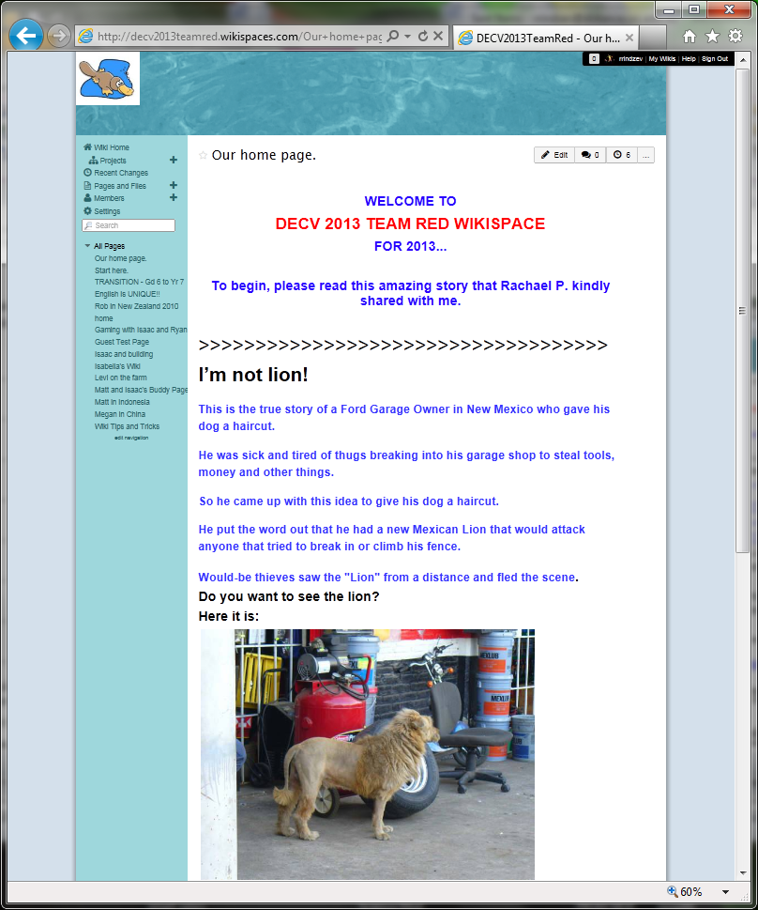In this Module you will have the

opportunity to make your own page in the class wikispace.

A wikispace has made for students doing RED English. Here are instructions about how you can join this wikispace:

1. contact your teacher by email or by phone and ask that you want to join this wikispace.
2. your teacher will give you details about how to log into the wikispace.
3. once you have logged in, you will need to learn how to make, edit and format your own wiki page in the wikispace.
4. however, before you start your own, spend time today looking at the following – this was a

wikispace done by students at

the DECV in 2013.

**Go to**: [www.decv2013teamred.wikispaces.com](http://www.decv2013teamred.wikispaces.com)

Username: TRwiki.GUEST

Password: TRwiki.GUEST

Look at each of the pages in that Wiki. This is a space that **belongs to everyone**, so please do not change or edit it. You are welcome to make comments in the discussion posts if you wish

Use the next page to plan your ideas for your own Wiki page in the Team Red wikispace.

Why not use this Wiki as an opportunity to introduce yourself to our class?

What do you want to tell others about yourself?

|  |  |  |
| --- | --- | --- |
| **Wiki PLANNER** | | |
| ***Suggested TITLE*** *for your Wiki page* |  | |
| *Suggested* ***FORMAT or STYLE*** |  | |
| *What ICT (TECHNOLOGY) is needed?* |  | |
| *What* ***INFORMATION or PHOTOS or VIDEO*** *clips are needed?* | **ITEM** | **Where to get it.** |
|  |  |
|  |  |
|  |  |
|  |  |
| Think about the elements you can put onto your Wiki page. What will you include? How will you organise your information? What will your page look like? | | |
|  | |  |
|  | |  |

Use some time now to explore a range of Wiki spaces to see what others have done.

Look at the 2013 Team Red Wikispace again and add a comment.

**Go to**: [www.decv2013teamred.wikispaces.com](http://www.decv2013teamred.wikispaces.com)

Username: TRwiki.GUEST

Password: TRwiki.GUEST

Now, contact your teacher who will set you up with a Wiki account so you can create your **own page in Team Red Wiki space.**

Reading



**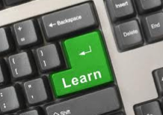**

Why not find and read some interesting Wiki spaces?

Read something for at least **30 minutes everyday**.

Complete your **Reading Lo**g at the front of this booklet.

Enjoy reading your book.

**DAY 3 & 4**

|  |
| --- |
| **Learning Intention:**   * Find your class wikispace * Design and produce your own wiki. |

**What am I going to do for my wiki page?**

Today and tomorrow you can get started on your own wiki page in your class’s wikispace.

Follow the instructions you received from your teacher to log into your class’s wikispace.

(if you have not received them yet, please contact your teacher)

Go to the Home page first and read or listen to what you need to do next.

Use the planner from yesterday to get you started.

Follow the instructions on the next page in this Module.

Find a video tutorial about creating your Wiki Page. This might give you some ideas.

|  |
| --- |
|  |
| <http://en.wikipedia.org/wiki/Wikipedia:Introduction>  *This space has a video tutorial you can watch.* |

**CREATING YOUR OWN WIKI PAGE.**

Use your Wiki page to tell everyone in our class about yourself.

Our wikispace is a controlled space and only you, your class and your teacher can look access wikispace.

The best way to learn is to ‘check it out’ then ‘do it’. It’s OK to get it wrong a few times – so be brave and create the best space you can.

When you have clicked “new page” you can upload:

* pictures,
* video clips,
* word documents,
* PowerPoint,
* links to other sites
* voice podcasts
* calendars,
* maps
* and many “widgets”

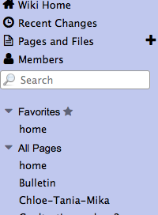

If you are not sure how to upload something go to the HELP part of the wikispace and learn from there.

If you are still having trouble, you can contact your teacher through the DISCUSSION tab on the BULLETIN page. Find the Bulletin on the left had panel of the home page.

Please keep all things about wikispaces in the Discussion tabs in wikispaces. **Please do not email your wikispace enquiries**.

Are you ready to add your own pages to the Team Red Wiki space?

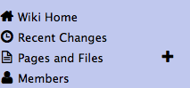

Create your new page by pressing the **Page and Files** tag on the left and clicking the cross that is next to it.

You will get a panel to name your new page. Think of a good name for your space, type it in the top line, and click ‘create.”

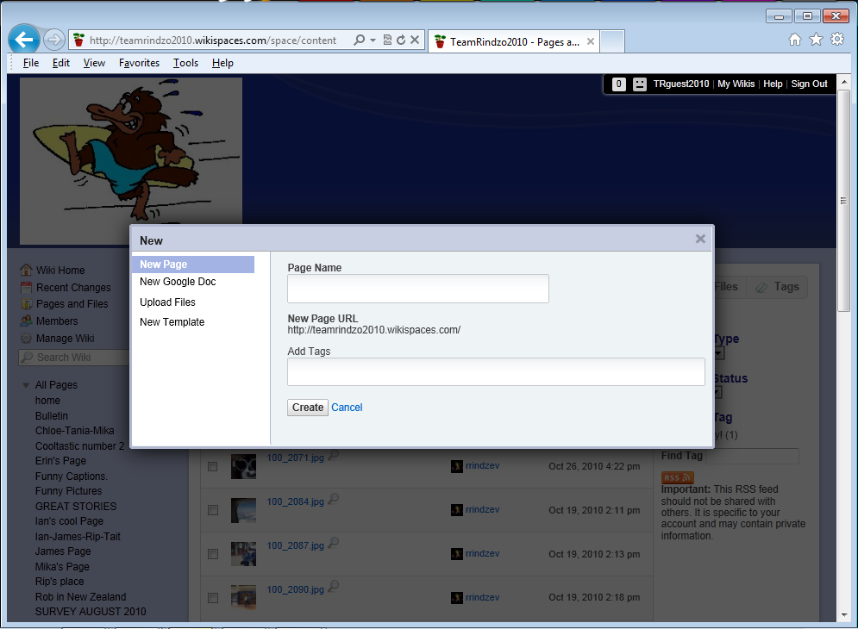

Type in your **Page Name** Don’t worry about the Add Tags bit yet. Then click **Create**.

Your own Wiki Page should appear.

Look in the top right hand corner of your page for the “Edit” mode. You can only work on your page when you have activated “Edit”



Clicking on “Edit” gives you a menu bar. Use the items in this menu to add or delete files on your page. Scrolling and pausing your cursor over each icon will tell you what it is for,

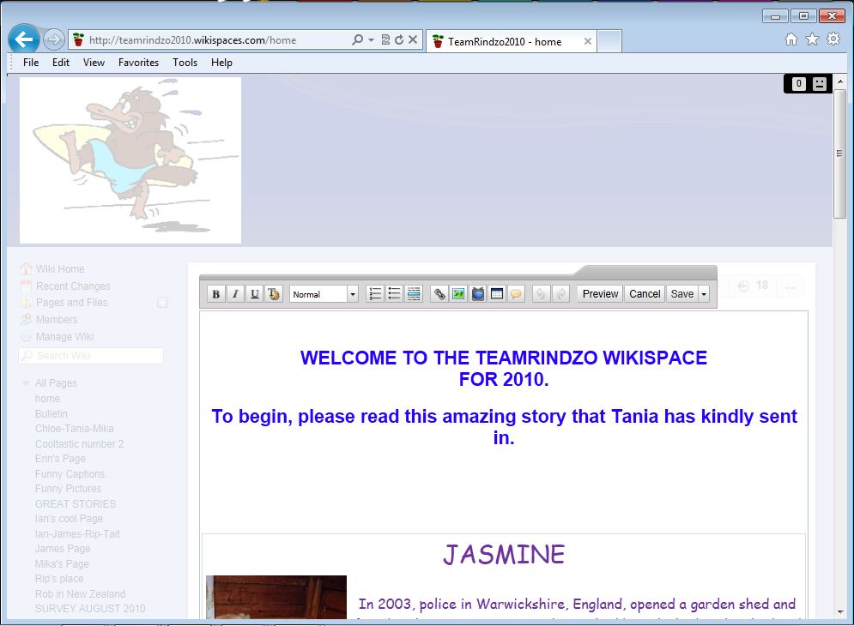

Experiment with your new page. Use the icons to se what each one does. If you don’t like something, or you are muddled, you can click on the “undo” icon.

This icon appears only after you have added or saved something to the page. One click will undo your last action.



Practise adding text, add links, insert images (upload these from your computer) or files.

Each icon has a sub menu for you to use.

Your work needs to be SAVED to be visible on the page.



IF you need to change something, click EDIT again.

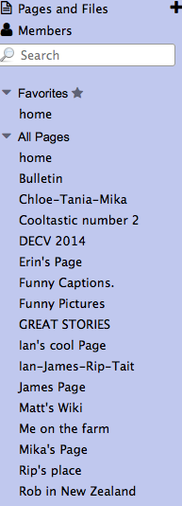



Look at the tabs on the left. Read what other students in our class have been doing in their pages. Look for new pages as well.  
The Number 1 Rule in wikispaces: **Think twice! Be nice!** Be positive. Sloppy comments will reflect poorly on YOU, so make sure that you add things you are proud of. **If you think something might be ‘not quite right’, don’t add it.** Please let your teacher know when you have added your wiki space.

**DAY 5**

|  |
| --- |
| **Learning Intention:**   * Learn how to make an avatar * Show you know how to spell your wiki words correctly. |

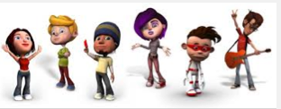

**AVATAR**

Explain to your supervisor what you think an ‘avatar’ is.

You might think you are very modern and up to date using the word ‘avatar’. “Avatar” is a word that belongs to ancient Hindu mythology. When Gods came out of the skies to Earth, they came in a form that was not their own. They may have come as a peasant, or as an animal – not as themselves.

On line, many people do not want to put photos of themselves, so they create “avatars” to represent themselves on their wiki space.

Create your own avatar and add it to your page in our wikispace.

Visit this web page to create your own avatar:

<http://www.voki.com>

Make sure you do this activity with your Supervisor. You will need an email address to create your avatar.

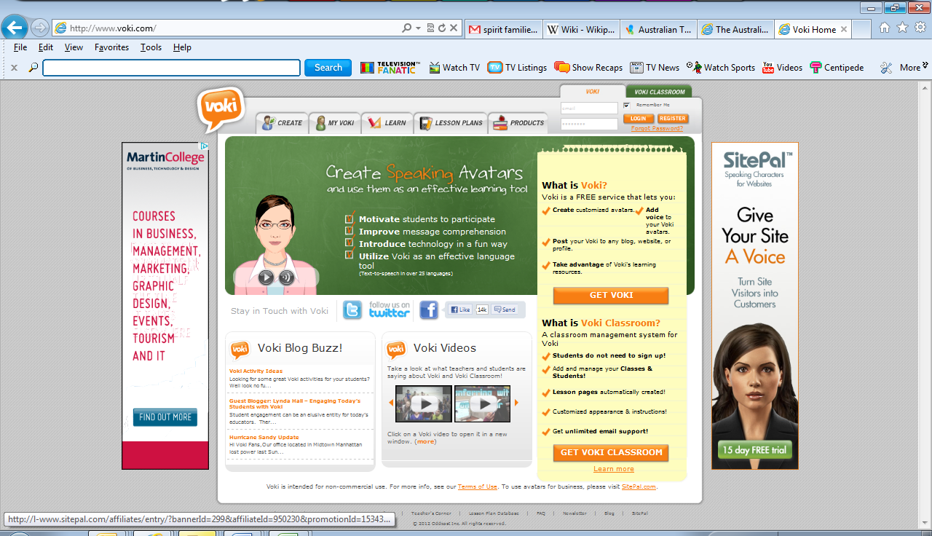

Go to the Login button

This screen will appear:

Click the **GET VOKI** tab and the registration screen will appear.

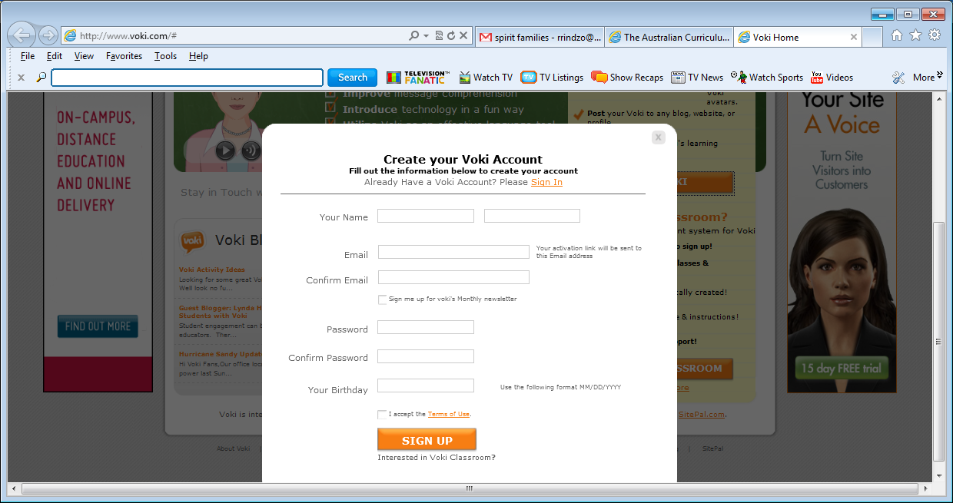

Complete all the details. Use your own email address and remember your password!

Tick the **I accept the terms of Use** button and then click the **SIGN UP** button.

When you have joined voki.com, you will receive a welcome email. Click the link in the email to activate your account. Return to voki.com and create your avatar.

When you are happy with your avatar, add it to your Wiki space.

Instructions for creating an avatar:

* While in the “create Voki” space, choose the **Publish your voki** option.
* Choose the size as medium.
* Then copy the **Embed code**.
* Now go to [www.wikispaces.com](http://www.wikispaces.com), sign in and go to your class’s wiki
* Choose the **Edit** toolbar and choose the **Embed Widget** icon (the little TV)
* Choose **Other** from bottom of the second list

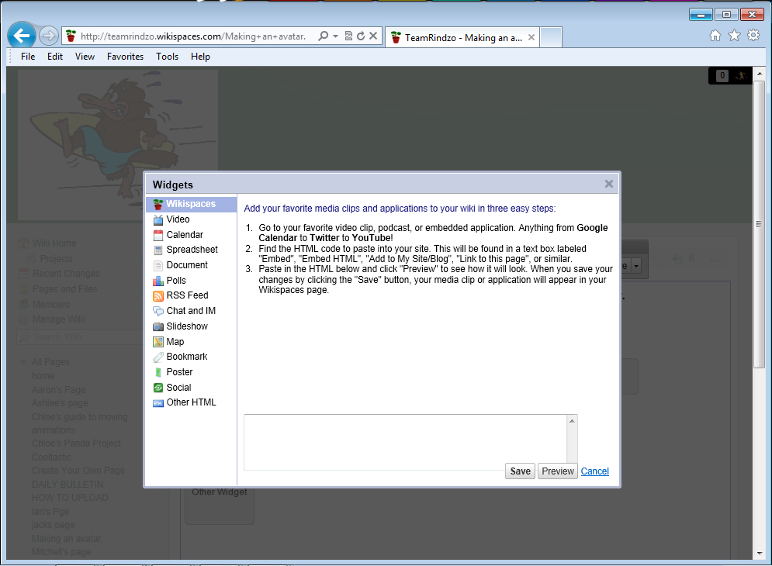

* Paste the **Embed Code** you copied from Voki.com in the space provided.
* Click the **Save** tab.

If all went well you should have an avatar in your wiki. Congratulations!

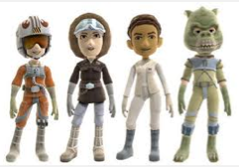

**Words** – vocabulary and spelling



**Spelling Test**

Your supervisor will test you on 20 of your spelling words for Week 1

Supervisors please encourage your student to review his or her own work and identify their own errors. Do not use a cross for an incorrect word – instead highlight or underline the **error** and ask the student to write the word correctly.

|  |  |
| --- | --- |
|  |  |
|  |  |
|  |  |
|  |  |
|  |  |
|  |  |
|  |  |
|  |  |
|  |  |
|  |  |

**To the student:** Congratulations if you spelt every word correctly!

If you wrote some words incorrectly, look at the word and try to work out why you made that error – tick the statements that apply to you.

*•I was careless. • I didn’t listen to the word properly. •It sounded like something else.*

*•I didn’t understand. •I got it mixed up with another word. • I didn’t pay attention.*

**DAY 6**

|  |
| --- |
| **Learning Intention:**  Continue to develop your own inspiring, fun to read wiki page. |

You will find this very useful and informative You Tube video at the links below. You may need to watch the video a few times to capture the main ideas.

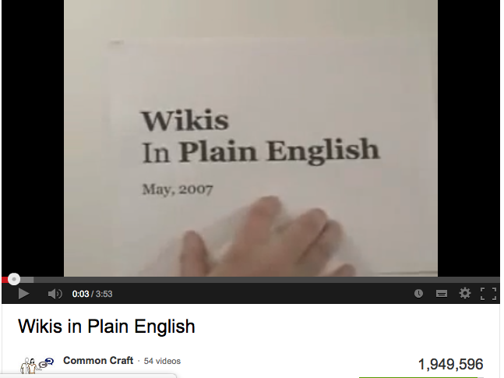

<http://tinyurl.com/decv6red> or

<http://www.youtube.com/watch?v=-dnL00TdmLY&feature=fvw>

List some things that you learnt from watching “Wikis in Plain English”.

…………………………………………………………………………………………………………………………………………………

…………………………………………………………………………………………………………………………………………………

…………………………………………………………………………………………………………………………………………………

…………………………………………………………………………………………………………………………………………………

****………………………………………………………………………………………………………………………………………………….

**Words** – vocabulary and spelling



There are several patterns in this week’s words to learn.

Can you see the common letter patterns in the words?

Use the flash cards to organise the words into their groups.

|  |  |
| --- | --- |
| symphony | thorough |
| polygraph | physician |
| photograph | pharmacy |
| pharmaceutical | pharaoh |
| phantom | hyphenated |
| homograph | holograph |
| graphite | geography |
| calligraphy | catastrophic |
| autobiography | biography |
| although | atmospheric |

These common patterns in this week’s words are:

…………………………………………………………………………………………………………………………………………………

…………………………………………………………………………………………………………………………………………………

…………………………………………………………………………………………………………………………………………………

…………………………………………………………………………………………………………………………………………………

Say the words carefully. Listen for the syllables. Rewrite the words with their syllables.

|  |  |
| --- | --- |
| although | al – though |
| atmospheric | at – mos – phe -ric |
| autobiography |  |
| biography |  |
| calligraphy |  |
| catastrophic |  |
| geography |  |
| graphite |  |
| holograph |  |
| homograph |  |
| hyphenated |  |
| phantom |  |
| pharaoh |  |
| pharmaceutical |  |
| pharmacy |  |
| photograph |  |
| physician |  |
| polygraph |  |
| symphony |  |
| thorough |  |

Go to this website: http://www.eduplace.com/kids/hmsv/smg/index.html

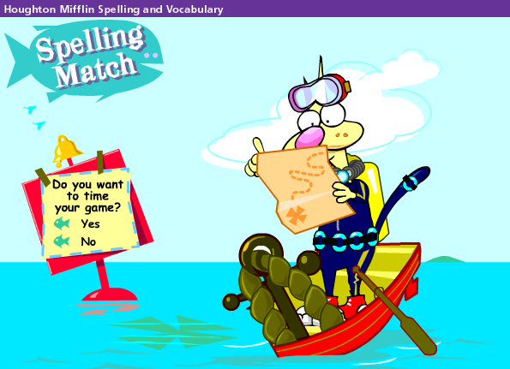 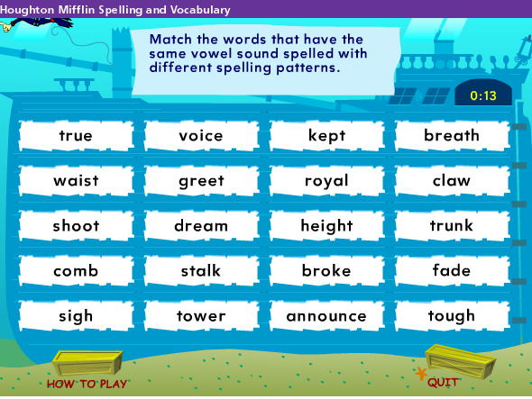

Test your skills in matching syllables to create words.

If you do not have Internet, play some Hangman Games with the list words. All you need is pen and paper. Make sure you get the words right so that this poor stick figure does not meet a sad end!

**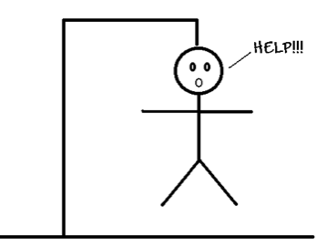**

**DAY 7 & 8**

|  |
| --- |
| **Learning Intention:**  Today you will learn how to:   * collaborate with others in the wikispace * design a buddy page in the wikispace. |

**How can I use wikispaces to collaborate with others?**

Look through the DECV Wikispace. Find someone with whom you might have something in common: perhaps you like to read the same books, play the same games or you have the same hobbies. For example, if you like cooking, making things, building with Lego, playing Minecraft, working with computers– see if there is someone with a wikipage with these interests.

If you find someone who shares your interests, go to the Discussion Post on the Discussion Post on their page and ask them to work with you.

Check your own **Discussion**

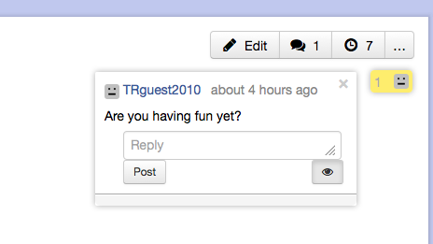

post for anyone who is also requesting to make you their ‘wiki partner’. Click on the **speech bubble** to add to a discussion. Be patient and wait for the text window to load.

Use the **Discussion** posts to share your ideas create

your shared Wiki Space.

There are TWO places you can comment in. You can also make comments directly on the page using the **Edit** function.

Here is a guideline to help you create a collaborative wiki space.

Using your self evaluation skills, indicate how well you achieved these goals with your Wiki work. **H** = High; **M** = Medium; **L** = Low.

|  |  |  |  |  |
| --- | --- | --- | --- | --- |
| **ELEMENT** | **Exemplary achievement is demonstrated by:** | **H** | **M** | **L** |
| **Content** | Including interesting ideas which capture interest. |  |  |  |
| Explaining ideas clearly and concisely in a logical way with effective supporting evidence. |  |  |  |
| Presenting all information in a style that will appeal to the intended audience and meet the purpose of the Wiki. |  |  |  |
| **Group/**  **Partner Collaboration** | Evidence of contributing equally with other group members in researching, writing, and editing information to the Wiki Space. |  |  |  |
| Meeting goals and deadlines. |  |  |  |
| Exhibiting appropriate wiki etiquette when editing and respects the work of others. |  |  |  |
| **Initiative** | Capacity to follow instructions and show initiative when creating the Wiki. |  |  |  |
| **Organization** | Using a consistent plan for the content: grouping related information, define specialised vocabulary and/or provides a table of contents. |  |  |  |
| **Text Layout** | Making frequent and effective use of headings, fonts, bullet points and white space to make it look nice and make it easy to read the information. |  |  |  |
| **Hyperlinks** | Including links to websites or documents that improve the information presented. |  |  |  |
| Connecting to relevant, up-to-date resources. |  |  |  |
| **Graphics and Multimedia** | Selecting high quality graphics and multimedia when appropriate. |  |  |  |
| Acknowledging all image and multimedia sources with captions or annotations. |  |  |  |
| **Citation** | Identifying the sources of materials that are used from other sites or places. |  |  |  |
| Including information that can be verified by data or other sources. |  |  |  |
| **Writing Mechanics** | Editing the text with no errors in grammar, capitalization, punctuation, and spelling. |  |  |  |

**DAY 9**

**Learning Intention:**

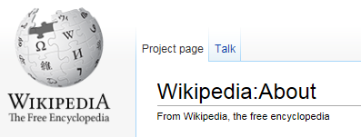Work collaboratively, use reading strategies to understand a challenging text.

**ABOUT WIKIPEDIA**

*A note to supervisors: this text is very challenging.*

*Your student might need your support to find the main ideas.*

This activity is a challenge for Year 6 – but we will work together to help you understand a little bit more about the World of “Wiki”. *Please work with your supervisor to develop strategies to understand this difficult text.*

This text is copied directly from: <http://en.wikipedia.org/wiki/Wikipedia:About> . Use this clue to help you complete Activity 1.

**Activity 1:**

**Looking at the title** (above) and without looking at the next few pages, **PREDICT** what you might read about in this text. Think about the ideas you are already familiar with.

Write your ideas here, or discuss your ideas with your supervisor.

**Answer the question:** *“What might I read about in this text?”* You might not be able to write something down in every box.

|  |  |  |
| --- | --- | --- |
| **What?** | **When?** | **Where?** |
| **Why?** | **Who?** | **How?** |

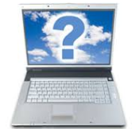**Why am I doing this?**

*Questioning is always a good strategy to help you understand unfamiliar text. In learning, asking a good question is better than providing a good answer.*

**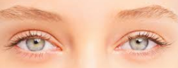**

**Activity 2:**

Without actually READING each word, use your eyes to **SCAN** the text below.

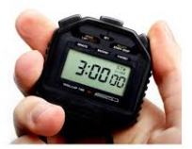

**Set a timer for 3 minutes and use that time to complete your scan of the text.**

You may scan the text as many times as you like within 3 minutes.

Please answer the questions for **Activity 2.**



***Why am I doing this?***

*You are getting a sense of what is in the text and what it might be about.*

*You are* ***preparing your brain*** *to deal with the complex information in this article.*

*When you ‘scan,’ ignore the smaller words like “a”, “the” “is” etc. These words* ***are important in reading*** *for meaning, but you don’t need to focus on them for scanning a text. You need to get a sense of what will be in your reading. This strategy is called ‘prediction’.*

**Activity 3:**

With a highlighter, pencil or sticky notes, mark **words** that are **challenging** for you to read or words you **might not understand**. You do not need to read the text closely yet – just find the words that might stop you from understanding the text.

Find the four most challenging unfamiliar words. Read the section of text with your Supervisor. Can you make sense of the text without knowing the meaning of the word?

*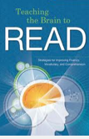***With your supervisor, or with your dictionary, find and discuss the meaning of some of the unfamiliar words.**

**Why am I doing this?**

*By finding out the meanings of unfamiliar words and phrases in the text, you are helping your brain to get ready to make sense of what the words mean. This will help you understand the text much better.*

Look over the next two pages to see what I think might be difficult words for a Year 6 reader. Did you highlight some of the same words?

You are on your own now! Take your time to read and understand the main ideas about Wikipedia. You can read quietly to yourself or read aloud to your supervisor. You are reading to find five interesting facts about Wikipedia.

**ABOUT WIKIPEDIA**

Wikipedia" is a portmanteau of the words *wiki* (a technology for creating collaborative websites, from the Hawaiian word *wiki*, meaning "quick") and *encyclopedia*. Wikipedia's articles provide links designed to guide the user to related pages with additional information.

Wikipedia is written collaboratively by largely anonymous Internet volunteers who write without pay. Anyone with Internet access can write and make changes to Wikipedia articles, except in limited cases where editing is restricted to prevent disruption or vandalism. Users can contribute anonymously, under a pseudonym, or, if they choose to, with their real identity.

The fundamental principles by which Wikipedia operates are the five pillars. The Wikipedia community has developed many policies and guidelines to improve the encyclopedia; however, it is not a formal requirement to be familiar with them before contributing.

Since its creation in 2001, Wikipedia has grown rapidly into one of the largest reference websites, attracting 470 million unique visitors monthly as of February 2012.[[1]](http://en.wikipedia.org/wiki/Wikipedia:About#cite_note-1) There are more than 77,000 active contributors working on more than 22,000,000 articles in 285 languages. As of today, there are 4,368,629 articles in English. Every day, hundreds of thousands of visitors from around the world collectively make tens of thousands of edits and create thousands of new articles to augment the knowledge held by the Wikipedia encyclopedia. (See the statistics page for more information.)

People of all ages, cultures and backgrounds can add or edit article prose, references, images and other media here. What is contributed is more important than the expertise or qualifications of the contributor.

What will remain depends upon whether the content is free of copyright restrictions and contentious material about living people, and whether it fits within Wikipedia's policies, including being verifiable against a published reliable source, thereby excluding editors' opinions and beliefs and unreviewed research. Contributions cannot damage Wikipedia because the software allows easy reversal of mistakes and many experienced editors are watching to help ensure that edits are cumulative improvements. Begin by simply clicking the *Edit* link at the top of any editable page!

Wikipedia is a live collaboration differing from paper-based reference sources in important ways. Unlike printed encyclopedias, Wikipedia is continually created and updated, with articles on historic events appearing within minutes, rather than months or years. Older articles tend to be more comprehensive and balanced; newer articles may contain misinformation, unencyclopedic content, or vandalism. Awareness of this helps the reader to obtain valid information and avoid recently added misinformation (see *Wikipedia:Researching with Wikipedia*).

\* \* \* \* \* \* \* \* \* \* \* \* \* \* \* \* \* \* \* \* \* \* \* \* \* \* \* \* \* \* \* \* \* \* \* \* \* \* \* \* \* \* \* \* \* \* \* \* \* \* \* \* \* \* \*

**Activity 1 Ideas:**

Before you start to read, did you think about any of these ideas?

|  |  |  |
| --- | --- | --- |
| * Wikipedia | * What is Wikipedia? | * Who started it? |
| * How did it get started? | * Who looks after Wikipedia | * When did Wikipedia start? |
| * Why do we have Wikipedia? | * internet | * computers |
| * World Wide Web | * Online | * information |
| * search engines | * links | * learning |

**Activity 2: Did you notice these things about the text:**

|  |  |
| --- | --- |
| * There is a lot of text. | * There is underlined, blue text. |
| * There are a few paragraphs. | * Some words are not familiar. |
| * I can recognise quite a few words. | * There are a few big words in the text. |
| * There are words in brackets | * Some words are in quotation marks. |

**Activity 3: Unfamiliar Words**

* Did you highlight any of these words?
* Put a line through the ones you can say and you know the meaning of.
* Discuss some of the words with your supervisor to work out what they mean.
* Use a dictionary (book or on line).
* Find a **SYNONYM** for some of the more challenging words.

|  |  |  |  |
| --- | --- | --- | --- |
| *access* | *largely* | *cumulative* | *restrictions* |
| *additional* | *material* | *designed* | *reversal* |
| *anonymous* | *media* | *disruption* | *simply editable* |
| [*anonymously*](http://en.wikipedia.org/wiki/Wikipedia:IPs_are_human_too)*,* | *cultures* | *editors* | *software* |
| *augment* | *misinformation,* | [*encyclopedia*](http://en.wikipedia.org/wiki/Encyclopedia) | *sources* |
| *awareness* | [*opinions*](http://en.wikipedia.org/wiki/Wikipedia:Neutral_point_of_view) |  | *statistics* |
| *balanced* | [*guidelines*](http://en.wikipedia.org/wiki/Wikipedia:Policies_and_guidelines) | *excluding* | *technology* |
| *restricted* | [*policies*](http://en.wikipedia.org/wiki/Wikipedia:Editing_policy)*,* | *experienced* | *thereby* |
| *collaboration* | [*portmanteau*](http://en.wikipedia.org/wiki/Portmanteau) | *familiar* | *unencyclopedic* |
| *collaborative* | *principles* | [*five pillars*](http://en.wikipedia.org/wiki/Wikipedia:Five_pillars) | *unique* |
| [*collaboratively*](http://en.wikipedia.org/wiki/Collaborative_writing) | *prose,* | *formal* | [*unreviewed*](http://en.wikipedia.org/wiki/Wikipedia:Original_research) |
| *collectively* | *pseudonym* | *fundamental* | *valid* |
| *comprehensive* | *published* | [*Hawaiian*](http://en.wikipedia.org/wiki/Hawaiian_language) | *vandalism* |
| *content,* | *qualifications* | *historic* | *creation* |
| *contentious* | *rapidly* | *identity* | [*verifiable*](http://en.wikipedia.org/wiki/Wikipedia:Verifiable) |
| *contribute* | *reference* | *images* | [*volunteers*](http://en.wikipedia.org/wiki/Wikipedia:Wikipedians) |
| *contributing* | [*reliable source*](http://en.wikipedia.org/wiki/Wikipedia:Reliable_source)*,* | *important* | *Wikipedia* |
| *contributor* | *requirement* | *improvements* | *policies* |
| [*copyright*](http://en.wikipedia.org/wiki/Wikipedia:Copyright_violations) | *research* | *information* | *contributors* |

Put **five words** from the above list into each category:

|  |  |  |
| --- | --- | --- |
| **Unusual words** | **Words with suffixes** | **Words I like:** |
|  |  |  |
|  |  |  |
|  |  |  |
|  |  |  |
|  |  |  |

Have you understood what you have read? Based on your reading, answer **True** or **False**. *You can find the answers at the end of the Module.*

*\*\*\*\*\*\*\*\*\*\*\*\*\*\*\*\*\*\*\*\*\*\*\*\*\*\*\*\*\*\*\*\*\*\*\*\*\*\*\*\*\*\*\*\*\*\*\*\*\*\*\*\*\*\*\*\*\*\*\*\*\*\*\*\*\*\*\*\*\*\*\*\*\*\*\*\*\*\*\*\*\**

|  |  |
| --- | --- |
| The word Wikipedia means “quick encyclopaedia”. |  |
| Readers of Wikipedia can use links to go to other pages about their topic. |  |
| Many different people from all over the world can add information to Wikipedia. |  |
| The difference between Wikipedia and print encyclopaedias is that the information in Wikipedia can be updated quickly. |  |
| Generally, it is difficult to change something in Wikipedia. |  |
| People who write information for Wikipedia must show their real name on the page. |  |
| Wikipedia was created in 2012. |  |
| Wikipedia holds over four million articles on many different topics. |  |
| Wikipedia can be updated quickly as events occur. |  |
| People can work together to update information in Wikipedia. |  |
| There are editors who keep an eye on what people add to the Wikipedia. |  |
| People are encouraged to write their own opinion into Wikipedia. |  |

**\* \* \* \* \* \* \* \* \* \* \* \* \* \* \* \* \* \* \* \* \* \* \* \* \* \* \*\***

**What did you think?**

Think about how you did this reading activity.

Highlight, tick or circle **the ideas** that apply to you.

|  |  |  |
| --- | --- | --- |
| *I learnt something* | *Too hard for me* | *Too easy for me* |
| *Interesting* | *I managed OK* | *I liked the challenge* |
| *I didn’t like the challenge* | *I had a lot of help* | *I did this by myself* |
| *It didn’t make sense* | *I learned a lot* | *I can learn some reading strategies.* |

**DAY 10**

**Words** – vocabulary and spelling



Your supervisor will choose 20 words to test you for Week Two.

Supervisors please encourage your student to review his or her own work and identify their own errors. Do not use a cross for an incorrect word – instead highlight or underline the **error** and ask the student to write the word correctly.

|  |  |
| --- | --- |
|  |  |
|  |  |
|  |  |
|  |  |
|  |  |
|  |  |
|  |  |
|  |  |
|  |  |
|  |  |

**To the student:** Congratulations if you spelt every word correctly!

If you wrote some words incorrectly, look at the word and try to work out why you made that error – tick the statements that apply to you.

*I was careless. I didn’t listen to the word properly. It sounded like something else.*

*I didn’t understand. I got it mixed up with another word. I didn’t pay attention.*

**Continue to Work on Your WIKI PAGE**

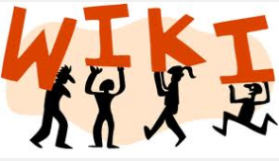

Take the opportunity to meet other DECV students on your Wiki.

Use the “Discussion” post on WIKI to ask questions or compliment people on their work.

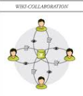



\* \* \* \* \* \* \* \* \* \* \* \* \* \* \* \* \*\* \* \* \* \* \* \* \* \* \* \* \* \* \* \* \* \*\* \* \* \* \* \* \* \* \* \* \* \*

As you work on your Wiki, think about what you have learnt. Tell me about your work with the Wiki:

**……………………………………………………………………………………………………………………………………………….**

**……………………………………………………………………………………………………………………………………………….**

**……………………………………………………………………………………………………………………………………………….**

**………………………………………………………………………………………………………………………………………..………**

**……………………………………………………………………………………………………………………………………….………**

**……………………………………………………………………………………………………………………………………………….**

**Complete the Wiki ‘Success Meter”.**

|  |  |  |  |
| --- | --- | --- | --- |
| At the end of this Module, how much do you feel you have learnt about WikiSpaces? | **No** | **A bit** | **Yes** |
| Did you understand what a Wiki Space is? |  |  |  |
| Were you able to log into the DECV WikiSpace (TRguest20100?) |  |  |  |
| Were you able to understand and follow instructions to create a WikiSpace? |  |  |  |
| Do you prefer to read instructions in the Module? |  |  |  |
| Do you prefer to read you instruction on-line? |  |  |  |
| Do you prefer to have someone else work with you to do the Wiki Space? |  |  |  |
| Were you able to read WikiSpaces other students created? |  |  |  |
| Did you like any of the other WikiSpaces? |  |  |  |
| Did you respond to or leave a comment for someone’s Wikispace? |  |  |  |
| Were you able to create your own Wiki Space? |  |  |  |
| Put a tick on the items in this tool bar that you were able to use to create your Wiki. | | | |
| Were you able to use some of the items in the tool bars (below)? | | | |
| Were you able to go back into your space and edit the page? |  |  |  |
| Were you able to add photos, pictures or other links to your space? |  |  |  |
| Did you add a post or make a comment in the discussion part of Wiki? |  |  |  |
| Did you work with another DECV student in the space – to share ideas or exchange pictures? |  |  |  |
| Are you happy with the Wiki Space you created? |  |  |  |
| Did you enjoy learning about Wikispaces and working together? |  |  |  |

****



Our **BIG IDEA** / **Essential Question** at the start of this module was:

***How can we use technology***

***to communicate and collaborate?***

**Our focus** was how we could use WikiSpaces

to communicate and work with others.

Reflecting on the work you have done in this module and in your Wiki Space….. add a few ideas to the **PLUS** (the good things) MINUS (the ‘not so good’ things) and INTERESTING in this chart:



**PLUS**

**INTERESTING**

**MINUS**



****

**Solutions: Day 1 Wiki Words.**

|  |  |
| --- | --- |
| A series of interconnected computers and databases around the world – | *Internet* |
| A piece of equipment that is used to send information from a computer through a telephone system - | *modem* |
| “WWW” is part of an internet address that stands for - | *World Wide Web* |
| To press the button on a computer mouse or track pad - | *click* |
| To organize and design the words on a page or written document - | *format* |
| A computer program which allows you to look at pages on the internet - | *browser* |
| A part of a website that can be read on a computer screen - | *web page* |
| The first page that you can see when you look at a website (*all being well*!) - | *home page* |
| To electronically copy computer programs or information from another place | *download* |
| A connection between documents on areas on the internet - | *link* |
|  |  |

*The flash cards for Day 6 Spelling are on the next page. Cut them out along the dotted lines.*

|  |  |
| --- | --- |
| although | atmospheric |
| autobiography | biography |
| calligraphy | catastrophic |
| graphite | geography |
| homograph | holograph |
| phantom | hyphenated |
| pharmaceutical | pharaoh |
| photograph | pharmacy |
| polygraph | physician |
| symphony | thorough |

**Solutions: Day 9 Wikipedia Reading True or False;**

|  |  |
| --- | --- |
| The word Wikipedia means “quick encyclopaedia”. | ***True*** |
| Readers of Wikipedia can use links to go to other pages about their topic. | ***True*** |
| Many different people from all over the world can add information to Wikipedia. | ***True*** |
| The difference between Wikipedia and print encyclopaedias is that the information in Wikipedia can be updated quickly. | ***True*** |
| Generally, it is difficult to change something in Wikipedia. | ***False*** |
| People who write information for Wikipedia must show their real name on the page. | ***False*** |
| Wikipedia was created in 2012. | ***False*** |
| Wikipedia contains over four million articles on many different topics. | ***True*** |
| Wikipedia can be updated quickly and easily. | ***True*** |
| People can work together to update information in Wikipedia. | ***True*** |
| There are editors who keep an eye on what people add to the Wikipedia. | ***True*** |
| People are encouraged to write their own opinion into Wikipedia. | ***False*** |
|  |  |

|  |  |  |  |  |  |
| --- | --- | --- | --- | --- | --- |
| **Student Name**: | |  | **Student ID**: |  | |
| **Date:** | | | | \_ \_ \_ / \_ \_ \_ /\_ \_ \_ | |

**ENGLISH**

|  |  |  |  |  |  |  |
| --- | --- | --- | --- | --- | --- | --- |
| **Level** | **SPEAKING & LISTENING** | **Demonstrated** | **Needs further opportunity** | | **Teacher assessment** | |
| 6 | Participate in and contribute to discussions, clarifying and interrogating ideas, developing and supporting arguments, sharing and evaluating information, experiences and opinions [(ACELY1709)](http://ausvels.vcaa.vic.edu.au/Curriculum/ContentDescription/ACELY1709) |  |  | |  | |
|  | **READING & VIEWING** | | | | |
| 6 | Use comprehension strategies to interpret and analyse information and ideas, comparing content from a variety of textual sources including media and digital texts |  |  | |  | |
| 6 | Select, navigate and read increasingly complex texts for a range of purposes, applying appropriate text processing strategies to recall information and consolidate meaning |  |  | |  | |
| 6 | Understand how authors often innovate on text structures and play with language features to achieve particular aesthetic, humorous and persuasive purposes and effects, |  |  | |  | |
| 6 | Analyse and evaluate similarities and differences in texts on similar topics, themes or plots |  |  | |  | |
|  | **WRITING** | | | | |
| 6 | Understand how to use banks of known words, word origins, base words, suffixes and prefixes, spelling patterns and generalisations to learn and spell new words, for example technical words and words adopted from other languages |  |  |  | |
| 6 | Plan, draft and publish imaginative, informative and persuasive texts, choosing and experimenting with text structures, language features, images and digital resources appropriate to purpose and audience |  |  |  | |
| 6 | Understand how ideas can be expanded and sharpened through careful choice of verbs |  |  |  | |



|  |  |  |  |  |  |  |  |
| --- | --- | --- | --- | --- | --- | --- | --- |
| Description: Description: Description: Description: Description: Description: Description: Description: logoCAPS2**315 Clarendon Street, Thornbury 3071**  **Telephone (03) 8480 0000**  **FAX (03) 9416 8371 (Despatch)**  **Free call(1800) 133 511**   |  |  | | --- | --- | | |  | | --- | | **STUDENT NUMBER \_\_\_\_\_\_\_\_\_\_\_\_\_\_\_\_\_\_\_**  **STUDENT NAME \_\_\_\_\_\_\_\_\_\_\_\_\_\_\_\_\_\_\_\_\_\_**  **\_\_\_\_\_\_\_\_\_\_\_\_\_\_\_\_\_\_\_\_\_\_\_\_\_\_\_\_\_\_\_\_\_\_\_\_\_\_\_** | | | | | | | |  |
| Fix your student barcode  label over this space. |
|  |
| 6107  [6107] |
| **SUBJECT** | English | | | [ZX] |
| **COLOUR** | Red | **MODULE** | G |
| **TEACHER** | \_\_\_\_\_\_\_\_\_\_\_\_\_\_\_\_\_\_\_\_\_\_\_\_\_\_\_ | | |

|  |
| --- |
| **THINKING ABOUT YOUR LEARNING**  Description: Description: Description: Description: http://t0.gstatic.com/images?q=tbn:ANd9GcTiyp1Q0EWVRSXlqyIMaG6be3rodf0nBbu2oBIY8JlYVh1iP8U7**I understand \_\_\_\_\_\_\_\_\_\_\_\_\_\_\_\_\_\_\_\_\_\_\_\_\_\_\_\_\_\_\_\_\_\_\_\_\_\_\_\_\_\_\_\_\_\_\_\_\_**  **\_\_\_\_\_\_\_\_\_\_\_\_\_\_\_\_\_\_\_\_\_\_\_\_\_\_\_\_\_\_\_\_\_\_\_\_\_\_\_\_\_\_\_\_\_\_\_\_\_\_\_\_\_\_\_\_\_\_\_\_\_\_\_\_\_\_\_\_\_\_\_\_\_\_\_**  **\_\_\_\_\_\_\_\_\_\_\_\_\_\_\_\_\_\_\_\_\_\_\_\_\_\_\_\_\_\_\_\_\_\_\_\_\_\_\_\_\_\_\_\_\_\_\_\_\_\_\_\_\_\_\_\_\_\_\_\_\_\_\_\_\_\_\_\_\_\_\_\_\_\_\_**  **\_\_\_\_\_\_\_\_\_\_\_\_\_\_\_\_\_\_\_\_\_\_\_\_\_\_\_\_\_\_\_\_\_\_\_\_\_\_\_\_\_\_\_\_\_\_\_\_\_\_\_\_\_\_\_\_\_\_\_\_\_\_\_\_\_\_\_\_\_\_\_\_\_\_\_**  **\_\_\_\_\_\_\_\_\_\_\_\_\_\_\_\_\_\_\_\_\_\_\_\_\_\_\_\_\_\_\_\_\_\_\_\_\_\_\_\_\_\_\_\_\_\_\_\_\_\_\_\_\_\_\_\_\_\_\_\_\_\_\_\_\_\_\_\_\_\_\_\_\_\_\_**  **Description: Description: Description: Description: http://t2.gstatic.com/images?q=tbn:ANd9GcQ72LH2Bxoxf3yTTP_t93kaIPDpv8jVzb20Dfacv1j6Jv1Vb43VI need help with\_\_\_\_\_\_\_\_\_\_\_\_\_\_\_\_\_\_\_\_\_\_\_\_\_\_\_\_\_\_\_\_\_\_\_\_\_\_\_\_\_\_\_\_\_\_\_\_**  **\_\_\_\_\_\_\_\_\_\_\_\_\_\_\_\_\_\_\_\_\_\_\_\_\_\_\_\_\_\_\_\_\_\_\_\_\_\_\_\_\_\_\_\_\_\_\_\_\_\_\_\_\_\_\_\_\_\_\_\_\_\_\_\_\_\_\_\_\_\_\_\_\_\_\_**  **\_\_\_\_\_\_\_\_\_\_\_\_\_\_\_\_\_\_\_\_\_\_\_\_\_\_\_\_\_\_\_\_\_\_\_\_\_\_\_\_\_\_\_\_\_\_\_\_\_\_\_\_\_\_\_\_\_\_\_\_\_\_\_\_\_\_\_\_\_\_\_\_\_\_\_**  **\_\_\_\_\_\_\_\_\_\_\_\_\_\_\_\_\_\_\_\_\_\_\_\_\_\_\_\_\_\_\_\_\_\_\_\_\_\_\_\_\_\_\_\_\_\_\_\_\_\_\_\_\_\_\_\_\_\_\_\_\_\_\_\_\_\_\_\_\_\_\_\_\_\_\_**  **\_\_\_\_\_\_\_\_\_\_\_\_\_\_\_\_\_\_\_\_\_\_\_\_\_\_\_\_\_\_\_\_\_\_\_\_\_\_\_\_\_\_\_\_\_\_\_\_\_\_\_\_\_\_\_\_\_\_\_\_\_\_\_\_\_\_\_\_\_\_\_\_\_\_\_** |

|  |
| --- |
| **YOUR QUESTIONS OR COMMENTS** |
| **TEACHER’S COMMENTS**  **Some great things about your work were:**  **Try to do the following next time:** |
|  |

