Student Workbook
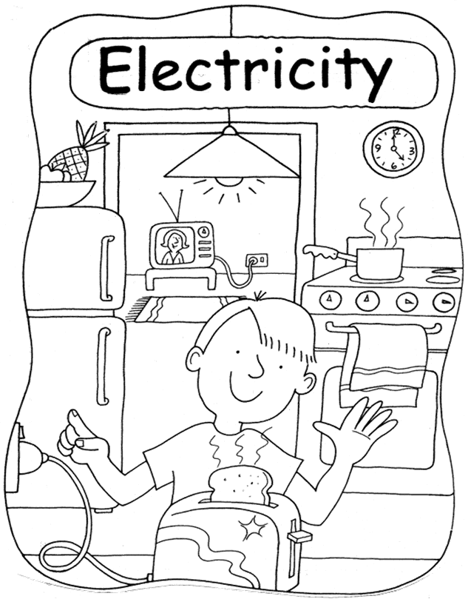

What is Electricity?

What do you know about electricity?
Parent or carer, help your child to show what he or she knows about electricity by writing words in each circle. These words might be answers to questions such as:
- Where does electricity come from?
- How do we use electricity?
- What things in our house use electricity?

Electricity makes a lot of things work.

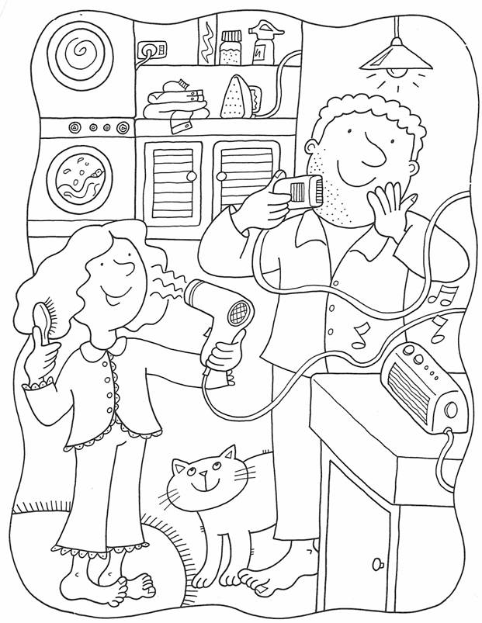

If you have access to the Internet, watch the following introductory video on YouTube:
Introduction to Electricity- video for kids

Read the names of the appliances to your child.
- In the first column tick the appliances your family use. Can you think of three more?
- In the second column, tick which appliances your parents used when they were children.
- In the third column, tick which ones your grandparents used.
- In the last column, find out what was used in your grandparent’s time in place of each appliance.
Appliances | Your family | Parents | Grand-parents | What was used instead
Dishwasher
Microwave oven
Oven
Blender
Hair dryer
Food mixer (processor)
Coffee maker
Toaster
Slow cooker
Refrigerator
Vacuum cleaner
Clothes dryer
Heater
Water heater
Colour TV
Black and white TV
Room air conditioner
Electric shaver
Electric blanket

Current electricity is made in a power station. It flows along wires to houses, shops, schools and other buildings.

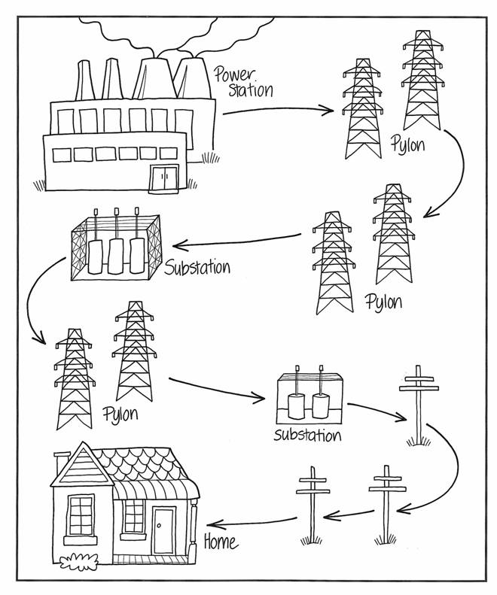

We cannot see electricity,
but we know about it by what it does.

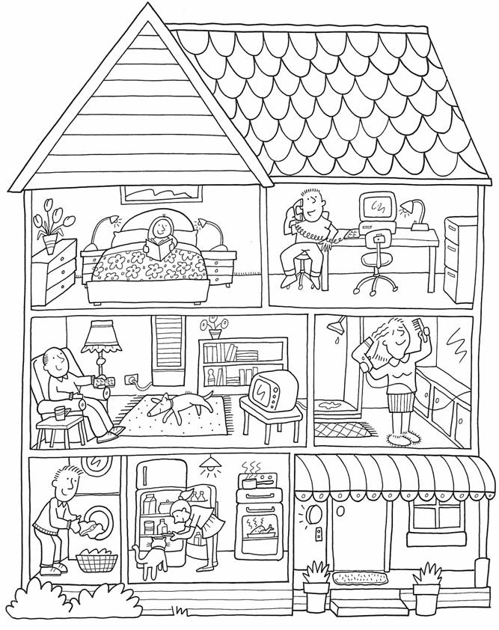

Colour in all the objects that use electricity in the home.
Continue the lines of letters.
Copy the sentence in the space below.
E
e
Electricity Electricity
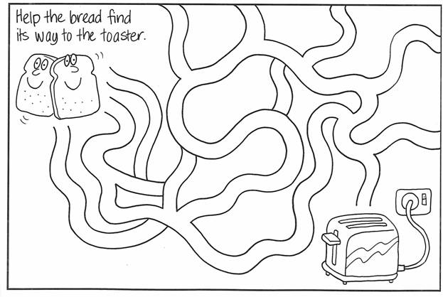

Electricity helps make our life easier and more comfortable, but we must not waste it.

You can waste electricity or you can save it.  Ask a parent or carer to help you read this sheet.  Write W if you think the suggestion wastes  electricity and S if you think it saves electricity.  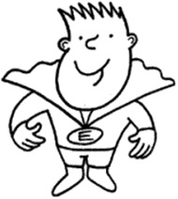 | 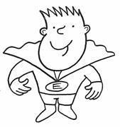
Wear warm clothes in winter.
Leave the front door and windows open in winter.
At night close the curtains.
Let the sunshine in, in the winter.
Insulate your home.
Have a bath full of water.
Rinse all the dishes with running hot water.
Fix a dripping hot water tap.
Wash the dishes in the dishwasher after every meal.
Fill the kettle up with water for 2 cups of tea.
Leave the hot water system on while on holidays.
Place wet clothes in the dryer on a sunny day.
Leave on lights.
Use energy saver globes instead of ordinary globes.
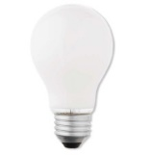
Switch off television when no one is watching it.
Leave computer on overnight.

This family is wasting a lot of electricity.

There is at least one bad habit happening in each room.
Talk about all the bad habits you see. Circle the bad habits.
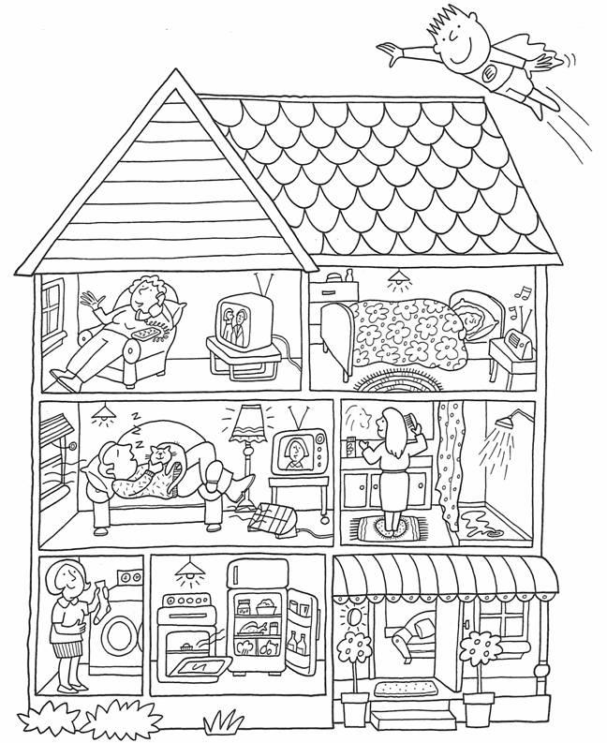

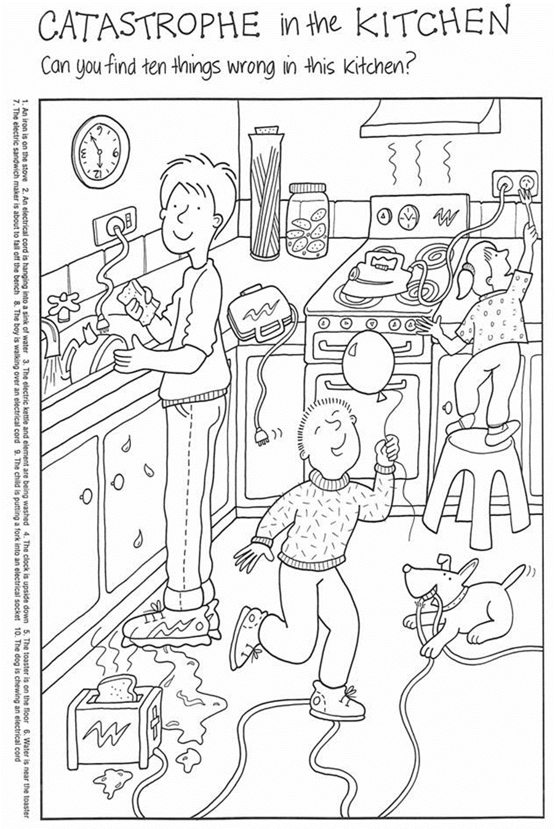
Circle the 10 things that are wrong in this kitchen.

Writing practice – copy the sentences  Electricity makes a lot of things work. | E______ m____ a l__ o_ t____ w____.
The Energy Watch Game
How to play

To decide the order of play, each player tosses the die.

The first will be the player who tosses the highest number on the die.

The next highest toss will be second and so on.

If two players throw the same number, they will toss again.
To finish, the winning player must throw the exact number to reach the finish box.
This isn’t funny.  It’s wasting money.  Go back to 67. | Turned the  dishwasher on  when there was  room for more.  Go back to 39. | Overdone toast  is such a  waste. Miss  a turn. | You had a  shower to save  energy . Skip  this one.
The gas flame  is licking up  the sides of the  saucepan.  Go back 4. | You see a  kettle boiling  for tea. Go  tell someone  and skip 3. | You forgot to  switch the  light off.  Go back 3. | You used the  sun’s light.  Have another  turn.
Turn your gas  heater off  when not in  the room. | Using Mum’s  hair dryer to  play space guns  is expensive  fun. Go back 4. | A frayed cord  that’s ignored.  Tell Mum. Have  another turn. | Fill the tub  just half  way. Save the  hot water for  another day.
Forget to turn  the record off?  It goes round  for evermore and  you go back  to number 4. | Closed the door,  jump 2 more. | You didn’t fill  the tub up half  way. Go back 3  the other way. | Turn off the  radio for a  while. You’ll  hear music of a  different style.  Move ahead 4.
Open a  refrigerator  door only when  you know what  you’re looking  for. Go to 52. | Turned off the  lights on  leaving the room.  You’ll move  ahead soon. | You need a  cup, why fill  the kettle up.  Go back 2. | If you shower  to save energy,  skip this one.
Put a jumper  on inside in winter.  Have  an extra turn. | Instead of  watching TV,  colour in a bumble  bee. Move along 3. | More plugs  than a socket  used, can  blow a fuse.  Miss a turn. | You saw a  dripping hot  water tap.  You got Mum and  Dad to fix it quick.  Go to 36.

The Energy Watch Game |  | What you need to play  1 x die.  1 x counter for each player,  e.g. coloured buttons. |  |  |  | 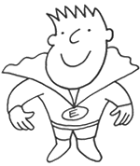 |  |  | How to play  To decide the order of play, each player tosses the die.  The first will be the player who tosses the highest number on the die.  The next highest toss will be second and so on.  If two players throw the same number, they will toss again.  To finish, the winning player must throw the exact number to reach the finish box.
71 | 72 |  | 73  You didn’t fill the tub up half way.  Go back 3 the other way. | 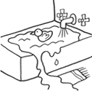  74 | 75 |  | 76 | 77  This isn’t funny.  It’s wasting money.  Go back to 67. |  | 78 | 79 | 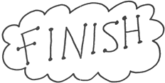  - You’re an Energy  - Watch it.
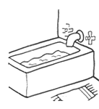  70 | 69 |  | 68  Turn off the radio for a while. You’ll hear music of a different style.  Move ahead 4. | 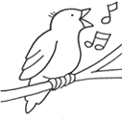  67 | 66 |  | 65  Instead of watching TV, colour in a Bumble Bee. Move along 3. | 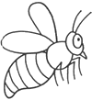  64 |  | 63 | 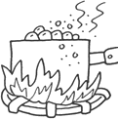  62 | 61  The gas flame is licking up the sides of the saucepan.  Go back 4. | 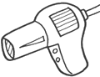  60 | 59  Using Mum’s hair dryer to play space guns is expensive fun.  Go back 4.
47 | 48  Fill the tub just half way.  Save the hot water for another day. |  | 49 | 50 | 51 |  | 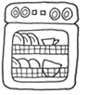  52 | 53  You need a cup, why fill the kettle up.  Go back 2. |  | 54 | 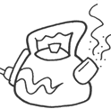  55 | 56  You see a kettle boiling for tea. Go tell someone and skip 3. | 57 | 58
46 | 45 |  | 44  Open a refrigerator door only when you know what you’re looking for.  Go to 52. | 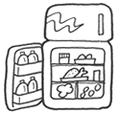  43 | 42 |  | 41  More plugs than a socket used can blow a fuse.  Miss a turn. | 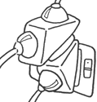  40 |  | 39 | 38 | 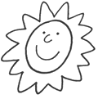  37 | 36  You used the sun’s light.  Have another turn. | 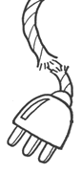  35
23 | 24 |  | 25 | 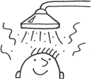  26 | 27  If you shower to save energy, skip this one. |  | 28 | 29 |  | 30  Overdone toast is such a waste. Miss a turn. | 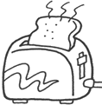  31 | 32 | 33 | 34  A frayed cord that’s ignored. Tell Mum.  Have another turn.
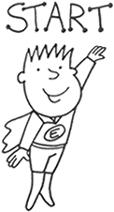 | 22  Forgot to turn the record off?  It goes round for evermore and you go back to number 4. |  | 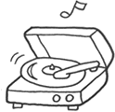  21 | 20 | 19 |  | 18  You saw a dripping hot water tap.  You got Mum and Dad to fix it quick.  Go to 36. | 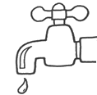  17 |  | 16 | 15 | 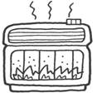  14 | 13  Turn your gas heater off when not in the room. | 12
 | 1  Closed the door, jump 2 more. |  | 2  Turned off the lights on leaving the room.  You’ll move ahead soon. | 3 | 4  Put a jumper on inside in winter. Have an extra turn. |  | 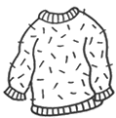  5 | 6 |  | 7  You had a shower to save energy.  Skip this one. | 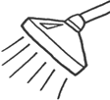  8 | 9  You forgot to switch the light off.  Go back 3. | 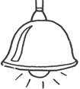  10 | 11

YOUR QUESTIONS OR COMMENTS

Copyright

The Department of Education and Training (DET) encourages the dissemination and re-use of information provided in this document.

Material on this website is provided under a Creative Commons Attribution 4.0 international licence, with the exception of:

- any images, photographs, trademarks or branding, including the Victorian Government logo and the DET logo; and
- content supplied by third parties.

For licence conditions, see: Creative Commons Attribution 4.0 international licence

Attribution

Material to be attributed as:
© State of Victoria (Department of Education and Training)

