Mathematics

C:\Users\kanderso\AppData\Local\Microsoft\Windows\Temporary Internet Files\Content.IE5\HM1JB2LM\MC900361024[1].wmf

***How does a shopkeeper work out my change?***



**About Gold Level Mathematics**

1. **Focus**

|  |  |
| --- | --- |
| This is when I tell you what you will be doing for the activities! | S21570467708050209410 |

2. **Introduction**

|  |
| --- |
| *During the discussion you will learn the how, why, what and when of the maths topic.*  S21570467708050209430000000 |

**Did you know?**

|  |  |
| --- | --- |
| Find out interesting facts about the topic you are studying! | DidYouKnow |

|  |  |
| --- | --- |
| Contents | |
| 1 | Estimating and measuring volume using water.  Estimating and measuring length, width and height using blocks.  Measuring ingredients for cooking. |
| 2 | Measuring the capacity of larger containers using smaller containers of water.  Estimating and measuring floor area.  Exploring the properties of a metre.  Measuring perimeters. |
| 3 | Counting money and recording a progressive tally.  Working out the correct coins for a given amount. |
| 4 | Calculating the cost of a lunch order.  Calculating change.  Identifying items that cost less than or more than a given amount |
| 5 | Revision of concepts. |
| 6 | Complete number patterns 2,3,4,5,6 & 10, using the *Hundreds Chart.*  Timed tables practice. |
| 7 | Using a calculator.  Estimate answers to equations and check with a calculator.  Play *Calculator Bingo.* |
| 8 | Key money amounts into a calculator.  Using a calculator to add lunch order items.  Using a range of strategies to work out the costs of furniture in a catalogue and choose items. |
| 9 | Review concepts. |

**Mathematics**

The activities will help us to answer the question:

***“How does a shopkeeper work out my change?”***

**You will be learning to:**

**Number**

* Practise skip counting
* Use the 7 times table
* Explore numbers to 9999
* Check answers with calculator

**Measurement**

* Estimating and measuring volume
* Measuring volume with length, width and height
* Measuring the area and perimeter of objects

**Money**

* Add and subtract money
* Use mental strategies to add up different money amounts
* Learn how to ‘give change’ in different ways
* Work out the cost of buying ingredients

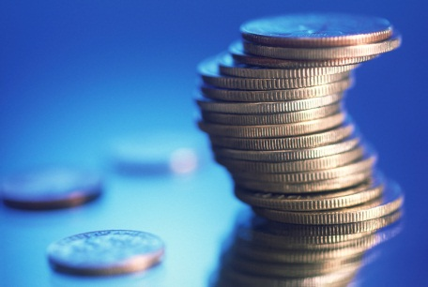

# 1

## Focus

You will be estimating and measuring volume.

|  |
| --- |
| S2157046770805020943014  Use a calculator once you have finished to see how you are going with your estimates. |

Introduction

How do I measure volume?

I can measure the volume of a box with blocks or marbles or pegs.

I can measure the volume of the bucket with jugs of water.

When you measure volume you measure the space inside something that is 3 dimensional. You can measure the space inside a box or a jug.

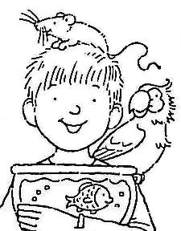

**PITCH002CLEAN010TOY028TOY028SHIP023**

**Introduction continued**

**Revision of vocabulary used in measurement activities**

**Estimate**: When you estimate you use your judgement. *I estimate that it will take 5 full cups of water to fill the 1 litre container.*

**Approximate** – means almost, but not completely, exact. You get an approximate result when you estimate. *I can fill approximately 6 glasses from the lemonade bottle.*

**Standard unit of measure**: An exact measure that is widely used. Some standard units of measure we use are millilitres and litres.

**Informal units of measure**: A unit of measurement that is not exact. It could be a cup, a jug or a bottle.

**Volume** *is the amount of space an object takes up*. Sometimes you can see if one container has a greater volume than another container. In this picture one container has a greater volume than all the others. If you can see which one it is, put a cross on it.

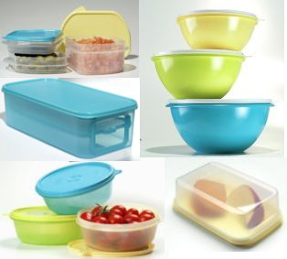

source: <http://www.tupperware.com.au/>

## Introduction continued

|  |
| --- |
| Sometimes objects look the same size. If you need to know which one has greater volume, you have to work out how much space it takes up.    If you cannot tell which box takes up the greatest space by looking, you need to measure the volume.  One way to measure volume is fill each box with objects. To measure accurately, they must be the same size. At school you might use square blocks. You could also use Duplo or Lego blocks, matchboxes, marbles, pegs or tennis balls.  blocks lego  source: <http://www1.lego.com>  As a distance education student, you may not have access to enough of these objects to measure volume, but you do have access to containers and water.  Use containers and water whenever you need to measure volume and do not have objects to use.  HMISC003 jug |

## Activity 1

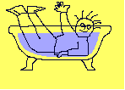 bd06121_**For you to do – Water Displacement**

In this activity you will be *using water to work   
out how much space an object takes up.*

**You will need:**

* two identical containers such as clear plastic tubs, jars or glasses
* assorted objects such as rocks or marbles (objects that will sink)
* a suitable workplace such as the sink, a tray at your workplace or outside

**What to do:**

* Begin with the two identical containers filled to about half with water.
* Think about what will happen when you place a rock in one of the containers?
* Put the rock into the container and see what happens.

Did you think the water level would rise or overflow?

You were right. The water rises because the rock takes up some of the space where the water was.

Select three objects of different sizes that will fit into the containers.

List your objects here:

1. \_\_\_\_\_\_\_\_\_\_\_\_\_\_\_\_\_\_\_\_\_\_\_\_\_\_\_\_\_\_\_\_\_\_\_
2. \_\_\_\_\_\_\_\_\_\_\_\_\_\_\_\_\_\_\_\_\_\_\_\_\_\_\_\_\_\_\_\_\_\_\_
3. \_\_\_\_\_\_\_\_\_\_\_\_\_\_\_\_\_\_\_\_\_\_\_\_\_\_\_\_\_\_\_\_\_\_\_

Can you use the containers of water to find out which of the three objects takes up the most space? Write what you plan to do below:

## \_\_\_\_\_\_\_\_\_\_\_\_\_\_\_\_\_\_\_\_\_\_\_\_\_\_\_\_\_\_\_\_\_\_\_\_\_\_\_\_\_\_\_\_\_\_\_\_\_\_\_\_\_\_\_\_\_\_\_\_\_\_\_\_\_\_

## \_\_\_\_\_\_\_\_\_\_\_\_\_\_\_\_\_\_\_\_\_\_\_\_\_\_\_\_\_\_\_\_\_\_\_\_\_\_\_\_\_\_\_\_\_\_\_\_\_\_\_\_\_\_\_\_\_\_\_\_\_\_\_\_\_\_

## \_\_\_\_\_\_\_\_\_\_\_\_\_\_\_\_\_\_\_\_\_\_\_\_\_\_\_\_\_\_\_\_\_\_\_\_\_\_\_\_\_\_\_\_\_\_\_\_\_\_\_\_\_\_\_\_\_\_\_\_\_\_\_\_\_\_

## Activity 1 continued

The object that takes up the most amount of space has the most volume. Work out the volume of your 3 objects, then list them from *greatest* to *least* volume:

1. \_\_\_\_\_\_\_\_\_\_\_\_\_\_\_\_\_\_\_\_\_\_\_\_\_\_\_\_\_\_\_\_\_\_\_
2. \_\_\_\_\_\_\_\_\_\_\_\_\_\_\_\_\_\_\_\_\_\_\_\_\_\_\_\_\_\_\_\_\_\_\_
3. \_\_\_\_\_\_\_\_\_\_\_\_\_\_\_\_\_\_\_\_\_\_\_\_\_\_\_\_\_\_\_\_\_\_\_

Did you have to change or modify your plan so that you could accurately work out which object had the most volume? If it was different from your plan, write what you had to do.

\_\_\_\_\_\_\_\_\_\_\_\_\_\_\_\_\_\_\_\_\_\_\_\_\_\_\_\_\_\_\_\_\_\_\_\_\_\_\_\_\_\_\_\_\_\_\_\_\_\_\_\_\_\_\_\_\_\_\_\_\_\_\_\_\_\_

\_\_\_\_\_\_\_\_\_\_\_\_\_\_\_\_\_\_\_\_\_\_\_\_\_\_\_\_\_\_\_\_\_\_\_\_\_\_\_\_\_\_\_\_\_\_\_\_\_\_\_\_\_\_\_\_\_\_\_\_\_\_\_\_\_\_

\_\_\_\_\_\_\_\_\_\_\_\_\_\_\_\_\_\_\_\_\_\_\_\_\_\_\_\_\_\_\_\_\_\_\_\_\_\_\_\_\_\_\_\_\_\_\_\_\_\_\_\_\_\_\_\_\_\_\_\_\_\_\_\_\_\_

\_\_\_\_\_\_\_\_\_\_\_\_\_\_\_\_\_\_\_\_\_\_\_\_\_\_\_\_\_\_\_\_\_\_\_\_\_\_\_\_\_\_\_\_\_\_\_\_\_\_\_\_\_\_\_\_\_\_\_\_\_\_\_\_\_\_

This image shows how to measure volume accurately with a measuring flask.

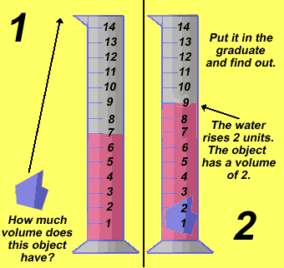

source: **<http://www.dmturner.org/Teacher/Pictures/displace.gif>**

## Activity 2

bd06121_**For you to do**

## In this activity you will be *estimating and measuring how many objects you need to place in a container to make the water in it rise to the top.*

## You will need:

## two different sized containers such as a glass, a jar or clear plastic container

## a collection of similar sized marbles, small rocks or other objects that will sink

## What to do:

## Fill both containers to about half full of water. Estimate, then measure, how many marbles you will have to add to each container for the water reach the top.

## 

|  |  |  |
| --- | --- | --- |
|  | Estimate number of objects to raise water level to top | Measure number of objects to raise water level to top |
| Type of container:\_\_\_\_\_\_\_\_\_\_\_\_\_\_\_\_\_\_\_\_ Object used to measure:  \_\_\_\_\_\_\_\_\_\_\_\_\_\_\_\_\_\_\_\_ |  |  |
| Type of container:\_\_\_\_\_\_\_\_\_\_\_\_\_\_\_\_\_\_\_\_ Object used to measure:  \_\_\_\_\_\_\_\_\_\_\_\_\_\_\_\_\_\_\_\_ |  |  |

## Activity 3

## Measuring Volume with Length, Width and Height

Look at these objects. To work out the space they take up, you can measure the length, width and height, in blocks, then add or multiply these figures to work out the volume.

You can only work out volume in this way if you use objects that have straight sides, such as boxes or shapes made of cubes that are the same size.

|  |  |
| --- | --- |
| **Width**  **Height**  **Length** | |
| You can’t see all the blocks, but you can work out how many there are if you multiply the length by the width, then multiply this by the height.  Length: 2 blocks  Width: 2 blocks  Height: 2 blocks  Length x Width x Height  2 ≈ 2 ≈ 2 = 8  This object takes up 8 blocks of space. | |
| I can count 9 blocks in the top row. There are 3 rows.  3 ≈ 3 ≈ 3 = ?  Do you know how many blocks are in this object? | TOY064 |

**Activity 3 continued**

bd06121_ **For you to do**

Work out the volume, in blocks, of these objects using L x W x H

To help you count the blocks you could make your own model like the ones shown.

|  |  |
| --- | --- |
| b0681  Volume = \_\_\_\_\_ blocks | 3cube  Volume = \_\_\_\_\_ blocks |
| Volume = \_\_\_\_\_ blocks | Volume = \_\_\_\_\_ blocks |
| cube5  Volume = \_\_\_\_\_ blocks | MAB 1000 second    Volume = \_\_\_\_\_ blocks |

**Activity 4**

**Optional**

bd06121_ **For you to do**

Do this activity if you have blocks or cubes to use. You will use blocks or cubes to estimate and measure volume.

**You will need:**

* cubes or blocks
* 2 small boxes or containers

**What to do:**

* Estimate the volume of each small box or container in cubes.
* Use cubes to measure the length, width, height and volume of each container.
* Record your findings in the table.

|  |  |  |  |  |  |
| --- | --- | --- | --- | --- | --- |
| **Estimated volume** | **Container length**  **(cubes)** | **Container width**  **(cubes)** | **Number of cubes in base** | **Container height (cubes)** | **Container volume**  **(cubes)** |
| Container 1:  \_\_\_\_\_\_\_\_ |  |  |  |  |  |
| Container 2:  \_\_\_\_\_\_\_\_ |  |  |  |  |  |

Which container has the greatest volume? \_\_\_\_\_\_\_\_\_\_\_\_\_\_\_\_\_\_\_\_\_\_\_\_\_\_\_

If you used different sized blocks or cubes to measure the volume, what do you think the volume would be? Why?

\_\_\_\_\_\_\_\_\_\_\_\_\_\_\_\_\_\_\_\_\_\_\_\_\_\_\_\_\_\_\_\_\_\_\_\_\_\_\_\_\_\_\_\_\_\_\_\_\_\_\_\_\_\_\_\_\_\_\_\_\_\_\_\_\_\_

\_\_\_\_\_\_\_\_\_\_\_\_\_\_\_\_\_\_\_\_\_\_\_\_\_\_\_\_\_\_\_\_\_\_\_\_\_\_\_\_\_\_\_\_\_\_\_\_\_\_\_\_\_\_\_\_\_\_\_\_\_\_\_\_\_\_

\_\_\_\_\_\_\_\_\_\_\_\_\_\_\_\_\_\_\_\_\_\_\_\_\_\_\_\_\_\_\_\_\_\_\_\_\_\_\_\_\_\_\_\_\_\_\_\_\_\_\_\_\_\_\_\_\_\_\_\_\_\_\_\_\_\_

## Optional

|  |  |  |
| --- | --- | --- |
| bd06121_For you to do | Make Fresh Apple Muffins | FOOD137FOOD137FOOD137 |

**You will need an adult to help with this activity.**

**Fresh Apple Muffins**

Measure out these ingredients:

* 1 cups plain flour
* cup sugar



* 2 teaspoons baking powder
* teaspoon salt (optional)



* teaspoon cinnamon



*  cup vegetable oil
* 1 egg
* cup milk



* 1 cup grated or finely chopped apple

Follow these instructions:

* Wash hands
* Sift together flour, sugar, baking powder and cinnamon. Set aside.
* Combine oil, egg and milk. Add to dry ingredients.
* Add apple and stir just until ingredients are blended.
* Fill greased muffin pans full and sprinkle with topping.
* Bake at 200 degrees for approximately 20 minutes.

Topping for apple muffins:

*  cup brown sugar
* teaspoon cinnamon



* cup chopped nuts



Mix brown sugar, cinnamon and nuts together and sprinkle over muffins.

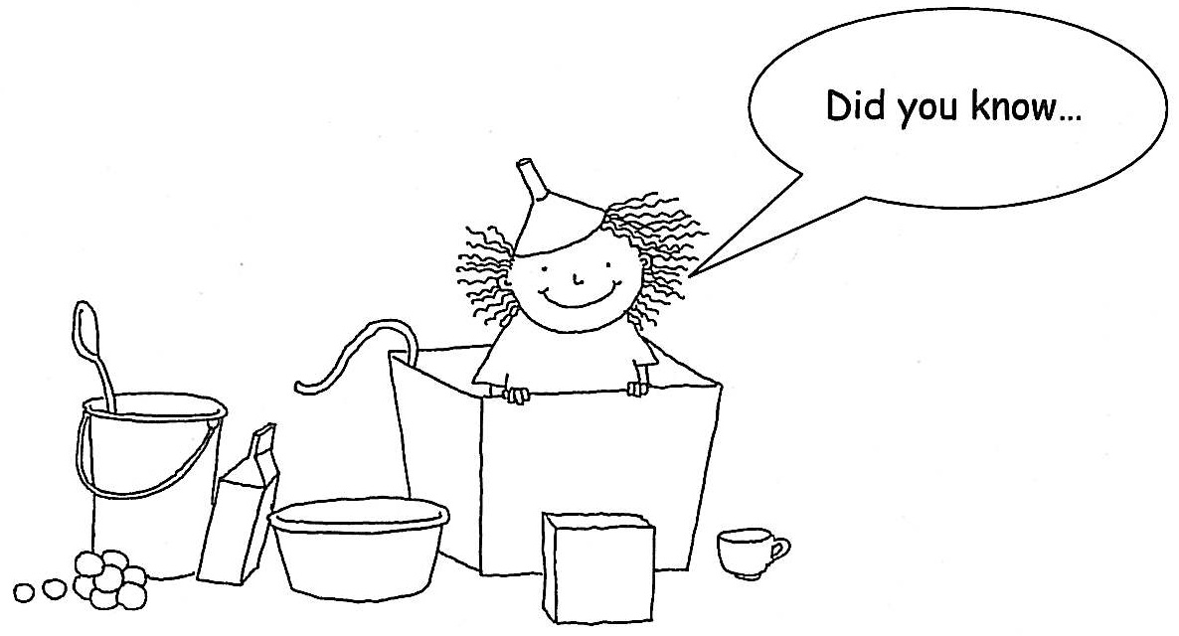

**…** the greatest height from which fresh eggs have been dropped to the ground and remained intact is 213 metres.

The eggs were dropped from a helicopter onto a golf course in England in 1994.

I wonder if they were wearing little parachutes?

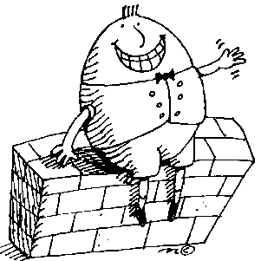

# 2

## Focus

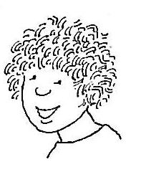

You will be doing some measurement activities. You will be revising what you have learnt earlier in the year about *volume, capacity, area, perimeter* and *length.*

Introduction

I know the difference between **volume** and **capacity**.

**Volume** is the amount of space an object takes up. I can measure **volume** with objects such as blocks or marbles, or with water. **Capacity** is the amount a container can hold. A box might hold 10 cans of drink, and a can of drink might hold 250 ml of lemonade.

I sometimes confuse **perimeter** and **area**. I have to remember that **perimeter** is the distance around something, and I have to multiply length by width to work out the **area** of something.

I measure **length** in centimetres and metres. I always like to estimate first and then see how accurate I am.



## Introduction continued

**Revision**

You might like to read over each definition now, or you could refer back to the relevant section when you are doing each activity.

**Volume –** **is the amount of space something takes up.**

When you measure **volume** you measure **the space in something that is 3 dimensions**.

You can measure the volume of a three dimensional object using objects such as blocks, marbles or cups of water.

The volume of this box is 8 blocks.

|  |
| --- |
| **Height 2 blocks**  **Width 2 blocks**  **Length 2 blocks** |

**Capacity – is the amount a container can hold.**

|  |  |
| --- | --- |
| This box holds 24 toy blocks.  COBJE175 | j0290936  2 blocks  3 blocks  4 blocks |
| This soft drink can holds 250 mL.  DRINK151 | jug |

## Introduction continued

## Area – is the amount of space covered or taken up by an object.

To measure the area or amount of space taken up by this shape we could use tiles, counters, coins, bottle tops or playing cards.

To measure area, we cover the total surface of the object we are measuring.

|  |  |
| --- | --- |
| It takes 19 coins  to measure  the area of this octagon.  COINS018 | COINS023 |
| It takes 6 cards  to measure the area of this rectangle.  CARDS007 |  |
| Each of the squares is 1 centimetre long and 1 centimetre wide, so I can see that the area of this grid is 25 square centimetres. | 5cm  5cm |

## Introduction continued

## Perimeter – is the distance around the outside of an object.

|  |  |
| --- | --- |
| The perimeter of this square  is 20 cm.  5 + 5 + 5 + 5 = 20 cm | 5 cm  5 cm |

**Length – To measure how long an object or distance is, we can use informal units of measure such as hand spans or footsteps.**

We can also use standard units of measure such as centimetres and metres.

*When measuring the length of an object, you measure the longest edge, from end to end.*

|  |  |
| --- | --- |
| The box shown here is  four handspans long.  HAND083  When I use a ruler I work out it is 68 cm long. | j0290936  length  The length of the box =  4 hand spans  or 68 cm. |

## Activity 1

bd06121_**For you to do**

## In this activity you will be: *estimating and measuring volume.*

## You will need:

## a container – use a plastic ice-cream tub or something similar.

## a small jug – use a cup if you don’t have a jug.

## a collection of objects to measure volume .

## If you do not have a collection of blocks, marbles, matchboxes or other objects, you could do this activity with fruit or vegetables.

You will need to work at the sink for the first part of this activity.

|  |  |  |  |  |
| --- | --- | --- | --- | --- |
| **HMISC003** | blocks | FRUIT084 | VEGTB061 | TENNS048 TENNS048 TENNS048 TENNS048 |

**Follow these steps:**

1. Estimate the volume of the container using the small jug or cup filled with water. Write how many jugs full of water you think it will take to fill the container in the column headed **estimate** in the table over the page.
2. Estimate the volume twice again, this time using blocks, apples, potatoes or other objects. Write your estimates in the table over the page.
3. Measure the volume of the container using the cup or small jug. Count how many times you empty the cup or jug full of water into the ice-cream container. Write the answer in the column headed **volume.**
4. Measure the volume of the container using the other objects. Count how many objects are needed to fill the container to the top. Do not fill the container higher than the top of the sides. Write the answer in the table.

## Activity 1 continued

|  |  |  |
| --- | --- | --- |
| **What I am**  **measuring with**  (write what you are using) | **Estimate** | **Volume**  (the space inside your container) |
| HMISC003  small jug of water | cups | cups |
|  |  |  |
|  |  |  |

## Activity 2

## bd06121_For you to do—Measuring Capacity

## In this activity you will be: *measuring the capacity of containers of different sizes.*

Fill in the gaps after working out the answers.

|  |  |
| --- | --- |
| CLEAN010 | A bucket holds \_\_\_\_\_\_\_\_\_\_\_\_\_\_\_\_ ice-cream tubs (or other similar sized container) full of water. |
| bowl | A large bowl holds \_\_\_\_\_\_\_\_\_\_\_\_\_\_ small jugs of water. |
| HMISC003 | A small jug holds \_\_\_\_\_\_\_\_\_\_\_\_\_\_\_ egg cups full of water. |
| egg cup | An egg cup holds \_\_\_\_\_\_\_\_\_\_\_\_\_\_\_ spoonfuls of water. |

## Activity 3

bd06121_**For you to do—Estimating and Measuring Area**

## In this activity you will be: *working out the area of your body when you are in different positions*

Estimate the answer to this problem.

If you stand, sit, kneel or lie on a piece of newspaper, which position will take up the **greatest** space and which position will take up the **least** space?

|  |  |
| --- | --- |
| **Estimate** | |
| Write 1 beside the position you think will take up the **least** space.  Write 2 beside the position you think will take up the next smallest space.  Write 3 beside the next position.  Write 4 beside the position you think will take up the **greatest** space. | Sit |
| Stand |
| Kneel |
| Lie |

Now think of a way to work out the correct answer.

**You will need:**

* some sheets of newspaper

|  |  |
| --- | --- |
| **Answer** | |
| Write 1 beside the position that takes up the **least** space.  Write 2 beside the position that takes up the next smallest space.  Write 3 beside the next position.  Write 4 beside the position that takes up the **greatest** space. | Sit |
| Stand |
| Kneel |
| Lie |

## Activity 3 continued

Write down how you worked out your answer.

\_\_\_\_\_\_\_\_\_\_\_\_\_\_\_\_\_\_\_\_\_\_\_\_\_\_\_\_\_\_\_\_\_\_\_\_\_\_\_\_\_\_\_\_\_\_\_\_\_\_\_\_\_\_\_\_\_\_

\_\_\_\_\_\_\_\_\_\_\_\_\_\_\_\_\_\_\_\_\_\_\_\_\_\_\_\_\_\_\_\_\_\_\_\_\_\_\_\_\_\_\_\_\_\_\_\_\_\_\_\_\_\_\_\_\_\_

\_\_\_\_\_\_\_\_\_\_\_\_\_\_\_\_\_\_\_\_\_\_\_\_\_\_\_\_\_\_\_\_\_\_\_\_\_\_\_\_\_\_\_\_\_\_\_\_\_\_\_\_\_\_\_\_\_\_

\_\_\_\_\_\_\_\_\_\_\_\_\_\_\_\_\_\_\_\_\_\_\_\_\_\_\_\_\_\_\_\_\_\_\_\_\_\_\_\_\_\_\_\_\_\_\_\_\_\_\_\_\_\_\_\_\_\_

\_\_\_\_\_\_\_\_\_\_\_\_\_\_\_\_\_\_\_\_\_\_\_\_\_\_\_\_\_\_\_\_\_\_\_\_\_\_\_\_\_\_\_\_\_\_\_\_\_\_\_\_\_\_\_\_\_\_

## Activity 4

bd06121_**For you to do—Measuring Perimeter**

## In this activity you will be: *measuring the perimeter of shapes in centimetres.*

Find the perimeter of these rectangles.

Use a calculator to check your answers when you have finished.

|  |  |  |
| --- | --- | --- |
| 4 cm  2cm    P = \_\_\_\_\_\_\_ cm | 3 cm  3 cm    P = \_\_\_\_\_\_\_ cm | 3 cm  10 cm  P = \_\_\_\_\_\_\_ cm |
| 4 cm  1 cm    P = \_\_\_\_\_\_\_ cm | 5 cm  5 cm    P = \_\_\_\_\_\_\_ cm |

## Activity 5

bd06121_**For you to do—Length: Metre Quiz**

## In this activity you will be *recording what you know about the metre measurement.*

## You will need:

## 1 metre ruler

1. What is a metre? Write the best sentence you can think of to explain it.

## \_\_\_\_\_\_\_\_\_\_\_\_\_\_\_\_\_\_\_\_\_\_\_\_\_\_\_\_\_\_\_\_\_\_\_\_\_\_\_\_\_\_\_\_\_\_\_\_\_\_\_\_\_\_\_\_\_\_\_\_\_\_\_\_\_\_

## \_\_\_\_\_\_\_\_\_\_\_\_\_\_\_\_\_\_\_\_\_\_\_\_\_\_\_\_\_\_\_\_\_\_\_\_\_\_\_\_\_\_\_\_\_\_\_\_\_\_\_\_\_\_\_\_\_\_\_\_\_\_\_\_\_\_

## \_\_\_\_\_\_\_\_\_\_\_\_\_\_\_\_\_\_\_\_\_\_\_\_\_\_\_\_\_\_\_\_\_\_\_\_\_\_\_\_\_\_\_\_\_\_\_\_\_\_\_\_\_\_\_\_\_\_\_\_\_\_\_\_\_\_

\_\_\_\_\_\_\_\_\_\_\_\_\_\_\_\_\_\_\_\_\_\_\_\_\_\_\_\_\_\_\_\_\_\_\_\_\_\_\_\_\_\_\_\_\_\_\_\_\_\_\_\_\_\_\_\_\_\_\_\_\_\_\_\_\_\_

1. How many centimetres make a metre? \_\_\_\_\_\_\_\_\_\_\_\_\_\_\_\_\_\_\_\_\_\_\_\_\_\_\_
2. How many of your hand spans make a metre? \_\_\_\_\_\_\_\_\_\_\_\_\_\_\_\_\_\_\_\_\_
3. How many of your foot lengths make a metre? \_\_\_\_\_\_\_\_\_\_\_\_\_\_\_\_\_\_\_\_

## What part of your body measures about a metre? \_\_\_\_\_\_\_\_\_\_\_\_\_\_\_\_\_\_

## How much taller than a metre are you? \_\_\_\_\_\_\_\_\_\_\_\_\_\_\_\_\_\_\_\_\_\_\_\_\_\_\_

1. How much shorter than two metres are you? \_\_\_\_\_\_\_\_\_\_\_\_\_\_\_\_\_\_\_\_\_\_



…Mount Kosciusko (2228 metres) is the tallest mountain on the Australian mainland, but it is not the tallest mountain on Australian territory. The highest point is Mawson’s Peak, on Heard Island. Mawson’s Peak is 2745 metres high, and forms the summit of an active volcano called Big Ben. Heard Island is south of the Australian continent, near the coast of Antarctica, in the Southern Ocean.

# 3

## Focus

You will be doing some activities with **money**. You will count money, add and subtract with money, and work on ‘giving change’ in different ways.

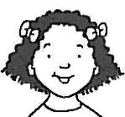

Introduction

I bought a muffin for $1.35 and I gave the shopkeeper $2.00. I’m not sure if he gave me the right change.

Did the shopkeeper count the change?

If the shopkeeper counts the change you can check if you have the right amount of money.

I think it is important to be able to work out the change in your head so that you know if you have been given the right amount of money. He should have given you

65 cents.



## Introduction continued

Whenever you are shopping, you need to be able to check that you have received the right change.

## Example 1

You buy a muffin that costs $1.35. You give the shopkeeper $2.00. The shopkeeper counts out your change, starting with the amount you paid for the muffin, and ending with the amount of money you gave him. This is the easiest way to receive change because you can check it as it is counted into your hand.

The muffin is $1.35.

Here’s your change.

$1.40, $1.60, $1.80, $2.00.

|  |
| --- |
| S215704677080502094301 FOOD137 |

Did you know which coins the shopkeeper was handing over?

He started by saying $1.35 and handing over 5 cents to take the amount up to $1.40.

He then handed over three 20 cent pieces, counting up by 20 cents

each time.

|  |  |  |  |  |
| --- | --- | --- | --- | --- |
| $1.35 | $1.40 | $1.60 | $1.80 | $2.00 |
|  | 5CCOIN | 20CCOIN | 20CCOIN | 20CCOIN |

The five cent piece was given first, because that took the total to $1.40, and then it was easy to count up in multiples of 20.

**Introduction continued**

**Example 2**

|  |
| --- |
| 2·00 |
| - 1·35 |
| ·65 |

## There is another way the shopkeeper can give change. He must first calculate the change, either by using the cash register to do it, by subtracting the cost mentally, or by writing down the sum. He will then count that amount out to you.

|  |
| --- |
| The muffin is $1.35.  Your change is 65c.  20, 40, 60, 65. S215704677080502094323311 FOOD137 |

|  |  |
| --- | --- |
| You are usually given your change in the least amount of notes or coins, so that it is easy to count and check. Your change of 65 cents could look like this... | OFEQP018 |
| 50CCOIN 10CCOIN 5CCOIN  or this.  20CCOIN 20CCOIN 20CCOIN 5CCOIN | |

## Activity 1

## bd06121_For you to do

Can you count money?

* 1. Write down the count for each example.

The first one has been done for you.

* 1. When you have finished check your answers with your calculator.

|  |
| --- |
| 1DOLLCOI 1DOLLCOI50CCOIN 10CCOIN 5CCOIN  $1 $2 $2.50 $2.60 $2.65 total |
| 20CCOIN 20CCOIN 20CCOIN 20CCOIN 10CCOIN 5CCOIN |
| 2DOLLCOI 2DOLLCOI 2DOLLCOI 2DOLLCOI 1DOLLCOI 20CCOIN 5CCOIN |
| 2DOLLCOI 1DOLLCOI 20CCOIN 20CCOIN 20CCOIN 20CCOIN |
| 2DOLLCOI 10CCOIN 10CCOIN 10CCOIN 5CCOIN |

## Activity 2

## bd06121_For you to do

In this activity you are going to work out combinations of coins that equal exactly $2.00?

|  |
| --- |
| What is the biggest number of coins you can use to make $2.00?  Circle the answer you think is correct.  7 12 20 25 40 100  When you have completed Activity 2, check if your answer was right. |

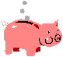

**Instructions:**

Draw a combination of coins for each example below.

The first two have been done for you.

Use your own coin collection.

|  |
| --- |
| 1 coin = $2.00  2DOLLCOI |
| 2 coins = $2.00  1DOLLCOI1DOLLCOI |
| 3 coins = $2.00 |
| 4 coins = $2.00 |
| 5 coins = $2.00 |
| Activity 2 continued |
| 6 coins = $2.00 |
| 7 coins = $2.00 |
| 8 coins = $2.00 |
| 9 coins = $2.00 |
| 10 coins = $2.00 |

## Activity 2 continued

|  |
| --- |
| What do you think is the biggest number of coins you could use to make $2.00?  \_\_\_\_\_\_\_\_\_\_\_\_\_\_\_\_\_  Check your answer.  Draw the coins or write down the number of coins and what coins you used.  PBANK001 |



A website with money activities for you to do is:

<http://www.funbrain.com/cashreg/index.html>



…the original fifty cent piece in Australian decimal currency had around $2.00 worth of silver in it before it was replaced with a less expensive twelve sided coin.

# 4

## Focus

You will be doing some more activities with money.

You will be using a lunch order list to work out the change for different lunch orders.

You will then work out the cost of buying the ingredients you need for making muffins.

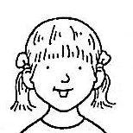

Introduction

What are you having for lunch?

I am allowed to buy one sandwich, one snack and one drink. I have to add up the cost and my parents give me the exact money.

I can buy what I like as long as I don’t spend more than $5.00.



|  |  |  |
| --- | --- | --- |
| sandwich | watermelon slice | milk carton |

## Activity 1

## bd06121_For you to do—Lunch Orders

## In this activity you will be: *working out the cost of each lunch order and the amount of change.*

## Prices are on the Lunch Menu & Price List following this activity.

Use your collection of coins to work out the answers or write an equation.

|  |  |  |  |
| --- | --- | --- | --- |
| **Example**  Pastie with sauce  Apple juice  Sultanas | | 2.60  .80  .60  4.00 | Lasagne  Mineral water  Fruit jelly |
| $5.00 enclosed  How much change? | 5.00  - 4.00  1.00 | | $5.00 enclosed  How much change? |
| 2 dim sims  Chocolate milk  Yoghurt | | | 2 party pies  Strawberry milk  Cheese & biscuits |
| $5.00 enclosed  How much change? | | | $5.00 enclosed  How much change? |

## Activity 1 continued

|  |  |
| --- | --- |
| Chicken & salad sandwich  Apple  Sultanas  Chocolate milk  Yoghurt | Tomato & cheese sandwich  Strawberry milk  Yoghurt  Peanuts |
| $10.00 enclosed  How much change? | $10.00 enclosed  How much change? |
| Choose a sandwich, a snack and a drink from the Lunch Menu & Price List.Write your lunch order and add up the total cost. | You have $5.00 to spend on lunch. Write your menu and prices here and add up the cost.  What is the change from $5.00? |

## Activity 1 continued

|  |  |  |  |
| --- | --- | --- | --- |
| **Lunch Menu and Price List** | | | |
| **Hot Food**  matzo ball soup | | **Sandwiches**  submarine sandwich | |
| Pie  Party pie  Pastie  Sausage roll  Hot dog  Lasagne  Pizza  Dim sim  Sauce 10 c extra | $2.50  $1.00  $2.50  $1.40  $1.50  $3.00  $1.80  60c | Vegemite  Peanut butter  Cheese  Cheese & lettuce  Tomato  Tomato & cheese  Salad  Ham  Ham & salad  Chicken  Chicken & salad  Rolls 20c extra | $1.20  $1.20  $1.40  $1.60  $1.40  $1.60  $2.00  $1.80  $2.30  $1.80  $2.30 |
| **Snacks**  gingerbread cookies |  | **Drinks**  milk carton and straw |  |
| Piece of fruit  Yoghurt  Cheese & biscuits  Fruit jelly  Sultanas  Peanuts | 50c  70c  $1.10  80c  60c  60c | Plain milk  Flavoured milk  Apple juice  Orange juice  Mineral water | 80c  $1.00  80c  80c  90c |

## Activity 2

bd06121_**For you to do – Muffin Maths**

FOOD137FOOD137FOOD137FOOD137FOOD137FOOD137FOOD137FOOD137FOOD137FOOD137FOOD137

Did you make muffins this week? You will see the muffin ingredients in the **Price List** below. Use the price list to complete the problems.

Use your coin collection to help you with the problems.

PBANK001PBANK001PBANK001PBANK001PBANK001PBANK001PBANK001PBANK001PBANK001

|  |  |  |
| --- | --- | --- |
| Supermarket Price List | | |
| [Go to fullsize image](http://av.rds.yahoo.com/_ylt=A0Je5XfEmLdBjlkBOF0_EqMX;_ylu=X3oDMTBvMmFkM29rBHBndANhdl9pbWdfcmVzdWx0BHNlYwNzcg--/SIG=1218fb9bu/**http:/www.goodnessdirect.co.uk/cgi-local/detail/316466.html)  Plain flour 1 kg $2.50 | **FODDR092**  Milk 1 litre $1.40 | FODDR025  Eggs  dozen $2.50  1 dozen $4.50 |
| H_HKT040  Vegetable oil  500 ml $4.85 | FODVF053  Apples 1 kg $3.10 | [Go to fullsize image](http://av.rds.yahoo.com/_ylt=A0Je5XR6f7ZBj30BZVQ_EqMX;_ylu=X3oDMTBvMmFkM29rBHBndANhdl9pbWdfcmVzdWx0BHNlYwNzcg--/SIG=12m2kmfpu/**http:/strongben.blogspot.com/2003/11/happy-november-everyone-once-upon-time.html)  Butter 250g $1.10 |
| [Go to fullsize image](http://av.rds.yahoo.com/_ylt=A0Je5Xcxf7ZBmlYAmRw_EqMX;_ylu=X3oDMTBvMmFkM29rBHBndANhdl9pbWdfcmVzdWx0BHNlYwNzcg--/SIG=1223i5nfi/**http:/www.especiallyoffice.com/webalogue/en-gb/dept_612.html)  Sugar 1kg $2.73 | Cinnamon  25g $1.04 | [Go to fullsize image](http://av.rds.yahoo.com/_ylt=A0Je5W82mrdBjTYAJnU_EqMX;_ylu=X3oDMTBvMmFkM29rBHBndANhdl9pbWdfcmVzdWx0BHNlYwNzcg--/SIG=135sceevt/**http:/www.meilleurduchef.com/cgi/mdc/l/en/boutique/produits/introuvables/met-baking_powder.html)  Baking Powder  125g $1.76 |

**Activity 2 continued**

|  |  |
| --- | --- |
| Find 2 ingredients that cost less than $2.00 each.  Write the name of each ingredient.  Draw coins to show how much each item cost. | |
|  |  |
| Find 2 ingredients that cost more than $2.00 each.  Write the name of each item.  Draw coins to show how much each item cost. | |
|  |  |

**Activity 2 continued**

|  |
| --- |
| Find 2 items that have a **total** of **less than** $5.00.  Write the names of the items.  Draw the coins or write an equation to show how much they cost. |
|  |
| Find 2 items that have a **total** of **more than** $5.00.  Write the names of the items.  Draw the coins or write an equation to show how much they cost. |
|  |

**Activity 2 continued – Optional**

Complete this part of the activity to practise adding up money.

List all the muffin ingredients and work out the **total** cost.

|  |  |
| --- | --- |
| **Ingredients** | **Cost** |
| dozen eggs | $2.50 |
|  |  |
|  |  |
|  |  |
|  |  |
|  |  |
|  |  |
|  |  |
|  |  |
|  |  |
| **Total cost** | |

|  |
| --- |
| Work out how much change would you get from $30.00. |



…coins can be worth a lot of money. An 1804 silver dollar, one of only fifteen in existence, was sold for a record $1815 million (American dollars) in 1997.

## 5

|  |
| --- |
| Focus 4irb_yvz[1]  You have completed many activities. It is time to slow down and revise the work you have done. |

|  |
| --- |
|  |

**What do you know about volume?**

|  |
| --- |
| Write 3 important things that you have learnt about volume.  \_\_\_\_\_\_\_\_\_\_\_\_\_\_\_\_\_\_\_\_\_\_\_\_\_\_\_\_\_\_\_\_\_\_\_\_\_\_\_\_\_\_\_\_\_\_\_\_\_\_\_\_\_\_\_\_\_\_\_\_\_\_\_\_\_  \_\_\_\_\_\_\_\_\_\_\_\_\_\_\_\_\_\_\_\_\_\_\_\_\_\_\_\_\_\_\_\_\_\_\_\_\_\_\_\_\_\_\_\_\_\_\_\_\_\_\_\_\_\_\_\_\_\_\_\_\_\_\_\_\_  \_\_\_\_\_\_\_\_\_\_\_\_\_\_\_\_\_\_\_\_\_\_\_\_\_\_\_\_\_\_\_\_\_\_\_\_\_\_\_\_\_\_\_\_\_\_\_\_\_\_\_\_\_\_\_\_\_\_\_\_\_\_\_\_\_  \_\_\_\_\_\_\_\_\_\_\_\_\_\_\_\_\_\_\_\_\_\_\_\_\_\_\_\_\_\_\_\_\_\_\_\_\_\_\_\_\_\_\_\_\_\_\_\_\_\_\_\_\_\_\_\_\_\_\_\_\_\_\_\_\_  \_\_\_\_\_\_\_\_\_\_\_\_\_\_\_\_\_\_\_\_\_\_\_\_\_\_\_\_\_\_\_\_\_\_\_\_\_\_\_\_\_\_\_\_\_\_\_\_\_\_\_\_\_\_\_\_\_\_\_\_\_\_\_\_\_  \_\_\_\_\_\_\_\_\_\_\_\_\_\_\_\_\_\_\_\_\_\_\_\_\_\_\_\_\_\_\_\_\_\_\_\_\_\_\_\_\_\_\_\_\_\_\_\_\_\_\_\_\_\_\_\_\_\_\_\_\_\_\_\_\_ |

|  |
| --- |
| Imagine that your friend doesn’t know how to find the volume of a container. What would you tell them?  \_\_\_\_\_\_\_\_\_\_\_\_\_\_\_\_\_\_\_\_\_\_\_\_\_\_\_\_\_\_\_\_\_\_\_\_\_\_\_\_\_\_\_\_\_\_\_\_\_\_\_\_\_\_\_\_\_\_\_\_\_\_\_\_\_\_  \_\_\_\_\_\_\_\_\_\_\_\_\_\_\_\_\_\_\_\_\_\_\_\_\_\_\_\_\_\_\_\_\_\_\_\_\_\_\_\_\_\_\_\_\_\_\_\_\_\_\_\_\_\_\_\_\_\_\_\_\_\_\_\_\_\_  \_\_\_\_\_\_\_\_\_\_\_\_\_\_\_\_\_\_\_\_\_\_\_\_\_\_\_\_\_\_\_\_\_\_\_\_\_\_\_\_\_\_\_\_\_\_\_\_\_\_\_\_\_\_\_\_\_\_\_\_\_\_\_\_\_\_  \_\_\_\_\_\_\_\_\_\_\_\_\_\_\_\_\_\_\_\_\_\_\_\_\_\_\_\_\_\_\_\_\_\_\_\_\_\_\_\_\_\_\_\_\_\_\_\_\_\_\_\_\_\_\_\_\_\_\_\_\_\_\_\_\_\_ |

Draw 2 containers that have the same volume but are different shapes.

|  |
| --- |
|  |

What could the volume of the containers be? \_\_\_\_\_\_\_\_\_\_\_\_\_\_\_\_\_\_\_\_\_\_\_\_

Why do you think this?

\_\_\_\_\_\_\_\_\_\_\_\_\_\_\_\_\_\_\_\_\_\_\_\_\_\_\_\_\_\_\_\_\_\_\_\_\_\_\_\_\_\_\_\_\_\_\_\_\_\_\_\_\_\_\_\_\_\_\_\_\_\_\_\_\_\_

\_\_\_\_\_\_\_\_\_\_\_\_\_\_\_\_\_\_\_\_\_\_\_\_\_\_\_\_\_\_\_\_\_\_\_\_\_\_\_\_\_\_\_\_\_\_\_\_\_\_\_\_\_\_\_\_\_\_\_\_\_\_\_\_\_\_

**Area**

Work out the area of the rectangles in squares. Calculate how many squares and write the answers inside the rectangles.

|  |  |  |  |  |  |  |  |  |  |  |  |  |  |  |
| --- | --- | --- | --- | --- | --- | --- | --- | --- | --- | --- | --- | --- | --- | --- |
|  |  |  |  |  |  |  |  |  |  |  |  |  |  |  |
|  |  |  |  |  |  |  |  |  |  |  |  |  |  |  |
|  |  |  |  |  |  |  |  |  |  |  |  |  |  |  |
|  |  |  |  |  |  |  |  |  |  |  |  |  |  |  |
|  |  |  |  |  |  |  |  |  |  |  |  |  |  |  |
|  |  |  |  |  |  |  |  |  |  |  |  |  |  |  |
|  |  |  |  |  |  |  |  |  |  |  |  |  |  |  |
|  |  |  |  |  |  |  |  |  |  |  |  |  |  |  |
|  |  |  |  |  |  |  |  |  |  |  |  |  |  |  |
|  |  |  |  |  |  |  |  |  |  |  |  |  |  |  |
|  |  |  |  |  |  |  |  |  |  |  |  |  |  |  |
|  |  |  |  |  |  |  |  |  |  |  |  |  |  |  |
|  |  |  |  |  |  |  |  |  |  |  |  |  |  |  |
|  |  |  |  |  |  |  |  |  |  |  |  |  |  |  |
|  |  |  |  |  |  |  |  |  |  |  |  |  |  |  |

**Length**

Answer the questions on the next page using the information provided here. You will find the questions easier to follow if you record the distances on the Treasure Island Map.

**Treasure Island**

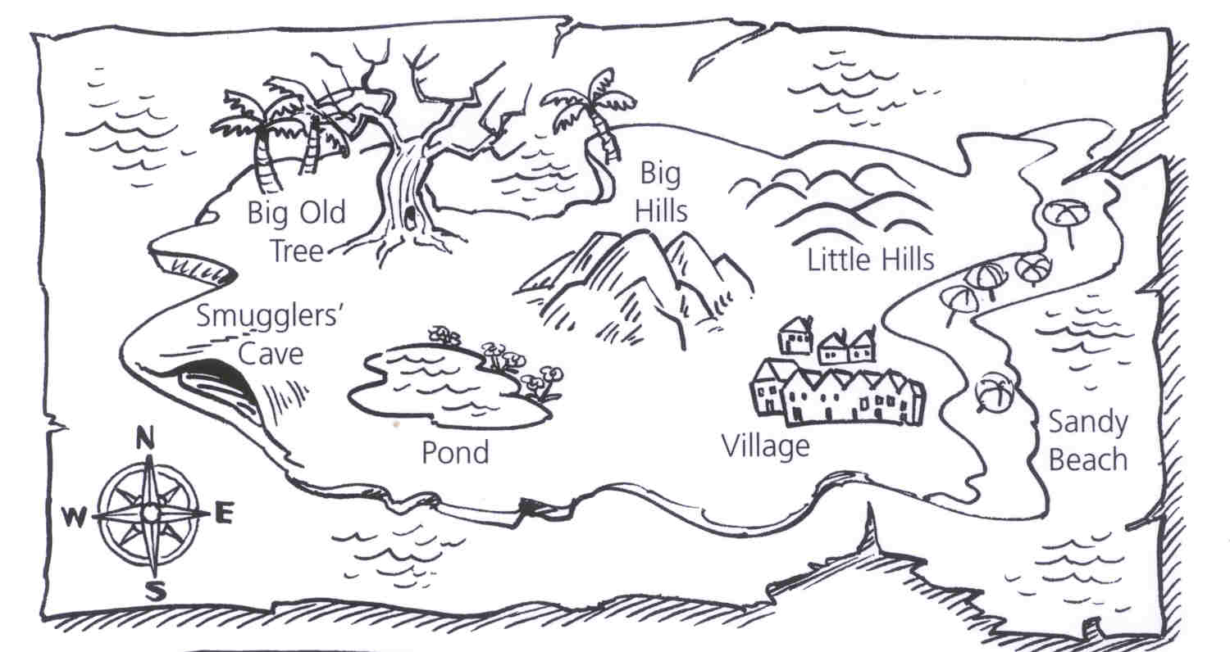

Map source: Rigby Maths for Victoria – Year 4 student book

|  |  |  |  |
| --- | --- | --- | --- |
| **From** | **To** | **Distance** | |
| Big Old Tree | Smugglers’ Cave | 350 metres | |
| Smugglers’ Cave | Pond | 300 metres | |
| Pond | Village | 470 metres | |
| Village | Sandy Beach | 290 metres | |
| Village | Little Hills | 312 metres | |
| Village | Big Hills | 310 metres | |
| Sandy Beach | Little Hills | 417 metres | |
| Little Hills | Big Hills | 180 metres | |
| Big Hills | Big Old Tree | 490 metres | |
| Write an equation to work out the answers to these questions.  An example has been done for you. | | | |
| What distance would you travel if you walked from the Village to Little Hills to see if you could spot any hidden treasure, then went to Sandy Beach for a swim before going home to the village? | | | 312  + 417  290  1019 |
| You begin at the Village and go hunting for treasure at the Big Old Tree. You take the route via Big Hills. How far do you walk there and back? | | |  |
| You leave your house at the Village to go for a swim at the pond. You spot something that looks like treasure near Smugglers’ Cave and walk over to the cave to explore before returning home. How far do you walk? | | |  |
| You are caught exploring the Smugglers’ Cave. You run all the way around the island to get away from the smugglers. From the cave you run to the Big Old Tree, to Big Hills, to Little Hills and then home to the Village. How far did you run? | | |  |

|  |
| --- |
|  |
|  |

**6**

Focus

You will be practising skip counting by 2, 3, 4, 5, 6 and 10.

The skip counting will be based on the times tables. You are also going to begin learning your 7 times tables.

|  |
| --- |
| S215704677080502094131 |

Introduction

I learnt about skip counting in Unit 1 this year.

I learnt that when you skip count you are counting in a pattern. You have to work out what the pattern is before you can continue a count.

Skip counting helps me to learn my times tables. I can sing the 5 times tables.

5, 10, 15, 20, 25, 30, 35, 40, 45, 50, 55, 60.

## 

## Activity 1

bd06121_**For you to do**

In this activity you will: continue a pattern on a chart. In Unit 1 you worked out the pattern of squares in a chart.

Think about the pattern in each of the three charts below. When you work out the pattern, continue it along both rows of each chart. You can colour the squares or draw a cross in them.

|  |  |  |  |  |  |  |  |  |  |  |  |
| --- | --- | --- | --- | --- | --- | --- | --- | --- | --- | --- | --- |
|  |  |  |  |  |  |  |  |  |  |  |  |
|  |  |  |  |  |  |  |  |  |  |  |  |

|  |  |  |  |  |  |  |  |  |  |  |  |  |  |  |
| --- | --- | --- | --- | --- | --- | --- | --- | --- | --- | --- | --- | --- | --- | --- |
|  |  |  |  |  |  |  |  |  |  |  |  |  |  |  |
|  |  |  |  |  |  |  |  |  |  |  |  |  |  |  |

|  |  |  |  |  |  |  |  |  |  |  |  |  |  |  |  |  |  |  |
| --- | --- | --- | --- | --- | --- | --- | --- | --- | --- | --- | --- | --- | --- | --- | --- | --- | --- | --- |
|  |  |  |  |  |  |  |  |  |  |  |  |  |  |  |  |  |  |  |
|  |  |  |  |  |  |  |  |  |  |  |  |  |  |  |  |  |  |  |

Make up your own pattern by colouring or drawing in the squares on the chart below.

|  |  |  |  |  |  |  |  |  |  |  |  |  |  |  |  |  |  |  |
| --- | --- | --- | --- | --- | --- | --- | --- | --- | --- | --- | --- | --- | --- | --- | --- | --- | --- | --- |
|  |  |  |  |  |  |  |  |  |  |  |  |  |  |  |  |  |  |  |
|  |  |  |  |  |  |  |  |  |  |  |  |  |  |  |  |  |  |  |

## Activity 2

## bd06121_For you to do

**Patterns in Number Counting**

On the number chart below I have coloured in every thirdspace.

Can you work out what the next number will be? \_\_\_\_\_\_\_\_

What are you adding each time? \_\_\_\_\_\_\_\_\_\_

Complete the pattern to 40. Say it aloud to an adult.

|  |  |  |  |  |  |  |  |  |  |
| --- | --- | --- | --- | --- | --- | --- | --- | --- | --- |
| 1 | 2 | 3 | 4 | 5 | 6 | 7 | 8 | 9 | 10 |
| 11 | 12 | 13 | 14 | 15 | 16 | 17 | 18 | 19 | 20 |
| 21 | 22 | 23 | 24 | 25 | 26 | 27 | 28 | 29 | 30 |
| 31 | 32 | 33 | 34 | 35 | 36 | 37 | 38 | 39 | 40 |

On the number chart below I have coloured in every fourth space.

## Complete the pattern to 50. Say it aloud to an adult.

|  |  |  |  |  |  |  |  |  |  |
| --- | --- | --- | --- | --- | --- | --- | --- | --- | --- |
| 1 | 2 | 3 | 4 | 5 | 6 | 7 | 8 | 9 | 10 |
| 11 | 12 | 13 | 14 | 15 | 16 | 17 | 18 | 19 | 20 |
| 21 | 22 | 23 | 24 | 25 | 26 | 27 | 28 | 29 | 30 |
| 31 | 32 | 33 | 34 | 35 | 36 | 37 | 38 | 39 | 40 |
| 41 | 42 | 43 | 44 | 45 | 46 | 47 | 48 | 49 | 50 |

## Complete the gaps: 12, 16, \_\_\_\_\_, \_\_\_\_\_, 28, 32, \_\_\_\_\_, \_\_\_\_\_.Activity 3

bd06121_**For you to do**

**Patterns in Skip Counting**

You can learn patterns to help you remember a count. In many counts, numbers repeat regularly in the **units** column. When counting by **2s** the pattern in the **units** column is:

2 4 6 8 0

Circle the **units** pattern in the 2s count below.

|  |  |  |  |  |  |  |  |  |  |
| --- | --- | --- | --- | --- | --- | --- | --- | --- | --- |
| 1 | 2 | 3 | 4 | 5 | 6 | 7 | 8 | 9 | 10 |
| 11 | 12 | 13 | 14 | 15 | 16 | 17 | 18 | 19 | 20 |
| 21 | 22 | 23 | 24 | 25 | 26 | 27 | 28 | 29 | 30 |
| 31 | 32 | 33 | 34 | 35 | 36 | 37 | 38 | 39 | 40 |

The units patterns in the 5s and 10s counts are easy to remember.

Circle the **units** pattern in the 5s count red and the 10s count blue.

|  |  |  |  |  |  |  |  |  |  |
| --- | --- | --- | --- | --- | --- | --- | --- | --- | --- |
| 1 | 2 | 3 | 4 | 5 | 6 | 7 | 8 | 9 | 10 |
| 11 | 12 | 13 | 14 | 15 | 16 | 17 | 18 | 19 | 20 |
| 21 | 22 | 23 | 24 | 25 | 26 | 27 | 28 | 29 | 30 |
| 31 | 32 | 33 | 34 | 35 | 36 | 37 | 38 | 39 | 40 |

What do you notice about the **units** patterns? \_\_\_\_\_\_\_\_\_\_\_\_\_\_\_\_\_\_\_\_\_\_\_

\_\_\_\_\_\_\_\_\_\_\_\_\_\_\_\_\_\_\_\_\_\_\_\_\_\_\_\_\_\_\_\_\_\_\_\_\_\_\_\_\_\_\_\_\_\_\_\_\_\_\_\_\_\_\_\_\_\_\_\_\_\_\_\_\_\_

## Activity 3 continued

Use this table to complete the following activities.

|  |  |  |  |  |  |  |  |  |  |
| --- | --- | --- | --- | --- | --- | --- | --- | --- | --- |
| 1 | 2 | 3 | 4 | 5 | 6 | 7 | 8 | 9 | 10 |
| 11 | 12 | 13 | 14 | 15 | 16 | 17 | 18 | 19 | 20 |
| 21 | 22 | 23 | 24 | 25 | 26 | 27 | 28 | 29 | 30 |
| 31 | 32 | 33 | 34 | 35 | 36 | 37 | 38 | 39 | 40 |
| 41 | 42 | 43 | 44 | 45 | 46 | 47 | 48 | 49 | 20 |
| 51 | 52 | 53 | 54 | 55 | 56 | 57 | 58 | 59 | 60 |
| 61 | 62 | 63 | 64 | 65 | 66 | 67 | 68 | 69 | 70 |
| 71 | 72 | 73 | 74 | 75 | 76 | 77 | 78 | 79 | 80 |
| 81 | 82 | 83 | 84 | 85 | 86 | 87 | 88 | 89 | 90 |
| 91 | 92 | 93 | 94 | 95 | 96 | 97 | 98 | 99 | 100 |

Circle or colour the 3s count yellow. Start at number 3.

List all the units in the 3s pattern.

\_\_\_\_\_, \_\_\_\_\_, \_\_\_\_\_, \_\_\_\_\_, \_\_\_\_\_, \_\_\_\_\_, \_\_\_\_\_, \_\_\_\_\_, \_\_\_\_\_, \_\_\_\_\_.

## Activity 3 continued

Circle or colour the 4s count orange. Start at number 4.

List all the units in the 4s pattern.

\_\_\_\_\_, \_\_\_\_\_, \_\_\_\_\_, \_\_\_\_\_, \_\_\_\_\_.

Circle or colour the 6s count green. Start at number 6.

List all the units in the 6s pattern.

\_\_\_\_\_, \_\_\_\_\_, \_\_\_\_\_, \_\_\_\_\_, \_\_\_\_\_.

Circle or colour the 7s count in black. Start at number 7.

List all the units in the 7s pattern.

\_\_\_\_\_, \_\_\_\_\_, \_\_\_\_\_, \_\_\_\_\_, \_\_\_\_\_, \_\_\_\_\_, \_\_\_\_\_, \_\_\_\_\_, \_\_\_\_\_, \_\_\_\_\_.

Which number counts do you think would be easiest to learn and remember?

\_\_\_\_\_\_\_\_\_\_\_\_\_\_\_\_\_\_\_\_\_\_\_\_\_\_\_\_\_\_\_\_\_\_\_\_\_\_\_\_\_\_\_\_\_\_\_\_\_\_\_\_\_\_\_\_\_\_\_\_\_\_\_\_\_\_

Why do you think this? \_\_\_\_\_\_\_\_\_\_\_\_\_\_\_\_\_\_\_\_\_\_\_\_\_\_\_\_\_\_\_\_\_\_\_\_\_\_\_\_\_\_\_\_

\_\_\_\_\_\_\_\_\_\_\_\_\_\_\_\_\_\_\_\_\_\_\_\_\_\_\_\_\_\_\_\_\_\_\_\_\_\_\_\_\_\_\_\_\_\_\_\_\_\_\_\_\_\_\_\_\_\_\_\_\_\_\_\_\_\_

\_\_\_\_\_\_\_\_\_\_\_\_\_\_\_\_\_\_\_\_\_\_\_\_\_\_\_\_\_\_\_\_\_\_\_\_\_\_\_\_\_\_\_\_\_\_\_\_\_\_\_\_\_\_\_\_\_\_\_\_\_\_\_\_\_\_

Work out the pattern and complete these counts.

* 2, 6, 10, \_\_\_\_\_, \_\_\_\_\_, 22, \_\_\_\_\_, \_\_\_\_\_
* 1, 4, 7, \_\_\_\_\_, \_\_\_\_\_, \_\_\_\_\_, 19, 22, \_\_\_\_\_
* 6, 11, 16, \_\_\_\_, \_\_\_\_, 31, 36, \_\_\_\_, \_\_\_\_

## Activity 4

bd06121_**For you to do**

Use a clock with a second hand to time how long it takes to do these multiplication equations.

|  |  |  |
| --- | --- | --- |
| 1 ≈ 7 = | 1 ≈ 3 = | 1 ≈ 4 = |
| 2 ≈ 7 = | 2 ≈ 4 = | 2 ≈ 5 = |
| 3 ≈ 7 = | 3 ≈ 5 = | 3 ≈ 6 = |
| 4 ≈ 7 = | 4 ≈ 6 = | 4 ≈ 10 = |
| 5 ≈ 7 = | 5 ≈ 10 = | 5 ≈ 5 = |
| 6 ≈ 7 = | 6 ≈ 2 = | 6 ≈ 10 = |
| 7 ≈ 7 = | 7 ≈ 3 = | 7 ≈ 2 = |
| 8 ≈ 7 = | 8 ≈ 4 = | 8 ≈ 0 = |
| 9 ≈ 7 = | 9 ≈ 5 = | 9 ≈ 2 = |
| 10 ≈ 7 = | 10 ≈ 6 = | 10 ≈ 5 = |
| 11 ≈ 7 = | 11 ≈ 2 = | 11 ≈ 1 = |
| 12 ≈ 7 = | 12 ≈ 3 = | 12 ≈ 2 = |



...a table is an arrangement of letters or numbers in rows or columns. When multiplication facts are arranged in order, they are then called multiplication tables.

# 7

## Focus

You will be exploring numbers to 9999. You will also be making estimates when

adding numbers.

|  |
| --- |
| 444444  Sometimes there are easier ways to do things. You will be using a calculator to check your answers.    calculator character |

Introduction

I like using a calculator to work out the answers to Maths problems.

I can add numbers up using the calculator. All I do is turn the calculator on, press the digit buttons for the first number, press the + sign, key in the next number and press the = sign.

I always like to estimate the answer first, then I check it with the calculator. I estimate first so that I can be sure I have not made a mistake pressing the buttons on the calculator.



## Introduction continued

Have you used a calculator before? You will be learning about the **on** and **off** keys, the **clear** key, the **number** keys, the **operations** keys and the **display**.

Read and complete this activity to learn about some different parts of the calculator.

|  |
| --- |
| **Colour a calculator**  *calculator*  Source:Lewis & Marks,  *Adding Calculators* |

## Introduction continued

**Draw your calculator**

Your calculator will be different to the one you coloured in.

Copy the calculator you use on to this blank one.

Colour it like you did on the **Colour a calculator** page.

## Source: Lewis & Marks, *Adding Calculators*

## Keying in Numbers

## It is easy to enter a number into your calculator.

## You press the buttons in the order you say the number.

## You enter sixty-seven by pressing the 6 and the 7 .

## You enter one hundred and twenty-six by pressing 1 then 2 then 6 .

## Practise entering some numbers into your calculator.

## Practise adding some numbers too. Press the keys for one number, press the + key, press the keys for the next number, then press the = key. You will see the answer in the display.

|  |
| --- |
| 1 Remember to press **C** to clear the display before entering the next number or equation. |

## Activity 1

## bd06121_For you to do

Complete this activity using the **ON** key and the **number** keys of your calculator.

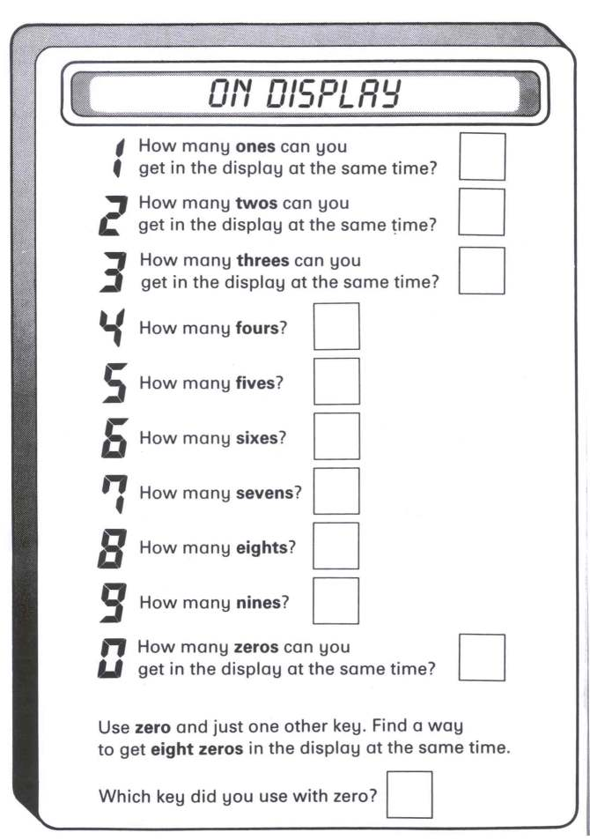

Source:Lewis & Marks,  *Adding Calculators*

## Activity 2

## bd06121_For you to do

In this activity you will: estimate the answers to some equations and circle the number you think is the correct answer for each one.

To estimate the answer, round the numbers off to the nearest 10 before adding them together.

After you circle the most likely answer, use your calculator to check if you are right.

Here is an example:

|  |  |  |
| --- | --- | --- |
| 73 + 49 = ? | 110 122 130 | |
| j0078622  73 can be rounded off to 70.  49 can be rounded off to 50.  I know that 7 + 5 = 12, so 70 + 50 = 120.  The closest number to 120 is 122. I will circle it and check it on the calculator.  73 + 49 = 122. I am right! | | |
| 55 + 22 = ? | | 60 82 77 |
| 73 + 77 = ? | | 115 122 150 |
| 166 + 20 = ? | | 186 160 190 |
| 510 + 210 = ? | | 710 820 720 |
| 45 + 49 = ? | | 85 105 94 |

## Activity 3

In this activity you will work out numbers that are **less than** and **more than** in your head, then use your calculator to check if you

are right.

|  |
| --- |
| **How to subtract using the calculator**    To complete the equation  76 – 39 =  press: **7 6**  press: **–**      press: **3 9**  press: **=**  You will see the answer on the display. |

|  |
| --- |
| bd06121_For you to do |

|  |  |  |
| --- | --- | --- |
| Work it out mentally, check, then write the number 10 **less** than: | | |
| 9100 | 1871 | 5004 |
| 4090 | 9890 | 7060 |
| 8010 | 2904 | 8600 |
| 1000 | 1500 | 1559 |
| 7105 | 8654 | 9475 |

## Activity 3 continued

|  |  |  |
| --- | --- | --- |
| Work it out mentally, check, then write the number 100 **less** than: | | |
| 9160 | 1871 | 5094 |
| 4090 | 9890 | 7060 |
| Work it out mentally, check, then write the number 100 **more** than: | | |
| 9160 | 1871 | 5994 |
| 4090 | 9890 | 7060 |
| 9899 | 9090 | 1440 |

## Activity 4

## bd06121_For you to do

## Calculator Bingo

You will need:

* a partner
* a calculator
* counters of two different colours

Take turns to:

* Select a number from **Group A** and a number from **Group B** that you estimate will add up to a number on the grid.
* Use a calculator to add the numbers.
* Find the total on the grid. Put a counter on it. If the number already has a counter on it, miss a turn.
* The first player to get five counters in a row wins.

## Activity 4 continued

## Group A Group B

|  |
| --- |
| **24 91 65 8**  **16 48 72 57**  **85 33 29** |

|  |
| --- |
| **66 38 13 54**  **9 84 21 78**  **32 45 97** |

|  |  |  |  |  |  |  |  |  |  |
| --- | --- | --- | --- | --- | --- | --- | --- | --- | --- |
| 1 | 2 | 3 | 4 | 5 | 6 | 7 | 8 | 9 | 10 |
| 11 | 12 | 13 | 14 | 15 | 16 | 17 | 18 | 19 | 20 |
| 21 | 22 | 23 | 24 | 25 | 26 | 27 | 28 | 29 | 30 |
| 31 | 32 | 33 | 34 | 35 | 36 | 37 | 38 | 39 | 40 |
| 41 | 42 | 43 | 44 | 45 | 46 | 47 | 48 | 49 | 20 |
| 51 | 52 | 53 | 54 | 55 | 56 | 57 | 58 | 59 | 60 |
| 61 | 62 | 63 | 64 | 65 | 66 | 67 | 68 | 69 | 70 |
| 71 | 72 | 73 | 74 | 75 | 76 | 77 | 78 | 79 | 80 |
| 81 | 82 | 83 | 84 | 85 | 86 | 87 | 88 | 89 | 90 |
| 91 | 92 | 93 | 94 | 95 | 96 | 97 | 98 | 99 | 100 |



An Australian man spent sixteen years typing

the numbers 1 to 1,000,000 on 19,900 sheets

of paper. Starting in 1982, he made the final keystroke in 1998.

Guinness Book of Records 2001

**8**

You will be solving addition and subtraction problems with money.

You will solve some problems mentally, on paper, and with your calculator.

## Focus

|  |
| --- |
| S21570467708050209410 |

Introduction

I have been practicing adding up money and working out the approximate change the shopkeeper will give me. I round the numbers off to the nearest ten or the nearest dollar.

I work out the change too. Yesterday I bought a drink for $2.30 and a banana for 50c. When I gave the shopkeeper $3.00 I knew he had to give me back 20c.

My mum lets me buy treats for the family at the bakery.

I work out in my head how many custard tarts and jam tarts I can buy with the money she gives me.



## Introduction continued

|  |
| --- |
| Working with money on the calculator Look at the calculator.  You will not see a **$** key.  Press:  **4 . 5 0**  to show $4.50  Source:Lewis & Marks,  *Adding Calculators* |

## Activity 1

|  |
| --- |
| bd06121_For you to do |

Complete this activity to show that you know how to key money amounts into the calculator.

## Write the keys you press for each amount of money.

## Match the keys to the numbers in the display.

## Clear the calculator after each exercise. Press C to clear.

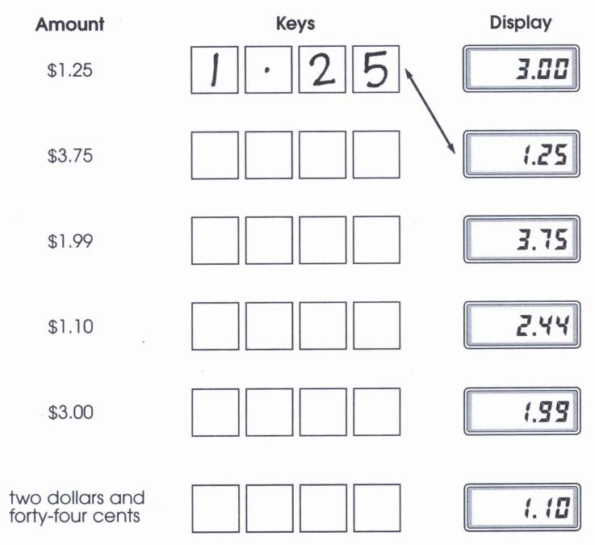

## Source:Lewis & Marks, *Adding Calculators*

## Activity 1 continued

Use your calculator to add the cost of these items. The prices are

listed below.

* hamburger and banana \_\_\_\_\_\_\_\_\_\_\_\_\_\_\_\_\_\_\_\_\_
* hamburger, banana and milk \_\_\_\_\_\_\_\_\_\_\_\_\_\_\_\_\_\_\_
* salad roll, ice-cream and milk \_\_\_\_\_\_\_\_\_\_\_\_\_\_\_\_\_\_\_
* salad roll, banana and milk \_\_\_\_\_\_\_\_\_\_\_\_\_\_\_\_\_\_\_\_\_\_\_

Choose what you would like to eat from the food pictured below.

List the items and the total cost.

\_\_\_\_\_\_\_\_\_\_\_\_\_\_\_\_\_\_\_\_\_\_\_\_\_\_\_ \_\_\_\_\_\_\_\_\_\_\_\_\_\_\_\_\_\_\_\_\_\_\_\_\_\_\_

\_\_\_\_\_\_\_\_\_\_\_\_\_\_\_\_\_\_\_\_\_\_\_\_\_\_\_ \_\_\_\_\_\_\_\_\_\_\_\_\_\_\_\_\_\_\_\_\_\_\_\_\_\_\_

\_\_\_\_\_\_\_\_\_\_\_\_\_\_\_\_\_\_\_\_\_\_\_\_\_\_\_ \_\_\_\_\_\_\_\_\_\_\_\_\_\_\_\_\_\_\_\_\_\_\_\_\_\_\_

Total cost: \_\_\_\_\_\_\_\_\_\_\_\_\_\_\_\_\_\_\_\_\_\_\_\_\_\_\_

|  |  |  |
| --- | --- | --- |
| FODMT010  Hamburger $4.50 | FODPR183  Salad roll $3.20 | FODVF055  Banana 60c |
| FODDR041  Icecream $2.50 | FODDR092  Milk $1.20 | FODBK008  Muffin $2.80 |
| Activity 2 bd06121_**For you to do** | | |

**Game: Calculator Subtraction**

## This is a game for two players.

## You will need:

* a calculator
* partner

**How to play:**

Begin by entering 101 in the calculator.

Each player takes turns to subtract a number between 1 and 10 from the number on the display.

Before subtracting, each player must say what number they are subtracting and what they think the display will read.

If either player is incorrect, their partner has an extra turn.

The first player to make the display read 0 is the winner.

**Variation:**

Begin with 2001 and subtract a number between 1 and 99 on each turn.

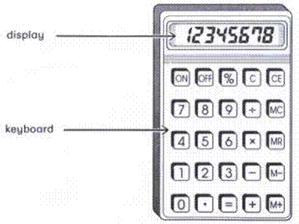

## Activity 3

## bd06121_For you to do – Furnish your bedroom

Imagine you have $1000 to buy furniture for your room. Choose from the items pictured. Circle the bed, drawers, desk, chair, book/toy shelf and lamp you like. Circle each item, estimate the tally. Round the cost of each item off to the nearest hundred dollars.

|  |  |  |
| --- | --- | --- |
| H_HFR069  $389 | H_HFR073  $ 219 | H_HFR065  $305 |
| H_HFR196  $230 | 4  H_HFR198  $230 | 2  H_HFR190  $99 |
| H_HFR188  $129 | H_HFR187  $189 | H_HFR289  $79 |
| H_HFR141  $99 | H_HFR134  $39 | H_HFR189  $189 |
| H_HFR206  $69 | H_HFR211  $15 | H_HFR253  $109 |

## Activity 3 continued

How much did you estimate your furniture choices would add up to?

$\_\_\_\_\_\_\_\_\_\_\_\_\_\_\_\_

**Use your calculator to solve these problems**.

1. Add up the cost of the furniture you chose.

Total = $\_\_\_\_\_\_\_\_\_\_\_\_\_\_\_\_

1. How did you work out the total?

\_\_\_\_\_\_\_\_\_\_\_\_\_\_\_\_\_\_\_\_\_\_\_\_\_\_\_\_\_\_\_\_\_\_\_\_\_\_\_\_\_\_\_\_\_\_\_\_\_\_\_\_\_\_\_\_\_\_\_\_

\_\_\_\_\_\_\_\_\_\_\_\_\_\_\_\_\_\_\_\_\_\_\_\_\_\_\_\_\_\_\_\_\_\_\_\_\_\_\_\_\_\_\_\_\_\_\_\_\_\_\_\_\_\_\_\_\_\_\_\_\_

1. How much will you have left from $1000? $\_\_\_\_\_\_\_\_\_\_\_\_

*or*

How much more than $1000 does the furniture cost? $\_\_\_\_\_\_\_\_

1. If the cost is more than $1000, exchange some of your furniture so that you do not spend more than $1000.

What is your new tally?

$\_\_\_\_\_\_\_\_\_\_\_\_\_\_\_

1. Circle the bed, drawers, desk, chair, book/toy shelf and lamp that add up to a total that is close to $1000.
2. What is the least amount of money you could spend to buy:

* a bed
* drawers
* desk
* chair
* book/toy shelf
* lamp Total: $\_\_\_\_\_\_\_\_\_\_\_\_\_\_

# 9

## Focus

j0078735

You have been working very hard. Now you will be **revising** work completed.

**Completing the work**

|  |
| --- |
|  |

You completed number counts based on the times tables.

Can you complete these number counts made up of bigger numbers?

Remember: *When you skip count you have to work out what the pattern is before you can work out what the next number is.*

To work out the pattern you need to know the difference between each number.

|  |
| --- |
| In this pattern you have to add \_\_\_\_\_\_\_\_\_?  1720, 1723, 1726, \_\_\_\_\_, \_\_\_\_\_, \_\_\_\_\_, \_\_\_\_\_ |
| In this pattern you have to add \_\_\_\_\_\_\_\_\_?  1954, 1959, 1964, \_\_\_\_\_, \_\_\_\_\_, \_\_\_\_\_, \_\_\_\_\_ |
| In this pattern you have to subtract \_\_\_\_\_\_\_\_\_?  7515, 7510, 7505, \_\_\_\_\_, \_\_\_\_\_, \_\_\_\_\_, \_\_\_\_\_ |
| In this pattern you have to add \_\_\_\_\_\_\_\_\_?  8748, 8750, 8752, \_\_\_\_\_, \_\_\_\_\_, \_\_\_\_\_, \_\_\_\_\_ |
| In this pattern you have to add \_\_\_\_\_\_\_\_\_?  8748, 8848, 8948, \_\_\_\_\_, \_\_\_\_\_, \_\_\_\_\_, \_\_\_\_\_ |
| In this pattern you have to add \_\_\_\_\_\_\_\_\_?  7, 14, 21, \_\_\_\_, \_\_\_\_, \_\_\_\_, \_\_\_\_, \_\_\_\_, \_\_\_\_, \_\_\_\_ |

Have you practised your times tables?

Use a clock with a second hand to time how long it takes.

|  |  |  |
| --- | --- | --- |
| 1 ≈ 7 = | 1 ≈ 3 = | 1 ≈ 4 = |
| 2 ≈ 7 = | 2 ≈ 4 = | 2 ≈ 5 = |
| 3 ≈ 7 = | 3 ≈ 5 = | 3 ≈ 6 = |
| 4 ≈ 7 = | 4 ≈ 6 = | 4 ≈ 10 = |
| 5 ≈ 7 = | 5 ≈ 10 = | 5 ≈ 5 = |
| 6 ≈ 7 = | 6 ≈ 2 = | 6 ≈ 10 = |
| 7 ≈ 7 = | 7 ≈ 3 = | 7 ≈ 2 = |
| 8 ≈ 7 = | 8 ≈ 4 = | 8 ≈ 0 = |
| 9 ≈ 7 = | 9 ≈ 5 = | 9 ≈ 2 = |
| 10 ≈ 7 = | 10 ≈ 6 = | 10 ≈ 5 = |
| 11 ≈ 7 = | 11 ≈ 2 = | 11 ≈ 1 = |
| 12 ≈ 7 = | 12 ≈ 3 = | 12 ≈ 2 = |

Time taken: \_\_\_\_\_\_\_\_\_\_\_\_\_\_\_\_\_ How much faster? \_\_\_\_\_\_\_\_\_\_\_\_\_\_\_\_\_

**Check your answers with a calculator**Calculate how much change you would get back from $5.00 for each of these items.

Use your calculator *or* show your working.

Draw the change in the coin shapes in each space.

You can add more coin shapes if you choose.

|  |  |
| --- | --- |
| Use your own collection of coins to check your equations  and change. | PBANK001 |

The first one has been done for you.

|  |  |  |  |  |  |
| --- | --- | --- | --- | --- | --- |
| bunch of grapes  cost: $3.90 | | FRUIT109 | | sandwich  cost: $2·20 | FOOD043 |
|  | | | |  | |
|  | 5·00 | |  |
|  | - 3·90 | |  |
|  | 1·10 | |  |
| 1 dollar 10 cents | | | |

|  |  |  |  |
| --- | --- | --- | --- |
| apple  cost: 80 cents | FRUIT068 | can of drink  cost: $1.80 | DRINK155 |
|  | |  | |
| ice-cream  cost: $2.40 | DAIRY043 | hamburger  cost: $4.50 | FOOD038 |
|  | |  | |