**History Inquiry**

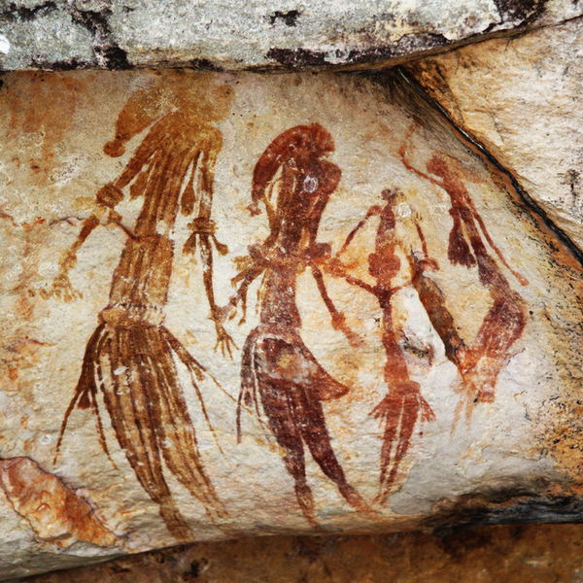

[*http://commons.wikimedia.org/wiki/File:Bradshaw_rock_paintings2.jpg*](http://commons.wikimedia.org/wiki/File:Bradshaw_rock_paintings2.jpg)

What do early archaeological sites tell us about Australia’s Indigenous people?



**GETTING KNOWLEDGE READY**

1. What do you think life would have been like for Aboriginals and Torres Strait Islanders before the Europeans arrived? Write your answer in the thought bubble below.

**Early Archaeological Sites**

Many ancient Aboriginal sites have been discovered across Australia. Evidence from camping sites and rock art show how and when Aboriginal peoples lived in each particular site.

**Northern Australia**

Many sandstone shelters (caves) have been found in northern Australia, where the earliest inhabitants of Australia lived. Evidence from camping sites and rock art show how and when Aboriginal peoples lived in each particular site.

1. What do you think these shelters were used for?

1. What would you imagine layered the floors of these shelters?

Shelters were used for camping and for meals. The floors of some shelters are layered with charcoal and ash from camp fires. Remains of food, such as shells and bones, stone tools and pieces of ochre can be found in the layers.

1. Look up the meaning of ***ochre*** and write it below.

1. What do you think Aboriginals used ochre for?

**Earliest Evidence**

Two rock shelters in Arnhem Land in the Northern Territory show evidence of human occupation from about 60 000 to 50 000 years ago. They have been named Malakunanja II and Nauwalabila I.

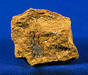

Used pieces of ochre, picture above, were found in the Arnhem Land shelters. Aboriginal peoples used ochre for rock painting. Stone tools were also found, as well as ground haematite.

1. Look up the meaning of ***haematite*** and write it below.

1. What do you think Aboriginals used haematite for?

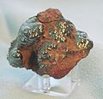

Haematite, pictured above, was used for rock art, body paint, decoration of artefacts, ceremonies and even protection from insects.

1. Look up the meaning of ***artefact*** and write it below.

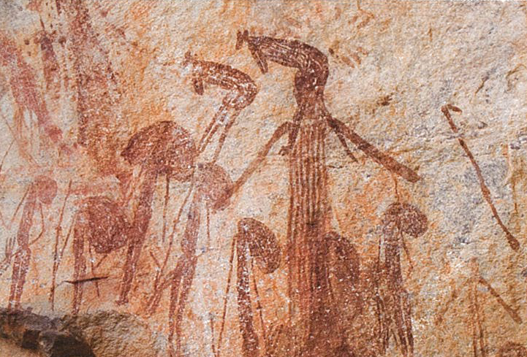

|  |
| --- |
| *Rock art was an important part of Aboriginal culture. In this rock painting, the Wandjina spirits bring the wet season rains to the people of the Kimberley.* |

***Source: Discovering History (Middle Primary) / Arrival and Lifestyle***

***– Jennifer Lawless and Kate Cameron* (PEARSON AUSTRALIA)**

1. Research the following website to learn about early archaeological sites in the Grampians, Victoria:

<https://www.visitgrampians.com.au/see-do/culture/indigenous-culture/aboriginal-rock-art-sites>

1. Can you find any other sites within Victoria?
2. Present your findings about the location and significance of one Aboriginal archaeological site in Victoria below. Alternatively, you can type a Word document or create a PowerPoint presentation. Be sure to include a photo or draw a replica.

|  |
| --- |
| *VICTORIAN ABORIGINAL ARTEFACT* |

**REFLECTION**

Please think about what you’ve learnt in this module. In your own words please write your answer below.

1. *Do you think there is value in seeing and learning about archaeological sites related to Indigenous Australians? Explain your answer.*