**History Inquiry**

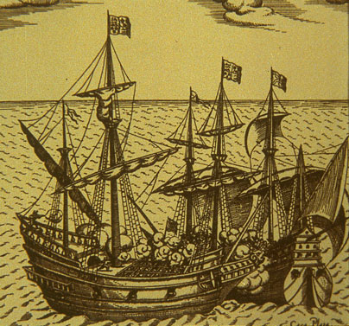

What was life like for the great explorers?



**Making maps**

Even though the explorers had clever tools like astrolabes and telescopes sometimes they got horribly lost and confused. Christopher Columbus thought he was in Asia when he was in the Bahamas. Have you ever been lost? It’s not a very nice feeling. One way to avoid getting lost is by making a map.

**What is a map?**

A map is a drawing of an area as you would see it if you were looking from high up above. You can make maps of all sorts of places. You can make a map of your bedroom or, like the explorers you can make a map of the world. Today you will learn some map making skills using some stuff you might have around the place.

**Collect together the following things:**

|  |  |
| --- | --- |
| * **A box of matches** | * **A small bowl** |
| * **A bottle** | * **A pencil** |
| * **A button** | * **A leaf** |

Spread them out on a sheet of A4 paper on the floor. Ask your someone to help you to stand up on a chair so that you can look down at them. Notice how different things look from up above. Each of the objects just looks like a shape. If you’ve got a camera take a photo of your collection. Have a look at my example.

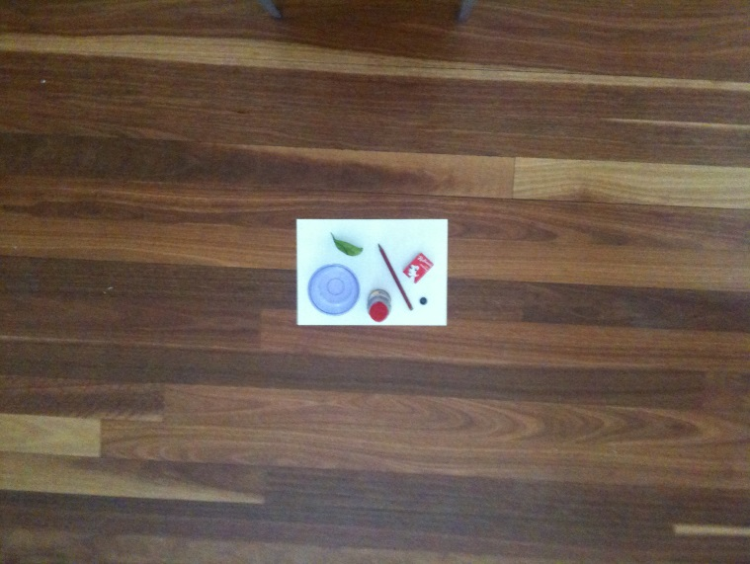

Now, fold an A4 piece of paper in half and draw a picture of your photo on the right half of the paper. If you don’t have a camera you can draw a picture of my photo.

Here’s my picture. If you hadn’t seen my photo would you know what the items were?

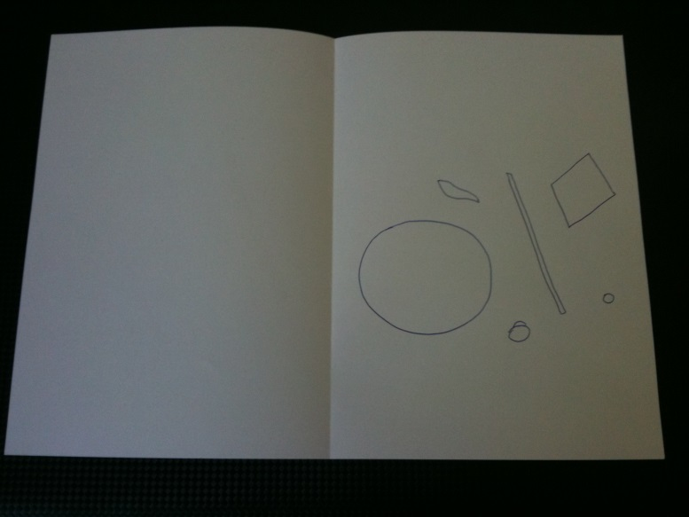

What about if I add some colour? Use your coloured pencils to colour each item a different colour.

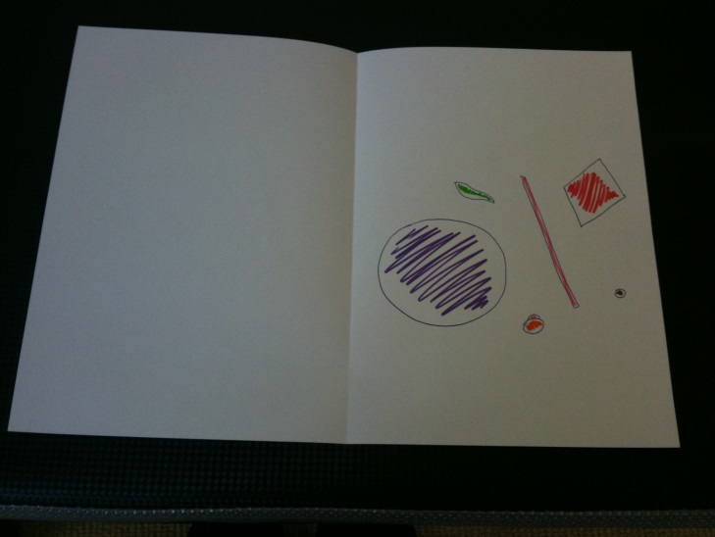

What else can you do to show what each item is in the picture? How about a list? A list on a map is sometimes called a key and sometimes it is called a **legend.**

|  |  |
| --- | --- |
| **Legend**  purple = bowl  green = leaf  orange = bottle  pink = pencil  red = matchbox  brown = button | 015 |

Make a legend to go with your picture. Write it on the left side of your page like I have in the picture above.

To truly turn our pictures into maps there is some other information we need to include. We need to find out the orientation of the items on our map. In other words we need to find out where our items are on the points of a compass. Is the orientation to the North, South, East or West?

Our planet Earth has an imaginary line running through the middle of it. We call this line the axis. In fact, the Earth [rotates around this axis](http://www.whyzz.com/answer/detail/category/7/subcategory/48/qid/862) once each day. At the top of the axis is an area called the [North Pole](http://www.whyzz.com/answer/detail/category/7/subcategory/48/qid/2330), and at the bottom is the [South Pole](http://www.whyzz.com/answer/detail/category/7/subcategory/48/qid/2330). North, south, east and west - these are the four main directions, also called cardinal directions, and they help us get where we need to go!

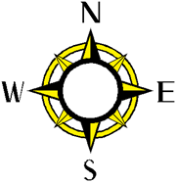

Many smart phones have a compass app. If your supervisor has a smart phone, tap on the compass app and hold it over your items. It will show you which is North. Perhaps you have a real compass. This will also show you North when you hold it over your items. Have a look at how I’ve included this information on my map below. Add this to your map too.

|  |  |
| --- | --- |
| **Legend**  N    purple = bowl  green = leaf  orange = bottle  pink = pencil  red = matchbox  brown = button | **003** |

If you look at the map we are making you can see where the different items are placed and now that we have a legend, you can tell what they are. Something that you can’t tell is the real size of each item and how far apart they are. When we draw maps, we show the real distance and size of objects as a much smaller distance and size on paper. The word to describe this is representation. Map makers show how big things are by including a scale on the map.

If you were one of the explorers this would be important information. You would want to know how big an island was if you had to sail around it or how far it was from one shore to the other.

When you folded your piece of A4 paper in half you made your map half the size which then made the objects on the page half the size as well of the original arrangement of items on the paper. This means that on your map everything is really twice the size of the picture you have drawn. This is called scale and there are a couple of different ways you can show it on your map.

We are going to use a word statement. This word statement is:

One centimetre represents two centimetres.

Write this statement on your map.

One centimetre represents two centimetres.

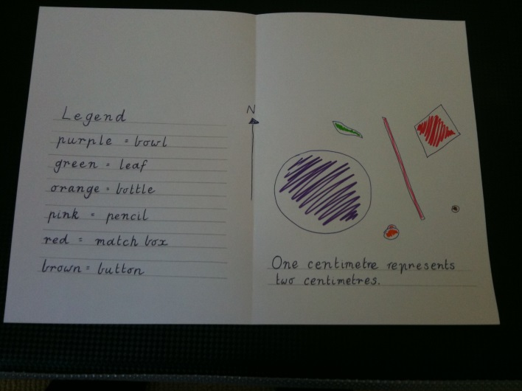

The next thing a map needs is a border. Rule a neat border around your map.

Only two more things to do and then your map will be finished. You have to give your map a title. I’m going to call mine *Kitchen Stuff*. You can choose your own name which briefly describes what is on the map. Write the title at the top of the page.

The last thing is to write down the source of the map and the date it was made. In this case you can write down your name and school work. You also need to include the date. Write this information under the title.

Here’s my finished map.

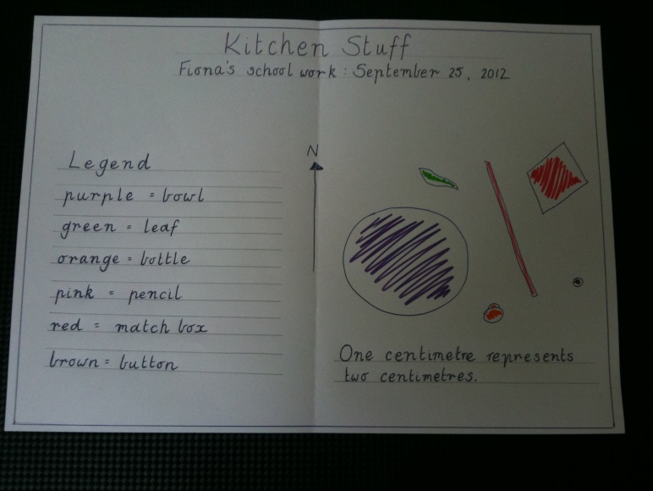

What makes a map different to a drawing or photo? A map is a visual representation. It doesn’t look like the real thing. It also must have the following six features:

**B**order

**O**rientation

**L**egend

**T**itle

**S**cale

**S**ource

There’s an easy rule you can use to remember the six features.

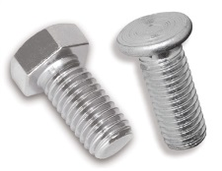

BOLTSS

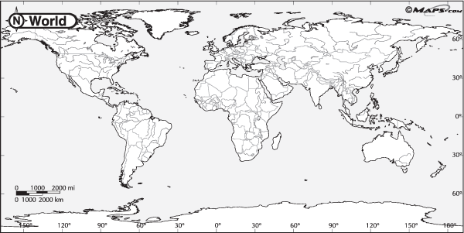

One of the BOLTSS is missing on this map of the world. Can you work out which one?

_________________________________________________________________

Hoist the main sail! We’re getting back on board with the explorers. Today you will learn about the ships the explorers sailed in and the life they led on board.

*Read A Life at Sea below.* When you have finished,complete the following quiz.

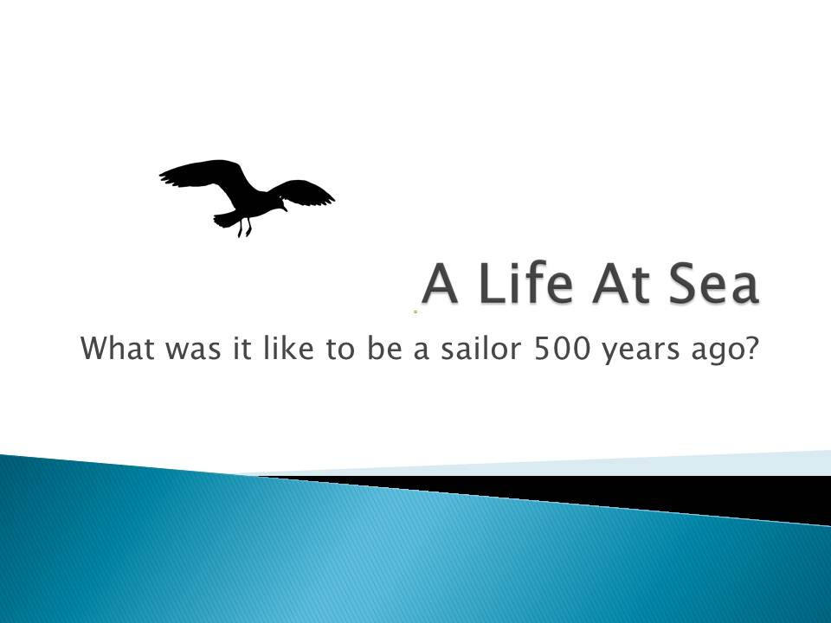

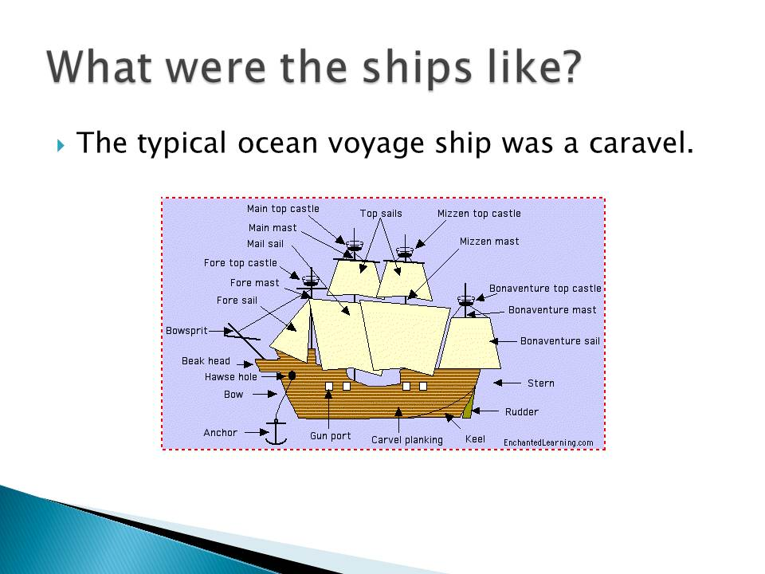

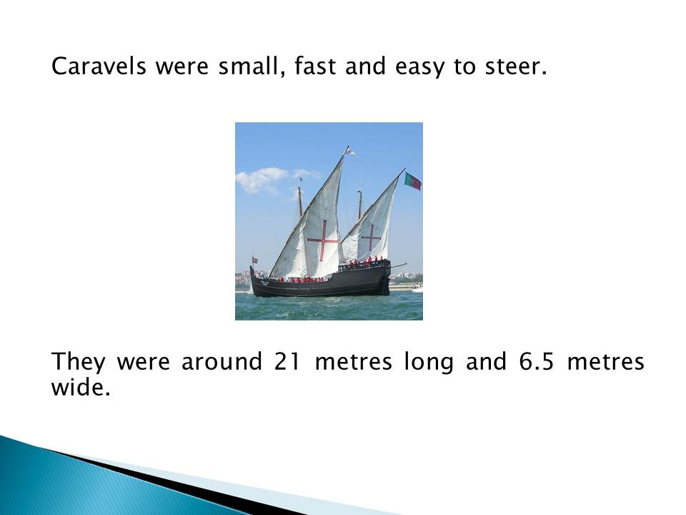

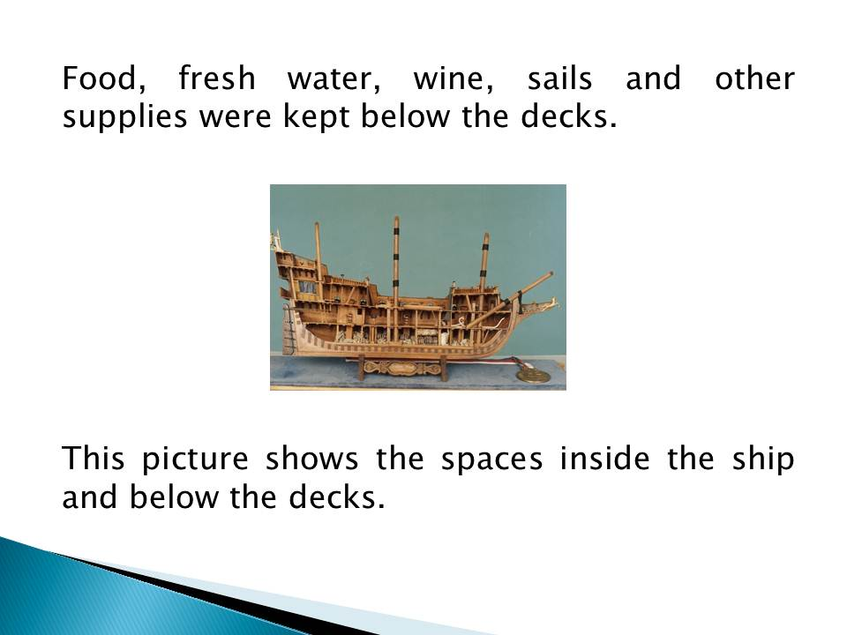

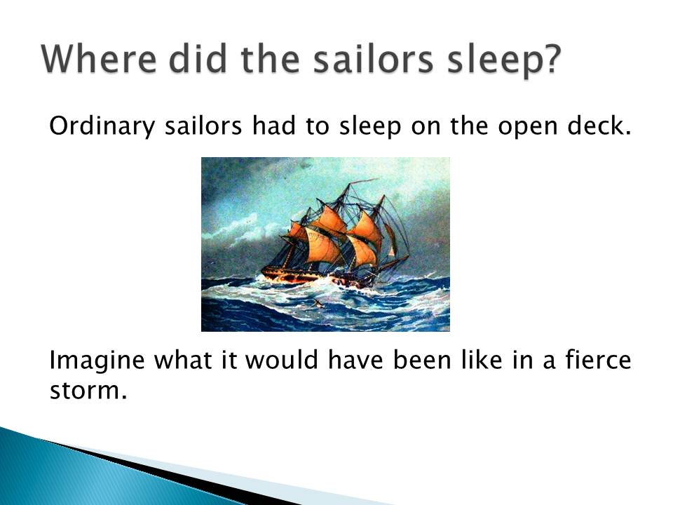

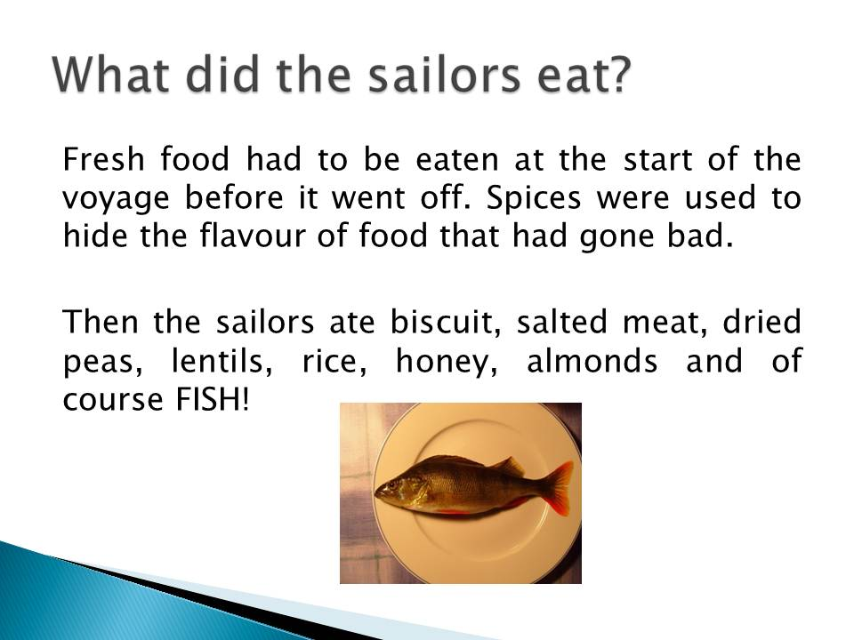

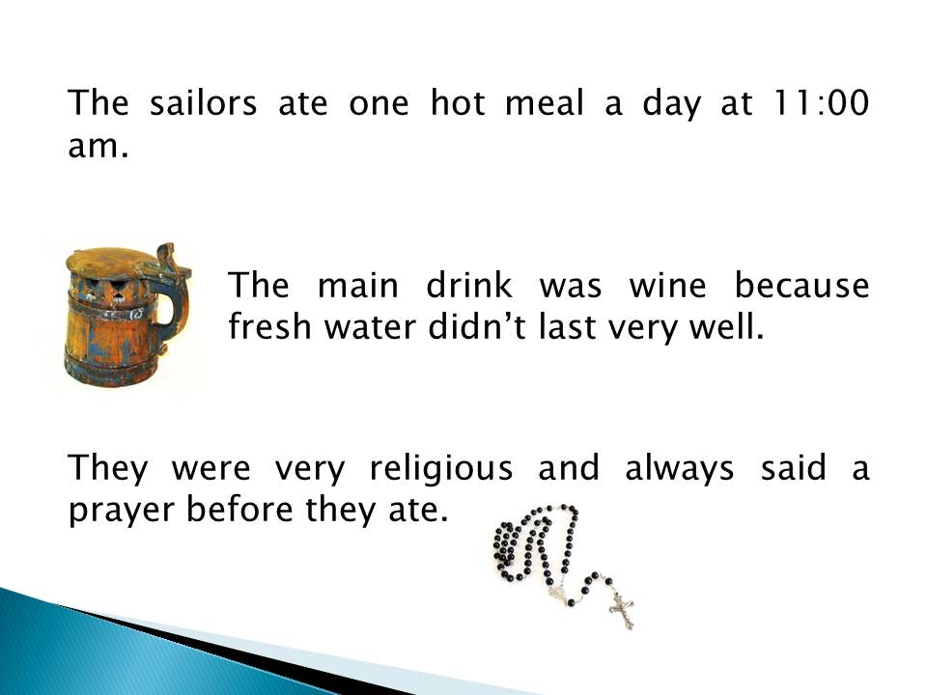

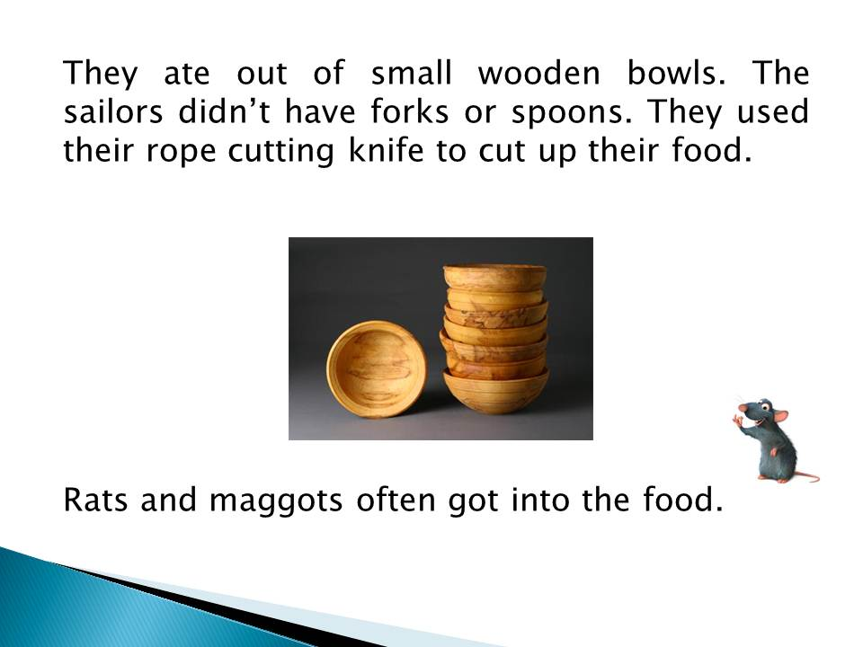

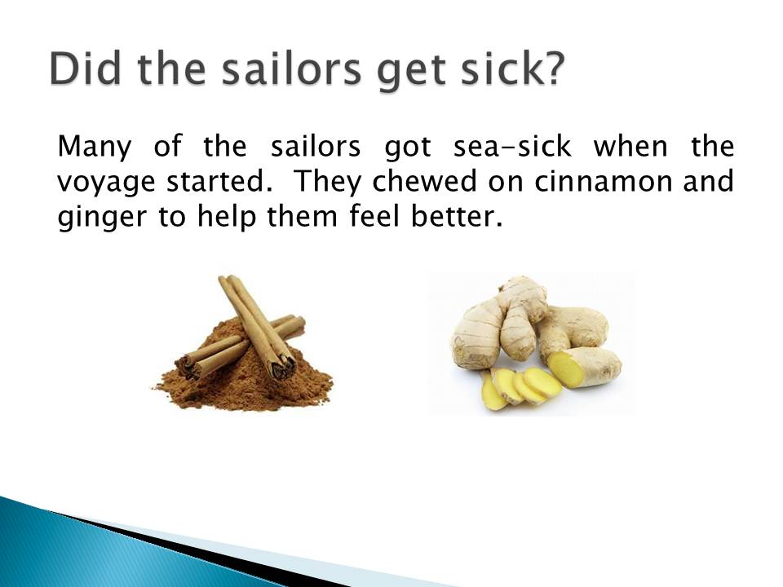

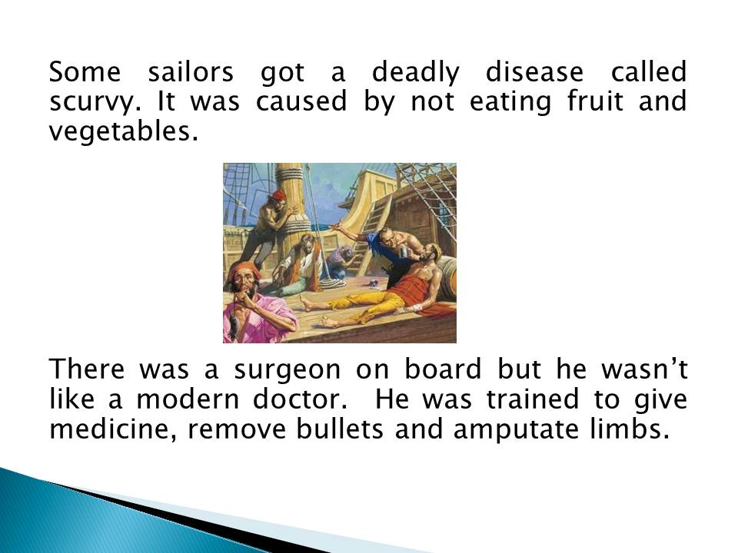

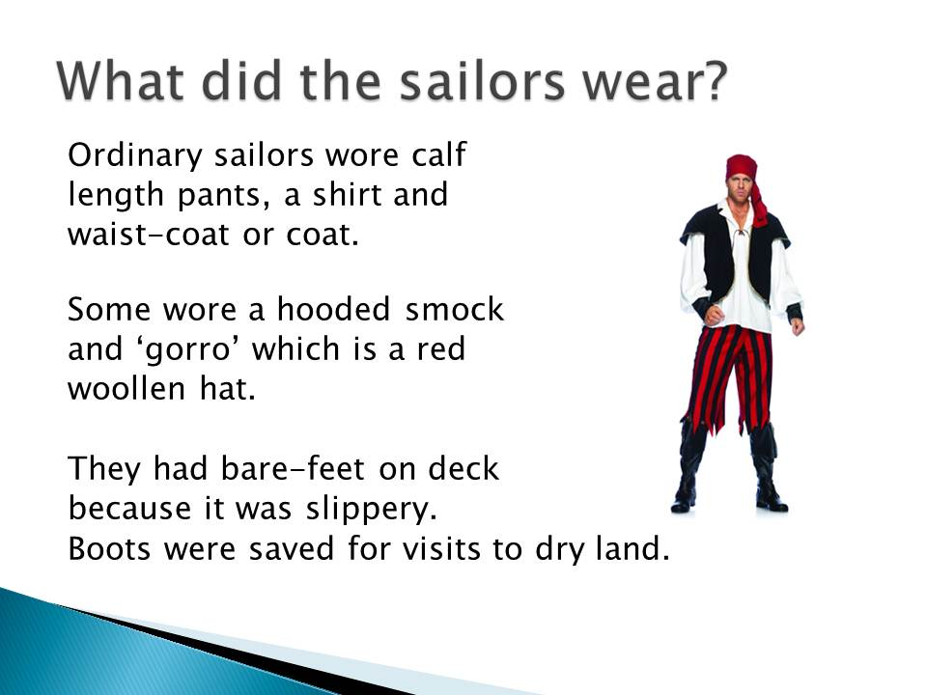

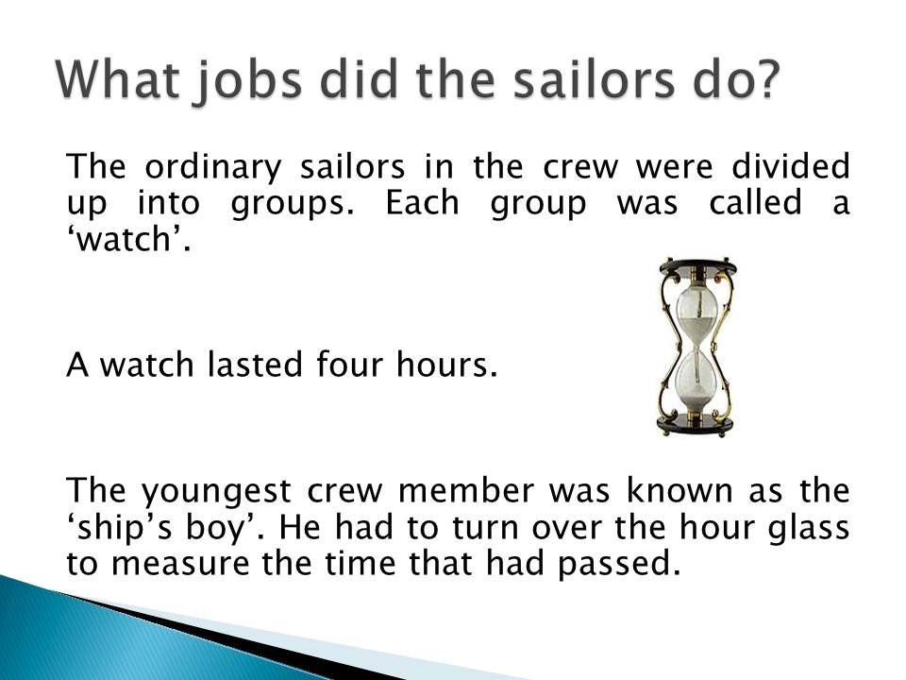

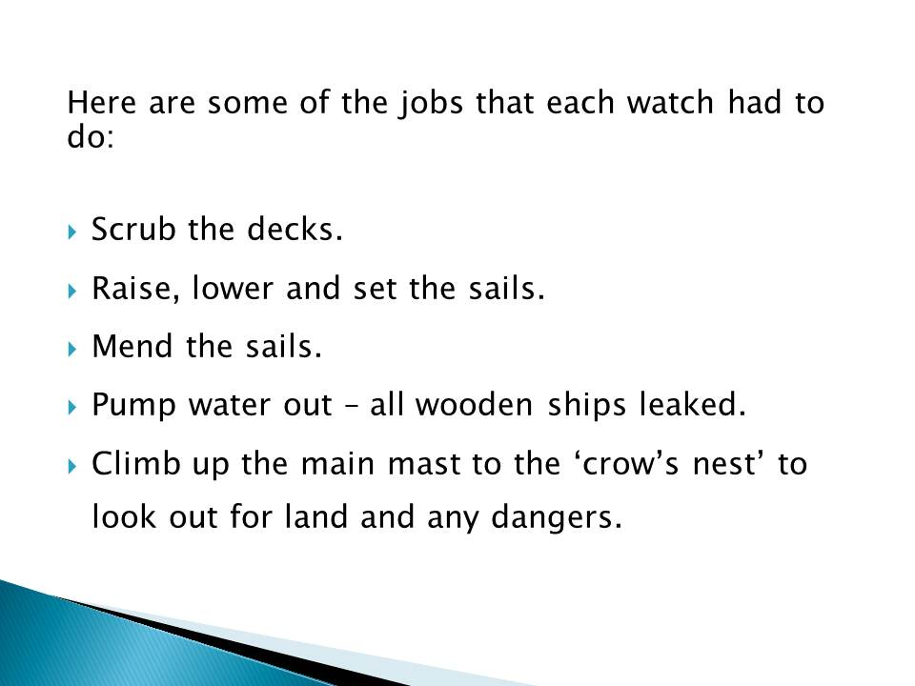

|  |
| --- |
| sailing%20ship**Life at Sea Quiz** |
| **Tick the correct answer to each question below.**   1. What was the name of a typical ocean voyage ship 500 hundred years ago?   a) Caroline  b) Carousel  c) Schooner  d) Caravel  2. Where did the sailors sleep?  a) In a cabin  b) In a hammock  c) On the open deck  d) Below the decks  3. Two foods the sailors ate were:  a) Ice-cream and jelly  b) Lentils and salted meat  c) Chicken and potatoes  d) Pasta and cake  4. What causes Scurvy?  a) Rats and maggots in the food  b) Drinking salt water  c) Not eating fruit and vegetables  d) Wearing tight clothing |

|  |
| --- |
| 5. The sailors drank wine because:  a) They liked the taste  b) Fresh water didn’t last very well  c) The captain made them drink it  d) They wanted to celebrate their birthdays  6. Sailors had bare feet because:  a) They didn’t get paid enough to buy shoes  b) The decks were slippery  c) Their shoes were too small  d) Only the captain was allowed to wear shoes  7. It was the ship’s boy’s job to:  a) Cook the dinner  b) Catch fish for the captain  c) Turn the hour glass and measure the time that had passed  d) Mend sails and make maps  **Score ____ / 7** |

Imagine that you are a sailor on an explorer’s ship 500 years ago. Write a diary entry for a typical day in your life on the following pages. Here are some ideas about what to include:

* Where did you sleep? Was it comfortable?
* What did you eat? Was it yummy or had the rats been at it?
* What did you wear? Were you comfortable? Did you look good?
* What jobs did you do?
* How did you feel? Were you excited about the trip or sick as a dog all day?
* Include the date, e.g. May 30, 1654
* Begin with Dear Diary

|  |
| --- |
|  |
|  |
|  |
|  |
|  |
|  |
|  |
|  |
|  |
|  |
|  |
|  |
|  |
|  |
|  |
|  |
|  |
|  |
|  |
|  |
|  |
|  |
|  |
|  |
|  |
|  |
|  |
|  |
|  |
|  |
|  |
|  |
|  |
|  |
|  |
|  |
|  |
|  |
|  |
|  |
|  |
|  |
|  |
|  |
|  |

|  |
| --- |
|  |
|  |
|  |
|  |
|  |
|  |
|  |
|  |
|  |
|  |
|  |
|  |
|  |
|  |
|  |
|  |
|  |
|  |
|  |
|  |
|  |
|  |
|  |
|  |
|  |
|  |
|  |
|  |
|  |
|  |
|  |
|  |
|  |
|  |
|  |
|  |
|  |
|  |
|  |
|  |
|  |
|  |
|  |
|  |
|  |

**REFLECTION**

Please think about what you’ve learnt in this module. In your own words please write your answers below.

***a***. ***What was life like for the great explorers?***

|  |
| --- |
|  |
|  |
|  |
|  |
|  |
|  |
|  |
|  |
|  |
|  |
|  |
|  |
|  |
|  |
|  |

***b. List 4 things that you found fascinating about the life of the great explorers.***

|  |
| --- |
|  |
|  |
|  |
|  |
|  |
|  |
|  |
|  |
|  |
|  |
|  |
|  |
|  |
|  |
|  |