Maths

Pictographs

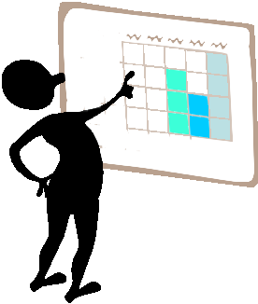

**Copyright**

*The Department of Education and Training (DET) encourages the dissemination and re-use of information provided in this document.*

Material on this website is provided under a Creative Commons Attribution 4.0 international licence, with the exception of:

* any images, photographs, trademarks or branding, including the Victorian Government logo and the DET logo; and
* content supplied by third parties.



For licence conditions, see: [Creative Commons Attribution 4.0 international licence](http://creativecommons.org/licenses/by/4.0/)

**Attribution**

Material to be attributed as:

© State of Victoria (Department of Education and Training)

|  |  |
| --- | --- |
| Learning Intentions | what-is-a-learning-style_pg8 |

* Interpretation of pictograph and collection and sorting of items or data in preparation for the creation of a pictograph
* Reading a simple pictograph to record findings
* Collecting and displaying data related to their own activities using simple pictographs
* Recognizing some days of the week and some months of the year related to events in his/her life

Note: Activity sheets are numbered and provided at the back of this resource

###### math2Task 1

### Step 1

Revise the number rhymes: *The Beehive.*

*One, Two, Buckle My Shoe.*

Introduce *Two Little Eyes.* See Activity sheet 13*.*

### Step 2

Using play dough, ask your child to make:

3 big balls

2 snails

1 house

4 little balls

5 nests, etc.

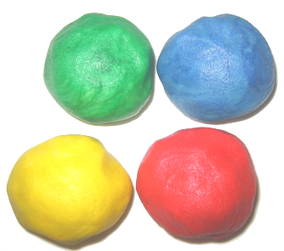

### Step 3

Use the number and number word flashcards. See Activity sheet 20

Revise the flashcards: ***one****,* ***two****,* ***1*** and ***2***.Show all the cards to your child.

Say: *When you see the word for 2, stand up.*

*When you see the word for 1, stand on one leg.*

*When you see the numeral for 2, clap two times.*

*When you see the numeral for 1, jump once.*

*When you see the word for 1, put one hand in the air.*

*When you see the word for 2, sit down,* etc.

### Step 4

Using a large piece of paper, ask your child to lie down and you then draw around their body shape.

If you do not have a large sheet of paper you may like to stick a photo of your child on a piece of paper and label that. Alternatively, ask your child to draw a small outline of a body shape on paper, similar to the one on this page.

At the top of the page write: **This is me**.

Then write: **I have**

down the sides of the outline as shown here.

**This is Me**

**I have:**

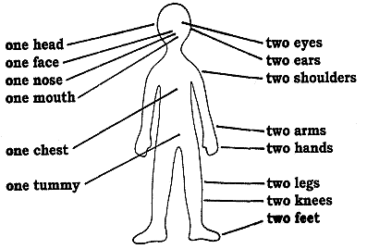

**1 2**

Draw lines from the label to the appropriate body part.

Write the number **l** on the bottom left-hand side of the page and the number **2** on the bottom right-hand side of the page.

Let your child colour the skin and add eyes, ears, nose, etc. to the outline. Give them wrapping paper or fabric scraps to paste clothes to complete the picture of themself.

###### math2Task 2

**Step 1** Revise *Ten Little Fish and The Beehive.*

**Step 2** **1:1 matching**

Ask your child to put out three cups, find four shoes, touch two books, clap three

times, stack five blocks, etc.

**Step 3** **Revise one, two, 1 and 2**

Revise the chart of *This is me* from Task 1, checking the numeral and number words for ***one*** and ***two***.

Ask your child if they can think of anything else you could have written.



Sing the song *Can You Walk on Two Legs?* Activity sheet 14.

### Step 4

**Use Activity sheet 1.**

Show the new worksheet page for a counting book, **2 two eyes.**

Using scrap paper, paste and decorate the numeral two.

Complete the page by colouring and cutting out the eyes on the work- sheet and pasting them on.

Display this page alongside the page for **1 one sun.**

**Step 5 An Introduction to Graphs**

Write your child’s name and ask him/her to count the letters in his/her name.

Repeat for other members in the family.

Explain that you now have a lot of information about the number of letters in each family members name but it is difficult to take in all the information. If you make a graph, which is a number story, you can read the information more easily.

### Step 6

**Use Activity sheet 2.**

On the worksheet, ask your child to draw a *face* for each member of the family in the boxes on the sheet provided. Write their names in the boxes underneath. Cut them out carefully.

### Step 7

**Use Activity sheet 3.**

Paste the faces with names beneath on the graph sheet in the appropriate place. (Change or add numbers if the numbers you need are not on the sheet.)

*Read* the graph with your child.

Who has the most letters in their name? Who has the least? Do any names have the same number of letters?

Here is Hayden’s *Letters in our names pictograph*

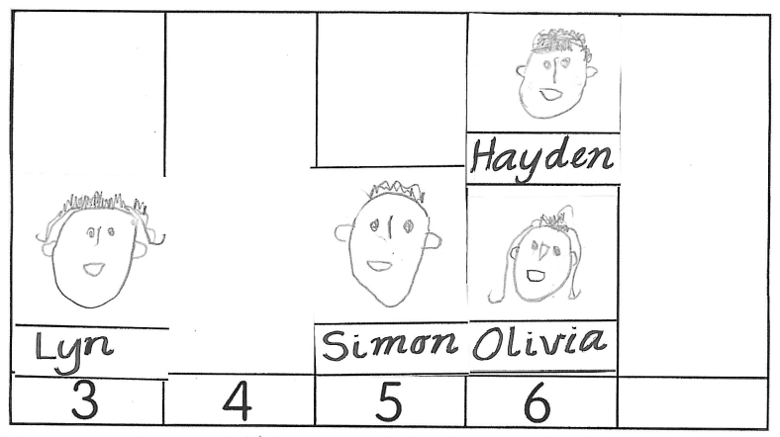

###### math2Task 3

**Step 1** Choose a number of counting rhymes to revise.

Revise the song *Can You Walk on Two Legs?*

### Step 2

**Use Activity sheet 4.**

Show your child the worksheet, and explain that to complete it the pictures have to be coloured and then write the numeral **1** or **2** in the space next to each picture.

### Step 3

Discuss your child’s birth date.

Display a calendar and discuss the months of the year.

Your child does not need to be able to remember the order of the months but should know which month his or her birthday is in. Is it near the middle of the year, the last month of the year, the second month of the year?

Write your child’s birth date. Explain what the numerals mean. For example, 7.6.10 means you were born on the seventh day in the sixth month (which is June), in the year 2010.

Your child should know his or her birth date. Help your child to learn it.

### Step 4

If you have a *Baby Book*, show this to your child and discuss it with him or her.

Take a sheet of paper and divide it into sections, one section for each year of your child’s life. Write the year at the top of each section.

Discuss with your child something of importance that happened to him or her during each year, e.g. learned to walk, moved house, got a two-wheeler bike, a sibling was born, etc.

Write a brief sentence about this special happening in the appropriate section and ask your child to illustrate it.

Review the whole page when it is finished.

###### math2Task 4

### Step 1

Revise known counting rhymes.

### Step 2

Can your child remember his birth date?

There are lots of numbers associated with his house that your child should know. such as

1. number of house
2. postcode
3. telephone number.

Show where these numbers can be found.

Look at the number on your house or letterbox. Check the postcode book or a letter addressed to your house. Find your name and number in the contact list of a phone. Explain what these numbers are for and how they make life easier for us. (Houses didn’t always have house numbers and areas didn’t always have postcodes. They were introduced to assist mail delivery.)

Write your address and telephone number on a card and help your child to learn them.

### Step 3

**Use Activity sheet 5.**

Give your child the pile of coloured squares you have already cut out (from the worksheet). Explain that every square is a room for a house, and that she/he is going to be the architect. Your child can plan lots of different houses but every house has to have exactly five rooms and every house has to have a different floor plan. The edges must touch and the corners line up.

Ask your child to count out five squares and put them together.

When your child has arranged one set of five squares, he or she can paste it down and start another.

Continue like this until all the squares are used up.

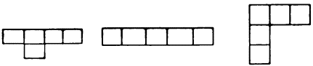

###### math2Task 5

|  |  |
| --- | --- |
| Step 1 Revise the song *Can You Walk on Two Legs?* Step 2 Can your child remember his birth date, his address and his telephone number? Go over these things with him. Show him the numbers written down. Read the chart. | j0432630[2] |

|  |  |
| --- | --- |
| Step 3 Make a three-dimensional house from paper.  Take a piece of square paper.  Fold it into sixteen squares, the same way as the basket was folded.  Colour the four central squares (the roof).  Cut along the six creases (as in the diagram).  Paste 2 over 3 and 6 over 7.  Paste edges of 1 over 4 and 5 over 8 to form the house.  Cut out door.  Paste on windows, chimney, etc. Step 4 Give your child the opportunity to build with blocks or manipulative equipment. | image067  image069 image071 |

**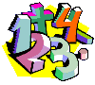Task 6**

### Step 1

1. Revise some counting rhymes, including *Two Little Eyes.*
2. Put out an egg carton and place one to five objects in each section down one side. Ask your child to put a matching number of objects in each corresponding section down the other side.

### Step 2

Can your child remember his or her telephone number, birth date and address? Spend time helping your child to learn these (if he or she does not know them). Paste a coloured sticker next to the number facts already known.

**Step 3 Practice in Estimation**

Using a large piece of paper, ask your child to lie down and draw around their

body shape.

Ask: *How many times do you think your hand will fit into your shape*?

At the top of the page write, **Guess ... hands.** Add the number your child has guessed.

Give your child a crayon and get him/her to place his/her hand on the paper with his/her fingers together. Get your child to draw around his or her hand as many times as it can fit into the body shape. Make sure your child doesn’t leave any space between the hand outlines. When your child has finished, count the number of hands he or she has drawn. Was the guess near the correct total?

Write underneath the body outline:

**I can fit my hand into my shape \_\_\_\_\_\_\_ times.**

### Step 4

Repeat the aboveprocedure for the outline of a shoe. Make sure he or she uses a different colour crayon to draw over the hand outlines.

Ask: *Will there be more shoe prints or more hand prints? Why?*

###### math2Task 7

### Step 1

Use Activity sheet 21

Give your child the animal pictures.

Ask your child to:

* put them into two sets.
* tell you about the sets?
* to put them into two sets a different way.
* tell you about these sets?
* paste the animals in two different sets on a piece of paper.

Write what he or she says the sets are underneath the work.

### Step 2

Introduce the counting rhyme *Mary at the Cottage Gate.*

See Activity sheet 15

Count quietly by ones to ten emphasising the numbers two, four, six, eight, ten to show how this counting pattern works.

Explain that there are lots of times when it is quicker to count by twos,

e.g. two dollar coins when counting money.

### Step 3

Put out an even number of blocks.

Ask: *Can you put these blocks into sets of two so that there are two blocks in each set?* (This is very different from sorting into two sets. Make sure you ask the question as it is printed.)

*How many sets of two are there?*

Repeat this several times, using odd and even numbers of blocks.

When using an odd number of blocks, there is always one left over so all the blocks cannot be sorted into sets of two. Explain this.

### Step 4

Use Activity sheet 6.

Show your child the worksheet. He or she has to draw a line around the circles to make sets of two. The first one is done for him or her.

### Step 5

Give your child time to build a house using blocks or manipulative equipment

###### math2Task 8

### Step 1

Revise the counting rhymes: *Mary At the Cottage Gate* and

*The Beehive.*

### Step 2

Talk about number *three.*

Unlike the numbers *one* and *two* we have nothing on our bodies for *three.*

Point out :

Triangles always have three corners and three sides. Can you spot any triangles where you are?

Some stools have three legs.

Tricycles have three wheels.

We always say three cheers.

There are three prime colours.

Three is an important number, particularly in old folk tales such as:

1. *Goldilocks and the Three Bears.*
2. *Three Billy Goats Gruff.*
3. *The Three little Pigs.*

**Step 3**

Tell the story of *The Three Little Pigs*. <https://www.youtube.com/watch?v=CtP83CWOMwc>

Ask your child to draw a picture of *The Three Little Pigs.*

Make sure he or she includes three pigs and three houses in the picture.

Ask him or her to count the pigs and the houses.

Are there three doors, three chimneys, three paths, three fences, three gates and three windows in his picture?

Ask him or her to add these things and count each time as he or she does so.

Write the numerals ***1, 2, 3*** next to the pigs and the houses in this picture.

### Step 4

Use Activity sheet 20

Can your child recognise the numeral ***3*** amongst the flashcards?

Say: *Put your hands on your knees when you see the numeral* ***3****.*

Repeat the activity, asking him or her to touch the toes, the head, the shoulders, etc. each time.

###### math2Task 9

|  |  |
| --- | --- |
| Step 1 Introduce the song **Goldilocks** See Activity sheet 16 |  |

If you don’t know the tune, then just say the rhyme.

1. Using play dough, ask your child to make the three bowls - one huge, one small and one tiny.
2. Repeat for the chairs, the beds and the bears.
3. Make sure he or she counts them each time.

### Step 2

Show your child the numeral card **3** and the number word card **three** from Activity sheet 20

Ask him or her to make a long sausage with his play dough, and show how to make the numeral **3.**

Can your child find the numeral and number word cards for ***three*** from amongst the other flash cards?

**Step 3** – **Consolidate the term *after***

Ask your child to:

* make five balls and put them in a line.
* touch each one as he or she counts them.
* to do it again but to stop at three.

Say: *Three always comes* ***after*** *two when we are counting by ones.*

Line up six bottles in a row. Say, for instance:

If this bottle is at beginning of the line, touch the bottle that comes **after** it.

Touch the bottle that comes after the one with the lid on.

Touch the bottle that comes after the one with the label.

Ask: *What did the little pigs do after they left home?*

*What did the first little pig do after the wolf blew his house down?*

*What did the second little pig do after the wolf blew his house down?*

*What did the three little pigs do after they heard the wolf climbing up on the roof?*

*What did the wolf do after he fell in the pot of water?*

### Step 4

Use Activity sheet 7.

Read ***3 three pigs*** on the work sheet.

Your child is to colour the pictures of the three pigs and use scrap paper to decorate the numeral 3.

Display this page with those for **one** and **two** when dry.

###### math2Task 10

### Step 1

Make a new, bigger *Facts About Me* chart.

Write today’s date at the top of the new chart.

Paste the chart you have already made, together with your child’s birth date, address and telephone number, onto the bigger chart.

Discuss, then add other number facts about your child to the chart, e.g.

age

height

weight

chest measurement

number of sisters

number of brothers

number of letters in his name,

plus anything else that is relevant.

Talk about it.

**Step 2**

Revise the numeral 3.

Say: *I know something we can make that needs only three ingredients in it. It’s marshmallow.*

**Use Activity sheet 8** which contains the recipe for Marshmallow.

Make some marshmallow letting your child measure, count and help as much as possible.

**Step 3**

Do you know what month your birthday is? \_\_\_\_\_\_\_\_\_\_\_.

Read months aloud to student.

|  |  |  |  |  |  |
| --- | --- | --- | --- | --- | --- |
| January | February | March | April | May | June |
| July | August | September | October | November | December |

Complete this sentence with a day of the week in the first gap.

On \_\_\_\_\_\_\_\_\_\_\_\_\_\_ I like to \_\_\_\_\_\_\_\_\_\_\_\_\_\_.

|  |  |  |  |
| --- | --- | --- | --- |
| Monday | Tuesday | Wednesday | Thursday |
| Friday | Saturday | Sunday |  |

|  |
| --- |
| **Activity Pages** |

**Maths Activity Sheet 1**

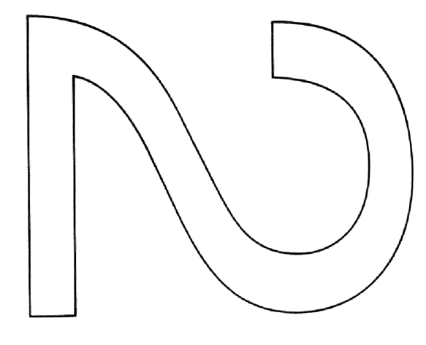

two eyes

**Maths Activity Sheet 2 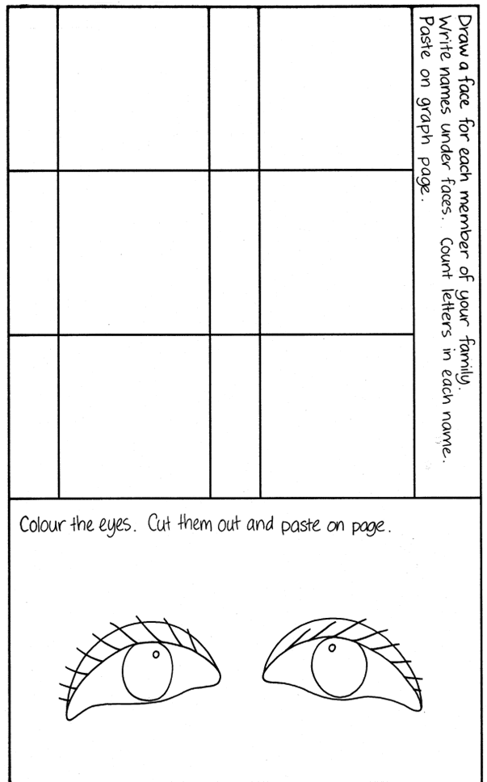**

**Maths Activity Sheet 3**

|  |  |
| --- | --- |
| image006 | Letters in our names pictograph |

**Maths Activity Sheet 4**

**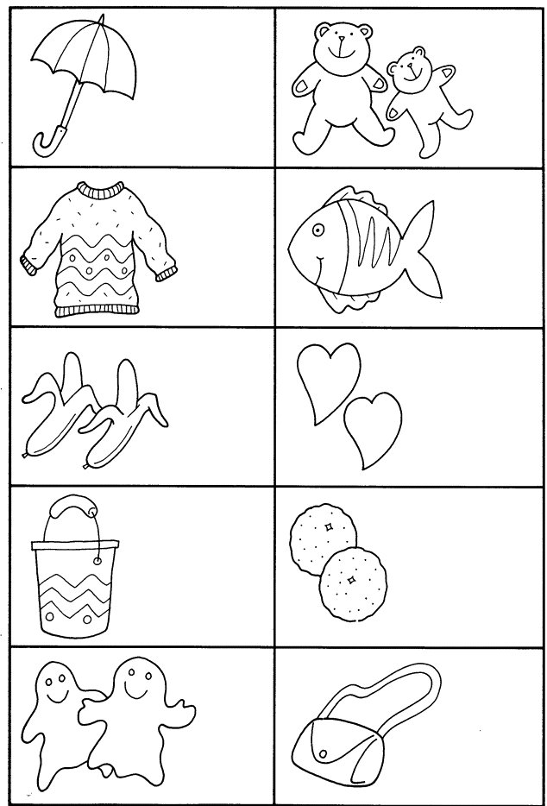**

**Maths Activity Sheet 5**

Make some house plans. Make every house different.

Use just 5 squares for every house.

|  |  |  |  |  |
| --- | --- | --- | --- | --- |
|  |  |  |  |  |
|  |  |  |  |  |
|  |  |  |  |  |
|  |  |  |  |  |
|  |  |  |  |  |
|  |  |  |  |  |
|  |  |  |  |  |

**Maths Activity Sheet 6**

Draw a line around the circles to make sets of 2.

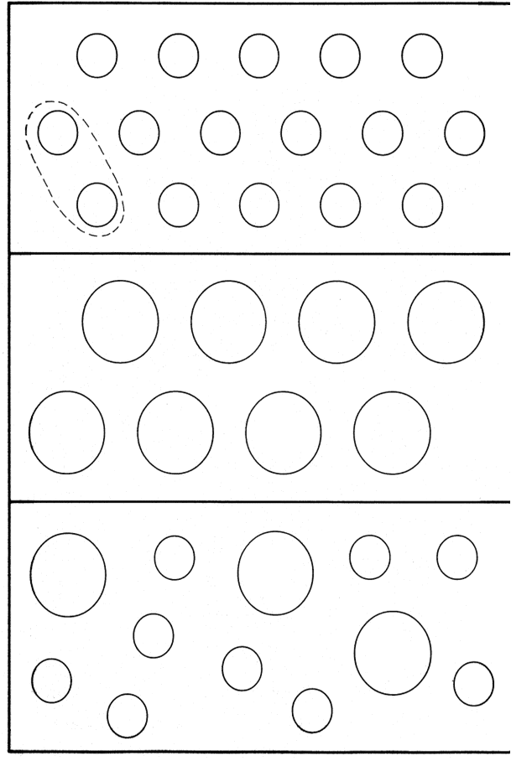

|  |  |  |
| --- | --- | --- |
|  | **Maths Activity Sheet 7**  image002 | |
| three pigs | | image003 |

**Maths Activity Sheet 8**

**Monster Marshmallows**

Note: You can do this activity with store bought marshmallows.

|  |  |
| --- | --- |
| **Ingredients:**  1 cup white sugar  1 cup water  1 rounded tablespoon gelatine | In the microwave, an ordinary marshmallow will puff up until it’s monster-mallowsenormous! |
| **Method:**  Put ingredients into saucepan and bring to the boil.  Simmer for about two minutes.  Cool to warm. Don’t allow to get cold.  Grease a slice tray approximately 20 cm x 30 cm.  Pour mixture into a bowl.  Beat with electric mixer until mixture is very thick and white.  If you wish, add a teaspoon of vanilla essence and a few drops of pink colouring.  Pour mixture into tray and place in refrigerator.  When set, cut into sections, tip out and roll in coconut.  This marshmallow will keep for a number of days if kept in the refrigerator.  **To make Monster Marshmallows**   |  |  |  |  |  |  | | --- | --- | --- | --- | --- | --- | | |  | | --- | | **1.** Put two marshmallows on a paper plate or paper towel. | | **2.** Put the plate in the microwave. Set the timer for 1 minute (60 seconds) on high. | | **3.** Stand back and watch through the window of the microwave. After about 20 seconds, you’ll see the marshmallows start to puff up. They’ll grow to about four times their original size! | | **4.** When the microwave turns off, take the plate out and put it on the counter. | | **5.** Wait a few seconds, then pull one marshmallow off. Is the marshmallow hollow inside? Is the inside the same colour as the outside? When you eat it, is it soft or crunchy? Leave the other marshmallow on the plate and watch it for a minute. When it shrinks back down, you can pull it with your fingers and make it into whatever shape you want. It will stay in that shape and get hard and crunchy. You can eat it, too.  To find out more visit: <http://www.exploratorium.edu/cooking/candy/activity-mallows.html> | | | |

**Maths Activity Sheet 9**

**One, two, buckle my shoe**

One, two, buckle my shoe  
Three, four, shut the door  
Five, six, pick up sticks  
Seven, eight, lay them straight  
Nine, ten, begin again

Okay everybody, one more time

One, two, buckle my shoe  
Three, four, shut the door  
Five, six, pick up sticks  
Seven, eight, lay them straight  
Nine, ten, that's the end

That's the end

**1, 2, 3, 4, 5, Once I Caught a Fish Alive**

One, Two, Three, Four, Five,

Once I caught a fish alive,

Six, Seven, Eight, Nine, Ten,

Then I threw him back again.

Why did you let him go?

Because he bit my finger so.

Which finger did he bite?

This little finger on my right.

**Maths Activity Sheet 10**

Tic, Tac, Toe

Tic, tac, toe, here I go.

Where I land I do not know.

To play the game Tic, Tac, Toe choose a topic sheet of mixed symbols and images

Your child taps each picture in turn, as you say the rhyme together

He or she stops at the picture when the rhyme finishes. He or she counts the objects in that particular picture or names the image, then the rhyme begins again.

**Maths Activity Sheet 11**

**Ten in the Bed**

There were ten in the bed and the Little One said,

“Roll over! Roll over!”

So they all rolled over and one fell out.

There were nine in the bed and the little one said,

“Roll over! Roll over!”

So they all rolled over and one fell out.

There were eight in the bed and the little one said,

“Roll over! Roll over!”

So they all rolled over and one fell out.

There were seven in the bed and the little one said,

“Roll over! Roll over!”

So they all rolled over and one fell out.

There were six in the bed and the little one said,

“Roll over! Roll over!”

So they all rolled over and one fell out.

There were five in the bed and the little one said,

“Roll over! Roll over!”

So they all rolled over and one fell out.

There were four in the bed and the little one said,

“Roll over! Roll over!”

So they all rolled over and one fell out.

There were three in the bed and the little one said,

“Roll over! Roll over!”

So they all rolled over and one fell out.

There were two in the bed and the little one said,

“Roll over! Roll over!”

So they all rolled over and one fell out.

There was one in the bed and the little one said,

“I’m lonely! I’m lonely!”

So they all climbed back in

**Maths Activity Sheet 12**

Two Little Kittens

Two little kittens, one stormy night,  
Began to quarrel, and then to fight;  
One had a mouse and the other had none,  
And that's the way the quarrel begun.  
  
"I'll have that mouse," said the biggest cat,  
"You'll have that mouse? We'll see about that!"  
"I will have that mouse," said the eldest son;  
"You shan't have that mouse," said the little one.  
  
I told you before 't was a stormy night  
When these two little kittens began to fight;  
The old woman seized her sweeping broom,  
And swept the two kittens right out of the room.  
  
The ground was covered with frost and snow,  
And the two little kittens had nowhere to go.  
So they laid them down on the mat at the door  
While the old woman finished sweeping the floor.  
  
Then they crept in, as quiet as mice,  
All wet with snow and as cold as ice;  
For they found it was better, that stormy night,  
To lie down and sleep than to quarrel and fight.

**Maths Activity Sheet 13**

The beehive

Here is the beehive.  
But where are all the bees?  
Hiding away where nobody sees.  
Here they come flying out of their hive.  
One, two, three, four, five!

Here is the beehive.  
But where are all the bees?  
Hiding away where nobody sees.  
Here they come flying out of their hive.  
One, two, three, four, five!

Buzz up high. Buzz down low.  
Buzzing fast. Buzzing slow.  
Buzz to the left. Buzz to the right.  
Buzz all day but sleep at night.

Here is the beehive.  
But where are all the bees?  
Hiding away where nobody sees.  
Here they come flying out of their hive.  
One, two, three, four, five!

Two Little Eyes

Two little eyes to look around.  
Two little ears to hear each sound.  
  
One little nose to smell what's sweet.  
One little mouth that likes to eat.

**Maths Activity Sheet 14**

Can you Walk on Two Legs?

Can you walk on two legs, two legs, two legs?

Can you walk on two legs,

Round and round and round?

I can walk on two legs, two legs, two legs,

I can walk on two legs,

Round and round and round.

Can you hop on one leg, one leg, one leg?

Can you hop on one leg,

Round and round and round?

I can hop on one leg, one leg, one leg,

I can hop on one leg,

Round and round and round.

Can you wave with one hand, one hand, one hand?

Can you wave with one hand,

Round and round and round?

I can wave with one hand, one hand, one hand,

I can wave with one hand,

Round and round and round.

Can you wave with two hands, two hands, two hands?

Can you wave with two hands,

Round and round and round?

I can wave with two hands, two hands, two hands,

I can wave with two hands,

Round and round and round.

**Maths Activity Sheet 15**

Mary at the Cottage Gate

One, two, three, four

Mary at the cottage door

Two, four, six, eight

Mary at the garden gate

The Squirrel

Five little squirrels, sitting by the door

One ran away and then there were four

Four little squirrels, climbing up a tree

One ran down and that left three

The little squirrels, with coats so new

One got dirty and then there were two

Two little squirrels sitting in the sun

One got sun burnt and that left one

**Maths Activity Sheet 16**

Goldilocks

When Goldilocks went to the house of the bears,

Oh what did her blue eyes see?

A bowl that was huge,

A bowl that was small,

A bowl that was tiny and that was all,

She counted them one, two, three.

When Goldilocks went to the house of the bears,

Oh what did her blue eyes see?

A chair that was huge,

A chair that was small,

A chair that was tiny and that was all,

She counted them one, two, three.

When Goldilocks went to the house of the bears,

Oh what did her blue eyes see?

A bed that was huge,

A bed that was small,

A bed that was tiny and that was all,

She counted them one, two, three.

When Goldilocks went to the house of the bears,

Oh what did her blue eyes see?

A bear that was huge,

A bear that was small,

A bear that was tiny and that was all,

They growled at her “Grrrrr! Grrr! Grr!”

**Maths Activity Sheet 17**

Three Little Kittens

The three little kittens, they lost their mittens,

And they began to cry,

"Oh, mother dear, we sadly fear,

That we have lost our mittens."

"What!   Lost your mittens, you naughty kittens!

Then you shall have no pie."

"Meow, meow, meow."

"Then you shall have no pie."

The three little kittens, they found their mittens,

And they began to cry,

"Oh, mother dear, see here, see here,

For we have found our mittens."

"Put on your mittens, you silly kittens,

And you shall have some pie."

"Purr, purr, purr,

Oh, let us have some pie."

The three little kittens put on their mittens,

And soon ate up the pie,

"Oh, mother dear, we greatly fear,

That we have soiled our mittens."

"What, soiled your mittens, you naughty kittens!"

Then they began to sigh,

"Meow, meow, meow,"

Then they began to sigh.

The three little kittens, they washed their mittens,

And hung them out to dry,

"Oh, mother dear, do you not hear,

That we have washed our mittens?"

"What, washed your mittens, then you're good kittens,

But I smell a rat close by."

"Meow, meow, meow,

We smell a rat close by."

**Maths Activity Sheet 18**

Ten Fingers

I have ten little fingers and they all belong to me.  
I can make them do things, would you like to see?  
I can shut them up tight, I can open them wide.  
I can put them together, I can make them hide.  
I can make them jump high, I can make them jump low.  
I can rolly, rolly, them around and fold them just so.

Five Little Ladies

Five little ladies going for a walk.   
Five little ladies stopping for a talk.  
Along came five little gentlemen,  
And they all danced together and that makes 10!

Five Little Soldiers

Five little Soldiers stand in a row,  
Four stand up straight and one bends low.  
Along came the Seargent and what do you think?  
Up pops the Soldier, as quick as a wink.

**Maths Activity Sheet 19**

Ten Little Fish

One little fishy swimming in the sea.  
Along came another one, and then there were two.

Two little fishies swimming in the sea.  
Along came another one, and then there were three.

Three little fishies swimming in the sea.  
Along came another one, and then there were four.

Swimming swimming swimming in the sea.  
That big ol’ shark will never catch me.

Four little fishies swimming in the sea.  
Along came another one, and then there were five.

Five little fishies swimming in the sea.  
Along came another one, and then there were six.

Six little fishies swimming in the sea.  
Along came another one, and then there were seven

Swimming swimming swimming in the sea.  
That big ol’ shark will never catch me.

Seven little fishies swimming in the sea.  
Along came another one, and then there were eight.

Eight little fishies swimming in the sea.  
Along came another one, and then there were nine.

Nine little fishies swimming in the sea.  
Along came another one, and then there were ten.

Swimming swimming swimming in the sea.  
That big ol’ shark will never catch me.

Swimming swimming swimming in the sea.  
That big ol’ shark will never catch me.

Swimming swimming swimming in the sea.  
That big ol’ shark will never catch me.

He’ll never,  
Never,  
Never,  
Never,  
That big old shark will never catch me!

Maths Activity Sheet 20

|  |  |  |  |
| --- | --- | --- | --- |
| **three** |  | **two** | **one** |
| **4** | **3** | **five** | **four** |
| **5** |  | **2** | **1** |

**Maths Activity Sheet 21**

