**Geography**

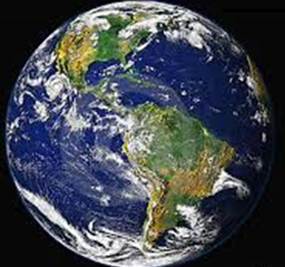

What is the significance of vegetation to the environment, animals and people?



As you know, tropical rainforests are lush with dense vegetation and hot deserts are dry. This is because of where they are located throughout the world as well as their climate and rainfall levels. Have you thought about how humans and animals depend on these environments to live, survive and thrive?

1. Watch the following video clip:

[**http://tinyurl.com/l2caksp**](http://tinyurl.com/l2caksp)**.**

2. Write some interesting dot points about the importance of vegetation to the environment, animals and people in the video clip.

|  |
| --- |
|  |
|  |
|  |
|  |
|  |
|  |
|  |
|  |
|  |
|  |
|  |
|  |
|  |
|  |
|  |
|  |
|  |
|  |
|  |
|  |
|  |
|  |
|  |
|  |
|  |
|  |
|  |

1. Choose an animal in a particular environment to investigate.

2. Research your chosen animal and add notes to the table below.

3. List your source/s of information.

|  |  |
| --- | --- |
| Name of animal |  |
| Description |  |
| Location in the world |  |
| Food |  |
| Habitat |  |
| Vegetation the animal needs for survival |  |
| Relationship with humans |  |
| Describe ways the animal can thrive |  |

Source/s of information: ____________________________________________________________________________________________________________________

1. Present your findings on your research. You can present your work as a Word document, PowerPoint presentation, short video presentation, handwritten report or an audio file. Remember to list your source/sources of information.

**REFLECTION**

1. How would the animal you chose to investigate cope if it lived in a completely different environment? Explain.

|  |
| --- |
|  |
|  |
|  |
|  |
|  |
|  |
|  |
|  |
|  |
|  |
|  |
|  |
|  |
|  |
|  |
|  |
|  |
|  |
|  |
|  |
|  |
|  |
|  |
|  |
|  |
|  |
|  |
|  |
|  |
|  |