**Geography**

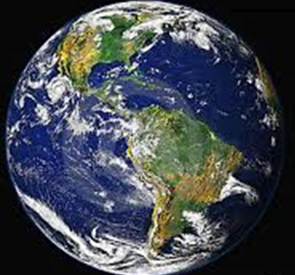

Where is South America located in relation to Australia?

**GETTING KNOWLEDGE READY**

1. Record what you know (or think) about South America in the mind map below.

**SOUTH AMERICA**

1. A ***continent*** is any of the world's main continuous expanses of land (Europe, Asia, South America, North and South America, Australia, Antarctica). Visit the following link to view a map of the world’s continents:

<http://www.nationsonline.org/oneworld/continents_map.htm>

1. On the blank world map below, outline Australia and South America in two different coloured textas. Colour in and rule a line to the name of each continent.

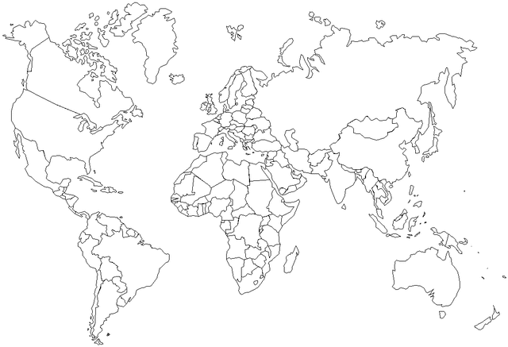

*SOUTH AMERICA AUSTRALIA*

1. Earth is divided into two ***hemispheres*** – the Northern and Southern Hemispheres. These two hemispheres meet at the ***equator***.

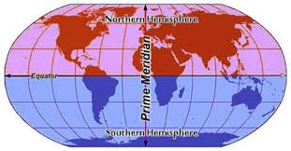

1. Rule a line to show the equator on the world map on page 5. Use the map above as a guide.
2. What is similar about where Australia and South America are located in the world? Write your answer below.

|  |
| --- |
|  |
|  |
|  |
|  |
|  |
|  |
|  |
|  |
|  |
|  |
|  |
|  |
|  |
|  |
|  |
|  |
|  |
|  |

1. Visit the following website at:

<http://www.distancefromto.net/>

1. Measure the distance ***From*** Australia ***To*** South America.
2. What is the air distance between these two continents?

________________________________ km

1. The air distance is between which two specific points in Australia and South America?

__________________________________________________________________

1. What ocean is between Australia and South America?

__________________________________________________________________

1. Where are you in the world currently?

__________________________________________________________________

1. Mark your location on the map below. Label your location in the box beneath the map.



|  |
| --- |
|  |

1. Using <http://www.distancefromto.net/> measure the distance from where you are in the world to South America, e.g. Melbourne to South America or Italy to South America.
2. How far away are you from South America?

________________________________ km

1. Rule a line from your current location in the world to South America on the map above.

**GEOGRAPHY QUIZ**

1. Circle the correct answer. A ***continent*** is any of the world's main continuous expanses of land.

***TRUE*** or ***FALSE***

1. Circle the correct answer. Australia and Europe are examples of continents.

***TRUE*** or ***FALSE***

1. Circle the correct answer. Earth is divided into two ***hemispheres*** – the Northern and Southern Hemispheres.

***TRUE*** or ***FALSE***

1. Circle the correct answer. The Northern and Southern Hemispheres meet at the equator.

***TRUE*** or ***FALSE***

1. Circle the correct answer. The ocean between Australia and South America is the:
2. Indian Ocean.
3. North Pacific Ocean.
4. South Pacific Ocean.

**Score: __ / 5**

**REFLECTION**

1. *In your own words, briefly explain where South America is located in relation to Australia.*

|  |
| --- |
|  |
|  |
|  |
|  |
|  |
|  |
|  |
|  |
|  |
|  |
|  |
|  |
|  |
|  |
|  |

